Name of journal: World Journal of Gastroenterology
ESPS Manuscript NO: 2261
Columns: CASE REPORT

Intrahepatic endometriosis as differential diagnosis: Case report and literature review

Fluegen G et al. Intrahepatic endometriosis as DD of cysts

Georg Fluegen, Frank Jankowiak, Luisa Zacarias Foehrding, Feride Kroepil, Wolfram T Knoefel, Stefan A Topp

Georg Fluegen, Luisa Zacarias Foehrding, Feride Kroepil, Wolfram T Knoefel, Stefan A Topp, Department of Surgery (A), Heinrich-Heine-University and University Hospital Duesseldorf, 40225 Duesseldorf, Germany

Frank Jankowiak, Institute of Pathology, Heinrich-Heine-University and University Hospital Duesseldorf, 40225 Duesseldorf, Germany

Author contributions: Fluegen G designed the report and analyzed and interpreted the data; Fluegen G, Kroepil F, Knoefel WT and Topp SA were attending doctors of the patient; Topp SA performed the operation; Jankowiak F performed pathological examinations; Zacarias Foehrding L, Knoefel WT and Topp SA critically revised the report and gave important intellectual input.

Correspondence to: Dr. Stefan A Topp, Professor, Department of Surgery (A), Heinrich-Heine-University and University Hospital Duesseldorf, Moorenstr 5, 40225 Düsseldorf, Germany. stefan.topp@uni-duesseldorf.de

Telephone: +49-211-8117349 Fax: +49-211-8119205
Received: February 10, 2013 Revised: April 17, 2013
Accepted: May 8, 2013

Published Online:

Abstract
Intrahepatic endometriosis is one of the rarest forms of atypical endometriosis; only eighteen cases have been reported in the English literature. We describe the case of a thirty-two-year-old woman, who presented with persistent, non-cyclical upper right quadrant abdominal pain, a central liver cyst, and no history of endometriosis. Three years previous, she was diagnosed with an intrahepatic cyst. The lesion progressed and two laparoscopic deroofing-operations were performed, yet the diagnosis of intrahepatic endometriosis was never reached. She presented in our clinic with further progress of the cyst as well as obstruction of the intrahepatic biliary system. The magnetic resonance imaging showed a 9.5 cm × 12 cm, lobulated intrahepatic cyst. We performed an ultrasonic pericystectomy. Immunostaining confirmed intrahepatic endometriosis. Only one of the previously described eighteen patients with intrahepatic endometriosis presented with cyclical pain in the upper right abdominal quadrant accompanying menstruation. This lack of a “typical” clinic makes it challenging to diagnose extragonadal endometriosis without histopathology. A previous history of endometriosis was described in only twelve cases, thus the diagnosis of this condition should not be limited to patients with a known history of endometriosis. Six of eighteen patients were postmenopausal, demonstrating this condition is not limited to women of reproductive age. A preoperative diagnosis was only reached in seven of the previously described cases, highlighting the importance of preoperative biopsies. Yet due to the potential adverse effects, a transhepatic biopsy must be discussed individually. Although rare, intrahepatic endometriosis should always be considered as a differential diagnosis in women with recurrent hepatic cysts, regardless of age or previous medical history. In such cases, histology is essential and a pericystectomy should be performed as standard of care.

© 2013 Baishideng. All rights reserved.

Key words: Intrahepatic endometriosis; Atypical endometriosis; Extrapelvic endometriosis; Hepatic cysts

Core tip: We describe the case of a thirty-two-year-old woman who presented with non-cyclical upper right quadrant abdominal pain and a central liver cyst. Upon ultrasonic pericystectomy, the patient was diagnosed with intrahepatic endometriosis. The lack of “typical” clinical symptoms makes it challenging to diagnose extragonadal endometriosis without histopathology. Only eighteen cases of intrahepatic endometriosis have been reported in the literature, with only one reporting cyclical pain. Six of the eighteen patients were postmenopausal, and in twelve cases a previous history of endometriosis was described. Intrahepatic endometriosis should always be considered as a differential diagnosis in women of any age.

Fluegen G, Jankowiak F, Zacarias Foehrding L, Kroepil F, Knoefel WT, Topp SA. Intrahepatic endometriosis as differential diagnosis: Case report and literature review. World J Gastroenterol 2013;
Available from: URL: http://www.wjgnet.com/esps/
DOI: http://dx.doi.org/10.3748/wjg.v19.i0.0000

INTRODUCTION
Endometriosis, a common clinical condition most commonly noted in the pelvis, is found in approximately 6%-10% of women of reproductive age^{[1]} and approximately 2.5% of postmenopausal women^{[2]}. Atypical endometriosis, when the condition is found in extrapelvic regions^{[3]}, is rare. Endometrial tissue deposits have been described in almost all organs of the human body, and even very rarely in males^{[4]}. Intrahepatic endometriosis is one of the rarest forms of atypical endometriosis. Since the first description of intrahepatic endometriosis in 1986^{[5]}, only eighteen cases have been reported in the English literature^{[5-20]}. We describe the case of a thirty-two-year-old woman, who presented with persistent upper right quadrant abdominal pain and a central liver cyst. We discuss the occurrence of intrahepatic endometriosis in review of the previously published eighteen cases and summarize the proposed pathogenesis of this rare condition.

CASE REPORT
A thirty-two-year-old woman, nulligravida, nullipara, consulted our hospital with constant right upper quadrant abdominal tenderness. She had no history of endometriosis. Three years previous, she was diagnosed with an intrahepatic cyst in segment IV. The lesion was closely monitored and upon progression two laparoscopic deroofing-operations, one in combination with a cholecystectomy, were performed. Due to further progression of the cyst with obstruction of the intrahepatic biliary system and resulting jaundice, multiple endoscopic retrograde cholangio pancreaticographies were performed and on three occasions transhepatic drains were applied. As the patient presented at our clinic, the preoperative magnetic resonance imaging showed a 9.5 cm × 12 cm, lobulated cyst in segments IV, V and VIII (Figure 1). The serology for echinococcal disease and the tumor markers (carcinoembryonic antigen, carbohydrate antigen 19-9, α-fetoprotein) were normal, as was the routine lab work. We performed an ultrasonic pericystectomy and were able to remove the cyst with minimal damage to the surrounding liver tissue. We did not detect any other abnormalities during the operation. The patient was discharged on the eleventh postoperative day.
Histopathology analysis revealed a lobulated cyst, filled with old blood and detritus. While the surrounding liver tissue was normal, immunostaining of the cyst showed strong coloring for estrogen and progesterone receptor as well as CK7, which proved the epithelial origin of the cyst. Since no atypical cells were detected, the diagnosis of a benign intrahepatic endometriosis was confirmed (Figure 2).

DISCUSSION
Only eighteen cases of this rare form of endometriosis are reported in the English literature (Table 1). Further, only one (5.5%) of these patients presented with cyclical pain in the upper right abdominal quadrant accompanying menstruation. In all other cases, patients presented with tenderness or pain, even jaundice, but no obvious connection to the menstrual cycle. This lack of a “typical” clinic makes it difficult to diagnose extragonadal endometriosis without histopathology. Twelve cases (67%) reported a previous history of endometriosis, mostly in a typical pelvic location, while six patients (33%) had no history of endometriosis at all. Thus the diagnosis of this condition should not be limited to patients with a known history of endometriosis. Also, six of eighteen patients (33%) were postmenopausal, thus showing this condition is not limited to women of reproductive age. Due to the difficulty of diagnosing this condition by preoperative radiography^{[6]}, only seven (39%) of the previously described eighteen cases were diagnosed preoperatively. In these cases, a transhepatic biopsy was obtained and the diagnosis verified histologically. Although our patient underwent several invasive procedures previous to the operation at our hospital, unfortunately no histological sample was obtained. This prolonged the suffering of the patient and highlights the importance of both histological and microbiological samples in any cystic formation.
The cause of endometriosis, first described by Rokitansky in 1860 in the pelvis, is still largely uncertain. Two major theories involve either the implantation of endometrial cells (implantation theory)^{[21]} or the metaplasia of the peritoneal epithelium (coelomic metaplasia theory)^{[22]} in the region of occurrence. Each theory, individually, fails to explain all cases of endometriosis. The frequent occurrence of retrograde menstruation is a strong argument for the implantation theory^{[23]}. Yet how these endometrial cells may reach atypical locations such as the brain, the heart^{[24,25]} or, and in our case, the parenchyma of the liver, is hard to explain with this theory. The transport of endometrial cells via blood and lymph vessels, similar to the metastasis of cancerous cells, may be a possible explanation for these atypical locations^{[9,21,26]}. Keichel et al^{[26]} found endometriosis-like cells in lymphatic vessels as well as endometriosis in locoregional lymph nodes in patients with deep infiltrating endometriosis.
The metaplasia of (peritoneal) epithelium due to chronic inflammation or an unknown signaling cascade^{[22]} may be better suited to explain the occurrence of endometriosis in obscure locations, such as in the heart or even the male. Yet the observation that atypical endometriosis usually occurs in only one location in each individual is hard to resolve. If, as postulated by this theory, some signaling cascade prompts coelomic cells to develop into endometrial tissue, why does this usually happen in only one atypical location in a prone individual? Also, the high number of extragonadal, pelvic cases of endometriosis seems to favor a model in which proximity to the uterus may play an important role.
In conclusion, intrahepatic endometriosis is a rare condition in women. Due to the difficulties of radiographic diagnosis and the “atypical” clinic (no cyclical pain and lack of dysmenorrhea), the diagnosis may only be reached preoperatively by transhepatic biopsy^{[6]}. Due to the potential adverse effects (risk of bleeding, possible dissemination of cells, biliary leakage) this procedure should be discussed individually. The operation of problematic cysts is a proven cure of the tenderness and pain mostly reported with this condition^{[27]}. A selective operation should be considered top priority, even if a malignant progression is very rare^{[28]}. Lifelong hormone therapy may also reduce the symptoms, as described in the case of Inal et al^{[12]}, but carries the risk of side effects and long-term dependence on medication. Rare conditions like intrahepatic endometriosis should always be considered as a differential diagnosis in women with recurrent hepatic cysts after surgical deroofing, regardless of age or previous medical history. In such cases, histology is essential and a pericystectomy should be performed.

REFERENCES
1 Giudice LC. Clinical practice. Endometriosis. N Engl J Med 2010; 362: 2389-2398 [PMID: 20573927]
2 Haas D, Chvatal R, Reichert B, Renner S, Shebl O, Binder H, Wurm P, Oppelt P. Endometriosis: a premenopausal disease? Age pattern in 42,079 patients with endometriosis. Arch Gynecol Obstet 2012; 286: 667-670 [PMID: 22562384]
3 Sonavane SK, Kantawala KP, Menias CO. Beyond the boundaries-endometriosis: typical and atypical locations. Curr Probl Diagn Radiol 2011; 40: 219-232 [PMID: 21939816]
4 Martin JD, Hauck AE. Endometriosis in the male. Am Surg 1985; 51: 426-430 [PMID: 4014886]
5 Finkel L, Marchevsky A, Cohen B. Endometrial cyst of the liver. Am J Gastroenterol 1986; 81: 576-578 [PMID: 3717122]
6 Asran M, Rashid A, Szklaruk J. Hepatic endometriosis mimicking metastatic disease: a case report and review of the literature. J Radiol Case Rep 2010; 4: 26-31 [PMID: 22470699]
7 Chung CC, Liew CT, Hewitt PM, Leung KL, Lau WY. Endometriosis of the liver. Surgery 1998; 123: 106-108 [PMID: 9457231]
8 Cravello L, D'Ercole C, Le Treut YP, Blanc B. Hepatic endometriosis: a case report. Fertil Steril 1996; 66: 657-659 [PMID: 8816634]
9 Goldsmith PJ, Ahmad N, Dasgupta D, Campbell J, Guthrie JA, Lodge JP. Case hepatic endometriosis: a continuing diagnostic dilemma. HPB Surg 2009; 2009: 407206 [PMID: 19587832]
10 Grabb A, Carr L, Goodman JD, Mendelson DS, Cohen B, Finkel L. Hepatic endometrioma. J Clin Ultrasound 1986; 14: 478-480 [PMID: 3091652]
11 Huang WT, Chen WJ, Chen CL, Cheng YF, Wang JH, Eng HL. Endometrial cyst of the liver: a case report and review of the literature. J Clin Pathol 2002; 55: 715-717 [PMID: 12195007]
12 Inal M, Biçakçi K, Soyupak S, Oğuz M, Ozer C, Demirbaş O, Akgül E. Hepatic endometrioma: a case report and review of the literature. Eur Radiol 2000; 10: 431-434 [PMID: 10756990]
13 Jeanes AC, Murray D, Davidson B, Hamilton M, Watkinson AF. Case report: hepatic and retro-peritoneal endometriosis presenting as obstructive jaundice with ascites: a case report and review of the literature. Clin Radiol 2002; 57: 226-229 [PMID: 11952319]
14 Khan AW. Liver tumours due to endometriosis and endometrial stromal sarcoma. HPB 2002; 4: 43-45
15 N'Senda P, Wendum D, Balladur P, Dahan H, Tubiana JM, Arrivé L. Adenosarcoma arising in hepatic endometriosis. Eur Radiol 2000; 10: 1287-1289 [PMID: 10939492]
16 Reid GD, Kowalski D, Cooper MJ, Kaloo P. Hepatic endometriosis: a case report and review of the literature. Aust N Z J Obstet Gynaecol 2003; 43: 87-89 [PMID: 12755358]
17 Rovati V, Faleschini E, Vercellini P, Nervetti G, Tagliabue G, Benzi G. Endometrioma of the liver. Am J Obstet Gynecol 1990; 163: 1490-1492 [PMID: 2240093]
18 Tuech JJ, Rousselet MC, Boyer J, Descamps P, Arnaud JP, Ronceray J. Endometrial cyst of the liver: case report and review. Fertil Steril 2003; 79: 1234-1236 [PMID: 12738526]
19 Verbeke C, Härle M, Sturm J. Cystic endometriosis of the upper abdominal organs. Report on three cases and review of the literature. Pathol Res Pract 1996; 192: 300-34; discussion 305 [PMID: 8739477]
20 Weinfeld RM, Johnson SC, Lucas CE, Saksouk FA. CT diagnosis of perihepatic endometriosis complicated by malignant transformation. Abdom Imaging 1998; 23: 183-184 [PMID: 9516511]
21 Sampson JA. Metastatic or Embolic Endometriosis, due to the Menstrual Dissemination of Endometrial Tissue into the Venous Circulation. Am J Pathol 1927; 3: 93-110.43 [PMID: 19969738]
22 Agarwal N, Subramanian A. Endometriosis - morphology, clinical presentations and molecular pathology. J Lab Physicians 2010; 2: 1-9 [PMID: 21814398]
23 Liu DT, Hitchcock A. Endometriosis: its association with retrograde menstruation, dysmenorrhoea and tubal pathology. Br J Obstet Gynaecol 1986; 93: 859-862 [PMID: 3741813]
24 Ceccaroni M, Clarizia R, Placci A. Pericardial, pleural, and diaphragmatic endometriosis. J Thorac Cardiovasc Surg 2010; 140: 1189-1190 [PMID: 20951262]
25 Ichida M, Gomi A, Hiranouchi N, Fujimoto K, Suzuki K, Yoshida M, Nokubi M, Masuzawa T. A case of cerebral endometriosis causing catamenial epilepsy. Neurology 1993; 43: 2708-2709 [PMID: 8255485]
26 Keichel S, Barcena de Arellano ML, Reichelt U, Riedlinger WF, Schneider A, Köhler C, Mechsner S. Lymphangiogenesis in deep infiltrating endometriosis. Hum Reprod 2011; 26: 2713-2720 [PMID: 21791438]
27 Reddy S, Rock JA. Treatment of endometriosis. Clin Obstet Gynecol 1998; 41: 387-392 [PMID: 9646971]
28 Jelovsek JE, Winans C, Brainard J, Falcone T. Endometriosis of the liver containing mullerian adenosarcoma: case report. Am J Obstet Gynecol 2004; 191: 1725-1727 [PMID: 15547552]

P-Reviewers Wang CC, Rodriguez DC, Drenth JPH S-Editor Gou SX
L-Editor E-Editor

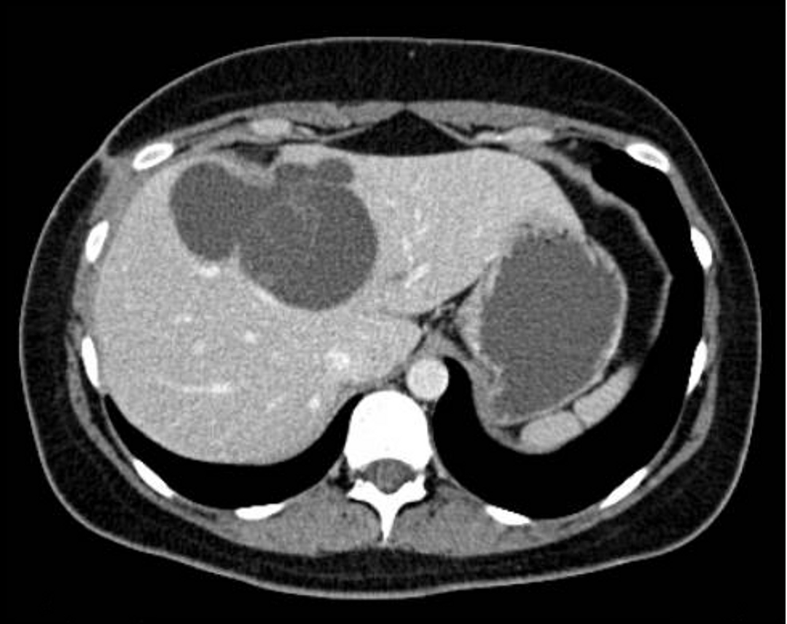
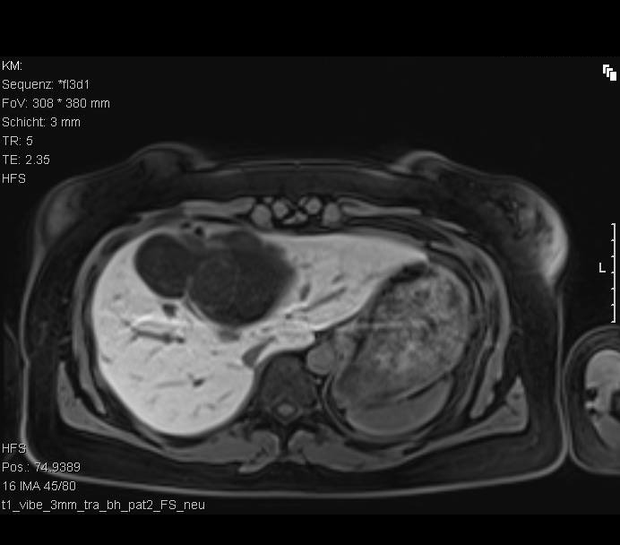
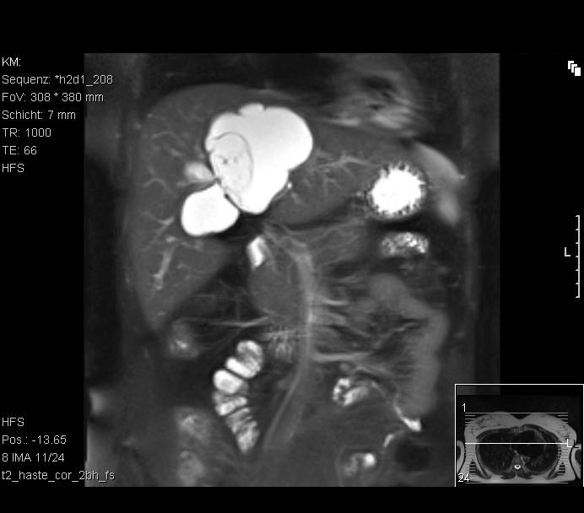
C
B
A

Figure 1 Radiographic images of the central liver cyst. Magnetic resonance imaging (MRI) demonstrated a well-defined lobulated cystic lesion without enhancement after administration of liver-specific contrast material (gadoxetic acid) in the arterial, venous or delayed phase. A: MRI, T2, coronary reconstruction; B: MRI, T1, transversal; C: Contrast-enhanced computed tomography scan, transversal.

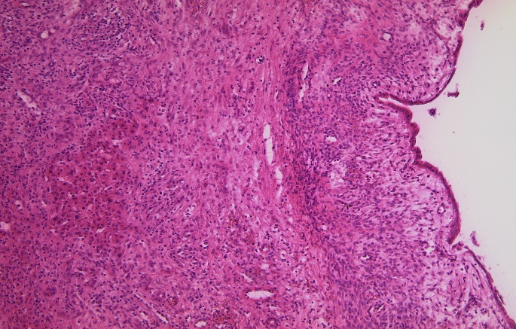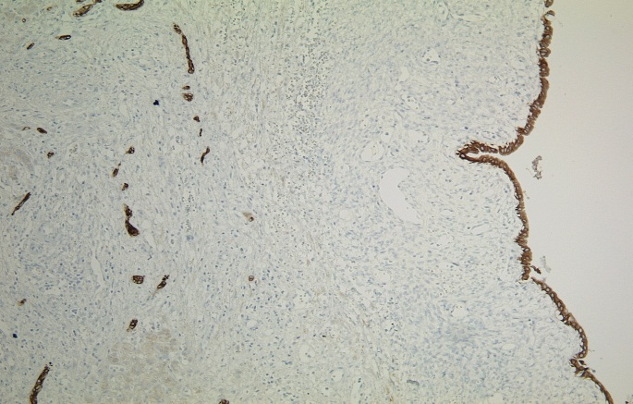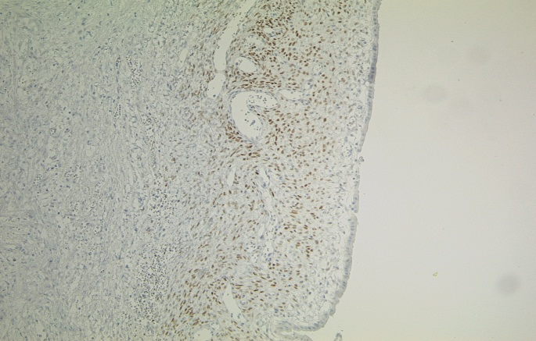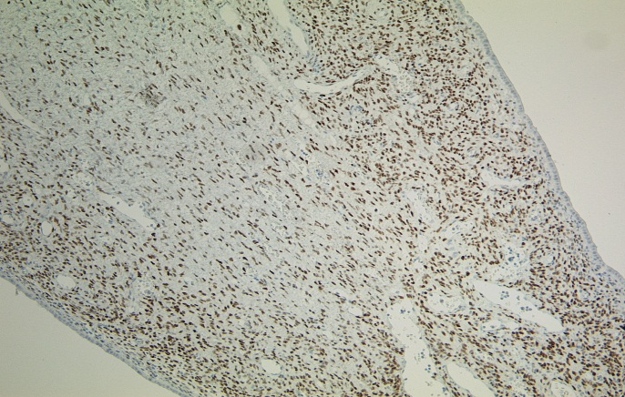
A
B
C
D
Figure 2 Immunohistochemistry of the cyst. A: Cyst and normal liver tissue in HE staining, × 100; B: Immunohistochemistry for CK7, an epithelial marker, × 100. The intrahepatic vessels (arrows, endothelium) and the cystic wall (arrowheads) are indicated; C and D: Estrogen receptor and progesterone receptor staining of the cystic wall (respectively), × 100. Arrows indicate positive cells.

Table 1 Case reports of intrahepatic endometriosis
Author | Age  (yr) | Meno pause | Cyclical pain | History of endo metriosis | Pre-operation diagnosis | Previous operations
Finkel et al^{[5]}, 1986 | 21 | No | No | No | No | Yes
Grabb et al^{[10]}, 1986 | 21 | No | No | No | No | Yes
Rovati et al^{[17]}, 1990 | 37 | No | No | Yes | Yes | No
Cravello et al^{[8]}, 1996 | 34 | No | Yes | Yes | Yes | No
Verbeke et al^{[19]}, 1996 | 62 | Yes | No | No | No | Yes
Verbeke et al^{[19]}, 1996 | 34 | No | No | No | No | No
Chung et al^{[7]}, 1998 | 40 | No | No | Yes | No | Yes
Weinfeld et al^{[20]}, 1998 | 60 | Yes | No | Yes | No | Yes
Inal et al^{[12]}, 2000 | 25 | No | No | Yes | No | No
N´Senda et al^{[15]}, 2000 | 54 | Yes | No | No | Yes | Yes
Huang et al^{[11]}, 2002 | 56 | Yes | No | Yes | No | Yes
Jeanes et al^{[13]}, 2002 | 31 | No | No | Yes | Yes | Yes
Khan et al^{[14]}, 2002 | 31 | No | No | Yes | Yes | Yes
Khan et al^{[14]}, 2002 | 59 | Yes | No | Yes | Yes | Yes
Tuech et al^{[18]}, 2002 | 42 | No | No | No | No | No
Reid et al^{[16]}, 2003 | 46 | No | No | Yes | No | Yes
Goldsmith et al^{[9]}, 2009 | 48 | No | No | Yes | No | Yes
Asran et al^{[6]}, 2010 | 61 | Yes | No | Yes | Yes | Yes
Fluegen et al, 2013 (this study) | 32 | No | No | No | No | Yes

