Name of Journal: World Journal of Clinical Cases
Manuscript NO: 82926
Manuscript Type: CASE REPORT

Efficacy of anlotinib combined with radioiodine to treat scalp metastasis of papillary thyroid cancer: A case report and review of literature

Zhang LY et al. Neoadjuvant anlotinib therapy for PTC

Li-Yong Zhang, Shao-Jun Cai, Bo-Yan Liang, Shou-Yi Yan, Bo Wang, Meng-Yao Li, Wen-Xin Zhao

Li-Yong Zhang, Shao-Jun Cai, Bo-Yan Liang, Shou-Yi Yan, Bo Wang, Meng-Yao Li, Wen-Xin Zhao, Department of Thyroid Surgery, General Surgery, Minimal Invasive Center, The Training Center for Intraoperative Neurophysiologic Monitoring of Thyroid and Parathyroid, Fujian Medical University Union Hospital, Fujian Medical University, Fuzhou 350001, Fujian Province, China

Author contributions: Zhang LY and Zhao WX contributed to the study design; Liang BY and Yan SY contributed to the data collection; Cai SJ, Wang B and Li MY contributed to the data analysis and interpretation; Zhang LY, Cai SJ and Yan SY wrote the draft; Wang B, Li MY and Zhao WX contributed to the revising/editing draft; all authors read and approved the final manuscript.

Corresponding author: Wen-Xin Zhao, PhD, Professor, Department of Thyroid Surgery, General Surgery, Minimal Invasive Center, The Training Center for Intraoperative Neurophysiologic Monitoring of Thyroid and Parathyroid, Fujian Medical University Union Hospital, Fujian Medical University, No. 29 Xinquan Road, Fuzhou 350001, Fujian Province, China. zhaowx@fjmu.edu.cn

Received: December 30, 2022
Revised: February 27, 2023
Accepted: March 22, 2023
Published online: April 26, 2023

Abstract
BACKGROUND
Papillary thyroid cancer (PTC) is one of the well-differentiated thyroid tumors. Cutaneous metastasis from differentiated thyroid cancers occurs in < 1% of primary thyroid carcinomas but produces the worst survival prognosis. The multi-targeting tyrosine kinase inhibitor anlotinib has been approved to treat refractory advanced non-small-cell lung cancer as well as advanced soft-tissue and clear cell sarcomas in China.

CASE SUMMARY
In a patient with scalp metastasis caused by PTC, thyroid and skull metastasis tumor sizes were significantly reduced after a trial of neoadjuvant anlotinib therapy for 3 cycles. Anlotinib maintenance medication after thyroidectomy further reduced the metastatic skull tumor size thereby preventing the requirement for craniotomy.

CONCLUSION
The outcome of the present trial confirmed the potential of anlotinib therapy to treat scalp metastasis induced by PTC and point the way for the treatment of similar diseases in the future.

Key Words: Papillary thyroid cancer; Tyrosine kinase inhibitor; Neoadjuvant anlotinib therapy; Literature review; Case report

©The Author(s) 2023. Published by Baishideng Publishing Group Inc. All rights reserved.

Citation: Zhang LY, Cai SJ, Liang BY, Yan SY, Wang B, Li MY, Zhao WX. Efficacy of anlotinib combined with radioiodine to treat scalp metastasis of papillary thyroid cancer: A case report and review of literature. World J Clin Cases 2023; 11(12): 2839-2847
URL: https://www.wjgnet.com/2307-8960/full/v11/i12/2839.htm
DOI: https://dx.doi.org/10.12998/wjcc.v11.i12.2839

Core Tip: Cutaneous metastasis to the scalp is a site in patients which occurs after papillary thyroid cancers (PTC). Tyrosine kinase inhibitors represent a new approach to treat certain types of thyroid cancer. Here we report a case of scalp metastasis caused by PTC, in which neoadjuvant therapy of anlotinib before thyroidectomy was beneficial in reducing the thyroid and skull metastasis tumor sizes. Anlotinib maintenance regimen after thyroidectomy reduced the size of the metastatic skull tumor further, which successfully avoided the need for craniotomy.
INTRODUCTION
Papillary thyroid cancer (PTC) and follicular thyroid cancer (FTC) are the two most common differentiated thyroid tumors (DTC)^{[1,2]}, with lymph nodes metastasis occurring frequently, but cutaneous metastasis to the scalp being a rare site. The average survival time for patients with thyroid carcinoma skin metastasis was about 19 mo from the end of the last century^{[1]}. Most patients with thyroid cancer undergo surgery combined with subsequent radioactive iodine (RAI) therapy to clear any remaining tumor tissue and to prevent thyroid cancer recurrence^{[3]}. RAI therapy is also given for more advanced cancers and/or cancers that have spread to lymph nodes or distant areas^{[4]}. Apart from these regular treatment regimens, novel target therapies including a tyrosine kinase inhibitor (TKI) has become a new approach to treat certain types of thyroid cancer.
For example, sorafenib was approved by the United States Food and Drug Administration (FDA) in 2014 for the treatment of radioiodine-resistant DTC with metastasis^{[5]}. Anlotinib is a new TKI that targets the vascular endothelial growth factor, fibroblast growth factor and platelet-derived growth factor receptors as well as c-kit^{[6]}. Anlotinib was approved as third-line therapy for refractory advanced non-small-cell lung cancer in 2018, and as second-line treatment for advanced soft-tissue and clear cell sarcomas in 2019 in China^{[7]}. In a preclinical study, anlotinib inhibited the cell viability of PTC, suppressed migration of thyroid cancer cells in vitro and also xenograft thyroid tumor growth in mice^{[8]}. In a phase 2b study of medullary thyroid cancer patients treated with anlotinib, the median progression free survival (PFS) was found to be significantly prolonged (20.7 vs 11.1 mo)^{[9]}. Another recent case of a patient with recurrent and metastatic radioactive iodine-refractory DTC (RAIR-DTC) treated with anlotinib showed a partial response after 2 cycles of anlotinib treatment and a PFS of 37 mo^{[10]}.

CASE PRESENTATION
Chief complaints
A 72-year-old woman presented to our hospital with a scalp mass on November 3, 2020.

History of present illness
A scalp mass biopsy puncture indicated that thyroid cancer metastasis.

History of past illness
The patient had no previous history of any illnesses.

Personal and family history
The patient had no previous personal and family history.

Physical examination
On December 4, 2020, a 3.0 cm × 3.0 cm nodule was palpable on the left thyroid and a 4.0 cm × 3.0 cm nodule was palpable on the right thyroid. In addition, a 6.5 cm × 5.0 cm mass was palpable in the left temporoparietal junction region.

Laboratory examinations
Immunohistochemical results: TTF-1 (+), CK7 (+), NapsinA (+), CDX-2 (-).

Imaging examinations
A scheme of the diagnoses and treatments in chronological order is provided in Figure 1. On November 16, 2020, a positron emission tomography-computed tomography (PET-CT) imaging diagnosis was conducted in which a hypermetabolic mass was revealed in the left parietal skull bone, indicating skin metastasis (Figure 2A), which was confirmed by a fine-needle aspiration biopsy diagnosis (Figure 2B). In addition, a bilaterally enlarged thyroid gland with increased metabolism was found (Figure 2C).
Lung CT was performed on November 26, 2020, which revealed ground glass nodules at the posterior end of the right upper lung lobe and in the dorsal portion of the right lower lung lobe. The ground glass nodules observed at the posterior end of the right upper lobe may correlate with the possibility of primary lung adenocarcinoma and oblique fissure. Both lungs exhibited scattered ground glass patches, likely due to chronic inflammation.
On January 19, 2021, A thyroid color ultrasound image revealed a left thyroid nodule with calcification (Chinese TI-RADS category 4) and a right thyroid nodule with calcification (Chinese TI-RADS category 3c)^{[11]} (Figure 3).

FINAL DIAGNOSIS
According to the findings, bilobed PTC with scalp and skull metastasis was diagnosed based on histopathology data and PET-CT imaging. Next-generation sequencing (NGS) by an Illumina Novaseq 6000 system (Illumina, San Diego, CA, United States) revealed mutations in the BRAF, KRAS and IGF1R genes of the PTC. In addition, neck metastasis of the PTC and primary lung cancer were provisionally diagnosed.

TREATMENT
On November 30, 2020, a thoracoscopic radical resection of the right upper lung cancer (resection of the posterior segment of the right upper lung + mediastinal lymph node sampling) plus wedge resection of the right lower lung were carried out. The operation went without complications and the postoperative recovery of the patient was good.
On January 19, 2021, the patient was given the first oral dose of anlotinib in 3-wk cycles of 12 mg qd during the first 2 wk and 1-wk off (Figure 3B). After 3 cycles of anlotinib treatment, the skull tumor size was significantly reduced. The nodule palpated on the left thyroid gland became 3.0 cm × 2.0 cm, and the nodule palpated on the lower part of the right gland became 4.0 cm × 2.0 cm. In addition, preoperative color ultrasonography also showed that the thyroid tumor size was significantly reduced after neoadjuvant anlotinib therapy (Figure 3E).
A thyroidectomy was performed on March 17, 2021 with the left thyroid lobule and isthmus and the right thyroid lobule and lymph nodes in the central region successfully removed. The histopathology confirmed PTC (Figure 2D). Targeted maintenance therapy of anlotinib was administered after the operation in order to avoid craniotomy (Figure 3C).

OUTCOME AND FOLLOW-UP
By postoperative day 2 (March 18 2021), the neck incision had healed and the patient recovered well. The intact parathyroid hormone concentration was 1.10 pmol/L and the electrolytic calcium concentration was 2.21 mmol/L.
Once iodine-131 therapy (dosage: 150 mci) was performed after the operation on May 18, 2021 and continued in combination with anlotinib (currently in the 11th cycle), a regimen which successfully avoided the need for craniotomy.

DISCUSSION
The 4 main subtypes of thyroid carcinoma are papillary, follicular, medullary and anaplastic forms^{[12]}, with PTC being the most frequently occurring followed by FTC^{[13,14]}. In this case report, the potential of anlotinib therapy to treat scalp metastasis induced by PTC was demonstrated. Scalp metastasis of thyroid cancer has been also been described in other case reports^{[15-22]} (Table 1). Most of the patients were females of advanced age with FTC and in the majority of the cases the scull metastasis had been diagnosed before thyroid cancer, as in the present case. Only 2 patients received post-operative TKI medication and the lung was the major organ of cancer lesions, which were supposed to be metastatic (Table 1). TKIs are small molecules which inhibit the activity of tyrosine kinases (Figure 4).
TKI therapy is usually the final option for metastatic lesions, which are normally incurable by surgery and/or RAI therapy combined, but encouragingly a study involving 147 patients demonstrated that TKI treatment improved the prognosis of patients with distant metastasis and progressive disease^{[23]}. A number of TKIs have been approved by the FDA to treat thyroid cancer, including vandetanib, cabozantinib, sorafenib and lenvatinib (Table 2). Vandetanib and cabozantinib were the first and second approved drugs for the therapy of advanced and progressive and/or symptomatic medullary thyroid cancer^{[24,25]}. Sorafenib was approved for the treatment of ¹³¹I-refractory DTC after the findings of the phase 3 DECISION clinical trial^{[26]}. Lenvatinib is an anti-angiogenic TKI that has been approved for the treatment of advanced and progressive ¹³¹I- refractory DTC^{[27]}. A real-world study conducted in the United States demonstrated that treatment with first-line lenvatinib followed by subsequent second-line therapy delivered a clear clinical benefit^{[28]}. A study carried out in Korea mainly focused on the adverse events of TKIs (lenvatinib and sorafenib) elicited in patients with DTC. Seventy-one cases (lenvatinib, n = 23; sorafenib, n = 48) were involved without new safety concerns being identified for either drug. Most AEs were managed with dose modification and medical therapy^{[29]}. In former in vitro experiments, anlotinib reduced the viability of PTC and anaplastic thyroid cancer cell lines, most likely due to aberrant spindle assembly, G2/M arrest and TP53 activation, while in a murine model anlotinib suppressed migration and growth of thyroid tumor xenografts^{[8]}. Recently, a phase 2 trial of anlotinib in Chinese patients with radioiodine-refractory DTC showed promising results with a median PFS of 40.54 mo in the treatment group compared to 8.38 mo in the placebo group at a data cutoff date of January 2020^{[30]}.
Nevertheless, the present case report can be considered as a kind of pilot study. Besides conservative treatments, anlotinib has been used as neoadjuvant therapy, which significantly reduced the sizes of a metastatic skull tumor and of the primary PTC, while in combination with anlotinib maintenance medication a craniotomy was avoided.
NGS analysis of the PTC found mutations in the BRAF, KRAS and IGF1R genes, which did not match with the previously described undeferential thyroid cancer specific mutations of the TERT promoter, RET fusion and TP53^{[31]}. On the other hand, BRAF mutations have been found to be key drivers of DTC, leading to the proposal of BRAF-directed therapies^{[32]}. In line with the findings of the present study, a recent case report found that anlotinib was effective for the treatment of a RAIR-DTC patient with TERT promoter and BRAF mutations^{[10]}. Another case report of a RAIR-DTC PTC patient with a BRAF^{V600E} mutation noted that the patient developed tumor progression, with clinical symptoms that worsened after dabrafenib-trametinib withdrawal^{[33]}. In our case we will continue to monitor the outcome of anlotinib maintenance therapy.
A limitation of the present study was the lack of NGS and histopathology data about the lung lesions and the neck lymph nodes, which had been provisionally diagnosed as primary lung cancer and PTC metastasis into the neck.

CONCLUSION
Neoadjuvant therapy of anlotinib before surgery was beneficial in reducing the thyroid tumor volume, but also that of the metastatic skull tumor. A craniotomy was thus avoided by using anlotinib maintenance therapy. Our findings point the way for the treatment of similar diseases in the future.

REFERENCES
1 Dahl PR, Brodland DG, Goellner JR, Hay ID. Thyroid carcinoma metastatic to the skin: a cutaneous manifestation of a widely disseminated malignancy. J Am Acad Dermatol 1997; 36: 531-537 [PMID: 9092737 DOI: 10.1016/s0190-9622(97)70239-1]
2 Koller EA, Tourtelot JB, Pak HS, Cobb MW, Moad JC, Flynn EA. Papillary and follicular thyroid carcinoma metastatic to the skin: a case report and review of the literature. Thyroid 1998; 8: 1045-1050 [PMID: 9848721 DOI: 10.1089/thy.1998.8.1045]
3 Carballo M, Quiros RM. To treat or not to treat: the role of adjuvant radioiodine therapy in thyroid cancer patients. J Oncol 2012; 2012: 707156 [PMID: 23193402 DOI: 10.1155/2012/707156]
4 Lee SL. Radioactive iodine therapy. Curr Opin Endocrinol Diabetes Obes 2012; 19: 420-428 [PMID: 22914564 DOI: 10.1097/MED.0b013e328357fa0c]
5 Thomas L, Lai SY, Dong W, Feng L, Dadu R, Regone RM, Cabanillas ME. Sorafenib in metastatic thyroid cancer: a systematic review. Oncologist 2014; 19: 251-258 [PMID: 24563075 DOI: 10.1634/theoncologist.2013-0362]
6 Shen G, Zheng F, Ren D, Du F, Dong Q, Wang Z, Zhao F, Ahmad R, Zhao J. Anlotinib: a novel multi-targeting tyrosine kinase inhibitor in clinical development. J Hematol Oncol 2018; 11: 120 [PMID: 30231931 DOI: 10.1186/s13045-018-0664-7]
7 Li S. Anlotinib: A Novel Targeted Drug for Bone and Soft Tissue Sarcoma. Front Oncol 2021; 11: 664853 [PMID: 34094958 DOI: 10.3389/fonc.2021.664853]
8 Ruan X, Shi X, Dong Q, Yu Y, Hou X, Song X, Wei X, Chen L, Gao M. Antitumor effects of anlotinib in thyroid cancer. Endocr Relat Cancer 2019; 26: 153-164 [PMID: 30139768 DOI: 10.1530/ERC-17-0558]
9 Li D, Chi Y, Chen X, Ge M, Zhang Y, Guo Z, Wang J, Chen J, Zhang J, Cheng Y, Li Z, Liu H, Qin J, Zhu J, Cheng R, Xu Z, Zheng X, Tang P, Gao M. Anlotinib in Locally Advanced or Metastatic Medullary Thyroid Carcinoma: A Randomized, Double-Blind Phase IIB Trial. Clin Cancer Res 2021; 27: 3567-3575 [PMID: 33832949 DOI: 10.1158/1078-0432.CCR-20-2950]
10 Su Y, Cheng S, Qian J, Zhang M, Li T, Zhang Y, Diao C, Zhang L, Cheng R. Case Report: Anlotinib Therapy in a Patient With Recurrent and Metastatic RAIR-DTC Harboring Coexistent TERT Promoter and BRAF(V600E) Mutations. Front Oncol 2021; 11: 626076 [PMID: 33842329 DOI: 10.3389/fonc.2021.626076]
11 Xue E, Zheng M, Zhang S, Huang L, Qian Q, Huang Y. Ultrasonography-Based Classification and Reporting System for the Malignant Risk of Thyroid Nodules. J Nippon Med Sch 2017; 84: 118-124 [PMID: 28724845 DOI: 10.1272/jnms.84.118]
12 Barbaro D, Desogus N, Boni G. Pituitary metastasis of thyroid cancer. Endocrine 2013; 43: 485-493 [PMID: 23008095 DOI: 10.1007/s12020-012-9806-9]
13 Shen J, Wang S, Zhao X, Shao X, Jiang X, Dai Y, Xu S, Pan X. Skull metastasis from follicular thyroid carcinoma: report of three cases and review of literature. Int J Clin Exp Pathol 2015; 8: 15285-15293 [PMID: 26823882]
14 Cabanillas ME, Ryder M, Jimenez C. Targeted Therapy for Advanced Thyroid Cancer: Kinase Inhibitors and Beyond. Endocr Rev 2019; 40: 1573-1604 [PMID: 31322645 DOI: 10.1210/er.2019-00007]
15 Cihan BY, Koc A, Tokmak TT. The Role of Radiotherapy in Skull Metastasis of Thyroid Follicular Carcinoma. Klin Onkol 2019; 32: 300-302 [PMID: 31426647 DOI: 10.14735/amko2019300]
16 Aghasi MR, Valizadeh N, Soltani S. A 64 year-old female with scalp metastasis of papillary thyroid cancer. Indian J Endocrinol Metab 2011; 15: S136-S137 [PMID: 21966651 DOI: 10.4103/2230-8210.83353]
17 Huang TC, Cheng YK, Chen TW, Hsu YC, Liu EW, Chen HH. A 'silent' skull metastatic follicular thyroid carcinoma mimicking as a benign scalp tumor in a pregnant woman. Endocrinol Diabetes Metab Case Rep 2017; 2017 [PMID: 28203373 DOI: 10.1530/EDM-16-0100]
18 Singh V, Singh A, Bhadada SK, Nada R. Isolated dural metastasis of follicular carcinoma of the thyroid presenting as scalp swelling. J Cancer Res Ther 2020; 16: S248-S249 [PMID: 33380691 DOI: 10.4103/jcrt.JCRT_461_18]
19 Monti E, Dono M, Gonella E, Spina B, Pitto F, Petrogalli F, Conte L, Ambrosetti E, Minuto MN, Ansaldo GL, Morbelli S, Zupo S, Giusti M. An H-TERT Mutated Skin Metastasis as First Occurrence in a Case of Follicular Thyroid Carcinoma. Front Endocrinol (Lausanne) 2019; 10: 513 [PMID: 31417495 DOI: 10.3389/fendo.2019.00513]
20 Nwaeze O, Obidike S, Mullen D, Aftab F. Follicular variant papillary thyroid carcinoma with a twist. Int J Surg Case Rep 2015; 8C: 107-110 [PMID: 25651538 DOI: 10.1016/j.ijscr.2015.01.019]
21 Phelan PS, Mull JL, Rajput MZ, Musiek AC. Concurrent metastases of papillary thyroid carcinoma to the scalp and Meckel's cave. BMJ Case Rep 2018; 2018 [PMID: 29914897 DOI: 10.1136/bcr-2017-222552]
22 Sager S, Yilmaz S, Doner RK, Niyazoglu M, Halac M, Kanmaz B. A rare case of solitary subcutaneous scalp metastasis from follicular thyroid carcinoma revealed with positron emission tomography/computed tomography: a case report and review. J Cancer Res Ther 2014; 10: 431-433 [PMID: 25022416 DOI: 10.4103/0973-1482.136681]
23 Iwasaki H, Yamazaki H, Takasaki H, Suganuma N, Sakai R, Nakayama H, Hatori S, Toda S, Masudo K. Treatment outcomes of differentiated thyroid cancer with distant metastasis improve by tyrosine kinase inhibitors. Oncol Lett 2019; 17: 5292-5300 [PMID: 31186746 DOI: 10.3892/ol.2019.10180]
24 Wells SA Jr, Robinson BG, Gagel RF, Dralle H, Fagin JA, Santoro M, Baudin E, Elisei R, Jarzab B, Vasselli JR, Read J, Langmuir P, Ryan AJ, Schlumberger MJ. Vandetanib in patients with locally advanced or metastatic medullary thyroid cancer: a randomized, double-blind phase III trial. J Clin Oncol 2012; 30: 134-141 [PMID: 22025146 DOI: 10.1200/JCO.2011.35.5040]
25 Brose MS, Robinson B, Sherman SI, Krajewska J, Lin CC, Vaisman F, Hoff AO, Hitre E, Bowles DW, Hernando J, Faoro L, Banerjee K, Oliver JW, Keam B, Capdevila J. Cabozantinib for radioiodine-refractory differentiated thyroid cancer (COSMIC-311): a randomised, double-blind, placebo-controlled, phase 3 trial. Lancet Oncol 2021; 22: 1126-1138 [PMID: 34237250 DOI: 10.1016/S1470-2045(21)00332-6]
26 Brose MS, Nutting CM, Jarzab B, Elisei R, Siena S, Bastholt L, de la Fouchardiere C, Pacini F, Paschke R, Shong YK, Sherman SI, Smit JW, Chung J, Kappeler C, Peña C, Molnár I, Schlumberger MJ; DECISION investigators. Sorafenib in radioactive iodine-refractory, locally advanced or metastatic differentiated thyroid cancer: a randomised, double-blind, phase 3 trial. Lancet 2014; 384: 319-328 [PMID: 24768112 DOI: 10.1016/S0140-6736(14)60421-9]
27 Schlumberger M, Tahara M, Wirth LJ, Robinson B, Brose MS, Elisei R, Habra MA, Newbold K, Shah MH, Hoff AO, Gianoukakis AG, Kiyota N, Taylor MH, Kim SB, Krzyzanowska MK, Dutcus CE, de las Heras B, Zhu J, Sherman SI. Lenvatinib versus placebo in radioiodine-refractory thyroid cancer. N Engl J Med 2015; 372: 621-630 [PMID: 25671254 DOI: 10.1056/NEJMoa1406470]
28 Kish JK, Chatterjee D, Wan Y, Yu HT, Liassou D, Feinberg BA. Lenvatinib and Subsequent Therapy for Radioactive Iodine-Refractory Differentiated Thyroid Cancer: A Real-World Study of Clinical Effectiveness in the United States. Adv Ther 2020; 37: 2841-2852 [PMID: 32382946 DOI: 10.1007/s12325-020-01362-6]
29 Kim SY, Kim SM, Chang H, Kim BW, Lee YS, Chang HS, Park CS. Safety of Tyrosine Kinase Inhibitors in Patients With Differentiated Thyroid Cancer: Real-World Use of Lenvatinib and Sorafenib in Korea. Front Endocrinol (Lausanne) 2019; 10: 384 [PMID: 31244783 DOI: 10.3389/fendo.2019.00384]
30 Chi Y, Gao M, Zhang Y, Shi F, Cheng Y, Guo Z, Ge M, Qin J, Zhang J, Li Z, Zhou X, Huang R, Chen X, Liu H, Cheng R, Xu Z, Zheng X, Li D, Tang P. Anlotinib in locally advanced or metastatic radioiodine-refractory differentiated thyroid carcinoma: A randomized, double-blind, multicenter phase II trial. Ann Oncol 2020; 31 Suppl 6: S1347 [DOI: 10.1016/j.annonc.2020.10.259]
31 Li Q, Zhang X, Feng J, Cheng D, Cai L, Dai Z, Zhao S, Li J, Huang J, Fang Y, Zhu H, Wang D, Wang S, Ma T, Lu X. Case Report: Next-Generation Sequencing Reveals Tumor Origin in a Female Patient With Brain Metastases. Front Oncol 2021; 11: 569429 [PMID: 33912440 DOI: 10.3389/fonc.2021.569429]
32 Pozdeyev N, Rose MM, Bowles DW, Schweppe RE. Molecular therapeutics for anaplastic thyroid cancer. Semin Cancer Biol 2020; 61: 23-29 [PMID: 31991166 DOI: 10.1016/j.semcancer.2020.01.005]
33 Martín-Soberón MC, Ruiz S, De Velasco G, Yarza R, Carretero A, Castellano D, Sepúlveda-Sánchez JM. Pneumatosis intestinalis in a radioactive iodine-refractory metastasic thyroid papillary carcinoma with BRAF(V600E) mutation treated with dabrafenib-trametinib: a case report. J Med Case Rep 2021; 15: 109 [PMID: 33653337 DOI: 10.1186/s13256-020-02581-9]

Footnotes
Informed consent statement: Informed written consent was obtained from the patient for publication of this report and any accompanying images.

Conflict-of-interest statement: The authors declare that they have no conflict of interest to disclose.

CARE Checklist (2016) statement: The authors have read the CARE Checklist (2016), and the manuscript was prepared and revised according to the CARE Checklist (2016).

Open-Access: This article is an open-access article that was selected by an in-house editor and fully peer-reviewed by external reviewers. It is distributed in accordance with the Creative Commons Attribution NonCommercial (CC BY-NC 4.0) license, which permits others to distribute, remix, adapt, build upon this work non-commercially, and license their derivative works on different terms, provided the original work is properly cited and the use is non-commercial. See: https://creativecommons.org/Licenses/by-nc/4.0/

Provenance and peer review: Unsolicited article; Externally peer reviewed.
Peer-review model: Single blind

Peer-review started: December 30, 2022
First decision: January 17, 2023
Article in press: March 22, 2023

Specialty type: Oncology
Country/Territory of origin: China
Peer-review report’s scientific quality classification
Grade A (Excellent): A
Grade B (Very good): B
Grade C (Good): C
Grade D (Fair): 0
Grade E (Poor): 0

P-Reviewer: Covantsev S, Russia; Watanabe T, Japan S-Editor: Yan JP L-Editor: A P-Editor: Yan JP

Figure Legends
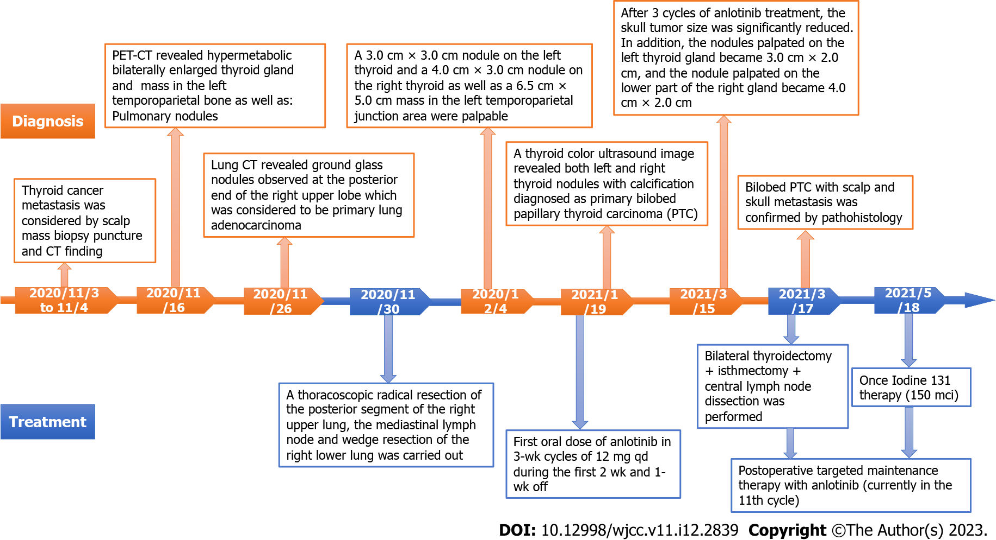
Figure 1 A scheme of the diagnoses and treatments in chronological order. PTC: Papillary thyroid cancer; PET-CT: Positron emission tomography-computed tomography.

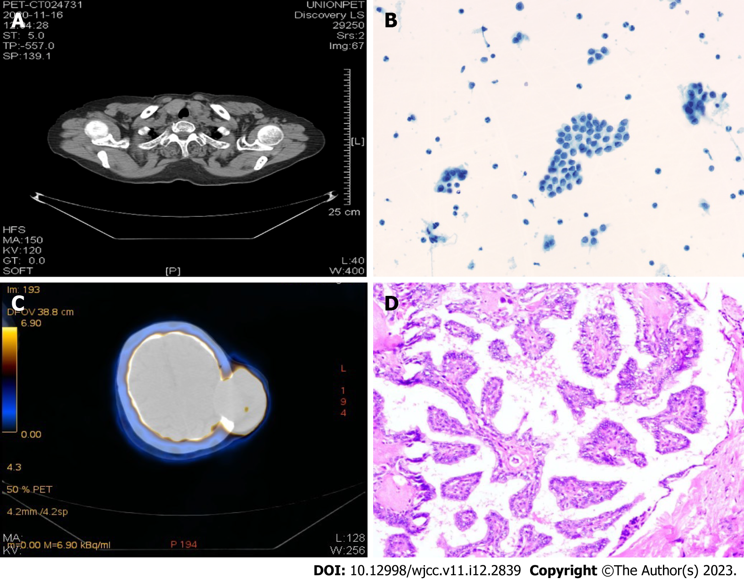
Figure 2 Histological and computed tomography images of the skull tumor. A: positron emission tomography-computed tomography (PET-CT) imaging of the thyroid performed on initial diagnosis of the patient (November 16, 2020); B: Pathology of scalp mass biopsy (November 3, 2020). Scalp tumor histology similar to papillary thyroid carcinoma; papillary thyroid carcinoma metastasis was considered; C: PET-CT imaging of scalp metastasis (November 16, 2020). Note the hypermetabolic mass in the left temporoparietal bone, thinning of the corresponding temporoparietal bone due to compression, and local disappearance of the cerebral sulcus on the left side; D: Postoperative thyroid nodule pathology (paraffin) (March 18, 2021). Papillary thyroid carcinoma, classical type, interstitial fibrosis, no nerve infiltration or blood vessel invasion were observed. The tumor involved extra-glandular fibrofatty tissue.

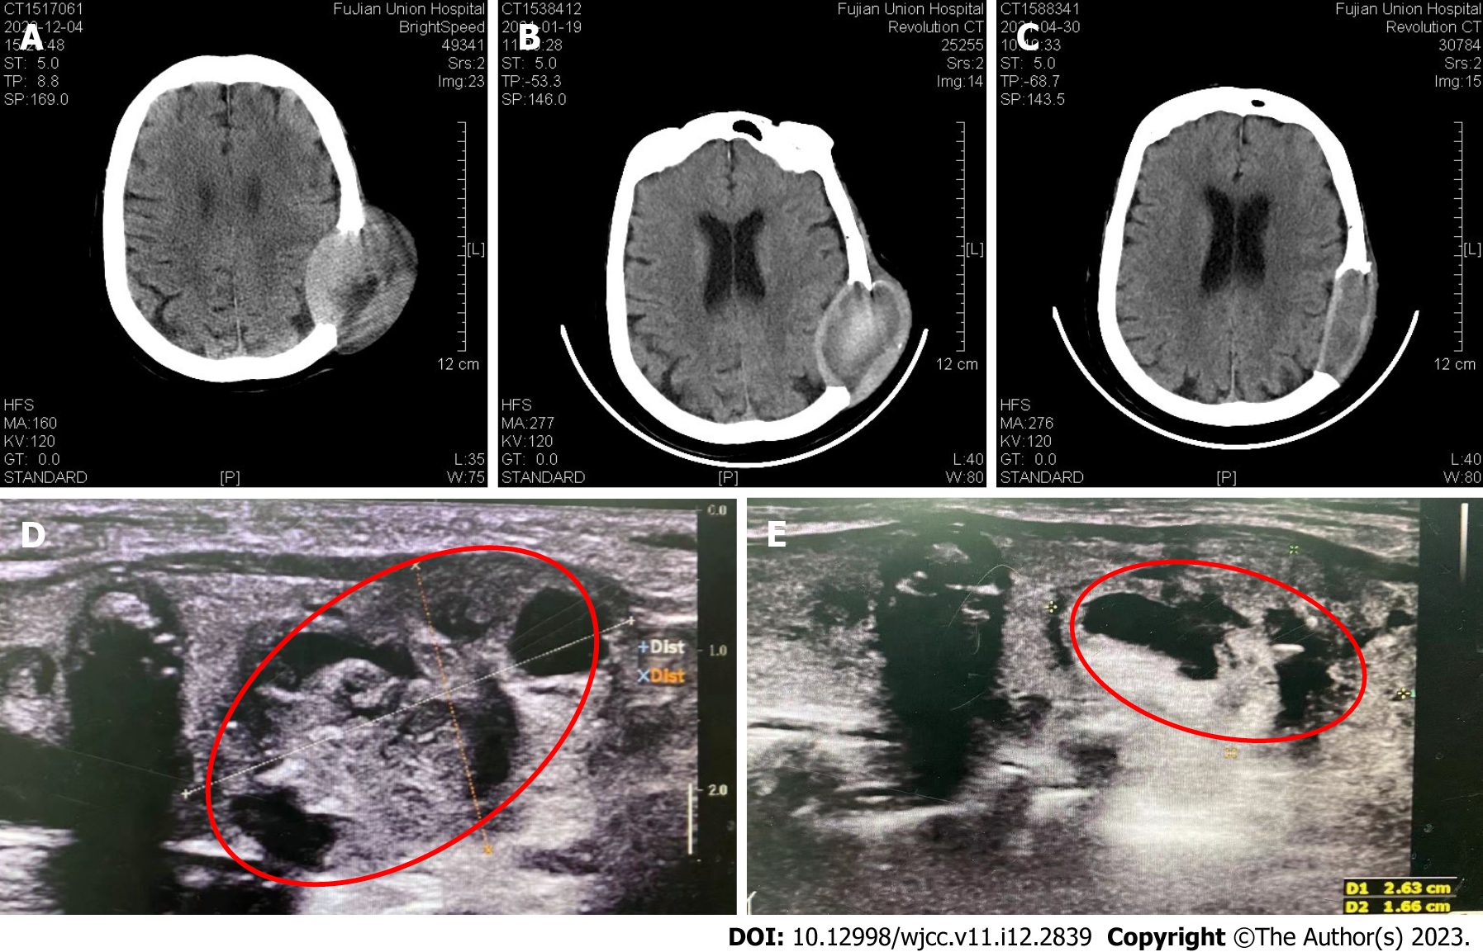
Figure 3 Computed tomography image and color ultrasound of the skull throughout the treatment course and of the thyroid gland. A-C: Computed tomography images at admission (November 4, 2020; A), at the start of anlotinib treatment (January 19, 2021; B), and during maintenance medication (April 30, 2021; C); D: Color ultrasound images of a thyroid nodule with calcification (January 19, 2021); E: Preoperative color ultrasonography showed that the thyroid tumor size was significantly reduced after neoadjuvant anlotinib therapy (March 15, 2021).

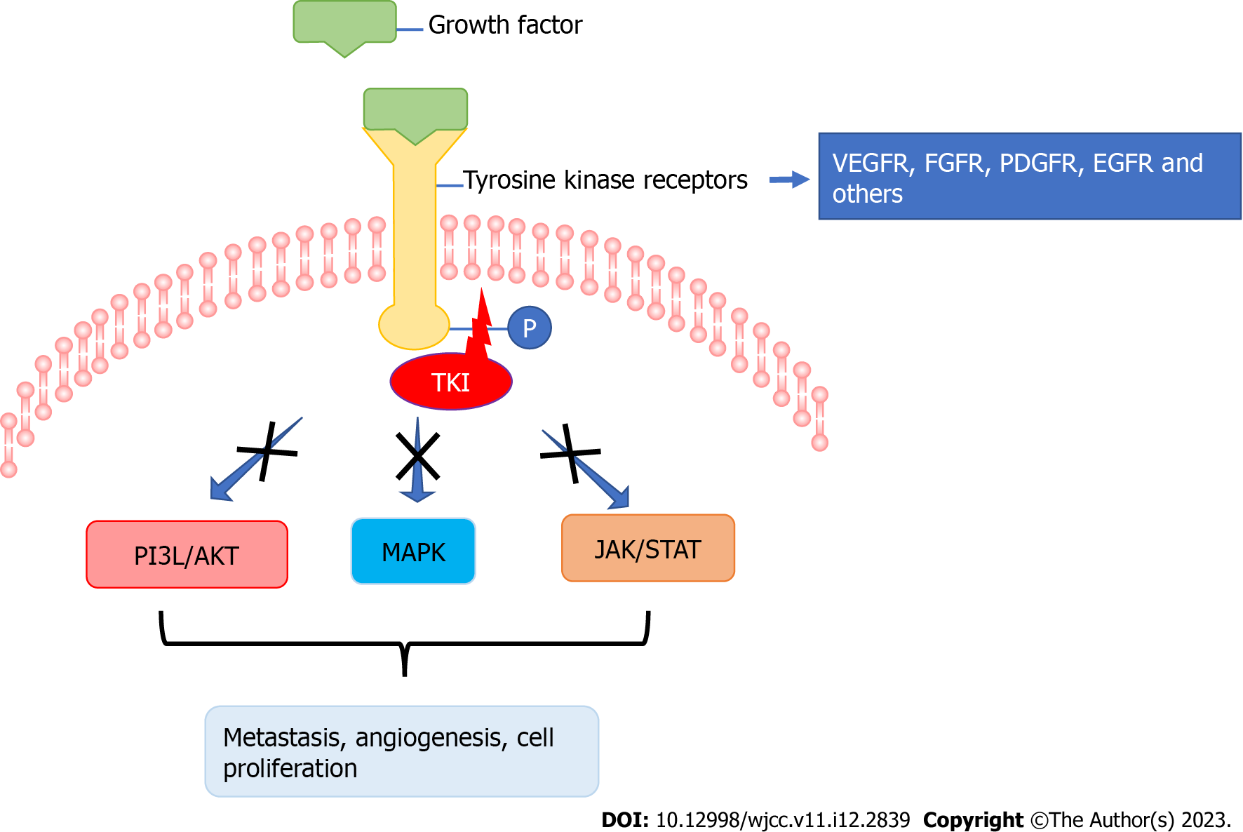
Figure 4 Scheme of tyrosine kinase inhibitor activity. In order to activate signal transduction cascades, tyrosine kinase receptors must be phosphorylated by a tyrosine kinase in addition to binding with their specific ligands. Tyrosine kinase inhibitors block the activity of tyrosine kinases via different mechanisms. TKI: Tyrosine kinase inhibitor; P: Phosphate; PI3L/Akt: Phosphatidylinositol-3-kinase/Akt; MAPK: Mitogen-activated protein kinase; JAK/STAT: Janus kinase/signal transducer and activator of transcription.

Table 1 List of case reports about scalp metastasis of thyroid cancer published during the last decade
Gender | Age | Type | Time of diagnosis | Metastasis | Treatment | Ref.
Female | 51 | Follicular | Before thyroid cancer | Lung, bone | Surgery, I-131 | [15]
Female | 64 | Papillary | After medical history of total thyroidectomy | Lung, liver | Excisional biopsy I-131 | [16]
Female | 37 | Follicular | Before thyroid cancer | Lung, bone, cranium | Resection, I-131, post-operative TKI | [17]
Female | 60 | Follicular | Before thyroid cancer | No | Surgery | [18]
Female | 70 | Follicular | Before thyroid cancer | Lung | Surgery, I-131 | [19]
Female | 75 | Follicular | 1 year after thyroidectomy | Lung | Surgery, I-131 | [20]
Male | 65 | Papillary | Before thyroid cancer | Vertebral and iliac lesions | Shave biopsy, I-131, post-operative sorafenib | [21]
Female | 49 | Follicular | 4 years after thyroidectomy | No | Surgery, I-131 | [22]
TKI: Tyrosine kinase inhibitor.

Table 2 Tyrosine kinase inhibitors for treatments of thyroid cancer
Medication | Target | Indication | Ref.
Vandetanib | RET-tyrosine kinase, VEGFR and EGFR | Unresectable locally advanced or metastatic thyroid cancer | [24]
Cabozantinib | c-Met- tyrosine kinase, VEGFR 2, RET-tyrosine kinase, AXL | RAIR locally advanced or metastatic thyroid cancer after VEGFR-targeted therapy | [25]
Sorafenib | VEGFR 1-3, PDGFR and RAF and RET-kinases | Metastatic RAIR thyroid cancer | [26]
Lenvatinib | VEGFRs 1-3, FGFRs 1- 4, PDGFR-α, RET and KIT signaling | RAIR thyroid cancer | [27]
AXL: Tyrosine-protein kinase receptor UFO; FGFR: Fibroblast growth factor receptor; PDGFR: Platelet-derived growth factor receptor; RAIR: Radioactive iodine-refractory; VEGFR: Vascular endothelial growth factor receptor.

Published by Baishideng Publishing Group Inc
7041 Koll Center Parkway, Suite 160, Pleasanton, CA 94566, USA
Telephone: +1-925-3991568
E-mail: bpgoffice@wjgnet.com
Help Desk: https://www.f6publishing.com/helpdesk
https://www.wjgnet.com

© 2023 Baishideng Publishing Group Inc. All rights reserved.

