Name of journal: World Journal of Gastroenterology
ESPS Manuscript NO: 14910
Columns: CASE REPORT

Aplastic anemia and severe pancytopenia during treatment with peg-interferon, ribavirin and telaprevir for chronic hepatitis C

Lens S et al. Aplastic anemia during HCV antiviral therapy

Sabela Lens, Jose L Calleja, Ana Campillo, Jose A Carrión, Teresa Broquetas, Christie Perello, Juan de la Revilla, Zoe Mariño, María-Carlota Londoño, Jose M Sánchez-Tapias, Álvaro Urbano, Xavier Forns

Sabela Lens, Zoe Mariño, María-Carlota Londoño, Jose M Sánchez-Tapias, Xavier Forns, Liver Unit, Hospital Clinic, 08036 Barcelona, Spain

Jose L Calleja, Christie Perello, Juan de la Revilla, Liver Unit, Hospital Puerta del Hierro, 28222 Majadahonda, Madrid, Spain

Ana Campillo, Gastroenterology Department, Hospital Reina Sofia, 31500 Tudela, Navarra, Spain

Jose A Carrión, Teresa Broquetas, Liver Unit, Hospital Del Mar, 08003 Barcelona, Spain

Álvaro Urbano, Hematology Unit, Hospital Clinic, 08036 Barcelona, Spain

Sabela Lens, Ana Campillo, Zoe Mariño, María-Carlota Londoño, Jose M Sánchez-Tapias,Álvaro Urbano, Xavier Forns, IDIBAPS, CIBERehd, 08036 Barcelona, Spain

Jose L Calleja, Christie Perello, Juan de la Revilla, IDIPHIM, CIBERehd, 08036 Barcelona, Spain

Jose A Carrión, Teresa Broquetas, IMIM, CIBERehd, 08036 Barcelona, Spain

Author contributions: All authors equally contributed to this manuscript.

Supported by (in part) Instituto de Salud Carlos III (PI11/01907), Ministerio de Economía y Competitividad, co-funded by Fondo Europeo de Desarrollo Regional, Unión Europea, Una manera de hacer Europa; and Roche Organ Transplantation Research Foundation (ROTRF, CI: 442035057) (all to Forns X).

Ethics approval: The study was reviewed and approved by the Hospital Clínic Institutional Review Board.

Informed consent: All study participants, or their legal guardian, provided informed written consent prior to study enrollment.

Conflict-of-interest: The authors declare no conflict of interest.

Open-Access: This article is an open-access article which was selected by an in-house editor and fully peer-reviewed by external reviewers. It is distributed in accordance with the Creative Commons Attribution Non Commercial (CC BY-NC 4.0) license, which permits others to distribute, remix, adapt, build upon this work non-commercially, and license their derivative works on different terms, provided the original work is properly cited and the use is non-commercial. See: http://creativecommons.org/licenses/by-nc/4.0/

Correspondence to: Sabela Lens, MD, Liver Unit, Hospital Clinic, C/Villarroel 170, 08036 Barcelona, Spain. slens@clinic.ub.es

Telephone: +34-93-2275400
Received: October 30, 2014
Peer-review started: October 30, 2014
First decision: November 14, 2014
Revised: December 20, 2014
Accepted: February 11, 2015

Article in press:
Published online:

Abstract
Telaprevir and Boceprevir are the first direct acting antivirals approved for chronic hepatitis C in combination with perginterferon alfa and ribavirin. Pancytopenia due to myelotoxicity caused by these drugs may occur but severe hematological abnormalities or aplastic anemia (AA) have not been described. We collected all cases of severe pancytopenia observed during triple therapy with telaprevir in four Spanish centers since the approval of the drug (2011). Among 142 cirrhotic patients receiving treatment, 7 cases of severe pancytopenia (5%) were detected and three of them were consistent with the diagnosis of AA. Mean age was 59 years, five patients had compensated cirrhosis and two patients had severe hepatitis C recurrence after liver transplantation. Severe pancytopenia was diagnosed a median of 10 weeks after the initiation of therapy. Three patients had pre-treatment hematological abnormalities related to splenomegaly. In six patients, antiviral treatment was interrupted at the onset of hematological abnormalities. Two patients died due to septic complications and one patient due to acute alveolar haemorrhage. The remaining patients recovered. Severe pancytopenia and, especially, aplastic anemia are not rare during triple therapy with telaprevir in patients with advanced liver disease. Close monitoring is imperative in this setting to promptly detect serious hematological disorders and to prevent further complications.

Key words: Aplastic anemia; Hepatitis C; Telaprevir; Interferon; Protease inhibitors

© The Author(s) 2015. Published by Baishideng Publishing Group Inc. All rights reserved.

Core tip: The addition of new directly acting antivirals Telaprevir and Boceprevir clearly improved sustained virological response rates in patients with chronic hepatitis C. However, these combinations have also increased the risk for serious adverse events, especially in patients with advanced liver fibrosis. We describe the development of severe pancytopenia and, aplastic anemia during triple therapy with telaprevir in patients with advanced liver disease (before or after liver transplantation). Close monitoring is imperative in this setting to promptly detect serious hematological disorders and to prevent further complications.

Lens S, Calleja JL, Campillo A, Carrión JA, Broquetas T, Perello C, de la Revilla J, Mariño Z, Londoño MC, Sánchez-Tapias JM, Urbano Á, Forns X. Aplastic anemia and severe pancytopenia during treatment with peg-interferon, ribavirin and telaprevir for chronic hepatitis C. World J Gastroenterol 2015; In press

Introduction
The addition of new directly acting antivirals (DAAs) Telaprevir and Boceprevir clearly improved sustained virological response (SVR) rates in patients with chronic hepatitis C^{[1-5]}. However, these combinations have also increased the risk for serious adverse events (SAEs). One of the most common adverse events associated to triple therapy compared to standard peg-interferon and ribavirin (PR) regimens is anemia^{[6]}. Interferon- related bone marrow suppression and ribavirin related haemolytic anemia are common and may lead to dose-reduction, especially in patients with baseline cytopenia^{[7]}. Nonetheless, very few cases of severe pancytopenia and only one case of aplastic anemia related to interferon therapy have been reported in patients with chronic hepatitis C virus (HCV)^{[8,9]}. Thus, severe hematological disorders appear to be anecdotic since a great number of patients have been treated with these drugs during the last decades. As far as we know, cases of aplastic anemia related to telaprevir or boceprevir combination therapy have not been reported. Instead, a case of successful triple therapy in a patient with severe aplastic anemia has been recently reported^{[10]}.
We describe here 7 cases of severe pancytopenia in patients receiving antiviral treatment with PR and telaprevir, three of them being consistent with the diagnosis of aplastic anemia (AA).

CASE REPORT
Case 1
This patient was a 51 year-old woman with genotype 1b HCV related cirrhosis. She had stable neutropenia (1500 cells/μl⁾ and thrombocytopenia (74 x 10⁹/L) that were likely related to portal hypertension (hepatic venous portal pressure gradient (HVPG) of 16 mmHg). Esophageal varices were not found in upper gastrointestinal endoscopy. She had no comorbidities and she did not take any medications. Viral load (VL) was undetectable at week 4 of triple therapy including telaprevir. At this time, blood analysis revealed worsening of neutropenia (1000 cells/μl), thrombocytopenia (42 x 10⁹/L) and a decrease of 2.5 g/dl in haemoglobin (Hb) level, leading to interferon and ribavirin dose reduction. One week later, she complained of worsening of general condition, epistaxis, and mild rash. Blood tests revealed severe pancytopenia (Table 1). The patient was admitted to the hospital; antiviral therapy was immediately interrupted and blood and platelet transfusions were administered. In spite of supportive blood transfusion and granulocyte colony-stimulating factor (GCSF) hematological abnormalities did not improve. A bone marrow aspirate showed a leucocyte population formed by lymphocytes (41%) and normal phenotypic plasmatic cells (55%) with absence of neutrophils. Bone marrow biopsy was compatible with AA (Figures 1 and 2). Other acquired causes of bone marrow failure such as myelodisplasic syndromes, leukemia, megaloblastic anemia, paroxysmal nocturnal hemoglobinuria and viral hemophagocytic syndrome were excluded. Due to the lack of improvement of hematological parameters and the contraindication of bone marrow transplantation, cyclosporine was started with no improvement. The patient developed pulmonary aspergillosis and subsequently presented progressive liver and renal failure and died 50 days after admission.

Case 2
This patient is a 56 year old woman with HCV genotype 1a related cirrhosis that was diagnosed 6 years earlier by liver biopsy and remained compensated. She was on oral therapy for diabetes mellitus. Two days after the initiation of triple therapy with telaprevir she developed a grade I micropapular rash which was successfully treated with topical corticoids and anti-histaminics. At week 4 of therapy she complained of fever, odynophagia and cough. Physical examination showed an erythematous tonsillitis with candidiasic lesions. Blood tests showed a total leukocyte count of 570 cells/μl with 0% neutrophils, 19 x 10⁹/L platelets, 7 g/dl of Hb, and 0.1% reticulocytes (Table 1). The chest X ray was normal. The patient was admitted to hospital and antiviral therapy was withdrawn. A bone marrow biopsy showed marked hypocellularity without morphologic abnormalities, consistent with AA. Supportive treatment with erythropoietin (EPO), GCSF and blood and platelet transfusion was initiated. Oral candidiasis by Candida albicans was successfully eradicated. Two months later the patient had fully recovered from of hematological abnormalities.

Case 3
This patient was a 67 year old woman with HCV genotype 1a compensated cirrhosis, autoimmune hypothyroidism, arterial hypertension, and well controlled diabetes mellitus. Concomitant medications were metformin, levothyroxin, atenolol and eprosartan. Four weeks after initiation of antiviral therapy with PR and telaprevir, VL was undetectable. There was an Hb concentration decrease of 5 g/dl from baseline and a blood transfusion was administered at this time. Ribavirin dose was adjusted and treatment with EPO was initiated. Three weeks later she was admitted to Intensive Care Unit with the diagnosis of septic shock requiring vasoactive drug support and severe pancytopenia. Antiviral therapy was stopped at admission. Staphylococcus aureus meticillin-sensitive was isolated in blood cultures within 48 h and specific antibiotic therapy was started (cloxacilin and piperacillin-tazobactam). Despite extensive investigations the source of the infection was not identified. Pancytopenia progressively worsened (Table 1). The patient developed renal failure needing haemodialysis as well as liver failure with bilirubin increasing up to 18 mg/dl and ascitic decompensation. The patient presented a multiorgan invasive zygomycosis and died one month after admission. Necropsy confirmed AA with severe hypocelullarity in the bone marrow.

Case 4
The patient was a 62 year-old woman with HCV genotype 1b cirrhosis. She had durable neutropenia (about 900 cells/μl) possibly related to hyperesplenism due to portal hypertension (HVPG 8 mmHg). Upper gastrointestinal endoscopy detected a small oesophageal varicose vein. She did not have co morbidities and did not take medications. VL was undetectable at week four of triple therapy with telaprevir. At this point total neutrophil and platelet counts were 700 cells/μl and 47 x 10⁹/L, respectively. One week later she was admitted to the hospital because of fever and chills lasting 48 h. The chest ray showed a right inferior lobe pneumonia and broad spectrum coverage antibiotic therapy was started. Blood tests disclosed severe pancytopenia (Table 1). Antiviral therapy was interrupted and supportive treatment with red blood cell and platelet transfusion was initiated. Seventy-two hours after admission, she suddenly presented a massive hemoptysis with alveolar haemorrhage. Despite orotraqueal intubation and mechanical ventilation the patients suffered a cardiac arrest that was not recovered. Necropsy was not performed.

Case 5
This patient is a 68 year old woman with HCV genotype 1b related cirrhosis and cryoglobulinemia. She had no comorbidities and she did not take any medications. VL was undetectable at week 4 of triple therapy with telaprevir. Patient was hospitalized at week 8 due to acute pyelonephritis by Escherichia coli. Infection resolved after 2 wk under intravenous antibiotic therapy. Because of grade 3 anemia the patient needed a blood transfusion on week 12, and treatment with EPO and ribavirin dose reduction were required at this time. The patient completed 12 wk of telaprevir therapy and then continued on treatment with PR. During the following 4 wk, the patient developed severe pancytopenia (Table 1) in spite of supportive treatment with transfusions, EPO and GCSF administration. Reticulocyte count was < 1% x 10⁹/L. Other causes of pancytopenia were ruled out. The patient continued on antiviral therapy until week 48, at reduced doses of both PR. She achieved SVR and is currently recovering from the hematological disorder.

Case 6
This patient is a 51-year old man who underwent orthotopic liver transplantation (LT) 24 mo before because of advanced HCV genotype 1b cirrhosis. Immunosuppressive therapy consisted in tacrolimus monotherapy with stable levels and no dose modifications during the previous months. He was also taking statins for hypercholesterolemia. No other comorbidities or medications were present. The patient developed HCV recurrence with severe liver injury at 21 mo after LT, as indicated by cholestasis, high VL (4 x 10⁶ IU/mL) and increasing transient elastography values (14kPa). The HVPG value was 8.5 mmHg, and a transjugular liver biopsy showed necroinflammatory activitiy and periportal fibrosis (F2) in METAVIR scale but no signs of rejection. At week 16 of triple therapy with telaprevir, 4 wk after telaprevir was stopped, he presented with grade 3 anemia, neutropenia and severe thrombocytopenia. Antiviral therapy was withdrawn and blood and platelet transfusion were administered (Table 1). Supportive care with EPO and GCSF was maintained for 3 additional months. The patient achieved SVR despite early discontinuation of antivirals, and he also recovered from the hematological abnormalities.

Case 7
This patient is a 63 year old woman whose liver histology showed advance fibrosis (F3) 18 mo after LT. She had a genotype 1b infection, viral load was 2 x 10⁶ IU/L, and ALT and AST values were 235 and 536 IU/L respectively. Immunosuppressive treatment consisted of tacrolimus and low-dose prednisone. She had developed diabetes mellitus after LT and was receiving insulin therapy. At the time when triple therapy with PR and telaprevir was initiated, she presented a stable mild thrombocytopenia of 78 x 10⁹/L. At week 4 of therapy, there was a marked decrease of neutrophils (500 cells/μl) along with anemia (Hb 10 g/l) and a further decrease in platelet count (50 x 10⁹/L). The VL was undetectable. Doses of PR were adjusted and supplementary therapy with EPO and GCSF was given. Despite these measures, the neutrophil count continued decreasing and antiviral therapy was interrupted at week 6 (Table 1). One month later the hematological abnormalities disappeared and this was followed by SVR in spite of early discontinuation of therapy.

Discussion
The approval of first generation protease inhibitors (PIs), boceprevir and telaprevir, has been a major step forward in the treatment of chronic hepatitis C^{[1,2,4,5]}. Beyond efficacy results, PIs-based regimens in real life compensated cirrhosis may be associated with SAEs such as severe infections (4%-6%), clinical decompensation (3%-4%) and even death. These events were not reported in the registration trials possibly because patients included in these studies were mostly very well compensated cirrhotics without significant portal hypertension. Indeed, a low platelet count was an exclusion criteria (< 90 x 10⁹/L for telaprevir and < 100 x 10⁹/L for boceprevir) in these trials. The results of triple therapy in real life cirrhotic patients demonstrated that a low platelet count (< 100 x 10⁹/L) and a low serum albumin (< 35 g/L) were strong predictors of severe complications. Importantly, the risk for severe complications was 44% in patients with both factors as compared to 3.4% in patients with normal platelet and albumin values^{[11]}.
The mechanism of hematological toxicity during triple therapy is not still completely understood, but is probably related to the concomitant administration of all three drugs. Interferon results in bone marrow suppression and ribavirin leads to haemolysis while PIs may cause direct bone marrow toxicity (as suggested in a few reports in the setting of HIV infection^{[12,13]}) in patients with portal hypertension or advanced cirrhosis. Finally, the risk of hematological abnormalities could be also influenced by genetic factors^{[14]}.
Severe AA is defined by a bone marrow cellularity < 25%, or 25%-50% with < 30% residual haematopoietic cells, and at least 2 of the following data: neutrophils < 0.5 cells/μl, platelets < 20 x 10⁹/L and low reticulocyte count. The overall incidence of this disease is low, as it is estimated to occur only in 2-4 million people per year^{[15]}. Among currently licensed drugs which have been associated with aplastic anemia there are antibiotics, anti-inflammatory drugs and anticonvulsants^{[16]}.
Severe hypocellular bone marrow related to interferon administration has been reported not only in the setting of HCV infection^{[8,9]}. However taking into account the huge number of patients treated with this drug worldwide, the incidence of this adverse event appears to be extremely low. Indeed, in our center, among 1700 HCV patients treated with PR therapy in the last decades, there has been no case of AA. The only reported case in literature is a non-cirrhotic 46-year-old man who developed AA 4 months after the initiation of PR therapy and presented a fatal outcome despite bone marrow transplantation^{[8]}.
Among 142 cirrhotic patients receiving treatment in four Spanish centers since the approval of the triple therapy (2011), 7 cases of severe pancytopenia (5%) were detected and three of them accomplished the diagnostic features consistent with AA (2%). Mean age was 59 years, 5 were Child A cirrhotics and two had severe HCV recurrence after LT. Mean liver stiffness value was 18 kPa, three patients had portal hypertension (range: 8.5-16 mmHg) and 3 patients presented pre-treatment abnormal hematological values possibly related to splenomegaly (Table 1). All patients were closely monitored from the beginning of treatment (at least biweekly) and PR dose adjustments were made depending on hematological values. Severe pancytopenia diagnosis was made at a median of 10 wk after telaprevir initiation and antiviral therapy was interrupted at the time of the diagnosis in all cases but one (case 5). At diagnosis, MeDRA classification of adverse events was > 3 in all cases (severe or medically significant but not immediately life-threatening with hospitalization indicated).
Importantly, when these patients were offered triple therapy, data on predictive factors associated to severe complications were not yet available. However, when retrospectively analysing if these patients would have been candidates for antiviral treatment with telaprevir, only case 1 would have been excluded due to the presence of both, thrombocytopenia and hypoalbuminemia (case 1).
Three patients accomplished diagnostic features of AA (cases 1-3). In case 3, AA developed during septic shock and antibiotic treatment, thus, an influence on the development of bone marrow toxicity cannot be disregarded. In the remaining patients, other potential causes of AA were excluded by anamnesis and laboratory tests. Bone marrow biopsy histology revealed hypocellularity and discarded an infiltrative disease (Figures 1 and 2).
Despite all patients were diagnosed very early and received support in referral centers; two patients presented septic complications and deceased in context of multiorgan failure and one patient presented a massive hemoptysis not recovered despite vital support measures.
In conclusion, hematological adverse events are frequent during antiviral therapy with protease inhibitors in chronic hepatitis C. A specialised centre with expertise should be contacted soon in order to start measures aimed at obtaining the best supportive care and exclude other possible causes of pancytopenia. Although AA is a rare condition, it has now been diagnosed during triple therapy with telaprevir in patients with advanced liver disease. Close monitoring of hematological tests is advised during treatment and therapy should be promptly interrupted in case of a decrease of the three hematopoietic series to prevent the establishment of AA and its complications.

COMMENTS
Case characteristics
Seven cases of severe pancytopenia were detected and three of them accomplished the diagnostic features consistent with aplastic anemia (AA) during triple therapy with telaprevir. Mean age was 59 years, 5 were Child A cirrhotics and two had severe hepatitis C virus (HCV) recurrence after liver transplantation. Mean liver stiffness value was 18 kPa, three patients had portal hypertension (range: 8.5-16 mmHg).

Clinical diagnosis
Severe pancytopenia diagnosis was made at a median of 10 wk after telaprevir initiation

Differential diagnosis
Other causes of hematological disorders were discarded (drug toxicity, vitamin deficiency, bone marrow infiltration, malignancy).

Laboratory diagnosis
Severe AA was defined by a bone marrow cellularity < 25%, or 25%-50% with < 30% residual haematopoietic cells, and at least 2 of the following data: neutrophils < 0.5 cells/ul, platelets < 20 x 10⁹/L and low reticulocyte count. The remaining cases had severe pancytopenia (hemoglobin levels < 10 g/dl, neutrophils < 0.75 cells/ul and platelets < 50 x 10⁹/L)

Pathological diagnosis
Bone marrow biopsy histology revealed hypocellularity and discarded an infiltrative disease.

Treatment
Early discontinuation of therapy after diagnosis. Supportive care with G-CSF and blood and platelet transfusion was administered. One patient received cyclosporine.

Related reports
Interferon- related bone marrow suppression and ribavirin related haemolytic anemia are common and may lead to dose-reduction, especially in patients with baseline cytopenia. Nonetheless, very few cases of severe pancytopenia and only one case of AA related to interferon therapy have been reported in patients with chronic hepatitis C infection

Term explanation
The addition of a protease inhibitor to antiviral treatment may induce bone-marrow toxicity, especially in patients with advanced liver disease.

Experiences and lessons
In conclusion, hematological adverse events are frequent during antiviral therapy with protease inhibitors in chronic hepatitis C. A specialized centre with expertise should be contacted soon in order to start measures aimed at obtaining the best supportive care and exclude other possible causes of pancytopenia. Although AA is a rare condition, it has now been diagnosed during triple therapy with telaprevir in patients with advanced liver disease. Close monitoring of hematological tests is advised during treatment and therapy should be promptly interrupted in case of a decrease of the three hematopoietic series to prevent the establishment of AA and its complications.

Peer-review
The authors presents seven cases of severe pancytopenia (three of them with AA) occurred in patients with HCV related cirrhosis during triple therapy (peginterferon + ribavirin + telaprevir). The adverse effects associated with triple therapy are common and well-known

REFERENCES
1 Jacobson IM, McHutchison JG, Dusheiko G, Di Bisceglie AM, Reddy KR, Bzowej NH, Marcellin P, Muir AJ, Ferenci P, Flisiak R, George J, Rizzetto M, Shouval D, Sola R, Terg RA, Yoshida EM, Adda N, Bengtsson L, Sankoh AJ, Kieffer TL, George S, Kauffman RS, Zeuzem S. Telaprevir for previously untreated chronic hepatitis C virus infection. N Engl J Med 2011; 364: 2405-2416 [PMID: 21696307 DOI: 10.1056/NEJMoa1012912]
2 Poordad F, McCone J, Bacon BR, Bruno S, Manns MP, Sulkowski MS, Jacobson IM, Reddy KR, Goodman ZD, Boparai N, DiNubile MJ, Sniukiene V, Brass CA, Albrecht JK, Bronowicki JP. Boceprevir for untreated chronic HCV genotype 1 infection. N Engl J Med 2011; 364: 1195-1206 [PMID: 21449783 DOI: 10.1056/NEJMoa1010494]
3 McHutchison JG, Manns MP, Muir AJ, Terrault NA, Jacobson IM, Afdhal NH, Heathcote EJ, Zeuzem S, Reesink HW, Garg J, Bsharat M, George S, Kauffman RS, Adda N, Di Bisceglie AM. Telaprevir for previously treated chronic HCV infection. N Engl J Med 2010; 362: 1292-1303 [PMID: 20375406 DOI: 10.1056/NEJMoa0908014]
4 Zeuzem S, Andreone P, Pol S, Lawitz E, Diago M, Roberts S, Focaccia R, Younossi Z, Foster GR, Horban A, Ferenci P, Nevens F, Müllhaupt B, Pockros P, Terg R, Shouval D, van Hoek B, Weiland O, Van Heeswijk R, De Meyer S, Luo D, Boogaerts G, Polo R, Picchio G, Beumont M. Telaprevir for retreatment of HCV infection. N Engl J Med 2011; 364: 2417-2428 [PMID: 21696308 DOI: 10.1056/NEJMoa1013086]
5 Bacon BR, Gordon SC, Lawitz E, Marcellin P, Vierling JM, Zeuzem S, Poordad F, Goodman ZD, Sings HL, Boparai N, Burroughs M, Brass CA, Albrecht JK, Esteban R. Boceprevir for previously treated chronic HCV genotype 1 infection. N Engl J Med 2011; 364: 1207-1217 [PMID: 21449784 DOI: 10.1056/NEJMoa1009482]
6 Zeuzem S, DeMasi R, Baldini A, Coate B, Luo D, Mrus J, Witek J. Risk factors predictive of anemia development during telaprevir plus peginterferon/ribavirin therapy in treatment-experienced patients. J Hepatol 2014; 60: 1112-1117 [PMID: 24486089 DOI: 10.1016/j.jhep.2014.01.013]
7 Fried MW, Shiffman ML, Reddy KR, Smith C, Marinos G, Gonçales FL, Häussinger D, Diago M, Carosi G, Dhumeaux D, Craxi A, Lin A, Hoffman J, Yu J. Peginterferon alfa-2a plus ribavirin for chronic hepatitis C virus infection. N Engl J Med 2002; 347: 975-982 [PMID: 12324553 DOI: 10.1056/NEJMoa020047]
8 Ioannou S, Hatzis G, Vlahadami I, Voulgarelis M. Aplastic anemia associated with interferon alpha 2a in a patient with chronic hepatitis C virus infection: a case report. J Med Case Rep 2010; 4: 268 [PMID: 20704699 DOI: 10.1186/1752-1947-4-268]
9 Hoffmann A, Kirn E, Krueger GR, Fischer R. Bone marrow hypoplasia and fibrosis following interferon treatment. In Vivo 1994; 8: 605-612 [PMID: 7893989]
10 Balkan II, Bozcan S, Yemisen M, Kutlubay Z, Ozaras R. Chronic hepatitis C successfully treated with telaprevir, pegylated interferon and ribavirin in severe aplastic anemia. Ann Hepatol 2014; 13: 843-844 [PMID: 25332274]
11 Hézode C, Fontaine H, Dorival C, Larrey D, Zoulim F, Canva V, de Ledinghen V, Poynard T, Samuel D, Bourlière M, Zarski JP, Raabe JJ, Alric L, Marcellin P, Riachi G, Bernard PH, Loustaud-Ratti V, Métivier S, Tran A, Serfaty L, Abergel A, Causse X, Di Martino V, Guyader D, Lucidarme D, Grando-Lemaire V, Hillon P, Feray C, Dao T, Cacoub P, Rosa I, Attali P, Petrov-Sanchez V, Barthe Y, Pawlotsky JM, Pol S, Carrat F, Bronowicki JP. Triple therapy in treatment-experienced patients with HCV-cirrhosis in a multicentre cohort of the French Early Access Programme (ANRS CO20-CUPIC) - NCT01514890. J Hepatol 2013; 59: 434-441 [PMID: 23669289 DOI: 10.1016/j.jhep.2013.04.035]
12 Fernández Ibieta M, Ramos Amador JT, González Tomé MI, Guillén Martín S, Bellón Cano JM, Navarro Gómez M, de José MI, Beceiro J, Iglesias E, Rubio B, Relaño Garrido P, Santos MJ, Martínez Guardia N, Roa MA, Regidor J. [Anaemia and neutropenia in a cohort of non-infected children of HIV-positive mothers]. An Pediatr (Barc) 2008; 69: 533-543 [PMID: 19128766 DOI: 10.1016/S1695-4033(08)75236-6]
13 Cingolani A, Torti L, Pinnetti C, de Gaetano Donati K, Murri R, Tacconelli E, Larocca LM, Teofili L. Detrimental clinical interaction between ritonavir-boosted protease inhibitors and vinblastine in HIV-infected patients with Hodgkin's lymphoma. AIDS 2010; 24: 2408-2412 [PMID: 20671541]
14 Thompson AJ, Clark PJ, Singh A, Ge D, Fellay J, Zhu M, Zhu Q, Urban TJ, Patel K, Tillmann HL, Naggie S, Afdhal NH, Jacobson IM, Esteban R, Poordad F, Lawitz EJ, McCone J, Shiffman ML, Galler GW, King JW, Kwo PY, Shianna KV, Noviello S, Pedicone LD, Brass CA, Albrecht JK, Sulkowski MS, Goldstein DB, McHutchison JG, Muir AJ. Genome-wide association study of interferon-related cytopenia in chronic hepatitis C patients. J Hepatol 2012; 56: 313-319 [PMID: 21703177 DOI: 10.1016/j.jhep.2011.04.021]
15 Young NS. Acquired aplastic anemia. Ann Intern Med 2002; 136: 534-546 [PMID: 11926789 DOI: 10.7326/0003-4819-136-7-200204020-00011]
16 Marsh JC, Ball SE, Cavenagh J, Darbyshire P, Dokal I, Gordon-Smith EC, Keidan J, Laurie A, Martin A, Mercieca J, Killick SB, Stewart R, Yin JA. Guidelines for the diagnosis and management of aplastic anaemia. Br J Haematol 2009; 147: 43-70 [PMID: 19673883 DOI: 10.1111/j.1365-2141.2009.07842.x]

P-Reviewer: Abenavoli L, Stasi C, Trifan A S-Editor: Ma YJ L-Editor: E-Editor:

Table 1 Liver function and blood tests at baseline and at the development of severe pancytopenia and final outcome
 | Case 1 | Case 2 | Case 3 | Case 4 | Case 5 |  | Case 6  (LT) | Case 7  (LT)
Features at baseline
Haemoglobin (g/dL) | 14.3 | 14.2 | 12.9 | 13.5 | 13.4 |  | 13.9 | 14
Neutrophils (mm³) | 1500 | 1320 | 1900 | 900 | 3810 |  | 2880 | 1700
Platelets (mm³) | 74000 | 96000 | 108000 | 101000 | 199000 |  | 102000 | 78000
ALT (IU/L) | 59 | 77 | 46 | 96 | 77 |  | 120 | 536
Bilirubin (mg/dl) | 1.3 | 0.93 | 0.6 | 1.1 | 0.5 |  | 1.4 | 1.2
Albumin (g/dl) | 32 | 47 | 37 | 40 | 45 |  | 35 | 36
INR | 1.1 | 1.1 | 1 | 1 | 1 |  | 1.1 | 1.28
Liver stiffness (kPa) | 50 | 10.8 | 16 | 11 | 16.8 |  | 14.2 | 12
HVPG (mmHg) | 16 | - | - | 8.5 | - |  | 8.5 | -
Child-Pugh score | 6 | 5 | 5 | 5 | 5 |  | 6 | 5
Features at diagnosis of pancytopenia
Triple therapy (wk) | 10 | 4 | 7 | 5 | 16 |  | 16 | 8
Haemoglobin (g/dl) | 7.5 | 7 | 7.8 | 7.6 | 7.2 |  | 7.9 | 8.5
Neutrophils (cells/ul) | 400 | 0 | 250 | 200 | 400 |  | 400 | 300
Platelets (10⁹/L) | 5000 | 19000 | 2400 | 23000 | 12000 |  | 9000 | 30000
Reticulocytes (10⁹/L) | 0.2% | 0.1% | 0.6% | - | <1% |  | <1% | -
Bone Marrow Biopsy | Yes | Yes | Yes | - | - |  | - | -
Specific treatment
Treatment interruption | Yes | Yes | Yes | Yes | No |  | Yes | Yes
Blood transfusion (units) | 14 | 7 | na | 6 | 20 |  | 10 | 0
EPO (days of therapy) | 30 | 60 | 60 | 6 | 240 |  | 90 | 30
GCSF (days of therapy) | 30 | 60 | 30 | 6 | 90 |  | 90 | 45
Outcome | Death | Recovered | Death | Death | Recovered |  | Recovered | Recovered

LT: Liver transplantation; ALT: Alananin-aminotransferase; INR: International normalized ratio; HVPG: Hepatic venous pressure gradient; AA: Aplastic anemia; EPO: Erythropoietin; GCSF: Granulocyte colony stimulating factor; NA: Not available.

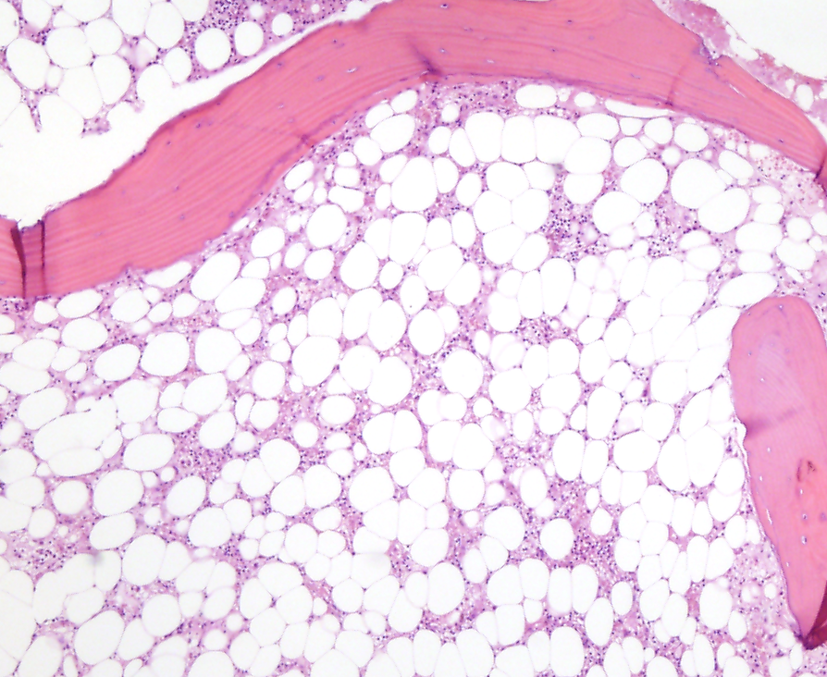
Figure 1 Bone marrow section showing a marked reduction in hemopoietic precursors which are mainly replaced by fat (HE 200 x).

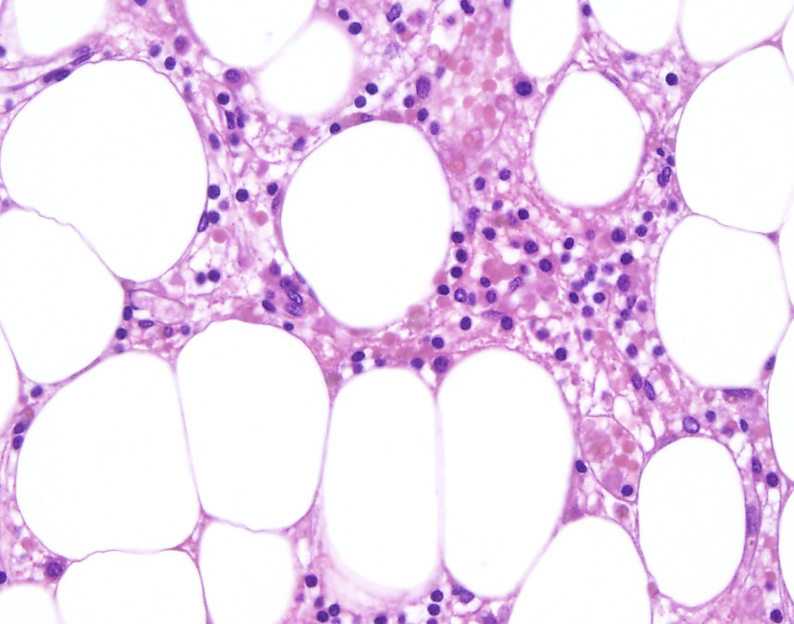
Figure 2 Hematopoietic cells replaced by fat vacuoles and a variable inflammatory infiltrate composed of lymphocytes and plasma cells is observed. No megakaryocytes are present (HE 400 x).

