Name of Journal: World Journal of Gastroenterology
Manuscript NO: 84230
Manuscript Type: ORIGINAL ARTICLE

Observational Study
Inflammation-related nomogram for predicting survival of patients with unresectable hepatocellular carcinoma received conversion therapy

Wu JL et al. Nomogram for conversion therapy

Jia-Lin Wu, Jun-Yang Luo, Zai-Bo Jiang, Si-Bo Huang, Ge-Run Chen, Hui-Ying Ran, Qi-Yue Liang, Ming-Sheng Huang, Li-Sha Lai, Jun-Wei Chen

Jia-Lin Wu, Jun-Yang Luo, Zai-Bo Jiang, Ming-Sheng Huang, Jun-Wei Chen, Department of Interventional Radiology, The Third Affiliated Hospital of Sun Yat-sen University, Guangzhou 510630, Guangdong Province, China

Si-Bo Huang, Ge-Run Chen, The First Clinical Medical College, Guangdong Medical University, Zhanjiang 524000, Guangdong Province, China

Hui-Ying Ran, Qi-Yue Liang, Zhongshan School of Medicine, Sun Yat-sen University, Guangzhou 510080, Guangdong Province, China

Li-Sha Lai, Department of Radiology, Guangzhou First People's Hospital, School of Medicine, South China University of Technology, Guangzhou 510010, Guangdong Province, China

Author contributions: Jiang ZB, Chen JW, and Huang MS contributed to conceptualization; Wu JL, Huang SB, Chen GR, Ran HY, and Liang QY contributed to acquisition of data, formal analysis (statistics), and visualization; Wu JL and Luo JY contributed to writing-original draft; Chen JW contributed to writing-review and editing; Huang MS, Jiang ZB, Lai LS, and Chen JW contributed to supervision; and all authors read and approved the final version of the manuscript.

Supported by the National Natural Science Foundation of China, No. 82072035; and Science and Guangzhou Planned Project of Science and Technology, No. 202102010028.

Corresponding author: Jun-Wei Chen, MD, Professor, Interventional Radiologist, Department of Interventional Radiology, The Third Affiliated Hospital of Sun Yat-sen University, No. 600 Tianhe Road, Guangzhou 510630, Guangdong Province, China. chenjw53@mail.sysu.edu.cn

Received: March 3, 2023
Revised: April 2, 2023
Accepted: April 24, 2023
Published online:

Abstract
BACKGROUND
The efficacy of conversion therapy for patients with unresectable hepatocellular carcinoma (HCC) is a common clinical concern.

AIM
To analyse the prognostic factors of overall survival (OS) in patients with unresectable HCC who received conversion therapy.

METHODS
One hundred and fifty patients who met the inclusion criteria were enrolled and divided into a training cohort (n = 120) and a validation cohort (n = 30). Using the independent risk factors in the training cohort, a nomogram model was constructed to predict OS for patients treated with transarterial chemoembolization following hepatic resection. The nomogram was internally validated with the bootstrapping method. The predictive performance of nomogram was assessed by Harrell’s concordance index (C-index), calibration plot and time-dependent receiver operating characteristic curves and compared with six other conventional HCC staging systems.

RESULTS
Multivariate Cox analysis identified that albumin, blood urea nitrogen, gamma-glutamyl transpeptidase to platelet ratio, platelet to lymphocyte ratio, macrovascular invasion and tumour number were the six independent prognostic factors correlated with OS in nomogram model. The C-index in the training cohort and validation cohort were 0.752 and 0.807 for predicting OS, which were higher than those of the six conventional HCC staging systems (0.563 to 0.715 for the training cohort and 0.458 to 0.571 for the validation cohort). The calibration plots showed good consistency between the nomogram prediction of OS and the actual observations of OS. Decision curve analyses indicated satisfactory clinical utility. With a total nomogram score of 196, patients were accurately classified into low-risk and high-risk groups. Furthermore, we have deployed the model into online calculators that can be accessed for free at https://ctmodelforunresectablehcc.shinyapps.io/DynNomapp/.

CONCLUSION
The nomogram achieved optimal individualized prognostication of OS in HCC patients who received conversion therapy, which could be a useful clinical tool to help guide postoperative personalized interventions and prognosis judgement.

Key Words: Hepatocellular carcinoma; Conversion therapy; Nomogram; Inflammation; Transarterial chemoembolization

Wu JL, Luo JY, Jiang ZB, Huang SB, Chen GR, Ran HY, Liang QY, Huang MS, Lai LS, Chen JW. Inflammation-related nomogram for predicting survival of patients with unresectable hepatocellular carcinoma received conversion therapy. World J Gastroenterol 2023; In press

Core Tip: We developed and validated a prognostic nomogram based on inflammation-related biomarkers for patients with unresectable hepatocellular carcinoma after conversion therapy. The proposed conversion therapy model shows increased accuracy, good clinical utility, and better prognostic performance compared with conventional staging systems. Based on the total predictive risk scores, the patients were classified into two groups: low-risk (score < 196) and high-risk group (score ≥ 196), to guide postoperative adjuvant interventions and follow-ups. Furthermore, we have made this prognostic nomogram online for free use (https://ctmodelforunresectablehcc.shinyapps.io/DynNomapp/).

INTRODUCTION
Hepatocellular carcinoma (HCC), the most common type of primary liver cancer, ranks as the sixth most prevalent malignancy and third leading cause of cancer-related deaths worldwide^{[1]}. More so than other cancers, hepatitis B virus (HBV) infection is a hallmark of HCC, with 70%-90% of diagnoses occurring with a background of cirrhosis in highly prevalent Asian countries^{[2]}. Hepatic resection (HR) is deemed the most efficacious therapeutic option for patients diagnosed with early to intermediate stages of HCC. Unfortunately, the majority of Chinese patients with HCC are diagnosed at intermediate or advanced stages with massive or multifocal lesions. Nevertheless, HR is possible for a minority of carefully selected patients with the help of a “conversion therapy” strategy, which refers to conversion of an unresectable HCC to achieve adequate tumour shrinkage and downstaging to undergo HR. However, only a limited number of meticulously screened patients with intermediate or advanced stage HCC qualify for HR.
As per the Barcelona Clinic Liver Cancer (BCLC) staging system, transarterial chemoembolization (TACE) is recommended as the first-line treatment for intermediate stage HCC and has been extensively investigated and widely acknowledged as an effective approach for conversion therapy^{[3]}. Previous studies have demonstrated that HR after local treatments, such as TACE, hepatic artery infusion chemotherapy and radiotherapy with or without other systemic therapeutic measures, can improve tumour shrinkage as well as downstaging. Moreover, these treatments have been shown to enhance patient survival rates without causing significant complications^{[4-7]}. While TACE could potentially provide surgical options to previously ineligible HCC patients, its high incidence of short-term recurrence remains a significant challenge for conversion therapy. Meanwhile, active conversion strategies to increase the volume of future liver remnant and planning for patients who cannot achieve R0 resection are worth greater consideration. Thus, the development of a validated clinical risk score based on preoperative indices to assess those at high risk of recurrence and death may help formulate optimal management strategies and prevent disease progression.
Links between inflammation and the development of cancer are well established, and HCC is one of the most classic inflammation-linked tumours. During liver inflammation, inflammatory cells and mediators are present before hepatocarcinogenesis and prompt the malignant activity of cancer cells. Additionally, a persistent cancer-related inflammatory microenvironment leads to immune suppression, which promotes the development of HCC^{[8]}. Recently, numerous previous studies have indicated that preoperative inflammatory biomarkers can be capable of predicting HCC prognosis after HR^{[9,10]}. A previous study by Wang et al^{[9]} assessed the prognostic value of inflammation-related markers prior to surgery and demonstrated their high effectiveness in predicting survival after surgical resection of HCC. In addition, the researchers concluded that two inflammation-related markers, gamma-glutamyl transpeptidase (GGT) to platelet ratio (GPR) and neutrophil to lymphocyte ratio (NLR), were independently associated with prognosis. However, it is unclear whether preoperative inflammatory biomarkers have a high efficacy in predicting the overall survival (OS) of unresectable HCC patients following conversion therapy.
Nomograms have recently been used as an easy-to-operate predictive tool in HCC and have compared favorably to traditional tumour staging systems^{[10,11]}. However, studies focusing on inflammatory biomarkers for the prognosis of HCC treated with TACE following HR are rare. Therefore, the aim of this study was to develop a conversion therapy model (CT model) that combined clinical factors, tumour radiologic features, inflammation biomarkers and TACE strategy for prognosis in patients with unresectable HCC successfully treated with conversion therapy. A browser-based calculator was developed to conveniently help guide individualized follow-up. A precise estimation of OS prognosis can assist clinical surgeons in selecting more appropriate therapeutic measures for recurrent patients through risk-benefit analysis.

MATERIALS AND METHODS
Study population and design
This study was conducted in accordance with the Declaration of Helsinki and approved by the Institutional Review Board of Ethical Committee of the Third Affiliated Hospital of Sun Yat-sen University (No. II2023-027). Due to the retrospective design of this study, written informed consent from patients was waived. Consecutive Chinese adult individuals with pathologically confirmed primary unresectable HCC who were treated with TACE following HR in our institution from January 2011 to July 2020 were enrolled. The inclusion criteria were as follows: (1) Age between 18 years and 80 years; (2) pathologically proven HCC; and (3) unresectable HCC according to the Chinese expert consensus and acceptance of TACE as the conventional therapy following HR^{[3]}. The exclusion criteria were as follows: (1) Extrahepatic metastasis; (2) history of other malignancies; (3) previous anticancer therapy; (4) current or recent system infection disease and incomplete clinical data; and (5) death or loss to follow-up within 30 d after resection. One hundred fifty patients from our center were included in this study and randomly assigned to a training cohort (n = 120) and a validation cohort (n = 30). The flow chart of patient selection is shown in Supplementary Figure 1.

Data collection and preoperative examination
For each patient, the following clinical parameters were collected: (1) Preoperative patient characteristics (age, sex, factor of HCC, aetiology of HCC, ascites, and Child-Pugh class); (2) TACE technique [conventional-TACE (cTACE) or drug eluting bead-TACE (DEB-TACE)] and number of TACE treatments; (3) baseline laboratory data, including alpha fetoprotein (AFP) level, white blood cell count, haemoglobin level, platelet count, neutrophil count, lymphocyte ratio, monocyte ratio, neutrophil ratio, aspartate aminotransferase (AST) level, alanine aminotransferase level, GGT level, albumin (ALB) level, total bilirubin level, blood urea nitrogen (BUN) level, serum creatinine level, urea level and prothrombin time (PT); (4) inflammation biomarkers, including GPR, NLR, lymphocyte to monocyte ratio, prognostic nutritional index, platelet to lymphocyte ratio (PLR), systemic immune inflammation index, neutrophil times GGT-to-lymphocyte ratio, AST to platelet ratio index, AST to neutrophil ratio index, and AST (the detailed formulas of inflammation biomarkers are summarized in Supplementary Table 1); (5) baseline tumour radiologic features [tumour number, largest tumour diameter, tumour capsule, macrovascular invasion (MVI)]; and (6) surgical factors (resection margin and blood transfusion).

TACE procedure and HR
The cTACE or DEB-TACE procedure was performed according to our previously reported protocol^{[12]}. Repeated TACE was implemented according to a multidisciplinary treatment board (consisting of interventional radiologists, liver surgeons, and medical oncologists) during the follow-up periods and after in-depth discussion with the patient. HR was performed according to the liver surgeons’ assessment that the unresectable HCC had transformed into radically operable HCC. HR was performed by clinicians who possessed more than ten years of experience in hepatectomy. Under general anesthesia, HR was conducted through an L-shaped laparotomy or bilateral subcostal incision with a midline extension. Intraoperative ultrasound (US) was performed as standard practice to assess tumor burden, liver remnant, and resection margin^{[13]}. Curative resection was defined as complete remove of all tumor nodules with no residual tumor margin (R0 resection), which was confirmed through pathological examination.

Follow-up and assessment
All patients were monitored in the first month post HR, then at three-month intervals for the first two years, and bi-annual assessments thereafter. During each follow-up, routine blood tests, liver function tests, AFP and imaging examinations (abdominal contrast-enhanced magnetic resonance imaging and computed tomography) were performed. Follow-up ended in July 2022. OS was described as the period from the initial TACE treatment to death attributable to any cause, and patients alive at the end of follow-up were recorded as censored.

Statistical analysis
The statistical analyses were conducted using R software (Version 4.2.1, http://www.r-project.org). Categorical variables are presented as n (%) and were compared using the chi-square test or Fisher’s exact test. Continuous variables are reported as the mean ± SD, compared by Student’s t test, or median (interquartile range, IQR), compared by the Mann-Whitney U test. We determined the optimal cut-off value for continuous variables and inflammation biomarkers, except AFP and tumour diameter, based on the outcome of OS among all patients, using the “surv_cutpoint” function form the “survminer” R package. OS was calculated using the Kaplan-Meier method, and the log-rank test was used to construct survival curves. Univariate and multivariate Cox proportional hazard regression were conducted to select the independent factors of OS. All factors with P < 0.1 in univariate Cox regression were selected for multivariate Cox regression. The nomograms were created using multivariate analysis in the training cohort. The final model selection for the nomograms was determined by a backwards step-down process with the Akaike information criterion.
The predictive performance was measured by the concordance index (C-index) and time-dependent area under the curve (AUC). To assess the clinical utility of the nomogram, decision curve analysis (DCA) was performed by quantifying the net benefits relative-e to six other conventional HCC staging systems (including BCLC^{[14]}, American Joint Committee on Cancer Tumour-Node-Metastasis eighth edition (AJCC TNM 8th)^{[15]}, China liver cancer staging (CNLC)^{[16]}, Japan integrated staging (JIS)^{[17]}, Cancer of the Liver Italian Program (CLIP)^{[18]} and Okuda staging system^{[19]}). The total score of nomogram was used to categorize patients into low-risk and high-risk groups using X-tile^{[20]}. A 2-sided P value of less than 0.05 in multivariate Cox regression was considered statistically significant.

RESULTS
Baseline characteristics
A total of 150 patients were recruited in this study and randomly divided into training (n = 120) and validation (n = 30) cohorts in an 8:2 ratio. The baseline characteristics of patients in the training and validation cohorts are summarized in Table 1. Among all patients, the mean age was 52.1 years (SD: 11.9), 128 (85.3%) patients were male, and 134 (89.3%) patients were HBsAg positive. Regarding TACE techniques, a total of 100 (66.7%) patients received cTACE therapy. In terms of surgical aspects, a resection margin larger than 1 cm was present in 133 patients (88.7%). Fifty-two patients (34.7%) required a blood transfusion during the perioperative period. The median size of the largest intrahepatic tumours was 62.5 mm (range: 10.0-191.0), and 100 (66.7%) were larger than 5.0 cm. More than half of the patients (n = 96, 64.0%) were with solitary tumour. Tumour radiologic features showed that well-defined tumour capsule, satellite nodules, and MVI were observed in 110 (73.3%), 36 (24.0%) and 68 (45.3%) patients, respectively. There were no statistically significant differences in baseline clinicopathological features between the training and validation cohorts.

Overall survival
In this study, the median follow-up was 31.5 (range: 4.0-112.0) months. The median survival of the entire cohort was 54 [95% confidence interval (CI) 42-95] mo (Figure 1A). The 1-, 2-, and 3-year OS rates for the training and validation cohorts were 87.5%, 49.3%, 44.2%, and 83.3%, 66.7%, 53.3%, respectively (Figure 1B and C). There was no significant difference observed in OS between the training and validation cohorts [mean OS 37.9 (range, 4-112) mo vs 38.0 (range, 5-93 mo, P = 0.7].

Independent risk factors and development of the prognostic nomogram
Univariate and multivariate Cox regression analyses were performed in 120 patients from the training cohort to determine the risk factors associated with OS (Supplementary Table 2). As previously described, the optimal cutoff values for inflammation biomarkers were recorded (Supplementary Table 3). Briefly, multivariate analysis identified that preoperative ALB level, BUN level, GPR, PLR, MVI and tumour number were independent risk factors associated with OS (Figure 2). All of these significant independent factors of OS were incorporated into the nomogram (Figure 3A). In addition, a mobile online tool was built to facilitate clinical application, available at https://ctmodelforunresectablehcc.shinyapps.io/DynNomapp/ (Figure 3B).

Validation of the prediction CT model
Bootstrapping with 1000 resamples in the primary training cohort revealed good predictive performance for OS, resulting in a C-index of 0.752 (95%CI, 0.688 to 0.815). The AUC in predicting the 1-, 2-, and 3-year OS rates were 0.779 (95%CI, 0.0.646-0.912), 0.801 (95%CI, 0.693-0.908) and 0.839 (95%CI, 0.748-0.931) in the training cohort and 0.872 (95%CI, 0.682-0.951), 0.892 (95%CI, 0.753-0.974) and 0.876 (95%CI, 0.727-0.962) in the validation cohort, respectively (Figure 4A and B). Accordingly, the C-index in the validation cohort reached 0.807 (95%CI 0.705 to 0.908), while the calibration plot for the probability of OS at 1, 2, and 3 years depicted a favorable concordance between the predicted and actual outcomes (Figure 4C).

Comparison of model predictive performance
The discrimination power of the nomogram and common staging systems were compared by the C-index and time-dependent AUC (1, 2, and 3 years). In both the training and validation cohorts, the predictive performance of the CT model was superior to that of the other six conventional HCC staging systems (P < 0.01, Figure 5A and B, Supplement Table 4). DCA indicated a good net benefit compared with six other conventional HCC staging systems at 1, 2 and 3 years after conversion therapy in the training cohort (Figure 5C-E).

Risk stratification based on nomogram scores and prognostic assessment
The patients were categorized into two groups based on their overall predictive risk score: Low risk (score < 196) and high risk (score ≥ 196). The distribution of clinical features and corresponding risk scores in each patient are presented in Figure 6A. The OS curves exhibited significant discrimination between the low-risk and high-risk groups among the entire (P < 0.001), training (P < 0.001) and validation (P = 0.041) cohorts (Figure 6B-D). Additionally, given that inflammation biomarkers are associated with postoperative prognosis, we found that high values of both GPR and PLR were significantly correlated with worse prognostic outcomes in patients after conversion therapy. The low-GPR group exhibited higher 1-, 2-, and 3-year OS rates compared to the high-GPR group (0.93, 0.69, and 0.54 vs 0.79, 0.55, and 0.36, P = 0.038). Similarly, the low-PLR group demonstrated greater 1-, 2-, and 3-year OS rates in contrast to the high-PLR group (0.92, 0.73, and 0.58 vs 0.84, 0.58, and 0.40, P = 0.01) (Figure 7A and B). Besides, individuals who exhibited MVI demonstrated an inferior prognosis in contrast to those without vascular invasion (Figure 7C).

DISCUSSION
Conversion therapy is a new therapeutic strategy for individuals diagnosed with HCC at an advanced stage and who may not initially be suitable for radical surgery. Several studies have shown that patients with unresectable HCC who underwent conversion following surgical excision have a much longer OS than those who received palliative treatments such as TACE^{[3,6,21]}. Furthermore, 5-year survival rates for patients with unresectable HCC after conversion therapy (25%-57%) are comparable to those for patients with resectable HCC (30%-60%)^{[22]}. Previous studies have developed prognostic models using preoperative factors to predict postoperative outcomes of early-stage HCC patients after curative resection that achieved good results^{[9-11]}, but it remains unclear in the CT model. In this study, we developed and validated a CT model that could accurately predicts prognosis for patients with unresectable HCC treated with TACE following HR.
The nomogram demonstrated great accuracy in predicting conversion therapy outcomes of patients with unresectable HCC. The nomogram developed in our study achieved AUC of 0.779, 0.801, and 0.839 in the training cohort and 0.872, 0.892 and 0.876 in the validation cohort, which were superior to those of the other six conventional HCC staging systems. DCA was also performed and revealed that the nomograms have good clinical utility in patients with unresectable HCC who received the CT model.
Using the nomogram score, clinicians can classify unresectable HCC patients into low- and high-risk groups. Effective postoperative therapeutic management and intensive clinical follow-up can be guided for high-risk individuals following this strategy. Additionally, a web-based dynamic nomogram provides a well-calibrated tool for predicting future clinical outcomes.
The present study combined liver and renal function factors, tumour burden and inflammation biomarkers (six significantly independent predictors: ALB, BUN, MVI, tumour number, GPR, and PLR) to establish a more comprehensive model and construct a nomogram CT model that could accurately predict the prognosis for patients with unresectable HCC after conversion therapy. Our findings are consistent with research in previous HCC populations that lower ALB level, MVI presence and multiple tumours were risk factors for long-term survival in patients with unresectable HCC with the CT model^{[10,23-26]}.
In terms of clinical utility, the prediction ability of the CT model was significantly improved compared with that of six conventional staging systems (AJCC TNM 8th, CNLC, JIS, CLIP, Okuda, and BCLC staging systems) in both the training and validation cohorts (Figure 5). The conventional staging systems mainly contain factors that may only take certain aspects of the tumour into consideration. Previous studies have noted that inflammatory biomarker combination scores have promising prognostic values in predicting patient survival for different HCC stages in various therapeutic modalities^{[27,28]}, indicating that combining these potential indicators would greatly improve the model’s predictive abilities. Meanwhile, the AUC for the prediction of the 1-, 2-, and 3-year OS rates reached 0.755, 0.750, and 0.838 in the training cohort when we only used clinical information (MVI, ALB, tumour number and BUN) to develop a model, and they were unable to perform robustly in the validation cohort (Supplementary Figure 2). Hence, we constructed a nomogram CT model with clinical information (ALB, BUN, MVI, tumour number) and inflammation biomarkers (PLR and GPR).
PLR and GPR have been reported to be risk indicators of prognosis for OS in previous studies^{[10,29]}. Meanwhile, high GPR was also proven to be an independent risk factor for HCC development and recurrence^{[30-32]}. Our findings indicate that the high-PLR (> 84.38) and high-GPR (> 0.38) groups had significantly lower 12-, 24-, and 36-mo survival rates. Since inflammatory factors in the tumor microenvironment are crucial for HCC therapies, this information can assist clinicians in devising follow-up regimens and postoperative therapies for HCC patients at high or low risk of tumor recurrence after hepatectomy.
We also found that BUN was an independent prognostic factor in this study. Renal function impairment represents a clinically significant event in cirrhosis patients^{[33]}. Preoperative renal dysfunction with high levels of BUN may lead to the development of major complications such as intractable ascites and spontaneous bacterial peritonitis (SBP). Moreover, the development of hepatorenal impairment is strongly associated with circulatory dysfunction, which can lead to various complications such as complicated or refractory ascites, SBP, hyponatremia and hepatorenal syndrome, and a high risk of mortality^{[34]}. In clinical practice, serum creatinine concentration is generally used to assess kidney function in patients with liver diseases, which is also a major prognostic factor of cirrhosis included in the Model for End-Stage Liver Disease. However, several reports have shown that BUN levels have greater prognostic accuracy than serum creatinine concentrations^{[35-37]}. In this study, our findings also showed that high BUN levels were related to worse liver function stage and poor OS outcomes (Figure 7D). Further research is needed to better understand this factor in advanced HCC and better classify and manage patients after conversion therapy.
While this nomogram CT model performed well, we do acknowledge a few potential limitations to this study. First, the nomogram was formulated based on a relatively small sample size obtained from our single institution, which unavoidably led to selection bias. Further prospective and multicenter cohorts are required to evaluate its performance. Second, statistical power may be limited because several routine clinical variables were not included in our study. Because our study was retrospective, there were variations in performance score, body mass index, dosage and type of injected drugs during TACE, as well as postoperative treatments, among patients. To further bolster our findings, it is necessary to conduct larger and multicenter prospective cohorts. Hence, we will undertake additional research that incorporates more complete clinicopathological information, treatment details, and postoperative treatment modalities to improve the predictive performance of our model. Third, this study was mainly based on HBV-infected patients. Our results may not be applicable in different geographic regions and aetiologies. Fourth, systematic bioinformatic analyses were not included in this nomogram, which showed excellent predictive ability for early-stage HCC patients^{[38,39]}. We will therefore develop a robust prognostic model that integrates both clinical parameters and multi-omics biomarkers to facilitate an understanding of HCC from a biological perspective and contribute to tailoring therapeutic strategies. Despite these limitations, we believe that our work is meaningful for individualized management in HCC patients following conversion therapy.

CONCLUSION
We developed and validated a prognostic nomogram combined with inflammation biomarkers for patients with unresectable HCC after conversion therapy. The proposed CT model shows increased accuracy, good clinical utility, and better prognostic performance than conventional staging systems. Furthermore, we have uploaded this prognostic nomogram online for free use (https://ctmodelforunresectablehcc.shinyapps.io/DynNomapp/).

ARTICLE HIGHLIGHTS
Research perspectives
Larger and multicentre prospective cohorts were required to further strengthen our results. We will conduct further investigation that incorporates more complete clinicopathological information, treatment details, and postoperative treatment modalities to improve the predictive performance of our model.

Research conclusions
The nomogram achieved optimal individualized prognostication of OS in HCC patients who received conversion therapy. It could be a useful clinical tool to help guide postoperative personalized interventions and prognosis judgement.

Research results
Multivariate Cox analysis identified that albumin, blood urea nitrogen, gamma-glutamyl transpeptidase to platelet ratio, platelet to lymphocyte ratio, macrovascular invasion and tumour number were the six independent prognostic factors correlated with OS in nomogram model. The C-indices in the training cohort and validation cohort were 0.752 and 0.807 for predicting OS, which were higher than those of the six conventional HCC staging systems (0.563 to 0.715 for the training cohort and 0.458 to 0.571 for the validation cohort). We have deployed the model into online calculators that are freely available at https://ctmodelforunresectablehcc.shinyapps.io/DynNomapp/.

Research methods
All patients met the inclusion criteria were enrolled and divided into training and a validation cohort. Using the independent risk factors in the training cohort, nomogram models were constructed to predict OS for patients treated with transarterial chemoembolization following HR. The nomograms were internally validated with the bootstrapping method. The predictive performance of the nomograms was assessed by Harrell’s concordance index, calibration plot and time-dependent receiver operating characteristic curves and compared with six other conventional HCC staging systems.

Research objectives
To develop a nomogram to help guide postoperative personalized interventions and prognosis judgement

Research motivation
To investigate the prognostic factors of overall survival (OS) in patients with unresectable HCC who received conversion therapy.

Research background
Hepatocellular carcinoma (HCC) is the sixth most common malignancy and the third leading cause of cancer-related mortality worldwide. Hepatic resection (HR) is the best therapeutic option for patients with early- and some intermediate-stage HCC. Unfortunately, the majority of Chinese patients with HCC are diagnosed at intermediate or advanced stages with massive or multifocal lesions. HR is possible for a minority of carefully selected patients with the help of a “conversion therapy” strategy, which refers to conversion of an unresectable HCC to achieve adequate tumour shrinkage and downstaging to undergo HR.

REFERENCES
1 Villanueva A. Hepatocellular Carcinoma. N Engl J Med 2019; 380: 1450-1462 [PMID: 30970190 DOI: 10.1056/NEJMra1713263]
2 Lavanchy D. Hepatitis B virus epidemiology, disease burden, treatment, and current and emerging prevention and control measures. J Viral Hepat 2004; 11: 97-107 [PMID: 14996343 DOI: 10.1046/j.1365-2893.2003.00487.x]
3 Sun HC, Zhou J, Wang Z, Liu X, Xie Q, Jia W, Zhao M, Bi X, Li G, Bai X, Ji Y, Xu L, Zhu XD, Bai D, Chen Y, Chen Y, Dai C, Guo R, Guo W, Hao C, Huang T, Huang Z, Li D, Li G, Li T, Li X, Li G, Liang X, Liu J, Liu F, Lu S, Lu Z, Lv W, Mao Y, Shao G, Shi Y, Song T, Tan G, Tang Y, Tao K, Wan C, Wang G, Wang L, Wang S, Wen T, Xing B, Xiang B, Yan S, Yang D, Yin G, Yin T, Yin Z, Yu Z, Zhang B, Zhang J, Zhang S, Zhang T, Zhang Y, Zhang Y, Zhang A, Zhao H, Zhou L, Zhang W, Zhu Z, Qin S, Shen F, Cai X, Teng G, Cai J, Chen M, Li Q, Liu L, Wang W, Liang T, Dong J, Chen X, Wang X, Zheng S, Fan J; Alliance of Liver Cancer Conversion Therapy, Committee of Liver Cancer of the Chinese Anti-Cancer Association. Chinese expert consensus on conversion therapy for hepatocellular carcinoma (2021 edition). Hepatobiliary Surg Nutr 2022; 11: 227-252 [PMID: 35464283 DOI: 10.21037/hbsn-21-328]
4 Hamaoka M, Kobayashi T, Kuroda S, Iwako H, Okimoto S, Kimura T, Aikata H, Nagata Y, Chayama K, Ohdan H. Hepatectomy after down-staging of hepatocellular carcinoma with portal vein tumor thrombus using chemoradiotherapy: A retrospective cohort study. Int J Surg 2017; 44: 223-228 [PMID: 28676383 DOI: 10.1016/j.ijsu.2017.06.082]
5 Zhao HT, Cai JQ. Chinese expert consensus on neoadjuvant and conversion therapies for hepatocellular carcinoma. World J Gastroenterol 2021; 27: 8069-8080 [PMID: 35068855 DOI: 10.3748/wjg.v27.i47.8069]
6 Fan J, Tang ZY, Yu YQ, Wu ZQ, Ma ZC, Zhou XD, Zhou J, Qiu SJ, Lu JZ. Improved survival with resection after transcatheter arterial chemoembolization (TACE) for unresectable hepatocellular carcinoma. Dig Surg 1998; 15: 674-678 [PMID: 9845635 DOI: 10.1159/000018676]
7 Lau WY, Lai EC. Salvage surgery following downstaging of unresectable hepatocellular carcinoma--a strategy to increase resectability. Ann Surg Oncol 2007; 14: 3301-3309 [PMID: 17891443 DOI: 10.1245/s10434-007-9549-7]
8 Mantovani A, Allavena P, Sica A, Balkwill F. Cancer-related inflammation. Nature 2008; 454: 436-444 [PMID: 18650914 DOI: 10.1038/nature07205]
9 Wang Y, Sun K, Shen J, Li B, Kuang M, Cao Q, Peng S. Novel Prognostic Nomograms Based on Inflammation-Related Markers for Patients with Hepatocellular Carcinoma Underwent Hepatectomy. Cancer Res Treat 2019; 51: 1464-1478 [PMID: 30913869 DOI: 10.4143/crt.2018.657]
10 Zeng J, Zeng J, Liu J, Zeng J. Development of pre and post-operative nomograms to predict individual survival for ideal liver resection candidates with hepatocellular carcinoma. Liver Int 2021; 41: 2974-2985 [PMID: 34416088 DOI: 10.1111/liv.15042]
11 Wang JC, Hou JY, Chen JC, Xiang CL, Mao XH, Yang B, Li Q, Liu QB, Chen J, Ye ZW, Peng W, Sun XQ, Chen MS, Zhou QF, Zhang YJ. Development and validation of prognostic nomograms for single large and huge hepatocellular carcinoma after curative resection. Eur J Cancer 2021; 155: 85-96 [PMID: 34371445 DOI: 10.1016/j.ejca.2021.07.009]
12 Chen J, Lai L, Luo J, Wang H, Li M, Huang M. DEM-TACE as the initial treatment could improve the clinical efficacy of the hepatocellular carcinoma with portal vein tumor thrombus: a retrospective controlled study. BMC Cancer 2022; 22: 1242 [PMID: 36451104 DOI: 10.1186/s12885-022-10361-5]
13 Chen J, Lai L, Lin Q, Huang W, Cai M, Zhu K, Huang M. Hepatic resection after transarterial chemoembolization increases overall survival in large/multifocal hepatocellular carcinoma: a retrospective cohort study. Oncotarget 2017; 8: 408-417 [PMID: 27880724 DOI: 10.18632/oncotarget.13427]
14 Llovet JM, Brú C, Bruix J. Prognosis of hepatocellular carcinoma: the BCLC staging classification. Semin Liver Dis 1999; 19: 329-338 [PMID: 10518312 DOI: 10.1055/s-2007-1007122]
15 Amin MB, Greene FL, Edge SB, Compton CC, Gershenwald JE, Brookland RK, Meyer L, Gress DM, Byrd DR, Winchester DP. The Eighth Edition AJCC Cancer Staging Manual: Continuing to build a bridge from a population-based to a more "personalized" approach to cancer staging. CA Cancer J Clin 2017; 67: 93-99 [PMID: 28094848 DOI: 10.3322/caac.21388]
16 Zhou J, Sun H, Wang Z, Cong W, Wang J, Zeng M, Zhou W, Bie P, Liu L, Wen T, Han G, Wang M, Liu R, Lu L, Ren Z, Chen M, Zeng Z, Liang P, Liang C, Chen M, Yan F, Wang W, Ji Y, Yun J, Cai D, Chen Y, Cheng W, Cheng S, Dai C, Guo W, Hua B, Huang X, Jia W, Li Y, Li Y, Liang J, Liu T, Lv G, Mao Y, Peng T, Ren W, Shi H, Shi G, Tao K, Wang W, Wang X, Wang Z, Xiang B, Xing B, Xu J, Yang J, Yang J, Yang Y, Yang Y, Ye S, Yin Z, Zhang B, Zhang B, Zhang L, Zhang S, Zhang T, Zhao Y, Zheng H, Zhu J, Zhu K, Liu R, Shi Y, Xiao Y, Dai Z, Teng G, Cai J, Wang W, Cai X, Li Q, Shen F, Qin S, Dong J, Fan J. Guidelines for the Diagnosis and Treatment of Hepatocellular Carcinoma (2019 Edition). Liver Cancer 2020; 9: 682-720 [PMID: 33442540 DOI: 10.1159/000509424]
17 Kudo M, Chung H, Osaki Y. Prognostic staging system for hepatocellular carcinoma (CLIP score): its value and limitations, and a proposal for a new staging system, the Japan Integrated Staging Score (JIS score). J Gastroenterol 2003; 38: 207-215 [PMID: 12673442 DOI: 10.1007/s005350300038]
18 A new prognostic system for hepatocellular carcinoma: a retrospective study of 435 patients: the Cancer of the Liver Italian Program (CLIP) investigators. Hepatology 1998; 28: 751-755 [PMID: 9731568 DOI: 10.1002/hep.510280322]
19 Okuda K, Ohtsuki T, Obata H, Tomimatsu M, Okazaki N, Hasegawa H, Nakajima Y, Ohnishi K. Natural history of hepatocellular carcinoma and prognosis in relation to treatment. Study of 850 patients. Cancer 1985; 56: 918-928 [PMID: 2990661 DOI: 10.1002/1097-0142(19850815)56:4<918::AID-CNCR2820560437>3.0.CO;2-E]
20 Camp RL, Dolled-Filhart M, Rimm DL. X-tile: a new bio-informatics tool for biomarker assessment and outcome-based cut-point optimization. Clin Cancer Res 2004; 10: 7252-7259 [PMID: 15534099 DOI: 10.1158/1078-0432.CCR-04-0713]
21 Lewandowski RJ, Kulik LM, Riaz A, Senthilnathan S, Mulcahy MF, Ryu RK, Ibrahim SM, Sato KT, Baker T, Miller FH, Omary R, Abecassis M, Salem R. A comparative analysis of transarterial downstaging for hepatocellular carcinoma: chemoembolization vs radioembolization. Am J Transplant 2009; 9: 1920-1928 [PMID: 19552767 DOI: 10.1111/j.1600-6143.2009.02695.x]
22 Zhang T, Merle P, Wang H, Zhao H, Kudo M. Combination therapy for advanced hepatocellular carcinoma: do we see the light at the end of the tunnel? Hepatobiliary Surg Nutr 2021; 10: 180-192 [PMID: 33898559 DOI: 10.21037/hbsn-2021-7]
23 Wang YY, Xiang BD, Ma L, Zhong JH, Ye JZ, Wang K, Xing BC, Li LQ. Development and Validation of a Nomogram to Preoperatively Estimate Post-hepatectomy Liver Dysfunction Risk and Long-term Survival in Patients With Hepatocellular Carcinoma. Ann Surg 2021; 274: e1209-e1217 [PMID: 32097166 DOI: 10.1097/SLA.0000000000003803]
24 Zhang B, Zhang B, Zhang Z, Huang Z, Chen Y, Chen M, Bie P, Peng B, Wu L, Wang Z, Li B, Fan J, Qin L, Chen P, Liu J, Tang Z, Niu J, Yin X, Li D, He S, Jiang B, Mao Y, Zhou W, Chen X. 42,573 cases of hepatectomy in China: a multicenter retrospective investigation. Sci China Life Sci 2018; 61: 660-670 [PMID: 29417360 DOI: 10.1007/s11427-017-9259-9]
25 Zeng J, Zeng J, Lin K, Lin H, Wu Q, Guo P, Zhou W, Liu J. Development of a machine learning model to predict early recurrence for hepatocellular carcinoma after curative resection. Hepatobiliary Surg Nutr 2022; 11: 176-187 [PMID: 35464276 DOI: 10.21037/hbsn-20-466]
26 Wang X, Mao M, He Z, Zhang L, Li H, Lin J, He Y, Dai S, Hu W, Liu W. Development and Validation of a Prognostic Nomogram in AFP-negative hepatocellular carcinoma. Int J Biol Sci 2019; 15: 221-228 [PMID: 30662361 DOI: 10.7150/ijbs.28720]
27 Nakano M, Kuromatsu R, Niizeki T, Okamura S, Iwamoto H, Shimose S, Shirono T, Noda Y, Kamachi N, Koga H, Torimura T; Kurume Liver Cancer Study Group of Japan. Immunological inflammatory biomarkers as prognostic predictors for advanced hepatocellular carcinoma. ESMO Open 2021; 6: 100020 [PMID: 33399083 DOI: 10.1016/j.esmoop.2020.100020]
28 Wang C, He W, Yuan Y, Zhang Y, Li K, Zou R, Liao Y, Liu W, Yang Z, Zuo D, Qiu J, Zheng Y, Li B, Yuan Y. Comparison of the prognostic value of inflammation-based scores in early recurrent hepatocellular carcinoma after hepatectomy. Liver Int 2020; 40: 229-239 [PMID: 31652394 DOI: 10.1111/liv.14281]
29 Li J, Liao Y, Suo L, Zhu P, Chen X, Dang W, Liao M, Qin L, Liao W. A novel prognostic index-neutrophil times γ-glutamyl transpeptidase to lymphocyte ratio (NγLR) predicts outcome for patients with hepatocellular carcinoma. Sci Rep 2017; 7: 9229 [PMID: 28835713 DOI: 10.1038/s41598-017-09696-y]
30 Zhu YF, Tan YF, Xu X, Zheng JL, Zhang BH, Tang HR, Yang JY. Gamma-glutamyl transpeptidase-to-platelet ratio and the fibrosis-4 index in predicting hepatitis B virus-related hepatocellular carcinoma development in elderly chronic hepatitis B patients in China: A single-center retrospective study. Medicine (Baltimore) 2019; 98: e18319 [PMID: 31852119]
31 Lemoine M, Shimakawa Y, Nayagam S, Khalil M, Suso P, Lloyd J, Goldin R, Njai HF, Ndow G, Taal M, Cooke G, D'Alessandro U, Vray M, Mbaye PS, Njie R, Mallet V, Thursz M. The gamma-glutamyl transpeptidase to platelet ratio (GPR) predicts significant liver fibrosis and cirrhosis in patients with chronic HBV infection in West Africa. Gut 2016; 65: 1369-1376 [PMID: 26109530 DOI: 10.1136/gutjnl-2015-309260]
32 Wang WL, Zheng XL, Zhang ZY, Zhou Y, Hao J, Tang G, Li O, Xiang JX, Wu Z, Wang B. Preoperative γ-glutamyl transpeptidase to platelet ratio (GPR) is an independent prognostic factor for HBV-related hepatocellular carcinoma after curative hepatic resection. Medicine (Baltimore) 2016; 95: e4087 [PMID: 27399101 DOI: 10.1097/MD.0000000000004087]
33 Sort P, Navasa M, Arroyo V, Aldeguer X, Planas R, Ruiz-del-Arbol L, Castells L, Vargas V, Soriano G, Guevara M, Ginès P, Rodés J. Effect of intravenous albumin on renal impairment and mortality in patients with cirrhosis and spontaneous bacterial peritonitis. N Engl J Med 1999; 341: 403-409 [PMID: 10432325 DOI: 10.1056/NEJM199908053410603]
34 Piano S, Tonon M, Angeli P. Management of ascites and hepatorenal syndrome. Hepatol Int 2018; 12: 122-134 [PMID: 28836115 DOI: 10.1007/s12072-017-9815-0]
35 Shimada M, Takenaka K, Fujiwara Y, Gion T, Shirabe K, Yanaga K, Sugimachi K. Risk factors linked to postoperative morbidity in patients with hepatocellular carcinoma. Br J Surg 1998; 85: 195-198 [PMID: 9501814 DOI: 10.1046/j.1365-2168.1998.00567.x]
36 Wang Q, Ma L, Li J, Yuan C, Sun J, Li K, Qin L, Zang C, Zhao Y, Zhao Y, Zhang Y. A Novel Scoring System for Patients with Recurrence of Hepatocellular Carcinoma After Undergoing Minimal Invasive Therapies. Cancer Manag Res 2019; 11: 10641-10649 [PMID: 31908536 DOI: 10.2147/CMAR.S224711]
37 Yoneyama K, Taniguchi H, Kiuchi Y, Shibata M, Mitamura K. Prognostic index of liver cirrhosis with ascites with and without hepatocellular carcinoma. Scand J Gastroenterol 2004; 39: 1272-1279 [PMID: 15743006 DOI: 10.1080/00365520410008042]
38 Liu F, Liu D, Wang K, Xie X, Su L, Kuang M, Huang G, Peng B, Wang Y, Lin M, Tian J, Xie X. Deep Learning Radiomics Based on Contrast-Enhanced Ultrasound Might Optimize Curative Treatments for Very-Early or Early-Stage Hepatocellular Carcinoma Patients. Liver Cancer 2020; 9: 397-413 [PMID: 32999867 DOI: 10.1159/000505694]
39 Wan S, Lei Y, Li M, Wu B. A prognostic model for hepatocellular carcinoma patients based on signature ferroptosis-related genes. Hepatol Int 2022; 16: 112-124 [PMID: 34449009 DOI: 10.1007/s12072-021-10248-w]

Footnotes
Institutional review board statement: This study was reviewed and approved by the Institutional Review Board of Ethical Committee of the Third Affiliated Hospital of Sun Yat-sen University (approval No. II2023-027-11).

Informed consent statement: Written informed consent of the patients was waived because of the retrospective nature of this study.

Conflict-of-interest statement: The authors declare that they have no known competing financial interests or personal relationships that could have appeared to influence the work reported in this paper.

Data sharing statement: The datasets used and/or analysed during the current study are available from the corresponding author on reasonable request.

STROBE statement: The authors have read the STROBE Statement—checklist of items, and the manuscript was prepared and revised according to the STROBE Statement—checklist of items.

Open-Access: This article is an open-access article that was selected by an in-house editor and fully peer-reviewed by external reviewers. It is distributed in accordance with the Creative Commons Attribution NonCommercial (CC BY-NC 4.0) license, which permits others to distribute, remix, adapt, build upon this work non-commercially, and license their derivative works on different terms, provided the original work is properly cited and the use is non-commercial. See: https://creativecommons.org/Licenses/by-nc/4.0/

Provenance and peer review: Unsolicited article; Externally peer reviewed.
Peer-review model: Single blind

Peer-review started: March 3, 2023
First decision: March 24, 2023
Article in press:

Specialty type: Oncology
Country/Territory of origin: China
Peer-review report’s scientific quality classification
Grade A (Excellent): 0
Grade B (Very good): B, B
Grade C (Good): 0
Grade D (Fair): 0
Grade E (Poor): 0

P-Reviewer: Li YW, China; Yang M, United States S-Editor: Chen YL L-Editor: A P-Editor:
Figure Legends
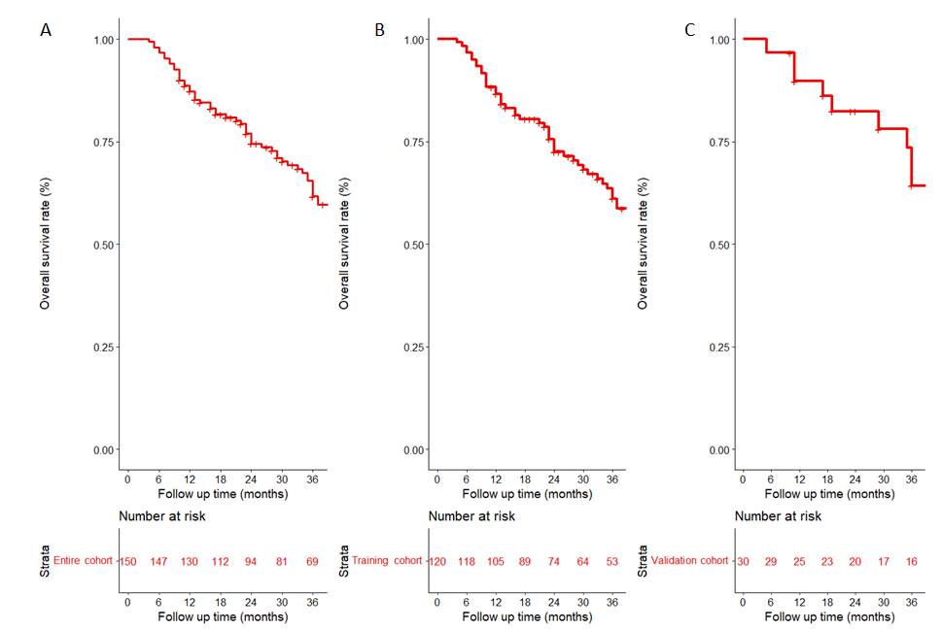
Figure 1 Overall survival for unresectable hepatocellular carcinoma patients accepted conversion therapy. A: Entire cohort; B: Training cohort; C: Validation cohort.

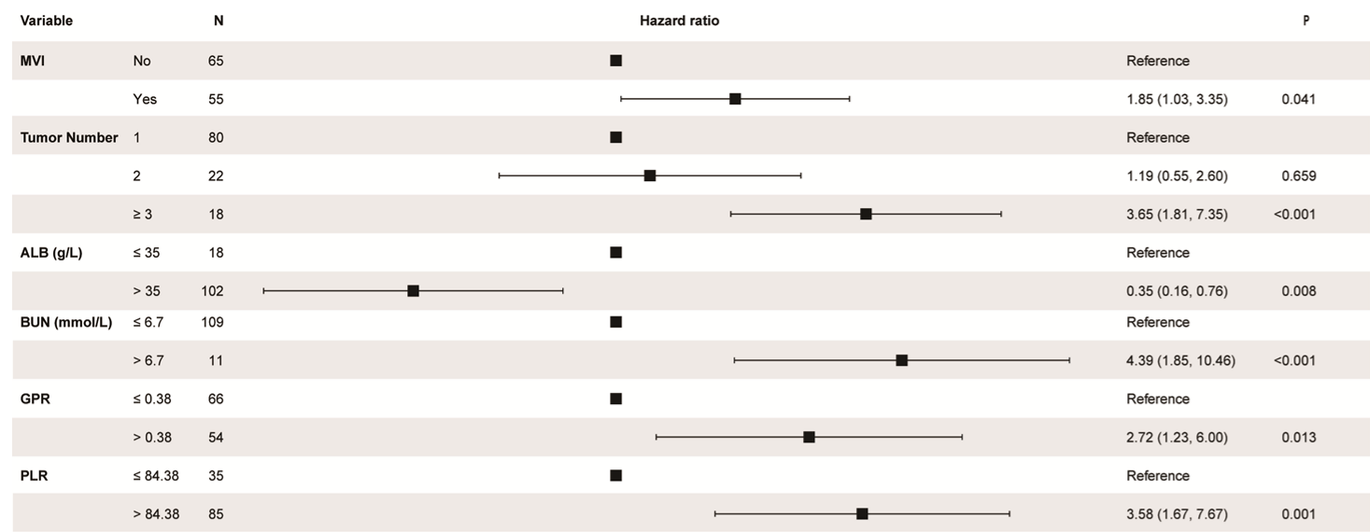

Figure 2 Forest plot for multivariance cox analysis of overall survival in the training cohort. CI: Confident interval; MVI: Macrovascular invasion; ALB: Albumin; BUN: Blood urea nitrogen; GPR: Gamma-glutamyl transpeptidase to platelet ratio; PLR: Platelet to lymphocyte ratio.

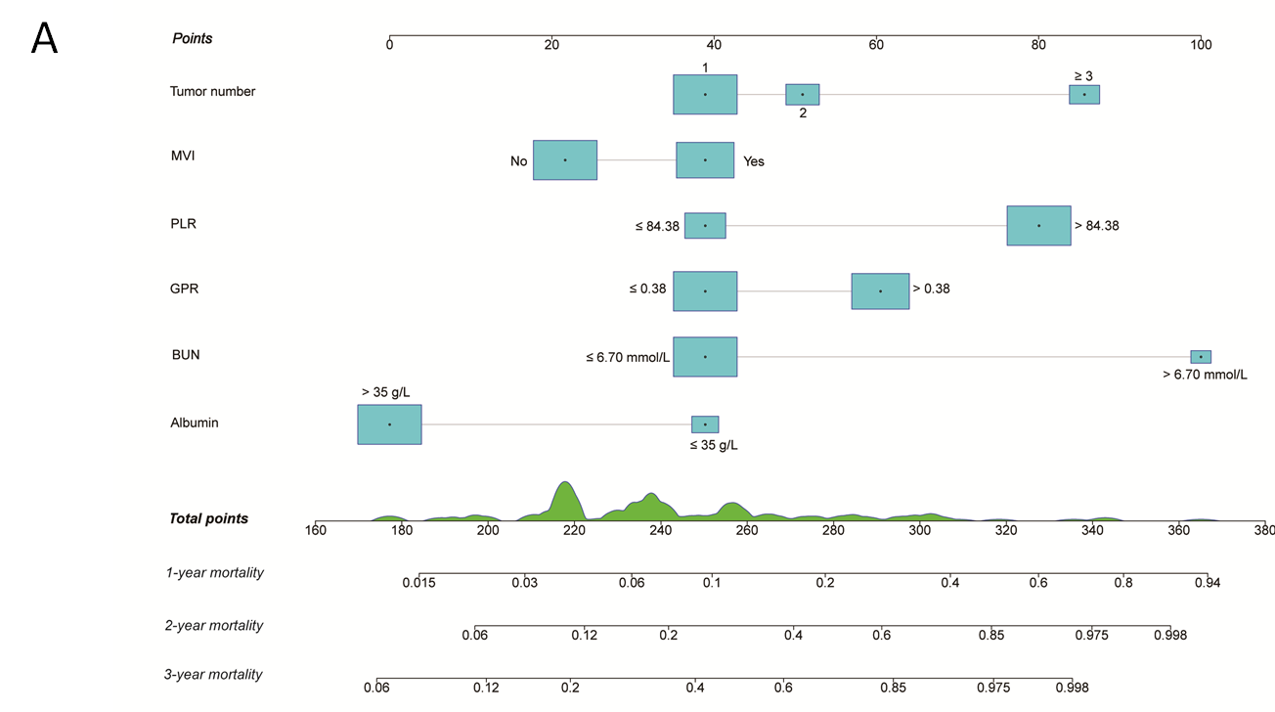
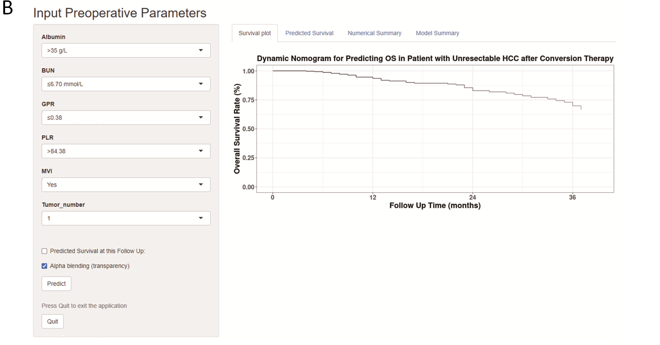
Figure 3 Conversion therapy model for unresectable hepatocellular carcinoma patients accepted conversion therapy. A: A constructed nomogram for predicting 1-, 2-, 3-year overall survival; B: Screenshot of the online individualized prediction tool based on the overall survival nomogram model. OS: Overall survival; MVI: Macrovascular invasion; BUN: Blood urea nitrogen; GPR: Gamma-glutamyl transpeptidase to platelet ratio; PLR: Platelet to lymphocyte ratio.

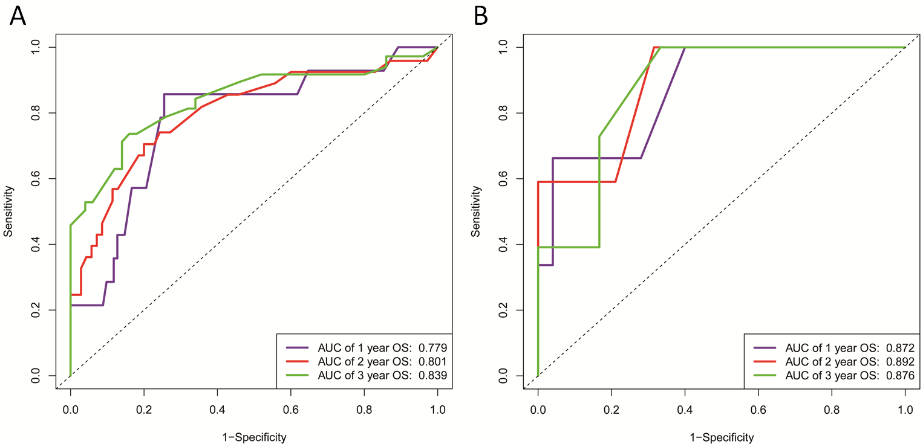
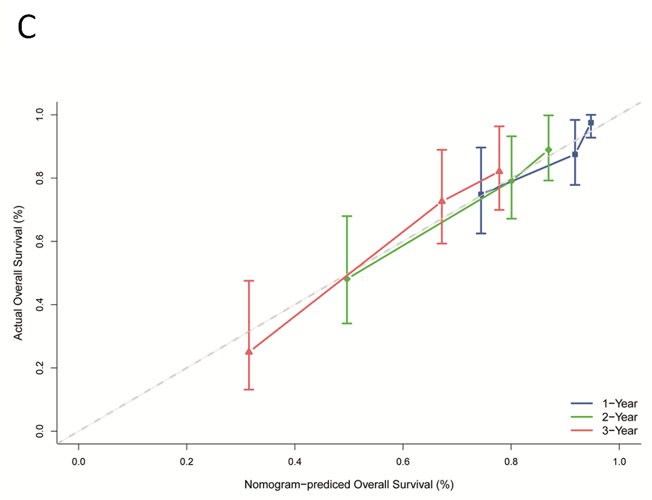
Figure 4 The receiver operating characteristic curves, calibration curve and decision curve analysis curves of the model. A and B: Receiver operating characteristic for overall survival in the training (A) and validation cohort (B), respectively; C: Calibration curve plots of nomogram for predicting 1-year, 2-year and 3-year probability of survival in the training cohort. OS: Overall survival; AUC: Area under the curve.

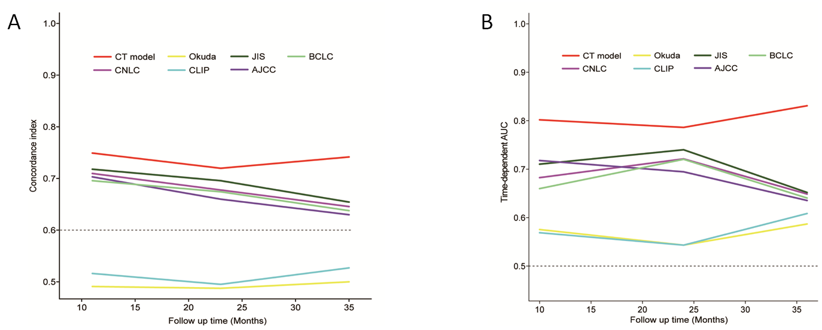
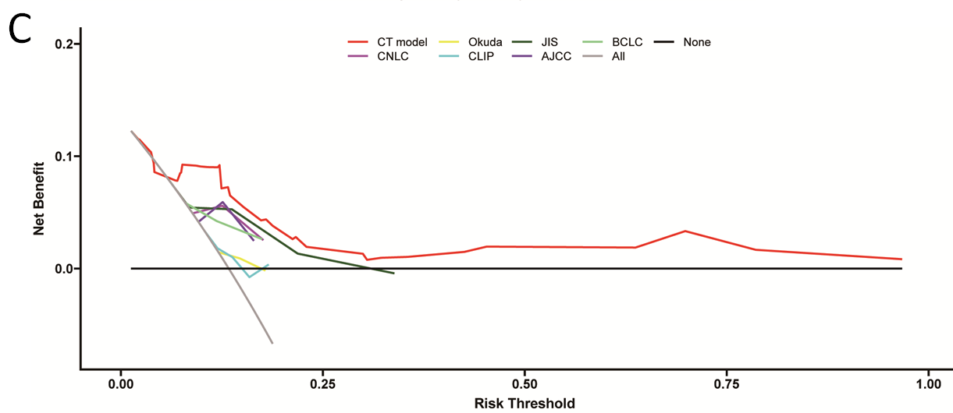
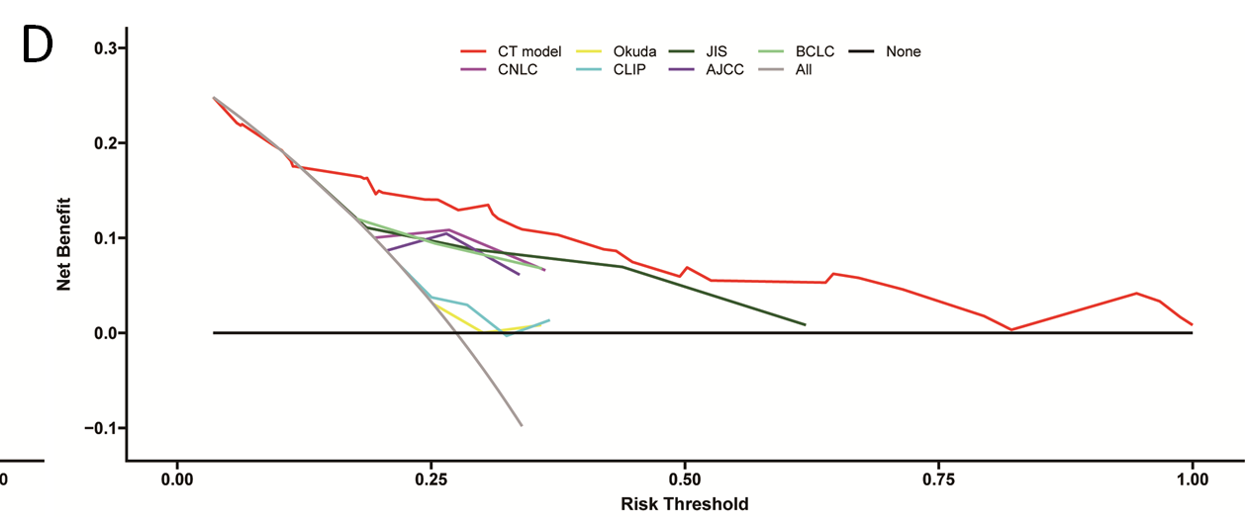
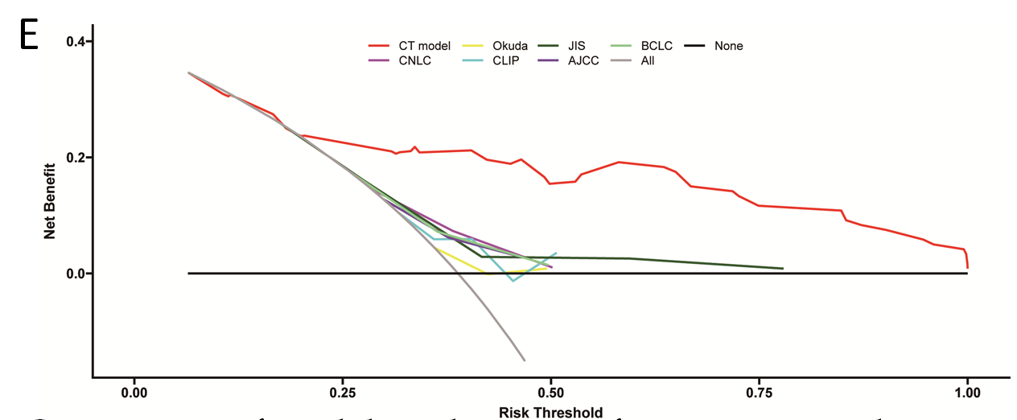

Figure 5 Comparison of model predictive performance in predicting overall survival. A: Comparison of concordance index between conversion therapy (CT) model and traditional staging systems in the training cohort; B: Comparison of time-dependent areas under receiver operating characteristic curve between CT model and other staging systems in the training cohort; the decision curve analysis curve compared the clinical practicability of the CT model and other six conventional hepatocellular carcinoma staging systems; C-E: 1-year (C), 2-year (D) and 3-year (E) survival benefit in the training cohort. AUC: Areas under receiver operating characteristic curve; CT: Conversion therapy; CNLC: China liver cancer staging; CLIP: Cancer of the Liver Italian Program; JIS: Japan integrated staging; BCLC: Barcelona Clinic Liver Cancer; AJCC: American Joint Committee on Cancer.

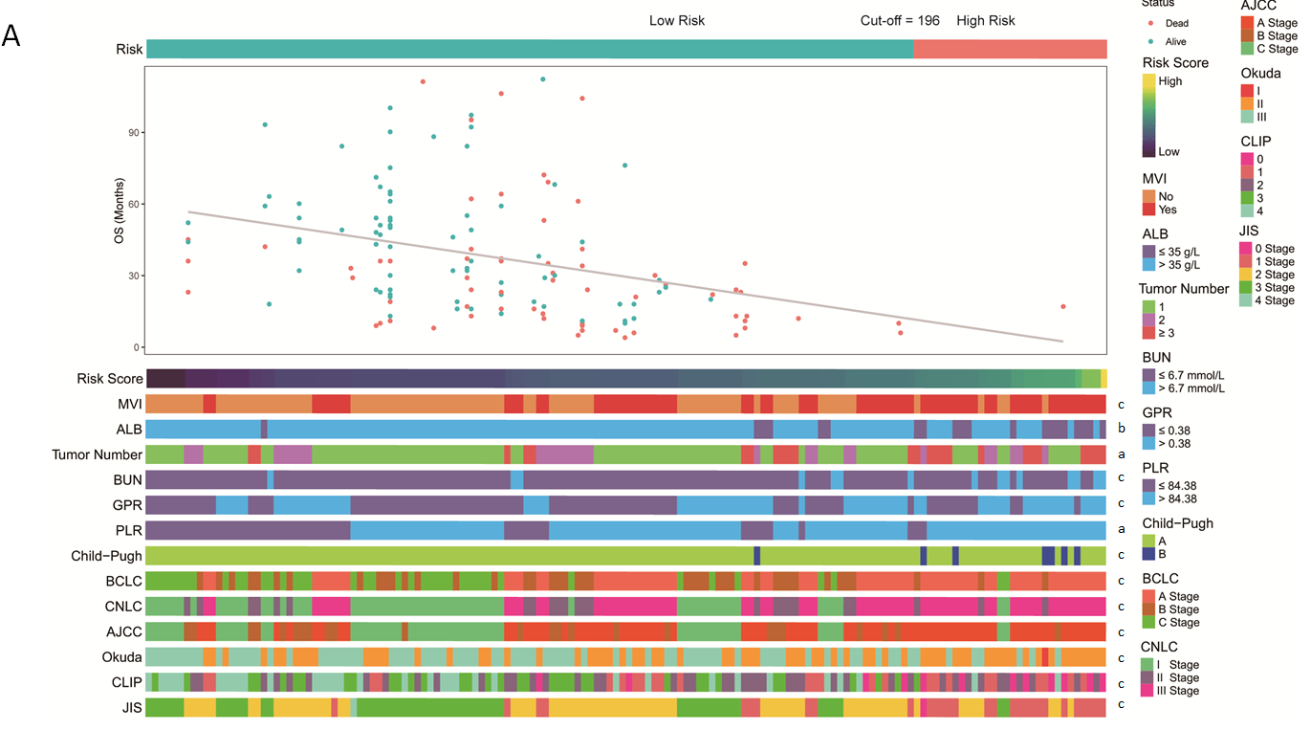
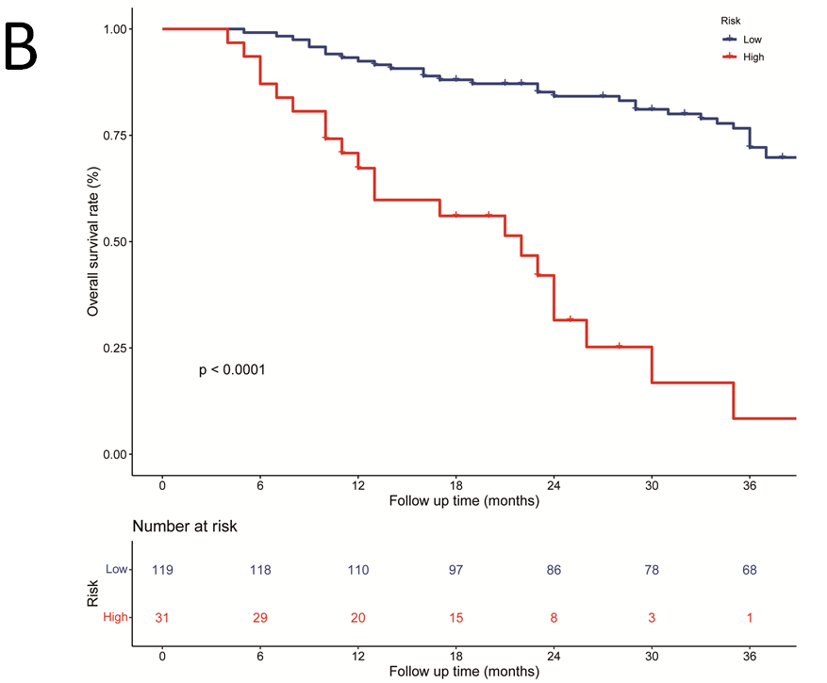
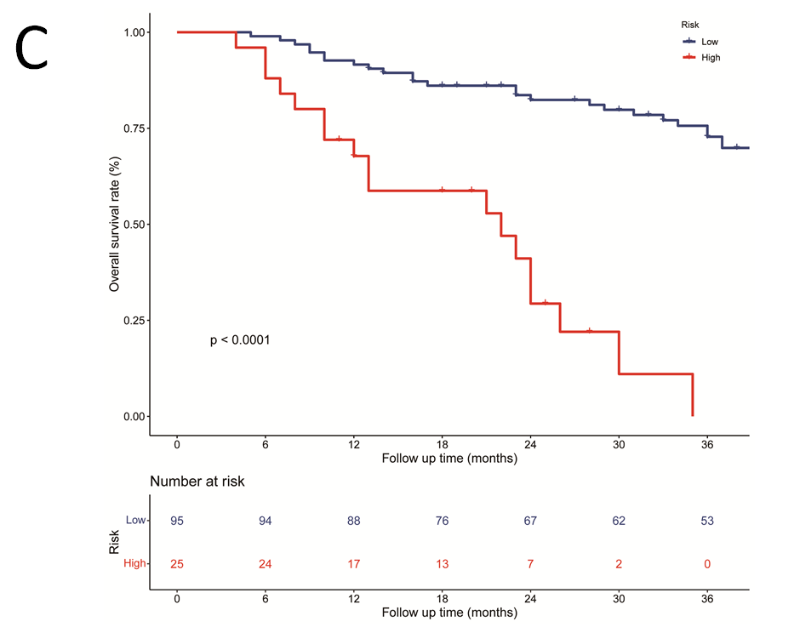
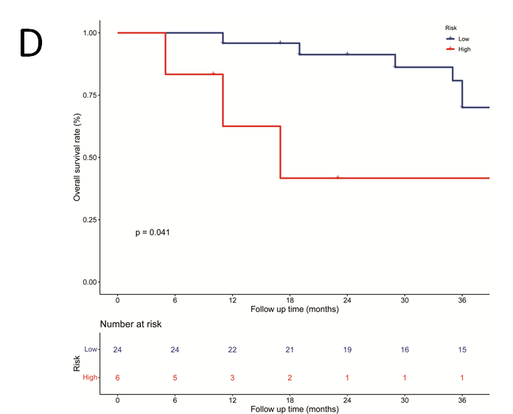

Figure 6 A Heatmap presents the distribution of corresponding risk score and clinical feature in each patient within high and low risk groups. A: It shows that the patients in low-risk group have more favourable prognosis; B-D: Kaplan-Meier survival curves for patients with low and high risk stratified by the total nomogram score in the entire cohort (B), training cohort (C), and validation cohort (D). ªP < 0.05, ^{b}P < 0.01, ^{c}P < 0.001 was considered significant. ALB: Albumin; MVI: Macrovascular invasion; BUN: Blood urea nitrogen; GPR: Gamma-glutamyl transpeptidase to platelet ratio; PLR: Platelet to lymphocyte ratio; CNLC: China liver cancer staging; CLIP: Cancer of the Liver Italian Program; JIS: Japan integrated staging; BCLC: Barcelona Clinic Liver Cancer; AJCC: American Joint Committee on Cancer.

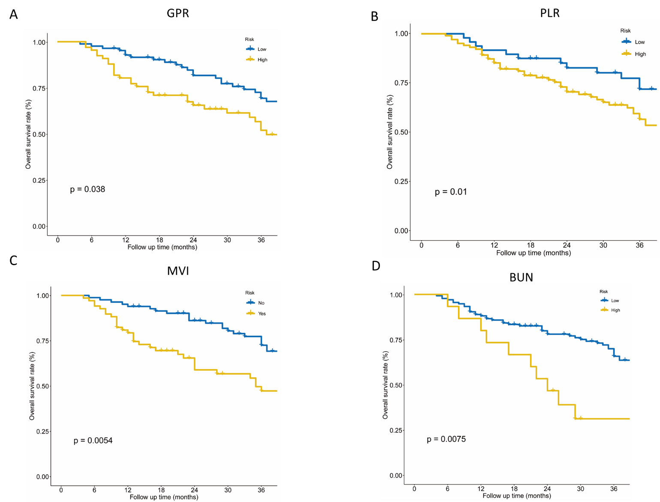
Figure 7 Kaplan-Meier survival curves for patients with different level of gamma-glutamyl transpeptidase to platelet ratio, platelet to lymphocyte ratio, macrovascular invasion, and blood urea nitrogen in the entire cohort. A: Gamma-glutamyl transpeptidase to platelet ratio; B: Platelet to lymphocyte ratio; C: Macrovascular invasion; D: Blood urea nitrogen. GPR: Gamma-glutamyl transpeptidase to platelet ratio; PLR: Platelet to lymphocyte ratio; MVI: Macrovascular invasion; BUN: Blood urea nitrogen.

Table 1 Demographics and clinical characteristics of hepatocellular carcinoma patients
Variables | Training cohort (n = 120) | Validation cohort (n = 30) | Overall cohort (n = 150) | P value
Patient factors
Age [yr, mean (SD)] | 51.5 (12.1) | 54.4 (10.9) | 52.1 (11.9) | 0.419
Sex, male/female | 104/16 (86.7%/13.3%) | 24/6 (80.0%/20.0%) | 128/22 (85.3%/14.7%) | 0.526
Etiology, HBV/other | 109/11 (90.8%/9.2%) | 25/5 (83.3%/16.7%) | 134/16 (89.3%/10.7%) | 0.390
Ascites, yes/no | 20/100 (16.7%/83.3%) | 7/23 (23.3%/76.7%) | 27/123 (18.0%/82.0%) | 0.559
Child-Pugh, A/B | 114/6 (95.0%/5.0%) | 29/1 (96.7%/3.3%) | 143/7 (95.3%/4.7%) | 1.000
Laboratory parameters
AFP (ng/mL, ≤ 200/> 200) | 68/52 (56.7%/43.3%) | 15/15 (50.0%/50.0%) | 83/67 (55.3%/44.7%) | 0.652
HGB [g/dL, median (min, max)] | 139 (72, 838) | 139 (100, 162) | 139 (72, 838) | 0.714
PLT [count, × 10⁹/L, median (min, max)] | 197 (70, 950) | 189 (97, 370) | 192 (70, 950) | 0.873
AST [U/L, median (min, max)] | 36.0 (2, 471) | 33.0 (16, 251) | 35.0 (2, 471) | 0.925
ALT [U/L, median (min, max)] | 34.0 (9, 423) | 29.0 (12, 329) | 34.0 (9, 423) | 0.541
ALB (g/L, ≤ 35/> 35) | 18/102 (15.0%/85.0%) | 2/28 (6.7%/93.3%) | 20/130 (13.3%/86.7%) | 0.368
TB [μmol/L, median (min, max)] | 12.5 (3.2, 28.2) | 12.9 (4.3, 30.9) | 12.7 (3.2, 30.9) | 0.996
GGT [U/L, median (min, max)] | 59.5 (15, 435) | 57.0 (22, 375) | 59.0 (15, 435) | 0.987
BUN (mmol/L, ≤ 6.7/> 6.7( | 109/11 (90.8%/9.2%) | 26/4 (86.7%/13.3%) | 135/15 (90.0%/10.0%) | 0.734
Creatinine [μmol/L, median (min, max)] | 77.6 (23, 218) | 74.0 (43, 110) | 77.0 (23, 218) | 0.263
UA [μmol/L, median (min, max)] | 335 (172, 680) | 329 (143, 572) | 334 (143, 680) | 0.899
PT [s, median (min, max)] | 13.6 (11.1, 16.5) | 13.6 (12.1, 15.6) | 13.6 (11.1, 16.5) | 0.212
Tumor factors
Tumor number (1/2/≥ 3) | 80/22/18 (66.7%/18.3%/15.0%) | 16/7/7 (53.3%//23.3%/23.3%) | 96/29/25 (64.0%/19.3%/16.7%)
Tumor size (cm, ≤ 5/> 5) | 39/81 (32.5%/67.5%) | 11/19 (36.7%/63.3%) | 50/100 (33.3%/66.7%) | 0.829
MVI, yes/no | 55/65 (45.8%/54.2%) | 13/17 (43.3%/56.7%) | 68/82 (45.3%/54.7%) | 1.000
Tumor capsule, ill-defined/well-defined | 29/91 (24.2%/75.8%) | 11/19 (36.7%/63.3%) | 40/110 (26.7%/73.3%) | 0.249
Satellite nodules, yes/no | 26/94 (21.7%/78.3%) | 10/20 (33.3%/66.7%) | 36/114 (24.0%/76.0%) | 0.272
Surgical factors
TACE (c-TACE/DEB-TACE) | 79/41 (65.8%/34.2%) | 21/9 (70.0%/30.0%) | 100/50 (66.7%/33.3%) | 0.829
Resection Margin (cm, < 1/≥ 1) | 13/107 (10.8%/89.2%) | 4/26 (13.3%/86.7%) | 17/133 (11.3%/88.7%) | 0.949
Blood transfusion, yes/no | 38/82 (31.7%/68.3%) | 14/16 (46.7%/53.3%) | 52/98 (34.7%/65.3%) | 0.184
Conventional staging system
AJCC (I/II/III) | 42/20/58 (35.0%/16.7%/48.3%) | 10/4/16 (33.3%/13.3%/53.3%) | 52/24/74 (34.7%/16.0%/49.3%) | 0.889
BCLC (A/B/C) | 31/35/54 (25.8%/29.2%/45.0%) | 10/7/13 (33.3%/23.3%/43.3%) | 41/42/67 (27.3%/28.0%/44.7%) | 0.678
CNLC (I/II/III) | 47/19/54 (39.2%/15.8%/45.0%) | 12/5/13 (40.0%/16.7%/43.3%) | 59/24/67 (39.3%/16.0%/44.7%) | 1.000
Okuda (I/II/III) | 65/54/1 (54.2%/45.0%/0.8%) | 15/15/0 (50.0%/50.0%/0%) | 80/69/1 (53.3%/46.0%/0.7%) | 0.749
JIS (0/1/2/3/4) | 1/42/55/21/1 (0.8%/35.0%/45.8%/17.5%/0.8%) | 0/10/12/8/0 (0%/33.3%/40.0%/26.7%/0%) | 1/52/67/29/1 (0.7%/34.7%/44.7%/19.3%/0.7%) | 0.716
CLIP (0/1/2/3/4) | 27/28/35/21/9 (22.5%/23.3%/29.2%/17.5%/7.5%) | 7/7/9/4/3 (23.3%/23.3%/30.0%/13.3%/10.0%) | 34/35/44/25/12 (22.7%/23.3%/29.3%/16.7%/8.0%) | 0.962
Inflammation index
GPR (≤ 0.38/> 0.38) | 66/54 (55.0%/45.0%) | 18/12 (60.0%/40.0%) | 84/66 (56.0%/44.0%) | 0.773
LMR (≤ 2.39/> 2.39) | 26/94 (21.7%/78.3%) | 6/24 (20.0%/80.0%) | 32/118 (21.3%/78.7%) | 1.000
NLR (≤ 2.00/> 2.00) | 60/60 (50.0%/50.0%) | 16/14 (53.3%/46.7%) | 76/74 (50.7%/49.3%) | 0.903
PLR (≤ 84.38/> 84.38) | 35/85 (29.2%/70.8%) | 13/17 (43.3%/56.7%) | 48/102 (32.0%/68.0%) | 0.204
NrLR (≤ 644.61/> 644.61) | 106/14 (88.3%/11.7%) | 28/2 (93.3%/6.7%) | 134/16 (89.3%/10.7%) | 0.643
APRI (≤ 0.30/> 0.30) | 91/29 (75.8%/24.2%) | 20/10 (66.7%/33.3%) | 111/39 (74.0%/26.0%) | 0.429
ANRI (≤ 4.76/> 4.76) | 10/110 (8.3%/91.7%) | 4/26 (13.3%/86.7%) | 14/136 (9.3%/90.7%) | 0.623
ALRI (≤ 41.96/> 41.96) | 97/23 (80.8%/19.2%) | 24/6 (80.0%/20.0%) | 121/29 (80.7%/19.3%) | 1.000
PNI (≤ 52.62/> 52.62) | 93/27 (77.5%/22.5%) | 22/8 (73.3%/26.7%) | 115/35 (76.7%/23.3%) | 0.809
SII (≤ 336.22/> 336.22) | 48/72 (40.0%/60.0%) | 13/17 (43.3%/56.7%) | 61/89 (40.7%/59.3%) | 0.901
AFP: An alpha fetoprotein; HGB: Hemoglobin; PLT: Platelet; AST: Aspartate aminotransferase; ALT: Alanine aminotransferase; GGT: Gamma-glutamyl transpeptidase; ALB: Albumin; TBIL: Total bilirubin; BUN: Blood urea nitrogen; UA: Uric acid; PT: Prothrombin time; MVI: Microvascular invasion; TACE: Transarterial chemoembolization; cTACE: Conventional TACE; DEB-TACE: Drug-eluting beads TACE; GPR: Gamma-glutamyl transpeptidase to platelet ratio; LMR: Lymphocyte to monocyte ratio; NLR: Neutrophil to lymphocyte ratio; PLR: Platelet to lymphocyte ratio; NrLR: Neutrophil times GGT-to-lymphocyte ratio; APRI: Aspartate aminotransferase to platelet ratio index; ANRI: AST to neutrophil ratio index; ALRI: AST to lymphocyte ratio index; PNI: Prognostic nutritional index; SII: Systemic immune-inflammation index.

