Name of Journal: World Journal of Gastrointestinal Oncology
Manuscript NO: 80537
Manuscript Type: META-ANALYSIS

Rs3746444 T>C locus in miR-499 increases the susceptibility to hepatocellular carcinoma: A meta-analysis 14812 subjects

Jiang JK et al. MiR-499 rs3746444 T>C SNP and HCC

Jia-Kai Jiang, Han-Shen Chen, Wei-Feng Tang, Yu Chen, Jing Lin

Jia-Kai Jiang, Department of General Surgery, Changzhou No. 3 People’s Hospital, Changzhou 213000, Jiangsu Province, China

Han-Shen Chen, Department of Anesthesiology, The First Affiliated Hospital of Fujian Medical University, Fuzhou 350000, Fujian Province, China

Wei-Feng Tang, Department of Cardiothoracic Surgery, Nanjing Drum Tower Hospital, The Affiliated Hospital of Nanjing University Medical School, Nanjing 210000, Jiangsu Province, China

Yu Chen, Jing Lin, Department of Medical Oncology, Clinical Oncology School of Fujian Medical University, Fujian Cancer Hospital, Fuzhou 350000, Fujian Province, China

Yu Chen, Jing Lin, Cancer Bio-Immunotherapy Center, Clinical Oncology School of Fujian Medical University, Fujian Cancer Hospital, Fuzhou 350000, Fujian Province, China

Yu Chen, College of Chemistry, Fuzhou University, Fuzhou 350000, Fujian Province, China

Author contributions: Jiang JK and Chen HS contributed to this manuscript equally. Jiang JK, Lin J, Chen Y contributed to the conception of the study; Chen HS and Tang WF contributed significantly to the analysis and manuscript preparation; Jiang JK, Chen Y performed the data analyses and wrote the manuscript; HS Chen and Lin J helped perform the analysis with constructive discussions.

Supported by Fujian Provincial Clinical Research Center for Cancer Radiotherapy and Immunotherapy, No. 2020Y2012; the Startup Fund for Scientific Research, Fujian Medical University, No. 2019QH1071; the Science and Technology Supporting Project of Changzhou City, No. CE20205034; Joint Funds for the Innovation of Science and Technology, Fujian Province, No. 2021Y9227; and the National Natural Science Foundation of China, No. U1705282.

Corresponding author: Jing Lin, MA, Doctor, Department of Medical Oncology, Clinical Oncology School of Fujian Medical University, Fujian Cancer Hospital, No. 420 Fuma Road, Jin’an District, Fuzhou 350000, Fujian Province, China. 423559148@qq.com

Received: October 1, 2022
Revised: October 26, 2022
Accepted: November 28, 2022
Published online: January 15, 2023

Abstract
BACKGROUND
Recently, many investigations have suggested that the rs3746444 T>C locus in the microRNA (miR)-499 gene may contribute to the occurrence of cancer. However, reports on the association between rs3746444 and hepatocellular carcinoma (HCC) are conflicting.

AIM
To further understand and explore the potential correlation between the single-nucleotide polymorphism of rs3746444 and the incidence of HCC.

METHODS
In this meta-analysis, we obtained electronic literature by searching the PubMed, Embase and Chinese BioMedical Disc databases (through May 20, 2022). All eligible case-control, prospective cohort or nested case-control studies with sufficient data for calculating the odds ratios with their 95% confidence intervals were included.

RESULTS
Ultimately, a total of 17 independent studies were included. We identified that rs3746444 was associated with the development of HCC (C vs T: P = 0.019 and CC/CT vs TT: P = 0.016). In Asian individuals, rs3746444 was associated with susceptibility to HCC (C vs T: P = 0.013 and CC/CT vs TT: P = 0.016). In addition, this study identified that the miR-499 rs3746444 locus was associated with susceptibility to HCC in the normal/healthy control subgroup (C vs T: P = 0.034 and CC/CT vs TT: P = 0.024).

CONCLUSION
In summary, this meta-analysis highlights that rs3746444 in the miR-499 gene is involved in the occurrence of HCC, especially in Asian individuals.

Key Words: Polymorphism; MicroRNA-499; Hepatocellular carcinoma; Meta-analysis; Susceptibility

©The Author(s) 2023. Published by Baishideng Publishing Group Inc. All rights reserved.

Citation: Jiang JK, Chen HS, Tang WF, Chen Y, Lin J. Rs3746444 T>C locus in miR-499 increases the susceptibility to hepatocellular carcinoma: A meta-analysis 14812 subjects. World J Gastrointest Oncol 2023; 15(1): 171-185
URL: https://www.wjgnet.com/1948-5204/full/v15/i1/171.htm
DOI: https://dx.doi.org/10.4251/wjgo.v15.i1.171

Core Tip: Many investigations have suggested that the rs3746444 T>C locus in the microRNA (miR)-499 gene may contribute to the occurrence of cancer. However, reports on the association between rs3746444 and hepatocellular carcinoma (HCC) are conflicting. This meta-analysis highlights that rs3746444 in the miR-499 gene is involved in the occurrence of HCC, especially in Asian individuals.

INTRODUCTION
In 2020, liver cancer (LC) was the seventh most frequent malignancy, with 905677 new cases worldwide^{[1]}. Accordingly, LC is ranked as the second leading cause of malignancy-related deaths, as it has resulted in death for 830180 individuals^{[1]}. The incidence rates of LC and LC-related deaths remain higher in China than other parts of the world^{[2]}. Hepatocellular carcinoma (HCC) is the predominant subtype of LC, accounting for approximately 75%-85% of primary LC cases^{[3]}. Overall, the survival rate of HCC remains poor. To date, the etiology of HCC is not well established. Although it has been reported that chronic virus infection^{[4]}, type 2 diabetes^{[5,6]}, obesity^{[7,8]}, smoking^{[9,10]}, heavy alcohol intake^{[11-13]} and aflatoxin-contaminated food stuffs^{[14]} may contribute to the occurrence of HCC, other risk factors may also lead to the development of HCC, such as hereditary factors^{[15-18]}.
MicroRNAs (miRs) are noncoding RNAs of approximately 22 nucleotides in size. They may be implicated in the regulation of target genes and are involved in a number of cellular processes (e.g., growth, proliferation, differentiation, apoptosis, migration and invasion)^{[19-24]}. Recently, several investigations have reported that the expression profiling of serum miRs could be used as a marker for hepatitis C virus-related cases of HCC^{[25]}. Variants within miRs may alter target recognition, transcription, or posttranscriptional processing and then lead to malignant diseases^{[26]}. Additionally, most of the established miRs may influence many target genes; single-nucleotide polymorphisms (SNPs) in miRs could affect the level of multifarious proteins. MiR-499 is located within chromosome 20q. MiR-499 is involved in infection and inflammatory diseases^{[27]}. Rs3746444 T>C in miR-499 was identified to be correlated with the development of ankylosing spondylitis^{[28]}, arthritis susceptibility^{[29]}, and bronchial asthma^{[27]}.
Additionally, a number of investigations have suggested that the rs3746444 SNP in miR-499 may contribute to the occurrence of cancer. Liu et al^{[30]} reported that miR-499-5p could promote the metastasis of colorectal cancer and might be used as a vital target for colorectal cancer therapy. Additionally, a previous study identified that in HepG2 cells, miR-499 could inhibit the level of the E26 transformation specific sequence 1, which is an important proto-oncogene in the development of HCC^{[31]}. The miR-499 variant rs3746444 has been suggested to play an important role in the occurrence of various malignancies, such as adenocarcinoma of the esophagogastric junction^{[32]}, prostate cancer^{[33]}, cervical squamous cell carcinoma^{[34]}, oral squamous cell cancer^{[35]}, and lung cancer^{[36]}. Recently, a number of studies have focused on the relationship between rs3746444 in miR-499 and HCC^{[36-40]}; however, the obtained findings are conflicting. Several meta-analyses also reported controversial results. Some pooled analyses have suggested that the rs3746444 C allele could not confer a risk to HCC^{[41-44]}. However, other publications have reported that the rs3746444 C allele may contribute to the occurrence of HCC^{[40,45-47]}. These controversial findings may be due to the limited sample sizes included in these analyses. Recently, some case-control studies have been conducted to further explore this potential association^{[48-50]}. An updated meta-analysis is needed to shed new light on the relationship between rs3746444 in miR-499 and HCC regarding all available publications. Therefore, this meta-analysis involved a large sample size to verify whether the miR-499 rs3746444 SNP could influence the occurrence of HCC. And these possible relationships might be beneficial to the prevention of liver carcinogenesis.

MATERIALS AND METHODS
Study research
In this meta-analysis, we obtained electronic literature by searching the PubMed, Embase and Chinese BioMedical Disc (CBM) databases (through May 20, 2022). We used the following keywords: (SNP OR variant OR polymorphism) AND (neoplasm OR carcinoma OR tumor OR cancer) AND (hepatocellular OR liver) AND (microRNA499 OR miR499 OR microRNA-499 OR miR-499 OR rs3746444). The references included in the retrieved publications and relevant reviews, as well as published meta-analyses, were hand-searched to obtain more related data. Due to no restriction on language, a large amount of data was collected. We also cited high-quality articles in Reference Citation Analysis (https://www.referencecitationanalysis.com).

Inclusion and exclusion criteria
The inclusion criteria for the eligible literature were as follows: (1) Assessing the relationship of rs3746444 in miR-499 with HCC susceptibility; (2) Full-text study; (3) Designed as a case-control study, a prospective cohort or a nested case-control study; and (4) Sufficient data could be used to calculate the odds ratios (Ors) with their 95% confidence intervals (CIs). When a publication contained more than one investigation, it was treated as an independent case-control study. Accordingly, letters, reviews, comments, non-case-control studies, studies that violated Hardy-Weinberg equilibrium (HWE), literature without sufficient data and duplicated data were excluded.

Data extraction
Two authors (Jiang JK and Lin J) reviewed the eligible literature and extracted the data independently. The following information was collected: The first author, year of publication, mean age (years), sex (male, %), drinking status (%), smoking status (%), country/ethnicity, hepatitis B surface antigen (HBsAg) (positive, %), number of subjects, HWE, genotyping method and genotype data. In a case of a conflicting assessment, another author (Tang WF) took part in a discussion until a consensus opinion was obtained.
Statistical methods
The results of this meta-analysis were assessed in four genetic models: A dominant model (CC/TC vs TT), recessive model (CC vs TT/TC), homozygote comparison (CC vs TT) and allelic model (C vs T). The correlation between rs3746444 in miR-499 and HCC susceptibility was determined by using Ors and the corresponding 95%CIs. The heterogeneity among the eligible studies was assessed by using the I² test and Q test. For heterogeneity, the level of significance was P < 0.1 and/or I² ≥ 50%. When it was significant, we used a random-effects model (DerSimonian and Laird) to assess the association between rs3746444 in miR-499 and HCC susceptibility^{[51,52]}. Otherwise, we used a fixed-effects model (Mantel-Haenszel) to determine the potential association^{[53]}. In this study, a Galbraith radial plot was used to confirm the source of the heterogeneity. Sensitivity analysis was performed to explore whether an individual investigation might significantly influence the assessment. We used Egger’s test and Begg’s funnel plots to measure the possible bias among the publications. For publication bias, the level of significance was P < 0.1. STATA 12.0 software (Stata Corp., College Station, Texas) was used to conduct statistical analysis. All P-values were measured with two-sided tests. By using Power-SampleSize software, the power value (α = 0.05) was also used to assess the stability of our study^{[54]}. We used the Newcastle-Ottawa Quality Assessment Scale to assess the quality of eligible studies and defined scores ≥ 7 stars as high-quality studies^{[55]}.

RESULTS
Study characteristics
An electronic search of the CBM, PubMed and Embase databases obtained 117 publications. After the titles or abstracts were reviewed by two authors (Jiang JK and Lin J), 47 duplicates were removed. Fifty articles were excluded based on the inclusion criteria (Figure 1). Thus, 20 articles were reviewed in full text. Three publications were included after reading the references of eligible articles. However, 11 case-control studies were excluded for violating HWE. Finally, 13 publications with 17 independent case-control studies focusing on the relationship between the rs3746444 polymorphism and HCC risk were included^{[40,48,50,56-65]}.
These included studies were published between 2012 and 2020, and in the eligible case-control studies, the participant number ranged from 100 to 1507. Table 1 shows the included terms in the eligible studies. In summary, 7 case-control studies involving Caucasian individuals were found^{[50,56-58]}, and the others focused on Asian individuals^{[40,48,59-65]}. The distributions of the rs3746444 genotypes and alleles in the miR-499 SNP and the results of the quality assessment are summarized in Tables 1 and 2.

Main findings
The main results are summarized in Table 3. When we combined the included case-control studies, we identified that rs3746444 in miR-499 was associated with the development of HCC (C vs T: P = 0.019 and CC/CT vs TT: P = 0.016, Figure 2). In a subgroup analysis by different races, rs3746444 in miR-499 was found to be associated with susceptibility to HCC in the Asian population (C vs T: P = 0.013 and CC/CT vs TT: P = 0.016). When we considered the source of disease, the miR-499 rs3746444 locus was identified to be associated with susceptibility to HCC in normal/healthy control individuals (C vs T: P = 0.034 and CC/CT vs TT: P = 0.024) and hepatitis/virus-related control individuals (C vs T: P = 0.007, CC vs TT: P = 0.014 and CC/CT vs TT: P = 0.018).

Sensitivity analysis
To confirm the stability of our findings, we conducted a sensitivity analysis in this meta-analysis. We deleted an individual study in turn and calculated the Ors and CIs of the remaining studies to determine the influence of each datum. The findings suggested that these evaluations could not be altered by any eligible study (Figure 3).

Publication bias
By using Begg’s and Egger’s tests, publication bias among the eligible studies was determined. There was no significant bias among the eligible studies (Figure 4A, P > 0.1, data not shown).

Heterogeneity
In this meta-analysis, significant heterogeneity was identified. We conducted stratified analyses to explore the source of heterogeneity. Newcastle-Ottawa Scale (Nos) was used to evaluate the literature quality. We found an association between hospital-based (HB) studies, high-quality studies (Nos ≥ 7.0), Asian individuals, and normal/healthy control subgroups and significant heterogeneity. The Galbraith radial plot test suggested that 4 outliers^{[40,56,63,65]} might contribute to the significant heterogeneity (Figure 4B).

The power of the present study (α = 0.05)
By using Power-Sample Size software, the power value (α = 0.05) was also used to assess the stability of our study. As summarized in Table 3, in the overall comparison, the power value was more than 0.8 in the allele and dominant genetic models. In the subgroup analyses, the power value was more than 0.8 in Asian individuals and the normal/healthy control subgroups in the allele genetic model and in Asian individuals and the normal/healthy control subgroups in the dominant genetic model.

DISCUSSION
Recently, rs3746444 in miR-499 and its importance to the occurrence of HCC have been extensively investigated. However, several meta-analyses reported controversial results, which might be due to the limited sample sizes included in these analyses. Recently, some case-control studies have been conducted to further explore this potential association in different populations. Thus, an updated meta-analysis should be conducted to shed new light on the relationship between rs3746444 in miR-499 and HCC. As summarized in Table 3, we identified that rs3746444 in miR-499 was associated with the development of HCC in the allele and the dominant genetic models (the value of power ≥ 0.8).
The merit of this updated meta-analysis was that the present pooled analysis included a larger sample size to verify whether the miR-499 rs3746444 SNP could influence the occurrence of HCC. In this study, we identified that the miR-499 rs3746444 SNP could confer a risk to HCC. Some meta-analyses have focused on the potential correlation between rs3746444 in miR-499 and the risk of HCC. A previous pooled analysis suggested that the rs3746444T allele in the miR-499 gene could not play a vital role in the tumorigenesis of HCC^{[42]}. However, other meta-analyses reported that rs3746444 in miR-499 might confer susceptibility to HCC^{[40,45-47]}. Additionally, some more recent case-control studies have been conducted to explore the potential association between rs3746444 in the miR-499 SNP and the risk of HCC^{[48-50]}. The potential association was more controversial. Thus, we included 28 independent case-control studies with 5948 cases and 8864 controls and conducted an updated meta-analysis to focus on the relationship between rs3746444 in the miR-499 SNP and the risk of HCC. In this study, we identified that the miR-499 rs3746444 SNP could confer a risk to HCC.
Toraih et al^{[26]} reported that in silico data analysis, the T to C substitution in the miR-499 rs3746444 SNP did not prominently affect the structure of the hairpin loop. Functional prediction revealed that different miR-499 rs3746444 alleles have different targets. The miR-499 rs3746444*C allele only has 58.2% of the gene targets of the rs3746444*T variant and generates 763 new gene targets. The miR-499 gene can target both alcohol dehydrogenase 1 beta polypeptide (ADH1B) and aldehyde dehydrogenase 1 family member A3 (ALDH1A3) genes. Pettinelli et al^{[66]} suggested that hepatic ALDH1A3 was expressed at lower levels and was inversely correlated with the level of plasma retinol in nonalcoholic steatohepatitis cases, which may alter the risk for HCC. Recently, some studies have identified that the ADH1B gene may be involved in the development of HCC^{[67-69]}. A previous study indicated that rs3746444 in miR-499 was correlated with susceptibility to ulcerative colitis and that the expression of miR-499 was decreased (5-fold) in ulcerative colitis cases with the rs3746444 TC genotype compared with those with the rs3746444 TT variant^{[70]}. Taken together, these results indicate that the rs3746444 C allele in the miR-499 gene could decrease the expression of the miR-499 gene and alter the levels of the ADH1B and ALDH1A3 genes. Finally, this SNP could be implicated in the occurrence of HCC. However, the relationship between rs3746444 in miR-499 and HCC in different subgroups could not be well explained. In the future, more attention should be given to the potential mechanism by which hepatitis B virus infection acts in different ethnicities or statuses.
Since significant heterogeneity was found in this meta-analysis, subgroup analysis was performed to observe the major source of heterogeneity. The findings of the subgroup analysis indicated that the normal/healthy control, Asian and HB subgroups could greatly increase the heterogeneity. Additionally, the Galbraith radial plot identified 4 outliers^{[40,56,63,65]}, which could contribute to the major source of heterogeneity.
There are some limitations in this meta-analysis. First, the electronic literature was only searched in the PubMed, Embase and CBM databases, and bias might have occurred. Second, all investigations have been conducted in Caucasian and Asian populations; thus, our findings were only appropriate for these populations. Third, due to insufficient data (e.g., HBsAg, drinking, smoking, sex, age, body mass index and lifestyle) in this study, we did not consider these factors in the subgroup analysis. Fourth, due to the lack of environmental factors, we also did not take into account gene-environment interactions. Fifth, in this meta-analysis, significant heterogeneity was identified. Sixth, we did not pay close attention to the expression level of target genes, which could be controlled by rs3746444 T>C locus. Finally, in this study, we only included the relationship between rs3746444 in miR-499 and HCC risk. The potential role of other vital miR loci can’t be ignored.

CONCLUSION
In summary, this meta-analysis highlights that rs3746444 in miR-499 is involved in the occurrence of HCC, especially in Asian individuals. In the future, more investigations are needed to confirm our results.

ARTICLE HIGHLIGHTS
Research background
This meta-analysis highlights that rs3746444 in microRNA (miR)-499 is involved in the occurrence of hepatocellular carcinoma (HCC), especially in Asian individuals. These possible relationships might be beneficial to the prevention of liver carcinogenesis. In the future, more investigations are needed to confirm.

Research motivation
Recently, a number of studies have focused on the relationship between rs3746444 in miR-499 and HCC. However, the obtained findings are conflicting.

Research objectives
In summary, this meta-analysis highlights that rs3746444 in miR-499 is involved in the occurrence of HCC, especially in Asian individuals. In the future, more investigations are needed to confirm our results.

Research methods
This meta-analysis involved a large sample size to verify whether the miR-499 rs3746444 single-nucleotide polymorphism could influence the occurrence of HCC. These possible relationships might be beneficial to the prevention of liver carcinogenesis.

Research results
Reports on the association between rs3746444 and HCC are conflicting.

Research conclusions
The results of this meta-analysis were assessed in four genetic models: A dominant model (CC/TC vs TT), recessive model (CC vs TT/TC), homozygote comparison (CC vs TT) and allelic model (C vs T). The correlation between rs3746444 in miR-499 and HCC susceptibility was determined by using odd ratios and the corresponding 95% confidence intervals. We used a random-effects model (DerSimonian and Laird) to assess the association between rs3746444 in miR-499 and HCC susceptibility. Otherwise, we used a fixed-effects model (Mantel-Haenszel) to determine the potential association. We used the Newcastle-Ottawa Quality Assessment Scale to assess the quality of eligible studies and defined scores ≥ 7 stars as high-quality studies.

Research perspectives
Reports on the association between rs3746444 and HCC are conflicting. This meta-analysis highlights that rs3746444 in miR-499 is involved in the occurrence of HCC, especially in Asian individuals. These possible relationships might be beneficial to the prevention of liver carcinogenesis.

ACKNOWLEDGEMENTS
We wish to thank Dr. Hao Ding (Affiliated People’s Hospital of Jiangsu University, China) for technical support.

REFERENCES
1 Sung H, Ferlay J, Siegel RL, Laversanne M, Soerjomataram I, Jemal A, Bray F. Global Cancer Statistics 2020: GLOBOCAN Estimates of Incidence and Mortality Worldwide for 36 Cancers in 185 Countries. CA Cancer J Clin 2021; 71: 209-249 [PMID: 33538338 DOI: 10.3322/caac.21660]
2 Chen W, Zheng R, Baade PD, Zhang S, Zeng H, Bray F, Jemal A, Yu XQ, He J. Cancer statistics in China, 2015. CA Cancer J Clin 2016; 66: 115-132 [PMID: 26808342 DOI: 10.3322/caac.21338]
3 Bray F, Ferlay J, Soerjomataram I, Siegel RL, Torre LA, Jemal A. Global cancer statistics 2018: GLOBOCAN estimates of incidence and mortality worldwide for 36 cancers in 185 countries. CA Cancer J Clin 2018; 68: 394-424 [PMID: 30207593 DOI: 10.3322/caac.21492]
4 Zhang CH, Xu GL, Jia WD, Li JS, Ma JL, Ge YS. Effects of interferon treatment on development and progression of hepatocellular carcinoma in patients with chronic virus infection: a meta-analysis of randomized controlled trials. Int J Cancer 2011; 129: 1254-1264 [PMID: 21710498 DOI: 10.1002/ijc.25767]
5 Elemeery MN, Mohamed MA, Madkour MA, Shamseya MM, Issa NM, Badr AN, Ghareeb DA, Pan CH. MicroRNA signature in patients with hepatocellular carcinoma associated with type 2 diabetes. World J Gastroenterol 2019; 25: 6322-6341 [PMID: 31754293 DOI: 10.3748/wjg.v25.i42.6322]
6 Michel M, Kalliga E, Labenz C, Straub BK, Wörns MA, Galle PR, Schattenberg JM. A young patient with type 2 diabetes associated non-alcoholic steatohepatitis, liver cirrhosis, and hepatocellular carcinoma. Z Gastroenterol 2020; 58: 57-62 [PMID: 31931541 DOI: 10.1055/a-1062-8788]
7 Chong YC, Lim TE, Fu Y, Shin EM, Tergaonkar V, Han W. Indian Hedgehog links obesity to development of hepatocellular carcinoma. Oncogene 2019; 38: 2206-2222 [PMID: 30470823 DOI: 10.1038/s41388-018-0585-5]
8 Chen Y, Zhang F, Zhao Y, He K, Zheng X, Pan Y, Shao D, Shang P, Yang Y, Zhang D, Xie Y, Yao X, Chen L, Li J, Zhang X. Obesity-associated miR-27a upregulation promotes hepatocellular carcinoma metastasis through suppressing SFRP1. Onco Targets Ther 2018; 11: 3281-3292 [PMID: 29910623 DOI: 10.2147/OTT.S162978]
9 Guarino M, Dufour JF. Smoking favours hepatocellular carcinoma. Ann Transl Med 2019; 7: S99 [PMID: 31576306 DOI: 10.21037/atm.2019.04.90]
10 Li CL, Lin YK, Chen HA, Huang CY, Huang MT, Chang YJ. Smoking as an Independent Risk Factor for Hepatocellular Carcinoma Due to the α7-Nachr Modulating the JAK2/STAT3 Signaling Axis. J Clin Med 2019; 8 [PMID: 31492006 DOI: 10.3390/jcm8091391]
11 Mukaiya M, Nishi M, Miyake H, Hirata K. Chronic liver diseases for the risk of hepatocellular carcinoma: a case-control study in Japan. Etiologic association of alcohol consumption, cigarette smoking and the development of chronic liver diseases. Hepatogastroenterology 1998; 45: 2328-2332 [PMID: 9951917]
12 Okada S, Ishii H, Nose H, Okusaka T, Kyogoku A, Yoshimori M, Shimada K, Yamamoto J, Kosuge T, Yamasaki S, Sakamoto M, Hirohashi S. Effect of heavy alcohol intake on long-term results after curative resection of hepatitis C virus-related hepatocellular carcinoma. Jpn J Cancer Res 1996; 87: 867-873 [PMID: 8797895 DOI: 10.1111/j.1349-7006.1996.tb02113.x]
13 Ioannou GN, Green P, Kerr KF, Berry K. Models estimating risk of hepatocellular carcinoma in patients with alcohol or NAFLD-related cirrhosis for risk stratification. J Hepatol 2019; 71: 523-533 [PMID: 31145929 DOI: 10.1016/j.jhep.2019.05.008]
14 Hifnawy MS, Mangoud AM, Eissa MH, Nor Edin E, Mostafa Y, Abouel-Magd Y, Sabee EI, Amin I, Ismail A, Morsy TA, Mahrous S, Afefy AF, el-Shorbagy E, el-Sadawy M, Ragab H, Hassan MI, el-Hady G, Saber M. The role of aflatoxin-contaminated food materials and HCV in developing hepatocellular carcinoma in Al-Sharkia Governorate, Egypt. J Egypt Soc Parasitol 2004; 34: 479-488 [PMID: 15124754]
15 Yang J, Liu J, Chen Y, Tang W, Bo K, Sun Y, Chen J. Investigation of ICOS, CD28 and CD80 polymorphisms with the risk of hepatocellular carcinoma: a case-control study in eastern Chinese population. Biosci Rep 2019; 39 [PMID: 31235485 DOI: 10.1042/BSR20181824]
16 Yang J, Liu J, Chen Y, Tang W, Liu C, Sun Y, Chen J. Association of CTLA-4 tagging polymorphisms and haplotypes with hepatocellular carcinoma risk: A case-control study. Medicine (Baltimore) 2019; 98: e16266 [PMID: 31335675 DOI: 10.1097/MD.0000000000016266]
17 Zhang S, Lin J, Jiang J, Chen Y, Tang W, Liu L. Association between methylenetetrahydrofolate reductase tagging polymorphisms and susceptibility of hepatocellular carcinoma: a case-control study. Biosci Rep 2019; 39 [PMID: 31694048 DOI: 10.1042/BSR20192517]
18 Zhang S, Jiang J, Chen Z, Wang Y, Tang W, Chen Y, Liu L. Relationship of PPARG, PPARGC1A, and PPARGC1B polymorphisms with susceptibility to hepatocellular carcinoma in an eastern Chinese Han population. Onco Targets Ther 2018; 11: 4651-4660 [PMID: 30122956 DOI: 10.2147/OTT.S168274]
19 Wang L, Hu K, Chao Y, Wang X. MicroRNA-1296-5p suppresses the proliferation, migration, and invasion of human osteosarcoma cells by targeting NOTCH2. J Cell Biochem 2020; 121: 2038-2046 [PMID: 31633240 DOI: 10.1002/jcb.29438]
20 Hu XH, Zhao ZX, Dai J, Geng DC, Xu YZ. MicroRNA-221 regulates osteosarcoma cell proliferation, apoptosis, migration, and invasion by targeting CDKN1B/p27. J Cell Biochem 2019; 120: 4665-4674 [PMID: 30582227 DOI: 10.1002/jcb.27755]
21 Zhao X, Lu C, Chu W, Zhang Y, Zhang B, Zeng Q, Wang R, Li Z, Lv B, Liu J. microRNA-214 Governs Lung Cancer Growth and Metastasis by Targeting Carboxypeptidase-D. DNA Cell Biol 2016; 35: 715-721 [PMID: 27494742 DOI: 10.1089/dna.2016.3398]
22 Jian Y, Xu CH, Li YP, Tang B, Xie SH, Zeng EM. Down-regulated microRNA-30b-3p inhibits proliferation, invasion and migration of glioma cells via inactivation of the AKT signaling pathway by up-regulating RECK. Biosci Rep 2019; 39 [PMID: 31270250 DOI: 10.1042/BSR20182226]
23 Wang MJ, Zhang H, Li J, Zhao HD. microRNA-98 inhibits the proliferation, invasion, migration and promotes apoptosis of breast cancer cells by binding to HMGA2. Biosci Rep 2018; 38 [PMID: 30049846 DOI: 10.1042/BSR20180571]
24 Li J, Jin B, Wang T, Li W, Wang Z, Zhang H, Song Y, Li N. Serum microRNA expression profiling identifies serum biomarkers for HCV-related hepatocellular carcinoma. Cancer Biomark 2019; 26: 501-512 [PMID: 31658041 DOI: 10.3233/CBM-181970]
25 Chen LB, Zheng HK, Zhang L, An Z, Wang XP, Shan RT, Zhang WQ. A single nucleotide polymorphism located in microRNA-499a causes loss of function resulting in increased expression of osbpl1a and reduced serum HDL level. Oncol Rep 2017; 38: 3515-3521 [PMID: 29039586 DOI: 10.3892/or.2017.6016]
26 Toraih EA, Hussein MH, Al Ageeli E, Riad E, AbdAllah NB, Helal GM, Fawzy MS. Structure and functional impact of seed region variant in MIR-499 gene family in bronchial asthma. Respir Res 2017; 18: 169 [PMID: 28886711 DOI: 10.1186/s12931-017-0648-0]
27 Xu HY, Wang ZY, Chen JF, Wang TY, Wang LL, Tang LL, Lin XY, Zhang CW, Chen BC. Association between ankylosing spondylitis and the miR-146a and miR-499 polymorphisms. PLoS One 2015; 10: e0122055 [PMID: 25836258 DOI: 10.1371/journal.pone.0122055]
28 Toraih EA, Ismail NM, Toraih AA, Hussein MH, Fawzy MS. Precursor miR-499a Variant but not miR-196a2 is Associated with Rheumatoid Arthritis Susceptibility in an Egyptian Population. Mol Diagn Ther 2016; 20: 279-295 [PMID: 27002721 DOI: 10.1007/s40291-016-0194-3]
29 Liu X, Zhang Z, Sun L, Chai N, Tang S, Jin J, Hu H, Nie Y, Wang X, Wu K, Jin H, Fan D. MicroRNA-499-5p promotes cellular invasion and tumor metastasis in colorectal cancer by targeting FOXO4 and PDCD4. Carcinogenesis 2011; 32: 1798-1805 [PMID: 21934092 DOI: 10.1093/carcin/bgr213]
30 Wei W, Hu Z, Fu H, Tie Y, Zhang H, Wu Y, Zheng X. MicroRNA-1 and microRNA-499 downregulate the expression of the ets1 proto-oncogene in HepG2 cells. Oncol Rep 2012; 28: 701-706 [PMID: 22664953 DOI: 10.3892/or.2012.1850]
31 Tang W, Wang Y, Pan H, Qiu H, Chen S. Association of miRNA-499 rs3746444 A>G variants with adenocarcinoma of esophagogastric junction (AEG) risk and lymph node status. Onco Targets Ther 2019; 12: 6245-6252 [PMID: 31496728 DOI: 10.2147/OTT.S209013]
32 Nouri R, Ghorbian S. Association of single nucleotide polymorphism in hsa-miR-499 and hsa-miR-196a2 with the risk of prostate cancer. Int Urol Nephrol 2019; 51: 811-816 [PMID: 30863967 DOI: 10.1007/s11255-019-02099-0]
33 Srivastava S, Singh S, Fatima N, Mittal B, Srivastava AN. Pre-microRNA Gene Polymorphisms and Risk of Cervical Squamous Cell Carcinoma. J Clin Diagn Res 2017; 11: GC01-GC04 [PMID: 29207732 DOI: 10.7860/JCDR/2017/25361.10543]
34 Zhang E, Xu Z, Duan W, Huang S, Lu L. Association between polymorphisms in pre-miRNA genes and risk of oral squamous cell cancer in a Chinese population. PLoS One 2017; 12: e0176044 [PMID: 28609461 DOI: 10.1371/journal.pone.0176044]
35 Li D, Zhu G, Di H, Li H, Liu X, Zhao M, Zhang Z, Yang Y. Associations between genetic variants located in mature microRNAs and risk of lung cancer. Oncotarget 2016; 7: 41715-41724 [PMID: 27232940 DOI: 10.18632/oncotarget.9566]
36 Akkiz H, Bayram S, Bekar A, Akgöllü E, Üsküdar O. Genetic variation in the microRNA-499 gene and hepatocellular carcinoma risk in a Turkish population: lack of any association in a case-control study. Asian Pac J Cancer Prev 2011; 12: 3107-3112 [PMID: 22393998]
37 Wang XH, Wang FR, Tang YF, Zou HZ, Zhao YQ. Association of miR-149C>T and miR-499A>G polymorphisms with the risk of hepatocellular carcinoma in the Chinese population. Genet Mol Res 2014; 13: 5048-5054 [PMID: 25061729 DOI: 10.4238/2014.July.4.20]
38 Kou JT, Fan H, Han D, Li L, Li P, Zhu J, Ma J, Zhang ZH, He Q. Association between four common microRNA polymorphisms and the risk of hepatocellular carcinoma and HBV infection. Oncol Lett 2014; 8: 1255-1260 [PMID: 25120701 DOI: 10.3892/ol.2014.2257]
39 Shan YF, Huang YH, Chen ZK, Huang KT, Zhou MT, Shi HQ, Song QT, Yu ZP, Deng AM, Zhang QY. miR-499A>G rs3746444 and miR-146aG>C expression and hepatocellular carcinoma risk in the Chinese population. Genet Mol Res 2013; 12: 5365-5371 [PMID: 24301908 DOI: 10.4238/2013.November.7.11]
40 Kim WH, Min KT, Jeon YJ, Kwon CI, Ko KH, Park PW, Hong SP, Rim KS, Kwon SW, Hwang SG, Kim NK. Association study of microRNA polymorphisms with hepatocellular carcinoma in Korean population. Gene 2012; 504: 92-97 [PMID: 22583825 DOI: 10.1016/j.gene.2012.05.014]
41 Zheng L, Zhuang C, Zhao J, Ming L. Functional miR-146a, miR-149, miR-196a2 and miR-499 polymorphisms and the susceptibility to hepatocellular carcinoma: An updated meta-analysis. Clin Res Hepatol Gastroenterol 2017; 41: 664-676 [PMID: 28499985 DOI: 10.1016/j.clinre.2017.03.005]
42 Yu JY, Hu F, Du W, Ma XL, Yuan K. Study of the association between five polymorphisms and risk of hepatocellular carcinoma: A meta-analysis. J Chin Med Assoc 2017; 80: 191-203 [PMID: 28188097 DOI: 10.1016/j.jcma.2016.09.009]
43 Ye LX, Fu CW, Jiang F, Cui YX, Meng W. [A meta-analysis of microRNA-149, microRNA-499 gene polymorphism and susceptibility to hepatocellular carcinoma]. Zhonghua Yu Fang Yi Xue Za Zhi 2016; 50: 445-450 [PMID: 27141902 DOI: 10.3760/cma.j.issn.0253-9624.2016.05.011]
44 Liu F, Lin H, Cheng Y, Yang L, Liu Y. rs3746444 polymorphism and susceptibility to hepatocellular carcinoma: evidence from published studies. Cell Biochem Biophys 2014; 70: 1957-1961 [PMID: 25074528 DOI: 10.1007/s12013-014-0156-5]
45 Qiu D, Han F, Zhuang H. MiR-499 rs3746444 polymorphism and hepatocellular carcinoma risk: A meta-analysis. J Cancer Res Ther 2018; 14: S490-S493 [PMID: 29970712 DOI: 10.4103/0973-1482.179090]
46 Yu H, Wang Y, Wang S, Sun N. Association between miR-499 rs3746444 and the susceptibility of hepatocellular carcinoma. Cell Mol Biol (Noisy-le-grand) 2016; 62: 42-45 [PMID: 27453271]
47 Zhu SL, Zhong JH, Gong WF, Li H, Li LQ. Association of the miR-196a2 C>T and miR-499 A>G polymorphisms with hepatitis B virus-related hepatocellular carcinoma risk: an updated meta-analysis. Onco Targets Ther 2016; 9: 2111-2119 [PMID: 27143913 DOI: 10.2147/OTT.S96738]
48 Zhang S, Chen L, Wang Y, Tang W, Chen Y, Liu L. Investigation of the Association of miRNA-499, miRNA-146a, miRNA-196a2 Loci with Hepatocellular Carcinoma Risk: A Case-Control Study Involving 1507 Subjects. DNA Cell Biol 2020; 39: 379-388 [PMID: 32031872 DOI: 10.1089/dna.2019.5145]
49 Farokhizadeh Z, Dehbidi S, Geramizadeh B, Yaghobi R, Malekhosseini SA, Behmanesh M, Sanati MH, Afshari A, Moravej A, Karimi MH. Association of MicroRNA Polymorphisms With Hepatocellular Carcinoma in an Iranian Population. Ann Lab Med 2019; 39: 58-66 [PMID: 30215231 DOI: 10.3343/alm.2019.39.1.58]
50 Toraih EA, Fawz MS, Elgazzaz MG, Hussein MH, Shehata RH, Daoud HG. Combined Genotype Analyses of Precursor miRNA196a2 and 499a Variants with Hepatic and Renal Cancer Susceptibility a Preliminary Study. Asian Pac J Cancer Prev 2016; 17: 3369-3375
51 Higgins JP, Thompson SG, Deeks JJ, Altman DG. Measuring inconsistency in meta-analyses. BMJ 2003; 327: 557-560 [PMID: 12958120 DOI: 10.1136/bmj.327.7414.557]
52 DerSimonian R, Laird N. Meta-analysis in clinical trials. Control Clin Trials 1986; 7: 177-188 [PMID: 3802833 DOI: 10.1016/0197-2456(86)90046-2]
53 Mantel N, Haenszel W. Statistical aspects of the analysis of data from retrospective studies of disease. J Natl Cancer Inst 1959; 22: 719-748 [PMID: 13655060]
54 Tang W, Qiu H, Ding H, Sun B, Wang L, Yin J, Gu H. Association between the STK15 F31I polymorphism and cancer susceptibility: a meta-analysis involving 43,626 subjects. PLoS One 2013; 8: e82790 [PMID: 24349361 DOI: 10.1371/journal.pone.0082790]
55 Wang W, Shao Y, Tang S, Cheng X, Lian H, Qin C. Peroxisome proliferator-activated receptor-γ (PPARγ) Pro12Ala polymorphism and colorectal cancer (CRC) risk. Int J Clin Exp Med 2015; 8: 4066-4072 [PMID: 26064311]
56 Fteah AM, Ahmed AI, Mosaad NA, Hassan MM, Mahmoud SH. Association of MicroRNA 196a and 499 Polymorphisms with Development of Cirrhosis and Hepatocellular Carcinoma Post-HCV Infection in Egyptian Patients. Asian Pac J Cancer Prev 2019; 20: 3479-3485 [PMID: 31759375 DOI: 10.31557/APJCP.2019.20.11.3479]
57 Abdel-Hamid M, Elshaer S, Darwish A. Association of MicroRNA related single nucleotide polymorphisms 196A-2 and 499 with the risk of hepatocellular carcinoma in Egyptian patients. Meta Gene 2018; 16: 139-142 [DOI: 10.1016/j.mgene.2018.02.007]
58 Al-Qahtani AA, Al-Anazi MR, Nazir N, Wani K, Abdo AA, Sanai FM, Khan MQ, Al-Ashgar HI, Albenmousa A, Al-Hamoudi WK, Alswat KA, Al-Ahdal MN. Association of single nucleotide polymorphisms in microRNAs with susceptibility to hepatitis B virus infection and HBV-related liver complications: A study in a Saudi Arabian population. J Viral Hepat 2017; 24: 1132-1142 [PMID: 28685993 DOI: 10.1111/jvh.12749]
59 Zhang LH, Hao BB, Zhang CY, Dai XZ, Zhang F. Contributions of polymorphisms in miR146a, miR196a, and miR499 to the development of hepatocellular carcinoma. Genet Mol Res 2016; 15 [PMID: 27706712 DOI: 10.4238/gmr.15038582]
60 Li X, Li K, Wu Z. Association of four common SNPs in microRNA polymorphisms with the risk of hepatocellular carcinoma. Int J Clin Exp Pathol 2015; 8: 9560-9566 [PMID: 26464719]
61 Yan P, Xia M, Gao F, Tang G, Zeng H, Yang S, Zhou H, Ding D, Gong L. Predictive role of miR-146a rs2910164 (C>G), miR-149 rs2292832 (T>C), miR-196a2 rs11614913 (T>C) and miR-499 rs3746444 (T>C) in the development of hepatocellular carcinoma. Int J Clin Exp Pathol 2015; 8: 15177-15183 [PMID: 26823863]
62 Qi JH, Wang J, Chen J, Shen F, Huang JT, Sen S, Zhou X, Liu SM. High-resolution melting analysis reveals genetic polymorphisms in microRNAs confer hepatocellular carcinoma risk in Chinese patients. BMC Cancer 2014; 14: 643 [PMID: 25176041 DOI: 10.1186/1471-2407-14-643]
63 Chu YH, Hsieh MJ, Chiou HL, Liou YS, Yang CC, Yang SF, Kuo WH. MicroRNA gene polymorphisms and environmental factors increase patient susceptibility to hepatocellular carcinoma. PLoS One 2014; 9: e89930 [PMID: 24587132 DOI: 10.1371/journal.pone.0089930]
64 Zhou J, Lv R, Song X, Li D, Hu X, Ying B, Wei Y, Wang L. Association between two genetic variants in miRNA and primary liver cancer risk in the Chinese population. DNA Cell Biol 2012; 31: 524-530 [PMID: 21861697 DOI: 10.1089/dna.2011.1340]
65 Xiang Y, Fan S, Cao J, Huang S, Zhang LP. Association of the microRNA-499 variants with susceptibility to hepatocellular carcinoma in a Chinese population. Mol Biol Rep 2012; 39: 7019-7023 [PMID: 22311030 DOI: 10.1007/s11033-012-1532-0]
66 Pettinelli P, Arendt BM, Teterina A, McGilvray I, Comelli EM, Fung SK, Fischer SE, Allard JP. Altered hepatic genes related to retinol metabolism and plasma retinol in patients with non-alcoholic fatty liver disease. PLoS One 2018; 13: e0205747 [PMID: 30379862 DOI: 10.1371/journal.pone.0205747]
67 Udali S, Guarini P, Ruzzenente A, Ferrarini A, Guglielmi A, Lotto V, Tononi P, Pattini P, Moruzzi S, Campagnaro T, Conci S, Olivieri O, Corrocher R, Delledonne M, Choi SW, Friso S. DNA methylation and gene expression profiles show novel regulatory pathways in hepatocellular carcinoma. Clin Epigenetics 2015; 7: 43 [PMID: 25945129 DOI: 10.1186/s13148-015-0077-1]
68 Liu J, Yang HI, Lee MH, Jen CL, Hu HH, Lu SN, Wang LY, You SL, Huang YT, Chen CJ. Alcohol Drinking Mediates the Association between Polymorphisms of ADH1B and ALDH2 and Hepatitis B-Related Hepatocellular Carcinoma. Cancer Epidemiol Biomarkers Prev 2016; 25: 693-699 [PMID: 26827895 DOI: 10.1158/1055-9965.EPI-15-0961]
69 Gaviria-Calle M, Duque-Jaramillo A, Aranzazu M, Di Filippo D, Montoya M, Roldán I, Palacio N, Jaramillo S, Restrepo JC, Hoyos S, Navas MC. Polymorphisms in alcohol dehydrogenase (ADH1) and cytochrome p450 2E1 (CYP2E1) genes in patients with cirrhosis and/or hepatocellular carcinoma. Biomedica 2018; 38: 555-568 [PMID: 30653870 DOI: 10.7705/biomedica.v38i4.3897]
70 Ranjha R, Meena NK, Singh A, Ahuja V, Paul J. Association of miR-196a-2 and miR-499 variants with ulcerative colitis and their correlation with expression of respective miRNAs. PLoS One 2017; 12: e0173447 [PMID: 28301487 DOI: 10.1371/journal.pone.0173447]

Footnotes
Conflict-of-interest statement: All the authors report no relevant conflicts of interest for this article.

PRISMA 2009 Checklist statement: The authors have read the PRISMA 2009 Checklist, and the manuscript was prepared and revised according to the PRISMA 2009 Checklist.

Open-Access: This article is an open-access article that was selected by an in-house editor and fully peer-reviewed by external reviewers. It is distributed in accordance with the Creative Commons Attribution NonCommercial (CC BY-NC 4.0) license, which permits others to distribute, remix, adapt, build upon this work non-commercially, and license their derivative works on different terms, provided the original work is properly cited and the use is non-commercial. See: https://creativecommons.org/Licenses/by-nc/4.0/

Provenance and peer review: Unsolicited article; Externally peer reviewed.
Peer-review model: Single blind

Peer-review started: October 1, 2022
First decision: October 20, 2022
Article in press: November 28, 2022

Specialty type: Oncology
Country/Territory of origin: China
Peer-review report’s scientific quality classification
Grade A (Excellent): 0
Grade B (Very good): 0
Grade C (Good): C, C
Grade D (Fair): 0
Grade E (Poor): 0

P-Reviewer: Keikha M, Iran; Skrypnik D, Poland S-Editor: Wang JJ L-Editor: A P-Editor: Wang JJ

Figure Legends
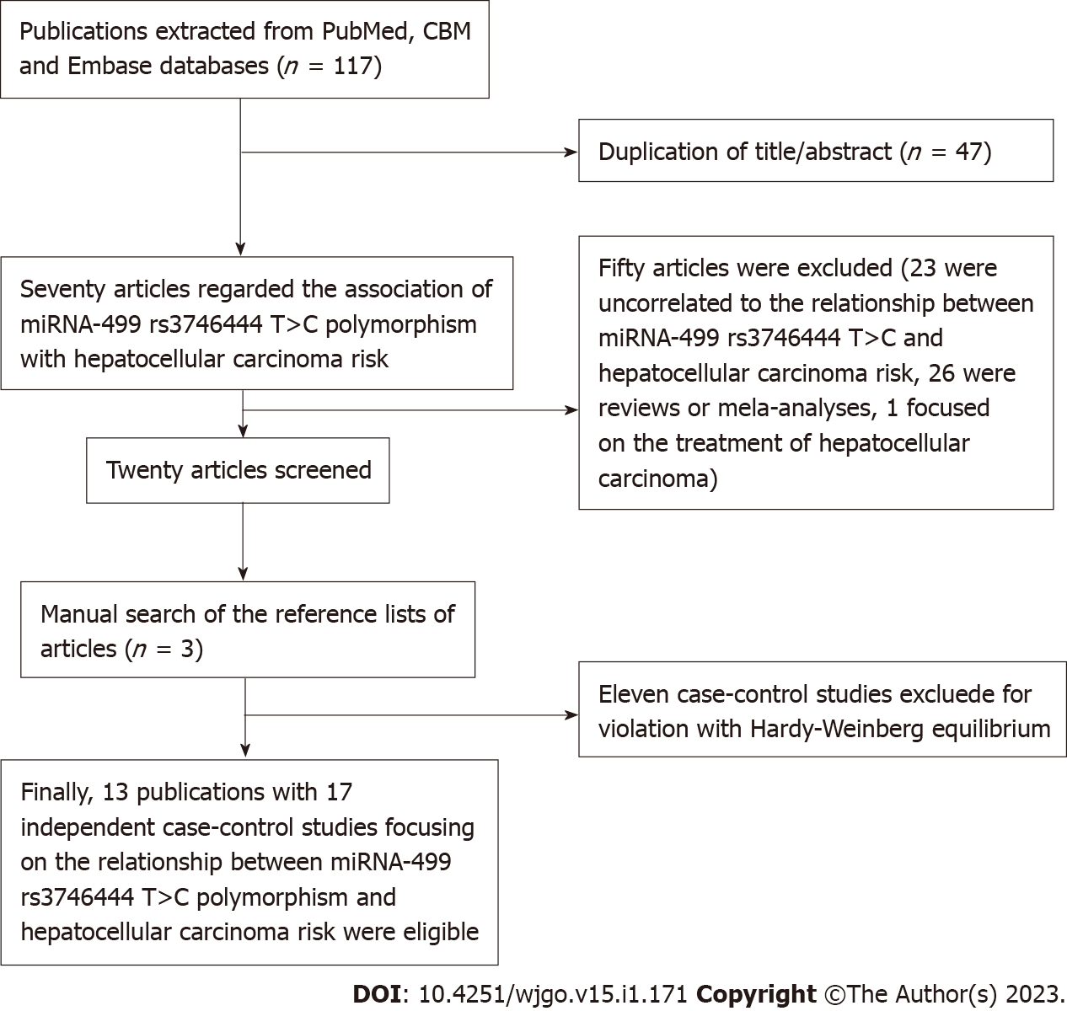
Figure 1 Flow diagram of the meta-analysis. CBM: Chinese BioMedical Disc; miRNA: MicroRNA.
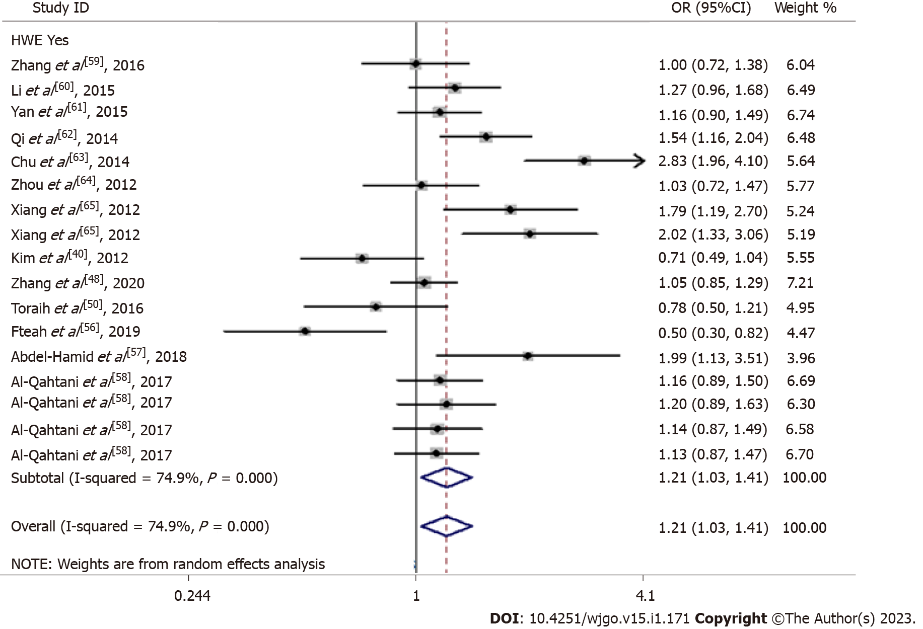
Figure 2 Meta-analysis of the relationship between rs3746444 in microRNA-499 single-nucleotide polymorphism with the risk of hepatocellular carcinoma (C vs T, random-effects model). OR: Odds ratio; CI: Confidence interval.

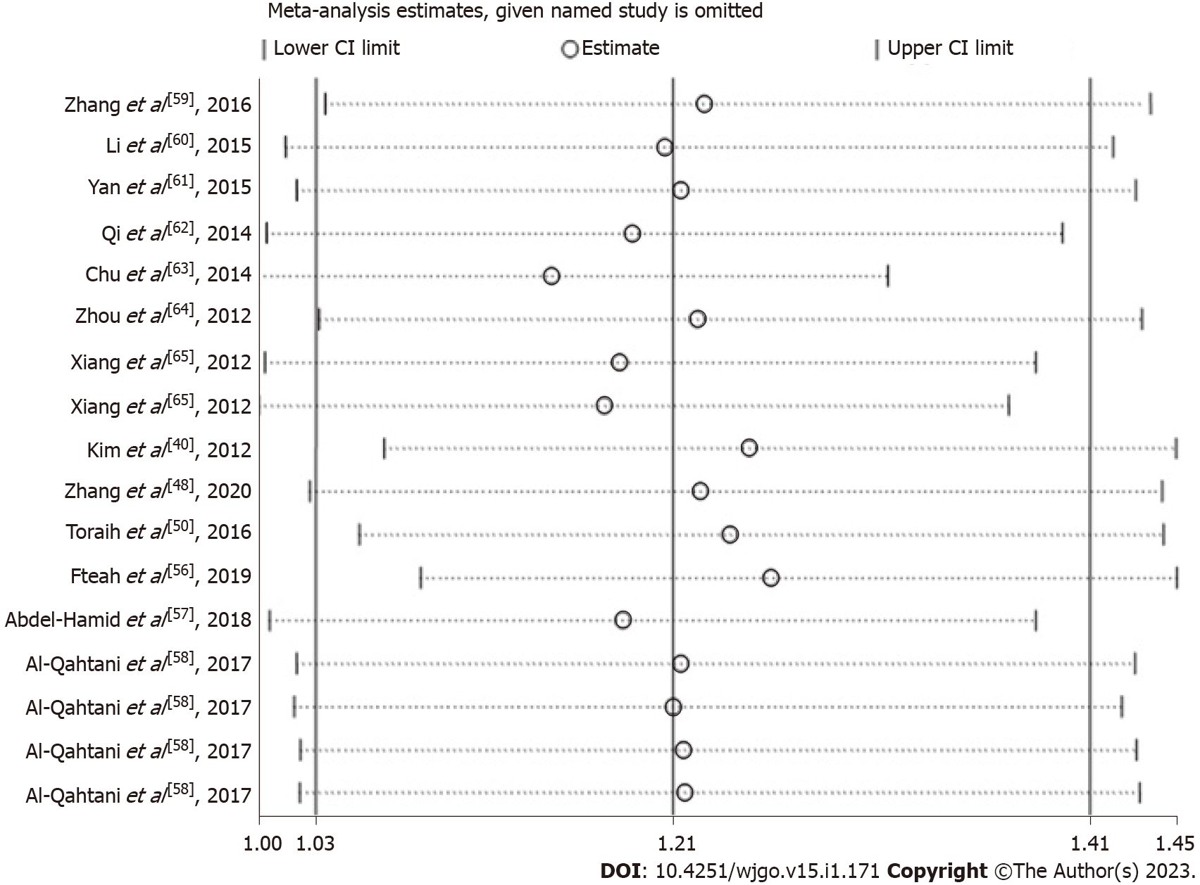
Figure 3 Sensitivity analysis of the influence of C vs T genetic model (random-effects model). CI: Confidence interval.

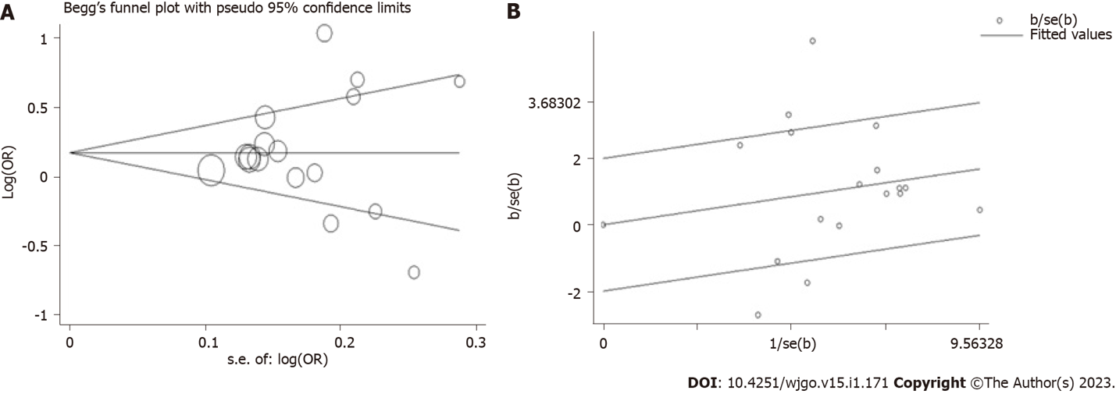Figure 4 Plot of meta-analysis (C vs T, random-effects model). A: Begg’s funnel; B: Galbraith radial. OR: Odds ratio.

Table 1 Characteristics of the studies in meta-analysis
Ref. | Country | Ethnicity | Study design | Sex, male (%); case/control | Mean age (yr); case/control | Smoking (%); case/control | Drinking (%); case/control | HBsAg, positivee (%); case/control | Number cases/controls | Type of control | Case |  |  | Control |  |  | HWE
 |  |  |  |  |  |  |  |  |  |  | TT | TC | CC | TT | TC | CC
Zhang et al^{[59]}, 2016 | China | Asian | HB | 70.29/56.29 | 56.13/54.96 | 34.29/30.79 | 50.29/36.09 | NA | 175/302 | Normal or healthy control | 115 | 49 | 11 | 197 | 87 | 18 | 0.052
Li et al^{[60]}, 2015 | China | Asian | PB | 75.56/75.56 | ≥ 55 yr, 55.26/≥55 yr, 53.38 | 36.47/31.58 | 47.37/36.47 | 41.35/12.03 | 266/250 | Normal or healthy control | 150 | 92 | 24 | 166 | 83 | 17 | 0.140
Yan et al^{[61]}, 2015 | China | Asian | PB | 77.74/63.41 | ≥ 55 yr, 55.84/≥ 55 yr, 45.43 | 47.81/42.68 | 58.76/40.55 | 61.31/10.37 | 274/328 | Normal or healthy control | 147 | 98 | 29 | 188 | 112 | 28 | 0.060
Qi et al^{[62]}, 2014 | China | Asian | PB | 83.8/83.8 | 50.7/49.6 | 38.9/NA | 27.4/NA | 83.2/0.0 | 314/406 | Normal or healthy control | 195 | 117 | 2 | 301 | 101 | 4 | 0.157
Chu et al^{[63]}, 2014 | China | Asian | HB | 72.34/74.78 | < 45 yr, 5.05, 45-59 yr, 30.85, ≥ 60 yr, 63.83/< 45 yr, 7.12, 45-59 yr, 40.06, ≥ 60 yr, 52.82 | 42.55/33.23 | 36.17/40.36 | 42.55/13.23 | 188/337 | Normal or healthy control | 119 | 60 | 9 | 281 | 55 | 1 | 0.321
Zhou et al^{[64]}, 2012 | China | Asian | PB | 82.8/NA | 52.1/NA | NA/NA | NA/NA | NA/NA | 186/483 | Normal or healthy control | 141 | 41 | 4 | 371 | 100 | 12 | 0.100
Xiang et al^{[65]}, 2012 | China | Asian | HB | 82/39 | 48.55/47.02 | NA/NA | NA/NA | NA/NA | 100/100 | Hepatitis or virus related control | 36 | 40 | 24 | 52 | 35 | 13 | 0.081
Xiang et al^{[65]}, 2012 | China | Asian | HB | 82/50 | 48.55/45.12 | NA/NA | NA/NA | NA/NA | 100/100 | Normal or healthy control | 36 | 40 | 24 | 54 | 36 | 10 | 0.284
Kim et al^{[40]}, 2012 | Korea | Asian | PB | NA/NA | NA/NA | NA/NA | NA/NA | NA/NA | 159/201 | NA/NA | 109 | 47 | 3 | 120 | 74 | 7 | 0.278
Zhang et al^{[48]}, 2020 | China | Asian | HB | 89.90/90.47 | 53.17/53.72 | 35.96/35.43 | 29.11/16.03 | 70.55/9.21 | 584/923 | Normal or healthy control | 409 | 154 | 12 | 669 | 230 | 22 | 0.673
Toraih et al^{[50]}, 2016 | Egypt | Caucasian | HB | NA/NA | NA/NA | NA/NA | NA/NA | NA/NA | 60/150 | Normal or healthy control | 28 | 23 | 9 | 57 | 66 | 27 | 0.307
Fteah et al^{[56]}, 2019, Abdel-Hamid et al^{[57]}, 2018 | Egypt | Caucasian | HB | 80.00/81.33 | 50.12/50.11 | 54.7/0.0 | NA/NA | NA/NA | 75/75 | Normal or healthy control | 41 | 32 | 2 | 31 | 30 | 14 | 0.175
 | Egypt | Caucasian | HB | 78.0/70.0 | 55.8/54.4 | 34.0/34.0 | NA/NA | 6.0/0.0 | 50/50 | Normal or healthy control | 3 | 32 | 15 | 16 | 23 | 11 | 0.617
Al-Qahtani et al^{[58]}, 2017 | Saudi Arabia | Caucasian | HB | NA/68.4 | NA/40.29 | NA/NA | NA/NA | NA/100.00 | 145/585 | Hepatitis or virus related control | 48 | 70 | 27 | 219 | 273 | 93 | 0.607
Al-Qahtani et al^{[58]}, 2017 | Saudi Arabia | Caucasian | HB | NA/79.7 | NA/36.33 | NA/NA | NA/NA | NA/100.00 | 145/222 | Hepatitis or virus related control | 48 | 70 | 27 | 87 | 100 | 35 | 0.486
Al-Qahtani et al^{[58]}, 2017 | Saudi Arabia | Caucasian | HB | NA/94.25 | NA/37.49 | NA/NA | NA/NA | NA/0.0 | 145/400 | Normal or healthy control | 48 | 70 | 27 | 148 | 187 | 65 | 0.647
Al-Qahtani et al^{[58]}, 2017 | Saudi Arabia | Caucasian | HB | NA/96.30 | NA/30.80 | NA/NA | NA/NA | NA/0.0 | 145/600 | Normal or healthy control | 48 | 70 | 27 | 216 | 291 | 93 | 0.758
PB: Population-based; HB: Hospital-based; NA: Not available; HBsAg: Hepatitis B surface antigen; HWE: Hardy-Weinberg equilibrium.

Table 2 Quality assessment of the meta-analysis
Ref. | Selection |  |  |  | Comparability of the cases and controls | Exposure |  |  | Total stars
 | Adequate case definition | Representativeness of the cases | Selection of the controls | Definition of Controls |  | Ascertainment of exposure | Same ascertainment method for cases and controls | Non-response rate
Zhang et al^{[59]}, 2016 | ★ | ★ | - | ★ | ★★ | ★ | ★ | - | 7
Li et al^{[60]}, 2015 | ★ | ★ | ★ | ★ | ★★ | ★ | ★ | - | 8
Yan et al^{[61]}, 2015 | ★ | ★ | ★ | ★ | ★ | ★ | ★ | - | 7
Qi et al^{[62]}, 2014 | ★ | ★ | ★ | ★ | ★ | ★ | ★ | - | 7
Chu et al^{[63]}, 2014 | ★ | ★ | - | ★ | ★★ | ★ | ★ | - | 7
Zhou et al^{[64]}, 2012 | ★ | ★ | ★ | ★ | ★★ | ★ | ★ | - | 8
Xiang et al^{[65]}, 2012 | ★ | ★ | - | ★ | ★ | ★ | ★ | - | 6
Xiang et al^{[65]}, 2012 | ★ | ★ | - | ★ | ★ | ★ | ★ | - | 6
Kim et al^{[40]}, 2012 | ★ | ★ | ★ | ★ | - | ★ | ★ | - | 6
Zhang et al^{[48]}, 2020 | ★ | ★ | - | ★ | ★★ | ★ | ★ | - | 7
Toraih et al^{[50]}, 2016 | ★ | ★ | - | ★ | - | ★ | ★ | - | 5
Fteah et al^{[56]}, 2019 | ★ | ★ | - | ★ | ★★ | ★ | ★ | - | 7
Abdel-Hamid et al^{[57]}, 2018 | ★ | ★ | - | ★ | ★★ | ★ | ★ | - | 7
Al-Qahtani et al^{[58]}, 2017 | ★ | ★ | - | ★ | - | ★ | ★ | - | 5
Al-Qahtani et al^{[58]}, 2017 | ★ | ★ | - | ★ | - | ★ | ★ | - | 5
Al-Qahtani et al^{[58]}, 2017 | ★ | ★ | - | ★ | - | ★ | ★ | - | 5
Al-Qahtani et al^{[58]}, 2017 | ★ | ★ | - | ★ | - | ★ | ★ | - | 5

Table 3 Summary of results of the meta-analysis from different comparative genetic model
Genetic comparison | Population | OR (95%CI) | P value | Test of heterogeneity |  | Model | Power value
 |  |  |  | P value | I²
C vs T | All | 1.21 (1.03-1.41) | 0.019 | < 0.001 | 74.9% | R | 1.000
 | Ethnicity
 | Asians | 1.32 (1.06-1.64) | 0.013 | < 0.001 | 79.4% | R | 1.000
 | Caucasians | 1.06 (0.86-1.32) | 0.586 | 0.010 | 64.2% | R | -
 | Study design
 | HB | 1.25 (1.01-1.54) | 0.039 | < 0.001 | 79.0% | R | 0.999
 | PB | 1.13 (0.90-1.42) | 0.285 | 0.027 | 63.6% | R | -
 | Controls
 | Normal or healthy control | 1.22 (1.02-1.48) | 0.034 | < 0.001 | 77.2% | R | 0.998
 | Hepatitis or virus related control | 1.27 (1.07-1.52) | 0.007 | 0.192 | 39.4% | F | 0.785
 | NA | 0.71 (0.49-1.04) | 0.080 | - | - | - | -
 | Nos quality assessment
 | ≥ 7.0 | 1.24 (0.97-1.58) | 0.088 | < 0.001 | 81.2% | R
 | < 7.0 | 1.17 (0.96-1.43) | 0.216 | 0.004 | 66.2% | R
CC vs TT | All | 1.33 (0.98-1.80) | 0.071 | 0.002 | 57.3% | R | -
 | Ethnicity
 | Asians | 1.48 (0.97-2.26) | 0.073 | 0.021 | 54.0% | R | -
 | Caucasians | 1.16 (0.72-1.87) | 0.534 | 0.008 | 65.3% | R | -
 | Study design
 | HB | 1.44 (0.97-2.16) | 0.074 | < 0.001 | 67.7% | R | -
 | PB | 1.20 (0.83-1.73) | 0.344 | 0.551 | 0.0% | F | -
 | Controls
 | Normal or healthy control | 1.31 (0.88-1.93) | 0.183 | 0.001 | 62.8% | R | -
 | Hepatitis or virus related control | 1.56 (1.10-2.23) | 0.014 | 0.329 | 10.1% | F | 0.725
 | NA | 0.47 (0.12-1.87) | 0.285 | - | - | - | -
 | Nos quality assessment
 | ≥ 7.0 | 1.26 (0.71-2.25) | 0.436 | 0.02 | 67.3% | R
 | < 7.0 | 1.41 (1.01-1.96) | 0.041 | 0.086 | 43.8% | R | 0.881
CC/CT vs TT | All | 1.26 (1.04-1.51) | 0.016 | < 0.001 | 70.0% | R | 0.999
 | Ethnicity
 | Asians | 1.34 (1.06-1.71) | 0.016 | < 0.001 | 75.7% | R | 0.999
 | Caucasians | 1.12 (0.83-1.51) | 0.468 | 0.021 | 59.7% | R | -
 | Study design
 | HB | 1.32 (1.03-1.70) | 0.031 | < 0.001 | 73.1% | R | 0.999
 | PB | 1.16 (0.87-1.54) | 0.309 | 0.014 | 67.9% | R | -
 | Controls
 | Normal or healthy control | 1.29 (1.03-1.60) | 0.024 | < 0.001 | 72.5% | R | 0.999
 | Hepatitis or virus related control | 1.37 (1.06-1.77) | 0.018 | 0.397 | 0.0% | F | 0.697
 | NA | 0.68 (0.44-1.05) | 0.084 | - | - | - | -
 | Nos quality assessment
 | ≥ 7.0 | 1.33 (1.01-1.76) | 0.044 | < 0.001 | 78.2% | R | 0.997
 | < 7.0 | 1.18 (0.92-1.51) | 0.191 | 0.026 | 56.1% | R
CC vs TT/CT | All | 1.21 (0.96-1.53) | 0.109 | 0.049 | 39.4% | R | -
 | Ethnicity
 | Asians | 1.37 (0.95-1.97) | 0.095 | 0.077 | 42.1% | R | -
 | Caucasians | 1.09 (0.87-1.37) | 0.448 | 0.127 | 39.6% | F | -
 | Study design
 | HB | 1.25 (0.93-1.70) | 0.145 | 0.014 | 53.7% | R | -
 | PB | 1.15 (0.80-1.65) | 0.449 | 0.640 | 0.0% | F | -
 | Controls
 | Normal or healthy control | 1.18 (0.87-1.60) | 0.284 | 0.029 | 47.5% | R | -
 | Hepatitis or virus related control | 1.36 (0.99-1.87) | 0.061 | 0.421 | 0.0% | F | -
 | NA | 0.53 (0.14-2.10) | 0.368 | - | - | - | -
 | Nos quality assessment
 | ≥ 7.0 | 1.08 (0.68-1.71) | 0.744 | 0.027 | 53.7% | R
 | < 7.0 | 1.30 (1.05-1.60) | 0.017 | 0.284 | 18.5% | F | 0.734
Bold values are statistically significant (P < 0.05). F: Indicates fixed model; R: Indicates random model; PB: Population-based; HB: Hospital-based; NA: Not available; OR: Odds ratio; CI: Confidence interval; NOS: Newcastle-Ottawa Scale.

Published by Baishideng Publishing Group Inc
7041 Koll Center Parkway, Suite 160, Pleasanton, CA 94566, USA
Telephone: +1-925-3991568
E-mail: bpgoffice@wjgnet.com
Help Desk: https://www.f6publishing.com/helpdesk
https://www.wjgnet.com

© 2023 Baishideng Publishing Group Inc. All rights reserved.

