Name of journal: World Journal of Gastroenterology
ESPS Manuscript NO: 12778
Columns: ORIGINAL ARTICLES

Overexpression of B7-H3 augments anti-apoptosis of colorectal cancer cells by Jak2-STAT3

Zhang T et al. B7-H3 augments anti-apoptosis by Jak2-STAT3

Ting Zhang, Bo Jiang, Shi-Tao Zou, Fen Liu, Dong Hua

Ting Zhang, Shi-Tao Zou, Fen Liu, Institute of Cancer, Affiliated hospital of Jiangnan University, Wuxi 214062, Jiangsu Province, China

Bo Jiang, Dong Hua, Department of Oncology, Affiliated hospital of Jiangnan University, Wuxi 214062, Jiangsu Province, China

Author contributions: Zhang T and Jiang B contributed equally to this work and should be considered as co-first authors; Jiang B and Hua D designed the research; Zhang T, Zou ST and Liu F performed the research; Zhang T analyzed the data and wrote the paper; Jiang B and Hua D revised the paper.

Supported by the Project of Natural Science Foundation of Jiangsu Province No. BK2012542; and the Project of Hospital Management Center of Wuxi City No. YGZ1108

Correspondence to: Dong Hua, MD, PhD, Department of Oncology, Affiliated hospital of Jiangnan University, No. 200 Huihe Road, Binhu District, Wuxi 214062, Jiangsu Province, China. wx89211@163.com

Telephone: +86-510-88682109 Fax: +86-510-85808820
Received: July 25, 2014 Revised: September 19, 2014
Accepted: October 21, 2014

Published online:

Abstract
AIM: To investigate the role of the overexpression of B7-H3 in apoptosis in colorectal cancer cell lines and the underlying molecular mechanisms.

METHODS: SW620 cells that highly overexpressed B7-H3 (SW620-B7-H3-EGFR) and HCT8 cells stably transfected with B7-H3 shRNA (HCT8-shB7-H3) were previously constructed in our laboratory. Cells transfected with pIRES2-EGFP were used as negative controls (SW620-NC and HCT8-NC). Relative real-time PCR and Western blot analysis were used to detect the expression of the apoptosis regulator proteins Bcl-2, Bcl-xl and Bax. A cell proliferation assay was used to evaluate the survival rate and drug sensitivity of the cells. The effect of drug resistance was detected by a cell cycle assay. Active Caspase-3 Western blot analysis was used to reflect the anti-apoptotic ability of cells. Western blot analysis was also performed to determine the expression of proteins associated with the Jak2-STAT3 signaling pathway and the apoptosis regulator proteins after the treatment with AG490, a Jak2 specific inhibitor, in B7-H3 overexpressing cells. The data were analyzed by GraphPad Prism 6 with a non-paired t-test.

RESULTS: Whether by overexpression in SW620 cells or down-regulation in HCT8, B7-H3 significantly affected the expression of anti- and pro-apoptotic proteins at both the transcriptional and translational levels compared with the negative control (P < 0.05). A cell proliferation assay revealed that B7-H3 overexpression increased the drug resistance of cells and resulted in a higher survival rate (P < 0.05). In addition, the results of cell cycle and Active Caspase-3 Western blot analysis proved that B7-H3 overexpression inhibited apoptosis in colorectal cancer cell lines (P < 0.05). B7-H3 overexpression improved Jak2 and STAT3 phosphorylation and, in turn, increased the expression of the downstream anti-apoptotic proteins B-cell CLL/lymphoma 2 (Bcl-2) and Bcl-xl, based on Western blot analysis (P < 0.05). After treating B7-H3 overexpressing cells with the Jak2-specific inhibitor AG490, the phosphorylation of Jak2 and STAT3 and expression of Bcl-2 and Bcl-xl decreased accordingly (P < 0.05). This finding suggested that the Jak2-STAT3 pathway is involved in the mechanism mediating the anti-apoptotic ability of B7-H3.

CONCLUSION: The overexpression of B7-H3 induces resistance to apoptosis in colorectal cancer cell lines by upregulating the Jak2-STAT3 signaling pathway, potentially providing new approaches to the treatment of colorectal cancer.

© 2014 Baishideng Publishing Group Inc. All rights reserved.

Key words: B7-H3; overexpression; Colorectal cancer; B-cell CLL/lymphoma 2; Apoptosis; Signaling pathway; Jak2-STAT3

Core tip: The expression of B7-H3 has been positively correlated with poor prognosis in colorectal cancer. Previous studies have illuminated the relationship between B7-H3 and tumor invasion and metastasis. In the present study, the role of B7-H3 in apoptosis in colorectal cancer has been investigated. Our results showed that overexpression of B7-H3 induced resistance to apoptosis in colorectal cancer cell lines by upregulating Jak2-STAT3 signaling pathway. These results provide a new outlook to design approaches targeting B7-H3 and the associated signaling pathways in the treatment of colorectal cancer.

Zhang T, Jiang B, Zou ST, Liu F and Hua D. Overexpression of B7-H3 augments anti-apoptosis of colorectal cancer cells by Jak2-STAT3. World J Gastroenterol 2014; In press

INTRODUCTION
B7-H3, first identified in 2001, is a member of the human B7 family of proteins, sharing 20%-27% amino acid identity with other B7 family members. As an important co-stimulatory molecule, B7-H3 promotes the proliferation of T cells and induces interferon IFN-γ production in the presence of T cell receptor signaling^{[1]}. However, B7-H3 also acts as a T cell co-inhibitor. Most of the published data support the notion that B7-H3 inhibits T cell activation. Both mouse and human B7-H3 inhibit CD4 T cell activation and the production of effector cytokines such as IFN-γ and IL-4^{[2]}. However, the function of B7-H3 in natural immunity and cancer immunity remains unclear.
The expression of B7-H3 in human tumor cells is positively correlated with the degree of malignancy in disease, and B7-H3 participates in the process of tumor cell immune escape^{[3]}. B7-H3 is highly expressed in many types of solid tumors, such as proSTATe cancer^{[4]}, pancreatic cancer^{[5]}, breast cancer^{[6]}, and gastric cancer^{[7]}. Previous studies have demonstrated a relationship between the expression of B7-H3 and poor prognosis in cancer patients^{[8,9][5]}. According to existing reports, the expression of B7-H3 is also closely related to colorectal cancer (CRC)^{[10]}. Novel expression of B7-H3 not only has a negative relationship with prognosis in CRC^{[11]} and the number of T cells in the tumor microenvironment^{[12]} but also is positively correlated with invasion^{[13]} and metastasis^{[14]} in CRC.
The relationship between B7-H3 and the outcome of colorectal cancer cannot simply be explained by the regulation of B7-H3 in the immune system. The mechanism of abnormal B7-H3 expression in CRC and its role in the changes of tumor biological behavior need to be elucidated. Apoptosis, the process of programmed cell death, has been an important field in tumor study^{[15]}. However, few published studies exist studying the relationship between B7-H3 and apoptosis, particularly in CRC. Therefore, we focused on the function of B7-H3 in apoptosis in CRC cells to discover the signaling transduction pathway involved.

MATERIALS AND METHODS
Antibodies and reagents
Anti-human B7-H3, Bcl-2, Bcl-xl, Jak2, pJak2^{Tyr1007/1008}, STAT3, pSTAT3^{Tyr705}, and Active Caspase-3 antibodies were purchased from Abcam (Cambridge, MA, USA). An antibody against Bcl-2-associated X protein (Bax) was purchased from Santa Cruz Biotechnology, Inc. (Dallas, TX, USA). The horseradish peroxidase conjugated secondary anti-mouse and anti-rabbit antibodies and the GAPDH antibody were from Beyotime (Nantong, China). Tryphostins AG490 was from Sigma-Aldrich (St. Louis, MO, USA). The Cell Counting Kit-8 (CCK-8) was purchased from Dojindo Laboratory (Kumamoto, Japan).

Cells and cell culture
Two human CRC cell lines, SW620 and HCT8, exhibit different expression levels of B7-H3. We constructed SW620 cells that highly expressed B7-H3 (SW620-B7-H3-EGFR), and HCT8 cells stably transfected with B7-H3 siRNA (HCT8-shB7-H3) in our laboratory. Cells transfected with pIRES2-EGFP were used as negative controls (SW620-NC and HCT8-NC). All of the cells were cultured in Dulbecco’s high glucose modified eagles medium (DMEM) (HyClone GE Healthcare Life Sciences, South Logan, UT, USA) supplemented with 10% fetal bovine serum at 37℃ in a humidified atmosphere with 5% CO₂. AG490, a Jak2 protein tyrosine kinase inhibitor, was dissolved in DMSO at a final concentration of 100 μM. Clinical chemotherapeutics Oxaliplatin (L-OHP) and 5-Fluorouracil (5-Fu) were used to detect the anti-apoptotic ability of cancer cells.

RNA isolation, purification and first strand cDNA synthesis
Total RNA was isolated from 1.5 × 10⁶ cells using TRIzol following the manufacturer’s instructions and quantified by NanoDrop 2000 (Thermo Scientific, Waltham, MA, USA). Total RNA was treated with RNase-free DNase to remove residual genomic DNA. The first strand cDNA was synthesized from 1μg RNA using an oligo-dT primer and AMV reverse transcriptase.

Relative real-time PCR
The expression levels of B7-H3, Bcl-2, Bcl-xl and Bax were analyzed relative to the level of the β-actin gene transcript using the Prism 7300 real-time PCR instrument (Applied Biosystems Inc., Foster City, CA, USA). First-strand cDNA was amplified in a 20 μL PCR reaction mixture: 10 μL 2 × Sybrgreen PCR master mix, 0.4 Μl 50 × ROX, 0.4 μL of each specific primer sets, and ddH2O added to 20 μL. The sequences of primers were as follows: β-actin 5’- AGCGAGCATCCCCCAAAGTT-3’ (sense); 5’- GGGCACGAAGGCTCATCATT-3’ (antisense), B7-H3 5'-AGCACTGTGGTTCTGCCTCACA-3' (sense); 5'-CACCAGCTGTTTGGTATCTGTCAG-3' (antisense), Bcl-2 5’-CTGCACCTGACGCCCTTCACC-3’ (sense); 5’-CACATGACCCCACCGAACTCAAAGA-3’ (antisense), Bcl-xl 5’-GATCCCCATGGCAGCAGTAAAGCAAG-3’ (sense); 5’-CCCCATCCCGGAAGAGTTCATTCACT-3’ (antisense); Bax 5’-TCAACTGGGGCCGGGTTGTC-3’ (sense); 5’-CCTGGTCTTGGATCCAGCC-3’ (antisense). The PCR cycling consisted of 40 cycles of amplification of the cDNA with annealing at 60℃.

Western blot analysis
Western blot analysis was performed on whole-cell extracts prepared by lysing 1 × 10⁶ cells in RIPA lysis buffer containing phosphatase inhibitor, protease inhibitor and 100 mM PMSF (KeyGEN BioTECH, China) for 20 min on ice. The proteins were separated by 10% SDS-PAGE, except for Active Caspase-3 (15%), and then transferred onto a PVDF membrane (Merck Millipore, Germany). The membranes were blocked with 5% nonfat dry milk for 1 h at room temperature, and then incubated with the indicated antibodies at a concentration of 1:1000, except for Bax (1:100), at 4℃ overnight, followed by incubation with secondary antibody for 1 h at room temperature. The immunoreactive bands were visualized using Beyo ECL Plus (Beyotime, China).

Cell proliferation assay
Cells were seeded in 96-well plates at 5 × 10³ - 8 × 10³ cells/well and cultured overnight in DMEM. The next day, medium was replaced with DMEM containing the different drugs with a twofold concentration gradient. After 48 h, cell proliferation was quantified by a CCK-8 assay for calculating the inhibition rate. The results were repeated at least three times.

Cell cycle and apoptosis assays
To analyze the effect of drugs on the different phases of the cell cycle, cells were incubated with different drug concentrations for 48 h. Cells harvested from each sample were then fixed with cold 70% ethanol at 4℃ over night. The cells were incubated with RNase A at 37℃ for 30 min and then stained for 30 min in propidium iodide staining solution in the dark. Cell cycle analyses were performed with a FACScantoII flow cytometer and ModFit LT software (Verity Software House, ME, USA). For apoptosis analyses, we referred to the data of sub-G1 peak.

Statistical analyses
Differences in mean values between groups were analyzed by a non-paired t-test. At least two independent experiments were performed for all of the studies. Differences were considered to be Statistically significant when P values were < 0.05. All of the data were analyzed using GraphPad Prism 6 (GraphPad Software Inc., La Jolla, CA, USA).

RESULTS
Overexpression of B7-H3 inhibited apoptosis
To investigate the relationship between B7-H3 and apoptosis in CRC cell lines, we performed Western blot analysis with cell extracts from SW620-NC, SW620-B7-H3-EGFR, HCT8-NC and HCT8-shB7-H3 to demonstrate the expression of the apoptosis regulator proteins of the Bcl-2 family, including the anti-apoptotic proteins Bcl-2 and Bcl-xl and the pro-apoptotic protein Bax (Figure 1). Both B7-H3 overexpression in SW620 cells and down-regulation in HCT8 cells affected the expression of anti- and pro-apoptotic proteins at both the transcriptional and translational levels. In SW620-B7-H3-EGFP, the anti-apoptotic proteins Bcl-2 and Bcl-xl were more highly expressed than in SW620-NC (P < 0.05), while expression of the pro-apoptotic protein Bax decreased (P < 0.05). We observed a similar phenomenon in HCT8 cells (P < 0.05). The expression of B7-H3 and the anti-apoptotic proteins had a positive correlation in CRC cell lines. This suggested that the overexpression of B7-H3 might increase the resistance to apoptosis in tumor cells.

Overexpression of B7-H3 increased cell survival
To investigate whether B7-H3 altered the survival of CRC cells after chemotherapeutic treatment, we used a cell proliferation assay to detect the inhibition rate of SW620-NC, SW620-B7-H3-EGFR, HCT8-NC and HCT8-shB7-H3 treated with different concentrations of L-OHP and 5-Fu for 48 h (Figure 2). After treatment with L-OHP or 5-Fu at any concentration, the inhibition rate of SW620-B7-H3-EGFP was less than SW620-NC (P < 0.05). The HCT8 cells showed similar results (P < 0.05). Therefore, we hypothesized that overexpression of B7-H3 increased the cells’ resistance to drugs, which caused the cells which overexpressed B7-H3 to have a higher survival rate.

Overexpression of B7-H3 suppressed the apoptotic ability of CRC cells by weakening their sensitivity to drugs
We described the increased anti-apoptotic effect in the B7-H3 overexpressing cells above. To investigate the exact response to apoptosis resulting from chemotherapeutic treatment, we treated SW620-NC, SW620-B7-H3-EGFP, HCT8-NC and HCT8-shB7-H3 cells with a high concentration (50 μg/mL) of 5-Fu or L-OHP for 48 h. A cell cycle assay was used to detect the rate of apoptosis in each cell line according to the sub-G1 peak (Figure 4A and 4B). We found that SW620-B7-H3-EGFP had a stronger resistance to 5-Fu or L-OHP and less apoptosis compared to SW620-NC (P < 0.05). Similar results were found in the HCT8 cells (P < 0.01). We used Western blot analysis to detect Active Caspase-3 and compare apoptosis pairwise (Figure 4C). Similarly, the expression of Active Caspase-3 in B7-H3 overexpressing cells was less than that seen in cells down-regulating B7-H3. We concluded that overexpression of B7-H3 could inhibit apoptosis in CRC cell lines.

Overexpression of B7-H3 enhanced the anti-apoptotic effect in CRC cells via the activation of Jak2-STAT3 pathway
Because we observed chemoresistance accompanied by decreased apoptosis in 5-Fu or L-OHP treated B7-H3 overexpressing cells, we investigated which signaling pathway was involved in the apoptotic response. The Jak2-STAT3 pathway was reported to regulate anti-apoptotic molecules downstream of B7-H3 in breast cancer cells^{[16]}. As can be seen in Figure 1A, the overexpression of B7-H3 indeed upregulated the expression of anti-apoptotic proteins. We therefore asked whether the Jak2-STAT3 pathway played the same role in CRC cells. We treated SW620-B7-H3-EGFR cells with the Jak2-specific inhibitor AG490 for 24 h at final concentration of 1μM. We performed Western blot analysis with whole-cell lysates from SW620 cells to detect the expression of Jak2, STAT3 and their phosphorylated forms. To investigate the involvement of the Jak2-STAT3 pathway in the anti-apoptotic effect of B7-H3, we also assayed the expression of downstream apoptotic regulator proteins by Western blot analysis (Figure 4). We observed that the phosphorylation levels of Jak2 and STAT3 increased following B7-H3 overexpression (P < 0.05). After AG490 treatment, the phosphorylation level of STAT3 was almost abolished due to the inhibition of Jak2 tyrosine phosphorylation (P < 0.05). This result indicated that the effect of B7-H3 on STAT3 occurred through Jak2. The expression of the anti-apoptotic proteins Bcl-2 and Bcl-xl decreased with reduced expression of phosphorylation level of Jak2 and STAT3 (P < 0.05), and the expression of the pro-apoptotic protein Bax increased correspondingly (P < 0.05). In summary, these results suggested that B7-H3 overexpression increased Jak2 phosphorylation, leading to higher STAT3 phosphorylation that, in turn, led to the increased expression of the anti-apoptotic proteins Bcl-2 and Bcl-xl. Thus, we confirmed that the Jak2-STAT3 signaling pathway played an important role in regulating the anti-apoptotic ability of B7-H3.

DISCUSSION
In this study, the role of B7-H3 in apoptosis in colorectal cancer cell lines was investigated. Overexpression of B7-H3 increased the anti-apoptotic ability and resistance to chemotherapeutics, whereas the knockdown of B7-H3 led to increased sensitivity to drug-induced apoptosis. Furthermore, we proved that B7-H3 regulated the expression of Bcl-2, Bcl-xl and Bax via the Jak2-STAT3 signaling pathway to affect the anti-apoptotic ability of cancer cells.
First we examined the B7-H3 expression level in CRC cell lines in our lab. B7-H3 was expressed at different levels in all cell lines. SW620 had lower B7-H3 expression, while HCT8 had higher expression. SW620 was therefore chosen to generate a B7-H3 upregulated stably transfected derivative cell line, and HCT8 was chosen to construct a B7-H3 downregulated stably transfected derivative cell line. Four stably transfected CRC cell lines were generated: the B7-H3 overexpressing cell line SW620-B7-H3-EGFP, the B7-H3 knockdown cell line HCT8-shB7-H3, and the control lines SW620-NC and HCT8-NC.
The apoptosis regulator Bcl-2 is a member of a family of evolutionarily related proteins. These proteins can be either pro-apoptotic (including Bax, Bad, Bak and Bok) or anti-apoptotic (including Bcl-2 proper, Bcl-xl, and Bcl-w). Bcl-2 is one of the most important oncogenes in apoptosis research^{[17, 18]}. In our study, overexpression of B7-H3 caused the CRC cells to be more resistant to apoptosis due to the upregulation of Bcl-2 and Bcl-xl and the downregulation of Bax, thus reducing the sensitivity of cells to chemotherapeutics. In contrast, knockdown of B7-H3 increased drug-induced apoptosis. This is consistent with Zhao’s investigation, in which the silencing of B7-H3 increased the sensitivity of the human pancreatic carcinoma cell line Patu8988 to gemcitabine as a result of enhanced drug-induced apoptosis^{[19]}. This suggested that overexpression of B7-H3 in CRC patients made these patients inappropriate candidates for treatment with chemotherapeutics. This may also explain why the expression of B7-H3 associated with poor prognosis in CRC^{[11]}. It may be important to downregulate the expression of B7-H3 in patients in order for them to benefit from drug-induced apoptosis.
STAT3 is a transcription factor which mediates the expression of a variety of genes in response to cell stimuli^{[20,21]}, and thus plays a key role in many cellular processes such as cell growth^{[22]} and apoptosis^{[23]}. It is activated through phosphorylation by the non-receptor tyrosine kinase Jak2, and high activity has been shown to predict resistance to chemotherapeutics due to the upregulation of anti-apoptotic proteins^{[24]}. Jak2-STAT3 signaling, while regulating many aspects of cancer development and progression, promotes invasion and metastasis^{[25]}. Interestingly, we found that upregulation of B7-H3 activated the phosphorylation of both Jak2 and STAT3, which led to the increased expression of Bcl-2 and Bcl-xl. This may explain why B7-H3 overexpressing cells were more resistant to drug-induced apoptosis. In previous studies, Liu et al. reported a similar finding in breast cancer. In this previous study, they only generated a B7-H3 knockdown model, and lacked a functional recruitment experiment^{[16]}. Our results confirmed the relationship between B7-H3 and the Jak2-STAT3 signal transduction pathway by both B7-H3 down-regulation and over-expression models. Furthermore, the blockage of Jak2 phosphorylation by its specific inhibitor AG490 resulted in a reduction in STAT3 phosphorylation and expression of anti-apoptotic proteins in B7-H3 overexpressing cells AG490, a specific Jak2 inhibitor, can block B7-H3 regulation of apoptosis related proteins, providing more insight into Jak2-STAT3 signal transduction and B7-H3.
A great deal of evidence exists reinforcing the link between inflammation and colorectal cancer^{[26-28]}. The molecular pathobiology of CRC implicates pro-inflammatory conditions in promoting the progression of tumor malignancy, invasion and metastasis^{[29]}. Patients with inflammatory bowel disease are at higher risk of CRC^{[30]}. Furthermore, the Jak2-STAT3 signaling pathway mediates the progression of inflammation, according to related studies^{[31, 32]}. Activators of the Jak2-STAT3 signaling pathway are important components of the factors released during inflammation^{[33]}. In particular, anti-inflammatory cytokines such as IL-10 activate STAT3 phosphorylation via Jak2^{[34]}. Oxidative stress and cytokines such as IL-6 also activate STAT3 by a Jak2-dependent mechanism^{[35]}. The primary consequence of the activation of this pathway is to promote inflammation-associated gene expression, but pathway activation also regulates survival-associated gene expression^{[36]}. The role of B7-H3 overexpression in tumor cells in activating the Jak2-STAT3 signaling pathway augmented the activation of inflammation by Jak2-STAT3. This partially explained the reports of the negative relationship between B7-H3 and prognosis of CRC.
In summary, our study investigated the impact of the overexpression of B7-H3 in resistance to apoptosis mediated by the Jak2-STAT3 signaling pathway. We focused on the non-immunological function of B7-H3 in CRC. These results suggest that new CRC treatments could target B7-H3 overexpression or associated signaling pathways in tumors as a novel approach to weaken drug resistance.

COMMENTS
Background
The novel expression of B7-H3 has been positively correlated with poor prognosis in colorectal cancer. Previous studies have illuminated the relationship between B7-H3 and tumor invasion and metastasis. However, the function of B7-H3 in apoptosis and the molecular mechanism involved in remains obscure.

Research frontiers
This study was performed to explore the role of B7-H3 in apoptosis in colorectal cancer cell lines through cellular and molecular biological methods. CRC cell lines that either up- or down-regulated B7-H3 expression were constructed to detect the related indicators of apoptosis, such as the expression of apoptosis regulator proteins, the cell cycle and the expression of Active Caspase-3 with drug treatment. Furthermore, the molecular mechanism of B7-H3 in regulating apoptosis was also discussed in detail.

Innovations and breakthroughs
This study showed that overexpression of B7-H3 induces resistance to apoptosis in colorectal cancer cell lines by upregulating the Jak2-STAT3 signaling pathway.

Applications
These results provide a new way of thinking to design treatment strategies targeting B7-H3 and signaling pathways in CRC treatment.

Peer review
This study provides novel and interesting insights into the function of B7-H3 on tumor cells apart from its co-inhibitory role in T cell activation.

REFERENCES
1 Chapoval AI, Ni J, Lau JS, Wilcox RA, Flies DB, Liu D, Dong H, Sica GL, Zhu G, Tamada K, Chen L. B7-H3: a costimulatory molecule for T cell activation and IFN-gamma production. Nat Immunol 2001; 2: 269-274 [PMID: 11224528 DOI: 10.1038/85339]
2 Hofmeyer KA, Ray A, Zang X. The contrasting role of B7-H3. Proc Natl Acad Sci U S A 2008; 105: 10277-10278 [PMID: 18650376 DOI: 10.1073/pnas.0805458105]
3 Zang X, Allison JP. The B7 family and cancer therapy: costimulation and coinhibition. Clin Cancer Res 2007; 13: 5271-5279 [PMID: 17875755 DOI: 10.1158/1078-0432.CCR-07-1030]
4 Yuan H, Wei X, Zhang G, Li C, Zhang X, Hou J. B7-H3 over expression in prostate cancer promotes tumor cell progression. J Urol 2011; 186: 1093-1099 [PMID: 21784485 DOI: 10.1016/j.juro.2011.04.103]
5 Zhao X, Li DC, Zhu XG, Gan WJ, Li Z, Xiong F, Zhang ZX, Zhang GB, Zhang XG, Zhao H. B7-H3 overexpression in pancreatic cancer promotes tumor progression. Int J Mol Med 2013; 31: 283-291 [PMID: 23242015 DOI: 10.3892/ijmm.2012.1212]
6 Liu C, Liu J, Wang J, Liu Y, Zhang F, Lin W, Gao A, Sun M, Wang Y, Sun Y. B7-H3 expression in ductal and lobular breast cancer and its association with IL-10. Mol Med Rep 2013; 7: 134-138 [PMID: 23128494 DOI: 10.3892/mmr.2012.1158]
7 Arigami T, Uenosono Y, Hirata M, Yanagita S, Ishigami S, Natsugoe S. B7-H3 expression in gastric cancer: a novel molecular blood marker for detecting circulating tumor cells. Cancer Sci 2011; 102: 1019-1024 [PMID: 21251161 DOI: 10.1111/j.1349-7006.2011.01877.x]
8 Brunner A, Hinterholzer S, Riss P, Heinze G, Brustmann H. Immunoexpression of B7-H3 in endometrial cancer: relation to tumor T-cell infiltration and prognosis. Gynecol Oncol 2012; 124: 105-111 [PMID: 21982044 DOI: 10.1016/j.ygyno.2011.09.012]
9 Katayama A, Takahara M, Kishibe K, Nagato T, Kunibe I, Katada A, Hayashi T, Harabuchi Y. Expression of B7-H3 in hypopharyngeal squamous cell carcinoma as a predictive indicator for tumor metastasis and prognosis. Int J Oncol 2011; 38: 1219-1226 [PMID: 21344157 DOI: 10.3892/ijo.2011.949]
10 Ingebrigtsen VA, Boye K, Nesland JM, Nesbakken A, Flatmark K, Fodstad Ø. B7-H3 expression in colorectal cancer: associations with clinicopathological parameters and patient outcome. BMC Cancer 2014; 14: 602 [PMID: 25139714 DOI: 10.1186/1471-2407-14-602]
11 Ingebrigtsen VA, Boye K, Tekle C, Nesland JM, Flatmark K, Fodstad O. B7-H3 expression in colorectal cancer: nuclear localization strongly predicts poor outcome in colon cancer. Int J Cancer 2012; 131: 2528-2536 [PMID: 22473715 DOI: 10.1002/ijc.27566]
12 Sun J, Chen LJ, Zhang GB, Jiang JT, Zhu M, Tan Y, Wang HT, Lu BF, Zhang XG. Clinical significance and regulation of the costimulatory molecule B7-H3 in human colorectal carcinoma. Cancer Immunol Immunother 2010; 59: 1163-1171 [PMID: 20333377 DOI: 10.1007/s00262-010-0841-1]
13 Lee H, Kim JH, Yang SY, Kong J, Oh M, Jeong DH, Chung JI, Bae KB, Shin JY, Hong KH, Choi I. Peripheral blood gene expression of B7 and CD28 family members associated with tumor progression and microscopic lymphovascular invasion in colon cancer patients. J Cancer Res Clin Oncol 2010; 136: 1445-1452 [PMID: 20140740 DOI: 10.1007/s00432-010-0800-4]
14 Lupu CM, Eisenbach C, Lupu AD, Kuefner MA, Hoyler B, Stremmel W, Encke J. Adenoviral B7-H3 therapy induces tumor specific immune responses and reduces secondary metastasis in a murine model of colon cancer. Oncol Rep 2007; 18: 745-748 [PMID: 17671729]
15 Hassan M, Watari H, AbuAlmaaty A, Ohba Y, Sakuragi N. Apoptosis and molecular targeting therapy in cancer. Biomed Res Int 2014; 2014: 150845 [PMID: 25013758 DOI: 10.1155/2014/150845]
16 Liu H, Tekle C, Chen YW, Kristian A, Zhao Y, Zhou M, Liu Z, Ding Y, Wang B, Mælandsmo GM, Nesland JM, Fodstad O, Tan M. B7-H3 silencing increases paclitaxel sensitivity by abrogating Jak2/Stat3 phosphorylation. Mol Cancer Ther 2011; 10: 960-971 [PMID: 21518725 DOI: 10.1158/1535-7163.MCT-11-0072]
17 . Functions of the C-terminal domains of apoptosis-related proteins of the Bcl-2 family. Chem Phys Lipids 2014; 183C: 77-90 [PMID: 24892727 DOI: 10.1016/j.chemphyslip.2014.05.003]
18 Czabotar PE, Lessene G, Strasser A, Adams JM. Control of apoptosis by the BCL-2 protein family: implications for physiology and therapy. Nat Rev Mol Cell Biol 2014; 15: 49-63 [PMID: 24355989 DOI: 10.1038/nrm3722]
19 Zhao X, Zhang GB, Gan WJ, Xiong F, Li Z, Zhao H, Zhu DM, Zhang B, Zhang XG and Li DC. Silencing of B7-H3 increases gemcitabine sensitivity by promoting apoptosis in pancreatic carcinoma. Oncol Lett 2013; 5: 805-812 [PMID: 23426281 DOI: 10.3892/ol.2013.1118]
20 Nguyen AV, Wu YY, Lin EY. STAT3 and sphingosine-1-phosphate in inflammation-associated colorectal cancer. World J Gastroenterol 2014; 20: 10279-10287 [PMID: 25132744 DOI: 10.3748/wjg.v20.i30.10279]
21 Qi QR, Yang ZM. Regulation and function of signal transducer and activator of transcription 3. World J Biol Chem 2014; 5: 231-239 [PMID: 24921012 DOI: 10.4331/wjbc.v5.i2.231]
22 De Simone V, Franze E, Ronchetti G, Colantoni A, Fantini MC, Di Fusco D, Sica GS, Sileri P, MacDonald TT, Pallone F, Monteleone G and Stolfi C. Th17-type cytokines, IL-6 and TNF-alpha synergistically activate STAT3 and NF-kB to promote colorectal cancer cell growth. Oncogene 2014 Sep 1; [PMID: 25174402 DOI: 10.1038/onc.2014.286]
23 Kim SM, Lee JH, Sethi G, Kim C, Baek SH, Nam D, Chung WS, Kim SH, Shim BS, Ahn KS. Bergamottin, a natural furanocoumarin obtained from grapefruit juice induces chemosensitization and apoptosis through the inhibition of STAT3 signaling pathway in tumor cells. Cancer Lett 2014; 354: 153-163 [PMID: 25130169 DOI: 10.1016/j.canlet.2014.08.002]
24 Gritsko T, Williams A, Turkson J, Kaneko S, Bowman T, Huang M, Nam S, Eweis I, Diaz N, Sullivan D, Yoder S, Enkemann S, Eschrich S, Lee JH, Beam CA, Cheng J, Minton S, Muro-Cacho CA, Jove R. Persistent activation of stat3 signaling induces survivin gene expression and confers resistance to apoptosis in human breast cancer cells. Clin Cancer Res 2006; 12: 11-19 [PMID: 16397018 DOI: 10.1158/1078-0432.CCR-04-1752]
25 Teng Y, Ross JL, Cowell JK. The involvement of JAK-STAT3 in cell motility, invasion, and metastasis. JAKSTAT 2014; 3: e28086 [PMID: 24778926 DOI: 10.4161/jkst.28086]
26 Kim ER, Chang DK. Colorectal cancer in inflammatory bowel disease: the risk, pathogenesis, prevention and diagnosis. World J Gastroenterol 2014; 20: 9872-9881 [PMID: 25110418 DOI: 10.3748/wjg.v20.i29.9872]
27 Arthur JC, Gharaibeh RZ, Mühlbauer M, Perez-Chanona E, Uronis JM, McCafferty J, Fodor AA, Jobin C. Microbial genomic analysis reveals the essential role of inflammation in bacteria-induced colorectal cancer. Nat Commun 2014; 5: 4724 [PMID: 25182170 DOI: 10.1038/ncomms5724]
28 Wimberly AL, Forsyth CB, Khan MW, Pemberton A, Khazaie K, Keshavarzian A. Ethanol-induced mast cell-mediated inflammation leads to increased susceptibility of intestinal tumorigenesis in the APC Δ468 min mouse model of colon cancer. Alcohol Clin Exp Res 2013; 37 Suppl 1: E199-E208 [PMID: 23320800 DOI: 10.1111/j.1530-0277.2012.01894.x]
29 Cario E. The human TLR4 variant D299G mediates inflammation-associated cancer progression in the intestinal epithelium. Oncoimmunology 2013; 2: e24890 [PMID: 24073372 DOI: 10.4161/onci.24890]
30 Janakiram NB, Rao CV. The role of inflammation in colon cancer. Adv Exp Med Biol 2014; 816: 25-52 [PMID: 24818718 DOI: 10.1007/978-3-0348-0837-8_2]
31 Saravanan S, Hairul Islam VI, Prakash Babu N, Pandikumar P, Thirugnanasambantham K, Chellappandian M, Simon Durai Raj C, Gabriel Paulraj M, Ignacimuthu S. Swertiamarin attenuates inflammation mediators via modulating NF-κB/I κB and JAK2/STAT3 transcription factors in adjuvant induced arthritis. Eur J Pharm Sci 2014; 56: 70-86 [PMID: 24582615 DOI: 10.1016/j.ejps.2014.02.005]
32 Zhang ZH, Yu LJ, Hui XC, Wu ZZ, Yin KL, Yang H, Xu Y. Hydroxy-safflor yellow A attenuates Aβ₁₋₄₂-induced inflammation by modulating the JAK2/STAT3/NF-κB pathway. Brain Res 2014; 1563: 72-80 [PMID: 24690200 DOI: 10.1016/j.brainres.2014.03.036]
33 Gyurkovska V, Stefanova T, Dimitrova P, Danova S, Tropcheva R, Ivanovska N. Tyrosine kinase inhibitor tyrphostin AG490 retards chronic joint inflammation in mice. Inflammation 2014; 37: 995-1005 [PMID: 24473905 DOI: 10.1007/s10753-014-9820-6]
34 Regis G, Pensa S, Boselli D, Novelli F, Poli V. Ups and downs: the STAT1: STAT3 seesaw of Interferon and gp130 receptor signalling. Semin Cell Dev Biol 2008; 19: 351-359 [PMID: 18620071 DOI: 10.1016/j.semcdb.2008.06.004]
35 Planas AM, Gorina R, Chamorro A. Signalling pathways mediating inflammatory responses in brain ischaemia. Biochem Soc Trans 2006; 34: 1267-1270 [PMID: 17073799 DOI: 10.1042/BST0341267]
36 Nicolas CS, Amici M, Bortolotto ZA, Doherty A, Csaba Z, Fafouri A, Dournaud P, Gressens P, Collingridge GL, Peineau S. The role of JAK-STAT signaling within the CNS. JAKSTAT 2013; 2: e22925 [PMID: 24058789 DOI: 10.4161/jkst.22925]

P-Reviewer: Pfistershammer K S-Editor: Yu J L-Editor: E-Editor:

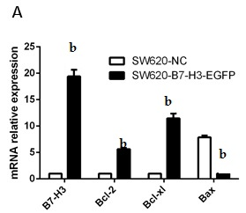

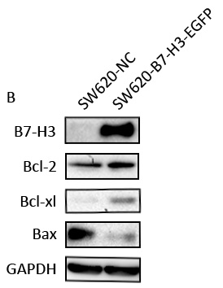
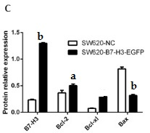
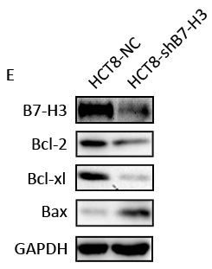
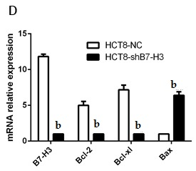

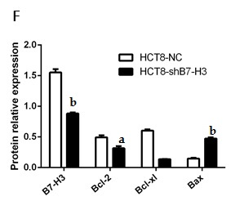

Figure 1 Overexpression of B7-H3 inhibited apoptosis. A: Real-time PCR for RNA levels of B7-H3, Bcl-2, Bcl-xl and Bax relative to β-actin in stably transfected SW620 cells: the control cells (SW620-NC) and the B7-H3 overexpressing cells (SW620-B7-H3-EGFP); B: Western blot analysis for B7-H3, Bcl-2, Bcl-xl, Bax and GAPDH protein levels in whole-cell lysates from the SW620 cells; C: Comparison of relative protein levels between the SW620 cells from (B); D: Real-time PCR for RNA levels of B7-H3, Bcl-2, Bcl-xl and Bax relative to β-actin in stably transfected HCT8 cell lines: the control cells (HCT8-NC) and the B7-H3 knockdown cells (HCT8-shB7-H3); E: Western blot analysis for B7-H3, Bcl-2, Bcl-xl, Bax and GAPDH protein levels in whole-cell lysates from the HCT8 cells; F: Comparison of relative protein levels between the HCT8 cells from (E). ªP < 0.05, ^{b}P < 0.01 vs control. Bax: Bcl-2-associated X protein; Bcl-2: B-cell CLL/lymphoma 2; Bcl-xl: B-cell lymphoma-extra large; NC: Negative control.

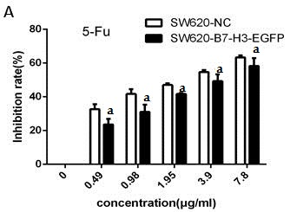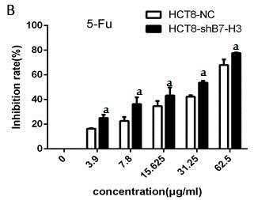
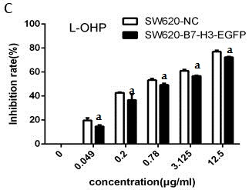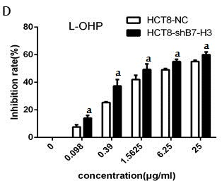
Figure 2 Overexpression of B7-H3 increased cell survival. Stably transfected SW620 and HCT8 cell lines were incubated with 5-Fu or L-OHP for 48 h. A CCK-8 assay was used to detect the inhibition rate of cells treated with different concentration of different drugs. A: The control cells (SW620-NC) and the B7-H3 overexpressing cells (SW620-B7-H3-EGFP) were incubated with 5-Fu; B: The control cells (HCT8-NC) and the B7-H3 knockdown cells (HCT8-shB7-H3) were incubated with 5-Fu; C: SW620-NC and SW620-B7-H3-EGFP were incubated with L-OHP; D: HCT8-NC and HCT8-shB7-H3 were incubated with L-OHP. ªP < 0.05 vs control. 5-Fu: 5-Fluorouracil; L-OHP: Oxaliplatin; NC: Negative control.

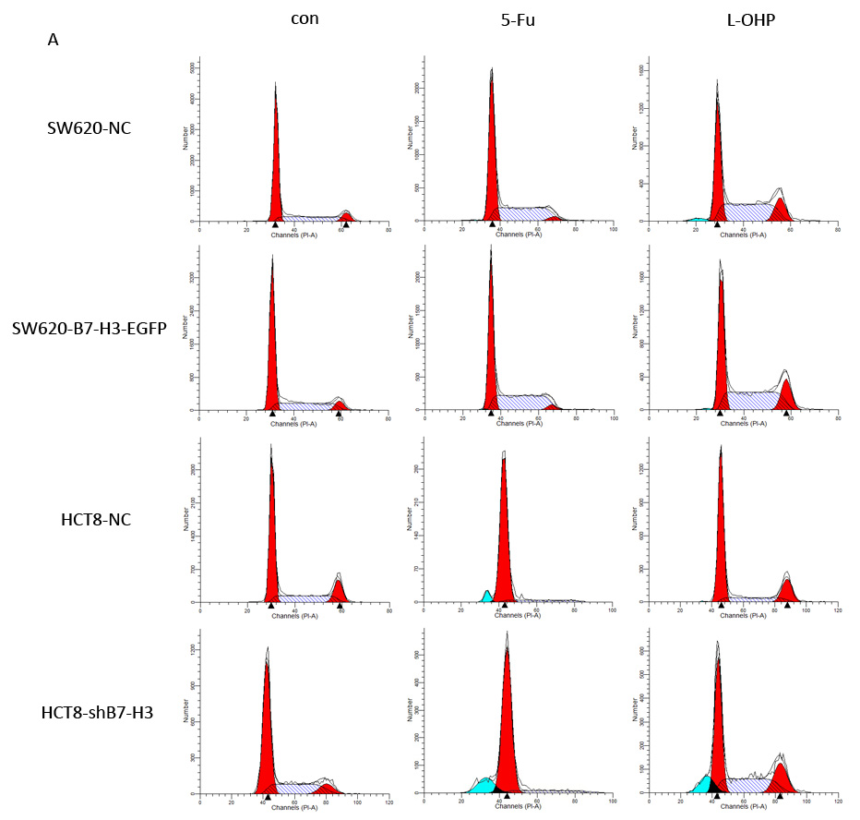
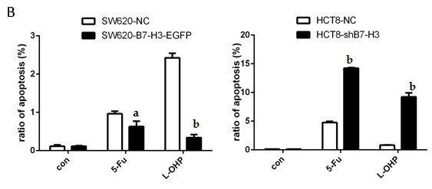

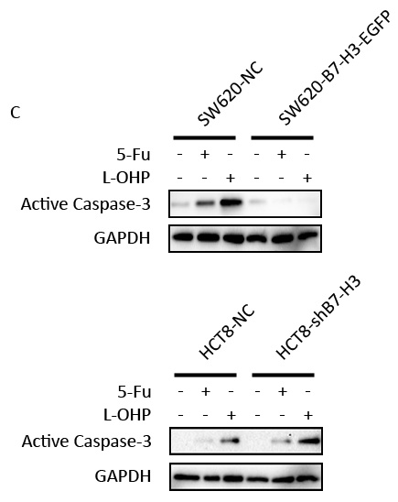

Figure 3 Overexpression of B7-H3 suppressed apoptosis in colorectal cancer cells by weakening the sensitivity to drugs. Stably transfected SW620 and HCT8 cell lines were incubated with a high concentration of 5-Fu or L-OHP (50μg/ml) for 48 h. A: The ratio of apoptosis was detected by cell cycle assay according to sub-G1 peak; B: Statistical results were used to analyze the rate of apoptosis from (A); C: Western blot analysis for Active Caspase-3 and GAPDH protein levels in whole-cell lysates from stably transfected SW620 and HCT8 cell lines. ªP < 0.05, ^{b}P < 0.01 vs control. 5-Fu: 5-Fluorouracil; L-OHP: Oxaliplatin.

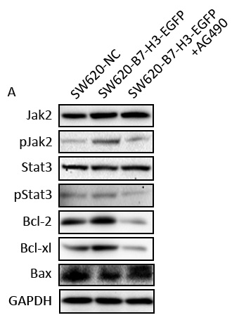
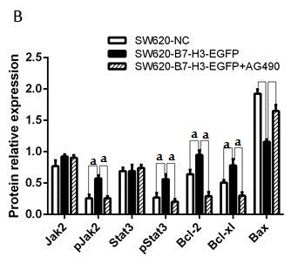

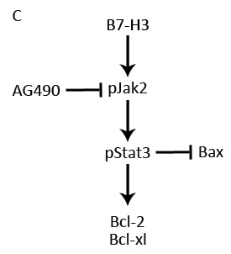

Figure 4 Overexpression of B7-H3 enhanced the anti-apoptotic effect in colorectal cancer cells via the activation of the Jak2-Stat3 pathway. A: Western blot analysis with the control cells (SW620-NC), the B7-H3 overexpressing cells (SW620-B7-H3-EGFP) and the AG490 treated B7-H3 overexpressing cells (SW620-B7-H3-EGFP+AG490) demonstrating the expression of Jak2-Stat3 pathway proteins and apoptosis regulator proteins; B: Comparison of relative protein levels from (A); C: A simple pathway map for B7-H3 regulation of the anti-apoptotic effect in CRC cells. ªP < 0.05 vs control. CRC: Colorectal cancer; Jak2: Janus kinase 2; NC: Negative control; STAT3: Signal transducer and activator of transcription 3.

