Name of Journal: World Journal of Gastrointestinal Oncology
Manuscript NO: 87941
Manuscript Type: ORIGINAL ARTICLE

Basic Study
Immune-related long noncoding RNA zinc finger protein 710-AS1-201 promotes the metastasis and invasion of gastric cancer cells

Ding W et al. ZNF710-AS1-201 promotes metastasis and invasion in GC

Wei Ding, Wei-Wei Chen, Yi-Qin Wang, Xue-Zhong Xu, Yi-Bo Wang, Yong-Min Yan, Yu-Lin Tan

Wei Ding, Wei-Wei Chen, Yi-Qin Wang, Xue-Zhong Xu, Yi-Bo Wang, Yu-Lin Tan, Department of General Surgery, Wujin Hospital Affiliated with Jiangsu University, Changzhou 213003, Jiangsu Province, China

Wei Ding, Yong-Min Yan, Changzhou Medical Center, Nanjing Medical University, Changzhou 213017, Jiangsu Province, China

Wei Ding, Yu-Lin Tan, Department of General Surgery, The Wujin Clinical College of Xuzhou Medical University, Changzhou 213003, Jiangsu Province, China

Author contributions: Ding W contributed to conceptualization; Chen WW and Wang YB contributed to methodology; Wang YQ contributed to validation; Wang YB contributed to formal analysis; Xu XZ contributed to resources; Ding W contributed to writing original draft preparation; Ding W and Tan YL contributed to writing-review and editing; Yan YM contributed to supervision; Tan YL contributed to project administration; Ding W and Tan YL contributed to funding acquisition; all authors contributed to the study and approved the submitted version of the manuscript.

Supported by Changzhou Sci and Tech Program, No. CJ20220008; Young Talent Development Plan of Changzhou Health Commission, No. CZQM2020118; Changzhou High-Level Medical Talents Training Project, No. 2022CZBJ105; Cultivation Project of Changzhou Medical Center, Nanjing Medical University, No. CMCB202211; and Development Foundation of Affiliated Hospital of Xuzhou Medical University, No. XYFC202304, and No. XYFM202307.

Corresponding author: Yu-Lin Tan, MMed, Chief Physician, Department of General Surgery, Wujin Hospital Affiliated with Jiangsu University, No. 2 Yongning Road, Changzhou 213003, Jiangsu Province, China. tanyldoctor@163.com

Received: September 4, 2023
Revised: December 2, 2023
Accepted: December 20, 2023
Published online: February 15, 2024

Abstract
BACKGROUND
Gastric cancer (GC) is a prevalent malignant tumor of the gastrointestinal system. ZNF710 is a transcription factor (TF), and zinc finger protein 710 (ZNF710)-AS1-201 is an immune-related long noncoding RNA (lncRNA) that is upregulated in GC cells.

AIM
To assess the correlation between ZNF710-AS1-201 and immune microenvironment features and to investigate the roles of ZNF710-AS1-201 in the invasion and metastasis processes of GC cells.

METHODS
We obtained data from The Cancer Genome Atlas and Wujin Hospital. We assessed cell growth, migration, invasion, and programmed cell death using cell counting kit-8, EdU, scratch, Transwell, and flow cytometry assays. Quantitative real-time polymerase chain reaction (qRT-PCR) was used to identify the potential downstream targets of ZNF710-AS1-201.

RESULTS
In GC tissues with low ZNF710-AS1-201 expression, immunoassays detected significant infiltration of various antitumor immune cells, such as memory CD8 T cells and activated CD4 T cells. In the low-expression group, the half-maximal inhibitory concentrations (IC₅₀s) of 5-fluorouracil, cisplatin, gemcitabine, and trametinib were lower, whereas the IC₅₀s of dasatinib and vorinostat were higher. The malignant degree of GC was higher and the stage was later in the high-expression group. Additionally, patients with high expression of ZNF710-AS1-201 had lower overall survival and disease-free survival rates. In vitro, the overexpression of ZNF710-AS1-201 greatly enhanced growth, metastasis, and infiltration while suppressing cell death in HGC-27 cells. In contrast, the reduced expression of ZNF710-AS1-201 greatly hindered cell growth, enhanced apoptosis, and suppressed the metastasis and invasion of MKN-45 cells. The expression changes in ZNF710 were significant, but the corresponding changes in isocitrate dehydrogenase-2, Semaphorin 4B, ARHGAP10, RGMB, hsa-miR-93-5p, and ZNF710-AS1-202 were not consistent or statistically significant after overexpression or knockdown of ZNF710-AS1-201, as determined by qRT-PCR.

CONCLUSION
Immune-related lncRNA ZNF710-AS1-201 facilitates the metastasis and invasion of GC cells. It appears that ZNF710-AS1-201 and ZNF710 have potential as effective targets for therapeutic intervention in GC. Nevertheless, it is still necessary to determine the specific targets of the ZNF710 TF.

Key Words: Gastric cancer; ZNF710-AS1-201; Proliferation; Metastasis; Invasion; Apoptosis

©The Author(s) 2024. Published by Baishideng Publishing Group Inc. All rights reserved.

Citation: Ding W, Chen WW, Wang YQ, Xu XZ, Wang YB, Yan YM, Tan YL. Immune-related long noncoding RNA zinc finger protein 710-AS1-201 promotes the metastasis and invasion of gastric cancer cells. World J Gastrointest Oncol 2023; 16(2): 458-474
URL: https://www.wjgnet.com/1948-5204/full/v16/i2/458.htm
DOI: https://dx.doi.org/10.4251/wjgo.v16.i2.458

Core Tip: In the field of oncology, there is significant interest in long noncoding RNAs (lncRNAs). They have a significant impact on the immune microenvironments of tumors and immunotherapy. In addition, lncRNAs regulate many crucial mechanisms of cancer immunity, including the presentation of antigens and the exhaustion of T cells. According to our prior investigation, the immune-associated lncRNA zinc finger protein 710 (ZNF710)-AS1-201 has the potential to function as an indicator of GC patient prognosis (recurrence, metastasis and survival). The primary focus of this study was to assess the correlation between ZNF710-AS1-201 and the immune microenvironment and to investigate the roles of ZNF710-AS1-201 in the cellular growth and metastasis processes within GC cells.

INTRODUCTION
Gastric cancer (GC) is a prevalent malignant tumor affecting the gastrointestinal tract. At present, surgical excision is the favored approach for treating stomach cancer^{[1]}. The prognosis of GC is mainly influenced by the recurrence and spread of the disease after surgery^{[2]}. To prevent the recurrence and spread of tumors after surgery, adjuvant chemotherapy, radiotherapy, targeted therapy, and immunotherapy are employed^{[3]}. The progression of GC is significantly influenced by recent advancements in comprehending the immune microenvironment^{[4]}. Compared to traditional chemotherapy and radiotherapy, immunotherapy is more effective and less toxic^{[5]}. The current methods of immunotherapy consist immune checkpoint inhibitors, adoptive cell therapy, vascular endothelial growth factor inhibitors, cancer vaccines, and chimeric antigen receptor T cell therapy^{[6]}. Immune checkpoint therapy has yielded surprising results^{[7]}. The related drugs include pembrolizumab, nivolumab, avelumab and so on^{[8]}. Nevertheless, the overall prognosis for advanced GC remains poor. Currently, there is a pressing requirement to identify additional, more efficient therapeutic targets.
In the field of oncology, there is a significant interest in long noncoding RNAs (lncRNAs). It has a significant impact on the immune microenvironments of tumors and immunotherapy^{[9,10]}. In addition, lncRNAs regulate many crucial mechanisms of cancer immunity, including the presentation of antigens and the exhaustion of T cells^{[11]}. According to our prior investigation, the immune-associated lncRNA zinc finger protein 710 (ZNF710)-AS1-201 has the potential to function as an indicator of patient prognosis (recurrence, metastasis and survival) in cases of GC^{[12]}. The study illustrated that patients with high ZNF710-AS1-201 expression in tumor tissues had poorer disease-free survival (DFS) than patients with low ZNF710-AS1-201 expression in both The Cancer Genome Atlas (TCGA) data and our data. ZNF710-AS1-201 is one of the transcripts of the ZNF710-AS1 gene, which acts as the opposite strand to ZNF710. The primary focus of this study was to assess the correlation between ZNF710-AS1-201 and the immune microenvironment and to investigate the roles of ZNF710-AS1-201 in the cellular growth and metastasis processes within GC cells.

MATERIALS AND METHODS
Data collection
The RNAseq data of all patients in the TCGA-stomach adenocarcinoma database for stomach cancer were acquired from The UCSC Xena website (https://xenabrowser.net/datapages/). To standardize the transcriptome sequencing data, the utilization of fragments per kilobase of transcript per million mapped reads was implemented. According to the median ZNF710-AS1-201 expression level, the patients were categorized into two groups: High expression (HExp) and low expression (LExp) groups.

Immune correlation analysis
To compare the infiltration of immune cells among each sample, we employed single-sample gene set enrichment analysis using the R package “GSVA (Ver.1.44.5)”^{[13]}. We acquired the feature genes of various immune cells from the TISIDB website (http://cis.hku.hk/TISIDB/). Additionally, we utilized the R package “estimate (Ver. 1.0.13)” to assess the stromal and immune cells within every sample, and a measurement was conducted. Wilcoxon analysis with the R package “stats (Ver. 4.2.0)” was utilized to compare the infiltration of various immune cells, including stromal and immune cells, as well as immune checkpoints, between the HExp and LExp groups.

Analysis of antitumor drug sensitivity
The R package “oncoPredict (Ver. 1.0.13)” was utilized to compute the half-maximal inhibitory concentrations (IC50s) of chemotherapy and targeted medications for every individual^{[14]}. We compared the IC₅₀s of 19 antitumor drugs (5-fluorouracil, afatinib, lapatinib, axitinib, cisplatin, crizotinib, dabrafenib, dasatinib, epirubicin, gefitinib, gemcitabine, irinotecan, lapatinib, nilotinib, oxaliplatin, paclitaxel, sorafenib, trametinib and vorinostat) between the HExp and LExp groups using Wilcoxon analysis.

Analysis of functional enrichment
The R package “limma (Ver. 1.3.54.2)” was used to screen for differentially expressed genes (DEGs) between the HExp and LExp groups, with a false discovery rate threshold (FDR) of less than 0.05 and a log2|fold change (FC)| greater than 1. Utilizing the R package “clusterProfiler (Ver. 4.4.4)” to assess these DEGs, we performed an enrichment analysis using Gene Ontology (GO) and Kyoto Encyclopedia of Genes and Genomes (KEGG) databases.

Patients and specimens
A total of 68 patients who underwent radical surgery for GC in Changzhou Wujin People’s Hospital were enrolled from January 2014 to November 2014. Below are the criteria for inclusion. First, the pathological diagnosis was gastric adenocarcinoma, and no distant metastasis was found on imaging. Second, none of the patients received preoperative chemotherapy or targeted therapy. Finally, all follow-up data were complete. Tumor and adjacent tissues were collected immediately after tumor isolation and stored in liquid nitrogen.

Cell culture
The HGC-27 (CL-0107) and MKN-45 (CL-0292) cell lines of GC, obtained from Procell Life Science and Technology Co. (Wuhan, China), were cultured in Roswell Park Memorial Institute (RPMI)-1640 medium (Procella, Wuhan, China) at 37 ℃ in a humid atmosphere consisting of 5% CO₂ and 95% air. RPMI-1640 contained 10% fetal bovine serum (FBS) (Procella, Wuhan, China) and 1% penicillin-streptomycin solution (Procell, Wuhan, China) as the medium.

Cell transfection
Yuanzi Biotech Co. (Shanghai, China) synthesized the overexpression and shRNA plasmids of ZNF710-AS1-201. The most efficient shRNA of the three was selected based on the experimental findings. For all cell transfections, Lipofectamine 3000 (Invitrogen, Carlsbad, CA, United States) was administered according to the instructions provided by Thermo Fisher for Lipofectamine 3000 Transfection Reagent.

Quantitative real-time polymerase chain reaction
TRIzol reagent (TaKaRa, Dalian, China) was used to extract RNA from HGC-27 and MKN-45 cells following the supplier's instructions, resulting in a total amount of RNA. The RNA sample was converted into complementary DNA using a kit from Moloney-murine leukemia virus (Promega Biotech, Beijing, China). To assess the RNA expression level in GC cells, SYBR Green Master Mix from Takara (Dalian, China) was utilized. Glyceraldehyde-3-phosphate dehydrogenase was employed as an endogenous control. The calculation of RNA expression was determined using the 2^{−ΔΔCT} approach. Table 1 displays the introductory details.

Assessment of cellular viability
The cell suspension (100 μL/well) was cultured in 96-well plates and incubated for 24, 48, and 72 h in the incubators. Next, we added 10 μL of cell counting kit-8 (CCK-8) (Beyotime, Shanghai, China) solution to every well. An enzyme label instrument (BioTek, Beijing, China) was used to measure the absorbance at 450 nm.

Assessment of cellular growth
The Cell-Light EdU Apollo567 In Vitro kit (RiboBio, China) was utilized to conduct EdU incorporation assays. The exponential increase was calculated for vascular smooth muscle cells plated in 96-well dishes at a density of 4 × 10³ cells per well. Following 24 h of the specified treatment, each well was exposed to 100 μL of 50 μM EdU medium for a duration of 2 h. Subsequently, the cells were immobilized in a PBS solution containing 4% paraformaldehyde for a period of 30 min. Next, a solution containing 2 milligrams per milliliter of glycine was introduced for a duration of 5 min. Following rinsing with phosphate buffered saline (PBS), the cells were subjected to an incubation period of 30 min with a 1 × Apollo staining solution. After discarding the staining solution, the cells were rinsed with PBS containing 0.5% Triton X-100 for 10 min. Following another round of washing with PBS, 1 × Hoechst 33342 was introduced and incubated at room temperature for 30 min. Following washing with PBS, fluorescence microscopy was used to observe the positive cells.

Cell apoptosis assay
The evaluation of cell apoptosis was conducted through a flow cytometry test (BD, New Jersey, United States). After being rinsed twice in PBS, the cells were then suspended in 1 × binding buffer. For the control group, 400 microliters of 1 × binding buffer was utilized, while for the remaining treatment groups, 100 microliters of 1 × binding buffer was employed. Then, 100 microliters was extracted from the aforementioned solution and transferred to the flow tube. Five microliters of Fluorescein isothiocyanate-Annexin V and five microliters of propidium iodide (at a concentration of 50 micrograms per milliliter) was added. The sample was left at room temperature (25 ℃) and away from light for a duration of 15 min. Next, 400 μL of 1 × binding buffer was added to each tube and mixed well. Analysis using flow cytometry was conducted within one hour. FlowJo software (BD, New Jersey, United States) was utilized to analyze the data.

Assays for cell metastasis
To evaluate the cell metastasis characteristics, a scratch assay was conducted in vitro by creating a linear scratch across the center of the layer of cultured cells. Pictures were captured at regular intervals (every 24 h), and the gathered data were utilized to analyze the experimental outcomes.

Cell invasion assays
The invasion of cells was observed by employing the Transwell assay with Transwell kits from Corning, United States. The Matrigel adhesive was melted overnight at a temperature of 4 ℃ and then mixed with the serum-free culture after dilution. The diluted Matrigel adhesive was applied onto the upper chamber and left in the incubator for 1-1.5 h until the adhesive hardened. After terminating digestion, the cells were centrifuged while waiting for the Matrigel gum to solidify. To adjust the cell density to 5 × 10⁵ cells/mL, the cells were suspended in medium that included 2% FBS. The upper chamber was inoculated with 200 μL of cell suspension, with 3 replicates per group. The lower chamber was supplemented with 800 μL of medium containing 20% FBS and cultured at 37 ℃ and 5% CO₂ for 48 h. After removing the chamber, the medium was discarded, and the chamber was washed twice with PBS. Then, the cells were fixed with 4% paraformaldehyde at room temperature for 30 min. The paraformaldehyde was disposed of and rinsed two times with PBS. After being thoroughly dried, the chamber was treated with crystal violet stain for 15 min. The excess crystal violet dye was washed away with PBS. A microscope (Olympus, Japan) was used to count the cells.

Assays for western blotting (WB)
WB was used to analyze the protein expression levels associated with apoptosis. Protein concentrations were measured with a bicinchoninic acid protein assay kit from Thermo, United States. Bax (Abcam, ab32503, 1:1000), Bcl2 (Abcam, ab182858, 1:2000), and β-actin (Affinity, AF7018, 1:3000) were left to react with the membrane overnight at 4 ℃. The blots were visualized using the Millipore Enterochromaffin-like detection system.

Statistical analysis
All analyses were conducted using GraphPad Prism (Version 9.4.1) and R (Version 4.2.0). Mean ± SD deviation values were used to present all continuous variable results. The t test was used if the variance was homogeneous, and the Mann-Whitney test was used if the variance was not homogeneous. Categorical variables were displayed using ratios. Differences between components were tested using chi-square tests. The grayscale values of bands on WB images were calculated using ImageJ from NIH (Bethesda, MD). The screening criteria for a significant difference were P < 0.05, P < 0.01, or P < 0.001.

RESULTS
ZNF710-AS1-201-associated immune microenvironment
To assess the relationship between ZNF710-AS1-200 and the immune microenvironment of GC patients, we analyzed the infiltration of immune cells in each sample. The findings demonstrated that the level of infiltration by central memory CD8 T cells, activated CD4 T cells, gamma delta T cells, type 17 T helper cells, CD56bright natural killer cells, CD56dim natural killer cells, and natural killer T cells was elevated in GC samples exhibiting reduced expression of ZNF710-AS1-201 (Figure 1A). Conversely, GC samples exhibiting high levels of ZNF710-AS1-201 displayed an increased infiltration level of effector memory CD4 T cells and memory B cells. Therefore, there was no significant variation in immune scores observed between the two groups exhibiting high or LExp (Figure 1B). Remarkably, the stromal scores was increased the high-expression cohort. Figure 1C demonstrates that B and T lymphocyte attenuator, butyrophilin-like 9, CD40LG, CD160, and tumor necrosis factor superfamily member 14 exhibited elevated levels of expression in GC samples with HExp of ZNF710-AS1-201. Conversely, PVR, HLA-DRB1, CD47, HLA-DMA, KIR2DL4, HAVCR2, HLA-DQB1, CD276, CD80, HLA-A, HLA-C, TNFRSF18, CD274, and CD86 displayed increased expression in GC samples with LExp of ZNF710-AS1-201.

Antitumor drug sensitivity analysis based on ZNF710-AS1-201 expression level
We additionally evaluated the correlation between the expression of ZNF710-AS1-201 and the responsiveness to antitumor drugs in GC. Figure 2 demonstrates that the IC₅₀s of 5-fluorouracil, cisplatin, gemcitabine, and trametinib were reduced in the low-expression group, whereas the IC₅₀s of dasatinib and vorinostat were elevated. The HExp and LExp groups showed no notable disparity in the IC₅₀s of other medications.

Functional enrichment analysis (FEA) based on ZNF710-AS1-201
Initially, we examined the disparity between the groups with high and LExp levels and identified 647 genes that exhibited differential expression (Supplementary Table 1). Then, we conducted FEA of these DEGs. In conclusion, KEGG analysis revealed significant enrichment in 28 mechanisms, whereas GO analysis showed significant enrichment in 565 functions (Figure 3). In the GO analysis, there was a significant enrichment of collagen-containing extracellular matrix, actin binding, G protein−coupled peptide receptor activity, ion channel activity, and others (Figure 3A). Significant enrichment of gastric acid secretion, chemical carcinogenesis-receptor activation, and other pathways was observed in the KEGG analysis (Figure 3B).

ZNF710-AS1-201 was closely related to GC
Clinical specimens were gathered to measure the expression level of ZNF710-AS1-201 in the samples. The findings indicated a notable increase in the expression level of ZNF710-AS1-201 in GC tissues compared to adjacent tissues (Figure 4A). Subsequently, we divided patients into high-expression and low-expression groups based on the expression level of ZNF710-AS1-201 in cancer tissues. The comparison of the clinicopathological features of patients between the low and HExp groups is shown in Table 2. The malignant degree of GC was higher and the stage was later in the high-expression group. Additionally, patients with HExp of ZNF710-AS1-201 had lower OS and DFS (Figure 4B and C). Consistent with this, the expression level of ZNF710-AS1-201 in GC cell lines (HGC-27, AGS, NCI-N87, and MKN-45) was elevated compared to that in the normal gastric mucosa cell line GES-1 (Figure 4D). To examine the biological role of ZNF710-AS1-201 in GC, HGC-27 cells were transfected with a plasmid overexpressing ZNF710-AS1-201 and an empty plasmid, while MKN-45 cells were transfected with a plasmid containing ZNF710-AS1-201 shRNA and an empty plasmid. The results demonstrated a significant increase in ZNF710-AS1-201 expression following the transfection of ZNF710-AS1-201 mimic in HGC-27 cells. Conversely, in MKN-45 cells, ZNF710-AS1-201 expression was markedly decreased upon transfection with ZNF710-AS1-201 shRNA (Figure 4E and F).

ZNF710-AS1-201 promoted GC cell viability and proliferation
Cell viability was assessed using the CCK-8 assay. After 24 h, 48 h, and 72 h of transfection with the ZNF710-AS1-201 overexpression plasmid, the viability of HGC-27 cells was significantly increased (Figure 5A). The viability of MKN-45 cells decreased when transfected with ZNF710-AS1-201 shRNA plasmid for 24, 48, and 72 h (Figure 5A). Furthermore, the EdU assay was utilized to assess cellular proliferation. The proliferation of HGC-27 cells was enhanced following transfection of the plasmid overexpressing ZNF710-AS1-201 for 72 h (Figure 5B). The growth rate of MKN-45 cells decreased after treatment with the ZNF710-AS1-201 shRNA plasmid for 72 h (Figure 5B).

ZNF710-AS1-201 inhibited GC cell apoptosis
The quantification of proteins related to apoptosis and the assessment of cell apoptosis were conducted using qRT-PCR, western blot, and flow cytometry. qRT-PCR and Western blot analysis revealed that ZNF710-AS1-201 overexpression in HGC-27 cells significantly decreased the expression of Bax and increased the expression of Bcl-2 (Figure 6A and B). In contrast, ZNF710-AS1-201 knockdown in MKN-45 cells led to an increase in Bax levels and a decrease in Bcl-2 levels (Figure 6A and B). The flow cytometry assay results showed that the overexpression of ZNF710-AS1-200 significantly reduced HGC-27 cell apoptosis after 24 h, 48 h, and 72 h (Figure 6C). In contrast, knockdown of ZNF710-AS1-201 significantly enhanced MKN-45 cell apoptosis at 48 h and 72 h (Figure 6D).

ZNF710-AS1-201 facilitated GC cell metastasis and invasion.
The study utilized the scratch assay to measure cell metastasis. The findings indicated that the overexpression of ZNF710-AS1-201 significantly enhanced the metastasis of HGC-27 cells after 48 and 72 h (Figure 7A). In contrast, the knockdown of ZNF710-AS1-201 significantly inhibited the metastasis of MKN-45 cells at 48 h and 72 h (Figure 7B). The study utilized the transwell assay to quantify cell invasion. The findings indicated that the overexpression of ZNF710-AS1-201 significantly enhanced HGC-27 cell invasion after 72 h (Figure 7C). In contrast, the invasion of MKN-45 cells was significantly inhibited by knockdown of ZNF710-AS1-201 for 72 h (Figure 7C).

Downstream target prediction
After conducting a thorough search in the StarBase database (https//starbase.sysu.edu.cn/), we identified the potential targets [ZNF710, isocitrate dehydrogenase-2 (IDH2), Semaphorin 4B (SEMA4B), ARHGAP10, RGMB, hsa-miR-93-5p, and ZNF710-AS1-202] for ZNF710-AS1-201. Additionally, we employed qRT-PCR to analyze the expression levels of these potential targets following cell transfection. The findings indicated that after overexpressing ZNF710-AS1-201 in HGC-27 cells, there were no significant changes observed in the expression levels of IDH2 and miR-93-5p. Moreover, in MKN-45 cells with decreased expression of ZNF710-AS1-201, the expression levels of SEMA4B, ARHGAP10, and ZNF710-AS1-202 also showed no significant changes. Additionally, whether ZNF710-AS1-202 was overexpressed or knocked down in GC cells, there was a consistent decrease in the expression levels of RGMB. However, the only expression change that was statistically significant and logically coherent was that for ZNF710 (Figure 8A and B).

DISCUSSION
This study focused on examining the contribution of ZNF710-AS1-201, an immune-related lncRNA, in facilitating the advancement and spread of GC. In line with prior research, GC tissues with low levels of ZNF710-AS1-201 exhibited significant infiltration of various antitumor immune cells^{[15-18]}, such as memory CD8 T cells, activated CD4 T cells, tumor-infiltrating gamma delta T cells, natural killer cells, and natural killer T cells. Furthermore, there was a significant presence of memory B cells in GC tissues exhibiting elevated levels of ZNF710-AS1-201 expression. These findings align with the outcomes of prior research indicating that memory B cells have the potential to facilitate the development of cancer^{[19]}. Nevertheless, the recruitment and activation of these immune cells by ZNF710-AS1-201 are still uncertain. While the ESTIMATE scores of GC samples with elevated expression of ZNF710-AS1-201 were greater than those of samples with LExp, the observed disparity did not reach statistical significance. In contrast, the HExp group exhibited a considerably elevated stromal score. The reason for this could be an escalation in the remodeling of the extracellular matrix, which has the potential to stimulate the growth of tumors, their spread to other parts of the body, and the formation of new blood vessels^{[20]}.
Chemotherapy, targeted therapy, and immunotherapy are the present methods used for conservatively treating advanced GC^{[21]}. By analyzing immune checkpoints and drug sensitivity, we have the ability to choose drugs that exhibit high sensitivity and immunotherapies targeting highly expressed immune checkpoints. Currently, the first-line chemotherapy treatment for GC is the combination of cisplatin and 5-fluorouracil^{[22]}. The survival of patients with human epidermal growth factor receptor 2-positive GC is improved by adding trastuzumab to the initial chemotherapy^{[23]}. Furthermore, pembrolizumab, an immune checkpoint inhibitor, has been authorized in various contexts based on the presence of programmed death ligand 1^{[24]}. According to prior studies, axitinib exhibited strong antineoplastic effects on human GC, either by itself or when combined with 5-fluorouracil or cisplatin^{[25]}. Considering these results and those of our study, the combination of axitinib and 5-fluorouracil may demonstrate enhanced antitumor impacts in individuals exhibiting elevated ZNF710-AS1-201 expression.
Based on the enrichment analysis, we identified several biological processes and mechanisms that are associated with tumors, such as collagen-containing extracellular matrix, actin binding, G protein-coupled peptide receptor activity and ion channel activity. According to the study conducted by Chen et al^{[26]}, the presence of collagen in the tumor microenvironment is an independent predictor of lymphatic metastasis in early GC. Jia et al^{[27]} discovered that Anillin, a protein that binds to actin, facilitated the advancement of GC both in laboratory settings and in mice. Yan et al^{[28]} demonstrated that the abnormal activation of G-protein-coupled receptors stimulated the growth and spread of GC cells, altered the tumor microenvironment, and enhanced immune evasion^{[28]}. In GC, Chen et al^{[29]} observed modified expression and/or malfunction of ion channels/transporters, which is believed to have a significant impact on tumor cell proliferation, metastasis, invasion, and apoptosis. In summary, ZNF710-AS1-201 might exert its influence on GC via these pathways, thereby facilitating the onset and progression of GC.
In a recent study, Li and colleagues found that ZNF710-AS1-202 played a role in enhancing cell growth and suppressing cell death in clear cell renal cell carcinoma through the reverse regulation of ZNF710^{[30]}. Nevertheless, there is no existing report on the regulatory impact of ZNF710-AS1-201 on tumors. The current research examined the influence of ZNF710-AS1-201 on the promotion of tumors in GC. In HGC-27 cells, we observed that the upregulation of ZNF710-AS1-201 stimulated cell growth, hindered cell death, and enhanced cell metastasis and infiltration. Conversely, in MKN-45 cells, the downregulation of ZNF710-AS1-201 suppressed cell proliferation, promoted cell death, and impeded cell metastasis and invasion.
qRT-PCR was used to validate possible targets for ZNF710-AS1-201. IDH2, also known as isocitrate dehydrogenase 2, is an isocitrate dehydrogenase that relies on NADP and is located in the mitochondria. Through inhibition of matrix metalloproteinase 7, it has been discovered to impede the invasion of GC cells^{[31]}. However, a significant reduction in IDH2 mRNA expression after ZNF710-AS1-201 overexpression appeared in MKN-45 cells. ARHGAP10 can promote gastric tumor metastasis^{[32]}. Nonetheless, the upregulation of ZNF710-AS1-201 suppressed the expression of ARHGAP10 mRNA in HGC-27 cells. In their study, Jian and colleagues demonstrated that the invasion of non-small cell lung cancer was hindered by SEMA4B through the suppression of matrix metallopeptidase 9 activation, which was dependent on phosphoinositide 3-kinase^{[33]}. According to the study conducted by Li et al^{[34]}, the overexpression of miR-93-5p was found to enhance the growth, movement, infiltration, and resistance to chemotherapy in SGC-7901 cells. In line with these perspectives, the mRNA expression of SEMA4B was inhibited when ZNF710-AS1-201 was overexpressed in HGC-27 cells, whereas the expression of miR-93-5p was enhanced when ZNF710-AS1-201 was knocked down in MKN-45 cells. Further investigation is needed to explore the role of these genes in GC, even though they might be controlled by ZNF710-AS1-201.
ZNF710-AS1-201 had a negative regulatory effect on the expression level of ZNF710 in both HGC-27 and MKN-45 cells. However, this result only showed that ZNF710 is negatively regulated by ZNF710-AS1-201. The function of ZNF710 in GC is currently not understood. ZNF710, as stated in the UniProt repository, is a transcription factor (TF)/cofactor of the Kruppel Cys2-His2-type zinc-finger protein^{[35]}. ZNF710 may function as a TF to regulate the occurrence and development of GC. TFs are key factors in gene regulation^{[36]}. TFs can regulate the migration of tumor cells through specific signaling pathways^{[37]}. In their study, Guo and colleagues discovered that the TF RUNX2 stimulated the yes-associated protein 1 signaling pathway, contributing to the development of GC^{[38]}. In their study, Zhao and colleagues found that the growth and metastasis of GC cells were suppressed by the TF kruppel-like factor 15 through the regulation of the TFAP2A-AS1/Neonatal Ichthyosis Sclerosing Cholangitis axis^{[39]}. This demonstrated that transcription regulators had a controlling function in the metastasis and invasion of stomach cancer.

CONCLUSION
The findings from this study indicate that ZNF710-AS1-201 facilitated growth, metastasis and invasion while suppressing cell death in GC cells. These findings suggest that ZNF710-AS1-201 and ZNF710 have potential as effective targets for therapeutic intervention in GC. Nevertheless, these findings have not been observed in living organisms. Furthermore, rescue experiments are needed to demonstrate the interaction mechanism between ZNF710-AS1-201 and ZNF710. Moreover, it is still necessary to determine the specific targets of the ZNF710 TF.

ARTICLE HIGHLIGHTS
Research background
Gastric cancer (GC) is a prevalent malignant tumor of the gastrointestinal system. ZNF710 is a transcription factor, and ZNF710-AS1-201 is an immune-related long noncoding RNA (lncRNA) that is upregulated in GC cells.

Research motivation
The research is motivated by the pressing challenges posed by GC and the need for a deeper understanding of its underlying molecular mechanisms. Specifically, investigating the functional role of lncRNA ZNF710-AS1-201 and exploring the dynamics of the immune microenvironment are crucial for unraveling the complexities of GC progression. The study aims to contribute valuable insights that may have implications for precision therapy approaches in addressing this formidable disease.

Research objectives
The primary objectives of this research are to elucidate the functional significance of lncRNA ZNF710-AS1-201 in GC, analyze its impact on cellular processes and pathways, investigate its potential as a biomarker, and comprehensively characterize the immune microenvironment in GC tissues. By achieving these objectives, the study aims to provide a foundation for developing targeted therapeutic strategies, advancing our understanding of GC pathogenesis, and contributing to the broader field of cancer research.

Research methods
This research employed a multidisciplinary approach, integrating molecular biology techniques, bioinformatics analyses, and in vitro experiments. The study involved the profiling of lncRNA ZNF710-AS1-201 expression in GC tissues, functional assays to assess its impact on cell behavior, and bioinformatics tools to unravel potential interacting pathways. Additionally, immune microenvironment analysis was conducted to explore the relationship between lncRNA expression and immune responses in GC. These methods collectively provided a comprehensive platform for investigating the role of ZNF710-AS1-201 in GC progression.

Research results
The research revealed a significant upregulation of lncRNA ZNF710-AS1-201 in GC tissues compared to adjacent normal tissues. Functional assays demonstrated that ZNF710-AS1-201 overexpression promoted cell proliferation, migration, and invasion, suggesting its potential oncogenic role. Bioinformatics analyses unveiled the involvement of ZNF710-AS1-201 in key cancer-related pathways. Moreover, immune microenvironment analysis indicated a correlation between ZNF710-AS1-201 expression and immune cell infiltration, providing insights into its potential influence on the tumor immune response in GC.

Research conclusions
In conclusion, this study elucidates the crucial role of lncRNA ZNF710-AS1-201 in GC progression, highlighting its potential as a diagnostic and therapeutic target. The findings underscore the significance of ZNF710-AS1-201 in modulating cellular processes and its association with cancer-related pathways. Furthermore, insights into the immune microenvironment suggest its impact on the tumor immune response. Overall, these results contribute to our understanding of the molecular mechanisms underlying GC and open avenues for future research and targeted therapeutic interventions.

Research perspectives
The study opens new perspectives for further investigation into the intricate mechanisms of lncRNA ZNF710-AS1-201 in GC. Future research should explore its potential as a biomarker for early diagnosis and prognosis. Additionally, understanding its interactions within the tumor microenvironment and elucidating its role in therapeutic resistance could pave the way for innovative treatment strategies. Collaborative efforts integrating multi-omics approaches may provide a comprehensive view of ZNF710-AS1-201’s involvement in GC, offering valuable insights for precision medicine and targeted therapies.

ACKNOWLEDGEMENTS
The authors would like to acknowledge Professor Li Yang for guidance and support.

REFERENCES
1 Sun H, Wang H, Pan H, Zuo Y, Zhao R, Huang R, Xue Y, Song H. CD19 (+) B Cell Combined with Prognostic Nutritional Index Predicts the Clinical Outcomes of Patients with Gastric Cancer Who Underwent Surgery. Cancers (Basel) 2023; 15 [PMID: 37173997 DOI: 10.3390/cancers15092531]
2 Zhang T, Wang B, Su F, Gu B, Xiang L, Gao L, Zheng P, Li XM, Chen H. TCF7L2 promotes anoikis resistance and metastasis of gastric cancer by transcriptionally activating PLAUR. Int J Biol Sci 2022; 18: 4560-4577 [PMID: 35864968 DOI: 10.7150/ijbs.69933]
3 Joshi SS, Badgwell BD. Current treatment and recent progress in gastric cancer. CA Cancer J Clin 2021; 71: 264-279 [PMID: 33592120 DOI: 10.3322/caac.21657]
4 Chen Y, Jia K, Sun Y, Zhang C, Li Y, Zhang L, Chen Z, Zhang J, Hu Y, Yuan J, Zhao X, Li Y, Gong J, Dong B, Zhang X, Li J, Shen L. Predicting response to immunotherapy in gastric cancer via multi-dimensional analyses of the tumour immune microenvironment. Nat Commun 2022; 13: 4851 [PMID: 35982052 DOI: 10.1038/s41467-022-32570-z]
5 Xiang Y, Gong M, Deng Y, Wang H, Ye D. T cell effects and mechanisms in immunotherapy of head and neck tumors. Cell Commun Signal 2023; 21: 49 [PMID: 36872320 DOI: 10.1186/s12964-023-01070-y]
6 Jin X, Liu Z, Yang D, Yin K, Chang X. Recent Progress and Future Perspectives of Immunotherapy in Advanced Gastric Cancer. Front Immunol 2022; 13: 948647 [PMID: 35844558 DOI: 10.3389/fimmu.2022.948647]
7 Li K, Zhang A, Li X, Zhang H, Zhao L. Advances in clinical immunotherapy for gastric cancer. Biochim Biophys Acta Rev Cancer 2021; 1876: 188615 [PMID: 34403771 DOI: 10.1016/j.bbcan.2021.188615]
8 Bang YJ, Ruiz EY, Van Cutsem E, Lee KW, Wyrwicz L, Schenker M, Alsina M, Ryu MH, Chung HC, Evesque L, Al-Batran SE, Park SH, Lichinitser M, Boku N, Moehler MH, Hong J, Xiong H, Hallwachs R, Conti I, Taieb J. Phase III, randomised trial of avelumab vs physician's choice of chemotherapy as third-line treatment of patients with advanced gastric or gastro-oesophageal junction cancer: primary analysis of JAVELIN Gastric 300. Ann Oncol 2018; 29: 2052-2060 [PMID: 30052729 DOI: 10.1093/annonc/mdy264]
9 Chen L, Deng J. Role of non-coding RNA in immune microenvironment and anticancer therapy of gastric cancer. J Mol Med (Berl) 2022; 100: 1703-1719 [PMID: 36329206 DOI: 10.1007/s00109-022-02264-6]
10 Park EG, Pyo SJ, Cui Y, Yoon SH, Nam JW. Tumor immune microenvironment lncRNAs. Brief Bioinform 2022; 23 [PMID: 34891154 DOI: 10.1093/bib/bbab504]
11 Wu M, Fu P, Qu L, Liu J, Lin A. Long Noncoding RNAs, New Critical Regulators in Cancer Immunity. Front Oncol 2020; 10: 550987 [PMID: 33194608 DOI: 10.3389/fonc.2020.550987]
12 Ding W, Sun P, Tan Y, Jiang H, Xi C, Zhuang L, Xu Y, Xu X. Construction of a Prognostic Immune-Related LncRNA Risk Model for Gastric Cancer. J Oncol 2022; 2022: 5137627 [PMID: 35794986 DOI: 10.1155/2022/5137627]
13 Hänzelmann S, Castelo R, Guinney J. GSVA: gene set variation analysis for microarray and RNA-seq data. BMC Bioinformatics 2013; 14: 7 [PMID: 23323831 DOI: 10.1186/1471-2105-14-7]
14 Maeser D, Gruener RF, Huang RS. oncoPredict: an R package for predicting in vivo or cancer patient drug response and biomarkers from cell line screening data. Brief Bioinform 2021; 22 [PMID: 34260682 DOI: 10.1093/bib/bbab260]
15 Han J, Khatwani N, Searles TG, Turk MJ, Angeles CV. Memory CD8(+) T cell responses to cancer. Semin Immunol 2020; 49: 101435 [PMID: 33272898 DOI: 10.1016/j.smim.2020.101435]
16 Borst J, Ahrends T, Bąbała N, Melief CJM, Kastenmüller W. CD4(+) T cell help in cancer immunology and immunotherapy. Nat Rev Immunol 2018; 18: 635-647 [PMID: 30057419 DOI: 10.1038/s41577-018-0044-0]
17 Saura-Esteller J, de Jong M, King LA, Ensing E, Winograd B, de Gruijl TD, Parren PWHI, van der Vliet HJ. Gamma Delta T-Cell Based Cancer Immunotherapy: Past-Present-Future. Front Immunol 2022; 13: 915837 [PMID: 35784326 DOI: 10.3389/fimmu.2022.915837]
18 Kucuksezer UC, Aktas Cetin E, Esen F, Tahrali I, Akdeniz N, Gelmez MY, Deniz G. The Role of Natural Killer Cells in Autoimmune Diseases. Front Immunol 2021; 12: 622306 [PMID: 33717125 DOI: 10.3389/fimmu.2021.622306]
19 Downs-Canner SM, Meier J, Vincent BG, Serody JS. B Cell Function in the Tumor Microenvironment. Annu Rev Immunol 2022; 40: 169-193 [PMID: 35044794 DOI: 10.1146/annurev-immunol-101220-015603]
20 Oya Y, Hayakawa Y, Koike K. Tumor microenvironment in gastric cancers. Cancer Sci 2020; 111: 2696-2707 [PMID: 32519436 DOI: 10.1111/cas.14521]
21 Nakamura Y, Kawazoe A, Lordick F, Janjigian YY, Shitara K. Biomarker-targeted therapies for advanced-stage gastric and gastro-oesophageal junction cancers: an emerging paradigm. Nat Rev Clin Oncol 2021; 18: 473-487 [PMID: 33790428 DOI: 10.1038/s41571-021-00492-2]
22 Wang FH, Zhang XT, Li YF, Tang L, Qu XJ, Ying JE, Zhang J, Sun LY, Lin RB, Qiu H, Wang C, Qiu MZ, Cai MY, Wu Q, Liu H, Guan WL, Zhou AP, Zhang YJ, Liu TS, Bi F, Yuan XL, Rao SX, Xin Y, Sheng WQ, Xu HM, Li GX, Ji JF, Zhou ZW, Liang H, Zhang YQ, Jin J, Shen L, Li J, Xu RH. The Chinese Society of Clinical Oncology (CSCO): Clinical guidelines for the diagnosis and treatment of gastric cancer, 2021. Cancer Commun (Lond) 2021; 41: 747-795 [PMID: 34197702 DOI: 10.1002/cac2.12193]
23 Shitara K, Bang YJ, Iwasa S, Sugimoto N, Ryu MH, Sakai D, Chung HC, Kawakami H, Yabusaki H, Lee J, Saito K, Kawaguchi Y, Kamio T, Kojima A, Sugihara M, Yamaguchi K; DESTINY-Gastric01 Investigators. Trastuzumab Deruxtecan in Previously Treated HER2-Positive Gastric Cancer. N Engl J Med 2020; 382: 2419-2430 [PMID: 32469182 DOI: 10.1056/NEJMoa2004413]
24 Patel TH, Cecchini M. Targeted Therapies in Advanced Gastric Cancer. Curr Treat Options Oncol 2020; 21: 70 [PMID: 32725377 DOI: 10.1007/s11864-020-00774-4]
25 He Q, Gao J, Ge S, Wang T, Li Y, Peng Z, Li Y, Shen L. Axitinib alone or in combination with chemotherapeutic drugs exerts potent antitumor activity against human gastric cancer cells in vitro and in vivo. J Cancer Res Clin Oncol 2014; 140: 1575-1583 [PMID: 24804814 DOI: 10.1007/s00432-014-1693-4]
26 Chen D, Chen G, Jiang W, Fu M, Liu W, Sui J, Xu S, Liu Z, Zheng X, Chi L, Lin D, Li K, Chen W, Zuo N, Lu J, Chen J, Li G, Zhuo S, Yan J. Association of the Collagen Signature in the Tumor Microenvironment With Lymph Node Metastasis in Early Gastric Cancer. JAMA Surg 2019; 154: e185249 [PMID: 30698615 DOI: 10.1001/jamasurg.2018.5249]
27 Jia H, Yu F, Li B, Gao Z. Actin-binding protein Anillin promotes the progression of gastric cancer in vitro and in mice. J Clin Lab Anal 2021; 35: e23635 [PMID: 33089886 DOI: 10.1002/jcla.23635]
28 Yan H, Zhang JL, Leung KT, Lo KW, Yu J, To KF, Kang W. An Update of G-Protein-Coupled Receptor Signaling and Its Deregulation in Gastric Carcinogenesis. Cancers (Basel) 2023; 15 [PMID: 36765694 DOI: 10.3390/cancers15030736]
29 Chen J, Zhang M, Ma Z, Yuan D, Zhu J, Tuo B, Li T, Liu X. Alteration and dysfunction of ion channels/transporters in a hypoxic microenvironment results in the development and progression of gastric cancer. Cell Oncol (Dordr) 2021; 44: 739-749 [PMID: 33856653 DOI: 10.1007/s13402-021-00604-1]
30 Li G, Xie M, Huang Z, Li H, Li P, Zhang Z, Ding Y, Jia Z, Yang J. Overexpression of antisense long non-coding RNA ZNF710-AS1-202 promotes cell proliferation and inhibits apoptosis of clear cell renal cell carcinoma via regulation of ZNF710 expression. Mol Med Rep 2020; 21: 2502-2512 [PMID: 32236626 DOI: 10.3892/mmr.2020.11032]
31 Wu D. Isocitrate dehydrogenase 2 inhibits gastric cancer cell invasion via matrix metalloproteinase 7. Tumour Biol 2016; 37: 5225-5230 [PMID: 26553362 DOI: 10.1007/s13277-015-4358-2]
32 Wang Z, Yao L, Li Y, Hao B, Wang M, Wang J, Gu W, Zhan H, Liu G, Wu Q. miR-337-3p inhibits gastric tumor metastasis by targeting ARHGAP10. Mol Med Rep 2020; 21: 705-719 [PMID: 31789419 DOI: 10.3892/mmr.2019.10856]
33 Jian H, Zhao Y, Liu B, Lu S. SEMA4B inhibits growth of non-small cell lung cancer in vitro and in vivo. Cell Signal 2015; 27: 1208-1213 [PMID: 25746385 DOI: 10.1016/j.cellsig.2015.02.027]
34 Li L, Zhao J, Huang S, Wang Y, Zhu L, Cao Y, Xiong J, Deng J. MiR-93-5p promotes gastric cancer-cell progression via inactivation of the Hippo signaling pathway. Gene 2018; 641: 240-247 [PMID: 29045821 DOI: 10.1016/j.gene.2017.09.071]
35 UniProt Consortium. UniProt: a worldwide hub of protein knowledge. Nucleic Acids Res 2019; 47: D506-D515 [PMID: 30395287 DOI: 10.1093/nar/gky1049]
36 Long P, Zhang L, Huang B, Chen Q, Liu H. Integrating genome sequence and structural data for statistical learning to predict transcription factor binding sites. Nucleic Acids Res 2020; 48: 12604-12617 [PMID: 33264415 DOI: 10.1093/nar/gkaa1134]
37 Hamidi AA, Taghehchian N, Basirat Z, Zangouei AS, Moghbeli M. MicroRNAs as the critical regulators of cell migration and invasion in thyroid cancer. Biomark Res 2022; 10: 40 [PMID: 35659780 DOI: 10.1186/s40364-022-00382-4]
38 Guo Z, Zhou K, Wang Q, Huang Y, Ji J, Peng Y, Zhang X, Zheng T, Zhang Z, Chong D, Yang Z. The transcription factor RUNX2 fuels YAP1 signaling and gastric cancer tumorigenesis. Cancer Sci 2021; 112: 3533-3544 [PMID: 34160112 DOI: 10.1111/cas.15045]
39 Zhao X, Chen L, Wu J, You J, Hong Q, Ye F. Transcription factor KLF15 inhibits the proliferation and migration of gastric cancer cells via regulating the TFAP2A-AS1/NISCH axis. Biol Direct 2021; 16: 21 [PMID: 34727954 DOI: 10.1186/s13062-021-00300-y]

Footnotes
Institutional review board statement: The study was reviewed and approved by the Institutional Review Board at Wujin Hospital affiliated with Jiangsu University approved this study.

Institutional animal care and use committee statement: All procedures involving animals were reviewed and approved by the Institutional Animal Care and Use Committee of the Wujin Hospital affiliated with Jiangsu University.

Conflict-of-interest statement: All other authors have nothing to disclose.

Data sharing statement: No additional data are available.

ARRIVE guidelines statement: The authors have read the ARRIVE guidelines, and the manuscript was prepared and revised according to the ARRIVE guidelines.

Open-Access: This article is an open-access article that was selected by an in-house editor and fully peer-reviewed by external reviewers. It is distributed in accordance with the Creative Commons Attribution NonCommercial (CC BY-NC 4.0) license, which permits others to distribute, remix, adapt, build upon this work non-commercially, and license their derivative works on different terms, provided the original work is properly cited and the use is non-commercial. See: https://creativecommons.org/Licenses/by-nc/4.0/

Provenance and peer review: Unsolicited article; Externally peer reviewed.

Peer-review model: Single blind

Peer-review started: September 4, 2023
First decision: November 22, 2023
Article in press: December 20, 2023

Specialty type: Oncology
Country/Territory of origin: China
Peer-review report’s scientific quality classification
Grade A (Excellent): 0
Grade B (Very good): B
Grade C (Good): C, C
Grade D (Fair): 0
Grade E (Poor): 0

P-Reviewer: Plaza MA, Spain; Watanabe T, Japan S-Editor: Qu XL L-Editor: A P-Editor: Cai YX

Figure Legends
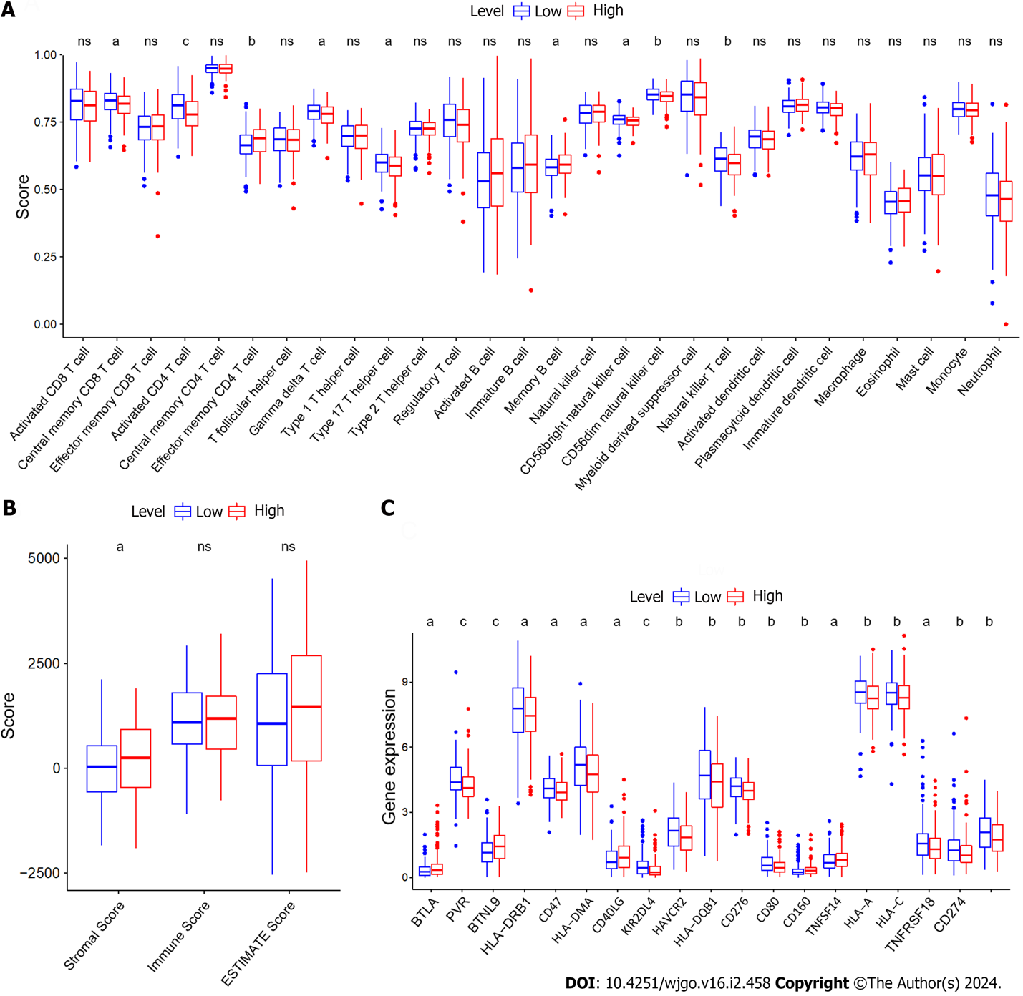
Figure 1 Immune correlation analysis of zinc finger protein 710-AS1-201. A: The infiltration levels of 28 immune cells in the high and low expression (LExp) groups; B: The stromal score, immune score, and ESTIMATE score in the high and LExp groups; C: The expression levels of 19 immune checkpoints in the high and LExp groups. ªP < 0.05; ^{b}P < 0.01; ^{c}P < 0.001; ns: Not significant.
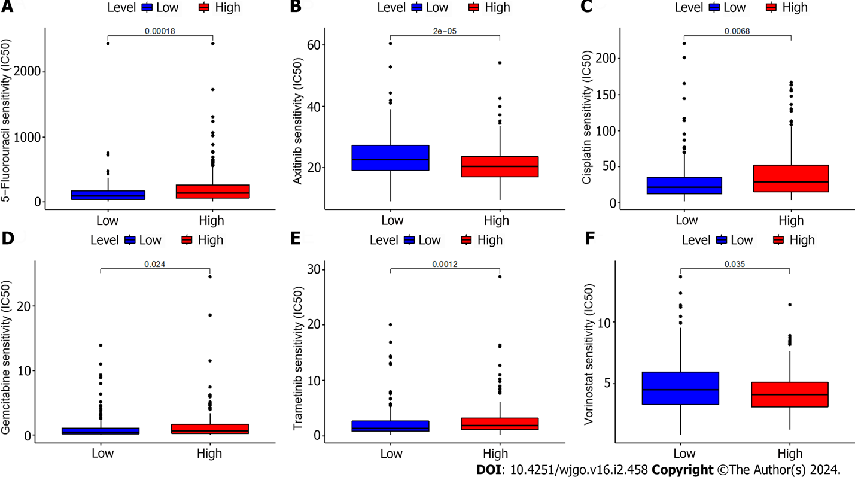
Figure 2 Sensitivity to different antitumor drugs in the high and low expression groups. A: Half-maximal inhibitory concentrations (IC₅₀s) of 5-fluorouracil; B: IC₅₀s of axitinib; C: IC₅₀s of cisplatin; D: IC₅₀s of gemcitabine; E: IC₅₀s of trametinib; F: IC₅₀s of vorinostat. IC₅₀s: Half-maximal inhibitory concentrations.
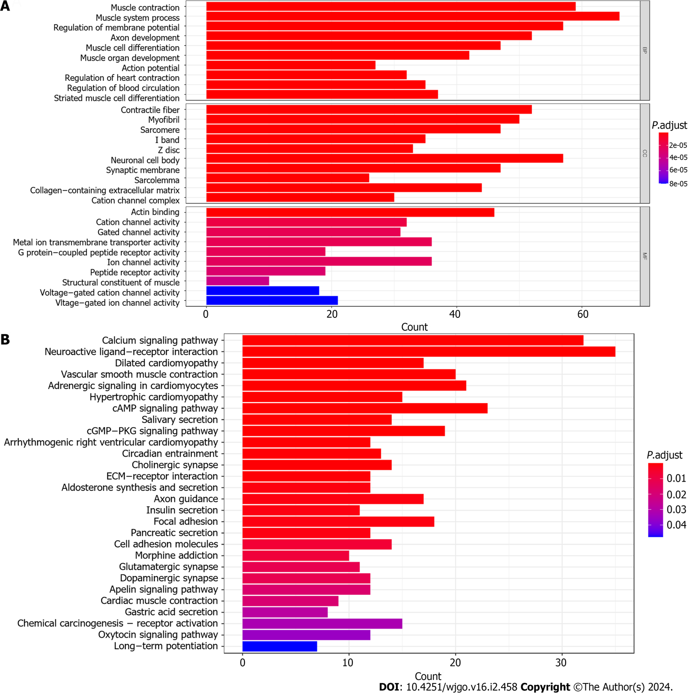
Figure 3 Gene ontology and kyoto encyclopedia of genes and genomes analysis of zinc finger protein 710-AS1-201. A: Gene ontology assessment of differentially expressed genes (DEGs) between the high and low expression (LExp) groups; B: Kyoto encyclopedia of genes and genomes evaluation of DEGs between the high and LExp groups..
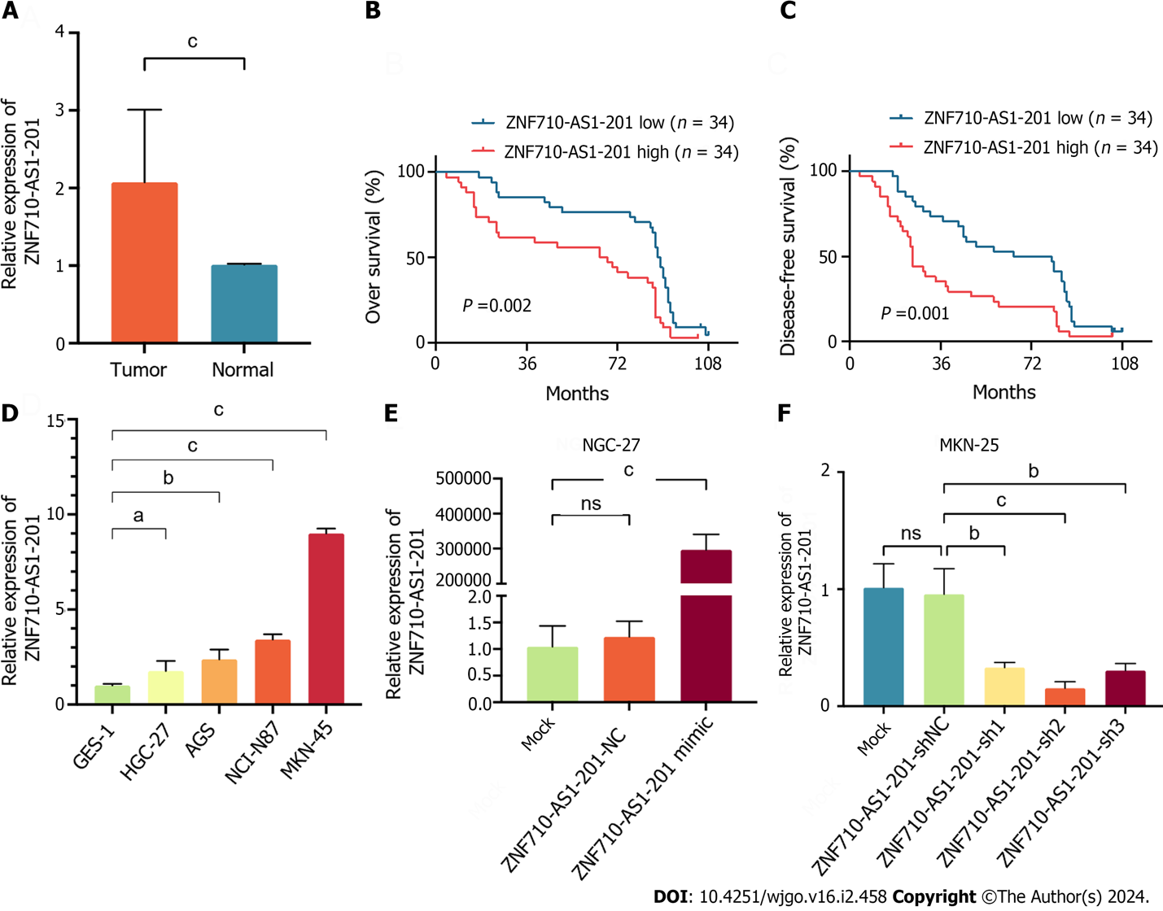
Figure 4 Zinc finger protein 710-AS1-201 is upregulated in gastric cancer tissues and cell lines. A: The expression level of zinc finger protein 710 (ZNF710)-AS1-201 in 64 paired gastric cancer and nontumoral tissues was determined by quantitative real-time polymerase chain reaction (qRT-PCR) assay; B and C: Patients with high expression of ZNF710-AS1-201 had lower overall survival and disease-free survival rates; D: The expression level of ZNF710-AS1-201 in a normal human gastric mucosa cell line and gastric cancer cell lines (HGC-27, AGS, NCI-N87 and MKN-45) was determined by qRT-PCR; E: The expression level of ZNF710-AS1-201 in HGC-27 cells after transfection with the overexpression plasmid; F: The expression level of ZNF710-AS1-201 in MKN-45 cells after transfection with the shRNA plasmid. Data are shown as the mean ± SD. ZNF710: Zinc finger protein 710. ªP < 0.05; ^{b}P < 0.01; ^{c}P < 0.001; ns: Not significant.

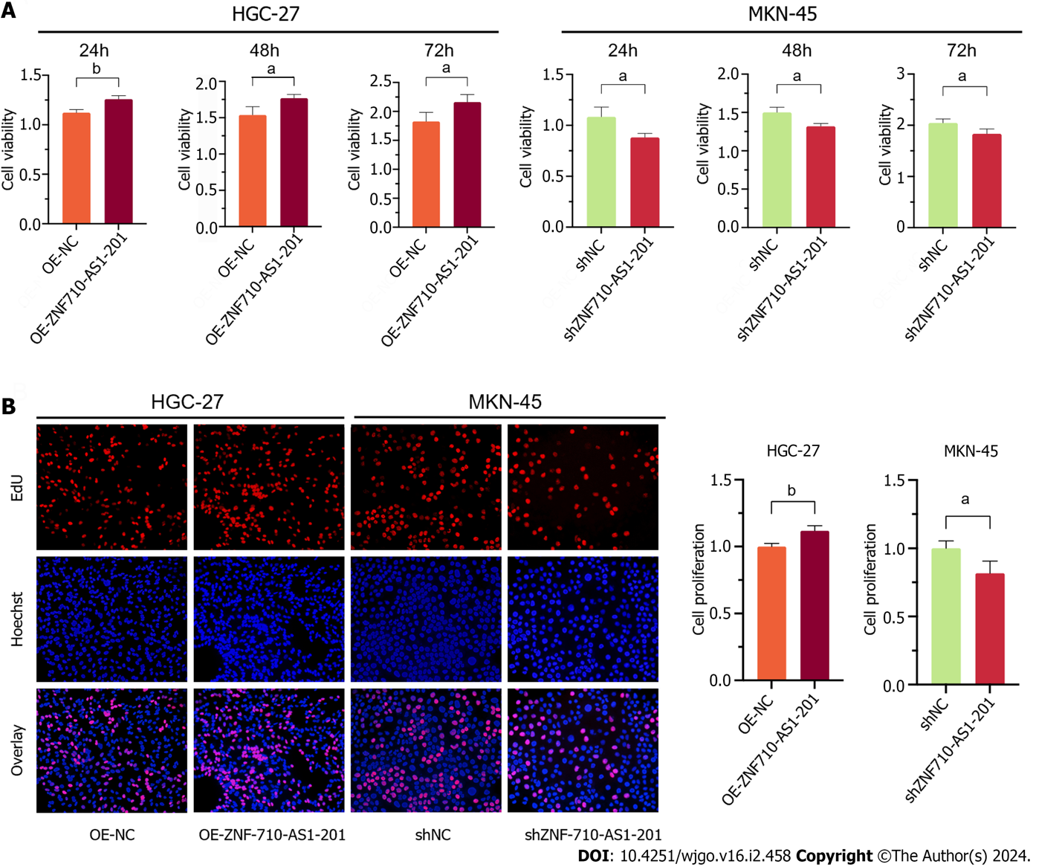
Figure 5 Zinc finger protein 710-AS1-201 promotes gastric cancer cell viability and proliferation. A: Cell viability was examined by cell counting kit-8 assay after cells were transfected for 24 h, 48 h, and 72 h; B: The cell proliferation rate was detected by EdU assay. ªP < 0.05; ^{b}P < 0.01.
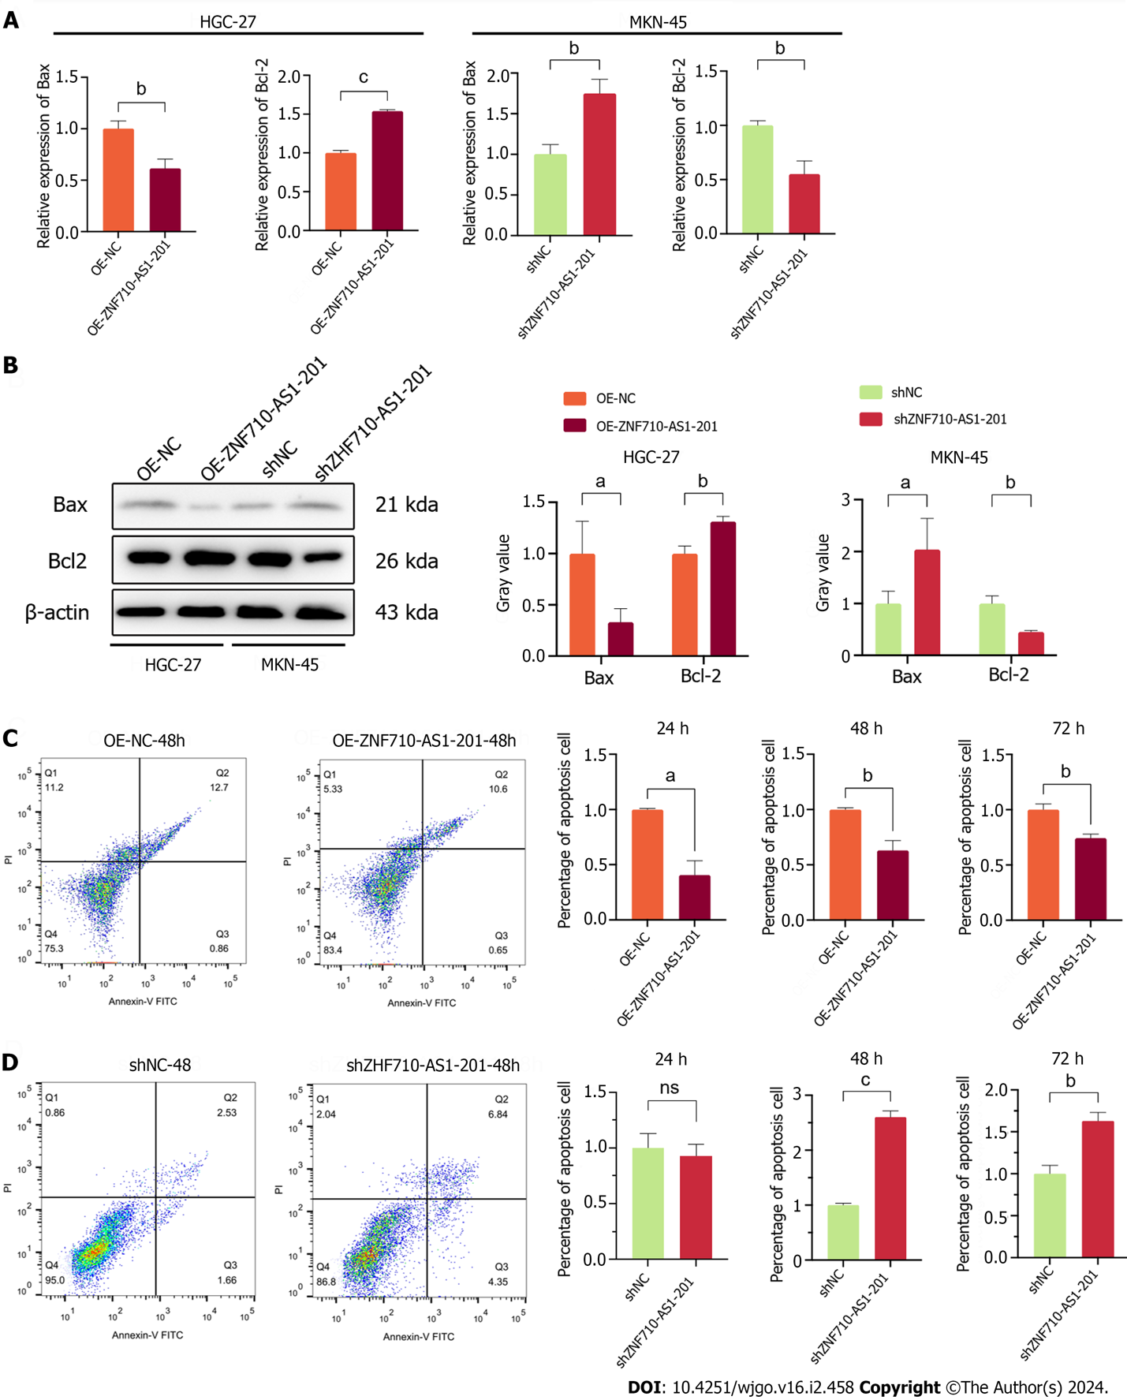
Figure 6 Zinc finger protein 710-AS1-201 inhibits gastric cancer cell apoptosis. A: Quantitative real-time polymerase chain reaction was used to detect the expression levels of apoptosis-related genes (Bax and Bcl-2); B: Western blot analysis was used to detect the expression levels of apoptosis-related proteins (Bax and Bcl-2); C: Cell apoptosis in HGC-27 cells was examined by flow cytometry after transfection with the zinc finger protein 710 (ZNF710)-AS1-201 overexpression plasmid for 24 h, 48 h, and 72 h; D: Cell apoptosis in MKN-45 cells was examined by flow cytometry after transfection with the ZNF710-AS1-201 shRNA plasmid for 24 h, 48 h, and 72 h. ªP < 0.05; ^{b}P < 0.01; ^{c}P < 0.001; ns: Not significant.

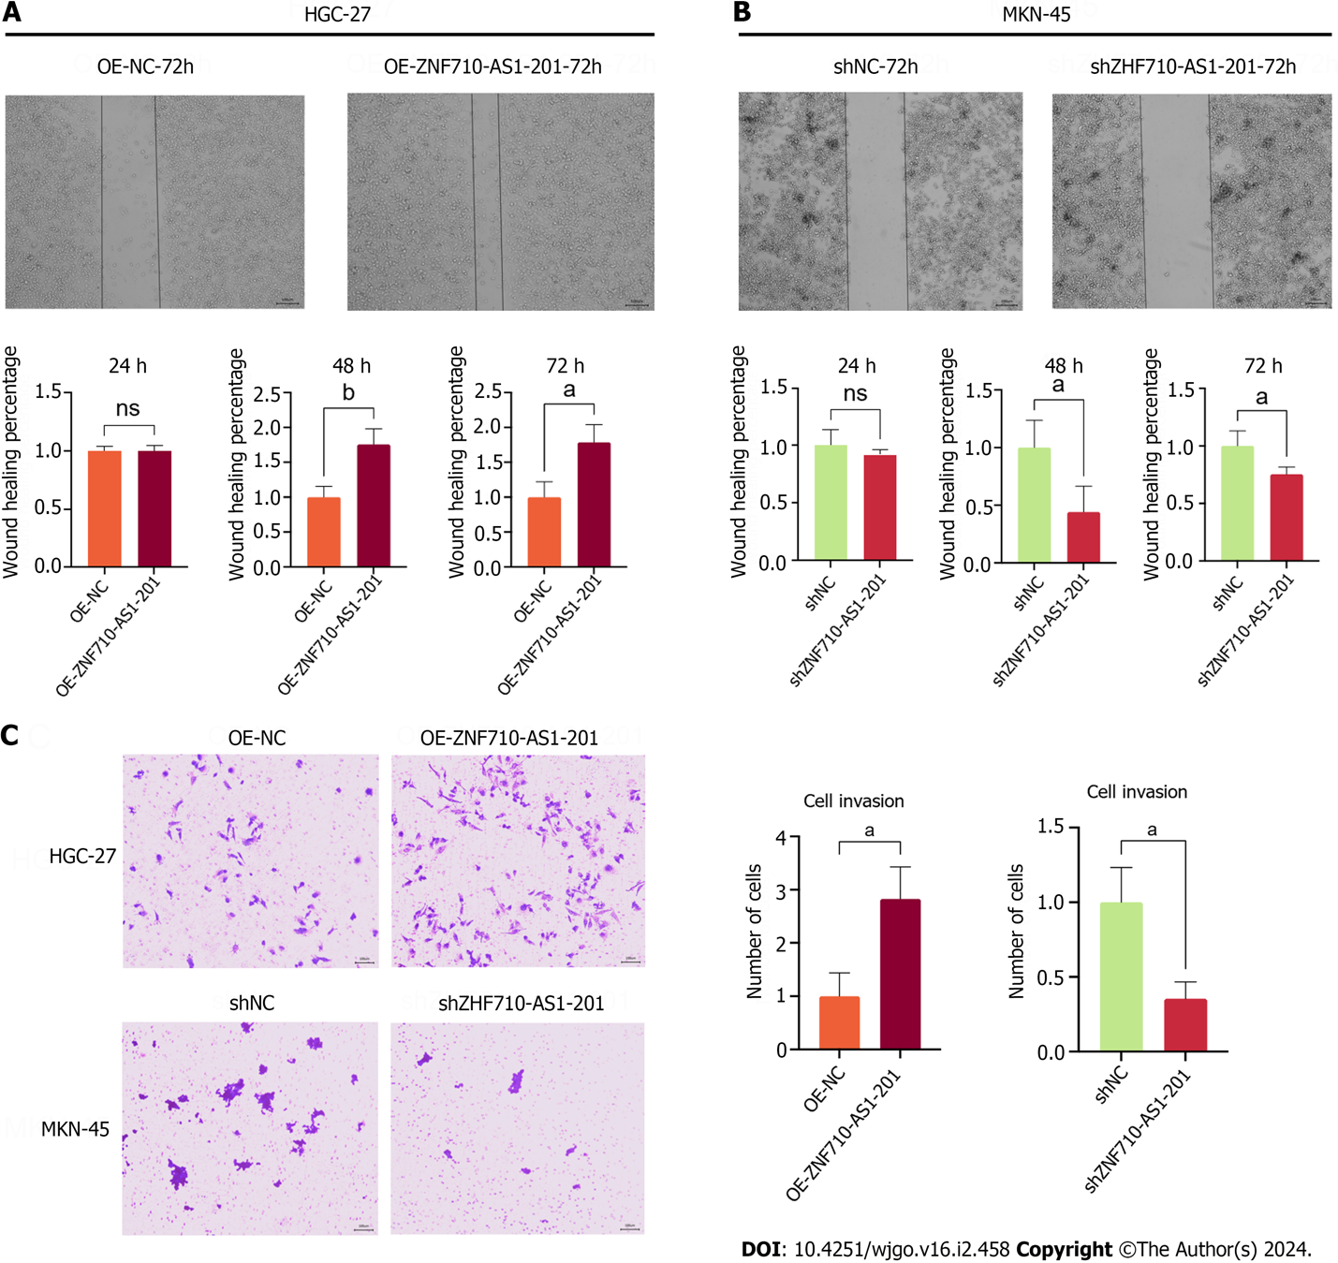
Figure 7 Zinc finger protein 710-AS1-201 promotes gastric cancer cell metastasis and invasion. A: Cell metastasis in HGC-27 cells was examined by scratch assays after transfection of zinc finger protein 710 (ZNF710)-AS1-201-overexpressing plasmids for 24 h, 48 h, and 72 h; B: Cell metastasis in MKN-45 cells was examined by scratch assay after transfection with ZNF710-AS1-201 shRNA plasmid for 24 h, 48 h, and 72 h; C: Cell invasion was examined by Transwell assay after transfection for 72 h. ZNF710: Zinc finger protein 710. ªP < 0.05; ^{b}P < 0.01; ns: Not significant.

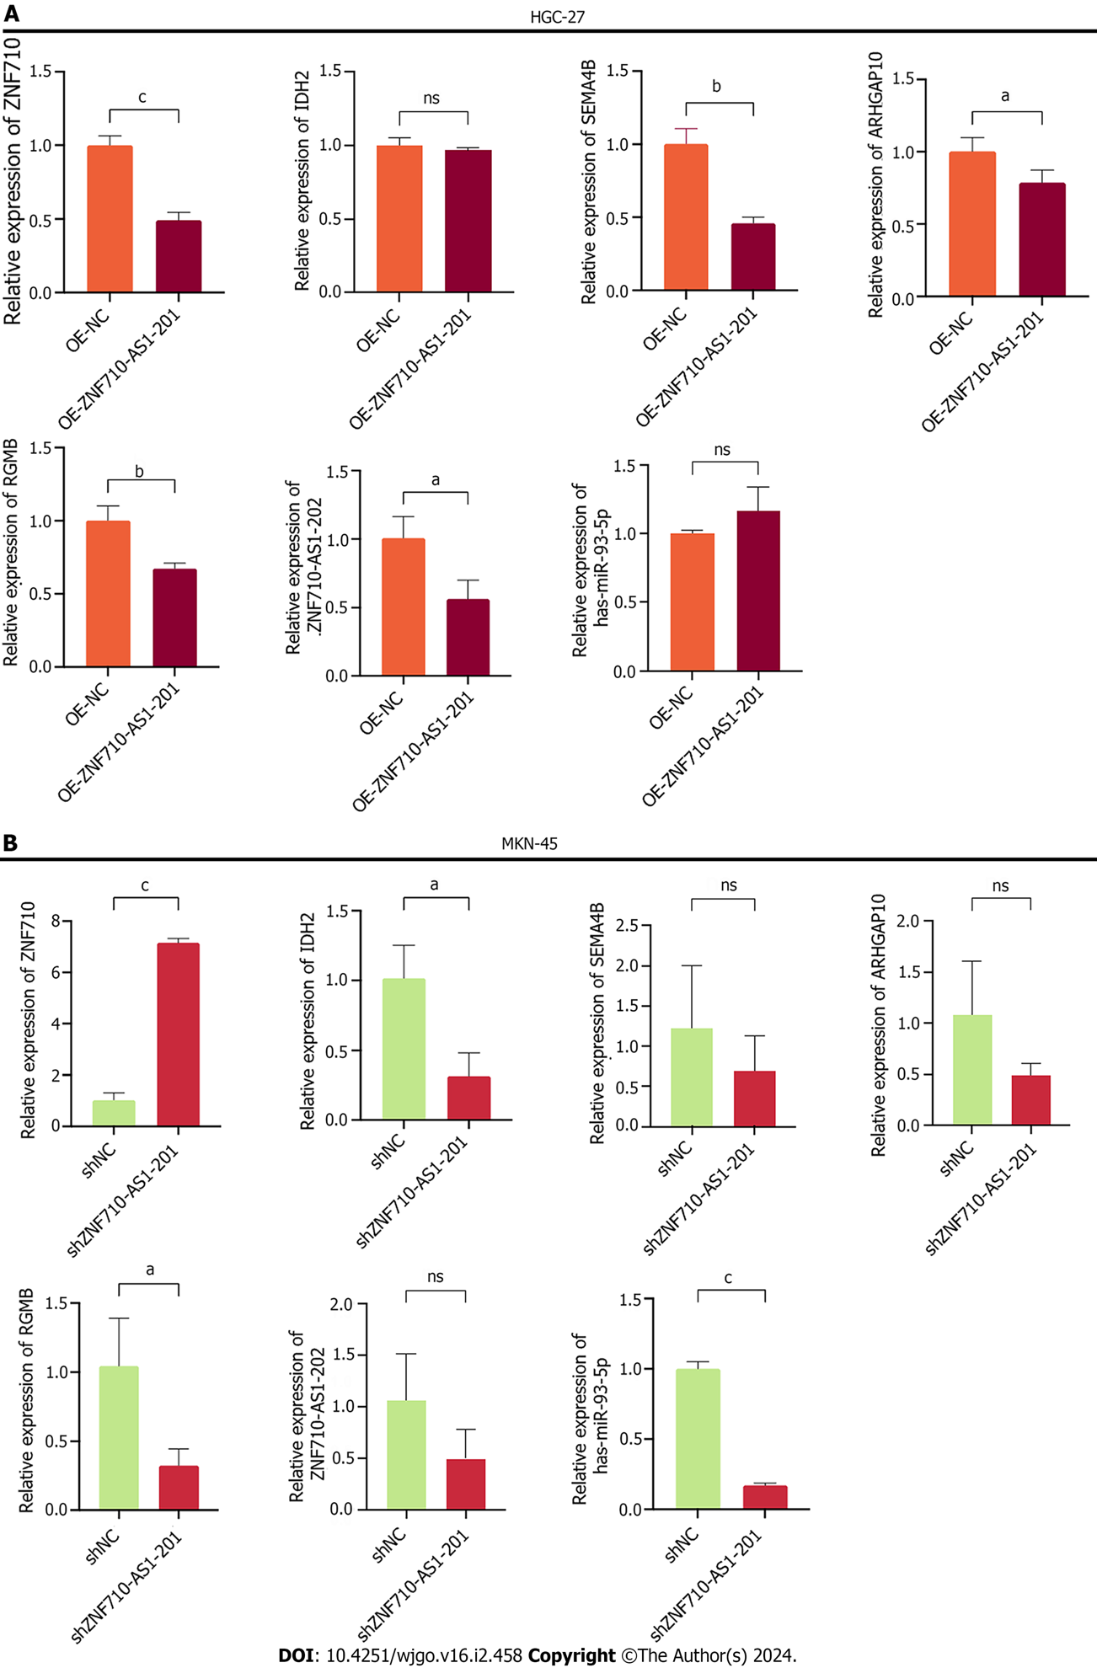
Figure 8 Prediction of downstream targets of zinc finger protein 710-AS1-201. A: The expression levels of genes in HGC-27 cells transfected with the zinc finger protein 710 (ZNF710)-AS1-201 overexpression plasmid were determined by quantitative real-time polymerase chain reaction (qRT-PCR); B: The expression levels of genes in MKN-45 cells transfected with the ZNF710-AS1-201 shRNA plasmid were determined by qRT-PCR. ªP < 0.05; ^{b}P < 0.01; ^{c}P < 0.001; ns: Not significant.

Table 1 Sequences of primers used in this study
Name | Primer sequence (5’ to 3’)
ZNF710-AS1-201-F | ACCGCAGGCACTTTGAAGA
ZNF710-AS1-201-R | AAGGGACATCAGAGGGGAG
Bcl-2-F | GGTGGGGTCATGTGTGTGG
Bcl-2-R | CGGTTCAGGTACTCAGTCATCC
Bax-F | CCCGAGAGGTCTTTTTCCGAG
Bax-R | CCAGCCCATGATGGTTCTGAT
ZNF710-F | AACAGGAGGTCTATGAGGTTTCT
ZNF710-R | CGCTGAGGTCGATCATCTTGA
IDH2-F | CGCCACTATGCCGACAAAAG
IDH2-R | ACTGCCAGATAATACGGGTCA
SEMA4B-F | GAGCGGCCATTCCTCAGATTC
SEMA4B-R | CACCCACGTACAGGGTCCT
ARHGAP10-F | CCCAGCGGAAGTTTGCTCAT
ARHGAP10-R | ACAGCTCCAAGTTGCTCTTTTC
RGMB-F | CCAGCCCAATGTCGAATCCA
RGMB-R | GGTCACTGATACCCAACACGG
miR-93-5p-F | CGCAAAGTGCTGTTCGTGC
miR-93-5p-R | AGTGCAGGGTCCGAGGTATT
ZNF710-AS1-202-F | GTCCGATCACAGTTCACTAC
ZNF710-AS1-202-R | ATACCAAACCAGGCAACATA
ZNF710: Zinc finger protein 710; IDH2: Isocitrate dehydrogenase-2; SEMA4B: Semaphorin 4B.

Table 2 Comparison of the clinical features of patients between the low- and high-expression groups, mean ± SD
Features | ZNF710-AS1-201 |  | P value
 | Low expression (n = 34) | High expression (n = 34)
Age, yr | 65.62 ± 6.85 | 67.85 ± 8.25 | 0.228
Sex, male (%) | 19 (55.9) | 22 (64.7) | 0.457
CEA, U/mL | 18.32 ± 69.96 | 11.09 ± 24.58 | 0.415¹
Neutrophil count, × 10⁹/L | 3.56 ± 0.97 | 4.67 ± 2.08 | 0.006^{1,a}
Lymphocyte count, × 10⁹/L | 1.89 ± 0.62 | 1.42 ± 0.47 | < 0.001ª
Monocyte count, × 10⁹/L | 0.38 ± 0.18 | 0.44 ± 0.24 | 0.240
Differentiation degree, III-IV (%) | 18 (52.9) | 26 (76.5) | 0.042ª
T stage, III-IV (%) | 15 (44.1) | 28 (82.4) | 0.001ª
Lymphatic invasion, positive (%) | 15 (44.1) | 24 (70.6) | 0.044ª
ªP < 0.05.
¹Mann-Whitney test.
CEA: Carcinoembryonic antigen; ZNF710: Zinc finger protein 710.

Published by Baishideng Publishing Group Inc
7041 Koll Center Parkway, Suite 160, Pleasanton, CA 94566, USA
Telephone: +1-925-3991568
E-mail: office@baishideng.com
Help Desk: https://www.f6publishing.com/helpdesk
https://www.wjgnet.com

© 2024 Baishideng Publishing Group Inc. All rights reserved.

