Department of Medicine and Therapeutics
9/F Prince of Wales Hospital
30-32 Ngan Shing Street,
Shatin, Hong Kong.
12 August, 2013

Lian-Sheng Ma
President and Editor-in-Chief
World Journal of Hepatology

Dear Prof Ma,

RE: Certifying the Language Quality of Invited Editorial

I certify that the language of my manuscript has reached Grade A (priority publishing; no language polishing required after editing). I hope my work can contribute to the high quality publications of the World Journal of Gastroenterology. Thank you very much for your kind attention.

Yours sincerely,
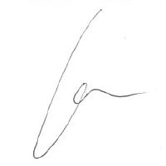
Grace Lai-Hung Wong, MD

