Name of Journal: World Journal of Clinical Cases
Manuscript NO: 73829
Manuscript Type: META-ANALYSIS

Prognostic value of computed tomography derived skeletal muscle mass index in lung cancer: A meta-analysis

Pan XL et al. SMI in lung cancer patients

Xue-Lin Pan, Hong-Jun Li, Zhen Li, Zhen-Lin Li

Xue-Lin Pan, Zhen Li, Zhen-Lin Li, Department of Radiology, West China Hospital, Sichuan University, Chengdu 610041, Sichuan Province, China

Hong-Jun Li, West China Hospital of Medicine, Sichuan University, Chengdu 610041, Sichuan Province, China

Author contributions: Li ZL made substantial contributions to the conception and design of the work; Pan XL and Li HJ searched and selected the materials and extracted the data; Pan XL wrote the manuscript; Pan XL, Li HJ, Li Z, and Li ZL revised the paper carefully and also contributed to the statistical analysis; all authors have read and approved the final manuscript.

Supported by 1·3·5 Project for Disciplines of Excellence, West China Hospital, Sichuan University, No. ZYGD18019.

Corresponding author: Zhen-Lin Li, MD, Professor, Department of Radiology, West China Hospital, Sichuan University, No. 37 Guoxuexiang, Chengdu 610041, Sichuan Province, China. 17380096151@163.com

Received: December 5, 2021
Revised: January 26, 2022
Accepted: May 22, 2022
Published online: July 16, 2022

Abstract
BACKGROUND
The prognostic role of the skeletal muscle mass index (SMI) derived from computed tomography (CT) imaging been well verified in several types of cancers. However, whether the SMI could serve as a reliable and valuable predictor of long-term survival in lung cancer patients remains unclear.

AIM
To identify the prognostic value of the CT-derived SMI in lung cancer patients.

METHODS
The PubMed, Web of Science, and Embase electronic databases were searched up to November 5, 2021 for relevant studies. The Reference Citation Analysis databases were used during the literature searching and selection. Hazard ratios (HRs) and 95% confidence intervals (CIs) were calculated to assess the association of the SMI with the overall survival (OS) of lung cancer patients. All statistical analyses were performed with STATA 12.0 software.

RESULTS
A total of 12 studies involving 3002 patients were included. The pooled results demonstrated that a lower SMI was significantly related to poorer OS (HR = 1.23, 95%CI: 1.11-1.37, P < 0.001). In addition, the subgroup analyses stratified by treatment (nonsurgery vs surgery), tumor stage (advanced stage vs early stage), and tumor type (non-small cell lung cancer vs lung cancer) showed similar results.

CONCLUSION
The CT-derived SMI is a novel and valuable prognostic indicator in lung cancer and might contribute to the clinical management and treatment of lung cancer patients.

Key Words: Skeletal muscle mass index; Computed tomography; Lung cancer; Prognosis; Meta-analysis

©The Author(s) 2022. Published by Baishideng Publishing Group Inc. All rights reserved.

Citation: Pan XL, Li HJ, Li Z, Li ZL. Prognostic value of computed tomography derived skeletal muscle mass index in lung cancer: A meta-analysis. World J Clin Cases 2022; 10(20): 6927-6935
URL: https://www.wjgnet.com/2307-8960/full/v10/i20/6927.htm
DOI: https://dx.doi.org/10.12998/wjcc.v10.i20.6927

Core Tip: We searched the PubMed, Web of Science, and Embase electronic databases up to November 5, 2021, and a total of 12 studies involving 3002 patients were included. The pooled results demonstrated that a lower skeletal muscle mass index (SMI) was significantly related to poorer overall survival (P < 0.001). In addition, the subgroup analyses stratified by treatment (nonsurgery vs surgery), tumor stage (advanced stage vs early stage), and tumor type (non-small cell lung cancer vs lung cancer) showed similar results. The computed tomography-derived SMI is a novel and valuable prognostic indicator in lung cancer and might contribute to the clinical management and treatment of lung cancer patients.

INTRODUCTION
Lung cancer is the leading cause of tumor-related deaths worldwide and can be categorized into non-small cell lung cancer (NSCLC) and small cell lung cancer (SCLC)^{[1,2]}. Despite considerable advances in the clinical diagnosis, treatment, and management of lung cancer, the overall prognosis of lung cancer patients remains poor^{[3,4]}. The tumor-node-metastasis (TNM) staging system is still the most authoritative tool to assess the disease severity and prognosis of lung cancer patients. However, in addition to disease stage, the prognosis of lung cancer patients can be affected or predicted by many factors.
In recent years, an increasing number of common clinical indicators have been identified to play a role in the evaluation of long-term survival in lung cancer, such as the D-dimer level, albumin-to-globulin ratio (AGR), lymphocyte-to-monocyte ratio, neutrophil-to-lymphocyte ratio, and platelet-to-lymphocyte ratio^{[5-8]}. However, these blood indicators are unstable and may be changed by a number of factors or diseases. There are also some other stable prognostic indicators, such as ctDNA and circulating tumor cells^{[9-11]}, but they are relatively expensive and cannot be widely applied in clinics.
The skeletal muscle mass index (SMI) is calculated according to computed tomography (CT) images and can reflect the nutritional status of the body to a large extent. In addition, the two indicators, the area of skeletal muscle and height, involved in the calculation of SMI are both stable and reliable. The prognostic value of SMI in several cancers has been identified, such as gastric cancer, colorectal cancer, pancreatic adenocarcinoma, and renal cell carcinoma^{[12-16]}. However, whether SMI could serve as a reliable and valuable prognostic index in lung cancer remains unclear.
Thus, the aim of this meta-analysis was to assess the prognostic role of CT-derived SMI in lung cancer, which might contribute to the evaluation of long-term survival and the formulation of therapy strategies for lung cancer patients.

MATERIALS AND METHODS
This meta-analysis was performed according to the Preferred Reporting Items for Systematic Reviews and Meta-Analysis (PRISMA 2020) checklist and has been registered in PROSPERO.

Literature retrieval
The PubMed, Web of Science, and Embase electronic databases were searched from inception to November 5, 2021. The search strategy consisted of Medical Subject Heading terms and free-text terms with logical operators. The following terms were used during the literature search: Skeletal muscle mass index, SMI, lung, pulmonary, tumor, cancer, carcinoma, neoplasm, prognostic, survival, and prognosis. In detail, the specific search strategy was as follows: (Skeletal muscle mass index OR SMI) AND (lung OR pulmonary) AND (tumor OR cancer OR carcinoma OR neoplasm) AND (prognostic OR survival OR prognosis). In addition, the reference lists of the included studies were searched to identify additional eligible studies.

Inclusion and exclusion criteria
The inclusion criteria were as follows: (1) Patients were pathologically diagnosed with lung cancer; (2) The SMI was calculated through CT images before antitumor treatment; and (3) The association between the SMI and overall survival (OS) was explored and assessed by hazard ratios (HRs) with 95% confidence intervals (CIs).
The exclusion criteria were as follows: (1) The HRs with 95%CIs were not directly reported in articles; (2) Reviews, meeting abstracts, letters, editorials, or case reports; and (3) Overlapping or duplicated data.
The Reference Citation Analysis databases were used during the literature searching and selection.

Data extraction
The following information was collected from the included studies: The first author, publication year, country, sample size, treatment (nonsurgery vs surgery), TNM stage, cutoff value of the SMI, tumor type, and HR with corresponding 95%CI.

Study quality assessment
The quality of the included studies was evaluated according to the Newcastle Ottawa Scale (NOS), and studies with an NOS score of 6 or higher were defined as high-quality studies^{[17]}.
The literature retrieval, selection, data extraction, and quality assessment were all conducted by two investigators independently. Any disagreement was resolved by team discussion.

Statistical analysis
All statistical analyses were conducted with STATA 12.0 software (College Station, TX, United States). The HRs with 95%CIs were calculated to assess the association between the SMI and OS. Heterogeneity was evaluated by Cochran’s Q test and Higgins I² statistic; P < 0.10 and/or I² > 50% were defined as significant heterogeneity among studies, and the random effects model was applied for the pooled effect estimates; otherwise, the fixed effects model was used^{[18]}. Subgroup analyses stratified by the treatment, tumor stage, and tumor type were further conducted. Sensitivity analysis for OS was performed by removing individual studies from the meta-analysis each time. Begg’s funnel plot and Egger’s test were conducted to evaluate publication bias. Significant publication bias was defined as a P-value less than 0.05, and the trim-and-fill method was applied to assess the influence of potentially unpublished papers on the stability of the pooled results^{[19]}.

RESULTS
Literature retrieval and selection
The detailed literature retrieval and selection process is presented in Figure 1. Ultimately, a total of 12 relevant retrospective studies were included in this meta-analysis^{[20-31]}.

Basic characteristics of the included studies
A total of 3002 lung cancer patients were enrolled among the 12 studies, with sample sizes ranging from 46 to 734. In most included studies, the patients were diagnosed at an advanced stage and received nonsurgical treatment. In addition, most studies only included NSCLC patients, and all studies were of high quality, with an NOS score of 6 or higher (Table 1).

Results of meta-analysis for association between SMI and OS
The pooled results demonstrated that a lower SMI was significantly related to poorer OS in lung cancer patients (HR = 1.23, 95%CI: 1.11-1.37, P < 0.001; I² = 84.7%, P < 0.001) (Figure 2). Then, subgroup analyses based on the treatment [nonsurgery (HR = 1.15, 95%CI: 1.06-1.26, P = 0.002) vs surgery (HR = 5.71, 95%CI: 2.94-11.10, P < 0.001)], tumor stage [advanced stage (HR = 1.34, 95%CI: 1.07-1.68, P = 0.011) vs early stage (HR = 5.71, 95%CI: 2.94-11.10, P < 0.001)], and tumor type [NSCLC (HR = 1.97, 95%CI: 1.33-2.93, P = 0.001) vs lung cancer (HR = 1.07, 95%CI: 1.03-1.11, P < 0.001)] were performed, which showed similar results (Table 2). In addition, according to the subgroup analysis, the treatment strategy and tumor stage might be potential sources of heterogeneity (Table 2).

Sensitivity analysis
The sensitivity analysis indicated that the results of this meta-analysis were stable and that none of the included studies had a significant impact on the overall results (Figure 3).

Publication bias
Begg’s funnel plot was asymmetric (Figure 4A), and Egger’s test was significant (P < 0.001); therefore, significant publication bias was observed. The trim-and-fill method was used to detect potentially unpublished articles and their impact on the overall results. Six potentially unpublished papers were identified (Figure 4B), and the pooled HR was 1.019 (95%CI: 1.005-1.033, P = 0.006) and 1.063 (95%CI: 0.949-1.192, P = 0.293) after combining these six studies, respectively. Thus, the six potentially unpublished studies might impact the overall results, and more high-quality studies are still needed to verify the above findings.

DISCUSSION
The current meta-analysis demonstrated that a lower pretreatment CT-derived SMI was significantly associated with poorer OS in lung cancer patients and might serve as a reliable and valuable prognostic indicator in lung cancer. The results of subgroup analyses based on the treatment, tumor stage, and tumor type all further verified the above findings.
The SMI is a novel indicator reflecting nutritional status, and it is well known that the nutritional condition of the body is essential for the prognosis of lung cancer patients. The clinical role of a number of nutritional indicators has been widely explored in lung cancer. Li et al^{[6]} included eight studies involving 3496 patients and demonstrated that a low pretreatment AGR was a predictor of poor OS (HR = 1.88, 95%CI: 1.49-2.38, P < 0.001) and disease-free survival (DFS) (HR = 2.09, 95%CI: 1.56-2.81, P < 0.001) in lung cancer^{[6]}. In addition, Li et al^{[32]} included ten relevant studies involving 5085 patients and showed that a low prognostic nutritional index calculated based on the peripheral serum albumin level and total lymphocyte count was significantly related to unfavorable OS (HR = 1.72, 95%CI: 1.43-2.06, P = 0.000) in lung cancer, especially in NSCLC (HR = 1.93, 95%CI: 1.56-2.37, P = 0.000)^{[32]}. Furthermore, a high pretreatment controlling nutritional status score calculated based on the peripheral serum albumin level, total blood cholesterol level, and total lymphocyte count was identified to be positively correlated with poor OS (HR = 1.63, 95%CI: 1.40-1.88, P < 0.001), DFS/recurrence-free survival (HR = 1.65, 95%CI: 1.35-2.01, P < 0.001), and postoperative complications (odds ratio = 1.58, 95%CI: 1.21-2.06, P = 0.001) in NSCLC patients^{[33]}. However, the clinical application of these indices is severely limited because they are unstable and could be affected by many factors.
In most of the included studies, the patients were divided into high or low SMI groups according to the values of SMI. However, the thresholds of SMI in the included studies were different, which means that the optimal cutoff values of SMI in different groups of lung cancer should be inconsistent. Although most relevant studies differentiated cutoff values based on sex, we deem that age should also be considered because age is a very important factor affecting the basic nutritional status. Thus, more rigorously differentiated thresholds should be applied in future relevant studies. In addition, SCLC is a pathological type with a high degree of malignancy and rapid progression, and most SCLC patients are diagnosed at an advanced stage. SCLC patients are prone to recurrence and metastasis, and the application of the current staging system for SCLC is extremely limited clinically. Unfortunately, none of the included studies focused on this type of lung cancer and explored the prognostic value of the SMI in SCLC. However, we believe that the SMI might be a novel and valuable predictor of survival and therapeutic effects in SCLC patients. Thus, we hope that more scholars could pay attention to the clinical role of the SMI in SCLC in the future.
There are several limitations in this meta-analysis. First, all included studies were retrospective, and the sample sizes were relatively small. Second, more specific subgroup analyses could not be conducted due to the lack of detailed data. Third, significant heterogeneity was observed in our meta-analysis, but the sources of heterogeneity were not identified.

CONCLUSION
The CT-derived SMI is a novel and valuable prognostic indicator in lung cancer and might contribute to the clinical management and treatment of lung cancer patients. However, more prospective high-quality studies are still needed to verify the above findings.

ARTICLE HIGHLIGHTS
Research background
The prognostic role of the skeletal muscle mass index (SMI) calculated through computed tomography (CT) images in several types of cancers has been demonstrated.

Research motivation
Whether the SMI could serve as a reliable and valuable predictor for long-term survival in lung cancer remains unclear.

Research objectives
To verify the prognostic value of the CT-derived SMI in lung cancer patients.

Research methods
Several electronic databases were searched up to November 5, 2021 for relevant studies. Hazard ratios (HRs) and 95% confidence intervals (CIs) were calculated to assess the association of the SMI with the overall survival (OS) of lung cancer patients. All statistical analyses were performed with STATA 12.0 software.

Research results
The pooled results demonstrated that a lower SMI was significantly related to poorer OS (HR = 1.23, 95%CI: 1.11-1.37, P < 0.001). In addition, the subgroup analyses stratified by treatment (nonsurgery vs surgery), tumor stage (advanced stage vs early stage), and tumor type (non-small cell lung cancer vs lung cancer) showed similar results.

Research conclusions
The CT-derived SMI is a novel and valuable prognostic indicator in lung cancer.

Research perspectives
The SMI might contribute to the clinical management and treatment of lung cancer patients.

REFERENCES
1 Cao W, Chen HD, Yu YW, Li N, Chen WQ. Changing profiles of cancer burden worldwide and in China: a secondary analysis of the global cancer statistics 2020. Chin Med J (Engl) 2021; 134: 783-791 [PMID: 33734139 DOI: 10.1097/CM9.0000000000001474]
2 Ferlay J, Colombet M, Soerjomataram I, Parkin DM, Piñeros M, Znaor A, Bray F. Cancer statistics for the year 2020: An overview. Int J Cancer 2021 [PMID: 33818764 DOI: 10.1002/ijc.33588]
3 American Cancer Society Cancer Statistics 2021 Report. J Nucl Med 2021; 62: 12N [PMID: 33622967]
4 Siegel RL, Miller KD, Fuchs HE, Jemal A. Cancer Statistics, 2021. CA Cancer J Clin 2021; 71: 7-33 [PMID: 33433946 DOI: 10.3322/caac.21654]
5 Li J, Wang Y, Li J, Che G. Prognostic Value of Pretreatment D-Dimer Level in Small-Cell Lung Cancer: A Meta-Analysis. Technol Cancer Res Treat 2021; 20: 1533033821989822 [PMID: 33563114 DOI: 10.1177/1533033821989822]
6 Li J, Wang Y, Wu Y, Li J, Che G. Prognostic Value of Pretreatment Albumin to Globulin Ratio in Lung Cancer: A Meta-Analysis. Nutr Cancer 2021; 73: 75-82 [PMID: 32148098 DOI: 10.1080/01635581.2020.1737155]
7 Wang Y, Hu X, Xu W, Wang H, Huang Y, Che G. Prognostic value of a novel scoring system using inflammatory response biomarkers in non-small cell lung cancer: A retrospective study. Thorac Cancer 2019; 10: 1402-1411 [PMID: 31104359 DOI: 10.1111/1759-7714.13085]
8 Wang Y, Huang D, Xu WY, Wang YW, Che GW. Prognostic Value of Pretreatment Lymphocyte-to-Monocyte Ratio in Non-Small Cell Lung Cancer: A Meta-Analysis. Oncol Res Treat 2019; 42: 523-531 [PMID: 31319409 DOI: 10.1159/000501726]
9 Xia L, Mei J, Kang R, Deng S, Chen Y, Yang Y, Feng G, Deng Y, Gan F, Lin Y, Pu Q, Ma L, Lin F, Yuan Y, Hu Y, Guo C, Liao H, Liu C, Zhu Y, Wang W, Liu Z, Xu Y, Li K, Li C, Li Q, He J, Chen W, Zhang X, Kou Y, Wang Y, Wu Z, Che G, Chen L, Liu L. Perioperative ctDNA-Based Molecular Residual Disease Detection for Non-Small Cell Lung Cancer: A Prospective Multicenter Cohort Study (LUNGCA-1). Clin Cancer Res 2021 [PMID: 34844976 DOI: 10.1158/1078-0432.CCR-21-3044]
10 Li H, Li B, Pan Y, Zhang Y, Xiang J, Zhang Y, Sun Y, Yu X, He W, Hu H. Preoperative Folate Receptor-Positive Circulating Tumor Cell Level Is a Prognostic Factor of Long Term Outcome in Non-Small Cell Lung Cancer Patients. Front Oncol 2020; 10: 621435 [PMID: 33585249 DOI: 10.3389/fonc.2020.621435]
11 Yang L, Yan X, Chen J, Zhan Q, Hua Y, Xu S, Li Z, Wang Z, Dong Y, Zuo D, Xue M, Tang Y, Herschman HR, Lu S, Shi Q, Wei W. Hexokinase 2 discerns a novel circulating tumor cell population associated with poor prognosis in lung cancer patients. Proc Natl Acad Sci U S A 2021; 118 [PMID: 33836566 DOI: 10.1073/pnas.2012228118]
12 Kim EY, Jun KH, Kim SY, Chin HM. Body mass index and skeletal muscle index are useful prognostic factors for overall survival after gastrectomy for gastric cancer: Retrospective cohort study. Medicine (Baltimore) 2020; 99: e23363 [PMID: 33217879 DOI: 10.1097/MD.0000000000023363]
13 Kang Z, Cheng L, Li K, Shuai Y, Xue K, Zhong Y, Chen L. Correlation between L3 skeletal muscle index and prognosis of patients with stage IV gastric cancer. J Gastrointest Oncol 2021; 12: 2073-2081 [PMID: 34790375 DOI: 10.21037/jgo-21-556]
14 Lee J, Suh J, Song C, You D, Jeong IG, Hong B, Hong JH, Kim CS, Ahn H. Association Between Sarcopenia and Survival of Patients with Organ-Confined Renal Cell Carcinoma after Radical Nephrectomy. Ann Surg Oncol 2022; 29: 2473-2479 [PMID: 34625877 DOI: 10.1245/s10434-021-10881-7]
15 Malik M, Michalak M, Radecka B, Gełej M, Jackowska A, Filipczyk-Cisarż E, Hetman K, Foszczyńska-Kłoda M, Kania-Zembaczyńska B, Mańka D, Orlikowska M, Rogowska-Droś H, Bodnar L. Prognostic Value of Sarcopenia in Metastatic Colorectal Cancer Patients Treated with Trifluridine/Tipiracil. J Clin Med 2021; 10 [PMID: 34768626 DOI: 10.3390/jcm10215107]
16 Rom H, Tamir S, Van Vugt JLA, Berger Y, Perl G, Morgenstern S, Tovar A, Brenner B, Benchimol D, Kashtan H, Sadot E. Sarcopenia as a Predictor of Survival in Patients with Pancreatic Adenocarcinoma After Pancreatectomy. Ann Surg Oncol 2022; 29: 1553-1563 [PMID: 34716836 DOI: 10.1245/s10434-021-10995-y]
17 Luchini C, Stubbs B, Solmi M, Veronese N. Assessing the quality of studies in meta-analyses: Advantages and limitations of the Newcastle Ottawa Scale. World J Meta-Anal 2017; 5: 80-84 [DOI: 10.13105/wjma.v5.i4.80]
18 Higgins JP, Thompson SG, Deeks JJ, Altman DG. Measuring inconsistency in meta-analyses. BMJ 2003; 327: 557-560 [PMID: 12958120 DOI: 10.1136/bmj.327.7414.557]
19 Wang Y, Li J, Chang S, Dong Y, Che G. Risk and Influencing Factors for Subsequent Primary Lung Cancer After Treatment of Breast Cancer: A Systematic Review and Two Meta-Analyses Based on Four Million Cases. J Thorac Oncol 2021; 16: 1893-1908 [PMID: 34256110 DOI: 10.1016/j.jtho.2021.07.001]
20 Jafri SH, Previgliano C, Khandelwal K, Shi R. Cachexia Index in Advanced Non-Small-Cell Lung Cancer Patients. Clin Med Insights Oncol 2015; 9: 87-93 [PMID: 26604850 DOI: 10.4137/CMO.S30891]
21 Sjøblom B, Grønberg BH, Wentzel-Larsen T, Baracos VE, Hjermstad MJ, Aass N, Bremnes RM, Fløtten Ø, Bye A, Jordhøy M. Skeletal muscle radiodensity is prognostic for survival in patients with advanced non-small cell lung cancer. Clin Nutr 2016; 35: 1386-1393 [PMID: 27102408 DOI: 10.1016/j.clnu.2016.03.010]
22 Suzuki Y, Okamoto T, Fujishita T, Katsura M, Akamine T, Takamori S, Morodomi Y, Tagawa T, Shoji F, Maehara Y. Clinical implications of sarcopenia in patients undergoing complete resection for early non-small cell lung cancer. Lung Cancer 2016; 101: 92-97 [PMID: 27794415 DOI: 10.1016/j.lungcan.2016.08.007]
23 Nattenmüller J, Wochner R, Muley T, Steins M, Hummler S, Teucher B, Wiskemann J, Kauczor HU, Wielpütz MO, Heussel CP. Prognostic Impact of CT-Quantified Muscle and Fat Distribution before and after First-Line-Chemotherapy in Lung Cancer Patients. PLoS One 2017; 12: e0169136 [PMID: 28107410 DOI: 10.1371/journal.pone.0169136]
24 Shoji F, Matsubara T, Kozuma Y, Haratake N, Akamine T, Takamori S, Katsura M, Toyokawa G, Okamoto T, Maehara Y. Relationship Between Preoperative Sarcopenia Status and Immuno-nutritional Parameters in Patients with Early-stage Non-small Cell Lung Cancer. Anticancer Res 2017; 37: 6997-7003 [PMID: 29187486 DOI: 10.21873/anticanres.12168]
25 Abbass T, Dolan RD, MacLeod N, Horgan PG, Laird BJ, McMillan DC. Comparison of the prognostic value of MUST, ECOG-PS, mGPS and CT derived body composition analysis in patients with advanced lung cancer. Clin Nutr ESPEN 2020; 40: 349-356 [PMID: 33183562 DOI: 10.1016/j.clnesp.2020.08.003]
26 Dolan RD, Maclay JD, Abbass T, Colville D, Buali F, MacLeod N, McSorley ST, Horgan PG, McMillan DC. The relationship between ¹⁸F-FDG-PETCT-derived tumour metabolic activity, nutritional risk, body composition, systemic inflammation and survival in patients with lung cancer. Sci Rep 2020; 10: 20819 [PMID: 33257741 DOI: 10.1038/s41598-020-77269-7]
27 Magri V, Gottfried T, Di Segni M, Urban D, Peled M, Daher S, Stoff R, Bar J, Onn A. Correlation of body composition by computerized tomography and metabolic parameters with survival of nivolumab-treated lung cancer patients. Cancer Manag Res 2019; 11: 8201-8207 [PMID: 31564979 DOI: 10.2147/CMAR.S210958]
28 Roch B, Coffy A, Jean-Baptiste S, Palaysi E, Daures JP, Pujol JL, Bommart S. Cachexia - sarcopenia as a determinant of disease control rate and survival in non-small lung cancer patients receiving immune-checkpoint inhibitors. Lung Cancer 2020; 143: 19-26 [PMID: 32200137 DOI: 10.1016/j.lungcan.2020.03.003]
29 Katsui K, Ogata T, Sugiyama S, Yoshio K, Kuroda M, Hiraki T, Kiura K, Maeda Y, Toyooka S, Kanazawa S. Sarcopenia is associated with poor prognosis after chemoradiotherapy in patients with stage III non-small-cell lung cancer: a retrospective analysis. Sci Rep 2021; 11: 11882 [PMID: 34088965 DOI: 10.1038/s41598-021-91449-z]
30 Lee J, Kim EY, Kim E, Kim KG, Kim YJ, Kim YS, Ahn HK, Lee SW. Longitudinal changes in skeletal muscle mass in patients with advanced squamous cell lung cancer. Thorac Cancer 2021; 12: 1662-1667 [PMID: 33829665 DOI: 10.1111/1759-7714.13958]
31 Yang M, Tan L, Xie L, Hu S, Liu D, Wang J, Li W. Factors That Improve Chest Computed Tomography-Defined Sarcopenia Prognosis in Advanced Non-Small Cell Lung Cancer. Front Oncol 2021; 11: 754975 [PMID: 34660324 DOI: 10.3389/fonc.2021.754975]
32 Li D, Yuan X, Liu J, Li C, Li W. Prognostic value of prognostic nutritional index in lung cancer: a meta-analysis. J Thorac Dis 2018; 10: 5298-5307 [PMID: 30416777 DOI: 10.21037/jtd.2018.08.51]
33 Peng J, Hao Y, Rao B, Cao Y. Prognostic impact of the pre-treatment controlling nutritional status score in patients with non-small cell lung cancer: A meta-analysis. Medicine (Baltimore) 2021; 100: e26488 [PMID: 34190175 DOI: 10.1097/MD.0000000000026488]

Footnotes
Conflict-of-interest statement: All the authors report no relevant conflicts of interest for this article.

PRISMA 2009 Checklist statement: The authors have read the PRISMA 2009 Checklist, and the manuscript was prepared and revised according to the PRISMA 2009 Checklist.

Open-Access: This article is an open-access article that was selected by an in-house editor and fully peer-reviewed by external reviewers. It is distributed in accordance with the Creative Commons Attribution NonCommercial (CC BY-NC 4.0) license, which permits others to distribute, remix, adapt, build upon this work non-commercially, and license their derivative works on different terms, provided the original work is properly cited and the use is non-commercial. See: https://creativecommons.org/Licenses/by-nc/4.0/

Provenance and peer review: Unsolicited article; Externally peer reviewed.

Peer-review model: Single blind

Peer-review started: December 5, 2021
First decision: January 25, 2022
Article in press: May 22, 2022

Specialty type: Medicine, research and experimental
Country/Territory of origin: China
Peer-review report’s scientific quality classification
Grade A (Excellent): 0
Grade B (Very good): 0
Grade C (Good): C, C
Grade D (Fair): 0
Grade E (Poor): 0

P-Reviewer: Geng J, China; Ozdemir HI, Turkey A-Editor: Liu (Online Science Editor) X, China S-Editor: Fan JR L-Editor: Wang TQ P-Editor: Fan JR

Figure Legends
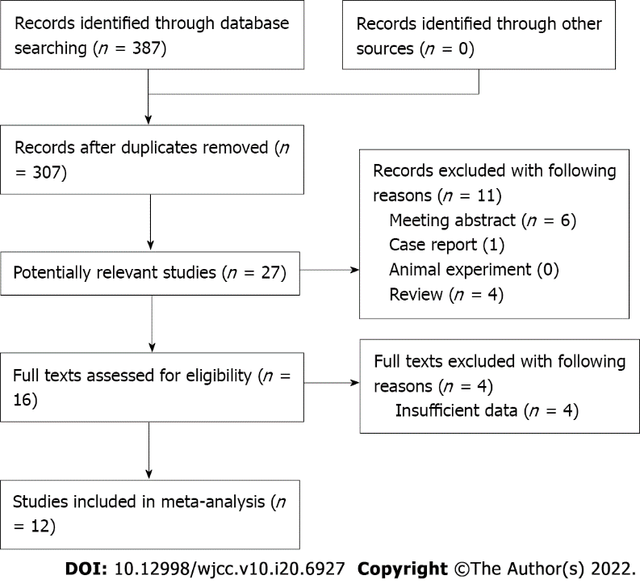
Figure 1 Flow diagram of the meta-analysis.

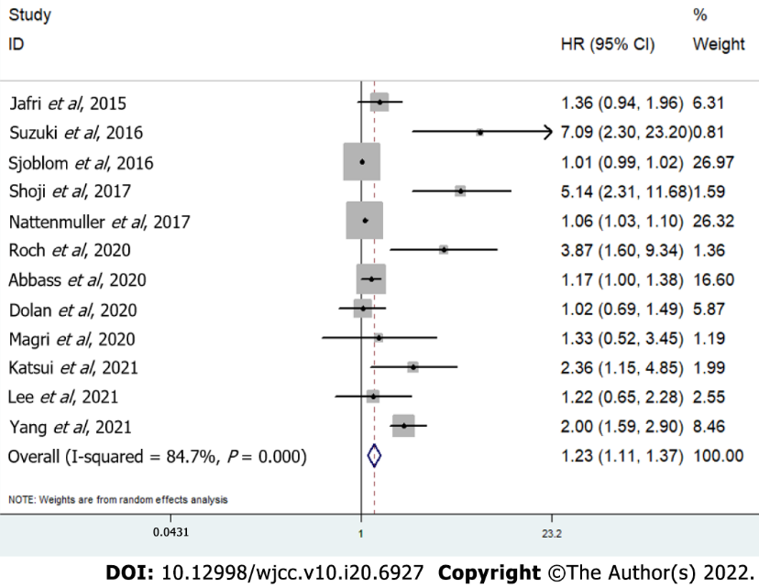
Figure 2 Forest plot for association between skeletal muscle mass index and overall survival of lung cancer patients.

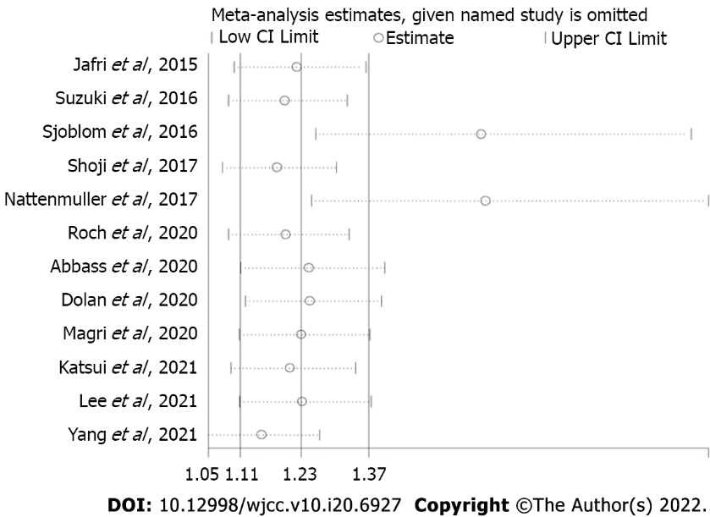
Figure 3 Sensitivity analysis of association between skeletal muscle mass index and overall survival of lung cancer patients.

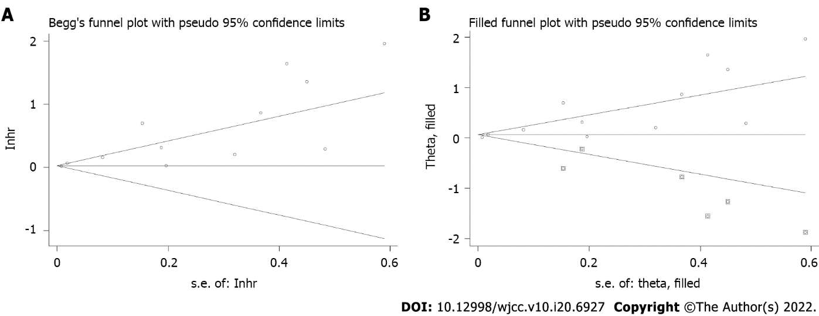
Figure 4 Association between skeletal muscle mass index and overall survival of lung cancer patients. A: Begg’s funnel plot; B: Filled funnel plot.
Table 1 Basic characteristics of included studies
Ref. | Year | Country | Sample size | Treatment | TNM stage | Threshold of SMI (cm²/m²) | Tumor type | NOS
Jafri et al^{[20]} | 2015 | United States | 112 | Non-surgery | IV | 40 | NSCLC | 7
Suzuki et al^{[22]} | 2016 | Japan | 90 | Surgery | I | Male: 43.75; female: 41.10 | NSCLC | 7
Sjøblom et al^{[21]} | 2016 | Norway | 734 | Non-surgery | III-IV | NR | NSCLC | 7
Shoji et al^{[24]} | 2017 | Japan | 147 | Surgery | I | Male: 43.75; female: 41.10 | NSCLC | 7
Nattenmüller et al^{[23]} | 2017 | Germany | 200 | Non-surgery | I-IV | NR | LC | 7
Roch et al^{[28]} | 2020 | France | 142 | Non-surgery | NR | Male: 52.4; female: 38.5 | NSCLC | 6
Abbass et al^{[25]} | 2020 | United Kingdom | 643 | Non-surgery | III-IV | Male: 43; female: 41 | LC | 6
Dolan et al^{[26]} | 2020 | United Kingdom | 119 | Non-surgery | I-III | Male: 53; female: 41 | NSCLC | 6
Magri et al^{[27]} | 2019 | Israel | 46 | Non-surgery | IV | NR | LC | 6
Katsui et al^{[29]} | 2021 | Japan | 60 | Non-surgery | III | Male: 43; female: 24 | NSCLC | 7
Lee et al^{[30]} | 2021 | Republic of Korea | 70 | Non-surgery | IIIB-IV | Male: 46; female: 29 | SCC | 6
Yang et al^{[31]} | 2021 | China | 639 | Non-surgery | IIIB-IV | Male: 32.48; female: 27.82 | NSCLC | 7
TNM: Tumor-node-metastasis; SMI: Skeletal muscle mass index; NOS: Newcastle-Ottawa Scale; NR: Not reported; NSCLC: Non-small cell lung cancer; LC: Lung cancer; SCC: Squamous cell cancer.
Table 2 Results of meta-analysis
 | No. of studies | HR | 95%CI | P value | I² (%) | P value
Overall survival | 12 | 1.23 | 1.11-1.37 | < 0.001 | 84.7 | < 0.001
Treatment
Non-surgery | 10 | 1.15 | 1.06-1.26 | 0.002 | 80.4 | < 0.001
Surgery | 2 | 5.71 | 2.94-11.10 | < 0.001 | 0.0 | 0.655
Tumor stage
Advanced stage | 7 | 1.34 | 1.07-1.68 | 0.011 | 80.8 | < 0.001
Early stage | 2 | 5.71 | 2.94-11.10 | < 0.001 | 0.0 | 0.655
Tumor type
Non-small cell lung cancer | 9 | 1.97 | 1.33-2.93 | 0.001 | 87.3 | < 0.001
Lung cancer | 3 | 1.07 | 1.03-1.11 | < 0.001 | 0.0 | 0.471
HR: Hazard ratios; CI: Confidence interval.

Published by Baishideng Publishing Group Inc
7041 Koll Center Parkway, Suite 160, Pleasanton, CA 94566, USA
Telephone: +1-925-3991568
E-mail: bpgoffice@wjgnet.com
Help Desk: https://www.f6publishing.com/helpdesk
https://www.wjgnet.com

© 2022 Baishideng Publishing Group Inc. All rights reserved.

