Name of journal: World Journal of Radiology
ESPS Manuscript NO: 3427
Columns: Original Article

3.0 Tesla vs 1.5 Tesla breast magnetic resonance imaging in newly diagnosed breast cancer patients

Butler RS et al. 3.0T pre-operative breast MRI

Reni S Butler, Christine Chen, Reena Vashi, Regina J Hooley, Liane E Philpotts

Christine Chen, Regina J Hooley, Liane E Philpotts, Department of Diagnostic Radiology
Yale University School of Medicine, New Haven, CT 06437, United States

Reena Vashi, Department of Diagnostic Radiology, Memorial Hermann Healthcare System, Houston, TX 77074, United States

Author contributions: All the authors contributed to this manuscript.

Correspondence to: Reni S Butler, MD, Assistant Professor, Department of Diagnostic Radiology, Yale University School of Medicine, 70 Woodside Rd., Guilford, CT 06437, United States. reni.butler@yahoo.com

Telephone: +1-847-3466755 Fax: +1-203-2005170
Received: April 29, 2013 Revised: June 27, 2013
Accepted: July 17, 2013
Published online:

Abstract
AIM: To compare 3.0 Tesla (T) vs 1.5T magnetic resonance (MR) imaging systems in newly diagnosed breast cancer patients.

METHODS: Upon Institutional Review Board approval, a Health Insurance Portability and Accountability Act-compliant retrospective review of 147 consecutive 3.0T MR examinations and 98 consecutive 1.5T MR examinations in patients with newly diagnosed breast cancer between 7/2009 and 5/2010 was performed. Eleven patients who underwent neoadjuvant chemotherapy in the 3.0T group were excluded. Mammographically occult suspicious lesions (BIRADS Code 4 and 5) additional to the index cancer in the ipsilateral and contralateral breast were identified. Lesion characteristics and pathologic diagnoses were recorded, and results achieved with both systems compared. Statistical significance was analyzed using Fisher’s exact test.

RESULTS: In the 3.0T group, 206 suspicious lesions were identified in 55% (75/136) of patients and 96% (198/206) of these lesions were biopsied. In the 1.5T group, 98 suspicious lesions were identified in 53% (52/98) of patients and 90% (88/98) of these lesions were biopsied. Biopsy results yielded additional malignancies in 24% of patients in the 3.0T group vs 14% of patients in the 1.5T group (33/136 vs 14/98, P = 0.07). Average size and histology of the additional cancers was comparable. Of patients who had a suspicious MR imaging study, additional cancers were found in 44% of patients in the 3.0T group vs 27% in the 1.5T group (33/75 vs 14/52, P = 0.06), yielding a higher positive predictive value (PPV) for biopsies performed with the 3.0T system.

CONCLUSION: 3.0T MR imaging detected more additional malignancies in patients with newly diagnosed breast cancer and yielded a higher PPV for biopsies performed with the 3.0T system.

© 2013 Baishideng. All rights reserved.

Key words: Breast; Breast cancer; Cancer staging; Outcome; Magnetic resonance imaging; Breast magnetic resonance imaging; 3 Tesla; Technical

Core tip: 3.0 Tesla (T) breast magnetic resonance (MR) imaging offers superior image quality through improved signal-to-noise ratio and resolution. In a comparison of two nearly identical patient populations of women with newly diagnosed breast cancer, a greater number of suspicious lesions and mammographically occult malignancies were detected using an optimized 3.0T system compared to a conventional 1.5T system. The positive predictive value of an abnormal MR imaging study was higher for 3.0T MR imaging compared to 1.5T imaging. These results attest to a clinical benefit and higher accuracy achievable with a 3.0T magnet.

Butler RS, Chen C, Vashi R, Hooley RJ, Philpotts LE. 3.0 Tesla vs 1.5 Tesla breast magnetic resonance imaging in newly diagnosed breast cancer patients. World J Radiol 2013;
Available from: URL: http://www.wjgnet.com/esps/
DOI: http://dx.doi.org/10.4329/wjr.v0.i0.0000

INTRODUCTION
High-power magnets greater than 1.5 Tesla (T) are becoming increasingly available for magnetic resonance imaging (MRI) of the breast. Among magnets in this category, 3.0T systems are the most commonly employed in clinical practice. Magnetic power influences imaging parameters, such as signal-to-noise ratio, spatial resolution, and sequence acquisition time^{[1-5]}. It is valuable, therefore, to understand the potential advantages and disadvantages of these newer systems and to compare their performance to the more familiar 1.5T scanners.
Patients with newly diagnosed breast cancer may benefit from pre-operative breast MRI to search for additional mammographically occult malignancies^{[6-34]}. Unsuspected multifocal and multicentric malignancies are seen within the same breast as the index cancer in 6%-34%^{[22,27-34]} of patients, and in the contralateral breast in 3%-9%^{[12,15,17,35]} of patients with a recent breast cancer diagnosis. The detection of these additional malignancies can alter surgical management, necessitating wider local excision or mastectomy in 8%-33%^{[22]} of women in this pre-surgical population.
This study was undertaken to evaluate the performance of 3.0T vs 1.5T MRI systems in the detection of additional mammographically occult malignancies in patients with newly diagnosed breast cancer.

MATERIALS AND METHODS
Patient selection
With institutional review board approval, a Health Insurance Portability and Accountability Act-compliant retrospective review was performed and the requirement for informed patient consent was waived. The study was conducted on 98 consecutive 1.5T MRI examinations between July 1, 2009 and December 19, 2009 and 147 consecutive 3.0T MRI examinations between December 20, 2009 and May 31, 2010 performed at a single institution in 245 women with newly diagnosed breast cancer. Eleven patients in the 3.0T patient group were treated with neoadjuvant chemotherapy prior to surgical excision. Due to the lack of pre-chemotherapy pathologic evaluation of the additional suspicious lesions seen in these patients, this subpopulation was excluded, yielding a total of 136 patients in the 3.0T study group.
All 245 patients were referred for pre-operative MR imaging because their clinical and mammographic evaluation at the time of diagnosis indicated a single index cancer confined to one quadrant of the breast, making them a potential candidate for breast conserving surgery. At our institution, the decision to perform pre-operative breast MRI on a newly diagnosed breast cancer patient is made by the referring breast surgeon. Our surgeons vary in the degree to which they utilize breast MRI and in the selection criteria they employ to determine which patients should be referred for this examination. During the time interval of this study, the referring surgeons at our institution and their practice patterns with regard to utilization of pre-operative breast MRI remained unchanged. Within this patient population, 127 studies with suspicious lesions additional to the known cancer, resulting in a BI-RADS Code 4 or 5 assessment, were selected for further analysis. Pathology results of all biopsied additional suspicious lesions were recorded.

MR imaging equipment and technique
Before December 19, 2009, breast MR imaging examinations were performed with the patient prone using a 1.5T magnet (Signa, GE Healthcare Medical Systems, Waukesha, WI, United States) and 4-channel Invivo dedicated surface breast coil (Invivo, Gainesville, FL, United States). After December 20, 2009, all breast MR imaging examinations were performed using a new 3.0T magnet (Magnetom Verio, Siemens Medical Solutions, Erlangen, Germany) and 8-channel Sentinelle Vanguard dedicated surface breast coil (Sentinelle Medical Division of Hologic, Toronto, Canada). The standard imaging protocol (Table 1) with both systems included a localizing sequence, followed by axial T1-weighted gradient-echo and T2-weighted images through both breasts. Fat suppressed axial gradient-echo T1-weighted images were obtained before and then two times at 15 s and 6 min following a rapid bolus injection of 0.1 mmol/L gadopentatate dimeglumine (Magnevist; Bayer HealthCare Pharmaceuticals, Wayne, NJ, United States) per kilogram of body weight delivered via an in-dwelling intravenous catheter at a rate of 2 mL/s. Post-processing included subtraction of the unenhanced images from the dynamic axial T1 sequence on a pixel-by-pixel basis. All MRI examinations were interpreted according to published criteria^{[37]} by the same group of 7 radiologists specializing in breast imaging with 1-16 years of experience.

Data collection
Patient demographic data, including age and breast cancer risk factors, were extracted from patient questionnaires completed at the time of MR imaging or from the electronic medical record. Breast cancer risk was categorized according to National Cancer Institute (NCI) guidelines and technologist entry into our PenRad mammography reporting system (PenRad, Minnetonka, MN, United States). When a family history of breast cancer was reported, the degree of risk was categorized according to NCI guidelines as weak, intermediate, or strong.
The location, size, and histology of the newly diagnosed index cancer were noted. MR imaging characteristics of suspicious lesions, including lesion type, kinetics, size and location, were determined on the basis of MRI reports. In some cases, where a required lesion descriptor was not included in the report, the images were reviewed on a picture archiving and communication system workstation (Synapse, Fujifilm Corporation, Edison, NJ, United States) by a consensus of 2 radiologists (Butler RS and Chen C) with 14 and 1 years of MR imaging experience, respectively. Lesion type was defined as a mass, focus or nonmass-like enhancement. The delayed enhancement kinetics were classified as a persistent, plateau, or wash-out pattern. The location of all suspicious lesions was recorded as multifocal, multicentric, or contralateral relative to the index cancer.
Second-look ultrasound examinations were performed for suspicious MR imaging lesions at the discretion of the interpreting radiologist. When a sonographic correlate was identified, percutaneous core-needle biopsy was performed using a 14-gauge hand-held biopsy needle (Achieve Automatic Biopsy Systems, Cardinal Health, Dublin, OH, United States). For suspicious MR imaging lesions with no sonographic correlate, the histologic diagnosis was obtained by MR-guided 9-gauge vacuum-assisted core needle biopsy (ATEC, Suros Division of Hologic, Indianapolis, IN, United States) or by surgical excision. Five MR imaging lesions were felt to correspond to mammographic calcifications, with the diagnosis confirmed using stereotactic 8-gauge vacuum-assisted core needle biopsy (Mammotome ST, Devicor Medical Products, Inc., Cincinnati, OH, United States). In cases of suspicious MR imaging lesions for which no histologic diagnosis was made, the reason for the lack of biopsy was recorded.

Statistical analysis
Pathology results were categorized as benign, high-risk benign, or malignant. The high-risk benign category included atypical ductal hyperplasia, lobular intraepithelial neoplasia, papillary lesions, and complex sclerosing lesions. When a surgical excision was performed for high-risk benign lesions diagnosed by core needle biopsy, the pathology of the surgical specimen was reviewed and the lesion was reclassified according to the final pathology. The incidence of MR-imaging detected multifocal, multicentric, and contralateral cancers was calculated for the 1.5T and 3.0T groups. The size and histology of the additional cancers was also recorded and compared. Statistical analysis of results was performed using R (R Foundation for Statistical Computing, Vienna, Austria) and the difference between the two cohorts was analyzed for statistical significance using Fisher’s exact test with a P < 0.05 considered to indicate a significant difference.

RESULTS
Patient and index cancer data
The demographic characteristics of the 1.5T and 3.0T patient populations were comparable, with no statistically significant differences in age or family history of breast cancer (Table 2). The distribution of sizes and histologic types of the index cancers were also similar in the two study groups (Table 2). Among the 98 index cancers in the 1.5T patient population, the average size was 17.3 mm (range 4-70 mm) whereas the mean size of the 136 index cancers in the 3.0T group was 18.1 mm (range 3-92 mm). Invasive ductal carcinoma was the most common histology in both patient cohorts, with 67 (68%) such cancers among the 1.5T patients and 83 (61%) in the 3.0T group.

Suspicious lesions
Although data was collected from consecutive time intervals of nearly equal length, a larger number of cases (147 vs 98) was observed on the 3.0T system (Table 3). Accordingly, a greater number of suspicious lesions (206 vs 98) was recorded in the 3.0T population. In addition to the increase in volume, there was also an independent increase in the number of suspicious lesions per patient [1.4 (range 0.0-8.0) vs 1.0 (range 0.0-6.0)] seen with the 3.0T system (P = 0.001, square root transformed). Lesion size was smaller but not significantly different in the 3.0T patients [10.5 mm (range 3.0-94.0 mm) vs the 1.5T patients 11.9 mm (range 3.0-60.0 mm)].
Almost all of the BI-RADS Code 4 and 5 lesions for which biopsy was recommended [88 of 98 (90%) in the 1.5T group and 198 of 206 (96%) in the 3.0T cohort] were histologically evaluated. The most common method of biopsy was MRI-guided 9-gauge vacuum-assisted core needle biopsy, which was performed in 43 (49%) of 1.5T lesions and 87 (44%) of 3.0T findings. The second most common method of obtaining a pathologic diagnosis was by surgical excision, which was carried out for 29 (33%) of 1.5T abnormalities and 72 (36%) of 3.0T lesions. Ultrasound-guided hand-held 14-gauge core needle biopsy was performed for 13 (15%) and 37 (19%) of suspicious MR imaging lesions in the 1.5T and 3.0T group, respectively, as these lesions had an identifiable sonographic correlate on second-look ultrasound. A small number of MR imaging lesions [3 (3%) of 1.5T lesions and 2 (1%) of 3.0T findings] were retrospectively correlated with mammographic calcifications and biopsied with stereotactic vacuum-assisted 8-gauge core needle biopsy. A total of 10 lesions in the 1.5T cohort and 8 lesions in the 3.0T group were not biopsied. Seven findings in 1.5T patients and 4 findings in 3.0T patients were not biopsied because the suspicious lesion was within a region of multiple similar findings, and it was elected to biopsy a single representative lesion within this region. Two 1.5T lesions and three 3.0T lesions were not reproduced on repeat MR imaging at the time of scheduled MR biopsy. Two of these patients had MRI follow-up one year after the cancelled biopsy, and all have had mammographic follow-up for at least 2 years since the cancelled biopsy, with no new cancers presenting in this subgroup. One lesion in each group was felt to correspond to a benign inflammatory cyst on second-look ultrasound. Finally, one patient with a single additional suspicious lesion in the 1.5T group was lost to follow-up.

There was no statistically significant difference in the morphology or kinetic behavior of the suspicious lesions seen in the two cohorts, as detailed in Table 3. MR imaging suspicious findings were also similarly distributed relative to the index cancer in the two patient groups.

Cancers
A total of 23 additional malignancies were detected with the 1.5T system, while 54 unsuspected cancers were discovered with the 3.0T system, yielding a positive biopsy rate of 26% and 27%, respectively (Table 4). The average size of these cancers of 12.4 mm in the 1.5T patients and 10.9 mm in the 3.0T group was smaller, but not statistically significant in the 3.0T group.
MRI-guided core needle biopsy diagnosed 4 (17%) cancers in the 1.5T cohort and 10 (19%) malignancies in the 3.0T group. Six (26%) malignancies in the 1.5T group and 19 (35%) cancers in the 3.0T group were diagnosed with ultrasound-guided core needle biopsy. Stereotactic core needle biopsy detected 1 (4%) cancer in the 1.5T group and 1 (2%) cancer in the 3.0T cohort. Surgical excision revealed 12 (52%) malignancies in the 1.5T patients and 24 (44%) malignancies in the 3.0T population.
The MR imaging finding of a mass was the most common morphology of cancers seen with both systems and the kinetic behavior of cancers in both groups was similar, as described in Table 4. The distribution of additional malignancies relative to the index cancer was not statistically different between the two cohorts, with 16 (70%) vs 33 (61%) multifocal cancers, 4 (17%) vs 12 (22%) multicentric cancers, and 3 (13%) vs 9 (17%) contralateral malignancies in the 1.5T and 3.0T group, respectively.
In both groups, the most common histology of MR imaging detected cancers was infiltrating ductal carcinoma, as shown in Table 4.

Patient outcomes
The outcomes for newly diagnosed breast cancer patients imaged with both systems are summarized in Table 5. Among patients imaged with the 1.5T system, 9 (9%) had multifocal cancers and 4 (4%) had multicentric cancers, for a total of 13 (13%) patients with additional MR imaging detected malignancies in the ipsilateral breast. By contrast, among women imaged with the 3.0T system, 22 (16%) had multifocal malignancies and 9 (7%) had multicentric ones, resulting in a total of 31 (23%) patients with ipsilateral MR imaging detected cancers. This difference approaches statistical significance with a P value of 0.09, suggesting a trend toward improved detection of mammographically occult ipsilateral cancers in women with newly diagnosed breast cancer imaged with the 3.0T system. Similarly, among patients in the 1.5T group, 3 (3%) had contralateral cancers, compared to 7 (5%) in the 3.0T cohort, although this difference was not statistically significant (P = 0.53). A trend approaching statistical significance with a P value of 0.07 was seen, however, when ipsilateral and contralateral cancers are combined for a total number of 14 (14%) additional cancers detected in the 1.5T group compared to 33 (24%) in the 3.0T cohort. In addition, 13 (13%) patients imaged with the 1.5T system and 12 (9%) patients imaged with the 3.0T magnet had high-risk lesions.
A similar percentage of patients were biopsied in both groups and, as discussed above, a similar positive biopsy rate of 26% and 27% was observed in the 1.5T and 3.0T cohorts, respectively. However, the positive predictive value of an abnormal MRI was 14/52 (27%) for patients imaged with the 1.5T magnet compared to 33/75 (44%) in the 3.0T group (P = 0.06), likely due to the greater number of suspicious lesions biopsied per patient in the 3.0T group. Of biopsied patients in the 1.5T population, 25 (48%) had benign results, 13 (25%) had high-risk lesions, and 14 (27%) had malignant findings, with 9 (17%) patients with multifocal, 4 (8%) women with multicentric, and 3 (6%) patients contralateral cancers. In the 3.0T group, 30 (40%) women had benign biopsies, 12 (16%) had high-risk findings, and 33 (44%) had malignant diagnoses, with 22 (29%) patients with multifocal, 9 (12%) women with multicentric, and 7 (9%) patients with contralateral malignancies.

DISCUSSION
The increasing availability of 3.0T MR imaging systems raises the question of whether this advance in technology leads to improved clinical outcomes in breast cancer care. Breast MR imaging at 3.0T has both technical advantages and challenges^{[1,2,4,5,36-38]}. The higher magnetic field strength (B₀) produces a proportionate increase in signal-to-noise ratio, allowing for improvements in both spatial and temporal resolution. The greater spectral separation of fat and water at 3.0T imaging enables superior fat suppression, further aiding in the visualization of enhancing lesions. However, technical image quality at 3.0T is challenged by greater B₀ and B₁ field inhomogeneity, and increased susceptibility to artifacts. These potential drawbacks can be overcome by adjusting imaging parameters, such as repetition time, short echo time, flip angle, and bandwidth, at the expense of some of the gains in supernova remnant (SNR) and image acquisition time. In our 3.0T protocol, we do, in fact, utilize a higher bandwidth of 698 for the T1-weighted gradient recalled echo sequence, compared to a bandwidth of 391 on the 1.5T system. After accounting for such parameter adjustments, the SNR remains 1.7-1.8 times greater than imaging at 1.5T^{[5]}.
Kuhl et al^{[38]} evaluated the appearance of 53 lesions in 37 patients imaged at both 1.5T and 3.0T, and reported a higher image quality and diagnostic confidence achieved with the 3.0T system. In this study, we posed the question of whether this perceived improvement in lesion characterization results in detection of a greater number of occult malignancies in newly diagnosed breast cancer patients at our institution. Although it would be ideal, as in the Kuhl study, to compare results from these two systems in the same patient population, it may be difficult or impractical to subject a large number of newly diagnosed breast cancer patients to repeat breast MR imaging. In this study, we compared outcomes in two patient populations that were imaged during consecutive time intervals corresponding to the 5.5 month time period just before and immediately after our switch from a 1.5T to a 3.0T system. These cohorts were nearly identical in age, family history of breast cancer, and size and histology of their index cancer - the demographic and risk factors most likely to influence outcome (Table 2). Thus, we propose that any observed difference in the number of additional detected cancers is likely to reflect the imaging systems, rather than the patients’ pre-existing probability of malignancy. Our results show a difference approaching statistical significance in the performance of the 3.0T and 1.5T systems, with additional malignancies detected in 24% of newly diagnosed breast cancer patients on the 3.0T magnet vs 14% on the 1.5T magnet (P = 0.07). This trend is most apparent for ipsilateral cancers, detected in 23% of women imaged with 3.0T vs 13% of those imaged with the 1.5T system (P = 0.09).
We emphasize that this study represents a comparison of two imaging systems that differ not only in magnet strength, but also in coil design and sequence parameters. Albeit not a pure comparison of 3.0T vs 1.5T magnets, this type of evaluation has the advantage of reflecting the performance of these two systems in the way they would likely be utilized in clinical practice. It has been recognized that a direct comparison of 1.5T and 3.0T magnets would be difficult, since coils for 3.0T systems are different and adjustments in sequence parameters are recommended to optimize image quality^{[5]}. The degree to which each of the above technical factors contributed to the observed increase in the number of additional detected cancers is uncertain, though all are likely to have played a role. The increased signal-to-noise ratio and superior fat suppression achieved with a higher power magnet likely produce an image of greater contrast resolution. The newer 8-channel phased-array breast coil is better equipped than earlier coils to capture the increased signal of the higher power magnet and allow for its translation into higher spatial and temporal resolution. Finally, the adjustments in matrix (320 × 320 vs 448 × 448), slice thickness (1 mm vs 0.7 mm), and voxel size (1.0 mm × 1.0 mm × 1.0 mm vs 0.7 mm × 0.7 mm × 0.7 mm) in the 1.5T vs 3.0T protocol, respectively, are likely to have also contributed to an increase in spatial resolution. It is possible that these improvements in resolution allowed the visualization of subtle lobulation or spiculation of margins that otherwise would have appeared smooth, and therefore resulted in a greater number of lesions being characterized as suspicious and a greater number of small additional cancers detected with the 3.0T system.
The positive biopsy rate was nearly identical with the two systems, with 27% of biopsied lesions yielding malignancy on the 3.0T system vs 26% on the 1.5T system. Since all studies were interpreted by the same radiologists utilizing the same interpretation criteria for the assessment of suspicious features, it is not surprising that a lesion assessed as suspicious on either system should carry the same likelihood of malignancy. However, a greater number of lesions overall (206 vs 98) and a greater number of lesions per patient (1.4 vs 1.0) were characterized as suspicious on the 3.0T system compared to the 1.5T system. This difference suggests that suspicious features may have been revealed in a greater number of lesions with the 3.0T system owing to its increased resolution. Therefore, while the positive predictive value (PPV) per suspicious lesion remained the same, the PPV per patient with an abnormal MRI examination increased from 27% to 44% with the 3.0T system due to the presence of a greater number of suspicious lesions per patient and the likelihood that at least one of the suspicious lesions would be malignant. The greater number of additional diagnosed cancers on the 3.0T system, therefore, results from a statistically significant increase in the number of suspicious lesions detected with the 3.0T magnet (Table 3, P = 0.001).
This study has several limitations. Our data is drawn from a small population of 98 patients in the 1.5T cohort and 136 patients in the 3.0T group. The ability of 3.0T imaging to improve detection of occult additional malignancies in newly diagnosed breast cancer patients needs to be confirmed in larger prospective randomized controlled trials. We obtained our data retrospectively and, with the exception of cases where the reported findings were incompletely described and the images reviewed, relied on the examination reports for the description and assessment of suspicious MR imaging lesions. Similarly, we collected our pathology data from the pathology reports and, in the cases of surgical pathology, relied on size and location descriptors to correlate MR imaging findings with histologic results. Finally, this is a single institution study with all MR imaging examinations interpreted by breast imaging specialists and our results may not be applicable to all practices.
In conclusion, the detection of early additional malignancies in the pre-operative patient with a recent breast cancer diagnosis is clinically desirable based on current practice standards. The superior sensitivity of MR imaging for detecting occult malignancies in newly diagnosed breast cancer patients has been well established. The literature reports a range of 6%-34%^{[22,27-34]} of additional occult ipsilateral cancers and 3%-9%^{[12,15,17,35]} of unsuspected contralateral cancers in this setting. Our results with both systems fall within this reported range. However, the improvement in image quality achievable with a 3.0T system, which includes improved coil design and high resolution sequence parameters, may translate into the detection of occult malignancies in a greater percentage of women. A trend toward a statistically significant increase in detection was observed in the overall number of additional occult cancers and the number of additional ipsilateral cancers with the 3.0T system, potentially altering surgical management.
The literature on MR imaging of the breast using a modern 3.0T system is presently limited. Although it is recognized that a 3.0T system can produce images of higher spatial, contrast, and temporal resolution^{[2,4,38]}, few investigators have evaluated the impact, if any, of this technical advancement on clinical outcomes in different patient populations^{[39]}. To our knowledge, this is the first study to compare the performance of a 3.0T vs a 1.5T system in women referred for pre-operative MRI after a recent breast cancer diagnosis. Further research is needed to corroborate these results and define the contributing roles of higher power magnets, coil design, and acquisition parameters in the optimization of image quality, accuracy of MRI interpretation, and potential influence on clinical outcomes.

COMMENTS
Background
3 Tesla (3.0T) magnets are becoming increasingly available for breast magnetic resonance (MR) imaging. The higher power of a 3.0T magnet, compared to a conventional 1.5T magnet, can be harnessed to achieve greater spatial and contrast resolution and faster acquisition times. For accuracy of interpretation, breast MR imaging requires an assessment of both morphology and contrast enhancement pattern. Greater contrast and spatial resolution aid in the assessment of morphologic features predictive of malignancy, such as margins. Faster acquisition times ensure that imaging can be performed immediately after contrast injection, providing optimal visualization of rapidly enhancing cancers. Therefore, 3.0T MR imaging provides an opportunity to improve both image quality and clinical outcomes.

Research frontiers
Breast MR imaging is a valuable tool in the pre-operative assessment of newly diagnosed breast cancer patients. Imaging with an optimized 3.0T system can detect a greater number of mammographically occult malignancies in both the ipsilateral and contralateral breast of these patients, potentially altering surgical management.

Innovations and breakthroughs
Previous authors have reported on the higher image quality and improved lesion visualization achievable with 3.0T MR imaging compared to conventional 1.5T imaging. Other authors have shown a clinical benefit from pre-operative MR imaging of newly diagnosed breast cancer patients. In this patient population, MR imaging reveals additional mammographically occult cancers in both the ipsilateral and contralateral breast. The detection of these unsuspected cancers prior to definite surgery is critical for surgical planning and complete tumor removal. To our knowledge, no prior authors have addressed whether the improvement in image quality with a 3.0T system translates into a greater clinical benefit in the pre-operative newly diagnosed breast cancer population. Authors have shown that 3.0T MR imaging increases the likelihood of detecting additional malignancies and the positive predictive value of an abnormal study, thereby improving the accuracy of breast MR imaging interpretation.

Applications
This article provides data to support that a 3.0T MR imaging system is superior to a 1.5T system in the pre-operative evaluation of newly diagnosed breast cancer patients. Furthermore, it specifies the components and techniques utilized to optimize the system, including a dedicated multi-channel breast coil and technical acquisition parameters. As radiologists throughout the global community strive to improve the accuracy of breast MR imaging interpretation, this article can provide guidance in selecting breast MR imaging equipment and techniques.

Terminology
3.0 Tesla (T): Tesla is the unit of measurement of magnetic field strength. Prior to the availability of 3.0T magnets, the standard magnetic field strength for breast MR imaging was 1.5T. Higher magnetic field strength is desirable because it provides higher signal-to-noise ratio, greater resolution and faster acquisition times. Gradient Recalled Echo: a pulse sequence that differs from basic spin echo in that it utilizes a flip angle of less than 90 degrees with no 180 degree refocusing pulse. This difference allows for faster image acquisition times. Flip angle: the angle to which the net proton magnetization is tipped via the application of a radiofrequency pulse. A smaller flip angle results in faster image acquisition. Signal-to-noise ratio (SNR): the ratio of desired signal to background noise. The SNR is directly proportional to magnetic field strength. However, adjustments required to compensate for the increased susceptibility to artifact at higher field strengths reduce some of the gain in SNR achieved with a 3.0T system, resulting in a net SNR of 1.7-1.8 times greater than a 1.5T system. Bandwidth: range of MR signal frequencies accepted by the receiver. The bandwidth can be adjusted to optimize image quality. A higher bandwidth is used in 3.0T MR imaging to reduce artifact at the expense of some of the gain in signal-to-noise ratio.

Peer review
Clinically interesting, well presented, a very good review of the literature.

REFERENCES
1 Hecht EM, Lee RF, Taouli B, Sodickson DK. Perspectives on body MR imaging at ultrahigh field. Magn Reson Imaging Clin N Am 2007; 15: 449-65, viii [PMID: 17893062 DOI: 10.1016/j.mric.2007.07.001]
2 Kuhl CK. Breast MR imaging at 3T. Magn Reson Imaging Clin N Am 2007; 15: 315-20, vi [PMID: 17893052 DOI: 10.1016/j.mric.2007.08.003]
3 Meeuwis C, Mann RM, Mus RD, Winkel A, Boetes C, Barentsz JO, Veltman J. MRI-guided breast biopsy at 3T using a dedicated large core biopsy set: feasibility and initial results. Eur J Radiol 2011; 79: 257-261 [PMID: 20541338]
4 Soher BJ, Dale BM, Merkle EM. A review of MR physics: 3T versus 1.5T. Magn Reson Imaging Clin N Am 2007; 15: 277-90, v [PMID: 17893049 DOI: 10.1016/j.mric.2007.06.002]
5 Chatterji M, Mercado CL, Moy L. Optimizing 1.5-Tesla and 3-Tesla dynamic contrast-enhanced magnetic resonance imaging of the breasts. Magn Reson Imaging Clin N Am 2010; 18: 207-24, viii [PMID: 20494307 DOI: 10.1016/j.mric.2010.02.011]
6 Al-Hallaq HA, Mell LK, Bradley JA, Chen LF, Ali AN, Weichselbaum RR, Newstead GM, Chmura SJ. Magnetic resonance imaging identifies multifocal and multicentric disease in breast cancer patients who are eligible for partial breast irradiation. Cancer 2008; 113: 2408-2414 [PMID: 18823018 DOI: 10.1002/cncr.23872]
7 Baker DR. Magnetic resonance imaging of occult breast cancer. Clin Breast Cancer 2000; 1: 66-67 [PMID: 11899392 DOI: 10.3816/CBC.2000.n.006]
8 Bedrosian I, Mick R, Orel SG, Schnall M, Reynolds C, Spitz FR, Callans LS, Buzby GP, Rosato EF, Fraker DL, Czerniecki BJ. Changes in the surgical management of patients with breast carcinoma based on preoperative magnetic resonance imaging. Cancer 2003; 98: 468-473 [PMID: 12879462 DOI: 10.1002/cncr.11490]
9 Biglia N, Bounous VE, Martincich L, Panuccio E, Liberale V, Ottino L, Ponzone R, Sismondi P. Role of MRI (magnetic resonance imaging) versus conventional imaging for breast cancer presurgical staging in young women or with dense breast. Eur J Surg Oncol 2011; 37: 199-204 [PMID: 21237612 DOI: 10.1016/j.ejso.2010.12.011]
10 Bilimoria KY, Cambic A, Hansen NM, Bethke KP. Evaluating the impact of preoperative breast magnetic resonance imaging on the surgical management of newly diagnosed breast cancers. Arch Surg 2007; 142: 441-45; discussion 441-45; [PMID: 17515485 DOI: 10.1001/archsurg.142.5.441]
11 Blair S, McElroy M, Middleton MS, Comstock C, Wolfson T, Kamrava M, Wallace A, Mortimer J. The efficacy of breast MRI in predicting breast conservation therapy. J Surg Oncol 2006; 94: 220-225 [PMID: 16900536 DOI: 10.1002/jso.20561]
12 Brennan ME, Houssami N, Lord S, Macaskill P, Irwig L, Dixon JM, Warren RM, Ciatto S. Magnetic resonance imaging screening of the contralateral breast in women with newly diagnosed breast cancer: systematic review and meta-analysis of incremental cancer detection and impact on surgical management. J Clin Oncol 2009; 27: 5640-5649 [PMID: 19805685 DOI: 10.1200/JCO.2008.21.5756]
13 Del Frate C, Borghese L, Cedolini C, Bestagno A, Puglisi F, Isola M, Soldano F, Bazzocchi M. Role of pre-surgical breast MRI in the management of invasive breast carcinoma. Breast 2007; 16: 469-481 [PMID: 17433681 DOI: 10.1016/j.breast.2007.02.004]
14 Gutierrez RL, DeMartini WB, Silbergeld JJ, Eby PR, Peacock S, Javid SH, Lehman CD. High cancer yield and positive predictive value: outcomes at a center routinely using preoperative breast MRI for staging. AJR Am J Roentgenol 2011; 196: W93-W99 [PMID: 21178040 DOI: 10.2214/AJR.10.4804]
15 Lehman CD, Gatsonis C, Kuhl CK, Hendrick RE, Pisano ED, Hanna L, Peacock S, Smazal SF, Maki DD, Julian TB, DePeri ER, Bluemke DA, Schnall MD. MRI evaluation of the contralateral breast in women with recently diagnosed breast cancer. N Engl J Med 2007; 356: 1295-1303 [PMID: 17392300 DOI: 10.1056/NEJMoa065447]
16 Liberman L. Breast MR imaging in assessing extent of disease. Magn Reson Imaging Clin N Am 2006; 14: 339-49, vi [PMID: 17098175 DOI: 10.1016/j.mric.2006.07.007]
17 Liberman L, Morris EA, Kim CM, Kaplan JB, Abramson AF, Menell JH, Van Zee KJ, Dershaw DD. MR imaging findings in the contralateral breast of women with recently diagnosed breast cancer. AJR Am J Roentgenol 2003; 180: 333-341 [PMID: 12540428 DOI: 10.2214/ajr.180.2.1800333]
18 Liberman L, Morris EA, Dershaw DD, Abramson AF, Tan LK. MR imaging of the ipsilateral breast in women with percutaneously proven breast cancer. AJR Am J Roentgenol 2003; 180: 901-910 [PMID: 12646427 DOI: 10.2214/ajr.180.4.1800901]
19 Chung A, Saouaf R, Scharre K, Phillips E. The impact of MRI on the treatment of DCIS. Am Surg 2005; 71: 705-710 [PMID: 16468502]
20 Girardi V, Carbognin G, Camera L, Baglio I, Bucci A, Bonetti F, Mucelli RP. Multifocal, multicentric and contralateral breast cancers: breast MR imaging in the preoperative evaluation of patients with newly diagnosed breast cancer. Radiol Med 2011; 116: 1226-1238 [PMID: 21744256 DOI: 10.1007/s11547-011-0704-7]
21 Ha GW, Yi MS, Lee BK, Youn HJ, Jung SH. Clinical outcome of magnetic resonance imaging-detected additional lesions in breast cancer patients. J Breast Cancer 2011; 14: 213-218 [PMID: 22031803 DOI: 10.4048/jbc.2011.14.3.213]
22 Houssami N, Ciatto S, Macaskill P, Lord SJ, Warren RM, Dixon JM, Irwig L. Accuracy and surgical impact of magnetic resonance imaging in breast cancer staging: systematic review and meta-analysis in detection of multifocal and multicentric cancer. J Clin Oncol 2008; 26: 3248-3258 [PMID: 18474876 DOI: 10.1200/JCO.2007.15.2108]
23 Lehman CD, Blume JD, Thickman D, Bluemke DA, Pisano E, Kuhl C, Julian TB, Hylton N, Weatherall P, O'loughlin M, Schnitt SJ, Gatsonis C, Schnall MD. Added cancer yield of MRI in screening the contralateral breast of women recently diagnosed with breast cancer: results from the International Breast Magnetic Resonance Consortium (IBMC) trial. J Surg Oncol 2005; 92: 9-15; discussion 15-6 [PMID: 16180217 DOI: 10.1002/jso.20350]
24 Mann RM, Kuhl CK, Kinkel K, Boetes C. Breast MRI: guidelines from the European Society of Breast Imaging. Eur Radiol 2008; 18: 1307-1318 [PMID: 18389253 DOI: 10.1007/s00330-008-0863-7]
25 Lau B, Romero LM. Does preoperative magnetic resonance imaging beneficially alter surgical management of invasive lobular carcinoma? Am Surg 2011; 77: 1368-1371 [PMID: 22127091]
26 Monticciolo DL. Magnetic resonance imaging of the breast for cancer diagnosis and staging. Semin Ultrasound CT MR 2011; 32: 319-330 [PMID: 21782122]
27 Harms SE, Flamig DP, Hesley KL, Meiches MD, Jensen RA, Evans WP, Savino DA, Wells RV. MR imaging of the breast with rotating delivery of excitation off resonance: clinical experience with pathologic correlation. Radiology 1993; 187: 493-501 [PMID: 8475297]
28 Orel SG, Schnall MD, Powell CM, Hochman MG, Solin LJ, Fowble BL, Torosian MH, Rosato EF. Staging of suspected breast cancer: effect of MR imaging and MR-guided biopsy. Radiology 1995; 196: 115-122 [PMID: 7784554]
29 Boetes C, Mus RD, Holland R, Barentsz JO, Strijk SP, Wobbes T, Hendriks JH, Ruys SH. Breast tumors: comparative accuracy of MR imaging relative to mammography and US for demonstrating extent. Radiology 1995; 197: 743-747 [PMID: 7480749]
30 Mumtaz H, Hall-Craggs MA, Davidson T, Walmsley K, Thurell W, Kissin MW, Taylor I. Staging of symptomatic primary breast cancer with MR imaging. AJR Am J Roentgenol 1997; 169: 417-424 [PMID: 9242745 DOI: 10.2214/ajr.169.2.9242745]
31 Fischer U, Kopka L, Grabbe E. Breast carcinoma: effect of preoperative contrast-enhanced MR imaging on the therapeutic approach. Radiology 1999; 213: 881-888 [PMID: 10580970]
32 Drew PJ, Chatterjee S, Turnbull LW, Read J, Carleton PJ, Fox JN, Monson JR, Kerin MJ. Dynamic contrast enhanced magnetic resonance imaging of the breast is superior to triple assessment for the pre-operative detection of multifocal breast cancer. Ann Surg Oncol 1999; 6: 599-603 [PMID: 10493630 DOI: 10.1007/s10434-999-0599-x]
33 Esserman L, Hylton N, Yassa L, Barclay J, Frankel S, Sickles E. Utility of magnetic resonance imaging in the management of breast cancer: evidence for improved preoperative staging. J Clin Oncol 1999; 17: 110-119 [PMID: 10458224]
34 Bedrosian I, Schlencker J, Spitz FR, Orel SG, Fraker DL, Callans LS, Schnall M, Reynolds C, Czerniecki BJ. Magnetic resonance imaging-guided biopsy of mammographically and clinically occult breast lesions. Ann Surg Oncol 2002; 9: 457-461 [PMID: 12052756 DOI: 10.1007/BF02557268]
35 Berg WA, Gutierrez L, NessAiver MS, Carter WB, Bhargavan M, Lewis RS, Ioffe OB. Diagnostic accuracy of mammography, clinical examination, US, and MR imaging in preoperative assessment of breast cancer. Radiology 2004; 233: 830-849 [PMID: 15486214 DOI: 10.1148/radiol.2333031484]
36 Azlan CA, Di Giovanni P, Ahearn TS, Semple SI, Gilbert FJ, Redpath TW. B1 transmission-field inhomogeneity and enhancement ratio errors in dynamic contrast-enhanced MRI (DCE-MRI) of the breast at 3T. J Magn Reson Imaging 2010; 31: 234-239 [PMID: 20027594 DOI: 10.1002/jmri.22018]
37 Rakow-Penner R, Daniel B, Yu H, Sawyer-Glover A, Glover GH. Relaxation times of breast tissue at 1.5T and 3T measured using IDEAL. J Magn Reson Imaging 2006; 23: 87-91 [PMID: 16315211 DOI: 10.1002/jmri.20469]
38 Kuhl CK, Jost P, Morakkabati N, Zivanovic O, Schild HH, Gieseke J. Contrast-enhanced MR imaging of the breast at 3.0 and 1.5 T in the same patients: initial experience. Radiology 2006; 239: 666-676 [PMID: 16549623 DOI: 10.1148/radiol.2392050509]
39 Pickles MD, Turnbull LW. Breast MRI at 3.0 T in a high-risk familial breast cancer screening cohort: comparison with 1.5 T screening studies. Br J Radiol 2012; 85: 990-995 [PMID: 22167509]

P-Reviewer Plataniotis G S-Editor Gou SX L-Editor E-Editor

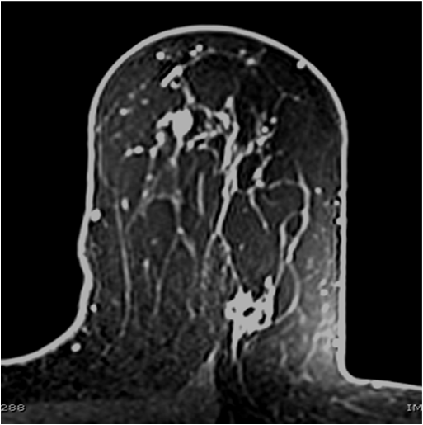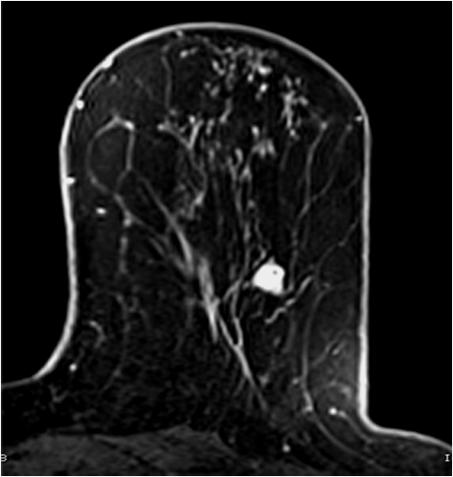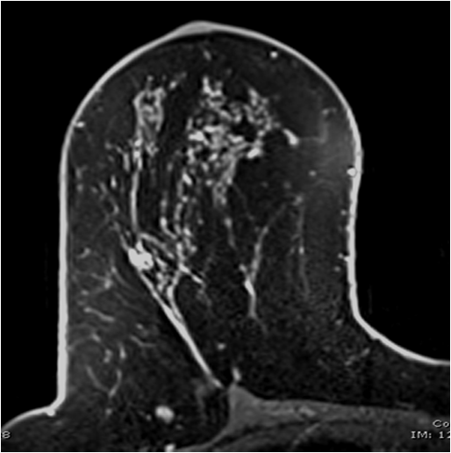A. B. C.
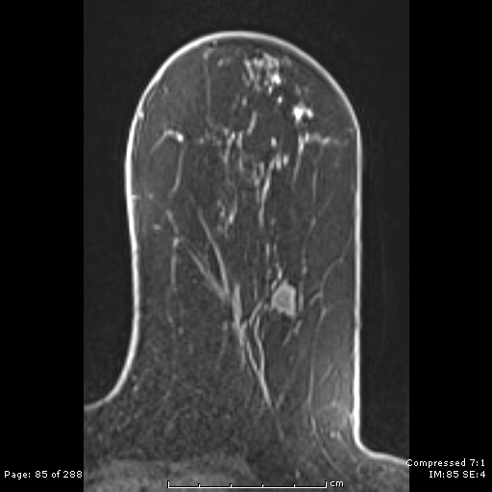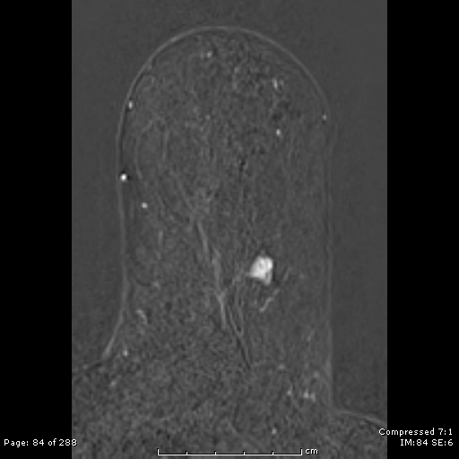
D. E.

Figure 1 3.0 Tesla axial T1-weighted fat-suppressed contrast enhanced images in 62-year-old woman with newly diagnosed left breast infiltrating ductal carcinoma. A: The index cancer is shown posteriorly in the superior lateral quadrant with signal void due to biopsy marker (long arrow) and a second mammographically occult multicentric lesion proven to represent ductal carcinoma in situ (short arrow) is revealed more anteriorly in the superior medial quadrant; B: An additional multicentric lesion proven to represent infiltrating ductal carcinoma (arrow) is seen in the inferior lateral quadrant; C: A suspicious lesion is visualized in the contralateral breast (arrow) which was confirmed as a benign papilloma; D: Note the uniformity of fat suppression in the pre-contrast fat-suppressed T1-weighted image using the 3.0 Tesla (T) system; E: Note the superior lesion conspicuity and margin visualization in the post contrast subtracted image using the 3.0T system.

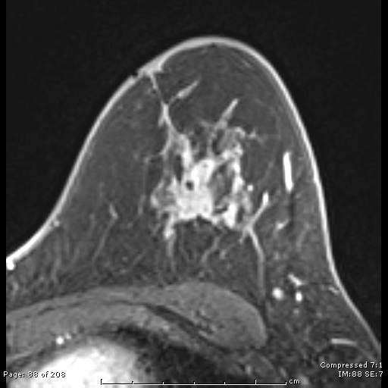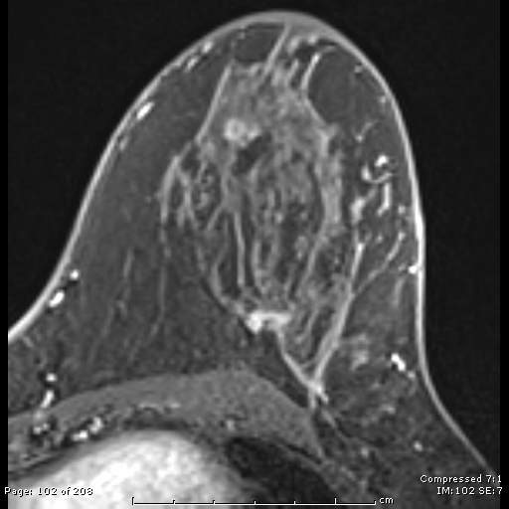
A. B.

Figure 2 1.5 Tesla axial T1-weighted fat-suppressed contrast enhanced subtraction images in 53-year-old woman with newly diagnosed left breast infiltrating ductal carcinoma. A: A conglomerate of masses is seen in the left superior breast with signal void due to biopsy marker (arrow); B: A mammographically occult rim-enhancing lesion (arrow) is revealed 2 cm inferior to the index cancer and confirmed as an additional infiltrating ductal carcinoma. Note the lower contrast and spatial resolution evident on these images compared to the 3.0 Tesla system.

Table 1 1.5 and 3.0 Tesla magnetic resonance imaging protocol
Parameter | Axial T2 | Axial T1 3D GRE no FS | Axial T1 pre 3D GRE | Axial T1 post 3D GRE
1.5 Tesla
TR (ms) | 5811 | 8.3 | 5.2 | 5.2
TE (ms) | 60 | 4.5 | 2.42 | 2.42
Fat saturation | STIR | No | Yes | Yes
Flip angle | 165 | 20 | 10 | 10
Field of view (mm) | 340 | 340 | 340 | 340
Matrix | 384 × 230 | 320 × 320 | 320 × 320 | 320 × 320
Slice thickness (mm) | 5 | 1 | 1 | 1
Voxel size (mm³) | 0.8 × 1.4 × 5.0 | 1.0 × 1.0 × 1.0 | 1.0 × 1.0 × 1.0 | 1.0 × 1.0 × 1.0
Bandwidth (Hz/pixel) | 250 | 347 | 391 | 391
Imaging time (min:s) | 2:50 | 2:50 | 2:26 | 2:26
3.0 Tesla
TR (ms) | 11660 | 4.57 | 4.57 | 3.99
TE (ms) | 69 | 2.46 | 2.46 | 1.61
Fat saturation | STIR | No | Yes | Yes
Flip angle | 120 | 10 | 10 | 9
Field of view (mm) | 324 | 323 | 323 | 323
Matrix | 384 × 384 | 448 × 448 | 448 × 448 | 448 × 448
Slice thickness (mm) | 3 | 0.7 | 0.7 | 0.7
Voxel size (mm³) | 0.8 × 0.8 × 3.0 | 0.7 × 0.7 × 0.7 | 0.7 × 0.7 × 0.7 | 0.7 × 0.7 × 0.7
Bandwidth (Hz/pixel) | 246 | 319 | 698 | 698
Imaging time (min:s) | 2:45 | 2:33 | 2:33 | 2:33

TR: Repetition time; TE: Echo time; GRE: Gradient echo sequence; FS: Fat suppression.
Table 2 Patient and index cancer characteristics n (%)
Characteristic | 1.5 Tesla | 3.0 Tesla | P value
Age (yr)
median (range) | 56  (35-85) | 55  (26-85) | 0.59
Family history of breast cancer
None | 77 (79) | 101 (74) | 0.53
Weak¹ | 10 (10) | 19 (14) | 0.43
Intermediate² | 5 (5) | 11 (8) | 0.44
Strong³ | 6 (6) | 5 (4) | 0.53
Index cancer size (mm)
mean (range) | 17.3  (4.0-70.0) | 18.1  (3.0-92.0) | 0.68
Index cancer histology
Invasive ductal carcinoma  Not otherwise specified  Mucinous type  Medullary type  Papillary type  Tubular type | 67 (68)  65 (66)  1 (1)  0  0  1 (1) | 91 (67)  86 (63)  3 (2)  1 (0.7)  1 (0.7)  0 | 0.13  0.14
Invasive lobular carcinoma | 3 (3) | 3 (2) | 0.11
Mixed invasive lobular and  ductal carcinoma | 3 (3) | 5 (4) | 0.70
Ductal carcinoma in situ | 25 (26) | 37 (27) | 0.56
¹Weak family history: second degree or other relatives; ²Intermediate family history: single post-menopausal first-degree relative; ³Strong family history: premenopausal first-degree relative or multiple post-menopausal first-degree relatives. Unless otherwise indicated, data are number of patients and data in parentheses are percentages

Table 3 Suspicious lesion characteristics n (%)
Characteristic | 1.5 Tesla | 3.0 Tesla | P value
Suspicious lesions (n)  Average number/imaged patient  Range | 98  1 (98/98)  0-6 | 206  1.4 (206/136)  0-8 | 0.001
Size (mm)  mean (range) | 11.9  (3-60) | 10.5  (3-94) | 0.27
Biopsied lesions  Average number/biopsied patient | 88 (90)  1.7 (88/52) | 198 (96)  2.6 (198/75) | 0.04
Method of biopsy  MRI–guided needle biopsy  Ultrasound-guided needle biopsy  Stereotactic needle biopsy  Surgical biopsy | 43 (49)  13 (15)  3 (3)  29 (33) | 87 (44)  37 (19)  2 (1)  72 (36) | 0.44  0.50  0.18  0.60
Reason for no biopsy  Another representative lesion biopsied  Not visualized at MRI-guided biopsy  Benign correlate on ultrasound  Lost to follow-up | 6  2  1  1 | 4  3  1  0
Morphology  Mass  Nonmass-like enhancement  Focus | 37 (38)  40 (41)  21 (21) | 87 (42)  62 (30)  57 (28) | 0.53  0.07  0.26
Kinetics  Wash-out  Plateau  Persistent | 22 (22)  41 (42)  35 (36) | 60 (29)  71 (35)  75 (36) | 0.27  0.25  1.00
Distribution  Multifocal  Multicentric  Contralateral | 34 (35)  33 (34)  31 (32) | 80 (39)  50 (24)  76 (37) | 0.53  0.10  0.44
Unless otherwise indicated, data are number of patients and data in parentheses are percentages. MRI: Magnetic resonance imaging.

Table 4 Magnetic resonance imaging-detected cancer characteristics n (%)
Characteristic | 1.5 Tesla | 3.0 Tesla | P value
Cancers (n)  Positive biopsy rate | 23  23/88 (26) | 54  54/198 (27) | 0.89
Size (mm)  mean (range) | 12.4  (3-50) | 10.9  (4-70) | 0.65
Method of biopsy  MRI–guided needle biopsy  Ultrasound-guided needle biopsy  Stereotactic needle biopsy  Surgical biopsy | 4 (17)  6 (26)  1 (4)  12 (52) | 10 (19)  19 (35)  1 (2)  24 (44)
Morphology  Mass  Nonmass-like enhancement  Focus | 13 (57)  3 (13)  7 (30) | 29 (53)  14 (26)  11 (20) | 1.00  0.25  0.38
Kinetics  Wash-out  Plateau  Persistent | 6 (26)  10 (44)  7 (30) | 19 (35)  21 (39)  14 (26) | 0.65  0.80  0.78
Distribution  Multifocal  Multicentric  Contralateral | 16 (70)  4 (17)  3 (13) | 33 (61)  12 (22)  9 (17) | 0.61  0.76  1.00
Histology  Infiltrating ductal carcinoma  Infiltrating lobular carcinoma  Ductal carcinoma in situ | 14 (61)  0 (0)  9 (39) | 30 (55)  1 (2)  23 (43) | 0.80  1.00  0.81
Unless otherwise indicated, data are number of patients and data in parentheses are percentages. MRI: Magnetic resonance imaging.

Table 5 Patient biopsy outcomes n (%)
Characteristic | 1.5 Tesla | 3.0 Tesla | P value
Imaged patients  Benign  High-risk  Malignant  Multifocal  Multicentric  Ipsilateral  Contralateral | 98  25 (26)  13 (13)  14 (14)  9 (9)  4 (4)  13 (13)  3 (3) | 136  30 (22)  12 (9)  33 (24)  22 (16)  9 (7)  31 (23)  7 (5) | 0.20  1.00  0.07  0.17  0.57  0.09  0.53
Biopsied patients  Benign  High-risk  Malignant  Multifocal  Multicentric  Ipsilateral  Contralateral  PPV of abnormal MRI | 52 (53)  25 (48)  13 (25)  14 (27)  9 (17)  4 (8)  13 (25)  3 (6)  14/52 (27) | 75 (55)  30 (40)  12 (16)  33 (44)  22 (29)  9 (12)  31 (41)  7 (9)  33/75 (44) | 0.79  0.47  0.26  0.06  0.14  0.56  0.06  0.52  0.06

Unless otherwise indicated, data are number of patients and data in parentheses are percentages. MRI: Magnetic resonance imaging; PPV: Positive predictive value.

