Name of Journal: World Journal of Gastrointestinal Oncology
Manuscript NO: 87150
Manuscript Type: ORIGINAL ARTICLE

Basic Study
Association between heat shock factor protein 4 methylation and colorectal cancer risk and potential molecular mechanisms: A bioinformatics study

Zhang WJ et al. Analysis of HSF4 methylation in CRC

Wen-Jing Zhang, Ke-Lin Yue, Jing-Zhai Wang, Yu Zhang

Wen-Jing Zhang, Department of Medical Oncology, The First People’s Hospital of Yunnan Province, Affiliated Hospital of Kunming University of Science and Technology, Kunming 650032, Yunnan Province, China

Ke-Lin Yue, Jing-Zhai Wang, Yu Zhang, Department of Gastroenterology, The First People’s Hospital of Yunnan Province, Affiliated Hospital of Kunming University of Science and Technology, Kunming 650032, Yunnan Province, China

Author contributions: Zhang WJ and Zhang Y conceived and designed the experiments; Zhang WJ, Yue KL, and Wang JZ analyzed the data; Zhang Y contributed to the data curation; Zhang WJ wrote-original draft preparation; Yue KL, Wang JZ, and Zhang Y participated in the writing-review and editing.

Supported by National Natural Science Foundation of China, No. 82260601; Joint Foundation of Kunming Medical University and Yunnan Provincial Science and Technology Department, No. 202201AY070001-256; Grant for Clinical Medical Center of Yunnan Provincial Health Commission, No. 2021LCZXXF-XH03; and Young Academic Talents Cultivation Foundation of Yunnan Province, No. 202205AC160070.

Corresponding author: Yu Zhang, MD, PhD, Associate Professor, Department of Gastroenterology, The First People’s Hospital of Yunnan Province, Affiliated Hospital of Kunming University of Science and Technology, No. 157 Jinbi Road, Kunming 650032, Yunnan Province, China. yuzhang320@sina.com

Received: July 28, 2023
Revised: October 16, 2023
Accepted: November 17, 2023
Published online: December 15, 2023

Abstract
BACKGROUND
We previously demonstrated that heat shock factor protein 4 (HSF4) facilitates colorectal cancer (CRC) progression. DNA methylation, a major modifier of gene expression and stability, is involved in CRC development and outcome.

AIM
To investigate the correlation between HSF4 methylation and CRC risk, and to uncover the underlying molecular mechanisms.

METHODS
Differences in β values of HSF4 methylation loci in multiple malignancies and their correlation with HSF4 mRNA expression were analyzed based on Shiny Methylation Analysis Resource Tool. HSF4 methylation-related genes were identified by LinkedOmics in CRC, and Gene Ontology and Kyoto Encyclopedia of Genes and Genomes enrichment analyses were performed. Protein-protein interaction network of HSF4 methylation-related genes was constructed by String database and MCODE algorithm.

RESULTS
A total of 19 CpG methylation loci were identified in HSF4, and their β values were significantly increased in CRC tissues and exhibited a positive correlation with HSF4 mRNA expression. Unfortunately, the prognostic and diagnostic performance of these CpG loci in CRC patients was mediocre. In CRC, there were 1694 HSF4 methylation-related genes; 1468 of which displayed positive and 226 negative associations, and they were involved in regulating phenotypes such as immune, inflammatory, and metabolic reprogramming. EGFR, RELA, STAT3, FCGR3A, POLR2K, and AXIN1 are hub genes among the HSF4 methylation-related genes.

CONCLUSION
HSF4 is highly methylated in CRC, but there is no significant correlation between it and the prognosis and diagnosis of CRC. HSF4 methylation may serve as one of the ways in which HSF4 mediates the CRC process.

Key Words: Colorectal cancer; DNA methylation; Prognosis; Diagnosis; Bioinformatics; Heat shock factor protein 4

©The Author(s) 2023. Published by Baishideng Publishing Group Inc. All rights reserved.

Citation: Zhang WJ, Yue KL, Wang JZ, Zhang Y. Association between heat shock factor protein 4 methylation and colorectal cancer risk and potential molecular mechanisms: A bioinformatics study. World J Gastrointest Oncol 2023; 15(12): 2150-2168
URL: https://www.wjgnet.com/1948-5204/full/v15/i12/2150.htm
DOI: https://dx.doi.org/10.4251/wjgo.v15.i12.2150

Core Tip: Colorectal cancer (CRC) is a common malignant tumor of the gastrointestinal tract with clinical manifestations of diarrhea, constipation, and abdominal pain. We previously demonstrated that heat shock factor protein 4 (HSF4) accelerates the malignant biological behavior of CRC cells in vivo and in vitro. This study reveals that HSF4 is highly methylated and associated with HSF4 overexpression in CRC. Although the diagnostic and prognostic value of HSF4 methylation is poor, it may be involved in the process of CRC by mediating the expression of HSF4 or related genes. Combined with the finding of our previous study, the present study suggests that the high expression of HSF4 mRNA and protein and its oncogenic effects are likely to be associated with HSF4 methylation.

INTRODUCTION
Colorectal cancer (CRC) is a malignant tumor of the digestive tract that occurs in the rectum, cecum, and entire colon, with symptoms such as abdominal pain, difficulty passing stool, constipation, or diarrhea^{[1]}. According to the latest statistics from the World Health Organization^{[2]}, CRC has become the third most common malignancy worldwide after lung cancer and breast cancer, with about 200000 new cases occurring worldwide each year, of which, 916000 die from CRC. According to the American Society of Clinical Oncology^{[3]}, the 5-year survival rate for patients with CRC is approximately 65%. Nevertheless, most CRC patients have already developed distal metastases by the time they receive a definitive diagnosis, which leads to a shrinking 5-year survival rate to 14%^{[3]}. Consequently, the search for new biomarkers will facilitate the timely diagnosis of CRC and provide new insights into the mechanisms of CRC occurrence and development.
DNA methylation is a process of chemical modification of DNA that affects biological processes such as gene expression, cell differentiation and development^{[4-6]}. In epigenetics, DNA methylation is an important marker of cellular genetic information and is widely applied in cancer prediction and diagnosis^{[7,8]}. For CRC, the United States Food and Drug Administration currently approves SEPT9 (blood samples) and a combination of NDRG4 and BMP3 (stool samples) as commercially available biomarkers related to methylation^{[9]}. In addition, APC, SFRP1, SFRP2, SDC2, MGMT, VIM and NDRG4 are methylation-related candidate markers of CRC^{[10]}. Mechanistically, DNA methylation can inhibit gene transcription or activate gene expression, thereby affecting protein synthesis to mediate the cancer process. For instance, teashirt zinc finger homeobox 3 (TSHZ3) promoter methylation effectively suppresses TSHZ3 expression, which facilitates CRC growth and metastasis^{[11]}. Heparanase 2 (HPSE2) is highly methylated in CRC and is associated with poor patient prognosis, and high methylation of HPSE2 reduces HPSE2 expression, which inhibits the p53/p21 signaling cascade and facilitates proliferation of CRC cells in vivo and in vitro^{[12]}. Heat shock response (HSR), an ancient cellular self-protective response, helps tumor cells to survive and proliferate smoothly under the stimulation of adverse microenvironment, oxidative stress and other stressors^{[13]}. Heat shock factor protein 4 (HSF4), a member of the heat shock transcription factor family, plays an important role in HSR by preventing abnormal protein folding and aggregation to maintain intracellular protein homeostasis^{[13,14]}. HSF4 has been identified as a cancer-promoting factor in lymphoma^{[15]}, breast cancer^{[16]}, and cervical cancer^{[17]}. Our previous study demonstrated that HSF4 is significantly upregulated in CRC, which predicts poor patient prognosis, and that it promotes CRC progression by enhancing the activity of c-MET and downstream ERK1/2 and AKT signaling pathways^{[18]}. Nevertheless, whether DNA methylation is involved in HSF4-mediated CRC progression remains to be investigated.
This study investigated the correlation between HSF4 methylation and HSF4 expression, and its prognostic and diagnostic value in CRC, and aimed to identify the potential molecular mechanisms associated with HSF4 methylation through bioinformatics analysis. The aim was to provide a theoretical basis and a novel perspective for HSF4 as a methylation-related biomarker for future CRC diagnosis and treatment.

MATERIALS AND METHODS
Differential analysis of HSF4 methylation and its prognostic and diagnostic value
The Shiny Methylation Analysis Resource Tool (SMART) APP is an interactive and user-friendly web application for comprehensive analysis of DNA methylation in the The Cancer Genome Atlas (TCGA) project, with data from TCGA (https://portal.gdc.cancer.gov/)^{[19]}. The level of methylation at each CpG loci of HSF4 was assessed using the β value, which is the ratio of the methylation of the allele to the intensity of unmethylation, ranging from 0 to 1. In this study, we analyzed differences in the β values of 19 methylation probes associated with HSF4 in 33 malignancies by SMART, including COAD, READ, BRCA, LAML, LGG, LIHC, BLCA, CESC, CHOL, KIRP, SKCM, LUAD, ACC, DLBC, KIRC, PCPG, OV, ESCA GBM, STAD, UCEC, UCS, HNSC, TGCT, THCA, THYM, KICH, PRAD, SARC, LUSC, MESO, PAAD, and UVM. Wilcoxon rank sum test was performed for difference analysis of β values, and data was adjusted using the Benjamini-Hochberg method. In addition, β values of 19 HSF4-related methylation probes were analyzed differentially in COAD stages and their correlation with HSF4 mRNA expression based on SMART. The differential analysis of β values in COAD stages was performed based on ANOVA, and the correlation between β values of each probe and HSF4 mRNA expression was performed based on Pearson. The COAD dataset in SMART was extracted and HSF4 methylation in prognostic and diagnostic value of COAD was assessed by survival (https://cran.r-project.org/web/packages/survival/index.html) and pROC^{[20]}/timeROC^{[21]} R packages, respectively. Kaplan-Meier survival curves, Receiver operating characteristic (ROC) curves and time-dependent ROC curves were visualized with the ggplot2 R package^{[22]}. Patient information is shown in Table 1.

Identification of HSF4 methylation-related genes and their enrichment analysis
LinkedOmics is a publicly available portal that includes three analysis modules, LinkFinder, LinkInterpreter and LinkCompare, to support users in performing multi-omics analysis in cancer, with data from TCGA (https://www.cancer.gov/ccg/ research/genome-sequencing/tcga) and Clinical Proteomic Tumor Analysis Consortium (https://proteomics.cancer.gov/programs/cptac)^{[23]}. In this study, genes associated with HSF4 methylation were identified at COAD through LinkedOmics. HSF4 methylation-associated genes were identified by Spearman and subjected to correction by the Benjamini-Hochberg method. Finally, HSF4 methylation-related genes were displayed by volcano plot and heatmap. Enrichment analysis of HSF4 methylation-related genes was performed by hypergeometric distribution algorithm based on Gene Ontology (GO)^{[24]} and Kyoto Encyclopedia of Genes and Genomes (KEGG)^{[25]} databases, and presented by bubble and histogram plots. The above results was visualized with the ggplot2 R package^{[22]}.

Protein-protein interaction network construction for HSF4 methylation-associated genes
The protein-protein interaction (PPI) network construction for HSF4 methylation-related genes was based on the String database^{[26]}, CytoScape software^{[27]} and the MCODE plugin^{[28]}. Briefly, HSF4 methylation-related genes obtained from LinkedOmics were extracted, and the interactions of these genes were predicted from the String database. The minimum required interaction score of the String database was set to highest confidence. The interactions were imported into CytoScape software (version:3.8.2) for visualization and clustering analysis of the PPI network was performed by the MCODE algorithm. The parameters of MCODE are degree cutoff = 2, node density cutoff = 0.1, node score cutoff = 0.2, K-core = 2, Max depth = 100.

RESULTS
Identification of HSF4 methylation levels
HSF4 is located on chromosome 16 with 19 CpG loci, with 14 on CpG island, three on N Shore and two on S Shore (Figure 1). Differential analysis revealed that β values of HSF4 CpG-aggregation methylation were significantly enhanced in most malignancies, including COAD, and READ (Figure 1B). Similarly, the β values of each CpG site were significantly higher in most malignant tumors than in the corresponding paracancerous tissues (Supplementary Figure 1). It is notable that all CpG loci of HSF4 had significantly elevated β values in these malignancies only in COAD (Supplementary Figure 1 and Figure 2). In READ, only two probes, cg07188665 and cg09567485, exhibited no significant difference in β values. We analyzed the methylation levels of HSF4 CpG loci in different tumor stages. The β values of cg06277900, cg03811260, cg04580872, cg06621126, cg03887094 and cg09567485 probes were significantly different at various stages of COAD (Supplementary Figure 2). Therefore, we further explored the correlation between HSF4 methylation and HSF4 expression. In COAD, the β values of the probes displayed a significant positive correlation with HSF4 expression, except for cg07188665 (Figure 3). Combined with our previous findings, we believe that HSF4 promotes the CRC process at least through DNA methylation.

HSF4 methylation correlates poorly with CRC prognosis and diagnosis
In view of the differences in HSF4 methylation in CRC, we further analyzed the prognostic and diagnostic value of HSF4 methylation. Kaplan-Meier curves indicated no significant difference in survival among COAD patients with high and low methylation levels for each CpG loci (Figure 4). Nevertheless, most patients with hypermethylated CpG loci had better prognosis. The ROC curve revealed that the area under the curve (AUC) of each CpG loci ranged from 0.498 to 0.574 in COAD patients, suggesting the mediocre diagnostic value of HSF4 methylation in COAD patients (Figure 5A). The time-dependent ROC curves suggested that the AUC of each CpG loci was greater with increasing time (Figure 5B). The above results indicated that the performance of HSF4 methylation as a prognostic and diagnostic biomarker in CRC was ordinary, which may have been caused by relatively low accumulation of single genes.

Identification of HSF4 methylation-related genes in CRC and their functional enrichment analysis
We analyzed the genes associated with HSF4 methylation in CRC by LinkedOmics. The expression of 1468 genes was positively correlated with HSF4 methylation levels, and expression of 226 genes was negatively correlated with HSF4 methylation levels in the COAD cohort (Figure 6A). The heatmap illustrated the top 50 genes with absolute correlation coefficients (Figures 6B and C). To further understand the functions and pathways involved in these genes, we performed GO and KEGG enrichment analysis. GO identified that the proteins encoded by these genes were mainly extracellular matrix, and associated with processes such as positive regulation of mitogen-activated protein kinase cascade, tumor necrosis factor superfamily cytokine production, neutrophil mediated cytotoxicity, and chemokine activity (Figure 6D). KEGG enrichment revealed that HSF4 methylation-related genes were involved in pathways including chemokine signaling pathway, calcium signaling pathway, glycosphingolipid biosynthesis - lacto and neolacto series, inflammatory bowel disease and inflammatory bowel disease (Figure 6E). It is suggested that HSF4 methylation mediates the phenotypic involvement of immune, inflammatory, and metabolic reprogramming in the CRC process.

PPI network of HSF4 methylation-associated genes in CRC
To identify the hub genes in HSF4 methylation-related genes, we constructed a relevant PPI network based on the String database and the MCODE algorithm. The PPI network constructed for HSF4 methylation positively correlated genes contained 422 nodes and 702 edges, and 22 clustering networks were obtained (Figure 7A). The top 20 genes in this network with the highest number of edges are displayed in Figure 7B, where EGFR, RELA, STAT3, ESR1, and F2 had the highest number of edges. The top 10 interworking networks with clustering scores are illustrated in Figure 7C. The network consisting of NUP98, SUMO3, IPO8, and HSPA6 had the highest clustering score, which contained 11 nodes and 35 edges (Figure 7C). In the same way, the network constructed for negatively associated genes contained 110 genes, 122 interactions and five clusters (Figure 8A). The edge numbers TOP5 of FCGR3A, POLR2K, AXIN1, CCL2 and COPS5 had eight, seven, six, five and five edges, respectively (Figure 8B). The five clustering networks composed of genes and interactions are shown in Figure 8C. It is suggested that these genes are involved in HSF4 methylation mediation of the CRC process.

DISCUSSION
CRC is the second leading cause of cancer-related deaths worldwide. CRC is the outcome of progressive accumulation of a series of mutations and epigenetic changes in the rectum, cecum, and colon, leading to the development of colorectal adenoma and invasive adenocarcinoma. DNA methylation, one of the major epigenetic modifications, has been partially identified as a commercial diagnostic and prognostic biomarker for CRC. We have previously identified HSF4 as an oncogenic gene in CRC^{[18]}. Therefore, we tapped the diagnostic and prognostic value of HSF4 and its possible molecular mechanisms in CRC. Unfortunately, HSF4, like most single-gene markers^{[29-32]}, has a mediocre diagnostic and prognostic value for its methylation levels in CRC. As in previous studies^{[29-32]}, this may be due to the small sample size analyzed or the insufficient accumulation of single gene methylation. Therefore, we analyzed the role of HSF4 methylation in CRC at the molecular mechanism level. It is noteworthy that we identified 1694 genes associated with HSF4 methylation, and their possible involvement in immune, inflammatory, and metabolic reprogramming. In addition, the constructed PPI network demonstrated that EGFR, RELA, STAT3, ESR1, FCGR3A, AXIN1, CCL2, and COPS5 are hub genes among HSF4 methylation-related genes.
Most of these hub genes have been demonstrated to be involved in the CRC process and have been applied as therapies for CRC. For instance, EGFR is a transmembrane receptor that plays a regulatory role in tumor cell function by binding to EGFs, promoting cell proliferation, differentiation, and survival^{[33]}. Currently, monoclonal antibodies against EGFR, such as cetuximab or panitumumab, are utilized in the clinical treatment of patients with metastatic CRC^{[34,35]}. RELA, also known as p65 or nuclear factor (NF)-κB p65, is known to be a key transcription factor in tumors, and it mediates immune and inflammatory responses to facilitate cancer cell survival and metastasis, which leads to it being a key target in tumor therapy^{[36,37]}. Similarly, FCGR3A belongs to the Fc γ receptor family, which is mainly expressed on the surface of natural killer cells, monocytes, and macrophages and plays an important role in antibody-mediated immune responses^{[38]}. Polymorphisms in FCGR3A are associated with progression-free survival in patients with metastatic CRC treated with cetuximab^{[39,40]}. COPS5, also known as CSN5 or JAB1, is one of the constituent proteins of the COP9 signalosome, is a nuclear-plasmid transmembrane protein with multiple functions, and is involved in the regulation of various cellular processes such as cell proliferation, differentiation, apoptosis, and DNA replication and repair^{[41]}. It has been demonstrated that COPS5 plays a role as a pro-cancer factor in CRC by regulating Wnt and PI14K/AKT pathways^{[42-44]}. Some of these hub genes have also been proven to be related to HSF family proteins. For example, HSR-induced activation of HSP1 is regulated by the NF-κB, which activates transcription of HSPA1A^{[45]}. In turn, HSP1 inhibits the activation of NF-κB pathway^{[46,47]}. Stephanou and Latchman^{[48]} showed that the activation of STAT3 alone facilitates the mobilization of the HSP promoter. Nevertheless, whether HSF4 methylation-mediated alterations in HSF4 expression are crosstalk with these hub genes in CRC remains to be further investigated.
Unfortunately, there were some limitations to this study. For instance, the sample size was small, and a larger sample might reveal satisfactory diagnostic and prognostic values^{[49,50]}. Exploring the correlation between HSF4 methylation and CRC subtypes or HSF4-related gene methylation combinations may improve the value of HSF4 in CRC^{[9,49]}. It is essential to verify HSF4 methylation in CRC tissues by methylation sequencing or microarrays, which could support the findings of this study^{[51]}. Although we demonstrated that HSF4 methylation levels exhibited a positive correlation with HSF4 mRNA expression, in vivo and in vitro experiments are lacking for validation. In the same way, the molecular mechanisms associated with HSF4 methylation remain to be explored in vivo and in vitro. The tumor immune microenvironment (TME) consists of immune cells, blood vessels, and extracellular matrix, and has a dual role in the growth and metastasis of tumor cells^{[52,53]}. HSF family proteins, especially HSF1, have been demonstrated to mediate tumor cell associated immune responses in the TME^{[54,55]}. This predicts that the function of HSF4 in CRC-associated TME is also worthy of investigation.

CONCLUSION
In conclusion, this study reveals that HSF4 is highly methylated in CRC and is associated with HSF4 overexpression. Although HSF4 methylation has poor diagnostic and prognostic value, it may be involved in the CRC process by mediating expression of HSF4 or related genes with potential mechanisms. Combined with our previously described findings^{[18]}, the present study believes that high expression of HSF4 mRNA and protein and its oncogenic effects are most probably due to HSF4 methylation (Figure 9). Specific mechanisms need to be confirmed by more in vivo and in vitro experiments.

ARTICLE HIGHLIGHTS
Research background
DNA methylation is involved in the regulation of gene expression and has been implicated in development and outcome of colorectal cancer (CRC).

Research motivation
We previously demonstrated that heat shock factor protein 4 (HSF4) expression is abnormally high, and contributes to the malignant biological behavior of CRC in vivo and in vitro. However, the correlation of HSF4 methylation with HSF4 expression and prognosis of CRC patients, and other potential molecular mechanisms need to be further investigated.

Research objectives
The present study was proposed to investigate the correlation between HSF4 methylation and CRC risk, and to uncover the underlying molecular mechanisms.

Research methods
Identification of HSF4 methylation sites, and analysis of the differences in β values of HSF4 methylation sites and their correlation with HSF4 mRNA expression were performed using Shiny Methylation Analysis Resource Tool Web. The genes associated with HSF4 methylation were identified by LinkedOmics Web for CRC, and Gene Ontology and Kyoto Encyclopedia of Genes and Genomes enrichment analyses were performed to reveal the functions and signaling that these associated genes may be involved in. The String database and MCODE algorithm were performed to construct protein-protein interaction (PPI) networks of HSF4 methylation-related genes.

Research results
The HSF4 gene had 19 CpG methylation sites, and their β-values were significantly higher in CRC tissues, positively correlating with HSF4 mRNA expression. The β value of the HSF4 methylation site was not associated with the prognosis of CRC patients. Notably, there are 1694 genes in CRC tissues whose expression is associated with HSF4 methylation and which are involved in immune, inflammatory, and metabolic reprogramming. EGFR, STAT3 and AXIN1 are hub genes in the PPI network constructed by these HSF4 methylation-related genes.

Research conclusions
The HSF4 gene is highly methylated in CRC, and is associated with the overexpression of HSF4 mRNA. HSF4 methylation may be involved in the process of CRC by mediating the expression of HSF4 or related genes.

Research perspectives
The finding will provide a theoretical basis and a new perspective on HSF4 as a methylation-related biomarker for future CRC diagnosis and treatment.

REFERENCES
1 Dekker E, Tanis PJ, Vleugels JLA, Kasi PM, Wallace MB. Colorectal cancer. Lancet 2019; 394: 1467-1480 [PMID: 31631858 DOI: 10.1016/S0140-6736(19)32319-0]
2 Singh D, Vignat J, Lorenzoni V, Eslahi M, Ginsburg O, Lauby-Secretan B, Arbyn M, Basu P, Bray F, Vaccarella S. Global estimates of incidence and mortality of cervical cancer in 2020: a baseline analysis of the WHO Global Cervical Cancer Elimination Initiative. Lancet Glob Health 2023; 11: e197-e206 [PMID: 36528031 DOI: 10.1016/S2214-109X(22)00501-0]
3 Morris VK, Kennedy EB, Baxter NN, Benson AB 3rd, Cercek A, Cho M, Ciombor KK, Cremolini C, Davis A, Deming DA, Fakih MG, Gholami S, Hong TS, Jaiyesimi I, Klute K, Lieu C, Sanoff H, Strickler JH, White S, Willis JA, Eng C. Treatment of Metastatic Colorectal Cancer: ASCO Guideline. J Clin Oncol 2023; 41: 678-700 [PMID: 36252154 DOI: 10.1200/JCO.22.01690]
4 Mattei AL, Bailly N, Meissner A. DNA methylation: a historical perspective. Trends Genet 2022; 38: 676-707 [PMID: 35504755 DOI: 10.1016/j.tig.2022.03.010]
5 Law PP, Holland ML. DNA methylation at the crossroads of gene and environment interactions. Essays Biochem 2019; 63: 717-726 [PMID: 31782496 DOI: 10.1042/EBC20190031]
6 Locke WJ, Guanzon D, Ma C, Liew YJ, Duesing KR, Fung KYC, Ross JP. DNA Methylation Cancer Biomarkers: Translation to the Clinic. Front Genet 2019; 10: 1150 [PMID: 31803237 DOI: 10.3389/fgene.2019.01150]
7 Saghafinia S, Mina M, Riggi N, Hanahan D, Ciriello G. Pan-Cancer Landscape of Aberrant DNA Methylation across Human Tumors. Cell Rep 2018; 25: 1066-1080.e8 [PMID: 30355485 DOI: 10.1016/j.celrep.2018.09.082]
8 Nishiyama A, Nakanishi M. Navigating the DNA methylation landscape of cancer. Trends Genet 2021; 37: 1012-1027 [PMID: 34120771 DOI: 10.1016/j.tig.2021.05.002]
9 Jung G, Hernández-Illán E, Moreira L, Balaguer F, Goel A. Epigenetics of colorectal cancer: biomarker and therapeutic potential. Nat Rev Gastroenterol Hepatol 2020; 17: 111-130 [PMID: 31900466 DOI: 10.1038/s41575-019-0230-y]
10 Müller D, Győrffy B. DNA methylation-based diagnostic, prognostic, and predictive biomarkers in colorectal cancer. Biochim Biophys Acta Rev Cancer 2022; 1877: 188722 [PMID: 35307512 DOI: 10.1016/j.bbcan.2022.188722]
11 Zhou Y, Wang S, Yin X, Gao G, Wang Q, Zhi Q, Han Y, Kuang Y. TSHZ3 functions as a tumor suppressor by DNA methylation in colorectal cancer. Clin Res Hepatol Gastroenterol 2021; 45: 101725 [PMID: 34089916 DOI: 10.1016/j.clinre.2021.101725]
12 Zhang H, Xu C, Shi C, Zhang J, Qian T, Wang Z, Ma R, Wu J, Jiang F, Feng J. Hypermethylation of heparanase 2 promotes colorectal cancer proliferation and is associated with poor prognosis. J Transl Med 2021; 19: 98 [PMID: 33663522 DOI: 10.1186/s12967-021-02770-0]
13 Lang BJ, Guerrero ME, Prince TL, Okusha Y, Bonorino C, Calderwood SK. The functions and regulation of heat shock proteins; key orchestrators of proteostasis and the heat shock response. Arch Toxicol 2021; 95: 1943-1970 [PMID: 34003342 DOI: 10.1007/s00204-021-03070-8]
14 Syafruddin SE, Ling S, Low TY, Mohtar MA. More Than Meets the Eye: Revisiting the Roles of Heat Shock Factor 4 in Health and Diseases. Biomolecules 2021; 11 [PMID: 33807297 DOI: 10.3390/biom11040523]
15 Jin X, Eroglu B, Cho W, Yamaguchi Y, Moskophidis D, Mivechi NF. Inactivation of heat shock factor Hsf4 induces cellular senescence and suppresses tumorigenesis in vivo. Mol Cancer Res 2012; 10: 523-534 [PMID: 22355043 DOI: 10.1158/1541-7786.MCR-11-0530]
16 Chen R, Liliental JE, Kowalski PE, Lu Q, Cohen SN. Regulation of transcription of hypoxia-inducible factor-1α (HIF-1α) by heat shock factors HSF2 and HSF4. Oncogene 2011; 30: 2570-2580 [PMID: 21258402 DOI: 10.1038/onc.2010.623]
17 Tu N, Hu Y, Mivechi NF. Heat shock transcription factor (Hsf)-4b recruits Brg1 during the G1 phase of the cell cycle and regulates the expression of heat shock proteins. J Cell Biochem 2006; 98: 1528-1542 [PMID: 16552721 DOI: 10.1002/jcb.20865]
18 Zhang W, Zhang X, Cheng P, Yue K, Tang M, Li Y, Guo Q, Zhang Y. HSF4 promotes tumor progression of colorectal cancer by transactivating c-MET. Mol Cell Biochem 2023; 478: 1141-1150 [PMID: 36229759 DOI: 10.1007/s11010-022-04582-2]
19 Li Y, Ge D, Lu C. The SMART App: an interactive web application for comprehensive DNA methylation analysis and visualization. Epigenetics Chromatin 2019; 12: 71 [PMID: 31805986 DOI: 10.1186/s13072-019-0316-3]
20 Robin X, Turck N, Hainard A, Tiberti N, Lisacek F, Sanchez JC, Müller M. pROC: an open-source package for R and S+ to analyze and compare ROC curves. BMC Bioinformatics 2011; 12: 77 [PMID: 21414208 DOI: 10.1186/1471-2105-12-77]
21 Blanche P, Dartigues JF, Jacqmin-Gadda H. Estimating and comparing time-dependent areas under receiver operating characteristic curves for censored event times with competing risks. Stat Med 2013; 32: 5381-5397 [PMID: 24027076 DOI: 10.1002/sim.5958]
22 Ito K, Murphy D. Application of ggplot2 to Pharmacometric Graphics. CPT Pharmacometrics Syst Pharmacol 2013; 2: e79 [PMID: 24132163 DOI: 10.1038/psp.2013.56]
23 Vasaikar SV, Straub P, Wang J, Zhang B. LinkedOmics: analyzing multi-omics data within and across 32 cancer types. Nucleic Acids Res 2018; 46: D956-D963 [PMID: 29136207 DOI: 10.1093/nar/gkx1090]
24 Mi H, Muruganujan A, Ebert D, Huang X, Thomas PD. PANTHER version 14: more genomes, a new PANTHER GO-slim and improvements in enrichment analysis tools. Nucleic Acids Res 2019; 47: D419-D426 [PMID: 30407594 DOI: 10.1093/nar/gky1038]
25 Kanehisa M, Furumichi M, Sato Y, Ishiguro-Watanabe M, Tanabe M. KEGG: integrating viruses and cellular organisms. Nucleic Acids Res 2021; 49: D545-D551 [PMID: 33125081 DOI: 10.1093/nar/gkaa970]
26 Szklarczyk D, Kirsch R, Koutrouli M, Nastou K, Mehryary F, Hachilif R, Gable AL, Fang T, Doncheva NT, Pyysalo S, Bork P, Jensen LJ, von Mering C. The STRING database in 2023: protein-protein association networks and functional enrichment analyses for any sequenced genome of interest. Nucleic Acids Res 2023; 51: D638-D646 [PMID: 36370105 DOI: 10.1093/nar/gkac1000]
27 Otasek D, Morris JH, Bouças J, Pico AR, Demchak B. Cytoscape Automation: empowering workflow-based network analysis. Genome Biol 2019; 20: 185 [PMID: 31477170 DOI: 10.1186/s13059-019-1758-4]
28 Bader GD, Hogue CW. An automated method for finding molecular complexes in large protein interaction networks. BMC Bioinformatics 2003; 4: 2 [PMID: 12525261 DOI: 10.1186/1471-2105-4-2]
29 Shao C, Dai W, Li H, Tang W, Jia S, Wu X, Luo Y. The relationship between RASSF1A gene promoter methylation and the susceptibility and prognosis of melanoma: A meta-analysis and bioinformatics. PLoS One 2017; 12: e0171676 [PMID: 28207831 DOI: 10.1371/journal.pone.0171676]
30 Laugsand EA, Brenne SS, Skorpen F. DNA methylation markers detected in blood, stool, urine, and tissue in colorectal cancer: a systematic review of paired samples. Int J Colorectal Dis 2021; 36: 239-251 [PMID: 33030559 DOI: 10.1007/s00384-020-03757-x]
31 Vedeld HM, Nesbakken A, Lothe RA, Lind GE. Re-assessing ZNF331 as a DNA methylation biomarker for colorectal cancer. Clin Epigenetics 2018; 10: 70 [PMID: 29854011 DOI: 10.1186/s13148-018-0503-2]
32 Gogna P, King WD. The relationship between colorectal cancer risk factors and LINE-1 DNA methylation in healthy colon tissue. Epigenomics 2020; 12: 1087-1093 [PMID: 32790479 DOI: 10.2217/epi-2019-0340]
33 Sigismund S, Avanzato D, Lanzetti L. Emerging functions of the EGFR in cancer. Mol Oncol 2018; 12: 3-20 [PMID: 29124875 DOI: 10.1002/1878-0261.12155]
34 Zhou J, Ji Q, Li Q. Resistance to anti-EGFR therapies in metastatic colorectal cancer: underlying mechanisms and reversal strategies. J Exp Clin Cancer Res 2021; 40: 328 [PMID: 34663410 DOI: 10.1186/s13046-021-02130-2]
35 Piawah S, Venook AP. Targeted therapy for colorectal cancer metastases: A review of current methods of molecularly targeted therapy and the use of tumor biomarkers in the treatment of metastatic colorectal cancer. Cancer 2019; 125: 4139-4147 [PMID: 31433498 DOI: 10.1002/cncr.32163]
36 Patel M, Horgan PG, McMillan DC, Edwards J. NF-κB pathways in the development and progression of colorectal cancer. Transl Res 2018; 197: 43-56 [PMID: 29550444 DOI: 10.1016/j.trsl.2018.02.002]
37 Peng C, Ouyang Y, Lu N, Li N. The NF-κB Signaling Pathway, the Microbiota, and Gastrointestinal Tumorigenesis: Recent Advances. Front Immunol 2020; 11: 1387 [PMID: 32695120 DOI: 10.3389/fimmu.2020.01387]
38 Wang TT, Ravetch JV. Functional diversification of IgGs through Fc glycosylation. J Clin Invest 2019; 129: 3492-3498 [PMID: 31478910 DOI: 10.1172/JCI130029]
39 Zhang W, Gordon M, Schultheis AM, Yang DY, Nagashima F, Azuma M, Chang HM, Borucka E, Lurje G, Sherrod AE, Iqbal S, Groshen S, Lenz HJ. FCGR2A and FCGR3A polymorphisms associated with clinical outcome of epidermal growth factor receptor expressing metastatic colorectal cancer patients treated with single-agent cetuximab. J Clin Oncol 2007; 25: 3712-3718 [PMID: 17704420 DOI: 10.1200/jco.2006.08.8021]
40 Pander J, Gelderblom H, Antonini NF, Tol J, van Krieken JH, van der Straaten T, Punt CJ, Guchelaar HJ. Correlation of FCGR3A and EGFR germline polymorphisms with the efficacy of cetuximab in KRAS wild-type metastatic colorectal cancer. Eur J Cancer 2010; 46: 1829-1834 [PMID: 20418097 DOI: 10.1016/j.ejca.2010.03.017]
41 Liu G, Claret FX, Zhou F, Pan Y. Jab1/COPS5 as a Novel Biomarker for Diagnosis, Prognosis, Therapy Prediction and Therapeutic Tools for Human Cancer. Front Pharmacol 2018; 9: 135 [PMID: 29535627 DOI: 10.3389/fphar.2018.00135]
42 Zhou R, Shao Z, Liu J, Zhan W, Gao Q, Pan Z, Wu L, Xu L, Ding Y, Zhao L. COPS5 and LASP1 synergistically interact to downregulate 14-3-3σ expression and promote colorectal cancer progression via activating PI3K/AKT pathway. Int J Cancer 2018; 142: 1853-1864 [PMID: 29226323 DOI: 10.1002/ijc.31206]
43 Jumpertz S, Hennes T, Asare Y, Schütz AK, Bernhagen J. CSN5/JAB1 suppresses the WNT inhibitor DKK1 in colorectal cancer cells. Cell Signal 2017; 34: 38-46 [PMID: 28229932 DOI: 10.1016/j.cellsig.2017.02.013]
44 Schütz AK, Hennes T, Jumpertz S, Fuchs S, Bernhagen J. Role of CSN5/JAB1 in Wnt/β-catenin activation in colorectal cancer cells. FEBS Lett 2012; 586: 1645-1651 [PMID: 22668871 DOI: 10.1016/j.febslet.2012.04.037]
45 Sasi BK, Sonawane PJ, Gupta V, Sahu BS, Mahapatra NR. Coordinated transcriptional regulation of Hspa1a gene by multiple transcription factors: crucial roles for HSF-1, NF-Y, NF-κB, and CREB. J Mol Biol 2014; 426: 116-135 [PMID: 24041570 DOI: 10.1016/j.jmb.2013.09.008]
46 Shang L, Wang L, Shi X, Wang N, Zhao L, Wang J, Liu C. HMGB1 was negatively regulated by HSF1 and mediated the TLR4/MyD88/NF-κB signal pathway in asthma. Life Sci 2020; 241: 117120 [PMID: 31825792 DOI: 10.1016/j.lfs.2019.117120]
47 Chen Y, Currie RW. Small interfering RNA knocks down heat shock factor-1 (HSF-1) and exacerbates pro-inflammatory activation of NF-kappaB and AP-1 in vascular smooth muscle cells. Cardiovasc Res 2006; 69: 66-75 [PMID: 16061216 DOI: 10.1016/j.cardiores.2005.07.004]
48 Stephanou A, Latchman DS. Transcriptional regulation of the heat shock protein genes by STAT family transcription factors. Gene Expr 1999; 7: 311-319 [PMID: 10440232]
49 Petit J, Carroll G, Zhao J, Roper E, Pockney P, Scott RJ. Evaluation of epigenetic methylation biomarkers for the detection of colorectal cancer using droplet digital PCR. Sci Rep 2023; 13: 8883 [PMID: 37264006 DOI: 10.1038/s41598-023-35631-5]
50 Fang Q, Yuan Z, Hu H, Zhang W, Wang G, Wang X. Genome-wide discovery of circulating cell-free DNA methylation biomarkers for colorectal cancer detection. Clin Epigenetics 2023; 15: 119 [PMID: 37501075 DOI: 10.1186/s13148-023-01518-5]
51 Ye Z, Song G, Liang J, Yi S, Gao Y, Jiang H. Optimized screening of DNA methylation sites combined with gene expression analysis to identify diagnostic markers of colorectal cancer. BMC Cancer 2023; 23: 617 [PMID: 37400791 DOI: 10.1186/s12885-023-10922-2]
52 Lv B, Wang Y, Ma D, Cheng W, Liu J, Yong T, Chen H, Wang C. Immunotherapy: Reshape the Tumor Immune Microenvironment. Front Immunol 2022; 13: 844142 [PMID: 35874717 DOI: 10.3389/fimmu.2022.844142]
53 El-Arabey AA, Abdalla M, Abd-Allah AR. SnapShot: TP53 status and macrophages infiltration in TCGA-analyzed tumors. Int Immunopharmacol 2020; 86: 106758 [PMID: 32663767 DOI: 10.1016/j.intimp.2020.106758]
54 Shan Q, Ma F, Wei J, Li H, Ma H, Sun P. Physiological Functions of Heat Shock Proteins. Curr Protein Pept Sci 2020; 21: 751-760 [PMID: 31713482 DOI: 10.2174/1389203720666191111113726]
55 Calderwood SK, Hightower LE. Report on the VIIth International Symposium on Heat Shock Proteins in Biology & Medicine. Cell Stress Chaperones 2015; 20: 213-216 [PMID: 25542250 DOI: 10.1007/s12192-014-0562-z]

Footnotes
Institutional review board statement: This study did not involve any animal and human experimentation.

Conflict-of-interest statement: All the authors report no relevant conflicts of interest for this article.

Data sharing statement: No additional data are available.

Open-Access: This article is an open-access article that was selected by an in-house editor and fully peer-reviewed by external reviewers. It is distributed in accordance with the Creative Commons Attribution NonCommercial (CC BY-NC 4.0) license, which permits others to distribute, remix, adapt, build upon this work non-commercially, and license their derivative works on different terms, provided the original work is properly cited and the use is non-commercial. See: https://creativecommons.org/Licenses/by-nc/4.0/

Provenance and peer review: Unsolicited article; Externally peer reviewed.
Peer-review model: Single blind

Peer-review started: July 28, 2023
First decision: September 26, 2023
Article in press: November 17, 2023

Specialty type: Oncology
Country/Territory of origin: China
Peer-review report’s scientific quality classification
Grade A (Excellent): 0
Grade B (Very good): B, B
Grade C (Good): C
Grade D (Fair): 0
Grade E (Poor): E

P-Reviewer: Duraes LC, United States; El-Arabey AA, Egypt; Rotondo JC, Italy; Shinozaki M, Japan S-Editor: Wang JJ L-Editor: A P-Editor: Zhang XD
Figure Legends
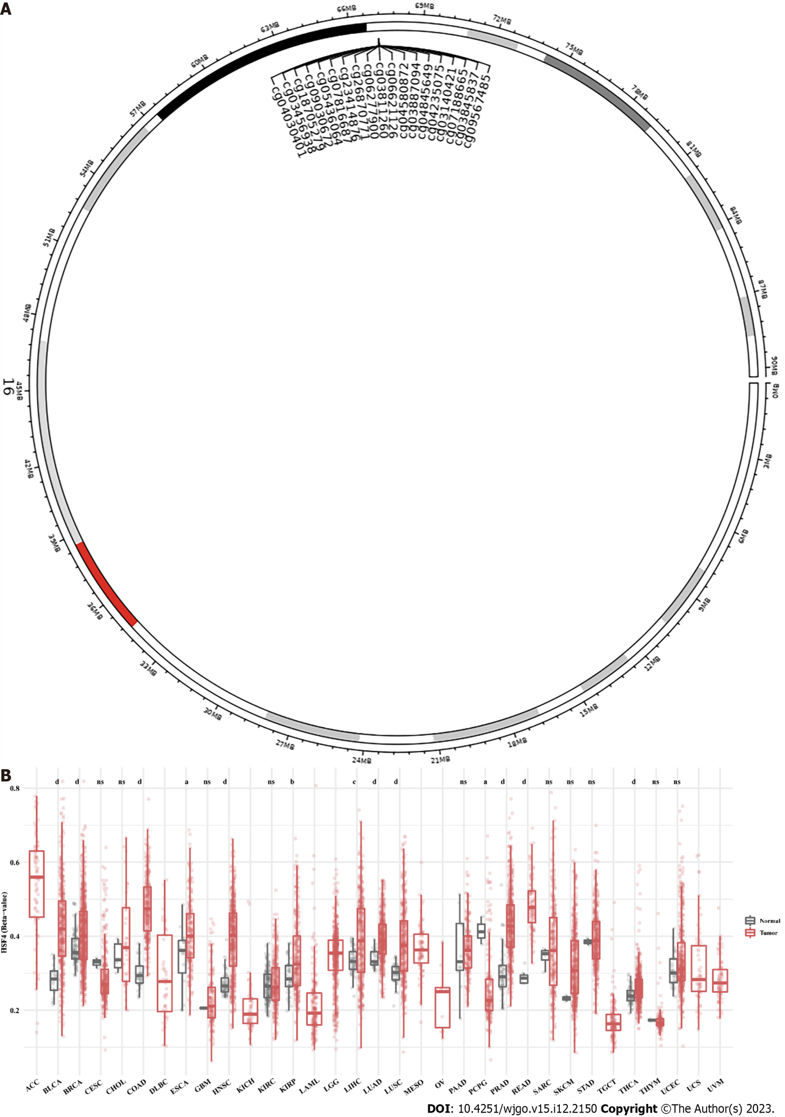
Figure 1 Pan-cancer analysis of heat shock factor protein 4 methylation levels. A: Schematic representation of the distribution of eat shock factor protein 4 (HSF4) methylated CpG loci. B: Differential analysis of the β values of 19 CpG methylation loci of HSF4 in multiple malignancies. ªP < 0.05, ^{b}P < 0.01, ^{c}P < 0.001, and ^{d}P < 0.0001; ns: No significant difference.

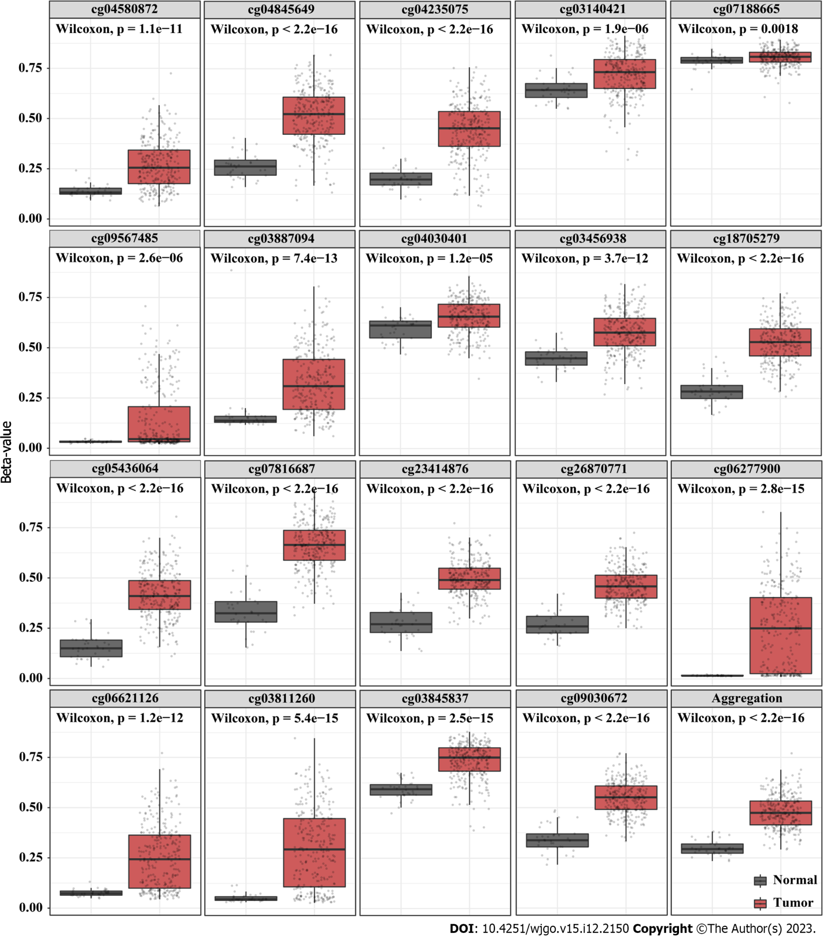
Figure 2 Differential analysis of β values of 19 probes related to heat shock factor protein 4 methylation in colon adenocarcinoma and paracancerous tissues. The β values of all 19 probes were significantly increased in the tissues of colon adenocarcinoma (COAD) patients. Black is paracancerous tissue, and red is COAD tissue.
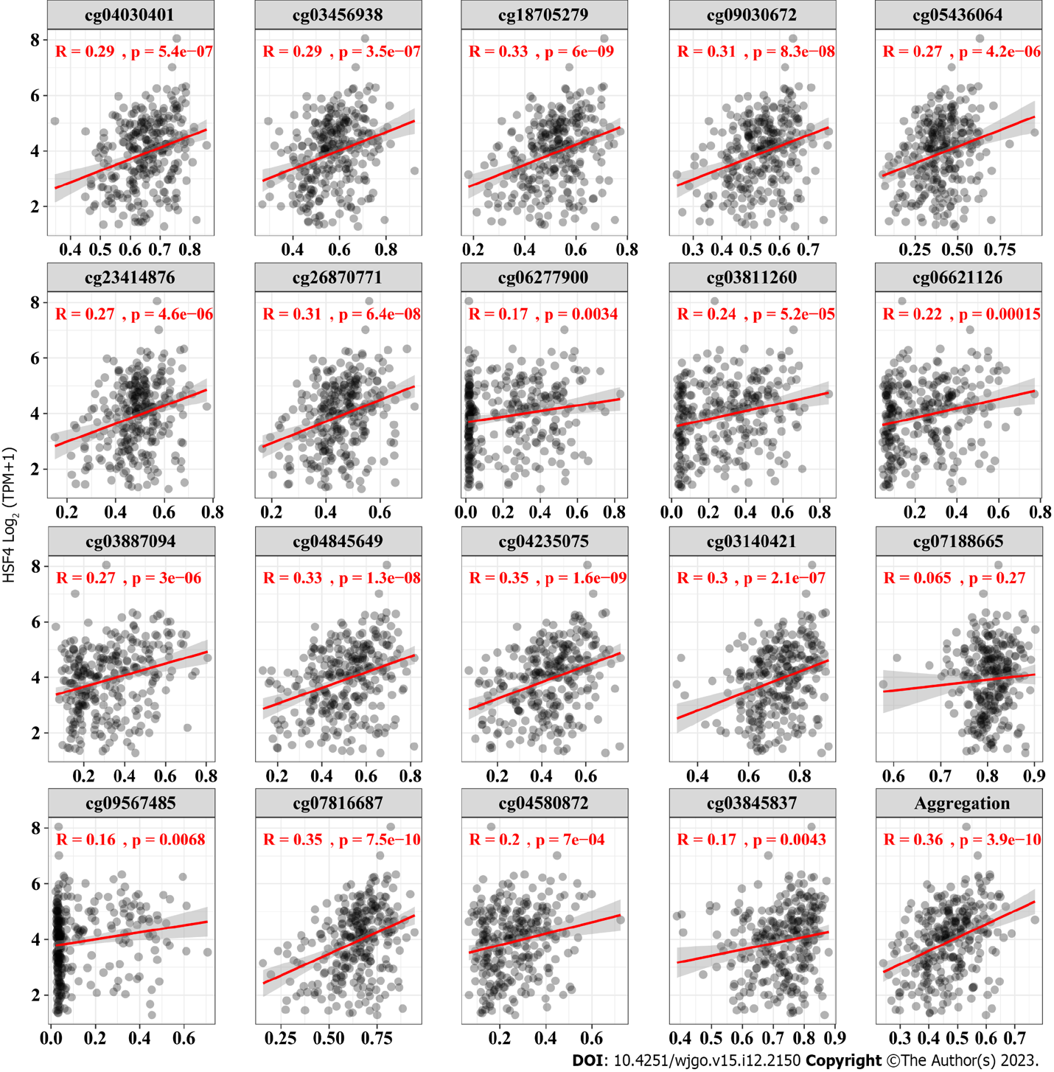
Figure 3 Correlation analysis of heat shock factor protein 4 expression and heat shock factor protein 4 methylation levels. The β values of all 19 probes exhibited a significant positive correlation with the expression of eat shock factor protein 4 (HSF4) mRNA. The x-axis is the β value of 19 probes, and y-axis is log₂ (TPM + 1) of HSF4 mRNA.

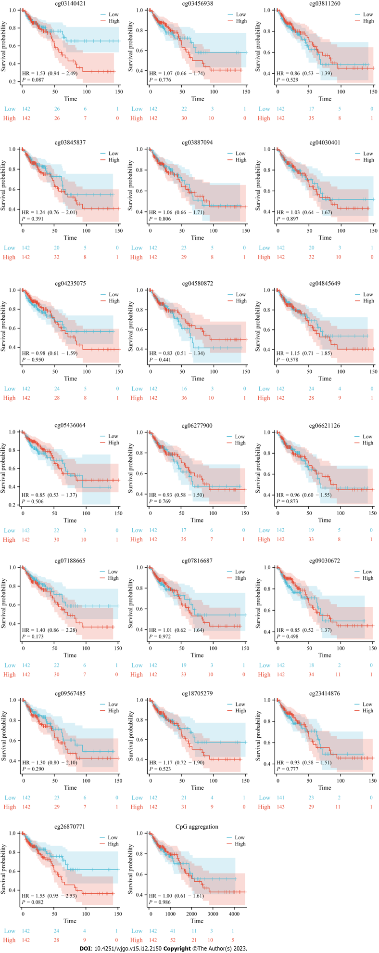
Figure 4 Correlation analysis of heat shock factor protein 4 methylation and prognosis of patients with colon adenocarcinoma. Kaplan Meier survival curves illustrating the survival of colon adenocarcinoma patients with high and low beta values for the 19 probes. The blue curve represents the cohort with low β values, and the red curve stands for the cohort with high β values.

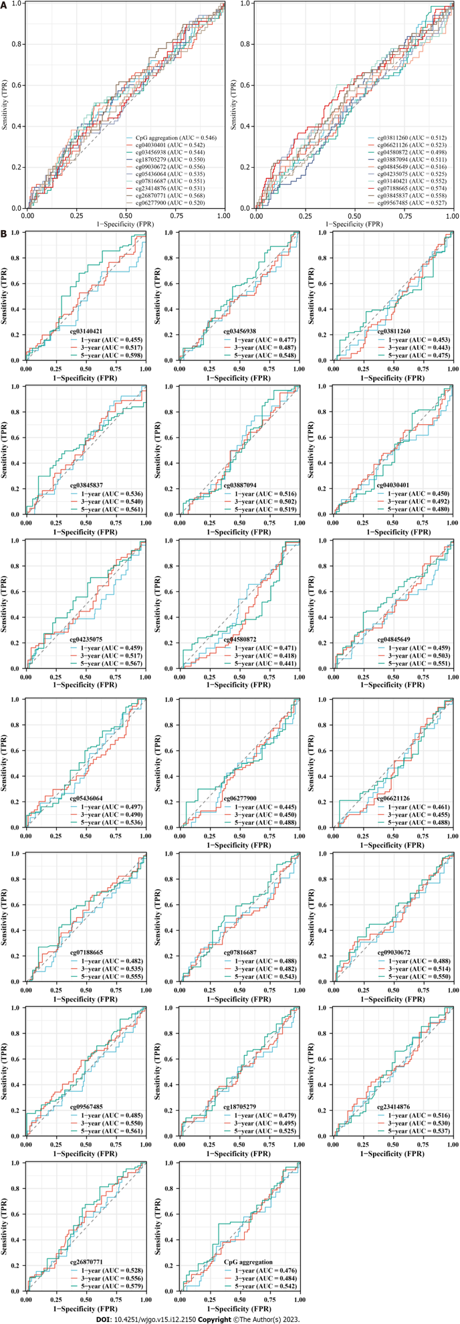
Figure 5 Correlation analysis of heat shock factor protein 4 methylation and diagnosis in patients with colonic adenocarcinoma. A: Receiver operating characteristic (ROC) curves exhibiting the diagnostic value of 19 heat shock factor protein 4 (HSF4) methylation-associated probes in colon adenocarcinoma patients. B: Time-dependent ROC curves displaying the area under the curve of HSF4 methylation at 1, 3 and 5 years. AUC: Area under the curve; TPR: True positive rate; FPR: False positive rate.

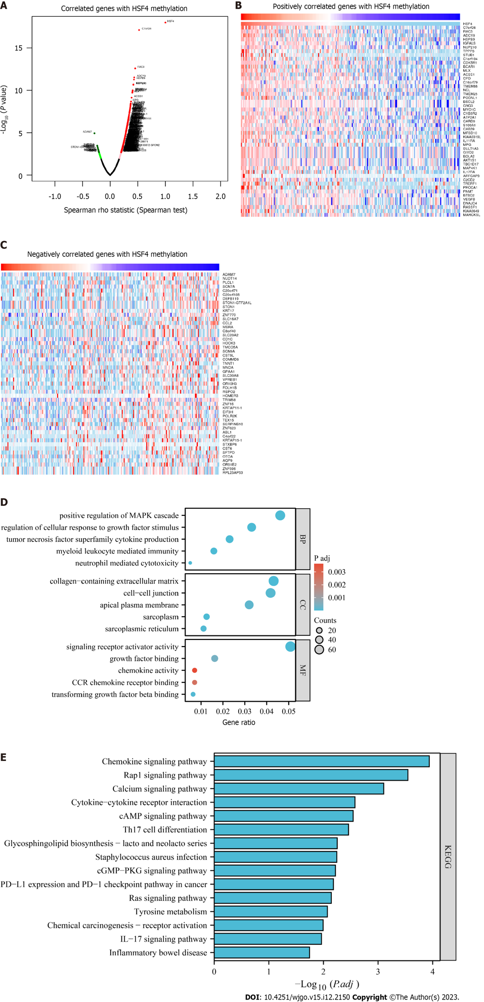
Figure 6 Identification of heat shock factor protein 4 methylation-related genes and their enrichment analysis in colorectal cancer. A: Volcano plot showing genes positively and negatively associated with heat shock factor protein 4 (HSF4) methylation in colorectal cancer. B, C: Expression profiles of the top 50 genes ranked by absolute correlation coefficient of HSF4 methylation-related genes. B is the expression profile of genes positively associated with HSF4 methylation; C is the expression profile of genes negatively associated with HSF4 methylation. D: Bubble plots exhibiting the GO enrichment results of all HSF4 methylation-related genes. E: Possible pathways involved in HSF4 methylation-related genes obtained by Kyoto Encyclopedia of Genes and Genomes enrichment analysis. HSF4: Heat shock factor protein 4; BP: Biological process; CC: Cell component; MF: Molecular function; PD-L1: Programmed cell death-Ligand 1; PD-1: Programmed death 1; IL-17: Interleukin-17.

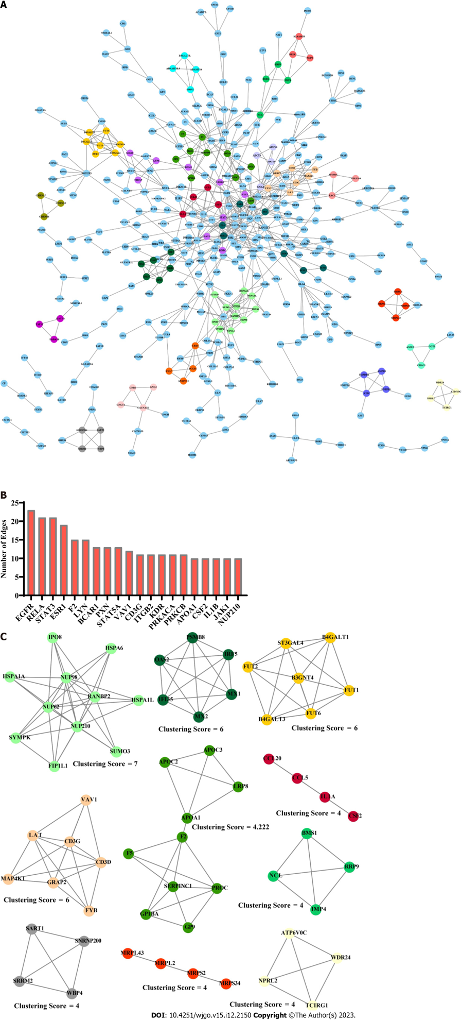
Figure 7 Protein-protein interaction network construction of heat shock factor protein 4 methylation positively associated genes. A: Protein-protein interaction (PPI) network of heat shock factor protein 4 methylation positively related genes constructed based on String database and MCODE algorithm. B: Top 20 genes in PPI network in terms of edge number. C: The top 10 clustering networks in terms of clustering scores obtained by the MCODE algorithm.

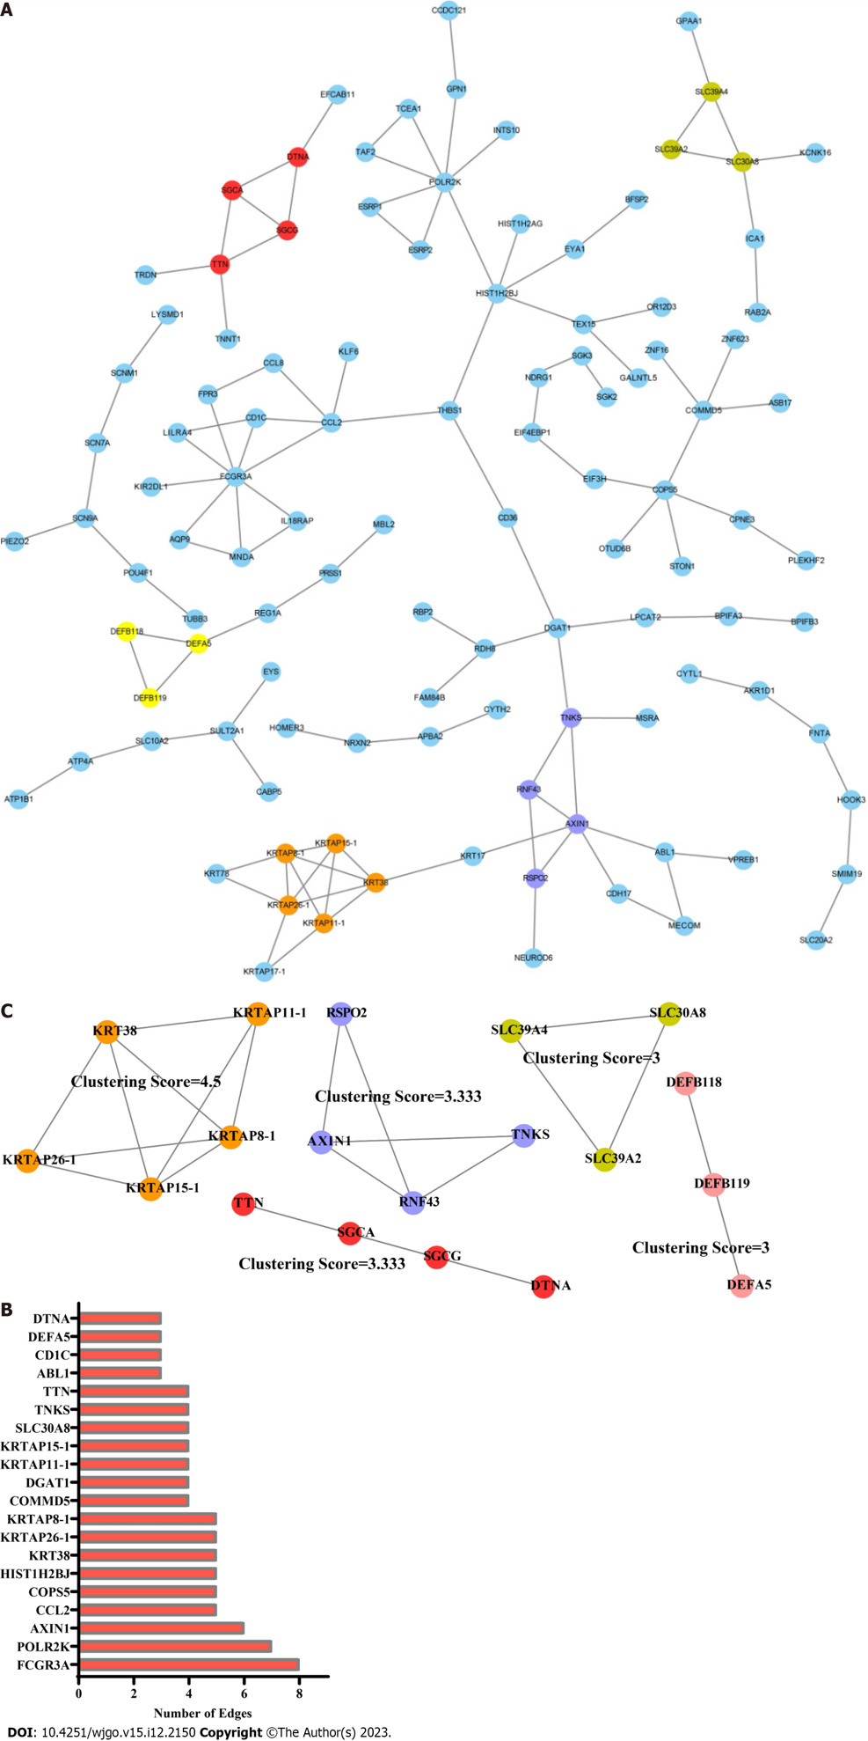
Figure 8 Protein-protein interaction network construction of heat shock factor protein 4 methylation negatively associated genes. A: Representative images of the protein-protein interaction (PPI) network of heat shock factor protein 4 methylation negatively associated genes. B: The bar chart displaying edge number of each gene in the PPI network. C: Gene composition and interactions of clustering networks obtained by the MCODE algorithm.

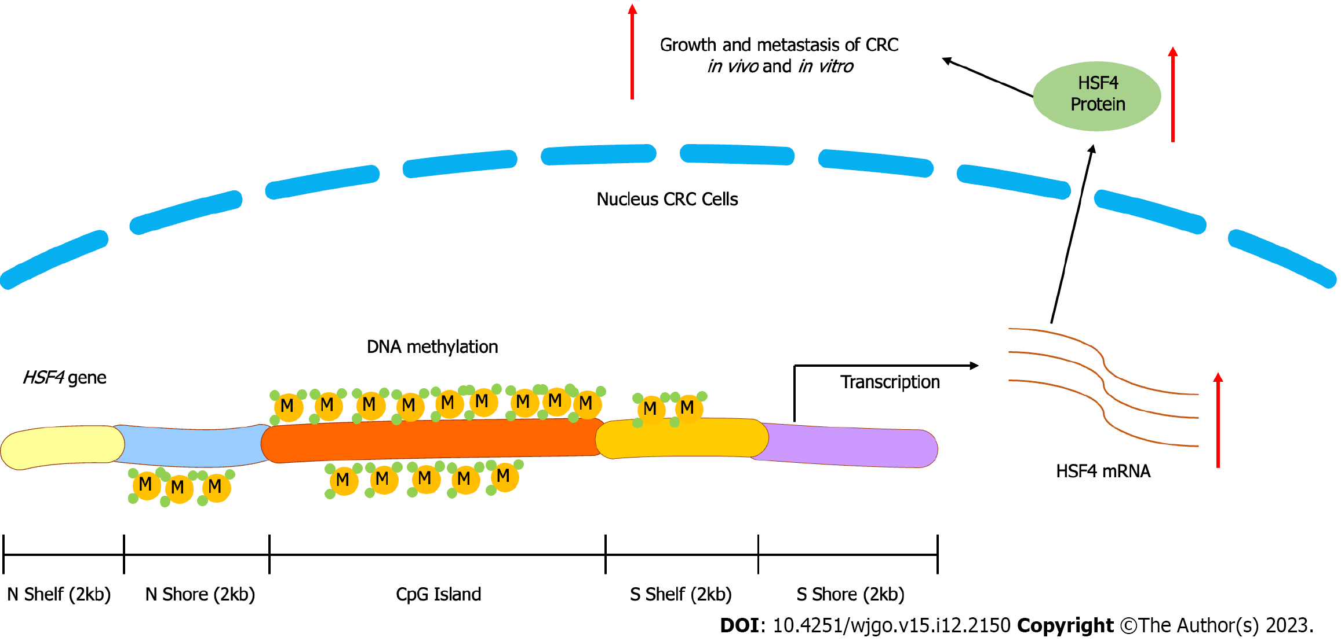
Figure 9 Diagrammatic representation of this study. CRC: Colorectal cancer; HSF4: Heat shock factor protein 4.

Table 1 Basic information of the dataset in this study
Web | Sample source | Sample type | Platform | Samples number
SMART | TCGA_COAD | Tissue | Methylation 450K | Normal = 34, tumor = 288
SMART | TCGA_32 cancer types | Tissue | Methylation 450K | Normal = 676, tumor = 8604
LinkedOmics | TCGA_COADREAD | Tissue | Methylation 27K | Tumor = 233

Published by Baishideng Publishing Group Inc
7041 Koll Center Parkway, Suite 160, Pleasanton, CA 94566, USA
Telephone: +1-925-3991568
E-mail: bpgoffice@wjgnet.com
Help Desk: https://www.f6publishing.com/helpdesk
https://www.wjgnet.com

© 2023 Baishideng Publishing Group Inc. All rights reserved.

