Name of Journal: World Journal of Clinical Cases
Manuscript NO: 73012
Manuscript Type: CASE REPORT

Simultaneous multiple primary malignancies diagnosed by endoscopic ultrasound-guided fine-needle aspiration: A case report

Yang J et al. Simultaneous MPMs diagnosed by EUS-FNA

Jian Yang, Yan Zeng, Jun-Wen Zhang

Jian Yang, Jun-Wen Zhang, Department of Gastroenterology, The First Affiliated Hospital of Chongqing Medical University, Chongqing 400016, China

Yan Zeng, Department of Psychology, The Second Affiliated Hospital of Chongqing Medical University, Chongqing 400010, China

Author contributions: Yang J, Zeng Y and Zhang JW designed and performed the research; Yang J and Zhang JW performed EUS-FNA; Yang J and Zeng Y analyzed the data and wrote the manuscript; all authors have read and approved the final manuscript.

Corresponding author: Jun-Wen Zhang, MD, Chief Doctor, Professor, Department of Gastroenterology, The First Affiliated Hospital of Chongqing Medical University, No. 1 Youyi Road, Yuzhong District, Chongqing 400016, China. 959308413@qq.com

Received: November 8, 2021
Revised: January 13, 2022
Accepted: April 21, 2022
Published online:

Abstract
BACKGROUND
Multiple primary malignancies (MPMs) refer to more than one primary malignancy in the same or separate organs of the same patient, and MPMs are considered when different histological characteristics are detected in epidemiological studies. Herein, we report a case presumed to be primary pancreatic cancer with multiple liver metastases by positron-emission tomography/computed tomography (PET/CT) and confirmed to be synchronous liver and pancreatic MPMs by endoscopic ultrasound-guided fine-needle aspiration (EUS-FNA).

CASE SUMMARY
A 50-year-old man was referred to our hospital due to abdominal discomfort for 2 mo. Abdominal CT at a local hospital revealed a pancreatic mass with multiple liver nodules. After being transferred to our hospital, PET/CT confirmed all these lesions to have elevated metabolic activity, and therefore primary pancreatic cancer with multiple liver metastases was considered. EUS-guided liver aspiration unexpectedly found signet-ring cells with a high Ki-67 positive rate (20%), while EUS-guided pancreatic aspiration detected pancreatic neuroendocrine cells with a relatively low Ki-67 positive rate (1%). The final diagnosis from the multidisciplinary team was simultaneous liver and pancreatic MPMs. The patient returned to his local hospital for neoadjuvant chemotherapy and surgery, and he is still alive during the 6-mo postoperative follow-up.

CONCLUSION
Although rare, MPMs should be considered when treating pancreatic mass with suspected metastatic lesions, and EUS-FNA has proved minimally invasive and accurate.

Key Words: Multiple primary malignancies; Endoscopic ultrasound; Fine-needle aspiration; Pancreatic cancer; Liver cancer; Case report

Yang J, Zeng Y, Zhang JW. Simultaneous multiple primary malignancies diagnosed by endoscopic ultrasound-guided fine-needle aspiration: A case report. World J Clin Cases 2022; In press

Core Tip: We report a rare case of synchronous multiple primary liver and pancreatic malignancies confirmed by endoscopic ultrasound-guided fine-needle aspiration (EUS-FNA), although this patient was first diagnosed as having primary pancreatic cancer with multiple liver metastases by computed tomography and positron-emission tomography/computed tomography. Although rare, multiple primary malignancies should be considered in patients with pancreatic mass and suspected metastatic lesions, and EUS-FNA has proven to be a minimally invasive and accurate preoperative diagnosis method.
INTRODUCTION
Multiple primary malignancies (MPMs) refer to more than one primary malignancy in the same or separate organs of the same patient, and MPMs are considered when different histological characteristics are detected^{[1]}. Simultaneous malignancies are defined as malignancies that are diagnosed at the same time or during the staging of the first malignancy, while synchronous and metachronous malignancies were usually distinguished by a 2-mo or 6-mo time point in different databases^{[2,3]}. In patients with digestive system MPMs, it is infrequent for liver or pancreatic cancer patients to have both primary malignancies detected simultaneously^{[4]}. Treatment strategies and associated prognoses of patients with digestive system MPMs are significantly different from those patients with primary digestive cancer and distant metastasis.
Preoperative endoscopic ultrasound-guided fine-needle aspiration (EUS-FNA) is an essential breakthrough in the endoscopic field and a substantial procedure to evaluate benign and malignant gastrointestinal tract lesions and nearby organs^{[5]}. Taking pancreatic cancer as an example, the overall survival of the preoperative EUS-FNA group was significantly higher than that of the non-FNA group, and there was no remarkable difference in the tumor recurrence rate or peritoneal implantation rate between the two groups^{[6]}.
Herein, we report a case presumed to be primary pancreatic cancer with multiple liver metastases by positron-emission tomography/computed tomography (PET/CT) and confirmed to be synchronous liver and pancreatic MPMs by EUS-FNA.

CASE PRESENTATION
Chief complaints
A 50-year-old Chinese man was referred to our hospital due to abdominal discomfort for approximately 2 mo.

History of present illness
Approximately 1 mo previously, this patient was admitted to a local hospital due to elevated blood amylase. He denied jaundice, vomiting, and gastrointestinal bleeding. He was diagnosed with acute pancreatitis, but CT revealed an enlarged pancreatic head and suspected liver metastases. Thus, he was referred to our hospital for further management.

History of past illness
The patient had no remarkable medical history.

Personal and family history
This patient had a 30-year smoking history (half a pack per day) and has not quit smoking. He denied any family history of cancer.

Physical examination
After admission, the patient’s physical examination revealed no abnormality.

Laboratory examinations
Blood analysis revealed elevated CA19-9 [106 U/mL (0-27 U/mL)], amylase [450 U/L (0-110 U/L)], and lipase [3795 U/L (0-300 U/L)]. Alpha-fetoprotein was within normal limits.

Imaging examinations
After admission, PET/CT detected increased soft tissues with elevated metabolic activity in the pancreatic head (Figure 1) and multiple liver nodules with increased metabolic activity (Figure 2), and therefore the initial diagnosis was primary pancreatic cancer with multiple liver metastases.
EUS confirmed an enlarged hypoechoic pancreatic head (Figure 3A) and multiple hypoechoic liver masses (Figure 3B). A linear Pentax echoendoscope (Hoya Co., Tokyo, Japan) and color Doppler flow imaging were employed to determine the puncture site. No malignant cells were detected in the fluid inside the peripancreatic cystic lesion extracted by EUS-FNA. EUS-FNA biopsy was performed with two 19-gauge needles (Boston Scientific Co., Natick, United States). EUS-guided liver aspiration unexpectedly revealed signet-ring cells (Figure 4A) with a high Ki-67 positive rate (20%), while EUS-guided pancreatic aspiration with another aspiration needle detected pancreatic neuroendocrine cells (Figure 4B) with a relatively low Ki-67 positive rate (1%). Three senior pathologists at our medical university confirmed that the considerable differences in immunohistochemical results indicated that the pancreatic mass and multiple liver nodules were not metastatic lesions from the other.
The gastric mucosa punctured by the EUS-guided liver aspiration needle was further inspected by magnifying endoscopy. No abnormal microsurface or microvessel was identified, and no malignant cells were found in deep excavation biopsies. The possibility of gastric signet-ring cell carcinoma was excluded. The patient’s colonoscopy was negative.

FINAL DIAGNOSIS
A multi-disciplinary team of pathologists, radiologists, and clinicians was convened. The final diagnoses were listed as follows: (1) Simultaneous liver and pancreatic MPMs (hepatic signet ring cell adenocarcinoma and pancreatic neuroendocrine tumor); and (2) Pancreatic pseudocyst.

TREATMENT
The patient returned to his local hospital for neoadjuvant chemotherapy (apatinib, 500 mg, once per day) and left liver resection, and postoperative pathological results confirmed the diagnoses of hepatic signet ring cell adenocarcinoma, pancreatic neuroendocrine tumor, and post-necrotic pancreatic pseudocyst.

OUTCOME AND FOLLOW-UP
The patient is still alive at the 6-mo postoperative follow-up.

DISCUSSION
To the best of our knowledge, this is the first report of simultaneous liver and pancreatic MPMs preoperatively diagnosed by EUS-FNA in Asian patients. This case will help prompt clinicians to consider other possibilities besides primary pancreatic cancer with liver metastasis when dealing with similar issues and raise their attention to routinely perform preoperative EUS-FNA in patients with presumed malignancies.
With the continuous progress of medical techniques and the extension of life expectancy, the incidence of MPMs has increased gradually. Most patients with MPMs were male and elderly patients (> 50 years old), and the leading location in all MPMTs was the digestive system^{[7]}. Compared with all other MPMs, liver malignancies revealed the fewest MPMs occurrences^{[8]}, and it is rarer to confirm both liver and pancreatic malignancies by EUS-FNA simultaneously. Lai et al^{[9]} reported a 56-year-old Caucasian woman with a pancreatic mass and a single liver nodule. Her EUS-FNA cytology revealed pancreatic ductal adenocarcinoma, while she underwent a liver core biopsy and was confirmed to have hepatocellular carcinoma. The absence of EUS-FNA for liver biopsy may be due to the location of her liver lesion. In addition, Zhang et al^{[10]} reported a 70-year-old man with pathologically confirmed pancreatic metastasis of hepatocellular carcinoma. Therefore, in patients with pancreatic masses and multiple liver nodules, clinicians should consider the following three possibilities: Primary pancreatic cancer with liver metastasis, primary liver cancer with pancreatic metastasis, and MPMs.
Correct diagnosis is the first and essential step in treating patients with malignancies. PET/CT, one of the sophisticated imaging methods that have been increasingly used in recent years, is playing a considerable role in the diagnosis of MPMs^{[11]}. Compared with the inability to obtain specimens from PET/CT, the accuracy and safety advantages have been proven in the process of securing cell and tissue specimens via EUS-FNA^{[12-14]}. EUS-FNA and associated procedures are expected to play an increasingly important role in the preoperative diagnosis of MPMs and other suspected malignancies.
This male patient in the present case had a smoking history of up to 30 years. Males and patients with a smoking history were considered to have a higher risk of developing multiple MPMs^{[1,15]}. Therefore, these patients need to be consciously inspected for the possibility of MPMs. Liver lesions are more often considered metastases than primary tumors^{[16]}, and thus the presumed diagnosis of this patient was primary pancreatic cancer with multiple liver metastases. However, the pathological results of EUS-guided liver and pancreatic aspiration unexpectedly confirmed a rare case of MPMs. This case also reminds us that a pathological biopsy should always be the final and definite diagnosis in patients with suspected malignancies^{[17]}.

CONCLUSION
A rare case of simultaneous liver and pancreatic MPMs has been confirmed by pathological biopsies of EUS-guided liver and pancreatic aspiration. MPMs should be considered in patients with pancreatic mass and suspected metastatic lesions, and EUS-FNA is a minimally invasive and accurate diagnostic method.

REFERENCES
1 Vogt A, Schmid S, Heinimann K, Frick H, Herrmann C, Cerny T, Omlin A. Multiple primary tumours: challenges and approaches, a review. ESMO Open 2017; 2: e000172 [PMID: 28761745 DOI: 10.1136/esmoopen-2017-000172]
2 Friedrich RE. Primary and second primary cancer in 649 patients with malignancies of the maxillofacial region. Anticancer Res 2007; 27: 1805-1818 [PMID: 17649777]
3 Xiong J, Su Y, Bing Z, Zhao B. Survival between synchronous and non-synchronous multiple primary cutaneous melanomas-a SEER database analysis. PeerJ 2020; 8: e8316 [PMID: 31915586 DOI: 10.7717/peerj.8316]
4 Ikubo A, Matsufuji S, Morifuji Y, Koga H, Kobarai T, Kouya N, Sakai M, Samejima R, Kojima K, Tabuchi M, Yunotani S. Clinical Features, Prognosis, Diagnostic Approaches and Treatment of Multiple Primary Malignancies in the Digestive System. Anticancer Res 2019; 39: 6863-6870 [PMID: 31810954 DOI: 10.21873/anticanres.13904]
5 Cazacu IM, Luzuriaga Chavez AA, Saftoiu A, Vilmann P, Bhutani MS. A quarter century of EUS-FNA: Progress, milestones, and future directions. Endosc Ultrasound 2018; 7: 141-160 [PMID: 29941723 DOI: 10.4103/eus.eus_19_18]
6 Alghamdi A, Palmieri V, Alotaibi N, Martel M, Barkun AN, Zogopoulos G, Chaudhury P, Chen YI. Sa1468 Preoperative EUS-guided FNA is associated with better overall survival in resectable pancreatic cancer when compared to upfront surgery without preoperative tissue acquisition: a systematic review and meta-analysis. Gastrointestinal Endoscopy 2020; 91: AB204 [DOI: 10.1016/j.gie.2020.03.1264]
7 Lv M, Zhang X, Shen Y, Wang F, Yang J, Wang B, Chen Z, Li P, Zhang X, Li S, Yang J. Clinical analysis and prognosis of synchronous and metachronous multiple primary malignant tumors. Medicine (Baltimore) 2017; 96: e6799 [PMID: 28445321 DOI: 10.1097/MD.0000000000006799]
8 Hayat MJ, Howlader N, Reichman ME, Edwards BK. Cancer statistics, trends, and multiple primary cancer analyses from the Surveillance, Epidemiology, and End Results (SEER) Program. Oncologist 2007; 12: 20-37 [PMID: 17227898 DOI: 10.1634/theoncologist.12-1-20]
9 Lai JZ, Zhou Y, Cao D. Synchronous Pancreatic Ductal Adenocarcinoma and Hepatocellular Carcinoma: Report of a Case and Review of the Literature. Anticancer Res 2018; 38: 3009-3012 [PMID: 29715132 DOI: 10.21873/anticanres.12554]
10 Zhang Y, Han T, Wang D, Li G, Zhang Y, Yang X, Chen T, Zheng Z. Hepatocellular carcinoma with pancreatic mass as the first symptom: a case report and literature review. Ann Palliat Med 2019; 8: 740-745 [PMID: 31865733 DOI: 10.21037/apm.2019.11.14]
11 Pang L, Liu G, Shi H, Hu P, Li B, Cheng D. Nineteen cases with synchronous multiple primary cancers studied by ¹⁸F-FDG PET/CT. Hell J Nucl Med 2017; 20: 36-40 [PMID: 28315906]
12 Yoshinaga S, Itoi T, Yamao K, Yasuda I, Irisawa A, Imaoka H, Tsuchiya T, Doi S, Yamabe A, Murakami Y, Ishikawa H, Saito Y. Safety and efficacy of endoscopic ultrasound-guided fine needle aspiration for pancreatic masses: A prospective multicenter study. Dig Endosc 2020; 32: 114-126 [PMID: 31166046 DOI: 10.1111/den.13457]
13 Ichim VA, Chira RI, Mircea PA, Nagy GA, Crisan D, Socaciu MA. Accuracy of endoscopic ultrasound-guided biopsy of focal liver lesions. Med Ultrason 2020; 22: 20-25 [PMID: 32096783 DOI: 10.11152/mu-2078]
14 Matsumoto K, Takeda Y, Onoyama T, Kawata S, Kurumi H, Koda H, Yamashita T, Isomoto H. Endoscopic ultrasound-guided fine-needle aspiration biopsy - Recent topics and technical tips. World J Clin Cases 2019; 7: 1775-1783 [PMID: 31417923 DOI: 10.12998/wjcc.v7.i14.1775]
15 Amer MH. Multiple neoplasms, single primaries, and patient survival. Cancer Manag Res 2014; 6: 119-134 [PMID: 24623992 DOI: 10.2147/CMAR.S57378]
16 Corvino A, Corvino F, Radice L, Catalano O. Synchronous mucinous colonic adenocarcinoma and multiple small intestinal adenocarcinomas: report of a case and review of literature. Clin Imaging 2015; 39: 538-542 [PMID: 25744428 DOI: 10.1016/j.clinimag.2014.12.019]
17 Matsubayashi H, Sasaki K, Ono S, Abe M, Ishiwatari H, Fukutomi A, Uesaka K, Ono H. Pathological and Molecular Aspects to Improve Endoscopic Ultrasonography-Guided Fine-Needle Aspiration From Solid Pancreatic Lesions. Pancreas 2018; 47: 163-172 [PMID: 29346217 DOI: 10.1097/MPA.0000000000000986]

Footnotes
Informed consent statement: Informed consent was obtained from the patient for publication of this report and any accompanying images.

Conflict-of-interest statement: No conflict of interest exists in the submission of this manuscript.

CARE Checklist (2016) statement: The authors have read the CARE Checklist (2016), and the manuscript was prepared and revised according to the CARE Checklist (2016).

Open-Access: This article is an open-access article that was selected by an in-house editor and fully peer-reviewed by external reviewers. It is distributed in accordance with the Creative Commons Attribution NonCommercial (CC BY-NC 4.0) license, which permits others to distribute, remix, adapt, build upon this work non-commercially, and license their derivative works on different terms, provided the original work is properly cited and the use is non-commercial. See: https://creativecommons.org/Licenses/by-nc/4.0/

Provenance and peer review: Unsolicited article; Externally peer reviewed.
Peer-review model: Single blind
Corresponding Author's Membership in Professional Societies: Chinese Society of Gastroenterology.

Peer-review started: November 8, 2021
First decision: January 11, 2022
Article in press:

Specialty type: Medicine, research and experimental
Country/Territory of origin: China
Peer-review report’s scientific quality classification
Grade A (Excellent): A
Grade B (Very good): 0
Grade C (Good): 0
Grade D (Fair): D
Grade E (Poor): 0

P-Reviewer: Corvino A, Kalayarasan R S-Editor: Gao CC L-Editor: Wang TQ P-Editor:

Figure Legends
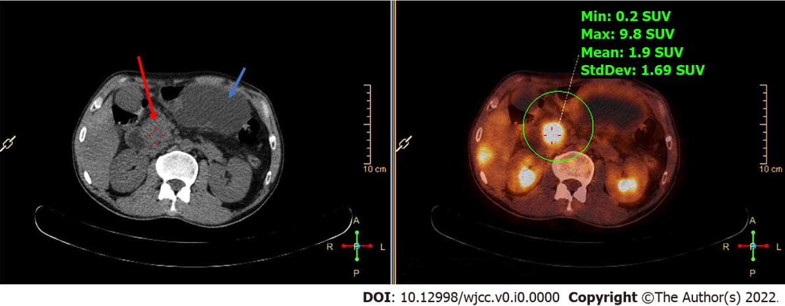
Figure 1 Positron-emission tomography/computed tomography images. Positron-emission tomography/computed tomography confirmed increased soft tissues in the pancreatic head (red arrow) with elevated metabolic activity (green circle) and pancreatic pseudocyst (blue arrow) without an increase in metabolic activity.

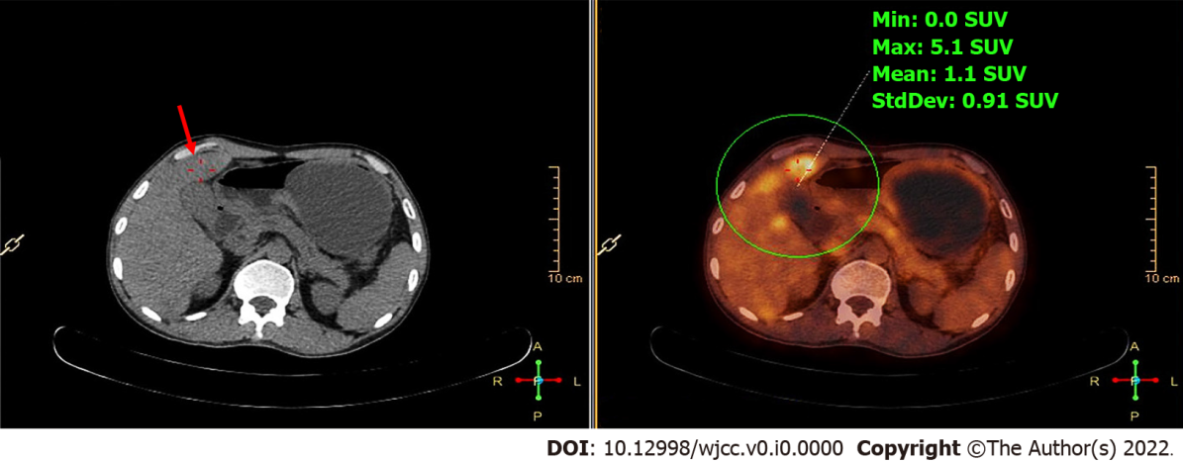
Figure 2 Positron-emission tomography/computed tomography images. Positron-emission tomography/computed tomography confirmed multiple liver masses (red arrow) with elevated metabolic activity (green circle).

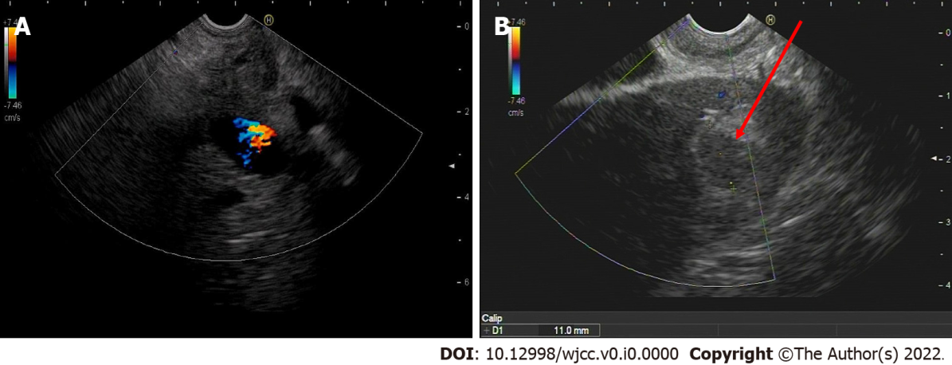
Figure 3 Endoscopic ultrasound images. A: An enlarged hypoechoic pancreatic head; B: Multiple hypoechoic liver masses (red arrow).

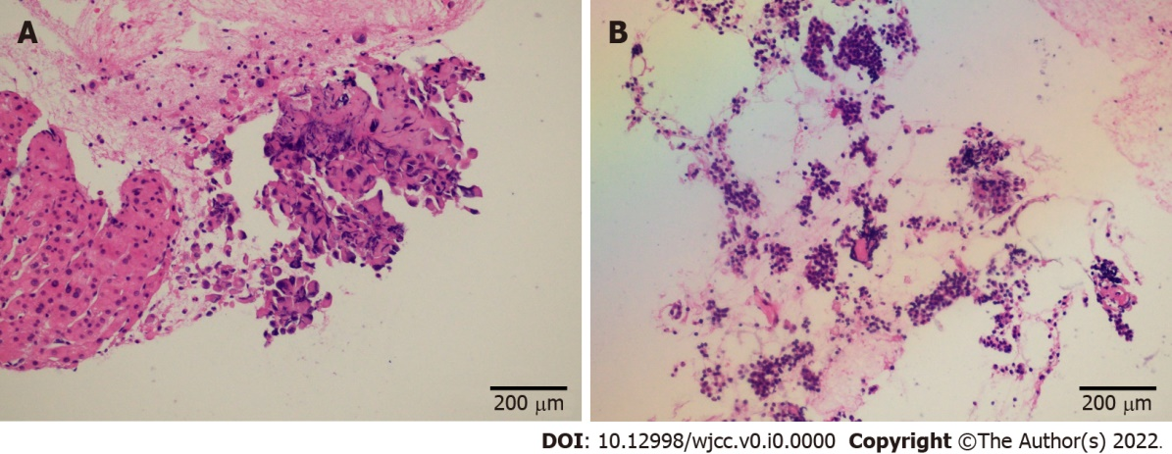
Figure 4 Histopathological images. A and B: Endoscopic ultrasound-guided fine-needle aspiration biopsy revealed histologies of endoscopic ultrasound-guided liver aspiration (A) and endoscopic ultrasound-guided pancreatic aspiration (B).

