Name of Journal: World Journal of Gastroenterology
Manuscript NO: 53534
Manuscript Type: ORIGINAL ARTICLE

Basic Study
Use of zebrafish embryos as avatar of patients with pancreatic cancer: A new xenotransplantation model towards personalized medicine

Di Franco G et al. Zebrafish as avatar of PDAC patients

Gregorio Di Franco, Alice Usai, Niccola Funel, Matteo Palmeri, Ida Elena Rosamaria Montesanti, Matteo Bianchini, Desirée Gianardi, Niccolò Furbetta, Simone Guadagni, Enrico Vasile, Alfredo Falcone, Luca Emanuele Pollina, Vittoria Raffa, Luca Morelli

Gregorio Di Franco, Matteo Palmeri, Matteo Bianchini, Desirée Gianardi, Niccolò Furbetta, Simone Guadagni, Luca Morelli, General Surgery Unit, Department of Translational Research and New Technologies in Medicine and Surgery, University of Pisa, Pisa 56124, Italy

Luca Morelli, EndoCAS (Center for Computer Assisted Surgery), University of Pisa, Pisa 56124, Italy

Alice Usai, Ida Elena Rosamaria Montesanti, Vittoria Raffa, Department of Biology, University of Pisa, Pisa 56127, Italy

Luca Emanuele Pollina, Niccola Funel, Department of Laboratory of Medicine, Division of Surgical Pathology, Hospital-University of Pisa, Pisa 56124, Italy

Enrico Vasile, Division of Medical Oncology, Pisa University Hospital, Pisa 56124, Italy

Alfredo Falcone, Department of Translational Research and New Technologies in Medicine and Surgery, University of Pisa, Pisa 56124, Italy

Author contributions: Di Franco G and Alice Usai A contributed equally to this work; Raffa V and Morelli L contributed equally to this work; Di Franco G, Usai A, Funel N, Palmeri M, Bianchini M, Gianardi D, Furbetta N, Guadagni S, Vasile E, Falcone A, Pollina LE, Raffa V and Morelli L contributed to the study conception and design; Di Franco G, Usai A, Funel N, Palmeri M, Montesanti IER, Bianchini M, Gianardi D, Furbetta N, Guadagni S, Pollina LE and Enrico Vasile E contributed to the data acquisition; Di Franco G, Usai A, Funel N, Palmeri M, Montesanti IER, Bianchini M, Gianardi D, Furbetta N, Guadagni S, Raffa V and Morelli L contributed to the data analysis and interpretation; Di Franco G, Usai A, Funel N, Palmeri M, Montesanti IER, Bianchini M, Gianardi D, Furbetta N, Guadagni S and Vasile E drafted the manuscript; Falcone A, Pollina LE, Raffa V and Morelli L contributed to the critical revision; all authors made the study final approval.

Supported by the Fondazione Pisa, No. 114/16.

Corresponding author: Luca Morelli, FACS, MD, Associate Professor, Surgeon, General Surgery Unit, Department of Translational Research and New Technologies in Medicine and Surgery, University of Pisa, Via Paradisa 2, Pisa 56124, Italy. luca.morelli@unipi.it

Received: December 31, 2019
Revised: March 27, 2020
Accepted: May 27, 2020
Published online:

Abstract
BACKGROUND
The response to chemotherapy treatment of patients with pancreatic ductal adenocarcinoma (PDAC) is difficult to predict and the identification of patients who most likely will benefit from aggressive chemotherapy approaches is crucial. The concept of personalized medicine has emerged in the last years with the objective to tailor the medical treatment to the individual characteristics of each patient, and particularly to the tumor biology of each patient. The need for in-vivo xenotransplantation models for cancer patients has increased exponentially, and for this reason zebrafish avatars have gained popularity. Preliminary studies were conducted also with PDAC tissue.

AIM
To develop a simple, not expensive, diffusible zebrafish embryo model as avatar for patients affected by PDAC.

METHODS
Tumor tissue was taken from the surgical specimen by the histopathologist. After its fragmentation into small pieces, they are stained with CM-Dil. Small pieces of stained tissue were transplanted into the yolk of wt AB zebrafish embryos with a glass capillary needle. Embryos were incubated at 35 °C in E3 medium supplemented with 1% Pen/Strep in the presence or absence of drugs for the following days in respect of the treatment plan (Gemcitabine; Gemcitabine and Oxaliplatin; Gemcitabine and nab-Paclitaxel; 5-Fluorouracil and Folinic acid and Oxaliplatin and Irinotecan). The response of zebrafish xenografts to the chemotherapy options has been analyzed by monitoring the fluorescent stained area at 2 h post injection (hpi), 1 d and 2 d post injection (dpi). In each time point, the mean size of the stained area was measured by ImageJ and it was normalized with respect to the 1 dpi time point mean relative tumor area (RTA). We evaluated the effect of the chemotherapy exposition comparing the mean RTA of each treated subgroup and the control group and evaluating the percentage reduction of the mean RTA by comparing each treated subgroup with the control group.

RESULTS
Between July 2018 and October 2019, a total of 15 patients with pancreatic cancer were prospectively enrolled. In all cases, it was possible to take a fragment of the tumor from the surgical specimen for the xenotransplantation in the zebrafish embryos. The histological examination confirmed the presence of a PDAC in all cases. In absence of chemotherapy (control group), over time the Dil-stained area showed a statistically significant increase in all cases. A statistically significant reduction of the mean RTA in the treated subgroups for at least one chemotherapy scheme was reported in 6/15 (40%) cases. The analysis of the percentage reduction of the RTA in treated subgroups in comparison to the control group revealed the presence of a linear relationship in each subgroup between the percentage reduction of the RTA and the number of cases reporting each percentage threshold considered for the analysis.

CONCLUSION
Our model seems to be effective for the xenotransplantation of PDAC tissue and evaluation of the effect of each chemotherapy scheme on the xenotransplanted tumor tissue.

Key words: Pancreatic ductal adenocarcinoma; Zebrafish embryos; Personalized medicine; Xenotransplantation; Chemotherapy efficacy; Avatar of oncological patients

Di Franco G, Usai A, Funel N, Palmeri M, Montesanti IER, Bianchini M, Gianardi D, Furbetta N, Guadagni S, Vasile E, Falcone A, Pollina LE, Raffa V, Morelli L. Use of zebrafish embryos as avatar of patients with pancreatic cancer: A new xenotransplantation model towards personalized medicine. World J Gastroenterol 2020; In press

Core tip: Patient-derived xenograft model has emerged as an important tool for personalized medicine. Zebrafish embryos offer several advantages: the short generation time, the large number of offspring, the transparency, and the small size therefore making zebrafish a more practical and less expensive laboratory system than others in vivo cancer models. We developed a model to use zebrafish embryos as avatar of patients with pancreatic ductal adenocarcinoma, standardizing the protocol for the xenotransplantation of pancreatic tumor tissue, for the exposition of the xenotransplanted zebrafish embryos to the chemotherapy drugs, and for the evaluation of the effects of chemotherapy on the xenotransplanted tumor tissue.
INTRODUCTION
Pancreatic ductal adenocarcinoma (PDAC) is one of the most aggressive malignancies worldwide, with a median survival time of less than 18 mo and with a 5-year survival rate for pancreatic cancer increased from 6% to 9% from 2014 to 2018^{[1,2]}. The annual death rate for PDAC is almost equal to the incidence rate^{[3]}, suggesting the lack of an effective screening method for targeted drug therapy. A radical surgical resection for a curative treatment option can be performed in less than 20% of cases because most patients have an advanced stage of the disease at the diagnosis. Chemotherapy plays a fundamental role for the treatment of patients affected by PDAC, as neoadjuvant, adjuvant or as unique treatment in non resectable PDAC. However, the response to chemotherapy treatment is difficult to predict and today different chemotherapy schemes are disposable for the treatment of PDAC. Recent trials showed significant improvement in over-all survival with the use of combined chemotherapy modalities compared to the gemcitabine monotherapy^{[4,5]}. Different regimens have been developed such as gemcitabine plus nab-paclitaxel and FOLFIRINOX and direct comparisons of these regimens are not available^{[6,7]}. Moreover, the incidence of adverse events increases with the use of combination regimens compared to gemcitabine: the proportion of patients who experienced at least one grade 3 or higher treatment-related, treatment-emergent adverse event was 77% with nab-paclitaxel plus gemcitabine and 51% with gemcitabine-alone in the MPACT study^{[6]}. FOLFIRINOX produced higher rate of both hematological and non-hematological grade 3 or higher toxicities such as diarrhea and sensory neuropathy^{[7]}. An appropriate patient selection is crucial to identify those that are most likely to benefit from aggressive chemotherapy approaches and those who are more likely to have only little benefit due to increased rates of severe side effects. Some clinical parameters can help in the choice of the most effective scheme. However, the concept of precision medicine has emerged in the last years with the objective to tailor the medical treatment to the individual characteristics of each patient, and particularly to the tumor biology of each patient. In this context, precision oncology seeks to identify the most effective therapy for an individual patient, based on the characterization of his cancer. “Mouse Avatar” is an emerging approach of precision medicine in oncology that has recently grown in popularity^{[8]}. It implicates the xenotransplantation of cancer cells from patient tumor sample in mouse models testing drug efficacy to run the so called “co-clinical trials”. The advantage of this approach is that each patient has his/her own tumor growing in an in vivo system, thereby allowing the identification of a personalized therapeutic approach. However, the use of mice as avatars has some limits such as high costs, the time-consuming process and the requirement of immunosuppressed strains. Recently, the use of zebrafish as avatar for oncological patients has gained popularity. After the first experiment reported in 2005^{[9]}, nowadays the use of the zebrafish model of xenotransplantation is one option for implementing strategies of personalized medicine, together with other models such as mouse patients-derived xenografts, patient-derived organoids^{[10,11]} or the whole tumor genome sequencing^{[12,13]}. Several human cancer cells e.g., melanoma, glioma, breast and prostate cancer cells as well as fragments of human cancer tissues have been tested to date^{[14]}. Preliminary studies were conducted also with patient-derived pancreatic cancer cells or tissue^{[15-17]}. The aim of this study is to propose a model that is possibly simple, not expensive and diffusible to use the zebrafish embryos as avatars for patients affected by PDAC to predict the efficacy of the different chemotherapy schemes and the clinical response to the treatment.

MATERIALS AND METHODS
Patients affected by PDAC that had undergone pancreatic resection were enrolled after written informed consent. After the surgical operation, the specimen was analyzed by the pathologist and a fragment of the tumor was taken for the xenotransplantation in zebrafish embryos.
Preoperative data included diagnosis, age, gender, body mass index (BMI), value of tumor marker Ca 19.9, and neoadjuvant chemotherapy and/or radiotherapy for neoplastic disease. Operative data included type of surgical procedure, if an associated vascular resection was performed, and if there were problems in taking a fragment of the tumor for the xenotransplantation. Histological data included: histological type of the tumor, grade of differentiation, tumor dimension, number of harvested lymph nodes, number of metastatic lymph nodes, presence of angioinvasion and perineural infiltration, presence of vascular infiltration in case of vascular resection. Patients were staged according to the T and N definitions proposed for the American Joint Committee on Cancer 8th edition^{[18]}. Proposed T-stage definitions are the following: T1 ≤ 2 cm maximal diameter, 2 < T2 ≤ 4 cm maximal diameter, T3 > 4 cm maximal diameter, T4 = locally unresectable. Extra-pancreatic extension was not included in these T-stage definitions. Proposed N-stage definitions included the following: N0 = node negative, N1 = 1-3 nodes positive for metastatic disease, N2 ≥ 4 nodes positive for metastatic disease.

Animal care and use statement
Zebrafish (Danio rerio) were handled in strict compliance with local animal welfare regulations (authorization n. 99/2012-A, 19.04.2012) and standard protocols approved by Italian Ministry of Public Health, in conformity with the Directive 2010/63/EU. Fish were housed at an average temperature of 28 °C in a recirculating system with a 14:10 h light to dark cycle. Zebrafish fertilized eggs were obtained by natural mating of wild-type AB strain at our facilities and the developing embryos were staged in incubator at 28 °C according to Kimmel et al^{[19]}. Before any procedure, embryos were anesthetized in 0.02% tricaine.

Zebrafish embryos xenotransplantation and chemotherapy test
We used the protocol described in our article on validation of zebrafish embryos as Avatar to test chemotherapy drugs^{[20]}. The tumor tissue taken from the surgical specimen by the histopathologist was washed three times with RPMI supplemented with 100 U/mL penicillin, 100 μg/mL streptomycin and 2.5 μg/mL Amphotericin B and cut into small pieces (1-3 mm) using a scalp blade. The pieces were then transferred to a 5 mL tube, and stained with 40 μg/mL CM-Dil in Dulbecco's phosphate buffered saline (D-PBS). The tissue pieces were incubated for 15 min at 37 °C and for 15 min in ice cubes. Tissue pieces were then washed and centrifuged three times by D-PBS and re-suspended in D-PBS supplemented with 10% fetal calf serum. For tissue transplantation, we used the manual method proposed by Marques et al^{[15]} 2009. Small pieces of stained tissue were further disaggregated using Dumont forceps (No.5) into a relative size of 1/4 to 1/2 the size of the yolk. Tissue pieces with the correct size were transferred to 1% agarose disks in which the 2-d post injection (dpi) embryos were laying, ready for transplantation. A glass transplantation needle was used to implant the tissue into the yolk. The tissue was picked up, put on the top of the yolk and then pushed inside. The yolk usually sealed itself and in the majority of embryos, the tumor remained in the yolk. After transplantation, embryos were incubated for 2 h at 35 °C, then embryos were checked for presence of tissue and incubated at 35 °C in E3 1% Pen/Strep medium with the presence or absence of drugs for the following days in respect of the treatment plan. The tumor tissue was xenotransplanted in n = 100 zebrafish embryos and injected embryos were randomly allocated among 5 groups (4 therapeutic options and one control group). The treated groups were exposed to the four main chemotherapy options used for PDAC: Gemcitabine (GEM), Gemcitabine + Oxaliplatin (GEMOX), Gemcitabine + nab-Paclitaxel (GEM/nab-P), and 5-Fluorouracil + Folinic acid + Oxaliplatin + Irinotecan (FOLFOXIRI). The chemotherapies were dissolved in fish water, using the equivalent dose (ED = 5) calculated with a toxicity study on zebrafish embryos and validated by test with cellular lines or tumor tissue xenotransplanted in zebrafish embryos^{[20]}. Two days post treatment the response of zebrafish xenografts to the chemotherapy options was analyzed by monitoring the stained area at 2 hpi, 1 dpi and 2 dpi using ImageJ (Figure 1). The mean size of the tumor mass area measured in each time point was normalized with respect to the 1 dpi time point mean relative tumor area (RTA). We evaluated the efficacy of the chemotherapy exposition using two modalities. The first one was the comparison of the mean RTA between each treated subgroup and the control group calculating the mean difference between the two groups. Moreover, we evaluated the possibility to use in the zebrafish model the “Response evaluation criteria in solid tumors (RECIST)” used in the common clinical practice to evaluate the response to the chemotherapy in oncological patients^{[21]} as an objective parameter for evaluation of data obtained with zebrafish embryos tests. To do this, we evaluated the percentage reduction of the mean RTA in each treated subgroup taking as reference the mean RTA of the control group. After that, we calculated how many cases reported a reduction of at least a percentage value equivalent to a referent threshold included between 0% and -90% decreasing the threshold value of 10% each time. We evaluated for each treated subgroup if there was a linear relationship between the threshold values of the percentage reduction of the mean RTA and the number of cases reporting a percentage reduction of the mean RTA equal or greater to each threshold value and calculated the linear regression line equation. We researched in the literature data the percentage of partial response according to the RECIST criteria reported for each chemotherapy protocol tested in xenotransplanted zebrafish embryos. Then, using the linear regression line equation, we calculated for each protocol the expected percentage RTA reduction (theoretically the percentage of RTA reduction reported in a percentage of cases in test with xenotransplanted zebrafish embryos equal to the percentage of partial response reported in literature) with the following formula: expected percentage reduction of the mean RTA = (percentage of PR reported in literature – qlinear regression line equation)/mlinear regression line equation. Then, for each chemotherapy protocol we calculated the mean value of the expected percentage reduction of the mean RTA in treated xenotransplanted zebrafish embryos corresponding to a partial response in oncological patient and compared them.

Xenografts imaging and quantification
All xenografts were imaged by fluorescence Nikon Eclipse E600 microscope to monitor the RTA and analyzed using ImageJ software. For the volumetric analysis of the nuclei the images were acquired by using a Nikon A1 confocal microscope with a 5 μm z-stacks. The quantifications were performed using the 3D Objects Counter function of ImageJ software.

Formalin-Fixed Paraffin Embedded samples preparation of Xenografts
Histological analysis: Two days post treatment zebrafish patient-derived xenografts (zPDX) were sampled for histopathological examination. Briefly, the embryos were fixed in 10% neutral buffered Formalin and dehydrated through increasing ethanol scale. Then the zPDX were embedded after immersion in liquid paraffin at 60 °C for 2 h. The Formalin-Fixed Paraffin Embedded (FFPE) were sectioned at 3 μm-thick, then rehydrated using xylene and ethanol solutions. Finally, zPDX sections were stained with hematoxylin and eosin for morphological analysis.

Immunohistochemistry: The expression of Pan-Cytokeratin proteins (PanCKs) was examined using immunohistochemistry in the preclinical models. FFPE sections were hydrated. Antigen retrieval was performed through soaking 3 times for 3 min in 10 mmol/L citrate buffer pH 6 at 96 °C. The sections were treated for endogenous peroxidase quenching, by incubating the specimens in a 3% H₂O₂ solution at room temperature in the dark for 15 min. Samples were incubated with monoclonal mouse anti-human PanCK antibody at 1:100 dilution for 1 h and stained with avidin-biotinperoxidase complex (Ventana system). The sections were counterstained with hematoxylin. Positive cells were identified through brown color visualization.

Statistical analysis
We used GraphPad Prism 7 as statistical analysis software. Data analysis was performed by ANOVA, followed by Bonferroni correction or Dunnett's post-hoc test. Statistical significance was set to 5%.
Continuous variables with normal distribution are expressed as mean ± SD and compared using t test. The statistical analysis was performed using SPSS (Statistical Production and Service Solution for Windows, SPSS Inc., Chicago, IL, United States), version 23.

RESULTS
Between July 2018 to October 2019, a total of 15 patients with PDAC were enrolled. Patients characteristics are summarized in Table 1. Of these 15 patients, 8 (53.3%) were male. The mean age was 71.2 ± 9.9 years (range 44.1-83.2) and the mean BMI was 26.4 ± 5.1 kg/m² (range 17.6-40.4). The mean preoperative Ca 19.9 was 347.1 ± 543.0 U/mL (range 1.7-2094) and it was increased in 12/15 (80%) patients. A pancreatoduodenectomy was performed in 11/15 (73.3%) patients, a distal splenopancreatectomy in 3/15 patients (20%) and a total splenopancreatectomy in 1/15 (6.7%) patients. An associated vascular resection was performed in 4/15 (26.7%) patients: a venous resection in 3 cases and resection of the celiac trunk in 1 case. No intra-operative complications were reported, and, in all cases, it was possible to take a fragment of the tumor from the surgical specimen for the xenotransplantation in the zebrafish embryos. The histological examination confirmed the presence of a PDAC in all cases. A moderately differentiated adenocarcinoma (G2/3) was reported in 11/15 (73.3%) cases, while a poorly differentiated adenocarcinoma (G3/3) was reported in 4/15 (26.7%) cases. The mean diameter of the pancreatic neoplasia was 3.3 ± 1.2 cm (range 1.5-5.0). The mean number of harvested lymph nodes was 40.6 ± 18.0 (range 19-74), while the mean number of positive lymph nodes was 5.7 ± 6.0 (range 0-22). The presence of positive lymph nodes was documented in 14/15 (93.3%) patients: a N1 status was reported in 7/15 (46.7%) patients, while a N2 status was reported in 7/15 (46.7%) patients. The presence of perineural infiltration was reported in 11/15 (73.3%) patients, while the angioinvasion was reported in 2/15 (13.3%) patients. In 2/4 cases of vascular resection the histological examination confirmed the presence of vascular infiltration.

Results of tests with zebrafish embryos
Tumor tissue was successfully engrafted in healthy zebrafish embryos in all cases (Figure 2). The volumetric analysis of the volume occupied by the nuclei of the patient’s tumor fragment inoculated in the zebrafish embryos revealed a volume of 6411 ± 10.96 μm³ (mean ± SEM) derived from two embryos xenotransplanted with different patient’s tumors. Considering a diameter of 6 µm for a typical mammalian nucleus, this value corresponds to about 60 cells per xenotransplant. We calculated the percentage of epithelial cells (mean PDAC counterpart) out of the total surface area (31.8% ± 4.9%, n = 3, Figure 2D). The mean survival rate of xenotransplanted zebrafish embryos was 71.5% at 1 dpi and 52.4% at 2 dpi (Table 2). In absence of chemotherapy (control group), the Dil-stained areas showed a statistically significant increase over time in all cases, while we observed a tendency to a reduction of the mean RTA in treated subgroups. In Figure 3 it is possible to observe the alteration due to the chemotherapy of xenotransplanted cells of some treated xenotransplanted zebrafish embryos. The mean RTA of each subgroup and the differences of the mean RTA between the control group and the treated subgroups are reported in Table 3. The analysis of the mean RTA revealed a statistically significant reduction of the mean RTA in the treated subgroups for at least one chemotherapy scheme in 6/15 (40%) cases (Figure 4). The percentage reduction of the mean RTA in each treated subgroup, taking as reference the mean RTA of the control group, is reported in Table 4.
Table 5 shows how many cases in each subgroup presented a percentage reduction of the mean RTA equal or greater to each threshold value in comparison to the control group. The analysis of percentage reduction of the RTA in the treated subgroups, compared to the control group, revealed the presence of a linear relation in each subgroup between the percentage reduction of the RTA and the number of cases reporting at least each percentage threshold considered for the analysis (Figure 5). The linear regression line equations for each subgroup are reported in Figure 5. Using the linear regression line equations, we calculated the expected RTA reduction corresponding to the percentage of partial response reported in the literature for each chemotherapy scheme administered to each treated subgroup. Data are reported in Table 6. The mean conversion factor calculated was -60.4% for FOLFOXIRI, -59.3% for GEM-nab/P, -62.4% for GEMOX, and -63.7% for GEM (P = 0.626).

DISCUSSION
In the last decade, patient-derived xenograft model has emerged as an important tool for translational research, retaining much of the complexity of the tumor microenvironment and heterogeneity of the original tumor in an individual patient, and representing the first step towards personalized medicine^{[22]}. Different patients-derived tumor models, both in vitro and in vivo, have been developed. Organoid cultures were a major breakthrough in the in vitro culture of tumor cells from patients, becoming the most attractive tool to be used as an in vitro screening platform. Recently, this technique was further developed to generate organoids from patient-derived cancer tissues^{[23]}. However, only few retrospective studies correlated patient clinical outcomes with organoid drug response^{[24-26]}. Moreover, the use of organoids has some limitations in comparison to the zebrafish model. First of all, the initial organoid generation requires 4-5 wk^{[23,27]}, which is border line for the time frame needed to guide first clinical decisions. Moreover, for the lack of stromal components, these models lack many complex interactions observed in the TME or in a living organism and do not allow, for instance, the evaluation of the metastatic or angiogenic potential^{[23]}. PDX into immunodeficient mice has been considered the gold standard model for assessing pre-clinical efficacy of cancer drugs. The methodology of initiation and propagation consists in sectioning the fresh surgical tissue into about 3 mm³ pieces, followed by subcutaneous or orthotopic implantation into the flank of an immunodeficient mouse. During the engraftment phase, tumors are allowed to establish and grow and then are harvested upon reaching a size of 1500 mm³. Similar protocols are employed for subsequent expansion cohort and treatment cohort^{[28]}. Despite this preclinical model more closely recapitulate the heterogeneity of human tumors, there are inherent limitations. For example, mice are expensive and require large vivarium space, limiting the scale of experimentation. Moreover, the tumor propagation required a long amount of time, resulting in several genetic, pathological, histological and micro-environmental niche changes, that may not mirror the patient’s tumor accurately. Mice are also furred, and is not possible to image disseminated cancer cells throughout the whole animal^{[29]}. To address these issues, have been developed zebrafish xenograft transplantation approaches to engraft human cancers into two days post fertilization zebrafish embryos at a stage prior to the development of the adaptive immune system^{[15]}. Moreover, both in organoids and in mPDX, to amplify tumor tissue to obtain enough material for chemoresponse analysis, the cells are subjected to a strong selection pressure, diverging from the original tumor^{[30]}. For our purpose, we do not need cell expansion, instead we directly observe the drug response of human tumor material xenotransplanted in zebrafish embryos. We believe that this is an appeal of zebrafish xenotransplantation and not a limitation.
When compared to other vertebrate model systems, zebrafish embryos offer several advantages. The short generation time, the large number of offspring, transparency (enabling noninvasive imaging), the external development of the embryos and the small size make zebrafish a more practical and less expensive laboratory system than other in vivo cancer models^{[31]}. The appeal of zebrafish xenograft lies also in the possibility to overcome some drawbacks of murine xenograft, such as the larger number of tumor cells needed (about 1 million), the long time required (from several weeks to months) to have a visible tumor implant, the need of immunosuppressed animals to avoid transplant rejection and the high difficulties to generate mouse xenotransplant models able to metastasize^{[32]}. The patients-derived zebrafish avatars do not require tumor cell expansion and the results of the chemosensitivity assay can be obtained in just few days. Previously study with different tumor type (patient derived gastric xenografts) demonstrate sensitivity to chemotherapy after 2 d post treatment^{[33]}. The difference in time scale of the assay is not due to the fast zebrafish’s biology, but rather because zebrafish larvae are 10000 times smaller than adult mice therefore they require reduced cells number to perform the injection (ranging from 500 to 5000 cells in each zebrafish embryo instead of 1 × 10⁶ in the mouse). A lower quantity of PDAC cells let to perform a higher number of xenograft that provide powerful statistical analysis^{[23,34]}. All these aspects make possible to evaluate an evident effect of chemotherapy in just few days.
Zebrafish transplantation models offer the possibility to study many hallmarks of cancer and steps of cancer progression, such as self-renewal, tumor-induced angiogenesis, invasion and dissemination, interaction between tumor and host, and drug responses^{[4]}. In fact, several studies have exemplified the potential of zebrafish models as transplantation metastatic models or to contribute more significantly and directly to precision oncology through identifying and testing drugs for targeted inhibition of specific pathways/alterations by utilizing zebrafish as an in vivo drug screening platform. In fact, zebrafish model has some advantages. Firstly, the aquatic environment of the zebrafish means that many drugs (depending on solubility) can be added directly to the embryo water and absorbed through the fish, avoiding the burden of administering drug to each individual animal^{[35]}. However, it is absolutely essential to determine the toxicity curve for each compound before embarking on xenograft studies and following completion of toxicity curves and in this setting drug toxicity can be easily evaluated in zebrafish. Indeed, xenografted zebrafish can be exposed to the appropriate concentration of drug and observed over time for cancer progression, in terms of cell proliferation, migration and angiogenesis^{[32]}. In this regard, we have performed a safety study with the calculation of the ED human to fish able to impair the increase of the mean RTA of xenotransplanted tumor tissue in zebrafish embryos^{[20]}. As reported in our initial experience, an ED = 5 was effective both for cancer cell lines and for tumor tissue xenotransplanted in zebrafish embryos. Therefore, in this analysis we used this ED in the tests performed with pancreatic tissue directly xenotransplanted in the zebrafish embryos.
To date, very few authors have used zebrafish embryos to test new drugs after xenotransplantation of pancreatic cancer tissue. Weiss and colleagues used zebrafish embryos as a patient-derived transplantation model of metastasis for pancreatic cancer^{[16]}. They transplanted pancreatic carcinoma cells and resected specimens of human pancreatic carcinoma into zebrafish embryos and the model was used to demonstrate the in vivo anti-metastatic activity of retinoid acid receptor antagonists, following the identification of the retinoid acid target miR-10A as a key mediator of metastasis in pancreatic cancer. Also, Guo et al^{[17]} used the pancreatic adenocarcinoma xenograft model in zebrafish embryos evaluating their possible use for the screening of new anti-cancer compounds. They found that a known small molecule inhibitor, U0126, targeting the KRAS signaling pathway, represses proliferation and migration of the transplanted of Mia PaCa-2 cells in zebrafish larvae^{[17]}. Due to the permeability of zebrafish embryos to small molecules, a number of compounds can be added directly to the embryo water, and Guo et al^{[17]} dissolved the drug treatment, U0126, in DMSO and added it directly to the water, as we performed in our study. The results reported by Guo et al^{[17]} suggest that zebrafish larvae as xenotransplantation model of pancreatic cancer is useful for facilitating in vivo drug screening and identification of new anti-pancreatic cancer compounds. Instead, in our experience, we tested the different chemotherapy schemes already used for the treatment of pancreatic cancer in the common clinical practice in order to evaluate if the zebrafish model could be used for the definition of a personalized treatment plan for each patient with pancreatic cancer. The idea of precision oncology is that in the future primary specimens from patients diagnosed with cancer could be xenotransplanted in zebrafish embryos to test the responses of the patient cancer cells to various available drugs and the output of the test, obtainable in a few days, will dictate the most effective treatment for the individual patient. The application of the zebrafish model to precision oncology is still in its infancy, and there are not yet examples of direct use of zebrafish to guide patient-specific cancer treatments in clinical practice. However, this field has matured enough to move towards this aim in the near future. Modeling cancer in zebrafish has provided important insights that contribute to the development of precision oncology as well as straightforward examples of advantages and feasibility of direct clinical utilization^{[36]}. As reported by different studies, it is possible to xenotransplant in zebrafish embryos tumor cells from cancer cell lines^{[32]} and preliminary studies about the possibility of a direct, real-time application of zebrafish xenograft models in clinical practice suggests the possibility to use zebrafish embryos for a precision oncology^{[37]}. However, in order to obtain a tool for precision medicine and personalized medicine, it is important to transplant primary cancer cells from biopsy or surgical specimen. In fact, studies with the use of commercially available cells lines are criticized because the results gleaned do not always correlate with those found in primary cancers^{[32]}. In fact cell lines do not capture the heterogeneity that exists within a given cancer because clones with a higher proliferative rate than that of the primary tumor are selected during the process of adaptation, and thus they could not be really representative of the cancer cell population^{[38]}. However, the experience with pancreatic tissue is limited. Marques et al. described the first use of primary patient material as the transplanted tissue using small samples from pancreas, colon and stomach adenocarcinomas^{[15]}. Pancreatic tumor fragments showed invasion and migration in the developing zebrafish and, comparing the non-invasive pancreatitis tissue xenografted with those from infiltrating pancreatic adenocarcinoma, only the latter invaded the embryos^{[15]}. Guo et al^{[17]} used cells acquired from culture dishes using a non-enzymatic cell-lifting solution and injected approximately 100-200 cancer cells labeled with CM-DiI into the perivitelline cavity of each zebrafish. Instead in our experience, in order to preserve the tumor micro-environment, we decided to xenotransplant fresh tissue fragments, by modifying the protocol published by Marques et al^{[15]}. Our data confirmed the possibility to xenotransplant tumor cells taken directly from the tumor tissue of each patient, obtaining a model for testing the sensibility to the different chemotherapies associated with the specific alterations present in the tumor of each patient. In fact, in all cases of the control group the tumor area increased at 1 dpi and 2 dpi.
Very few studies evaluate the use of zebrafish embryos for personalized medicine and passaging to the best of our knowledge there are no results in literature of treatment correlation between zebrafish xenografts and matched PDAC patients. However a preclinical human cancer xenotransplantation platform has been recently developed in zebrafish to inform therapeutic decisions in patients with T-cell acute lymphoblastic leukemia^{[37]}. Moreover, a retrospective study with zPDXs from multiple myeloma cells, demonstrate that zPDXs showed a response equivalent to patient’s clinical outcome^{[39]}. Similarly, Wu et al^{[33]} showed a retrospective correlation with one gastric tumor patient clinical outcome. In 2017 Fior et al^{[34]} performed a retrospective study, showing that colorectal patient’s avatars are predictive of patient clinical outcome in 4 out 5 patients (80%). These results bode well for our co-clinical trial (NCT03668418). Our study is the first one that evaluate the use of zebrafish embryos as avatar for patients affected by pancreatic cancer. Preliminary results are encouraging. Indeed, in all cases the tumor cells successfully engrafted in the xenotransplanted zebrafish embryos and the mean xenotransplanted zebrafish embryos survival rate was 71.5% at 1 dpi but decreased at 52.4% at 2 dpi, probably due to the high invasiveness of the tumor xenografts and the everyday embryo anesthetization and manipulation to image the tumor. Comparing directly the mean RTA between the treated subgroups and the control group we obtained a statistically significant reduction of the mean RTA in the treated subgroups for at least one chemotherapy scheme in only 6/15 (40%) cases. Moreover, due to the too short follow-up of the enrolled patients and the consequent absence of clinical data of response to chemotherapy treatments, we tried to use the RECIST criteria in the experiment with the xenotransplanted zebrafish embryos, with the intent to use an objective parameter in the evaluation of the robustness of our model. In this way, we evaluate if the results of the tests with the different chemotherapy scheme could be in accordance with data reported in large number of series published in literature. We evaluated the percentage of the mean RTA reduction in the treated subgroups in comparison to the control group for each case, reporting interesting results. First of all, we reported for each chemotherapy scheme tested the presence of a linear relationship between each threshold of the percentage reduction of the mean RTA and the number of cases in which we reported the mean RTA reduction at least for a percentage equal or greater to the threshold value. Interestingly, the FOLFOXIRI scheme resulted the most efficacious in accordance with data reported in the literature in the common clinical practice for the treatment of patients with PDAC^{[7,40-45]}. Moreover, using the linear regression line equation, we calculated a conversion factor for each chemotherapy scheme evaluating the percentage reduction of the mean RTA in each treated subgroup corresponding to the percentage of patients with a partial response after chemotherapy treatment reported in literature. Interestingly, the conversion factor value calculated for each chemotherapy scheme resulted similar to the other ones with a value ranging between -63.7% and -59.3%. So, we can hypothesize that our model reflects the different efficacy of the various chemotherapy schemes used for the treatment of patients affected by PDAC. In fact, we obtained different percentage reductions of the mean RTA and different linear regression lines for each treated subgroup and these data are in accordance with the different efficacy reported in literature of the various chemotherapy schemes used in the common clinical practice. In fact, we reported the same conversion factor in all subgroups. Naturally these are preliminary data and we do not have confirming data from the chemotherapy treatment of the patients enrolled because of the too short follow-up. We know that this comparison has important limitations and could not replace the comparison with data obtainable with the follow-up of the enrolled patients. We performed this analysis only to give an initial assessment of the reliability of our model. However, taking in consideration the previous premises, these preliminary results are encouraging because first of all they confirmed the possibility to successfully xenotransplant directly the tumor tissue in the zebrafish embryos. Moreover, we observed the effect of the chemotherapy on the xenotransplanted tumor tissue with the possibility to use the zebrafish embryos as a model to predict the possible efficacy of the chemotherapy treatment. The correlation between these data and the real clinical response to adjuvant chemotherapy will be essential to determine the possible role of our model in predicting the efficacy of the chemotherapy scheme administered to patients with PDAC. A co-clinical trial (NCT00070213) is underway in our institution and will be object of further publication.
In conclusion, the described model appears to be an effective, usable and not expensive model for the xenotransplantation of pancreatic tumor tissue and for the evaluation of the efficacy of the different chemotherapy schemes available for the treatment of patients with PDAC. This could open a new frontier to personalized medicine because the results of the tests obtained in our model in the xenotransplanted zebrafish embryos could reflect the clinical course of the patients’ medical history, and such an approach might improve the evaluation of the patient’s prognosis and the identification of the most appropriate individualized therapy.

ARTICLE HIGHLIGHTS
Research background
The response of patients with pancreatic ductal adenocarcinoma (PDAC) to the different chemotherapy schemes is difficult to predict. The concept of precision medicine has emerged recently with the objective to tailor the medical treatment to the individual characteristics of each patient, and particularly to the tumor biology of each patient.

Research motivation
Recently, the use of zebrafish as avatar for oncological patients has gained popularity. However, only preliminary studies were conducted with patient-derived pancreatic cancer cells or tissue.

Research objectives
The aim of this study is to evaluate the usability of zebrafish embryos as a model possibly simple, not expensive and diffusible, that could be used as avatar for patients affected by PDAC, to predict the efficacy of the different chemotherapy schemes and the clinical response to the treatment.

Research methods
A fragment of the tumor was taken from the surgical specimen and sectioned into about 3 mm³ pieces for DiI staining. Small pieces of stained tissue were xenotransplanted into the yolk of n = 100 zebrafish embryos 2 dpf. The zebrafish xenografts were incubated at 35°C with the presence or absence of drugs (GEM, GEMOX, GEM/nab-P, FOLFOXIRI) dissolved in fish water, using the equivalent dose (ED = 5). Firstly, we compared the mean relative tumor area (RTA) between each treated subgroup and the control group. Secondly, we evaluated the percentage reduction of the mean RTA (PRmRTA) in each treated subgroup in comparison to the control group, evaluating the presence of a linear relationship between each threshold value of the PRmRTA and the number of cases reporting a PRmRTA equal or greater to each threshold value. Using the linear regression line equation, we calculated for each protocol the expected percentage RTA reduction with the following formula: expected percentage reduction of the mean RTA = (percentage of PR reported in literature – qlinear regression line equation)/mlinear regression line equation. For each chemotherapy protocol, we calculated the mean value of the expected PRmRTA and compared each other’s.

Research results
In the control group the Dil-stained areas showed a statistically significant increase over time in all cases, while a tendency to a reduction of the mean RTA was observed in treated subgroups, with a statistically significant reduction of the mean RTA for at least one chemotherapy scheme in 6/15 (40%) cases. The presence of a linear relation between the percentage reduction of the RTA and the number of cases reporting at least each percentage threshold was observed in each subgroup. The mean conversion factor was -60.4% for FOLFOXIRI, -59.3% for GEM-nab/P, -62.4% for GEMOX, and -63.7% for GEM (P = 0.626).

Research conclusions
This study provides a simple, reliant and not expensive PDAC patients-derived xenograft model for the rapid pre-clinical evaluation of the efficacy of different chemotherapy schemes available for the treatment of each individual PDAC patient’s case.

Research perspectives
Our model seems to reflect the clinical response rate reported in literature. However, to determinate the possible capability of our model in predicting the efficacy of the chemotherapy scheme administered to patients with PDAC, it is necessary to evaluate the correlation between these data and the real clinical response to adjuvant chemotherapy on patients. A co-clinical trial (NCT00070213) is underway in our institution and will be object of further publication.

ACKNOWLEDGEMENTS
The authors thank Tizzi, Rotary, and Arpa Foundations, and Orvietani’s Family for their support.

REFERENCES
1 Ferlay J, Colombet M, Soerjomataram I, Dyba T, Randi G, Bettio M, Gavin A, Visser O, Bray F. Cancer incidence and mortality patterns in Europe: Estimates for 40 countries and 25 major cancers in 2018. Eur J Cancer 2018; 103: 356-387 [PMID: 30100160 DOI: 10.1016/j.ejca.2018.07.005]
2 Rawla P, Sunkara T, Gaduputi V. Epidemiology of Pancreatic Cancer: Global Trends, Etiology and Risk Factors. World J Oncol 2019; 10: 10-27 [PMID: 30834048 DOI: 10.14740/wjon1166]
3 Bray F, Ferlay J, Soerjomataram I, Siegel RL, Torre LA, Jemal A. Global cancer statistics 2018: GLOBOCAN estimates of incidence and mortality worldwide for 36 cancers in 185 countries. CA Cancer J Clin 2018; 68: 394-424 [PMID: 30207593 DOI: 10.3322/caac.21492]
4 Terashima T, Yamashita T, Sakai A, Ohta H, Hinoue Y, Toya D, Kawai H, Yonejima M, Urabe T, Noda Y, Mizukoshi E, Kaneko S. Treatment patterns and outcomes of unresectable pancreatic cancer patients in real-life practice: a region-wide analysis. Jpn J Clin Oncol 2018; 48: 966-973 [PMID: 30256958 DOI: 10.1093/jjco/hyy132]
5 Schlick K, Magnes T, Ratzinger L, Jaud B, Weiss L, Melchardt T, Greil R, Egle A. Novel models for prediction of benefit and toxicity with FOLFIRINOX treatment of pancreatic cancer using clinically available parameters. PLoS One 2018; 13: e0206688 [PMID: 30412592 DOI: 10.1371/journal.pone.0206688]
6 Goldstein D, El-Maraghi RH, Hammel P, Heinemann V, Kunzmann V, Sastre J, Scheithauer W, Siena S, Tabernero J, Teixeira L, Tortora G, Van Laethem JL, Young R, Penenberg DN, Lu B, Romano A, Von Hoff DD. nab-Paclitaxel plus gemcitabine for metastatic pancreatic cancer: long-term survival from a phase III trial. J Natl Cancer Inst 2015; 107 [PMID: 25638248 DOI: 10.1093/jnci/dju413]
7 Conroy T, Desseigne F, Ychou M, Bouché O, Guimbaud R, Bécouarn Y, Adenis A, Raoul JL, Gourgou-Bourgade S, de la Fouchardière C, Bennouna J, Bachet JB, Khemissa-Akouz F, Péré-Vergé D, Delbaldo C, Assenat E, Chauffert B, Michel P, Montoto-Grillot C, Ducreux M; Groupe Tumeurs Digestives of Unicancer; PRODIGE Intergroup. FOLFIRINOX versus gemcitabine for metastatic pancreatic cancer. N Engl J Med 2011; 364: 1817-1825 [PMID: 21561347 DOI: 10.1056/NEJMoa1011923]
8 Tentler JJ, Tan AC, Weekes CD, Jimeno A, Leong S, Pitts TM, Arcaroli JJ, Messersmith WA, Eckhardt SG. Patient-derived tumour xenografts as models for oncology drug development. Nat Rev Clin Oncol 2012; 9: 338-350 [PMID: 22508028 DOI: 10.1038/nrclinonc.2012.61]
9 Lee LM, Seftor EA, Bonde G, Cornell RA, Hendrix MJ. The fate of human malignant melanoma cells transplanted into zebrafish embryos: assessment of migration and cell division in the absence of tumor formation. Dev Dyn 2005; 233: 1560-1570 [PMID: 15968639 DOI: 10.1002/dvdy.20471]
10 Aboulkheyr Es H, Montazeri L, Aref AR, Vosough M, Baharvand H. Personalized Cancer Medicine: An Organoid Approach. Trends Biotechnol 2018; 36: 358-371 [PMID: 29366522 DOI: 10.1016/j.tibtech.2017.12.005]
11 Perkhofer L, Frappart PO, Müller M, Kleger A. Importance of organoids for personalized medicine. Per Med 2018; 15: 461-465 [PMID: 30418092 DOI: 10.2217/pme-2018-0071]
12 Nakagawa H, Fujita M. Whole genome sequencing analysis for cancer genomics and precision medicine. Cancer Sci 2018; 109: 513-522 [PMID: 29345757 DOI: 10.1111/cas.13505]
13 Prokop JW, May T, Strong K, Bilinovich SM, Bupp C, Rajasekaran S, Worthey EA, Lazar J. Genome sequencing in the clinic: the past, present, and future of genomic medicine. Physiol Genomics 2018; 50: 563-579 [PMID: 29727589 DOI: 10.1152/physiolgenomics.00046.2018]
14 Konantz M, Balci TB, Hartwig UF, Dellaire G, André MC, Berman JN, Lengerke C. Zebrafish xenografts as a tool for in vivo studies on human cancer. Ann N Y Acad Sci 2012; 1266: 124-137 [PMID: 22901264 DOI: 10.1111/j.1749-6632.2012.06575.x]
15 Marques IJ, Weiss FU, Vlecken DH, Nitsche C, Bakkers J, Lagendijk AK, Partecke LI, Heidecke CD, Lerch MM, Bagowski CP. Metastatic behaviour of primary human tumours in a zebrafish xenotransplantation model. BMC Cancer 2009; 9: 128 [PMID: 19400945 DOI: 10.1186/1471-2407-9-128]
16 Weiss FU, Marques IJ, Woltering JM, Vlecken DH, Aghdassi A, Partecke LI, Heidecke CD, Lerch MM, Bagowski CP. Retinoic acid receptor antagonists inhibit miR-10a expression and block metastatic behavior of pancreatic cancer. Gastroenterology 2009; 137: 2136-45.e1-7 [PMID: 19747919 DOI: 10.1053/j.gastro.2009.08.065]
17 Guo M, Wei H, Hu J, Sun S, Long J, Wang X. U0126 inhibits pancreatic cancer progression via the KRAS signaling pathway in a zebrafish xenotransplantation model. Oncol Rep 2015; 34: 699-706 [PMID: 26035715 DOI: 10.3892/or.2015.4019]
18 Amin MB, Edge SB, American Joint Committee on Cancer. AJCC cancer staging manual. 8th ed. New York: Springer, 2017
19 Kimmel CB, Ballard WW, Kimmel SR, Ullmann B, Schilling TF. Stages of embryonic development of the zebrafish. Dev Dyn 1995; 203: 253-310 [PMID: 8589427 DOI: 10.1002/aja.1002030302]
20 Usai A, Di Franco G, Colucci P, Pollina LE, Vasile E, Funel N, Palmeri M, Dente L, Falcone A, Morelli L, Raffa V. A Model of a Zebrafish Avatar for Co-Clinical Trials. Cancers (Basel) 2020; 12 [PMID: 32183229 DOI: 10.3390/cancers12030677]
21 Watanabe H, Okada M, Kaji Y, Satouchi M, Sato Y, Yamabe Y, Onaya H, Endo M, Sone M, Arai Y. [New response evaluation criteria in solid tumours-revised RECIST guideline (version 1.1)]. Gan To Kagaku Ryoho 2009; 36: 2495-2501 [PMID: 20009446 DOI: 10.1016/j.ejca.2008.10.026]
22 Gaudenzi G, Albertelli M, Dicitore A, Würth R, Gatto F, Barbieri F, Cotelli F, Florio T, Ferone D, Persani L, Vitale G. Patient-derived xenograft in zebrafish embryos: a new platform for translational research in neuroendocrine tumors. Endocrine 2017; 57: 214-219 [PMID: 27481363 DOI: 10.1007/s12020-016-1048-9]
23 Costa B, Estrada MF, Mendes RV, Fior R. Zebrafish Avatars towards Personalized Medicine-A Comparative Review between Avatar Models. Cells 2020; 9 [PMID: 31991800 DOI: 10.3390/cells9020293]
24 Ooft SN, Weeber F, Dijkstra KK, McLean CM, Kaing S, van Werkhoven E, Schipper L, Hoes L, Vis DJ, van de Haar J, Prevoo W, Snaebjornsson P, van der Velden D, Klein M, Chalabi M, Boot H, van Leerdam M, Bloemendal HJ, Beerepoot LV, Wessels L, Cuppen E, Clevers H, Voest EE. Patient-derived organoids can predict response to chemotherapy in metastatic colorectal cancer patients. Sci Transl Med 2019; 11 [PMID: 31597751 DOI: 10.1126/scitranslmed.aay2574]
25 Vlachogiannis G, Hedayat S, Vatsiou A, Jamin Y, Fernández-Mateos J, Khan K, Lampis A, Eason K, Huntingford I, Burke R, Rata M, Koh DM, Tunariu N, Collins D, Hulkki-Wilson S, Ragulan C, Spiteri I, Moorcraft SY, Chau I, Rao S, Watkins D, Fotiadis N, Bali M, Darvish-Damavandi M, Lote H, Eltahir Z, Smyth EC, Begum R, Clarke PA, Hahne JC, Dowsett M, de Bono J, Workman P, Sadanandam A, Fassan M, Sansom OJ, Eccles S, Starling N, Braconi C, Sottoriva A, Robinson SP, Cunningham D, Valeri N. Patient-derived organoids model treatment response of metastatic gastrointestinal cancers. Science 2018; 359: 920-926 [PMID: 29472484 DOI: 10.1126/science.aao2774]
26 Sachs N, de Ligt J, Kopper O, Gogola E, Bounova G, Weeber F, Balgobind AV, Wind K, Gracanin A, Begthel H, Korving J, van Boxtel R, Duarte AA, Lelieveld D, van Hoeck A, Ernst RF, Blokzijl F, Nijman IJ, Hoogstraat M, van de Ven M, Egan DA, Zinzalla V, Moll J, Boj SF, Voest EE, Wessels L, van Diest PJ, Rottenberg S, Vries RGJ, Cuppen E, Clevers H. A Living Biobank of Breast Cancer Organoids Captures Disease Heterogeneity. Cell 2018; 172: 373-386.e10 [PMID: 29224780 DOI: 10.1016/j.cell.2017.11.010]
27 Kim M, Mun H, Sung CO, Cho EJ, Jeon HJ, Chun SM, Jung DJ, Shin TH, Jeong GS, Kim DK, Choi EK, Jeong SY, Taylor AM, Jain S, Meyerson M, Jang SJ. Patient-derived lung cancer organoids as in vitro cancer models for therapeutic screening. Nat Commun 2019; 10: 3991 [PMID: 31488816 DOI: 10.1038/s41467-019-11867-6]
28 Rubio-Viqueira B, Jimeno A, Cusatis G, Zhang X, Iacobuzio-Donahue C, Karikari C, Shi C, Danenberg K, Danenberg PV, Kuramochi H, Tanaka K, Singh S, Salimi-Moosavi H, Bouraoud N, Amador ML, Altiok S, Kulesza P, Yeo C, Messersmith W, Eshleman J, Hruban RH, Maitra A, Hidalgo M. An in vivo platform for translational drug development in pancreatic cancer. Clin Cancer Res 2006; 12: 4652-4661 [PMID: 16899615 DOI: 10.1158/1078-0432.CCR-06-0113]
29 Malaney P, Nicosia SV, Davé V. One mouse, one patient paradigm: New avatars of personalized cancer therapy. Cancer Lett 2014; 344: 1-12 [PMID: 24157811 DOI: 10.1016/j.canlet.2013.10.010]
30 Inoue T, Terada N, Kobayashi T, Ogawa O. Patient-derived xenografts as in vivo models for research in urological malignancies. Nat Rev Urol 2017; 14: 267-283 [PMID: 28248952 DOI: 10.1038/nrurol.2017.19]
31 Schartl M. Beyond the zebrafish: diverse fish species for modeling human disease. Dis Model Mech 2014; 7: 181-192 [PMID: 24271780 DOI: 10.1242/dmm.012245]
32 Wertman J, Veinotte CJ, Dellaire G, Berman JN. The Zebrafish Xenograft Platform: Evolution of a Novel Cancer Model and Preclinical Screening Tool. Adv Exp Med Biol 2016; 916: 289-314 [PMID: 27165359 DOI: 10.1007/978-3-319-30654-4_13]
33 Wu JQ, Zhai J, Li CY, Tan AM, Wei P, Shen LZ, He MF. Patient-derived xenograft in zebrafish embryos: a new platform for translational research in gastric cancer. J Exp Clin Cancer Res 2017; 36: 160 [PMID: 29141689 DOI: 10.1186/s13046-017-0631-0]
34 Fior R, Póvoa V, Mendes RV, Carvalho T, Gomes A, Figueiredo N, Ferreira MG. Single-cell functional and chemosensitive profiling of combinatorial colorectal therapy in zebrafish xenografts. Proc Natl Acad Sci USA 2017; 114: E8234-E8243 [PMID: 28835536 DOI: 10.1073/pnas.1618389114]
35 Veinotte CJ, Dellaire G, Berman JN. Hooking the big one: the potential of zebrafish xenotransplantation to reform cancer drug screening in the genomic era. Dis Model Mech 2014; 7: 745-754 [PMID: 24973744 DOI: 10.1242/dmm.015784]
36 Astone M, Dankert EN, Alam SK, Hoeppner LH. Fishing for cures: The alLURE of using zebrafish to develop precision oncology therapies. NPJ Precis Oncol 2017; 1 [PMID: 29376139 DOI: 10.1038/s41698-017-0043-9]
37 Bentley VL, Veinotte CJ, Corkery DP, Pinder JB, LeBlanc MA, Bedard K, Weng AP, Berman JN, Dellaire G. Focused chemical genomics using zebrafish xenotransplantation as a pre-clinical therapeutic platform for T-cell acute lymphoblastic leukemia. Haematologica 2015; 100: 70-76 [PMID: 25281505 DOI: 10.3324/haematol.2014.110742]
38 Barriuso J, Nagaraju R, Hurlstone A. Zebrafish: a new companion for translational research in oncology. Clin Cancer Res 2015; 21: 969-975 [PMID: 25573382 DOI: 10.1158/1078-0432.CCR-14-2921]
39 Lin J, Zhang W, Zhao JJ, Kwart AH, Yang C, Ma D, Ren X, Tai YT, Anderson KC, Handin RI, Munshi NC. A clinically relevant in vivo zebrafish model of human multiple myeloma to study preclinical therapeutic efficacy. Blood 2016; 128: 249-252 [PMID: 27207793 DOI: 10.1182/blood-2016-03-704460]
40 Tong H, Fan Z, Liu B, Lu T. The benefits of modified FOLFIRINOX for advanced pancreatic cancer and its induced adverse events: a systematic review and meta-analysis. Sci Rep 2018; 8: 8666 [PMID: 29875415 DOI: 10.1038/s41598-018-26811-9]
41 Lakatos G, Petranyi A, Szűcs A, Nehéz L, Harsanyi L, Hegyi P, Bodoky G. Efficacy and Safety of FOLFIRINOX in Locally Advanced Pancreatic Cancer. A Single Center Experience. Pathol Oncol Res 2017; 23: 753-759 [PMID: 28062950 DOI: 10.1007/s12253-016-0176-0]
42 Nitsche U, Wenzel P, Siveke JT, Braren R, Holzapfel K, Schlitter AM, Stöß C, Kong B, Esposito I, Erkan M, Michalski CW, Friess H, Kleeff J. Resectability After First-Line FOLFIRINOX in Initially Unresectable Locally Advanced Pancreatic Cancer: A Single-Center Experience. Ann Surg Oncol 2015; 22 Suppl 3: S1212-S1220 [PMID: 26350368 DOI: 10.1245/s10434-015-4851-2]
43 Sadot E, Doussot A, O'Reilly EM, Lowery MA, Goodman KA, Do RK, Tang LH, Gönen M, D'Angelica MI, DeMatteo RP, Kingham TP, Jarnagin WR, Allen PJ. FOLFIRINOX Induction Therapy for Stage 3 Pancreatic Adenocarcinoma. Ann Surg Oncol 2015; 22: 3512-3521 [PMID: 26065868 DOI: 10.1245/s10434-015-4647-4]
44 Wang ZQ, Zhang F, Deng T, Zhang L, Feng F, Wang FH, Wang W, Wang DS, Luo HY, Xu RH, Ba Y, Li YH. The efficacy and safety of modified FOLFIRINOX as first-line chemotherapy for Chinese patients with metastatic pancreatic cancer. Cancer Commun (Lond) 2019; 39: 26 [PMID: 31068222 DOI: 10.1186/s40880-019-0367-7]
45 Kræmer PC, Schmidt HH, Ladekarl M. Danish experiences with FOLFIRINOX as first-line therapy in patients with inoperable pancreatic cancer. Dan Med J 2014; 61: A4819 [PMID: 24814594]
46 Shi YX, Xu RH, Jiang WQ, Zhang L, Lin TY, Li YH, Xia ZJ, Luo HY, Han B, Wang F, He YJ, Guan ZZ. [Efficacy of gemcitabine combined oxaliplatin on advanced pancreatic cancer]. Ai Zheng 2007; 26: 1381-1384 [PMID: 18076807]
47 Li J, Merl M, Lee MX, Kaley K, Saif MW. Safety and efficacy of single-day GemOx regimen in patients with pancreatobiliary cancer: a single institution experience. Expert Opin Drug Saf 2010; 9: 207-213 [PMID: 20095915 DOI: 10.1517/14740330903555181]
48 Von Hoff DD, Ervin T, Arena FP, Chiorean EG, Infante J, Moore M, Seay T, Tjulandin SA, Ma WW, Saleh MN, Harris M, Reni M, Dowden S, Laheru D, Bahary N, Ramanathan RK, Tabernero J, Hidalgo M, Goldstein D, Van Cutsem E, Wei X, Iglesias J, Renschler MF. Increased survival in pancreatic cancer with nab-paclitaxel plus gemcitabine. N Engl J Med 2013; 369: 1691-1703 [PMID: 24131140 DOI: 10.1056/NEJMoa1304369]
49 Casanova-Martinez C, Romero-Ventosa EY, González-Costas S, Arroyo-Conde C, Piñeiro-Corrales G. Evaluation of the use of nab-paclitaxel and gemcitabine in clinical practice. J Cancer Res Ther 2018; 14: S730-S735 [PMID: 30249895 DOI: 10.4103/0973-1482.188292]
50 Karasic TB, O'Hara MH, Loaiza-Bonilla A, Reiss KA, Teitelbaum UR, Borazanci E, De Jesus-Acosta A, Redlinger C, Burrell JA, Laheru DA, Von Hoff DD, Amaravadi RK, Drebin JA, O'Dwyer PJ. Effect of Gemcitabine and nab-Paclitaxel With or Without Hydroxychloroquine on Patients With Advanced Pancreatic Cancer: A Phase 2 Randomized Clinical Trial. JAMA Oncol 2019; 5: 993-998 [PMID: 31120501 DOI: 10.1001/jamaoncol.2019.0684]
51 Montes AF, Villarroel PG, Ayerbes MV, Gómez JC, Aldana GQ, Tuñas LV, Fernández MS, Fernández MJ. Prognostic and predictive markers of response to treatment in patients with locally advanced unresectable and metastatic pancreatic adenocarcinoma treated with gemcitabine/nab-paclitaxel: Results of a retrospective analysis. J Cancer Res Ther 2017; 13: 240-245 [PMID: 28643741 DOI: 10.4103/0973-1482.181181]
52 Louvet C, Labianca R, Hammel P, Lledo G, Zampino MG, André T, Zaniboni A, Ducreux M, Aitini E, Taïeb J, Faroux R, Lepere C, de Gramont A; GERCOR; GISCAD. Gemcitabine in combination with oxaliplatin compared with gemcitabine alone in locally advanced or metastatic pancreatic cancer: results of a GERCOR and GISCAD phase III trial. J Clin Oncol 2005; 23: 3509-3516 [PMID: 15908661 DOI: 10.1200/JCO.2005.06.023]
53 Ergun Y, Ozdemir NY, Guner EK, Esin E, Sendur MA, Koksoy EB, Demirci NS, Eren T, Dede I, Sezer A, Engin H, Oksuzoglu B, Yalcin B, Utkan G, Zengin N, Urun Y. Comparison of Gemcitabine monotherapy with Gemcitabine and Cisplatin combination in metastatic pancreatic cancer: a retrospective analysis. J BUON 2018; 23: 116-121 [PMID: 30722120]

Footnotes
Institutional review board statement: The study was approved by Ethics committee of “Area Vasta Nord Ovest (CEAVNO)” (protocol number 70213).

Institutional animal care and use committee statement: Zebrafish (Danio Rerio) were handled in compliance with local animal welfare regulations (authorization n. 99/2012-A, 19.04.2012) and standard protocols approved by Italian Ministry of Public Health, in conformity with the Directive 2010/63/EU.

Conflict-of-interest statement: The authors declare that there is no conflict of interest.

Data sharing statement: No additional data are available.

ARRIVE guidelines statement: The authors have read the ARRIVE guidelines, and the manuscript was prepared and revised according to the ARRIVE guidelines.

Open-Access: This article is an open-access article that was selected by an in-house editor and fully peer-reviewed by external reviewers. It is distributed in accordance with the Creative Commons Attribution NonCommercial (CC BY-NC 4.0) license, which permits others to distribute, remix, adapt, build upon this work non-commercially, and license their derivative works on different terms, provided the original work is properly cited and the use is non-commercial. See: http://creativecommons.org/licenses/by-nc/4.0/

Manuscript source: Invited manuscript

Peer-review started: December 31, 2019
First decision: February 24, 2020
Article in press:

Specialty type: Gastroenterology and hepatology
Country/Territory of origin: Italy
Peer-review report’s scientific quality classification
Grade A (Excellent): A, A
Grade B (Very good): 0
Grade C (Good): C
Grade D (Fair): D
Grade E (Poor): 0

P-Reviewer: Boscá L, Chen RF, Katuchova J, Kleeff J S-Editor: Dou Y L-Editor: E-Editor:

Figure Legends
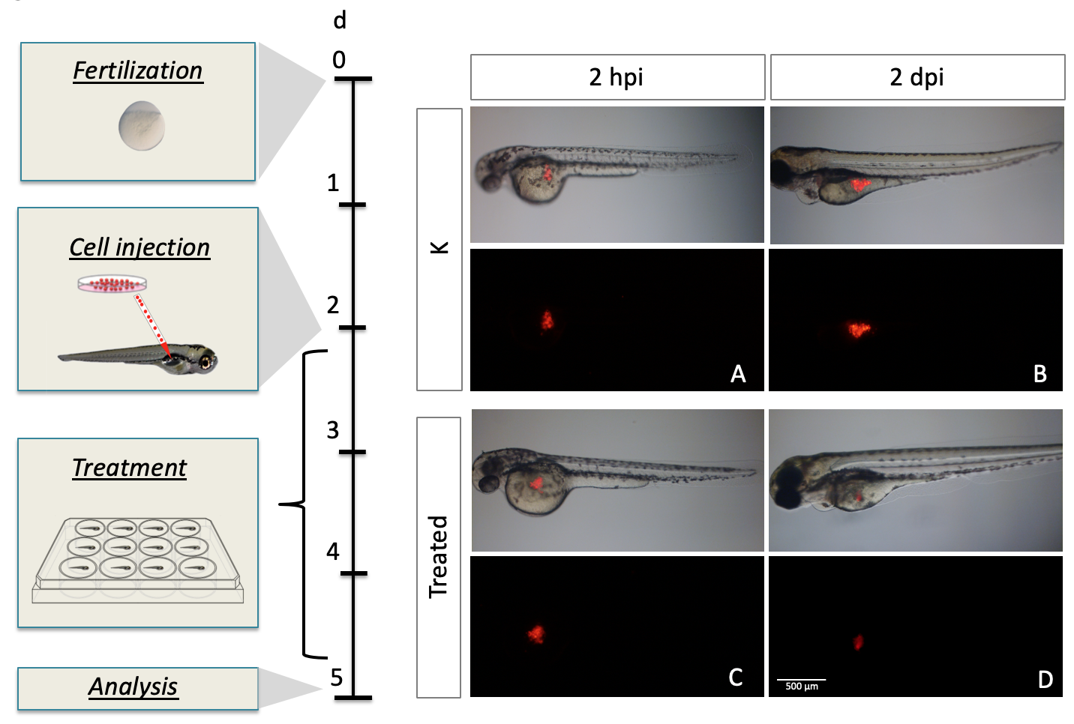Figure 1 Protocol used for the evaluation of the chemotherapy drugs efficacy. A piece of pancreatic ductal adenocarcinoma tumor tissue is injected into the yolk sac of zebrafish embryos 2 dpf. At 2 h post injection (hpi) the embryos are imaged and exposed to chemotherapy for 2 d. A and B: On the right panel a representative image of control embryos after 2 hpi and 2 dpi; C and D: On the right panel a representative image of treated embryos after 2 hpi and 2 dpi. Qualitatively images show the increased of fluorescent area in control group versus the regression in xenotransplanted embryos treated with chemotherapy.
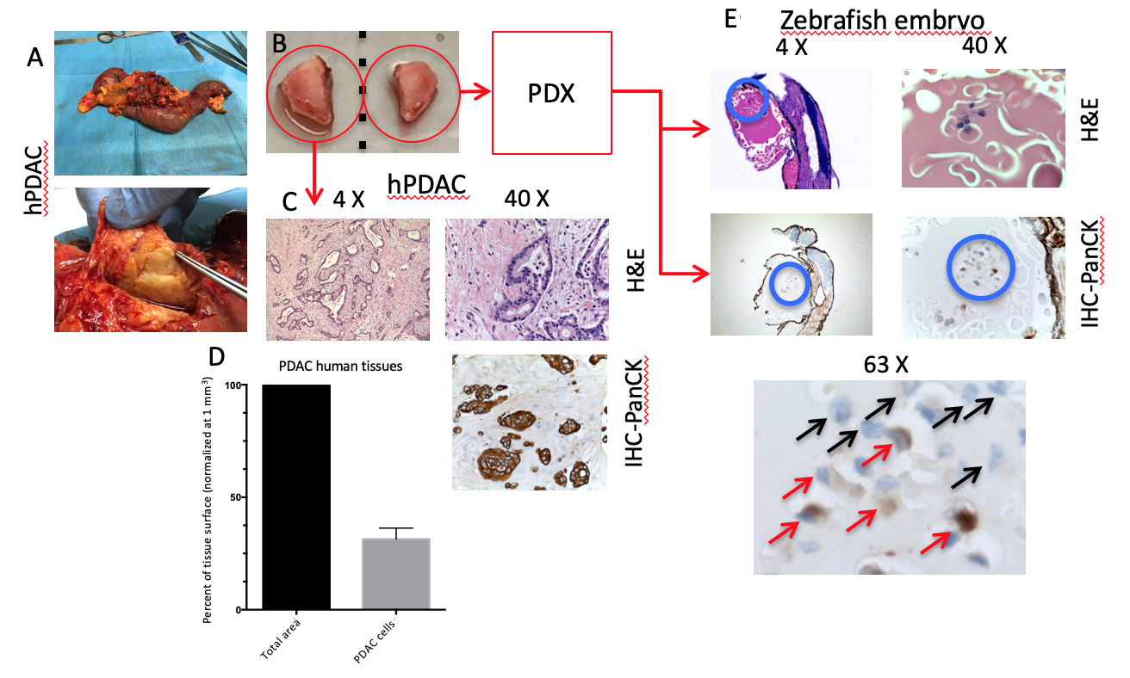
Figure 2 Tumor tissue was successfully engrafted in healthy zebrafish embryos in all cases. A: Surgical specimen was obtained from patient with diagnosed pancreatic ductal adenocarcinoma (PDAC); B: Two fragments of the tumor were taken; C and D: One of them was used for histological evaluation (C) revealing that the percentage of epithelial cells (mean PDAC counterpart) out of the total surface area is 31.8% ± 4.9% (n = 3) (D); E: The second fragment of the tumor was used for xenotransplantation into the yolk of zebrafish embryos 2 dpf. After 2 d post xenotransplantation, the zebrafish patient-derived xenografts (zPDX) are Formalin-Fixed Paraffin Embedded. We performed the hematoxylin and eosin staining and immunohistochemistry using anti-Human Pan-Cytokeratin antibody on zPDX sections, highlighting the presence of epithelial PDAC cells (red arrows) and the immune-negative counterpart (black arrows) that might be associated with the microenvironment side of PDAC human tissue. PDAC: Pancreatic ductal adenocarcinoma; PDX: Patient-derived xenografts; PanCK: Pan-Cytokeratin antibody.
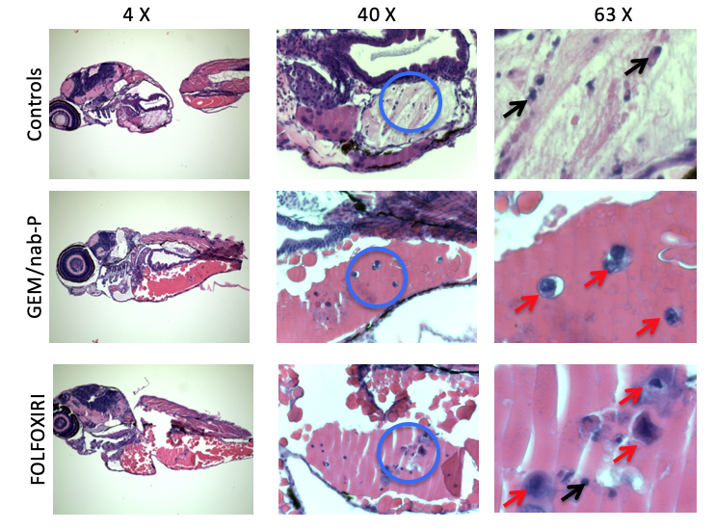
Figure 3 Representative hematoxylin and eosin stained sections of zebrafish patient-derived xenografts. Visible morphologic alteration of the human pancreatic ductal adenocarcinoma nuclei (red arrows) in zebrafish patient-derived xenografts exposed to Gemcitabine + nab-Paclitaxel and 5-Fluorouracil + Folinic acid + Oxaliplatin + Irinotecan could be associated with a chemotherapy damage. Control group shows normal nuclei (black arrows). GEM/nab-P: Gemcitabine + nab-Paclitaxel; FOLFOXIRI: 5-Fluorouracil + Folinic acid + Oxaliplatin + Irinotecan.
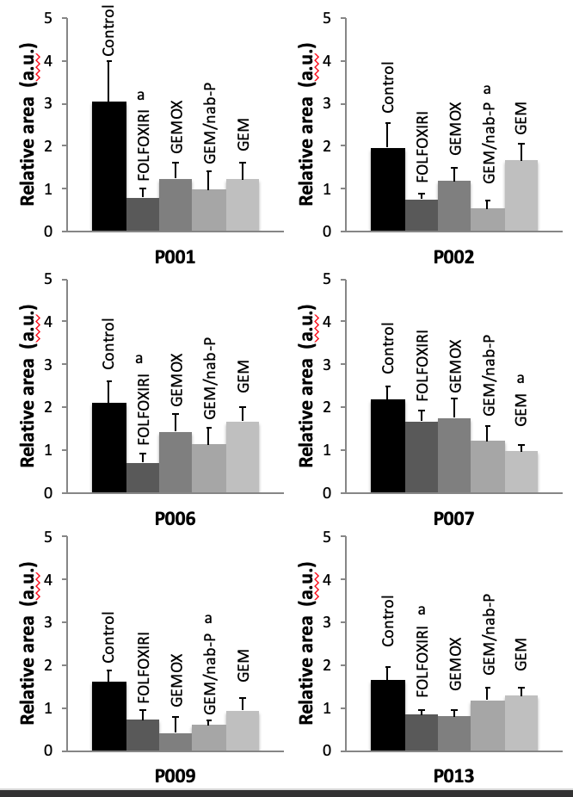
Figure 4 Cases with a statistically significant reduction of the mean relative tumor area for at least one chemotherapy scheme (the code below each diagram corresponds to the case number). Results are expressed as average ± SEM, ªP < 0.05, 1-way ANOVA followed by Dunnett’s multiple comparisons test. Control group shows normal nuclei (black arrows). GEM: Gemcitabine; GEMOX: Gemcitabine + Oxaliplatin; GEM/nab-P: Gemcitabine + nab-Paclitaxel; FOLFOXIRI: 5-Fluorouracil + Folinic acid + Oxaliplatin + Irinotecan.
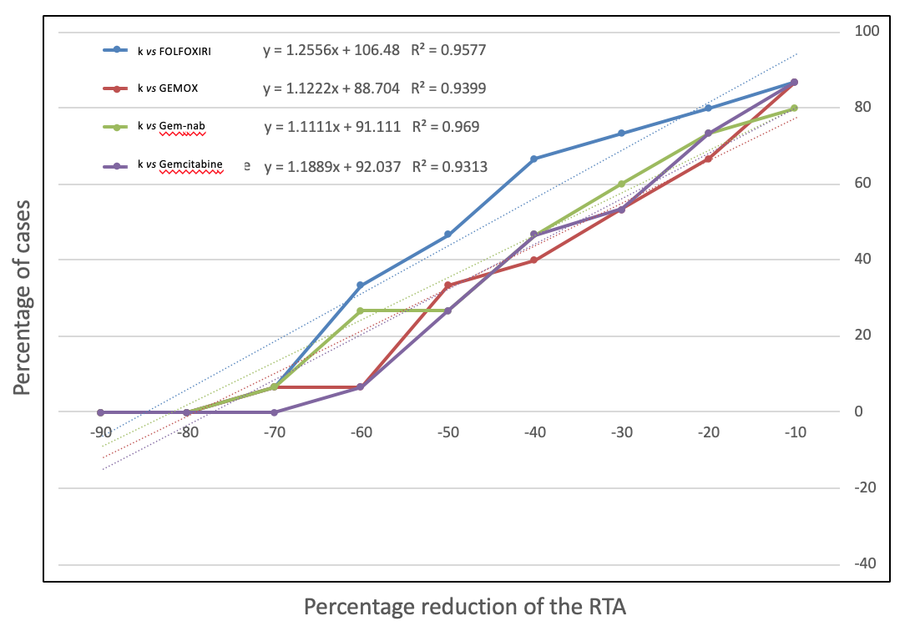
Figure 5 Percentage of cases with a percentage reduction of mean relative tumor area equal or greater to each threshold value. RTA: relative tumor area; Control group shows normal nuclei (black arrows). k: Control group; GEM: Gemcitabine; GEMOX: Gemcitabine + Oxaliplatin; GEM/nab-P: Gemcitabine + nab-Paclitaxel; FOLFOXIRI: 5-Fluorouracil + Folinic acid + Oxaliplatin + Irinotecan.

Table 1 Patients characteristics (n = 15)
Characteristics
Mean age, years ± SD | 71.2 ± 9.9 (44.1-83.2)
M:F, n (%) | 8:7 (53.3:46.7)
Mean BMI, kg/m2 ± SD | 26.4 ± 5.1 (17.6-40.4)
Ca 19.9, U/mL ± SD | 347.1 ± 543.0 (1.7-2094)
Type of surgical procedure, n (%)
Pancreatoduodenectomy | 11 (73.3)
Distal splenopancreatectomy | 3 (20)
Total splenopancreatectomy | 1 (6.7)
Vascular resection, n (%) | 4 (26.7)
Grade of differentiation, n (%)
G2/3 | 11 (73.3)
G3/3 | 4 (26.7)
Mean tumour dimension, cm | 3.3 ± 1.2 (1.5-5.0)
Mean harvest lymph nodes, n | 40.6 ± 18.0 (19-74)
Mean positive lymph nodes, n | 5.7 ± 6.0 (0-22)
T status, n (%)
T1 | 2 (13.3)
T2 | 7 (46.7)
T3 | 6 (40)
N status, n (%)
N0 | 1 (6.6)
N1 | 7 (46.7)
N2 | 7 (46.7)
Stage, n (%)
IB | 1 (6.7)
IIB | 6 (40)
III | 8 (53.3)
Angioinvasion, n (%) | 2 (13.3)
Perineural infiltration, n (%) | 11 (73.4)
Vascular infiltration, n (%) | 2 (13.3)
BMI: Body mass index; M: Male; F: Female.

Table 2 Survival rate of the xenotransplanted zebrafish embryos
No. of case | 1 d post injection |  |  |  |  | 2 d post injection
 | Control group | GEM | GEMOX | GEM/nab-P | FOLFOXIRI | Control group | GEM | GEMOX | GEM/nab-P
1 | 0.909 | 0.833 | 0.917 | 0.917 | 0.900 | 0.818 | 0.667 | 0.833 | 0.583
2 | 0.417 | 0.800 | 0.917 | 0.667 | 0.833 | 0.333 | 0.583 | 0.667 | 0.500
3 | 0.833 | 1.000 | 0.636 | 0.917 | 0.833 | 0.417 | 0.818 | 0.182 | 0.75
4 | 0.682 | 0.438 | 0.7692 | 0.750 | 0.647 | 0.545 | 0.375 | 0.692 | 0.688
5 | 0.533 | 0.750 | 0.667 | 1.000 | 0.555 | 0.533 | 0.625 | 0.267 | 0.824
6 | 0.476 | 0.429 | 0.462 | 0.563 | 0.688 | 0.477 | 0.429 | 0.462 | 0.563
7 | 0.857 | 0.692 | 0.846 | 0.733 | 0.688 | 0.667 | 0.538 | 0.615 | 0.267
8 | 0.864 | 0.533 | 0.765 | 0.933 | 0.588 | 0.727 | 0.533 | 0.539 | 0.800
9 | 0.652 | 0.471 | 0.058 | 0.471 | 0.556 | 0.609 | 0.353 | 0.059 | 0.471
10 | 0.800 | 0.611 | 0.733 | 0.800 | 0.800 | 0.150 | 0.5 | 0.667 | 0.600
11 | 0.917 | 0.923 | 1.000 | 0.800 | 1.000 | 0.500 | 0.462 | 0.571 | 0.500
12 | 0.789 | 0.75 | 0.687 | 0.556 | 0.529 | 0.632 | 0.625 | 0.312 | 0.167
13 | 0.957 | 0.824 | 0.75 | 0.765 | 0.833 | 0.739 | 0.647 | 0.500 | 0.471
14 | 0.700 | 0.467 | 0.556 | 0.500 | 0.333 | 0.550 | 0.267 | 0.278 | 0.167
15 | 0.846 | 0.786 | 0.786 | 0.538 | 0.833 | 0.615 | 0.357 | 0.429 | 0.462
Mean survival rate | 0.749 | 0.687 | 0.703 | 0.727 | 0.708 | 0.554 | 0.519 | 0.471 | 0.521
GEM: Gemcitabine; GEMOX: Gemcitabine + Oxaliplatin; GEM/nab-P: Gemcitabine + nab-Paclitaxel; FOLFOXIRI: 5-Fluorouracil + Folinic acid + Oxaliplatin + Irinotecan.

Table 3 Results of exposure to chemotherapy in xenotransplanted zebrafish embryos
Mean relative tumor area |  |  |  |  | Mean difference |  |  |  | 95%CI |  |  |  | P value
Control group | FOLFOXIRI | GEMOX | GEM/nab-P | GEM | k vs FOLFOXIRI | k vs GEMOX | k vs GEM/nab-P | k vs Gemcitabine | k vs FOLFOXIRI | k vs GEMOX | k vs GEM/nab-P | k vs Gemcitabine | k vs FOLFOXIRI | k vs GEMOX | k vs GEM/nab-P | k vs Gemcitabine
3.026 | 0.790 | 1.243 | 0.988 | 1.213 | 2.236 | 1.784 | 2.038 | 1.813 | 0.286 to 4.187 | -0.167 to 3.734 | -0.047 to 4.123 | -0.198 to 3.823 | 0.020 | 0.081 | 0.057 | 0.087
1.964 | 0.755 | 1.188 | 0.529 | 1.674 | 1.209 | 0.776 | 1.435 | 0.290 | -0.016 to 2.434 | -0.522 to 2.073 | 0.099 to 2.771 | -0.978 to 1.558 | 0.054 | 0.361 | 0.032 | 0.936
1.699 | 0.524 | 1.599 | 1.238 | 0.706 | 1.175 | 0.100 | 0.461 | 0.993 | -0.026 to 2.376 | -1.348 to 1.548 | -0.645 to 1.567 | -0.113 to 2.099 | 0.057 | 0.999 | 0.659 | 0.088
1.604 | 0.951 | 1.990 | 1.767 | 1.013 | 0.653 | -0.385 | -0.163 | 0.592 | -0.452 to 1.759 | -1.551 to 0.780 | -1.269 to 0.942 | -0.724 to 1.907 | 0.381 | 0.817 | 0.987 | 0.616
2.357 | 2.260 | 1.689 | 1.566 | 1.263 | 0.097 | 0.668 | 0.792 | 1.094 | -2.112 to 0.261 | -1.363 to 2.700 | -0.679 to 2.262 | -0.479 to 2.668 | >0.990 | 0.817 | 0.458 | 0.244
2.098 | 0.714 | 1.423 | 1.130 | 1.672 | 1.384 | 0.674 | 0.968 | 0.426 | -2.112 to 0.261 | -0.826 to 2.175 | -0.411 to 2.346 | -1.075 to 1.926 | 0.034 | 0.610 | 0.236 | 0.879
2.170 | 1.663 | 1.746 | 1.205 | 0.965 | 0.507 | 0.424 | 0.966 | 1.205 | -2.112 to 0.261 | -0.760 to 1.607 | -0.478 to 2.409 | 0.022 to 2.388 | 0.560 | 0.770 | 0.270 | 0.040
1.224 | 0.489 | 1.802 | 1.189 | 1.221 | 0.735 | -0.578 | 0.035 | 0.003 | -2.112 to 0.261 | -2.130 to 0.975 | -1.311 to 1.382 | -1.549 to 1.556 | 0.730 | 0.750 | >0.990 | >0.990
1.606 | 0.710 | 0.423 | 0.606 | 0.945 | 0.896 | 1.183 | 1.000 | 0.662 | -2.112 to 0.261 | -0.383 to 2.748 | 0.083 to 1.918 | -0.417 to 1.740 | 0.057 | 0.183 | 0.029 | 0.342
1.046 | 0.575 | 1.037 | 0.468 | 0.514 | 0.471 | 0.009 | 0.579 | 0.533 | -2.112 to 0.261 | -1.094 to 1.113 | -0.557 to 1.714 | -0.586 to 1.650 | 0.643 | >0.990 | 0.506 | 0.563
2.669 | 1.203 | 1.207 | 1.428 | 1.371 | 1.466 | 1.462 | 1.241 | 1.298 | -2.112 to 0.261 | -1.407 to 4.331 | -1.326 to 3.807 | -1.268 to 3.864 | 0.338 | 0.492 | 0.537 | 0.499
1.371 | 0.852 | 0.705 | 1.383 | 1.077 | 0.520 | 0.666 | -0.012 | 0.294 | -0.667 to 1.706 | -0.775 to 2.107 | -1.452 to 1.429 | -0.774 to 1.363 | 0.627 | 0.584 | >0.990 | 0.888
1.648 | 0.8481 | 0.8028 | 1.174 | 1.273 | 0.7996 | 0.8449 | 0.4737 | 0.3748 | 0.019 to 1.580 | -0.030 to 1.720 | -0.3717 to 1.319 | -0.471 to 1.220 | 0.043 | 0.061 | 0.433 | 0.632
1.275 | 1.704 | 0.888 | 2.157 | 1.683 | -0429 | 0.387 | -0.882 | -0.408 | -1.975 to 1.117 | -0.957 to 1.731 | -2.428 to 0.664 | -1.954 to 1.138 | 0.879 | 0.864 | 0.394 | 0.896
1.041 | 1.966 | 1.167 | 0.789 | 1.091 | -0.926 | -0.126 | 0.252 | -0.050 | -2.112 to 0.261 | -1.356 to 1.104 | -1.035 to 1.539 | -1.281 to 1.180 | 0.162 | >0.990 | 0.963 | >0.990
k: Control group; GEM: Gemcitabine; GEMOX: Gemcitabine + Oxaliplatin; GEM/nab-P: Gemcitabine + nab-Paclitaxel; FOLFOXIRI: 5-Fluorouracil + Folinic acid + Oxaliplatin + Irinotecan.

Table 4 Percentage reduction of the mean relative tumor area
No. of case | k vs FOLFOXIRI (%) | k vs GEMOX (%) | k vs Gem/nab-P (%) | k vs Gemcitabine (%)
1 | -74 | -59 | -67 | -60
2 | -62 | -40 | -73 | -15
3 | -69 | -6 | -27 | -58
4 | -41 | 24 | 10 | -37
5 | -4 | -28 | -34 | -46
6 | -66 | -32 | -46 | -20
7 | -23 | -20 | -44 | -56
8 | -60 | 47 | -3 | 0
9 | -56 | -74 | -62 | -41
10 | -45 | -1 | -55 | -51
11 | -55 | -55 | -46 | -49
12 | -38 | -49 | 1 | -21
13 | -49 | -51 | -29 | -23
14 | 34 | -30 | 69 | 32
15 | 54 | -8 | -38 | -14
k: Control group; GEM: Gemcitabine; GEMOX: Gemcitabine + Oxaliplatin; GEM/nab-P: Gemcitabine + nab-Paclitaxel; FOLFOXIRI: 5-Fluorouracil + Folinic acid + Oxaliplatin + Irinotecan.

Table 5 analysis of the percentage reduction of the mean relative tumor area in the treated subgroups in comparison to the control group
Threshold value | Number of cases, n (%)
 | k vs FOLFOXIRI | k vs GEMOX | k vs Gem/nab-P | k vs Gemcitabine
-10% | 13 (87) | 13 (87) | 12 (80) | 13 (87)
-20% | 12 (80) | 10 (67) | 11 (73) | 11 (73)
-30% | 11 (73) | 8 (53) | 9 (60) | 8 (53)
-40% | 10 (67) | 6 (40) | 7 (47) | 7 (47)
-50% | 7 (47) | 5 (33) | 4 (27) | 4 (27)
-60% | 5 (33) | 1 (7) | 4 (27) | 1 (7)
-70% | 1 (7) | 1 (7) | 1 (7) | 0 (0)
-80% | 0 (0) | 0 (0) | 0 (0) | 0 (0)
k: Control group; GEM: Gemcitabine; GEMOX: Gemcitabine + Oxaliplatin; GEM/nab-P: Gemcitabine + nab-Paclitaxel; FOLFOXIRI: 5-Fluorouracil + Folinic acid + Oxaliplatin + Irinotecan.

Table 6 Calculation of the conversion factor for the test with xenotransplanted zebrafish embryos
 | Study | Percentage of partial response reported in literature | Conversion Factor for xenotransplanted zebrafish embryos | Mean conversion factor (P = 0.626)
k vs FOLFOXIRI | Conroy et al^{[7]}, 2011 | 31 | -60.1 | -60.4
 | Tong et al^{[40]}, 2018 | 35.9 | -56.2
 | Lakatos et al^{[41]}, 2017 | 18.8 | -69.8
 | Nitsche et al^{[42]}, 2015 | 42.8 | -50.7
 | Sadot et al^{[43]}, 2015 | 29 | -61.7
 | Wang et al^{[44]}, 2019 | 32.3 | -59.1
k vs GEMOX | Shi et al^{[46]}, 2007 | 26.8 | -55.2 | -59.3
 | Li et al^{[47]}, 2010 | 25 | -56.8
k vs Gem/nab-P | Von Hoff et al^{[48]}, 2013 | 23 | -61.3 | -62.4
 | Casanova-Martinez et al^{[49]}, 2018 | 20 | -64.0
 | Karasic et al^{[50]}, 2019 | 21.1 | -63.0
 | Montes et al^{[51]}, 2017 | 23 | -61.3
k vs Gemcitabine | Conroy et al^{[7]}, 2011 | 16 | -63.9 | -63.7
 | Louvet et al^{[52]}, 2005 | 17.3 | -62.8
 | Ergun et al^{[53]}, 2018 | 15.3 | -64.5
k: Control group; GEM: Gemcitabine; GEMOX: Gemcitabine + Oxaliplatin; GEM/nab-P: Gemcitabine + nab-Paclitaxel; FOLFOXIRI: 5-Fluorouracil + Folinic acid + Oxaliplatin + Irinotecan.

