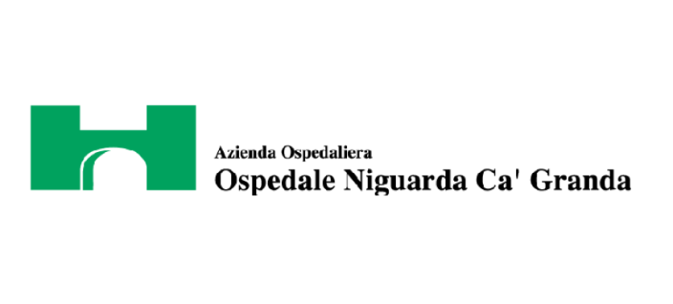

Milano, 23 March 2016

The statistical methods of the study called “Endoscopic multiple metal stenting for the treatment of enteral leaks near the biliary orifice: A novel effective rescue procedure.” were reviewed by Lorenzo Dioscoridi, MD.
This is a case series and retrospective study, so, the methods are appropriate and adequate to present the results.

Lorenzo Dioscoridi

