Name of Journal: World Journal of Gastrointestinal Surgery
Manuscript NO: 74923
Manuscript Type: ORIGINAL ARTICLE

Retrospective Study
Prognostic significance of the preoperative hemoglobin to albumin ratio for the short-term survival of gastric cancer patients

Hu CG et al. Prognostic significance of the preoperative hemoglobin to albumin ratio for GC

Ce-Gui Hu, Bai-e Hu, Jin-feng Zhu, Zheng-Ming Zhu, Chao Huang

Ce-Gui Hu, Bai-E Hu, Jin-Feng Zhu, Zheng-Ming Zhu, Chao Huang, Department of Gastrointestinal Surgery, The Second Affiliated Hospital of Nanchang University, Nanchang 330006, Jiangxi Province, China

Author contributions: Hu BE and Hu CG designed the study and contributed equally to this work; Hu BE, Hu CG and Zhu JF collected the clinical data; Hu BE analyzed the data and wrote the manuscript with contributions from all authors; Zhu ZM and Huang C provided critical comments for this paper; All authors read and approved the final version of the paper.

Supported by National Natural Science Foundation of China, No. 81560389; and Key Research and Development Program of Jiangxi Province, No. 20181BBG70015.

Corresponding author: Chao Huang, PhD, Doctor, Department of Gastrointestinal Surgery, The Second Affiliated Hospital of Nanchang University, No. 1 Minde Road, Nanchang 330006, Jiangxi Province, China. huangchao8041@163.com

Received: January 11, 2022
Revised: March 20, 2022
Accepted: May 28, 2022
Published online:

Abstract
BACKGROUND
Hemoglobin and albumin are associated with the prognosis of gastric cancer (GC) patients. However, the prognostic value of the hemoglobin to albumin ratio (HAR) for the short-term survival of GC patients with D2 radical resection has not been studied.

AIM
To investigate the significance of the HAR in evaluating the short-term survival of GC patients after D2 radical resection and to construct a nomogram to predict the prognosis in GC patients after surgery, thus providing a reference for the development of postoperative individualized treatment and follow-up plans.

METHODS
Cox regression and Kaplan-Meier analysis was used for prognostic analysis. Logistic regression was used to analyze the relationships between HAR and the clinicopathological characteristics of the GC patients. A prognostic nomogram model for the short-term survival of GC patients was constructed by R software.

RESULTS
HAR was an independent risk factor for the short-term survival of GC patients. GC patients with a low HAR had a poor prognosis (P < 0.001). Low HAR was markedly related to high stage [odds ratio (OR) = 0.45 for II vs I; OR = 0.48 for III vs I], T classification (OR = 0.52 for T4 vs T1) and large tumor size (OR = 0.51 for ≥ 4 cm vs < 4 cm) (all P < 0.05). The nomogram model was based on HAR, age, CA19-9, CA125 and stage, and the C-index was 0.820.

CONCLUSION
Preoperative low HAR was associated with short-term survival in GC patients. The prognostic nomogram model can accurately predict the short-term survival of GC patients with D2 radical resection.

Key Words: gastric cancer; hemoglobin to albumin ratio; short-term survival; prognosis; nomogram

Hu CG, Hu B, Zhu J, Zhu ZM, Huang C. Prognostic significance of the preoperative hemoglobin to albumin ratio for the short-term survival of gastric cancer patients. World J Gastrointest Surg 2022; In press

Core Tip: Hemoglobin and albumin are associated with the prognosis of gastric cancer (GC) patients. However, the prognostic value of the hemoglobin to albumin ratio (HAR) for the short-term survival of GC patients with D2 radical resection has not been studied. HAR was an independent risk factor for the short-term survival of GC patients. GC patients with a low HAR had a poor prognosis. Low HAR was markedly related to high stage, T classification and tumor size. The nomogram model was based on HAR, age, CA19-9, CA125 and stage and can accurately predict the short-term survival of D2 radical resection GC patients.
INTRODUCTION
For resectable gastric cancer (GC), radical surgery and adjuvant therapy are the standard therapies^{[1,2]}. Postoperative prognosis is evaluated by the American Joint Committee on Cancer TNM classification system^{[3,4]}. However, prognostic factors such as age, tumor size and tumor location are not considered in the prediction of individual survival. Moreover, the prognosis of patients in the same stage with similar treatment regimens varies greatly^{[5,6]}. Therefore, it is necessary to develop a comprehensive and accurate prognostic evaluation system to predict the prognosis of GC patients, which is of great significance in selecting individualized treatment plans for these patients.
In addition, studies have shown that the prognosis of cancer is not only correlated with tumor characteristics but also to the nutritional status and systemic inflammation of patients^{[7,8]}. The systemic inflammatory response can affect the progression and metastasis of tumors^{[9]}. Recently, studies also found that malnutrition is associated with decreased immunity, which increases the incidence of complications and mortality postoperatively, leading to poor postoperative prognosis in cancer patients^{[10,11]}.
Hemoglobin and albumin are used as the two most common indicators of nutritional status. Various perioperative nutritional parameters have been confirmed as independent prognostic factors in GC patients who underwent D2 radical resection^{[12]}. Low hemoglobin levels can lead to tumor hypoxia, which can accelerate tumor growth and promote the angiogenesis of tumor cells^{[13]}. Low serum albumin concentration was an independent risk factor affecting the survival of GC patients^{[14]}. In addition, low serum albumin levels can impair cellular immune function, leading to poor prognosis in cancer patients^{[15]}. Studies have demonstrated that preoperative low serum albumin and hemoglobin levels are closely associated with the poor prognosis of malignant tumors^{[16,17]}; the high preoperative C-reactive protein to albumin ratio was related to poor outcome in patients with GC^{[18,19]}.
However, the clinical value of the hemoglobin to albumin ratio (HAR) in the prognosis of GC patients with D2 radical resection has not been reported. Nomogram can provide the overall probability of specific outcomes for individual patients and provide more accurate predictions than the traditional TNM staging system, thereby improving personalized treatment decisions^{[20,21]}. Therefore, the aim of this study was to investigate the significance of the HAR in evaluating the short-term survival of GC patients after D2 radical resection and to construct a nomogram to predict the prognosis in GC patients after surgery, thus providing a reference for the development of postoperative individualized treatment and follow-up plans.

MATERIALS AND METHODS
Patient characteristics
The clinical and follow-up data of 312 GC patients who underwent D2 radical resection in our hospital were collected from January 2017 to January 2019. Tumor markers, serum albumin and fibrinogen levels and blood cell counts, including hemoglobin, neutrophils, platelets and lymphocytes, were extracted at the first admission. The HAR, platelet to hemoglobin ratio, platelet to lymphocyte ratio (PLR), platelet to albumin ratio (PAR), fibrinogen to lymphocyte ratio (FLR), albumin to fibrinogen ratio, hemoglobin to fibrinogen ratio (HFR), platelet to fibrinogen ratio, neutrophil to lymphocyte ratio (NLR) and albumin to lymphocyte ratio were calculated. According to the median HAR value, GC patients were divided into a high HAR group and a low HAR group. The stage of postoperative patients was based on the American Joint Committee on Cancer TNM classification system. Survival time was calculated from the day of surgery to the last follow-up. After surgery, all patients were followed up every 3 mo for the first 2 years and then every 6 mo until 5 years. The last follow-up date was March 1, 2020.

Inclusion and exclusion criteria
The inclusion criteria were as follows: (1) patients with GC were diagnosed by pathology after surgery; and (2) neoadjuvant chemoradiotherapy was not performed before surgery. The exclusion criteria were as follows: (1) patients with a history of surgery 2 mo before admission; (2) patients with a history of blood transfusion; (3) patients using hemostatic and anticoagulant drugs; (4) patients with bleeding, thrombotic disease or splenectomy; and (5) patients with pregnancy, chronic disease, acute infection, relapse or other distant organ metastases and those who were lost to follow-up or had incomplete information.

Statistical analysis
Prognostic analysis was performed using Kaplan-Meier and Cox regression analyses. The Mann-Whitney U test was used for comparisons between two groups. The relationships between HAR and clinicopathological characteristics were determined by logistic regression. The receiver operating characteristic curve was used to evaluate the ability of a single factor or combined factors to predict the short-term survival of GC patients. The rms package of R software was used to construct a prognostic nomogram model for the short-term survival of GC patients, and the scores of various indicators were obtained. In addition, Harrell’s concordance index (C-index) was calculated to evaluate the performance of the model’s prediction results^{[22]}. A p value less than 0.05 was considered to indicate a statistically significant result. Analyses were performed by SPSS 22.0 for Windows (SPSS Inc., Chicago, IL, United States) and R (version x64 3.6.1).

RESULTS
Prognostic analysis of GC patients with D2 radical resection
The factors associated with prognosis were as follows: age, CEA, CA19-9, CA125, HAR, platelet to hemoglobin ratio, PLR, PAR, FLR, HFR, tumor size, vascular infiltration, nerve infiltration and stage (all P < 0.05). Multivariate Cox regression analysis found that age, HAR and stage were independent risk factors affecting prognosis (all P < 0.05) (Table 1). Kaplan-Meier analysis found that the difference in the survival time of GC patients with a low HAR and high HAR was statistically significant (P = 0.003), indicating that GC patients with low HAR had a poor prognosis (Figure 1).

Association between HAR and clinicopathological characteristics
To analyze the association between HAR and clinicopathological characteristics, we performed logistic regression analysis. HAR was associated with stage, T classification and large tumor size (all P < 0.05) (Figure 2). Logistic regression analysis showed that a low HAR was effectively related to high stage [odds ratio (OR) = 0.45 for II vs I; OR = 0.48 for III vs I], T classification (OR = 0.52 for T4 vs T1) and large tumor size (OR = 0.51 for ≥ 4 cm vs < 4 cm) (all P < 0.05) in GC patients (Table 2). These results indicate that GC patients with a low HAR were more likely to have advanced GC.

Comparison between the low HAR group and the high HAR group
To further analyze the relationships between HAR and prognostic factors, we divided the GC patients into a low HAR group and a high HAR group according to the median HAR value. The factors with statistically significant differences between the two groups were sex, CA125, platelet to hemoglobin ratio, PLR, PAR, FLR, HFR, platelet to fibrinogen ratio, NLR, albumin to lymphocyte ratio, large tumor size, stage and T classification (all P < 0.05), suggesting that patients with a low HAR had high stage, T classification, CA125, FLR, PAR, PLR, large tumor sizes and low HFR (Table 3 and Figure 3).

Receiver operating characteristic curve analysis
To evaluate the ability of HAR or combined factors to predict the short-term survival of GC patients, we performed receiver operating characteristic curve analysis. The area under the curve (AUC) of HAR alone in predicting the 1-year survival of GC patients was 0.656, the sensitivity was 78.19%, and the specificity was 52.94%, while the AUC of predicting the 2.5-year survival was 0.804, the sensitivity was 85.29%, and the specificity was 74.95%. The AUC of HAR combined with age, CA19-9, CA125 and stage to predict the 1-year survival of GC patients was 0.833, the sensitivity was 86.83%, and the specificity was 84.77%, while the AUC of predicting the 2.5-year survival was 0.832, the sensitivity was 87.87%, and the specificity was 72.18% (Figure 4). These results indicate that HAR combined with prognostic factors can accurately predict the short-term survival of patients with GC.

Construction of the prognostic nomogram
To predict the short-term survival probability of GC patients after surgery, we used the rms package to construct a logistic regression model of HAR combined with age, CA19-9, CA125 and stage, and the C-index evaluated by this model was 0.820, indicating that this prediction model had certain accuracy. Then, the plotting function was employed, and the nomogram was plotted (Figure 5). A score of HAR ≥ 3.18 was 0 points, while a score of HAR < 3.18 was 37 points. A score of age ≥ 62 years was 13 points, while a score of age < 62 years was 0 points. A score of CA19-9 ≥ 13.255 U/mL was 26 points, while a score of CA19-9 < 13.255 U/mL was 0 points. A score of CA125 ≥ 8.5 U/mL was 18 points, while a score of CA125 < 8.5 U/mL was 0 points. A score of stage Ⅰ was 0 points, a score of stage II was 63 points, and a score of stage Ⅲ was 100 points. The highest score was 194 points, indicating that the 1-year survival probability of GC patients was 60%-65% and that the 5-year survival probability was < 10%. According to the total points, the probability of the short-term survival of GC patients can be predicted.

DISCUSSION
The systemic inflammatory response and malnutrition are markedly related to the prognosis of cancer^{[10,11,13]}. Neutrophils, lymphocytes, platelets and fibrinogen may play important roles in tumor-induced systemic inflammatory responses^{[23,24]}. Hemoglobin and albumin are the two most common indicators of nutritional status. At the same time, serum albumin can also reflect the inflammation of patients. Various scores and indicators based on inflammation and nutritional status have been produced to predict the prognosis of cancer, such as the controlling nutritional status score, C-reactive protein to albumin ratio, NLR, PLR, prognostic nutrition index and systemic immune inflammation index^{[25-27]}.
Deng et al^{[28]} showed that the preoperative PLR was significantly associated with poor prognosis in GC patients with surgical resection. Gu et al^{[29]} also found that GC patients with elevated PLR had poor overall survival. Sun et al^{[30]} indicated that the combination of NLR and PLR was an independent risk factor for the overall survival of stage III GC patients undergoing radical resection. In addition, Suzuki et al^{[31]} found that high plasma fibrinogen was related to tumor progression and poor overall survival in GC patients. Huang et al^{[32]} showed that elevated FLR was a high risk factor for peritoneal metastasis in patients with GC. This study also showed that PLR and FLR were significantly related to the prognosis of GC patients.
Hemoglobin is used to determine anemia. Hypoxia caused by anemia, on the one hand, may accelerate tumor angiogenesis to promote tumor progression; on the other hand, it may make tumor cells resistant to radiotherapy and chemotherapy through proteomics and genomic changes^{[13,33,34}]. Moreover, it is well known that hypoxia-inducible factor 1 can regulate gene products that promote tumor progression, and hypoxia increases its expression^{[35]}. However, the molecular mechanisms of hypoxia need to be further elucidated. Previous studies have found that anemia was an independent risk factor for poor prognosis in patients with malignant tumors^{[36,37]}.
Huang et al^{[38]} found that GC patients with low hemoglobin levels before surgery had poor survival. Liu et al^{[39]} demonstrated that preoperative low hemoglobin concentrations were significantly related to not only large tumor sizes but also poor 5-year overall survival and high postoperative complication rates in advanced GC patients. Shen et al^{[40]} suggested that preoperative anemia was markedly related to large tumor sizes, deep invasion depths and high stages and showed that stage I and II GC patients with anemia before surgery had a low long-term survival rate compared with patients without anemia before surgery.
Malnutrition and inflammation can inhibit albumin synthesis. Serum albumin was an independent prognostic indicator of malignant tumors^{[14,41]}. Lien et al^{[42]} showed that serum albumin was effectively associated with the 5-year survival of GC patients. Moreover, relevant studies have indicated that low albumin levels are related to poor prognosis in GC^{[14,43]}. However, Crumley et al^{[14]} demonstrated that GC patients with low albumin levels had a poor prognosis compared with those with high albumin levels, but this factor was not an independent predictor of prognosis. Moreover, Toyokawa et al^{[44]} believed that C-reactive protein to albumin ratio was an independent prognostic factor for overall survival in patients who underwent R0 resection for stage III gastric cancer.
This study indicated that HAR, stage and age were independent risk factors for the short-term survival of GC patients. Logistic regression analysis showed that a low HAR was markedly correlated with high stage, T classification and large tumor size in GC patients. To further analyze the relationships between HAR and prognostic factors, we divided GC patients into a low HAR group and a high HAR group according to the median HAR value, and the results showed that patients with low HAR had high stage, T classification, CA125 and large tumor size. In addition, Kaplan-Meier analysis indicated that low HAR was related to short survival in GC patients.
Serum tumor markers can be used to predict the prognosis of cancer. Previous studies have found that elevated CEA, CA19-9 and CA125 levels were related to the prognosis of GC^{[45-47]}. Related studies have also indicated that preoperative CEA and CA19-9 levels are related to tumor invasion depth and stage and can be used to predict prognosis^{[48,49]}. Kochi et al^{[50]} indicated that serum CA125 and CA19-9 were independent predictors of GC prognosis. This study also showed that CEA, CA19-9 and CA125 were associated with the prognosis of GC patients. The prognosis of patients with GC was evaluated mainly according to the American Joint Committee on Cancer TNM classification system^{[3,4]}. However, this system has some limitations in clinical application.
Currently, nomograms combining prognostic factors have been developed, and it has been found that nomograms including inflammation and tumor markers can predict the prognosis of cancer more accurately than the traditional TNM classification system^{[51-53]}. In this study, HAR, stage, age, CA19-9 and CA125 were used to construct a nomogram model for the short-term survival of GC patients, and the C-index for model evaluation was 0.820. The accuracy, sensitivity and specificity of this model for predicting the 1-year survival of GC patients were 83.30%, 86.83% and 84.77%, respectively, and the accuracy, sensitivity and specificity of the model for predicting the 2.5-year survival of GC patients were 83.20%, 87.87% and 72.18%, respectively, indicating that the model had a certain validity in predicting the short-term survival of patients with GC.
This study has some limitations. First, this was a single-center, small-sample retrospective study. Second, several other inflammatory markers correlated with prognosis were not included. Therefore, multicenter large-scale prospective randomized controlled trials are necessary.
In conclusion, this is the first study to apply HAR to predict the prognosis of GC patients with D2 radical resection and to construct a short-term survival prognostic nomogram for GC patients. Preoperative low HAR was associated with short survival in GC patients. The prognostic nomogram model based on HAR, stage, age, CA19-9 and CA125 can correctly predict the short-term survival of GC patients with D2 radical resection, thus providing a reference for the development of personalized postoperative treatment and follow-up plans.

CONCLUSION
Preoperative low HAR was associated with short survival in GC patients. The prognostic nomogram model can accurately predict the short-term survival of GC patients with D2 radical resection.

ARTICLE HIGHLIGHTS
Research background
Hemoglobin and albumin are associated with the prognosis of gastric cancer (GC) patients. However, the prognostic value of the hemoglobin to albumin ratio (HAR) for the short-term survival of GC patients with D2 radical resection has not been studied.

Research motivation
The clinical value of the HAR in the prognosis of GC patients with D2 radical resection has not been reported. Nomogram can provide the overall probability of specific outcomes for individual patients and provide more accurate predictions than the traditional TNM staging system, thereby improving personalized treatment decisions.

Research objectives
The aim of this study was to investigate the significance of the HAR in evaluating the short-term survival of GC patients after D2 radical resection and to construct a nomogram to predict the prognosis in GC patients after surgery.

Research methods
Cox regression and Kaplan-Meier analysis was used for prognostic analysis. Logistic regression was used to analyze the relationships between HAR and the clinicopathological characteristics of the GC patients. A prognostic nomogram model for the short-term survival of GC patients was constructed by R software.

Research results
HAR was an independent risk factor for the short-term survival of GC patients. GC patients with a low HAR had a poor prognosis (P < 0.001). Low HAR was markedly related to high stage [odds ratio (OR) = 0.45 for II vs I; OR = 0.48 for III vs I], T classification (OR = 0.52 for T4 vs T1) and large tumor size (OR = 0.51 for ≥ 4 cm vs < 4 cm) (all P < 0.05). The nomogram model was based on HAR, age, CA19-9, CA125 and stage, and the C-index was 0.820.

Research conclusions
Preoperative low HAR was associated with short survival in GC patients. The prognostic nomogram model can accurately predict the short-term survival of GC patients with D2 radical resection.

Research perspectives
The significance of the HAR in evaluating the short-term survival of GC patients after D2 radical resection and to construct a nomogram to predict the prognosis in GC patients after surgery may provide a reference for the development of postoperative individualized treatment and follow-up plans.

REFERENCES
1 Van Cutsem E, Sagaert X, Topal B, Haustermans K, Prenen H. Gastric cancer. Lancet 2016; 388: 2654-2664 [PMID: 27156933 DOI: 10.1016/S0140-6736(16)30354-3]
2 Songun I, Putter H, Kranenbarg EM, Sasako M, van de Velde CJ. Surgical treatment of gastric cancer: 15-year follow-up results of the randomised nationwide Dutch D1D2 trial. Lancet Oncol 2010; 11: 439-449 [PMID: 20409751 DOI: 10.1016/S1470-2045(10)70070-X]
3 Japanese Gastric Cancer Association. Japanese gastric cancer treatment guidelines 2014 (ver. 4). Gastric Cancer 2017; 20: 1-19 [PMID: 27342689 DOI: 10.1007/s10120-016-0622-4]
4 Ajani JA, D'Amico TA, Almhanna K, Bentrem DJ, Chao J, Das P, Denlinger CS, Fanta P, Farjah F, Fuchs CS, Gerdes H, Gibson M, Glasgow RE, Hayman JA, Hochwald S, Hofstetter WL, Ilson DH, Jaroszewski D, Johung KL, Keswani RN, Kleinberg LR, Korn WM, Leong S, Linn C, Lockhart AC, Ly QP, Mulcahy MF, Orringer MB, Perry KA, Poultsides GA, Scott WJ, Strong VE, Washington MK, Weksler B, Willett CG, Wright CD, Zelman D, McMillian N, Sundar H. Gastric Cancer, Version 3.2016, NCCN Clinical Practice Guidelines in Oncology. J Natl Compr Canc Netw 2016; 14: 1286-1312 [PMID: 27697982 DOI: 10.6004/jnccn.2016.0137]
5 Shah MA, Ajani JA. Gastric cancer--an enigmatic and heterogeneous disease. JAMA 2010; 303: 1753-1754 [PMID: 20442394 DOI: 10.1001/jama.2010.553]
6 Fujitani K, Yang HK, Mizusawa J, Kim YW, Terashima M, Han SU, Iwasaki Y, Hyung WJ, Takagane A, Park DJ, Yoshikawa T, Hahn S, Nakamura K, Park CH, Kurokawa Y, Bang YJ, Park BJ, Sasako M, Tsujinaka T; REGATTA study investigators. Gastrectomy plus chemotherapy versus chemotherapy alone for advanced gastric cancer with a single non-curable factor (REGATTA): a phase 3, randomised controlled trial. Lancet Oncol 2016; 17: 309-318 [PMID: 26822397 DOI: 10.1016/S1470-2045(15)00553-7]
7 Elinav E, Nowarski R, Thaiss CA, Hu B, Jin C, Flavell RA. Inflammation-induced cancer: crosstalk between tumours, immune cells and microorganisms. Nat Rev Cancer 2013; 13: 759-771 [PMID: 24154716 DOI: 10.1038/nrc3611]
8 Ogino S, Galon J, Fuchs CS, Dranoff G. Cancer immunology--analysis of host and tumor factors for personalized medicine. Nat Rev Clin Oncol 2011; 8: 711-719 [PMID: 21826083 DOI: 10.1038/nrclinonc.2011.122]
9 Balkwill F, Mantovani A. Inflammation and cancer: back to Virchow? Lancet 2001; 357: 539-545 [PMID: 11229684 DOI: 10.1016/S0140-6736(00)04046-0]
10 Obermair A, Simunovic M, Isenring L, Janda M. Nutrition interventions in patients with gynecological cancers requiring surgery. Gynecol Oncol 2017; 145: 192-199 [PMID: 28173966 DOI: 10.1016/j.ygyno.2017.01.028]
11 Kuroda D, Sawayama H, Kurashige J, Iwatsuki M, Eto T, Tokunaga R, Kitano Y, Yamamura K, Ouchi M, Nakamura K, Baba Y, Sakamoto Y, Yamashita Y, Yoshida N, Chikamoto A, Baba H. Controlling Nutritional Status (CONUT) score is a prognostic marker for gastric cancer patients after curative resection. Gastric Cancer 2018; 21: 204-212 [PMID: 28656485 DOI: 10.1007/s10120-017-0744-3]
12 Oh SE, Choi MG, Seo JM, An JY, Lee JH, Sohn TS, Bae JM, Kim S. Prognostic significance of perioperative nutritional parameters in patients with gastric cancer. Clin Nutr 2019; 38: 870-876 [PMID: 29503057 DOI: 10.1016/j.clnu.2018.02.015]
13 Vaupel P. The role of hypoxia-induced factors in tumor progression. Oncologist 2004; 9 Suppl 5: 10-17 [PMID: 15591418 DOI: 10.1634/theoncologist.9-90005-10]
14 Crumley AB, Stuart RC, McKernan M, McMillan DC. Is hypoalbuminemia an independent prognostic factor in patients with gastric cancer? World J Surg 2010; 34: 2393-2398 [PMID: 20602101 DOI: 10.1007/s00268-010-0641-y]
15 Oñate-Ocaña LF, Aiello-Crocifoglio V, Gallardo-Rincón D, Herrera-Goepfert R, Brom-Valladares R, Carrillo JF, Cervera E, Mohar-Betancourt A. Serum albumin as a significant prognostic factor for patients with gastric carcinoma. Ann Surg Oncol 2007; 14: 381-389 [PMID: 17160496 DOI: 10.1245/s10434-006-9093-x]
16 Artigas A, Wernerman J, Arroyo V, Vincent JL, Levy M. Role of albumin in diseases associated with severe systemic inflammation: Pathophysiologic and clinical evidence in sepsis and in decompensated cirrhosis. J Crit Care 2016; 33: 62-70 [PMID: 26831575 DOI: 10.1016/j.jcrc.2015.12.019]
17 Caro JJ, Salas M, Ward A, Goss G. Anemia as an independent prognostic factor for survival in patients with cancer: a systemic, quantitative review. Cancer 2001; 91: 2214-2221 [PMID: 11413508]
18 Saito H, Kono Y, Murakami Y, Shishido Y, Kuroda H, Matsunaga T, Fukumoto Y, Osaki T, Ashida K, Fujiwara Y. Prognostic Significance of the Preoperative Ratio of C-Reactive Protein to Albumin and Neutrophil-Lymphocyte Ratio in Gastric Cancer Patients. World J Surg 2018; 42: 1819-1825 [PMID: 29270656 DOI: 10.1007/s00268-017-4400-1]
19 Yu Q, Li KZ, Fu YJ, Tang Y, Liang XQ, Liang ZQ, Bai JH. Clinical significance and prognostic value of C-reactive protein/albumin ratio in gastric cancer. Ann Surg Treat Res 2021; 100: 338-346 [PMID: 34136430 DOI: 10.4174/astr.2021.100.6.338]
20 Han DS, Suh YS, Kong SH, Lee HJ, Choi Y, Aikou S, Sano T, Park BJ, Kim WH, Yang HK. Nomogram predicting long-term survival after d2 gastrectomy for gastric cancer. J Clin Oncol 2012; 30: 3834-3840 [PMID: 23008291 DOI: 10.1200/JCO.2012.41.8343]
21 Li Y, Jia H, Yu W, Xu Y, Li X, Li Q, Cai S. Nomograms for predicting prognostic value of inflammatory biomarkers in colorectal cancer patients after radical resection. Int J Cancer 2016; 139: 220-231 [PMID: 26933932 DOI: 10.1002/ijc.30071]
22 Harrell Jr FE. Regression modeling strategies: with applications to linear models, logistic and ordinal regression, and survival analysis: Springer; 2015 [DOI: 10.1111/biom.12569]
23 Schreiber RD, Old LJ, Smyth MJ. Cancer immunoediting: integrating immunity's roles in cancer suppression and promotion. Science 2011; 331: 1565-1570 [PMID: 21436444 DOI: 10.1126/science.1203486]
24 Lee SE, Lee JH, Ryu KW, Nam BH, Cho SJ, Lee JY, Kim CG, Choi IJ, Kook MC, Park SR, Kim YW. Preoperative plasma fibrinogen level is a useful predictor of adjacent organ involvement in patients with advanced gastric cancer. J Gastric Cancer 2012; 12: 81-87 [PMID: 22792520 DOI: 10.5230/jgc.2012.12.2.81]
25 Liu X, Sun X, Liu J, Kong P, Chen S, Zhan Y, Xu D. Preoperative C-Reactive Protein/Albumin Ratio Predicts Prognosis of Patients after Curative Resection for Gastric Cancer. Transl Oncol 2015; 8: 339-345 [PMID: 26310380 DOI: 10.1016/j.tranon.2015.06.006]
26 McQuade JL, Daniel CR, Hess KR, Mak C, Wang DY, Rai RR, Park JJ, Haydu LE, Spencer C, Wongchenko M, Lane S, Lee DY, Kaper M, McKean M, Beckermann KE, Rubinstein SM, Rooney I, Musib L, Budha N, Hsu J, Nowicki TS, Avila A, Haas T, Puligandla M, Lee S, Fang S, Wargo JA, Gershenwald JE, Lee JE, Hwu P, Chapman PB, Sosman JA, Schadendorf D, Grob JJ, Flaherty KT, Walker D, Yan Y, McKenna E, Legos JJ, Carlino MS, Ribas A, Kirkwood JM, Long GV, Johnson DB, Menzies AM, Davies MA. Association of body-mass index and outcomes in patients with metastatic melanoma treated with targeted therapy, immunotherapy, or chemotherapy: a retrospective, multicohort analysis. Lancet Oncol 2018; 19: 310-322 [PMID: 29449192 DOI: 10.1016/S1470-2045(18)30078-0]
27 Yang Y, Gao P, Song Y, Sun J, Chen X, Zhao J, Ma B, Wang Z. The prognostic nutritional index is a predictive indicator of prognosis and postoperative complications in gastric cancer: A meta-analysis. Eur J Surg Oncol 2016; 42: 1176-1182 [PMID: 27293109 DOI: 10.1016/j.ejso.2016.05.029]
28 Deng Q, He B, Liu X, Yue J, Ying H, Pan Y, Sun H, Chen J, Wang F, Gao T, Zhang L, Wang S. Prognostic value of pre-operative inflammatory response biomarkers in gastric cancer patients and the construction of a predictive model. J Transl Med 2015; 13: 66 [PMID: 25885254 DOI: 10.1186/s12967-015-0409-0]
29 Gu X, Gao XS, Cui M, Xie M, Peng C, Bai Y, Guo W, Han L, Gu X, Xiong W. Clinicopathological and prognostic significance of platelet to lymphocyte ratio in patients with gastric cancer. Oncotarget 2016; 7: 49878-49887 [PMID: 27409665 DOI: 10.18632/oncotarget.10490]
30 Sun X, Liu X, Liu J, Chen S, Xu D, Li W, Zhan Y, Li Y, Chen Y, Zhou Z. Preoperative neutrophil-to-lymphocyte ratio plus platelet-to-lymphocyte ratio in predicting survival for patients with stage I-II gastric cancer. Chin J Cancer 2016; 35: 57 [PMID: 27342313 DOI: 10.1186/s40880-016-0122-2]
31 Suzuki T, Shimada H, Nanami T, Oshima Y, Yajima S, Ito M, Washizawa N, Kaneko H. Hyperfibrinogenemia is associated with inflammatory mediators and poor prognosis in patients with gastric cancer. Surg Today 2016; 46: 1394-1401 [PMID: 27160890 DOI: 10.1007/s00595-016-1339-z]
32 Huang C, Liu Z, Xiao L, Xia Y, Huang J, Luo H, Zong Z, Zhu Z. Clinical Significance of Serum CA125, CA19-9, CA72-4, and Fibrinogen-to-Lymphocyte Ratio in Gastric Cancer With Peritoneal Dissemination. Front Oncol 2019; 9: 1159 [PMID: 31750248 DOI: 10.3389/fonc.2019.01159]
33 Vaupel P, Mayer A, Höckel M. Impact of hemoglobin levels on tumor oxygenation: the higher, the better? Strahlenther Onkol 2006; 182: 63-71 [PMID: 16447012 DOI: 10.1007/s00066-006-1543-7]
34 Franco P, Montagnani F, Arcadipane F, Casadei C, Andrikou K, Martini S, Iorio GC, Scartozzi M, Mistrangelo M, Fornaro L, Cassoni P, Cascinu S, Ricardi U, Casadei Gardini A. The prognostic role of hemoglobin levels in patients undergoing concurrent chemo-radiation for anal cancer. Radiat Oncol 2018; 13: 83 [PMID: 29720197 DOI: 10.1186/s13014-018-1035-9]
35 Semenza GL. Hypoxia, clonal selection, and the role of HIF-1 in tumor progression. Crit Rev Biochem Mol Biol 2000; 35: 71-103 [PMID: 10821478 DOI: 10.1080/10409230091169186]
36 Fyles A, Milosevic M, Hedley D, Pintilie M, Levin W, Manchul L, Hill RP. Tumor hypoxia has independent predictor impact only in patients with node-negative cervix cancer. J Clin Oncol 2002; 20: 680-687 [PMID: 11821448 DOI: 10.1200/JCO.2002.20.3.680]
37 Obermair A, Handisurya A, Kaider A, Sevelda P, Kölbl H, Gitsch G. The relationship of pretreatment serum hemoglobin level to the survival of epithelial ovarian carcinoma patients: a prospective review. Cancer 1998; 83: 726-731 [PMID: 9708937]
38 Huang XZ, Yang YC, Chen Y, Wu CC, Lin RF, Wang ZN, Zhang X. Preoperative Anemia or Low Hemoglobin Predicts Poor Prognosis in Gastric Cancer Patients: A Meta-Analysis. Dis Markers 2019; 2019: 7606128 [PMID: 30719182 DOI: 10.1155/2019/7606128]
39 Liu X, Qiu H, Huang Y, Xu D, Li W, Li Y, Chen Y, Zhou Z, Sun X. Impact of preoperative anemia on outcomes in patients undergoing curative resection for gastric cancer: a single-institution retrospective analysis of 2163 Chinese patients. Cancer Med 2018; 7: 360-369 [PMID: 29341506 DOI: 10.1002/cam4.1309]
40 Shen JG, Cheong JH, Hyung WJ, Kim J, Choi SH, Noh SH. Pretreatment anemia is associated with poorer survival in patients with stage I and II gastric cancer. J Surg Oncol 2005; 91: 126-130 [PMID: 16028285 DOI: 10.1002/jso.20272]
41 Tateishi R, Yoshida H, Shiina S, Imamura H, Hasegawa K, Teratani T, Obi S, Sato S, Koike Y, Fujishima T, Makuuchi M, Omata M. Proposal of a new prognostic model for hepatocellular carcinoma: an analysis of 403 patients. Gut 2005; 54: 419-425 [PMID: 15710994 DOI: 10.1136/gut.2003.035055]
42 Lien YC, Hsieh CC, Wu YC, Hsu HS, Hsu WH, Wang LS, Huang MH, Huang BS. Preoperative serum albumin level is a prognostic indicator for adenocarcinoma of the gastric cardia. J Gastrointest Surg 2004; 8: 1041-1048 [PMID: 15585392 DOI: 10.1016/j.gassur.2004.09.033]
43 Liu X, Qiu H, Liu J, Chen S, Xu D, Li W, Zhan Y, Li Y, Chen Y, Zhou Z, Sun X. A Novel Prognostic Score, Based on Preoperative Nutritional Status, Predicts Outcomes of Patients after Curative Resection for Gastric Cancer. J Cancer 2016; 7: 2148-2156 [PMID: 27877232 DOI: 10.7150/jca.16455]
44 Toyokawa T, Muguruma K, Yoshii M, Tamura T, Sakurai K, Kubo N, Tanaka H, Lee S, Yashiro M, Ohira M. Clinical significance of prognostic inflammation-based and/or nutritional markers in patients with stage III gastric cancer. BMC Cancer 2020; 20: 517 [PMID: 32493247 DOI: 10.1186/s12885-020-07010-0]
45 Wang W, Seeruttun SR, Fang C, Chen J, Li Y, Liu Z, Zhan Y, Li W, Chen Y, Sun X, Li Y, Xu D, Guan Y, Zhou Z. Prognostic Significance of Carcinoembryonic Antigen Staining in Cancer Tissues of Gastric Cancer Patients. Ann Surg Oncol 2016; 23: 1244-1251 [PMID: 26620645 DOI: 10.1245/s10434-015-4981-6]
46 Xiao J, He X, Wang Z, Hu J, Sun F, Qi F, Yang S, Xiao Z. Serum carbohydrate antigen 19-9 and prognosis of patients with gastric cancer. Tumour Biol 2014; 35: 1331-1334 [PMID: 24234331 DOI: 10.1007/s13277-013-1177-1]
47 Emoto S, Ishigami H, Yamashita H, Yamaguchi H, Kaisaki S, Kitayama J. Clinical significance of CA125 and CA72-4 in gastric cancer with peritoneal dissemination. Gastric Cancer 2012; 15: 154-161 [PMID: 21892754 DOI: 10.1007/s10120-011-0091-8]
48 Marchegiani G, Andrianello S, Malleo G, De Gregorio L, Scarpa A, Mino-Kenudson M, Maggino L, Ferrone CR, Lillemoe KD, Bassi C, Castillo CF, Salvia R. Does Size Matter in Pancreatic Cancer?: Reappraisal of Tumour Dimension as a Predictor of Outcome Beyond the TNM. Ann Surg 2017; 266: 142-148 [PMID: 27322188 DOI: 10.1097/SLA.0000000000001837]
49 Imaoka H, Shimizu Y, Senda Y, Natsume S, Mizuno N, Hara K, Hijioka S, Hieda N, Tajika M, Tanaka T, Ishihara M, Niwa Y, Yamao K. Post-adjuvant chemotherapy CA19-9 levels predict prognosis in patients with pancreatic ductal adenocarcinoma: A retrospective cohort study. Pancreatology 2016; 16: 658-664 [PMID: 27178104 DOI: 10.1016/j.pan.2016.04.007]
50 Kochi M, Fujii M, Kanamori N, Kaiga T, Kawakami T, Aizaki K, Kasahara M, Mochizuki F, Kasakura Y, Yamagata M. Evaluation of serum CEA and CA19-9 levels as prognostic factors in patients with gastric cancer. Gastric Cancer 2000; 3: 177-186 [PMID: 11984734 DOI: 10.1007/pl00011715]
51 Kattan MW, Karpeh MS, Mazumdar M, Brennan MF. Postoperative nomogram for disease-specific survival after an R0 resection for gastric carcinoma. J Clin Oncol 2003; 21: 3647-3650 [PMID: 14512396 DOI: 10.1200/JCO.2003.01.240]
52 Sternberg CN. Are nomograms better than currently available stage groupings for bladder cancer? J Clin Oncol 2006; 24: 3819-3820 [PMID: 16864852 DOI: 10.1200/JCO.2006.07.1290]
53 Touijer K, Scardino PT. Nomograms for staging, prognosis, and predicting treatment outcomes. Cancer 2009; 115: 3107-3111 [PMID: 19544538 DOI: 10.1002/cncr.24352]

Footnotes
Institutional review board statement: The study was reviewed and approved by the Medical Research Ethics Committee of the Second Affiliated Hospital of Nanchang University Institutional Review Board (Approval No. 20191130).

Conflict-of-interest statement: The authors declare that they have no conflicts of interest.

Data sharing statement: No additional data are available.

Open-Access: This article is an open-access article that was selected by an in-house editor and fully peer-reviewed by external reviewers. It is distributed in accordance with the Creative Commons Attribution NonCommercial (CC BY-NC 4.0) license, which permits others to distribute, remix, adapt, build upon this work non-commercially, and license their derivative works on different terms, provided the original work is properly cited and the use is non-commercial. See: https://creativecommons.org/Licenses/by-nc/4.0/

Provenance and peer review: Unsolicited article; Externally peer reviewed.
Peer-review model: Single blind

Peer-review started: January 11, 2022
First decision: March 12, 2022
Article in press:

Specialty type: Gastroenterology and hepatology
Country/Territory of origin: China
Peer-review report’s scientific quality classification
Grade A (Excellent): 0
Grade B (Very good): 0
Grade C (Good): C
Grade D (Fair): D
Grade E (Poor): 0

P-Reviewer: Silano F, Brazil; Xi Y, China A-Editor: Garg P, India S-Editor: Ma YJ L-Editor: Filipodia P-Editor: Ma YJ

Figure Legends
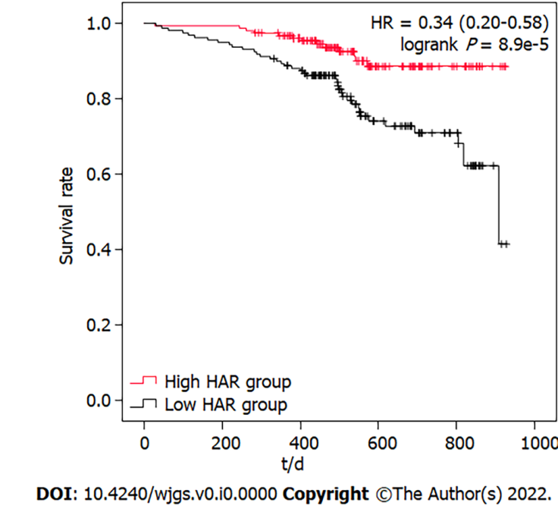
Figure 1 Survival curve of gastric cancer patients with low hemoglobin to albumin ratio and high hemoglobin to albumin ratio. HAR: hemoglobin to albumin ratio; HR: Hazard ratio.

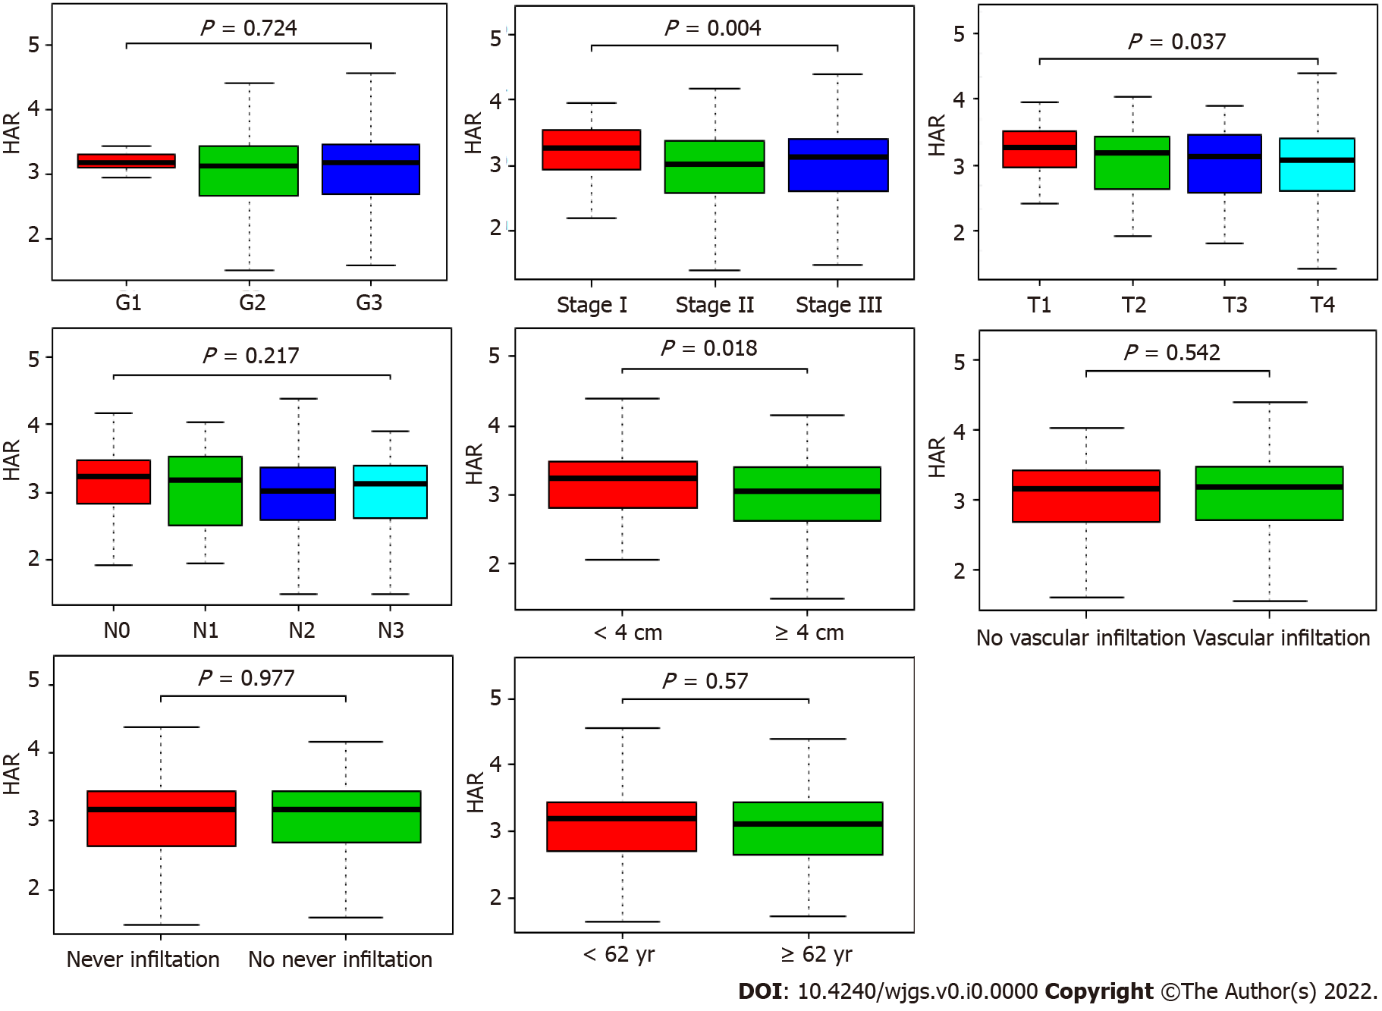
Figure 2 Association between hemoglobin to albumin ratio and clinicopathological characteristics, including grade, stage, T classification, N classification, tumor size, vascular infiltration, nerve infiltration and age. HAR: hemoglobin to albumin ratio.

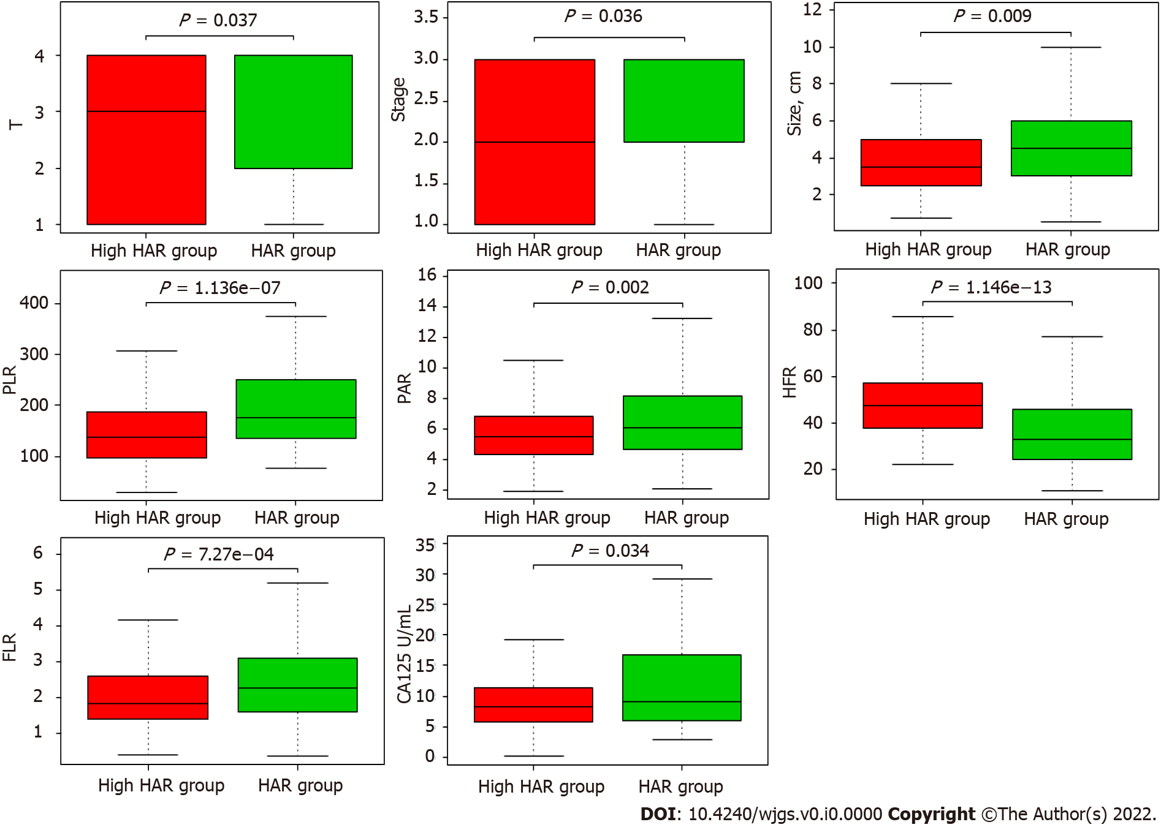
Figure 3 Relationships between hemoglobin to albumin ratio and prognostic factors, including stage, T classification, and tumor size, CA125, fibrinogen to lymphocyte ratio, platelet to albumin ratio, platelet to lymphocyte ratio and hemoglobin to fibrinogen ratio. HAR: hemoglobin to albumin ratio; FLR: Fibrinogen to lymphocyte ratio; HFR: Hemoglobin to fibrinogen ratio; PAR: Platelet to albumin ratio; PLR: Platelet to lymphocyte ratio.

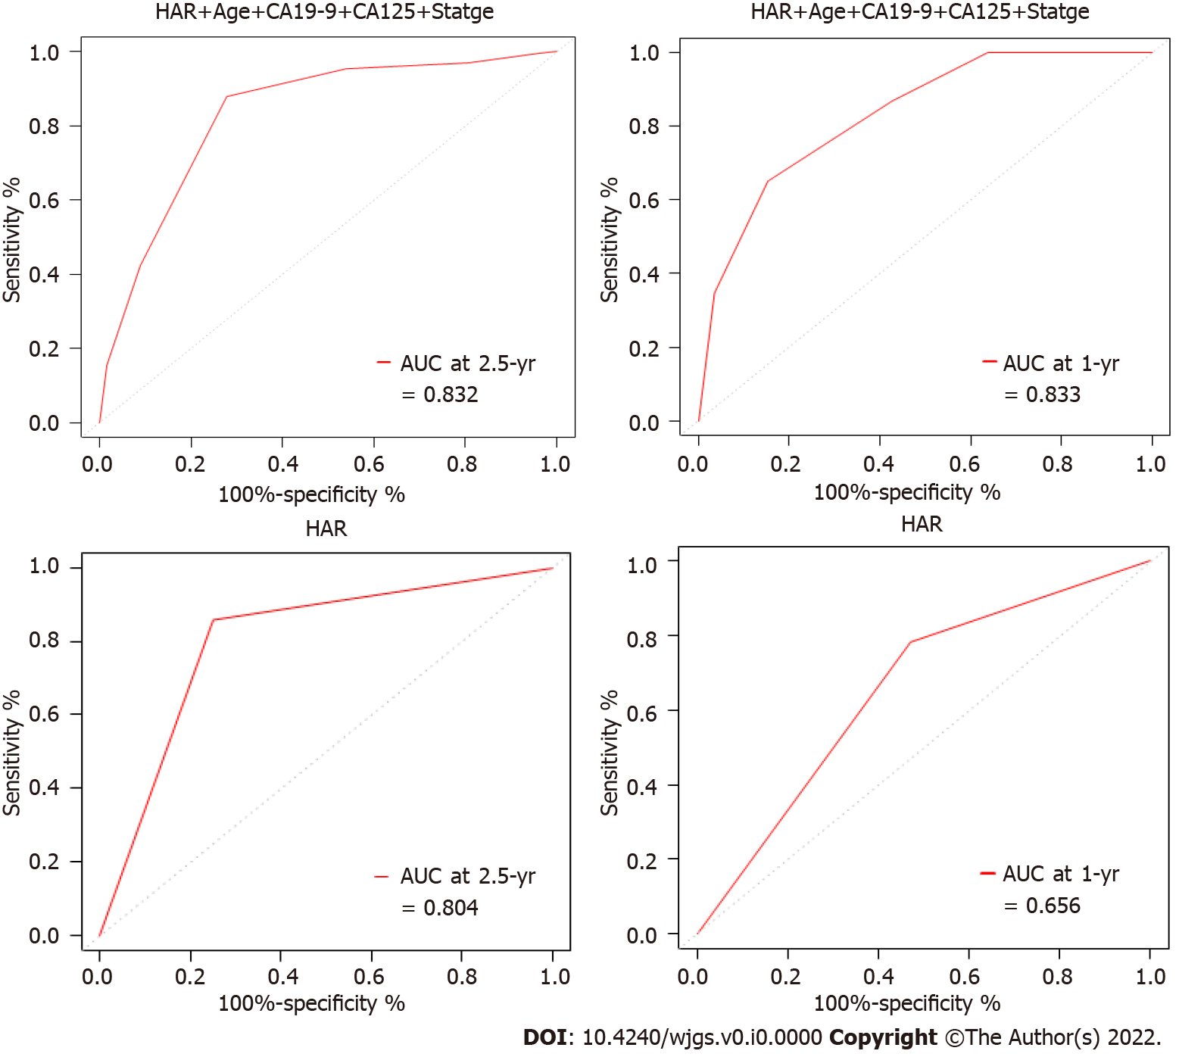
Figure 4 receiver operating characteristic curve of hemoglobin to albumin ratio or combined factors to predict the short-term survival of gastric cancer patients. HAR: hemoglobin to albumin ratio; AUC: Area under the curve.

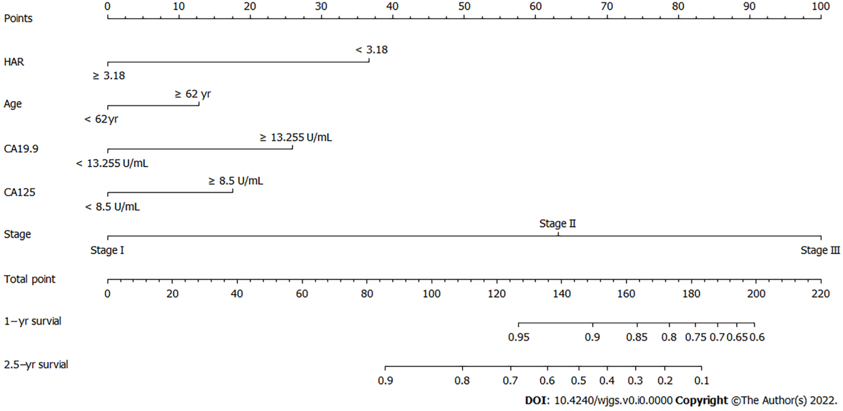
Figure 5 Nomogram of the logistic regression model. HAR: hemoglobin to albumin ratio.
Table 1 Prognostic analysis of clinical characteristics in patients with gastric cancer
Clinical variable | n | Univariate analysis |  | Multivariate analysis
 | 312 | HR (95%CI) | p value | HR (95%CI) | p value
Age (yr) | 62 (54-68) | 1.046 (1.015-1.077) | 0.003 | 1.049(1.017-1.081) | 0.002
Sex (male/female) | 225/87 | 0.715 (0.400-1.280) | 0.259
BMI (kg/m²) | 21.55 (19.53-23.55) | 0.983 (0.911-1.062) | 0.670
Smoking (yes/no) | 64/248 | 0.442 (0.189-1.034) | 0.060
Drinking (yes/no) | 49/263 | 1.316 (0.641-2.701) | 0.454
CEA (ng/ml) | 2.94 (1.85-5.29) | 1.006 (1.003-1.009) | 0.000
CA19-9 (U/ml) | 13.26 (7.36-23.70) | 1.001 (1.000-1.002) | 0.003
CA125 (U/ml) | 8.50 (5.90-13.80) | 1.008 (1.000-1.016) | 0.049
CA72-4 (IU/ml) | 1.81 (1.17-4.46) | 1.004 (0.990-1.018) | 0.57
HAR | 3.18 (2.68-3.44) | 0.425 (0.278-0.650) | 0.000 | 0.466 (0.301-0.720) | 0.001
PHR | 1.86 (1.40-2.58) | 1.371 (1.194-1.575) | 0.000
PLR | 157.74 (114.06-211.23) | 1.003 (1.001-1.006) | 0.004
PAR | 5.75 (4.51-7.48) | 1.184 (1.088-1.288) | 0.000
FLR | 2.05 (1.49-2.89) | 1.171 (1.018-1.347) | 0.028
AFR | 13.16 (10.36-16.85) | 0.970 (0.912-1.033) | 0.344
HFR | 42.52 ± 17.83 | 0.974 (0.955-0.993) | 0.007
PFR | 77.41 (57.84-101.46) | 1.005 (0.998-1.012) | 0.135
NLR | 2.47 (1.76-3.59) | 1.100 (0.974-1.242) | 0.124
ALR | 26.25 (22.16-35.08) | 1.008 (0.986-1.030) | 0.489
Tumor size (cm) | 4.0 (2.5-5.5) | 1.167 (1.079-1.262) | 0.000
Vascular infiltration (present/absent) | 168/144 | 3.230 (1.695-6.153) | 0.000
Nerve infiltration (present/absent) | 149/163 | 2.974 (1.651-5.359) | 0.000
Histological grade (G1/G2/G3) | 6/120/186 | 0.920 (0.553-1.530) | 0.748
Stage (Ⅰ/Ⅱ/Ⅲ) | 88/75/149 | 4.154 (2.291-7.531) | 0.000 | 4.112 (2.225-7.602) | 0.000
Survival status (death/survival) | 53/259
Follow-up time (d) | 531 (440-691)
BMI: Body mass index; PHR: platelet to hemoglobin ratio; PLR: platelet to lymphocyte ratio; PAR: platelet to albumin ratio; FLR: fibrinogen to lymphocyte ratio; AFR: albumin to fibrinogen ratio; HFR: hemoglobin to fibrinogen ratio; PFR: platelet to fibrinogen ratio; NLR: neutrophil to lymphocyte ratio; ALR: albumin to lymphocyte ratio. HR: Hazard ratio; CI: Confidence interval; HAR: Hemoglobin to albumin ratio.

Table 2 Hemoglobin to albumin ratio value associated with clinical pathological characteristics
Clinical characteristics | Total (n) | Odds ratio in HAR value | p value
Age (≥ 62 yr vs < 62 yr) | 312 | 0.78 (0.50-1.21) | 0.264
Size (≥ 4 cm vs < 4 cm) | 312 | 0.51 (0.32-0.80) | 0.004
Histological grade
(G2 vs G1) | 126 | 0.91 (0.16-5.06) | 0.905
(G3 vs G1) | 192 | 1.00 (0.18-5.52) | 1.000
Vascular infiltration (yes vs no) | 312 | 1.14 (0.73-1.79) | 0.552
Nerve infiltration (yes vs no) | 312 | 1.00 (0.64-1.56) | 0.988
Stage
(Ⅱ vs I) | 163 | 0.45 (0.24-0.83) | 0.012
(Ⅲ vs I) | 237 | 0.48 (0.28-0.81) | 0.007
T classification
(T2 vs T1) | 106 | 0.61 (0.27-1.39) | 0.243
(T3 vs T1) | 112 | 0.62 (0.28-1.35) | 0.227
(T4 vs T1) | 236 | 0.52 (0.29-0.91) | 0.022
N classification
(N1 vs N0) | 169 | 0.76 (0.33-1.74) | 0.518
(N2 vs N0) | 201 | 0.56 (0.30-1.04) | 0.067
(N3 vs N0) | 226 | 0.68 (0.39-1.16) | 0.160
HAR: hemoglobin to albumin ratio.

Table 3 Comparison of the relevant factors between the high hemoglobin to albumin ratio group and low hemoglobin to albumin ratio group
Factors | High HAR group (n = 158） | Low HAR group (n = 154） | P value
Age (yr) | 61 (53-67) | 63 (54-69) | 0.266
Sex (n) |  |  | 0.000
Male | 132 | 93
Female | 26 | 61
BMI (kg/m²) | 21.81 (19.90-23.82) | 21.30 (19.32-23.33) | 0.154
Smoking (n) |  |  | 0.468
Yes | 35 | 29
No | 123 | 125
Drinking (n) |  |  | 0.322
Yes | 28 | 21
No | 130 | 133
CEA (ng/ml) | 2.89 (1.87-5.23) | 2.97 (1.83-5.44) | 0.581
CA19-9 (U/ml) | 12.63 (7.43-21.52) | 13.38 (7.23-24.20) | 0.658
CA125 (U/ml) | 8.30 (5.68-11.30) | 9.15 (6.08-16.80) | 0.034
CA72-4 (IU/ml) | 1.91 (1.19-4.46) | 1.73 (1.14-4.46) | 0.396
PHR | 1.55 (1.25-1.95) | 2.29 (1.71-3.36) | 0.000
PLR | 138.71 (98.29-188.22) | 177.27 (134.34-252.12) | 0.000
PAR | 5.49 (4.36-6.86) | 6.04 (4.70-8.20) | 0.002
FLR | 1.83 (1.39-2.62) | 2.26 (1.57-3.11) | 0.001
AFR | 13.73 (10.92-16.83) | 12.62 (9.69-16.93) | 0.162
HFR | 48.46 ± 14.63 | 36.42 ± 18.78 | 0.000
PFR | 73.48 (57.12-92.62) | 79.78 (60.16-112.23) | 0.040
NLR | 2.32 (1.74-3.36) | 2.89 (1.92-3.78) | 0.024
ALR | 24.40 (19.05-32.52) | 27.87 (23.08-35.77) | 0.000
Tumor size (cm) | 3.5 (2.4-5.0) | 4.5 (3.0-6.1) | 0.009
Vascular infiltration (n) |  |  | 0.507
present | 88 | 80
absent | 70 | 74
Nerve infiltration (n) |  |  | 0.918
present | 75 | 74
absent | 83 | 80
Histological grade (n) |  |  | 0.682
G1 | 3 | 3
G2 | 59 | 61
G3 | 96 | 90
Stage (n) |  |  | 0.036
Ⅰ | 56 | 32
Ⅱ | 32 | 43
Ⅲ | 70 | 79
T classification (n) |  |  | 0.037
T1 | 44 | 27
T2 | 18 | 17
T3 | 20 | 21
T4 | 76 | 89
N classification (n) |  |  | 0.141
N0 | 79 | 63
N1 | 14 | 13
N2 | 25 | 34
N3 | 40 | 44
HAR: hemoglobin to albumin ratio; BMI: Body mass index; PHR: platelet to hemoglobin ratio; PLR: platelet to lymphocyte ratio; PAR: platelet to albumin ratio; FLR: fibrinogen to lymphocyte ratio; AFR: albumin to fibrinogen ratio; HFR: hemoglobin to fibrinogen ratio; PFR: platelet to fibrinogen ratio; NLR: neutrophil to lymphocyte ratio; ALR: albumin to lymphocyte ratio.

