Name of Journal: World Journal of Gastrointestinal Surgery
Manuscript NO: 90183
Manuscript Type: CASE REPORT

Stercoral perforation of the cecum: A case report

Yu HC et al. Stercoral perforation of the cecum

Hung-Chun Yu, Ta-Wei Pu, Jung-Cheng Kang, Chao-Yang Chen, Je-Ming Hu, Ruei-Yu Su

Hung-Chun Yu, Department of Surgery, Taichung Armed Forces General Hospital, Taichung 411228, Taiwan

Hung-Chun Yu, Department of Surgery, Tri-Service General Hospital, National Defense Medical Center, Taipei 11490, Taiwan

Ta-Wei Pu, Chao-Yang Chen, Division of Colon and Rectal Surgery, Department of Surgery, Tri-Service General Hospital Songshan Branch, National Defense Medical Center, Taipei 105, Taiwan

Jung-Cheng Kang, Division of Colon and Rectal Surgery, Department of Surgery, Taiwan Adventist Hospital, Taipei 105, Taiwan

Je-Ming Hu, Division of Colon and Rectal Surgery, Department of Surgery, Tri-Service General Hospital, National Defense Medical Center, Taipei 114, Taiwan

Ruei-Yu Su, Department of Pathology, Tri-Service General Hospital, National Defense Medical Center, Taipei 105, Taiwan

Ruei-Yu Su, Department of Pathology and Laboratory Medicine, Taoyuan Armed Forces General Hospital, Taoyuan 325, Taiwan

Author contributions: Yu HC, Pu TW, Kang JC, Chen CY, Hu JM, and Su RY designed and performed the research; Yu HC and Pu TW analyzed the data and wrote the manuscript; and all authors have read and approved the final manuscript.

Corresponding author: Ta-Wei Pu, MD, Assistant Professor, Chief Doctor, Doctor, Surgeon, Division of Colon and Rectal Surgery, Department of Surgery, Tri-Service General Hospital Songshan Branch, National Defense Medical Center, No. 131 Jiankang Road, Taipei 105, Taiwan. tawei0131@gmail.com

Received: November 26, 2023
Revised: January 11, 2024
Accepted: March 18, 2024
Published online:

Abstract
BACKGROUND
With less than 90 reported cases to date, stercoral perforation of the colon is a rare occurrence. Stercoral ulceration is thought to occur due to ischemic pressure necrosis of the bowel wall, which is caused by the presence of a stercoraceous mass. To underscore this urgent surgical situation concerning clinical presentation, surgical treatment, and results, we present the case of a 66-year-old man with a stercoral perforation.

CASE SUMMARY
A 66-year-old man with a history of hypertension, hyperlipidemia, and gout presented at the emergency department with lower abdominal pain and a low-grade fever lasting for a few hours. Abdominal computed tomography indicated a suspected bezoar (approximately 7.6 cm) in the dilated cecum, accompanied by pericolic fat stranding, mild proximal dilatation of the ileum, pneumoperitoneum, and minimal ascites. Intraoperatively, feculent peritonitis with isolated cecal perforation were observed. Consequently, a right hemicolectomy with peritoneal lavage was performed. A histopathological examination supported the intraoperative findings.

CONCLUSION
In stercoral perforations, a diagnosis should be diligently pursued, especially in older adults, and prompt surgical intervention should be implemented.

Key Words: Acute abdomen; Colectomy; Peritoneal lavage; Pneumoperitoneum; Bezoars; Case report

Yu HC, Pu TW, Kang JC, Chen CY, Hu JM, Su RY. Stercoral perforation of the cecum: A case report. World J Gastrointest Surg 2024; In press

Core Tip: Spontaneous perforations are classified as either stercoral or idiopathic based on underlying etiologic and pathologic factors. In this case, the operative findings and histopathology report led us to conclude that the perforation was stercoral. This perforation is characterized by a rounded or ovoid-shaped defect with underlying necrotic and inflammatory edges in the absence of significant injuries, obstructions, tumors, and diverticulosis. This condition is commonly observed in chronically ill patients at a rate of 47% in the sigmoid colon and 30% in the rectosigmoid colon. In this manuscript, we present a rare case of bezoar-induced stercoral perforation of the cecum.

INTRODUCTION
With less than 90 reported cases to date, stercoral perforation of the colon is a rare occurrence. Stercoral ulceration is thought to occur due to ischemic pressure necrosis of the bowel wall, which is caused by the presence of a stercoraceous mass^{[1]}. To underscore this urgent surgical situation concerning clinical presentation, surgical treatment, and results, we present the case of a 66-year-old man with a stercoral perforation.

CASE PRESENTATION
Chief complaints
A 66-year-old man presented at the emergency department with a 4-h history of lower abdominal and epigastric pain with low-grade fever.

History of present illness
The patient had a normal bowel movement at around 6 am on the day of presentation, then 4 h later he developed abdominal pain in the lower abdomen that increased in intensity and extended to the epigastric area. The pain was accompanied by multiple bowel movements, without nausea or vomiting. He presented to the hospital four hours after the abdominal pain started with lower abdominal pain.

History of past illness
The patient had a history of hypertension, hyperlipidemia, and gout, and regularly visited the cardiology outpatient department for follow-up and maintenance medication. The patient had no history of rectal bleeding, anorexia, or weight loss. Seven years before presentation, the patient underwent a colonoscopy, which revealed no abnormal mucosal or mass lesions up to the ileocecal valve.

Personal and family history
The patient has a history of cigarette smoking, averaging 1-1.5 packs per day for decades. Additionally, he occasionally consumed alcohol socially. Regarding family history, his mother had a history of hypertension and diabetes mellitus.

Physical examination
On physical examination, the patient was conscious and alert. His vital signs were: Body temperature, 36.2 degree Celcius; pulse, 96 beats per minute; blood pressure, 142/82 mmHg. Examination of the abdomen demonstrated rebound tenderness in the right lower quadrants and suprapubic area upon palpation, normal bowel sounds, no tympanic sounds, and no Murphy’s sign. A digital rectal examination revealed traces of stool with a minimal amount of gross blood. No masses were palpable.

Laboratory examinations
A complete blood count showed a white blood cell count of 18.05 × 10⁹/L and a haemoglobin level of 14.7 gm/dL. Other laboratory investigations showed normal results.

Imaging examinations
A plain radiograph of the kidneys, ureters, and bladder revealed a focal lesion in the right lower quadrant of the abdomen (Figure 1). Further imaging via an abdominal computed tomography scan showed a suspected bezoar (approximately 7.6 cm in diameter) in the dilated cecum accompanied by pericolic fat stranding, mild proximal dilatation of the ileum, pneumoperitoneum, and minimal ascites (Figure 2A and B).

FINAL DIAGNOSIS
Spontaneous cecal perforation, status post right hemicolectomy on admission to the hospital, status post wound debridement with rectus abdominis flap on post-operative day 12.

TREATMENT
The intravenous antibiotics flomoxef and metronidazole, were administered. A decision was made to perform exploratory laparotomy, during which a rounded perforation (7 cm × 5 cm in diameter) of the cecum was found (Figure 3A). Upon dissection, the cecal wall was found to be thin, without any obvious tumorous lesions on the mucosa (Figure 3B). Seropurulent fluid was present in the peritoneal cavity (Figure 3C) with fecal contamination (Figure 3D). The bezoar extracted from the dilated cecum was 9 centimeters in diameter (Figure 3E). Consequently, a right hemicolectomy with peritoneal lavage was performed. Histopathological examination revealed a grossly rounded cecal perforation with ischemic necrosis (Figure 4A). Microscopically, the mucosa around the perforation exhibited acute transmural inflammatory cell infiltration and fibroblast proliferation (Figure 4B). Remarkable ischemic necrosis with crypt loss was observed.

OUTCOME AND FOLLOW-UP
Postoperatively, the patient recovered from brief atelectasis. However, the wound did not respond well to local treatment with an aqua beta-iodine dressing. Fascial dehiscence occurred with bowel exposure. Therefore, wound debridement was performed using a rectus abdominis flap on post-operative day 12. After the operation, oral feeding was gradually advanced, and the patient tolerated it well. Subsequently, he was discharged in stable condition and followed up in our outpatient clinic.

DISCUSSION
Spontaneous cecal perforation is the sudden perforation of a previously clinically healthy colon in the absence of an underlying disease or injury. To date, fewer than 100 cases have been reported in the literature^{[2]}. In spontaneous perforations, the mean age of affected patients is 65 years. Furthermore, men are more susceptible to perforation, with a ratio of 2:1 in older adult men and women, respectively^{[3]}. Mortality rates associated with cecal perforation are high, ranging from 30% to 72%^{[4]}. The prognosis of spontaneous cecal perforation is influenced by various factors, such as the timing of perforation, the extent of peritoneal contamination, and the timeliness of intervention.
In 1894, Berry classified spontaneous perforations as either stercoral or idiopathic. This classification is based on underlying etiological and pathological factors^{[5]}. Maurer et al^{[6]} established guidelines for identifying stercoral perforation according to the defect’s form, size, its proximity to the mesentery, and the existence of fecalomas poking through the defect. At a microscopic level, pressure-induced necrosis or ulcer surrounded by chronic inflammatory response are observed near the perforation site. In this case, operative findings and histopathology report led us to conclude that the perforation was of the stercoral type. Stercoral perforation is characterized by a rounded or ovoid-shaped defect with underlying necrotic and inflammatory edges in the absence of significant injuries, obstructions, tumors, and diverticulosis^{[6]}. This condition is commonly observed in chronically ill patients. The increase in intraluminal and intra-abdominal pressure during defecation contributes to its etiology^{[7]}. Stercoral perforation is more frequently observed in the sigmoid colon in 47% of cases and the rectosigmoid colon in 30% of cases^{[8]}. In other parts of the colon, it was observed in 33% of cases. However, our patient did not have a history of a significant change of bowel habits and a colonoscopy conducted 7 years prior reported no abnormal mucosal or mass lesions up to the ileocecal valve. According to the intraoperative findings, bezoar-induced perforation is the most reasonable cause.
A bezoar is a firm, solid, enduring foreign object found in the gastrointestinal tract. They can be found in various parts of the gastrointestinal tract, such as the esophagus and colon. Four distinct types of bezoars have been identified based on their originating material: Phytobezoars, trichobezoars, concretions, and pharmacobezoars^{[9]}. None of these described causes seemed to match this patient’s condition. In a retrospective analysis study, alcohol consumption, hypertension, and diabetes were reported to serve as risk factors for bezoars^{[10]}. Therefore, further investigation may be necessary to identify the specific reason of bezoar formation in this case.
Idiopathic perforation occurs because of the asymmetrical distribution of intraluminal pressure at the pelvic-rectal angle in the absence of obviously impacted stool or any identifiable cause of perforation^{[11]}. The exact cause of spontaneous cecal perforation is unclear; however, it has been reported to be associated with certain conditions including hypothyroidism, intestinal hypomotility, chronic constipation, and fecal impaction^{[12]}. Notably, steroids and nonsteroidal anti-inflammatory drugs inhibit cyclo-oxygenase enzymes, resulting in a subsequent reduction in protective prostaglandins^{[13]}. Fecal impaction induced by drugs such as opiates, antacids, codeine, amitriptyline, and tranquilizers is becoming more prevalent and could lead to spontaneous cecal perforation.

CONCLUSION
Cecal perforation occurring spontaneously is an uncommon occurrence linked with heightened morbidity and mortality rates. Irrespective of the surgical approach, detecting it early and swiftly resorting to surgical intervention are key tactics linked with better results. Hence, it’s imperative to strive for a timely diagnosis, particularly in the elderly, and promptly initiate surgical measures.

ACKNOWLEDGEMENTS
The authors wish to acknowledge the assistance of the people at the Department of Surgery, Tri-Service General Hospital Songsang Branch. This report would not have been possible without their efforts in data collection and interprofessional collaboration in treating this patient.

REFERENCES
1 Patel VG, Kalakuntla V, Fortson JK, Weaver WL, Joel MD, Hammami A. Stercoral perforation of the sigmoid colon: report of a rare case and its possible association with nonsteroidal anti-inflammatory drugs. Am Surg 2002; 68: 62-64 [PMID: 12467320]
2 Makki AM, Hejazi S, Zaidi NH, Johari A, Altaf A. Spontaneous Perforation of Colon: A Case Report and Review of Literature. Case Rep Clin Med 2014; 3: 392-397 [DOI: 10.4236/crcm.2014.37087]
3 Galanis I, Dragoumis D, Kalogirou T, Lakis S, Kotakidou R, Atmatzidis K. Spontaneous perforation of solitary ulcer of transverse colon. Indian J Pathol Microbiol 2010; 53: 138-140 [PMID: 20090246 DOI: 10.4103/0377-4929.59207]
4 Laskin MD, Tessler K, Kives S. Cecal perforation due to paralytic ileus following primary caesarean section. J Obstet Gynaecol Can 2009; 31: 167-171 [PMID: 19327217 DOI: 10.1016/s1701-2163(16)34102-0]
5 Al Shukry S. Spontaneous perforation of the colon clinical review of five episodes in four patients. Oman Med J 2009; 24: 137-141 [PMID: 22334860 DOI: 10.5001/omj.2009.30]
6 Maurer CA, Renzulli P, Mazzucchelli L, Egger B, Seiler CA, Büchler MW. Use of accurate diagnostic criteria may increase incidence of stercoral perforation of the colon. Dis Colon Rectum 2000; 43: 991-998 [PMID: 10910249 DOI: 10.1007/BF02237366]
7 Dubinsky I. Stercoral perforation of the colon: case report and review of the literature. J Emerg Med 1996; 14: 323-325 [PMID: 8782027 DOI: 10.1016/0736-4679(96)00044-3]
8 Berry J. Dilatation and rupture of sigmoid flexure short report. BMJ 1894; 1: 301
9 Erdemir A, Ağalar F, Çakmakçı M, Ramadan S, Baloğlu H. A rare cause of mechanical intestinal obstruction: Pharmacobezoar. Ulus Cerrahi Derg 2015; 31: 92-93 [PMID: 26170758 DOI: 10.5152/UCD.2014.2749]
10 Liu LN, Wang L, Jia SJ, Wang P. Clinical Features, Risk Factors, and Endoscopic Treatment of Bezoars: A Retrospective Analysis from a Single Center in Northern China. Med Sci Monit 2020; 26: e926539 [PMID: 33027245 DOI: 10.12659/MSM.926539]
11 Kurane SB, Kurane BT. Idiopathic colonic perforation in adult-a rare case. Indian J Surg 2011; 73: 63-64 [PMID: 22211042 DOI: 10.1007/s12262-010-0127-z]
12 Parish KL, Chapman WC, Williams LF Jr. Ischemic colitis. An ever-changing spectrum? Am Surg 1991; 57: 118-121 [PMID: 1992867]
13 Ervens J, Schiffmann L, Berger G, Hoffmeister B. Colon perforation with acute peritonitis after taking clindamycin and diclofenac following wisdom tooth removal. J Craniomaxillofac Surg 2004; 32: 330-334 [PMID: 15458677 DOI: 10.1016/j.jcms.2004.05.007]

Footnotes
Informed consent statement: Informed written consent was obtained from the patient for publication of this report and any accompanying images.

Conflict-of-interest statement: All the authors report no relevant conflicts of interest for this article.

CARE Checklist (2016) statement: The authors have read the CARE Checklist (2016), and the manuscript was prepared and revised according to the CARE Checklist (2016).

Open-Access: This article is an open-access article that was selected by an in-house editor and fully peer-reviewed by external reviewers. It is distributed in accordance with the Creative Commons Attribution NonCommercial (CC BY-NC 4.0) license, which permits others to distribute, remix, adapt, build upon this work non-commercially, and license their derivative works on different terms, provided the original work is properly cited and the use is non-commercial. See: https://creativecommons.org/Licenses/by-nc/4.0/

Provenance and peer review: Unsolicited article; Externally peer reviewed.
Peer-review model: Single blind

Peer-review started: November 26, 2023
First decision: December 11, 2023
Article in press:

Specialty type: Gastroenterology and hepatology
Country/Territory of origin: Taiwan
Peer-review report’s scientific quality classification
Grade A (Excellent): 0
Grade B (Very good): B
Grade C (Good): 0
Grade D (Fair): 0
Grade E (Poor): 0

P-Reviewer: Ghannam WM, Egypt S-Editor: Wang JJ L-Editor: A P-Editor:

Figure Legends
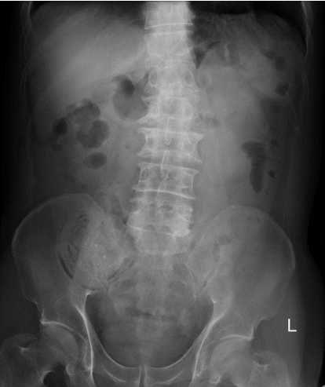
Figure 1 Plain radiograph of the patient’s kidneys, ureters, and bladder. The kidneys, ureters, and bladder radiograph displaying a focal lesion in the right lower quadrant of the patient’s abdomen.

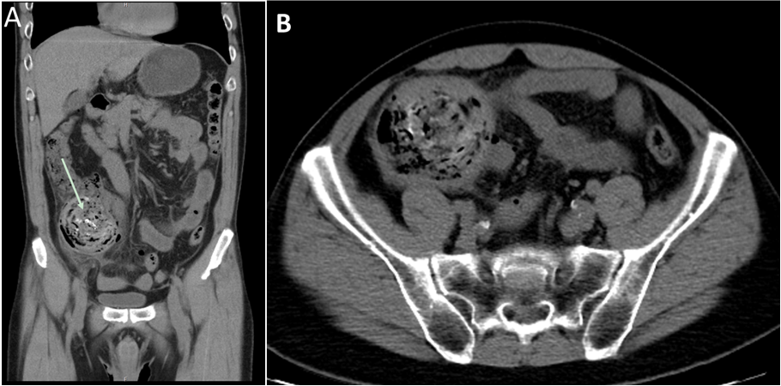
Figure 2 Abdominal computed tomography imaging of the patient’s abdomen. A: A suspected bezoar (approximately 7.6 cm) was seen in the dilated cecum (arrow); B: Pericolic fat stranding, mild proximal dilatation of the ileum, pneumoperitoneum and minimal ascites accompanied this lesion.

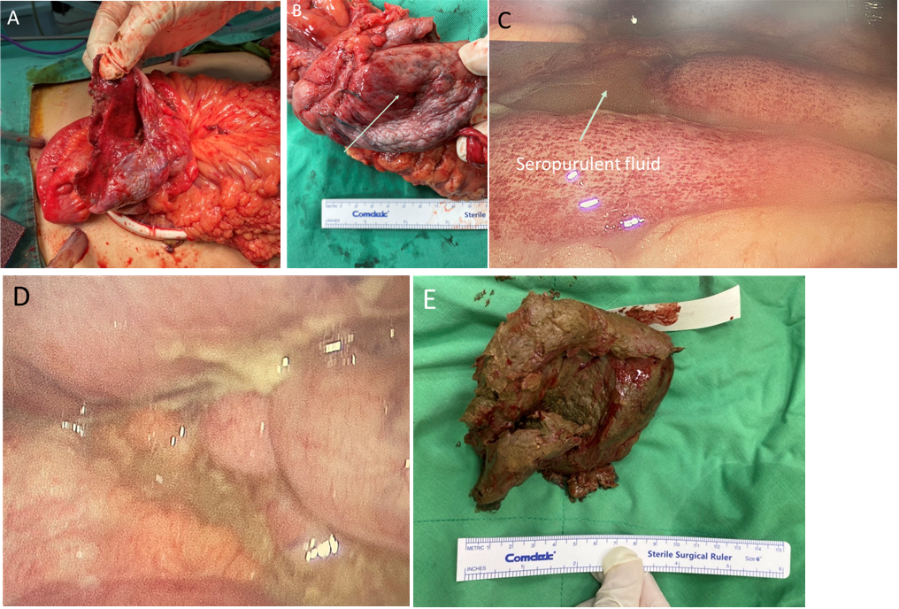
Figure 3 Intraoperative photographs of gross findings. A: A rounded perforation (7 cm × 5 cm in diameter) of the cecum was intraoperatively noted; B: The cecum was notably thin without any obvious tumorous lesions on the mucosa (as marked); C: Seropurulent fluid was freely present in the peritoneal cavity; D: Fecal contamination was observed in the peritoneal cavity; E: The bezoar extracted from the dilated cecum.

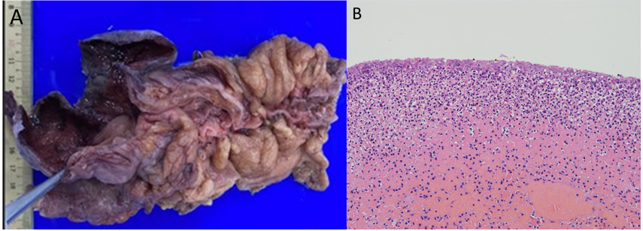
Figure 4 Gross and histopathological examination of the cecal specimen. A: A grossly rounded cecal perforation with ischemic necrosis was observed; B: Microscopically, the muscle layers show lymphoplasma cell infiltration with crypt effacement and hemorrhage.

