Name of Journal: World Journal of Gastrointestinal Oncology
Manuscript NO: 76941
Manuscript Type: ORIGINAL ARTICLE

Case Control Study
Inverse relations between Helicobacter pylori infection and risk of esophageal precancerous lesions in drinkers and peanut consumption

Pan D et al. H. pylori infection and esophageal cancer

Da Pan, Gui-Ju Sun, Ming Su, Xin Wang, Qing-Yang Yan, Guang Song, Yuan-Yuan Wang, Deng-Feng Xu, Nian-Nian Wang, Shao-Kang Wang

Da Pan, Gui-Ju Sun, Yuan-Yuan Wang, Deng-Feng Xu, Nian-Nian Wang, Shao-Kang Wang, Key Laboratory of Environmental Medicine and Engineering of Ministry of Education, Department of Nutrition and Food Hygiene, School of Public Health, Southeast University, Nanjing 210009, Jiangsu Province, China

Ming Su, Xin Wang, Qing-Yang Yan, Guang Song, Department of Chronic Disease, Huai’an District Center for Disease Control and Prevention, Huai’an 223200, Jiangsu Province, China

Author contributions: Pan D, Wang SK, and Sun GJ designed the research; Pan D, Su M, Yan QY, Song G, Wang YY, Xu DF, and Wang NN conducted the research; Wang SK, Su M, Wang X, and Sun GJ provided essential materials; Pan D analyzed the data and wrote the manuscript; Wang SK had primary responsibility for final content; all authors read and approved the final manuscript.

Supported by the Fellowship of China Postdoctoral Science Foundation, No. 2022M710675; the National Natural Science Foundation of China, No. 81673147; and the Danone Dietary Nutrition Research and Education Foundation, No. DIC2020-08.

Corresponding author: Shao-Kang Wang, MD, PhD, Associate Professor, Key Laboratory of Environmental Medicine and Engineering of Ministry of Education, Department of Nutrition and Food Hygiene, School of Public Health, Southeast University, No. 87 Dingjiaqiao, Nanjing 210009, Jiangsu Province, China. shaokangwang@seu.edu.cn

Received: April 7, 2022
Revised: June 16, 2022
Accepted: August 5, 2022
Published online:

Abstract
BACKGROUND
Helicobacter pylori (H. pylori) is a Gram-negative bacterium found in the upper digestive tract. Although H. pylori infection is an identified risk factor for gastric cancer, its role in esophageal squamous cell carcinoma (ESCC) remains a topic of much debate.

AIM
To evaluate the association between H. pylori infection and the risk of precancerous lesions of ESCC, and further explore the association between dietary factors and the risk of H. pylori infection.

METHODS
Two hundred patients with esophageal precancerous lesions (EPL) aged 63.01 ± 6.08 years and 200 healthy controls aged 62.85 ± 6.03 years were included in this case-control study. Epidemiological data and qualitative food frequency data were investigated. Enzyme-linked immunosorbent assay measuring serum immunoglobulin G antibodies was used to determine H. pylori seropositivity. An unconditional logistic regression model was used to assess the association between H. pylori infection and EPL risk dichotomized by gender, age, and the use of tobacco and alcohol, as well as the association between dietary factors and the risk of H. pylori infection.

RESULTS
A total of 47 (23.5%) EPL cases and 58 (29.0%) healthy controls had positive H. pylori infection. An inverse relation between H. pylori infection and the risk of EPL was found in the group of drinkers after adjustment for covariates [odds ratio (OR) = 0.32, 95% confidence interval (95%CI): 0.11-0.95]. Additionally, peanut intake was significantly associated with a decreased risk of H. pylori infection (OR = 0.39, 95%CI: 0.20-0.74).

CONCLUSION
Our study suggested that H. pylori infection may decrease the risk of EPL for drinkers in a rural adult Chinese population, and the consumption of peanut may reduce the risk of H. pylori infection. These findings should be framed as preliminary evidence, and further studies are required to address whether the mechanisms are related to the localization of lesions and alcohol consumption.

Key Words: Helicobacter pylori; Esophageal precancerous lesions; Peanut consumption; Esophageal squamous cell carcinoma

Pan D, Sun GJ, Su M, Wang X, Yan QY, Song G, Wang YY, Xu DF, Wang NN, Wang SK. Inverse relations between Helicobacter pylori infection and risk of esophageal precancerous lesions in drinkers and peanut consumption. World J Gastrointest Oncol 2022; In press

Core Tip: The association between Helicobacter pylori (H. pylori) infection and esophageal squamous cell carcinoma (ESCC) remains a topic of much debate. This study aimed to evaluate the association between H. pylori infection and the risk of precancerous lesions of ESCC, and further explore the association between dietary intake and the risk of H. pylori infection. Our findings suggested an inverse association between H. pylori infection and the risk of esophageal precancerous lesions in the group of drinkers [odds ratio (OR) = 0.32, 95% confidence interval (95%CI): 0.11-0.95]. Additionally, peanut consumption was significantly associated with a reduced risk of H. pylori infection (OR = 0.39, 95%CI: 0.20-0.74).

INTRODUCTION
Esophageal cancer and gastric cancer are upper gastrointestinal cancers that share many risk factors^{[1-3]}. However, their associations with Helicobacter pylori (H. pylori) infection can be completely different. It has been determined that H. pylori infection is an identified risk factor for gastric cancer^{[4]}, whereas the role of H. pylori in the risk of esophageal cancer remains controversial. Previous meta-analyses summarized that H. pylori infection is likely to be related to a reduced risk of esophageal adenocarcinoma (EAC)^{[5-9]}. One of the reliable assumptions related to this phenomenon is that H. pylori infection causes gastric atrophy and parietal cell loss, thus leading to alleviated reflux and consequently, a decreased incidence of reflux esophagitis and Barrett’s esophagus (precursor for EAC)^{[10-12]}. However, the impact of H. pylori infection on esophageal squamous cell carcinoma (ESCC) is not well understood, and research is inconclusive as to what population may be significantly influenced^{[9,13-15]}. Previous meta-analyses also reported that in the general population, no significant association was found between H. pylori infection and ESCC risk^{[6-8]}, whereas an inverse association was observed in the Middle East^{[9]}. In the other populations, the inverse relationship was found to be highly associated with age, smoking status, and drinking status^{[15]}.
H. pylori is a Gram-negative bacterium found in the upper digestive tract. In spite of the fact that H. pylori infection may reduce the risk of EAC, it may also cause an adverse effect on human health. Apart from the elevated risk of gastric cancer, H. pylori infection is also etiologically related to peptic ulcers, atrophic and non-atrophic gastritis, and lymphoma associated with gastric mucosa, and is able to induce reduced bioavailability and malabsorption of nutrients including iron and vitamin B₁₂^{[16-18]}. This case-control study aimed to investigate the association between H. pylori infection and the risk of precancerous lesions of ESCC, which is an identified early stage of carcinogenesis, and further examine the association between dietary factors and the risk of H. pylori infection.

MATERIALS AND METHODS
This study was carried out in a high-incidence area for ESCC located in Huai’an District, Huai’an City, Jiangsu Province, China, where the crude incidence rate from 1998 to 2016 was 91.85/100000^{[19]}. As described in our previous studies^{[20-22]}, the Early Diagnosis and Early Treatment Project of Esophageal Cancer (EDETPEC) supported by the government and Cancer Foundation of China has been carried out in the endemic regions including Huai’an District since 2010. Local residents were required to undergo routine endoscopies. A detailed introduction to esophageal precancerous lesions (EPL) based on histological criteria for dysplasia and methods for EPL diagnosis has already been given in a previous study^{[21]}. The localization of EPL was based on the definition of upper thoracic esophagus (from thoracic inlet to level of tracheal bifurcation; 18-23 cm from incisors), mid thoracic esophagus (from tracheal bifurcation midway to gastroesophageal junction; 24-32 cm from incisors), and lower thoracic esophagus (from midway between tracheal bifurcation and gastroesophageal junction to gastroesophageal junction, including abdominal esophagus; 32-40 cm from incisors)^{[23]}. Figure 1 shows the flowchart of the study population and data collection process. This study included 200 EPL cases aged 62.85 ± 6.03 years and 200 healthy controls aged 63.01 ± 6.08 years matched by gender, age (± 2 years), and villages. The collection of epidemiological data and dietary intake data based on questionnaire method has been introduced in detail previously^{[21]}. Subjects were required to provide the amount of beer/wine/liquor/any other alcoholic drinks consumed per day, which meant that the average alcohol units consumed per day could be estimated. Separated serum samples were obtained by centrifuging collected fasting blood samples at 3000 rpm for 5 min. Enzyme-linked immunosorbent assay (ELISA, KingMed Diagnostics Group Co., Ltd. Guangzhou, China) measuring serum immunoglobulin G (IgG) antibodies was used to determine H. pylori seropositivity. Sensitivity of the ELISA test was 97.9% [95% confidence interval (95%CI): 88.9%-99.9%] and specificity was 100% (95%CI: 86.8%-100%).
Epidata version 3.1 (EpiData Association, Odense, Denmark) was used for inputting and validating the epidemiological data and dietary intake data. Then, SPSS version 22.0 (SPSS, Chicago, IL, United States) was used to establish a database and perform statistical analyses. Two independent samples t-test and conditional logistic regression model were used to evaluate the differences in general characteristics and potential factors between healthy controls and EPL cases, wherever appropriate. The Fisher’s exact test was used to analyze the difference in localization of EPL and H. pylori infection. An unconditional logistic regression model was used to assess the association between H. pylori infection and EPL risk dichotomized by gender, age, and tobacco and alcohol use, as well as the association between dietary factors and H. pylori infection. Covariates including gender, age, body mass index (BMI), education level, annual income, number of cigarettes per day, and alcohol units consumed per day were adjusted in the logistic regression model. Meanwhile, odds ratio (OR) and 95%CI were calculated accordingly. Statistical significance was defined as P < 0.05 (two-tailed).
The study protocol was approved by the Institutional Review Board of Southeast University Zhongda Hospital (Approval No. 2016ZDKYSB017), and the written informed consent was obtained.

RESULTS
Two hundred EPL cases aged 63.01 ± 6.08 years and 200 healthy controls aged 62.85 ± 6.03 years were enrolled. Among the pairs, 100 were males and 100 were females. Table 1 shows that 47 (23.5%) and 58 (29.0%) out of 200 cases and 200 controls, respectively, had H. pylori infection. Two independent samples t-test and conditional logistic regression analysis indicated that there were no statistically significant differences in age, BMI, education level, annual income per person, current drinking status, or H. pylori infection between the two groups after adjustment for covariates (P > 0.05). Compared with non-smokers, a smoking habit of more than 20 cigarettes a day was significantly associated with an elevated risk of EPL (P < 0.05).
Based on routine endoscopy examination, the study found that the number of cases whose EPL developed in upper, mid, and lower thoracic esophagus was 3, 130, and 67, respectively. Table 2 shows that the control group had the highest positive rate of H. pylori infection (29.0%), followed by EPL cases of upper and mid thoracic esophagus (24.8%) and EPL cases of lower thoracic esophagus (20.9%), but there was no statistically significant differences.
As shown in Table 3, when subjects were dichotomized according to gender, age, and the use of tobacco and alcohol, the protective effect of H. pylori infection against the risk of EPL was found in the group of drinkers after adjustment for covariates (OR = 0.32, 95%CI: 0.11-0.95). Supplementary Tables 1 and 2 shows that there may be a nonsignificant decreasing trend of H. pylori infection rate when alcohol consumption is increasing.
Figure 2 illustrates the association between dietary factors and the risk of H. pylori infection after the adjustment for covariates via the unconditional logistic regression model. The result indicated that peanut intake was significantly associated with a reduced risk of H. pylori infection (OR = 0.39, 95%CI 0.20-0.74). Supplementary Table 3 shows that there may be a significant positive association between peanut consumption and alcohol drinking (P for trend < 0.05).

DISCUSSION
This study revealed that in drinkers, there was an association between H. pylori infection and a reduced risk of EPL, which is an identified early stage of esophageal carcinogenesis. However, the relationship between H. pylori infection and ESCC is still subject to much discussion. Some researchers believed that infection with H. pylori can increase the risk of ESCC by causing gastric atrophy that promotes excessive bacterial growth and causes endogenous nitrosamine production^{[24-26]}. However, other studies which held that H. pylori infection probably plays a protective role in ESCC postulated that the protection is mediated via gastric atrophy, whereas the mechanism is related to a reduced load of esophageal acid^{[27,28]}. Therefore, it is likely that ESCC might be affected in a double-edged manner by H. pylori infection, which is dependent on population and other possible external factors. For example, previous studies have indicated that acid regurgitation may be facilitated by the reduction in lower esophageal sphincter’s pressure and the retard of both esophageal motility and gastric emptying due to large consumption of alcoholic beverages^{[29-33]}. Therefore, the current hypothesis is that H. pylori infection just alleviates esophageal reflux caused by alcohol to some extent, thus reducing the risk of esophageal carcinogenesis caused by acid reflux. Our results also reported that EPL cases of lower thoracic esophagus had the lowest positive rate of H. pylori infection, which may support the hypotheses to some extent, although the difference was not statistically significant. In addition, there is more data indicating the positive role of this bacterium for humans. For example, a recent review considered the data on H. pylori and suggested that H. pylori may be a latent or opportunistic pathogen rather than a true pathogen of some diseases, and is possibly part of the normal human microbiome as a commensal or even a symbiont organism^{[34]}. However, it was reported that a regular but moderate alcohol intake could possibly facilitate elimination of H. pylori infection^{[35]}. The supplementary material of our study also shows a nonsignificant decreasing trend of H. pylori infection rate when alcohol consumption is increasing. This partly supports the hypothesis that there is a possibility that drinkers without H. pylori infection could have more alcohol consumption. In other words, the decreased EPL risk in drinkers with H. pylori infection is possibly related to a lower alcohol consumption. However, because the result was not statistically significant, and there was no significant association between alcohol consumption and EPL risk in Huai’an in both this study and the previous epidemiological investigation^{[21]}, it is hard to address whether the reduced risk of EPL in drinkers with H. pylori infection was related to a reduced alcohol intake.
Additionally, the present study reported that the consumption of peanuts may provide protection from H. pylori infection. Since peanuts are high in fat, the duodenal mucosa secretes the hormone enterogastrone when fatty food is present in the stomach or small intestine^{[36]}. Enterogastrone inhibits gastric movements and secretion of gastric acid, possibly by blocking the production or activity of gastrin, the hormone that initially leads to these functions^{[37]}. Therefore, the reduced amount of acid produced may influence the growth of H. pylori, as H. pylori is dependent on acidity to survive for a long time^{[38]}. In addition, in China, people are likely to drink and eat peanuts at the same time, and our supplementary material shows that there was a positive association between peanut consumption and alcohol drinking. Therefore, the inverse association between the consumption of peanut and the risk of H. pylori infection may be mediated by alcohol drinking. However, there is still a lack of evidence to verify the above hypotheses, thus further researches are required to evaluate the relationship between peanut consumption and H. pylori infection.
At present, about 50% of the global population and more than 70% of the population in some developing countries are infected by H. pylori^{[39]}. However, this study reported that the positive rates of H. pylori infection were only 23.5% and 29.0% in EPL cases and healthy controls. In an early study conducted by Gao et al^{[40]}, Huai’an, Jiangsu Province was selected as a high incidence area of upper digestive tract cancers, and Pizhou, Jiangsu Province was selected as a low incidence area. They used ELISA and latex agglutinate test for the detection of H. pylori infection, and found that the prevalence of H. pylori infection among the gastric cancer group/upper digestive tract cancer group in the low incidence area of Pizhou (66.67%/63.46%) was significantly higher than that in the high incidence area of Huai’an (38.64%/39.33%). However, in the high incidence area of Huai’an, the prevalence of H. pylori infection in non-cancer controls and the healthy family members of the cancer cases was higher than that of cases. Therefore, the previous study and our study found that the prevalence of H. pylori infection in Huai’an may be much lower than that in other areas, and the prevalence in upper digestive tract cancers or EPL cases can be lower than that in non-cancer population in this region.

CONCLUSION
In summary, our study suggested that H. pylori infection is likely to decrease EPL risk in drinkers for a rural adult Chinese population, and the consumption of peanuts may be related to a reduced risk of H. pylori infection. However, the sample size used is a limitation of the study, which may bring difficulties to evaluate statistical significance in some statistical analyses, thus the findings should be framed as preliminary evidence. A case-control study might be difficult to determine causality, so the statement of “protective role” might be overestimated. Hence, it is necessary to design a large-scale prospective cohort study to address the impact of H. pylori infection on ESCC, the localization of lesions, and the association with dietary intake and the use of alcohol in the future. Additionally, the low prevalence of H. pylori infection in Huai’an is a peculiar finding, which implies that further investigations are recommended.

ARTICLE HIGHLIGHTS
Research background
The role of Helicobacter pylori (H. pylori) infection in esophageal squamous cell carcinoma (ESCC) remains a topic of much debate.

Research motivation
To assess the relationship between H. pylori infection and the risk of precancerous lesions of ESCC, which is an identified early stage of carcinogenesis.

Research objectives
This study aimed to evaluate the association between H. pylori infection and the risk of esophageal precancerous lesions (EPL) in a high-incidence area in Huai’an, and further explore the association between dietary factors and the risk of H. pylori infection.

Research methods
The study was based on a case-control design. Epidemiological data were collected and H. pylori seropositivity was tested. An unconditional logistic regression model was used to analyze the association between H. pylori infection and EPL risk with adjustment for confounders, as well as the association between dietary factors and risk of H. pylori infection.

Research results
The control group had the highest positive rate of H. pylori infection (29.0%), followed by EPL cases of upper and mid thoracic esophagus (24.8%) and EPL cases of lower thoracic esophagus (20.9%). The protective effect of H. pylori infection against the risk of EPL was observed in the group of drinkers after adjustment for covariates [odds ratio (OR) = 0.32, 95% confidence interval (95%CI): 0.11-0.95]. Peanut intake was significantly associated with a reduced risk of H. pylori infection (OR = 0.39, 95%CI: 0.20-0.74).

Research conclusions
H. pylori infection may decrease the risk of EPL in drinkers for a rural adult Chinese population, and the consumption of peanuts may be related to a reduced risk of H. pylori infection.

Research perspectives
A well-designed prospective cohort study is required to address the impact of H. pylori infection on ESCC, the localization of lesions, and the association with dietary intake and alcohol drinking. Additionally, the low prevalence of H. pylori infection in Huai’an is a peculiar finding, which implies that further investigations are recommended.

ACKNOWLEDGEMENTS
Thanks to all the subjects and researchers for their contributions and hard work. We really appreciate Mr Rob Unwin’s assistance in polishing the manuscript.

REFERENCES
1 Yildirim M, Kaya V, Yildiz M, Demirpence O, Gunduz S, Dilli UD. Esophageal cancer, gastric cancer and the use of pesticides in the southwestern of Turkey. Asian Pac J Cancer Prev 2014; 15: 2821-2823 [PMID: 24761907 DOI: 10.7314/Apjcp.2014.15.6.2821]
2 Li M, Wan X, Wang Y, Sun Y, Yang G, Wang L. Time trends of esophageal and gastric cancer mortality in China, 1991-2009: an age-period-cohort analysis. Sci Rep 2017; 7: 6797 [PMID: 28754910 DOI: 10.1038/s41598-017-07071-5]
3 Castro C, Peleteiro B, Bento MJ, Lunet N. Trends in gastric and esophageal cancer incidence in northern Portugal (1994-2009) by subsite and histology, and predictions for 2015. Tumori 2017; 103: 155-163 [PMID: 27647232 DOI: 10.5301/tj.5000542]
4 Alipour M. Molecular Mechanism of Helicobacter pylori-Induced Gastric Cancer. J Gastrointest Cancer 2021; 52: 23-30 [PMID: 32926335 DOI: 10.1007/s12029-020-00518-5]
5 Rubenstein JH, Taylor JB. Meta-analysis: the association of oesophageal adenocarcinoma with symptoms of gastro-oesophageal reflux. Aliment Pharmacol Ther 2010; 32: 1222-1227 [PMID: 20955441 DOI: 10.1111/j.1365-2036.2010.04471.x]
6 Islami F, Kamangar F. Helicobacter pylori and esophageal cancer risk: a meta-analysis. Cancer Prev Res (Phila) 2008; 1: 329-338 [PMID: 19138977 DOI: 10.1158/1940-6207.CAPR-08-0109]
7 Rokkas T, Pistiolas D, Sechopoulos P, Robotis I, Margantinis G. Relationship between Helicobacter pylori infection and esophageal neoplasia: a meta-analysis. Clin Gastroenterol Hepatol 2007; 5: 1413-1417, 1417.e1-1417.e2 [PMID: 17997357 DOI: 10.1016/j.cgh.2007.08.010]
8 Zhuo X, Zhang Y, Wang Y, Zhuo W, Zhu Y, Zhang X. Helicobacter pylori infection and oesophageal cancer risk: association studies via evidence-based meta-analyses. Clin Oncol (R Coll Radiol) 2008; 20: 757-762 [PMID: 18793831 DOI: 10.1016/j.clon.2008.07.005]
9 Gao H, Li L, Zhang C, Tu J, Geng X, Wang J, Zhou X, Jing J, Pan W. Systematic Review with Meta-analysis: Association of Helicobacter pylori Infection with Esophageal Cancer. Gastroenterol Res Pract 2019; 2019: 1953497 [PMID: 31871444 DOI: 10.1155/2019/1953497]
10 Wang Z, Shaheen NJ, Whiteman DC, Anderson LA, Vaughan TL, Corley DA, El-Serag HB, Rubenstein JH, Thrift AP. Helicobacter pylori Infection Is Associated With Reduced Risk of Barrett's Esophagus: An Analysis of the Barrett's and Esophageal Adenocarcinoma Consortium. Am J Gastroenterol 2018; 113: 1148-1155 [PMID: 29880962 DOI: 10.1038/s41395-018-0070-3]
11 Thrift AP. The epidemic of oesophageal carcinoma: Where are we now? Cancer Epidemiol 2016; 41: 88-95 [PMID: 26851752 DOI: 10.1016/j.canep.2016.01.013]
12 Vohlonen IJ, Hakama M, Härkönen M, Malila N, Pukkala E, Koistinen V, Sipponen P. Oesophageal cancer incidence in 20-year follow-up in a population-based sample of 12 000 middle-age men with or without Helicobacter pylori infection in Finland. Gut 2018; 67: 1201-1202 [PMID: 28860351 DOI: 10.1136/gutjnl-2017-314913]
13 Poyrazoglu OB, Dulger AC, Gultepe BS. Helicobacter Pylory infection in patients with esophageal squamous cell carcinoma. Clinics (Sao Paulo) 2017; 72: 150-153 [PMID: 28355360 DOI: 10.6061/clinics/2017(03)04]
14 Khoshbaten M, Zadimani A, Bonyadi MR, Mohammadzadeh M, Gachkar L, Pourhoseingholi MA. Helicobacter pylori infection reduces the risk of esophageal squamous cell carcinoma: a case-control study in iran. Asian Pac J Cancer Prev 2011; 12: 149-151 [PMID: 21517248]
15 Wu DC, Wu IC, Lee JM, Hsu HK, Kao EL, Chou SH, Wu MT. Helicobacter pylori infection: a protective factor for esophageal squamous cell carcinoma in a Taiwanese population. Am J Gastroenterol 2005; 100: 588-593 [PMID: 15743356 DOI: 10.1111/j.1572-0241.2005.40623.x]
16 Vitale G, Barbaro F, Ianiro G, Cesario V, Gasbarrini G, Franceschi F, Gasbarrini A. Nutritional aspects of Helicobacter pylori infection. Minerva Gastroenterol Dietol 2011; 57: 369-377 [PMID: 22105725]
17 Aimasso U, D'onofrio V, D'eusebio C, Devecchi A, Pira C, Merlo FD, De Francesco A. Helicobacter pylori and nutrition: a bidirectional communication. Minerva Gastroenterol Dietol 2019; 65: 116-129 [PMID: 30759976 DOI: 10.23736/S1121-421X.19.02568-6]
18 Franceschi F, Annalisa T, Teresa DR, Giovanna D, Ianiro G, Franco S, Viviana G, Valentina T, Riccardo LL, Antonio G. Role of Helicobacter pylori infection on nutrition and metabolism. World J Gastroenterol 2014; 20: 12809-12817 [PMID: 25278679 DOI: 10.3748/wjg.v20.i36.12809]
19 Wang S, Pan D, Chen Z, Song G, Han R, Sun G, Su M. Trends in Incidence and Mortality of Esophageal Cancer in Huai'an District, a High-Risk Area in Northern Jiangsu Province, China. Cancer Control 2022; 29: 10732748221076824 [PMID: 35196897 DOI: 10.1177/10732748221076824]
20 Pan D, Su M, Huang G, Luo P, Zhang T, Fu L, Wei J, Wang S, Sun G. MTHFR C677T genetic polymorphism in combination with serum vitamin B₂, B₁₂ and aberrant DNA methylation of P16 and P53 genes in esophageal squamous cell carcinoma and esophageal precancerous lesions: a case-control study. Cancer Cell Int 2019; 19: 288 [PMID: 31754346 DOI: 10.1186/s12935-019-1012-x]
21 Pan D, Su M, Zhang T, Miao C, Fu L, Yang L, Song G, Raine PJ, Wang S, Sun G. A Distinct Epidemiologic Pattern of Precancerous Lesions of Esophageal Squamous Cell Carcinoma in a High-risk Area of Huai'an, Jiangsu Province, China. Cancer Prev Res (Phila) 2019; 12: 449-462 [PMID: 31040152 DOI: 10.1158/1940-6207.CAPR-18-0462]
22 Pan D, Wang S, Su M, Sun G, Zhu X, Ghahvechi Chaeipeima M, Guo Z, Wang N, Zhang Z, Cui M. Vitamin B₁₂ may play a preventive role in esophageal precancerous lesions: a case-control study based on markers in blood and 3-day duplicate diet samples. Eur J Nutr 2021; 60: 3375-3386 [PMID: 33619628 DOI: 10.1007/s00394-021-02516-0]
23 Ashraf HH, Palmer J, Dalton HR, Waters C, Luff T, Strugnell M, Murray IA. Can patients determine the level of their dysphagia? World J Gastroenterol 2017; 23: 1038-1043 [PMID: 28246477 DOI: 10.3748/wjg.v23.i6.1038]
24 Ye W, Held M, Lagergren J, Engstrand L, Blot WJ, McLaughlin JK, Nyrén O. Helicobacter pylori infection and gastric atrophy: risk of adenocarcinoma and squamous-cell carcinoma of the esophagus and adenocarcinoma of the gastric cardia. J Natl Cancer Inst 2004; 96: 388-396 [PMID: 14996860 DOI: 10.1093/jnci/djh057]
25 Iijima K, Koike T, Abe Y, Yamagishi H, Ara N, Asanuma K, Uno K, Imatani A, Nakaya N, Ohara S, Shimosegawa T. Gastric hyposecretion in esophageal squamous-cell carcinomas. Dig Dis Sci 2010; 55: 1349-1355 [PMID: 19513836 DOI: 10.1007/s10620-009-0853-x]
26 Houben GM, Stockbrügger RW. Bacteria in the aetio-pathogenesis of gastric cancer: a review. Scand J Gastroenterol Suppl 1995; 212: 13-18 [PMID: 8578226 DOI: 10.3109/00365529509090296]
27 Richter JE, Falk GW, Vaezi MF. Helicobacter pylori and gastroesophageal reflux disease: the bug may not be all bad. Am J Gastroenterol 1998; 93: 1800-1802 [PMID: 9772034 DOI: 10.1111/j.1572-0241.1998.00523.x]
28 Raghunath A, Hungin AP, Wooff D, Childs S. Prevalence of Helicobacter pylori in patients with gastro-oesophageal reflux disease: systematic review. BMJ 2003; 326: 737 [PMID: 12676842 DOI: 10.1136/bmj.326.7392.737]
29 Akiyama T, Inamori M, Iida H, Mawatari H, Endo H, Hosono K, Yoneda K, Fujita K, Yoneda M, Takahashi H, Goto A, Abe Y, Kobayashi N, Kubota K, Saito S, Nakajima A. Alcohol consumption is associated with an increased risk of erosive esophagitis and Barrett's epithelium in Japanese men. BMC Gastroenterol 2008; 8: 58 [PMID: 19077221 DOI: 10.1186/1471-230X-8-58]
30 Kaufman SE, Kaye MD. Induction of gastro-oesophageal reflux by alcohol. Gut 1978; 19: 336-338 [PMID: 25830 DOI: 10.1136/gut.19.4.336]
31 Keshavarzian A, Polepalle C, Iber FL, Durkin M. Esophageal motor disorder in alcoholics: result of alcoholism or withdrawal? Alcohol Clin Exp Res 1990; 14: 561-567 [PMID: 2221284 DOI: 10.1111/j.1530-0277.1990.tb01200.x]
32 Mincis M, Chebli JM, Khouri ST, Mincis R. [Ethanol and the gastrointestinal tract]. Arq Gastroenterol 1995; 32: 131-139 [PMID: 8728788]
33 Wang F, Li G, Ning J, Chen L, Xu H, Kong X, Bu J, Zhao W, Li Z, Wang X, Li X, Ma J. Alcohol accumulation promotes esophagitis via pyroptosis activation. Int J Biol Sci 2018; 14: 1245-1255 [PMID: 30123073 DOI: 10.7150/ijbs.24347]
34 Reshetnyak VI, Burmistrov AI, Maev IV. Helicobacter pylori: Commensal, symbiont or pathogen? World J Gastroenterol 2021; 27: 545-560 [PMID: 33642828 DOI: 10.3748/wjg.v27.i7.545]
35 Kuepper-Nybelen J, Rothenbacher D, Brenner H. Relationship between lifetime alcohol consumption and Helicobacter pylori infection. Ann Epidemiol 2005; 15: 607-613 [PMID: 16118005 DOI: 10.1016/j.annepidem.2004.11.001]
36 Gough AL, Rai VS, Mariano EC, Greco RS, Landor JH. Effect of an intravenous fat preparation on canine gastric secretion. Am J Surg 1980; 139: 829-831 [PMID: 6992614 DOI: 10.1016/0002-9610(80)90391-8]
37 Thulin L, Johansson C. Gastrointestinal hormones. Acta Chir Scand Suppl 1978; 482: 69-72 [PMID: 356498]
38 Waldum HL, Kleveland PM, Sørdal ØF. Helicobacter pylori and gastric acid: an intimate and reciprocal relationship. Therap Adv Gastroenterol 2016; 9: 836-844 [PMID: 27803738 DOI: 10.1177/1756283X16663395]
39 Li J, Perez-Perez GI. Helicobacter pylori the Latent Human Pathogen or an Ancestral Commensal Organism. Front Microbiol 2018; 9: 609 [PMID: 29666614 DOI: 10.3389/fmicb.2018.00609]
40 Gao C, Li Z, Ding J, Hu X, Xu T, Liu T, Takezaki T, Tajima K. The Relationship between Helicobacter pylori Infection and Gastric Cancer in High and Low Incidence Areas for Upper Digestive Tract Cancers in Jiangsu Province. Zhongguo Aizheng Zazhi 2000; 9: 395-396

Footnotes
Institutional review board statement: The study was reviewed and approved by the Institutional Review Board of Southeast University Zhongda Hospital (No. 2016ZDKYSB017).

Informed consent statement: Written informed consent was obtained from all subjects.

Conflict-of-interest statement: There are no conflicts of interest to report.

Data sharing statement: All data generated or analyzed during this study are included. The technical appendix and statistical procedure are available from the corresponding author.

STROBE statement: The authors have read the STROBE Statement—checklist of items, and the manuscript was prepared and revised according to the STROBE Statement—checklist of items.

Open-Access: This article is an open-access article that was selected by an in-house editor and fully peer-reviewed by external reviewers. It is distributed in accordance with the Creative Commons Attribution NonCommercial (CC BY-NC 4.0) license, which permits others to distribute, remix, adapt, build upon this work non-commercially, and license their derivative works on different terms, provided the original work is properly cited and the use is non-commercial. See: https://creativecommons.org/Licenses/by-nc/4.0/

Provenance and peer review: Unsolicited article; Externally peer reviewed.
Peer-review model: Single blind
Corresponding Author’s Membership in Professional Societies: Chinese Nutrition Society, No. M102201117M.

Peer-review started: April 7, 2022
First decision: June 2, 2022
Article in press:

Specialty type: Oncology
Country/Territory of origin: China
Peer-review report’s scientific quality classification
Grade A (Excellent): 0
Grade B (Very good): 0
Grade C (Good): C, C
Grade D (Fair): 0
Grade E (Poor): 0

P-Reviewer: Chen LW, Taiwan; Reshetnyak VI, Russia S-Editor: Chen YL L-Editor: Wang TQ P-Editor: Chen YL

Figure Legends

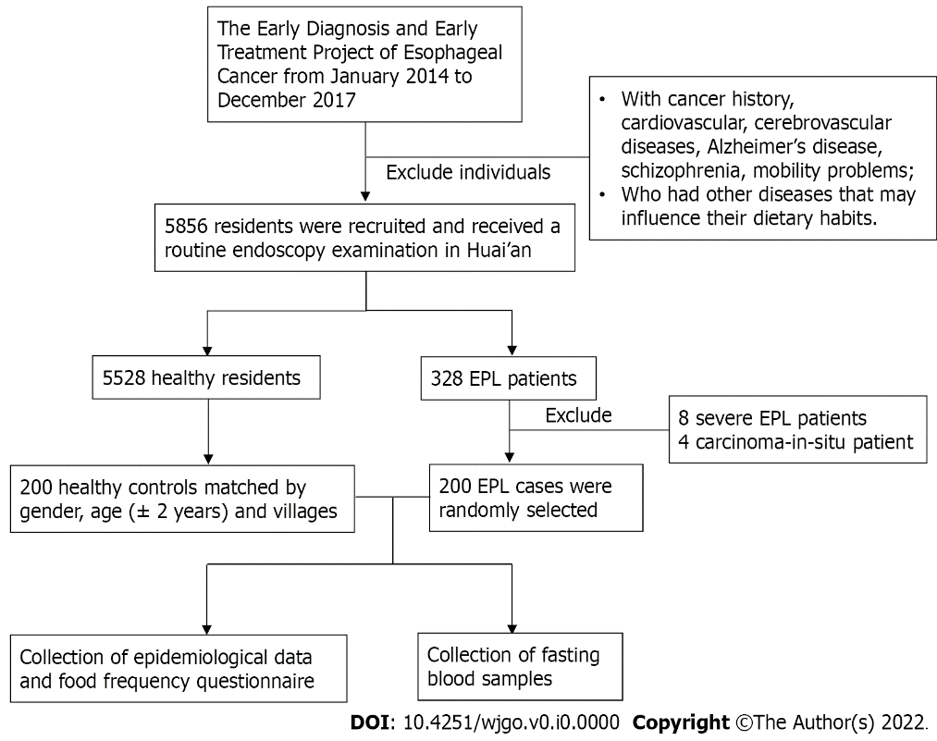
Figure 1 Flowchart of study population and sample collection.

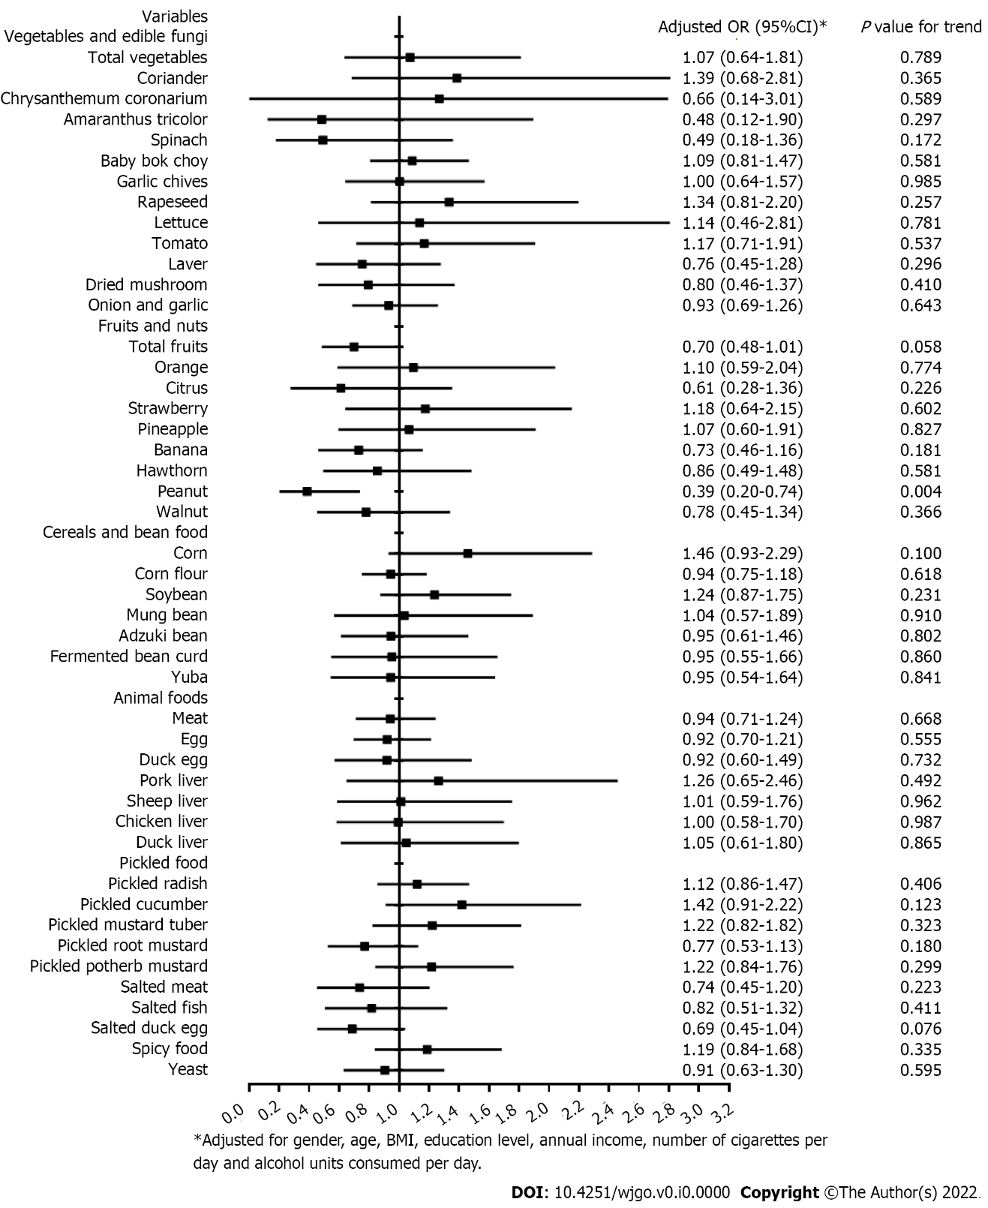
Figure 2 Association between dietary intake and the risk of Helicobacter pylori infection after adjustment for covariates via unconditional logistic regression model. BMI: Body mass index; OR: Odds ratio.

Table 1 Characteristics and potential factors in cases with esophageal precancerous lesions and controls
Category | Cases, n = 200 | Controls, n = 200 | Adjusted OR (95%CI)¹ | P value
Age (yr), mean ± SD | 63.01 ± 6.08 | 62.85 ± 6.03 |  | 0.792ª
BMI (kg/m²), mean ± SD | 24.52 ± 3.33 | 24.36 ± 3.37 |  | 0.631ª
Normal (18.5-23.9) | 82 (41.0%) | 84 (42.0%) | 1.00 (reference)
Underweight (< 18.5) | 4 (2.0%) | 5 (2.5%) | 0.61 (0.12-3.02) | 0.545
Overweight (24.0-28.0) | 84 (42.0%) | 89 (44.5%) | 0.95 (0.61-1.49) | 0.836
Obese (> 28.0) | 30 (15.0%) | 22 (11.0%) | 1.61 (0.83-3.12) | 0.164
Education level
Illiterate | 100 (50.0%) | 96 (48.0%) | 1.00 (reference)
Primary school education | 74 (37.0%) | 77 (38.5%) | 0.79 (0.45-1.39) | 0.413
Middle school education and higher | 26 (13.0%) | 27 (13.5%) | 0.81 (0.36-1.79) | 0.599
Annual income/person (RMB)
1-5000 | 53 (26.5%) | 42 (21.0%) | 1.00 (reference)
5001-10000 | 88 (44.0%) | 86 (43.0%) | 0.75 (0.45-1.25) | 0.267
> 10000 | 59 (29.5%) | 72 (36.0%) | 0.67 (0.37-1.21) | 0.183
Current smoking status (number of cigarettes/d)
Non-smoker | 126 (63.0%) | 134 (67.0%) | 1.00 (reference)
1-10 | 20 (10.0%) | 17 (8.5%) | 1.39 (0.67-2.87) | 0.381
11-20 | 38 (19.0%) | 41 (20.5%) | 1.10 (0.61-1.97) | 0.755
> 20 | 16 (8.0%) | 8 (4.0%) | 3.11 (1.00-9.63) | 0.049
Current drinking status (alcohol units consumed/d, 1 unit is 8 g or 10 mL of pure alcohol)
Non-drinker | 147 (73.5%) | 151 (75.5%) | 1.00 (reference)
< 4 | 10 (5.0%) | 10 (5.0%) | 1.03 (0.41-2.59) | 0.954
4- | 26 (13.0%) | 23 (11.5%) | 1.02 (0.52-2.02) | 0.946
8- | 17 (8.5%) | 16 (8.0%) | 1.06 (0.47-2.42) | 0.885
H. pylori infection
Negative | 153 (76.5%) | 142 (71.0%) | 1.00 (reference)
Positive | 47 (23.5%) | 58 (29.0%) | 0.75 (0.46-1.24) | 0.265
ªP value of two independent samples t-test.
¹Conditional logistic regression model with adjustment for gender, age, BMI, education level, annual income, number of cigarettes per day, and alcohol units consumed per day, except the specific variable itself.
H. pylori: Helicobacter pylori; BMI: Body mass index; OR: Odds ratio.

Table 2 Difference in Helicobacter pylori infection among controls and cases with esophageal precancerous lesions
Group | H. pylori infection |  |  | P valueª
 | Negative | Positive | Positive rate
Controls | 142 | 58 | 29.0%
EPL cases (upper and mid thoracic esophagus) | 100 | 33 | 24.8% | 0.384
EPL cases (lower thoracic esophagus) | 53 | 14 | 20.9%
ªP value of Fisher’s exact test.
H. pylori: Helicobacter pylori.

Table 3 Association between Helicobacter pylori infection and esophageal precancerous lesion risk dichotomized by gender, age, cigarette smoking, and alcohol drinking
 | Cases | Controls | Crude OR (95%CI) | P value | Adjusted OR (95%CI)¹ | P value
Male | n = 100 | n = 100
H. pylori (-) | 78 (78.0%) | 72 (72.0%) | 1.00 (reference) | - | 1.00 (reference) | -
H. pylori (+) | 22 (22.0%) | 28 (28.0%) | 0.73 (0.38-2.38) | 0.328 | 0.64 (0.32-1.27) | 0.200
Female | n = 100 | n = 100
H. pylori (-) | 75 (75.0%) | 70 (70.0%) | 1.00 (reference) | - | 1.00 (reference) | -
H. pylori (+) | 25 (25.0%) | 30 (30.0%) | 0.78 (0.42-1.45) | 0.429 | 0.82 (0.42-1.58) | 0.548
Age < 65 years | n = 107 | n = 107
H. pylori (-) | 76 (71.0%) | 73 (68.2%) | 1.00 (reference) | - | 1.00 (reference) | -
H. pylori (+) | 31 (29.0%) | 34 (31.8%) | 0.88 (0.49-1.57) | 0.656 | 0.89 (0.47-1.67) | 0.708
Age ≥ 65 years | n = 93 | n = 93
H. pylori (-) | 77 (82.8%) | 69 (74.2%) | 1.00 (reference) | - | 1.00 (reference) | -
H. pylori (+) | 16 (17.2%) | 24 (25.8%) | 0.60 (0.29-1.22) | 0.156 | 0.59 (0.27-1.28) | 0.183
Cigarette smoking (-) | n = 126 | n = 134
H. pylori (-) | 97 (77.0%) | 93 (69.4%) | 1.00 (reference) | - | 1.00 (reference) | -
H. pylori (+) | 29 (23.0%) | 41 (30.6%) | 0.68 (0.39-1.18) | 0.170 | 0.74 (0.42-1.32) | 0.310
Cigarette smoking (+) | n = 74 | n = 66
H. pylori (-) | 56 (75.7%) | 49 (74.2%) | 1.00 (reference) | - | 1.00 (reference) | -
H. pylori (+) | 18 (24.3%) | 17 (25.8%) | 0.93 (0.43-1.99) | 0.845 | 0.80 (0.34-1.86) | 0.601
Alcohol drinking (-) | n = 147 | n = 151
H. pylori (-) | 109 (74.1%) | 109 (72.2%) | 1.00 (reference) | - | 1.00 (reference) | -
H. pylori (+) | 38 (25.9%) | 42 (27.8%) | 0.91 (0.54-1.51) | 0.702 | 0.94 (0.55-1.61) | 0.831
Alcohol drinking (+) | n = 53 | n = 49
H. pylori (-) | 44 (83.0%) | 33 (67.3%) | 1.00 (reference) | - | 1.00 (reference) | -
H. pylori (+) | 9 (17.0%) | 16 (32.7%) | 0.42 (0.17-1.07) | 0.070 | 0.32 (0.11-0.95) | 0.040
¹Adjustment for gender, age, BMI, education level, annual income, number of cigarettes per day, and alcohol units consumed per day.
H. pylori: Helicobacter pylori; 95%CI: 95% confidence interval; OR: Odds ratio.

