Name of journal: World Journal of Gastroenterology
ESPS Manuscript NO: 20784
Manuscript Type: TOPIC HIGHLIGHT

2015 Advances in Gastrointestinal Endoscopy

Seeing better - Evidence based recommendations on optimizing colonoscopy adenoma detection rate

Aranda-Hernández J et al. Seeing better, optimizing colonoscopy adenoma detection

Javier Aranda-Hernández, Jason Hwang, Gabor Kandel

Javier Aranda-Hernández, Jason Hwang, Gabor Kandel, Division of Gastroenterology, University of Toronto, Therapeutic Endoscopy and Endoscopic Oncology, St. Michael's Hospital, Toronto, Ontario M5B 1W8, Canada

Author contributions: Aranda-Hernández J, Hwang J, Kandel G performed the literature review, wrote the manuscript; and approved the final manuscript.

Conflict-of-interest statement: The authors have no conflict-of-interest to report.

Open-Access: This article is an open-access article which was selected by an in-house editor and fully peer-reviewed by external reviewers. It is distributed in accordance with the Creative Commons Attribution Non Commercial (CC BY-NC 4.0) license, which permits others to distribute, remix, adapt, build upon this work non-commercially, and license their derivative works on different terms, provided the original work is properly cited and the use is non-commercial. See: http://creativecommons.org/licenses/by-nc/4.0/

Correspondence to: Gabor Kandel, MD, Division of Gastroenterology, University of Toronto, Therapeutic Endoscopy and Endoscopic Oncology, St. Michael's Hospital, 30 Bond St., Toronto, Ontario M5B 1W8, Canada. kandelg@smh.ca
Telephone: +1-416-8643093
Fax: +1-416-8645994

Received: June 22, 2015
Peer-review started: June 25, 2015
First decision: July 20, 2015
Revised: August 17, 2015
Accepted: November 30, 2015
Article in press:

Abstract
Colorectal cancer is one of the three most frequent causes of death in men and women in Europe and North America. Diagnosis and resection of adenomas has convincingly demonstrated its utility in diminishing colorectal cancer incidence. Therefore, colonoscopy is now the gold standard for colorectal cancer screening. But it is also known that colonoscopy effectiveness varies among endoscopists. Among different quality indicators, the most used is the adenoma detection rate (ADR) which is the percentage of average-risk patients for colorectal cancer who are found to have at least one adenoma or adenocarcinoma during a screening colonoscopy. There is compelling evidence supporting an inverse correlation between ADR and interval colorectal cancer (cancer found after a screening colonoscopy). Many factors such as quality of precolonoscopy preparation, additional observers, manoeuvres with the endoscope (second view, retroflexion, water inflation rather than air), time spent during withdrawal, changes in patient position, fold-flattener devices, new imaging or endoscopic modalities and use of intravenous or through the scope sprayed drugs, have been studied and developed with the aim of increasing the ADR. This review go through those factors and the current evidence, discuss them trying to know how to “seeing better” in the colon and optimize our ADR.

Key words: Adenoma; Detection; Colonoscopy; Screening; Cancer

© The Author(s) 2015. Published by Baishideng Publishing Group Inc. All rights reserved.

Core tip: Adenoma resection has demonstrated its utility in diminishing colorectal cancer incidence and colonoscopy has become the gold standard for screening. Nevertheless we also understand that colonoscopy does not predate cancer itself but “quality colonoscopy” does. Adenoma detection rate is the most important quality parameter that inversely correlates with colorectal cancer appearance after colonoscopy. Therefore we conducted an up to date review of the literature of different factors that may have an impact in the adenoma detection rate. We critically review the evidence and brought some crucial points for discussion.

Aranda-Hernández J, Hwang J, Kandel G. Seeing better - Evidence based recommendations on optimizing colonoscopy adenoma detection rate. World J Gastroenterol 2015; In press

INTRODUCTION
Colorectal cancer (CRC) is the third most frequent cause of cancer deaths in both men and women in the United States and Canada, and the second in Europe^{[1-3]}. Attempts at lowering mortality by improvements in primary prevention and life-extending treatment have been disappointing. Therefore recent efforts have been primarily focused on screening (secondary prevention), in the hope that detection of these neoplasms at an early enough stage will be curative. Screening is an especially theoretically appealing concept with colorectal neoplasms, since there is considerable evidence that adenomatous polyps amenable to endoscopic resection predate cancer, and that polypectomy reduces the likelihood of cancer^{[4]}. Commensurate with this data are randomized trials of screening programs with fecal occult blood demonstrating that such screening decreases mortality from colorectal cancer^{[5]}. In these studies, colonoscopy follows if even only one stool specimen is positive for occult blood. This has led to increasing adoption of colorectal cancer screening, especially in the United States. Such screening has been associated with a satisfying decrease in colorectal cancer deaths^{[6]}. Somewhat paradoxically, at around the same time that colorectal cancer screening was being shown to be successful, numerous reports appeared describing a surprisingly high miss rate of colonoscopy for cancer, especially in the ascending colon. For example, a population based retrospective study from Ontario reported a 4% miss rate of right sided colon cancer^{[7]}. Colonoscopy quality assurance (improvement) initiatives cannot focus on cancer detection rates because cancer is so uncommonly found at colonoscopy, but it turns out that adenoma detection rates (ADR – proportion of screening colonoscopies in average-risk population which at least one adenoma is found) correlate inversely with interval CRC (CRC after colonoscopy) and theoretically also with lower future mortality from colorectal cancer^{[8]}. It is for these reasons that ADR are increasingly being used to assess the quality of colonoscopy. Currently the ASGE recommends aiming for an ADR of 30% in men, 20% in women, based chiefly on a large study documenting that such detection rates correlate with a low risk of cancer following screening colonoscopy^{[9,10]}. Solely because of difficulties in collecting pathology data, polyp detection rate (PDR) is sometimes used as a surrogate marker for ADR^{[11]}.
Three caveats need to be kept in mind when discussing ADR’s. First, most studies were done in patients undergoing colonoscopy for a variety of indications, such as diarrhea, and abdominal pain, not just screening, so since the denominator varies among reports, the ADR can be expected to be variable. Second, just because a high ADR correlates with a lower rate of interval CRC, it does not necessarily follow that increasing the ADR will increase the cancer detection rate: the relationship between the two may be more association than causation. Increasing adenoma detection rate, particularly those under 1 cm in diameter, has not yet been shown to decrease interval cancers. For example, it may be that partially resected adenomas or missed adenomas are responsible for some interval cancers. Third, it is unclear if the total number of ademomas found per colonoscopy is more or less informative than the ADR.

FACTORS STUDIED FOR IMPACT ON THE ADR
Preparation
Most endoscopists consider it incontrovertible that adequate cleansing of the colon is a prerequisite for satisfactory ADR. Beyond this however, the literature provides only minimal guidelines in choosing among the myriad of formulations available for colonoscopy preparation. On the other hand four principles have been so clearly established that they are entrenched as consensus guidelines^{[12]}. First, the evidence favouring split-dose preparation is overwhelming: a second (“split”) dose of preparation started not earlier than 8 h before the procedure and finished no later than 2 h before the colonoscopy is strongly recommended by the American Society of Gastrointestinal Endoscopy (ASGE), the European Society of Gastrointestinal Endoscopy (ESGE) and the US Multi-Society Task Force on Colorectal Cancer^{[12-14]}. Full preparation the day of colonoscopy is acceptable for afternoon procedures. Second, every attempt should be made to individualize: e.g sodium picosulfate/magnesium citrate for patients who prioritize gentleness, polyethylene glycol–electrolyte solution if speed is the chief goal, polyethylene glycol-ascorbic acid combination if low volumes are desirable. Third, a low residue diet is recommended to be taken before the colonoscopy. Fourth, preparation is ideally discussed with the patient together with written instructions, and the inevitably of it being unpleasant but necessary emphasized. This is especially important with comorbidities, the elderly, if there is a history of constipation or other risk factors for inadequate preparation. Satisfactory bowel preparation, allowing the detection of lesions larger than 5 mm, should be achieved in more than 85% of our colonoscopies^{[14]}.
Several studies, including meta-analyses have demonstrated that adequate bowel cleansing is associated with a higher ADR^{[15,16]}, commensurate with clinical experience. For example, one prospective study with tandem colonoscopies within 3 mo in those patients with at least one adenoma larger than 5mm showed a higher than three times adenoma miss rate (AMR) among patients with poor or inadequate quality of bowel preparation compared with those with adequate preparation^{[17]}. Another retrospective study showed AMR of 42% (27% for lesions equal or larger than 10mm) in patients with poor or fair bowel preparations at index colonoscopy that had a new colonoscopy with good preparation within 3 years^{[18]}.
Yet surprisingly there is considerable data, even randomized controlled trials (RCT), failing to demonstrate any significant difference in ADR among patients with preparations ranged from fair to excellent^{[16,19-21]} with overall ADR in the study groups ranged from 22% to more than 50%. One recent retrospective study with the intriguing title of “good is better than excellent” reported a significantly higher polyp detection rate in patients with fair or good quality of preparations vs those with excellent preparation^{[22]}. Although the difference was not significant for ADR, the point was made that perhaps when colon cleansing is suboptimal, the extra time devoted by the endoscopist to washing the colon facilitates lesion recognition. However, the retrospective design of this study, the low record of bowel cleansing in the databases (49% and 19.2% in the two used) and the absence of data on withdrawal times limits its conclusions.

Withdrawal time
Who would have predicated at the dawn of colonoscopy that it would be more challenging to scope from the cecum to the rectum rather than vice versa, or that slowing down in the endoscopy unit would increase yields? Yet this is what the data shows. Initial concerns about missed lesions focused on challenges in reaching the cecum, and the long duration of time required for this outcome. More recent reports, however, describe a success rate of over 90% in cecal intubation by full time-endoscopists, usually within minutes^{[23]}. In contrast, withdrawal time varies significantly between endoscopists, and the bulk of the data demonstrates an inverse correlation between adenoma detection rate and withdrawal time^{[24]}. This may be more of an association than cause-effect. In other words, the association may simply reflect the increased time required by diligent observers to visualize mucosal lesions suggesting that simply increasing withdrawal time is insufficient to increase ADR. Unquestionably, the withdrawal time needs to be spent productively, with alert visualization, rotation of the endoscope to see the entire circumference of the colon, and aggressive wash and suction to remove debris. That this takes time is not surprising. But what is enlightening from the literature is firstly that mucosal visualization is best done on withdrawal, and secondly that on the average this takes 6 to 9 min to do properly. At least one study has reported that a 9 min withdrawal time increases ADR compared to 6 min^{[25]}, although this was based on registry not prospective data. Also of interest is that not all endoscopists require this much time: many have an acceptable ADR with shorter withdrawal times. At least two studies have found no connection between ADR and withdrawal time^{[26,27]}.
Rex et al^{[28]} emphasize that withdrawal time is a process measurement in contrast to ADR which is an outcome measurement. This implies that simply documenting a long withdrawal time is less preferable as a quality measurement than ADR. Instead, time of withdrawal is best considered as one component of a teaching program to help less successful endoscopists achieve acceptable ADR’s^{[23]}.

Visualization of the right colon
The majority of missed cancers are in the right colon^{[7]}. Although this may be due to factors unrelated to mucosal visualization, such as more aggressive biology of right sided vs left sided neoplasms, relatively more retained stool/residue leading to lower adenoma recognition, or to a greater proportion of incompletely resected polyps, most analyses indicate that the chief reason is that lesions in the ascending colon are difficult to recognize even when the bowel is well cleaned. This is most likely because right-sided polyps tend to be sessile serrated adenoma/polyps, flat, sometimes barely discernible but with a potential to evolve to cancer. To complicated matters further, a study of polyps seen on CT colonography, not recognized on initial colonoscopy but appreciated (only) when the site of the lesion on CT was described to the endoscopist (“segmental unblinding”)^{[29]} reports that the most frequent location of missed lesions is on the proximal side of mucosal folds, areas especially challenging for optical endoscopes to visualize. Thus it is not surprising that considerable attention has been paid to increasing polyp recognition in the ascending colon. The key point emerging from these studies is that visualizing the right colon twice increases the ADR by about 10%^{[30]}. Some reports suggest that this is best done by retroflexion^{[31]} whereas others indicate that a second forward view is just as satisfactory^{[30]} but the data is convincing that repeating visualization of the ascending colon increases ADR.

Changing patient position
Theoretically, and from extrapolation of barium enema/CT colonography practice, changing patient position should increase ADR if only because any residue shifts position when the patient changes position facilitating recognition of lesions hidden by such debris. There are two ways this can be studied. Firstly, colon segments can be visualized twice on withdrawal, no change in position during one withdrawal then changing position on the other withdrawal, and the ADR compared to position change to no position change. Two trials with this design showed a benefit approaching 10%, significant but less than just repeat segment visualization^{[32,33]}. Secondly, changing patient position during withdrawal to the anatomically attractive position of ascending colon/hepatic flexure in left lateral decubitus position, transverse colon in supine position, and splenic flexure/descending colon/sigmoid colon/rectum in right lateral decubitus position can be compared to the usual practice of changing position only if required for a specific reason (control). This turned out to not be advantageous^{[34]}. A reasonable conclusion is that changing patient position may help improve ADR, but less so than visualizing the same area twice irrespective of patient position. However more definitive trials would be helpful on this topic, since changing patient position is especially difficult with propofol. This general anaesthetic is increasingly being used for colonoscopy but challenges in rolling the patient deeply sedated with this drug would put it at a disadvantage to conscious sedation if changes in patient position could be demonstrated to increase ADR. On the other hand, it is difficult to think of a study design which overcomes the bias toward finding more lesions with position change, since blinding of the endoscopist to position change would be exceptionally difficult.

Rectal retroflexion
In the CT colonography study mentioned above^{[29]}, 6 of the 21 polyps larger than 6 mm in diameter missed by optical endoscopic colonoscopy were in the lower rectum, best seen by retroflexion. Nevertheless, reluctance to visualize the anorectal junction “backward” persists because it is time consuming, risky, painful and its yield for neoplasia low^{[35]}. Thus guidelines on colonoscopy quality indicators makes no mention about the need for this manoeuvre^{[28,36]}. The risk/benefit ratio is probably too high to warrant its use routinely if there has been rectal surgery, previous radiation, adhesions or if the pelvis is narrow. On the other hand every effort should be made to retroflex in the rectum if there is rectal bleeding, or there is a high risk for polyps. Given that it is painful, consideration should be given to retroflexing at the start of the colonoscopy when analgesia/sedation intensity is high rather than at the end of the endoscopy when these levels are usually waning.

Second observer
No matter how intense the scrutiny on the video screen, endoscopists will miss lesions because of “change blindness” – as the eye moves, visual scanning is interrupted, and changes in the mucosa are overlooked. Moreover, consistent focus on any object is so difficult that psychologists have coined a term – “inattention blindness” - to emphasize the universal lapses of focus even when motivation is strong to maintain concentration. The best way to overcome such innate human deficiencies is to include a second observer during screening colonoscopy. Two prospective studies have investigated whether nurses can take on this role. In the larger trial, there was no over-all increase in adenoma detection rate, but when only nurses with more than two years of experience were included, the ADR increased by about 10%, a statistically significant finding^{[37]}. A more recent smaller study which included only nurse with more than 1.5 years of experience (mean of 8.2 years) reported similar conclusions: there was an 13% increase in PDR, although admittedly only a trend rather than a statistically significant increase in ADR (47% vs 40%)^{[38]}. Results with fellows are even more mixed. In one retrospective study concomitant viewing by a fellow increased ADR^{[39]}. In another of similar design the only benefit was an increase in small adenoma detection^{[40]} while in a third but prospective trial there was no increase at all in adenoma detection^{[41]}. Aslanian et al^{[38]} make the astute point that with a second observer, there may be increase in lesion detection by the endoscopist because of a competition effect and attempts to avoid the embarrassment of a nurse detecting abnormalities. In the conglomerate it is difficult to avoid the conclusion that ADR is increased by a second viewer, ideally an endoscopically experienced assistant.

Water-aided colonoscopy
Water-aided colonoscopy uses water rather than air to distend the colon. Two techniques has been described^{[42]}: First, water immersion (WI) which implies infusion of water to fill the colon during the insertion that will be mostly removed in the withdrawal. Second, water exchange (WE) meaning avoiding any air insufflation (Leung et al^{[42]} recommends switch the air pump off), sucking any remnant air, infusing water (usually higher volumes) and sucking any stool debris. In WE, these manoeuvres are mainly carried out during the insertion.
These techniques were initially introduced to reduce the pain of colonoscopy and facilitate the path to the cecum, but in at least some studies polyp recognition is enhanced. This may be because liquid distension of the colon keeps polyps upright rather than flat, magnifies lesions, or because the large volumes of water used clean the mucosa better^{[42-45]}. There is no downside to the technique except time: in one study WE had a statistically significant increased insertion plus withdrawal times (excluding therapy time)^{[44]}.
Two recent RCT showed somewhat conflicting results for ADR. In the first one, a significant higher ADR was found in the WE group (25.8 %) vs air inflation (AI) (19.1 %)^{[43]} while in the other comparing AI, WI and WE there was a trend favouring WE but no significant in the overall ADR (43.3%, 45.6% and 56.7%, respectively)^{[44]}. Nevertheless that difference was statically significant for adenomas of the right colon (11.1%, 14.4% and 26.7%, respectively). Longer times in WE group may impact these results. A previous systematic review of RCT found similar results^{[45]}.

High definition endoscopy
High definition (HD) endoscopy has been increasingly used since the early 2000’s^{[46]}.
HD endoscopy displays 650 to 720 lines (height or vertical number of pixels) of resolution compared to standard definition (SD) offering 480 to 520 lines^{[46,47]}. One glance at a HD videoscreen unmistakably demonstrates that the image is better defined and sharper than SD, so it is no surprise that studies have consistently reported that HD improves the recognition of lesions at colonoscopy.
One large RCT compared SD-white light (WL) colonoscopy vs HD-WL endoscopy and HD narrow-band imaging (HD-NBI). HD-WL colonoscopy significantly improved the total number of adenomas, adenomas per colonoscopy, patients with flat adenomas and right-sided adenomas (19% vs 34%). There was a non-significant trend to improving the ADR (38.6% vs 45.7%, P = 0.17)^{[48]}. In other words, HD did not increase the number of patients with at least one adenoma but it was associated with the identification of more adenomas and more flat lesions in those patients that did have adenomas.
In contrast, a recent meta-analysis^{[49]} including RCT, prospective and retrospective studies, showed an overall increase in the ADR with the use of HD colonoscopy compared with SD colonoscopy. No difference in the detection of advanced adenomas (larger than 10 mm or with villous component or high-grade dysplasia) was observed. The authors recommended interpreting these results with caution given the heterogeneity of the studies with ADR ranging from 23% to 65%. They also suggested that longer term outcomes such the interval or missed CRC should be studied in prospective RCT.
Currently, the ESGE recommends the use of HD-WL endoscopy for average-risk population screening colonoscopy^{[50]}.

Virtual chromoendoscopy modalities (NBI, FICE and i-scan)
In parallel with the development of HD endoscopy, different endoscopic image-enhancement modalities have been developed: narrow-band imaging (NBI) (Olympus, Tokyo, Japan), flexible spectral imaging colour enhancement (FICE) (Fujinon, Tokyo, Japan) and i-scan (Pentax, Tokyo, Japan)^{[51,52]}.
A number of studies have been reported to determine if these sophisticated virtual chromoendoscopy modalities improve ADR compared to WL.

NBI: Olympus NBI utilises filters to selectively project light in the blue (415 nm) and green (540 nm) wavelengths from the processor unit which correspond with the two absorption peaks of haemoglobin. As shorter wavelengths have superficial tissue penetration and longer wavelengths deep tissue penetration, the images obtained with NBI correspond to enhanced prominence of superficial vascularity (blue light) and submucosal vessels (green light). Adenomas have a distinct vascular pattern which can be enhanced with NBI in comparison to normal colonic mucosa (Figure 1A-D).
Rastogi et al^{[48]} compared SD-WL colonoscopy vs HD-WL or HD-NBI. NBI significantly increased the total number of adenomas, adenomas per colonoscopy, patients with flat adenomas and right-sided adenomas over SD-WL. There was a trend in improvement in ADR; however this was not statistically significant (46.2% vs 38.6%, P = 0.14). Despite the absence of a comparison between HD-NBI and HD-WL, the improvement of NBI seemed similar and attributable to HD.
Two recent large meta-analyses of RCTs^{[53,54]} including tandem colonoscopy studies, did not demonstrate any significant differences in PDR, ADR or AMR when comparing HD-NBI and HD-WL either.
In contrast, a more recent single-center RCT with tandem colonoscopies comparing HD-NBI and HD-WL found higher ADR and PDR after the first colonoscopy in the HD-NBI group (48.3% vs 34.4%)^{[55]}. Similar results and AMR were observed after the second colonoscopy. These results need to be reproduced before they are accepted into practice, especially since they could be attributable to the new NBI generation (CF-HQ190 colonoscope and the EVIS-EXERA III CLV-190) used in this study but in none of the previous one.
Interestingly, one RCT study^{[56]} suggested a possible learning effect of NBI on WL; in other words, the endoscopist increased their ADR using WL after having used NBI. However, this effect was not confirmed in a more recent study^{[57]}.

FICE: FICE digitally transforms the endoscopic image with post-processing algorithms. It potentiates specific wavelengths to transmit a composite computerized enhanced color image. 10 presets are available but further customization may be carried out as wavelengths may be modified in 5nm increments from 400 nm to 695 nm.
Despite its flexibility with regards to customisation and selection of specific enhanced wavelengths, large studies, including a RCT in Germany and randomized tandem colonoscopy studies in Korea, involving a large number of patients, failed to demonstrate benefits of HD-FICE (modes 4 and 3, respectively) vs HD-WL^{[57-59]} in improving ADR or AMR.

i-scan: Pentax i-scan is a post-processor imaging enhancement that comes with 3 different image modalities to allow different grades of surface enhancement, contrast enhancement and tone enhancement.
Two prospective studies found a significant increase in ADR in the i-scan group when compared with WL^{[60,61]}. A significant limitation is that HD was used in the i-scan group but no in the WL group so those differences may be mostly due to HD which seems superior to SD^{[48,49]}. Prospective and randomized tandem colonoscopy trials have failed to demonstrate any benefit of i-scan 1 or 2 vs HD-WL in ADR or AMR^{[62,63]}.

Chromoendoscopy
Chromoendoscopy (CE) is the technique of using through-the-scope infusions to improve mucosal image recognition, especially for small or flat mucosal lesions. In contrast to its extensive study in other clinical scenarios, its utility in the context of average-risk population screening colonoscopy seems to have been relatively ignored. Indigo carmine (IC) has been used in most studies. One prospective randomized study compared CE with IC vs second WL exploration in the right colon. A significant higher number of right colon adenomas were found in the chromoendoscopy group^{[64]} but the use of both HD and SD colonoscopes not included in the analysis biased results. Another prospective study showed a significant improvement in the total number of adenomas, especially those flat or smaller than 5 millimetres^{[65]} in the group with panchromoendoscopy with IC. However the study was not randomized, and no withdrawal times were reported. A more rigorous prospective randomized study found a significant higher ADR (46.2% vs 36.3%), flat adenomas and serrated lesions in patients with panchromoendoscopy with IC vs the control group with regular colonoscopy ^{[66]} but this improvement may have been due to the slightly longer mean withdrawal times in the panchromoendoscopy group (11.6 min vs 10.1 min).
More RCT’s will be required to determine if CE with IC improves ADR. As with water distension, the statistical interpretation of studies is likely to be hampered by the invariably longer withdrawal time required for chromoendoscopy.

Drugs
All endoscopists have been at times frustrated by colon muscle spasms preventing satisfactory mucosal visualization at colonoscopy.
Therefore hyoscine N-butylbromide, an anti-cholinergic formulation available in an intravenous form, has been widely exploited for its smooth muscle relaxing (antispasmodic) effects, even though it has not been approved by the FDA for this purpose. However trials do not support its use for polyp recognition: One randomized double-blind controlled trial^{[67]} was able to only demonstrate only a statistically non-significant trend for ADR and PDR, and even these results were not confirmed in later meta-analysis of RCT^{[68-71]}.
L-Menthol is another antispasmodic agent with suspected action mechanism for smooth muscle relaxation related to ion calcium influx blocking^{[72]}. Recently, Inoue and collaborators conducted a single-blinded RCT in Japan comparing 1.6% L-Menthol solution (Kenei Pharmaceuticals, Osaka, Japan) spraying vs placebo. They found a significant higher ADR in the L-menthol group compared with the control group (60.2% vs 42.6%)^{[73]}. A significant reduction in colonic peristalsis was also observed but this result was biased by the absence of endoscopist blindness.

Fold-flattening devices
The proximal mucosa behind colonic folds is often poorly visualised due to the inherent nature of the retrograde approach of colonic inspection. Devices used to aid visualisation of these mucosal "blind spots" have been developed with an aim to reduce the rates of missed lesions.

Cap-assisted colonoscopy: Transparent plastic caps attached to the tip of the colonoscope may assist in the improvement of polyp detection rate by depressing haustral folds, allowing visualisation of otherwise blind mucosa. Ng et al^{[74]} performed a meta-analysis of 16 RCT investigating the efficacy of cap assisted colonoscopy (CAC) in comparison to standard colonoscopy (SC). Analysis showed a marginal benefit in PDR. ADR was not significantly improved in 6 studies specifically reporting this variable. The authors found cap length to influence rates of polyp detection with short caps (2 or 4mm) better than longer caps (7-11 mm). Insertion times were significantly shorter in the CAC vs SC group for both experts and trainees.

Endocuff: A novel endoscopic cuff [Endocuff (EC); ARC Medical] with 2 rows of flexible, hinged wings (Figure 2A) that help flatten colonic mucosa during withdrawal was recently introduced, receiving FDA approval in 2012. The EC is attached to the tip of the colonoscope and sits flush with the tip of the instrument, therefore not obscuring endoscopic views. Biecker et al^{[75]} performed a randomised controlled trial of 498 patients. The authors found significant differences in the PDR (56% vs 42%) in the EC group compared to SC group and overall number of polyps detected per patient (2 vs 1, respectively). ADR was also significantly higher in the EC group compared to the no EC group (36% vs 28%). The overall procedure time was significantly higher in the EC vs SC group, but due to a lack of measurement of withdrawal time, it is uncertain whether this was due to longer insertion, therapy or withdrawal times.

Balloon-assisted colonoscopy: The G-Eye system consists of an inflatable balloon that is integrated to the distal portion of the colonoscope shaft. Inflation during colonoscope withdrawal is controlled by a foot pedal allowing the inflated balloon to flatten and straighten colonic folds immediately downstream to the colonoscope tip. Improved views behind folds are facilitated by withdrawal of the colonoscope with the balloon inflated. Balloon pressure is monitored by the system, enabling changes to compensate for colonic wall pressure. The system can be reprocessed and may be integrated into existing colonoscope systems. Preliminary data, published in abstract form, of a multicentre RCT in 104 of an intended 1000 patients, has yielded favourable results for improvement in ADR with the G-Eye device (SC 39% vs G-Eye 59%) and seems promising^{[76]}.

New scope modalities
Third-Eye retroscope and third-eye panoramic device: The Third-Eye retroscope is a flexible 3.5 mm single-use catheter with a camera and a light source at its tip (Figure 2B). It provides a retroflexed view of the colon and the TERRACE study showed higher ADR in the retroscope group^{[77]}. The limitations including its complexity, single use and occupation of the working channel has led to stop its production.
The Third-Eye Panoramic device is the second generation of the device. It includes an external side-by-side catheter and the attachment device to the tip of the scope (Figure 2C). The attachment device has one source of light and one camera in each side providing a wider (330 degrees) view of the mucosa. There is just one feasibility study (abstract publication) and it is pending for FDA approval as a reusable device. Further studies will be required to assess its utility.

Full spectrum endoscopy (FUSE): The FUSE colonoscope incorporates a high definition, 330 degree viewing angle by implementing 3 imaging systems (image sensor and LED light source) on the tip of a conventional type instrument (Figure 2D, 2E). A forward viewing lens is complemented by side viewing lenses on each side of the instrument tip with images displayed on 3 video screens corresponding to each imaging group. The instrument has the standard working channel and irrigation capability found on conventional colonoscopes. A randomized, multicenter, back to back study comparing FUSE with a standard forward-viewing colonoscope has been performed in 185 patients^{[78]}. The study randomized patients to undergo standard or FUSE colonoscopy first followed by a second same day procedure using the alternate instrument. The authors reported AMR, rather than ADR, being significantly lower with FUSE-standard colonoscopy strategy compared with standard colonoscopy-FUSE (7.5% vs 40.8%).

Others
Other parameters or manoeuvres have been studied and explored as possible factors with impact in the ADR.
One interesting study compared^{[79]} the ADR of 6 experienced endoscopist before and after an announced video recording implementation and storage of all the colonoscopies in the unit. A positive, but not significant, trend for higher ADR was found after video recording implementation. In one of the two endoscopists with lower ADR, the impact of video recording in the ADR was remarkably and statistically significant (22.6% vs 57.7%). It was associated with an increase in the endoscopist withdrawal time. The authors suggested video recording as a possible strategy to increase ADR in endoscopists with lower ADR.
One retrospective study suggested that endoscopist fatigue may have a deleterious impact on adenoma detection^{[80]} but a prospective study showed no impact of time in the day or case rank of colonoscopy in ADR^{[81]}. One retrospective study showed higher ADR (42.3% vs 34.7%) and PDR in the morning procedures when compared to afternoon procedures^{[82]} as well as other Korean study found higher AMR in the afternoon procedures when compared with morning procedures^{[83]}.
Performing polypectomies during insertion and withdrawal vs just during the withdrawal did not show an impact on ADR in a RCT^{[84]}.
Colonoscopist experience has been also found to have a positive impact in ADR in several studies^{[57,80]} (Tables 1-3).

CONCLUSION
ADR is now recognized as a useful surrogate marker for colorectal cancer detection. In addition to innate, impossible-to-measure endoscopy skill, the data for optimizing ADR is most convincing for thorough precolonoscopy bowel cleansing preparation, withdrawal time of more than 6 to 9 min, and double visualization of the right colon. HD technology, mucosal visualization by an assistant, and changing patient position during withdrawal are also helpful but less so. At least some of the newer endoscopic technology are likely to improve ADR, but have yet to be proven.

REFERENCES
1 Siegel R, Ma J, Zou Z, Jemal A. Cancer statistics, 2014. CA Cancer J Clin 2014; 64: 9-29 [PMID: 24399786 DOI: 10.3322/caac.21208]
2 Canadian Cancer Society, Statistics Canada, Public Health Agency of Canada, Provincial/Territorial Cancer Registries. Canadian Cancer Statistics 2014. Available from: URL: http: //www.cancer.ca/statistics
3 Ferlay J, Steliarova-Foucher E, Lortet-Tieulent J, Rosso S, Coebergh JW, Comber H, Forman D, Bray F. Cancer incidence and mortality patterns in Europe: estimates for 40 countries in 2012. Eur J Cancer 2013; 49: 1374-1403 [PMID: 23485231 DOI: 10.1016/j.ejca.2012.12.027]
4 Winawer SJ, Zauber AG, Ho MN, O'Brien MJ, Gottlieb LS, Sternberg SS, Waye JD, Schapiro M, Bond JH, Panish JF. Prevention of colorectal cancer by colonoscopic polypectomy. The National Polyp Study Workgroup. N Engl J Med 1993; 329: 1977-1981 [PMID: 8247072]
5 Shaukat A, Mongin SJ, Geisser MS, Lederle FA, Bond JH, Mandel JS, Church TR. Long-term mortality after screening for colorectal cancer. N Engl J Med 2013; 369: 1106-1114 [PMID: 24047060 DOI: 10.1056/NEJMoa1300720]
6 American Cancer Society. Cancer Facts & Figures 2015. Atlanta: American Cancer Society; 2015. Available from: URL: http: //www.cancer.org/acs/groups/content/@editorial/documents/document/acspc-044552.pdf
7 Bressler B, Paszat LF, Vinden C, Li C, He J, Rabeneck L. Colonoscopic miss rates for right-sided colon cancer: a population-based analysis. Gastroenterology 2004; 127: 452-456 [PMID: 15300577]
8 Kaminski MF, Regula J, Kraszewska E, Polkowski M, Wojciechowska U, Didkowska J, Zwierko M, Rupinski M, Nowacki MP, Butruk E. Quality indicators for colonoscopy and the risk of interval cancer. N Engl J Med 2010; 362: 1795-1803 [PMID: 20463339 DOI: 10.1056/NEJMoa0907667]
9 Corley DA, Jensen CD, Marks AR, Zhao WK, Lee JK, Doubeni CA, Zauber AG, de Boer J, Fireman BH, Schottinger JE, Quinn VP, Ghai NR, Levin TR, Quesenberry CP. Adenoma detection rate and risk of colorectal cancer and death. N Engl J Med 2014; 370: 1298-1306 [PMID: 24693890 DOI: 10.1056/NEJMoa1309086]
10 Baxter NN, Sutradhar R, Forbes SS, Paszat LF, Saskin R, Rabeneck L. Analysis of administrative data finds endoscopist quality measures associated with postcolonoscopy colorectal cancer. Gastroenterology 2011; 140: 65-72 [PMID: 20854818 DOI: 10.1053/j.gastro.2010.09.006]
11 Williams JE, Holub JL, Faigel DO. Polypectomy rate is a valid quality measure for colonoscopy: results from a national endoscopy database. Gastrointest Endosc 2012; 75: 576-582 [PMID: 22341104 DOI: 10.1016/j.gie.2011.12.012]
12 Saltzman JR, Cash BD, Pasha SF, Early DS, Muthusamy VR, Khashab MA, Chathadi KV, Fanelli RD, Chandrasekhara V, Lightdale JR, Fonkalsrud L, Shergill AK, Hwang JH, Decker GA, Jue TL, Sharaf R, Fisher DA, Evans JA, Foley K, Shaukat A, Eloubeidi MA, Faulx AL, Wang A, Acosta RD. Bowel preparation before colonoscopy. Gastrointest Endosc 2015; 81: 781-794 [PMID: 25595062 DOI: 10.1016/j.gie.2014.09.048]
13 Hassan C, Bretthauer M, Kaminski MF, Polkowski M, Rembacken B, Saunders B, Benamouzig R, Holme O, Green S, Kuiper T, Marmo R, Omar M, Petruzziello L, Spada C, Zullo A, Dumonceau JM. Bowel preparation for colonoscopy: European Society of Gastrointestinal Endoscopy (ESGE) guideline. Endoscopy 2013; 45: 142-150 [PMID: 23335011 DOI: 10.1055/s-0032-1326186]
14 Johnson DA, Barkun AN, Cohen LB, Dominitz JA, Kaltenbach T, Martel M, Robertson DJ, Boland CR, Giardello FM, Lieberman DA, Levin TR, Rex DK. Optimizing adequacy of bowel cleansing for colonoscopy: recommendations from the US multi-society task force on colorectal cancer. Gastroenterology 2014; 147: 903-924 [PMID: 25239068 DOI: 10.1053/j.gastro.2014.07.002]
15 Froehlich F, Wietlisbach V, Gonvers JJ, Burnand B, Vader JP. Impact of colonic cleansing on quality and diagnostic yield of colonoscopy: the European Panel of Appropriateness of Gastrointestinal Endoscopy European multicenter study. Gastrointest Endosc 2005; 61: 378-384 [PMID: 15758907]
16 Clark BT, Rustagi T, Laine L. What level of bowel prep quality requires early repeat colonoscopy: systematic review and meta-analysis of the impact of preparation quality on adenoma detection rate. Am J Gastroenterol 2014; 109: 1714-123; quiz 1724 [PMID: 25135006 DOI: 10.1038/ajg.2014.232]
17 Hong SN, Sung IK, Kim JH, Choe WH, Kim BK, Ko SY, Lee JH, Seol DC, Ahn SY, Lee SY, Park HS, Shim CS. The Effect of the Bowel Preparation Status on the Risk of Missing Polyp and Adenoma during Screening Colonoscopy: A Tandem Colonoscopic Study. Clin Endosc 2012; 45: 404-411 [PMID: 23251889 DOI: 10.5946/ce.2012.45.4.404]
18 Lebwohl B, Kastrinos F, Glick M, Rosenbaum AJ, Wang T, Neugut AI. The impact of suboptimal bowel preparation on adenoma miss rates and the factors associated with early repeat colonoscopy. Gastrointest Endosc 2011; 73: 1207-1214 [PMID: 21481857 DOI: 10.1016/j.gie.2011.01.051]
19 Jover R, Zapater P, Polanía E, Bujanda L, Lanas A, Hermo JA, Cubiella J, Ono A, González-Méndez Y, Peris A, Pellisé M, Seoane A, Herreros-de-Tejada A, Ponce M, Marín-Gabriel JC, Chaparro M, Cacho G, Fernández-Díez S, Arenas J, Sopeña F, de-Castro L, Vega-Villaamil P, Rodríguez-Soler M, Carballo F, Salas D, Morillas JD, Andreu M, Quintero E, Castells A. Modifiable endoscopic factors that influence the adenoma detection rate in colorectal cancer screening colonoscopies. Gastrointest Endosc 2013; 77: 381-389.e1 [PMID: 23218945 DOI: 10.1016/j.gie.2012.09.027]
20 Anderson JC, Butterly LF, Robinson CM, Goodrich M, Weiss JE. Impact of fair bowel preparation quality on adenoma and serrated polyp detection: data from the New Hampshire colonoscopy registry by using a standardized preparation-quality rating. Gastrointest Endosc 2014; 80: 463-470 [PMID: 24818550 DOI: 10.1016/j.gie.2014.03.021]
21 Sherer EA, Imler TD, Imperiale TF. The effect of colonoscopy preparation quality on adenoma detection rates. Gastrointest Endosc 2012; 75: 545-553 [PMID: 22138085 DOI: 10.1016/j.gie.2011.09.022]
22 Calderwood AH, Thompson KD, Schroy PC, Lieberman DA, Jacobson BC. Good is better than excellent: bowel preparation quality and adenoma detection rates. Gastrointest Endosc 2015; 81: 691-699.e1 [PMID: 25708756 DOI: 10.1016/j.gie.2014.10.032]
23 Rex DK, Petrini JL, Baron TH, Chak A, Cohen J, Deal SE, Hoffman B, Jacobson BC, Mergener K, Petersen BT, Safdi MA, Faigel DO, Pike IM. Quality indicators for colonoscopy. Am J Gastroenterol 2006; 101: 873-885 [PMID: 16635231]
24 Barclay RL, Vicari JJ, Doughty AS, Johanson JF, Greenlaw RL. Colonoscopic withdrawal times and adenoma detection during screening colonoscopy. N Engl J Med 2006; 355: 2533-2541 [PMID: 17167136]
25 Butterly L, Robinson CM, Anderson JC, Weiss JE, Goodrich M, Onega TL, Amos CI, Beach ML. Serrated and adenomatous polyp detection increases with longer withdrawal time: results from the New Hampshire Colonoscopy Registry. Am J Gastroenterol 2014; 109: 417-426 [PMID: 24394752 DOI: 10.1038/ajg.2013.442]
26 Adler A, Wegscheider K, Lieberman D, Aminalai A, Aschenbeck J, Drossel R, Mayr M, Mroß M, Scheel M, Schröder A, Gerber K, Stange G, Roll S, Gauger U, Wiedenmann B, Altenhofen L, Rosch T. Factors determining the quality of screening colonoscopy: a prospective study on adenoma detection rates, from 12,134 examinations (Berlin colonoscopy project 3, BECOP-3). Gut 2013; 62: 236-241 [PMID: 22442161 DOI: 10.1136/gutjnl-2011-300167]
27 Moritz V, Bretthauer M, Ruud HK, Glomsaker T, de Lange T, Sandvei P, Huppertz-Hauss G, Kjellevold Ø, Hoff G. Withdrawal time as a quality indicator for colonoscopy - a nationwide analysis. Endoscopy 2012; 44: 476-481 [PMID: 22531983 DOI: 10.1055/s-0032-1306898]
28 Rex DK, Schoenfeld PS, Cohen J, Pike IM, Adler DG, Fennerty MB, Lieb JG, Park WG, Rizk MK, Sawhney MS, Shaheen NJ, Wani S, Weinberg DS. Quality indicators for colonoscopy. Gastrointest Endosc 2015; 81: 31-53 [PMID: 25480100 DOI: 10.1016/j.gie.2014.07.058]
29 Pickhardt PJ, Nugent PA, Mysliwiec PA, Choi JR, Schindler WR. Location of adenomas missed by optical colonoscopy. Ann Intern Med 2004; 141: 352-359 [PMID: 15353426]
30 Hewett DG, Rex DK. Miss rate of right-sided colon examination during colonoscopy defined by retroflexion: an observational study. Gastrointest Endosc 2011; 74: 246-252 [PMID: 21679946 DOI: 10.1016/j.gie.2011.04.005]
31 Chandran S, Parker F, Vaughan R, Mitchell B, Fanning S, Brown G, Yu J, Efthymiou M. Right-sided adenoma detection with retroflexion versus forward-view colonoscopy. Gastrointest Endosc 2015; 81: 608-613 [PMID: 25440687 DOI: 10.1016/j.gie.2014.08.039]
32 East JE, Bassett P, Arebi N, Thomas-Gibson S, Guenther T, Saunders BP. Dynamic patient position changes during colonoscope withdrawal increase adenoma detection: a randomized, crossover trial. Gastrointest Endosc 2011; 73: 456-463 [PMID: 20950801 DOI: 10.1016/j.gie.2010.07.046]
33 Köksal AŞ, Kalkan IH, Torun S, Taşkıran I, Öztaş E, Kayaçetin E, Şaşmaz N. A simple method to improve adenoma detection rate during colonoscopy: altering patient position. Can J Gastroenterol 2013; 27: 509-512 [PMID: 24078934]
34 Ou G, Kim E, Lakzadeh P, Tong J, Enns R, Ramji A, Whittaker S, Ko HH, Bressler B, Halparin L, Lam E, Amar J, Telford J. A randomized controlled trial assessing the effect of prescribed patient position changes during colonoscope withdrawal on adenoma detection. Gastrointest Endosc 2014; 80: 277-283 [PMID: 24629419 DOI: 10.1016/j.gie.2014.01.032]
35 Saad A, Rex DK. Routine rectal retroflexion during colonoscopy has a low yield for neoplasia. World J Gastroenterol 2008; 14: 6503-6505 [PMID: 19030202]
36 Armstrong D, Barkun A, Bridges R, Carter R, de Gara C, Dube C, Enns R, Hollingworth R, Macintosh D, Borgaonkar M, Forget S, Leontiadis G, Meddings J, Cotton P, Kuipers EJ. Canadian Association of Gastroenterology consensus guidelines on safety and quality indicators in endoscopy. Can J Gastroenterol 2012; 26: 17-31 [PMID: 22308578]
37 Lee CK, Park DI, Lee SH, Hwangbo Y, Eun CS, Han DS, Cha JM, Lee BI, Shin JE. Participation by experienced endoscopy nurses increases the detection rate of colon polyps during a screening colonoscopy: a multicenter, prospective, randomized study. Gastrointest Endosc 2011; 74: 1094-1102 [PMID: 21889137 DOI: 10.1016/j.gie.2011.06.033]
38 Aslanian HR, Shieh FK, Chan FW, Ciarleglio MM, Deng Y, Rogart JN, Jamidar PA, Siddiqui UD. Nurse observation during colonoscopy increases polyp detection: a randomized prospective study. Am J Gastroenterol 2013; 108: 166-172 [PMID: 23381064 DOI: 10.1038/ajg.2012.237]
39 Rogart JN, Siddiqui UD, Jamidar PA, Aslanian HR. Fellow involvement may increase adenoma detection rates during colonoscopy. Am J Gastroenterol 2008; 103: 2841-2846 [PMID: 18759826 DOI: 10.1111/j.1572-0241.2008.02085.x]
40 Buchner AM, Shahid MW, Heckman MG, Diehl NN, McNeil RB, Cleveland P, Gill KR, Schore A, Ghabril M, Raimondo M, Gross SA, Wallace MB. Trainee participation is associated with increased small adenoma detection. Gastrointest Endosc 2011; 73: 1223-1231 [PMID: 21481861 DOI: 10.1016/j.gie.2011.01.060]
41 Eckardt AJ, Swales C, Bhattacharya K, Wassef WY, Leung K, Levey JM. Does trainee participation during colonoscopy affect adenoma detection rates? Dis Colon Rectum 2009; 52: 1337-1344 [PMID: 19571713 DOI: 10.1007/DCR.0b013e3181a80d8f]
42 Leung FW. Water exchange may be superior to water immersion for colonoscopy. Clin Gastroenterol Hepatol 2011; 9: 1012-1014 [PMID: 21946120 DOI: 10.1016/j.cgh.2011.09.007]
43 Cadoni S, Gallittu P, Sanna S, Fanari V, Porcedda ML, Erriu M, Leung FW. A two-center randomized controlled trial of water-aided colonoscopy versus air insufflation colonoscopy. Endoscopy 2014; 46: 212-218 [PMID: 24218307 DOI: 10.1055/s-0033-1353604]
44 Hsieh YH, Koo M, Leung FW. A patient-blinded randomized, controlled trial comparing air insufflation, water immersion, and water exchange during minimally sedated colonoscopy. Am J Gastroenterol 2014; 109: 1390-1400 [PMID: 24890443 DOI: 10.1038/ajg.2014.126]
45 Leung FW, Amato A, Ell C, Friedland S, Harker JO, Hsieh YH, Leung JW, Mann SK, Paggi S, Pohl J, Radaelli F, Ramirez FC, Siao-Salera R, Terruzzi V. Water-aided colonoscopy: a systematic review. Gastrointest Endosc 2012; 76: 657-666 [PMID: 22898423 DOI: 10.1016/j.gie.2012.04.467]
46 Bruno MJ. Magnification endoscopy, high resolution endoscopy, and chromoscopy; towards a better optical diagnosis. Gut 2003; 52 Suppl 4: iv7-i11 [PMID: 12746262]
47 ASGE Technology Committee. High-definition and high-magnification endoscopes. Gastrointest Endosc 2014; 80: 919-927 [PMID: 25442091]
48 Rastogi A, Early DS, Gupta N, Bansal A, Singh V, Ansstas M, Jonnalagadda SS, Hovis CE, Gaddam S, Wani SB, Edmundowicz SA, Sharma P. Randomized, controlled trial of standard-definition white-light, high-definition white-light, and narrow-band imaging colonoscopy for the detection of colon polyps and prediction of polyp histology. Gastrointest Endosc 2011; 74: 593-602 [PMID: 21802078 DOI: 10.1016/j.gie.2011.04.050]
49 Subramanian V, Mannath J, Hawkey CJ, Ragunath K. High definition colonoscopy vs. standard video endoscopy for the detection of colonic polyps: a meta-analysis. Endoscopy 2011; 43: 499-505 [PMID: 21360420 DOI: 10.1055/s-0030-1256207]
50 Kamiński MF, Hassan C, Bisschops R, Pohl J, Pellisé M, Dekker E, Ignjatovic-Wilson A, Hoffman A, Longcroft-Wheaton G, Heresbach D, Dumonceau JM, East JE. Advanced imaging for detection and differentiation of colorectal neoplasia: European Society of Gastrointestinal Endoscopy (ESGE) Guideline. Endoscopy 2014; 46: 435-449 [PMID: 24639382 DOI: 10.1055/s-0034-1365348]
51 Manfredi MA, Abu Dayyeh BK, Bhat YM, Chauhan SS, Gottlieb KT, Hwang JH, Komanduri S, Konda V, Lo SK, Maple JT, Murad FM, Siddiqui UD, Wallace MB, Banerjee S. Electronic chromoendoscopy. Gastrointest Endosc 2015; 81: 249-261 [PMID: 25484330 DOI: 10.1016/j.gie.2014.06.020]
52 Subramanian V, Ragunath K. Advanced endoscopic imaging: a review of commercially available technologies. Clin Gastroenterol Hepatol 2014; 12: 368-76.e1 [PMID: 23811245 DOI: 10.1016/j.cgh.2013.06.015]
53 Pasha SF, Leighton JA, Das A, Harrison ME, Gurudu SR, Ramirez FC, Fleischer DE, Sharma VK. Comparison of the yield and miss rate of narrow band imaging and white light endoscopy in patients undergoing screening or surveillance colonoscopy: a meta-analysis. Am J Gastroenterol 2012; 107: 363-70; quiz 371 [PMID: 22186978 DOI: 10.1038/ajg.2011.436]
54 Dinesen L, Chua TJ, Kaffes AJ. Meta-analysis of narrow-band imaging versus conventional colonoscopy for adenoma detection. Gastrointest Endosc 2012; 75: 604-611 [PMID: 22341105 DOI: 10.1016/j.gie.2011.10.017]
55 Leung WK, Lo OS, Liu KS, Tong T, But DY, Lam FY, Hsu AS, Wong SY, Seto WK, Hung IF, Law WL. Detection of colorectal adenoma by narrow band imaging (HQ190) vs. high-definition white light colonoscopy: a randomized controlled trial. Am J Gastroenterol 2014; 109: 855-863 [PMID: 24751581 DOI: 10.1038/ajg.2014.83]
56 Adler A, Pohl H, Papanikolaou IS, Abou-Rebyeh H, Schachschal G, Veltzke-Schlieker W, Khalifa AC, Setka E, Koch M, Wiedenmann B, Rösch T. A prospective randomised study on narrow-band imaging versus conventional colonoscopy for adenoma detection: does narrow-band imaging induce a learning effect? Gut 2008; 57: 59-64 [PMID: 17681999]
57 Chung SJ, Kim D, Song JH, Kang HY, Chung GE, Choi J, Kim YS, Park MJ, Kim JS. Comparison of detection and miss rates of narrow band imaging, flexible spectral imaging chromoendoscopy and white light at screening colonoscopy: a randomised controlled back-to-back study. Gut 2014; 63: 785-791 [PMID: 23853211 DOI: 10.1136/gutjnl-2013-304578]
58 Chung SJ, Kim D, Song JH, Park MJ, Kim YS, Kim JS, Jung HC, Song IS. Efficacy of computed virtual chromoendoscopy on colorectal cancer screening: a prospective, randomized, back-to-back trial of Fuji Intelligent Color Enhancement versus conventional colonoscopy to compare adenoma miss rates. Gastrointest Endosc 2010; 72: 136-142 [PMID: 20493487 DOI: 10.1016/j.gie.2010.01.055]
59 Aminalai A, Rösch T, Aschenbeck J, Mayr M, Drossel R, Schröder A, Scheel M, Treytnar D, Gauger U, Stange G, Simon F, Adler A. Live image processing does not increase adenoma detection rate during colonoscopy: a randomized comparison between FICE and conventional imaging (Berlin Colonoscopy Project 5, BECOP-5). Am J Gastroenterol 2010; 105: 2383-2388 [PMID: 20628363 DOI: 10.1038/ajg.2010.273]
60 Hoffman A, Sar F, Goetz M, Tresch A, Mudter J, Biesterfeld S, Galle PR, Neurath MF, Kiesslich R. High definition colonoscopy combined with i-Scan is superior in the detection of colorectal neoplasias compared with standard video colonoscopy: a prospective randomized controlled trial. Endoscopy 2010; 42: 827-833 [PMID: 20803419 DOI: 10.1055/s-0030-1255713]
61 Testoni PA, Notaristefano C, Di Leo M, Vailati C, Mazzoleni G, Viale E. High-definition with i-Scan gives comparable accuracy for detecting colonic lesions by non-expert and expert endoscopists. Dig Liver Dis 2013; 45: 481-486 [PMID: 23375148 DOI: 10.1016/j.dld.2012.12.014]
62 Hoffman A, Loth L, Rey JW, Rahman F, Goetz M, Hansen T, Tresch A, Niederberger T, Galle PR, Kiesslich R. High definition plus colonoscopy combined with i-scan tone enhancement vs. high definition colonoscopy for colorectal neoplasia: A randomized trial. Dig Liver Dis 2014; 46: 991-996 [PMID: 25151550 DOI: 10.1016/j.dld.2014.07.169]
63 Hong SN, Choe WH, Lee JH, Kim SI, Kim JH, Lee TY, Kim JH, Lee SY, Cheon YK, Sung IK, Park HS, Shim CS. Prospective, randomized, back-to-back trial evaluating the usefulness of i-SCAN in screening colonoscopy. Gastrointest Endosc 2012; 75: 1011-1021.e2 [PMID: 22381530 DOI: 10.1016/j.gie.2011.11.040]
64 Park SY, Lee SK, Kim BC, Han J, Kim JH, Cheon JH, Kim TI, Kim WH. Efficacy of chromoendoscopy with indigocarmine for the detection of ascending colon and cecum lesions. Scand J Gastroenterol 2008; 43: 878-885 [PMID: 18584527 DOI: 10.1080/00365520801935442]
65 Togashi K, Hewett DG, Radford-Smith GL, Francis L, Leggett BA, Appleyard MN. The use of indigocarmine spray increases the colonoscopic detection rate of adenomas. J Gastroenterol 2009; 44: 826-833 [PMID: 19448968 DOI: 10.1007/s00535-009-0065-3]
66 Pohl J, Schneider A, Vogell H, Mayer G, Kaiser G, Ell C. Pancolonic chromoendoscopy with indigo carmine versus standard colonoscopy for detection of neoplastic lesions: a randomised two-centre trial. Gut 2011; 60: 485-490 [PMID: 21159889 DOI: 10.1136/gut.2010.229534]
67 Corte C, Dahlenburg L, Selby W, Griffin S, Byrne C, Chua T, Kaffes A. Hyoscine butylbromide administered at the cecum increases polyp detection: a randomized double-blind placebo-controlled trial. Endoscopy 2012; 44: 917-922 [PMID: 22893135 DOI: 10.1055/s-0032-1310009]
68 Ashraf I, Ashraf S, Siddique S, Nguyen DL, Choudhary A, Bechtold ML. Hyoscine for polyp detection during colonoscopy: A meta-analysis and systematic review. World J Gastrointest Endosc 2014; 6: 549-554 [PMID: 25400869 DOI: 10.4253/wjge.v6.i11.549]
69 Madhoun MF, Ali T, Tierney WM, Maple JT. Effect of hyoscine N-butylbromide on adenoma detection rate: meta-analysis of randomized clinical trials. Dig Endosc 2015; 27: 354-360 [PMID: 25115416 DOI: 10.1111/den.12340]
70 Rondonotti E, Zolk O, Amato A, Paggi S, Baccarin A, Spinzi G, Radaelli F. The impact of hyoscine-N-butylbromide on adenoma detection during colonoscopy: meta-analysis of randomized, controlled studies. Gastrointest Endosc 2014; 80: 1103-12.e2 [PMID: 25053528 DOI: 10.1016/j.gie.2014.05.319]
71 Cui PJ, Yao J, Han HZ, Zhao YJ, Yang J. Does hyoscine butylbromide really improve polyp detection during colonoscopy? A meta-analysis of randomized controlled trials. World J Gastroenterol 2014; 20: 7034-7039 [PMID: 24944499 DOI: 10.3748/wjg.v20.i22.7034]
72 Amato A, Liotta R, Mulè F. Effects of menthol on circular smooth muscle of human colon: analysis of the mechanism of action. Eur J Pharmacol 2014; 740: 295-301 [PMID: 25046841 DOI: 10.1016/j.ejphar.2014.07.018]
73 Inoue K, Dohi O, Gen Y, Jo M, Mazaki T, Tokita K, Yoshida N, Okayama T, Kamada K, Katada K, Uchiyama K, Ishikawa T, Handa O, Takagi T, Konishi H, Wakabayashi N, Yagi N, Naito Y, Itoh Y. L-menthol improves adenoma detection rate during colonoscopy: a randomized trial. Endoscopy 2014; 46: 196-202 [PMID: 24573731 DOI: 10.1055/s-0034-1365035]
74 Ng SC, Tsoi KK, Hirai HW, Lee YT, Wu JC, Sung JJ, Chan FK, Lau JY. The efficacy of cap-assisted colonoscopy in polyp detection and cecal intubation: a meta-analysis of randomized controlled trials. Am J Gastroenterol 2012; 107: 1165-1173 [PMID: 22664471 DOI: 10.1038/ajg.2012.135]
75 Biecker E, Floer M, Heinecke A, Ströbel P, Böhme R, Schepke M, Meister T. Novel endocuff-assisted colonoscopy significantly increases the polyp detection rate: a randomized controlled trial. J Clin Gastroenterol 2015; 49: 413-418 [PMID: 24921209 DOI: 10.1097/MCG.0000000000000166]
76 .- Hendel J, Mizrahi M, Hoffman A, Epshtein J, Ishaq S, Jacob H, Israeli E, Vilmann P, Hershcovici T, Rey JW, Tsvang E, Thielsen P, Neumann H, Goetz M, Siersema PD, Teubner D, Karstensen JG, Kiesslich R. 435 Prospective Randomized Multicenter Trial to Compare Adenoma Detection Rate of HD Colonoscopy With Standard HD Colonoscopy - Intermediate Results. Gastrointest Endosc 2015; 81: AB145–AB146 [DOI: 10.1016/j.gie.2015.03.1232]
77 Leufkens AM, DeMarco DC, Rastogi A, Akerman PA, Azzouzi K, Rothstein RI, Vleggaar FP, Repici A, Rando G, Okolo PI, Dewit O, Ignjatovic A, Odstrcil E, East J, Deprez PH, Saunders BP, Kalloo AN, Creel B, Singh V, Lennon AM, Siersema PD. Effect of a retrograde-viewing device on adenoma detection rate during colonoscopy: the TERRACE study. Gastrointest Endosc 2011; 73: 480-489 [PMID: 21067735 DOI: 10.1016/j.gie.2010.09.004]
78 Gralnek IM, Siersema PD, Halpern Z, Segol O, Melhem A, Suissa A, Santo E, Sloyer A, Fenster J, Moons LM, Dik VK, D'Agostino RB, Rex DK. Standard forward-viewing colonoscopy versus full-spectrum endoscopy: an international, multicentre, randomised, tandem colonoscopy trial. Lancet Oncol 2014; 15: 353-360 [PMID: 24560453 DOI: 10.1016/S1470-2045(14)70020-8]
79 Madhoun MF, Tierney WM. The impact of video recording colonoscopy on adenoma detection rates. Gastrointest Endosc 2012; 75: 127-133 [PMID: 21963062 DOI: 10.1016/j.gie.2011.07.048]
80 Lee TJ, Rees CJ, Blanks RG, Moss SM, Nickerson C, Wright KC, James PW, McNally RJ, Patnick J, Rutter MD. Colonoscopic factors associated with adenoma detection in a national colorectal cancer screening program. Endoscopy 2014; 46: 203-211 [PMID: 24473907 DOI: 10.1055/s-0033-1358831]
81 Leffler DA, Kheraj R, Bhansali A, Yamanaka H, Neeman N, Sheth S, Sawhney M, Lamont JT, Aronson MD. Adenoma detection rates vary minimally with time of day and case rank: a prospective study of 2139 first screening colonoscopies. Gastrointest Endosc 2012; 75: 554-560 [PMID: 22341102 DOI: 10.1016/j.gie.2011.11.021]
82 Paeck KH, Heo WJ, Park DI, Kim YH, Lee SH, Lee CK, Eun CS, Han DS. Colonoscopy scheduling influences adenoma and polyp detection rates. Hepatogastroenterology 2013; 60: 1647-1652 [PMID: 24634936]
83 Choi HN, Kim HH, Oh JS, Jang HS, Hwang HS, Kim EY, Kwon JG, Jung JT. [Factors influencing the miss rate of polyps in a tandem colonoscopy study]. Korean J Gastroenterol 2014; 64: 24-30 [PMID: 25073668]
84 Sanaka MR, Parsi MA, Burke CA, Barnes D, Church J, Rizk M, Zein N, Joseph R, Thota PN, Lopez R, Kiran RP. Adenoma detection at colonoscopy by polypectomy in withdrawal only versus both insertion and withdrawal: a randomized controlled trial. Surg Endosc 2015; 29: 692-699 [PMID: 25037727 DOI: 10.1007/s00464-014-3723-3]
P-Reviewer: Hayanga JA, Lassandro F, Lin JK S-Editor: Yu J
L-Editor: E-Editor:

A
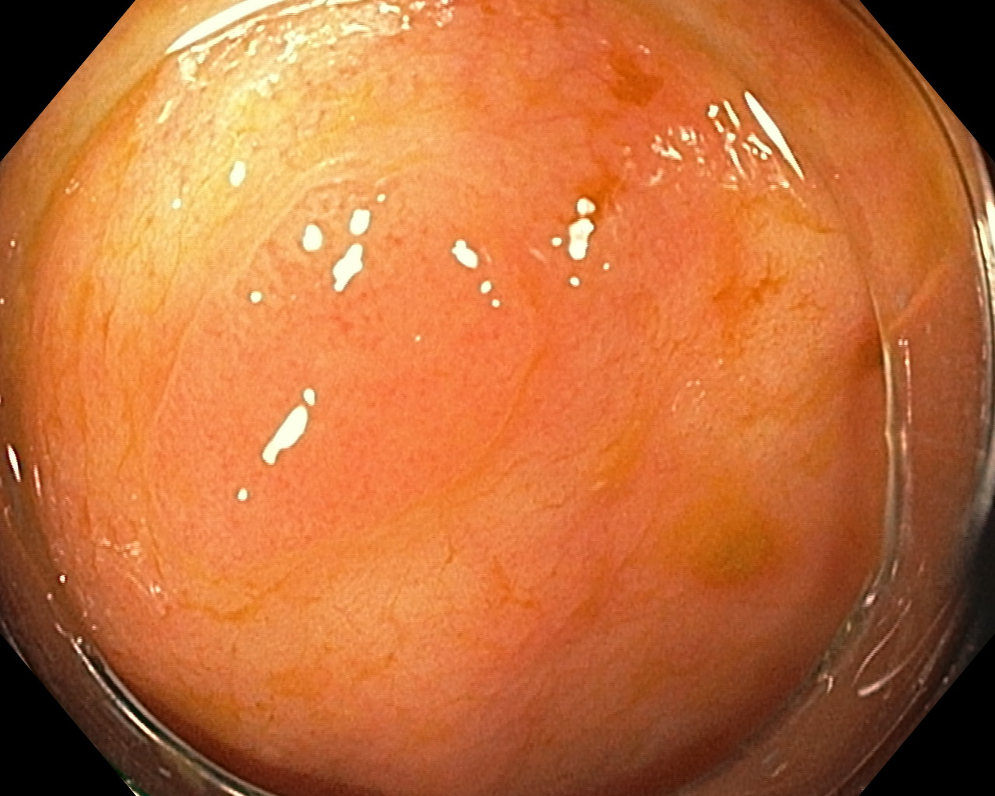
B
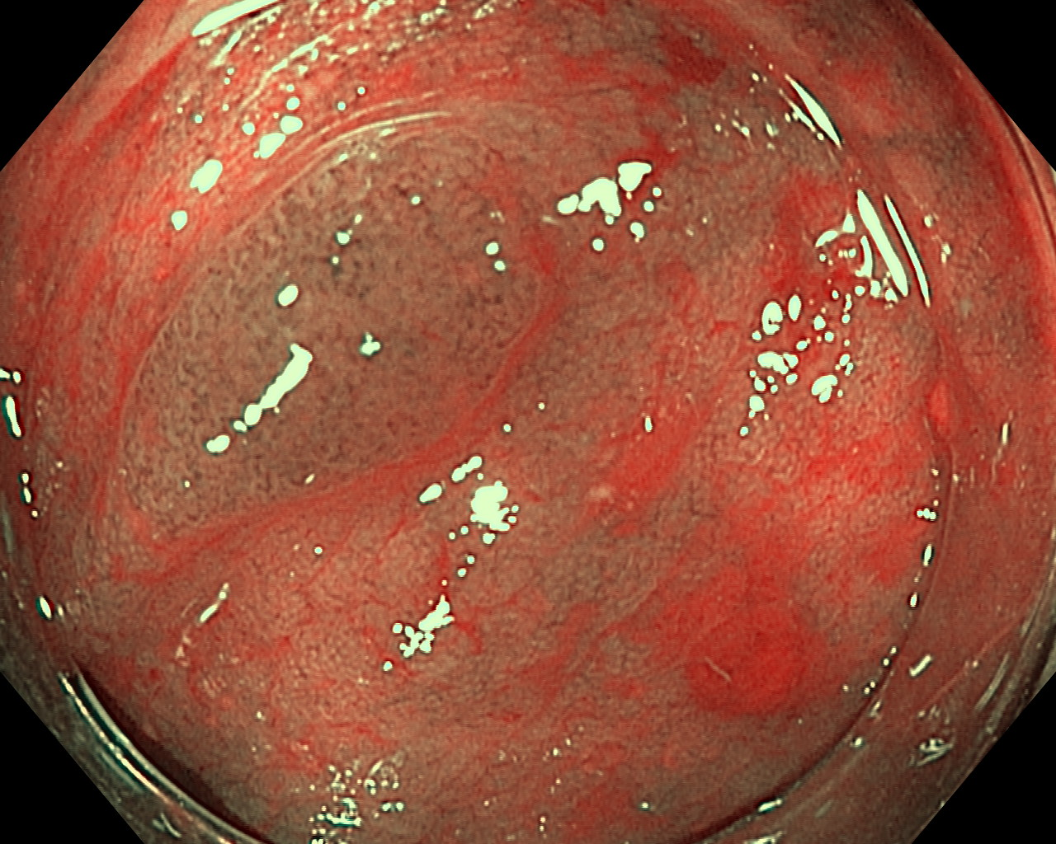
C
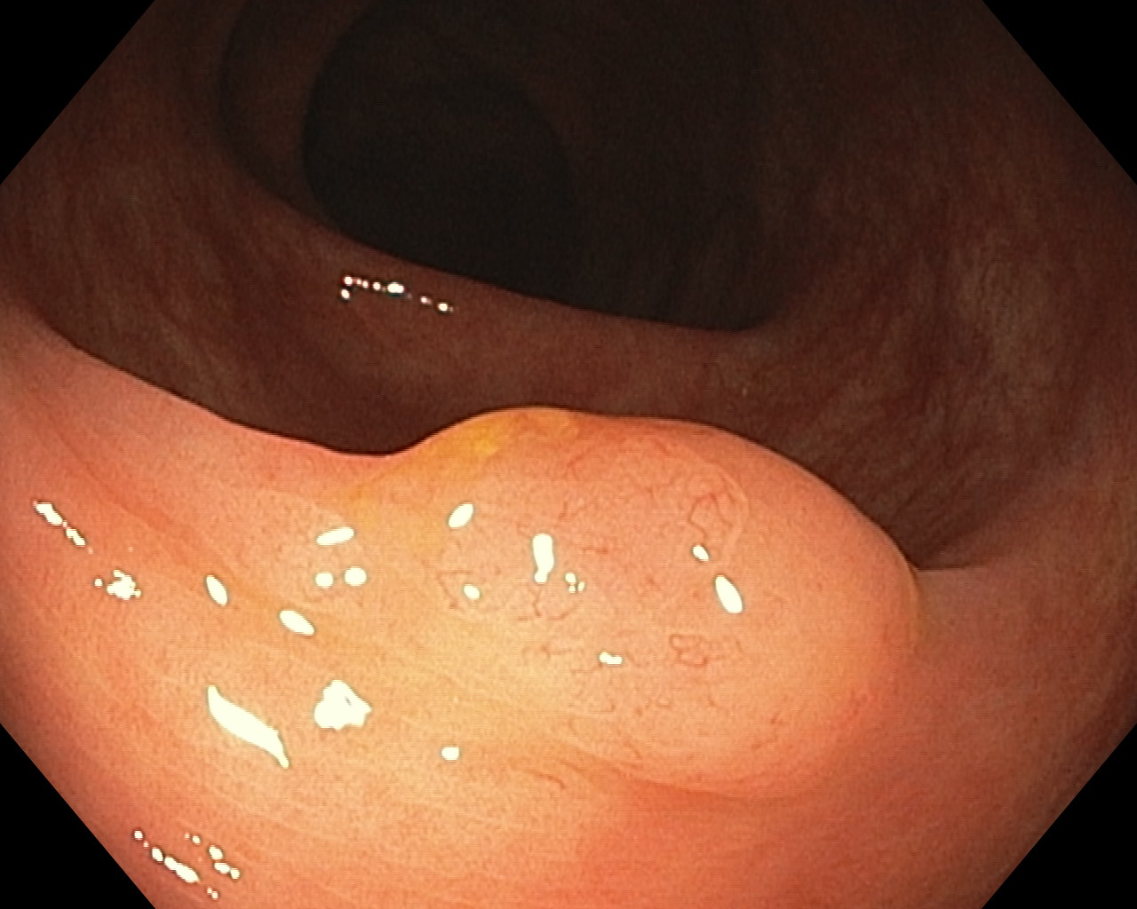
D
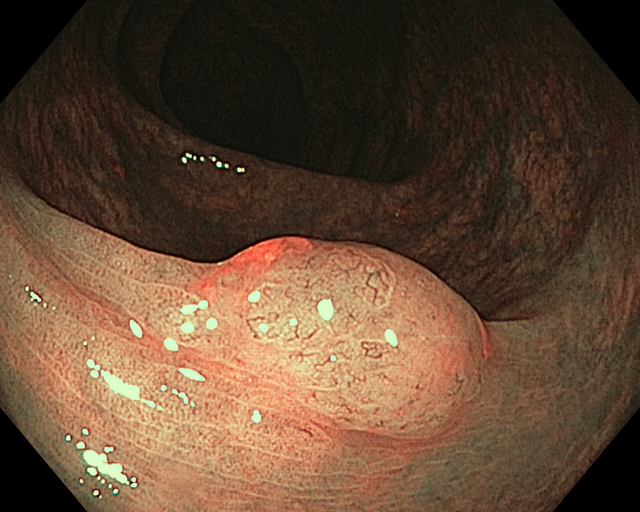
Figure 1 Tubular adenoma and small sessile serrated adenoma under white light (A, C) and narrow-band imaging (B, D), respectively.

A
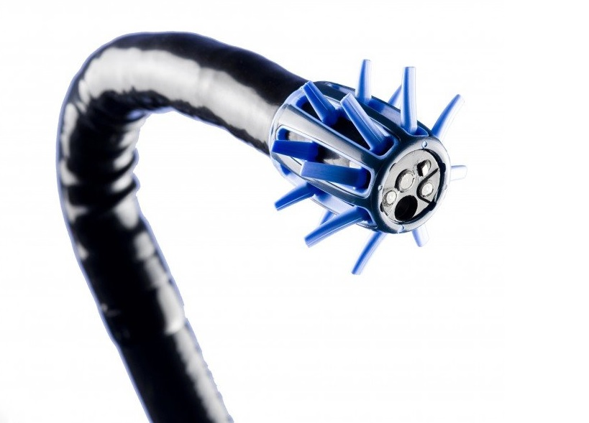
B
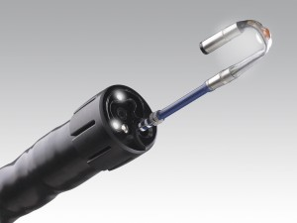
C
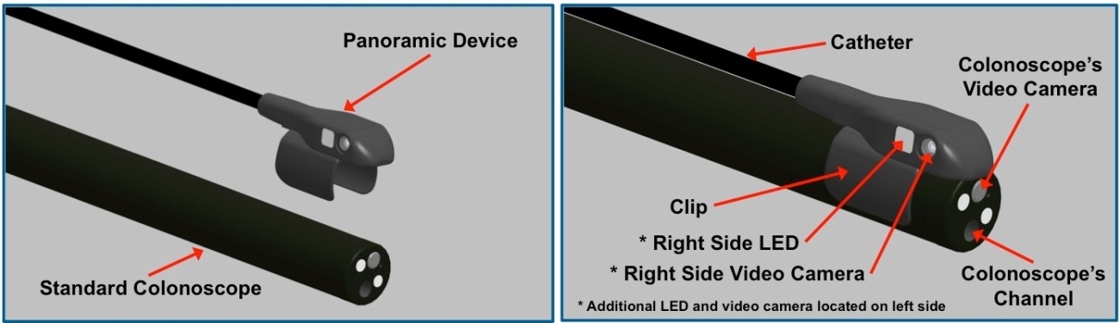
D
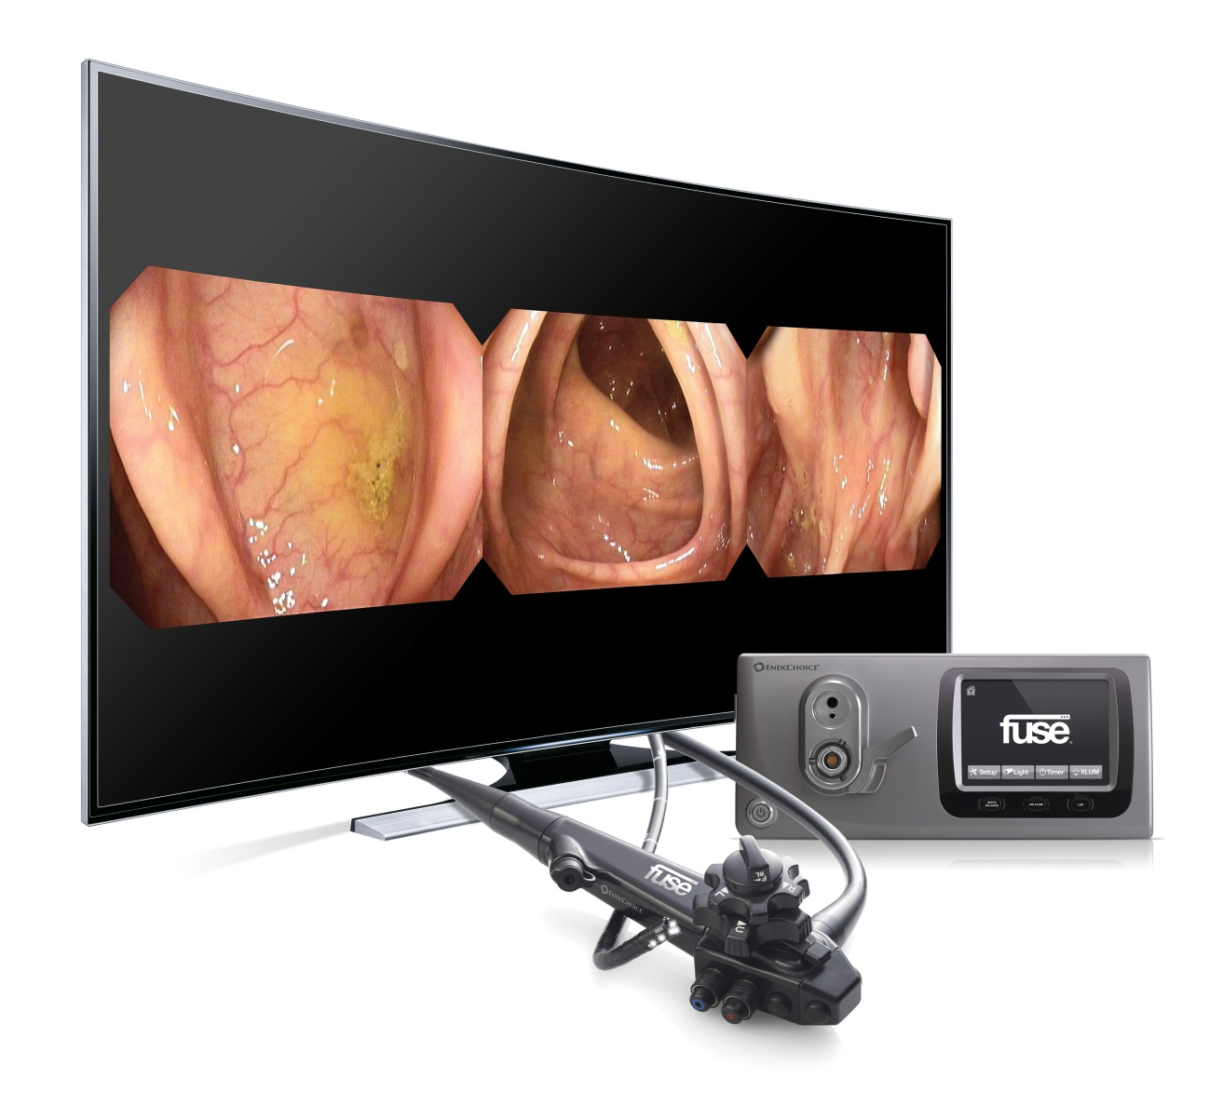
E
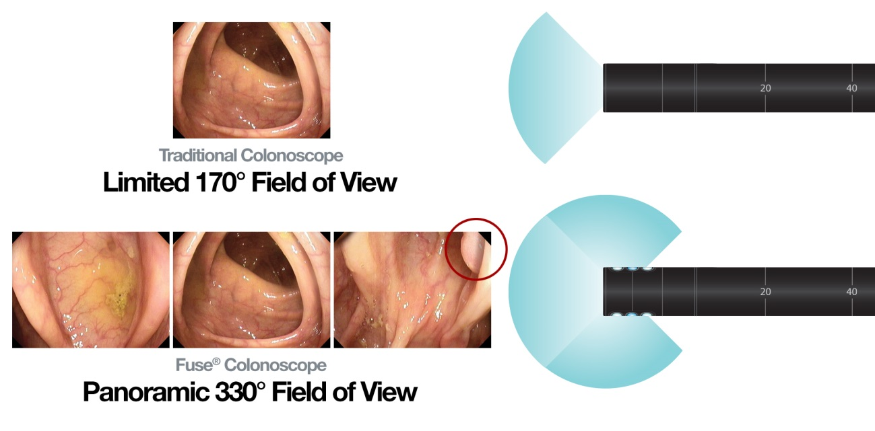
Figure 2 Endoscuff (A), Third-Eye retroscope (B), Third-Eye panoramic (C), full spectrum endoscopy (D: endoscope, processor and image; E: endoscopic view).

Table 1 Techniques that have demonstrated improve adenoma detection rate

 | Evidence | Limitations | Comments
Adequate bowel preparation | RCT and meta-analysis |  | Split-dose may have a positive impact itself on ADR  No significant differences from fair to excellent bowel preparation
Withdrawal time | Retrospective | Some contradictory data, maybe reflecting that it is an intermediate parameter | Withdrawal time needs to be productively spent  Likely more impact on low ADR endoscopists
Repeat right colon exploration or retroflexion | Prospective | Unclear if retroflexion preferable to forward view
Additional observers | Prospective | Heterogeneity in the type of observer | Marginal benefit, especially helpful if observers experienced
High definition endoscopy | RCT and one meta-analysis | Discrete effect for ADR, more significant for flat and right colonic lesions. Heterogeneity of the studies | ESGE recommends its use if available in average-risk screening colonoscopies
Position changes | Prospective, randomized | Unclear if the benefit is from seeing the colon segments twice
Water exchange | RCT | Slight impact on ADR  Procedure time may confound results | Most helpful to detect right colonic lesions

ADR: Adenoma detection rate; ESGE: European Society of Gastrointestinal Endoscopy; RCT: Retrospective cohort study.

Table 2 Techniques with limited evidence favouring an increase in adenoma detection rate
 | Evidence | Limitations | Comments
G-Eye | RCT | Only one RCT in progress | More studies are required
Endocuff | RCT |  | Not FDA approved
L-Menthol | RCT | Only one study  Not available in many countries out of Japan | Further RCT required
Indigo carmine | RCT, prospective | Only two studies  Withdrawal times confound results | Further RCT required.
AM procedures | Retrospective | Only two studies
RCT: Retrospective cohort study.

Table 3 Techniques that are unlikely to increase the adenoma detection rate
 | Evidence | Limitations | Comments
NBI | RCT and meta-analysis tandem colonoscopy studies |  | There may be a role in improving ADR for new NBI generation
FICE (modes 3 and 4) | RCT including tandem colonoscopy studies
i-scan | RCT including tandem colonoscopy studies
Hyoscine | RCT and meta-analysis
Water-immersion | RCT
Rank-position | Prospective and retrospective | Only two studies
Cap | RCT and meta-analysis
NBI: Narrow-band imaging; ADR: Adenoma detection rate; RCT: Retrospective cohort study.

