Name of Journal: World Journal of Clinical Cases
Manuscript NO: 71381
Manuscript Type: CASE REPORT

Pulmonary lymphomatoid granulomatosis in a 4-year-old girl: A case report

Yao JW et al. Pulmonary lymphomatoid granulomatosis

Jia-Wei Yao, Li Qiu, Ping Liang, Han-Min Liu, Li-Na Chen

Jia-Wei Yao, Division of Pediatric Pulmonology, Chengdu Women's and Children's Central Hospital, School of Medicine, University of Electronic Science and Technology of China, Chengdu 610091, Sichuan Province, China

Li Qiu, Ping Liang, Han-Min Liu, Li-Na Chen, Division of Pediatric Pulmonology and Immunology, Key Laboratory of Birth Defects and Related Diseases of Women and Children, Ministry of Education, West China Second University Hospital of Sichuan University, NHC Key Laboratory of Chronobiology, Chengdu 610041, Sichuan Province, China

Author contributions: Chen LN and Liu HM concepted the study; Chen LN, Qiu L, Liang P, and Yao JW did the investigation; Yao JW and Liang P did the writing and original draft; Chen LN writing the review and editing.

Supported by Science and Technology department of Sichuan Province, No. 2020YFS0105; and West China Second University Hospital of Sichuan University, No. KL036.

Corresponding author: Li-Na Chen, MD, Chief Doctor, Division of Pediatric Pulmonology and Immunology, Key Laboratory of Birth Defects and Related Diseases of Women and Children, Ministry of Education, West China Second University Hospital of Sichuan University, NHC Key Laboratory of Chronobiology, No. 20 Section 3 South Renmin Road, Chengdu 610041, Sichuan Province, China. chenlina_78@163.com

Received: September 6, 2021
Revised: December 23, 2021
Accepted: April 2, 2022
Published online: June 6, 2022

Abstract
BACKGROUND
Pulmonary lymphomatoid granulomatosis (PLG) is a lymphoproliferative disease associated with Epstein-Barr viral infection occurring mainly in adults and rarely in children. It is characterized by multiple pulmonary nodules. Its diagnosis depends on lung biopsy findings. Most patients are immunodeficient, and it commonly presents in children undergoing chemotherapy for leukemia. We report the case of a child with PLG caused by a mutation in the macrophage-expressed gene 1 (MPEG1), suggesting possible PLG occurrence in children undergoing treatment for pulmonary nodular lesions.

CASE SUMMARY
This study reports a case of PLG without apparent immunodeficiency, suggesting the possibility of this disease occurrence during the treatment of pulmonary nodular lesions in children. Initially, the cause was assumed to be an atypical pathogen. Following conventional anti-infective treatment, chest computed tomography findings revealed that there were still multiple nodules in the lungs. Additionally, the patient was found to be infected with the Epstein-Barr virus. Histopathological examination of the resected lung revealed lymphoproliferative lesions with necrosis. Small lymphocytes, plasma cells, and histiocytes were observed in the background, although Reed-Sternberg cells were absent. Immunohistochemical staining [CD20(+), CD30(+), and CD3(+)] and EBV-encoded small RNA1/2 in situ hybridization of small lymphocytes revealed approximately 200 cells/high-power field. Whole exon sequencing of the patient revealed a mutation in the MPEG1. The patient was eventually diagnosed with PLG and transferred to the Department of Pediatric Oncology for bone marrow transplantation.

CONCLUSION
As PLG is rare and fatal, it should be suspected in clinical settings when treatment of initial diagnosis is ineffective.

Key Words: Pulmonary lymphomatoid granulomatosis; Child; Epstein-Barr virus; Lymphoproliferative disease; Leukemia; Case report;

©The Author(s) 2022. Published by Baishideng Publishing Group Inc. All rights reserved.

Citation: Yao JW, Qiu L, Liang P, Liu HM, Chen LN. Pulmonary lymphomatoid granulomatosis in a 4-year-old girl: A case report. World J Clin Cases 2022; 10(16): 5380-5386
URL: https://www.wjgnet.com/2307-8960/full/v10/i16/5380.htm
DOI: https://dx.doi.org/10.12998/wjcc.v10.i16.5380

Core Tip: Pulmonary lymphomatoid granulomatosis is a rare but potentially fatal disease, especially in children. Based on the difficulty of diagnosis, the pulmonologist must have a high index of suspicion. Attention must be paid to histopathology and chest imaging findings. Furthermore, in our case, we found exome sequencing to reveal a pathogenic, pure heterozygous variant of macrophage-expressed gene 1 (NM_001039396: c.946C > T; p.P316S). No similar mutations have been reported in patients with PLG. Electronic bronchoscopy revealed many white nodules on the mucosa of the left and right main bronchi. It is necessary to consider genetic screening and the clinical application of electronic bronchoscopy.

INTRODUCTION
Pulmonary lymphomatoid granulomatosis (PLG) is a rare lymphoproliferative disease associated with Epstein-Barr virus (EBV) infection. It commonly affects adults aged 30–50 years. The clinical manifestations are usually non-specific, occasionally presenting with pulmonary nodular lesions^{[1,2]}. PLG is rarely observed in children. Herein, we present a case of a child diagnosed with PLG following a lung biopsy. This report aims to improve the clinical understanding of PLG in children.

CASE PRESENTATION
Chief complaints
A 4-year-old girl was hospitalized because of a 50-d history of pallor.

History of present illness
Four days before admission, the child developed intermittent fever (1–2 times per day; maximum temperature, 38.5 °C), accompanied by paroxysmal cough and sore throat.

History of past illness
The patient had no history of hemoptysis, hematemesis, hematuria, or hematochezia. She had a history of chronic diarrhea, which was unresolved despite a diet of deep hydrolyzed milk powder. Routine blood examination revealed severe anemia. Emergency infusion of leukocyte suspension (1.5 U) and mezlocillin-sulbactam antibiotics were administered.

Personal and family history
Birth and developmental history were unremarkable.

Physical examination
Physical examination at admission revealed normal vital signs (temperature, 36.5 °C; pulse rate, 119 beats/min; respiratory rate, 33 cycles/min; blood pressure, 98/64 mmHg; and oxygen saturation, 98% in room air) and a body weight of 13.5 kg. She had pallor and clubbing. Rhonchi were noted in both lung fields. The liver was palpable, 5 cm below the costal margin, with blunt edges. Other physical examination findings were unremarkable.

Laboratory examinations
Complete blood cell count showed normal total and differential white blood cell counts;, decreased hemoglobin level (5 g/dL), normal mean corpuscular volume (94.3 fL), mean corpuscular hemoglobin (28.4 pg) values, and increased reticulocyte count (4.98%). The platelet count and C-reactive protein levels were normal. The direct and indirect antiglobulin tests and isopropanol tests were negative. The serum glucose-6-phosphate dehydrogenase, folic acid, and vitamin B12 levels were normal. The serum ferritin and iron levels were normal. She was tested negative for thalassemia. Bone marrow aspiration showed granulocytosis and abnormal lymphocytes (3.5%).

Microbiological identification of the causative agent
Microbiologic examination for antigens of seven respiratory pathogens (influenza A, influenza B, respiratory syncytial virus, adenovirus, and parainfluenza 1, 2, and 3), Mycoplasma pneumoniae IgM and total antibody, and chlamydia IgM antibody were all negative. The serum fungal G, GM tests, and T-SPOT test were normal. The serum anti-EBV capsid antigen IgM (> 160.0 U/mL) and IgG (> 750.00 U/mL) were positive; anti-EBV early antigen IgG was also positive (> 150.00 U/mL). The quantity of EBV DNA was significantly high (5.14 × 10⁵ copies/mL). Humoral immunity, IgG subclasses, T lymphocytes, B lymphocytes, and natural killer cells were all within the normal ranges.

Exome sequencing
Exome sequencing revealed a pathogenic, pure heterozygous variant of macrophage-expressed gene 1 (MPEG1) (NM_001039396: c.946C > T; p.P316S). Both parents of the patient were genotypically heterozygous. Electronic bronchoscopy revealed many white nodules on the mucosa of the left and right main bronchi, left upper and lower lobe bronchi, and right upper and middle lobe bronchi, as well as mild hemorrhage in the posterior basal segment of the left lower lobe (Figure 1). Escherichia coli producing extended-spectrum β-lactamases were cultured in the bronchoalveolar lavage fluid. Histopathological examination of the resected lung revealed lymphoproliferative lesions with necrosis. The proliferative and infiltrating lymphocytes were moderately sized with round nuclei and occasional nucleoli. Mitosis and infiltration of the blood vessels by these cells were noted. Small lymphocytes, plasma cells, and histiocytes were observed in the background, although Reed-Sternberg cells were absent. Immunohistochemical staining [CD20(+), CD30(+), and CD3(+)] and EBV-encoded small RNA1/2 in situ hybridization (ISH) of small lymphocytes revealed approximately 200 cells/high-power field (Figure 2).

Imaging examinations
Chest computed tomography (CT) findings revealed multiple lower lobe nodules and shadows, multiple bilateral hilar and mediastinal lymph node enlargement, mild left pleural effusion, and bilateral pleural thickening (Figure 3A).

FINAL DIAGNOSIS
The patient was eventually diagnosed with PLG and transferred to the Department of Pediatric Oncology for further treatment.

TREATMENT
After admission, the patient was treated with imipenem-cilastatin and acyclovir antiviral therapy. However, the cough persisted, and chest CT findings showed no significant shrinkage of the pulmonary nodules even 1 mo after treatment (Figure 3B). Suspecting a possible lung tumor, we performed thoracoscopic wedge resection of the lower lobe of the left lung with pleural adhesion cauterization and lung biopsy for histopathological determination (Figure 4).

OUTCOME AND FOLLOW-UP
The patient was transferred to the Department of Pediatric Oncology. She was prescribed a chemotherapy regimen of prednisone, vincristine, and cyclophosphamide. Then, she received bone marrow transplantation. She remained relatively well throughout the treatment without immune deficiency or new infections.

DISCUSSION
Liebow et al^{[2]} first identified PLG. Besides multiple lung nodules, some patients with PLG may present with cough, dyspnea, chest pain, subcutaneous nodules, weight loss, and nervous system involvement (ataxia, hearing impairment, and dysarthria). Others may present with extrapulmonary involvement, such as those of the skin and nerves. PLG was renamed as mature B-cell tumor in 2016^{[3,4,5]}.
At present, the diagnosis of PLG is primarily based on histological findings of the lung tissue showing the "triad" of pleomorphic lymphocyte infiltration with necrosis, infiltration of lymphocytes in the arterial and venous walls, and EBV-positive B cells confirmed by ISH. In this case, lung histopathology showed moderate-sized infiltrating cells, lymphoid tissue hyperplasia with necrosis, and small lymphocytes, plasma cells, and histiocytes in the background. A variable number of CD20-positive B cells existed in the background of CD3-positive small lymphocytes and were EBER1/2-ISH-positive, thus, meeting the diagnostic criteria for PLG. Histologically, PLG is graded according to the proportion of EBV-positive large B lymphocytes determined by EBER: Grade 1 Lesion is composed of scattered EBV-positive cells without necrosis; Grade 2 Lesions include an increased number of large B cells and some necrosis; and Grade 3 Lesions consist mainly of many virus-positive cells with extensive necrosis^{[1,3,4]}. This case was classified as Grade 3 because the lesion comprised many EBV-positive cells.
EBV belongs to the γ subfamily of herpesvirus. The EBV genome is a linear double-stranded DNA molecule, a prototype virus of the genus of lymphofollicular viruses. In vitro, all γ herpesviruses can replicate in lymphoid cells, although only some can replicate lytically in epithelial cells and fibroblasts. Primate B lymphocyte infection usually leads to latent infection, characterized by the persistence of the viral genome and the expression of a series of limited latent gene products, thus, promoting the transformation process and helping to drive cell proliferation^{[6]}. The cleavage-associated gene of EBV has a significant homology with the human genome, and some genes have significant homology with human B-cell leukemia/Lymphoma 2. This gene is involved in the apoptosis of tissue B cells and other lymphocytes. In patients with congenital or acquired immunodeficiency, B cells infected by EBV easily undergo tumorigenic transformation^{[7,8]}. EBV is believed to play an important role in driving PLG. It is speculated that host immune deficiency leads to abnormal clearance response to EBV, consequently leading to abnormal lymphoid tissue proliferation and apoptosis inhibition. This results in a large number of leukocytes infiltrating the blood vessels, followed by injury and tissue destruction^{[9]}. Approximately half of the PLG cases in children are found in those undergoing treatment for leukemia. Some adult PLG cases are reportedly related to the use of certain drugs (methotrexate and imatinib) that, when withdrawn, lead to the disease resolution^{[10]}.
The MPEG1 is an ancient postnatal animal protein that belongs to the pore-forming protein of the membrane attack complex/perforin (MACPF) branch of the MACPF/cholesterol-dependent cytolytic cellulose superfamily. The MACPF functions in human immunity and development. The MPEG1 facilitates the entry of numerous antimicrobial effectors into cells, including proteases, reactive oxygen and nitrogen species, and bactericidal peptides, and mediates the harsh acidic environment of phagosomes^{[11]}. No case of MPEG1 mutations have been reported in patients with PLG. However, one study found this mutation in diffuse large B-cell lymphoma. Notably, a series of genetic mutations co-exist with MYD88, including PRDM1, all of which occur at a high frequency in the MCD subtype, as defined by Schmitz et al^{[12]}, which promote nuclear factor-κB activation in a B-cell receptor-dependent manner. These findings confirm that MYD88 alone is insufficient to drive the malignant transformation of B cells and may induce lymphoma with other genetic events.
There are few reported cases of PLG in children, including a literature review of 49 published pediatric cases of PLG^{[13]}. The affected patients were usually immunodeficient, and only one case reported hemolytic anemia.
Mild or severe PLG on chest CT usually shows well- or ill-defined bilateral pulmonary nodules mainly located in the lower lung fields. The nodules vary in size (usually 1 cm–2 cm in diameter) and are mostly related to interstitial lung diseases. Nodules are usually distributed along with the bronchovascular bundles or interlobular septa, possibly because of the tendency of lymphocytes to infiltrate the subintimal area of blood vessels. The size of the nodules can fluctuate gradually, and some of the nodules can be matted, in consistency with our observation. Bronchoscopy also revealed many small white nodules of different sizes in the bronchial lumen. Other cases also reported pleural effusion and hilar lymph node enlargement in patients with PLG. Diffuse ground-glass degeneration is uncommon and may be caused by peri-focal hemorrhage or pneumonia^{[14-17]}, which is consistent with bronchoscopic observation of the hemorrhage in the basal segment of the lower left lung lobe in this case.
The natural course of PLG varies greatly from spontaneous regression to death. The overall prognosis of PLG is poor, with a high mortality rate (60%–90%) within 5 years. Currently, the main treatments for patients with PLG are similar to those for non-Hodgkin’s lymphoma, including the use of rituximab to eliminate B cells. In previous reports, some patients received hematopoietic stem cell transplantation, and most were also treated with corticosteroids. According to the different grades of PLG, patients in advanced stages are more likely to receive treatment combined with immunochemotherapy, while low-grade lesions can be treated with interferon-α^{[13,18]}.

CONCLUSION
In conclusion, PLG is a rare but potentially fatal disease in children. Children usually present with diffuse pulmonary nodules. Owing to the difficulty of diagnosis using clinical data and chest imaging, histopathology and chest imaging findings should be closely examined. In clinical settings, when the initial diagnosis is pneumonia and the treatment is ineffective, PLG should be considered.

ACKNOWLEDGEMENTS
The authors thank Chen ZJ and Zhang PL for their help, guidance, and valuable discussions.

REFERENCES
1 Pittaluga S, Wilson WH, Jaffe ES. Lymphomatoid granulomatosis. In: Swerdlow SH, Campo E, Harris NL, Jaffe ES, Pileri SA, Stein H, Thiele J. WHO classification of tumours of haematopoietic and lymphoid tissues. Revised 4th ed. Lyon: IARC, 2017: 312
2 Liebow AA, Carrington CR, Friedman PJ. Lymphomatoid granulomatosis. Hum Pathol 1972; 3: 457-558 [PMID: 4638966 DOI: 10.1016/s0046-8177(72)80005-4]
3 Jaffe ES, Wilson WH. Lymphomatoid granulomatosis: pathogenesis, pathology and clinical implications. Cancer Surv 1997; 30: 233-248 [PMID: 9547995]
4 Myers JL. Lymphomatoid granulomatosis: past, present, ... future? Mayo Clin Proc 1990; 65: 274-278 [PMID: 2406524 DOI: 10.1016/s0025-6196(12)65021-6]
5 Swerdlow SH, Campo E, Pileri SA, Harris NL, Stein H, Siebert R, Advani R, Ghielmini M, Salles GA, Zelenetz AD, Jaffe ES. The 2016 revision of the World Health Organization classification of lymphoid neoplasms. Blood 2016; 127: 2375-2390 [PMID: 26980727 DOI: 10.1182/blood-2016-01-643569]
6 Kieff E, Rickinson AB. Epstein-Barr virus and its replication. In: Knipe DM, Howley PM. Fields virology. 5th ed. Philadelphia: Lippincott Williams and Wilkins, 2005: 2603
7 Liebowitz D. Epstein-Barr virus and a cellular signaling pathway in lymphomas from immunosuppressed patients. N Engl J Med 1998; 338: 1413-1421 [PMID: 9580648 DOI: 10.1056/NEJM199805143382003]
8 Gregory CD, Dive C, Henderson S, Smith CA, Williams GT, Gordon J, Rickinson AB. Activation of Epstein-Barr virus latent genes protects human B cells from death by apoptosis. Nature 1991; 349: 612-614 [PMID: 1705663 DOI: 10.1038/349612a0]
9 Nixon CP, Sweeney JD. Facilitation of the clinical diagnosis of Mycoplasma pneumoniae by the blood bank. Transfusion 2017; 57: 2564 [PMID: 29105832 DOI: 10.1111/trf.14115]
10 Aiko N, Sekine A, Umeda S, Katano T, Matama G, Isomoto K, Otoshi R, Ogura T. The Spontaneous Regression of Grade 3 Methotrexate-related Lymphomatoid Granulomatosis: A Case Report and Literature Review. Intern Med 2018; 57: 3163-3167 [PMID: 29877270 DOI: 10.2169/internalmedicine.0542-17]
11 Bayly-Jones C, Pang SS, Spicer BA, Whisstock JC, Dunstone MA. Ancient but Not Forgotten: New Insights Into MPEG1, a Macrophage Perforin-Like Immune Effector. Front Immunol 2020; 11: 581906 [PMID: 33178209 DOI: 10.3389/fimmu.2020.581906]
12 Shen R, Xu PP, Wang N, Yi HM, Dong L, Fu D, Huang JY, Huang HY, Janin A, Cheng S, Wang L, Zhao WL. Influence of oncogenic mutations and tumor microenvironment alterations on extranodal invasion in diffuse large B-cell lymphoma. Clin Transl Med 2020; 10: e221 [PMID: 33252851 DOI: 10.1002/ctm².221]
13 Tacke ZC, Eikelenboom MJ, Vermeulen RJ, van der Knaap MS, Euser AM, van der Valk P, Kaspers GJ. Childhood lymphomatoid granulomatosis: a report of 2 cases and review of the literature. J Pediatr Hematol Oncol 2014; 36: e416-e422 [PMID: 24390446 DOI: 10.1097/MPH.0000000000000090]
14 Chung JH, Wu CC, Gilman MD, Palmer EL, Hasserjian RP, Shepard JA. Lymphomatoid granulomatosis: CT and FDG-PET findings. Korean J Radiol 2011; 12: 671-678 [PMID: 22043148 DOI: 10.3348/kjr.2011.12.6.671]
15 Rezai P, Hart EM, Patel SK. Lymphomatoid granulomatosis. Radiology 2011; 259: 604-609 [PMID: 21502394 DOI: 10.1148/radiol.10092048]
16 Sood A, Parihar AS, Malhotra P, Vaiphei K, Kumar R, Singh H, Mittal BR. Pulmonary Recurrence of Lymphomatoid Granulomatosis Diagnosed on F-18 FDG PET/CT. Indian J Nucl Med 2020; 35: 167-169 [PMID: 32351275 DOI: 10.4103/ijnm.IJNM_174_19]
17 Handel AS, Davis J, Glass J, Hogan L, Schuval S, Beneri C. A 4-Year-Old Boy With Prolonged Cough and Fever. J Pediatric Infect Dis Soc 2020; 9: 92-95 [PMID: 31967647 DOI: 10.1093/jpids/piaa005]
18 Lee S, Kang MJ, Kim HJ, Kim HB, Lee J. Pulmonary lymphomatoid granulomatosis in a 4-year-old girl. Pediatr Radiol 2015; 45: 1082-1085 [PMID: 25432443 DOI: 10.1007/s00247-014-3233-4]

Footnotes
Informed consent statement: Informed written consent was obtained from the patient’s guardians for publication of this report and any accompanying images.

Conflict-of-interest statement: The authors declare that they have no conflict of interest

CARE Checklist (2016) statement: The authors have read the CARE Checklist (2016), and the manuscript was prepared and revised according to the CARE Checklist (2016).

Open-Access: This article is an open-access article that was selected by an in-house editor and fully peer-reviewed by external reviewers. It is distributed in accordance with the Creative Commons Attribution NonCommercial (CC BY-NC 4.0) license, which permits others to distribute, remix, adapt, build upon this work non-commercially, and license their derivative works on different terms, provided the original work is properly cited and the use is non-commercial. See: https://creativecommons.org/Licenses/by-nc/4.0/

Provenance and peer review: Unsolicited article; Externally peer reviewed.
Peer-review model: Single blind

Peer-review started: September 6, 2021
First decision: December 9, 2021
Article in press: April 2, 2022

Specialty type: Pediatrics
Country/Territory of origin: China
Peer-review report’s scientific quality classification
Grade A (Excellent): A
Grade B (Very good): B
Grade C (Good): C
Grade D (Fair): 0
Grade E (Poor): 0

P-Reviewer: Biondi A, Italy; Gaman MA, Romania; Sultana N, Bangladesh S-Editor: Xing YX L-Editor: A P-Editor: Xing YX

Figure Legends
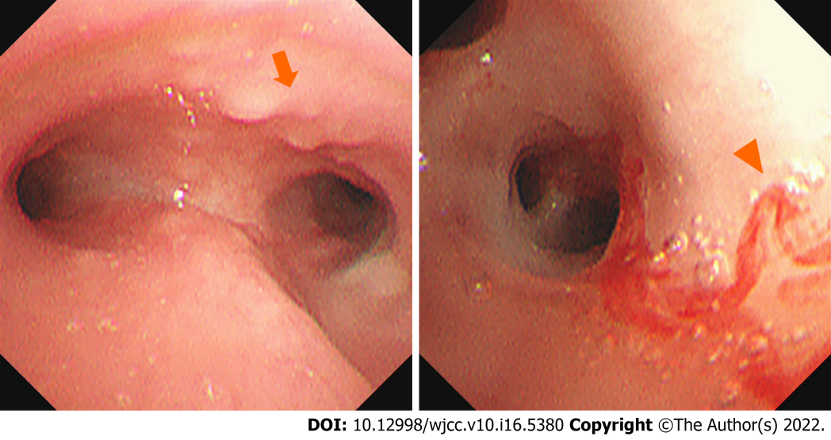
Figure 1 White nodules in trachea and the left main bronchus are observed (arrow). The mucosa of the posterior basal segment of the left lower lobe is pale, and mild hemorrhage in the posterior basal segment of the left lower lobe (arrowhead) is observed.

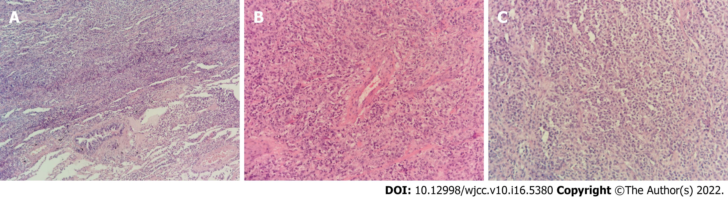
Figure 2 Lymphoproliferative lesions with necrosis. A: The proliferated and infiltrated lymphocytes are moderately large, the nucleus is round, and some nucleoli can be observed (HE × 100); B: Cells infiltrating blood vessels can be observed (HE × 200); C: Small lymphocytes, plasma cells, and histiocytes are observed in the background, (HE × 400).

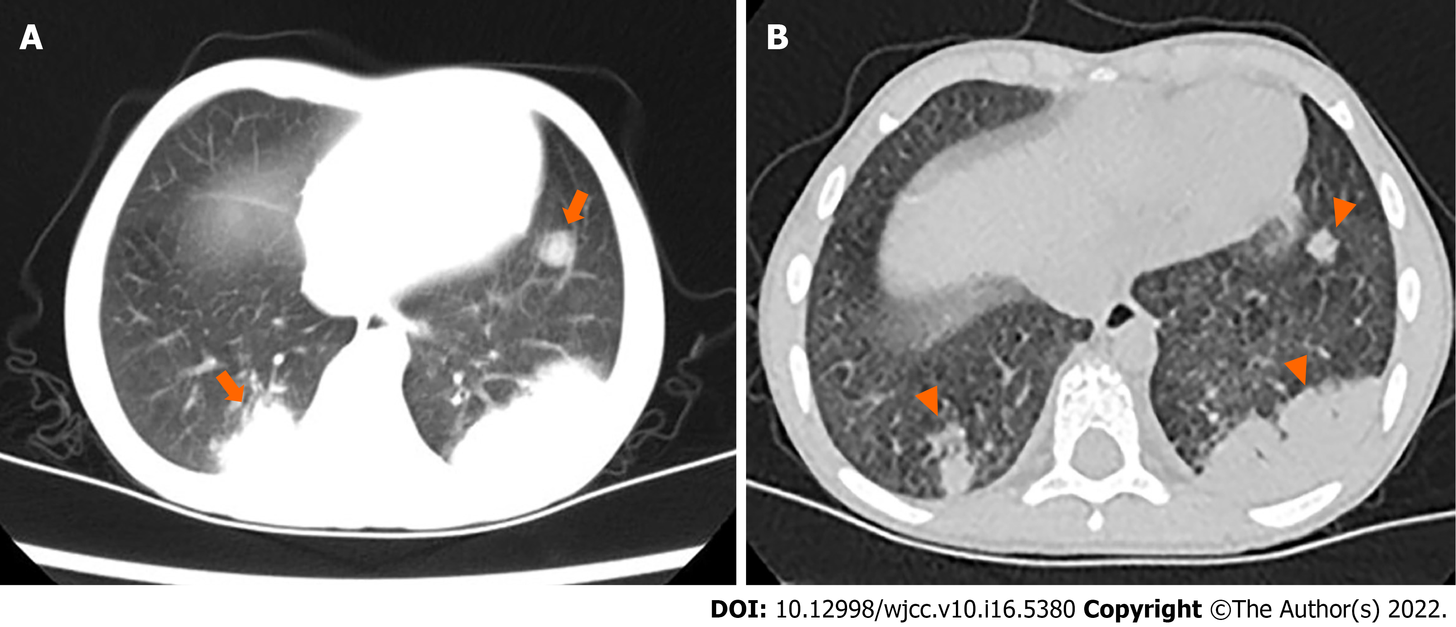
Figure 3 Chest computed tomography. A: Multiple nodules and mass shadows (arrows) are observed in the lower lobe of the right and left lungs, and significant bilateral lymphadenopathy in the hilum and mediastinum is visible; B: Multiple nodules and mass shadows are almost unchanged in the lower lobe of the right and left lungs (arrowhead) after anti-infective treatment. Bilateral hilar, mediastinal, and axillary lymphadenopathy is noted.

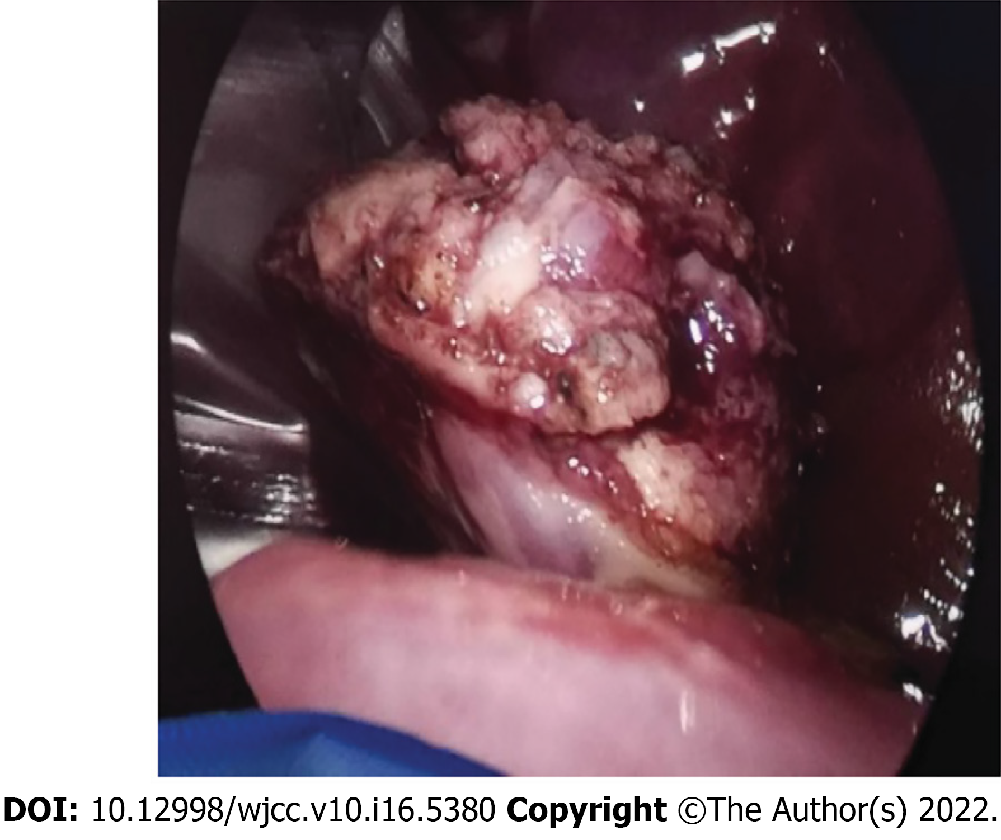
Figure 4 Thoracoscopic wedge resection of left lower lung. A small amount of yellowish effusion, pleural thickening, fascicular adhesion between the lower lobe of the left lung and pleura, and a hard mass with unclear boundaries in the basal segment of the lower lobe of the left lung are observed in the pleural cavity.

Published by Baishideng Publishing Group Inc
7041 Koll Center Parkway, Suite 160, Pleasanton, CA 94566, USA
Telephone: +1-925-3991568
E-mail: bpgoffice@wjgnet.com
Help Desk: https://www.f6publishing.com/helpdesk
https://www.wjgnet.com

© 2022 Baishideng Publishing Group Inc. All rights reserved.

