Name of journal: World Journal of Experimental Medicine

ESPS Manuscript NO: 16789

Columns: EDITORIAL

Eurytrematosis: An emerging and neglected disease in South Brazil

Schwertz CI et al. Eurytrematosis

Claiton I Schwertz, Neuber J Lucca, Aleksandro S da Silva, Piotr Baska, Gustavo Bonetto, Mateus E Gabriel, Fábio Centofanti, Ricardo E Mendes

Claiton I Schwertz, Neuber J Lucca, Gustavo Bonetto, Ricardo E Mendes, Department of Veterinary Pathology, Instituto Federal Catarinense - Campus Concórdia, Concórdia SC 89700-000, Brazil
Aleksandro S da Silva, Department of Animal Science, Universidade do Estado de Santa Catarina, Chapecó SC 89809-000, Brazil
Fábio Centofanti, Merial Animal Health, Campinas SP 13091-908, Brazil
Piotr Baska, Department of Preclinical Sciences, Faculty of Veterinary Medicine, Warsaw University of Life Sciences, 02-787 Warsaw, Poland

Author contributions: Schwertz CI contributed in all aspects to prepare the paper; Lucca NJ wrote the paper; Silva AS contributed with reagents and analytic tools; Baska P designed and performed research; Bonetto G wrote the paper; Gabriel ME performed research; Centofanti F designed research; Mendes RE contributed in all aspects to prepare the paper.

Supported by A grant from Instituto Federal Catarinense (IFC), Edital 445/2014 PROEX/IFC, and from National Counsel of Technological and Scientific Development (CNPq), No. 468602/2014-3.

Conflict-of-interest: We declare no conflicts of interest.

Open-Access: This article is an open-access article which was selected by an in-house editor and fully peer-reviewed by external reviewers. It is distributed in accordance with the Creative Commons Attribution Non Commercial (CC BY-NC 4.0) license, which permits others to distribute, remix, adapt, build upon this work non-commercially, and license their derivative works on different terms, provided the original work is properly cited and the use is non-commercial. See: http://creativecommons.org/licenses/by-nc/4.0/

Correspondence to: Ricardo E Mendes, Professor, Department of Veterinary Pathology, Instituto Federal Catarinense - Campus Concórdia, Concórdia SC 89700-000, Brazil. ricardo.mendes@ifc-concordia.edu.br
Telephone: +55-49-34414854
Fax: +55-49-34414800

Received: January 29, 2015
Peer-review started: January 29, 2015
First decision: March 20, 2015
Revised: May 10, 2015
Accepted: June 4, 2015
Article in press:
Published online:

Abstract
The trematodes of the genus Eurytrema are low pathogenic pancreatic parasites, but can be related to a decrease in cattle productive performance and eventually death. Parasitized animals develop chronic interstitial pancreatitis and may show a productive performance drop and emaciation. Human infection by Eurytrema sp. has already been reported in other countries as an incidental finding during autopsy or routine tests, but the parasite has not been found in humans in Brazil. However, it is possible that a large number of people could be infected, since parasitological tests have low sensitivity and the parasite is neglected as a pathogen for humans and even animals. Attempts to control and treat Eurytrematosis have generally presented low effectiveness. With the aim to control the disease and provide more information regarding its pathogenicity, our research group is developing a number of studies about Eurytrema spp. We hope to determine the damage in productivity, as well as, establish an efficient protocol for treatment and control of Eurytrematosis based on immunoprophylaxis and antiparasitical drug therapy.

Key words: Public health; Pathology; Diseases of cattle; Oxidative stress; Parasitical immunoprofilaxis

© The Author(s) 2015. Published by Baishideng Publishing Group Inc. All rights reserved.

Core tip: The trematodes of the genus Eurytrema are low pathogenic pancreatic parasites, but can be related to decrease in productive performance and eventually death of infected animals. Human infection has already been reported but could be underestimated in Brazil. With the aim to control the disease and provide more information regarding its pathogenicity, our research group is developing a number of studies about Eurytrema spp. We hope to determine the damage in productivity, as well as, establish an efficient protocol for treatment and control of Eurytrematosis based on immunoprophylaxis and antiparasitical drug therapy.

Schwertz CI, Lucca NJ, Silva AS, Baska P, Bonetto G, Gabriel ME, Centofanti F, Mendes RE. Eurytrematosis: An emerging and neglected disease in South Brazil. World J Exp Med 2015; In press

EURYTREMATOSIS: AN EMERGING AND NEGLECTED DISEASE IN SOUTH BRAZIL
The trematodes of the genus Eurytrema, belonging to the family Dicrocoeliidae are parasites known as low pathogenic and are generally considered to be an incidental finding at necropsy or at slaughterhouse, but they can be related to a decrease of an infected animals productive performance, and eventually death^{[1]}. Among the species of Eurytrema we can highlight Eurytrema pancreaticum (E. pancreaticum) and E. coelomaticum, common parasites of pancreatic ducts of ruminants, occasionally found in the bile ducts and rarely in the small intestine. E. pancreaticum has been reported in cattle, goats, sheep, swine, buffaloes, camelids, cervids and human beings, while the E. coelomaticum has been reported in cattle, goats, sheep, buffaloes, leporids and camelids^{[2]}. In Brazil the parasites have two different intermediate hosts, the mollusk Bradybaena similaris and different species of arthropods from the genus Conocephalus^{[2]}. The life cycle is explained in Figure 1.
In areas where the disease occurs, the prevalence among animals is generally high. In a study undertaken by our group^{[3]} we identified a prevalence of 75% of Eurytrema sp. in cattle from the West of Santa Catarina State, with 100% of the farms having at least one infected animal. In another Brazilian study, authors found a lower prevalence: between 8.3% and 40.55% in different regions of the State of Paraná (the state north of Santa Catarina) and also observed a seasonal variation in the parasitism^{[4]}. Bassani et al^{[5]} found prevalences between 26.9% and 72.9% in the central-west region of Paraná, but in this study a definite seasonal distribution was not observed. Whereas in the State of Rio Grande do Sul (the state south of Santa Catarina) the parasitism by Eurytrema sp. is uncommon^{[6]}. In spite of the high prevalence reported in some studies, clinical cases in cattle with emaciation and mortality are sporadic and when occurs affects no more than 3% of the herd^{[1]}.
Human infection by E. pancreaticum has already been described as an incidental finding at autopsy or in routine coproparasitological tests^{[7]}. There are no published reports in humans in Brazil, but it is possible that a great number of people could be infected, since in general, it is common that routine coproparasitological tests result in false negatives. Similarly to animals, human infection may be subclinical. Another important aspect is that nowadays in medical practice of parasitological diagnosis, many Brazilian physicians request serological tests, instead of the coproparasitological ones, mainly due to the higher sensitivity. However, since Eurytrema sp. has not been described as a human pathogen in Brazil, it is not investigated and is likely to be underestimated. Some feeding habits in areas with high prevalence of the parasite seem to be risk factors for human infection. The consumption of wild watercress as salad is common in our region and is an important risk factor for infection by Fasciola hepatica^{[8]} and could also be an important risk factor for Eurytrema sp.
In Brazil, the pathological pattern of the clinical cases of Eurytrematosis in cattle was described as chronic and progressive weight loss related to interstitial pancreatitis^{[1,9,10]}. In our routine necropsies of cattle that have died for different reasons, in about 92% of the cases Eurytrema sp. was found in the pancreatic ducts (Figure 2), most of the times with moderate to severe infections. During histopathology we have observed that the parenchyma of the pancreas is extensively replaced by fibrous connective tissue (Figure 3), which could disrupt the function of the organ.
Attempts to control and treat Eurytrematosis, when applied, generally present low efficiency. This fact seems to be a result of the parasites resistance against the main endoparasiticides used and the high rate of reinfection. Yamamura^{[11]} conducted a trial with four molecules of endoparasiticides commonly used in veterinary practice: nitroxinil, triclabendazole, rafoxanide and closantel, and reported that none of them were efficient. Araújo and Belém^{[12]} reported that albendazole was not efficient against Eurytrema sp. in naturally infected cattle, even when administrated in high dosages (17.5 mg/kg bw).
There are few reports about efficient treatments against Eurytrematosis in cattle. Sakamoto et al^{[13]} described treatment regimes involving two applications of nitroxinil with an interval of 20 d, and three applications of praziquantel with intervals of two days; both regimes reduced the output of eggs in feces to zero. Jiraungkoorskul et al^{[14]} in an in vitro trial concluded praziquantel should be the chosen drug for Eurytrematosis control, since it caused the death of 100% of the parasites, while triclabendazole did not present efficacy.
There have been only a few in vivo trials aiming to control the disease, and at the moment there are no treatment protocols establishing an appropriate chemotherapy. Even if there are some apparently efficient antiparasitics, the treatment of an infection cannot be accomplished in Brazil. There are no available products containing praziquantel authorized by the regulatory agencies to be administrated in cattle in Brazil, while nitroxinil, according to the current legislation, cannot be applied in dairy cows. Therefore, these two factors made the treatment of Eurytrematosis impossible in dairy cattle in Brazil, as well as in many other countries.
With the aim to control the disease, our group is developing many studies: (1) Molecular determination of the Eurytrema species that occurs in cattle and sheep in our region; (2) Establishment of the effectiveness of antiparasitic drugs against Eurytrema sp. strains presented in the west of Santa Catarina, Brazil. For this, dairy cattle herds will be segregated into groups, and each group will be treated with a different molecule, taking into account the main drugs used in the region and with known action against trematodes. The second aim of this work is to evaluate if the sub-clinical damage in the pancreatic parenchyma indirectly lead to economic losses; (3) Measure the oxidative stress caused by the parasitism. This comprises gauging the parameters that indicate cellular lesions and the antioxidant status in the pancreas. There are many studies that correlate oxidative stress with clinical-pathologic findings and pathogenesis in infectious diseases. The consequences of infection by Eurytrema sp. to an animals’ health and productivity have not been elucidated and articles about the oxidative stress in animals parasitized by Eurytrema sp. are not available; and (4) Another future study will reproduce the parasites’ complete life cycle in the laboratory, aiming to find possible immunogens in the newly encysted juveniles stage of Eurytrema sp.
The results of our studies will contribute to elucidate the real importance of Eurytrematosis to animal health and production in Brazil. In the long term, we expect to contribute with directly applicable results to both agribusiness and public health. It is necessary to determine protocols capable of controlling Eurytrematosis in an efficient and viable way. Productivity losses may also be estimated to determine the real economic impact and importance of the disease. We also expect to find different ways to apply a biological and/or immunoprophylaxis control against this parasite, as chemical therapy alone is typically insufficient for the control and prevention of many illnesses, both in veterinary and human medicine.

ACKNOWLEDGEMENTS
Authors are grateful to Dr. Luke James Norbury and Simon Hugh Wheeler for proofreading.

REFERENCES
1 Ilha MR, Loretti AP, Reis AC. Wasting and mortality in beef cattle parasitized by Eurytrema coelomaticum in the State of Paraná, southern Brazil. Vet Parasitol 2005; 133: 49-60 [PMID: 16046069 DOI: 10.1016/j.vetpar.2005.02.013]
2 Bassani CA, Sangioni LA, Saut JPE, Headley SA, Yamamura MH. Euritrematose bovina/Bovine eurytrematosis. Semina: Ciências Agrárias 2007; 28: 299-316 [DOI: 10.5433/1679-0359.2007v28n2p299]
3 Lucca NJ, Mendes RE, Henker LC, Schwertz CI, Stedille FA, Juvenardi E, Pappen FG, Casagrande RA. Determinação das principais parasitoses gastrointestinais em propriedades leiteiras de Concórdia, Santa Catarina. Câmpus Concórdia: Annals IV Mostra Iniciação Científica - Instituto Federal Catarinense, 2014. Available from: URL: http://anaismic.concordia.ifc.edu.br/trabalhos/2014/53af2ff3b670c60576f5c940.pdf
4 Azevedo JR, Mannigel RC, Agulhon AZ, Borba TR, Barbiéri AW, Oliveira DCL, Headley SA, Janeiro V. Prevalence and geographical distribution of bovine eurytrematosis in cattle slaughtered in northern Paraná, Brazil. Pesq Vet Bras 2004; 24: 23-26 [DOI: 10.1590/S0100-736X2004000100006]
5 Bassani CA, Sangioni LA, Saut JP, Yamamura MH, Headley SA. Epidemiology of eurytrematosis (Eurytrema spp. Trematoda: Dicrocoeliidae) in slaughtered beef cattle from the central-west region of the State of Paraná, Brazil. Vet Parasitol 2006; 141: 356-361 [PMID: 16860482 DOI: 10.1016/j.vetpar.2006.06.003]
6 Tessele B, Brum JS, Barros CSL. Human infection with the pancreas fluke, Eurytrema pancreaticum. Pesq Vet Bras 2013; 33: 873-889 [DOI: 10.1590/S0100-736X2013000700008]
7 Ishii Y, Koga M, Fujino T, Higo H, Ishibashi J, Oka K, Saito S. Human infection with the pancreas fluke, Eurytrema pancreaticum. Am J Trop Med Hyg 1983; 32: 1019-1022 [PMID: 6625056]
8 Tavil B, Ok-Bozkaya İ, Tezer H, Tunç B. Severe iron deficiency anemia and marked eosinophilia in adolescent girls with the diagnosis of human fascioliasis. Turk J Pediatr 2014; 56: 307-309 [PMID: 25341606]
9 Rachid MA, Aquino Neto HM, Facury-Filho EJ, Carvalho AU, Valle GR, Vasconcelos AC. Chronic interstitial pancreatitis and chronic wasting disease caused by Eurytrema coelomaticum in Nelore cow. Arq Bras Med Vet Zootec 2011; 63: 741-743 [DOI: 10.1590/S0102-09352011000300028]
10 Quevedo PS, Mendes M, Pappen FG, Soares MP, Muller G, Farias NAR. Pancreatite intersticial crônica em bovino causada por Eurytrema coelomaticum. Ciência Rural 2013; 8: 1449-1452 [DOI: 10.1590/S0103-84782013005000104]
11 Yamamura MH. Algumas avaliações sobre a patología e controle da euritrematíase bovina. Itaguaí, Rio de Janeiro, Brazil: Universidade Federal Rural do Rio de Janeiro, 1989
12 Araújo JV, Belém PAD. Effect of anti-helmintic treatment with Albendazole on the egg counts per gram of faeces of Eurytrema sp (Trematoda) in cattle. Arq bras med vet zootec 1993; 45: 111-114
13 Sakamoto T, Kono I, Yasuda N, Yamamoto Y, Nakagawa H. The Studies on Eurytrema coelomaticum II. Anthelmintic efficiency of Nitroxynil and Praziquantel against Eurytrema coelomaticum in cattle. Mem Fac Agr Kagoshima Univ 1980; 16: 93-101
14 Jiraungkoorskul W, Sahaphong S, Tansatit T, Kangwanrangsan N, Pipatshukiat S. Eurytrema pancreaticum: the in vitro effect of praziquantel and triclabendazole on the adult fluke. Exp Parasitol 2005; 111: 172-177 [PMID: 16125702 DOI: 10.1016/j.exppara.2005.07.004]
15 Centers for Disease Control and Prevention (CDC). Parasites - Fascioliasis (Fasciola Infection). [accessed 2014 Jan 20]. Available from: URL: http://www.cdc.gov/parasites/fasciola/treatment.html
16 Bennett C. Ectoparasites and endoparasites. The life cycle of Fasciola hepatica. 2013. [accessed 2014 Jan 20]. Available from: URL: http://gpvec.unl.edu/electives/Griffin/GriffinPMfiles/LiverFluke_Cattle.pdf

P-Reviewer: Abdel-Salam OME, Kita K, Sugawara I S-Editor: Tian YL
L-Editor: E-Editor:

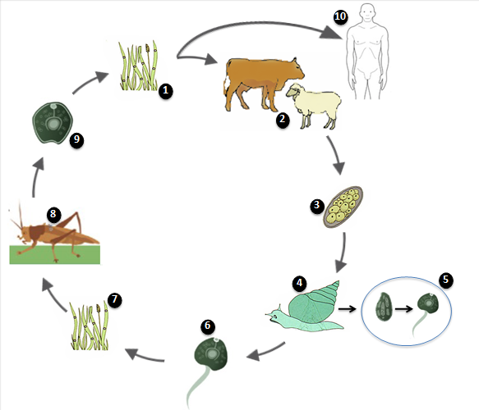
Figure 1 Eurytrema spp. life cycle. 1: Infection by grazing on infected grass; 2: Vertebrate host (cow or sheep); 3: Unembryonated eggs released in feces; 4: Ingestion of eggs by Bradybaena sp.; 5: Sporocyst mother in sporocyst son in the digestive tube between 90 and 350 d, according to envionmental conditions. Sporocyst sons containing cercarea are released in the environment few hours before dawn; 6: Cercarea released in the environment; 7: Ingestion of cercarea by Conocephalus sp.; 8: Development of infective metacercarea inside grasshopper; 9: Infective metacercarea released in the environment; 10: Possible human infection by consumption of infected salad. One egg of Eurytrema spp. produce 100 eporocyst sons which turn into 200 cercareas and latter 20.000 infective metacercarea. Adapted from Tessele, CDC and Bennett^{[6,15,16]}.
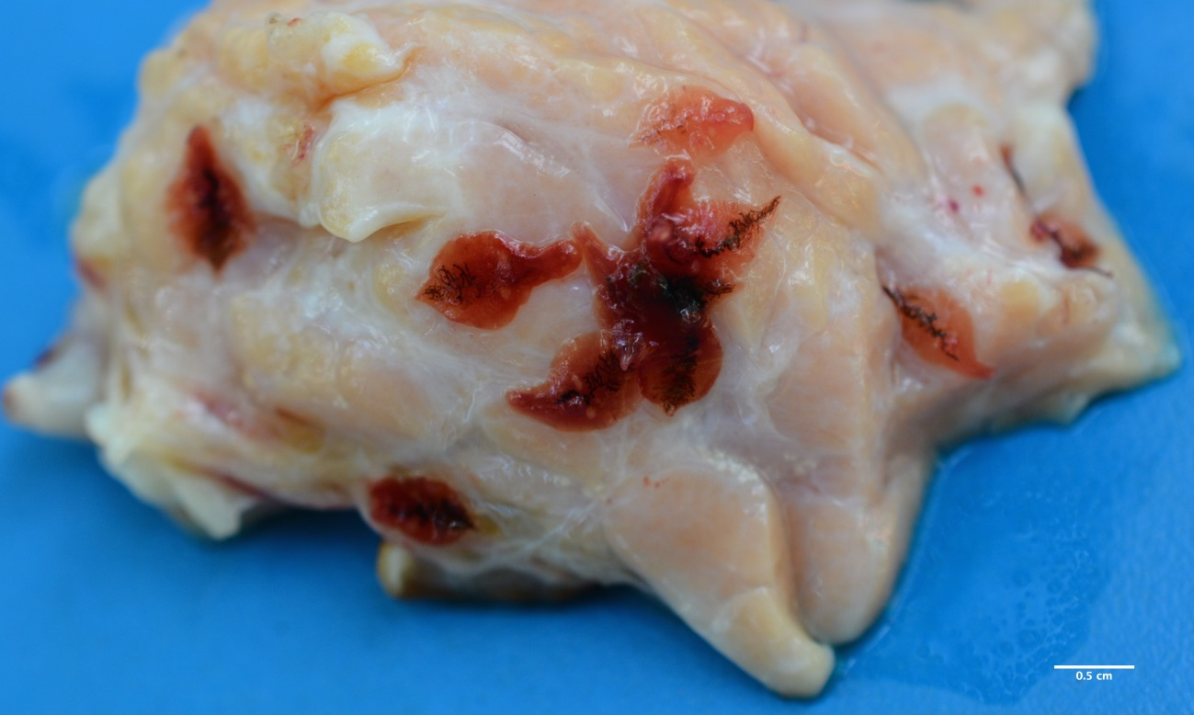
Figure 2 Eurytrema sp. in bovine pancreas. The fluke is red, oval shaped and measuring between 8 to 13 mm in length by 6 to 7 mm width. The pancreas of infected animals has a harder consistency and hyperplasic ducts partially filled with adult parasites are observed.
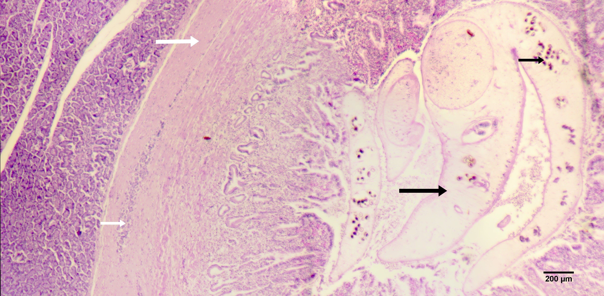
Figure 3 Histopathology of pancreas with Eurytrematosis. Moderate proliferation of connective tissue (white large arrow), severe hyperplasic ducts containing adult parasites (black large arrow), parasite eggs (black short arrow) and mild inflammatory infiltrates of lymphocytes, eosinophils, plasma cells and macrophages (white short arrow). The islets of Langerhans are usually not affected but in most severe cases, they are replaced by connective tissue.

