Name of journal: World Journal of Surgical Procedures
ESPS Manuscript NO: 7267
Columns: REVIEW

Endoscopic approaches to biliary intervention in patients with surgically altered gastroduodenal anatomy

Cosgrove ND et al. Biliary endoscopy in surgically altered anatomy

Natalie D Cosgrove, Andrew Y Wang

Natalie D Cosgrove, Andrew Y Wang, Division of Gastroenterology and Hepatology, University of Virginia, Charlottesville, VA 22908, United States

Author contributions: Cosgrove ND and Wang AY contributed equally to this manuscript.

Correspondence to: Andrew Y Wang, MD, FACG, FASGE, Associate Professor of Medicine, Co-Medical Director of Endoscopy, Division of Gastroenterology and Hepatology, University of Virginia Health System, 1215 Lee St, Charlottesville, VA 22908, United States. ayw7d@virginia.edu

Telephone: +1-434-9241653 Fax: +1-434-2447590
Received: November 11, 2013 Revised: January 1, 2014
Accepted: March 17, 2014
Published online:

Abstract
Over the past decade the ability of endoscopists to access the biliary tree in patients with surgically altered gastroduodenal anatomy has significantly advanced. Much of the progress has occurred as a result of the development of better tools to navigate the deep small bowel, such as single-balloon- (SBE), double-balloon- (DBE), and spiral-enteroscopy-assisted endoscopic retrograde cholangiopancreatography (ERCP). However, despite using a cap, accessing the papilla or bile duct using these forward-viewing enteroscopy platforms remains challenging, even in expert hands. In patients with Roux-en-Y gastric bypass (RYGB) anatomy, the excluded stomach is a potential point of access for either a delayed transgastric- or immediate laparoscopy-assisted-ERCP approach. However, the parallel advancement of therapeutic endoscopic ultrasound (EUS) also provides alternative approaches through which the biliary system can be accessed and intervened on in patients with surgically altered anatomies. Generally speaking, in patients with short gastro-jejunal “Roux” and bilio-pancreatic limbs, ideally less than 150 cm in length, starting with a (cap-assisted) push-enteroscopy or balloon-enteroscopy approach would offer reasonable diagnostic and therapeutic ERCP success. When available, short-SBE or short-DBE scopes should be used, as they allow the use of conventional ERCP equipment, are associated with shorter procedure times, and are easier to manipulate. In patients with RYGB who have longer Roux and/or bilio-pancreatic limbs (> 150 cm in total length), or in patients who have failed prior attempts at deep enteroscopy-assisted ERCP, transgastric laparoscopy-assisted-ERCP is associated with higher rates of diagnostic and therapeutic success as compared to deep-enteroscopy-assisted ERCP. Finally, EUS-guided biliary access for antegrade biliary intervention or for rendezvous enteroscopy-assisted ERCP is possible. While percutaneous transhepatic biliary drainage and surgical bile duct exploration remain viable alternatives, these methods are not without significant morbidity and mortality and should only be considered if less invasive endoscopic interventions are not feasible or appropriate.

© 2014 Baishideng Publishing Group Co., Limited. All rights reserved.

Key words: Endoscopic retrograde cholangiopancreatography; Bile duct; Roux-en-Y; Gastric bypass; Surgically altered anatomy

Core tip: In patients with short gastrojejunal “Roux” and bilio-pancreatic limbs, ideally less than 150 cm in length, starting with a (cap-assisted) push-enteroscopy or balloon-enteroscopy approach should offer reasonable diagnostic and therapeutic endoscopic retrograde cholangiopancreatography (ERCP) success. When available, short-single-balloon or short-double-balloon enteroscopes should be used, as they allow the use of conventional ERCP equipment, are associated with shorter procedure times, and are easier to manipulate. In patients with Roux-en-Y gastric bypass who have longer Roux and/or bilio-pancreatic limbs, or in patients who have failed prior attempts at deep enteroscopy-assisted ERCP, transgastric laparoscopy-assisted-ERCP should be considered, which is associated with high rates of diagnostic and therapeutic ERCP success.

Cosgrove ND, Wang AY. Endoscopic approaches to biliary intervention in patients with surgically altered gastroduodenal anatomy.
Available from:
DOI:

INTRODUCTION
According to the National Center for Health Statistics, 35.7% of US adults were classified as obese in 2009-2010, and there is a rising linear trend in obesity rates^{[1]}. As a result, many patients in the US have been undergoing bariatric surgery, such as Roux-en-Y gastric bypass (RYGB)^{[2]} (Figure 1). The increasing prevalence of patients with surgically altered gastroduodenal anatomy (most notably RYGB, but also including Billroth II gastrojejunostomy, pancreaticoduodenectomy, and Roux-en-Y hepaticojejunostomy, which is used in liver transplantation) has posed a unique challenge for the endoscopic management of biliary and pancreatic issues. In patients with Roux-en-Y (RY) anatomy, endoscopic retrograde cholangiopancreatography (ERCP) is typically impossible via an oral route using a duodenoscope, as the scope must be passed from the gastrojejunostomy through the jejunojejunostomy and into the afferent bilio-pancreatic limb to the papilla. Furthermore, the gastrojejunal Roux limb is typically made greater than 100 to 150 cm in order to produce weight loss, and the sharp angulation into the afferent bilio-pancreatic limb also poses a technical challenge to reaching the papilla. It is therefore no surprise that the primary reason for ERCP failure in patients with altered gastroduodenal anatomy is failure to reach the biliary-enteric anastomosis or ampulla^{[3,4]}. As obese, post-bariatric surgery patients are at an increased risk for developing gallstones and other associated complications that require biliary intervention^{[5,6]}, new technologies and approaches have been developed to manage these issues in patients with surgically altered anatomies.

USE OF A DUODENOSCOPE FOR “CONVENTIONAL” ERCP
Duodenoscopes have been optimized for performing ERCP in patients with normal gastroduodenal anatomy. Duodenoscopes possess an elevator and have side-viewing imaging to enable visualization of the major and minor papillae. Therapeutic duodenoscopes possess large accessory channels that allow for the use of a broad array of instruments and stents sizes, typically up to 10 French (Fr). However, the short working length (about 124 cm) of the duodenoscope is a limitation when attempting ERCP in patients with long-limbed small bowel anastomoses. For patients with shorter afferent limbs, such as those who have undergone a Billroth II gastrectomy, ERCP using a duodenoscope remains a potentially feasible technique. In a retrospective study by Hintze et al^{[7]} that included 59 patients with Billroth II anatomy, the papilla was reached in 92% of patients using a duodenoscope. Once the duodenal stump was reached, therapeutic success was achieved in 100% of patients. For patients with gastrojejunal limbs 100 cm or longer, such as patients with RYGB anatomy, ERCP using a duodenoscope is rarely possible. Hintze et al^{[7]} reported reaching the ampulla using a duodenoscope in only 33% of patients with RY reconstructions.

PUSH ENTEROSCOPY FOR ERCP
In patients with surgically altered gastroduodenal anatomies with long small bowel limbs, push enteroscopy using a standard forward-viewing enteroscope or a pediatric colonoscope without an overtube has the potential to reach the ampulla, bile duct, or pancreatic duct orifices (such as in patients with pancreaticoduodenectomy) (Figure 2). However, the forward viewing optics and lack of an elevator make cannulation of a native papilla (in the case of RYGB patients) and therapeutic ERCP very challenging. In a study of 15 patients with RY anatomy who underwent ERCP using a colonoscope, ERCP was successful in only 2 patients, despite successfully reaching the papilla in 12 of these patients^{[8]}. Furthermore, in a prospective study of 37 patients by Raithel et al^{[9]}, 91.8% of whom had RY anatomy, push enteroscopy was only able to reach the enteo-enteral anastomoses in 16.2% of patients. Other limitations of push-enteroscopy-assisted ERCP are high rates of loop formation and perforation^{[10]}.
In 2002, Wright et al^{[8]} described using a colonoscope to reach the ampulla or desired ductal orifice, at which point the colonoscope was exchanged over a guidewire for a duodenoscope, which was passed in to the afferent bilio-pancreatic limb using a “Hansel and Gretel” technique. In some cases, the duodenoscope was pulled into the afferent limb using counter-traction from a wire-guided balloon that was passed retrograde into the afferent limb or stomach; this might be the first description of a single-balloon technique to facilitate small bowel passage of an endoscope. Using these techniques for patients who failed attempted ERCP using a colonoscope, the ampulla was ultimately reached in 67% of patients, and biliary access was achieved in 84% after exchange for a duodenoscope. The complication rate was 12% in this series^{[8]}.

BALLOON-ENTEROSCOPY-ASSISTED ERCP
Balloon-assisted enteroscopy can be performed using a single-balloon enteroscopy (SBE) or a double-balloon enteroscopy (DBE) platform. DBE uses an enteroscope with a balloon at its distal tip and an overtube with an anchoring balloon, while SBE uses a standard enteroscope with an overtube with an anchoring balloon. Using a “push-pull” method of scope advancement and successive inflation of one or both balloons (depending on the platform) to pleat the small bowel, a significant distance of small bowel may be traversed.
Balloon-assisted enteroscopy was originally developed to aid in the diagnosis and treatment of small bowel diseases that were previously out of reach of push enteroscopy using a dedicated enteroscope or a pediatric colonoscope. However, balloon-assisted enteroscopy also enables accessing the bilio-pancreatic afferent limb in patients with surgically altered gastroduodenal anatomy. In 2005, Sakai et al^{[11]} described using DBE to reach the bypassed stomach in five out of six (83.3%) patients with RYGB anatomy.
In the abovementioned study by Raithel et al^{[9]}, when DBE was performed in the patients who failed ERCP via push enteroscopy (91.8% with RY anatomies), luminal access to the biliary tract was achieved in 74.1%, with diagnostic or therapeutic ERCP success in 87.2% of cases^{[9]}. However, even with balloon-enteroscopy-assisted ERCP (BEA-ERCP), procedure success remains limited by the length of the Roux limb. Schreiner et al^{[12]} calculated the summed (total) length of the Roux limb and the length from the ligament of Treitz to the jejunojejunal anastomosis in patients undergoing DBE-assisted ERCP (DBE-ERCP). They reported therapeutic success in 88% of cases with a total small bowel length less than 150 cm, but only 33% success for lengths from 150 to 225 cm, and 0% success for lengths greater than 225 cm.
While the efficacy of BEA-assisted ERCP can also be limited in patients with extensive abdominal adhesions and fixed bowel segments that limit small bowel manipulation and pleating, SBE-assisted ERCP (SBE-ERCP) and DBE-ERCP have a growing track record of significant diagnostic and therapeutic success (Table 1). Procedure times for SBE- and DBE-ERCP are similar, with average total procedure times of 72 to 78 min reported for SBE-ERCP^{[4,13]} and 93 to 128 min for DBE-ERCP^{[9,14,15]}. Complication rates for SBE-ERCP and DBE-ERCP also appear to be similar (Table 2).

LIMITATIONS OF SBE- AND DBE-ASSISTED ERCP
Like colonoscopes and push enteroscopes, the enteroscopes used for SBE and DBE also lack an elevator and have forward-viewing optics. Additionally, these scopes typically have small accessory channels (2.8 mm, which can accommodate only up to 7-Fr devices). Furthermore, their long working lengths (of around 200 cm) prevent the use of conventional ERCP accessories. Longer accessories (600-cm-long guidewires, long papillotomes, and long retrieval balloons) are now available for use in SBE- and DBE-ERCP when long enteroscopes are used. These long wires and devices make SBE- and DBE-ERCP possible, but exchanging devices is challenging given the long distances that need to be traversed.
Various methods have been developed to circumvent the issue of using a long enteroscope to perform ERCP. Exchanging the single- or double-balloon enteroscope over a guidewire for a duodenoscope or conventional forward-viewing gastroscope, after the papilla has been reached, allows for the use of conventional ERCP equipment and can circumvent some of the limitations of long enteroscopes^{[15]}. A short-DBE enteroscope with a working length of 152 cm is available that allows the use of standard ERCP accessories. A small retrospective study of patients with RY anatomy who underwent ERCP with either short DBE or long DBE reported 100% success in reaching the papilla in both groups. The collective therapeutic success rate for short- and long-DBE-ERCP during the first session was 67%. The short-DBE scopes reached the papilla more quickly (29 ± 19.2 min) as compared to the long-DBE scopes (64.8 ± 24.7 min)^{[15]}.
A short-SBE platform was recently described in a retrospective Japanese study of 22 patients. This scope has a working length of 152 cm, a large accessory channel with a diameter of 3.2 mm, and a water jet channel. Advantages of this scope include the ability to use more conventional ERCP devices, including duodenoscope-length wire-guided devices for stone extraction and stents up to 8.5 Fr in size, shorter setup time than for short DBE, and the ability to perform wire-guided intraductal ultrasonography. Despite its shorter length, these investigators reported a short-SBE-ERCP success rate of 90% for reaching the end of the afferent limb, and diagnostic and therapeutic ERCP success rates of 89% and 96%, respectively. Reported procedure times averaged at 40.2 min, which appears shorter than for most other BEA-ERCP platforms^{[16]}.
Itoi et al^{[15,17]} have described in two publications a novel modification that can be performed on either the single- or double-balloon overtubes so as to enable ERCP using a diagnostic gastroscope. Using SBE or DBE, a long enteroscope is passed to the papilla or ductal orifice. The overtube balloon is inflated anchoring the overtube in the afferent limb, and the enteroscope is withdrawn. A hole is then made in the overtube at 100 cm from the distal end and a diagnostic gastroscope can then be passed through this “shortened” overtube to perform ERCP using standard length instruments. Success rate of therapeutic ERCP on the first session was 76.9% for SBE^{[17]} and 66.7% for DBE^{[15]}, by using this method. The drawback to this technique is that a distal attachment cap cannot be used, as it cannot be passed through the overtube.

SPIRAL-ENTEROSCOPY-ASSISTED ERCP
Spiral enteroscopy (SE) uses a spiral overtube and rotational movement to advance the enteroscope deep into the small bowel. Unlike SBE and DBE, SE does not require a balloon inflation system^{[18]}. A retrospective study comparing SE-assisted ERCP (SE-ECP) to SBE-ERCP reported similar diagnostic yields (48.3% for SBE-ERCP vs 40% for SE-ERCP, P = 0.59) and comparable rates of therapeutic success (100% for SBE-ERCP vs 87.5% for SE-ERCP, P = 1.0). No diagnostic benefit was seen when changing from one technique to another^{[4]}.
A multi-centered retrospective study of 129 patients (93 of whom had RY anatomy) who underwent 180 enteroscopy-assisted ERCPs reported similar success rates among SBE- (87%), DBE- (85%), and SE-ERCP (90%), when the papilla or ductal orifice was reached^{[3]}. Procedure times for SE-ERCP also appear to be similar to those of BEA-ERCP, with mean times of 72 ± 34 min for SBE-ERCP and 81.9 ± 34.6 for SE-ERCP reported in another study^{[4]}. Complication rates for SE-ERCP appear to be low (Table 2) with 0.3% of patients sustaining severe complications, including 0.27% small bowel perforations that were reported in a large retrospective study of 2950 patients^{[19]}. Overall, studies of SE-ERCP report reasonable diagnostic and therapeutic success rates (Table 3), which are comparable to those published for SBE- and DBE-ERCP.

ADJUNCTIVE TECHNIQUES TO FACILITATE ENTEROSCOPY-ASSISTED ERCP
A soft, low-profile, distal attachment cap, similar to those used for endoscopic mucosal resection and endoscopic submucosal dissection, can improve visualization during enteroscopy-assisted ERCP and can be applied to SBE-, DBE-, or SE-platforms (Figure 3). The presence of a cap allows the scope to have an approximately 2-mm distance from the wall of the GI lumen, thereby improving visualization. The cap can also be used to manipulate small bowel folds enabling easier scope insertion. Furthermore, the cap can manipulate the ampulla so as to facilitate ductal cannulation and papillotomy (Figure 4). In a study of 10 patients with Billroth II anatomy undergoing ERCP with a forward-viewing endoscope, ampullary cannulation and sphincterotomy were successful in 100% of the patients when a cap-fitted enteroscope was used^{[20]}.
Intraluminal indigo carmine has been used to aid in the identification of the afferent bilio-pancreatic limb in patients with RY anatomies. Indigo carmine is a surface stain and can be injected through the enteroscope accessory channel to coat the mucosa at the RY anastomosis. Small bowel peristalsis moves the indigo carmine distally through the bowel, which will theoretically identify the efferent jejunal limb, as little (if any) indigo carmine should move by peristalsis into the afferent bilio-pancreatic limb. In a prospective study of 52 patients undergoing DBE-ERCP, application of indigo carmine correctly identified the afferent bilio-pancreatic limb in 80% of the patients^{[21]}. Patient positioning and gravity filling of the afferent limb were attributed to the cases of incorrect identification. Once the bilio-pancreatic limb is identified, tattooing of this afferent limb can simplify future identification.
Failure to ascend into the afferent limb, typically due to sharp angulation at the anastomosis, is another common reason for ERCP failure^{[3]}. Passing a biopsy forceps into the accessory channel to stiffen a long and floppy enteroscope can help in cannulation of the afferent limb. Passage of a long guidewire and a long retrieval balloon into the afferent limb has also been described to facilitate scope passage into the afferent limb^{[22]}. In cases where the afferent limb cannot be accessed despite use of all available maneuvers, an endoscopic ultrasound (EUS)-guided rendezvous procedure has been described using a guidewire passed in an anterograde manner to pull an enteroscope to the papilla or duct of interest^{[23]}.

GASTROSTOMY-ASSISTED DELAYED (TRANSGASTRIC) ERCP
In patients with RYGB anatomy, the excluded stomach may be accessed, thus enabling anterograde passage of a duodenoscope to the ampulla for conventional ERCP. One method of accessing the bypassed gastric remnant is via a surgically created gastrostomy (Figure 5), which was first described in 1998^{[24]}. Typically, a surgical Stamm gastrostomy is created using a 32- to 36-Fr Malecot tube, and the gastrostomy track is allowed to mature 2 to 4 wk prior to transgastric (TG) ERCP (Figure 6). The advantage of a surgical Stamm gastrostomy is that the gastrostomy tube may be replaced following transgastric ERCP, in case subsequent procedures are required (e.g., for stent removal, to treat potential post-sphincterotomy bleeding, etc.).
A retrospective study of 59 cases of patients with surgically altered gastroduodenal anatomy reported higher success rates of reaching the ampulla/duct orifice for TG-ERCP (100%) compared to SBE-ERCP (77%, P < 0.02)^{[25]}. This study also showed that TG-ERCP had a superior rate of therapeutic ERCP success (96% vs 64%, P < 0.01) as compared to SBE-ERCP. However, TG-ERCP was associated with a higher rate of complications (38% vs 9%, P < 0.08) as compared to SBE-ERCP, which trended towards statistical significance^{[25]}. Reported complications of TG-ERCP include bleeding at the gastrostomy site, post-ERCP pancreatitis, and bowel perforation^{[26]}. The main drawback of this technique is the need to allow the gastrostomy track to mature prior to ERCP, which obviates the use of this method in patients who require more urgent ERCP.

LAPAROSCOPY-ASSISTED ERCP
Again, in patients with RYGB anatomy, ERCP may be accomplished by passing a duodenoscope through a gastrostomy via the excluded stomach. In contrast to TG-ERCP, which requires a mature gastrostomy track, laparoscopy-assisted ERCP (LA-ERCP) uses a laparoscopically created track that enables immediate ERCP in the operating room. The stomach is first secured to the abdominal wall, and the excluded stomach is then accessed laparoscopically. Using this method, a large trocar can be placed into the bypassed stomach through which a therapeutic duodenoscope can be passed to perform ERCP. Use of a trocar is not mandatory to perform ERCP; as long as the stomach has been sutured or tacked to the abdominal wall, a duodenoscope can also be passed through a fresh gastrostomy track. A large Malecot tube (32- to 36 Fr) can be inserted to keep the track patent if repeated ERCP is required.
LA-ERCP provides similar success rates as compared to delayed TG-ERCP, but LA-ERCP offers the advantage of being able to perform same-day ERCP. A study of 30 patients reported a 93% rate of successful laparoscopic gastrostomy creation with a 100% therapeutic LA-ERCP success rate. While there was a 10% surgical re-exploration rate, no mortalities were reported^{[27]}. A retrospective study comparing LA-ERCP to BEA-ERCP (SBE or DBE) reported that LA-ERCP had statistically superior rates of papillary identification (100% vs 72%) and therapeutic success (100% vs 59%)^{[12]}. LA-ERCP also has a statistically significant advantage over SE-ERCP, with bile duct cannulation rates in one retrospective study reported at 57% for SE-ERCP versus 100% for LA-ERCP. However, LA-ERCP has a somewhat high complication rate of 13%-14.5%^{[27,28]}, which is not dissimilar to that found following delayed TG-ERCP. Other disadvantages include prolonged procedure times (with mean operative time of 172-200 min^{[12,27]}), the requirement to coordinate both endoscopy and surgical teams for the procedure, the need to maintain surgical sterility during the procedure, the need for post-surgical patient admission, and higher cost^{[29]}. LA-ERCP costs substantially more than BEA-ERCP, with mean total hospital charges of $9529 for LA-ERCP versus $6574 for BEA-ERCP. A cost analysis by Schreiner et al^{[12]} found that by performing LA-ERCP only after BEA-ERCP was attempted saved $1015 compared with starting with LA-ERCP.
Non-surgical, endoscopic methods of gastrostomy tube placement into the remnant stomach for subsequent ERCP have been described. Via EUS-guided puncture, the gastric remnant can be maximally insufflated to allow for percutaneous access guided by fluoroscopy. In a study of 10 patients, this procedure was 100% successful for gastrostomy tube placement with no complications^{[30]}. Another non-surgical method involves percutaneous endoscopic gastrostomy (PEG) tube placement using DBE (or any deep enteroscopy approach) to reach the excluded stomach. A small study of 4 patients using this technique reported a 75% success rate for PEG placement, with only 1 case failing due to lack of abdominal transillumination^{[31]}. No major complications were observed in any of these patients. Lastly, percutaneous computed tomography (CT)-guided gastrostomy placement has a reported success rate of 91%^{[32]}. Although these methods are less invasive than open surgical gastrostomy tube placement, their requirement for tract maturation following gastrostomy tube placement and before ERCP can be performed limits these procedures from being utilized in patients who require urgent ERCP.
Baron et al^{[33]} devised a novel endoscopic approach to enabling same-day ERCP in patients with RYGB via a technique known as percutaneous-assisted transprosthetic endoscopic therapy (PATENT)^{[34]}. The PATENT method uses SBE or DBE to access the remnant stomach and facilitate gastrostomy creation using a trocar, with gastric apposition secured by T-tags. An 18-mm-wide esophageal-type fully covered self-expandable metal stent (FC-SEMS) is then deployed across the gastrostomy and a high-burst pressure (16 ATM) balloon is used to expand the stent, through which ERCP using a duodenoscope can be performed. Following ERCP, a gastrostomy tube is placed through the stent and inflated to prevent leakage of gastric contents. The transgastric FC-SEMS may be sectioned and removed over the gastrostomy tube or left in place for repeated ERCP in the future. Although gastrostomy tube placement for this procedure can be performed percutaneously or via retrograde balloon enteroscopy, balloon enteroscopy is recommended for this procedure, as it allows direct visualization during PEG placement and FC-SEMS deployment^{[33]}. A case series of 5 patients who underwent ERCP via a transgastric FC-SEMS reported successful biliary sphincterotomy performed in all patients, and only 1 minor adverse event was observed. Median procedure time for this novel procedure was 97 min^{[34]}.

USE OF GASTRO-GASTRO FISTULA FOR ERCP
In patients with RYGB, defects in the staple line between the gastric remnant and the excluded stomach do occur; this “problem” can be used to patients’ advantage to enable ERCP, when indicated. Case reports have described (1) the passage of a duodenoscope through a fistulous communication between the gastric pouch and the excluded stomach to perform ERCP^{[35]}; and (2) the dilation of a defect in a gastric staple line through which a FC-SEMS was deployed, thus enabling anterograde passage of a duodenoscope into the excluded stomach to perform ERCP^{[36]}.

EUS-GUIDED ERCP
Therapeutic EUS is another method by which biliary access may be obtained in patients with surgically altered gastroduodenal anatomy (Figure 7). Weilert et al^{[23]} used a therapeutic linear echoendoscope to direct a 19-gauge fine-needle aspiration needle into the intrahepatic ducts of the left liver in order to perform transgastric-transhepatic, antegrade ERCP in patients with RYGB who had choledocholithiasis. Once guidewire access across the biliary system and the papilla was obtained, balloon sphincteroplasty followed by push-through of biliary stones was accomplished. This procedure was done in six patients and had a 67% rate of successful antegrade removal of biliary stones. Two patients in whom dilation catheters could not be advanced across the puncture site underwent successful rendezvous ERCP and stone extraction, by using a long guidewire that was passed across the gastrohepatic puncture site into the afferent limb to facilitate rendezvous DBE-ERCP. One patient sustained a subcapsular hematoma that resolved with conservative management; no cases of pancreatitis were reported. In a single operator, prospective, but non-randomized study, Park et al^{[37]} performed EUS-guided biliary drainage in 45 patients. Fourteen of these patients had surgically altered anatomy and underwent EUS-guided, transhepatic, antegrade stenting or balloon dilation with a success rate of 57%. In the 6 patients who failed this approach, EUS-guided hepaticogastrostomy with transluminal stenting was performed, and one patient required percutaneous transhepatic biliary drainage. The overall adverse event rate for EUS-guided biliary drainage procedures was 11%.

CONCLUSION
Over the past decade the ability of endoscopists to access the biliary tree in patients with surgically altered gastroduodenal anatomy has significantly advanced. Much of the progress has occurred as a result of the development of better tools to navigate the deep small bowel, namely through SBE-, DBE- and SE-ERCP. Despite using a cap, accessing the papilla or bile duct using these forward-viewing platforms remains challenging, even in expert hands. In patients with RYGB, the excluded stomach is a potential point of access for either a delayed TG-ERCP or an immediate LA-ERCP approach. However, the parallel advancement of therapeutic EUS also provides alternative approaches through which the biliary system can be accessed and intervened on in patients with surgically altered anatomies.
Adequate training and experience in deep enteroscopy, ERCP, and therapeutic EUS would be ideal for endoscopists who are frequently referred patients with altered gastroduodenal anatomies. However, combination procedures done in tandem by endoscopists with strengths in different skills are also feasible (i.e., a deep enteroscopist gets to the papilla and a biliary endoscopist does the ERCP, or an EUS specialist accesses the biliary tree and then an ERCP specialist does the transgastric-transhepatic biliary intervention).
Generally speaking, in patients with short gastro-jejunal “Roux” and bilio-pancreatic limbs, ideally less than 150 cm in total length, starting with a (cap-assisted) push-enteroscopy or BEA-ERCP approach would offer reasonable diagnostic and therapeutic ERCP success. When available, short-SBE or short-DBE scopes should be used, as they allow the use of conventional ERCP equipment, are associated with shorter procedure times, and are easier to manipulate than their longer counterparts. In patients with RYGB who have longer Roux and/or pancreatico-biliary limbs (>150 cm in total length), or in patients who have failed prior attempts at deep-enteroscopy-assisted ERCP, LA-ERCP (or delayed TG-ERCP if immediate ERCP is not required) is associated with higher rates of diagnostic and therapeutic success as compared to deep-enteroscopy-assisted ERCP. Finally, EUS-guided biliary access for antegrade biliary intervention or for rendezvous enteroscopy-assisted ERCP is possible. While percutaneous transhepatic biliary drainage^{[38]} and surgical bile duct exploration^{[39,40]} remain viable alternatives, these methods are not without significant morbidity and mortality and should only be considered if less invasive endoscopic interventions are not feasible or appropriate.

REFERENCES
1 Ogden CL, Carroll MD, Kit BK, Flegal KM. Prevalence of obesity in the United States, 2009-2010. NCHS Data Brief 2012; 82: 1-8 [PMID: 22617494]
2 Samuel I, Mason EE, Renquist KE, Huang YH, Zimmerman MB, Jamal M. Bariatric surgery trends: an 18-year report from the International Bariatric Surgery Registry. Am J Surg 2006; 192: 657-662 [PMID: 17071202]
3 Shah RJ, Smolkin M, Yen R, Ross AS, Kozarek RA, Howell DA, Bakis G, Jonnalagadda SS, Al-Lehibi AA, Hardy A, Morgan DR, Sethi A, Stevens PD, Akerman PA, Thakkar SJ, Brauer BC. A multi-center, US experience of single-balloon, double-balloon, and rotational overtube-assisted enteroscopy ERCP in patients with surgically altered pancreaticobiliary anatomy (with video). Gastrointest Endosc 2013; 77: 593-600 [DOI: 10.1016/j.gie.2012.10.015]
4 Lennon AM, Kapoor S, Khashah M, Corless E, Amateau S, Dunbar K, Chandrasekhara V, Singh V, 3rd OPI. Spiral Assisted ERCP is Equivalent to Single Balloon Assisted ERCP in Patients with Roux-en-Y Anatomy. Digest Dis Sci 2012; 57: 1391-1398 [DOI: 10.1007/s10620-011-2000-8]
5 Shiffman ML, Sugerman HJ, Kellum JM, Brewer WH, Moore EW. Gallstone formation after rapid weight loss: a prospective study in patients undergoing gastric bypass surgery for treatment of morbid obesity. Am J Gastroenterol 1991; 86: 1000-1005 [PMID: 1858735]
6 Amaral JF, Thompson WR. Gallbladder disease in the morbidly obese. Am J Surg 1985; 149: 551-557 [PMID: 3985293]
7 Hintze RE, Adler A, Veltzke W, Abou-Rebyeh H. Endoscopic Access to the Papilla of Vater for Endoscopic Retrograde Cholangiopancreatography in Patients with Billroth II or Roux-en-Y Gastrojejunostomy. Endoscopy 1997; 29: 69-73
8 Wright BE, Cass OW, Freeman ML. ERCP in patients with long-limb Roux-en-Y gastrojejunostomy and intact papilla. Gastrointest Endosc 2002; 56: 225-232 [PMID: 12145601]
9 Raithel M, Dormann H, Naegel A, Boxberger F, Hahn EG, Neurath MF, Maiss J. Double-balloon-enteroscopy-based endoscopic retrograde cholangiopancreatography in post-surgical patients. World J Gastroenterol 2011; 17: 2302-2314 [PMID: 21633596 DOI: 10.3748/wjg.v17.i18.2302]
10 Faylona JM, Qadir A, Chan AC, Lau JY, Chung SC. Small-bowel perforations related to endoscopic retrograde cholangiopancreatography (ERCP) in patients with Billroth II gastrectomy. Endoscopy 1999; 31: 546-549 [PMID: 10533739]
11 Sakai P, Kuga R, Safatle-Ribeiro AV, Faintuch J, Gama-Rodrigues JJ, Ishida RK, Furuya CK, Yamamoto H, Ishioka S. Is it feasible to reach the bypassed stomach after Roux-en-Y gastric bypass for morbid obesity? The use of the double-balloon enteroscope. Endoscopy 2005; 37: 566-569 [PMID: 15933931 DOI: 10.1055/s-2005-861444]
12 Schreiner MA, Chang L, Gluck M, Irani S, Gan SI, Brandabur JJ, Thirlby R, Moonka R, Kozarek RA, Ross AS. Laparoscopy-assisted versus balloon enteroscopy-assisted ERCP in bariatric post-Roux-en-Y gastric bypass patients. Gastrointest Endosc 2012; 75: 748-756 [PMID: 22301340 DOI: 10.1016/j.gie.2011.11.019]
13 Saleem A, Baron TH, Gostout CJ, Topazian MD, Levy MJ, B.T. P, Wong Kee Song LM. Endoscopic retrograde cholangiopancreatography using a single-balloon enteroscope in patients with altered Roux-en-Y anatomy. Endoscopy 2010; 42: 656-660 [DOI: 10.1055/s-0030-1255557]
14 Osoegawa T, Motomura Y, Akahoshi K, Higuchi N, Tanaka Y, Hisano T, Itaba S, Gibo J, Yamada M, Kubokawa M, Sumida Y, Akiho H, Ihara E, Nakamura K. Improved techniques for double-balloon-enteroscopy-assisted endoscopic retrograde cholangiopancreatography. World J Gastroenterol 2012; 18: 6843-6849 [PMID: 23239923 DOI: 10.3748/wjg.v18.i46.6843]
15 Itoi T, Ishii K, Sofuni A, Itokawa F, Tsuchiya T, Kurihara T, Tsuji S, Ikeuchi N, Fukuzawa K, Moriyasu F, Tsuchida A. Long- and short-type double-balloon enteroscopy-assisted therapeutic ERCP for intact papilla in patients with a Roux-en-Y anastomosis. Surg Endosc 2011; 25: 713-721 [PMID: 20976503 DOI: 10.1007/s00464-010-1226-4]
16 Yamauchi H, Kida M, Okuwaki K, Miyazawa S, Iwai T, Takezawa M, Kikuchi H, Watanabe M, Imaizumi H, Koizumi W. Short-type single balloon enteroscope for endoscopic retrograde cholangiopancreatography with altered gastrointestinal anatomy. World J Gastroenterol 2013; 19: 1728-1735 [PMID: 23555161 DOI: 10.3748/wjg.v19.i11.1728]
17 Itoi T, Ishii K, Sofuni A, Itokawa F, Tsuchiya T, Kurihara T, Tsuji S, Ikeuchi N, Umeda J, Moriyasu F. Single-balloon enteroscopy-assisted ERCP in patients with Billroth II gastrectomy or Roux-en-Y anastomosis (with video). Am J Gastroenterol 2010; 105: 93-99 [PMID: 19809409 DOI: 10.1038/ajg.2009.559]
18 Akerman PA, Agrawal D, Chen W, Cantero D, Avila J, Pangtay J. Spiral enteroscopy: a novel method of enteroscopy by using the Endo-Ease Discovery SB overtube and a pediatric colonoscope. Gastrointest Endosc 2009; 69: 327-332 [PMID: 19100974 DOI: 10.1016/j.gie.2008.07.042]
19 Akerman PA, Haniff M. Spiral enteroscopy: prime time or for the happy few? Best Pract Res Clin Gastroenterol 2012; 26: 293-301 [PMID: 22704571 DOI: 10.1016/j.bpg.2012.03.008]
20 Park CH, Lee WS, Joo YE, Kim HS, Choi SK, Rew JS. Cap-assisted ERCP in patients with a Billroth II gastrectomy. Gastrointest Endosc 2007; 66: 612-615 [PMID: 17725957 DOI: 10.1016/j.gie.2007.04.024]
21 Yano T, Hatanaka H, Yamamoto H, Nakazawa K, Nishimura N, Wada S, Tamada K, Sugano K. Intraluminal injection of indigo carmine facilitates identification of the afferent limb during double-balloon ERCP. Endoscopy 2012; 44 Suppl 2 UCTN: E340-E341 [PMID: 23012011 DOI: 10.1055/s-0032-1309865]
22 Wang AY, Sauer BG, Behm BW, Ramanath M, Cox DG, Ellen KL, Shami VM, Kahaleh M. Single-balloon enteroscopy effectively enables diagnostic and therapeutic retrograde cholangiography in patients with surgically altered anatomy. Gastrointest Endosc 2010; 71: 641-649 [PMID: 20189529 DOI: 10.1016/j.gie.2009.10.051]
23 Weilert F, Binmoeller KF, Marson F, Bhat Y, Shah JN. Endoscopic ultrasound-guided anterograde treatment of biliary stones following gastric bypass. Endoscopy 2011; 43: 1105-1108 [PMID: 22057823 DOI: 10.1055/s-0030-1256961]
24 Baron TH, Vickers SM. Surgical gastrostomy placement as access for diagnostic and therapeutic ERCP. Gastrointest Endosc 1998; 48: 640-641 [PMID: 9852460]
25 Flynn MM, Tekola BD, Schirmer BD, Hallowell PT, Yeaton P, Cox DG, Gaidhane M, Shami VM, Sauer BG, Kahaleh M, Wang AY. Gastrostomy-assisted transgastric ERCP is superior to single-balloon-enteroscopy-assisted ERCP in performing therapeutic interventions but is likely associated with more complications in patients with surgically altered anatomy. Gastrointest Endosc 2013; 77: AB388
26 Tekola B, Wang AY, Ramanath M, Burnette B, Ellen K, Schirmer BD, Hallowell PT, Sauer BG, Kahaleh M. Percutaneous gastrostomy tube placement to perform transgastrostomy endoscopic retrograde cholangiopancreaticography in patients with Roux-en-Y anatomy. Dig Dis Sci 2011; 56: 3364-3369 [PMID: 21625965 DOI: 10.1007/s10620-011-1743-6]
27 Gutierrez JM, Lederer H, Krook JC, Kinney TP, Freeman ML, Jensen EH. Surgical gastrostomy for pancreatobiliary and duodenal access following Roux en Y gastric bypass. J Gastrointest Surg 2009; 13: 2170-2175 [PMID: 19777312 DOI: 10.1007/s11605-009-0991-7]
28 Choi EK, Chiorean MV, Coté GA, El Hajj I, Ballard D, Fogel EL, Watkins JL, McHenry L, Sherman S, Lehman GA. ERCP via gastrostomy vs double balloon enteroscopy in patients with prior bariatric Roux-en-Y gastric bypass surgery. Surg Endosc 2013; 27: 2894-2899 [DOI: 10.1007/s00464-013-2850-6]
29 Desai SV, Naveed M, Jazwinski A, Jowell PS, Branch MS. Spiral enteroscopy versus laparoscopic-assisted endoscopy for completion of ERCP in patients with roux-en-Y gastric bypass surgery. Gastrointest Endosc 2011; 73(4S): AB122
30 Attam R, Leslie D, Freeman M, Ikramuddin S, Andrade R. EUS-assisted, fluoroscopically guided gastrostomy tube placement in patients with Roux-en-Y gastric bypass: a novel technique for access to the gastric remnant. Gastrointest Endosc 2011; 74: 677-682 [PMID: 21872717 DOI: 10.1016/j.gie.2011.05.018]
31 Ross AS, Semrad C, Alverdy J, Waxman I, Dye C. Use of double-balloon enteroscopy to perform PEG in the excluded stomach after Roux-en-Y gastric bypass. Gastrointest Endosc 2006; 64: 797-800 [PMID: 17055878 DOI: 10.1016/j.gie.2006.04.035]
32 Goitein D, Gagné DJ, Papasavas PK, McLean G, Foster RG, Beasley HS, Caushaj PF. Percutaneous computed tomography-guided gastric remnant access after laparoscopic Roux-en-Y gastric bypass. Surg Obes Relat Dis 2006; 2: 651-655 [PMID: 17138237 DOI: 10.1016/j.soard.2006.09.007]
33 Baron TH, Song LM, Ferreira LE, Smyrk TC. Novel approach to therapeutic ERCP after long-limb Roux-en-Y gastric bypass surgery using transgastric self-expandable metal stents: experimental outcomes and first human case study (with videos). Gastrointest Endosc 2012; 75: 1258-1263 [PMID: 22624815 DOI: 10.1016/j.gie.2012.02.026]
34 Law R, Wong Kee Song LM, Petersen BT, Baron TH. Single-session ERCP in patients with previous Roux-en-Y gastric bypass using percutaneous-assisted transprosthetic endoscopic therapy: a case series. Endoscopy 2013; 45: 671-675 [PMID: 23881807 DOI: 10.1055/s-0033-1344029]
35 Madan A, Urayama S. Successful ERCP in a Roux-en-Y gastric bypass patient, performed via a small remnant of gastro-gastric communication. Endoscopy 2011; 43: E73-74 [DOI: 10.1055/s-0030-1256038]
36 Shear W, Gaidhane M, Kahaleh M. ERCP in Roux-en-Y gastric bypass: creation of an antegrade gastrogastric conduit using a fully covered metal esophageal stent. Endoscopy 2012; 44: E58-59 [DOI: 10.1055/s-0031-1291562]
37 Park do H, Jeong SU, Lee BU, Lee SS, Seo DW, Lee SK, Kim MH. Prospective evaluation of a treatment algorithm with enhanced guidewire manipulation protocol for EUS-guided biliary drainage after failed ERCP (with video). Gastrointest Endosc 2013; 78: 91-101 [PMID: 23523301 DOI: 10.1016/j.gie.2013.01.042]
38 Saad WE, Wallace MJ, Wojak JC, Kundu S, Cardella JF. Quality improvement guidelines for percutaneous transhepatic cholangiography, biliary drainage, and percutaneous cholecystostomy. J Vasc Interv Radiol 2010; 21: 789-795 [PMID: 20307987 DOI: 10.1016/j.jvir.2010.01.012]
39 Noble H, Whitley E, Norton S, Thompson M. A study of preoperative factors associated with a poor outcome following laparoscopic bile duct exploration. Surg Endosc 2011; 25: 130-139 [PMID: 20567852 DOI: 10.1007/s00464-010-1146-3]
40 Grubnik VV, Tkachenko AI, Ilyashenko VV, Vorotyntseva KO. Laparoscopic common bile duct exploration versus open surgery: comparative prospective randomized trial. Surg Endosc 2012; 26: 2165-2171 [PMID: 22350244 DOI: 10.1007/s00464-012-2194-7]
41 Aabakken L, Bretthauer M, Line PD. Double-balloon enteroscopy for endoscopic retrograde cholangiography in patients with a Roux-en-Y anastomosis. Endoscopy 2007; 39: 1068-1071 [PMID: 18072058 DOI: 10.1055/s-2007-966841]
42 Emmett DS, Mallat DB. Double-balloon ERCP in patients who have undergone Roux-en-Y surgery: a case series. Gastrointest Endosc 2007; 66: 1038-1041 [PMID: 17963892 DOI: 10.1016/j.gie.2007.06.056]
43 Pohl J, May A, Aschmoneit I, Ell C. Double-balloon endoscopy for retrograde cholangiography in patients with choledochojejunostomy and Roux-en-Y reconstruction. Z Gastroenterol 2009; 47: 215-219 [PMID: 19197824 DOI: 10.1055/s-2008-1027800]
44 Shimatani M, Matsushita M, Takaoka M, Koyabu M, Ikeura T, Kato K, Fukui T, Uchida K, Okazaki K. Effective "short" double-balloon enteroscope for diagnostic and therapeutic ERCP in patients with altered gastrointestinal anatomy: a large case series. Endoscopy 2009; 41: 849-854 [PMID: 19750447 DOI: 10.1055/s-0029-1215108]
45 Cho S, Kamalaporn P, Kandel G, Kortan P, Marcon N, May G. 'Short' double-balloon enteroscope endoscopic retrograde cholangiopancreatography in patients with a surgically altered upper gastrointestinal tract. Can J Gastroenterol 2011; 25: 615-619 [PMID: 22059169]
46 Siddiqui AA, Chaaya A, Shelton C, Marmion J, Kowalski TE, Loren DE, Heller SJ, Haluszka O, Adler DG, Tokar JL. Utility of the short double-balloon enteroscope to perform pancreaticobiliary interventions in patients with surgically altered anatomy in a US multicenter study. Dig Dis Sci 2013; 58: 858-864 [PMID: 22975796 DOI: 10.1007/s10620-012-2385-z]
47 Wagh MS, Draganov PV. Prospective evaluation of spiral overtube-assisted ERCP in patients with surgically altered anatomy. Gastrointest Endosc 2012; 76: 439-443 [PMID: 22817798 DOI: 10.1016/j.gie.2012.04.444]

P-Reviewers: Ahmed F, Bayraktar Y, Xia SH S-Editor: Gou SX L-Editor: E-Editor:
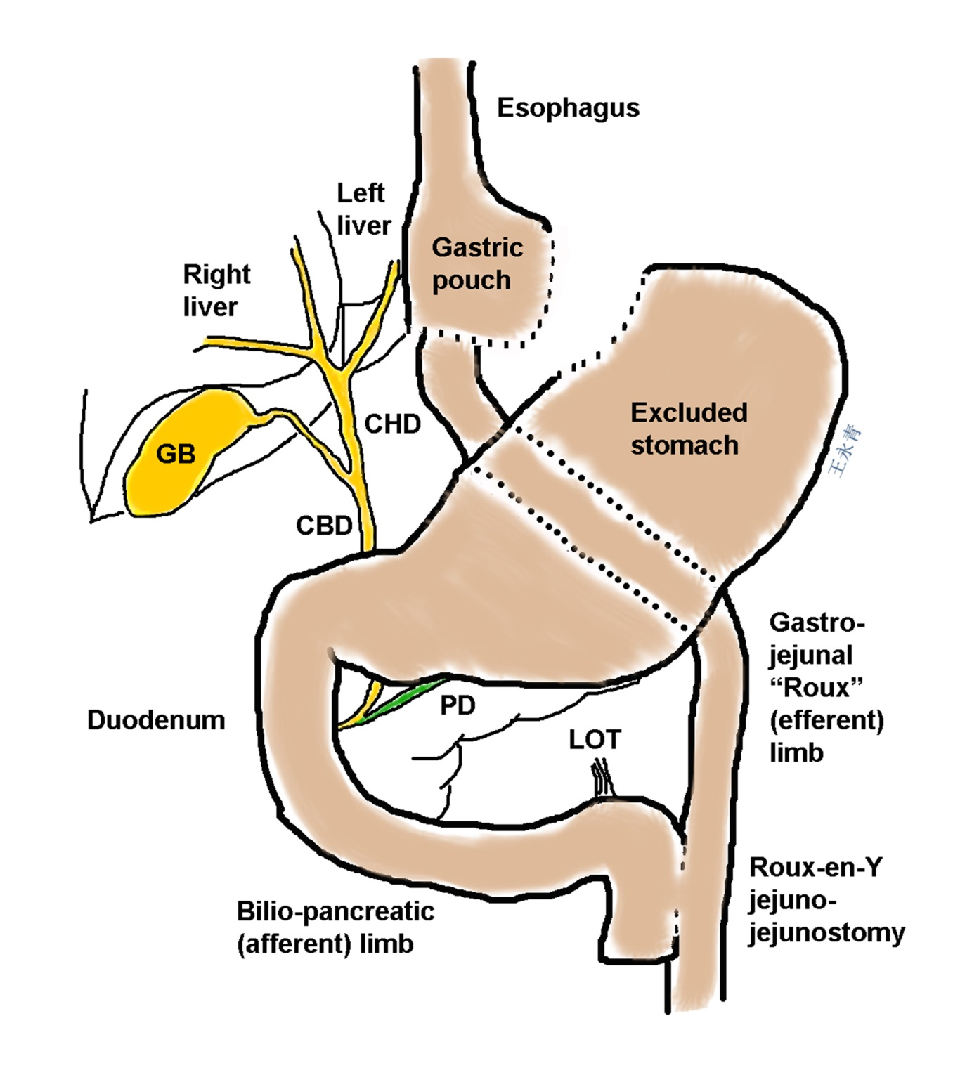
Figure 1 Surgically altered gastroduodenal anatomy found after Roux-en-Y gastric bypass.

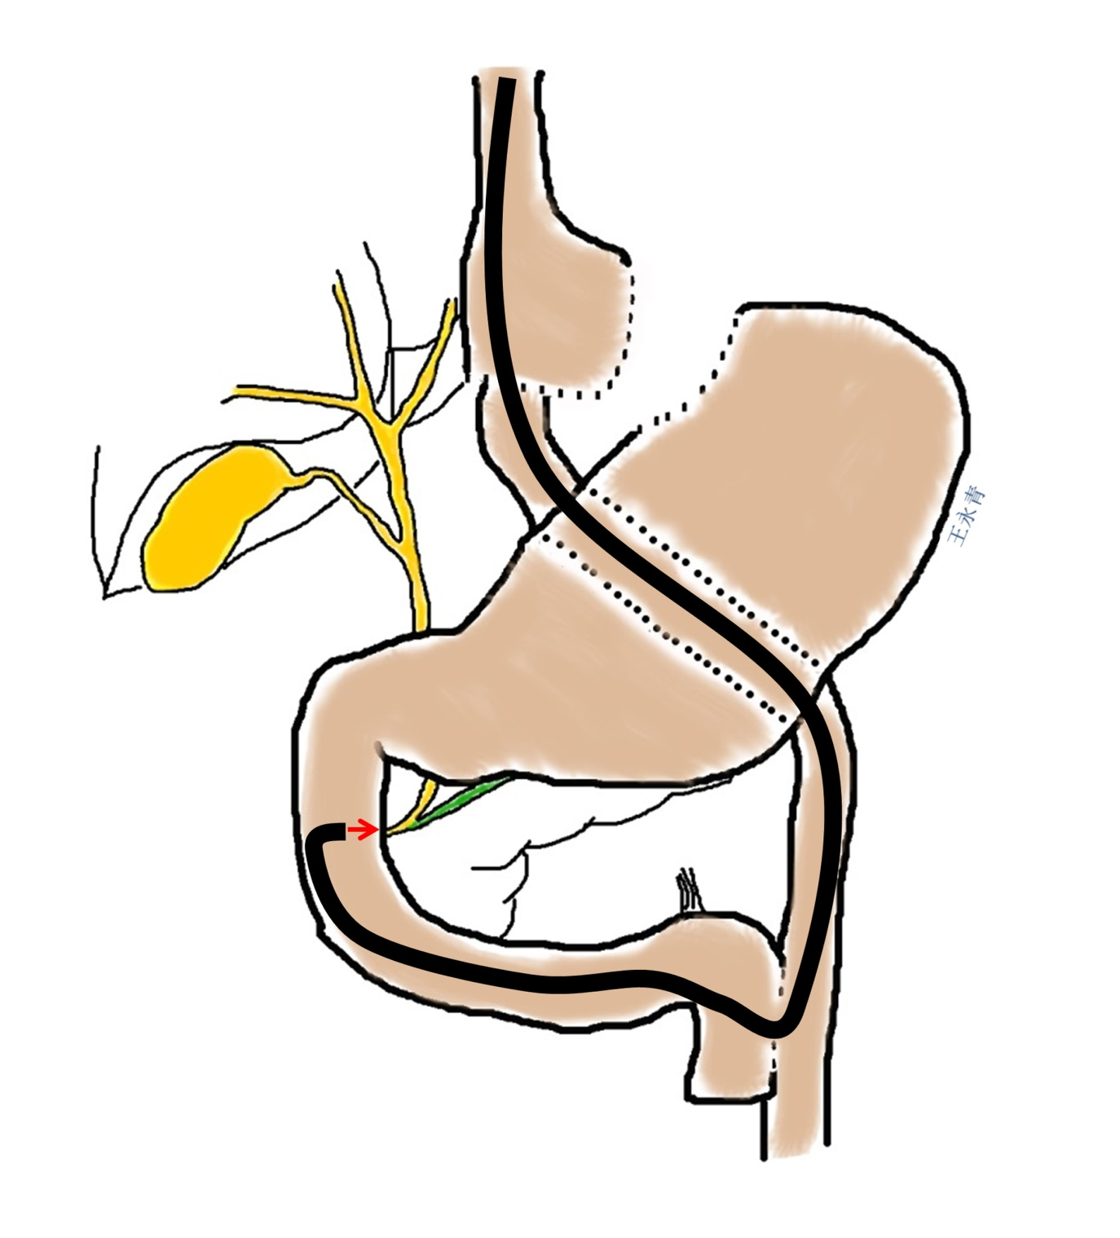
Figure 2 Using a long forward-viewing endoscope, such as an enteroscope with or without a spiral- or balloon-overtube or a pediatric colonoscope, endoscopic retrograde cholangiopancreatography can be performed in patients with Roux-en-Y gastric bypass anatomy or other surgically altered gastroduodenal anatomies. However, this technique is challenging due to forward-viewing optics, lack of an elevator, a smaller accessory channel, and need for speicalized long catheters and guidewires in order to accomplish endoscopic retrograde cholangiopancreatography.

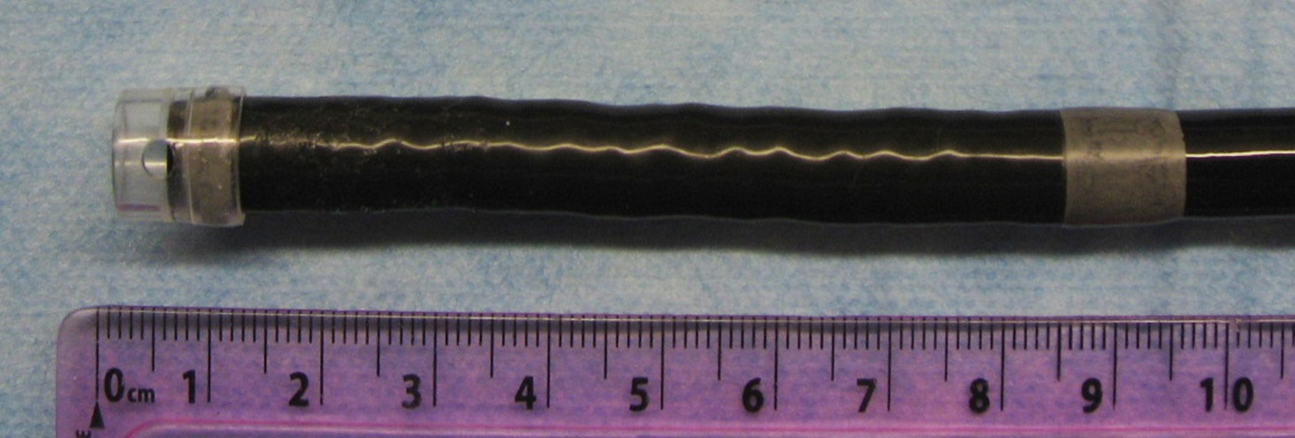

Figure 3 A low-profile, soft, distal attachment cap (D-201-10704, Olympus America, Center Valley, PA) is shown affixed to an enteroscope (SIF-Q180, Olympus America) for use in single-balloon-enteroscopy-assisted endoscopic retrograde cholangiopancreatography.

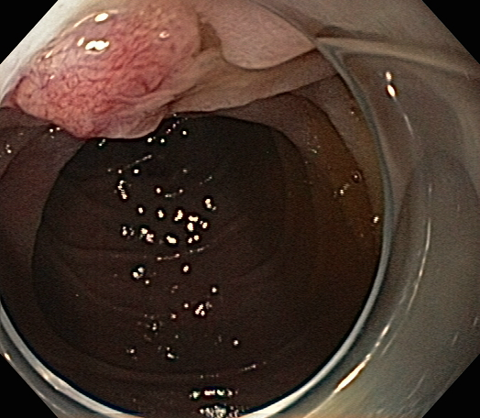
Figure 4 A low-profile, distal attachment cap was used in this case to push back duodenal folds to enable better visualization of the Ampulla of Vater during single-balloon-enteroscopy-assisted endoscopic retrograde cholangiopancreatography.

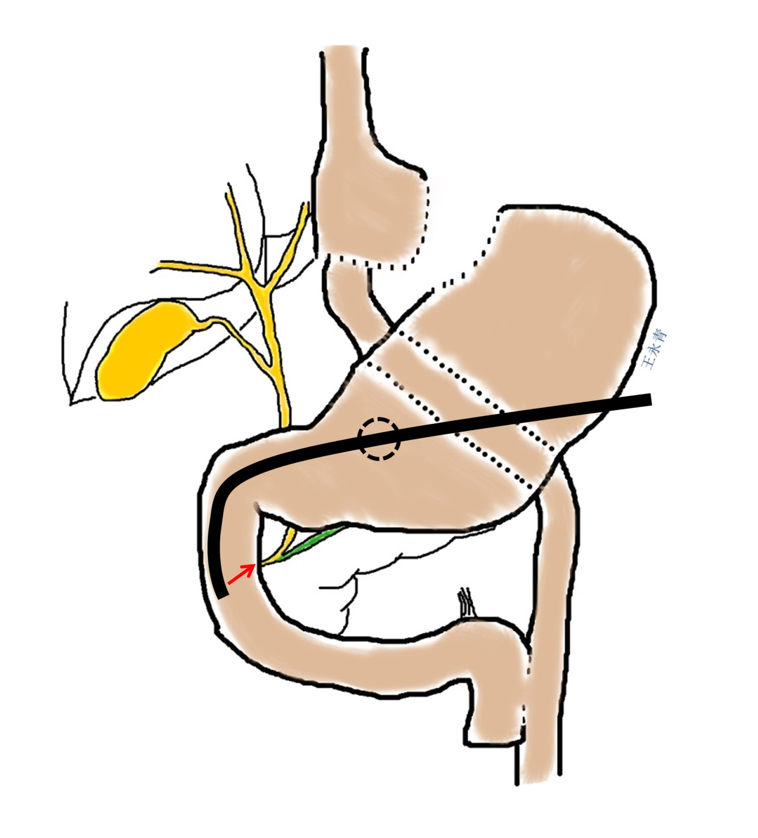
Figure 5 Endoscopic retrograde cholangiopancreatography using a duodenoscope can be performed in patients with Roux-en-Y gastric bypass anatomy by using a gastrostomy, which can be created surgically or endoscopically, to access the remnant stomach. Depending on the manner in which the gastrostomy is created, immediate or delayed endoscopic retrograde cholangiopancreatography can be performed.

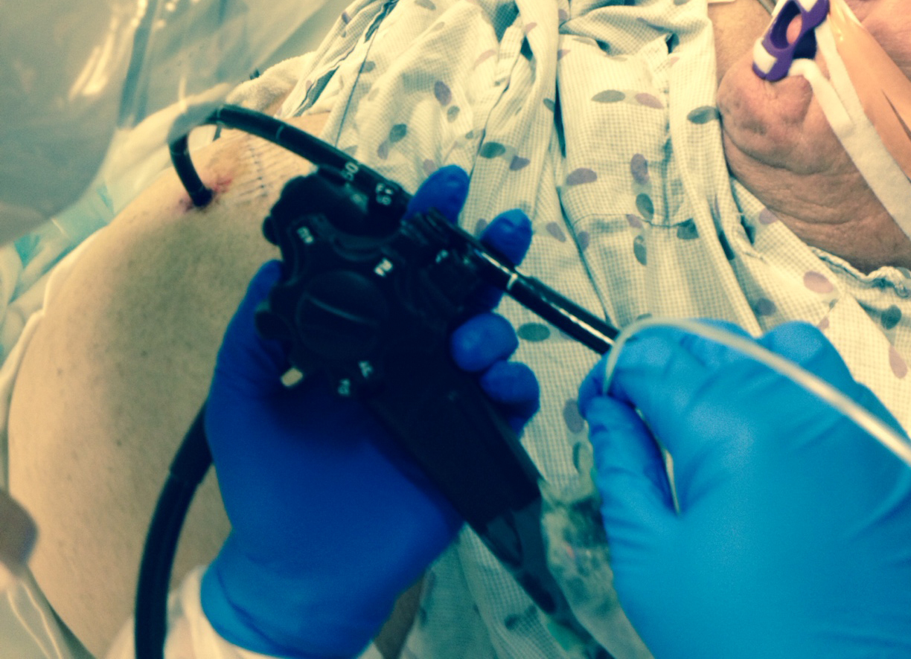

Figure 6 An example of transgastric endoscopic retrograde cholangiopancreatography in a patient with Roux-en-Y gastric bypass anatomy who underwent laparoscopic cholecystectomy and had an intraoperative cholangiogram that was suspicious for small, non-obstructing, bile duct stones. A 36-Fr Malecot tube had been left across a surgical Stamm gastrostomy. Endoscopic retrograde cholangiopancreatography in the supine position (under general anesthesia) was performed two weeks after surgical gastrostomy using a therapeutic duodenoscope. Despite an awkward scope position requiring the stabilization of the duodenoscope shaft using the left hand (as might be seen during complex colonoscopic polypectomy), biliary sphincterotomy and stone removal were successful.

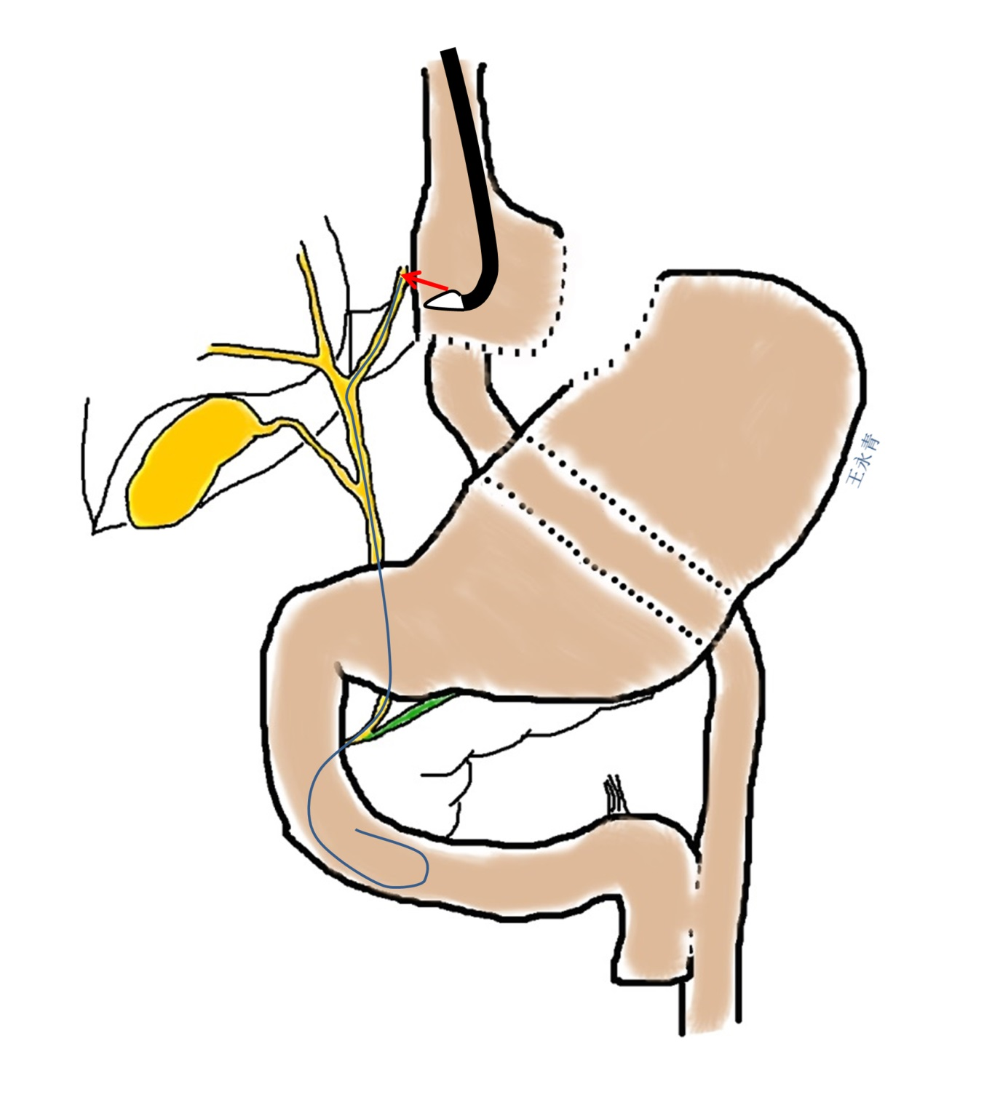
Figure 7 Using a therapeutic linear-array echoendoscope, a 19 G fine-needle-aspiration needle can be directed into dilated intrahepatic bile ducts in the left lobe of the liver. Once biliary access is established, up to an 0.035” guidewire can be passed antegrade across the extrahepatic bile duct and into the duodenum so as to facilitate rendezvous endoscopic retrograde cholangiopancreatography or antegrade bile duct therapy, such as large papillary balloon dilation to create sufficient space to push stones out of the bile duct and into the duodenum.

Table 1 Data from studies that evaluated the efficacy of single-balloon and double-balloon enteroscopy-assisted endoscopic retrograde cholangiopancreatography in patients with surgically altered gastroduodenal anatomy
Ref. | Method | Cases (n) | Cases with RY-anatomy | Reached ampulla/  orifice | Diagnostic ERCP success |  | Therapeutic ERCP success
Wang et al^{[22]} | SBE | 16 | 12 | 81.3% | 100% | 90%
Saleem et al^{[13]} | SBE | 56 | 56 | 75% | 92.8% | 91%
Itoi et al^{[17]} | SBE¹ | 13 | 11 | 92.3% | N/A | 83.3%
Shah et al^{[3]} | SBE | 45 | N/A | 69% | 87%² | 87%²
Yamauchi et al^{[16]} | Short SBE | 31 | 23 | 90% | 89% | 96%
Shah et al ^{3]} | DBE | 27 | N/A | 74% | 85%² | 85%²
Aabakken et al^{[41]} | DBE | 18 | 18 | 94.4% | 88% | 100%
Emmett et al^{[42]} | DBE | 20 | 20 | 85% | 94.1% | 100%
Pohl et al^{[43]} | DBE | 25 | 25 | 95.5% | N/A | 88.0%
Raithel et al^{[9]} | DBE | 86 | 29 | 74.1% | 91.3%² | 91.3%²
Shimatani et al^{[44]} | Short DBE | 103 | 81 | 97.1% | 98.0% | 100%
Itoi et al^{[15]} | Short and  Long DBE³ | 13⁴ | 13 | 100% | 66.7% | 100%
Cho et al^{[45]} | Short DBE | 29 | 13 | 86.2% | 96% | 100%
Osoegawa et al^{[14]} | Short DBE | 47 | 29 | 96% | 89% | 100%
Siddiqui et al^{[46]} | Short DBE | 79 | 51 | 89.9% | 90% | 100%
¹After the papilla was reached with the single-balloon enteroscope, it was replaced with a conventional forward-viewing upper gastrointestinal endoscope; ²Reported success was for both diagnostic and therapeutic procedures; ³For long double-balloon enteroscopy (DBE) cases, after the papilla was reached with the balloon enteroscope, it was replaced with a conventional forward-viewing gastroscope; ⁴Of 13 total cases, 5 patients underwent DBE, 4 patients underwent single-balloon enteroscopy (SBE). Diagnostic success rates were calculated only for those patients in whom the ampulla/orifice was reached. Therapeutic success rates do not include those patients in whom the ampulla/orifice was not reached and/or diagnostic endoscopic retrograde cholangiopancreatography (ERCP) failed or patients who did not require any therapeutic intervention.
Table 2 Reported rates of adverse events in patients with surgically altered gastroduodenal anatomy who underwent deep-enteroscopy-assisted endoscopic retrograde cholangiopancreatography
Ref. | Method | Cases (n) | Cases with RY anatomy | Pancreatitis | All adverse events
Wang et al^{[22]} | SBE | 16 | 12 | 12.5% | 12.5%
Saleem et al^{[13]} | SBE | 56 | 56 | 0% | 0%
Itoi et al^{[17]} | SBE | 13 | 11 | 0% | 0%
Yamauchi et al^{[16]} | Short SBE | 31 | 23 | 7.7% | N/A
Emmett et al^{[42]} | DBE | 20 | 20 | 0% | 0%
Raithel et al^{[9]} | DBE | 86 | 34 | 2.3% | N/A
Shimatani et al^{[44]} | Short DBE | 103 | 81 | 0% | 4.9%
Itoi et al^{[15]} | Long and short DBE | 13 | 13 | 0% | 7.7%
Siddiqui et al^{[46]} | Short DBE | 79 | 51 | 4% | 5%
Lennon et al^{[4]} | Spiral | 29 | 29 | 0% | 0%
Wagh et al^{[47]} | Spiral | 57 | 6 of 7 pts | 0% | 0%
DBE: Double-balloon enteroscopy; SBE: Single-balloon enteroscopy.

Table 3 Studies that evaluated the efficacy of spiral-enteroscopy-assisted ndoscopic retrograde cholangiopancreatography in patients with surgically altered gastroduodenal anatomy
Ref. | Method | Cases (n) | Cases with RY anatomy | Reached ampulla/orifice | Diagnostic ERCP success | Therapeutic ERCP success
Shah et al^{[3]} | Spiral | 57 | N/A | 72% | 90%¹ | 90%¹
Lennon et al^{[4]} | Spiral | 29 | 29 | N/A | 40% | 87.5%
Wagh et al^{[47]} | Spiral | 13 | 6 of 7 patients | 77% | 89% | 90%
¹Reported success was for both diagnostic and therapeutic procedures. Diagnostic success rates were calculated only for those patients in whom the ampulla/orifice was reached. Therapeutic success rates do not include those patients in whom the ampulla/orifice was not reached and/or diagnostic endoscopic retrograde cholangiopancreatography (ERCP) failed or patients who did not require any therapeutic intervention.

