Name of Journal: World Journal of Radiology
Manuscript NO: 44843
Manuscript Type: Minireviews

Artificial intelligence in breast ultrasound

Wu GG et al. AI in breast ultrasound

Ge-Ge Wu, Li-Qiang Zhou, Jian-Wei Xu, Jia-Yu Wang, Qi Wei, You-Bin Deng, Xin-Wu Cui, Christoph F Dietrich

Ge-Ge Wu, Li-Qiang Zhou, Jia-Yu Wang, Qi Wei, You-Bin Deng, Xin-Wu Cui, Christoph F Dietrich, Sino-German Tongji-Caritas Research Center of Ultrasound in Medicine, Department of Medical Ultrasound, Tongji Hospital, Tongji Medical College, Huazhong University of Science and Technology, Wuhan 430030, Hubei Province, China

Jian-Wei Xu, Department of Ultrasound, The first affiliated hospital of Zhengzhou University, Zhengzhou 450052, Henan Province, China

Christoph F Dietrich, Medical Clinic 2, Caritas-Krankenhaus Bad Mergentheim, Academic Teaching Hospital of the University of Würzburg, Würzburg 97980, Germany

ORCID number: Ge-Ge Wu (0000-0002-7159-2483); Li-Qiang Zhou (0000-0002-6025-2694); Jia-Yu Wang (0000-0001-9902-0666); Qi Wei (0000-0002-7955-406X); You-Bin Deng (0000-0001-8002-5109); Xin-Wu Cui (0000-0003-3890-6660); Christoph F Dietrich (0000-0001-6015-6347).

Author contributions: Cui XW established the design and conception of the paper; Wu GG, Zhou LQ, Xu JW, Wang JY, Wei Q, Deng YB, Cui XW and Dietrich CF explored the literature data; Wu GG provided the first draft of the manuscript, which was discussed and revised critically for intellectual content by Wu GG, Zhou LQ, Xu JW, Wang JY, Wei Q, Deng YB, Cui XW, Dietrich CF; all authors discussed the statement and conclusions and approved the final version to be published.

Conflict-of-interest statement: We declared that we do not have anything to disclose regarding funding or conflict of interest with respect to this manuscript.

Open-Access: This article is an open-access article which was selected by an in-house editor and fully peer-reviewed by external reviewers. It is distributed in accordance with the Creative Commons Attribution Non Commercial (CC BY-NC 4.0) license, which permits others to distribute, remix, adapt, build upon this work non-commercially, and license their derivative works on different terms, provided the original work is properly cited and the use is non-commercial. See: http://creativecommons.org/licenses/by-nc/4.0/

Manuscript source: Invited manuscript

Corresponding author: Xin-Wu Cui, MD, PhD, Professor, Deputy Director, ino-German Tongji-Caritas Research Center of Ultrasound in Medicine, Department of Medical Ultrasound, Tongji Hospital, Tongji Medical College, Huazhong University of Science and Technology, Jiefang Avenue No. 1095, Wuhan 430030, Hubei Province, China. cuixinwu@live.cn
Telephone: +86-27-83663754
Fax: +86-27-83663754

Received: November 29, 2018
Peer-review started: November 30, 2018
First decision: January 4, 2019
Revised: January 14, 2019
Accepted: January 26, 2019
Article in press: January 27, 2019
Published online: February 28, 2019

Abstract
Artificial intelligence (AI) is gaining extensive attention for its excellent performance in image-recognition tasks and increasingly applied in breast ultrasound. AI can conduct a quantitative assessment by recognizing imaging information automatically and make more accurate and reproductive imaging diagnosis. Breast cancer is the most common diagnosed cancer in women, severely threatening women’s health, the early screening of which is closely related to prognosis of patients. Therefore, utilization of AI in breast cancer screening and detection is of great significance, which can not only save time for radiologists, but also make up for experience and skill deficiency on some beginners. This article illustrates basic technical knowledge regarding AI in breast ultrasound, including early machine learning algorithms and deep learning algorithms, and their application in the differential diagnosis of benign and malignant masses. At last, we talk about the future perspectives of AI in breast ultrasound.

Key words: Breast; Ultrasound; Artificial intelligence; Machine learning; Deep learning

© The Author(s) 2019. Published by Baishideng Publishing Group Inc. All rights reserved.

Core tip: Artificial intelligence (AI) is gaining extensive attention for its excellent performance in image-recognition tasks and increasingly applied in breast ultrasound. In this review, we summarize the current knowledge of AI in breast ultrasound, including the technical aspects, its applications in the differentiation between benign and malignant breast masses. In the meanwhile, we also discuss the future perspectives, such as combining with elastography, contrast-enhanced ultrasound to improve the performance of AI in breast ultrasound.

Citation: Wu GG, Zhou LQ, Xu JW, Wang JY, Wei Q, Deng YB, Cui XW, Dietrich CF. Artificial intelligence in breast ultrasound. World J Radiol 2019; 11(2): 19-26
URL: https://www.wjgnet.com/1949-8470/full/v11/i2/19.htm
DOI: https://dx.doi.org/10.4329/wjr.v11.i2.19

Introduction
Breast cancer is the most common malignant tumor and the second leading cause of cancer death among women in the United States^{[1]}. In recent years, the incidence and mortality of breast cancer have increased year by year^{[2,3]}. Mortality can be reduced by early detection and timely therapy. Therefore, its early and correct diagnosis have received significant attention. There are several predominant diagnostic methods for breast cancer, such as X-ray mammography, ultrasound and magnetic resonance imaging (MRI).
Ultrasound is a first-line imaging tool for breast lesion characterization for its high availability, cost-effectiveness, acceptable diagnostic performance, and noninvasive and real-time capabilities. In addition to B-mode ultrasound, new techniques such as color Doppler, spectral Doppler, contrast-enhanced ultrasound, and elastography can also help ultrasound doctors obtain more accurate information. However, it suffers from operator dependence^{[4]}.
In recent years, artificial intelligence (AI), particularly deep learning (DL) algorithms, is gaining extensive attention for its extremely excellent performance in image-recognition tasks. AI can make a quantitative assessment by recognizing imaging information automatically so as to improve ultrasound performance in imaging breast lesions^{[5]}.
The use of AI in breast ultrasound has also combined with other novel technology, such as ultrasound radio frequency (RF) time series analysis^{[6]}, multimodality GPU-based computer-assisted diagnosis of breast cancer using ultrasound and digital mammography image^{[7]}, optical Breast imaging^{[8,9]}, QT-based breast tissue volume imaging^{[10]}, automated breast volume scanning (ABVS)^{[11]}.
So far, most studies on the use of AI in breast ultrasound focus on the differentiation of benign and malignant breast masses based on the B-mode ultrasound features of the masses. There is a need of a review to summarize the current status and future perspectives of the use of AI in breast ultrasound. In this paper, we introduce the applications of AI for breast mass detection and diagnosis with ultrasound.

Early AI
Early AI mainly refers to traditional machine learning. It solves problem with two steps: Object detection and object recognition. Firstly, machine uses a bounding box detection algorithm to scan the entire image to find the possible area of the object; secondly the object recognition algorithm identifies and recognizes the object based on the previous step.
In the identification process, experts need to determine certain features and encode them into a data type. The machine extracts such features through images, performs quantitative analysis processing and then gives a judgment. It will be able to assist the radiologist to discover and analyze the lesions and improve the accuracy and efficiency of the diagnosis.
In the 1980s, computer-aided diagnosis (CAD) technology developed rapidly in medical imaging diagnosis. The workflow of the CAD system is roughly divided into several processes: data preprocessing, image segmentation-feature, extraction, selection and classification recognition, and result output (Figure 1).

Feature extraction
In traditional machine learning, most applied features of breast mass on ultrasound, including shape, texture, location, orientation and so on, require experts to identify and encode each as a data type. Therefore, the performance of machine learning algorithms depends on the accuracy of the extracted features of benign and malignant breast masses.
Identifying effective computable features from the Breast Imaging Reporting and Data System (BI-RADS) can help distinguish between benign and potential malignant lesions with different machine learning methods. Lesion margin and orientation were optimum features in almost all of the different machine learning methods^{[12]}.
CAD model can also be used to classify benign and metastatic lymph nodes in patients with breast tumor. Zhang et al^{[13]} proposed a computer-assisted method through dual-modal features extracted from real-time elastography (RTE) and B-mode ultrasound. With the assistance of computer, five morphological features describing the hilum, size, shape, and echogenic uniformity of a lymph node were extracted from B-mode, and three elastic features consisting of hard area ratio, strain ratio, and coeﬃcient of variance were extracted from RTE. This computer-assisted method is proved to be valuable for the identification of benign and metastatic lymph nodes.

Segmentation
Recently, great progress has been made in processing and segmentation of images and selection of region of interest (ROI) in CAD. Feng et al^{[14]} proposed a method of adaptively utilizing neighboring information, which can effectively improve the breast tumor segmentation performance on ultrasound images. Cai et al^{[15]} proposed a phased congruency-based binary pattern texture descriptor, which is effective and robust to segamenta and classify B-mode ultrasound images regardless of image grey-scale variation.

Classification and recognition
According to the similarity of algorithm functions and forms, machine learning generally includes support vector machine, fuzzy logic, artificial neural network, etc., and each has its own advantages and disadvantages. Bing et al^{[16]} proposes a novel method based on sparse representation for breast ultrasound image classification under the framework of multi-instance learning (MIL). Compared with state-of-the-art MIL method, this method achieved its obvious superiority in classification accuracy.
Lee et al^{[17]} studied a novel Fourier-based shape feature extraction techniques and proved that this technique provides higher classification accuracy for breast tumors in computer-aided B-mode ultrasound diagnosis system.
Otherwise, more features extracted and trained may benefit the recognition effciency. De et al^{[18]} questioned the claim that training of machines with a simplified set of features would have a better effect on recognition, they conducted related experiments, the results showed that the performance obtained with all 22 features in this experiment was slightly better than that obtained with a reduced set of features.

DL algorithms
In contrast to traditional machine learning algorithms, DL algorithms do not rely on the features and ROI humans set in advance^{[19,20]}. On the contrary, it prefers carrying out all the task processions on its own. Take the convolutional neural networks (CNNs), the most popular architecture in DL as for medical imaging, for example, input layers, hidden layers, and output layers constitute the whole model, among which hidden layers are the key determinant of accomplishing the recognition. Hidden layers consist of quantities of convolutional layers and the fully connected layer. Convolutional layers handle different and massive problems the machine raise itself on the basis of the input task, and the fully connected layer then connects them to be a complex system so as to output the outcome easily^{[21]}. It has been proved that DL won an overwhelming victory over other architectures in computer vision completion despite its excessive data and hardware dependencies^{[22]}. In medical imaging, besides ultrasound^{[23]}, studies have found that DL methods also perform perfectly on computed tomography^{[24]} and MRI^{[25]} (Figure 2).

Classification and recognition
Becker et al^{[26]} conducted a retrospective study to evaluate the performance of a generic deep learning software (DLS) on classifying breast cancer based on ultrasound images. They found that the accuracy of DLS to diagnose breast cancer is comparable to radiologists, and DLS can learn better and faster than a human reader without prior experience.
Zhang et al^{[27]} established a DL architecture that could automatically extract image features from shear-wave elastography and evaluated the DL architecture in differentiation between benign and malignant breast tumors. The results showed that DL achieved better classification performance with an accuracy of 93.4%, a sensitivity of 88.6%, a specificity of 97.1%, and an area under the receiver operating characteristic curve (AUC) of 0.947.
Han et al^{[28]} used CNN DL framework to differentiate the distinctive types of lesions and nodules in breast acquired with ultrasound imaging. The networks showed an accuracy of about 0.9, a sensitivity of 0.86 and a specificity of 0.96. This method shows promising results to classify malignant lesions in a short time and supports the diagnosis of radiologists in discriminating malignant lesions. Therefore, the proposed method can work in tandem with human radiologists to improve performance.

Transferred Deep Neural Networks
CNN has proven to be an effective task classifier, while it requires a large amount of training data, which can be a difficult task. Transferred deep neural networks are powerful tools for training deeper networks without overfitting and they may have better performance than CNN. Xiao et al^{[29]} compared the performance of three transferred models, a CNN model and a traditional machine learning-based model to differentiate benign and malignant tumors from breast ultrasound data and found that the transfer learning method outperformed the traditional machine learning model and the CNN model, where the transferred InceptionV3 achieved the best performance with an accuracy of 85.13% and an AUC of 0.91. Moreover, they built the model with combined features extracted from all three transferred models which achieved the best performance with an accuracy of 89.44% and an AUC of 0.93 on an independent test set.
Yap et al^{[30]} studied the use of three DL methods (patch-based LeNet, U-Net, a transfer learning approach with a pretrained FCN-AlexNet) for breast ultrasound lesion detection and compared their performance against four state-of-the-art lesion detection algorithms. The results demonstrate that transfer learning method showed the best performance over the other two DL approaches when assessed on two datasets in terms of True Positive Fraction, False Positives per image, and F-measure.

AI equipped in ultrasound system
Images are usually uploaded from the ultrasonic machine to the workstation for image re-processing, while a DL technique (S-detect) can directly identified and marked breast masses on ultrasound system. S-detect is a tool equipped in Samsung RS80A ultrasound system, it is based on the DL algorithm, it performs lesion segmentation, feature analysis and descriptions according to the BI-RADS 2003 or BI-RADS 2013 lexicon. It can give immediate judgment of benign or maglignance in the freezd images on the ultrasound machine after choosing ROI automatically or manually (Figure 3). Kim et al^{[31]} evaluates the diagnostic performance of S-detect for the differentiation of benign from malignant breast lesions. When the cutoff was set at category 4a in BI-RADS, the specificity, PPV, and accuracy was significantly higher in S-Detect compared to the radiologist (all P < 0.05), and the AUC is 0.725 compared to 0.653 (P = 0.038).
Di Segni et al^{[32]} also evaluated the diagnostic performance of S-detect in the assessment of focal breast lesions. S-detect showed sensitivity > 90% and 70.8% specificity, with inter-rater agreement ranging from moderate to good. S-detect may be a feasible tool for the characterization of breast lesions and assist physicians in making clinical decisions.

Conclusion
AI has been increasingly applied in ultrasound and proved to be a powerful tool to provide a reliable diagnosis with higher accuracy and efficiency and reduce the workload of pyhsicians. It is roughly divided into early machine learning controlled by manual input algorithms, and DL, with which software can self-study. There is still no guidelines to recommend the application of AI with ultrasound in clinical practice, more studies are required to explore more advanced methods and to prove their usefulness.
In near future, we believe that AI in breast ultrasound can not only distinguish between benign and malignant breast masses, but also further classify specific benign diseases, such as inflammative breast mass, fibroplasia, etc. In addition, AI in ultrasound may also predict Tumor Node Metastasis classification^{[33]}, prognosis and the treatment response for patients with breast cancer. Last but not the least, the accuracy of AI on ultrasound to differentiation benign from malignant breast lesions may not only base on B-mode ultrasound images, but also could combine images from other advanced techniqes, such as ABVS, elastography, contrast-enhanced ultrasound and so on.

REFERENCES
1 Siegel RL, Miller KD, Jemal A. Cancer Statistics, 2017. CA Cancer J Clin 2017; 67: 7-30 [PMID: 28055103 DOI: 10.3322/caac.21387]
2 Ferlay J, Soerjomataram I, Dikshit R, Eser S, Mathers C, Rebelo M, Parkin DM, Forman D, Bray F. Cancer incidence and mortality worldwide: sources, methods and major patterns in GLOBOCAN 2012. Int J Cancer 2015; 136: E359-E386 [PMID: 25220842 DOI: 10.1002/ijc.29210]
3 Global Burden of Disease Cancer Collaboration, Fitzmaurice C, Dicker D, Pain A, Hamavid H, Moradi-Lakeh M, MacIntyre MF, Allen C, Hansen G, Woodbrook R, Wolfe C, Hamadeh RR, Moore A, Werdecker A, Gessner BD, Te Ao B, McMahon B, Karimkhani C, Yu C, Cooke GS, Schwebel DC, Carpenter DO, Pereira DM, Nash D, Kazi DS, De Leo D, Plass D, Ukwaja KN, Thurston GD, Yun Jin K, Simard EP, Mills E, Park EK, Catalá-López F, deVeber G, Gotay C, Khan G, Hosgood HD 3rd, Santos IS, Leasher JL, Singh J, Leigh J, Jonas JB, Sanabria J, Beardsley J, Jacobsen KH, Takahashi K, Franklin RC, Ronfani L, Montico M, Naldi L, Tonelli M, Geleijnse J, Petzold M, Shrime MG, Younis M, Yonemoto N, Breitborde N, Yip P, Pourmalek F, Lotufo PA, Esteghamati A, Hankey GJ, Ali R, Lunevicius R, Malekzadeh R, Dellavalle R, Weintraub R, Lucas R, Hay R, Rojas-Rueda D, Westerman R, Sepanlou SG, Nolte S, Patten S, Weichenthal S, Abera SF, Fereshtehnejad SM, Shiue I, Driscoll T, Vasankari T, Alsharif U, Rahimi-Movaghar V, Vlassov VV, Marcenes WS, Mekonnen W, Melaku YA, Yano Y, Artaman A, Campos I, MacLachlan J, Mueller U, Kim D, Trillini M, Eshrati B, Williams HC, Shibuya K, Dandona R, Murthy K, Cowie B, Amare AT, Antonio CA, Castañeda-Orjuela C, van Gool CH, Violante F, Oh IH, Deribe K, Soreide K, Knibbs L, Kereselidze M, Green M, Cardenas R, Roy N, Tillmann T, Li Y, Krueger H, Monasta L, Dey S, Sheikhbahaei S, Hafezi-Nejad N, Kumar GA, Sreeramareddy CT, Dandona L, Wang H, Vollset SE, Mokdad A, Salomon JA, Lozano R, Vos T, Forouzanfar M, Lopez A, Murray C, Naghavi M. The Global Burden of Cancer 2013. JAMA Oncol 2015; 1: 505-527 [PMID: 26181261 DOI: 10.1001/jamaoncol.2015.0735]
4 Hooley RJ, Scoutt LM, Philpotts LE. Breast ultrasonography: state of the art. Radiology 2013; 268: 642-659 [PMID: 23970509 DOI: 10.1148/radiol.13121606]
5 Hosny A, Parmar C, Quackenbush J, Schwartz LH, Aerts HJWL. Artificial intelligence in radiology. Nat Rev Cancer 2018; 18: 500-510 [PMID: 29777175 DOI: 10.1038/s41568-018-0016-5]
6 Uniyal N, Eskandari H, Abolmaesumi P, Sojoudi S, Gordon P, Warren L, Rohling RN, Salcudean SE, Moradi M. Ultrasound RF time series for classification of breast lesions. IEEE Trans Med Imaging 2015; 34: 652-661 [PMID: 25350925 DOI: 10.1109/TMI.2014.2365030]
7 Sidiropoulos KP, Kostopoulos SA, Glotsos DT, Athanasiadis EI, Dimitropoulos ND, Stonham JT, Cavouras DA. Multimodality GPU-based computer-assisted diagnosis of breast cancer using ultrasound and digital mammography images. Int J Comput Assist Radiol Surg 2013; 8: 547-560 [PMID: 23354971 DOI: 10.1007/s11548-013-0813-y]
8 Pearlman PC, Adams A, Elias SG, Mali WP, Viergever MA, Pluim JP. Mono- and multimodal registration of optical breast images. J Biomed Opt 2012; 17: 080901-080901 [PMID: 23224161 DOI: 10.1117/1.JBO.17.8.080901]
9 Lee JH, Kim YN, Park HJ. Bio-optics based sensation imaging for breast tumor detection using tissue characterization. Sensors (Basel) 2015; 15: 6306-6323 [PMID: 25785306 DOI: 10.3390/s150306306]
10 Malik B, Klock J, Wiskin J, Lenox M. Objective breast tissue image classification using Quantitative Transmission ultrasound tomography. Sci Rep 2016; 6: 38857 [PMID: 27934955 DOI: 10.1038/srep38857]
11 Wang HY, Jiang YX, Zhu QL, Zhang J, Xiao MS, Liu H, Dai Q, Li JC, Sun Q. Automated Breast Volume Scanning: Identifying 3-D Coronal Plane Imaging Features May Help Categorize Complex Cysts. Ultrasound Med Biol 2016; 42: 689-698 [PMID: 26742895 DOI: 10.1016/j.ultrasmedbio.2015.11.019]
12 Shen WC, Chang RF, Moon WK, Chou YH, Huang CS. Breast ultrasound computer-aided diagnosis using BI-RADS features. Acad Radiol 2007; 14: 928-939 [PMID: 17659238 DOI: 10.1016/j.acra.2007.04.016]
13 Zhang Q, Suo J, Chang W, Shi J, Chen M. Dual-modal computer-assisted evaluation of axillary lymph node metastasis in breast cancer patients on both real-time elastography and B-mode ultrasound. Eur J Radiol 2017; 95: 66-74 [PMID: 28987700 DOI: 10.1016/j.ejrad.2017.07.027]
14 Feng Y, Dong F, Xia X, Hu CH, Fan Q, Hu Y, Gao M, Mutic S. An adaptive Fuzzy C-means method utilizing neighboring information for breast tumor segmentation in ultrasound images. Med Phys 2017; 44: 3752-3760 [PMID: 28513858 DOI: 10.1002/mp.12350]
15 Cai L, Wang X, Wang Y, Guo Y, Yu J, Wang Y. Robust phase-based texture descriptor for classification of breast ultrasound images. Biomed Eng Online 2015; 14: 26 [PMID: 25889570 DOI: 10.1186/s12938-015-0022-8]
16 Bing L, Wang W. Sparse Representation Based Multi-Instance Learning for Breast Ultrasound Image Classification. Comput Math Methods Med 2017; 2017: 7894705 [PMID: 28690670 DOI: 10.1155/2017/7894705]
17 Lee JH, Seong YK, Chang CH, Park J, Park M, Woo KG, Ko EY. Fourier-based shape feature extraction technique for computer-aided B-Mode ultrasound diagnosis of breast tumor. Conf Proc IEEE Eng Med Biol Soc 2012; 2012: 6551-6554 [PMID: 23367430 DOI: 10.1109/EMBC.2012.6347495]
18 de S Silva SD, Costa MG, de A Pereira WC, Costa Filho CF. Breast tumor classification in ultrasound images using neural networks with improved generalization methods. Conf Proc IEEE Eng Med Biol Soc 2015; 2015: 6321-6325 [PMID: 26737738 DOI: 10.1109/EMBC.2015.7319838]
19 Miotto R, Wang F, Wang S, Jiang X, Dudley JT. Deep learning for healthcare: review, opportunities and challenges. Brief Bioinform 2018; 19: 1236-1246 [PMID: 28481991 DOI: 10.1093/bib/bbx044]
20 Shen D, Wu G, Suk HI. Deep Learning in Medical Image Analysis. Annu Rev Biomed Eng 2017; 19: 221-248 [PMID: 28301734 DOI: 10.1146/annurev-bioeng-071516-044442]
21 Suzuki K. Overview of deep learning in medical imaging. Radiol Phys Technol 2017; 10: 257-273 [PMID: 28689314 DOI: 10.1007/s12194-017-0406-5]
22 Erickson BJ, Korfiatis P, Akkus Z, Kline TL. Machine Learning for Medical Imaging. Radiographics 2017; 37: 505-515 [PMID: 28212054 DOI: 10.1148/rg.2017160130]
23 Metaxas D, Axel L, Fichtinger G, Szekely G. Medical image computing and computer-assisted intervention--MICCAI2008. Preface. Med Image Comput Comput Assist Interv 2008; 11: V-VII [PMID: 18979724 DOI: 10.1007/978-3-540-85988-8]
24 González G, Ash SY, Vegas-Sánchez-Ferrero G, Onieva Onieva J, Rahaghi FN, Ross JC, Díaz A, San José Estépar R, Washko GR; COPDGene and ECLIPSE Investigators. Disease Staging and Prognosis in Smokers Using Deep Learning in Chest Computed Tomography. Am J Respir Crit Care Med 2018; 197: 193-203 [PMID: 28892454 DOI: 10.1164/rccm.201705-0860OC]
25 Ghafoorian M, Karssemeijer N, Heskes T, van Uden IWM, Sanchez CI, Litjens G, de Leeuw FE, van Ginneken B, Marchiori E, Platel B. Location Sensitive Deep Convolutional Neural Networks for Segmentation of White Matter Hyperintensities. Sci Rep 2017; 7: 5110 [PMID: 28698556 DOI: 10.1038/s41598-017-05300-5]
26 Becker AS, Mueller M, Stoffel E, Marcon M, Ghafoor S, Boss A. Classification of breast cancer in ultrasound imaging using a generic deep learning analysis software: a pilot study. Br J Radiol 2018; 91: 20170576 [PMID: 29215311 DOI: 10.1259/bjr.20170576]
27 Zhang Q, Xiao Y, Dai W, Suo J, Wang C, Shi J, Zheng H. Deep learning based classification of breast tumors with shear-wave elastography. Ultrasonics 2016; 72: 150-157 [PMID: 27529139 DOI: 10.1016/j.ultras.2016.08.004]
28 Han S, Kang HK, Jeong JY, Park MH, Kim W, Bang WC, Seong YK. A deep learning framework for supporting the classification of breast lesions in ultrasound images. Phys Med Biol 2017; 62: 7714-7728 [PMID: 28753132 DOI: 10.1088/1361-6560/aa82ec]
29 Xiao T, Liu L, Li K, Qin W, Yu S, Li Z. Comparison of Transferred Deep Neural Networks in Ultrasonic Breast Masses Discrimination. Biomed Res Int 2018; 2018: 4605191 [PMID: 30035122 DOI: 10.1155/2018/4605191]
30 Yap MH, Pons G, Marti J, Ganau S, Sentis M, Zwiggelaar R, Davison AK, Marti R, Moi Hoon Yap, Pons G, Marti J, Ganau S, Sentis M, Zwiggelaar R, Davison AK, Marti R. Automated Breast Ultrasound Lesions Detection Using Convolutional Neural Networks. IEEE J Biomed Health Inform 2018; 22: 1218-1226 [PMID: 28796627 DOI: 10.1109/JBHI.2017.2731873]
31 Kim K, Song MK, Kim EK, Yoon JH. Clinical application of S-Detect to breast masses on ultrasonography: a study evaluating the diagnostic performance and agreement with a dedicated breast radiologist. Ultrasonography 2017; 36: 3-9 [PMID: 27184656 DOI: 10.14366/usg.16012]
32 Di Segni M, de Soccio V, Cantisani V, Bonito G, Rubini A, Di Segni G, Lamorte S, Magri V, De Vito C, Migliara G, Bartolotta TV, Metere A, Giacomelli L, de Felice C, D'Ambrosio F. Automated classification of focal breast lesions according to S-detect: validation and role as a clinical and teaching tool. J Ultrasound 2018; 21: 105-118 [PMID: 29681007 DOI: 10.1007/s40477-018-0297-2]
33 Plichta JK, Ren Y, Thomas SM, Greenup RA, Fayanju OM, Rosenberger LH, Hyslop T, Hwang ES. Implications for Breast Cancer Restaging Based on the 8th Edition AJCC Staging Manual. Ann Surg 2018 [PMID: 30312199 DOI: 10.1097/SLA.0000000000003071]

P-Reviewer: Bazeed MF, Gao BL S-Editor: Ji FF L-Editor: A E-Editor: Song H

Specialty type: Radiology, nuclear medicine and medical imaging
Country of origin: China
Peer-review report classification
Grade A (Excellent): 0
Grade B (Very good): B
Grade C (Good): C
Grade D (Fair): 0
Grade E (Poor): 0

Image acqusition and pre-processsing

Feature algorithm
imput
Classificati-on and recognition
Outcome
output

Figure 1 Workflow of machine learining algorithm.

Image acqusition and pre-processsing
Imput 60% of pictures and answers
Auto studying and training
Modification by 20% of images
Examined by 20% of images

Figure 2 Workflow of deep learining algorithm.

A
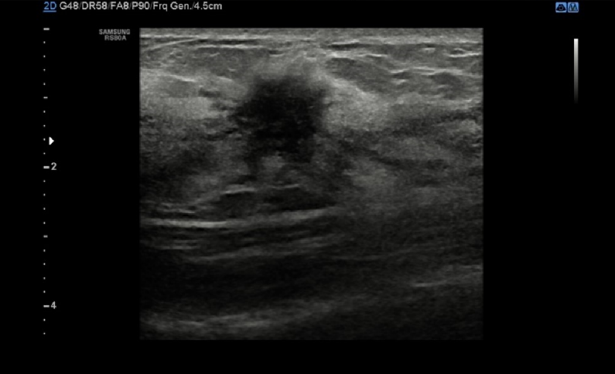
B
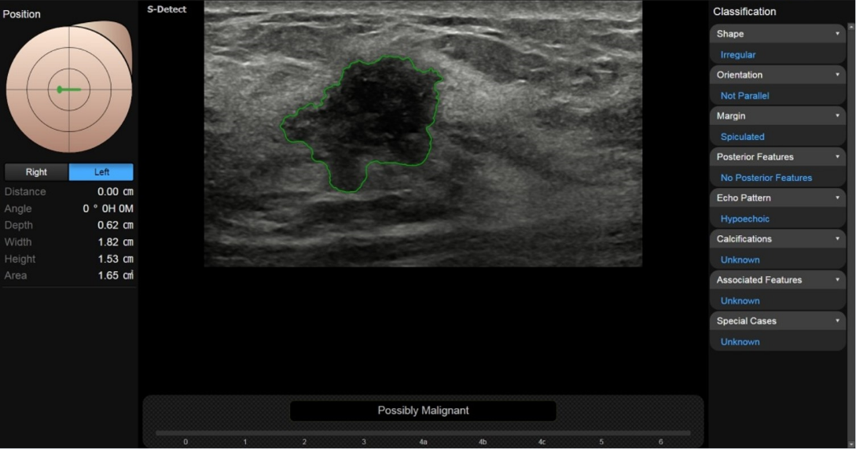
C
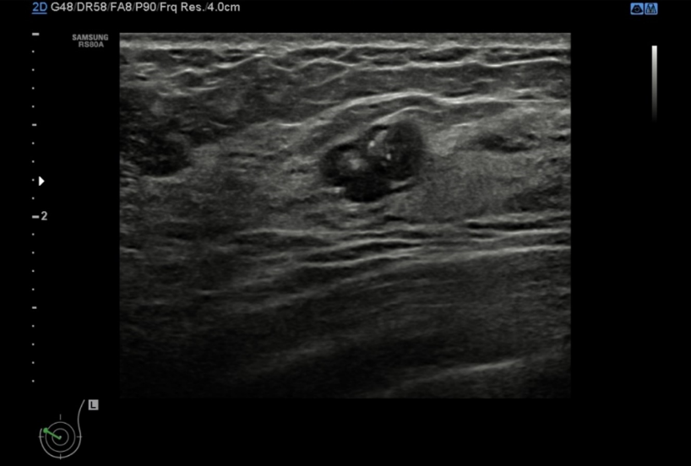
D
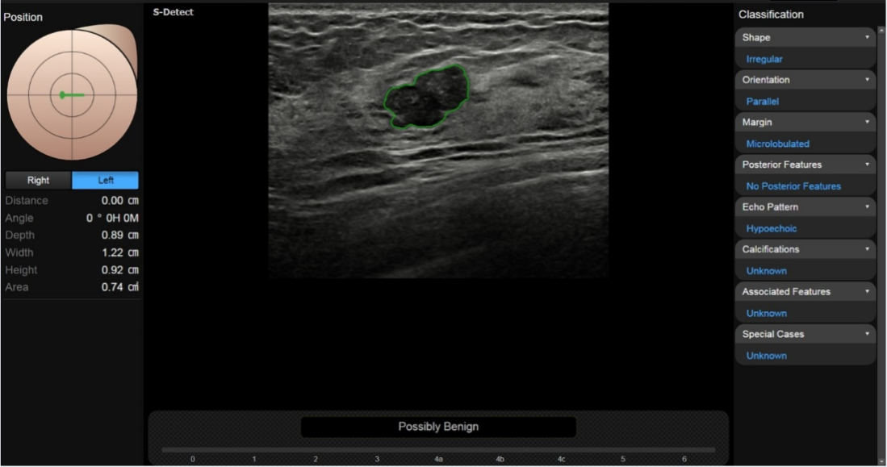

Figure 3 S-detect technique in Samsung RS80A ultrasound system. A, B: A 47 years old woman with left invasive breast cancer on B-mode ultrasound (A), S-detect correctly concluded it is “Possibly Malignant” base on the lesion features listed on the right column (B); C, D: A 55 years old woman with fibroadenoma of left breast on B-mode ultrasound (C), S-detect correctly concluded it is “Possibly Benign” base on the lesion features listed on the right column (D).

