Name of Journal: World Journal of Gastrointestinal Endoscopy
Manuscript NO: 69038
Manuscript Type: CASE REPORT

Acute upper gastrointestinal bleeding caused by esophageal right bronchial artery fistula: A case report

Martino A et al. Esophageal right bronchial artery fistula

Alberto Martino, Gaspare Oliva, Francesco Paolo Zito, Mattia Silvestre, Raffaele Bennato, Luigi Orsini, Raffaella Niola, Luigia Romano, Giovanni Lombardi

Alberto Martino, Francesco Paolo Zito, Raffaele Bennato, Luigi Orsini, Giovanni Lombardi, Department of Gastroenterology and Digestive Endoscopy, AORN “Antonio Cardarelli”, Napoli 80131, Italy

Gaspare Oliva, Luigia Romano, Department of General and Emergency Radiology, AORN “Antonio Cardarelli”, Napoli 80131, Italy

Mattia Silvestre, Raffaella Niola, Department of Interventional Radiology, AORN “Antonio Cardarelli”, Napoli 80131, Italy

Author contributions: Martino A, Oliva G was responsible for the conception of the paper; Martino A, Oliva G, Zito FP, Silvestre M, Bennato R and Orsini L drafting of the article, interpretation of the data and final approval of the article; Martino A execution of the endoscopic procedures; Oliva G execution of the diagnostic radiological examinations; Silvestre M execution of the interventional radiological procedures; Niola R, Romano L and Lombardi G analysis and interpretation of data, revision of the manuscript for important intellectual content and final approval of the article.

Corresponding author: Alberto Martino, MD, Staff Physician, Department of Gastroenterology and Digestive Endoscopy, AORN “Antonio Cardarelli”, Via Antonio Cardarelli 9, Napoli 80131, Italy. albertomartinomd@gmail.com

Received: June 29, 2021
Revised: August 4, 2021
Accepted: October 15, 2021
Published online: November 16, 2021

Abstract
BACKGROUND
Fistula between the esophagus and bronchial artery is an extremely rare and potentially life-threatening cause of acute upper gastrointestinal bleeding. Here, we report a case of fistula formation between the esophagus and a nonaneurysmal right bronchial artery (RBA).

CASE SUMMARY
An 80-year-old woman with previous left pneumonectomy and recent placement of an uncovered self-expandable metallic stent for esophageal adenocarcinoma was admitted due to hematemesis. Emergent computed tomography showed indirect signs of fistulization between the esophagus and a nonaneurysmal RBA, in the absence of active bleeding. Endoscopy revealed the esophageal stent correctly placed and a moderate amount of red blood within the stomach, in the absence of active bleeding or tumor ingrowth/overgrowth. After prompt multidisciplinary evaluation, a step-up approach was planned. The bleeding was successfully controlled by esophageal restenting followed by RBA embolization. No signs of rebleeding were observed and the patient was discharged home with stable hemoglobin level on postoperative day 7.

CONCLUSION
This was a previously unreported case of an esophageal RBA fistula successfully managed by esophageal restenting followed by RBA embolization.

Key Words: Upper gastrointestinal bleeding; Acute upper gastrointestinal bleeding; Esophageal fistula; Bronchial artery esophageal fistula; Esophageal stenting; Esophageal self-expandable metal stenting; Case report

©The Author(s) 2021. Published by Baishideng Publishing Group Inc. All rights reserved.

Citation: Martino A, Oliva G, Zito FP, Silvestre M, Bennato R, Orsini L, Niola R, Romano L, Lombardi G. Acute upper gastrointestinal bleeding caused by esophageal right bronchial artery fistula: A case report. World J Gastrointest Endosc 2021; 13(11): 565-570
URL: https://www.wjgnet.com/1948-5190/full/v13/i11/565.htm
DOI: https://dx.doi.org/10.4253/wjgo.v13.i11.565

Core Tip: Esophageal bronchial artery fistula is an extremely rare cause of upper gastrointestinal bleeding. Here, we describe a previously unreported case of fistula formation between the esophagus and a nonaneurysmal right bronchial artery (RBA), in the setting of palliative esophageal metallic stenting and previous left pneumonectomy. Hemostasis was achieved by the use of esophageal restenting followed by RBA embolization.

INTRODUCTION
Acute upper gastrointestinal bleeding (UGIB) is a potentially life-threatening emergency with a reported incidence of about 100 per 100000 persons per year^{[1,2]}. Its etiology has been divided into variceal and nonvariceal bleeding. The most common causes of acute UGIB include peptic ulcer disease and esophageal varices, followed by Mallory–Weiss syndrome and neoplasms^{[1-3]}. Acute UGIB caused by esophageal bronchial artery fistula is extremely rare. To date, only a few cases of fistula formation between the esophagus and the right bronchial artery (RBA) have been reported worldwide. Here, we describe a previously unreported case of a fistula between the esophagus and a nonaneurysmal RBA, in the setting of palliative esophageal metallic stenting and previous left pneumonectomy.

CASE PRESENTATION
Chief complaints
An 80-year-old woman was admitted to our bleeding unit due to severe anemia (hemoglobin 7.1 g/dL) and hematemesis with signs of hemodynamic instability.

History of present illness
One episode of hematemesis with presyncope occurred 1 h prior to hospital admission.

History of past illness
The patient underwent left pneumonectomy with adjuvant chemoradiotherapy for lung cancer 6 years before. An uncovered self-expandable metallic stent (SEMS) had been placed 3 mo prior at another institution for the palliation of a locally advanced esophageal adenocarcinoma.

Personal and family history
The patient denied further medical history. There was no family history of GI cancer.

Physical examination
On presentation, the patient was hemodynamically unstable (pulse 115 bpm, blood pressure 90/60 mmHg). She was afebrile, with respiratory rate 17 breaths/min and oxygen saturation 94%. On general physical examination, she looked pale and dehydrated. Abdominal examination revealed nondistended, nontender abdomen with normal bowel sounds. The rectal examination exhibited melena.

Laboratory examinations
Complete blood count analysis was notable for hemoglobin of 7.1 g/dL and hematocrit of 23.6%. All remaining laboratory examinations, including liver enzymes, coagulation studies and renal function tests, were within normal limits.

Imaging examinations
After blood transfusion and hemodynamic stabilization, emergent computed tomography (CT) angiography was performed showing no active GI bleeding with the esophageal stent correctly placed. The RBA appeared tortuous, dilated and tightly adherent to the thickened middle esophagus wall. Although no contrast extravasation was noted, the tissue planes between the RBA and the esophagus appeared obliterated (Figure 1).

MULTIDISCIPLINARY EXPERT CONSULTATION
After prompt multidisciplinary evaluation, involving a GI endoscopist, surgeon, and a diagnostic and interventional radiologist, a minimally invasive step-up approach with esophageal restenting followed, if necessary, by RBA embolization was planned.

FINAL DIAGNOSIS
Fistula formation between the esophagus and a nonaneurysmal RBA, in the setting of palliative esophageal metallic stenting and previous left pneumonectomy.

TREATMENT
Under fluoroscopic and direct endoscopic guidance, an over-the-guidewire partially covered SEMS was placed through the previously inserted uncovered SEMS. Immediately thereafter, diffuse esophageal bleeding controlled by the partially covered SEMS was endoscopically noted (Figure 2). On postoperative day (POD) 1, hematemesis with severe anemization (hemoglobin 5.7 g/dL) and hemodynamic instability occurred. After blood transfusion and hemodynamic stabilization, emergent CT angiography was repeated, showing the esophageal stents correctly placed with unmodified previous findings and no GI active bleeding. Esophagogastroduodenoscopy (EGD) revealed fresh blood within the esophagus and a large amount of dark blood under the partially covered SEMS, in the absence of identifiable active bleeding sites (Figure 3). Thus, operative angiography was performed. Selective RBA arteriography showed contrast extravasation within the esophagus and RBA was successfully embolized with microcoils (Figure 4).

OUTCOME AND FOLLOW-UP
Postoperative stay was complicated by the occurrence of pulmonary edema responsive to medical therapy. No rebleeding was observed and the patient was discharged home with stable hemoglobin level (9.1 g/dL) on POD 7. The patient died at home 1 mo postoperatively, in the absence of overt GI rebleeding or anemization.

DISCUSSION
Arterioesophageal fistulas (AEFs) are pathological communications between an arterial system and the esophagus, which may lead to exsanguination from massive UGIB if not recognized promptly. They develop most commonly due to aortic fistulization caused by foreign bodies, aortic aneurysm, or esophageal neoplasms^{[4-6]}. Nonaortic AEFs have been less frequently reported, with the bronchial artery being the most commonly involved vessel. Etiology includes foreign bodies, vascular surgery and thoracic arterial malformations, and chemoradiotherapy in esophageal cancer patients with invasion of the aorta^{[7,8]}.
Although extremely rare, an esophageal RBA fistula is a potentially life-threatening condition. To date, only a few cases of fistula formation between the esophagus and a bronchial artery aneurysm have been reported. Shaer and Bashist^{[9]} first reported a fatal case of massive UGIB due to a bronchial artery aneurysm with an esophageal fistula (BAAEF). Later on, two cases of BAAEFs successfully treated with RBA coil embolization have been reported^{[10,11]}. In 2018, Nakada et al^{[12]} reported a case of BAAEF caused by bronchial arterial embolization. Due to the unfeasibility of transcatheter coil embolization, hemostasis was achieved by emergent thoracic endovascular aortic repair. Subsequently, aneurysmotomy, debridement and pedicled omental flap repair were successfully performed. Finally, a case of fistula between the esophagus and a RBA pseudoaneurysm secondary to an endobronchial ultrasound-guided transbronchial needle aspiration has been recently reported. This was successfully managed by endoscopic clipping followed by transcatheter coil embolization^{[13]}.
Moreover, only four cases of esophageal fistulas with a nonaneurysmal RBA have been reported, including three patients with locally advanced esophageal cancer and one with Mallory–Weiss tear refractory to endoscopic hemostasis. In all cases, the esophageal bleeding was successfully controlled by means of transcatheter arterial embolization^{[14-16]}.
However, to our knowledge, this is the first reported case of a fistula between the esophagus and a nonaneurysmal RBA, in the setting of palliative esophageal metallic stenting and previous left pneumonectomy.
In our case, emergent CT showed no active GI bleeding with the esophageal stent correctly placed. Although no direct signs of fistulization were observed, the RBA appeared tortuous, dilated and tightly adherent to the thickened middle esophagus wall, with obliteration of the tissue planes between the RBA and the esophagus. Subsequent emergent EGD confirmed the absence of active bleeding without identifiable bleeding sources. After prompt multidisciplinary evaluation, a minimally invasive step-up approach with esophageal restenting followed, if necessary, by RBA embolization was planned. However, after esophageal restenting, rebleeding occurred. Thus, operative angiography was performed. Selective RBA arteriography showed contrast extravasation within the esophageal lumen and RBA embolization was performed.

CONCLUSION
Digestive endoscopists should be aware of this critical, albeit extremely rare, cause of UGIB, in order to provide prompt diagnosis and treatment. In our opinion, early diagnosis, multidisciplinary evaluation and prompt tailored treatment seem to be crucial for the proper management of an esophageal RBA fistula.

REFERENCES
1 van Leerdam ME. Epidemiology of acute upper gastrointestinal bleeding. Best Pract Res Clin Gastroenterol 2008; 22: 209-224 [PMID: 18346679 DOI: 10.1016/j.bpg.2007.10.011]
2 Hearnshaw SA, Logan RF, Lowe D, Travis SP, Murphy MF, Palmer KR. Acute upper gastrointestinal bleeding in the UK: patient characteristics, diagnoses and outcomes in the 2007 UK audit. Gut 2011; 60: 1327-1335 [PMID: 21490373 DOI: 10.1136/gut.2010.228437]
3 Longstreth GF. Epidemiology of hospitalization for acute upper gastrointestinal hemorrhage: a population-based study. Am J Gastroenterol 1995; 90: 206-210 [PMID: 7847286]
4 Kokatnur L, Rudrappa M. Primary aorto-esophageal fistula: Great masquerader of esophageal variceal bleeding. Indian J Crit Care Med 2015; 19: 119-121 [PMID: 25722556 DOI: 10.4103/0972-5229.151022]
5 Heckstall RL, Hollander JE. Aortoesophageal fistula: recognition and diagnosis in the emergency department. Ann Emerg Med 1998; 32: 502-505 [PMID: 9774937 DOI: 10.1016/s0196-0644(98)70182-9]
6 Hollander JE, Quick G. Aortoesophageal fistula: a comprehensive review of the literature. Am J Med 1991; 91: 279-287 [PMID: 1892150 DOI: 10.1016/0002-9343(91)90129-l]
7 Yang KC, Lin MY, Huang LT, Chang WL. Massive upper gastrointestinal bleeding caused by an intercostal arterio-esophageal fistula: A rare case report. Radiol Case Rep 2020; 15: 2026-2030 [PMID: 32922582 DOI: 10.1016/j.radcr.2020.07.083]
8 Tajima T, Haruki S, Usui S, Ito K, Matsumoto A, Matsuhisa A, Takiguchi N. Transcatheter arterial embolization for intercostal arterio-esophageal fistula in esophageal cancer. Surg Case Rep 2017; 3: 70 [PMID: 28510809 DOI: 10.1186/s40792-017-0345-8]
9 Shaer AH, Bashist B. Computed tomography of bronchial artery aneurysm with erosion into the esophagus. J Comput Assist Tomogr 1989; 13: 1069-1071 [PMID: 2584487 DOI: 10.1097/00004728-198911000-00023]
10 Kim JS, Lee SY, Son KH, Kim KW, Choi CH, Lee JI, Park KY, Park CH. Bronchial Artery Aneurysm Presenting as Hematemesis and Mediastinal Hemorrhage. Korean J Thorac Cardiovasc Surg 2015; 48: 298-301 [PMID: 26290845 DOI: 10.5090/kjtcs.2015.48.4.298]
11 Fukunaga A, Okushiba S, Ohno K, Kitashiro S, Kawarada Y, Shitinohe T, Kondo S, Katoh H. Mediastinal bronchial artery aneurysm with hematemesis. Dis Esophagus 2003; 16: 328-331 [PMID: 14641298 DOI: 10.1111/j.1442-2050.2003.00360.x]
12 Nakada T, Takahashi K, Ito E, Fukushima S, Yamamoto S, Takahashi N, Toya N, Akiba T, Morikawa T, Ohki T. A case of bronchial artery aneurysm with an esophageal fistula as an extremely rare complication after bronchial arterial embolization. J Thorac Dis 2018; 10: E476-E480 [PMID: 30069409 DOI: 10.21037/jtd.2018.05.164]
13 Jadeja S, Green K, Shuja A, Malespin M, De Melo S. Esophageal Bronchial Artery Fistulaization: A Complication of an Endobronchial Ultrasound. ACG Case Rep J 2020; 7: e00355 [PMID: 32548187 DOI: 10.14309/crj.0000000000000355]
14 Taniguchi H, Yamazaki K, Boku N, Funakoshi T, Hamauchi S, Tsushima T, Todaka A, Sakamoto T, Tomita H, Machida N, Taku K, Fukutomi A, Onozawa Y, Tsubosa Y, Sato H, Nishimura T, Yasui H. Risk factors and clinical courses of chemoradiation-related arterio-esophageal fistula in esophageal cancer patients with clinical invasion of the aorta. Int J Clin Oncol 2011; 16: 359-365 [PMID: 21347631 DOI: 10.1007/s10147-011-0192-8]
15 Aoki M, Tokue H, Koyama Y, Tsushima Y, Oshima K. Transcatheter arterial embolization with N-butyl cyanoacrylate for arterial esophageal bleeding in esophageal cancer patients. World J Surg Oncol 2016; 14: 54 [PMID: 26912065 DOI: 10.1186/s12957-016-0803-y]
16 Kim EM, Lee JH, Sung JK, Kang SH, Kim JI, Moon HS, Lee BS, Kim SH, Jeong HY. Successful bronchial artery embolization for refractory esophageal bleeding after failed endoscopic therapy. Endoscopy 2010; 42 Suppl 2: E42 [PMID: 20157881 DOI: 10.1055/s-0029-1214794]

Footnotes
Informed consent statement: Informed consent was obtained from the patient for the publication of this report and any accompanying images.

Conflict-of-interest statement: No conflict of interest declared.

CARE Checklist (2016) statement: The authors have read the CARE Checklist (2016), and the manuscript was prepared and revised according to the CARE Checklist (2016).

Open-Access: This article is an open-access article that was selected by an in-house editor and fully peer-reviewed by external reviewers. It is distributed in accordance with the Creative Commons Attribution NonCommercial (CC BY-NC 4.0) license, which permits others to distribute, remix, adapt, build upon this work non-commercially, and license their derivative works on different terms, provided the original work is properly cited and the use is non-commercial. See: http://creativecommons.org/Licenses/by-nc/4.0/

Manuscript source: Unsolicited manuscript
Corresponding Author's Membership in Professional Societies: European Society of Gastrointestinal Endoscopy (ESGE); Italian Association of Hospital Gastroenterologists and Digestive Endoscopists (AIGO); Italian Society for Digestive Endoscopy (SIED).

Peer-review started: June 29, 2021
First decision: July 27, 2021
Article in press: October 15, 2021

Specialty type: Gastroenterology and hepatology
Country/Territory of origin: Italy
Peer-review report’s scientific quality classification
Grade A (Excellent): 0
Grade B (Very good): 0
Grade C (Good): C
Grade D (Fair): 0
Grade E (Poor): 0

P-Reviewer: Chi TY S-Editor: Liu M L-Editor: Kerr C P-Editor: Liu M
Figure Legends
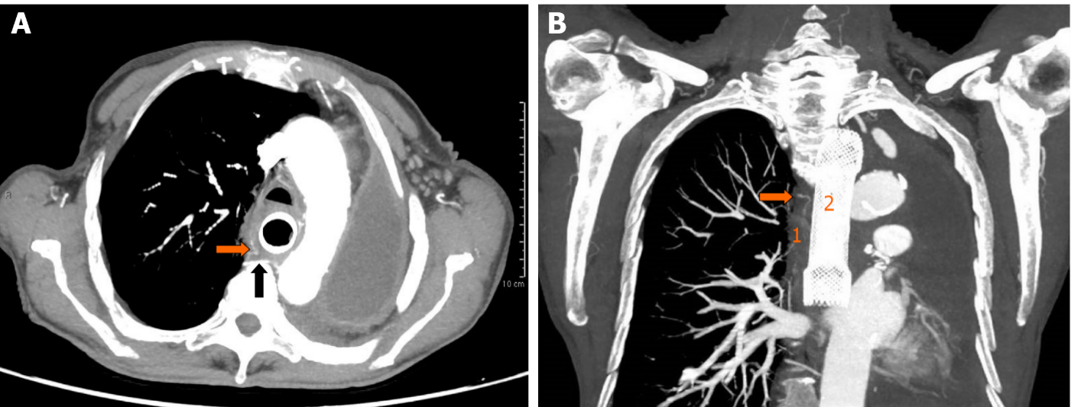
Figure 1 Arterial phase contrast-enhanced computed tomography. A: Axial view showing the tortuous and dilated right bronchial artery (orange arrow) originating from the right third posterior intercostal artery (black arrow); B: Coronal view showing delation of the tissue planes between the right bronchial artery (orange arrow) and the thickened middle esophageal wall (1), with correct placement of the esophageal metal stent (2).

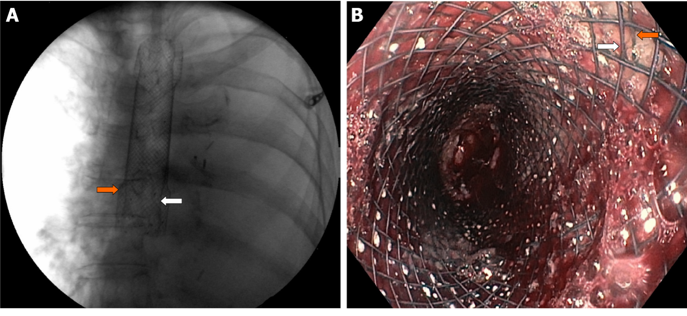
Figure 2 Placement of partially covered self-expandable metal stent (white arrow) through the previously inserted uncovered metal stent (orange arrow). A: fluoroscopic view; B: Endoscopic view showing esophageal bleeding controlled by the partially covered metal stent.

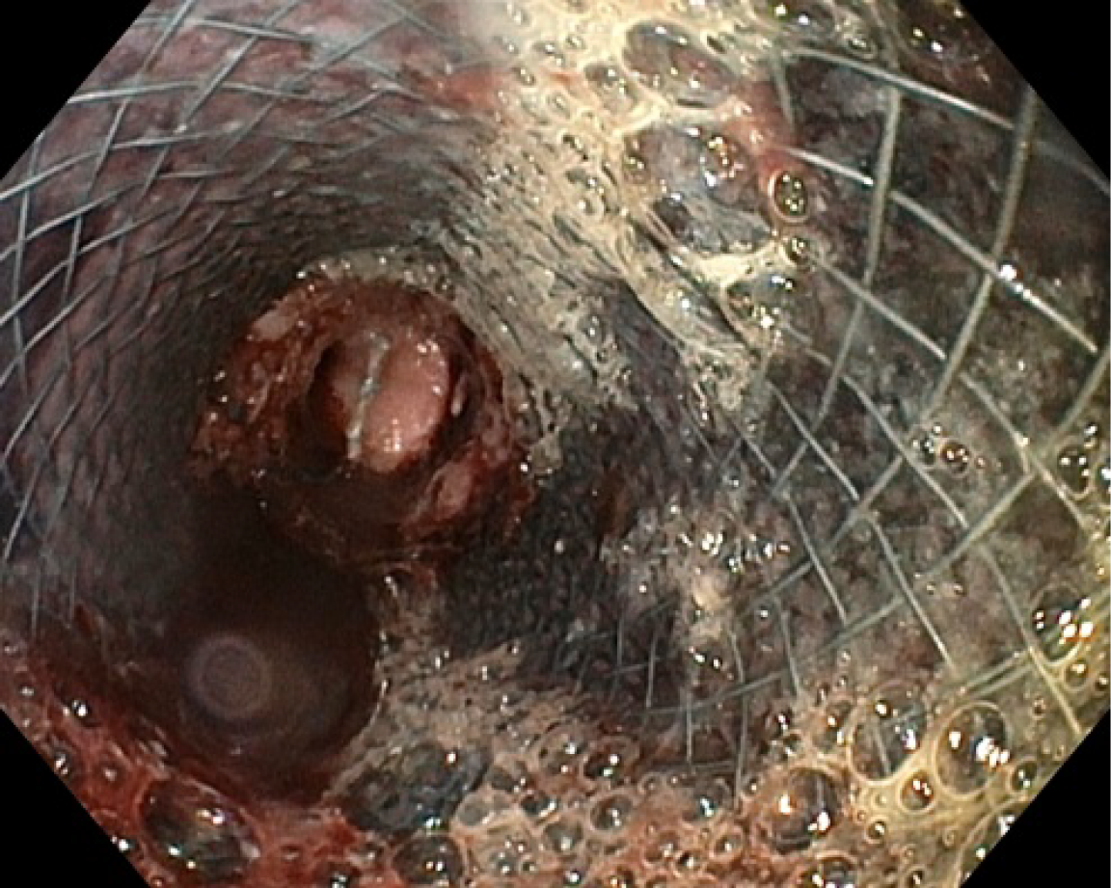
Figure 3 Second upper endoscopy showing fresh blood within the esophageal lumen and a diffuse amount of dark blood under the partially covered metal stent, in the absence of active bleeding sites.

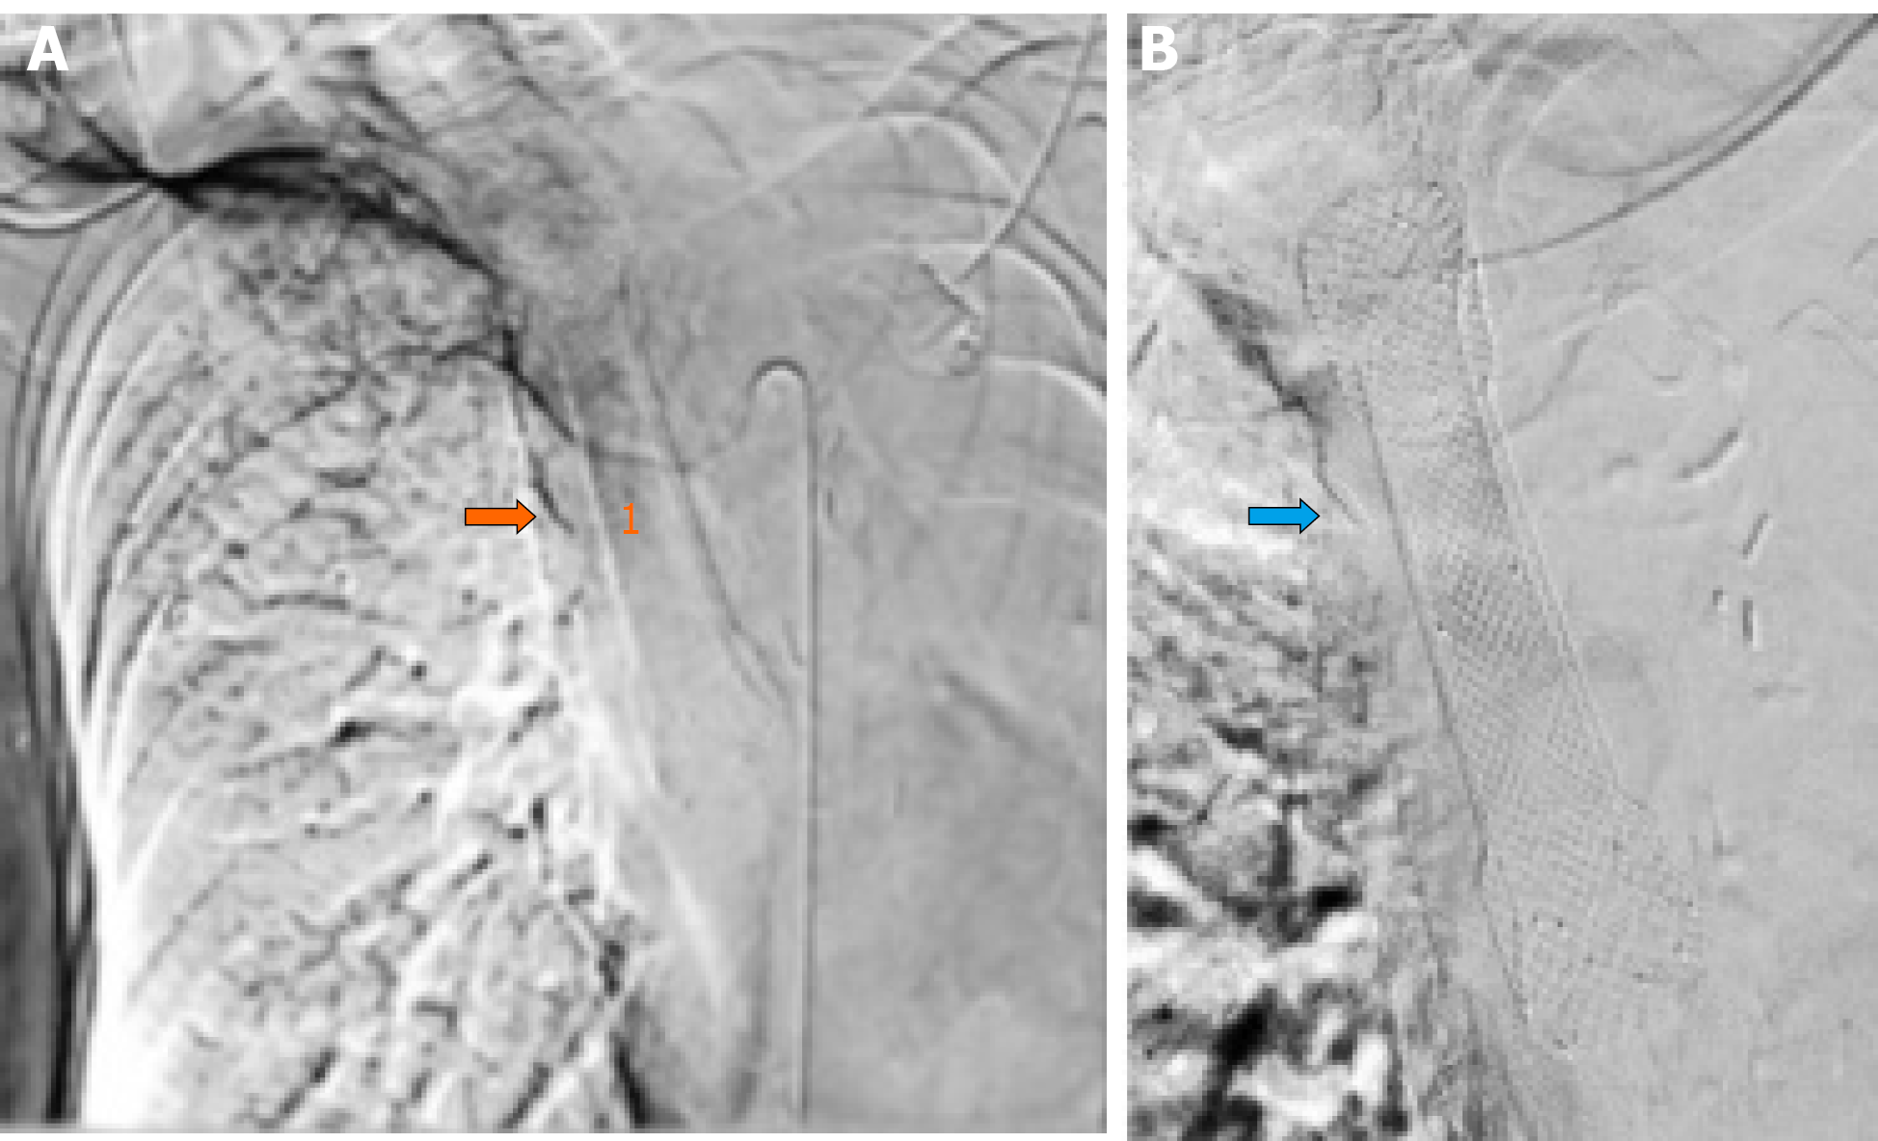
Figure 4 Operative angiography. A: Selective arteriogram of the right bronchial artery (orange arrow) showing contrast extravasation within the esophageal lumen (1); B: Right bronchial artery coil embolization (blue arrow).

Published by Baishideng Publishing Group Inc
7041 Koll Center Parkway, Suite 160, Pleasanton, CA 94566, USA
Telephone: +1-925-3991568
E-mail: bpgoffice@wjgnet.com
Help Desk: https://www.f6publishing.com/helpdesk
https://www.wjgnet.com

© 2021 Baishideng Publishing Group Inc. All rights reserved.

