Name of Journal: World Journal of Gastroenterology
Manuscript NO: 82707
Manuscript Type: ORIGINAL ARTICLE

Prospective Study
Prospective study comparing hepatic steatosis assessment by magnetic resonance imaging and four ultrasound methods in 105 successive patients

Collin R et al. Ultrasound for hepatic steatosis assessment

Remi Collin, Benoit Magnin, Constance Gaillard, Carine Nicolas, Armand Abergel, Benjamin Buchard

Remi Collin, Gastroenterology and Endoscopy Unit, Dupuytren University Hospital, Limoges 87000, France

Remi Collin, Carine Nicolas, Armand Abergel, Benjamin Buchard, Department of Hepatology and Gastroenterology, Clermont-Ferrand University Hospital, Clermont-Ferrand 63000, France

Benoit Magnin, Constance Gaillard, Department of Radiology, Clermont-Ferrand University Hospital, Clermont-Ferrand 63000, France

Author contributions: Collin R, Nicolas C, Abergel A and Buchard B conceived and designed the analysis; Collin R, Magnin B, Gaillard C, Nicolas C and Buchard B collected the data; Collin R, Magnin B, Gaillard C, Nicolas C, Abergel A and Buchard B contributed data or analysis tools; Collin R, Magnin B and Buchard B performed the analysis; Collin R and Buchard B wrote the paper.

Corresponding author: Remi Collin, MD, Doctor, Gastroenterology and Endoscopy Unit, Dupuytren University Hospital, 2 Avenue Martin Luther King, Limoges 87000, France. remi.collin@chu-limoges.fr

Received: February 8, 2023
Revised: April 4, 2023
Accepted: May 12, 2023
Published online:

Abstract
BACKGROUND
Non-alcoholic fatty liver disease (NAFLD) is becoming a major health problem, resulting in hepatic, metabolic and cardio-vascular morbidity.

AIM
To evaluate new ultrasonographic tools to detect and measure hepatic steatosis.

METHODS
We prospectively included 105 patients referred to our liver unit for NAFLD suspicion or follow-up. They underwent ultrasonographic measurement of liver sound speed estimation (SSE) and attenuation coefficient (AC) using Aixplorer MACH 30 (Supersonic Imagine, France), continuous controlled attenuation parameter (cCAP) using Fibroscan (Echosens, France) and standard liver ultrasound with hepato-renal index (HRI) calculation. Hepatic steatosis was then classified according to magnetic resonance imaging proton density fat fraction (PDFF). Receiver operating curve (ROC) analysis was performed to evaluate the diagnostic performance in the diagnosis of steatosis.

RESULTS
Most patients were overweight or obese (90%) and had metabolic syndrome (70%). One third suffered from diabetes. Steatosis was identified in 85 patients (81%) according to PDFF. Twenty-one patients (20%) had advanced liver disease. SSE, AC, cCAP and HRI correlated with PDFF, with respective Spearman correlation coefficient of -0.39, 0.42, 0.54 and 0.59 (P < 0.01). Area under the receiver operating characteristic curve (AUROC) for detection of steatosis with HRI was 0.91 (0.83-0.99), with the best cut-off value being 1.3 (Se = 83%, Sp = 98%). The optimal cCAP threshold of 275 dB/m, corresponding to the recent EASL-suggested threshold, had a sensitivity of 72% and a specificity of 80%. Corresponding AUROC was 0.79 (0.66-0.92). The diagnostic accuracy of cCAP was more reliable when standard deviation was < 15 dB/m with an AUC of 0.91 (0.83-0.98). An AC threshold of 0.42 dB/cm/MHz had an AUROC was 0.82 (0.70-0.93). SSE performed moderately with an AUROC of 0.73 (0.62-0.84).

CONCLUSION
Among all ultrasonographic tools evaluated in this study, including new-generation tools such as cCAP and SSE, HRI had the best performance. It is also the simplest and most available method as most ultrasound scans are equipped with this module.

Key Words: Non-alcoholic fatty liver disease; Ultrasonography; Steatosis assessment; Magnetic resonance imaging; Controlled attenuation parameter

Collin R, Magnin B, Gaillard C, Nicolas C, Abergel A, Buchard B. Prospective study comparing hepatic steatosis assessment by magnetic resonance imaging and four ultrasound methods in 105 successive patients. World J Gastroenterol 2023; In press

Core Tip: Among all ultrasonographic tools evaluated in this study, including new-generation systems such as continuous controlled attenuation parameter and sound speed examination, hepato-renal index had the best performance. It is also the simplest and most available method as most ultrasound (US) scans are equipped with this module. The presence of an hyperechogenic liver on US also performed well, confirming that US should remain the first-line screening tool for steatosis.
INTRODUCTION
Non-alcoholic fatty liver disease (NAFLD), considered as the liver manifestation of the metabolic syndrome, has become a major public health issue, affecting around 25% of people in western societies. Its presence has been associated with an increased risk of both cardiovascular, hepatic and cancer-related morbidity^{[1]}. Therefore, identifying steatosis among individuals with increased metabolic risk is crucial for primary care.
Hepatic steatosis is the key manifestation of NAFLD and refers to the excess of fat within the hepatocytes, histologically defined by the presence of at least 5% of hepatocytes containing fat. Histological assessment of steatosis is the gold standard for the diagnosis of liver steatosis but is an invasive procedure and cannot be performed for all patients with metabolic risk factors^{[2]}.
Ultrasound (US) is currently the first-line screening test, but several studies have shown that US is lacking the necessary sensitivity to assess mild steatosis < 20%, particularly in obese patients with body mass index (BMI) > 35 kg/m^{2[3-7]}. It is also subject to inter-observer and intra-observer variabilities^{[8]}.
Magnetic resonance imaging (MRI) has demonstrated excellent performances for the diagnosis and grading of steatosis using either spectroscopy, in-phase and opposed-phase technique or multiecho gradient sequences but this process is expensive, with limited access^{[9-11]}.
Controlled attenuation parameter (CAP) is a promising technique for steatosis assessment and grading. The interpretation of CAP values remains difficult in practice for several reasons: many cutoffs have been published, the influence of the chosen probe is still debated and solid quality criteria of measures are unavailable^{[12-17]}. A new CAP method called continuous CAP (cCAP) is emerging. The major difference with the alternative method is that it uses ultrasound data continuously acquired during the imaging phase examination^{[18]}.
Other non-invasive techniques including B-mode image-guided US attenuation parameter or hepato-renal index (HRI) have been developed in the past years^{[19-23]}.
Recently, a new US technique based on sound speed estimation (SSE) demonstrated accurate performances for the detection of steatosis. The speed of sound decreased as the fat content in liver increased. SSE could be used to detect, quantify and grade liver steatosis. However, the evaluation of steatosis was not specifically done in overweighted/obese patients suffering from NAFLD and SSE needs further investigations in this indication^{[24-26]}.
In a monocentric prospective study, we aimed at evaluating diagnosis performances of various US tools compared to MRI proton density fat fraction assessment (PDFF).

MATERIALS AND METHODS
Participants
Study participants were consecutively and prospectively recruited from the University Hospital of Clermont-Ferrand, France, from January 2021 to October 2021 by physicians of the hepatology department. Inclusion criteria were: age over 18 years, patients with known or suspected NAFLD, referred for non-invasive fibrosis evaluation using impulse elastography, with willingness and ability to participate. Exclusion criteria were clinical, laboratory, or histologic evidence of a liver disease other than NAFLD (chronic hepatitis B or C, autoimmune liver disease, excessive alcohol consumption defined by WHO criteria, Wilson's disease or other), hepatocellular carcinoma and all other liver tumors, secondary causes of liver steatosis (genetic disease, steatogenic or hepatoxic medication use) and contraindications to MRI.
Demographic and anthropometric data were recorded. Biological data collected included platelets, prothrombin time (PT), international normalized ratio (INR), albumin, bilirubin, transaminases (aspartate aminotransferase, AST and alanine aminotransferase, ALT), gamma-glutamyltransferase (GGT), alkaline phosphatase (ALP), total cholesterol, high density lipoprotein (HDL) cholesterol, low density lipoprotein (LDL) cholesterol, triglycerides, fasting glucose, fasting insulinemia.
The study design was approved by local ethic committee (study M210401, Clermont-Ferrand University Hospital) and informed consent was obtained for all participants.

US examinations
All participants underwent US liver examinations using the Aixplorer MACH 30® US system (Supersonic Imagine, Aix-en-Provence, France). Participants were asked to fast for at least 3 h prior to US examinations. They were positioned in the dorsal decubitus position with the right arm at maximum abduction for intercostal stretching. A 3.5 MHz abdominal curved transducer (C6-1X probe) was used. Acquisitions were performed during neutral respiratory apnea as follows: (1) Right intercostal (between the 7th and 9th intercostal space) and subcostal view was considered for every patient; (2) US transducer was placed so that the hepatic capsule was parallel to the US transducer; and (3) Care was taken to avoid the presence of large hepatic vessels or artifacts in the image (ultrasound reflection caused by abdominal gas or by rib interposition). For HRI, the probe was placed to obtain an adequate visualization of the liver and the right kidney in a sagittal or oblique image with minimal artifacts. HRI was calculated using the region of interest (ROI) measure tool, with average brightness ratio between two ROI at least 3 mm wide placed at the same depth in hepatic parenchyma and in renal cortex (Figure 1).
For each patient, 5 measures of sound speed, 5 of attenuation coefficient (AC) and 3 of HRI acquisitions were performed by the same physician. The mean values were used for statistical analysis.
Simultaneously, liver stiffness and cCAP measurements were performed using FibroScan SmartExam® (Echosens, Paris, France) by experienced operators. All patients were measured using either an M- or an XL-probe, according to the device automatically-selected probe.
A liver US was also performed by a radiologist at patient’s discretion, in any radiological center, unaware of the study, in the standard clinical care of NAFLD. The presence of a hyperechogenic liver described on the US report was noted (steatosis vs. no steatosis or not mentioned).

MRI PDFF technique
Within the month following US examinations, all participants underwent a chemical shift-encoded liver MRI using a 3.0 Tesla MAGNETOM Vida® system (Siemens Medical Solutions, Erlangen, Germany). A gradient echo dedicated sequence developed by the manufacturer to measure hepatic PDFF was systematically included in MRI acquisition protocols. This sequence is characterized by a low flip angle to reduce T1 bias and six echoes to correct for T2* effect. Images were acquired during a single breath hold. In and out-phases imaging was used prior to fat quantification to assess homogeneity of fat distribution. PDFF (%) estimation was obtained by placing three large regions of interest in the liver parenchyma. Steatosis was regarded as fat fraction ≥ 5.6 %, as defined by EASL. Steatosis grading was not evaluated because correspondence between the steatosis histologic grading and PDFF value has not yet been standardized in the literature^{[27]}. Iron content was also measured using this technique.

Statistical analysis
Patients data were recorded in e-case report form via a secure web platform (REDCap® version 9.3.7, Vanderbilt University, United States) where these data were monitored and a database extraction was performed.
Data were expressed as descriptive statistics (mean ± SD, median with IQR or number with corresponding percentage as appropriate). The normality assumption was assessed using the Shapiro-Wilk's test. Chi-Square and Student t-test were used to compare categorical and continuous variables. If normality was not ascertained, the Mann-Whitney test was used for continuous variables. Receiver operating curve (ROC) analysis was performed to evaluate the diagnostic performance of US tools compared to MRI PDFF. Optimal cutoff values were identified by maximizing the Youden index, and corresponding sensitivities, specificities, likelihood ratios (LR) were derived. Comparison of areas under receiver operating characteristic curves was made according to Hanley and McNeil. Pearson and Spearman linear correlation coefficients were used to evaluate the relationship between continuous variables, respectively when normality was assessed or not. A non-linear regression analysis was also conducted to assess the relationship between SSE AC, cCAP, HRI and PDFF. All tests were considered statistically significant in the case of P < 0.05. Statistical analysis were performed and graphs were designed using GraphPad Prism® (v8, GraphPad Software, La Jolla, California, United States). Multivariable linear regression was used to evaluate the influence of anthropometric parameters and fibrosis severity on US measures (R Software, R Foundation for Statistical Computing, Vienna, Austria).

RESULTS
Clinical, biological and radiological characteristics of the study population
One hundred and five patients were included in this study. Main characteristics are presented in Table 1. Median BMI was 31 kg/m². Most patients were overweight or obese (90%) and had metabolic syndrome (70%). One third suffered from diabetes. Steatosis was identified in 85 patients (81%) according to PDFF. Twenty-five patients (20%) were suspected to have advanced liver disease according to shear-wave elastography.
Mean AST and ALT were respectively 35 (± 28) U/L and 65 (± 49) U/L. Mean GGT was 120 (± 125) U/mL. Only ALT levels correlated significantly but moderately with PDFF (Spearman's ρ = 0.4, P < 0.001). One patient failed to receive Fibroscan® and HRI measurement due to poor US signal.
Patients characteristics according to the presence of steatosis are shown in Table 2. Steatotic patients had significantly higher BMI and waist circumference. As expected, metabolic syndrome was more prevalent in patients with steatosis. Mean SSE, AC and cCAP values significantly differed between non-steatotic and steatotic patients, but not liver stiffness.

Relationship between SSE, AC, HRI and cCAP with MRI PDFF
SSE, AC, HRI and cCAP correlated with PDFF, with respective Spearman correlation coefficient of -0.39, 0.42, 0.59 and 0.54 (P < 0.01) (Figure 2). SSE, AC, cCAP and HRI specifically displayed a significant non-linear relationship with PDFF as previously demonstrated (Supplementary Figure 1)^{[28]}.

Performances of SSE and AC
Intercostal SSE performed moderately for the diagnosis of steatosis with an area under curve (AUC) of 0.73 [0.62-0.84] (P = 0.001) (Figure 3A). Using the manufacturer cutoff of 1537 m/s resulted in a sensitivity and specificity of 80% and 45%. The best cutoff identified in our work was 1518 m/s but performances remained modest with sensitivity and specificity of 60% and 80% respectively. Of note, using 5 measures of SSE compared to 3 measures did not improve performances (data not shown).
Intercostal AC performed well for the diagnosis of steatosis with an AUC of 0.82 (0.70-0.93) (P = 0.001) (Figure 3B). The best cutoff identified in our work was 0.42 dB/cm/MHz with sensitivity and specificity of 84 % and 75 % respectively.

Performances of cCAP
cCAP was accurate for the diagnosis of steatosis with AUC of 0.79 (0.66-0.92) but did not perform better than AC. The best cutoff identified in our work was 275 dB/m but lacked sensitivity and specificity (respectively 72% and 80%) (Figure 3C).
As expected, using cCAP resulted in low coefficient variation with 96% of patients having a coefficient of less than 10%. The diagnostic accuracy of cCAP was significantly improved when SD of cCAP was < 15 dB/m with an AUC of 0.91 (95% confidence interval: 0.83-0.98, P < 0.01) resulting in a sensitivity and specificity of 74% and 92%. In this work, one third of patients had an SD > 15 dB/m (Figure 4).

Performances of HRI
HRI performed the best with an AUC of 0.91 (0.83-0.99) (P < 0.0001) (Figure 3D). Using a cutoff set at 1.3 resulted in a sensitivity of 82% and specificity of 98%. In other words, only 2 patients had an increased hepatorenal gradient without having liver steatosis. The first patient had borderline steatosis (4% on MRI) and severe fibrosis on elastography (19 KPa) which could explain the increased HRI. For the other patient, moderate iron overload may have increased hepatorenal gradient. Among the 15 false negative patients, two third had mild steatosis on MRI (defined as PDFF < 10%).

Performances of standard ultrasound
Hyperechogenic liver was described in 73/85 steatotic patients (Figure 5). It showed a sensitivity of 86% and specificity of 70%. Among the 6 patients presenting a hyperechogenic liver on US but no steatosis on MRI, none had severe fibrosis (assessed using Fibroscan) or iron overload. Among the 12 patients with no hyperechogenic liver but steatosis on MRI, 7/12 (58%) had mild steatosis based on PDFF. No other steatosis sign was described by radiologists.

Intercostal or subcostal access
SSE and AC measurements were made for every patient using intercostal and subcostal view. However, if intercostal access was successful in every patient (success rate: 100% for SSE and AC), subcostal access showed a lower success rate (94% for SSE, 92% for AC) and lower performances (data not shown).

Influence of BMI and severity of fibrosis
Using multivariable linear regression, we demonstrated that both HRI, cCAP, AC and SSE were associated with the presence of steatosis on MRI, independently from BMI, waist circumference elastography, iron overload and the presence of diabetes or metabolic syndrome.

DISCUSSION
Standard ultrasound is widely used as first diagnostic exam for NAFLD. Our results confirmed past studies reporting poor sensitivity for mild steatosis^{[3,5]}. Furthermore, BMI and fibrosis negatively influence US performances^{[6,7]}, and it suffers from inter- and intra-observer variability^{[8]}. Our study collected US report from various radiologists, unaware of the study, chosen at patient’s discretion. Steatosis was only described according to parenchyma hyperechogenicity. No other steatosis sign, like vessels blurring, gallbladder blurring or inability to visualize the diaphragm, nor steatosis scoring system, was used by radiologist, even if it proved to improve its diagnostic performance.
HRI calculation is a simple way to improve capabilities, as most US devices or radiology systems propose a dedicated module^{[21,29,30]}. It can be easily performed by someone already familiar with US scan evaluation. Webb et al^{[31]} proved that the known limitation of sonography to detect high grade steatosis of more than 30% of hepatocytes is resolved by HRI. In our study, HRI performed the best with a cut-off of 1.30. Previously described cut-off for the detection of any grade steatosis may vary in the literature from 1.22 to 1.49, influenced by system settings and different gold standards, and thus limiting HRI reproducibility and applicability^{[21,28,30-32]}.
It was the most reliable technique in our work, permitting an objective and quantitative assessment of steatosis better than cCAP and SSE. Furthermore, B-mode guidance permits to suspect heterogenous steatosis and adapt the location of measurement, which cannot be done with cCAP.
cCAP demonstrated promising performances for diagnosis of steatosis. This confirms a pilot study, which showed that cCAP outperformed significantly conventional CAP for the diagnostic of steatosis^{[33]}. Indeed, the continuous method allows for larger volume sampling, reducing intraindividual variability and increasing correlation with MRI-PDFF. Caussy et al^{[34]} described an IQR-based validity criteria significantly improving CAP performances. CAP results were generally expressed as the median and interquartile range of several manually triggered sequential attenuation measurements. Individual measurements collected with the cCAP method being much numerous, its results are expressed as the mean and SD. Thus, we proposed a quality criteria based on SD. In our work, cCAP proved to be perform significantly better for the diagnosis of steatosis when SD < 15 dB/m, reaching HRI measurement performances.
One main advantage of cCAP is to be combined with simultaneous fibrosis measurement, rapidly and without additional capabilities. This is of particular interest considering that the degree of fibrosis is the main prognosis factor in patients suffering from NAFLD^{[35]}. However, on a practical level, not all medical structures have access to this device. This a major issue knowing that the growing prevalence of NAFLD worldwide cannot be fully handled by tertiary-care centers.
SSE and AC measurement on Aixplorer MACH 30 system are new non-invasive tools to quantify liver fat content, which may be useful in patient follow-up or therapeutic studies^{[36]}. Using MRI-PDFF as reference, our study proved mixed performances for detection or exclusion of steatosis, with AUC ranging from 0.73 to 0.82.
SSE is a novel, understudied technique, based on the decrease of US speed as liver fat increases. Dioguardi Burgio et al^{[25]} showed that SSE could be used for the detection and quantification of liver steatosis. However, in this study, SSE was acquired during US exam but calculated off-site. This resulted in invalid measurements in almost one quarter of patients due to poor signal quality. Moreover, this study included patients presenting liver diseases of various etiologies, and NAFLD-patients are not the only one known to present a poor echogenicity.
AC uses the same physical principles as cCAP but is performed under B-mode visual control. Several studies demonstrated promising performances, using various devices^{[19,37]}. Nevertheless, optimal thresholds values slightly differ among different published studies, probably due to the use of different US scans and different reference standards (biopsy or MRI). A recent meta-analysis explored performances of AC for the detection of any grade steatosis, compiling 11 studies and more than 1400 patients: AUC was 0.83, close to what was assessed in our work^{[38]}.
SSE and AC intra-individual variability with 5 measures per patient was too low to suggest any validity criteria assessing better correlation to PDFF. Using three instead of five measures did not result in significant lower performances. To be noted, even if technical success was high (99% to 100%) with both cCAP and SSE/AC, these last tools were the most difficult to tame as they require a stable position, the strict absence of large hepatic vessels or artifacts in the image.
We found no influence of BMI, waist circumference elastography, iron overload or presence of diabetes or metabolic syndrome on the correlation between MRI-PDFF and both HRI, cCAP, AC and SSE. Previous studies reported unsure influence^{[37,39]}.
Several scores have also been developed to detect steatosis: fatty liver index, hepatic steatosis index and NAFLD liver fat score, which combine various clinical and biological parameters^{[40-42]}. These algorithms demonstrated modest performances for the detection of steatosis and were inaccurate for the staging of steatosis^{[43]}. They do not provide add-on features compared to standard clinical and biological data and are mainly used as epidemiological tools.
One limit of this study is that AC, SSE and HRI were assessed by two different examinators. As both examinators did not perform US liver examinations for all patients, we are unable to report an interobserver comparison or concordance.
Although our sample size is quite small, this work is the first one to prospectively evaluate diagnosis performances of various new generations US tools using MRI as gold standard on an exclusively-NAFLD population. Our study population contained patients with high BMI and weight, with a low fibrosis prevalence and moderate hepatic biological abnormalities, representing NAFLD-patients in real life situations.
These results should be validated in a population with a different prevalence of steatosis and in a multicenter study.

CONCLUSION
Among all ultrasonographic tools evaluated in this study, including new-generation systems such as cCAP and SSE, HRI had the best performance. It is also the simplest and most available method as most US scans are equipped with this module.
The presence of an hyperechogenic liver on US also performed well, confirming that US should remain the first-line screening tool for steatosis.

ARTICLE HIGHLIGHTS
Research background
Non-alcoholic fatty liver disease (NAFLD) is the most common liver disease worldwide, ranging from simple steatosis to aggressive hepatitis leading to liver fibrosis, cirrhosis and hepatocellular carcinoma.

Research motivation
Diagnose fatty liver disease and assess its severity during follow-up and after treatment is a key in clinical practice. Liver biopsy can deliver this information, but it is an invasive procedure with potentially severe. Therefore, non-invasive techniques were developed to stage steatosis. Ultrasound is the primary imaging modality in the assessment of patients with confirmed or suspected NAFLD.

Research objectives
We wanted to evaluate new ultrasonographic tools to detect and measure hepatic steatosis.

Research methods
One hundred and five patients underwent ultrasonographic measurement of liver sound speed estimation (SSE) and attenuation coefficient (AC) using Aixplorer MACH 30 (Supersonic Imagine, France), continuous Controlled Attenuation Parameter (cCAP) using Fibroscan (Echosens, France) and standard liver ultrasound with hepato-renal index (HRI) calculation. Hepatic steatosis was then classified according to MRI proton density fat fraction (PDFF) as gold standard.

Research results
SSE, AC, cCAP and HRI correlated with PDFF, with respective Spearman correlation coefficient of -0.39, 0.42, 0.54 and 0.59 (P < 0.01). Area under the receiver operating characteristic curve (AUROC) for detection of steatosis with HRI was 0.91 (0.83-0.99), with the best cut-off value being 1.3 (Se = 83%, Sp = 98%). The optimal cCAP threshold of 275 dB/m, corresponding to the recent EASL-suggested threshold, had a sensitivity of 72% and a specificity of 80%. Corresponding AUROC was 0.79 (0.66-0.92). The diagnostic accuracy of cCAP was more reliable when standard deviation was < 15 dB/m with an AUC of 0.91 (0.83-0.98). An AC threshold of 0.42 dB/cm/MHz had an AUROC was 0.82 (0.70-0.93). SSE performed moderately with an AUROC of 0.73 (0.62-0.84).

Research conclusions
HRI had the best performance. It is also the simplest and most available method as most US scans are equipped with this module.

Research perspectives
Measurement quality criteria need to be defined and validated for a wider use of theses techniques. Their improvement could open the way to efficient and easily accessible non-invasive steatosis grading.

REFERENCES
1 Huang DQ, El-Serag HB, Loomba R. Global epidemiology of NAFLD-related HCC: trends, predictions, risk factors and prevention. Nat Rev Gastroenterol Hepatol 2021; 18: 223-238 [PMID: 33349658 DOI: 10.1038/s41575-020-00381-6]
2 Diehl AM, Day C. Cause, Pathogenesis, and Treatment of Nonalcoholic Steatohepatitis. N Engl J Med 2017; 377: 2063-2072 [PMID: 29166236 DOI: 10.1056/NEJMra1503519]
3 Charatcharoenwitthaya P, Lindor KD. Role of radiologic modalities in the management of non-alcoholic steatohepatitis. Clin Liver Dis 2007; 11: 37-54, viii [PMID: 17544971 DOI: 10.1016/j.cld.2007.02.014]
4 Bril F, Ortiz-Lopez C, Lomonaco R, Orsak B, Freckleton M, Chintapalli K, Hardies J, Lai S, Solano F, Tio F, Cusi K. Clinical value of liver ultrasound for the diagnosis of nonalcoholic fatty liver disease in overweight and obese patients. Liver Int 2015; 35: 2139-2146 [PMID: 25847730 DOI: 10.1111/liv.12840]
5 Hernaez R, Lazo M, Bonekamp S, Kamel I, Brancati FL, Guallar E, Clark JM. Diagnostic accuracy and reliability of ultrasonography for the detection of fatty liver: a meta-analysis. Hepatology 2011; 54: 1082-1090 [PMID: 21618575 DOI: 10.1002/hep.24452]
6 Hannah WN Jr, Harrison SA. Noninvasive imaging methods to determine severity of nonalcoholic fatty liver disease and nonalcoholic steatohepatitis. Hepatology 2016; 64: 2234-2243 [PMID: 27338123 DOI: 10.1002/hep.28699]
7 de Moura Almeida A, Cotrim HP, Barbosa DB, de Athayde LG, Santos AS, Bitencourt AG, de Freitas LA, Rios A, Alves E. Fatty liver disease in severe obese patients: diagnostic value of abdominal ultrasound. World J Gastroenterol 2008; 14: 1415-1418 [PMID: 18322958 DOI: 10.3748/wjg.14.1415]
8 Strauss S, Gavish E, Gottlieb P, Katsnelson L. Interobserver and intraobserver variability in the sonographic assessment of fatty liver. AJR Am J Roentgenol 2007; 189: W320-W323 [PMID: 18029843 DOI: 10.2214/AJR.07.2123]
9 Cassidy FH, Yokoo T, Aganovic L, Hanna RF, Bydder M, Middleton MS, Hamilton G, Chavez AD, Schwimmer JB, Sirlin CB. Fatty liver disease: MR imaging techniques for the detection and quantification of liver steatosis. Radiographics 2009; 29: 231-260 [PMID: 19168847 DOI: 10.1148/rg.291075123]
10 Cowin GJ, Jonsson JR, Bauer JD, Ash S, Ali A, Osland EJ, Purdie DM, Clouston AD, Powell EE, Galloway GJ. Magnetic resonance imaging and spectroscopy for monitoring liver steatosis. J Magn Reson Imaging 2008; 28: 937-945 [PMID: 18821619 DOI: 10.1002/jmri.21542]
11 Boudinaud C, Abergel A, Joubert-Zakeyh J, Fontarensky M, Pereira B, Chauveau B, Garcier JM, Chabrot P, Boyer L, Magnin B. Quantification of steatosis in alcoholic and nonalcoholic fatty liver disease: Evaluation of four MR techniques vs biopsy. Eur J Radiol 2019; 118: 169-174 [PMID: 31439237 DOI: 10.1016/j.ejrad.2019.07.025]
12 Sasso M, Beaugrand M, de Ledinghen V, Douvin C, Marcellin P, Poupon R, Sandrin L, Miette V. Controlled attenuation parameter (CAP): a novel VCTE™ guided ultrasonic attenuation measurement for the evaluation of hepatic steatosis: preliminary study and validation in a cohort of patients with chronic liver disease from various causes. Ultrasound Med Biol 2010; 36: 1825-1835 [PMID: 20870345 DOI: 10.1016/j.ultrasmedbio.2010.07.005]
13 Karlas T, Petroff D, Sasso M, Fan JG, Mi YQ, de Lédinghen V, Kumar M, Lupsor-Platon M, Han KH, Cardoso AC, Ferraioli G, Chan WK, Wong VW, Myers RP, Chayama K, Friedrich-Rust M, Beaugrand M, Shen F, Hiriart JB, Sarin SK, Badea R, Jung KS, Marcellin P, Filice C, Mahadeva S, Wong GL, Crotty P, Masaki K, Bojunga J, Bedossa P, Keim V, Wiegand J. Individual patient data meta-analysis of controlled attenuation parameter (CAP) technology for assessing steatosis. J Hepatol 2017; 66: 1022-1030 [PMID: 28039099 DOI: 10.1016/j.jhep.2016.12.022]
14 Caussy C, Reeder SB, Sirlin CB, Loomba R. Noninvasive, Quantitative Assessment of Liver Fat by MRI-PDFF as an Endpoint in NASH Trials. Hepatology 2018; 68: 763-772 [PMID: 29356032 DOI: 10.1002/hep.29797]
15 de Lédinghen V, Vergniol J, Foucher J, Merrouche W, le Bail B. Non-invasive diagnosis of liver steatosis using controlled attenuation parameter (CAP) and transient elastography. Liver Int 2012; 32: 911-918 [PMID: 22672642 DOI: 10.1111/j.1478-3231.2012.02820.x]
16 Petroff D, Blank V, Newsome PN, Shalimar, Voican CS, Thiele M, de Lédinghen V, Baumeler S, Chan WK, Perlemuter G, Cardoso AC, Aggarwal S, Sasso M, Eddowes PJ, Allison M, Tsochatzis E, Anstee QM, Sheridan D, Cobbold JF, Naveau S, Lupsor-Platon M, Mueller S, Krag A, Irles-Depe M, Semela D, Wong GL, Wong VW, Villela-Nogueira CA, Garg H, Chazouillères O, Wiegand J, Karlas T. Assessment of hepatic steatosis by controlled attenuation parameter using the M and XL probes: an individual patient data meta-analysis. Lancet Gastroenterol Hepatol 2021; 6: 185-198 [PMID: 33460567 DOI: 10.1016/S2468-1253(20)30357-5]
17 European Association for the Study of the Liver; Clinical Practice Guideline Panel; Chair:; EASL Governing Board representative:; Panel members:. EASL Clinical Practice Guidelines on non-invasive tests for evaluation of liver disease severity and prognosis - 2021 update. J Hepatol 2021; 75: 659-689 [PMID: 34166721 DOI: 10.1016/j.jhep.2021.05.025]
18 Audière S, Miette V, Fournier C, Whitehead J, Paredes AH, Sandrin L, Harrison SA. Continuous CAP method: reduced variability in a prospective cohort of 113 patients. J Hepatol 2020; 73: S436 [DOI: 10.1016/S0168-8278(20)31354-4]
19 Ferraioli G, Maiocchi L, Savietto G, Tinelli C, Nichetti M, Rondanelli M, Calliada F, Preda L, Filice C. Performance of the Attenuation Imaging Technology in the Detection of Liver Steatosis. J Ultrasound Med 2021; 40: 1325-1332 [PMID: 32960457 DOI: 10.1002/jum.15512]
20 Fujiwara Y, Kuroda H, Abe T, Ishida K, Oguri T, Noguchi S, Sugai T, Kamiyama N, Takikawa Y. The B-Mode Image-Guided Ultrasound Attenuation Parameter Accurately Detects Hepatic Steatosis in Chronic Liver Disease. Ultrasound Med Biol 2018; 44: 2223-2232 [PMID: 30077415 DOI: 10.1016/j.ultrasmedbio.2018.06.017]
21 Marshall RH, Eissa M, Bluth EI, Gulotta PM, Davis NK. Hepatorenal index as an accurate, simple, and effective tool in screening for steatosis. AJR Am J Roentgenol 2012; 199: 997-1002 [PMID: 23096171 DOI: 10.2214/AJR.11.6677]
22 Martín-Rodríguez JL, Arrebola JP, Jiménez-Moleón JJ, Olea N, González-Calvin JL. Sonographic quantification of a hepato-renal index for the assessment of hepatic steatosis in comparison with 3T proton magnetic resonance spectroscopy. Eur J Gastroenterol Hepatol 2014; 26: 88-94 [PMID: 23921844 DOI: 10.1097/MEG.0b013e3283650650]
23 Ballestri S, Lonardo A, Romagnoli D, Carulli L, Losi L, Day CP, Loria P. Ultrasonographic fatty liver indicator, a novel score which rules out NASH and is correlated with metabolic parameters in NAFLD. Liver Int 2012; 32: 1242-1252 [PMID: 22520641 DOI: 10.1111/j.1478-3231.2012.02804.x]
24 Imbault M, Faccinetto A, Osmanski BF, Tissier A, Deffieux T, Gennisson JL, Vilgrain V, Tanter M. Robust sound speed estimation for ultrasound-based hepatic steatosis assessment. Phys Med Biol 2017; 62: 3582-3598 [PMID: 28225357 DOI: 10.1088/1361-6560/aa6226]
25 Dioguardi Burgio M, Imbault M, Ronot M, Faccinetto A, Van Beers BE, Rautou PE, Castera L, Gennisson JL, Tanter M, Vilgrain V. Ultrasonic Adaptive Sound Speed Estimation for the Diagnosis and Quantification of Hepatic Steatosis: A Pilot Study. Ultraschall Med 2019; 40: 722-733 [PMID: 30396216 DOI: 10.1055/a-0660-9465]
26 Popa A, Bende F, Șirli R, Popescu A, Bâldea V, Lupușoru R, Cotrău R, Fofiu R, Foncea C, Sporea I. Quantification of Liver Fibrosis, Steatosis, and Viscosity Using Multiparametric Ultrasound in Patients with Non-Alcoholic Liver Disease: A "Real-Life" Cohort Study. Diagnostics (Basel) 2021; 11 [PMID: 33926073 DOI: 10.3390/diagnostics11050783]
27 Gu J, Liu S, Du S, Zhang Q, Xiao J, Dong Q, Xin Y. Diagnostic value of MRI-PDFF for hepatic steatosis in patients with non-alcoholic fatty liver disease: a meta-analysis. Eur Radiol 2019; 29: 3564-3573 [PMID: 30899974 DOI: 10.1007/s00330-019-06072-4]
28 Moret A, Boursier J, Houssel Debry P, Riou J, Crouan A, Dubois M, Michalak Provost S, Aubé C, Paisant A. Evaluation of the Hepatorenal B-Mode Ratio and the "Controlled Attenuation Parameter" for the Detection and Grading of Steatosis. Ultraschall Med 2022; 43: 479-487 [PMID: 32992377 DOI: 10.1055/a-1233-2290]
29 Shiralkar K, Johnson S, Bluth EI, Marshall RH, Dornelles A, Gulotta PM. Improved method for calculating hepatic steatosis using the hepatorenal index. J Ultrasound Med 2015; 34: 1051-1059 [PMID: 26014325 DOI: 10.7863/ultra.34.6.1051]
30 Johnson SI, Fort D, Shortt KJ, Therapondos G, Galliano GE, Nguyen T, Bluth EI. Ultrasound Stratification of Hepatic Steatosis Using Hepatorenal Index. Diagnostics (Basel) 2021; 11 [PMID: 34441377 DOI: 10.3390/diagnostics11081443]
31 Webb M, Yeshua H, Zelber-Sagi S, Santo E, Brazowski E, Halpern Z, Oren R. Diagnostic value of a computerized hepatorenal index for sonographic quantification of liver steatosis. AJR Am J Roentgenol 2009; 192: 909-914 [PMID: 19304694 DOI: 10.2214/AJR.07.4016]
32 Kjaergaard M, Lindvig KP, Hansen CD, Detlefsen S, Krag A, Thiele M. Hepatorenal Index by B-Mode Ratio Versus Imaging and Fatty Liver Index to Diagnose Steatosis in Alcohol-Related and Nonalcoholic Fatty Liver Disease. J Ultrasound Med 2023; 42: 487-496 [PMID: 35475550 DOI: 10.1002/jum.15991]
33 Audière S, Labourdette A, Miette V, Fournier C, Ternifi R, Boussida S, Pouletaut P, Charleux F, Bensamoun SF, Harrison SA, Sandrin L. Improved Ultrasound Attenuation Measurement Method for the Non-invasive Evaluation of Hepatic Steatosis Using FibroScan. Ultrasound Med Biol 2021; 47: 3181-3195 [PMID: 34373137 DOI: 10.1016/j.ultrasmedbio.2021.07.007]
34 Caussy C, Alquiraish MH, Nguyen P, Hernandez C, Cepin S, Fortney LE, Ajmera V, Bettencourt R, Collier S, Hooker J, Sy E, Rizo E, Richards L, Sirlin CB, Loomba R. Optimal threshold of controlled attenuation parameter with MRI-PDFF as the gold standard for the detection of hepatic steatosis. Hepatology 2018; 67: 1348-1359 [PMID: 29108123 DOI: 10.1002/hep.29639]
35 Ekstedt M, Hagström H, Nasr P, Fredrikson M, Stål P, Kechagias S, Hultcrantz R. Fibrosis stage is the strongest predictor for disease-specific mortality in NAFLD after up to 33 years of follow-up. Hepatology 2015; 61: 1547-1554 [PMID: 25125077 DOI: 10.1002/hep.27368]
36 European Association for the Study of the Liver (EASL); European Association for the Study of Diabetes (EASD); European Association for the Study of Obesity (EASO). EASL-EASD-EASO Clinical Practice Guidelines for the management of non-alcoholic fatty liver disease. J Hepatol 2016; 64: 1388-1402 [PMID: 27062661 DOI: 10.1016/j.jhep.2015.11.004]
37 Tada T, Kumada T, Toyoda H, Yasuda S, Sone Y, Hashinokuchi S, Ogawa S, Oguri T, Kamiyama N, Chuma M, Akita T, Tanaka J. Liver stiffness does not affect ultrasound-guided attenuation coefficient measurement in the evaluation of hepatic steatosis. Hepatol Res 2020; 50: 190-198 [PMID: 31661724 DOI: 10.1111/hepr.13442]
38 Jang JK, Choi SH, Lee JS, Kim SY, Lee SS, Kim KW. Accuracy of the ultrasound attenuation coefficient for the evaluation of hepatic steatosis: a systematic review and meta-analysis of prospective studies. Ultrasonography 2022; 41: 83-92 [PMID: 34399043 DOI: 10.14366/usg.21076]
39 Cassinotto C, Jacq T, Anselme S, Ursic-Bedoya J, Blanc P, Faure S, Belgour A, Guiu B. Diagnostic Performance of Attenuation to Stage Liver Steatosis with MRI Proton Density Fat Fraction as Reference: A Prospective Comparison of Three US Machines. Radiology 2022; 305: 353-361 [PMID: 35819322 DOI: 10.1148/radiol.212846]
40 Bedogni G, Bellentani S, Miglioli L, Masutti F, Passalacqua M, Castiglione A, Tiribelli C. The Fatty Liver Index: a simple and accurate predictor of hepatic steatosis in the general population. BMC Gastroenterol 2006; 6: 33 [PMID: 17081293 DOI: 10.1186/1471-230X-6-33]
41 Lee JH, Kim D, Kim HJ, Lee CH, Yang JI, Kim W, Kim YJ, Yoon JH, Cho SH, Sung MW, Lee HS. Hepatic steatosis index: a simple screening tool reflecting nonalcoholic fatty liver disease. Dig Liver Dis 2010; 42: 503-508 [PMID: 19766548 DOI: 10.1016/j.dld.2009.08.002]
42 Kotronen A, Peltonen M, Hakkarainen A, Sevastianova K, Bergholm R, Johansson LM, Lundbom N, Rissanen A, Ridderstråle M, Groop L, Orho-Melander M, Yki-Järvinen H. Prediction of non-alcoholic fatty liver disease and liver fat using metabolic and genetic factors. Gastroenterology 2009; 137: 865-872 [PMID: 19524579 DOI: 10.1053/j.gastro.2009.06.005]
43 Fedchuk L, Nascimbeni F, Pais R, Charlotte F, Housset C, Ratziu V; LIDO Study Group. Performance and limitations of steatosis biomarkers in patients with nonalcoholic fatty liver disease. Aliment Pharmacol Ther 2014; 40: 1209-1222 [PMID: 25267215 DOI: 10.1111/apt.12963]

Footnotes
Institutional review board statement: The study was reviewed and approved by the Clermont-Ferrand University Hospital Institutional Review Board.

Clinical trial registration statement: This study is registered at Clermont-Ferrand University Hospital. The registration identification number is M210401.

Informed consent statement: All study participants, or their legal guardian, provided informed written consent prior to study enrollment.

Conflict-of-interest statement: All the authors report no relevant conflicts of interest for this article.

Data sharing statement: No additional data are available.

CONSORT 2010 statement: The authors have read the CONSORT 2010 statement, and the manuscript was prepared and revised according to the CONSORT 2010 statement.

Open-Access: This article is an open-access article that was selected by an in-house editor and fully peer-reviewed by external reviewers. It is distributed in accordance with the Creative Commons Attribution NonCommercial (CC BY-NC 4.0) license, which permits others to distribute, remix, adapt, build upon this work non-commercially, and license their derivative works on different terms, provided the original work is properly cited and the use is non-commercial. See: https://creativecommons.org/Licenses/by-nc/4.0/

Provenance and peer review: Unsolicited article; Externally peer reviewed.
Peer-review model: Single blind
Corresponding Author's Membership in Professional Societies: Société Nationale Française de Gastro-Entérologie, No. 2019021; Société Française d'Endoscopie Digestive; European Association for the Study of the Liver, No. 64959.

Peer-review started: February 8, 2023
First decision: March 21, 2023
Article in press:

Specialty type: Gastroenterology and hepatology
Country/Territory of origin: France
Peer-review report’s scientific quality classification
Grade A (Excellent): 0
Grade B (Very good): B, B, B
Grade C (Good): C, C, C, C
Grade D (Fair): 0
Grade E (Poor): 0

P-Reviewer: Gupta T, India; Liu M, China; Ma L, China; Mu C, Canada; Shariati MBH, Iran S-Editor: Gao CC L-Editor: P-Editor:

Figure Legends
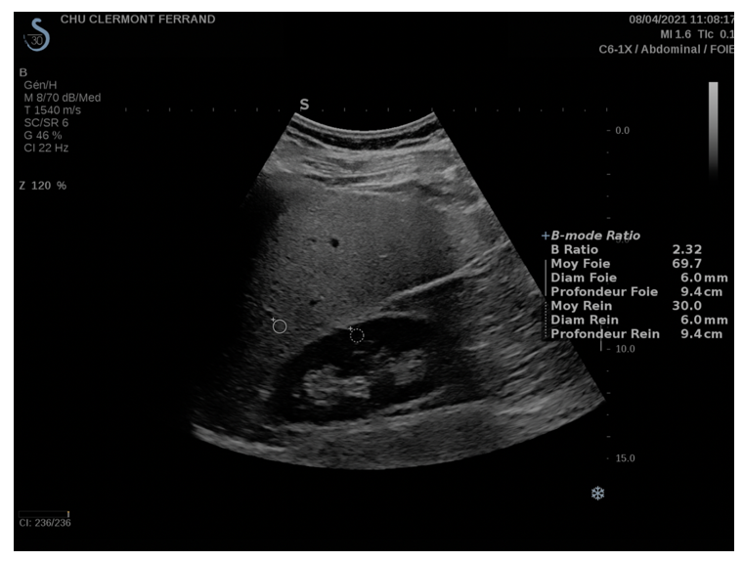
Figure 1 Hepato-renal index measurement with 6 mm wide regions of interest, at a depth of 9.4 cm in liver right lobe and right kidney, University Hospital of Clermont-Ferrand.
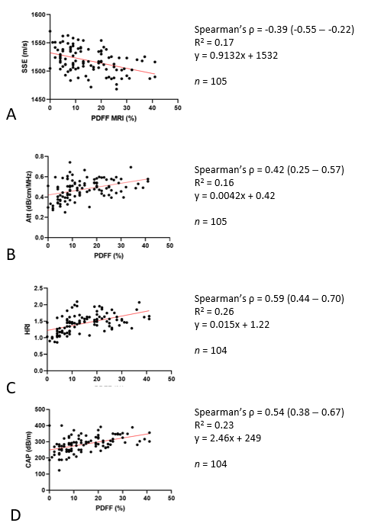
Figure 2 Scatterplots. A-D: Scatterplots showing linear relationship between sound speed estimation (A), attenuation coefficient (B), hepato-renal index (C) and continuous controlled attenuation parameter (D) with magnetic resonance imaging-proton density fat fraction using 6-echo gradient (P < 0.001). PDFF: Proton density fat fraction; cCAP: Continuous controlled attenuation parameter; SSE: Sound speed estimation; AC: Attenuation coefficient; HRI: Hepato-renal index.
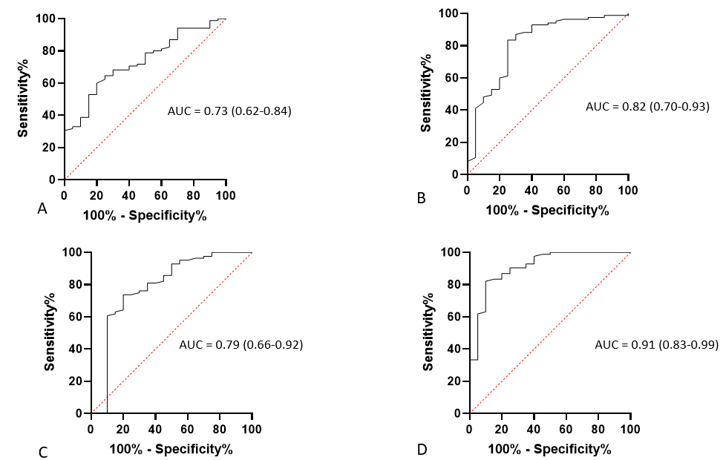
Figure 3 Receiver operating curve. A-D: Receiver operating curve for sound speed estimation (A), attenuation coefficient (B), continuous controlled attenuation parameter (C) and hepato-renal index (D). PDFF: Proton density fat fraction; cCAP: Continuous controlled attenuation parameter; SSE: Sound speed estimation; AC: Attenuation coefficient; HRI: Hepato-renal index.
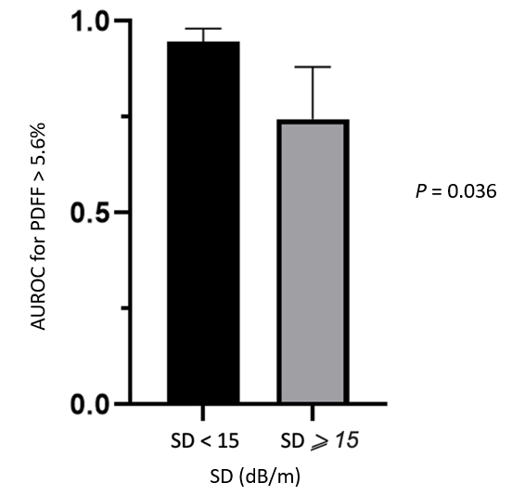
Figure 4 Continuous controlled attenuation parameter area under the receiver operating characteristic curve for the diagnosis of steatosis according to SD. PDFF: Proton density fat fraction; AUROC: Area under the receiver operating characteristic curve.
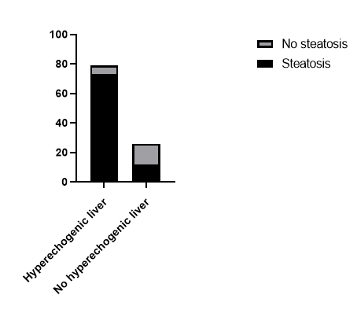
Figure 5 Ultrasound finding according to liver steatosis based on proton density fat fraction.
Table 1 Characteristics of the 105 patients, n (%)
Characteristics of the 105 patients
Demographic and anthropometric data
Sex (male) | 51 (49)
Age (yr) | 56 ± 14
BMI (kg/m²) | 31 ± 6
Overweight | 94 (90)
Obesity | 50 (48)
Waist circumference (cm)¹ | 107 ± 15
Diabetes | 38 (36)
Hypertension | 42 (40)
Metabolic syndrome | 73 (70)
Biological data
Platelets count (G/L)¹ | 231 ± 72
AST (U/L)¹ | 35 ± 28
ALT (U/L)¹ | 65 ± 49
GGT (U/L)¹ | 120 ± 125
Triglycerides (g/L)¹ | 1.7 ± 0.93
HDL cholesterol (g/L)¹ | 1.3 ± 0.4
Ferritin (ng/mL)¹ | 232 ± 283
Steatosis assessment
PDFF (%)¹ | 15 ± 10
Steatosis on MRI | 85 (81)
Fibroscan®
Technical success | 104 (99)
cCAP (dB/m) | 283 ± 58
Liver stiffness (KPa)¹ | 8 ± 7
Liver stiffness > 10 KPa | 21 (20)
Use of M probe | 83 (80)
Use of XL probe | 21 (20)
Aixplorer MACH 30®
Technical success | 105 (100
SSE (m/s)¹ | 1519 ± 22
AC (dB/cm/MHz)¹ | 0.48 ± 0.1
HRI¹ | 1.43 ± 0.28
Technical success | 104 (99)
¹Data are means ± SD. BMI: Body mass index; AST: Aspartate aminotransferase; ALT: Alanine aminotransferase; GGT: Gamma glutamyl transferase; PDFF: Proton density fat fraction; cCAP: Continuous controlled attenuation parameter; SSE: Sound speed estimation; AC: Attenuation coefficient; HRI: Hepato-renal index.
Table 2 Characteristics of steatotic and non-steatotic patients, n (%)
 | Patients with steatosis (n = 85) | Patients without steatosis (n = 20) | P value
Demographic and anthropometric data
Sex (male) | 40 (47) | 11 (55) | 0.62
Age (yr) | 56 ± 14 | 53 ± 14 | 0.5
BMI (kg/m²) | 31 ± 5 | 28 ± 6 | 0.0004
Normal BMI | 7 (8) | 4 (20)
Overweight | 31 (37) | 13 (65)
Obesity | 47 (55) | 3 (15)
Waist circumference (cm)¹ | 108 ± 14 | 99 ± 15 | 0.004
Diabetes | 33 (39) | 5 (25) | 0.3
Hypertension | 37 (44) | 5 (25) | 0.2
Metabolic syndrome | 65 (76) | 8 (40) | 0.0026
Biological data
Platelets count (G/L)¹ | 236 ± 71 | 213 ± 78 | 0.2
AST (U/L)¹ | 37 ± 30 | 27 ± 10 | 0.13
ALT (U/L)¹ | 37 ± 30 | 49 ± 29 | 0.044
GGT (U/L)¹ | 68 ± 53 | 116 ± 85 | 0.68
Triglycerides (g/L)¹ | 1.8 ± 0.9 | 1.3 ± 0.9 | 0.0058
HDL cholesterol (g/L)¹ | 1.3 ± 0.4 | 1.3 ± 0.3 | 0.1
Ferritin (ng/mL)¹ | 121 ± 134 | 172 ± 127 | 0.45
Steatosis assessment
PDFF (%)¹ | 18 ± 9 | 2 ± 3 | < 0.0001
Fibroscan®
Technical success | 84 (99) | 20 (100)
cCAP (dB/m) | 296 ± 42 | 246 ± 67 | < 0.0001
Liver stiffness (KPa)¹ | 8 ± 8 | 7 ± 5 | NS
Liver stiffness > 10 KPa | 19 (22) | 2 (10)
Use of M probe | 65 (76) | 18 (90)
Use of XL probe | 20 (24) | 2 (10)
Aixplorer MACH 30®
Technical success | 85 (100) | 20 (100)
SSE (m/s)¹ | 1515 ± 22 | 1533 ± 19 | 0.0009
AC (dB/cm/MHz)¹ | 0.5 ± 0.1 | 0.39 ± 0.1 | < 0.0001
HRI | 1.52 ± 0.24 | 1.1 ± 0.18 | < 0.0001
Technical success | 84 (99) | 20 (100)
¹Data are means ± SD. BMI: Body mass index; AST: Aspartate aminotransferase; ALT: Alanine aminotransferase; GGT: Gamma glutamyl transferase; PDFF: Proton density fat fraction; cCAP: Continuous controlled attenuation parameter; SSE: Sound speed estimation; AC: Attenuation coefficient; HRI: Hepato-renal index; NS: Non-significant.

