Name of Journal: World Journal of Clinical Cases
Manuscript NO: 70330
Manuscript Type: CASE REPORT

Spermatocytic tumor: A rare case report

Hao ML et al. Spermatocytic tumor

Mei-Ling Hao, Chun-Hui Li

Mei-Ling Hao, Chun-Hui Li, Department of Pathology, Chengde Medical College Affiliated Hospital, Chengde 067000, Hebei Province, China

Author contributions: Hao ML was responsible for the data curation; Hao ML reviewed the literature and contributed to original manuscript drafting; Li CH was responsible for the review of the manuscript; all authors issued final approval for the version to be submitted.

Corresponding author: Chun-Hui Li, PhD, Chief Doctor, Department of Pathology, Chengde Medical College Affiliated Hospital, No. 36 Nanyingzi Dajie, Chengde 067000, Hebei Province, China. chli612@126.com

Received: July 30, 2021
Revised: September 6, 2021
Accepted: October 27, 2021
Published online: December 16, 2021

Abstract
BACKGROUND
Spermatocytic tumor is a rare, malignant neoplasm of the testes. Since the prognosis for this tumor type is favorable, accurate diagnosis and differentiation from other malignant testicular neoplasms (classic seminoma and lymphoma) are crucial. To add to the existing literature on the diagnosis of spermatocytic tumor, herein we report the detailed clinical and histopathologic findings for a case that we encountered.

CASE SUMMARY
A 60-year-old Chinese man presented with a solid mass in the right scrotum. The mass was surgically removed and spermatocytic tumor was diagnosed. On microscopy, the tumor cells displayed an unusual arrangement in lobules, presenting a pseudo-glandular appearance. To summarize and compare the diagnostic features of this tumor and those of the differential diagnoses, we report our case findings and those mentioned in the literature for various testicular tumors. Although imaging methods can detect masses early in development, their diagnostic capabilities are limited. Biopsy, histopathology, and immunohistochemistry are necessary for confirmatory diagnosis.

CONCLUSION
It is important to identify and review the key diagnostic features of spermatocytic tumor.

Key Words: Spermatocytic tumor; Germ cell tumor; Immunohistochemistry; Pseudo-glandular; Case report

Hao ML, Li CH. Spermatocytic tumor: A rare case report. World J Clin Cases 2021; 9(35): 11115-11121
URL: https://www.wjgnet.com/2307-8960/full/v9/i35/11115.htm
DOI: https://dx.doi.org/10.12998/wjcc.v9.i35.11115

Core Tip: Spermatocytic tumor is a rare malignant testicular tumor. At present, there are few reported cases in the world. The understanding of clinicians and pathologists about this disease is not comprehensive enough. Here we report a case of spermatocytic tumor, emphasizing the morphological features of spermatocytic tumor and the key points of differentiation from classic seminoma and lymphoma, so as to avoid misdiagnosis.

INTRODUCTION
Spermatocytic tumor is a rare malignancy that accounts for 0.61% of testicular germ cell tumors^{[1]}. Tumor development is independent of ethnicity and a history of cryptorchidism. Older men with an average age of 52 years are often the most affected^{[2]}. At present, as spermatocytic tumors are extremely rare, there is a paucity of data for clinicians and pathologists to make differential diagnosis. Herein, we present a case of spermatocytic tumor, and review and consult the relevant literature. We summarize the morphological characteristics of spermatocytoma, hoping to provide clinicians and pathologists with more reliable diagnostic data and diagnostic ideas to help them serve patients better, reduce patients' pain, and avoid unnecessary, if not harmful, treatments.

CASE PRESENTATION
Chief complaints
A 60-year-old Chinese male farmer presented with a 3-mo history of right scrotal enlargement.

History of present illness
The patient presented with right scrotal enlargement and had no scrotal tenderness, chills, fever, or other discomfort. No abnormality of the left testis, epididymis, or spermatic cord was discerned. The patient did not self-medicate or seek alternative therapies. He reported no lumbar or abdominal pain and no increased frequency, urgency, or pain associated with urination, but had a slight weight loss.

History of past illness
The patient had no history of trauma, tuberculosis, or other relevant infectious disease.

Personal and family history
The patient denied any family history.

Physical examination
A 4 cm × 5 cm, slightly moveable, solid mass was palpated in the right scrotum, which drooped and was pale in color. No normal testicular or epididymal structures were palpated in the affected testis. No abnormality of the left testis, epididymis, or spermatic cord was discerned.

Laboratory examinations
The results such as routine hematological testing, blood sedimentation rate, vascular endothelial growth factor, human chorionic gonadotropin (HCG), serum carbohydrate antigen (CA)199, CA125, CA153, alpha-fetoprotein (AFP), thymidine kinase 1, and carcinoembryonic antigen (CEA) were normal.

Imaging examinations
Within 1 wk from presentation, the patient underwent scrotal ultrasound showing a 4.5 cm × 2.7 cm × 3.7 cm oval-shaped hypoechoic mass, with uneven internal echogenicity in the right testicle (Figure 1A). Color Doppler showed scattered color blood flow signals within the lesion. Meanwhile, the patient underwent computed tomography (CT), which revealed an enlarged right testis, with indistinct contour, uneven density, and uniform nodular change (Figure 1B). No normal testicular or epididymal structures were palpated in the affected testis.

FINAL DIAGNOSIS
Spermatocytic tumor.

TREATMENT
The patient agreed and voluntarily underwent orchiectomy after 1 wk. The testicular specimens were fixed with 4% formalin for 24 h. Gross examination of the right testis identified a well-demarcated, solid, lobulated, expansile, yellow-gray nodule that was 3 cm × 3 cm × 2 cm in size. The mass contained multiple areas of myxoid degeneration. The postoperative specimens were made into wax blocks and observed after hematoxylin-eosin staining. Microscopy revealed a pseudo-glandular appearance of the tumor tissue, in which aggregates of tumor cells were arranged in an edematous stroma containing scant fibrous tissue (Figure 2A and C). The tumor cells formed diffuse sheets and nests (Figure 2B). Large, small, and medium-sized tumor cells were identified. The medium-sized cell type predominated and was characterized by eosinophilic cytoplasm, suggesting decreased glycogen, round nuclei, and a filamentous chromatin pattern similar to that of spermatocytes (Figure 2A and C). The small cells resembled lymphocytes and had no obvious cytoplasm (Figure 2A and C). The large mononuclear tumor cells had round, oval, or indented nuclei, with thick chromatin and multiple nucleoli (Figure 2A and C). No mitotic figures were observed. Mucinous degeneration was observed in some areas (Figure 2D). No lymphocyte infiltration or granulomatous inflammatory response was noted. Thereafter, we performed indirect immunohistochemical staining and used mouse anti-human primary antibody and rabbit anti-mouse secondary antibody. The results revealed: CD117(+) (Figure 3A), PLAP(-) (Figure 3B), CD30(-), HCG(-), SOX-2(-), CK(-), CD45_{RO}(-), CD3(-), D2-40(-), CK8/18(-), AFP(-), and GPC3(-). The proliferation index (Ki-67) was 80%.

OUTCOME AND FOLLOW-UP
The patient only underwent orchiectomy without radiotherapy or chemotherapy. No recurrence or metastasis has been observed till date (12 mo post surgery).

DISCUSSION
The theory that spermatocytic tumor precursor cells originate in embryogenesis is disputed^{[3]}. Some scholars^{[1]} believe that spermatocytic tumor develops from mature cells such as pachytene spermatocytes. A recent study found that these tumor cells express reproductive cell-specific markers^{[4]}. Morphological and immunohistochemical features of the tumor cells suggest derivation from spermatogonial stem cells^{[5]}.
Clinical symptoms associated with spermatocytic tumor include painless and slowly progressive testicular swelling^{[6,7]} and low back pain in cases with a poor prognosis due to retroperitoneal metastasis. Spermatocytic tumors range from 2 cm to 20 cm in diameter, with an average diameter of 7 cm. Grossly, Hu et al^{[7]} reported that these lobulated tumors have a homogeneous parenchymal appearance and most tumors were pink-tan, brown-tan, or white-tan and typically soft and lobulated, mucinous. They often contain areas of edema, hemorrhage, and necrosis. The majority of these tumors are contained within the testis and do not breach the testicular sheath to infiltrate surrounding tissues^{[8-10]}. The histomorphologic spectrum of spermatocytic tumor^{[11]} is characterized by several points as follows: (1) At low magnification, the tumors are mainly multinodular or diffuse. All tumors have typical cell populations of three different sizes; (2) spermatocytic tumors often show edematous or myxoid degeneration with edematous stroma forming slit like structures and follicular like or irregular patterns, which are seen in some classical seminomas and rare in lymphomas; (3) tumor nodules focally show fibrous margins, and closely anastomosing connected island like structures; and (4) there is marked lymphocytic infiltration with granulomatous inflammation. It is important to recognize all the above characteristics, which will help the pathologist to diagnose and make a differential diagnosis^{[5]}. Notably, its immunohistochemical markers are also very special. Although it belongs to germ cell tumors of the testis, it does not express useful markers in other germ cell tumors, such as OCT3/4, PLAP, AFP, HCG, and CD30. It often shows positive or weak positive expression of a key marker, CD117, and the proliferation index (Ki-67) tended to be very high. This adds challenges to our diagnostic work and requires pathologists to constantly expand their diagnostic ideas.
Spermatocytic tumor must be distinguished from classic and anaplastic seminoma. Classic seminoma is characterized by an earlier average age of onset (30 years)^{[2]} and tumor cells that are often rich in glycogen with clear cytoplasm. The tumor cells form nests that are rimmed by fibrous tissue bands. Lymphocytic infiltration and a granulomatous inflammatory response are seen in the stroma. Classic seminoma tumor cells are positive for the immunohistochemical markers such as PLAP, CD117, vimentin, LDH, ferritin, and germ cell antigen, but usually negative for high molecular weight keratin and CD30. Anaplastic seminoma cells display obvious heteromorphism and increased mitotic rate, but do not stain positively for the abovementioned immunohistochemical markers^{[12]}. Some experts proposed that classic seminoma and anaplastic seminoma are variants of the same tumor^{[13]}. An elevated serum HCG level and/or tumor features, such as hemorrhage, necrosis, and vascular infiltration, are seen in patients with invasive, late clinical stage anaplastic seminoma that has a poor prognosis^{[14]}. The spermatocytic tumor we identified in our patient contained small, medium, and large tumor cells that were slightly separated within an edematous stroma, creating a pseudo-glandular tissue appearance. The lack of lymphocytic infiltration, granulomatous inflammatory response, increased level of mitosis, and sarcomatous components were features of our patient’s tumor that were consistent with this diagnosis. The tumor in our patient’s case lacked markers (OCT3/4, AE1, AE3, and CD30) that are absent in spermatocytic tumor, but present in other germ cell tumors. Moreover, immunohistochemical staining for CD117 was positive in our patient’s tumor; this marker is a key feature for identifying spermatocytic tumor.
The clinical features and imaging findings of testicular spermatocytic tumor are not distinct from those of classic spermatoplasm cytomaspermatocytic tumor and other types of testicular tumors. Laboratory test results for serum LDH, HCG, and AFP levels are usually not elevated. Ultrasound is useful for early testicular tumor detection and is a preferred imaging method due to its non-invasive nature^{[14-18]}. CT provides more information regarding features such as tumor boundary, internal architecture, involvement of surrounding structures, and lymph node metastasis, and is useful for establishing a preoperative presumptive diagnosis and for postoperative follow-up^{[19-22]}. However, biopsy and histopathology are required to confirm the diagnosis. Currently, orchiectomy is the preferred treatment for testicular spermatocytic tumor. The scope of surgical resection should include the testicular epididymis and a portion of the spermatic cord to ensure complete excision for the 10%-15% of testicular tumors that invade these structures^{[23-26]}. Most spermatocytic tumors exhibit benign behavior, with a low potential for invasion and metastasis. Given the favorable prognosis for this tumor type, no adjuvant therapy is usually required following excision by orchidectomy^{[27,28]}. However, tumors that are larger than 4 cm in diameter, involve the epididymis or spermatic cord, or have sarcomatous features may have an increased risk for malignant behavior and recurrence. Long term follow-up is necessary in such cases.

CONCLUSION
In summary, we report a typical case of spermatocytic tumor, review its epidemiology and various examined features, as well as pathological features such as three typical cellular morphologies and interstitial mucinous degeneration, and make a differential diagnosis with its similar counterpart. The first line of therapy for spermatocytic tumor is orchiectomy, which does not require other adjuvant therapy unless there is an incomplete or spermatic cord, or recurrent features. Long-term follow-up may be recommended to identify potential postoperative recurrence.

REFERENCES
1 Grogg JB, Schneider K, Bode PK, Wettstein MS, Kranzbühler B, Eberli D, Sulser T, Beyer J, Hermanns T, Fankhauser CD. A systematic review of treatment outcomes in localised and metastatic spermatocytic tumors of the testis. J Cancer Res Clin Oncol 2019; 145: 3037-3045 [PMID: 31646373 DOI: 10.1007/s00432-019-03056-1]
2 Facchini G, Rossetti S, Berretta M, Cavaliere C, D'Aniello C, Iovane G, Mollo G, Capasso M, Della Pepa C, Pesce L, Facchini S, Imbimbo C, Pisconti S. Prognostic and predictive factors in testicular cancer. Eur Rev Med Pharmacol Sci 2019; 23: 3885-3891 [PMID: 31115016 DOI: 10.26355/eurrev_201905_17816]
3 Menon S, Karpate A, Desai S. Spermatocytic seminoma with rhabdomyosarcomatous differentiation: a case report with a review of the literature. J Cancer Res Ther 2009; 5: 213-215 [PMID: 19841567 DOI: 10.4103/0973-1482.57131]
4 Haroon S, Tariq MU, Fatima S, Kayani N. Spermatocytic seminoma: a 21 years' retrospective study in a tertiary care hospital in Pakistan. Int J Clin Exp Pathol 2013; 6: 2350-2356 [PMID: 24228096]
5 Waheeb R, Hofmann MC. Human spermatogonial stem cells: a possible origin for spermatocytic seminoma. Int J Androl 2011; 34: e296-305; discussion e305 [PMID: 21790653 DOI: 10.1111/j.1365-2605.2011.01199.x]
6 Patel PM, Patel HD, Koehne EL, Doshi C, Belshoff A, Seffren CM, Baker M, Gorbonos A, Gupta G. Contemporary Trends in Presentation and Management of Spermatocytic Seminoma. Urology 2020; 146: 177-182 [PMID: 33049234 DOI: 10.1016/j.urology.2020.10.002]
7 Hu R, Ulbright TM, Young RH. Spermatocytic Seminoma: A Report of 85 Cases Emphasizing Its Morphologic Spectrum Including Some Aspects Not Widely Known. Am J Surg Pathol 2019; 43: 1-11 [PMID: 29280854 DOI: 10.1097/PAS.0000000000001001]
8 Jha RK, Mathur S, Saidha NK. A case of spermatocytic seminoma in young individual. Med J Armed Forces India 2018; 74: 276-279 [PMID: 30093773 DOI: 10.1016/j.mjafi.2017.01.007]
9 Pandey V, Khatib Y, Khade AL, Pandey R, Khare MS. Spermatocytic seminoma with rhabdomyoblastic differentiation: Case report and review of literature. Indian J Pathol Microbiol 2018; 61: 437-439 [PMID: 30004076 DOI: 10.4103/IJPM.IJPM_243_17]
10 Stueck AE, Grantmyre JE, Wood LA, Wang C, Merrimen J. Spermatocytic Tumor With Sarcoma: A Rare Testicular Neoplasm. Int J Surg Pathol 2017; 25: 559-562 [PMID: 28440090 DOI: 10.1177/1066896917706156]
11 Mikuz G. [Spermatocytic seminoma. A tumor with many faces]. Pathologe 2014; 35: 232-237 [PMID: 24682373 DOI: 10.1007/s00292-014-1899-x]
12 Lieng H, Warde P, Bedard P, Hamilton RJ, Hansen AR, Jewett MAS, O'malley M, Sweet J, Chung P. Recommendations for followup of stage I and II seminoma: The Princess Margaret Cancer Centre approach. Can Urol Assoc J 2018; 12: 59-66 [PMID: 29381453 DOI: 10.5489/cuaj.4531]
13 Marko J, Wolfman DJ, Aubin AL, Sesterhenn IA. Testicular Seminoma and Its Mimics: From the Radiologic Pathology Archives. Radiographics 2017; 37: 1085-1098 [PMID: 28574809 DOI: 10.1148/rg.2017160164]
14 Azizi M, Peyton CC, Boulware DC, Gilbert SM, Sexton WJ. Primary tumor size thresholds in stage IA testicular seminoma: Implications for adjuvant therapy after orchiectomy and survival. Urol Oncol 2020; 38: 7.e9-7.e18 [PMID: 31704139 DOI: 10.1016/j.urolonc.2019.09.022]
15 He Y, Liao H, Xiang X, Cai D, Qiu L. High-frequency ultrasonography and contrast-enhanced ultrasound for the evaluation of testicular capillary hemangioma: A case report. Medicine (Baltimore) 2019; 98: e14779 [PMID: 30882650 DOI: 10.1097/MD.0000000000014779]
16 Huang H, Ling W, Qiu T, Luo Y. Ultrasonographic features of testicular metastasis from renal clear cell carcinoma that mimics a seminoma: A case report. Medicine (Baltimore) 2018; 97: e12728 [PMID: 30290683 DOI: 10.1097/MD.0000000000012728]
17 Fu J, Yang W, Wang S, Bai J, Wu H, Wang H, Yan K, Chen M. Clinical value of contrast-enhanced ultrasound in improving diagnostic accuracy rate of transthoracic biopsy of anterior-medial mediastinal lesions. Chin J Cancer Res 2016; 28: 617-625 [PMID: 28174490 DOI: 10.21147/j.issn.1000-9604.2016.06.08]
18 Saba L. The primitive extratesticular seminoma: diagnosis of a rare pathology. Acta Biomed 2017; 88: 82-85 [PMID: 28467339 DOI: 10.23750/abm.v88i1.5601]
19 Lwin TT, Yoneyama A, Maruyama H, Takeda T. Visualization Ability of Phase-Contrast Synchrotron-Based X-Ray Imaging Using an X-Ray Interferometer in Soft Tissue Tumors. Technol Cancer Res Treat 2021; 20: 15330338211010121 [PMID: 33896273 DOI: 10.1177/15330338211010121]
20 Bantis A, Sountoulides P, Metaxa L, Pavlidis P, Aggelonidou E, Arif H, Zisimopoulos A. The diagnostic yield of fluorine-18 fluorodeoxyglucose positron emission tomography-computed tomography in recurrent testicular seminoma. Urol Ann 2016; 8: 496-499 [PMID: 28058002 DOI: 10.4103/0974-7796.192090]
21 Gossner J. Computed tomography as a problem solving tool in non-radiopaque central venous port systems - A report of three cases. Interv Med Appl Sci 2014; 6: 43-45 [PMID: 24672675 DOI: 10.1556/IMAS.6.2014.1.7]
22 von Amsberg G, Sehovic M, Hartmann M, Bokemeyer C. [Diagnosis and treatment of rare testicular tumors using the example of malignant mesothelioma of the tunica vaginalis testis and Sertoli cell tumors]. Urologe A 2021; 60: 872-879 [PMID: 34185119 DOI: 10.1007/s00120-021-01575-9]
23 Bois JI, Vagni RL, de Badiola FI, Moldes JM, Losty PD, Lobos PA. Testis-sparing surgery for testicular tumors in children: a 20 year single center experience and systematic review of the literature. Pediatr Surg Int 2021; 37: 607-616 [PMID: 33454815 DOI: 10.1007/s00383-020-04850-6]
24 Al-Obaidy KI, Idrees MT. Testicular Tumors: A Contemporary Update on Morphologic, Immunohistochemical and Molecular Features. Adv Anat Pathol 2021; 28: 258-275 [PMID: 33871428 DOI: 10.1097/PAP.0000000000000302]
25 Miao X, Li Y, Zhou T, Lv M. Testis-sparing surgery in children with testicular tumors: A systematic review and meta-analysis. Asian J Surg 2021 [PMID: 33893031 DOI: 10.1016/j.asjsur.2021.03.016]
26 Michalová K, Michal M, Hora M, Hes O, Michal M. Practices recommendations in the applications of immunohistochemistry and molecular genetics in testicular tumors. Review article. Cesk Patol 2020; 56: 153-160 [PMID: 33076667]
27 Schwarze V, Marschner C, Sabel B, de Figueiredo GN, Marcon J, Ingrisch M, Knösel T, Rübenthaler J, Clevert DA. Multiparametric ultrasonographic analysis of testicular tumors: a single-center experience in a collective of 49 patients. Scand J Urol 2020; 54: 241-247 [PMID: 32449437 DOI: 10.1080/21681805.2020.1765863]
28 Fankhauser CD, Roth L, Kranzbühler B, Eberli D, Bode P, Moch H, Oliveira P, Ramani V, Beyer J, Hermanns T. The Role of Frozen Section Examination During Inguinal Exploration in Men with Inconclusive Testicular Tumors: A Systematic Review and Meta-analysis. Eur Urol Focus 2020 [PMID: 32684510 DOI: 10.1016/j.euf.2020.06.019]

Footnotes
Informed consent statement: Informed consent was obtained from the patient for the publication of this case report.

Conflict-of-interest statement: The authors have nothing to disclose.

CARE Checklist (2016) statement: The authors have read the CARE Checklist (2016), and the manuscript was prepared and revised according to the CARE Checklist (2016).

Open-Access: This article is an open-access article that was selected by an in-house editor and fully peer-reviewed by external reviewers. It is distributed in accordance with the Creative Commons Attribution NonCommercial (CC BY-NC 4.0) license, which permits others to distribute, remix, adapt, build upon this work non-commercially, and license their derivative works on different terms, provided the original work is properly cited and the use is non-commercial. See: http://creativecommons.org/Licenses/by-nc/4.0/

Manuscript source: Unsolicited manuscript

Peer-review started: July 30, 2021
First decision: September 1, 2021
Article in press: October 27, 2021

Specialty type: Andrology
Country/Territory of origin: China
Peer-review report’s scientific quality classification
Grade A (Excellent): 0
Grade B (Very good): 0
Grade C (Good): C
Grade D (Fair): 0
Grade E (Poor): 0

P-Reviewer: Exbrayat JM S-Editor: Yan JP L-Editor: Wang TQ P-Editor: Yan JP

Figure Legends

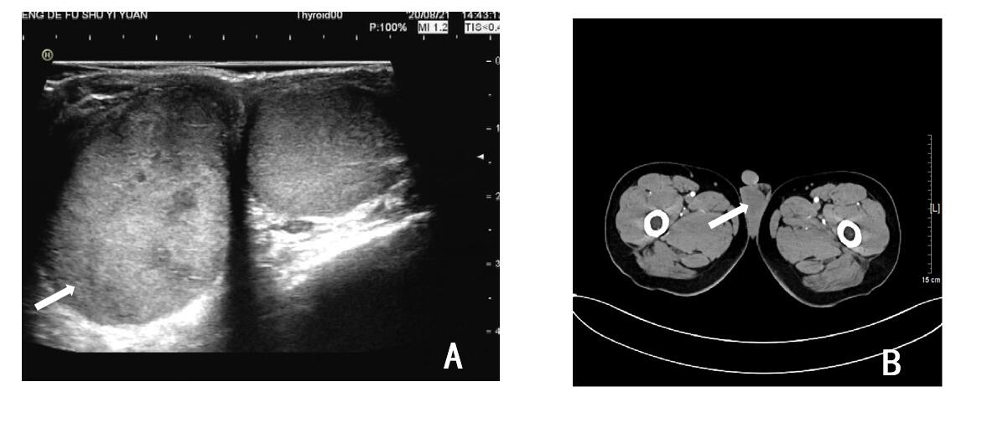
Figure 1 Ultrasound (left) and computed tomographic scans (right) of the testicles. A: Increased volume of the right testicle, with a lesion of uneven parenchymal echo (white arrow); B: Uniform nodular change in the right testicle (white arrow).

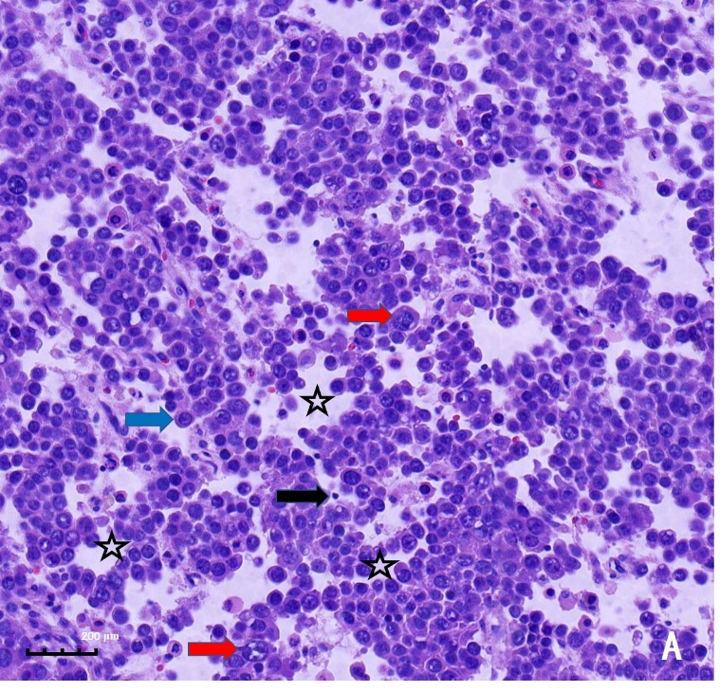

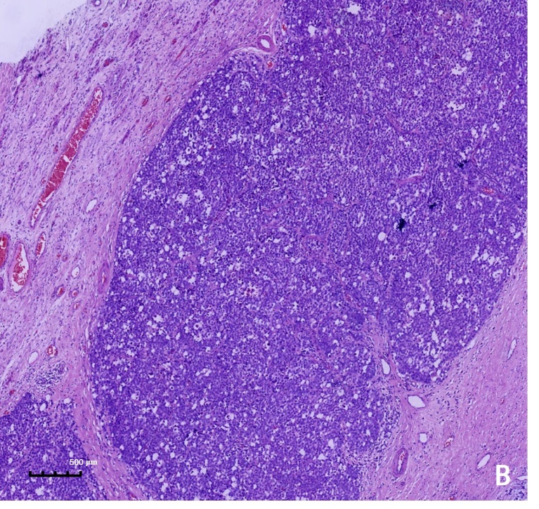
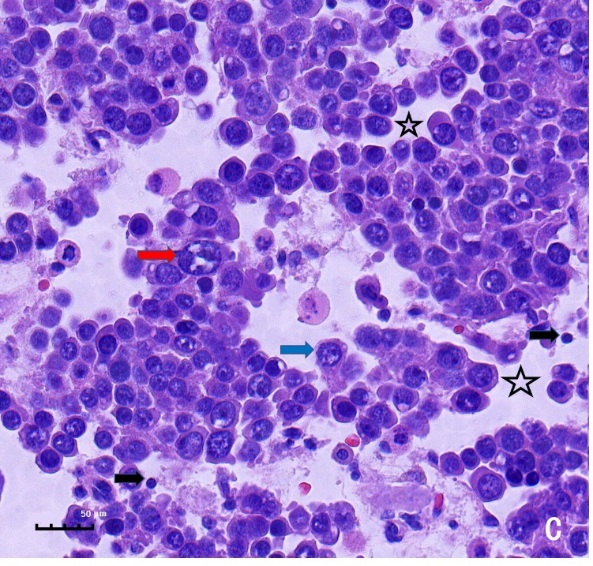
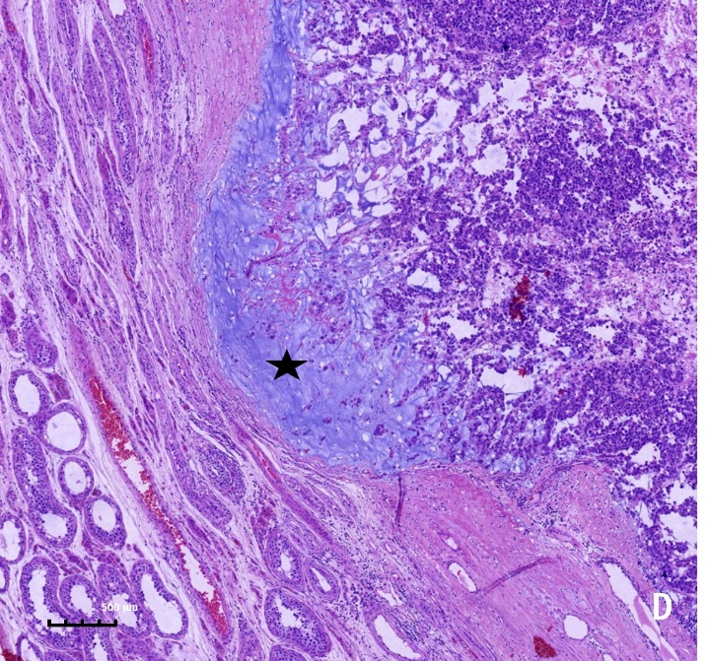
Figure 2 Histopathology findings. A and C: Neoplastic testicular tissue with stromal edema (hollow pentagram) that produces pseudo-adenomatous change; three sizes of tumor cells were identified: Large (red arrow), small (black arrow), and medium-sized cells (blue arrow); B: Tumor cells form diffuse sheets and nests; D: Mucinous degeneration occurs in some areas (solid pentagram). Hematoxylin & eosin staining. Magnification: 100 × (A); 40 × (B and D); 400 × (C).

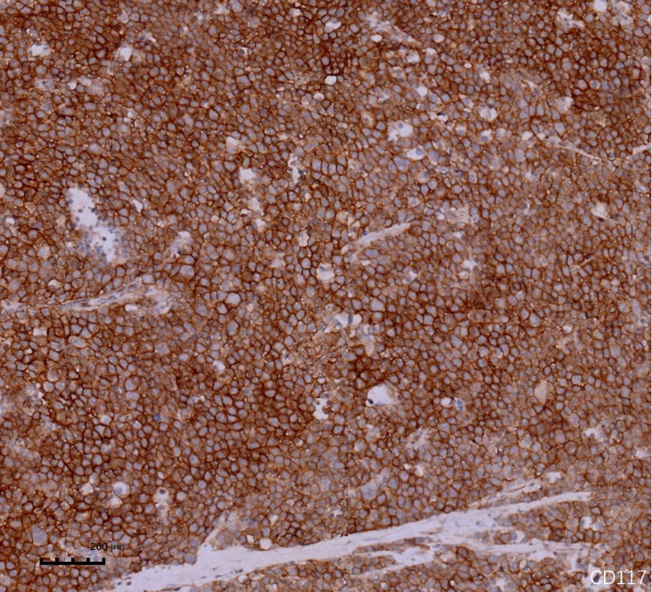
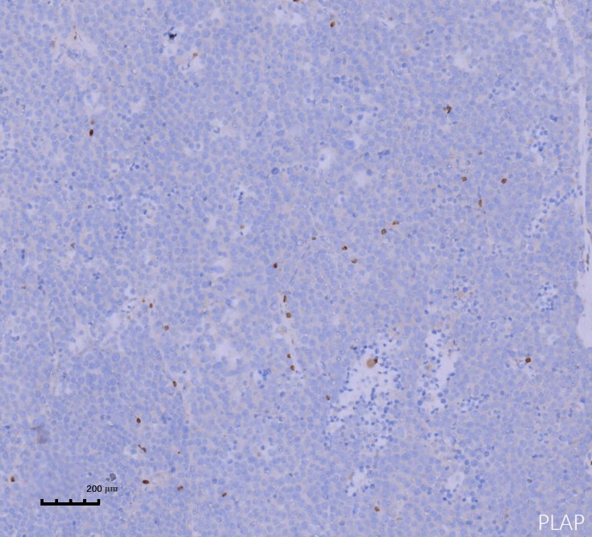
Figure 3 Immunohistochemistry staining. A: Positive staining of tumor cell membranes for CD117 (100 ×); B: No nuclear staining for PLAP (100 ×).

Published by Baishideng Publishing Group Inc
7041 Koll Center Parkway, Suite 160, Pleasanton, CA 94566, USA
Telephone: +1-925-3991568
E-mail: bpgoffice@wjgnet.com
Help Desk: https://www.f6publishing.com/helpdesk
https://www.wjgnet.com

© 2021 Baishideng Publishing Group Inc. All rights reserved.

