Name of Journal: World Journal of Gastrointestinal Oncology
Manuscript NO: 86605
Manuscript Type: CASE REPORT

Response of cholangiocarcinoma with epigastric metastasis to lenvatinib plus sintilimab: A case report and review of literature

Luo WH et al. Lenvatinib plus sintilimab for CCA

Wen-Hui Luo, Shao-Jun Li, Xue-Feng Wang

Wen-Hui Luo, Shao-Jun Li, Xue-Feng Wang, The Second Department of Hepatobiliary Surgery, Yantai Yuhuangding Hospital, Yantai 264000, Shandong Province, China

Co-first authors: Wen-Hui Luo and Shao-Jun Li.

Author contributions: Li SJ provided insights into the direction of this study and assisted in the writing. For example, Li SJ and two other authors proposed at the beginning of the article that liver is an immunological preferential organ with strong immune tolerance, which may affect the development of metastatic tumors. During the writing process, Li SJ collected images, such as Figure 1 for magnetic resonance imaging images of patients before surgery, Figure 2 for baseline magnetic resonance imaging images before targeted immunotherapy, and Figure 4 for magnetic resonance imaging images of different tumor sites after treatment, to find out typical and clear pictures, and labeled typical lesions in the figures at each stage. Additionally, he provided necessary help for literature search, such as finding new articles on targeted immunization of cholangiocarcinoma. After the completion of the writting, the co-first authors reviewed the paper and corrected language logic problems. When looking for a journal to submit our study, we have sought for the opinions of Li SJ and we all think it is appropriate to submit our article to the World Journal of Gastrointestinal Oncology.

Corresponding author: Xue-Feng Wang, MD, Associate Chief Physician, Doctor, The Second Department of Hepatobiliary Surgery, Yantai Yuhuangding Hospital, No. 20 Yuhuangding East Road, Zhifu District, Yantai 264000, Shandong Province, China. seasonslo@126.com

Received: July 6, 2023
Revised: September 15, 2023
Accepted: September 28, 2023
Published online: November 15, 2023

Abstract
BACKGROUND
Cholangiocarcinoma (CCA) poses a significant clinical challenge due to its low radical resection rate and a propensity for high postoperative recurrence, resulting in a poor dismal. Although the combination of targeted therapy and immunotherapy has demonstrated notable efficacy in several solid tumors recently, however, its application in CCA remains underexplored and poorly documented.

CASE SUMMARY
This case report describes a patient diagnosed with stage IV CCA, accompanied by liver and abdominal wall metastases, who underwent palliative surgery. Subsequently, the patient received two cycles of treatment combining lenvatinib with sintilimab, which resulted in a reduction in abdominal wall metastasis, while intrahepatic metastasis displayed progression. This unexpected observation illustrates different responses of intrahepatic and extrahepatic metastases to the same therapy.

CONCLUSION
Lenvatinib combined with sintilimab shows promise as a potential treatment strategy for advanced CCA. Genetic testing for related driver and/or passenger mutations, as well as an analysis of tumor immune microenvironment analysis, is crucial for optimizing drug combinations and eventually addressing the issue of non-response in specific metastatic sites.

Key Words: Cholangiocarcinoma; Immune-checkpoint-inhibitor; Lenvatinib; Sintilimab; Epigastric metastasis; Immunotherapy; Case report

©The Author(s) 2023. Published by Baishideng Publishing Group Inc. All rights reserved.

Citation: Luo WH, Li SJ, Wang XF. Response of cholangiocarcinoma with epigastric metastasis to lenvatinib plus sintilimab: A case report and review of literature. World J Gastrointest Oncol 2023; 15(11): 2033-2040
URL: https://www.wjgnet.com/1948-5204/full/v15/i11/2033.htm
DOI: https://dx.doi.org/10.4251/wjgo.v15.i11.2033

Core Tip: Cholangiocarcinoma (CCA) is a highly lethal hepatobiliary neoplasm. This report presents a case with advanced CCA who received immunotherapy, revealing differences in treatment responses between intrahepatic vs. extrahepatic epigastric metastatic sites. This hitherto unreported phenomenon prompted us to investigate the differential outcomes of these metastatic patterns following treatment with lenvatinib combined with sintilimab, culminating in a summary report elucidating potential underlying mechanisms.

INTRODUCTION
Cholangiocarcinoma (CCA), characterized by its high lethality within the hepatobiliary malignancy spectrum, traditionally necessitates surgical management as the primary therapeutic approach. However, due to multifaceted clinical considerations, only about 50% of patients with CCA are considered suitable candidates for surgical intervention based on preoperative assessment^{[1]}. Moreover, surgical procedures often unveil multiple tumor metastases, thereby limiting the feasibility of surgical resection to a mere 30%^{[2]}. Even with surgical intervention, the persistent risk of locoregional recurrence or lymph node metastasis rate remains high. Currently, chemotherapy is the first-line treatment for advanced CCA, yet it yields suboptimal outcomes^{[3]}.
The emergence of immunotherapy, particularly immune-checkpoint-inhibitors (ICIs), has ignited optimism for patients with CCA^{[4]}. Previous studies on CCA have underscored the superiority of combined immune-based intervention strategies over conventional chemotherapy.
In this report, we present a case of advanced CCA that underwent palliative surgery followed by combined immunotherapy. Surprisingly, differences in treatment responses were observed between intrahepatic metastases and those having extrahepatic epigastric metastases were observed. To the best of our knowledge, this phenomenon has not been previously reported.

CASE PRESENTATION
Chief complaints
A 79-year-old male presented to our outpatient clinic for cutaneous scleral jaundice.

History of present illness
Over the past two weeks, the patient experienced a weight loss of 3 kg. He reported no fever or abdominal pain.

History of past illness
Three years ago, the patient underwent “atrial fibrillation radiofrequency ablation” for “atrial fibrillation”.

Personal and family history
The patient had no relevant family medical history.

Physical examination
The patient had cutaneous scleral jaundice, and no other abnormalities were observed.

Laboratory examinations
The laboratory workup showed the following results: Total bilirubin, 271.8 μmol/L (reference range, 3.2-23.5 μmol/L); aspartate aminotransferase, 277 U/L (reference range, 15-40 U/L); alanine aminotransferase, 535 U/L (reference range, 9-50 U/L); albumin, 35 g/L (reference range, 40-55 g/L); and glycoprotein, 19-9 102 U/mL (reference range, 0-39 U/L).

Imaging examinations
Contrast-enhanced magnetic resonance imaging (MRI) of the hepatobiliary system revealed a carcinoma measuring 1.1 cm in the middle and lower bile duct, with an unclear boundary, a high diffusion-weighted imaging signal, moderately heterogeneous enhancement, and the presence of an enlarged retroperitoneal lymph node in group 13 measuring 1.5 cm (Figure 1). This presentation led to the consideration of CCA with lymph node metastasis. Preoperative examination suggested a tumor marker carbohydrate antigen 19-9 (CA19-9) > 1000 U/mL. Following a multidisciplinary discussion, the patient received palliative surgery involving laparoscopic choledochojejunostomy for CCA on August 13, 2021.
On January 6, 2022, approximately five months after surgical treatment, a mass was identified in the right epigastric region. Contrast-enhanced abdominal computed tomography (CT) revealed a carcinoma measuring 1.1 cm in diameter in the middle and lower bile duct, along with a retroperitoneal metastatic lymph node measuring 1.3 cm, exhibiting minimal change compared to previous measurements. However, new intrahepatic metastases were identified, including a metastatic carcinoma measuring 0.5 cm × 0.4 cm in the left lateral lobe of the liver and another measuring 1.3 cm × 1.2 cm in the fifth segment of the right lobe of the liver. Furthermore, metastasis in the right epigastric subcutaneous fat layer metastases measuring 2.0 cm × 1.9 cm was also observed (Figure 2). A needle biopsy confirmed that the right epigastric metastasis was infiltrative adenocarcinoma consistent with metastatic CCA (Figure 3). The patient declined the administration of gemcitabine plus cisplatin.
On January 31, 2022 (six months postoperatively), the patient initiated the first cycle of combined immunotherapy, receiving oral lenvatinib at a dosage of 8 mg once daily and intravenous sintilimab at a dosage of 200 mg every three weeks. The patient completed two treatment cycles. Following the second cycle, a contrast-enhanced abdominal CT scan on March 15, 2022, revealed a carcinoma measuring 1.1 cm in the bile duct and a retroperitoneal metastatic lymph node measuring 1.3 cm in size. Notably, the right epigastric metastases significantly reduced in size to 0.4 cm × 0.5 cm. However, the intrahepatic metastases displayed an increase in size compared to previous measurements, with metastatic carcinoma in the left lateral lobe of the liver measuring 0.9 cm × 0.9 cm and the other measuring 1.8 cm × 1.7 cm in the fifth segment of the right lobe of the liver (Figure 4). CA19-9 decreased to 105.5 U/mL after targeted immunotherapy. We recommended interventional therapy to control the progression of intrahepatic metastases, but the patient declined and opted to suspend the abovementioned treatments.

FINAL DIAGNOSIS
On August 8, 2021, the patient was diagnosed with distal CCA (T3N1M0).

TREATMENT
On January 31, 2022 (six months postoperatively), the patient initiated the first cycle of combined immunotherapy, receiving oral lenvatinib at a dosage of 8 mg once daily and intravenous sintilimab at a dosage of 200 mg every three weeks. The patient completed two treatment cycles.

OUTCOME AND FOLLOW-UP
Unfortunately, the patient passed away six months after commencing combined targeted immunotherapy. To assess the therapeutic progress, a comparison was made with the initial. Various aspects were evaluated, including the primary lesions, retroperitoneal lymph node metastases, epigastric metastases, and intrahepatic metastases. The post-immunotherapy assessments adhered to the Response Evaluation Criteria in Solid Tumors (RECIST) 1.1. The patient’s treatment process is shown in Figure 5.

DISCUSSION
CCAs represent a heterogeneous group of malignancies originating from the epithelial cells of the bile ducts, manifesting as solid tumors that can occur anywhere along the biliary tree, including intrahepatic CCA and extrahepatic CCA. These cancers are characterized by their aggressive biological behavior, often remain latent until reaching advanced stages, and are associated with a high postoperative recurrence rate of up to 67%, a 5-year survival rate of below 5%, even after surgical intervention^{[5,6]}. Currently, the primary therapeutic approach for metastatic or recurrent CCA involves the combination of gemcitabine and cisplatin^{[7]}. However, CCA exhibits limited sensitivity to chemotherapy, resulting in a median survival of only 6 to 8 mo^{[8]}. Therefore, there is an urgent need for innovative treatments to improve patient survival rates and enhance their quality of life.
In recent years, the field of oncology and immunology has witnessed significant advancements, particularly in the realm of immunotherapy, which has demonstrated remarkable efficacy in treating solid tumors. Multiple studies have suggested a close association between CCA and chronic inflammation, as well as the tumor immune microenvironment^{[5]}. The presence of specific immune cells typed within the tumor milieu significantly influences therapeutic response and overall prognosis. For instance, Marks and Yee^{[9]} reported that 70% to 87% of CCA cases exhibit macrophage infiltration, resulting in the release of proinflammatory and angiogenic factors that facilitate tumor growth. Conversely, a predominance of intratumoral lymphocyte infiltration, such as increased CD4⁺ and CD8⁺ T cells, is indicative of a more favorable prognosis^{[10]}.
In our case, the emergence of intrahepatic metastases and epigastric metastases occurred five months after the patient underwent palliative surgery for CCA. Although lenvatinib plus sintilimab is typically prioritized as an anti-tumor treatment option, it is important to note that lenvatinib is a multitargeted tyrosine kinase inhibitor (TKI) focused on inhibiting vascular endothelial growth factor (VEGF) and fibroblast growth factor (FGF) receptors^{[11]}. Many studies have revealed that lenvatinib enhances the anti-tumor activity of T lymphocytes within the tumor immune microenvironment, primarily through its anti-angiogenic properties, thereby augmenting the effectiveness of programmed cell death-1(PD-1) blockade such as sintilimab^{[12-14]}. For example, Kato et al^{[15]} explored the immunomodulatory effects of lenvatinib during the anti-tumor process and uncovered its ability to increase the proportion of T cells in the tumor microenvironment. It achieved this by reducing tumor-associated macrophages and increasing the percentage of activated CD8⁺ T cells that secrete interferon-γ + and granzyme B, ultimately triggering the host immune response against tumor cells. Additionally, Okazaki et al ^{[16]} highlighted that although lenvatinib plays a vital role in controlling tumor cells, the immune escape mechanisms of tumor cells pose significant risks for tumor recurrence. These mechanisms involve inadequate numbers of effective CD8⁺ T cells or the failure of CD8⁺ T cells to recognize tumor antigens. The PD-1 signaling pathway is a key regulator of CD8⁺ T cell exhaustion. However, using PD-1 blockade alone in patients with solid cancer yields an overall response rate of only around 20% to 30%^{[17-19]}. Chen et al^{[20]} suggested that the combination of lenvatinib plus PD-1 blocker in the treatment of unresectable CCA achieved an objective response rate of 42.1%, with a median survival time of 17.7 mo. The growing body of evidence supports this approach as a promising treatment option^{[21,22]}. This perspective greatly influenced our decision to administer lenvatinib combined with sintilimab to our patient.
After two cycles of treatment, a positive therapeutic effect was evident. The primary bile duct carcinoma and retroperitoneal metastatic lymph nodes achieved stable disease as per RECIST 1.1. Notably, there was a significant decrease in the size of the epigastric metastasis, resulting in a complete response where the lesions shrank to less than 1 cm in the short axis. These favorable treatment outcomes were observed. However, it was surprising to note that the intrahepatic metastases exhibited progressive disease. The subsequent CT scan conducted after treatment revealed an increase in size from 1.3 cm × 1.2 cm to 1.8 cm × 1.7 cm in the metastases within the liver’s fifth segment, and from 0.5 cm × 0.4 cm to 0.9 cm × 0.9 cm in metastases within the left lateral lobe. The inconsistent responses observed in different metastatic tumor sites to the same treatment regimen warrant further analysis. Upon a thorough review of the relevant literature, previous studies have consistently highlighted significant differences in the tumor immune microenvironments between intrahepatic and extrahepatic tumors^{[23]}. The liver exhibits characteristics of immune tolerance^{[24]}, rendering it largely unresponsive to most antigens. As a result, the immune microenvironment in the liver, where the tumor resides, tends to be suppressed. This state inhibits immune cells from effectively recognizing tumor cells or results in an insufficient activation of immune cells, ultimately facilitating immune evasion by liver tumors and allowing for their continued progression. Lu et al^{[25]} elaborated on the suppressive state of the immune microenvironment in CCA. In contrast, the immune microenvironment in extrahepatic tumors may lean toward an immune-activated state, rendering them more susceptible to attack by activated immune cells and the anti-angiogenesis effects of targeted immune drugs. This dynamic can ultimately lead to tumor regression. Lu et al^{[25]} also underscored the notable resistance of CCA cells and the broader overall liver microenvironment to immunotherapies that demonstrate efficacy in other cancer sites, thereby necessitating the use of treatment combinations. Lenvatinib can inhibit tumor angiogenesis by targeting VEGF and FGF to exert anti-tumor effects^{[26]}. Sintilimab, an immunoglobulin G4 immunoglobulin that binds to PD-1, acts as an ICI by selectively blocking the interaction between PD-1 expressed on activated T cells and its ligands, PD-1 ligand 1 (PD-L1) or PD-1 ligand 2, expressed on immune cells and tumor cells. In studies involving CCA samples, PD-L1 expression was found to range from 9% to 72%, and from 46% to 63% in extrahepatic metastases^{[27-29]}. Haffner found that although PD-L1 expression was rare in primary tumors, it exhibited increased rates in metastatic tumors^{[30]}. Kim et al^{[31]} found that positive expression of PD-L1 expression in tumors was associated with significantly prolonged progression-free survival. This variability may elucidate the disparate responses of intrahepatic and extrahepatic tumors to targeted immunotherapy in the current case, potentially stemming from differences in the expression rates of molecular targets between the primary and metastatic tumors. However, further investigation, including molecular profiling and immune checkpoint molecule detection, is warranted for definitive confirmation. Unfortunately, the patient declined these tests due to financial constraints.
In this case, we have gained valuable insights into the use of TKI drugs combined with ICIs for the treatment of advanced CCA. Moving forward, we will continue to focus on exploring molecular profiling and tumor microenvironment research in similar cases. This will enhance our understanding of the immune evasion observed in intrahepatic metastases, enable us to identify more appropriate targeted immunotherapeutic drugs, overcome the barriers in the intrahepatic microenvironment, and ultimately achieve enhanced anti-tumor efficacy. Additionally, in cases where immune therapy fails to yield the expected results, more direct invasive approaches, such as transcatheter hepatic artery embolization or radiofrequency ablation, may be considered for treating intrahepatic tumors.

CONCLUSION
In conclusion, the use of lenvatinib plus sintilimab for the treatment of advanced CCA has yielded inconsistent responses across different metastatic tumor sites. The prospects of refining the treatment response lie in the potential adjustments to the drug regimen through molecular profiling and in-depth analysis of the tumor microenvironment.

REFERENCES
1 Brandi G, Rizzo A, Dall'Olio FG, Felicani C, Ercolani G, Cescon M, Frega G, Tavolari S, Palloni A, De Lorenzo S, Abbati F, Mollica V, Ricci AD, Serra C. Percutaneous radiofrequency ablation in intrahepatic cholangiocarcinoma: a retrospective single-center experience. Int J Hyperthermia 2020; 37: 479-485 [PMID: 32396398 DOI: 10.1080/02656736.2020.1763484]
2 Kelley RK, Bridgewater J, Gores GJ, Zhu AX. Systemic therapies for intrahepatic cholangiocarcinoma. J Hepatol 2020; 72: 353-363 [PMID: 31954497 DOI: 10.1016/j.jhep.2019.10.009]
3 Valle J, Wasan H, Palmer DH, Cunningham D, Anthoney A, Maraveyas A, Madhusudan S, Iveson T, Hughes S, Pereira SP, Roughton M, Bridgewater J; ABC-02 Trial Investigators. Cisplatin plus gemcitabine versus gemcitabine for biliary tract cancer. N Engl J Med 2010; 362: 1273-1281 [PMID: 20375404 DOI: 10.1056/NEJMoa0908721]
4 Vaddepally RK, Kharel P, Pandey R, Garje R, Chandra AB. Review of Indications of FDA-Approved Immune Checkpoint Inhibitors per NCCN Guidelines with the Level of Evidence. Cancers (Basel) 2020; 12 [PMID: 32245016 DOI: 10.3390/cancers12030738]
5 Chai Y. Immunotherapy of biliary tract cancer. Tumour Biol 2016; 37: 2817-2821 [PMID: 26729196 DOI: 10.1007/s13277-015-4743-x]
6 Valle JW, Lamarca A, Goyal L, Barriuso J, Zhu AX. New Horizons for Precision Medicine in Biliary Tract Cancers. Cancer Discov 2017; 7: 943-962 [PMID: 28818953 DOI: 10.1158/2159-8290.CD-17-0245]
7 Malenica I, Donadon M, Lleo A. Molecular and Immunological Characterization of Biliary Tract Cancers: A Paradigm Shift Towards a Personalized Medicine. Cancers (Basel) 2020; 12 [PMID: 32781527 DOI: 10.3390/cancers12082190]
8 Park JO, Oh DY, Hsu C, Chen JS, Chen LT, Orlando M, Kim JS, Lim HY. Gemcitabine Plus Cisplatin for Advanced Biliary Tract Cancer: A Systematic Review. Cancer Res Treat 2015; 47: 343-361 [PMID: 25989801 DOI: 10.4143/crt.2014.308]
9 Marks EI, Yee NS. Immunotherapeutic approaches in biliary tract carcinoma: Current status and emerging strategies. World J Gastrointest Oncol 2015; 7: 338-346 [PMID: 26600933 DOI: 10.4251/wjgo.v7.i11.338]
10 Paijens ST, Vledder A, de Bruyn M, Nijman HW. Tumor-infiltrating lymphocytes in the immunotherapy era. Cell Mol Immunol 2021; 18: 842-859 [PMID: 33139907 DOI: 10.1038/s41423-020-00565-9]
11 Tohyama O, Matsui J, Kodama K, Hata-Sugi N, Kimura T, Okamoto K, Minoshima Y, Iwata M, Funahashi Y. Antitumor activity of lenvatinib (e7080): an angiogenesis inhibitor that targets multiple receptor tyrosine kinases in preclinical human thyroid cancer models. J Thyroid Res 2014; 2014: 638747 [PMID: 25295214 DOI: 10.1155/2014/638747]
12 Kimura T, Kato Y, Ozawa Y, Kodama K, Ito J, Ichikawa K, Yamada K, Hori Y, Tabata K, Takase K, Matsui J, Funahashi Y, Nomoto K. Immunomodulatory activity of lenvatinib contributes to antitumor activity in the Hepa1-6 hepatocellular carcinoma model. Cancer Sci 2018; 109: 3993-4002 [PMID: 30447042 DOI: 10.1111/cas.13806]
13 Dirkx AE, oude Egbrink MG, Castermans K, van der Schaft DW, Thijssen VL, Dings RP, Kwee L, Mayo KH, Wagstaff J, Bouma-ter Steege JC, Griffioen AW. Anti-angiogenesis therapy can overcome endothelial cell anergy and promote leukocyte-endothelium interactions and infiltration in tumors. FASEB J 2006; 20: 621-630 [PMID: 16581970 DOI: 10.1096/fj.05-4493com]
14 Shigeta K, Datta M, Hato T, Kitahara S, Chen IX, Matsui A, Kikuchi H, Mamessier E, Aoki S, Ramjiawan RR, Ochiai H, Bardeesy N, Huang P, Cobbold M, Zhu AX, Jain RK, Duda DG. Dual Programmed Death Receptor-1 and Vascular Endothelial Growth Factor Receptor-2 Blockade Promotes Vascular Normalization and Enhances Antitumor Immune Responses in Hepatocellular Carcinoma. Hepatology 2020; 71: 1247-1261 [PMID: 31378984 DOI: 10.1002/hep.30889]
15 Kato Y, Tabata K, Kimura T, Yachie-Kinoshita A, Ozawa Y, Yamada K, Ito J, Tachino S, Hori Y, Matsuki M, Matsuoka Y, Ghosh S, Kitano H, Nomoto K, Matsui J, Funahashi Y. Lenvatinib plus anti-PD-1 antibody combination treatment activates CD8+ T cells through reduction of tumor-associated macrophage and activation of the interferon pathway. PLoS One 2019; 14: e0212513 [PMID: 30811474 DOI: 10.1371/journal.pone.0212513]
16 Okazaki T, Chikuma S, Iwai Y, Fagarasan S, Honjo T. A rheostat for immune responses: the unique properties of PD-1 and their advantages for clinical application. Nat Immunol 2013; 14: 1212-1218 [PMID: 24240160 DOI: 10.1038/ni.2762]
17 Topalian SL, Hodi FS, Brahmer JR, Gettinger SN, Smith DC, McDermott DF, Powderly JD, Carvajal RD, Sosman JA, Atkins MB, Leming PD, Spigel DR, Antonia SJ, Horn L, Drake CG, Pardoll DM, Chen L, Sharfman WH, Anders RA, Taube JM, McMiller TL, Xu H, Korman AJ, Jure-Kunkel M, Agrawal S, McDonald D, Kollia GD, Gupta A, Wigginton JM, Sznol M. Safety, activity, and immune correlates of anti-PD-1 antibody in cancer. N Engl J Med 2012; 366: 2443-2454 [PMID: 22658127 DOI: 10.1056/NEJMoa1200690]
18 McDermott DF, Atkins MB. PD-1 as a potential target in cancer therapy. Cancer Med 2013; 2: 662-673 [PMID: 24403232 DOI: 10.1002/cam4.106]
19 Hamid O, Robert C, Daud A, Hodi FS, Hwu WJ, Kefford R, Wolchok JD, Hersey P, Joseph RW, Weber JS, Dronca R, Gangadhar TC, Patnaik A, Zarour H, Joshua AM, Gergich K, Elassaiss-Schaap J, Algazi A, Mateus C, Boasberg P, Tumeh PC, Chmielowski B, Ebbinghaus SW, Li XN, Kang SP, Ribas A. Safety and tumor responses with lambrolizumab (anti-PD-1) in melanoma. N Engl J Med 2013; 369: 134-144 [PMID: 23724846 DOI: 10.1056/NEJMoa1305133]
20 Chen Q, Zhu D, Liu J, Zhang M, Xu H, Xiang Y, Zhan C, Zhang Y, Huang S, Yang Y. Clinical-radiomics Nomogram for Risk Estimation of Early Hematoma Expansion after Acute Intracerebral Hemorrhage. Acad Radiol 2021; 28: 307-317 [PMID: 32238303 DOI: 10.1016/j.acra.2020.02.021]
21 Lin J, Yang X, Long J, Zhao S, Mao J, Wang D, Bai Y, Bian J, Zhang L, Yang X, Wang A, Xie F, Shi W, Yang H, Pan J, Hu K, Guan M, Zhao L, Huo L, Mao Y, Sang X, Wang K, Zhao H. Pembrolizumab combined with lenvatinib as non-first-line therapy in patients with refractory biliary tract carcinoma. Hepatobiliary Surg Nutr 2020; 9: 414-424 [PMID: 32832493 DOI: 10.21037/hbsn-20-338]
22 Lwin Z, Gomez-Roca C, Saada-Bouzid E, Yanez E, Muñoz FL, Im SA, Castanon E, Senellart H, Graham D, Voss M, Doherty M, Lopez J, Ghori R, Kubiak P, Jin F, Norwood K, Chung HC. LBA41 LEAP-005: Phase II study of lenvatinib (len) plus pembrolizumab (pembro) in patients (pts) with previously treated advanced solid tumours. Annals of Oncology 2020; 31: S1170 [DOI: 10.1016/j.annonc.2020.08.2271]
23 Yi B, Zhao Z, Dong H, Yuan L, Wu Y, Xu Y, Jiang X, Sun C, Wu D, Xiao Y. Case Report: Durable Complete Response After Combined Immunotherapy Following Resection of Primary Tumor in a Gallbladder Cancer Patient With Distant Metastatic Lymph Nodes of Favorable Immune-Microenvironment. Front Immunol 2022; 13: 820566 [PMID: 35242133 DOI: 10.3389/fimmu.2022.820566]
24 Jewell AP. Is the liver an important site for the development of immune tolerance to tumours? Med Hypotheses 2005; 64: 751-754 [PMID: 15694692 DOI: 10.1016/j.mehy.2004.10.002]
25 Lu X, Green BL, Xie C, Liu C, Chen X. Preclinical and clinical studies of immunotherapy for the treatment of cholangiocarcinoma. JHEP Rep 2023; 5: 100723 [PMID: 37229173 DOI: 10.1016/j.jhepr.2023.100723]
26 Montella L, Palmieri G, Addeo R, Del Prete S. Hepatocellular carcinoma: Will novel targeted drugs really impact the next future? World J Gastroenterol 2016; 22: 6114-6126 [PMID: 27468204 DOI: 10.3748/wjg.v22.i27.6114]
27 Kwok G, Yau TC, Chiu JW, Tse E, Kwong YL. Pembrolizumab (Keytruda). Hum Vaccin Immunother 2016; 12: 2777-2789 [PMID: 27398650 DOI: 10.1080/21645515.2016.1199310]
28 Gani F, Nagarajan N, Kim Y, Zhu Q, Luan L, Bhaijjee F, Anders RA, Pawlik TM. Program Death 1 Immune Checkpoint and Tumor Microenvironment: Implications for Patients With Intrahepatic Cholangiocarcinoma. Ann Surg Oncol 2016; 23: 2610-2617 [PMID: 27012989 DOI: 10.1245/s10434-016-5101-y]
29 Fontugne J, Augustin J, Pujals A, Compagnon P, Rousseau B, Luciani A, Tournigand C, Cherqui D, Azoulay D, Pawlotsky JM, Calderaro J. PD-L1 expression in perihilar and intrahepatic cholangiocarcinoma. Oncotarget 2017; 8: 24644-24651 [PMID: 28445951 DOI: 10.18632/oncotarget.15602]
30 Haffner MC, Guner G, Taheri D, Netto GJ, Palsgrove DN, Zheng Q, Guedes LB, Kim K, Tsai H, Esopi DM, Lotan TL, Sharma R, Meeker AK, Chinnaiyan AM, Nelson WG, Yegnasubramanian S, Luo J, Mehra R, Antonarakis ES, Drake CG, De Marzo AM. Comprehensive Evaluation of Programmed Death-Ligand 1 Expression in Primary and Metastatic Prostate Cancer. Am J Pathol 2018; 188: 1478-1485 [PMID: 29577933 DOI: 10.1016/j.ajpath.2018.02.014]
31 Kim RD, Chung V, Alese OB, El-Rayes BF, Li D, Al-Toubah TE, Schell MJ, Zhou JM, Mahipal A, Kim BH, Kim DW. A Phase 2 Multi-institutional Study of Nivolumab for Patients With Advanced Refractory Biliary Tract Cancer. JAMA Oncol 2020; 6: 888-894 [PMID: 32352498 DOI: 10.1001/jamaoncol.2020.0930]

Footnotes
Informed consent statement: Informed written consent was obtained from the patient for publication of this report and any accompanying images.

Conflict-of-interest statement: The authors declare that they have no conflict of interest.

CARE Checklist (2016) statement: The authors have read the CARE Checklist (2016), and the manuscript was prepared and revised according to the CARE Checklist (2016).

Open-Access: This article is an open-access article that was selected by an in-house editor and fully peer-reviewed by external reviewers. It is distributed in accordance with the Creative Commons Attribution NonCommercial (CC BY-NC 4.0) license, which permits others to distribute, remix, adapt, build upon this work non-commercially, and license their derivative works on different terms, provided the original work is properly cited and the use is non-commercial. See: https://creativecommons.org/Licenses/by-nc/4.0/

Provenance and peer review: Unsolicited article; Externally peer reviewed.

Peer-review model: Single blind

Peer-review started: July 6, 2023
First decision: September 5, 2023
Article in press: September 28, 2023

Specialty type: Oncology
Country/Territory of origin: China
Peer-review report’s scientific quality classification
Grade A (Excellent): A
Grade B (Very good): B, B
Grade C (Good): 0
Grade D (Fair): 0
Grade E (Poor): 0

P-Reviewer: Janvilisri T, Thailand; Tsai HW, Taiwan; Yildiz K, Turkey S-Editor: Qu XL L-Editor: A P-Editor: Zhang XD

Figure Legends
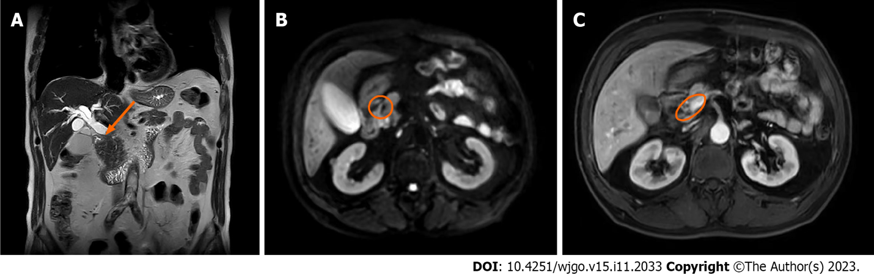
Figure 1 The first admission was hepatobiliary enhanced magnetic resonance imaging. A: Sagittal images shows carcinoma in the middle and lower segment of the common bile duct (red arrow); B: Diffusion-weighted imaging images shows carcinoma size of 1.1 cm (red circle); C: Retroperitoneal enlarged lymph nodes size of 1.5 cm (red circle).

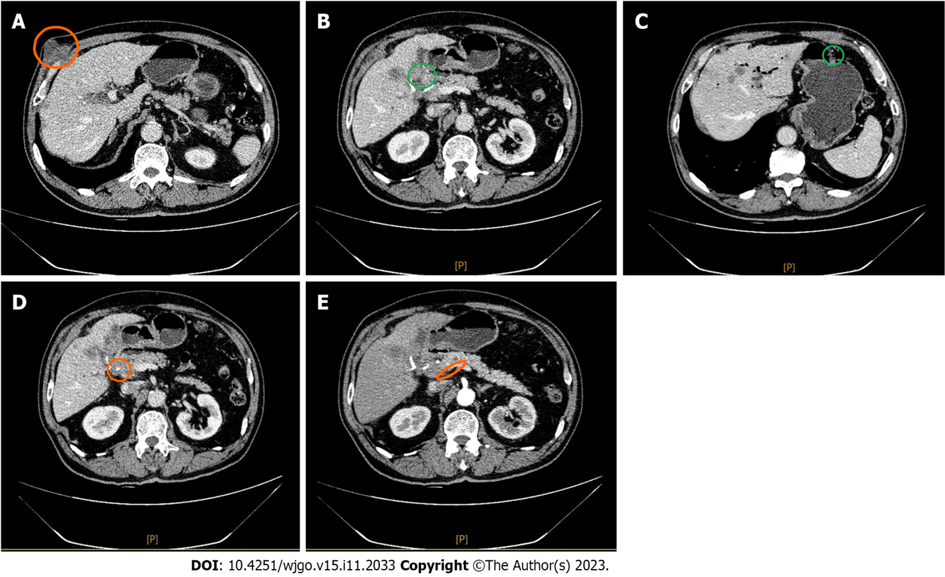
Figure 2 Baseline hepatobiliary enhanced magnetic resonance imaging before targeted immunotherapy. A: Right epigastric metastases size of 2 cm × 1.9 cm (red circle); B: Liver metastases in S5 segment size of 1.3 cm × 1.2 cm (green circle); C: Left lateral lobe of the livermetastasis size of 0.5 cm × 0.4 cm (green circle); D: Carcinoma in the middle and lower segment of the common bile duct size of 1.1 cm (red circle); E: Retroperitoneal enlarged lymph nodes size of 1.3 cm (red circle).

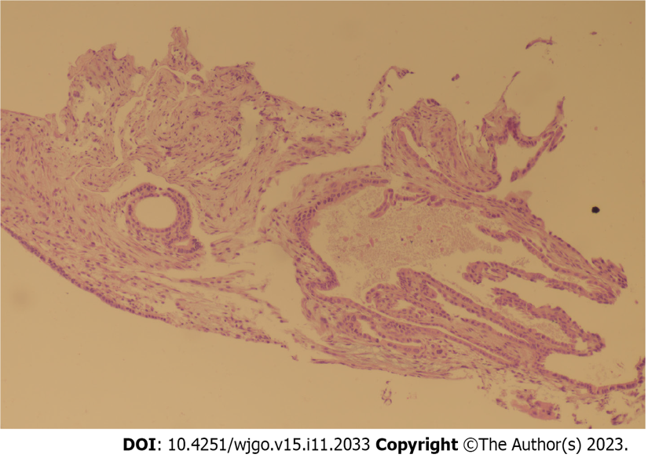
Figure 3 Pathological report adenocarcinoma infiltrates hepatic encephalopathy (200 ×).
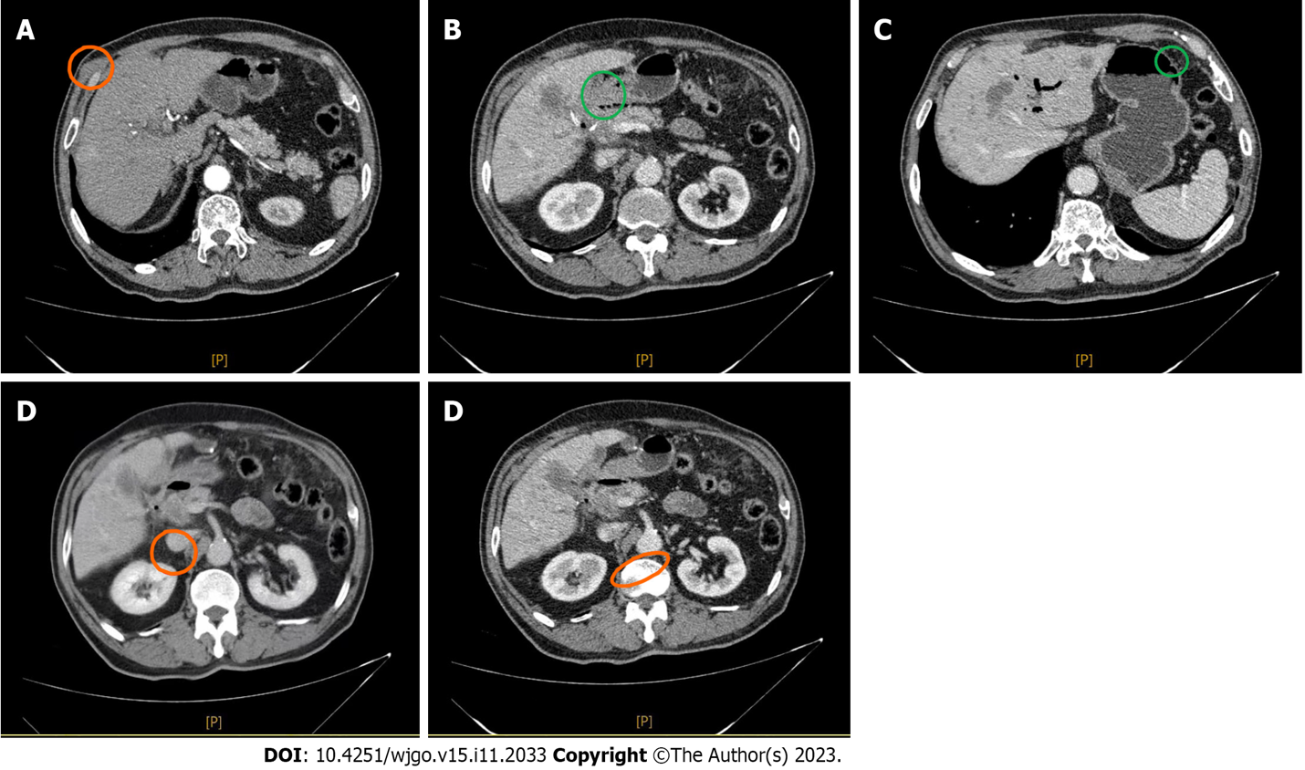
Figure 4 Hepatobiliary enhanced magnetic resonance imaging after two cycles of targeted immunotherapy. A: Right epigastric metastases size of 0.4 cm × 0.5 cm (red circle); B: Liver metastases in S5 segment size of 1.8 cm × 1.7 cm (green circle); C: Left lateral lobe of the livermetastasis size of 0.9 cm × 0.9 cm (green circle); D: Carcinoma in the middle and lower segment of the common bile duct size of 1.1 cm (red circle); E: Retroperitoneal enlarged lymph nodes size of 1.3 cm (red circle).
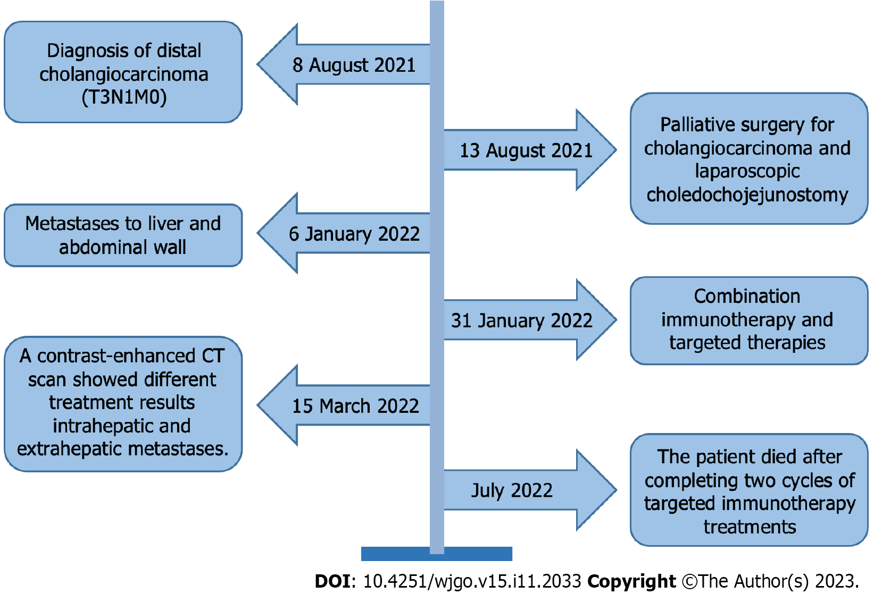
Figure 5 Timeline of the case report. CT: Computed tomography.

Published by Baishideng Publishing Group Inc
7041 Koll Center Parkway, Suite 160, Pleasanton, CA 94566, USA
Telephone: +1-925-3991568
E-mail: bpgoffice@wjgnet.com
Help Desk: https://www.f6publishing.com/helpdesk
https://www.wjgnet.com

© 2023 Baishideng Publishing Group Inc. All rights reserved.

