Name of Journal: World Journal of Gastroenterology
ESPS Manuscript No: 20496
Manuscript Type: REVIEW

Combination antiretroviral studies for patients with primary biliary cirrhosis

Lytvyak E et al. Combination antiretroviral therapy for PBC

Ellina Lytvyak, Aldo J Montano-Loza, Andrew L Mason

Ellina Lytvyak, Aldo J Montano-Loza, Andrew L Mason, Division of Gastroenterology and Hepatology, University of Alberta, Edmonton T6G 2E1, Alberta, Canada

Author contributions: Both Lytvyak E and Mason AL wrote the manuscript; Lytvyak E analyzed and interpreted the data, edited the manuscript; Mason AL conceived the studies, contributed new analytic tools, analyzed and interpreted the data.

Supported by research support from Alberta Innovates Health Solutions, Canadian Institutes for Health Research (to Mason AL, MOP 97798); and Canadian Liver Foundation relevant to this manuscript.

Conflict-of-interest statement: All authors have no conflict of interest to declare. Abbott and Gilead have provided antiviral therapy for patients with primary biliary cirrhosis participating in clinical trials.

Open-Access: This article is an open-access article which was selected by an in-house editor and fully peer-reviewed by external reviewers. It is distributed in accordance with the Creative Commons Attribution Non Commercial (CC BY-NC 4.0) license, which permits others to distribute, remix, adapt, build upon this work non-commercially, and license their derivative works on different terms, provided the original work is properly cited and the use is non-commercial. See: http://creativecommons.org/licenses/by-nc/4.0/

Correspondence to: Andrew L Mason, MBBS, FRCPI, Professor of Medicine, Division of Gastroenterology and Hepatology, University of Alberta, 7-142 Katz Group Rexall Centre, Edmonton T6G 2E1, Alberta, Canada. andrew.mason@ualberta.ca
Telephone: +1-780-4928176
Fax: +1-780-4921655

Received: June 8, 2015
Peer-review started: June 10, 2015
First decision: July 14, 2015
Revised: August 12, 2015
Accepted: November 9, 2015
Article in press:
Published online:

Abstract
Following the characterization of a human betaretrovirus in patients with primary biliary cirrhosis (PBC), pilot studies using antiretroviral therapy have been conducted as proof of principal to establish a link of virus with disease and with the eventual aim to find better adjunct therapies for patients unresponsive to ursodeoxycholic acid. In the first open label pilot study, the reverse transcriptase inhibitor lamivudine had little demonstrable biochemical or histological effect after 1 year. Whereas, lamivudine in combination with zidovudine was associated with a significant reduction in alkaline phosphatase as well as improvement in necroinflammatory score, cholangitis and ductopenia over a 12 mo period. A double blind, multi-center randomized controlled trial using lamivudine with zidovudine for 6 months confirmed a significant reduction in alkaline phosphatase, ALT and AST in patients on antiviral therapy. However, none of the patients achieved the stringent endpoint criteria for normalization of alkaline phosphatase. Furthermore, some patients developed biochemical rebound consistent with drug resistance. A major fault of these studies has been the inability to measure the viral load in peripheral blood and therefore, provide a direct correlation between improvement of hepatic biochemistry and reduction in viral load. Nevertheless, viral mutants to lamivudine with zidovudine were later characterized in the NOD.c3c4 mouse model of PBC that has been used to test other antiretroviral regimens to betaretrovirus. The combination of tenofovir and emtricitabine reverse transcriptase inhibitors and the HIV protease inhibitor, lopinavir were found to abrogate cholangitis in the NOD.c3c4 mouse model and the same regimen normalized the liver tests in a PBC patient with HIV and human betaretrovirus infection. This combination antiretroviral therapy has now been used in a double blind randomized controlled crossover study for patients with PBC followed by an open label extension study. Only a third of the PBC patients were able to tolerate the lopinavir but those maintained on tenofovir, emtricitabine and lopinavir experienced sustained and clinically meaningful reduction in hepatic biochemistry. While we await the histological and virological evaluation, it is clear that better tolerated regimens of antiretroviral treatment will be required in future clinical trials.

Key words: Primary biliary cirrhosis; Human betaretrovirus; Antiretroviral therapy; Randomized controlled trial; Endpoints for trials

© The Author(s) 2015. Published by Baishideng Publishing Group Inc. All rights reserved.

Core tip: Early experience with antiretroviral therapy in primary biliary cirrhosis (PBC) patients strongly suggests that reverse transcriptase inhibitors alone lack efficacy to provide sustained and clinically meaningful biochemical responses. In contrast, combination antiretroviral therapy with human immunodeficiency virus protease inhibitors have been linked with robust and long-lived biochemical responses in PBC patients capable of tolerating the therapy. The use of digital droplet polymerase chain reaction has markedly improved the sensitivity of viral detection in peripheral blood and should enable studies to link reduction in viral load with improvements in hepatic biochemistry and histology.

Lytvyak E, Montano-Loza AJ, Mason AL. Combination antiretroviral studies for patients with primary biliary cirrhosis. World J Gastroenterol 2015; In press

INTRODUCTION
In 2003, our group characterized a human betaretrovirus (HBRV) in patients with primary biliary cirrhosis (PBC) as part of an international collaboration. The discovery of a virus in PBC was unexpected because most researchers at the time were studying the role of molecular mimicry of bacterial proteins with mitochondrial antigens^{[1]}. Although studies have linked infection with a disease specific mitochondrial phenotype in cell culture and in mouse models of PBC, we currently lack definitive ways to prove a causal association between HBRV infection and PBC^{[2]}. Indeed, it is challenging to provide proof of any infectious process in a complex and chronic disease with genetic predisposition^{[3]}. Accordingly, there is a justification for performing interventional studies aimed at investigating a causal association between microbe and disease^{[4,5]}. One of our clinical objectives, therefore, has been to conduct a proof of principal interventional study to link HBRV infection with PBC^{[6]} and to identify safe and efficacious antiviral regimens for patients with PBC^{[7,8]}.
At the time we initiated pilot clinical studies prior to 2003, lamivudine was commonly used to treat patients with hepatitis B virus infection^{[9]}. As this reverse transcriptase inhibitor had broad coverage and a proven safety record in patients with liver disease, we embarked on the first antiviral study in patients with PBC. We subsequently progressed to using dual reverse transcriptase inhibitors^{[9,10]} and then HIV protease inhibitors^{[11]}, once we had demonstrated utility of these regimens in vitro and in mouse models of PBC^{[8]}. Herein, we give an overview of the investigation of antiretroviral activity against betaretroviruses and our experience to date in treating patients with PBC with antiviral therapy.

DISCOVERY OF THE HUMAN BETARETROVIRUS IN PRIMARY BILIARY CIRRHOSIS
In the years running up to 2003, several exploratory studies were conducted looking for potential environmental triggers for PBC. We found no evidence of bacterial infection in PBC patients livers using 16s RNA PCR and turned to the subtractive hybridization methodology, representational difference analysis to uncover viral sequences in a PBC patient’s liver^{[12]}. Follow up studies were performed to demonstrate serum reactivity to viral proteins in PBC patients serum using Western blots^{[13]} and virus-like particles in biliary epithelium isolated from PBC patients by electron microscopy^{[14]}. Then an unbiased approach was employed using consensus PCR primers capable of amplifying retroviral pol gene sequences to identify a betaretrovirus pol sequence. The full-length virus was cloned from PBC patient samples that shared marked nucleotide similarity with the mouse mammary tumor virus (MMTV), a betaretrovirus associated with breast cancer in mice^{[14,15]}. The HBRV was also found to have 97% identity with human mammary tumor virus sequences found in human breast cancer samples^{[16,17]}. The agent was referred to as HBRV because of the similarity with the mouse betaretrovirus, MMTV^{[14-16]}. HBRV is an exogenous virus that is not encoded within the human genome as an endogenous retrovirus. Whereas MMTV is encoded in the genome of most mice and infection can be acquired from an exogenous source, such as breast milk or from an endogenously expressed provirus^{[18]}. At present, it is not known whether HBRV infection in humans is passaged as a zoonosis from mice or acquired as a result of spread from other infected individuals.

ROLE OF HUMAN BETARETROVIRUS IN PRIMARY BILIARY CIRRHOSIS
The role that HBRV plays in the pathogenesis of PBC is still debated^{[2,19]}. In early studies, the virus was predominantly detected in lymph nodes rather than in the liver, similar to observations of MMTV infection in mice^{[20]}. Approximately 75% of peri-hepatic lymph node samples derived from PBC patients at the time of liver transplantation were positive for HBRV protein and RNA, whereas only 1 in 3 PBC patients had detectable HBRV RNA in the liver^{[14]}. Other groups experienced difficulty with detection virus in the liver. For example, one lab was unable to detect viral DNA in PBC liver using a single round of PCR and a separate group found HBRV in 5% of patients with PBC during a survey of liver disease patients for infection^{[21]}. In agreement, our lab rarely found hepatic HBRV DNA (~5%) using nested-PCR. Taken together, these studies are concordant and suggest that more sensitive techniques have a higher detection rate in different tissue compartments^{[4,14]}. Nevertheless, the perceived lack of detection of HBRV at the site of disease has caused considerable controversy and confusion^{[21,22]}. Indeed, Selmi and colleagues suggested^{[22]}, “In our opinion, the only possible final evidence for a role of a betaretrovirus in PBC could be provided by the direct demonstration, possibly through chromatograms, of the insertion of viral sequences in the genome of a large number of patients with PBC.”
It is generally agreed that the detection of proviral integrations is considered the gold standard to confirm retroviral infection. To address this issue, ligation mediated-polymerase chain reaction (PCR) was used to identify the junction regions where the betaretroviral long terminal repeat joins up with the human genome. Next generation sequencing was employed to characterize the proviral integrations and increase the sensitivity of the reactions. In these studies, HBRV proviral integrations and HBRV RNA were detected in two thirds of PBC patients’ biliary epithelium samples^{[23]}. Viral integrations studies also established the presence of HBRV in PBC patients’ lymph nodes, whereas integrations were rarely observed in the liver, in keeping with clinical observations from most laboratories. In vitro studies confirmed that PBC patients’ lymph nodes harbored infectious virus following the isolation of the HBRV in cell culture ^{[24]}. Taken together, these data suggest that HBRV can be found at the site of disease and isolated from patients with PBC.
The prevalence studies also revealed the presence of HBRV in patients without PBC, bringing up the concern with lack of specificity. In our viral integration studies, infection was commonly found in patients with cryptogenic liver disease and autoimmune hepatitis (AIH) as well as a small a proportion of control samples^{[23]}. We had previously observed HBRV in patients with AIH^{[25]}, which is consistent with the knowledge that up to 20% of patients with PBC have overlap features with AIH^{[26,27]}. These data suggest a hypothesis that HBRV may be associated with different phenotypic manifestations of liver disease modulated by genetic and other factors. However, another lab using nested PCR found HBRV in patients with various hepatic diagnoses - but not healthy controls^{[21]}. If HBRV infection is associated with the development of liver disease per se, these data could be compared with early observations following the discovery of hepatitis C virus. Viral infection was not just confined to those with blood transfusions and high risk behavior but also found in patients with various diagnostic categories, such as alcoholic liver disease, hepatitis B virus co-infection, autoimmune hepatitis and cryptogenic cirrhosis to name a few. Another consideration is that better diagnostic methods will be required to determine the true prevalence of HBRV infection in patients and healthy subjects as PCR studies can be prone to artifact.
It is important to emphasize that the association of HBRV with PBC does not imply causation as many further layers of proof are required to support an etiological role for virus and in the disease process^{[2]}. In this regard, it is interesting that HBRV has been linked with a disease specific phenotype of PBC. It is thought that patients with PBC make anti-mitochondrial antibodies (AMA) because the mitochondrial antigen that reacts with AMA is found exposed on the cell surface of biliary epithelium and peri-hepatic lymph nodes^{[28]}. This in turn leads to the loss of tolerance to self-proteins. HBRV is implicated in the process because viral proteins have been found in the same cells that have the aberrant mitochondrial protein expression in PBC patients’ lymph nodes^{[14]}. As lymph nodes are a major reservoir for HBRV in humans, we used lymph nodes homogenates to construct an in vitro transmission model of PBC. In these studies, the homogenates were co-cultured with normal biliary epithelial cells that developed cell surface expression of the AMA reactive mitochondrial proteins^{[29]}. Subsequently, pure isolates of MMTV and HBRV were shown to promote the PBC phenotype, whereas control viruses did not. Taken together, these studies provide a theoretical model for the viral induction of autoimmunity where the virus triggers an immune response to viral proteins but at the same time the lymphocytes respond to self antigens that are usually hidden within the cells^{[1]}.

ROLE OF MOUSE MAMMARY TUMOR VIRUS IN AUTOIMMUNE BILIARY DISEASE
MMTV has also been linked with a disease specific phenotype of PBC in mice models of autoimmune biliary disease^{[8,30]}. These PBC mouse models are mainly derived from immunodeficient mice that develop spontaneous liver disease with AMA production ^{[3, 31]}; they include the NOD.c3c4 mouse^{[32,33]}, IL-2 receptor α^{-/-[34]}, T cell TGF-β receptor II dominant-negative (dnTGFβRII) ^{[35]}, and Scurfy mouse lacking T regulatory cells^{[36]}. The NOD.c3c4 mouse has several features of PBC with progressive granulomatous cholangitis and liver failure, whereas the other models die from multi-organ disease^{[36-39]}. However, the NOD.c3c4 mouse also has features inconsistent with PBC, such as cystic dilatation of bile ducts (Figure 1).
MMTV is common in laboratory mice and the frequent appearance of AMA in immunodeficient mice suggested a hypothesis that disease was being triggered by MMTV^{[31]}. The viral infection may be acquired from an endogenous MMTV provirus source or from an exogenous infection passaged in milk^{[18]}. Indeed, it is known that endogenous retroviruses can recombine and emerge as pathogens in mice with defective innate and adaptive immune responses^{[40,41]}. Evidence for a similar process was found in autoimmune biliary disease mouse models, where MMTV infection was located in lymphoid tissues that also expressed AMA reactive protein^{[30]}. The NOD.c3c4 had evidence of MMTV proteins in the bile ducts associated with mitochondrial protein expression (Figure 1A and 1B). Moreover, the NOD.c3c4 mice were found to develop contemporaneous humoral immune responses to MMTV with AMA production^{[30]}. These data are consistent with the model that betaretrovirus infection triggers autoantigen expression that in turn, breaks tolerance to self-antigens^{[1]}.

Using mouse models to test combination antiretroviral therapy against betaretrovirus
The NOD.c3c4 model has been treated with anti-retroviral therapy to investigate whether MMTV is implicated in the development of autoimmune biliary disease. It has been established that MMTV is sensitive to the HIV reverse transcriptase inhibitors zidovudine^{[42]} and tenofovir^{[43]} and the HIV protease inhibitor lopinavir^{[7]} in vitro. Accordingly, the in vivo mouse model studies have served the dual purpose for examining whether specific antiviral regimens may be useful for testing in translational studies for patients with PBC as well.
For the NOD.c3c4 studies, mice were treated from age 8 weeks to 20 wk and evaluated for reduction in alkaline phosphatase (ALP), hepatic MMTV levels as well as liver histology using the Ishak score. Up to 20 mice per group were treated with the reverse transcriptase inhibitors lamivudine and zidovudine (CombivirTM) alone or in combination with lopinavir boosted with ritonavir or tenofovir and emtricitabine (TruvadaTM) alone or in combination with KaletraTM. The important finding was that groups treated with combination antiretroviral with lopinavir - with either lamivudine/zidovudine or tenofovir/emtricitabine - developed a significant reduction in ALP, hepatic MMTV RNA levels and viral proteins within the liver (Figure 1) associated with marked amelioration in cholangitis and necroinflammatory score in the liver^{[8]}. Whereas NOD.c3c4 mice treated with lamivudine/zidovudine or tenofovir/emtricitabine alone fared less well with hepatic biochemistry and histology. Indeed, some mice treated with lamivudine and zidovudine developed high levels of MMTV indicative of viral resistance to therapy. This occurrence was associated with variants in the MMTV pol gene (Figure 2), which are consistent with escape variants similarly reported with HBV and HIV infection as a result of lamivudine treatment^{[8]}. Indeed, we observed evidence for virological resistance in our pilot studies of lamivudine and zidovudine therapy in patients with PBC, where one individual developed a picture of biochemical and virological rebound (Figure 3). In summary, the NOD.c3c4 studies suggest a role of MMTV in the development of autoimmune biliary disease and have provided a valuable resource for evaluating potential regimens in randomized controlled trials for patients with PBC.

EXPERIENCE IN TREATING PBC PATIENTS WITH ANTIRETROVIRAL THERAPY
Two major issues arise with evaluating new therapies for PBC. The first is who to treat and the second is what endpoints to use. It has been well documented that patients unresponsive to the standard of care with ursodeoxycholic acid (UDCA) have a diminished survival and are in need of additional therapy^{[5,44]}. As multiple criteria have been used to predict response to treatment, a global PBC consortium has used collective data to demonstrate that both ALP and bilirubin act as good surrogate markers for survival and have arrived at a Global scoring system to predict patients at risk for transplantation^{[45-47]}. These studies help to provide guidance for an accurate assessment of the patients in need of treatment with adjunctive therapy to UDCA as well as inclusion criteria for clinical trials.
The Global PBC studies also provide insight into appropriate endpoints for clinical trials. Large prospective studies have been performed to study outcomes with PBC without providing positive data leading us to rethink the appropriate endpoints for studying intervention in PBC^{[48,49}. For example, the methotrexate multi-center RCT of 265 PBC patients was stopped after 11 years due to lack histological effect of the treatment in 2005^{[49]}. Subsequently, the American Association for the Study of Liver Disease (AASLD) have recommended the following for PBC studies: patients should be on UDCA (unless the medication was not tolerated), biochemical markers with drop in ALP levels and normalization of bilirubin are satisfactory primary endpoints after 6 mo therapy and histology can be used as a primary endpoint^{[50]}. The major discussion now is what constitutes a meaningful reduction. The criteria most recently used in a phase 3 study of obeticholic acid for patients with PBC was a reduction of ALP to less than 1.67 × the upper limit of normal and ≥ 15% reduction and a total bilirubin less than or equal to the upper limit of normal^{[51]}.
However, these measures were not in practice for the first studies of antiretroviral therapy in patients with autoimmune liver disease. These were designed to determine whether antiviral therapy might have any biochemical or histological impact on the disease process and find out whether antiviral treatment is safe and well tolerated in patients with PBC^{[6,9-11]}.

Pilot study of lamivudine therapy
In our first study, 11 patients with PBC were treated with the reverse transcriptase inhibitor, lamivudine 150 mg daily for 1 year. The main endpoints were assessment of hepatic biochemistry and histology as determined using a modified Ishak scoring system: necroinflammatory score, bile duct injury, fibrosis stage, and ductopenia with the percentage of portal triads without bile ducts^{[9]}. None of the patients experienced reduction of ALP below upper limit of normal and there was little change in median levels. Overall, histologic characteristics did not differ significantly between baseline and follow–up time points; if anything, there was a tendency towards worsening of scores with no reversal in ductopenia (Figure 4). Despite overall trends, some patients experienced considerable improvement in biochemical and histological parameters indicating that the treatment may have positively impacted the course of PBC. Apart from the fact that the medication was well tolerated, it was essentially a negative study.

Pilot study of lamivudine and zidovudine therapy
In our second study, 11 patients with PBC were treated with lamivudine 150 mg and zidovudine 300 mg BID for 1 year, including 7 patients who had previously participated in the lamivudine study^{[9]}. Analyses of the biochemical data available from 10 patients revealed significant improvement in ALP after 1 year’s therapy with a reduction from baseline of 218 IU/L to 150 IU/L at the end of study. The biochemical studies also showed significant reduction in ALT and AST levels at 6 months after the initiation of antiretroviral therapy; however, this improvement was short lived and no significant changes were observed in these liver studies at 1 year compared to baseline. Paired liver biopsies were available from 7 subjects that showed an improvement in all histological parameters including the necroinflammatory score, bile duct injury, and fibrosis after 1 year of treatment (Figure 4). Overall, there was a significant improvement in ductopenia with a 30% increase in the proportion of portal tracts with demonstrable bile ducts. Considering individual patients’ trends, ductopenia - defined as a finding of fewer than 80% of portal tracts with bile ducts^{[52]} - was observed in 4 of the 7 cases at baseline. Subsequently, 6 patients demonstrated return of bile ducts with lamivudine and zidovudine treatment, whereas one patient experienced a minor reduction (Figure 4).
The reversal of ductopenia was one of the most important findings in this study. Previous investigations using UDCA therapy have reported positive impact on the lobular inflammation, piecemeal necrosis and even possible delay in the development of fibrosis/cirrhosis; however, ductopenia usually remained at the same degree in patients with a good biochemical response to UDCA and progressed in patients with an incomplete biochemical response^{[53-55]}. A combination of UDCA plus colchicine as well as UDCA plus prednisone and azathioprine were also reported to improve an overall histological grade/score and lobular inflammation without any particular impact on the percentage of portal tracts with bile ducts^{[56,57]}. Similarly, many immunosuppressive agents have been associated with a reduction in hepatic necroinflammatory scores but have not been shown to be effective in the reversal of ductopenia^{[58-62]}.

Randomized controlled trial using lamivudine and zidovudine
As our pilot study had delivered promising results by demonstrating substantial biochemical and histological improvements on lamivudine and zidovudine therapy, we progressed to a multicenter, double-blind, randomized placebo controlled trial^{[10]}. Fifty–nine patients with an ALP level greater than 1.5 the upper limit of normal and stabilized on UDCA therapy were randomized to either lamivudine and zidovudine or placebo regimen for 6 months. Liver biopsies were not reviewed due to short duration of the study and the end points were hepatic biochemistry. Patients on lamivudine and zidovudine experienced significant improvement in biochemical parameters compared to the placebo arm. They experienced a 66 IU/L reduction in ALP (21% reduction, P < 0.04 vs placebo, Figure 5). Significant differences were also achieved in the lamivudine and zidovudine arm versus placebo with serial reduction in ALT (P < 0.03) and AST (P < 0.04) levels from their baseline values, mirroring observations from the pilot study. However, the established biochemical endpoints were not reached over the 6 months treatment period, with normalization of ALP.
This endpoint was too stringent to provide significant responses and none of the patients normalized their ALP levels over the study period. On re-examination of the study data, only a small proportion achieved responses using the newer endpoint criteria adopted for the obeticholic acid phase III studies^{[63]}. However, we could only evaluate a subset of patients, as the entry criteria for the lamivudine and zidovudine study included patients with lower ALP levels of 1.5 the upper limit of normal. Moreover, several patients treated with lamivudine and zidovudine developed a clinically meaningful reduction in alkaline phosphatase at 3 mo but then developed biochemical rebound by the end of treatment suggesting viral resistance to therapy. Furthermore, patients experienced side effects with anemia and alopecia secondary to the anti-metabolic effects of zidovudine^{[10]}. Despite the positive effects on histology in the pilot study (Figure 4), the accumulative observations from the pilot and randomized controlled trials strongly suggested that lamivudine and zidovudine alone lacked long-term efficacy for patients with PBC because of the development of viral resistance and adverse side effect profile.
Another important consideration is that lamivudine and zidovudine had little impact on limiting progressive HIV infection until the introduction of combination antiretroviral therapy with protease inhibitors^{[64]}. Similar to observations in PBC patients, viral resistance developed within weeks of lamivudine and zidovudine therapy in patients with HIV infection. These observations prompted the consideration that combination antiretroviral therapy may be required to treat PBC patients unresponsive to UDCA. Indeed, combination antiretroviral therapy has already been reported to be efficacious in one individual with PBC. In a case report, a patient with biopsy proven PBC and evidence of co-infection with HBRV infection and HIV, was started on tenofovir, emtricitabine and lopinavir. He normalized his hepatic biochemistry studies within a year of starting combination antiretroviral therapy and importantly, he experienced a 400 IU/L reduction in ALP prior to starting UDCA^{[65]}. Accordingly, after demonstrating the efficacy of this combination in our mouse model of PBC^{[8]}, we studied the effects of tenofovir, emtricitabine and lopinavir in a randomized controlled trial.
One last piece of the puzzle that needs to be resolved is the use of virological endpoints. The HBRV antiviral studies described so far are somewhat reminiscent of early use of interferon-α subcutaneous injection three times a week for patients with hepatitis C virus infection. Twenty five years ago, the study endpoints were normalization of hepatic biochemistry (ALT) with response rates below 20%. Whereas histological improvement was generally observed in a larger proportion of patients, the relapse rates of recurrent hepatitis C virus infection were high. Once virological endpoints were instituted with more potent regimens, we observed more robust and predictably durable antiviral responses^{[66]}. In a similar fashion, the HBRV studies have been conducted somewhat in the dark because we have lacked sensitive virological assessment in blood. In prior studies, HBRV was generally found in plasma of 25% patients with levels at the limits of detection using real-time RT-PCR^{[67]}. With the use of digital droplet PCR, we can now detect low level virus infection with a wide dynamic range without need for generating standard curves^{[68-71]}. The latter employs emulsion PCR to perform individual reactions within a droplet, reducing the amount of template DNA that competes for the PCR primers. We have started to employ this method for monitoring virological response to therapy with improved detection rates.

Six month randomized controlled trial of tenofovir, emtricitabine and lopinavir
A total of 13 patients unresponsive to UDCA with serologically and histologically proven PBC were included in this randomized, placebo controlled 6 mo crossover study using tenofovir, emtricitabine and lopinavir boosted with ritonavir. We adopted similar criteria as the obeticholic acid trial for endpoints with a reduction in ALP levels to less than 1.67 × the upper limit of normal^{[72,73]}. Following initial screening, the patients were maintained on UDCA 13-15 mg/kg and randomized into the treatment arm with tenofovir/emtricitabine 300/200 mg and lopinavir/ritonavir 800/200 mg versus placebo and then followed for a 6 mo period. Then, four patients from the placebo arm were crossed over to the treatment arm and followed for the same period.
The interim analyses in this cohort demonstrated an incremental larger reduction in ALP after 6 mo compared to prior studies using reverse transcriptase inhibitors alone (Figure 5). However by the end of the study, the reduction in ALP levels was not preserved. Only one patient (13%) cleared virus in PBMC DNA and none of the patients in the treatment arm reached the primary biochemical endpoint at 6 mo despite the significant decline in ALP levels. The major problem was that lopinavir boosted with ritonavir was not well tolerated. First of all, it caused an increase in liver biochemistry tests in the first 3 mo. Subsequently, only a third of the patients could stay on lopinavir due to gastrointestinal intolerance throughout the whole study and this limited the enrollment into the randomized controlled trial. Indeed, the prevalence of side effects experienced by patients with PBC was over double that reported for patients with HIV^{[64]}.

Open label tenofovir, emtricitabine and lopinavir for a total of 24 mo
Once patients had completed the 6 month trial, they were given the opportunity to continue in an open label extension study; 6 patients remained on tenofovir/emtricitabine alone, whereas the other 3 patients stayed on tenofovir/emtricitabine and lopinavir/ritonavir for the 2-year open label period. Patients on tenofovir/emtricitabine alone showed some early response but eventually did not fair any better than a historical control group of clinic patients maintained on UDCA who met entry criteria for the study. Overall, a significant reduction in ALP levels was maintained in the patients treated with combination tenofovir/emtricitabine and lopinavir/ritonavir with a continued improvement from 1 to 2 years treatment. Two of the patients (66%) cleared virus from PBMC DNA.
These studies are the first to apply antiviral therapy in patients with PBC and follow–up using a complete set of clinical, biochemical, histological and virological endpoints. The demonstrable superiority of combination therapy is encouraging despite the lack of tolerance to lopinavir. The histological and virological responses to the different treatment regimens are currently being analyzed. Liver biopsies were performed on all patients at the completion of two years therapy to determine whether long–term evolution of biochemical, clinical, and virological parameters correlate with improvement or progression in histological disease. This is deemed important because liver biochemistry can improve whereas patients develop worse histological and clinical outcomes as reported in patients with primary sclerosing cholangitis maintained on high dose UDCA therapy^{[74,75]}. In addition, it is important to obtain histological and biochemical data over a protracted period for two years to provide important safety and tolerability data.

FUTURE DIRECTIONS FOR ANTIRETROVIRAL THERAPY IN PATIENTS WITH PBC
There is a need to find better adjunctive therapy for PBC patients unresponsive to UDCA. This cohort constitutes over a third of all PBC patients and contributes up to 10% of patients requiring liver transplantation worldwide. There are now credible data based on our long-term extension study that combination antiretroviral therapy should be studied further in the setting of randomized controlled trials as adjunctive therapy with UDCA. Some of the previous barriers to investigating antiretroviral therapy in PBC have been circumnavigated. It has been established that the majority of PBC patients have evidence of HBRV in their bile ducts and digital droplet PCR has considerably improved the frequency of detecting HBRV in peripheral blood.
While the lack of tolerability of lopinavir is disappointing, the in vitro studies and combination antiretroviral studies stand as a proof of principal that protease inhibitors for HIV may also serve to inhibit HBRV as well. However, HBRV was still present in all but one patient after six months therapy suggesting that despite the additional benefit of a protease inhibitor, the antiviral potency of tenofovir/emtricitabine and lopinavir/ritonavir is limited for HBRV. Ongoing laboratory studies in vitro and in vivo suggest that other HIV protease inhibitors and integrase inhibitors may provide superior antiviral effect and most of these medications are better tolerated than lopinavir/ritonavir. Once better regimens have been identified, it will be worth conducting pilot studies to assess efficacy and safety in patients with PBC, in order to provide better outcomes for those with progressive liver disease unresponsive to UDCA.

REFERENCES
1 Wasilenko ST, Mason GE, Mason AL. Primary biliary cirrhosis, bacteria and molecular mimicry: what's the molecule and where's the mimic? Liver Int 2009; 29: 779-782 [PMID: 19638105]
2 Sharon D, Mason A. Role of Novel Retroviruses in Chronic Liver Disease: Assessing the Link of Human Betaretrovirus with Primary Biliary Cirrhosis. Curr Infect Dis Rep 2015: 17: 460 [PMID: 25754451 DOI: 10.1007/s11908-014-0460-7]
3 Hirschfield GM, Chapman RW, Karlsen TH, Lammert F, Lazaridis KN, Mason AL. The genetics of complex cholestatic disorders. Gastroenterology 2013; 144: 1357-1374 [PMID: 23583734 DOI: 10.1053/j.gastro.2013.03.053]
4 Mason AL, Zhang G. Linking human beta retrovirus infection with primary biliary cirrhosis. Gastroenterol Clin Biol 2010; 34: 359-366 [PMID: 20580176 DOI: S0399-8320(10)00147-8]
5 Poupon R, Poupon RE. Retrovirus infection as a trigger for primary biliary cirrhosis? Lancet 2004; 363: 260-261 [PMID: 14751695]
6 Mason A, Xu L, Neuberger J. Proof of principal studies to assess the role of the human betaretrovirus in patients with primary biliary cirrhosis. Am J Gastroenterol 2004; 99: 2499-2500 [PMID: 15571601]
7 Montano-Loza AJ, Wasilenko S, Bintner J, Mason AL. Cyclosporine A inhibits in vitro replication of betaretrovirus associated with primary biliary cirrhosis. Liver Int 2010; 30: 871-877 [PMID: 20492501 DOI: LIV2257]
8 Sharon D, Chen M, Zhang G, Girgis S, Sis B, Graham D, McDougall C, Wasilenko ST, Montano-Loza A, Mason AL. Impact of combination antiretroviral therapy in the NOD.c3c4 mouse model of autoimmune biliary disease. Liver Int 2015; 35: 1442-1450 [PMID: 25302564 DOI: 10.1111/liv.12699]
9 Mason AL, Farr GH, Xu L, Hubscher SG, Neuberger JM. Pilot studies of single and combination antiretroviral therapy in patients with primary biliary cirrhosis. Am J Gastroenterol 2004; 99: 2348-2355 [PMID: 15571581]
10 Mason AL, Lindor KD, Bacon BR, Vincent C, Neuberger JM, Wasilenko ST. Clinical Trial: Randomized controlled trial of zidovudine and lamivudine for patients with primary biliary cirrhosis stabilized on ursodiol. Aliment Pharmacol Ther 2008; 9: 9 [DOI: 10.1111/j.1365-2036.2008.03799.x]
11 Mason AL, Montano-Loza AJ, Saxinger L. Letter: biochemical response to combination anti-retroviral therapy in patients with primary biliary cirrhosis. Aliment Pharmacol Ther 2014; 39: 236-237 [PMID: 24330248 DOI: 10.1111/apt.12575]
12 Xu L, Guo L, Shen Z, Loss G, Gish R, Wasilenko S, Mason AL. Duplication of MER115 on chromosome 4 in patients with primary biliary cirrhosis. Liver Int 2009; 29: 375-383 [PMID: 19018986 DOI: LIV1888]
13 Mason AL, Xu L, Guo L, Munoz S, Jaspan JB, Bryer-Ash M, Cao Y, Sander DM, Shoenfeld Y, Ahmed A, Van de Water J, Gershwin ME, Garry RF. Detection of retroviral antibodies in primary biliary cirrhosis and other idiopathic biliary disorders. Lancet 1998; 351: 1620-1624 [PMID: 9620716]
14 Xu L, Shen Z, Guo L, Fodera B, Keogh A, Joplin R, O'Donnell B, Aitken J, Carman W, Neuberger J, Mason A. Does a betaretrovirus infection trigger primary biliary cirrhosis? Proc Natl Acad Sci U S A 2003; 100: 8454-8459 [PMID: 12832623]
15 Xu L, Sakalian M, Shen Z, Loss G, Neuberger J, Mason A. Cloning the human betaretrovirus proviral genome from patients with primary biliary cirrhosis. Hepatology 2004; 39: 151-156 [PMID: 14752833 DOI: 10.1002/hep.20024]
16 Holland JF, Pogo BG. Mouse mammary tumor virus-like viral infection and human breast cancer. Clin Cancer Res 2004; 10: 5647-5649 [PMID: 15355888]
17 Pogo BG, Holland JF. Possibilities of a viral etiology for human breast cancer. Biol Trace Elem Res 1997; 56: 131-142 [PMID: 9152517]
18 Bentvelzen P. The biology of the mouse mammary tumor virus. Int Rev Exp Pathol 1972; 11: 259-297 [PMID: 4349859]
19 Mason AL. The evidence supports a viral aetiology for primary biliary cirrhosis. J Hepatol 2011; 54: 1312-1314 [PMID: 21147183]
20 Acha-Orbea H, Palmer E. Mls--a retrovirus exploits the immune system. Immunol Today 1991; 12: 356-361 [PMID: 1659830]
21 Johal H, Scott GM, Jones R, Camaris C, Riordan S, Rawlinson WD. Mouse mammary tumour virus-like virus (MMTV-LV) is present within the liver in a wide range of hepatic disorders and unrelated to nuclear p53 expression or hepatocarcinogenesis. J Hepatol 2009; 50: 548-554 [PMID: 19168254 DOI: S0168-8278(08)00799-X]
22 Selmi C, Ross SR, Ansari AA, Invernizzi P, Podda M, Coppel RL, Gershwin ME. Lack of immunological or molecular evidence for a role of mouse mammary tumor retrovirus in primary biliary cirrhosis. Gastroenterology 2004; 127: 493-501 [PMID: 15300582]
23 Wang W, Indik S, Wasilenko ST, Faschinger A, Carpenter EJ, Tian Z, Zhang Y, Wong GK, Mason AL. Frequent proviral integration of the human betaretrovirus in biliary epithelium of patients with autoimmune and idiopathic liver disease. Aliment Pharmacol Ther 2015; 41: 393-405 [PMID: 25521721 DOI: 10.1111/apt.13054]
24 Wang W, Wasilenko S, Indik S, Wong G, Mason A. Isolation of the human betaretrovirus and demonstration of integration sites in patients with primary biliary cirrhosis. Canadian J Gastroenterol 2012; 26: 84A
25 McDermid J, Chen M, Li Y, Wasilenko S, Bintner J, McDougall C, Pang X, Bain VG, Mason AL. Reverse transcriptase activity in patients with primary biliary cirrhosis and other autoimmune liver disorders. Alimentary Pharmacology & Therapeutics 2007; 26: 587-595 [DOI: 10.1111/j.1365-2036.2007.03402.x]
26 Gish RG, Mason A. Autoimmune liver disease. Current standards, future directions. Clin Liver Dis 2001; 5: 287-314 [PMID: 11385965]
27 Poupon R. Primary biliary cirrhosis: a 2010 update. J Hepatol 2010; 52: 745-758 [PMID: 20347176 DOI: S0168-8278(10)00027-9]
28 Joplin R, Gershwin ME. Ductular expression of autoantigens in primary biliary cirrhosis. Semin Liver Dis 1997; 17: 97-103 [PMID: 9170196]
29 Sadamoto T, Joplin R, Keogh A, Mason A, Carman W, Neuberger J. Expression of pyruvate-dehydrogenase complex PDC-E2 on biliary epithelial cells induced by lymph nodes from primary biliary cirrhosis. Lancet 1998; 352: 1595-1596 [PMID: 9843108]
30 Zhang G, Chen M, Graham D, Subsin B, McDougall C, Gilady S, Kneteman M, Swain M, Trauner M, Wrzesinski S, Flavell R, Wasilenko S, Mason A. Mouse Mammary Tumor Virus in Anti-Mitochondrial Antibody Producing Mouse Models. J Hepatol 2011; 55: 876-884 [PMID: 21334408]
31 Mason AL. An autoimmune biliary disease mouse model for primary biliary cirrhosis: something for everyone. Hepatology 2006; 44: 1047-1050 [PMID: 17006941]
32 Irie J, Wu Y, Wicker LS, Rainbow D, Nalesnik MA, Hirsch R, Peterson LB, Leung PS, Cheng C, Mackay IR, Gershwin ME, Ridgway WM. NOD.c3c4 congenic mice develop autoimmune biliary disease that serologically and pathogenetically models human primary biliary cirrhosis. J Exp Med 2006; 203: 1209-1219 [PMID: 16636131]
33 Koarada S, Wu Y, Fertig N, Sass DA, Nalesnik M, Todd JA, Lyons PA, Fenyk-Melody J, Rainbow DB, Wicker LS, Peterson LB, Ridgway WM. Genetic control of autoimmunity: protection from diabetes, but spontaneous autoimmune biliary disease in a nonobese diabetic congenic strain. J Immunol 2004; 173: 2315-2323 [PMID: 15294944]
34 Wakabayashi K, Lian ZX, Moritoki Y, Lan RY, Tsuneyama K, Chuang YH, Yang GX, Ridgway W, Ueno Y, Ansari AA, Coppel RL, Mackay IR, Gershwin ME. IL-2 receptor alpha(-/-) mice and the development of primary biliary cirrhosis. Hepatology 2006; 44: 1240-1249 [PMID: 17058261]
35 Oertelt S, Lian ZX, Cheng CM, Chuang YH, Padgett KA, He XS, Ridgway WM, Ansari AA, Coppel RL, Li MO, Flavell RA, Kronenberg M, Mackay IR, Gershwin ME. Anti-mitochondrial antibodies and primary biliary cirrhosis in TGF-beta receptor II dominant-negative mice. J Immunol 2006; 177: 1655-1660 [PMID: 16849474]
36 Zhang W, Sharma R, Ju ST, He XS, Tao Y, Tsuneyama K, Tian Z, Lian ZX, Fu SM, Gershwin ME. Deficiency in regulatory T cells results in development of antimitochondrial antibodies and autoimmune cholangitis. Hepatology 2009; 49: 545-552 [PMID: 19065675 DOI: 10.1002/hep.22651]
37 Gorelik L, Flavell RA. Abrogation of TGFbeta signaling in T cells leads to spontaneous T cell differentiation and autoimmune disease. Immunity 2000; 12: 171-181 [PMID: 10714683]
38 Torgerson TR, Ochs HD. Immune dysregulation, polyendocrinopathy, enteropathy, X-linked: forkhead box protein 3 mutations and lack of regulatory T cells. J Allergy Clin Immunol 2007; 120: 744-50; quiz 751-2 [PMID: 17931557 DOI: S0091-6749(07)01646-6]
39 Willerford DM, Chen J, Ferry JA, Davidson L, Ma A, Alt FW. Interleukin-2 receptor alpha chain regulates the size and content of the peripheral lymphoid compartment. Immunity 1995; 3: 521-530 [PMID: 7584142]
40 Young GR, Eksmond U, Salcedo R, Alexopoulou L, Stoye JP, Kassiotis G. Resurrection of endogenous retroviruses in antibody-deficient mice. Nature 2012; 491: 774-778 [PMID: 23103862 DOI: 10.1038/nature11599]
41 Yu P, Lübben W, Slomka H, Gebler J, Konert M, Cai C, Neubrandt L, Prazeres da Costa O, Paul S, Dehnert S, Döhne K, Thanisch M, Storsberg S, Wiegand L, Kaufmann A, Nain M, Quintanilla-Martinez L, Bettio S, Schnierle B, Kolesnikova L, Becker S, Schnare M, Bauer S. Nucleic acid-sensing Toll-like receptors are essential for the control of endogenous retrovirus viremia and ERV-induced tumors. Immunity 2012; 37: 867-879 [PMID: 23142781 DOI: 10.1016/j.immuni.2012.07.018]
42 Held W, Waanders GA, Acha-Orbea H, MacDonald HR. Reverse transcriptase-dependent and -independent phases of infection with mouse mammary tumor virus: implications for superantigen function. J Exp Med 1994; 180: 2347-2351 [PMID: 7525852]
43 Cihlar T. Nucleotide HIV reverse transcriptase inhibitors: tenofovir and beyond. Curr Opin HIV AIDS 2006; 1: 373-379 [PMID: 19372836 DOI: 10.1097/01.COH.0000239849.20828.09]
44 Pares A, Caballeria L, Rodes J. Excellent Long-Term Survival in Patients With Primary Biliary Cirrhosis and Biochemical Response to Ursodeoxycholic Acid. Gastroenterology 2006; 130: 715-720 [PMID: 16530513 DOI: 10.1053/j.gastro.2005.12.029]
45 Lammers WJ, Kowdley KV, van Buuren HR. Predicting outcome in primary biliary cirrhosis. Ann Hepatol 2014; 13: 316-326 [PMID: 24927602]
46 Lammers WJ, van Buuren HR, Hirschfield GM, Janssen HL, Invernizzi P, Mason AL, Ponsioen CY, Floreani A, Corpechot C, Mayo MJ, Battezzati PM, Parés A, Nevens F, Burroughs AK, Kowdley KV, Trivedi PJ, Kumagi T, Cheung A, Lleo A, Imam MH, Boonstra K, Cazzagon N, Franceschet I, Poupon R, Caballeria L, Pieri G, Kanwar PS, Lindor KD, Hansen BE. Levels of alkaline phosphatase and bilirubin are surrogate end points of outcomes of patients with primary biliary cirrhosis: an international follow-up study. Gastroenterology 2014; 147: 1338-49.e5; quiz e15 [PMID: 25160979 DOI: 10.1053/j.gastro.2014.08.029]
47 Lammers W, Janssen H, Invernizzi P, Battezzati P, Floreani A, Hirschfield G, Pares A, Ponsioen C, Corpechot C, Mayo M, Talwalkar J, urroughs A, Nevens F, Mason A, Kowdley K, Leeman M, Caballeria L, Trivedi P, Cheung A, Lleo A, Cazzagon N, Franceschet I, Boonstra K, de Vries E, Poupon R, Imam M, Pieri G, Kanwar P, Lindor K, Hansen B. Identification of PBC patients in need of additional therapy during the course of UDCA treatment - an international multicenter study. J Hepatol 2015; 62: S796
48 Combes B, Emerson SS, Flye NL, Munoz SJ, Luketic VA, Mayo MJ, McCashland TM, Zetterman RK, Peters MG, Di Bisceglie AM, Benner KG, Kowdley KV, Carithers RL, Rosoff L, Garcia-Tsao G, Boyer JL, Boyer TD, Martinez EJ, Bass NM, Lake JR, Barnes DS, Bonacini M, Lindsay KL, Mills AS, Markin RS, Rubin R, West AB, Wheeler DE, Contos MJ, Hofmann AF. Methotrexate (MTX) plus ursodeoxycholic acid (UDCA) in the treatment of primary biliary cirrhosis. Hepatology 2005; 42: 1184-1193 [PMID: 16250039 DOI: 10.1002/hep.20897]
49 Rong J, Chrisbleackley R, Kane K. Direct detection of cytolytic T lymphocyte-mediated cytotoxicity on antigen-transfected cell microarray. J Immunol Methods 2007; 326: 1-9 [PMID: 17673228 DOI: 10.1016/j.jim.2007.06.008]
50 Silveira MG, Brunt EM, Heathcote J, Gores GJ, Lindor KD, Mayo MJ. American Association for the Study of Liver Diseases Endpoints Conference: Design and Endpoints for Clinical Trials in Primary Biliary Cirrhosis. Hepatology 2010; 52: 349-359 [PMID: 20578151 DOI: 10.1002/hep.23637]
51 Hirschfield GM, Mason A, Luketic V, Lindor K, Gordon SC, Mayo M, Kowdley KV, Vincent C, Bodhenheimer HC, Parés A, Trauner M, Marschall HU, Adorini L, Sciacca C, Beecher-Jones T, Castelloe E, Böhm O, Shapiro D. Efficacy of obeticholic acid in patients with primary biliary cirrhosis and inadequate response to ursodeoxycholic acid. Gastroenterology 2015; 148: 751-61.e8 [PMID: 25500425 DOI: 10.1053/j.gastro.2014.12.005]
52 Suriawinata AA, Thung SN. Liver Pathology: An Atlas and Concise Guide: Demos Medical Publishing, 2011
53 Degott C, Zafrani ES, Callard P, Balkau B, Poupon RE, Poupon R. Histopathological study of primary biliary cirrhosis and the effect of ursodeoxycholic acid treatment on histology progression. Hepatology 1999; 29: 1007-1012 [PMID: 10094939]
54 Parés A, Caballería L, Rodés J, Bruguera M, Rodrigo L, García-Plaza A, Berenguer J, Rodríguez-Martínez D, Mercader J, Velicia R.. Long-term effects of ursodeoxycholic acid in primary biliary cirrhosis: results of a double-blind controlled multicentric trial. J Hepatol 2000; 32: 561-566 [PMID: 10782903 DOI: 10.1016/S0168-8278(00)80216-0]
55 Angulo P, Batts KP, Therneau TM, Jorgensen RA, Dickson ER, Lindor KD. Long-term ursodeoxycholic acid delays histological progression in primary biliary cirrhosis. Hepatology 1999; 29: 644-647 [PMID: 10051462]
56 Almasio PL, Floreani A, Chiaramonte M, Provenzano G, Battezzati P, Crosignani A, Podda M, Todros L, Rosina F, Saccoccio G, Manenti F, Ballardini G, Bianchi FP, Scheuer PJ, Davies SE, Craxì A. Multicentre randomized placebo-controlled trial of ursodeoxycholic acid with or without colchicine in symptomatic primary biliary cirrhosis. Alimentary Pharmacology & Therapeutics 2000; 14: 1645-1652 [DOI: 10.1046/j.1365-2036.2000.00869.x]
57 Wolfhagen FH, van Hoogstraten HJ, van Buuren HR, van Berge-Henegouwen GP, ten Kate FJ, Hop WC, van der Hoek EW, Kerbert MJ, van Lijf HH, den Ouden JW, Smit AM, de Vries RA, van Zanten RA, Schalm SW. Triple therapy with ursodeoxycholic acid, prednisone and azathioprine in primary biliary cirrhosis: a 1-year randomized, placebo-controlled study. J Hepatol 1998; 29: 736-742 [PMID: 9833911]
58 Levy C, Lindor KD. Current management of primary biliary cirrhosis and primary sclerosing cholangitis. J Hepatol 2003; 38 Suppl 1: S24-S37 [PMID: 12591184]
59 Oo YH, Neuberger J. Options for treatment of primary biliary cirrhosis. Drugs 2004; 64: 2261-2271 [PMID: 15456326]
60 Crowe J, Christensen E, Smith M, Cochrane M, Ranek L, Watkinson G, Doniach D, Popper H, Tygstrup N, Williams R. Azathioprine in primary biliary cirrhosis: a preliminary report of an international trial. Gastroenterology 1980; 78 (5 Pt 1): 1005-1010 [PMID: 6991353]
61 Hoofnagle JH, Davis GL, Schafer DF, Peters M, Avigan MI, Pappas SC, Hanson RG, Minuk GY, Dusheiko GM, Campbell G. Randomized trial of chlorambucil for primary biliary cirrhosis. Gastroenterology 1986; 91: 1327-1334 [PMID: 3533699]
62 Kaplan MM. Primary biliary cirrhosis. N Engl J Med 1996; 335: 1570-1580 [PMID: 8900092]
63 Luketic VA, Invernizzi P, Trauner M, Regula J, Mazzella G, Strasser SI, Floreani A, Hohenester S, van Erpecum KJ, Pockros PJ. Efficacy of Obeticholic Acid In Primary Biliary Cirrhosis as Assessed by Response Criteria Associated With Clinical Outcome: A Poise Analysis. Proceedings of the Hepatology. NJ: Wiley-Blackwell, 2014: 355A-356A
64 Palella FJ, Delaney KM, Moorman AC, Loveless MO, Fuhrer J, Satten GA, Aschman DJ, Holmberg SD. Declining morbidity and mortality among patients with advanced human immunodeficiency virus infection. HIV Outpatient Study Investigators. N Engl J Med 1998; 338: 853-860 [PMID: 9516219]
65 Schembri G, Schober P. Killing two birds with one stone. Lancet 2011; 377: 96 [PMID: 21195252 DOI: 10.1016/s0140-6736(10)61343-8]
66 Nair S, Khan S, Loss G, Eason J, Blazek J, Lipscomb J, Mason A. Treatment of recurrent hepatitis C in liver transplant recipients: is there any histologic benefit? Liver Transpl 2003; 9: 354-359 [PMID: 12682885]
67 McDermid J, Chen M, Li Y, Wasilenko S, Bintner J, McDougall C, Pang X, Bain VG, Mason AL. Reverse transcriptase activity in patients with primary biliary cirrhosis and other autoimmune liver disorders. Aliment Pharmacol Ther 2007; 26: 587-595 [PMID: 17661762 DOI: APT3402]
68 White RA, Quake SR, Curr K. Digital PCR provides absolute quantitation of viral load for an occult RNA virus. J Virol Methods 2012; 179: 45-50 [PMID: 21983150 DOI: 10.1016/j.jviromet.2011.09.017]
69 Strain MC, Lada SM, Luong T, Rought SE, Gianella S, Terry VH, Spina CA, Woelk CH, Richman DD. Highly precise measurement of HIV DNA by droplet digital PCR. PLoS One 2013; 8: e55943 [PMID: 23573183 DOI: 10.1371/journal.pone.0055943]
70 Henrich TJ, Gallien S, Li JZ, Pereyra F, Kuritzkes DR. Low-level detection and quantitation of cellular HIV-1 DNA and 2-LTR circles using droplet digital PCR. J Virol Methods 2012; 186: 68-72 [PMID: 22974526 DOI: 10.1016/j.jviromet.2012.08.019]
71 Hayden RT, Gu Z, Ingersoll J, Abdul-Ali D, Shi L, Pounds S, Caliendo AM. Comparison of droplet digital PCR to real-time PCR for quantitative detection of cytomegalovirus. J Clin Microbiol 2013; 51: 540-546 [PMID: 23224089 DOI: 10.1128/JCM.02620-12]
72 Kumagi T, Guindi M, Fischer SE, Arenovich T, Abdalian R, Coltescu C, Heathcote EJ, Hirschfield GM. Baseline ductopenia and treatment response predict long-term histological progression in primary biliary cirrhosis. Am J Gastroenterol 2010; 105: 2186-2194 [PMID: 20502446 DOI: ajg2010216]
73 Momah N, Silveira MG, Jorgensen R, Sinakos E, Lindor KD. Optimizing biochemical markers as endpoints for clinical trials in primary biliary cirrhosis. Liver Int 2012; 32: 790-795 [PMID: 22136310 DOI: 10.1111/j.1478-3231.2011.02678.x]
74 Lindor KD, Kowdley KV, Luketic VA, Harrison ME, McCashland T, Befeler AS, Harnois D, Jorgensen R, Petz J, Keach J, Mooney J, Sargeant C, Braaten J, Bernard T, King D, Miceli E, Schmoll J, Hoskin T, Thapa P, Enders F. High-dose ursodeoxycholic acid for the treatment of primary sclerosing cholangitis. Hepatology 2009; 50: 808-814 [PMID: 19585548 DOI: 10.1002/hep.23082]
75 Sinakos E, Marschall HU, Kowdley KV, Befeler A, Keach J, Lindor K. Bile acid changes after high-dose ursodeoxycholic acid treatment in primary sclerosing cholangitis: Relation to disease progression. Hepatology 2010; 52: 197-203 [PMID: 20564380 DOI: 10.1002/hep.23631]
P-Reviewer: Gatselis NK, Malnick SDH S-Editor: Yu J L-Editor: E-Editor:

A
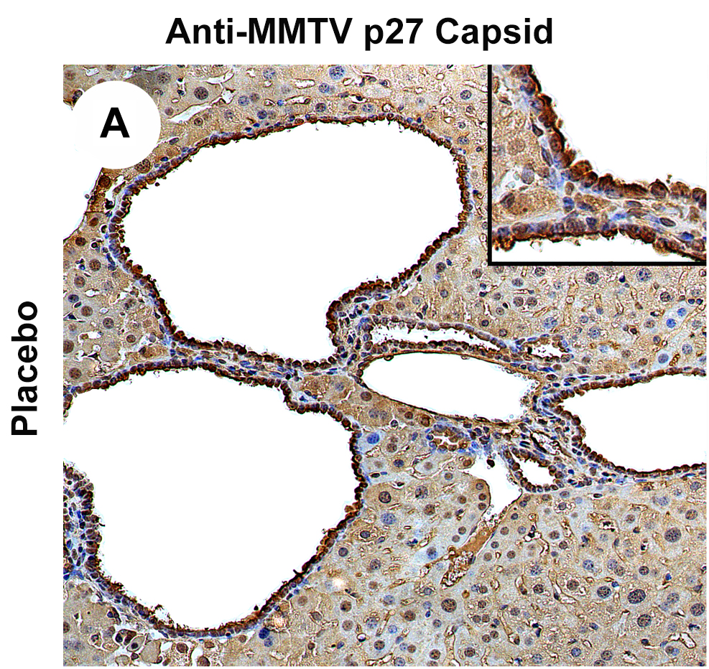
B
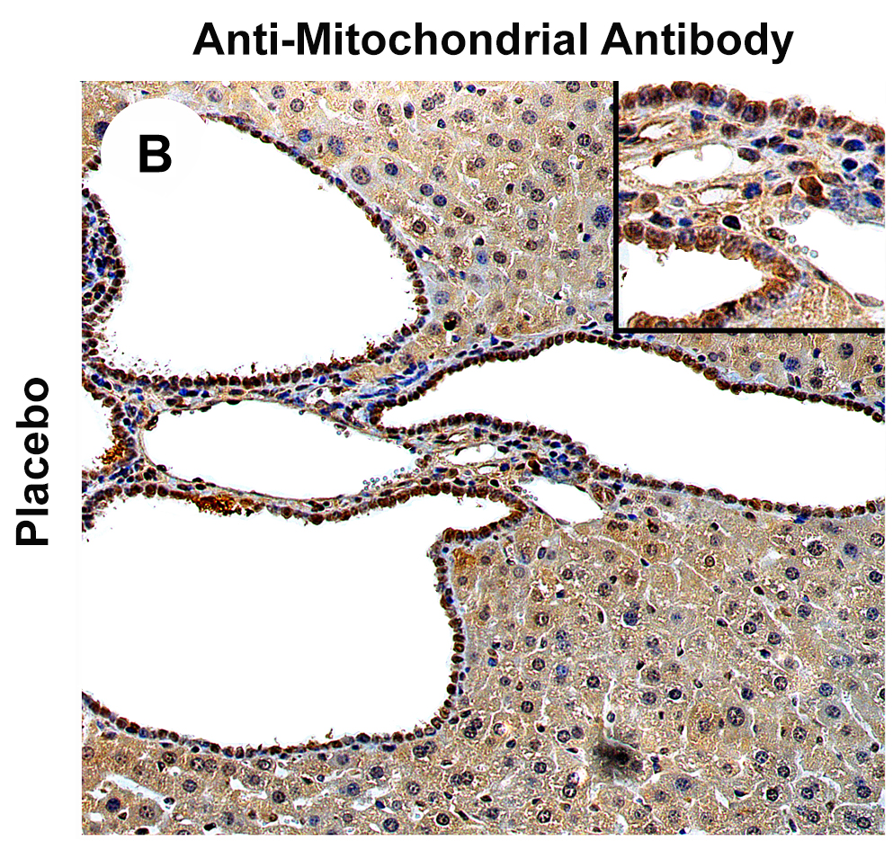
C
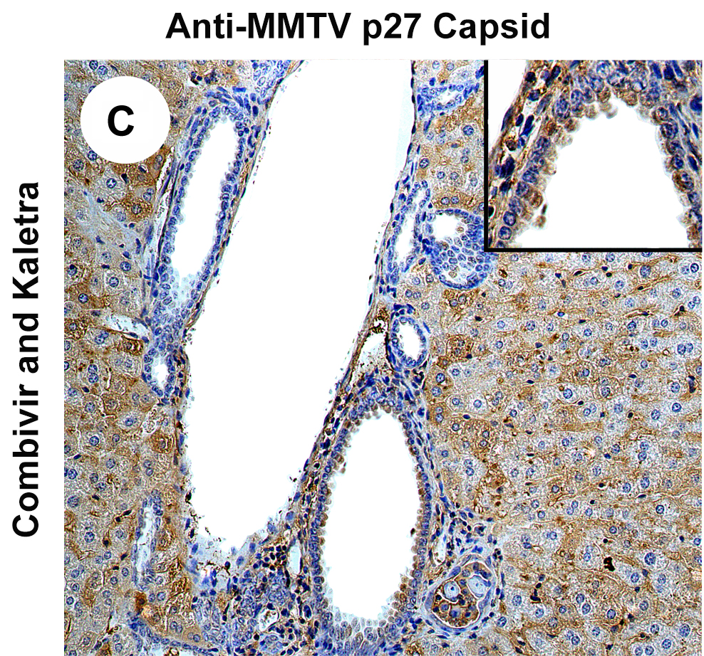
D
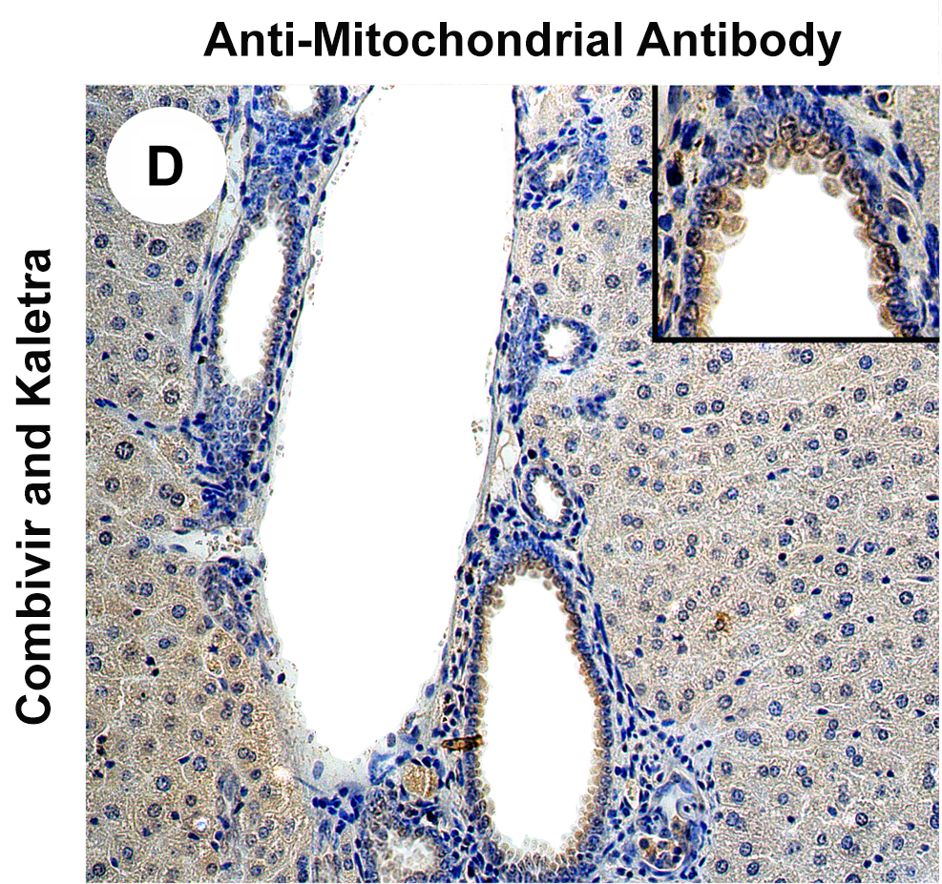
Figure 1 Hepatic immunohistochemistry study of NOD.c3c4 mice treated with placebo (A and B) or tenofovir/emtricitabine and lopinavir/ritonavir (C and D) for 12 wk. A: Mice receiving placebo showed anti-MMTV p27 Capsid reactivity in biliary epithelial cells and hepatocyte nuclei to a lesser extent; B: The distribution of anti-mitochondrial antibody staining was observed in a similar biliary distribution pattern on the bile duct epithelium; C and D: The reactivity to both viral and mitochondrial proteins was attenuated in mice treated with tenofovir/emtricitabine and lopinavir/ritonavir. Haematoxylin, 2009 magnification with 4009 in insets showing staining in biliary epithelial cells. (With permission from Sharon et al^{[8]}).

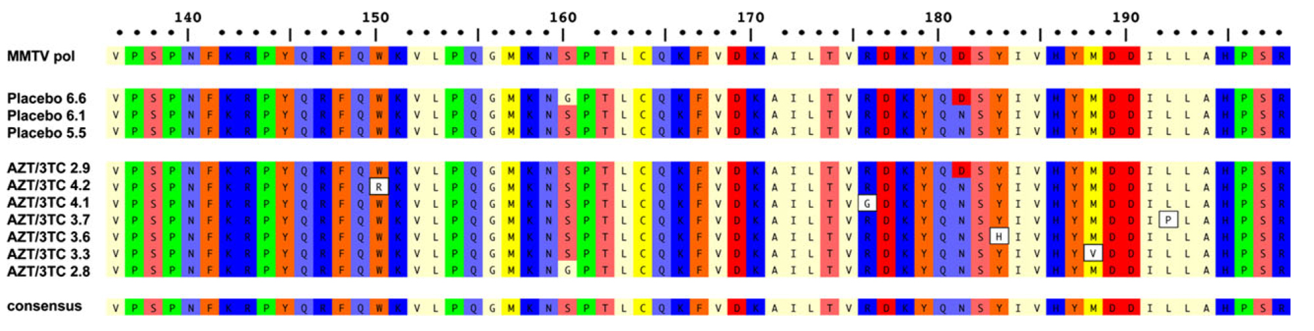
Figure 2 Variations in MMTV pol gene were observed after 12 wk lamivudine/zidovudine therapy in the NOD.c3c4 mouse. Alignment of amino acid sequence 136–198 of MMTV Pol P03365.2 using ClustalW alignment (MacVector 11.1 software) showing the amino acid variations W150R, R176G, Y183H, M188V and L192P in five clones derived from two mice treated with lamivudine/zidovudine that were not observed in control mice on placebo. Variants G160S and D181N were observed in mice receiving placebo and antiretroviral therapy. (With permission from Sharon et al^{[8]}).

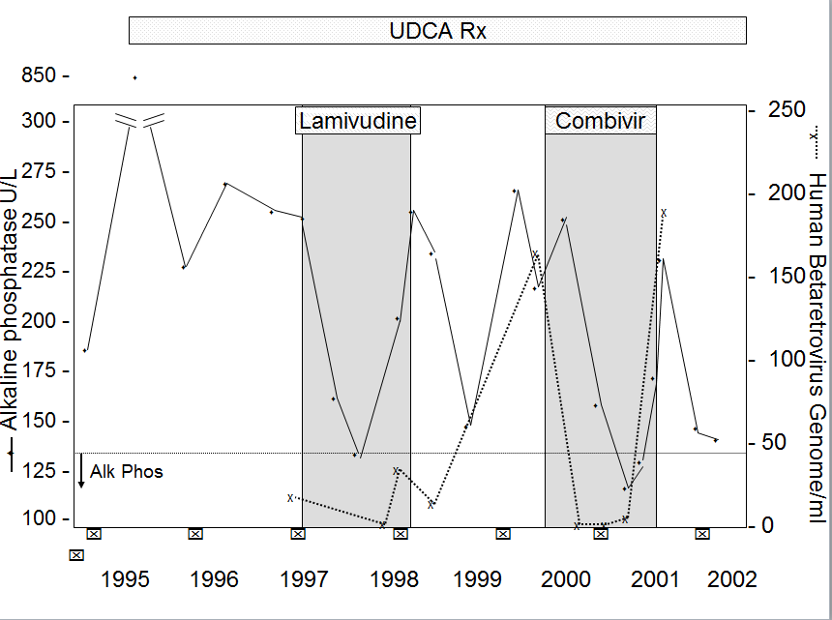
Figure 3 Viral and biochemical rebound in a patient with primary biliary cirrhosis treated with antiviral therapy. Partial biochemical response was observed after starting lamivudine treatment by 3 mo that relapsed. With the commencement of CombivirTM therapy, the patient normalized alkaline phosphatase from months 6 and 9 with a concomitant loss of viremia, which then rebounded with increased alkaline phosphatase levels and recurrent viremia. (With permission from Mason AL, Farr GH, Xu L, et al. Pilot studies of single and combination antiretroviral therapy in patients with primary biliary cirrhosis. Am J Gastroenterol 2004; 99: 2353).

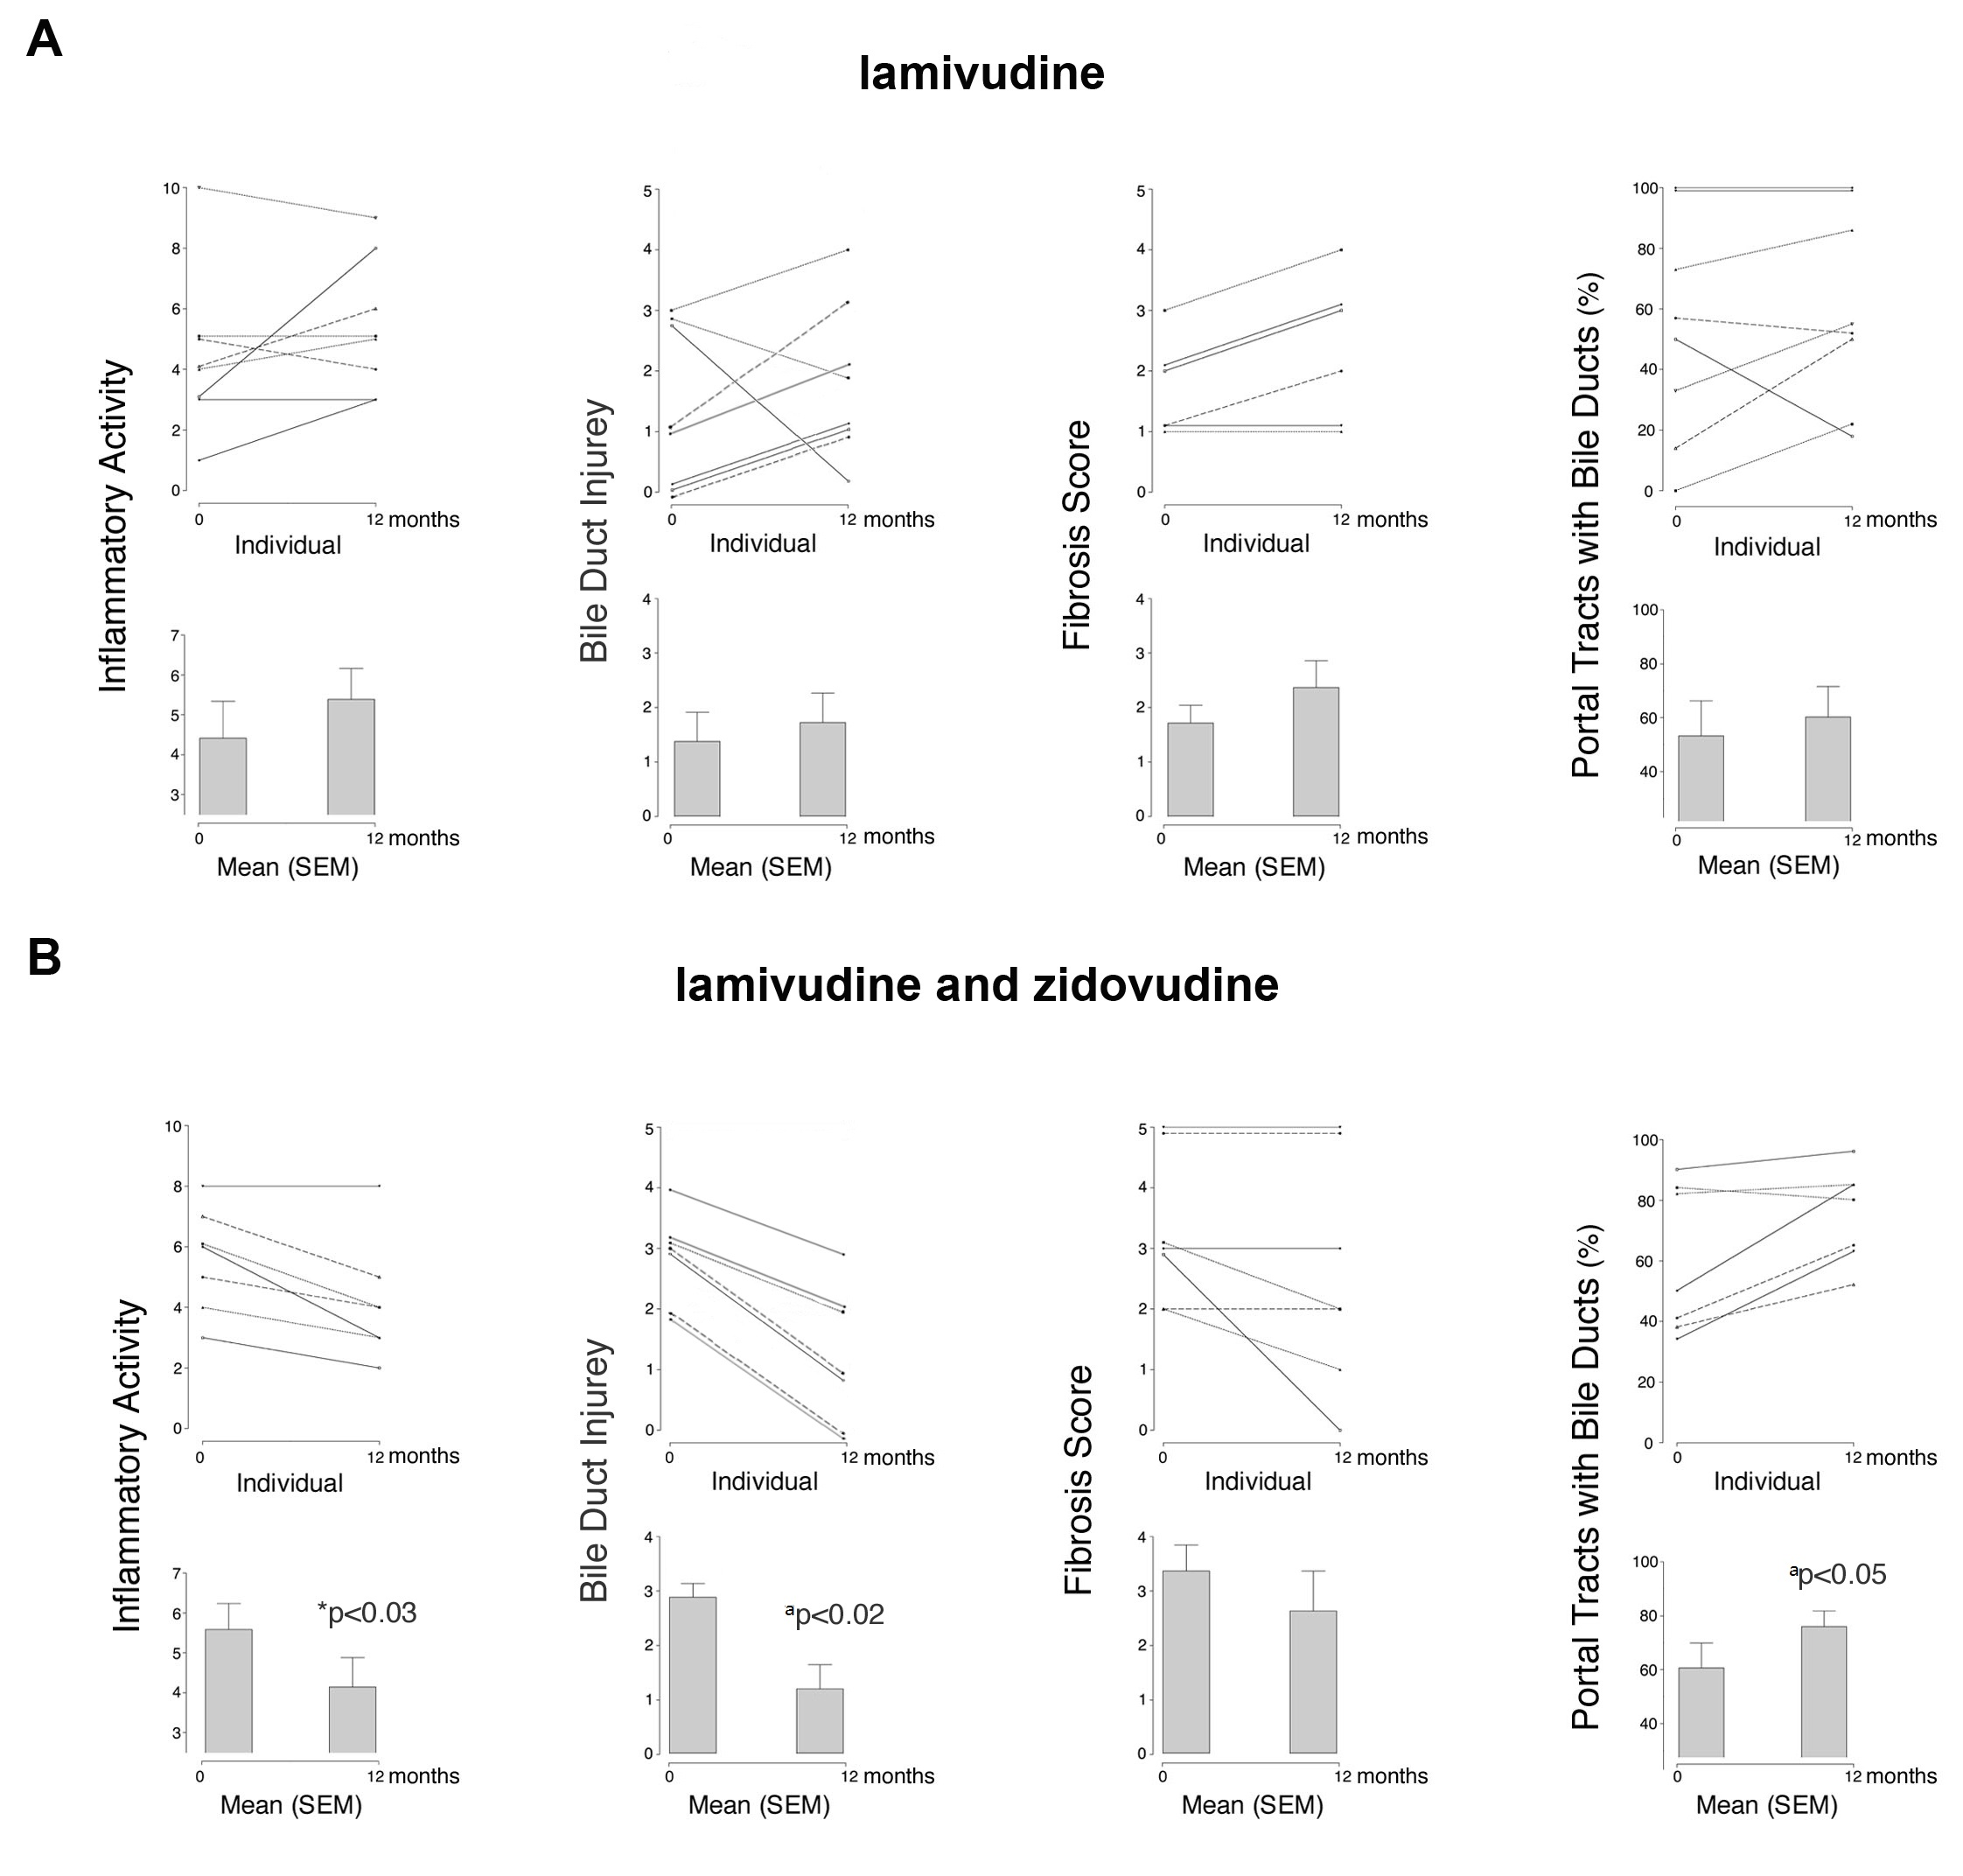
Figure 4 Serial liver biopsies assessed before and after 1 years’ open label therapy with (A) lamivudine and (B) lamivudine and zidovudine showing a significant reduction in necroinflammatory activity, bile duct injury, and improvement in ductopenia for subjects receiving lamivudine and zidovudine therapy. (With permission from Mason AL, Farr GH, Xu L, et al. Pilot studies of single and combination antiretroviral therapy in patients with primary biliary cirrhosis. Am J Gastroenterol 2004; 99: 2352).

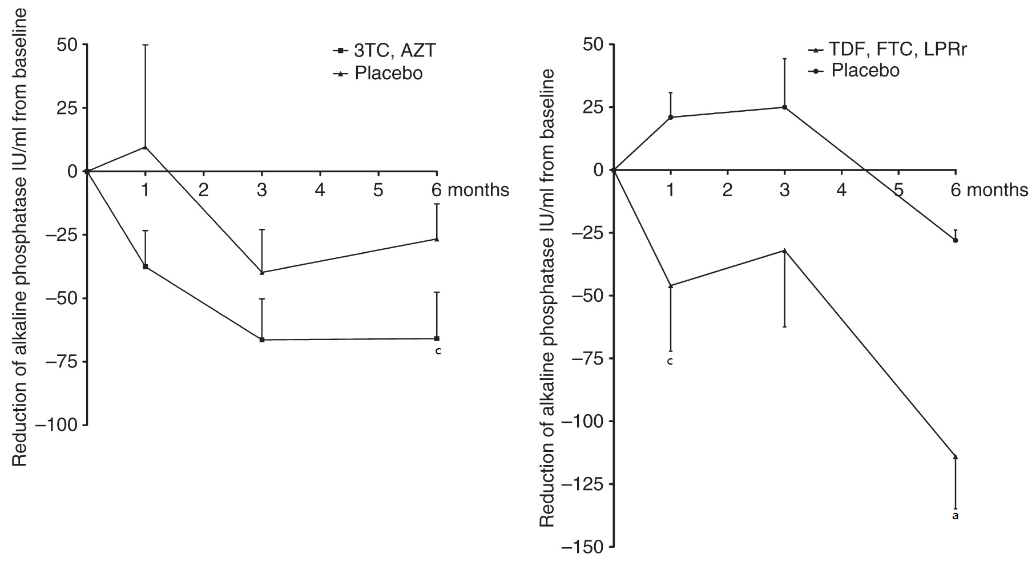
Figure 5 Incremental improvement of hepatic biochemistry observed in primary biliary cirrhosis patients maintained on UDCA receiving combination antiretroviral therapy with a protease inhibitor. Patients treated with daily lamivudine 150 mg (3TC) and zidovudine 300 mg (AZT) developed a 66 IU/mL mean reduction in ALP, whereas those receiving daily tenofovir/emtricitabine 300/200 mg (TDF, FTC) and lopinavir/ritonavir 800/200 mg (LPRr) for 6 months (n = 13) experienced a mean ALP reduction of 114 IU/mL (two-way ANOVA, ªP < 0.001, ^{c}P < 0.05 vs control). (With permission, adapted from Mason AL, Montano-Loza JL, Saxinger L. Letter: biochemical response to combination antiretroviral therapy in patients with primary biliary cirrhosis. Alimentary Pharmacology & Therapeutics 2014; 39: 229-237).

