Name of Journal: World Journal of Clinical Cases
Manuscript NO: 77676
Manuscript Type: CASE REPORT

Extensive right coronary artery thrombosis in a patient with COVID-19: A case report

Dall’Orto CC et al. RCA thrombosis in a COVID-19 patient

Clarissa Campo Dall’Orto, Rubens Pierry Ferreira Lopes, Mariana Torres Cancela, Ciria de Sales Padilha, Gilvan Vilella Pinto Filho, Marcos Raphael da Silva

Clarissa Campo Dall’Orto, Rubens Pierry Ferreira Lopes, Gilvan Vilella Pinto Filho, Marcos Raphael da Silva, Therapy Center, Brazilian Society of Health Support Hospital, Teixeira de Freitas 45987-088, Bahia, Brazil

Mariana Torres Cancela, Department of Cardiology, Deputy Luis Eduardo Magalhães Hospital, Porto Seguro 45810-000, Bahia, Brazil

Ciria de Sales Padilha, Intensive Care Unit, Medical Assistance Extreme South Hospital, Eunápolis 45820-131, Bahia, Brazil

Author contributions: Dall’Orto CC and Lopes RPF contributed to manuscript writing, editing and supervision; Pinto Filho GV and Raphael M contributed to data analysis; Cancela MT contributed to conceptualization; de Sales Padilha C contributed to data collection; all authors have read and approved the final manuscript.

Corresponding author: Clarissa Campo Dall’Orto, MD, PhD, Chief Doctor, Therapy Center, Brazilian Society of Health Support Hospital, Av. Pres. Getúlio Vargas-Recanto do Lago 2752, Teixeira de Freitas 45987-088, Bahia, Brazil. clarissadallorto@alumni.usp.br

Received: May 12, 2022
Revised: July 27, 2022
Accepted: September 21, 2022
Published online:

Abstract
BACKGROUND
Occurring in approximately 30% of hospitalized patients, cardiovascular complications that take place during the course of coronavirus disease 2019 (COVID-19) have been shown to cause morbidity and mortality. This case is the first report of extensive right coronary artery (RCA) thrombosis that was evaluated by intracoronary imaging and intracoronary invasive physiology in a patient with COVID-19.

CASE SUMMARY
A 62-year-old woman presented with flu-like symptoms; ten days later, she presented with inferior ST-segment elevations, chest pain, dyspnea, nausea and vomiting. The patient was diagnosed with COVID-19 following a positive test result. Emergency angiography of the RCA and its branches indicated intraluminal filling defects, suggesting a thrombus. Intravascular ultrasound confirmed a subacute thrombus in the RCA, the right posterior descending branch and the right posterior ventricular (RPV) branch. There was also an acute thrombus in the RPV branch and atherosclerosis in the RCA. Dual antiplatelet/anticoagulation therapy was administered. After 7 d, angiography revealed complete disappearance of the thrombi. Optical coherence tomography confirmed this with the exception of a small thrombus in the RPV branch and atherosclerotic plaque in the RCA. The atherosclerotic RCA was measured using the resting full-cycle ratio, indicating no impairment to coronary physiology. The patient was discharged on the 11th day of hospitalization and remained asymptomatic through the 6-mo follow-up.

CONCLUSION
This was the first report of RCA thrombosis in a patient with COVID-19. Dual antiplatelet/anticoagulation therapy was successful.

Key Words: Acute coronary syndrome; Coronary angiography; COVID-19, Intravascular ultrasound; Thrombosis; Case report

Dall’Orto CC, Lopes RPF, Cancela MT, de Sales Padilha C, Pinto Filho GV, da Silva MR. Extensive right coronary artery thrombosis in a patient with COVID-19: A case report. World J Clin Cases 2022; In press

Core Tip: Cardiovascular complications occurring during the course of coronavirus disease 2019 (COVID-19) cause morbidity and mortality. We report the case of a 62-year-old woman with COVID-19 and ST-elevation myocardial infarction. Angiography of the right coronary artery suggested a thrombus, and findings were confirmed via intravascular ultrasound and optimal coherence tomography. Dual antiplatelet therapy and anticoagulation with enoxaparin therapy was administered for 7 d, followed by disappearance of the thrombi. Resting full-cycle ratio was performed without damage to coronary physiology. There is no consensus on the ideal management approach for acute coronary syndrome in this scenario; however, in this case the thrombi disappeared after dual antiplatelet and anticoagulation therapy.

INTRODUCTION
Cardiovascular complications occurring in the course of coronavirus disease 2019 (COVID-19) cause morbidity and mortality affecting 30% of hospitalized patients^{[1-3]}. One possible explanation for the damage caused to the myocardium by severe acute respiratory syndrome coronavirus 2 (SARS-CoV-2) involves hypoxia following respiratory failure along with excessive inflammation, excess cytokine production, angiotensin-converting enzyme 2 receptor expression downregulation, platelet activation, coagulation cascade, endothelial cell injury, rupture of previously existing plaques [type 1 acute myocardial infarction (AMI)] and direct myocyte infiltration by the virus^{[4-6]}.

CASE PRESENTATION
Chief complaints
A 62-year-old woman with COVID-19 who presented with chest pain, dyspnea, nausea, and vomiting.

History of present illness
The patient initially presented with flu-like symptoms and was diagnosed with COVID-19 following a positive reading on a polymerase chain reaction (PCR) test. Ten days later, the patient presented with chest pain, dyspnea, nausea and vomiting.

Personal and family history
The patient’s medical history included dyslipidemia and incipient atherosclerosis in the carotid and aortic territories, continuous use of nortriptyline for migraines and 9 years of tiboline [Libiam 1.25 mg once a day (Libbs-São Paulo–SP/BR)] use as menopausal hormone therapy. The patient had received three doses of a vaccine for SARS-CoV-2; two chimpanzee adenovirus vector vaccines (ChAdOx1 nCoV-19 AZD1222; Oxford/AstraZeneca/Fiocruz, Rio de Janeiro, Brazil) on April 12, 2021 and July 13, 2021, respectively, and one BNT162b2 mRNA COVID-19 vaccine (BioNTech/Pfizer, New York City, NY, United States) on December 13, 2021. Timeline is showed in Figure 1.

Physical examination
Upon physical examination, the vital signs were as follows: Body temperature 36.5 °C; blood pressure 122/78 mmHg; heart rate 82 beats per min; and respiratory rate 22 breaths per min. The patient’s clinical presentation was compatible with Killip-Kimball grade I classification.

Laboratory examinations
Laboratory examination results were as follows: Blood cardiac biomarkers included a creatine kinase level of 6105 IU/L, a creatine kinase myocardial band fraction of 300 IU/L, a cardiac troponin I level of 25000 pg/mL, a C-reactive protein level of 75.8 mg/dL, a lactic dehydrogenase level of 1.510 U/L and a D-dimer level of 2.540 mcg/L FEU. In addition, transthoracic Doppler echocardiography revealed akinesis in the inferior mid-basal and apical infero-basal portions of the left ventricle.

Imaging examinations
Emergency coronary angiography revealed that the anterior descending coronary artery and its diagonal branches and circumflex artery and its marginal branches were free of obstructive atherosclerotic lesions (Figure 2). However, images of the right coronary artery (RCA) and its right posterior descending (RPD) and right posterior ventricular (RPV) branches indicated defects in intraluminal filling, suggesting a thrombus (Figure 3).

Graphic methods
Electrocardiography showed sinus rhythm, inferior ST-segment elevations and reciprocal changes in the anterolateral leads (Figure 4). The patient was referred for emergency angiography.

Further diagnostic work-up
We evaluated the RCA by intracoronary ultrasound. Intravascular ultrasound (IVUS) pullbacks were performed using a 40 MHz IVUS OPTICROSS catheter (Boston Scientific, Natick, MA, United States) at 0.5 mm/s. The images suggested a subacute, homogeneous, echolucent thrombus in a large extension of the RCA, RPD branch, and RPV branch. Additionally, they showed an acute thrombus with a bright aspect, clear outline and no signal attenuation in the RPV branch (Figure 5)^{[7]}. We believe that the presence of thrombi on IVUS in the acute and subacute stages was due to the fact that at the time the patient was studied, the process had already been evolving for over 24 h and the thrombotic process (when it does not culminate with vessel occlusion) is a continuum of thrombus stages. We also identified mild to moderate atherosclerosis in the middle third of the RCA (Figure 5).

FINAL DIAGNOSIS
The patient was diagnosed with AMI with inferior ST-segment elevations, Killip grade I heart failure and COVID-19.

TREATMENT
On angiography, the patient was pain-free and had thrombolysis in myocardial infarction grade 3 flow, despite extensive thrombotic burden in the RCA. Therefore, we did not perform primary angioplasty and, instead, opted for dual antiplatelet therapy with ticagrelor and aspirin and anticoagulation therapy with enoxaparin 1 mg/kg twice a day. Additionally, we administered the pharmacology recommended by current guidelines for patients with AMI with ST-segment elevation, including statins, a beta-blocker, an angiotensin-converting enzyme or angiotensin II receptor blocker and a mineralocorticoid receptor antagonist^{[8-10]}.

OUTCOME AND FOLLOW-UP
On angiography and IVUS, we were unable to identify any culprit lesions. Therefore, we used optical coherence tomography (OCT) for confirmation to look for signs of erosion or plaque rupture, which could have explained the condition and guided treatment; for example, if there was a need for mechanical passivation of the plate with a stent. However, we did not find plaque erosion or rupture on OCT.
After 7 d, repeat coronary angiography showed complete disappearance of the thrombi located in the RCA and its branches (Figure 6). Therefore, we performed intravascular OCT for confirmation, using the ILUMIENTM OPISTM, OPTIS Integrated, and OPTIS Mobile systems (Abbott Vascular, Santa Clara, CA, United States) with a rapid exchange catheter (DragonflyTM DUO, DragonflyTM OPISTM, and Dragonfly OpStarTM Imaging Catheter; Abbott Vascular, Santa Clara, CA, United States) with a 75 mm/2.1 s (36 mm/s) pullback and 180 frames/s. The OCT exam confirmed that the thrombi had disappeared with the exception of a small residual thrombus in the RPV branch (Figure 7). It also identified a plaque in the middle third of the RCA. Severity of coronary stenosis was measured using the resting full-cycle ratio, a non-hyperemic index based on unbiased detection of the lowest existing relationship between distal coronary pressure and aortic pressure (Pd/Pa), independent of the electrocardiogram, landmark identifications and time within the heart cycle. We evaluated this plaque as 40% mild in the RCA, causing 40% arterial lumen obstruction. We used PressureWire X (Abbott Vascular, Santa Clara, CA, United States), which reported a value of 0.99, indicating the absence of impairment to coronary physiology.
The patient recovered without further event and was discharged on the 11th day of hospitalization. After showing good tolerance to medications with no adverse effects, she was prescribed ticagrelor, aspirin, statins, beta-blockers and angiotensin-converting enzyme inhibitors.
The patient has been under follow-up until the present day by our team, with a 6 mo follow-up completed thus far, and she remains asymptomatic without any other clinical conditions since then.

DISCUSSION
In the present case, the diagnosis of AMI with ST-segment elevation was confirmed by clinical findings, electrocardiogram, laboratory blood tests and coronary angiography. The latter showed extensive failure of intraluminal filling suggesting a thrombus, which was then confirmed by IVUS and OCT findings. The plaque in the middle third of the RCA, which we believe was not responsible for the event, did not cause any hemodynamic repercussions, a fact confirmed by the assessment of invasive physiology.
The diagnosis that proved to be feasible in this case was AMI with ST-segment elevation type 2; that is, AMI not related to the instability of atherosclerotic plaque in the coronary artery. Faced with this diagnosis, it is necessary to reflect on the possible causes to guide us towards the most appropriate treatment. A possible cause suggested in this patient could be hormone replacement therapy for menopause. The patient was chronically using tibolone, which is a synthetic steroid whose metabolites have estrogenic, androgenic and progestogenic properties. In the Long-term Intervention on Fracture with Tibolone study, tibolone in postmenopausal women was linked to an excessive risk of stroke in women receiving tibolone compared with placebo. However, there were no significant differences in the risk of coronary heart disease or venous thromboembolism between the two groups^{[11]}.
The hypothesis of a post-vaccination reaction to the vaccine for COVID-19 could also be raised. However, we did not emphasize the possibility that the patient's clinical condition was due to an adverse effect of the vaccine because the event occurred more than 30 d after the third dose; additionally, she had a positive PCR test result indicating active infection.
In view of the abovementioned findings, with a positive PCR test result for SARS-CoV-2, in addition to inflammatory markers, with very high serum (lactic dehydrogenase, C-reactive protein and D-dimer) levels corroborating active infection, the most plausible cause we found for the etiology of AMI with ST-segment elevation type 2 in this case was COVID-19.
The common occurrence of extra-respiratory involvement in SARS-CoV-2 infections has become more evident over time. AMI with ST-segment elevation is observed with a pattern on angiography, and extensive thrombosis can affect one or more coronary arteries and different vascular territories simultaneously, not caused by rupture of atherosclerotic plaques. These occurrences present new challenges to treating and managing this viral infection^{[10,12]}. The increased incidence of stent thrombosis may be associated with these phenomena, and severe inflammation with consequent hypercoagulation is another primary pathology associated with SARS-CoV-2^{[13]}.
There is no specific finding that confirms the relationship between COVID-19 infection and AMI other than the known extensive thrombotic burden, which is not a specific finding. The high thrombotic load in patients with AMI and COVID is known. In addition to the findings in other studies in the literature^{[14,15]}, there are also other important reports addressing this issue, such as a statement from the American College of Cardiology in which the authors concluded that patients with ST-segment elevation myocardial infarction and concurrent COVID-19 experienced a higher thrombotic burden than those without concurrent COVID-19^{[13]}.
AMI without plaque rupture (type 2) can indeed occur in addition to COVID-19; however, we did not identify any other causes of type 2 AMI, such as coronary dissection, vasospasm, emboli, microvascular dysfunction or increases in demand with or without underlying coronary artery disease.
The difference between this case and those previously published is that we were able to document the absence of plaque rupture or erosion in a patient with coronary artery disease and to demonstrate that the plaque had no hemokinetic repercussions, shown via invasive physiology. We believe that our case corroborates a body of evidence that has been building toward an understanding of COVID and AMI.
While the importance of differentiating between type I and type II AMI and myocarditis in patients with COVID-19 presenting with acute coronary syndrome (ACS) is established, there is no consensus on the ideal management approach for ACS in this scenario. In patients with known or suspected COVID-19, treatment of ST-segment elevation myocardial infarction is similar to that for patients without COVID-19, using aspirin, nitrate, beta-blockers, anticoagulation, antiplatelet aggregation with a P2Y12 agent, statins, and reperfusion therapy with fibrinolytics or primary angioplasty. Percutaneous coronary intervention, aspiration and antiplatelet thrombectomy are options, with the latter being the most generally agreed upon for treating these patients^{[16]}. However, in this study, the thrombi disappeared after dual antiplatelet therapy, anticoagulation therapy and traditional post-myocardial infarction pharmaceutical interventions were administered.

CONCLUSION
This was the first report of extensive RCA thrombosis in a patient with COVID-19 evaluated by intracoronary imaging and intracoronary invasive physiology.

REFERENCES
1 Zhou F, Yu T, Du R, Fan G, Liu Y, Liu Z, Xiang J, Wang Y, Song B, Gu X, Guan L, Wei Y, Li H, Wu X, Xu J, Tu S, Zhang Y, Chen H, Cao B. Clinical course and risk factors for mortality of adult inpatients with COVID-19 in Wuhan, China: a retrospective cohort study. Lancet 2020; 395: 1054-1062 [PMID: 32171076 DOI: 10.1016/S0140-6736(20)30566-3]
2 Arentz M, Yim E, Klaff L, Lokhandwala S, Riedo FX, Chong M, Lee M. Characteristics and Outcomes of 21 Critically Ill Patients With COVID-19 in Washington State. JAMA 2020; 323: 1612-1614 [PMID: 32191259 DOI: 10.1001/jama.2020.4326]
3 Guo T, Fan Y, Chen M, Wu X, Zhang L, He T, Wang H, Wan J, Wang X, Lu Z. Cardiovascular Implications of Fatal Outcomes of Patients With Coronavirus Disease 2019 (COVID-19). JAMA Cardiol 2020; 5: 811-818 [PMID: 32219356 DOI: 10.1001/jamacardio.2020.1017]
4 Stefanini GG, Montorfano M, Trabattoni D, Andreini D, Ferrante G, Ancona M, Metra M, Curello S, Maffeo D, Pero G, Cacucci M, Assanelli E, Bellini B, Russo F, Ielasi A, Tespili M, Danzi GB, Vandoni P, Bollati M, Barbieri L, Oreglia J, Lettieri C, Cremonesi A, Carugo S, Reimers B, Condorelli G, Chieffo A. ST-Elevation Myocardial Infarction in Patients With COVID-19: Clinical and Angiographic Outcomes. Circulation 2020; 141: 2113-2116 [PMID: 32352306 DOI: 10.1161/CIRCULATIONAHA.120.047525]
5 Bois MC, Boire NA, Layman AJ, Aubry MC, Alexander MP, Roden AC, Hagen CE, Quinton RA, Larsen C, Erben Y, Majumdar R, Jenkins SM, Kipp BR, Lin PT, Maleszewski JJ. COVID-19-Associated Nonocclusive Fibrin Microthrombi in the Heart. Circulation 2021; 143: 230-243 [PMID: 33197204 DOI: 10.1161/CIRCULATIONAHA.120.050754]
6 Masi P, Hékimian G, Lejeune M, Chommeloux J, Desnos C, Pineton De Chambrun M, Martin-Toutain I, Nieszkowska A, Lebreton G, Bréchot N, Schmidt M, Edouard Luyt C, Combes A, Frere C. Systemic Inflammatory Response Syndrome Is a Major Contributor to COVID-19-Associated Coagulopathy: Insights From a Prospective, Single-Center Cohort Study. Circulation 2020; 142: 611-614 [PMID: 32776849 DOI: 10.1161/CIRCULATIONAHA.120.048925]
7 Groenland FTW, Ligthart JMR, Witberg KT, Daemen J. Patterns of intracoronary thrombus by high-definition intravascular ultrasound. EuroIntervention 2022; 18: e158-e159 [PMID: 34984982 DOI: 10.4244/EIJ-D-21-00796]
8 Ibanez B, James S, Agewall S, Antunes MJ, Bucciarelli-Ducci C, Bueno H, Caforio ALP, Crea F, Goudevenos JA, Halvorsen S, Hindricks G, Kastrati A, Lenzen MJ, Prescott E, Roffi M, Valgimigli M, Varenhorst C, Vranckx P, Widimský P; ESC Scientific Document Group. 2017 ESC Guidelines for the management of acute myocardial infarction in patients presenting with ST-segment elevation: The Task Force for the management of acute myocardial infarction in patients presenting with ST-segment elevation of the European Society of Cardiology (ESC). Eur Heart J 2018; 39: 119-177 [PMID: 28886621 DOI: 10.1093/eurheartj/ehx393]
9 Mahmud E, Dauerman HL, Welt FGP, Messenger JC, Rao SV, Grines C, Mattu A, Kirtane AJ, Jauhar R, Meraj P, Rokos IC, Rumsfeld JS, Henry TD. Management of acute myocardial infarction during the COVID-19 pandemic: A Consensus Statement from the Society for Cardiovascular Angiography and Interventions (SCAI), the American College of Cardiology (ACC), and the American College of Emergency Physicians (ACEP). Catheter Cardiovasc Interv 2020; 96: 336-345 [PMID: 32311816 DOI: 10.1002/ccd.28946]
10 Task Force for the management of COVID-19 of the European Society of Cardiology. ESC guidance for the diagnosis and management of cardiovascular disease during the COVID-19 pandemic: part 2-care pathways, treatment, and follow-up. Eur Heart J 2022; 43: 1059-1103 [PMID: 34791154 DOI: 10.1093/eurheartj/ehab697]
11 Cummings SR, Ettinger B, Delmas PD, Kenemans P, Stathopoulos V, Verweij P, Mol-Arts M, Kloosterboer L, Mosca L, Christiansen C, Bilezikian J, Kerzberg EM, Johnson S, Zanchetta J, Grobbee DE, Seifert W, Eastell R; LIFT Trial Investigators. The effects of tibolone in older postmenopausal women. N Engl J Med 2008; 359: 697-708 [PMID: 18703472 DOI: 10.1056/NEJMoa0800743]
12 Kermani-Alghoraishi M. A Review of Coronary Artery Thrombosis: A New Challenging Finding in COVID-19 Patients and ST-elevation Myocardial Infarction. Curr Probl Cardiol 2021; 46: 100744 [PMID: 33218787 DOI: 10.1016/j.cpcardiol.2020.100744]
13 Choudry FA, Hamshere SM, Rathod KS, Akhtar MM, Archbold RA, Guttmann OP, Woldman S, Jain AK, Knight CJ, Baumbach A, Mathur A, Jones DA. High Thrombus Burden in Patients With COVID-19 Presenting With ST-Segment Elevation Myocardial Infarction. J Am Coll Cardiol 2020; 76: 1168-1176 [PMID: 32679155 DOI: 10.1016/j.jacc.2020.07.022]
14 Pandit BN, Shrivastava A, Nath RK, Kuber D, Sinha SK, Aggarwal P. Impact of COVID-19 on Thrombus Burden and Outcome in Acute Myocardial Infarction. Cureus 2021; 13: e16817 [PMID: 34522477 DOI: 10.7759/cureus.16817]
15 Trivi M, Lalor N, Spaletra P, Raffaeli A, Costabel J, Belardi J. [Acute myocardial infarction in patients recovering from COVID-19 pneumonia]. Medicina (B Aires) 2020; 80 Suppl 6: 97-99 [PMID: 33481739]
16 Varga Z, Flammer AJ, Steiger P, Haberecker M, Andermatt R, Zinkernagel AS, Mehra MR, Schuepbach RA, Ruschitzka F, Moch H. Endothelial cell infection and endotheliitis in COVID-19. Lancet 2020; 395: 1417-1418 [PMID: 32325026 DOI: 10.1016/S0140-6736(20)30937-5]

Footnotes
Informed consent statement: Informed written consent was obtained from the patient for publication of this report and any accompanying images.

Conflict-of-interest statement: All the authors report no relevant conflicts of interest for this article.

CARE Checklist (2016) statement: The authors have read the CARE Checklist (2016), and the manuscript was prepared and revised according to the CARE Checklist (2016).

Open-Access: This article is an open-access article that was selected by an in-house editor and fully peer-reviewed by external reviewers. It is distributed in accordance with the Creative Commons Attribution NonCommercial (CC BY-NC 4.0) license, which permits others to distribute, remix, adapt, build upon this work non-commercially, and license their derivative works on different terms, provided the original work is properly cited and the use is non-commercial. See: https://creativecommons.org/Licenses/by-nc/4.0/

Provenance and peer review: Unsolicited article; Externally peer reviewed.

Peer-review model: Single blind

Peer-review started: May 12, 2022
First decision: June 27, 2022
Article in press:

Specialty type: Medicine, research and experimental
Country/Territory of origin: Brazil
Peer-review report’s scientific quality classification
Grade A (Excellent): 0
Grade B (Very good): 0
Grade C (Good): C
Grade D (Fair): D, D
Grade E (Poor): 0

P-Reviewer: Ito S, Japan; Kharlamov AN, Netherlands S-Editor: Fan JR L-Editor: Filipodia P-Editor: Fan JR

Figure Legends
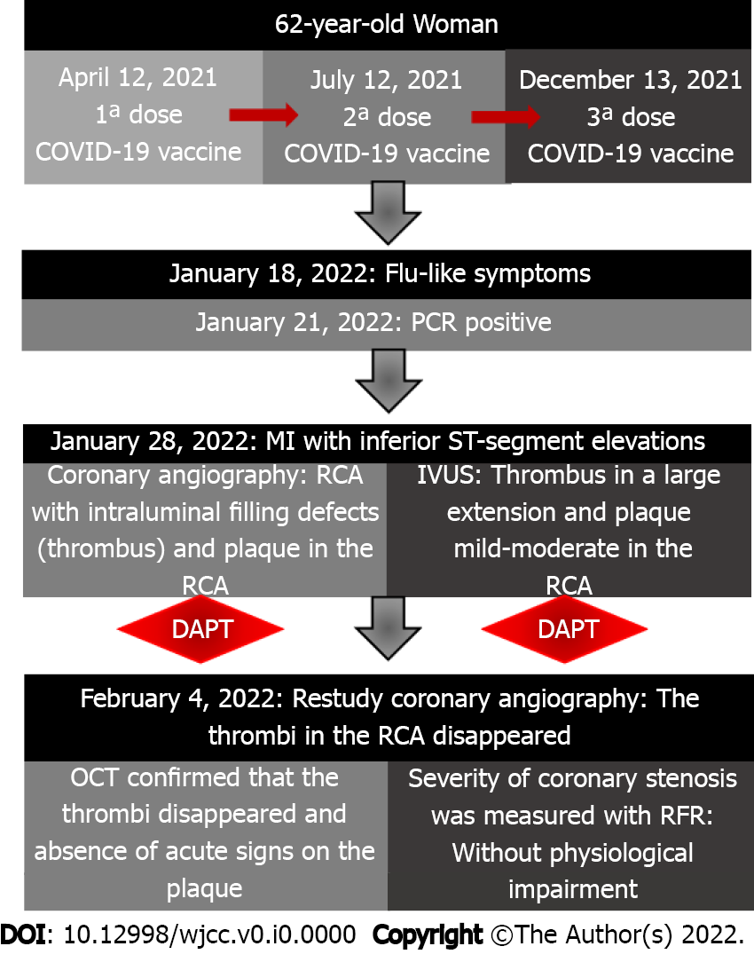
Figure 1 Timeline. PCR: Polymerase chain reaction; MI: Myocardial infarction; RCA: Right coronary artery; IVUS: Intravascular ultrasound; OCT: Optical coherence tomography; RFR: Resting full-cycle ratio; COVID-19: Coronavirus disease 2019.

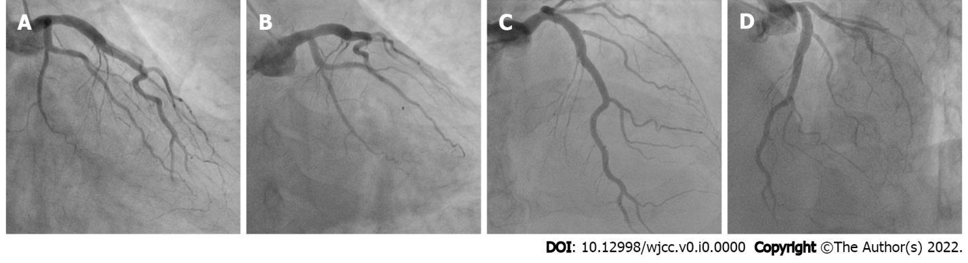
Figure 2 Emergency coronary angiogram: Left coronary artery. Angiography reveals no significant stenoses. A: Left coronary artery (LCA) in the conventional right anterior oblique projection; B: LCA in the caudal right anterior oblique projection; C: LCA in the cranial posteroanterior projection; D: LCA in the cranial left anterior oblique projection.

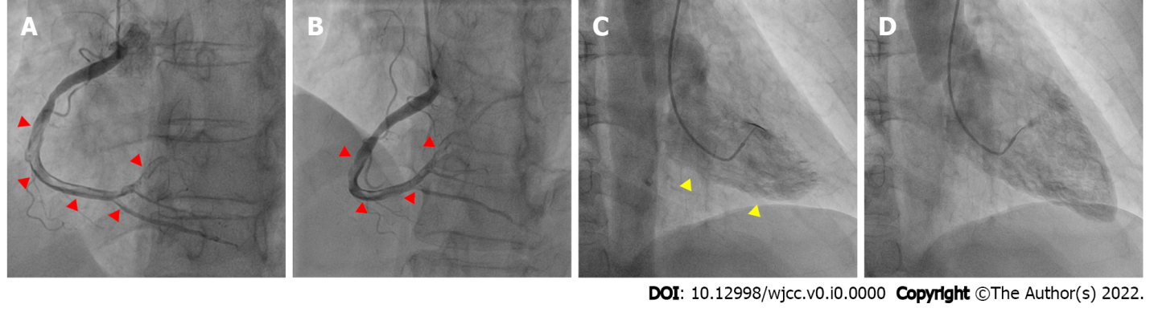
Figure 3 Emergency coronary angiogram: Right coronary artery and left ventriculography. The images show intraluminal filling defects (red arrows) starting in the middle third of the right coronary artery (RCA) and extending to the distal third, affecting the posterior descending and posterolateral RCA branches. A: RCA in the conventional left anterior oblique projection; B: RCA in the cranial left anterior oblique projection; C: Left ventriculography (LV) in systole demonstrates inferior akinesia (yellow arrows); D: LV in diastole.
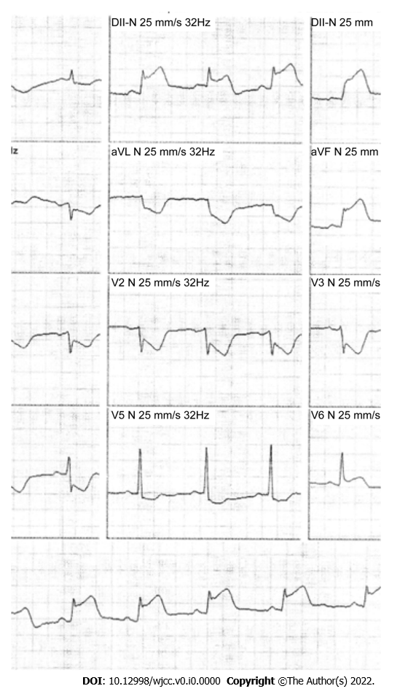
Figure 4 Electrocardiogram on admission. The results show sinus rhythm with ST-segment elevation in the inferior wall and reciprocal changes in the anterolateral leads.

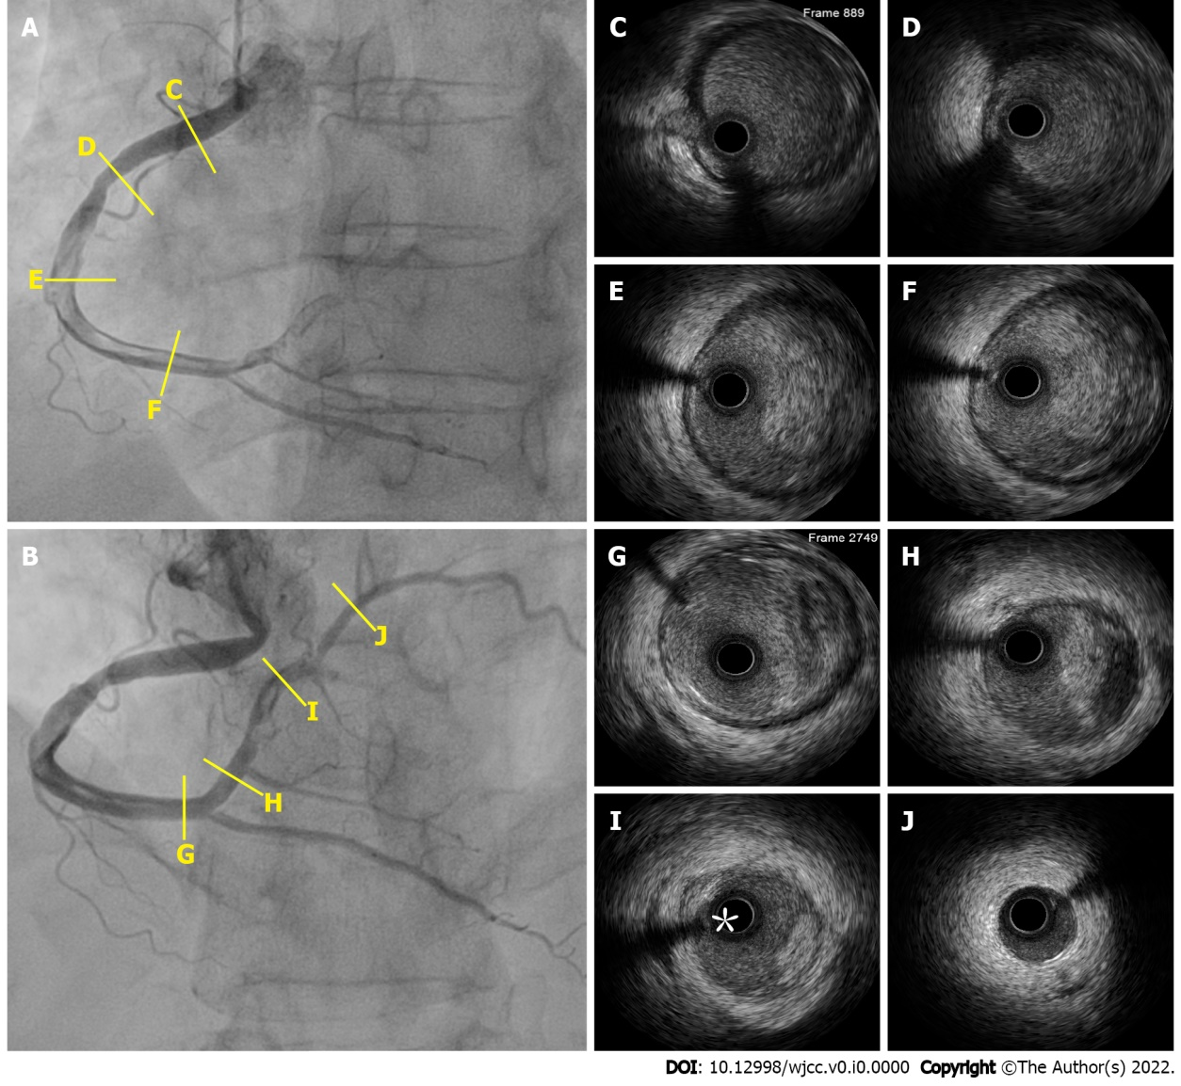
Figure 5 Intravascular ultrasound images from two angles. A: Right coronary artery (RCA) in the conventional left anterior oblique projection; B: RCA in the cranial left anterior oblique projection; C: An incipient plaque; D: A concentric plaque-causing moderate luminal stenosis; E-H: A subacute-appearing thrombus with a layered light to dark-gray appearance with white patches and less clear delineations. Moderate-to-severe signal attenuation may also be observed, likely due to the deviation or absorption of ultrasound waves by the subacute thrombus; I: An acute thrombus (asterisk) with a bright appearance, clear outline, and no signal attenuation; J: Discreet intimal thickening.

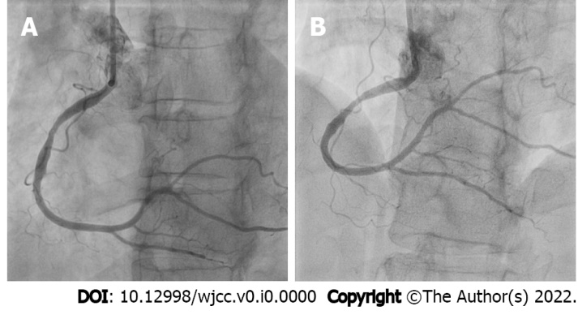
Figure 6 Reexamination of the right coronary artery after 7 d. The images show nearly complete resolution of the right coronary artery (RCA) thrombus. A: RCA in the conventional left anterior oblique projection; B: RCA in the cranial left anterior oblique projection.

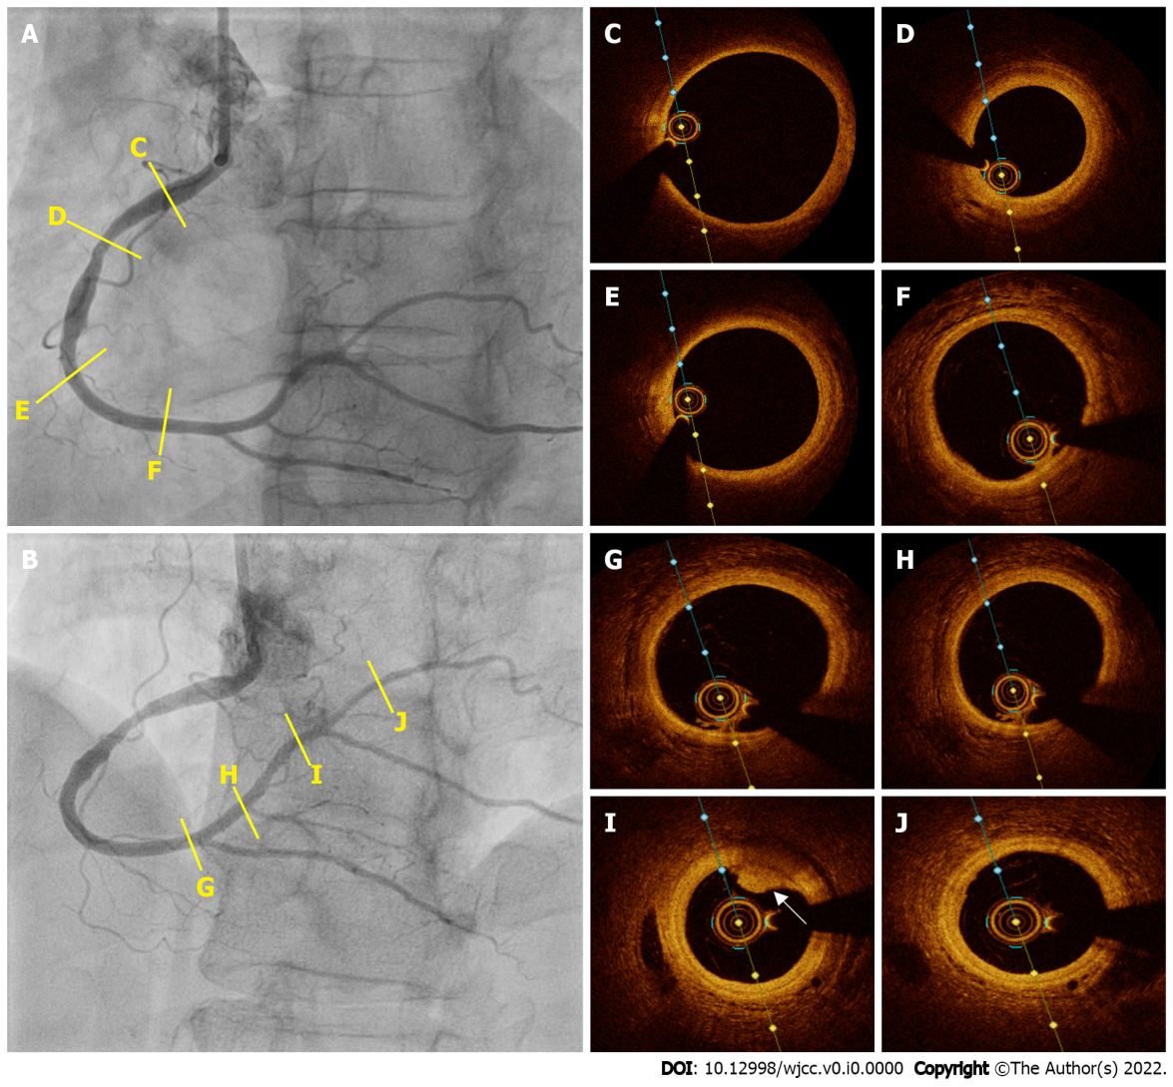
Figure 7 Optical coherence tomography images from two angles. A: Right coronary artery (RCA) in the conventional left anterior oblique projection; B: RCA in the cranial left anterior oblique projection; C: A normal vessel with a three-layered structure; D: A fibrotic plaque; E and F: Normal vessels with a three-layer structure; G, H, and J: Normal vessels with a three-layer structure; I: Mild signal attenuation and easily delineated borders suggest white thrombus remnants (white arrow).

