Name of journal: World Journal of Gastrointestinal Endoscopy
ESPS Manuscript NO: 1592
Columns: CASE REPORT

Endoscopic mucosal resection with circumferential mucosal incision of duodenal carcinoid tumors

Otaki Y et al. Modified EMR for duodenal carcinoid tumors

Yuzo Otaki, Kiyoaki Homma, Yoshitakata Nawata, Kazuomi Imaizumi, Shigeru Arai

Yuzo Otaki, Kiyoaki Homma, Yoshitakata Nawata, Department of Therapeutic Endoscopy, Nihonkai General Hospital, Yamagata 998-0828, Japan

Kazuomi Imaizumi, Department of Gastroenterology, Nihonkai General Hospital, Yamagata 998-0828, Japan

Shigeru Arai, Department of Pathology, Nihonkai General Hospital,Sakata, Yamagata 998-0828, Japan

Author contributions: Otaki Y and Nawata Y designed the report; Homma K, Nawata Y and Imaizumi K were attending doctors for the patients; Homma K performed endoscopic operation; Arai S performed pathological examinations; Homma K and Imaizumi K were performed image diagnosis; Otaki Y organized the report and wrote paper.

Correspondence to: Yuzo Otaki, MD, Department of Therapeutic Endoscopy, Nihonkai General Hospital, 30 Akiho, Sakata, Yamagata 998-0828, Japan. 99016yo@jichi.ac.jp

Telephone: +81-234-262001 Fax: +81-234-265114
Received: December 21, 2012 Revised: January 7, 2013
Accepted: January 29, 2013

Published Online:

Abstract
Duodenal carcinoids are a rare form of neuroendocrine tumors, and tend to invade the submucosa during the early stage. Endoscopic treatment is generally recommended for duodenal carcinoids less than 10 mm in diameter. Although a few reports have described the use of endoscopic resection of duodenal carcinoids, there are no published studies on endoscopic mucosal resection with circumferential mucosal incision (EMR-CMI). We performed EMR-CMI for 5 cases of duodenal carcinoids in the duodenal bulb. The mean tumor diameter was 4.6 mm ± 1.8 mm. Although all of the tumors were located in the submucosa, R0 resection was performed without complication in each case. EMR-CMI may thus be a safe and effective treatment for duodenal carcinoids less than 10 mm in diameter.

© 2013 Baishideng. All right reserved.

Key words: Case study; Digestive system endoscopic surgery; Duodenal neoplasms; Submucosa; Neuroendocrine tumor

Core tip: Endoscopic treatment for duodenal carcinoids is generally recommended less than 10 mm in diameter. Although a few reports have described endoscopic resection of duodenal carcinoids, there are no published studies on endoscopic mucosal resection with circumferential mucosal incision (EMR-CMI). We performed EMR-CMI for 5 cases of duodenal carcinoids in the duodenal bulb. The mean tumor diameter was 4.6 mm. Although all of the tumors were located in the submucosa, R0 resection was performed without complication in each case. EMR-CMI may thus be a safe and effective treatment for duodenal carcinoids less than 10 mm in diameter.

Otaki Y, Homma K, Nawata Y, Imaizumi K, Arai S. Endoscopic mucosal resection with circumferential mucosal incision of duodenal carcinoid tumors
Available from:
DOI:

INTRODUCTION
Carcinoid tumors are a rare neuroendocrine malignancies that are most frequently found in the gastrointestinal (GI) tract^{[1]}. Duodenal carcinoids account for 2%−5% of GI carcinoid tumors, and usually present as solitary small lesions confined to the duodenal submucosa^{[2,3]}. Endoscopic treatment is generally recommended for duodenal carcinoids less than 10 mm as it is associated with a low frequency of lymph node invasion and distant metastases^{[3-5]}. A few reports have described the use of endoscopic resection for the treatment of duodenal carcinoids. However, to our knowledge, no studies have been published to date on endoscopic mucosal resection with circumferential mucosal incision (EMR-CMI) for these tumors. In this study, we described our experience of EMR-CMI for the treatment of 5 cases of duodenal carcinoids.

CASE REPORT
Between December 2006 and September 2012, 5 patients (4 men and 1 woman) with a duodenal carcinoid tumor underwent EMR-CMI at Nihonkai General Hospital. All patients were asymptomatic, and the tumors were incidentally detected during a screening esophago-gastro-duodenoscopy (EGD). All procedures were performed by a single endoscopist (Homma K), and all patients were examined by endoscopic ultrasonography (EUS) and abdominal computed tomography (CT) before EMR-CMI. The diagnosis of carcinoid tumor was confirmed by an endoscopic forceps biopsy. Indications for treatment by EMR-CMI were a tumor of diameter 10 mm or less that was confined to the submucosal layer with a clear separation between the tumor and the muscularis propria layer, as assessed by a 20-MHz EUS microprobe (UM2R, Olympus, Tokyo, Japan), and no lymph node invasion or distant metastases on abdominal CT.
After obtaining informed consent from the patient, EMR-CMI was performed under moderate sedation with a combination of pentazocine and flunitrazepam. A single-channel upper GI endoscope with a water-jet system (GIF-Q260J, Olympus) was used. The procedure began with a submucosal injection of hyaluronic acid solution (Mucoup, Johnson and Johnson, Japan) with a 0.1 mL mixture of 0.1% epinephrine and 0.4% indigocarmine dye in order to maintain prolonged elevation and good visibility. A circumferential mucosal incision was performed using a SB knife Jr (Sumitomo Bakelite, Tokyo, Japan) or Mantis Hook (Pentax, Tokyo, Japan), and an additional submucosal injection of hyaluronic acid solution was given beneath the lesion. The adequately raised lesion was then ensnared using a snare (B wave; Zeon Medical, Tokyo, Japan or K-snare; Pentax) in the same manner as the standard polypectomy technique. After EMR-CMI, the mucosal wound was closed with endoscopic clippings as much as possible in order to prevent postoperative bleeding and delayed perforation. To evaluate local recurrence at the resection site, periodic follow-up EGD was performed for all patients. The average age at the time of diagnosis was 64.2 ± 10.2 years (range 47−74 years). The tumors were located in the submucosa within the duodenal bulb in all cases, and the mean tumor size was 4.6 ± 1.8 mm (range 3−8 mm). En bloc resection was performed for all patients, and no complications were observed. The average resection time was 19.4 ± 3.6 min (Table 1) and the subsequent postoperative hospitalization period was 5 d in all patients. The median follow-up period was 13 ± 8.8 mo (range 2−29 mo).
In this study, we described one of the cases in greater detail in order to illustrate the typical endoscopic and histological findings associated with these tumors (Case 1). A 74-year-old woman presented with a carcinoid tumor located in the anterior wall of the duodenal bulb (Figure 1A). EUS revealed a hypoechoic mass measuring 3 mm in diameter, originating from the submucosal layer (Figure 1B). Abdominal CT revealed no lymph-node invasion or distant metastases. After local injection of hyaluronic acid solution with epinephrine and an indigocarmine dye to the submucosa around the lesion, a circumferential incision was performed using a SB knife Jr (Figure 2A). En bloc resection was then performed by using a standard polypectomy technique with K-snare (Figure 2B and C). The mucosal defect was closed with endoscopic clippings, and the entire procedure was completed in 26 min. A negative surgical margin was confirmed histologically (Figure 3).

DISCUSSION
Duodenal carcinoids are generally considered to be indolent tumors, but because of rarity, their natural history has not been adequately described to date^{[6]}. The metastatic potential of duodenal carcinoids is closely dependent on the size of the tumor. In a series of 99 duodenal carcinoids, Burke et al^{[3]} reported that the mean tumor diameter was 18 mm (range 2−50 mm) and that metastasis was presented in 21% of the cases. None of the patients with tumors less than 10 mm in diameter developed metastatic disease during a mean follow-up period of 65 mo. Zyromski et al^{[6]}also reported that 24 patients with duodenal carcinoid tumors less than 20 mm remained disease free after local excision during a mean follow-up of 46 mo. In another author described 14% of 201 patients with duodenal carcinoids less than 10 mm in diameter developed metastases, whereas this increased to 47% for patients with tumor diameters between 21 and 50 mm^{[7]}.
In addition to the tumor size, involvement of the muscularis propria and the presence of mitotic figures have also been proposed as possible risk factors for metastases in duodenal carcinoids^{[3]}. Therefore, the accurate assessment of invasion depth is important for a successful treatment outcome. EUS has been reported to be an appropriate method for assessing carcinoid tumors including duodenal lesions^{[8-10]}. In a series of 36 GI carcinoid tumors including 7 duodenal lesions evaluated by EUS, Yoshikane et al^{[8]} reported that the tumors were generally visualized as hypoechoic and homogenous lesions, and the accuracy of determining the depth of invasion was 75%. Furthermore, when limiting this assessment to the lesions detectable on EUS, the accuracy was as high as 90%. In the present study, all cases were detectable on EUS and the accuracy of determining the depth of invasion was 100%, despite the relatively small number of cases.
European guidelines recommended that duodenal carcinoids less than 10 mm in diameter that are confined to the submucosa as seen on EUS should be treated by endoscopy in the absence of apparent lymph node invasion and distant metastases^{[5]}. However, the appropriate treatment for duodenal carcinoids larger than 10 mm is still controversial. Endoscopic treatment might be considered in patients with a high risk of perioperative complications because of old age or advanced comorbidity. If endoscopy is deemed unsuitable, laparoscopic techniques could be a suitable alternative^{[11]}.
Several endoscopic approaches have been reported for the treatment of carcinoid tumors. Endoscopic resection of carcinoid tumors with polypectomy or strip biopsy with grasping forceps is sometimes associated with margin involvement and crush injury of the resected specimens^{[12-14]}. EMR with band ligation, which is clinically accepted for R0 resection method for carcinoid tumors in the rectum, has been scarcely reported in the duodenal lesions, and its safety profile for the treatment of duodenal carcinoids is unknown^{[15,16]}. We believe that duodenal wall is thin, and band ligation of duodenal wall has a potential risk of muscular involvement. Endoscopic submucosal dissection, which is an emerging technique for the treatment of superficial GI lesion, has high perforation rates for the treatment of duodenal carcinoids (Suzuki et al^{[17]}; 2/3 perforations, Matsumoto et al^{[18]}; 2/5 perforations). Meanwhile, EMR-CMI was originally introduced as a preferred technique for large colonic lesions by Moss et al^{[19]}. They reported that EMR-CMI resulted in deeper submucosal resections histologically compared to conventional EMR, which would be a preferred feature for the resection of duodenal carcinoids originating from the submucosa. In the present study, in which the tumors originated from the submucosa, R0 resection was successfully completed in all of the cases without any complications. We believe that adequate injection of hyaluronic acid solution into the submucosa and careful mucosal incision using a scissor-type knife was key to perform EMR-CMI safely. The average resection time, of nearly 20 min, was considered to be a safe even for older patients.
In conclusion, EMR-CMI may be a safe and effective approach for the treatment of duodenal carcinoids less than 10 mm in diameter in the absence of lymph node invasion or distant metastases. We hope that further clinical studies will help to verify these findings.

REFERENCES
1 Thomas RM, Sobin LH. Gastrointestinal cancer. Cancer 1995; 75: 154-170 [PMID: 8000994 DOI: 10.1002/1097-0142(19950101)75: 1]
2 Klöppel G, Heitz PU, Capella C, Solcia E. Pathology and nomenclature of human gastrointestinal neuroendocrine (carcinoid) tumors and related lesions. World J Surg 1996; 20: 132-141 [PMID: 8661808]
3 Burke AP, Sobin LH, Federspiel BH, Shekitka KM, Helwig EB. Carcinoid tumors of the duodenum. A clinicopathologic study of 99 cases. Arch Pathol Lab Med 1990; 114: 700-704 [PMID: 1694655 DOI: 10.1097/00000478-198910000-00002]
4 Mullen JT, Wang H, Yao JC, Lee JH, Perrier ND, Pisters PW, Lee JE, Evans DB. Carcinoid tumors of the duodenum. Surgery 2005; 138: 971-97; discussion 971-97; [PMID: 16360380 DOI: 10.1016/j.surg.2005.09.016]
5 Delle Fave G, Kwekkeboom DJ, Van Cutsem E, Rindi G, Kos-Kudla B, Knigge U, Sasano H, Tomassetti P, Salazar R, Ruszniewski P. ENETS Consensus Guidelines for the management of patients with gastroduodenal neoplasms. Neuroendocrinology 2012; 95: 74-87 [PMID: 22262004 DOI: 10.1159/000335595]
6 Zyromski NJ, Kendrick ML, Nagorney DM, Grant CS, Donohue JH, Farnell MB, Thompson GB, Farley DR, Sarr MG. Duodenal carcinoid tumors: how aggressive should we be? J Gastrointest Surg 2001; 5: 588-593 [PMID: 12086896 DOI: 10.1016/S1091-255X(01)80100-1]
7 Soga J. Endocrinocarcinomas (carcinoids and their variants) of the duodenum. An evaluation of 927 cases. J Exp Clin Cancer Res 2003; 22: 349-363 [PMID: 14582691 DOI: 10.3919/jjsa.64.2953]
8 Yoshikane H, Tsukamoto Y, Niwa Y, Goto H, Hase S, Mizutani K, Nakamura T. Carcinoid tumors of the gastrointestinal tract: evaluation with endoscopic ultrasonography. Gastrointest Endosc 1993; 39: 375-383 [PMID: 8514069 DOI: 10.1016/S0016-5107(93)70109-1]
9 Nishimori I, Morita M, Sano S, Kino-Ohsaki J, Kohsaki T, Suenaga K, Yokoyama Y, Onishi S, Sugimoto T, Araki K. Endosonography-guided endoscopic resection of duodenal carcinoid tumor. Endoscopy 1997; 29: 214-217 [PMID: 9201475 DOI: 10.1055/s-2007-1004167]
10 Karagiannis S, Eshagzaiy K, Duecker C, Feyerabend B, Mozdzanowski E, Faiss S. Endoscopic resection with the cap technique of a carcinoid tumor in the duodenal bulb. Endoscopy 2009; 41 Suppl 2: E288-E289 [PMID: 19899043 DOI: 10.1055/s-0029-1215123]
11 Dalenbäck J, Havel G. Local endoscopic removal of duodenal carcinoid tumors. Endoscopy 2004; 36: 651-655 [PMID: 15243891 DOI: 10.1055/s-2004-814539]
12 Shirouzu K, Isomoto H, Kakegawa T, Morimatsu M. Treatment of rectal carcinoid tumors. Am J Surg 1990; 160: 262-265 [PMID: 2393053 DOI: 10.1016/S0002-9610(06)80019-X]
13 Matsui K, Iwase T, Kitagawa M. Small, polypoid-appearing carcinoid tumors of the rectum: clinicopathologic study of 16 cases and effectiveness of endoscopic treatment. Am J Gastroenterol 1993; 88: 1949-1953 [PMID: 8237948]
14 Iishi H, Tatsuta M, Yano H, Narahara H, Iseki K, Ishiguro S. More effective endoscopic resection with a two-channel colonoscope for carcinoid tumors of the rectum. Dis Colon Rectum 1996; 39: 1438-1439 [PMID: 8969673 DOI: 10.1007/BF02054536]
15 Gomez V, Groce JR, Xaio SY, Bhutani MS, Raju GS. Band ligation resection of duodenal carcinoid (with video). Gastrointest Endosc 2007; 66: 397; discussion 398 [PMID: 17643721 DOI: 10.1016/j.gie.2007.01.029]
16 Mashimo Y, Matsuda T, Uraoka T, Saito Y, Sano Y, Fu K, Kozu T, Ono A, Fujii T, Saito D. Endoscopic submucosal resection with a ligation device is an effective and safe treatment for carcinoid tumors in the lower rectum. J Gastroenterol Hepatol 2008; 23: 218-221 [PMID: 18289355 DOI: 10.1111/j.1440-1746.2008.05313.x]
17 Suzuki S, Ishii N, Uemura M, Deshpande GA, Matsuda M, Iizuka Y, Fukuda K, Suzuki K, Fujita Y. Endoscopic submucosal dissection (ESD) for gastrointestinal carcinoid tumors. Surg Endosc 2012; 26: 759-763 [PMID: 21993939 DOI: 10.1007/s00464-011-1948-y]
18 Matsumoto S, Miyatani H, Yoshida Y, Nokubi M. Duodenal carcinoid tumors: 5 cases treated by endoscopic submucosal dissection. Gastrointest Endosc 2011; 74: 1152-1156 [PMID: 21944312 DOI: 10.1016/j.gie.2011.07.029]
19 Moss A, Bourke MJ, Tran K, Godfrey C, McKay G, Chandra AP, Sharma S. Lesion isolation by circumferential submucosal incision prior to endoscopic mucosal resection (CSI-EMR) substantially improves en bloc resection rates for 40-mm colonic lesions. Endoscopy 2010; 42: 400-404 [PMID: 20213591 DOI: 10.1055/s-0029-1243990]

P-Reviewer Garcia-Cano J S-Editor Zhai HH L-Editor E-Editor

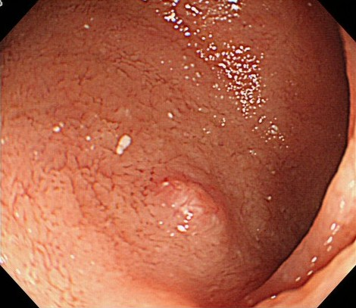
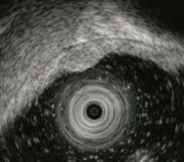
A
B

Figure 1 Endoscopic and endoscopic ultrasonography findings.A: Endoscopic image showing an elevated lesion in the anterior wall of duodenal bulb; B: Endoscopic ultrasonography image of the lesion, a 3 mm hypoechoic mass lesion that was located in the submucosal layer.

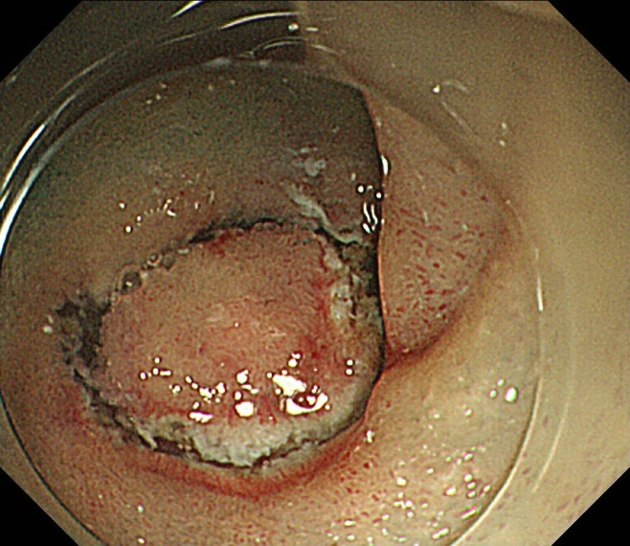
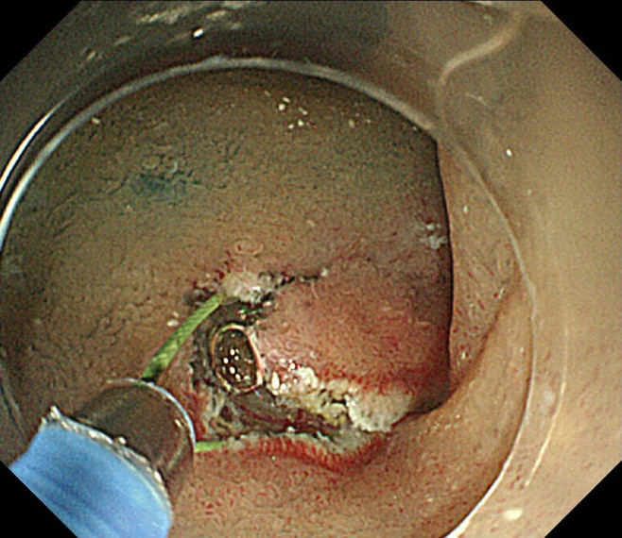
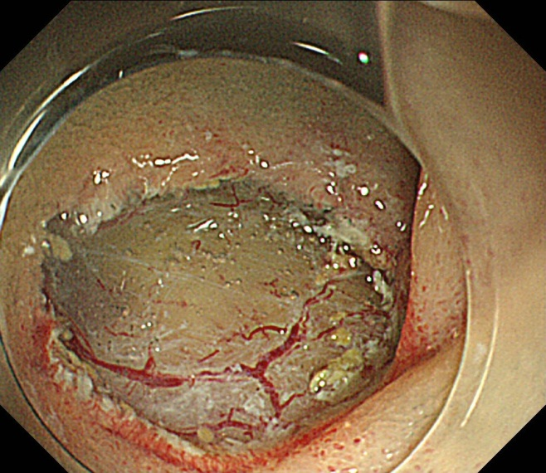
A
B
Ｃ

Figure 2 Endoscopic image showing the endoscopic mucosal resection with circumferential mucosal incision procedures. A-C: The entire lesion was removed en bloc.

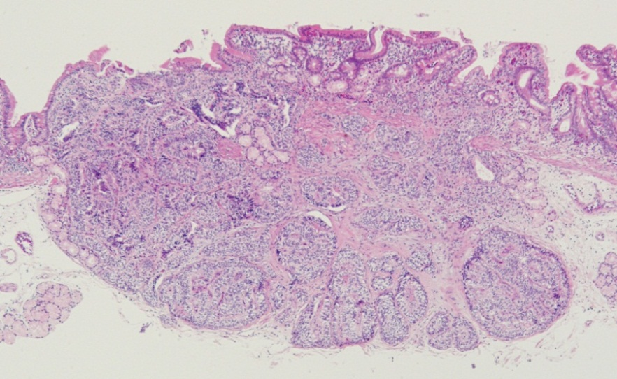
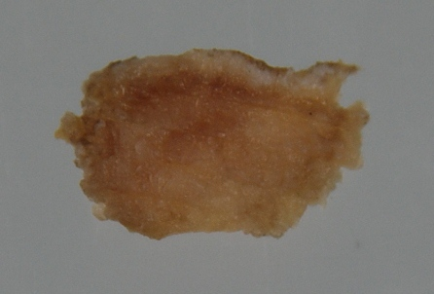
B
A

Figure 3 Histopathologic assessment of the resected specimen. A: Macroscopic view of the resected specimen; B: Well-differentiated neuroendocrine tumor was confined to the submucosa (hematoxylin and eosin, original magnification ×20).

Table 1 Characteristics of five patients with a duodenal carcinoid tumor

F: Female; M: Male; Sm: Submucosa.

No. | Age (yr) | Sex | Site | Size, (mm) | Depth | Time, (min) | En bloc resection | Complication
1 | 74 | F | Bulb, anterior | 3 | Sm | 20 | Yes | No
2 | 67 | M | Bulb, anterior | 4 | Sm | 15 | Yes | No
3 | 47 | M | Bulb, anterior | 5 | Sm | 21 | Yes | No
4 | 74 | M | Bulb, anterior | 3 | Sm | 25 | Yes | No
5 | 59 | M | Bulb, anterior | 8 | Sm | 16 | Yes | No

