Supplementary Table 1: International Classification of Disease 9th Revision –Clinical Modification Codes (ICD-9 CM) and Clinical Classifications Software (CCS) and procedure (PR) codes used for Comorbidities and Complications not provided by NIS database.

(The comorbidity codes provided by database:
https://www.hcup-us.ahrq.gov/toolssoftware/comorbidity/Table2-FY2010-V3_5.pdf)

Comorbidities | ICD9 CM/CCS/PR Codes:
Congestive Heart Failure | 398.91, 402.01, 402.11, 402.91, 404.01, 404.03, 404.11, 404.13, 404.91, 404.93, 428.0-428.9
Valvular disease | 093.20-093.24, 394.0-397.1, 397.9, 424.0-424.99, 746.3-746.6, V42.2, V43.4
Pulmonary Circulation disorders | 415.11-415.19, 416.0-416.9, 417.9
Peripheral vascular disease | 440-440.9, 441.00-441.9, 442.0-442.9, 443.1-443.9, 444.21-444.22, 447.1,449, 557.1, 557.9, V43.5
Hypertension (combine uncomplicated and complicated) | Hypertension, uncomplicated: 401.1, 401.9, 642.00-642.04
 | Hypertension, complicated: 401.0, 402.00-405.99, 437.2, 642.10-642.24, 642.70-642.94
Other neurological disorders | 330.1-331.9, 332.0, 333.5, 333.5, 333.71-333.79, 333.85, 333.94, 334.0- 335.9, 338.0, 340, 341.1-341.9, 345.00- 345.11, 345.2-345.3, 345.40-345.91, 347.00-347.01, 347.10-347.11, 649.40- 649.44, 768.7, 768.70, 768.71, 768.72, 768.73, 780.3, 780.31, 780.32, 780.39, 780.97, 784.3
Chronic pulmonary disease | 490-492.8, 493.00-493.92, 494-494.1, 495.0-505, 506.4,
Diabetes without chronic complications | 249.00-249.31 250.00-250.33, 648.00- 648.04
Diabetes with chronic complications | 249.40-249.91 250.40-250.93, 775.1
Hypothyroidism | 243-244.2, 244.8, 244.9
Renal failure | 403.01, 403.11, 403.91, 404.02, 404.03, 404.12, 404.13, 404.92, 404.93, 585.3, 585.4, 585.5, 585.6, 585.9, 586, V42.0, V45.1, V45.11, V45.12, V56.0-V56.32, V56.8
Liver disease | 070.22, 070.23, 070.33, 070.44, 070.54, 456.0, 456.1, 456.20, 456.21, 571.0, 571.2, 571.3, 571.40-571.49, 571.5, 571.6, 571.8, 571.9, 572.3, 572.8, V42.7
Chronic Peptic ulcer disease (includes bleeding only if obstruction is also present) | 531.41, 531.51, 531.61, 531.70, 531.71, 531.91, 532.41, 532.51, 532.61, 532.70, 532.71, 532.91, 533.51, 533.51, 533.61, 533.70, 533.71, 533.91, 534.41, 534.51, 534.61, 534.70, 534.71, 534.91
Rheumatoid arthritis/collagen vascular diseases | 701.0, 710.0-710.9, 714.0-714.9, 720.0- 720.9, 725
Coagulation deficiency | 286.0-286.9, 287.1, 287.3-287.5, 289.84, 649.30-649.34
Obesity | 278.0, 278.00, 278.01, 649.10-649.14, 793.91, V85.30-V85.4, V85.54
Fluid and electrolyte disorders | 276.0-276.9
Blood loss anemia | 280.0, 648.20-648.24
Deficiency anemias | 280.1-280.9, 285.21-285.29, 285.9
Alcohol abuse | 291.0-291.3, 291.5, 291.8, 291.81, 281.82, 291.89, 291.9, 303.00-303.93, 305.00-305.03
Drug abuse | 292.0, 292.82-292.89, 292.9, 304.00- 304.93, 305.20-305.93, 648.30-648.34
Smoking | ICD 9 305.1 V15.82
Dyslipidemia | CCS 53
Coronary atherosclerosis | CCS 101
Previous myocardial infarction | ICD-9 412
Previous percutaneous coronary intervention (PCI) | ICD-9 V45.82
Previous coronary artery bypass grafting (CABG) | ICD-9 V45.81
Procedures
Thrombolysis | ICD-9 V45.88, 99.10
Percutaneous coronary intervention | ICD-9 00.66 36.01 36.02 30.05 36.06 36.07 17.55
Coronary artery bypass grafting | CCS 44
Complications
Cardiogenic shock | ICD-9 785.51
Cardiac Arrest | ICD-9 427.5
Insertion of percutaneous external heart assist device | ICD-9 PR 37.68
Implant of pulsation balloon | ICD-9 PR 37.61
Phlebitis; thrombophlebitis and thromboembolism | CCS 118
Respiratory failure; insufficiency; arrest (adult) | CCS 131
Hemorrhage or Hematoma complicating a procedure | ICD-9 998.1 998.11 998.12 998.13
Perioperative autologous transfusions of whole blood or blood components | ICD-9 V58.2,99.00
Periprocedural hypotension or shock | ICD-9 458.2, 998.0x
Myocardial infarction | CCS100, ICD-9 410. x
Postoperative stroke | ICD-9 997.02
Respiratory complications | ICD-9 97.3 997.31 997.32 997.39
Gastrointestinal complications including GIH | ICD-9 997.4 , CCS 153
AKI + Dialysis | ICD-9 584.9 , ICD-9 PR 39.95
Postoperative Urinary complications | ICD-9 997.5
Postoperative infection | ICD-9 998.5, 998.51, 998.59, 999.3, 038.0, 995.91, 995.92

Supplemental Table/Figure 2:

Covariates adjusted in propensity-score matching for revascularization with vs. without gout = Age, sex, race, alcohol abuse, hypertension, diabetes, dyslipidemia, diabetes, drug abuse, acute and chronic renal failure, dialysis status, smoking

Ratio = 1:1
Caliper = 0.01
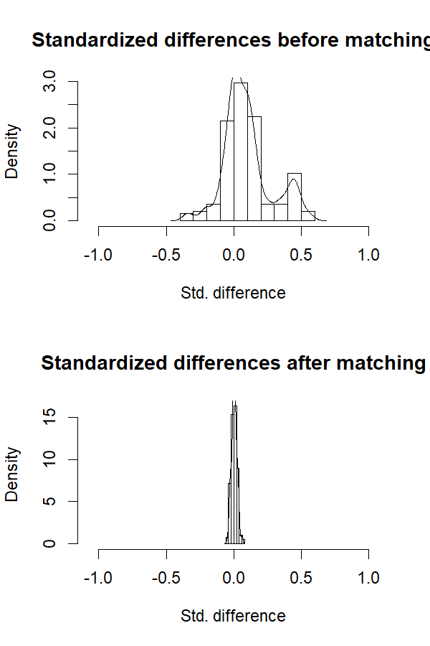
Supplemental Table 3: Outcomes of revascularization with vs. Without gout: propensity-score matched analysis
 | No Gout (n=40,310) |  | Gout (n=40,358) |  | P
 | N | % | N | %
Age (years) at admission Mean±SD | 67.1 ±12 |  | 67.4 ±12 |  | <0.001
Sex |  |  |  |  | <0.001
Male | 33,318 | 82.7% | 32,837 | 81.4%
Female | 6,993 | 17.3% | 7,522 | 18.6%
Race |  |  |  |  | 0.121
White | 30,316 | 75.2% | 30,463 | 75.5%
African American | 5,036 | 12.5% | 4,864 | 12.1%
Hispanic | 1,917 | 4.8% | 1,955 | 4.8%
Asian or Pacific Islander | 1,678 | 4.2% | 1,658 | 4.1%
Native American | 190 | 0.5% | 163 | 0.4%
Others | 1,173 | 2.9% | 1,256 | 3.1%
Comorbidities
Alcohol abuse | 1,714 | 4.3% | 1,739 | 4.3% | 0.69
Congestive heart failure | 215 | 0.5% | 100 | 0.2% | <0.001
Diabetes, uncomplicated | 14,291 | 35.5% | 14,120 | 35.0% | 0.166
Diabetes with chronic complications | 3,826 | 9.5% | 3,764 | 9.3% | 0.422
Drug abuse | 635 | 1.6% | 700 | 1.7% | 0.076
Hypertension | 34,046 | 84.5% | 33,710 | 83.5% | <0.001
Obesity | 6,626 | 16.4% | 10,413 | 25.8% | <0.001
Peripheral vascular disorders | 5,495 | 13.6% | 5,354 | 13.3% | 0.128
Pulmonary circulation disorders | 40 | 0.1% | 25 | 0.1% | 0.062
Renal failure | 13,312 | 33.0% | 13,891 | 34.4% | <0.001
Dyslipidemia | 30,767 | 76.3% | 30,693 | 76.1% | 0.361
Previous History of MI | 4,933 | 12.2% | 5,297 | 13.1% | <0.001
Previous PCI | 7,038 | 17.5% | 7,173 | 17.8% | 0.242
Previous CABG | 2,616 | 6.5% | 2,458 | 6.1% | 0.02
Smoking | 14,535 | 36.1% | 14,962 | 37.1% | 0.003
Chronic kidney disease | 13,521 | 33.5% | 14,151 | 35.1% | <0.001
Dialysis status | 1,390 | 3.4% | 1,348 | 3.3% | 0.396
Outcomes
All-cause in-hospital mortality | 1,428 | 3.5% | 862 | 2.1% | <0.001
Disposition of patient |  |  |  |  | <0.001
Routine | 29,161 | 72.3% | 28,768 | 71.3%
Transfer to short term hospital | 628 | 1.6% | 549 | 1.4%
Transfer to other hospitals (SNF, ICF) | 4,295 | 10.7% | 4,839 | 12.0%
Home health care | 4,630 | 11.5% | 5,260 | 13.0%
Postoperative Hemorrhage | 1,094 | 2.7% | 1,217 | 3.0% | 0.01
Perioperative blood Transfusion | 439 | 1.1% | 481 | 1.2% | 0.169
Postoperative hypotension/shock | 231 | 0.6% | 243 | 0.6% | 0.59
Postoperative cardiac complications | 1,209 | 3.0% | 1,328 | 3.3% | 0.018
Postoperative MI | 606 | 1.5% | 689 | 1.7% | 0.021
Postoperative Stroke | 171 | 0.4% | 129 | 0.3% | 0.015
Postoperative respiratory complications | 1,392 | 3.5% | 1,476 | 3.7% | 0.118
Postoperative GI complications | 812 | 2.0% | 842 | 2.1% | 0.471
Postoperative AKI requiring dialysis | 434 | 1.1% | 538 | 1.3% | 0.001
Postop urinary complications | 150 | 0.4% | 278 | 0.7% | <0.001
Postop infections | 843 | 2.1% | 585 | 1.5% | <0.001
Length of stay Mean | 5.6 days |  | 5.9 days |  | <0.001
Total charges Mean | $109,904 |  | $111,215 |  | 0.066
P<0.05 indicates statistical significance. MI=myocardial infarction, PCI=percutaneous coronary intervention, CABG=coronary artery bypass grafting, GI-gastrointestinal, AKI=acute kidney injury, SNF=skilled nursing facility, ICF=intermediate care facility.

