Name of Journal: World Journal of Clinical Cases
Manuscript NO: 58955
Manuscript Type: CASE REPORT

Atypical adult-onset Still’s disease with an initial and sole manifestation of liver injury: A case report and review of literature

Yu F et al. Liver injury secondary to AOSD

Fan Yu, Shao-You Qin, Chang-Yu Zhou, Lu Zhao, Yan Xu, Er-Na Jia, Jiang-Bin Wang

Fan Yu, Shao-You Qin, Chang-Yu Zhou, Yan Xu, Er-Na Jia, Jiang-Bin Wang, Department of Gastroenterology and Hepatology, China-Japan Union Hospital of Jilin University, Changchun 130033, Jilin Province, China

Lu Zhao, Department of Digestive, Heze Municipal Hospital, Heze 274000, Shandong Province, China

Author contributions: Yu F, Zhou CY, Zhao L and Wang JB were members of the patient’s medical team, reviewed the literature and contributed to manuscript drafting; Xu Y and Jia EN reviewed the literature and contributed to manuscript drafting; Qin SY performed data interpretation and contributed to manuscript drafting; Qin SY and Wang JB were responsible for the revision of the manuscript for important intellectual content; all authors issued final approval for the version to be submitted; Yu F and Qin SY contributed equally to the manuscript.

Corresponding author: Jiang-Bin Wang, PhD, Chief Physician, Department of Gastroenterology and Hepatology, China-Japan Union Hospital of Jilin University, No. 126 Xiantai Street, Changchun 130033, Jilin Province, China. jiangbin@jlu.edu.cn

Received: August 17, 2020
Revised: October 21, 2020
Accepted: November 4, 2020
Published online: January 6, 2021

Abstract
BACKGROUND
Adult-onset Still's disease (AOSD) typically presents with a high spiking fever, polyarthritis, transient maculopapular rash, neutrophilic leukocytosis, and hepatosplenomegaly. It has a wide spectrum of clinical symptoms ranging from mild to severe, with extensive involvement of almost every organ. Although liver involvement in the form of increased hepatic enzymes and bilirubin is common, no AOSD case with liver involvement as the initial manifestation of AOSD has been reported.

CASE SUMMARY
A 35-year-old woman presented to the hepatology department with progressively worsening jaundice for one week. Liver chemistry tests revealed a significantly increased liver enzymes and bilirubin level. Given that the clinical examination was unremarkable, liver biopsy was considered because the patient had a history of AOSD 6 years ago. Liver histopathology revealed that most hepatic lobules were still recognizable. Fusional necrosis was observed around most central veins. A few bridging necrotic zones were also found. Infiltration of multiple plasma cells were observed in the necrotic zone, and the reticular scaffold was still expanded. Additionally, no obvious fibrosis was observed in the portal area. Mild mixed inflammatory cell infiltration was noted in the interstitium of the portal area. Further examination was unremarkable except for a remarkably high level of ferritin. Collectively, a presumptive diagnosis of liver injury secondary to AOSD was made. The hepatic involvement responded well to glucocorticoid treatment.

CONCLUSION
This case highlights that hepatic involvement as an initial and sole manifestation could be a pattern of relapsed AOSD. The diagnosis of AOSD should be considered in the case of nonresolving liver injury after the exclusion of common etiologies for liver diseases. A liver biopsy can be useful for the differential diagnosis of liver injury associated with AOSD.

Key Words: Adult-onset Still's disease; Liver injury; Liver biopsy; Histopathology; Glucocorticoid treatment; Case report

Yu F, Qin SY, Zhou CY, Zhao L, Xu Y, Jia EN, Wang JB. Atypical adult-onset Still’s disease with an initial and sole manifestation of liver injury: A case report and review of literature. World J Clin Cases 2021; 9(1): 224-231 URL: https://www.wjgnet.com/2307-8960/full/v9/i1/224.htm DOI: https://dx.doi.org/10.12998/wjcc.v9.i1.224

Core Tip: Liver involvement in the form of increased hepatic enzymes and bilirubin is common in adult-onset Still's disease (AOSD). Herein, we presented a patient with relapsed AOSD with hepatic involvement as an initial and sole manifestation responding well to glucocorticoid treatment. This case highlights that hepatic involvement as an initial and sole manifestation could be a pattern of relapsed AOSD. The diagnosis of AOSD should be considered in the case of nonresolving liver injury after the exclusion of common etiologies for liver diseases. A liver biopsy can be useful for the differential diagnosis of liver injury associated with AOSD.

INTRODUCTION
Adult-onset Still’s disease (AOSD) is a rare condition characterized by a high spiking fever, polyarthritis, transient maculopapular rash, and neutrophilic leukocytosis^{[1,2]}. It has a wide spectrum of clinical symptoms ranging from mild to severe, with extensive involvement of almost every organ. Moreover, life-threatening complications, such as myocarditis and disseminated intravascular coagulopathy (DIC), appear in approximately 15%-20% of patients with AOSD^{[3]}. The early diagnosis and intervention of AOSD are vital to achieving sustained clinical remission and reducing the mortality rate^{[4,5]}. However, early identification of AOSD in some cases remains a challenge because of highly varied symptoms, the involvement of multiple organs, and the lack of diagnostic tests and serologic markers^{[5-8]}. Although hepatic involvement is commonly observed in AOSD with a prevalence of 50%-75%^{[9]}, liver injury is not a prerequisite to diagnose AOSD according to the Yamaguchi’s criteria^{[8]}, partly because many diseases can cause liver injury. Thus, it remains a challenge to decide whether the involvement of the liver as the initial organ is caused by AOSD or other etiologies. To date, no AOSD case with liver involvement as the initial manifestation of AOSD has been reported. We here present a patient with relapsed AOSD with hepatic involvement as an initial and sole manifestation.

CASE PRESENTATION
Chief complaints
A 35-year-old woman presented to the hepatology department with progressively worsening jaundice.

History of present illness
Patient’s symptoms started a week ago with progressively worsening jaundice. The patient denied fever, anorexia, fatigue, and abdominal distention.

History of past illness
The patient had a history of AOSD 6 years previously and responded well to standardized glucocorticoid therapy in the first episode, but experienced a relapse 5 mo before the self-discontinuation of methylprednisolone. She had no risk factors for viral hepatitis or toxin. She does not smoke and drink. Her family history was not notable for autoimmune diseases or hepatic virus diseases. She had no risk factors for viral hepatitis.

Personal and family history
No abnormalities.

Physical examination
The patient’s temperature was 36.7 °C, heart rate was 84 bpm, respiratory rate was 18 breaths per min, blood pressure was 116/75 mmHg and oxygen saturation in room air was 100%. The clinical examination revealed that the skin and sclera were jaundiced.

Laboratory examinations
Liver chemistry tests revealed a significantly increased alanine transaminase (ALT) level (1009.71 IU/L; normal: 5-40 IU/L), aspartate transaminase level (455.41 IU/L; normal: 5-40 IU/L), gamma-glutamyl transferase level (721.85 IU/L; normal: 8-57 IU/L) and bilirubin level (137.59 µmol/L; normal: 0-21 µmol/L). Peripheral blood revealed a mildly elevated white blood cell (WBC) count (11.6 × 10⁹/L; normal: 4-10 × 10⁹/L) with 76.5% neutrophils (normal: 50.0%-70.0%) and a C-reactive protein (CRP) level of 31.22 mg/dL (normal: 0-8 mg/L). Results of other liver markers are demonstrated in Table 1. Full-blood screening analyses to determine the etiology of liver involvement were all negative or within normal limits.

Imaging examinations
Ultrasound showed a smoothly contoured liver and healthy thin-walled gallbladder. Thorax and abdominal computed tomography (CT) scans demonstrated generalized lymph nodes with the largest one measuring 1.1 cm × 1.2 cm; no solid masses were identified. Echocardiography and serum protein electrophoresis were normal.

Histopathology examination
Liver histopathology revealed that most hepatic lobules were still recognizable. Fusional necrosis was observed around most central veins. A few bridging necrotic zones were also present. Infiltration of multiple plasma cells was observed in the necrotic zone, and the reticular scaffold was still expanded, without obvious collagen deposition (Figure 1A). Additionally, no obvious fibrosis was observed in the portal area. Mild mixed inflammatory cell infiltration was noted in the interstitium of the portal area. Interfacial inflammation was not significant (Figure 1B).

MULTIDISCIPLINARY EXPERT CONSULTATION
Given that the clinical examination was unremarkable, liver biopsy was considered by the hepatology team at this point. However, it was decided to await rheumatology review because the patient had a history of AOSD 6 years ago, with symptoms including unexplained fever, arthritis, rash, and neutrophilic leukocytosis. Additionally, laboratory tests showed a remarkably high level of CRP and ferritin, and elevated liver enzymes. The patient responded well to standardized glucocorticoid therapy in the first episode but experienced a relapse 5 mo before the self-discontinuation of methylprednisolone. At the rheumatology review, the patient did not describe any systemic symptoms but felt constitutionally unwell with significant fatigue. There was no history of Raynaud’s phenomenon or any features suggestive of other autoimmune connective tissue diseases or vasculitis. Systemic examination was unremarkable except for a remarkably high level of ferritin (> 1650.0 ng/mL). After a discussion with the rheumatology team concerning diagnosis options, liver histological examination was still needed to determine whether the liver injury was caused by AOSD or liver disease per se (Figure 2).

FINAL DIAGNOSIS
There were two reasons why we considered liver injury as a result of relapsed AOSD rather than liver diseases. First, liver involvement is a well-characterized feature of AOSD, with highly varied manifestations ranging from minimally elevated hepatic enzymes to hyperbilirubinemia and even fulminant hepatic failure. However, the liver injury typically appears as one of the disease activity signs rather than as the only manifestation in patients with AOSD^{[2,10]}, further highlighting the importance of histological examination. Second, both fevers with unknown causes and elevated ferritin levels are features of active AOSD. Fever with unknown causes in Europe accounted for 3% - 20% of AOSD ^{[11,12]}. A retrospective study in China involving 517 individuals revealed that fever occurred in 472 (91.3%) patients with AOSD who satisfied the Yamaguchi criteria^{[13]}. Additionally, hyperferritinemia still served as a marker of disease activity in AOSD^{[14]}, although its specificity remains to be confirmed^{[15]}. Collectively, given the patient’s presenting features, especially the liver histological findings, in combination with the history of AOSD, a presumptive diagnosis of liver injury secondary to AOSD was made.

TREATMENT
After early treatment with intravenous methylprednisolone (80mg/d ) for three days, the patient was switched to oral steroids (starting at prednisolone 40 mg daily), followed by a tapered dose. Additionally, she was referred for intensive physiotherapy, which is an essential part of overall management.

OUTCOME AND FOLLOW-UP
In response to treatment, the liver enzymes were normalized within four weeks and remained normal with symptom improvement (Figure 3). The patient also reported considerable improvements in anorexia and fatigue. Six months after discharge, the patient’s subsequent clinical course was stable, while the dose of oral methylprednisolone continued at 4 mg/d.

DISCUSSION
Although hepatic involvement is a well-characterized feature in patients with ASOD^{[16-19]}, it is uncommon for the prevalence of liver injury as the initial manifestation of AOSD. For the first time, we present an AOSD case with elevated hepatic enzymes and bilirubin as an initial and sole manifestation that was successfully treated with methylprednisolone.
It remains a challenge to make a differential diagnosis for hepatic enzyme elevations because many causes could induce liver injury. Seven AOSD cases with increased liver enzymes have been previously reported. The etiologies of liver injury in these cases included NSAID-induced liver injury (n = 2)^{[20,21]}, hepatic injury associated with AOSD itself (n = 2)^{[2,22]}, and AOSD with concurrent autoimmune hepatitis (n = 3)^{[23-25]}.
The largest challenge to identify the etiologies of liver injury in patients with AOSD is the lack of specific biomarkers and pathological findings. Highly variable hepatic pathological features in AOSD has been previously reported, ranging from mild portal inflammatory cell infiltration and Kupffer cell hyperplasia ^{[20,21,26-28]} to portal fibrosis and massive or submassive hepatic necrosis^{[29-33]} . Taken together, no histological finding has been identified to be specific for liver injury secondary to AOSD. Although the value of liver biopsy in diagnosing AOSD remains debatable^{[34]}, the liver histological findings may provide valuable information to rule out liver disorders induced by viruses, autoimmune factors, and drugs, facilitating the early detection of AOSD and subsequent prompt intervention with methylprednisolone ^{[29]}.
Several potential mechanisms responsible for liver injury in AOSD have been proposed^{[33]}. Notably, the serum interleukin-18 (IL-18) concentration is markedly increased in patients with AOSD and active hepatitis and correlates with serum aminotransferase levels^{[35,36]}. Moreover, previous studies have found a marked increase in IL-18 expression by activated macrophages and Kupffer cells within the liver parenchyma of a patient with AOSD^{[37]}. However, it remains unknown whether serum IL-18 serves as an early predictor of liver injury in patients with AOSD^{[29]}.
Collectively, liver involvement in the form of elevated bilirubin and liver enzymes can be an initial and sole presentation of relapsed AOSD which responds well to glucocorticoid treatment. Therefore, the diagnosis of AOSD should be considered in the case of nonresolving liver injury after the exclusion of common etiologies for liver diseases.

CONCLUSION
Although liver involvement in the form of increased hepatic enzymes and bilirubin is common in AOSD patients, no AOSD case with liver involvement as the initial manifestation of AOSD has been reported. Liver involvement in the form of elevated bilirubin and liver enzymes can be an initial and sole presentation of relapsed AOSD which responds well to glucocorticoid treatment. Therefore, our study suggests that the diagnosis of AOSD should be considered in the case of nonresolving liver injury after the exclusion of common etiologies for liver diseases.

REFERENCES
1 Giacomelli R, Ruscitti P, Shoenfeld Y. A comprehensive review on adult onset Still's disease. J Autoimmun 2018; 93: 24-36 [PMID: 30077425 DOI: 10.1016/j.jaut.2018.07.018]
2 Sahutoglu T, Kara E, Dogan IO, Gulluoglu M, Akyuz F, Besisik F. Acute Severe Hepatitis and Hemophagocytosis in Adult Onset Still's Disease. Arch Iran Med 2015; 18: 724-728 [PMID: 26443256]
3 Kawaguchi H, Tsuboi H, Yagishita M, Terasaki T, Terasaki M, Shimizu M, Honda F, Ohyama A, Takahashi H, Miki H, Yokosawa M, Asashima H, Hagiwara S, Kondo Y, Matsumoto I, Sumida T. Severe Adult-onset Still Disease with Constrictive Pericarditis and Pleuritis That Was Successfully Treated with Tocilizumab in Addition to Corticosteroids and Cyclosporin A. Intern Med 2018; 57: 1033-1038 [PMID: 29269680 DOI: 10.2169/internalmedicine.9809-17]
4 Cagatay Y, Gul A, Cagatay A, Kamali S, Karadeniz A, Inanc M, Ocal L, Aral O, Konice M. Adult-onset Still's disease. Int J Clin Pract 2009; 63: 1050-1055 [PMID: 17511792 DOI: 10.1111/j.1742-1241.2007.01393.x]
5 Gerfaud-Valentin M, Jamilloux Y, Iwaz J, Sève P. Adult-onset Still's disease. Autoimmun Rev 2014; 13: 708-722 [PMID: 24657513 DOI: 10.1016/j.autrev.2014.01.058]
6 Fautrel B, Zing E, Golmard JL, Le Moel G, Bissery A, Rioux C, Rozenberg S, Piette JC, Bourgeois P. Proposal for a new set of classification criteria for adult-onset still disease. Medicine (Baltimore) 2002; 81: 194-200 [PMID: 11997716 DOI: 10.1097/00005792-200205000-00003]
7 Jiang L, Wang Z, Dai X, Jin X. Evaluation of clinical measures and different criteria for diagnosis of adult-onset Still's disease in a Chinese population. J Rheumatol 2011; 38: 741-746 [PMID: 21285163 DOI: 10.3899/jrheum.100766]
8 Yamaguchi M, Ohta A, Tsunematsu T, Kasukawa R, Mizushima Y, Kashiwagi H, Kashiwazaki S, Tanimoto K, Matsumoto Y, Ota T. Preliminary criteria for classification of adult Still's disease. J Rheumatol 1992; 19: 424-430 [PMID: 1578458]
9 Linde B, Oelzner P, Katenkamp K, Hein G, Wolf G. [Fulminate liver failure in a 39-year-old female patient with leukocytosis, unclear fever, and arthralgic pain]. Med Klin (Munich) 2007; 102: 846-851 [PMID: 17928968 DOI: 10.1007/s00063-007-1103-7]
10 Evensen KJ, Swaak TJ, Nossent JC. Increased ferritin response in adult Still's disease: specificity and relationship to outcome. Scand J Rheumatol 2007; 36: 107-110 [PMID: 17476616 DOI: 10.1080/03009740600958504]
11 Crispín JC, Martínez-Baños D, Alcocer-Varela J. Adult-onset Still disease as the cause of fever of unknown origin. Medicine (Baltimore) 2005; 84: 331-337 [PMID: 16267408 DOI: 10.1097/01.md.0000188009.47085.76]
12 Zenone T. Fever of unknown origin in adults: evaluation of 144 cases in a non-university hospital. Scand J Infect Dis 2006; 38: 632-638 [PMID: 16857607 DOI: 10.1080/00365540600606564]
13 Hu QY, Zeng T, Sun CY, Luo CN, Liu S, Ding TT, Ji ZF, Lu A, Yimaiti K, Teng JL, Cheng XB, Ye JN, Su YT, Shi H, Sun Y, Chi HH, Zhou ZC, Chen LJ, Xu J, Jiang LD, Wu LJ, Lin J, Yang CD, Liu HL. Clinical features and current treatments of adult-onset Still's disease: a multicentre survey of 517 patients in China. Clin Exp Rheumatol 2019; 37 Suppl 121: 52-57 [PMID: 31573475]
14 Mehta B, Efthimiou P. Ferritin in adult-onset still's disease: just a useful innocent bystander? Int J Inflam 2012; 2012: 298405 [PMID: 22536541 DOI: 10.1155/2012/298405]
15 Efthimiou P, Kadavath S, Mehta B. Life-threatening complications of adult-onset Still's disease. Clin Rheumatol 2014; 33: 305-314 [PMID: 24435354 DOI: 10.1007/s10067-014-2487-4]
16 Mehrpoor G, Owlia MB, Soleimani H, Ayatollahi J. Adult-onset Still's disease: a report of 28 cases and review of the literature. Mod Rheumatol 2008; 18: 480-485 [PMID: 18754076 DOI: 10.1007/s10165-008-0104-6]
17 Andrès E, Kurtz JE, Perrin AE, Pflumio F, Ruellan A, Goichot B, Dufour P, Blicklé JF, Brogard JM, Schlienger JL. Retrospective monocentric study of 17 patients with adult Still's disease, with special focus on liver abnormalities. Hepatogastroenterology 2003; 50: 192-195 [PMID: 12630021]
18 Zhu G, Liu G, Liu Y, Xie Q, Shi G. Liver abnormalities in adult onset Still's disease: a retrospective study of 77 Chinese patients. J Clin Rheumatol 2009; 15: 284-288 [PMID: 19734733 DOI: 10.1097/RHU.0b013e3181b57199]
19 Efthimiou P, Paik PK, Bielory L. Diagnosis and management of adult onset Still's disease. Ann Rheum Dis 2006; 65: 564-572 [PMID: 16219707 DOI: 10.1136/ard.2005.042143]
20 Ott SJ, Baron A, Berghaus T, Lamerz R, Beuers U. Liver failure in adult Still's disease during corticosteroid treatment. Eur J Gastroenterol Hepatol 2003; 15: 87-90 [PMID: 12544700 DOI: 10.1097/00042737-200301000-00015]
21 Omagari K, Matsunaga Y, Yamashita H, Nishiyama H, Hazama H, Oda H, Isomoto H, Mizuta Y, Murase K, Kohno S. Successful treatment with cyclosporin in adult-onset Still disease manifesting as acute hepatitis with marked hyperferritinemia. Am J Med Sci 2003; 326: 148-151 [PMID: 14501232 DOI: 10.1097/00000441-200309000-00009]
22 Bishara R, Braun-Moscovici Y, Dagan A, Toledano K, Saadi T, Sabo E, Balbir-Gurman A. Severe hyperferritinemia--a clue for severe hepatitis in a patient with adult-onset Still's disease. Clin Rheumatol 2016; 35: 795-800 [PMID: 25413736 DOI: 10.1007/s10067-014-2829-2]
23 Fujii K, Rokutanda R, Osugi Y, Koyama Y, Ota T. Adult-onset Still's disease complicated by autoimmune hepatitis: successful treatment with infliximab. Intern Med 2012; 51: 1125-1128 [PMID: 22576401 DOI: 10.2169/internalmedicine.51.6824]
24 Liu LL, Feng ML, Wang LN, Li XL, Yao L. A case report of successful treatment with plasma exchange for adult-onset Still's disease with autoimmune hepatitis. J Clin Apher 2010; 25: 74-76 [PMID: 20101675 DOI: 10.1002/jca.20227]
25 Efe C, Purnak T, Ozaslan E. The diagnosis of autoimmune hepatitis in patients with adult-onset Still's disease. J Clin Apher 2010; 25: 235; author reply 236 [PMID: 20818719 DOI: 10.1002/jca.20237]
26 Kim HA, Kwon JE, Yim H, Suh CH, Jung JY, Han JH. The pathologic findings of skin, lymph node, liver, and bone marrow in patients with adult-onset still disease: a comprehensive analysis of 40 cases. Medicine (Baltimore) 2015; 94: e787 [PMID: 25929927 DOI: 10.1097/MD.0000000000000787]
27 Hot A, Toh ML, Coppéré B, Perard L, Madoux MH, Mausservey C, Desmurs-Clavel H, Ffrench M, Ninet J. Reactive hemophagocytic syndrome in adult-onset Still disease: clinical features and long-term outcome: a case-control study of 8 patients. Medicine (Baltimore) 2010; 89: 37-46 [PMID: 20075703 DOI: 10.1097/MD.0b013e3181caf100]
28 Gallo M, Calvanese A, Oscuro F, Gallo A, Caso P, Annibale E, Farinato N. [Acute hepatitis in a patient with adult onset Still disease]. Clin Ter 1997; 148: 183-187 [PMID: 9377853]
29 Lim KB, Schiano TD. Still disease and the liver-an underappreciated association. Gastroenterol Hepatol (N Y) 2011; 7: 844-846 [PMID: 22347828]
30 Thabah MM, Singh KK, Madhavan SM, Gupta R. Adult onset Still's disease as a cause of acute liver failure. Trop Gastroenterol 2008; 29: 35-36 [PMID: 18564666]
31 Muta T, Yamano Y. Fulminant hemophagocytic syndrome with a high interferon gamma level diagnosed as macrophage activation syndrome. Int J Hematol 2004; 79: 484-487 [PMID: 15239401 DOI: 10.1532/ijh97.04008]
32 Valluru N, Tammana VS, Windham M, Mekonen E, Begum R, Sanderson A. Rare Manifestation of a Rare Disease, Acute Liver Failure in Adult Onset Still's Disease: Dramatic Response to Methylprednisolone Pulse Therapy-A Case Report and Review. Case Rep Med 2014; 2014: 375035 [PMID: 24991218 DOI: 10.1155/2014/375035]
33 Hogan T, Kao KT, Tung J. A rare case of severe acute hepatitis associated with adult-onset still disease dramatically improved by high-dose steroid therapy. Gastroenterol Hepatol (N Y) 2011; 7: 841-844 [PMID: 22347827]
34 Andrès E, Locatelli F, Pflumio F, Marcellin L. Liver biopsy is not useful in the diagnosis of adult Still's disease. QJM 2001; 94: 568-569 [PMID: 11588218 DOI: 10.1093/qjmed/94.10.568]
35 Ogata A, Kitano M, Yamanaka J, Yamasaki T, Hashimoto N, Iwasaki T, Hamano T, Fujimoto J, Kakishita E. Interleukin 18 and hepatocyte growth factor in fulminant hepatic failure of adult onset Still's disease. J Rheumatol 2003; 30: 1093-1096 [PMID: 12734913]
36 Yumoto E, Higashi T, Nouso K, Nakatsukasa H, Fujiwara K, Hanafusa T, Yumoto Y, Tanimoto T, Kurimoto M, Tanaka N, Tsuji T. Serum gamma-interferon-inducing factor (IL-18) and IL-10 levels in patients with acute hepatitis and fulminant hepatic failure. J Gastroenterol Hepatol 2002; 17: 285-294 [PMID: 11982699 DOI: 10.1046/j.1440-1746.2002.02690.x]
37 Priori R, Barone F, Alessandri C, Colafrancesco S, McInnes IB, Pitzalis C, Valesini G, Bombardieri M. Markedly increased IL-18 liver expression in adult-onset Still's disease-related hepatitis. Rheumatology (Oxford) 2011; 50: 776-780 [PMID: 21149398 DOI: 10.1093/rheumatology/keq397]

Footnotes
Informed consent statement: Informed written consent was obtained from the patient for publication of this report and any accompanying images.

Conflict-of-interest statement: The authors declare that they have no conflict of interest.

CARE Checklist (2016) statement: The authors have read the CARE Checklist (2016), and the manuscript was prepared and revised according to the CARE Checklist (2016).

Open-Access: This article is an open-access article that was selected by an in-house editor and fully peer-reviewed by external reviewers. It is distributed in accordance with the Creative Commons Attribution NonCommercial (CC BY-NC 4.0) license, which permits others to distribute, remix, adapt, build upon this work non-commercially, and license their derivative works on different terms, provided the original work is properly cited and the use is non-commercial. See: http://creativecommons.org/Licenses/by-nc/4.0/

Manuscript source: Unsolicited manuscript

Peer-review started: August 17, 2020
First decision: October 18, 2020
Article in press: November 4, 2020

Specialty type: Medicine, research and experimental
Country/Territory of origin: China
Peer-review report’s scientific quality classification
Grade A (Excellent): 0
Grade B (Very good): B, B
Grade C (Good): C
Grade D (Fair): 0
Grade E (Poor): 0

P-Reviewer: Huan C, Yong D S-Editor: Gao CC L-Editor: MedE-Ma JY P-Editor: Xing YX
Figure Legends
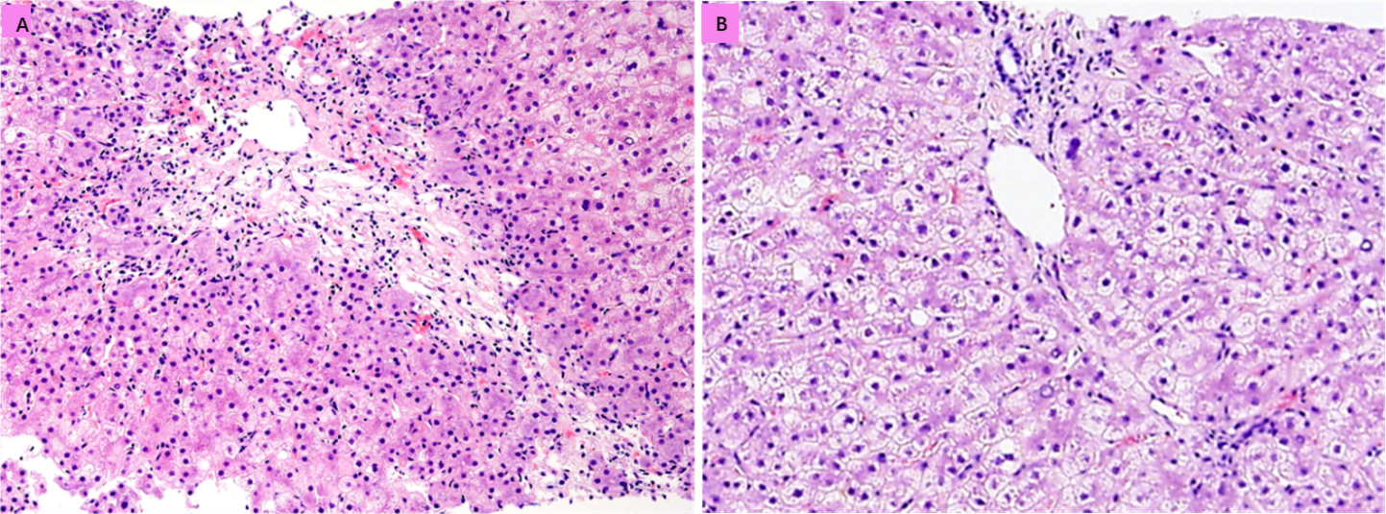
Figure 1 Liver histopathology. A: Infiltration of multiple plasma cells was observed in the necrotic zone, and the reticular scaffold was still expanded, without obvious collagen deposition; B: Mild mixed inflammatory cell infiltration was noted in the interstitium of the portal area. Interfacial inflammation was not significant.
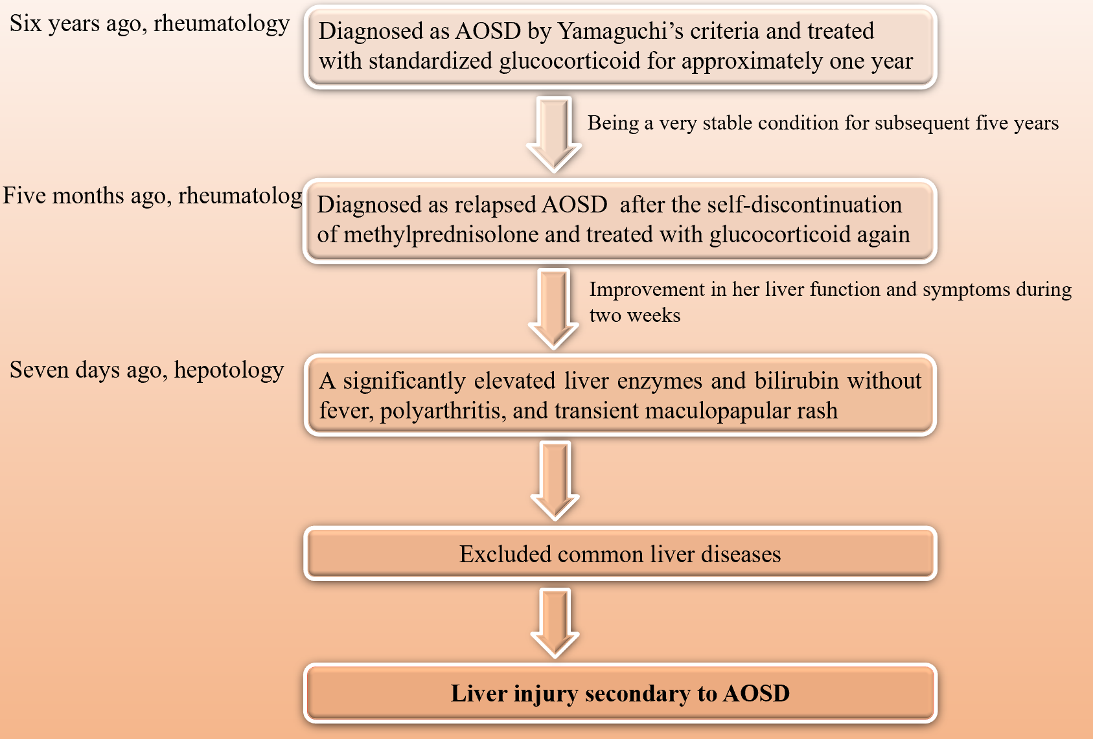
Figure 2 Diagnosis flowchart. AOSD: Adult-onset Still's disease.
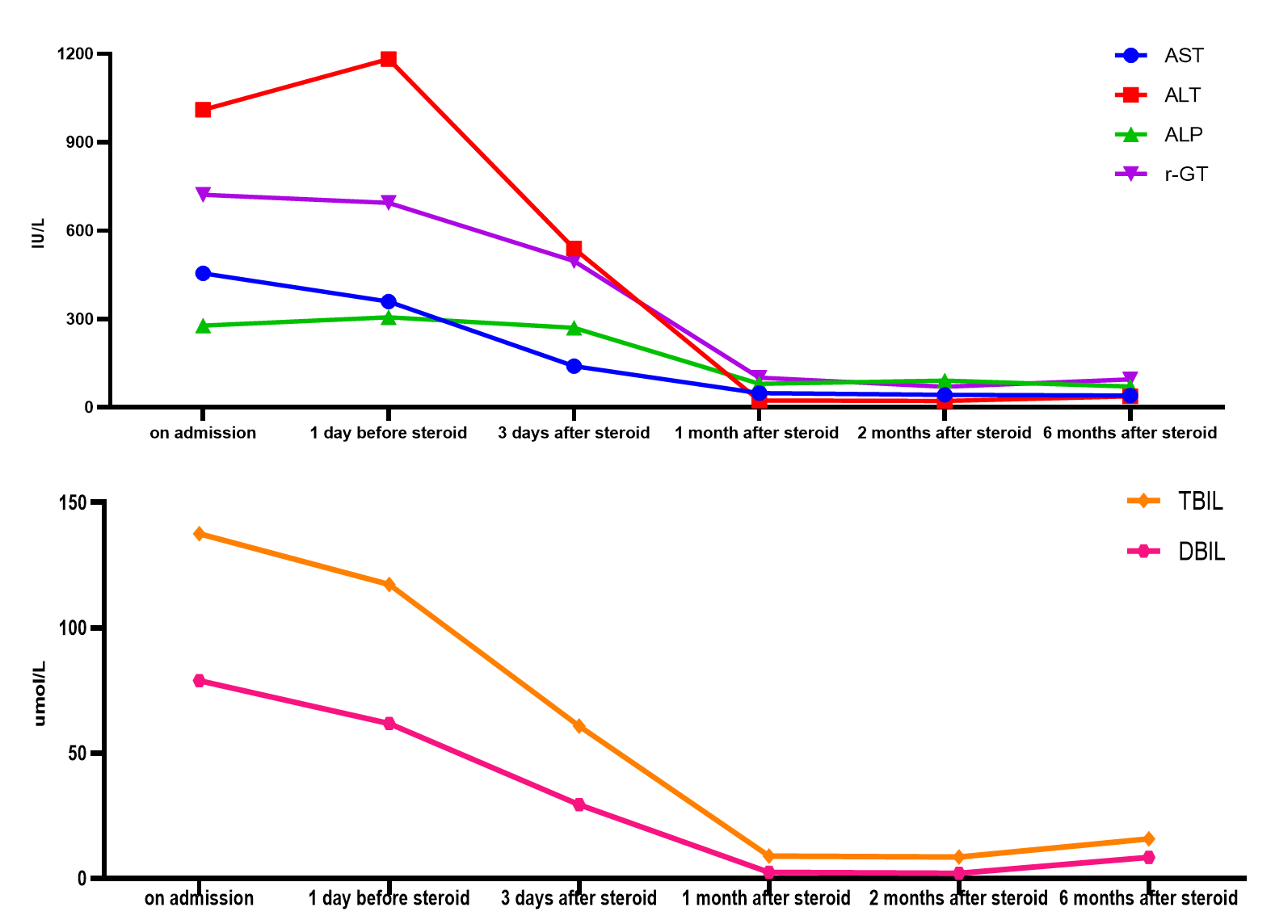
Figure 3 Changes in liver function throughout the disease course. AST: Aspartate aminotransferase; ALT: Alanine aminotransferase; ALP: Alkaline phosphatase; r-GT: r-Glutamyltransferase; TBIL: Total bilirubin; DBIL: Direct bilirubin.
Table 1 Results of serologic tests
Serologic tests | Negative/positive
Anti-HAV | Negative
Anti-HAV | Negative
HBsAg | Negative
Anti-HBs | Positive
Anti-HBc IgM | Negative
Anti-HCV | Negative
Anti-HEV | Negative
Anti-EBV-VCA IgM | Negative
Anti-CMV IgM | Negative
Anti-HIV | Negative
HCV-RNA | Negative
Anti-nuclear antibody | Negative
Anti-HIV | Negative
Anti-nuclear antibody | Negative
Anti-smooth muscle antibody | Negative
Anti-soluble liver antibody | Negative
Antineutrophil cytoplasmic antibody | Negative
Antimitochondrial antibody | Negative
Anti-liver-kidney microsomal type-1 antibody | Negative
HAV: Hepatitis A virus; HBsAg: Hepatitis B surface antigen; Anti-HBc: Hepatitis B core antibody; IgM: Immunoglobulin M; HCV: Hepatitis C virus; HEV: Hepatitis E virus; EBV: Epstein Barr virus; VCA: Viral capsid antigen; CMV: Cytomegalovirus; HIV: Human immunodeficiency virus.

