Name of journal: World Journal of Hepatology
ESPS Manuscript NO: 13471
Columns: Minireviews

Relevance of ADAMTS13 to liver transplantation and surgery

Ko S et al. ADAMTS13 in liver transplantation and surgery

Saiho Ko, Hisanao Chisuwa, Masanori Matsumoto, Yoshihiro Fujimura, Eiji Okano, Yoshiyuki Nakajima

Saiho Ko, Department of Surgery, Nara Prefecture General Medical Center, Nara 631-0846, Japan

Saiho Ko, Eiji Okano, Yoshiyuki Nakajima, Departement of Surgery, Nara Medical University, Kashihara, Nara 634-8522, Japan

Hisanao Chisuwa, Department of Surgery, Kofu City Hospital, Kofu, Yamanashi 400-0832, Japan

Masanori Matsumoto, Yoshihiro Fujimura, Departement of Blood Transfusion Medicine, Nara Medical University, Kashihara, Nara 634-8522, Japan

Author contributions: Nakajima Y conducted entire study; Fujimura Y constructed study design of the analysis of ADAMTS13 and von Willebrand factor related molecules; Matsumoto M instructed the analysis of ADAMTS13 and von Willebrand factor related molecules and refined and improved the entire study; Chisuwa H performed analysis and management of pediatric liver transplant patients; Ko S and Okano E conceived the idea of the study and performed analysis of data, adult liver transplantion, syrgery, and management of the patients.

Conflict-of-interest: The authors declare no conflict of interest associated with this study.

Open-Access: This article is an open-access article which was selected by an in-house editor and fully peer-reviewed by external reviewers. It is distributed in accordance with the Creative Commons Attribution Non Commercial (CC BY-NC 4.0) license, which permits others to distribute, remix, adapt, build upon this work non-commercially, and license their derivative works on different terms, provided the original work is properly cited and the use is non-commercial. See: http://creativecommons.org/licenses/by-nc/4.0/

Correspondence to: Saiho Ko, Director, Departement of Surgery, Nara Prefecture General Medical Center, 1-30-1 Hiramatsu, Nara-city, Nara 631-0846, Japan. saihoko@naramed-u.ac.jp

Telephone: +81-742-466001
Fax: +81-742-466011

Received: August 24, 2014
Peer-review started: August 24, 2014
First decision: September 16, 2014
Revised: March 23, 2015
Accepted: April 10, 2015
Article in press:
Published online:

Abstract
ADAMTS13 specifically cleaves unusually-large von Willebrand factor (VWF) multimers under high shear stress, and down-regulates VWF function to form platelet thrombi. Deficiency of plasma ADAMTS13 activity induces a life-threatening systemic disease, termed Thrombotic microangiopathy (TMA) including thrombotic thrombocytopenic purpura (TTP). Children with advanced biliary cirrhosis due to congenital biliary atresia sometimes showed pathological features of TMA, with a concomitant decrease of plasma ADAMTS13 activity. Disappearance of their clinical findings of TTP after successful liver transplantation suggested that the liver is a major organ producing plasma ADAMTS13. In situ hybridization analysis showed that ADAMTS13 was produced by hepatic stellate cells. Subsequently, it was found that ADADTS13 was not merely responsible to development of TMA and TTP, but also related to some kinds of liver dysfunction after liver transplantation. Ischemia-reperfusion injury and acute rejection in liver transplant recipients were often associated with marked decrease of ADAMTS13 and concomitant formation of unusually large VWF multimers without findings of TMA/TTP. The similar phenomenon was observed also in patients who underwent hepatectomy for liver tumors. Imbalance between ADAMTS13 and VWF in the hepatic sinusoid might cause liver damage due to microcirculatory disturbance. It can be called as “local TTP like mechanism” which plays a crucial role in liver dysfunction after liver transplantation and surgery.

Key words: ADAMTS13; Von Willebrand factor; Thrombocytopenia; Microcirculation; Liver dysfunction; Liver transplantation; Acute rejection; Ischemia-reperfusion injury; Hepatectomy; Liver surgery; Local thrombotic thrombocytopenic purpura like mechanism

© The Author(s) 2015. Published by Baishideng Publishing Group Inc. All rights reserved.

Core tip: ADAMTS13 is a cleaving protease of von Willebrand factor (VWF). The deficiency of this molecule is known to cause thrombotic thrombocytopenic purpura (TTP). Recent studies revealed that ADAMTS13 might have functional relevance to pathogenesis of various liver disease separately from the development of TTP. Imbalance between ADAMTS13 and VWF in the hepatic sinusoid might cause liver damage due to microcirculatory disturbance. It can be called as “local TTP like mechanism” which plays a crucial role in liver dysfunction after liver transplantation and surgery including ischemia reperfusion injury and acute rejection.

Ko S, Chisuwa H, Matsumoto M, Fujimura Y, Okano E, Nakajima Y. Relevance of ADAMTS13 to liver transplantation and surgery. World J Hepatol 2015; In press

INTRODUCTION
The liver produces a variety of coagulation and fibrinolytic proteins, which are essential to create the hemostatic network on a basis of coagulation cascade^{[1,2]}. In contrast, plasma von Willebrand factor (VWF) plays a pivotal role in primary hemostasis by anchoring platelets onto the denuded vascular subendothelial matrices under high shear stress generated in microvasculatures. VWF is produced exclusively in vascular endothelial cells as unusually large VWF multimers (UL-VWFM) and then secreted into circulation. Before secretion, VWF is cleaved into the smaller multimers by a specific plasma protease, termed ADAMTS13 (a disintegrin-like and metalloproteinase with thrombospondin type-1 motifs 13), at the peptide bond between Tyr1605 and Met1606 within the VWF-A2 domain^{[3,4]}. The lack of ADAMTS13 induces excess activity of UL-VWFM and may results in microcirculatory disturbance with formation of thrombi in microvasculatures.
The ADAMTS13 gene is located on chromosome 9q34, and the enzyme consists of 1427 amino acid residues with a multi-domain structure^{[5]}. The initial northern blotting studies indicated that ADAMTS13 mRNA is exclusively expressed in the liver^{[6]}, and the subsequent immunological studies with in situ hybridization analyses revealed that ADAMTS13 is unambiguously produced in hepatic stellate cells (Itoh cells)^{[7]}. However, ADAMTS13 was also identified in platelets^{[8]}, vascular ECs^{[9]}, and kidney podocytes^{[10]}. Therefore, an important question has been arisen which organ is most responsible for maintaining the plasma levels of ADAMTS13 activity. In this regard, we found that pediatric patients with advanced biliary cirrhosis due to bile duct atresia often showed pathological features resembling to thrombotic microangiopathy (TMA) which shows microangiopathic hemolytic anemia, destructive thrombocytopenia, and organ dysfunction caused by platelet thrombi. Further, these patients usually had a significantly low plasma level of ADAMTS13 activity, and interestingly their clinical and laboratory findings rapidly improved after a successful liver transplantation (our original data). These results strongly suggested that the liver is a major organ producing plasma ADAMTS13. In the absence of ADAMTS13, UL-VWFM released from vascular endothelial cells left uncleaved, which induce platelet hyperagglutination under high shear stress and generate platelet thrombi in organ microcirculation^{[3,4,11-13]}, typically shown in thrombotic thrombocytopenic purpura (TTP), a life-threatening generalized disease and a phenotype of common pathological features of TMA.
Subsequently we have reported that the decrease of plasma ADAMTS13 activity correlates with the disease progression of various chronic liver diseases including hepatitis C-associated liver cirrhosis^{[14]}, the ischemia-reperfusion injury and acute rejection in liver transplant recipients^{[15]}, and hepatic dysfunction after hepatectomy for liver tumors^{[16]}. The hepatic sinusoid is the narrowest vascular structure within the liver and is the principal site of blood flow regulation. The anatomical location of hepatic stellate cells, which embrace the sinusoids, provides a favorable arrangement for sinusoidal constriction, and for control of sinusoidal vascular tone and blood flow^{[17]}. Because of this specific microanatomical environment, it is suspected that hepatic stellate cell is a key player in regulating hepatic sinusoidal blood circulation. From this point of view, this review is showing the dynamics of ADAMTS13 activity and its clinical relevance to the pathogenesis of liver dysfunction after liver transplantation and surgery.

ENDOTHELIAL CELL INJURY AND ADAMTS13 IN CIRRHOTIC LIVER
The mechanism of thrombocytopenia in patients with liver cirrhosis provides suggestion to relevance of ADAMTS 13 to development of liver dysfunction due to microcirculatory disturbance. It has been speculated that thrombocytopenia in liver cirrhosis is caused by hypersplenism and impaired synthesis of thrombopoietin in the liver^{[18,19]}. However, Uemura et al^{[14,20]} provided an evidence of increase of UL-VWFM in patients with severe liver cirrhosis. Thrombocytopenia may be enhanced by platelet aggregation increased UL-VWFM under high shear stress. Their data showed a significant reduction of plasma ADAMTS13 activity in patients with advanced liver cirrhosis mainly caused by hepatitis C virus infection^{[20]}. The results are consistent with reports by Mannucci et al^{[21]} and Feys et al^{[22]}. Severity of decreased ADAMTS13 activity was parallel to impaired hepatic functional reserve^{[20]}. The plasma ADAMTS13 activity in Child-Pugh classification (Child) C patients was significantly lower than those in patients with Child A and B patients. Among these UL-VWFM-positive patients showed the lowest plasma ADAMTS13 activity, most impaired liver and renal function, and lowest Child-Pugh scores. These results indicate that severe cirrhosis may be prone to platelet aggregation. High susceptibility to thrombotic formation may be supported by high incidence of portal or hepatic venous thrombosis in patients with severe liver cirrhosis^{[23,24]}. Even in the absence of clinically overt thrombotic events, microcirculation may be disturbed by formation of platelet micro thrombi caused by the enzyme-substrate imbalance between ADAMTS13 and UL-VWFM.
Substantial increase of plasma VWF levels according to progression of liver diseases has been reported previously^{[25,26]}. This is probably due to endothelial damage of the hepatic sinusoid caused by endotoxin and cytokines^{[25-28]}. Hepatic cell necrosis and subsequent liver regeneration, and/or high shear stress due to portal hypertension in cirrhotic liver may play major roles in up-regulating VWF in hepatic sinusoidal endothelium. The mechanism responsible for the decrease of ADAMTS13 activity in advanced cirrhotic patients may include enhanced consumption due to a degradation of a large quantities of VWF^{[21]}, inflammatory cytokines^{[29,30]}, and/or ADAMTS13 plasma inhibitor^{[13,31]}. These findings in patients with liver cirrhosis suggest that imbalance between ADAMTS13 and VWF can induce liver dysfunction due to microcirculatory disturbance.
It is well-known that ticlopidine, which is one of the most popular antiplatelet agents, can be a cause of severe deficiency of ADAMTS13 activity, the condition known as TTP^{[32]}. The drug may induce inhibitor of ADAMTS13. Because the patients with cirrhosis are prone to deficiency of ADAMTS13 activity, the use of ticlopidine is better to be avoided as possible.

ASSAY SYSTEM OF ADAMTS13 AND UL-VWFM
The article contains some original data in the part of liver transplantation. ADAMTS13 and UL-VWFM were measured with the methods described below. Written informed consent was obtained in all patients in whom the blood samples were used for the assay.
Traditionally, the activity of plasma ADAMTS13 was measured by the multimer method using full length VWF as a substrate according to the method reported by Furlan et al^{[12]}, although we made slight modification to this method as described in our previous study^{[15]}. The method required at least 3 d to assay the activity of ADAMTS13. Our newly developed method is enzyme-linked immunosorbent assay (ELISA) using a specific murine monoclonal antibody to Tyr1605 residue of VWF-A2 domain which is generated by ADAMTS13 cleavage. Rrecombinant GST-VWF73-His polypeptide is used as a substrate^{[33]}. One of the advantages of this method is that the assay time is significantly shortened. This new method is more sensitive and more rapid than the traditional multimer method. This ELISA kit is available on commercial base now. Plasma UL-VWFM can be analyzed by vertical agarose gel electrophoresis as described^{[15]}.

IMPACT OF ADAMTS13 IN PATIENTS WITH LIVER TRANSPLANTATION
We have revealed significant decrease of ADAMTS13 activity in very sick children with advanced cirrhotic biliary atresia (BA) and full recovery of the activity after living-related liver transplantation (LRLT). This finding strongly suggested that the liver is the major source of ADAMTS13. Briefly, 8 pediatric patients with BA received LRLT from adult live donors, indicating that almost a normal size of liver was transplanted into the recipients (Table 1). Before LRLT, plasma ADMTS13 activity showed a significant decrease in 7 out of 8 patients, and the value for two patients (cases 1 and 8) was extremely low at 13% and 6% of the control, respectively. One to three months after successful LRLT, six patients showed an increase in ADAMTS13 activity. It is noteworthy that decreased ADAMTS13 activity restored by liver transplantation in the majority of patients (Figure 1). Table 1 and Figure 1 are original data of our research team in which the main researcher of this pediatric transplant subject was Hisanao Chisuwa. With regard to the increase in ADAMTS13 activity after LRLT, there were two possible explanations. One is simply that the liver is the major organ to synthesize ADAMTS13, like blood coagulation factors VIII and IX previously shown in hemophiliacs who received liver transplantation^{[34-36]}. Another explanation might be that liver dysfunction produces a harmful substance which may affect the systemic production or activity of ADAMTS13. However, the presence of a substance interfering with the enzyme activity is plausible, because no inhibitor was detected in sick BA patients. While the site of ADAMTS13 synthesis still remained to be elucidated at time of study about pediatric BA patients, the results strongly suggested that the liver is the critical organ in the synthesis of ADAMTS13. Following this finding, our research group performed in situ hybridization analyses of the liver, which revealed that stellate cells (Ito cells) of sinusoid of the liver produced ADAMTS13 ^{[7]}.
Subsequently, we experienced one noticeable adult patient who developed severe thrombocytopenia soon after LRLT because of advanced liver failure due to Budd-Chiari syndrome (Figure 2). The analysis of the thrombocytopenic mechanism in this patient gave a paradigm shift, which closely linked the axis of VWF-ADAMTS13 reaction to liver transplantation. Briefly, during his uneventful clinical course in the early stage after liver transplantation, the platelet count decreased gradually from 83000/μL to 62000/μL until postoperative day 5, and decreased further to 25000/μL until day 7 (Figure 2, left). While the patient developed graft liver dysfunction due to acute rejection around day 7, no possible causes of thrombocytopenia were found from clinical findings and usual laboratory tests. To make a decision of platelet transfusion to this patient, plasma ADMTS13 activity was assessed. This was because it has been said that prophylactic platelet transfusion is better avoided to TMA-patients, who had no manifestations of overt bleeding^{[37]}. The result of assay showed a remarkable decrease of ADAMTS13 activity to 3% from 108% before surgery. Presence of UL-VWFM in patient plasma was also identified apparently on day 1 and day 7 using SDS-agarose gel electrophoretic analysis (Figure 2, right panel). Transfusion of a large amount of fresh frozen plasma (FFP) as at treatment for TMA together with a high-dose steroid pulse therapy as a treatment for acute rejection resulted in a recovery of thrombocytopenia, the impaired liver function and substantial increase of ADMTS13. Thereafter, the ADAMTS13 activity finally recovered to 50%, corresponding to the lower limit of the normal range, until day 98. The UL-VWFM tended to diminish on day 15, but again became prominent on day 22 during the second episode of acute rejection, and became undetectable until day 45. Profound decrease of plasma ADAMTS13 is a specific finding of TMA which is known as a sporadic serious complication after solid organ transplantation with an estimated frequency of 0.5%-3.0%^{[38-41]}. However, the patient never showed any apparent clinical features including renal dysfunction, neuro-psychological symptoms or hemolytic anemia, as typically seen in TMA^{[41]}. Because the patient certainly had a remarkably increased plasma level of VWF, together with the presence of UL-VWFM, we have supposed that platelet transfusion might generate microcirculatory disturbance due to the enhanced micro-thrombi formation, initially localized to the transplant liver, but later could be expanded systematically. This idea came from the findings, in which liver transplantation often accompanies with the endothelial cell damage due to ischemia-reperfusion injury and acute rejection. In fact, the injured hepatic vascular endothelial cells may release a large quantity of VWF/UL-VWFM^{[42,43]}, which may induce a consumption of ADAMTS13 in plasma. Then we supposed new hypothesis that the initiation of pathological mechanism may occurs locally at the site of the transplanted liver.
Based on these findings, we have started analysis of ADAMTS13 activity and UL-VWFM in patients after liver transplant recipients. The results revealed that significant decrease of ADAMTS13 and up-regulation of UL-VWFM were commonly and frequently observed after liver transplantation without findings of usual systemic TMA or TTP^{[15]}. These changes in ADAMTS13 activity and UL-VWFM were relevant to posttransplant liver dysfunction, including ischemia-reperfusion injury and acute rejection (Figure 3). Many of patients with decreased ADAMTS13 activity showed concurrent thrombocytopenia. The clinical manifestation was analogous with TMA, especially to TTP. However, different from TTP, the deterioration was restricted to the transplanted liver, without development of renal dysfunction or neurological disorders which were characteristic to usual TTP. Then we have advocated “local TTP like mechanism” for the first time as a pathogenesis of imbalance between plasma ADAMTS13 and UL-VWFM in liver transplant recipients^{[15]}.
It was reported that increased numbers of activated platelets and VWF expression were indicated in the hepatic sinusoidal endothelial cells of the re-perfused or cold-preserved liver^{[42-43]}. VWF expression was increased significantly in the grafted liver with acute rejection due to allogenic immune response^{[43]}. After up-regulation of VWF, formation of UL-VWFM on the vascular endothelial cells may induce platelet thrombi in the hepatic sinusoid. This may be the mechanism of microcirculatory disturbance due to imbalance between ADAMTS13 and UL-VWFM in patients with liver transplant recipients. This hypothesis explains clearly why organ dysfunction restricts to the grafted liver in liver transplant recipients with low ADAMTS13 activity, distinct from systemic organ disorders in patients with “classical TTP”.
Recent report by Kobayashi et al^{[44]} confirmed our findings by showing cross correlation between decrease of ADAMTS13 activity and thrombocytopenia in 81 liver transplant recipients. They also showed increased levels of VWF and up-regulated UL-VWFM. More recently, Hori et al^{[45]} reported poor outcomes in patients who developed TMA like disorder after liver transplantation. Most of these patients showed marked decrease of ADAMTS13 activity, while they did not include ADAMTS activity in the diagnostic criteria of the disorder. Cross correlation between low ADAMTS13 activity and poor outcomes of the patients was shown in their study.
Following our study^{[15]}, another group also reported that a reduction of ADAMTS13 activity after liver transplantation^{[46]}. They insisted that reduction of ADAMTS13 correlated to thrombotic complication by showing a patient with hepatic artery thrombosis. However, different from our findings, they failed to detect UL-VWFM in any patients with decreased ADAMTS13 activity. The authors speculated that increased plasmin or other proteolytic enzymes cleaved UL-VWFM demonstrating increased plasma levels of tissue plasminogen activator in these patients^{[46,47]}. However, if plasmin cleaves UL-VWFM effectively, thrombotic complications could be prevented. Actually, it has been accepted commonly that UL-VWFM is detected in patients with TTP^{[20,48]}. This may suggest that the deficiency of ADAMTS13 can induce formation of UL-VWFM independently of plasmin and other proteolytic pathways. In addition, hepatic artery thrombosis is a complication crossly linked technical and anatomical implications at the arterial anastomotic site. Basically, ADAMTS13 relates to the formation of platelet thrombi at the “micro”vasculature. Thrombosis of peripheral arterial system as a consequence of microcirculatory disturbance of the graft liver and surgical hepatic arterial thrombosis at the anastomotic site should be distinguished strictly to elucidate the real correlation between ADAMTS13 and the development of thrombotic complications after liver transplantation.
Our experience in liver transplant recipients strongly emphasize the importance of monitoring plasma ADAMTS13 activity not only in diagnosing adverse events including ischemic injury and acute rejection, but also in the treatment of thrombocytopenia after liver transplantation. It should be stressed that platelet transfusion under the decreased activity of ADAMTS13 in liver transplant recipients may deteriorate graft microcirculatory disturbance due to further formation of platelet aggregates in the liver via the “local TTP” mechanism^{[15]}. Liver dysfunction with marked decrease of ADAMTS13 activity should be treated with a large amount of FFP or plasma exchange as indicated for TTP, even when the patient shows no clinical signs of usual TTP.

KINETICS OF ADAMTS13 AFTER HEPATECTOMY FOR LIVER TUMORS
Hepatectomy is mainly indicated for treatment of liver tumors. Because hepatic functional mass is reduced after hepatectomy, thrombo-hemostatsis related agents produced in the liver may decrease at least in the early phase before regeneration of the residual liver. Because ADAMTS13 is produced mainly by the hepatic stellate cells^{[7]}, production of ADAMTS13 may decrease after hepatetctomy. In addition, ischemia-reperfusion injury of the liver is an inevitable event in liver surgery due to manipulation of the liver and/or Pringle’s maneuver which occlude hepatic blood inflow transiently to decrease bleeding during hepatic transection^{[49]}. Therefore, hepatectomy may induce UL-VWFM in the hepatic sinusoid and result in microcirculatory disturbance via the “local TTP like mechanism” as mentioned in the liver transplantation section. Liver failure is a most serious complication after liver surgery. Microcirculatory disturbance may further deteriorate liver dysfunction after hepatetcmomy.
We reported that plasma ADAMTS13 decreased significantly after hepatectomy^{[16]}. The activity of ADMTS13 showed marked and rapid drop from 67% ± 30.6% before surgery to 48% ± 24.6% (mean ± standard deviation) on day 1 after hepatetctomy (n = 70, P < 0.0001)^{[16]}. The decrease of ADAMTS13 activity was more profound in patients with major hepatectomy in comparison to those with minor hepatectomy^{[16]}. Multivariate analysis revealed that patients with Pringle’s maneuver for longer than 60 min induced most marked decrease of ADAMTS13 activity compared to those with shorter Pringle’s maneuver and those without Pringle’s maneuver (Figure 4). The severity of ADAMTS13 reduction was significantly correlated with the amount of resected liver mass and the severity of ischemic injury of the liver. ADAMTS13 activity on day 1 strongly correlated with the postoperative maximal levels of total bilirubin as an indicator of postoperative liver dysfunction^{[16]}. These results suggested crucial roles of ADAMTS13 in liver dysfunction and liver failure after hepatetctomy.
Figure 5 shows kinetics of ADAMTS13 and UL-VWFM in a patient who underwent major hepatectomy with long Pringle’s maneuver. Interestingly, ADAMTS13 activity did not decrease during ischemia by Pringle’s maneuver, and decreased very significantly after re-perfusion until the next day. UL-VWFM did not appear during ischemia, and significantly up-regulated after surgery. Induction of UL-VWFM and decrease of ADAMTS may develop in the reperfusion phase after ischemic events.
Marked decrease of platelet count with unexplainable origin is often observed during the first postoperative week after hepatectomy. In our study, significant correlation was observed between ADAMTS13 activity and decrease of platelet count^{[16]}. Reduction of ADAMTS13 synthesis by decreased hepatic functional mass after hepatectomy may be a cause of decreased plasma ADAMTS13 activity. Another possible mechanism of marked decrease of ADAMTS13 may be high share stress after major hepatectomy. Major hepatectomy increases relative amount of portal inflow of residual liver. Because UL-VWFM is stretched by high share stress, a large amount of ADAMTS 13 may be consumed (Figure 6). Decrease of ADAMTS13 may be a possible indicator of postoperative liver dysfunction. From our findings, 40% may be the safe line of ADAMTS13 activity after hepatectomy^{[16]}. Replacement therapy for decreased ADAMTS13 may prevent postoperative liver dysfunction.
Recent study also reported decrease of ADAMTS13 after major hepatectomy^{[50]}. The study showed correlation between increased VWF to ADAMTS13 ratio and thrombotic complication after major hepatetcomy. Melloul et al^{[51]} refered to the possible role of ADAMTS13 activity in development of pulmonary embolism after hepatetcomy. Correlation between overt embolism and decreased activity of ADAMTS after hepatetcomy is needs to be further elucidated.

THROMBOCYTOPENIA AND TRANSFUSION OF PLATELET CONCENTRATES
Various degrees of thrombocytopenia are commonly observed in cirrhotic patients and in those who received surgical interventions, such as liver transplantation and hepatectomy^{[52,53]}. Before a discovery of ADAMTS13, transfusion of platelet concentrates to these patients has been simply and routinely performed to prevent hemorrhagic events. But after a discovery of ADAMTS13, the investigators have become cautious to platelet transfusions to such patients. This is because our groups of investigators have shown that a significant decrease of plasma ADMTS13 activity and vice versa a remarkably high plasma concentration of VWF, containing UL-VWFM, are both frequently observed in patients with various liver diseases including surgical interventions^{[15,16,20]}. These circumstances generate an extreme high plasma ratio of VWF or UL-VWFM to ADAMTS13, that lead to an unstable condition forming platelet thrombi by UL-VWFM under high shear stress generated in microvasculatures, and may induce multiple organ failure resembling to TTP. Actually, porto-pulmonary hypertension exacerbated by platelet transfusion in a patient with ADAMTS13 deficiency due to platelet aggregation in microcirculation of the liver and lung, and the pulmonary arterial pressure fell after replacement of plasma ADAMTS13 by infusion of FFP^{[54]}. Thus, our opinion is that the measurement of plasma ADAMTS13 activity is pre-requisite during the clinical course in these patients, and the prophylactic platelet infusion is better to be avoided or rather contraindicated. However, we also must emphasize that platelet transfusions should be performed if overt bleeding once developed, supplying ADAMTS13 by infusion of FFP simultaneously.

CONCLUSION
ADAMTS13/UL-VWFM paradigm, which we advocated, is a new concept in the field of liver disease and surgery. The partnership between hematology and hepatology not only suggests a novel mechanism for thrombocytopenia, but also provides a useful diagnostic tool for the treatment of thrombocytopenia and liver dysfunction in patients with various liver diseases. Introduction of ADAMTS13 activity assay system as a routine clinical laboratory tests may help to prevent inadequate platelet transfusion. The efficacy of preemptive supplementation of ADAMTS13 activity by administrating FFP as a source of ADAMTS13 after liver surgery should be investigated in view of ADAMTS13/UL-VWF dynamics. We are particularly interested in developing recombinant ADAMTS13 preparations, which provides a new therapy for patients with hematologic and various liver diseases.

ACKNOWLEDGEMENT
The late Professor Masahiro Uemura, Third Department of Internal Medicine, Nara Medical University Hospital who provided many useful ideas and advices especially on the topic of correlation between ADAMTS13 and chronic liver disease contributed significantly to this article. We sincerely remark that Professor Masahito Uemura was an extraordinary excellent hepatologist, deceased before the completion of the manuscript.

REFERENCES
1 Kujovich JL. Hemostatic defects in end stage liver disease. Crit Care Clin 2005; 21: 563-587 [PMID: 15992673 DOI: 10.1016/j.ccc.2005.03.002]
2 Northup PG, Sundaram V, Fallon MB, Reddy KR, Balogun RA, Sanyal AJ, Anstee QM, Hoffman MR, Ikura Y, Caldwell SH; Coagulation in Liver Disease Group. Hypercoagulation and thrombophilia in liver disease. J Thromb Haemost 2008; 6: 2-9 [PMID: 17892532 DOI: 10.1111/j.1538-7836.2007.02772.x]
3 Moake JL. Thrombotic microangiopathies. N Engl J Med 2002; 347: 589-600 [PMID: 12192020 DOI: 10.1056/NEJMra020528]
4 Fujimura Y, Matsumoto M, Yagi H, Yoshioka A, Matsui T, Titani K. Von Willebrand factor-cleaving protease and Upshaw-Schulman syndrome. Int J Hematol 2002; 75: 25-34 [PMID: 11843286 DOI: 10.1007/BF02981975]
5 Plaimauer B, Zimmermann K, Völkel D, Antoine G, Kerschbaumer R, Jenab P, Furlan M, Gerritsen H, Lämmle B, Schwarz HP, Scheiflinger F. Cloning, expression, and functional characterization of the von Willebrand factor-cleaving protease (ADAMTS13). Blood 2002; 100: 3626-3632 [PMID: 12393399 DOI: 10.1182/blood-2002-05-1397]
6 Soejima K, Mimura N, Hirashima M, Maeda H, Hamamoto T, Nakagaki T, Nozaki C. A novel human metalloprotease synthesized in the liver and secreted into the blood: possibly, the von Willebrand factor-cleaving protease? J Biochem 2001; 130: 475-480 [PMID: 11574066 DOI: 10.1093/oxfordjournals.jbchem.a003009]
7 Uemura M, Tatsumi K, Matsumoto M, Fujimoto M, Matsuyama T, Ishikawa M, Iwamoto TA, Mori T, Wanaka A, Fukui H, Fujimura Y. Localization of ADAMTS13 to the stellate cells of human liver. Blood 2005; 106: 922-924 [PMID: 15855280]
8 Suzuki M, Murata M, Matsubara Y, Uchida T, Ishihara H, Shibano T, Ashida S, Soejima K, Okada Y, Ikeda Y. Detection of von Willebrand factor-cleaving protease (ADAMTS-13) in human platelets. Biochem Biophys Res Commun 2004; 313: 212-216 [PMID: 14672719 DOI: 10.1016/j.bbrc.2003.11.111]
9 Turner NA, Nolasco L, Ruggeri ZM, Moake JL. Endothelial cell ADAMTS-13 and VWF: production, release, and VWF string cleavage. Blood 2009; 114: 5102-5111 [PMID: 19822897 DOI: 10.1182/blood-2009-07-231597]
10 Manea M, Kristoffersson A, Schneppenheim R, Saleem MA, Mathieson PW, Mörgelin M, Björk P, Holmberg L, Karpman D. Podocytes express ADAMTS13 in normal renal cortex and in patients with thrombotic thrombocytopenic purpura. Br J Haematol 2007; 138: 651-662 [PMID: 17627784 DOI: 10.1111/j.1365-2141.2007.06694.x]
11 Levy GG, Nichols WC, Lian EC, Foroud T, McClintick JN, McGee BM, Yang AY, Siemieniak DR, Stark KR, Gruppo R, Sarode R, Shurin SB, Chandrasekaran V, Stabler SP, Sabio H, Bouhassira EE, Upshaw JD, Ginsburg D, Tsai HM. Mutations in a member of the ADAMTS gene family cause thrombotic thrombocytopenic purpura. Nature 2001; 413: 488-494 [PMID: 11586351 DOI: 10.1038/35097008]
12 Furlan M, Robles R, Solenthaler M, Wassmer M, Sandoz P, Lämmle B. Deficient activity of von Willebrand factor-cleaving protease in chronic relapsing thrombotic thrombocytopenic purpura. Blood 1997; 89: 3097-3103 [PMID: 9129011]
13 Tsai HM, Lian EC. Antibodies to von Willebrand factor-cleaving protease in acute thrombotic thrombocytopenic purpura. N Engl J Med 1998; 339: 1585-1594 [PMID: 9828246 DOI: 10.1056/NEJM199811263392203]
14 Uemura M, Fujimura Y, Ko S, Matsumoto M, Nakajima Y, Fukui H. Pivotal role of ADAMTS13 function in liver diseases. Int J Hematol 2010; 91: 20-29 [PMID: 20054668 DOI: 10.1007/s12185-009-0481-4]
15 Ko S, Okano E, Kanehiro H, Matsumoto M, Ishizashi H, Uemura M, Fujimura Y, Tanaka K, Nakajima Y. Plasma ADAMTS13 activity may predict early adverse events in living donor liver transplantation: observations in 3 cases. Liver Transpl 2006; 12: 859-869 [PMID: 16528712 DOI: 10.1002/lt.20733]
16 Okano E, Ko S, Kanehiro H, Matsumoto M, Fujimura Y, Nakajima Y. ADAMTS13 activity decreases after hepatectomy, reflecting a postoperative liver dysfunction. Hepatogastroenterology 2010; 57: 316-320 [PMID: 20583434]
17 Rockey DC. Hepatic blood flow regulation by stellate cells in normal and injured liver. Semin Liver Dis 2001; 21: 337-349 [PMID: 11586464 DOI: 10.1055/s-2001-17551]
18 Aster RH. Pooling of platelets in the spleen: role in the pathogenesis of "hypersplenic" thrombocytopenia. J Clin Invest 1966; 45: 645-657 [PMID: 5327481 DOI: 10.1172/JCI105380]
19 Peck-Radosavljevic M, Wichlas M, Zacherl J, Stiegler G, Stohlawetz P, Fuchsjäger M, Kreil A, Metz-Schimmerl S, Panzer S, Steininger R, Mühlbacher F, Ferenci P, Pidlich J, Gangl A. Thrombopoietin induces rapid resolution of thrombocytopenia after orthotopic liver transplantation through increased platelet production. Blood 2000; 95: 795-801 [PMID: 10648388]
20 Uemura M, Fujimura Y, Matsumoto M, Ishizashi H, Kato S, Matsuyama T, Isonishi A, Ishikawa M, Yagita M, Morioka C, Yoshiji H, Tsujimoto T, Kurumatani N, Fukui H. Comprehensive analysis of ADAMTS13 in patients with liver cirrhosis. Thromb Haemost 2008; 99: 1019-1029 [PMID: 18521503 DOI: 10.1160/TH08-01-0006]
21 Mannucci PM, Canciani MT, Forza I, Lussana F, Lattuada A, Rossi E. Changes in health and disease of the metalloprotease that cleaves von Willebrand factor. Blood 2001; 98: 2730-2735 [PMID: 11675345]
22 Feys HB, Canciani MT, Peyvandi F, Deckmyn H, Vanhoorelbeke K, Mannucci PM. ADAMTS13 activity to antigen ratio in physiological and pathological conditions associated with an increased risk of thrombosis. Br J Haematol 2007; 138: 534-540 [PMID: 17608762 DOI: 10.1111/j.1365-2141.2007.06688.x]
23 Amitrano L, Guardascione MA, Brancaccio V, Margaglione M, Manguso F, Iannaccone L, Grandone E, Balzano A. Risk factors and clinical presentation of portal vein thrombosis in patients with liver cirrhosis. J Hepatol 2004; 40: 736-741 [PMID: 15094219 DOI: 10.1016/j.jhep.2004.01.001]
24 Wanless IR, Wong F, Blendis LM, Greig P, Heathcote EJ, Levy G. Hepatic and portal vein thrombosis in cirrhosis: possible role in development of parenchymal extinction and portal hypertension. Hepatology 1995; 21: 1238-1247 [PMID: 7737629 DOI: 10.1016/0270-9139(95)90043-8]
25 Albornoz L, Alvarez D, Otaso JC, Gadano A, Salviú J, Gerona S, Sorroche P, Villamil A, Mastai R. Von Willebrand factor could be an index of endothelial dysfunction in patients with cirrhosis: relationship to degree of liver failure and nitric oxide levels. J Hepatol 1999; 30: 451-455 [PMID: 10190728 DOI: 10.1016/S0168-8278(99)80104-4]
26 Ferro D, Quintarelli C, Lattuada A, Leo R, Alessandroni M, Mannucci PM, Violi F. High plasma levels of von Willebrand factor as a marker of endothelial perturbation in cirrhosis: relationship to endotoxemia. Hepatology 1996; 23: 1377-1383 [PMID: 8675154 DOI: 10.1002/hep.510230613]
27 Schorer AE, Moldow CF, Rick ME. Interleukin 1 or endotoxin increases the release of von Willebrand factor from human endothelial cells. Br J Haematol 1987; 67: 193-197 [PMID: 3499929 DOI: 10.1111/j.1365-2141.1987.tb02326.x]
28 Tornai I, Hársfalvi J, Boda Z, Udvardy M, Pfliegler G, Rak K. Endothelium releases more von Willebrand factor and tissue-type plasminogen activator upon venous occlusion in patients with liver cirrhosis than in normals. Haemostasis 1993; 23: 58-64 [PMID: 8477909]
29 Bernardo A, Ball C, Nolasco L, Moake JF, Dong JF. Effects of inflammatory cytokines on the release and cleavage of the endothelial cell-derived ultralarge von Willebrand factor multimers under flow. Blood 2004; 104: 100-106 [PMID: 15026315]
30 Cao WJ, Niiya M, Zheng XW, Shang DZ, Zheng XL. Inflammatory cytokines inhibit ADAMTS13 synthesis in hepatic stellate cells and endothelial cells. J Thromb Haemost 2008; 6: 1233-1235 [PMID: 18433458 DOI: 10.1111/j.1538-7836.2008.02989.x]
31 Furlan M, Robles R, Galbusera M, Remuzzi G, Kyrle PA, Brenner B, Krause M, Scharrer I, Aumann V, Mittler U, Solenthaler M, Lämmle B. von Willebrand factor-cleaving protease in thrombotic thrombocytopenic purpura and the hemolytic-uremic syndrome. N Engl J Med 1998; 339: 1578-1584 [PMID: 9828245 DOI: 10.1056/NEJM199811263392202]
32 Bennett CL, Jacob S, Dunn BL, Georgantopoulos P, Zheng XL, Kwaan HC, McKoy JM, Magwood JS, Qureshi ZP, Bandarenko N, Winters JL, Raife TJ, Carey PM, Sarode R, Kiss JE, Danielson C, Ortel TL, Clark WF, Ablin RJ, Rock G, Matsumoto M, Fujimura Y. Ticlopidine-associated ADAMTS13 activity deficient thrombotic thrombocytopenic purpura in 22 persons in Japan: a report from the Southern Network on Adverse Reactions (SONAR). Br J Haematol 2013; 161: 896-898 [PMID: 23530950 DOI: 10.1111/bjh.12303]
33 Kato S, Matsumoto M, Matsuyama T, Isonishi A, Hiura H, Fujimura Y. Novel monoclonal antibody-based enzyme immunoassay for determining plasma levels of ADAMTS13 activity. Transfusion 2006; 46: 1444-1452 [PMID: 16934083 DOI: 10.1111/j.1537-2995.2006.00914.x]
34 Gordon FH, Mistry PK, Sabin CA, Lee CA. Outcome of orthotopic liver transplantation in patients with haemophilia. Gut 1998; 42: 744-749 [PMID: 9659174 DOI: 10.1136/gut.42.5.744]
35 McCarthy M, Gane E, Pereira S, Tibbs CJ, Heaton N, Rela M, Hambley H, Williams R. Liver transplantation for haemophiliacs with hepatitis C cirrhosis. Gut 1996; 39: 870-875 [PMID: 9038673 DOI: 10.1136/gut.39.6.870]
36 Scharrer I, Encke A, Hottenrott C. Clinical cure of haemophilia A by liver transplantation. Lancet 1988; 2: 800-801 [PMID: 2901648 DOI: 10.1016/S0140-6736(88)92456-7]
37 Swisher KK, Terrell DR, Vesely SK, Kremer Hovinga JA, Lämmle B, George JN. Clinical outcomes after platelet transfusions in patients with thrombotic thrombocytopenic purpura. Transfusion 2009; 49: 873-887 [PMID: 19210323 DOI: 10.1111/j.1537-2995.2008.02082.x]
38 Trimarchi HM, Truong LD, Brennan S, Gonzalez JM, Suki WN. FK506-associated thrombotic microangiopathy: report of two cases and review of the literature. Transplantation 1999; 67: 539-544 [PMID: 10071024 DOI: 10.1097/00007890-199902270-00009]
39 Ramasubbu K, Mullick T, Koo A, Hussein M, Henderson JM, Mullen KD, Avery RK. Thrombotic microangiopathy and cytomegalovirus in liver transplant recipients: a case-based review. Transpl Infect Dis 2003; 5: 98-103 [PMID: 12974791 DOI: 10.1034/j.1399-3062.2003.00019.x]
40 Nakazawa Y, Hashikura Y, Urata K, Ikegami T, Terada M, Yagi H, Ishizashi H, Matsumoto M, Fujimura Y, Miyagawa S. Von Willebrand factor--cleaving protease activity in thrombotic microangiopathy after living donor liver transplantation: a case report. Liver Transpl 2003; 9: 1328-1333 [PMID: 14625834 DOI: 10.1016/j.lts.2003.09.021]
41 Burke GW, Ciancio G, Cirocco R, Markou M, Olson L, Contreras N, Roth D, Esquenazi V, Tzakis A, Miller J. Microangiopathy in kidney and simultaneous pancreas/kidney recipients treated with tacrolimus: evidence of endothelin and cytokine involvement. Transplantation 1999; 68: 1336-1342 [PMID: 10573073 DOI: 10.1097/00007890-199911150-00020]
42 Basile J, Busuttil A, Sheiner PA, Emre S, Guy S, Schwartz ME, Boros P, Miller CM. Correlation between von Willebrand factor levels and early graft function in clinical liver transplantation. Clin Transplant 1999; 13: 25-31 [PMID: 10081631 DOI: 10.1034/j.1399-0012.1999.t01-2-130104.x]
43 Kiuchi T, Oldhafer KJ, Schlitt HJ, Nashan B, Deiwick A, Wonigeit K, Ringe B, Tanaka K, Yamaoka Y, Pichlmayr R. Background and prognostic implications of perireperfusion tissue injuries in human liver transplants: a panel histochemical study. Transplantation 1998; 66: 737-747 [PMID: 9771837 DOI: 10.1097/00007890-199809270-00008]
44 Kobayashi T, Wada H, Usui M, Sakurai H, Matsumoto T, Nobori T, Katayama N, Uemoto S, Ishizashi H, Matsumoto M, Fujimura Y, Isaji S. Decreased ADAMTS13 levels in patients after living donor liver transplantation. Thromb Res 2009; 124: 541-545 [PMID: 19423151 DOI: 10.1016/j.thromres.2009.03.010]
45 Hori T, Kaido T, Oike F, Ogura Y, Ogawa K, Yonekawa Y, Hata K, Kawaguchi Y, Ueda M, Mori A, Segawa H, Yurugi K, Takada Y, Egawa H, Yoshizawa A, Kato T, Saito K, Wang L, Torii M, Chen F, Baine AM, Gardner LB, Uemoto S. Thrombotic microangiopathy-like disorder after living-donor liver transplantation: a single-center experience in Japan. World J Gastroenterol 2011; 17: 1848-1857 [PMID: 21528059 DOI: 10.3748/wjg.v17.i14.1848]
46 Pereboom IT, Adelmeijer J, van Leeuwen Y, Hendriks HG, Porte RJ, Lisman T. Development of a severe von Willebrand factor/ADAMTS13 dysbalance during orthotopic liver transplantation. Am J Transplant 2009; 9: 1189-1196 [PMID: 19422343 DOI: 10.1111/j.1600-6143.2009.02621.x]
47 Lisman T, Porte RJ. Rebalanced hemostasis in patients with liver disease: evidence and clinical consequences. Blood 2010; 116: 878-885 [PMID: 20400681 DOI: 10.1182/blood-2010-02-261891]
48 Yagita M, Uemura M, Nakamura T, Kunitomi A, Matsumoto M, Fujimura Y. Development of ADAMTS13 inhibitor in a patient with hepatitis C virus-related liver cirrhosis causes thrombotic thrombocytopenic purpura. J Hepatol 2005; 42: 420-421 [PMID: 15710227 DOI: 10.1016/j.jhep.2004.08.030]
49 Belghiti J, Noun R, Zante E, Ballet T, Sauvanet A. Portal triad clamping or hepatic vascular exclusion for major liver resection. A controlled study. Ann Surg 1996; 224: 155-161 [PMID: 8757378]
50 Kobayashi S, Yokoyama Y, Matsushita T, Kainuma M, Ebata T, Igami T, Sugawara G, Takahashi Y, Nagino M. Increased von Willebrand Factor to ADAMTS13 ratio as a predictor of thrombotic complications following a major hepatectomy. Arch Surg 2012; 147: 909-917 [PMID: 23117828 DOI: 10.1001/archsurg.2012.998]
51 Melloul E, Dondéro F, Vilgrain V, Raptis DA, Paugam-Burtz C, Belghiti J. Pulmonary embolism after elective liver resection: a prospective analysis of risk factors. J Hepatol 2012; 57: 1268-1275 [PMID: 22889956 DOI: 10.1016/j.jhep.2012.08.004]
52 Chatzipetrou MA, Tsaroucha AK, Weppler D, Pappas PA, Kenyon NS, Nery JR, Khan MF, Kato T, Pinna AD, O'Brien C, Viciana A, Ricordi C, Tzakis AG. Thrombocytopenia after liver transplantation. Transplantation 1999; 67: 702-706 [PMID: 10096525 DOI: 10.1097/00007890-199903150-00010]
53 Ben Hamida C, Lauzet JY, Rézaiguia-Delclaux S, Duvoux C, Cherqui D, Duvaldestin P, Stéphan F. Effect of severe thrombocytopenia on patient outcome after liver transplantation. Intensive Care Med 2003; 29: 756-762 [PMID: 12677370]
54 Elias JE, Mackie I, Eapen CE, Chu P, Shaw JC, Elias E. Porto-pulmonary hypertension exacerbated by platelet transfusion in a patient with ADAMTS13 deficiency. J Hepatol 2013; 58: 827-830 [PMID: 23149063 DOI: 10.1016/j.jhep.2012.11.003]

P- Reviewer: Ikura Y, Makishima M, Poltronieri P S- Editor: Gong XM
L- Editor: E- Editor:

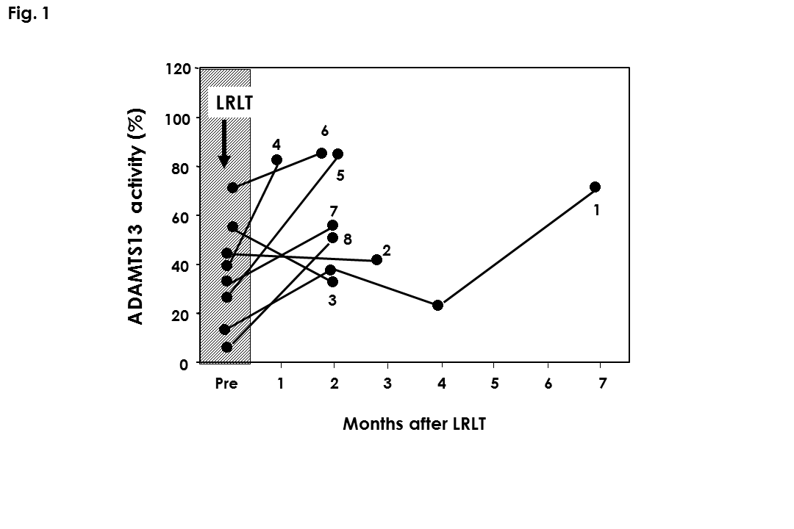
Figure 1 Plasma ADAMTS13 activity before and after living–related liver transplantation. Predominantly decreased ADAMTS13 activity could be fully restored after living–related liver transplantation in 6 out of 8 sick children with advanced cirrhotic biliary atresia (cases 1, 4, 5, 6, 7 and 8). Pre: Before transplantation; LRLT: Living-related liver transplantation.

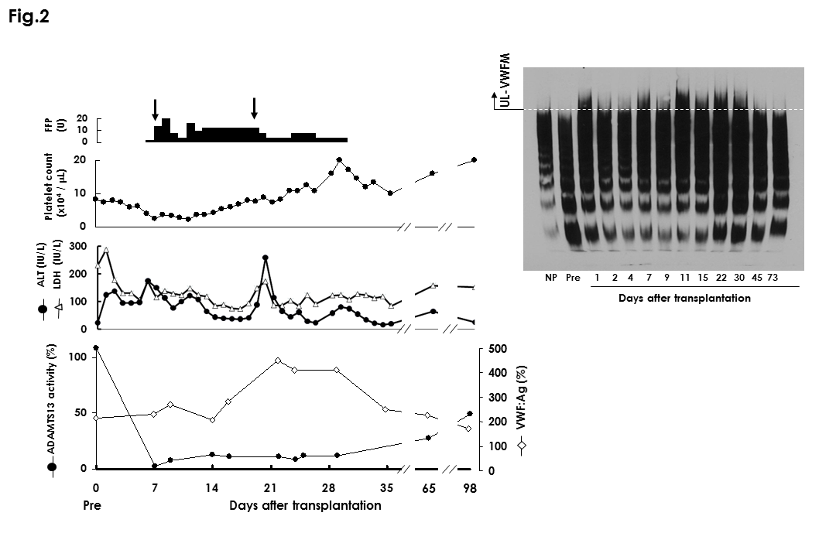
Figure 2 Clinical course of 27-year-old male with Budd-Chiari syndrome after liver transplantation. Serum ALT level was mildly increased on days 1 and 2 because of ischemia-reperfusion injury, decreased thereafter, but rapidly increased again on day 7 due to acute rejection (left panel). The platelet count decreased gradually and reached a nadir on day 7, when ADAMTS13 activity decreased markedly to less than 3% from 108% before surgery. After the administration of fresh frozen plasma and bolus injection of methylprednisolone (arrow), ALT level decreased and the platelet count gradually increased. The ADAMTS13 activity increased to 22% on day 14. After the first episode of acute rejection, VWF: Ag increased further and reached 368% on day 21, when ALT again increased due to a second episode of acute rejection. Bolus injection of methylprednisolone (arrow) led to a rapid decrease of ALT and a gradual increase in the platelet count. VWF: Ag decreased gradually, and ADAMTS13 activity finally recovered to 50% until day 98. Plasma UL-VWFM was detectable on day 1 at the time of ischemia-reperfusion injury, thereafter diminishing gradually during days 2 to 4, and again becoming evident on day 7 when acute rejection developed (right panel). The UL-VWFM disappeared transiently on day 9, but reappeared on day 11, coinciding with a mild increase of transaminase. UL-VWFM tended to diminish on day 15, but again became prominent on day 22 during the second episode of acute rejection. Pre: Before transplantation; NP: Normal plasma control. ALT: Alanine transaminase; VWF: Von Willebrand factor; UL-VWFM: Unusually large VWF multimers.

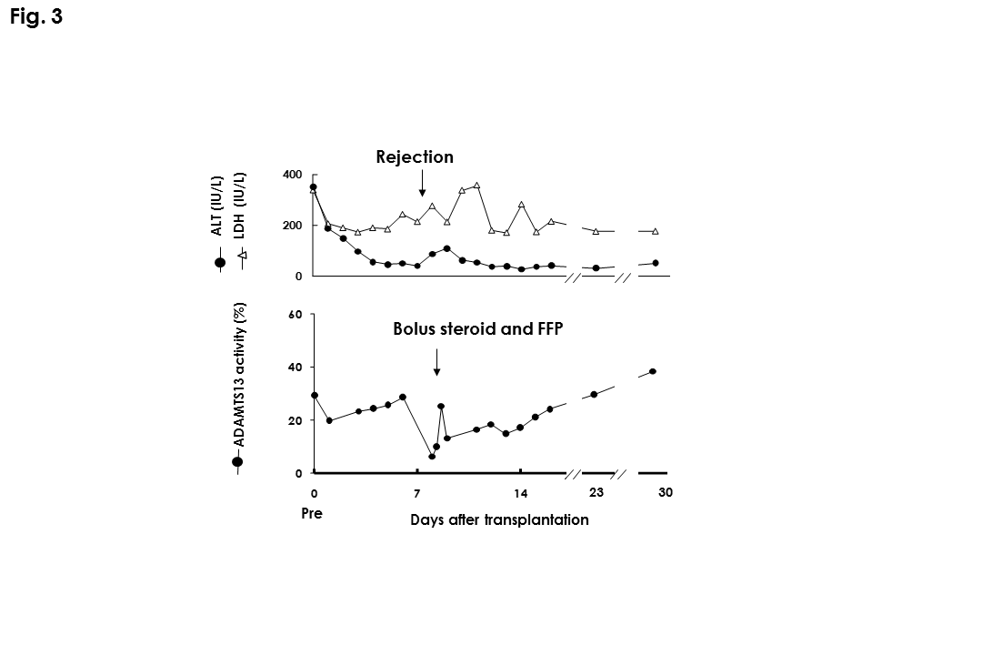
Figure 3 ADAMTS13 activity before and after treatment for acute rejection in a liver transplant recipient. Decreased ADAMTS13 activity during acute rejection recovered after treatment for rejection. Pre: Before transplantation; FFP: Fresh frozen plasma; ALT: Alanine transaminase; LDH: Lactate dehydrogenase.

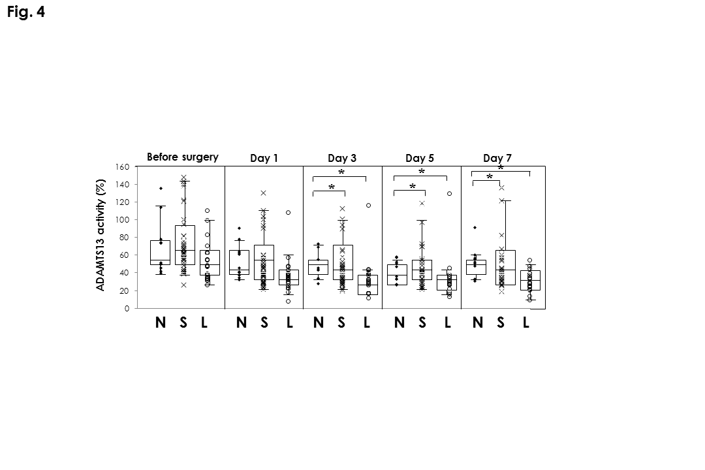
Figure 4 ADAMTS13 activity according to blood occlusion time by Pringle’s maneuver. Pringle’s maneuver for long time (over 60 min: L) induced significantly profound decrease of ADAMTS13 activity, comparing to short (15-45 min: S) or no blood occlusion (N). The box shows the 25th-75th percentile, the bar indicates the median value, and the whiskers indicates the 5th-95th percentile. ªP < 0.05 by ANOVA. ANOVA: Analysis of variance.

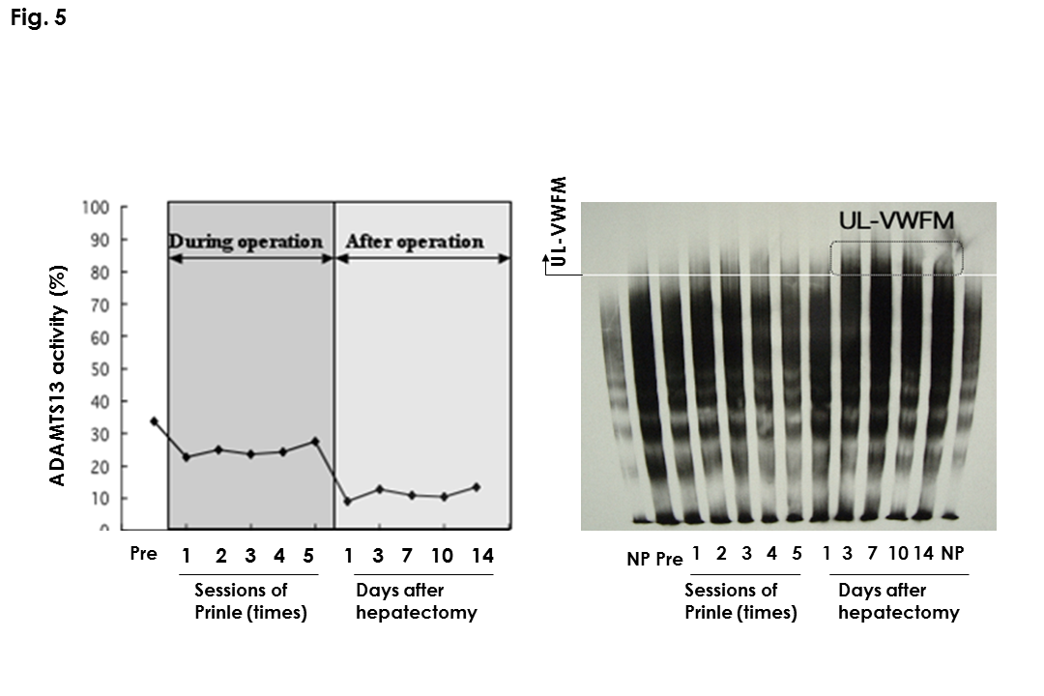
Figure 5 Perioperative changes of ADAMTS13 activity and unusually large von Willebrand factor multimers in a patient with large hepatectomy. The patient underwent long Pringles’s maneuver (75 min). While ADAMTS13 did not decrease during hepatectomy even with long ischemic time by hepatic inflow occlusion, the activity markedly decreased until the next day. Consistently, UL-VWFM did not appeared during hepatectomy, and significantly up-regulated from day 3. Pre: Before transplantation; NP: Normal plasma controls; UL-VWFM: Unusually large von Willebrand factor multimers.

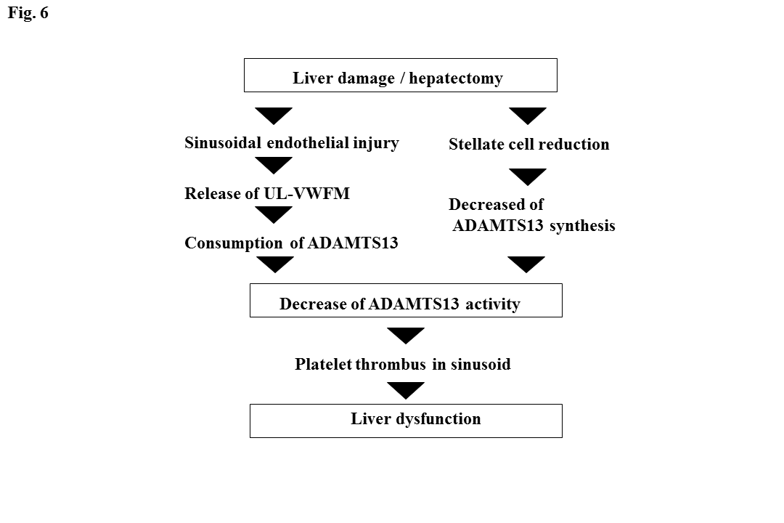
Figure 6 Hypothesis about mechanism of liver dysfunction via the local thrombotic thrombocytopenic purpura like mechanism. UL-VWFM: Unusually large von Willebrand factor multimers; TTP: Thrombotic thrombocytopenic purpura.

Table 1 Profiles of patients who received living-related liver transplantation
Recipient |  |  |  |  |  |  | Donor
Case | Age | Sex | Underlying  disease | ABO-Rh (D) blood group | SV  (g) | Presence of schistocytes before LRLT | Relation to the recipient | Age | ABO-Rh(D) blood group | GV  (g) | GV/SV ratio
1 | 9 mo | M | BA | A+ | 274 | + | Father | 35 yr | A+ | 290 | 1.06
2 | 1 yr 4 mo | F | BA | A+ | 245 | + | Mother | 38 yr | A+ | 314 | 1.28
3 | 12 yr | F | BA | A+ | 891 | - | Mother | 44 yr | A+ | 392 | 0.44
4 | 11 mo | F | BA | A+ | 259 | + | Mother | 35 yr | A+ | 306 | 1.18
5 | 8 mo | F | BA | O+ | 185 | + | Father | 36 yr | O+ | 263 | 1.42
6 | 1 yr | F | BA | A+ | 262 | + | Mother | 41 yr | O+ | 215 | 0.82
7 | 11 mo | F | BA | AB+ | 280 | - | Mother | 35 yr | A+ | 266 | 0.95
8 | 7 mo | M | BA | A+ | 226 | - | Mother | 30 yr | A+ | 228 | 1.01
LRLT: Living-related liver transplantation; SV: Standard liver volume; GV: Graft liver volume; BA: Biliary atresia.

