Name of Journal: World Journal of Clinical Cases
Manuscript NO: 78528
Manuscript Type: CASE REPORT

Giant struma ovarii with pseudo-Meigs’syndrome and raised cancer antigen-125 levels: A case report

Liu Y et al. Struma ovarii with pseudo-Meigs’syndrome

Yan Liu, Gao-Yan Tang, Lu Liu, Hui-Min Sun, Hai-Yan Zhu

Yan Liu, Lu Liu, Department of Gynecology, Weifang People’s Hospital, Weifang 261032, Shandong Province, China

Gao-Yan Tang, Hai-Yan Zhu, Department of Oncology, Weifang People’s Hospital, Weifang 261032, Shandong Province, China

Hui-Min Sun, Department of Pathology, Weifang People’s Hospital, Weifang 261032, Shandong Province, China

Author contributions: Tang GY wrote the first draft of the manuscript; Liu Y and Liu L were responsible for treatment of the patient; Sun HM provided images of hematoxylin-eosin and immunohistochemistry; Zhu HY revised the manuscript; all authors have read and approved the final manuscript.

Supported by the Shandong Medical and Health Technology Development Project, No. 202102080115.

Corresponding author: Hai-Yan Zhu, MS, Chief Doctor, Department of Oncology, Weifang People's Hospital, No. 151 Guangwen Street, Weifang 261032, Shandong Province, China. 15169696986@163.com

Received: July 1, 2022
Revised: August 12, 2022
Accepted: August 25, 2022
Published online: October 26, 2022

Abstract
BACKGROUND
Struma ovarii is a type of monodermal mature teratoma composed entirely or mainly of thyroid tissue, accounting for 1% to 3% of all ovarian teratomas and 0.3% to 1.0% of all ovarian tumors. Of which, struma ovarii with ascites and pleural effusion, called pseudo-Meigs’syndrome and raised cancer antigen-125 levels (CA 125) is even rarer.

CASE SUMMARY
This paper reports the diagnosis and treatment of a patient of struma ovarii with pseudo-Meigs’syndrome, presenting with the clinical features of ovarian carcinoma: Complex pelvic mass, gross ascites, right pleural effusion and markedly elevated serum CA 125 levels. During the operation, a cystic-solid mass about 20 cm × 10 cm × 5 cm in the right adnexa and a solid mass with the size of 3 cm × 2 cm × 0.1 cm in the left ovary were observed. She underwent right adnexectomy and resection of the left ovarian mass and histopathology revealed a mature left-sided ovarian teratoma and struma ovarii of right adnexal mass. During 1-year follow-up, the patient recovered well, tumor markers and other indicators returned to normal.

CONCLUSION
The diagnosis and treatment process of this case suggests that the clinical symptoms of struma ovarii with pseudo-Meigs’syndrome are lack specificity, which is easily misdiagnosed. Clinicians should improve the understanding of this disease, enhance the awareness of early screening, and improve the level of diagnosis and treatment.

Key Words: Struma ovarii; pseudo-Meigs’syndrome; Ascites; Pleural effusion; Cancer antigen-125; Case report

©The Author(s) 2022. Published by Baishideng Publishing Group Inc. All rights reserved.

Citation: Liu Y, Tang GY, Liu L, Sun HM, Zhu HY. Giant struma ovarii with pseudo-Meigs’syndrome and raised cancer antigen-125 levels: A case report. World J Clin Cases 2022; 10(30): 11155-11161
URL: https://www.wjgnet.com/2307-8960/full/v10/i30/11155.htm
DOI: https://dx.doi.org/10.12998/wjcc.v10.i30.11155

Core Tip: Struma ovarii with pseudo-Meigs’syndrome and elevated serum cancer antigen-125 is easily preoperatively misdiagnosed as ovarian cancer, leading to unnecessary extended surgery. In this case, the patient of giant struma ovarii with pseudo-Meigs’syndrome underwent conservative surgery in the form of a right salpingo-oophorectomy, as there was no evidence of malignancy according to the preoperative biopsy and intraoperative frozen analysis. Besides, this patient was premenopausal and to our knowledge, she is the youngest with this disease.
INTRODUCTION
Struma ovarii, a special type of ovarian teratoma, is a highly differentiated monodermal teratoma that arises from ovarian primordial germ cells and is defined as mature teratoma composed of a minimum of 50% of thyroid tissue by World Health Organisation, accounting for 1% to 3% of all ovarian teratomas and 0.3% to 1.0% of all ovarian tumors^{[1,2]}. Meigs’syndrome represents a solid benign ovarian neoplasm, such as fibroma, granulosa cell tumor or thecoma with hydrothorax and ascites which are completely resolved spontaneously after surgical removal of the tumour^{[3]}. When ascites and hydrothorax are associated with other ovarian tumors, it is defined as pseudo-Meigs’syndrome^{[4]}. Struma ovarii is rare, but struma ovarii with pseudo-Meigs’syndrome is even rarer and it is easily misdiagnosed in clinical practice^{[5]}. In order to deepen clinicians' understanding of this disease, here, we present a case of benign struma ovarii associated with pseudo-Meigs’syndrome and elevated cancer antigen-125 (CA 125).

CASE PRESENTATION
Chief complaints
A 37-year-old, Chinese woman, premenopausal, presented to gynecologic clinic with a complaint of abdominal bulge for 4 mo.

History of present illness
Symptoms started 4 mo before presentation with abdominal bulge, without abdominal pain.

History of past illness
She had a history of breast fibroma surgery 6 years ago.

Personal and family history
The patient denied any family history of malignant tumours.

Physical examination
Physical examination revealed obvious abdominal distension, positive mobility voiced sounds, positive fluid wave tremor and weak bowel sounds. Besides, the vital signs were as follows: Body temperature, 37.2 °C; blood pressure, 122/83 mmHg; pulse, 102 beats per min; respiratory rate, 18 breaths per min. Furthermore, the right breast had old surgical scars. Gynecological examination: an irregular mass, with a diameter of 12 cm, was found on the right ovary; left ovary and uterus had no obvious abnormalities.

Laboratory examinations
Tumor marker carbohydrate antigen 199 was not elevated (33.87 U/mL, reference, 0-37), but CA 125 was 1492.23 U/mL (reference, 0-35). Besides, thyroid function tests were within normal limits: free triiodothyronine, 6.24 pmol/L (reference, 3.5-6.5); free thyroxine, 19.63 pmol/L (reference, 11.5-22.7); thyroid-stimulating hormone, 1.44 μIU/mL, (reference, 0.55-4.78). No abnormality was found in routine blood analyses.

Imaging examinations
Ultrasonography showed a 12.8 cm × 8.0 cm right adnexal mass containing solid and cystic components with abundant vascularization and 2.8 cm × 2.1 cm solid left adnexal mass. Besides, there was a large amount of free peritoneal fluid and thickened greater omentum (Figure 1). Computed tomography (CT) scan of the chest, abdomen, and pelvis revealed right lung atelectasis with a large right pleural effusion, gross ascites, and a large complex cystic pelvic mass (Figure 2). Overall, the radiological findings were suspicious of ovarian cancer.

FINAL DIAGNOSIS
Cytological examination of pleural fluid and ascites indicated only reactive mesothelial cells with a few lymphocytes, histiocytes and neutrophils with no malignant cells identified. Then pathological histology of percutaneous biopsy of the pelvic mass showed hyperplastic fibrous tissue and mature thyroid follicles, without cellular and structural atypia, which was suspecious of struma ovarii combined with immunohistochemistry (Figure 3). Combined with the analysis of pathological histology and immunohistochemistry of the biopsies, the preoperative diagnosis was highly suspecious of struma ovarii.
The final histopathology revealed a mature left-sided ovarian teratoma and struma ovarii of right adnexal mass (Figure 4).

TREATMENT
The patient was arranged for an exploratory laparotomy for diagnostic and therapeutic purposes on October 22, 2020. During the operation, 3000 mL of straw-colored ascites was drained. A large solid neoplasm (20 cm × 10 cm × 5 cm) originating from the right ovary was twisted clockwise for half a turn together with the right fallopian tube and part of the intestinal canal was adherent to the mass. Besides, the left ovary was slightly atrophic, containing a cystic mass, with the size of 3 cm × 2 cm × 0.1 cm. Intraoperative examination of all abdominal and pelvic organs did not show any additional lesions. The patient subsequently underwent right salpingo-oophorectomy and resection of the left ovarian mass and intestinal adhesiolysis and the excised specimens were sent for frozen analysis to rule out malignancy.

OUTCOME AND FOLLOW-UP
The patient recovered uneventfully and pleural effusion disappeared 5 d after surgery. Besides, CA 125 returned to normal range level (27.26 U/mL) 1 mo after surgery. The patient was followed up for 1 year after operation and there were no signs of obvious abnormality.

DISCUSSION
Struma ovarii, as a highly specific mature teratoma, is mostly benign, with malignant transformation only occurring in 0.5%-10 % of cases^{[1,6]}. Struma ovarii can occur in female patients of any age, but perimenopause is the peak period of the disease, and it is usually asymptomatic, whereas patients with large struma ovarii may show abdominal distention, as in our case^{[7]}. Because there are no obvious specificities in ultrasound, CT or magnetic resonance imaging (MRI) for struma ovarii, it is difficult to differentiate from ovarian cancer on imaging, especially for struma ovarii accompanied by ascites and pleural effusion, called pseudo-Meigs’syndrome and elevated CA 125, which can mimic ovarian malignancy. Fujiwara et al^{[8]} reported positron emission tomography/CT combined with thyroid scintigraphy may be useful to define the diagnosis in struma ovarii with pseudo-Meigs’syndrome. Up to now, accurate preoperative diagnosis for struma ovarii by conventional imaging alone remains challenging and postoperative pathology is still required to confirm the diagnosis.
In the literature, 13 cases have been published on struma ovarii combined with pseudo-Meigs’syndrome and elevated CA 125, we describe another case of struma ovarii combined with pseudo-Meigs’syndrome and elevated CA 125^{[5,8-18]}. Of all the cases, most of the patients were in their fifth or sixth decade when diagnosed with struma ovarii and almost 78.6% (11/14) of cases were postmenopausal women. Then, the most common presenting symptom was abdominal distension and the tumour sizes ranged between 5-23 cm in the large dimension, with an average size of 12 cm. Besides, most cases were preoperatively misdiagnosed as ovarian cancer and were treated by hysterectomy and bilateral salpingo-oophorectomy^{[5,8-17]} and only two patients (including this case) underwent conservative surgery^{[18]}. The ascites and hydrothorax disappeared completely and CA 125 levels returned to normal following surgery and all the cases had good prognosis. There are some unique features in our patient. Firstly, she was premenopausal, and to our knowledge, she is the youngest with this disease. Secondly, considering young age of our patient in order to avoid postoperative hormonal substitution, she underwent conservative surgery in the form of a right salpingo-oophorectomy as there was no evidence of malignancy according to analysis of percutaneous biopsy of the pelvic mass and frozen examination.

CONCLUSION
In summary, we confirm that struma ovarii is difficult to characterize on conventional imaging modalities and such patients should be diagnosed based on imaging features combined with pathology. In addition, more precise preoperative diagnosis should be performed to avoid unnecessary extended surgery.

ACKNOWLEDGEMENTS
We would like to thank our patient for participating in this study.

REFERENCES
1 Oudoux A, Leblanc E, Beaujot J, Gauthier-Kolesnikov H. Treatment and follow-up of malignant struma ovarii: Regarding two cases. Gynecol Oncol Rep 2016; 17: 56-59 [PMID: 27355004 DOI: 10.1016/j.gore.2016.05.014]
2 Gobitti C, Sindoni A, Bampo C, Baresic T, Giorda G, Alessandrini L, Canzonieri V, Franchin G, Borsatti E. Malignant struma ovarii harboring a unique NRAS mutation: case report and review of the literature. Hormones (Athens) 2017; 16: 322-327 [PMID: 29278520 DOI: 10.14310/horm.2002.1750]
3 MEIGS JV. Fibroma of the ovary with ascites and hydrothorax; Meigs' syndrome. Am J Obstet Gynecol 1954; 67: 962-985 [PMID: 13148256 DOI: 10.1016/0002-9378(54)90258-6]
4 Amant F, Gabriel C, Timmerman D, Vergote I. Pseudo-Meigs' syndrome caused by a hydropic degenerating uterine leiomyoma with elevated CA 125. Gynecol Oncol 2001; 83: 153-157 [PMID: 11585430 DOI: 10.1006/gyno.2001.6251]
5 Rana V, Srinivas V, Bandyopadhyay S, Ghosh SK, Singh Y. Bilateral benign non functional struma ovarii with Pseudo-Meigs' syndrome. Indian J Pathol Microbiol 2009; 52: 94-96 [PMID: 19136795 DOI: 10.4103/0377-4929.44978]
6 Brusca N, Del Duca SC, Salvatori R, D'Agostini A, Cannas P, Santaguida MG, Virili C, Bianchi L, Gargano L, Centanni M. A case report of thyroid carcinoma confined to ovary and concurrently occult in the thyroid: is conservative treatment always advised? Int J Endocrinol Metab 2015; 13: e18220 [PMID: 25745492 DOI: 10.5812/ijem.18220]
7 Nurliza Binti Md Nor, Kusumoto T, Inoue S, Nakamura K, Seki N, Hongo A, Kodama J, Hiramatsu Y. Three cases of struma ovarii underwent laparoscopic surgery with definite preoperative diagnosis. Acta Med Okayama 2013; 67: 191-195 [PMID: 23804143 DOI: 10.18926/amo/50413]
8 Fujiwara S, Tsuyoshi H, Nishimura T, Takahashi N, Yoshida Y. Precise preoperative diagnosis of struma ovarii with pseudo-Meigs' syndrome mimicking ovarian cancer with the combination of ¹³¹I scintigraphy and ¹⁸F-FDG PET: case report and review of the literature. J Ovarian Res 2018; 11: 11 [PMID: 29391043 DOI: 10.1186/s13048-018-0383-2]
9 Bethune M, Quinn M, Rome R. Struma ovarii presenting as acute pseudo-Meigs syndrome with an elevated CA 125 Level. Aust N Z J Obstet Gynaecol 1996; 36: 372-373 [PMID: 8883774 DOI: 10.1111/j.1479-828x.1996.tb02734.x]
10 Long CY, Chen YH, Chen SC, Lee JN, Su JH, Hsu SC. Pseudo-Meigs syndrome and elevated levels of tumor markers associated with benign ovarian tumors-two case reports. Kaohsiung J Med Sci 2001; 17: 582-585 [PMID: 11852467]
11 Huh JJ, Montz FJ, Bristow RE. Struma ovarii associated with pseudo-Meigs' syndrome and elevated serum CA 125. Gynecol Oncol 2002; 86: 231-234 [PMID: 12144834 DOI: 10.1006/gyno.2002.6741]
12 Uehara T, Sawada M. Struma ovarii associated with Meigs syndrome. Jpn J Clin Oncol 2007; 37: 73 [PMID: 17272322 DOI: 10.1093/jjco/hyl159]
13 Obeidat BR, Amarin ZO. Struma ovarii with pseudo-Meigs' syndrome and elevated CA125 Levels. J Obstet Gynaecol 2007; 27: 97-98 [PMID: 17365481 DOI: 10.1080/01443610601076267]
14 Mitrou S, Manek S, Kehoe S. Cystic struma ovarii presenting as pseudo-Meigs' syndrome with elevated CA125 Levels. A case report and review of the literature. Int J Gynecol Cancer 2008; 18: 372-375 [PMID: 18334015 DOI: 10.1111/j.1525-1438.2007.00998.x]
15 Jiang W, Lu X, Zhu ZL, Liu XS, Xu CJ. Struma ovarii associated with pseudo-Meigs' syndrome and elevated serum CA 125: a case report and review of the literature. J Ovarian Res 2010; 3: 18 [PMID: 20670426 DOI: 10.1186/1757-2215-3-18]
16 Mostaghel N, Enzevaei A, Zare K, Fallahian M. Struma ovarii associated with Pseudo-Meig's syndrome and high serum level of CA 125; a case report. J Ovarian Res 2012; 5: 10 [PMID: 22436494 DOI: 10.1186/1757-2215-5-10]
17 Jin C, Dong R, Bu H, Yuan M, Zhang Y, Kong B. Coexistence of benign struma ovarii, pseudo-Meigs' syndrome and elevated serum CA 125: Case report and review of the literature. Oncol Lett 2015; 9: 1739-1742 [PMID: 25789033 DOI: 10.3892/ol.2015.2927]
18 Loizzi V, Cormio G, Resta L, Fattizzi N, Vicino M, Selvaggi L. Pseudo-Meigs syndrome and elevated CA125 associated with struma ovarii. Gynecol Oncol 2005; 97: 282-284 [PMID: 15790478 DOI: 10.1016/j.ygyno.2004.12.040]

Footnotes
Informed consent statement: Informed written consent was obtained from the patient for publication of this report and any accompanying images.

Conflict-of-interest statement: All authors declare that they have no conflict of interest to disclose.

CARE Checklist (2016) statement: All authors have read the CARE Checklist (2016), and the manuscript was prepared and revised according to the CARE Checklist (2016).

Open-Access: This article is an open-access article that was selected by an in-house editor and fully peer-reviewed by external reviewers. It is distributed in accordance with the Creative Commons Attribution NonCommercial (CC BY-NC 4.0) license, which permits others to distribute, remix, adapt, build upon this work non-commercially, and license their derivative works on different terms, provided the original work is properly cited and the use is non-commercial. See: https://creativecommons.org/Licenses/by-nc/4.0/

Provenance and peer review: Unsolicited article; Externally peer reviewed.
Peer-review model: Single blind

Peer-review started: July 1, 2022
First decision: August 1, 2022
Article in press: August 25, 2022

Specialty type: Medicine, research and experimental
Country/Territory of origin: China
Peer-review report’s scientific quality classification
Grade A (Excellent): 0
Grade B (Very good): B, B
Grade C (Good): C
Grade D (Fair): 0
Grade E (Poor): 0

P-Reviewer: Hassan SA, United States; Paparoupa M, Germany S-Editor: Wang LL L-Editor: A P-Editor: Wang LL

Figure Legends
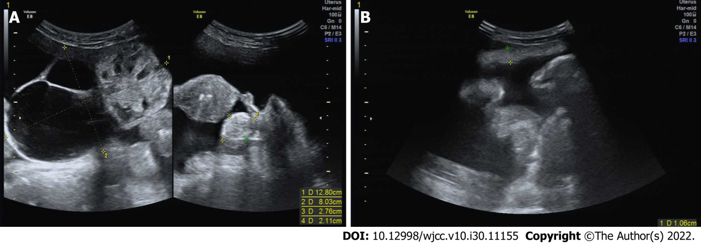
Figure 1 Transvaginal ultrasound images. A: Transvaginal ultrasound (US) demonstrating a large (12.8 cm × 8.0 cm), solid, cystic mass, originating in the right ovary and a small (2.8 cm × 2.1 cm), solid left adnexal mass; B: US showing a large amount of free peritoneal fluid and thickened greater omentum.
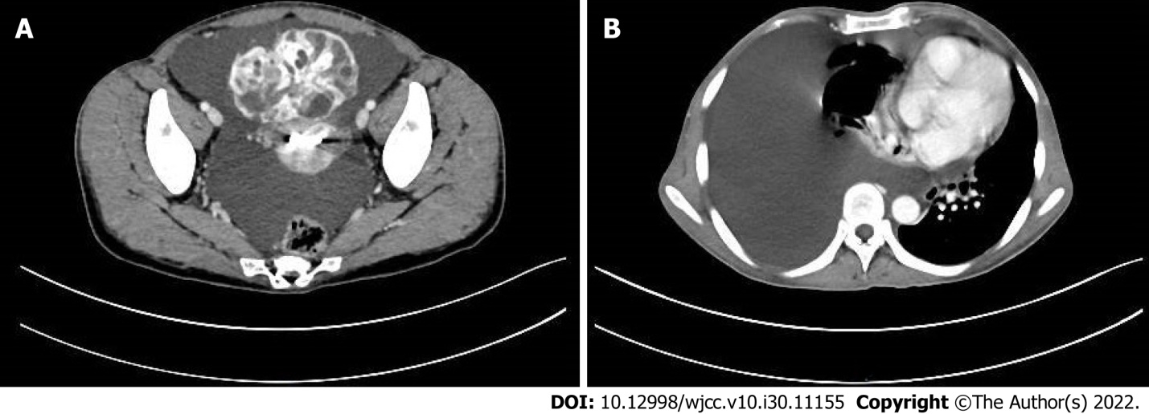
Figure 2 Computed tomography scan imaging of the chest and pelvis. A: Computed tomography (CT) scan of the chest revealing right lung atelectasis with a large right pleural effusion; B: CT scan of the pelvis showing gross ascites and a large complex cystic pelvic mass.
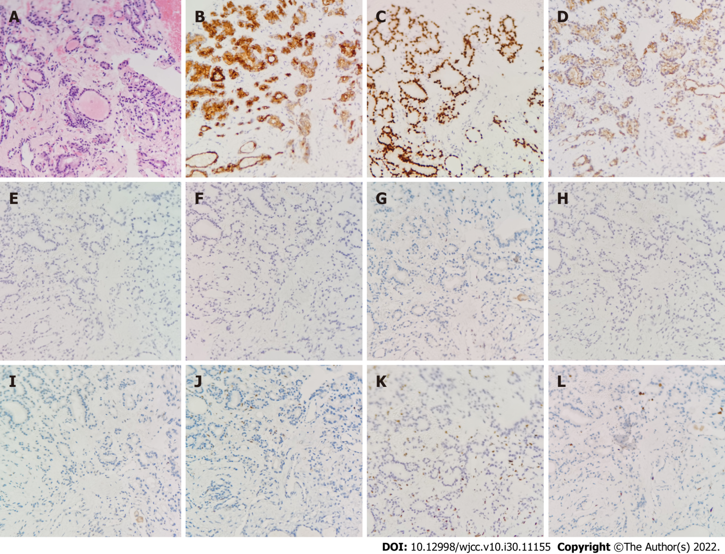
Figure 3 Hematoxylin-eosin staining and immunohistochemistry of percutaneous biopsy of the pelvic mass. A: Hematoxylin-eosin staining showed multiple benign colloid-filled thyroid follicles (× 200); B-D: Immunohistochemistry (IHC) examination revealed that pelvic mass was positive for thyrobolulin (× 200), thyroid transcription factor-1 (× 200) and Cytokeratin-7 (× 200), respectively; E-L: IHC examination revealed that pelvic mass was negtive for Cytokeratin-20 (× 200), caudal-related homeobox transcription factor 2 (× 200), Estrogen receptor (× 200), calretinin (× 200), P53 (× 200), P16 (× 200), Wilms tumor-1 (× 200) and Ki-67 (× 200), respectively.
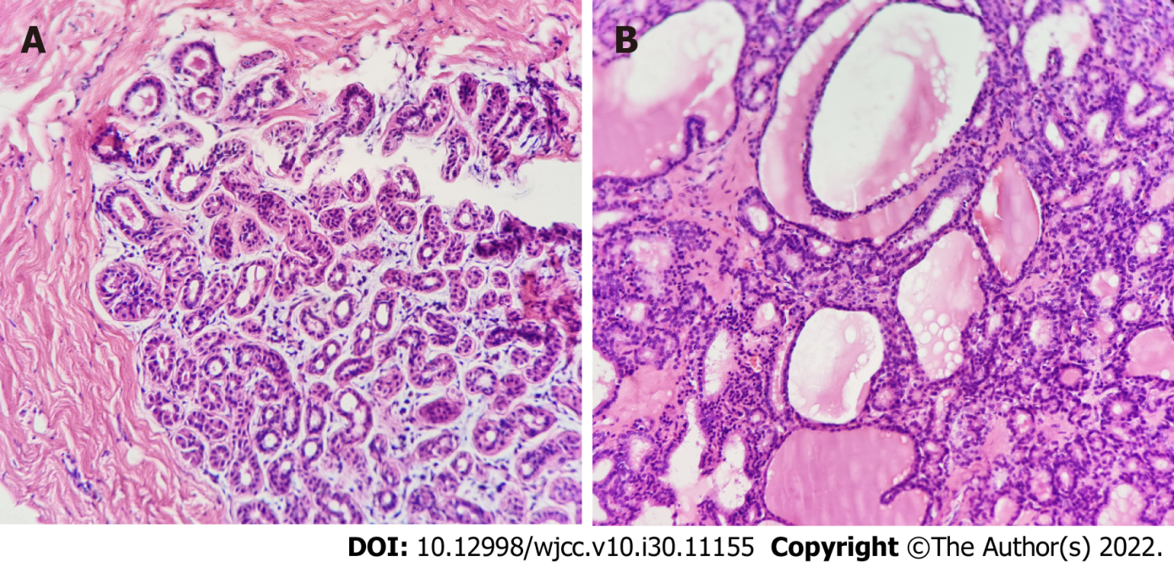
Figure 4 Histopathological analysis of the resected specimen. A: Hematoxylin-eosin stained left ovary showing teratoma (× 200); B: Microscopic appearance of the right ovary showing variable-sized thyroid follicles (× 200).

Published by Baishideng Publishing Group Inc
7041 Koll Center Parkway, Suite 160, Pleasanton, CA 94566, USA
Telephone: +1-925-3991568
E-mail: bpgoffice@wjgnet.com
Help Desk: https://www.f6publishing.com/helpdesk
https://www.wjgnet.com

© 2022 Baishideng Publishing Group Inc. All rights reserved.

