Name of Journal: World Journal of Gastrointestinal Oncology
Manuscript NO: 68022
Manuscript Type: ORIGINAL ARTICLE

Basic Study
Preventive and inhibitive effects of Yiwei Xiaoyu granules on the development and progression of spasmolytic polypeptide-expressing metaplasia lesions

Chen WQ et al. Treatment effect and mechanism of YWXY on SPEM

Wan-qun Chen, Feng-liang Tian, Jin-wei Zhang, Xiao-jun Yang, Yan-ping Li

Wan-qun Chen, Feng-liang Tian, Xiao-jun Yang, Yan-ping Li, Department of Gastroenterology, Chongqing hospital of Traditional Chinese Medicine, Chongqing 400000, China

Jin-wei Zhang, Department of Dermatology and Cosmetology, Chongqing hospital of Traditional Chinese Medicine, Chongqing 400000, China

Author contributions: Yang XJ and Li YP contributed equally to this work; Chen WQ, Tian FL, Yang XJ and Li YP designed the research study; Chen WQ and Zhang JW performed the research; Tian FL and Zhang JW contributed new reagents and analytic tools; Chen WQ, Yang XJ and Li YP analyzed the data and wrote the manuscript; All authors have read and approved the final manuscript.

Supported by National Natural Science Foundation of China, No. 81904175; Natural Science Foundation of Chongqing, China, No. cstc2018jcyjAX0756; and Chongqing Health Planning Commission Project, No. ZY201802063 and No. 2019ZY013111.

Corresponding author: Yan-ping Li, PhD, Professor, Department of Gastroenterology, Chongqing hospital of Traditional Chinese Medicine, No. 6 Panxi Qizhi Road, Jiangbei District, Chongqing 400000, China. lyp20210203@163.com

Received: June 3, 2021
Revised: July 10, 2021
Accepted: August 24, 2021
Published online:
Abstract
BACKGROUND
Spasmolytic polypeptide-expressing metaplasia (SPEM) is a potential preneoplastic lesion.

AIM
To elucidate the microRNA (miR)-7-mediated preventive and inhibitive effects of Yiwei Xiaoyu granules (YWXY) in SPEM lesions.

METHODS
Gastric mucosa biopsies were collected from chronic atrophic gastritis patients and healthy people with signed informed consent. YWXY was administered to the mice with induced SPEM by tamoxifen, and the gastric mucosa was harvested on the tenth day of the experiment. Then immunohistochemistry and immunofluorescence were performed to validate the SPEM, lesions and the potential mechanism was investigated. RNA transcripts were detected with reverse transcription-quantitative polymerase chain reaction.

RESULTS
The expression of miR-7 was downregulated in the SPEM lesions, and expression of trefoil factor 2 (TFF2) and clusterin was high in the human gastric mucosa. In vivo experiments showed that YWXY could inhibit the cell proliferation in the tamoxifen-induced SPEM lesions by regulating Ki67. Simultaneously, YWXY could restore the expression of miR-7 by regulating TFF2 by detection with immunofluorescence but not with reverse transcription-quantitative polymerase chain reaction, indicating its potential mechanism of targeting miR-7 by mediating TFF2. The expression of vascular endothelial growth factor-β and gastric intrinsic factor was restored within 3 d of YWXY administration for the SPEM lesions, speculating that the possible mechanism of YWXY is to inhibit the development and progression of SPEM by regulating vascular endothelial growth factor-β and gastric intrinsic factor.

CONCLUSION
miR-7 downregulation is an early event in SPEM through regulation of TFF2 in human gastric mucosa. YWXY is able to inhibit the cell proliferation and restore the expression of miR-7 by mediating TFF2 in the SPEM mouse model.

Key Words: Spasmolytic polypeptide-expressing metaplasia; Yiwei Xiaoyu Granules; MicroRNA-7; Chronic atrophic gastritis; Trefoil factor 2; Gastric precancerous lesions

Chen WQ, Tian FL, Zhang JW, Yang XJ, Li YP. Preventive and inhibitive effects of Yiwei Xiaoyu Granules on the development and progression of spasmolytic polypeptide-expressing metaplasia lesions. World J Gastrointest Oncol 2021; In press

Core Tip: We showed evidence that microRNA-7 downregulation is an early event in the cascade from metaplasia to gastric cancer and that it contributes to the establishment of an intestinal expression profile through regulation of trefoil factor 2 in both human gastric mucosa and in vivo experiments. To the best of our knowledge, we used the spasmolytic polypeptide-expressing metaplasia mouse model for the first time to reveal the effectiveness and the potential mechanism of Chinese medicine Yiwei Xiaoyu granules for the precursor of gastric adenocarcinoma.

INTRODUCTION
Gastric cancer is one of the most frequent and deadly cancers worldwide^{[1]}. The Correa pathway from gastritis to gastric cancer including the oxyntic atrophy (loss of acid-secreting parietal cells) and the development of spasmolytic polypeptide-expressing metaplasia (SPEM) has been well described. SPEM and intestinal metaplasia (IM) have been considered as preneoplastic lesions, whereas SPEM is the first metaplastic lesion to evolve and probably progresses to IM^{[2-4]}. Therefore, it is important to clarify the cause of parietal cell atrophy and the regulatory mechanisms for the chief cell transdifferentiation to explore novel treatments for the gastric precancerous lesions and eventually prevent the occurrence of gastric cancer.
The international consensus has recommended follow-up or endoscopic resection of the precancerous lesions of the stomach; however, it has been reported that gastric IM still persisted even after successful eradication of low-grade dysplasia with radiofrequency ablation^{[5,6]}. In the previous work, our group proved that Yiwei Xiaoyu granules (YWXY) could improve the mucosa atrophy, IM and dysplasia of chronic gastric gastritis (CAG) in the clinic trial^{[7]}. Then we optimized water reflux extraction technology and established the quality standard of YWXY^{[8,9]}. In addition, we explored the mechanism of how YWXY inhibits atrophy and IM of the stomach using a rat model^{[10,11]}. However, the specific mechanism of YWXY still remains largely unknown.
In our previous work, we found that targeting some microRNAs (miRNAs) could prevent or retard the occurrence and development of gastric cancer and its precancerous lesions, such as miR-7 and let-7^{[12-14]}. miR-7a-5p and miR-7a-3p strand consist of a short duplex mature miRNA, and miR-7a-5p has been the focus of the majority of studies and is commonly referred to as “miR-7”^{[15]}. miR-7 has been proved to be a novel prognostic biomarker and potential therapeutic target by mediating p65 and activating NF-κB^{[16]}. Based on our prior investigation, the expression of miR-7 in gastric cancer was decreased compared with the matched normal tissues and adjacent tissues^{[14]}. Therefore, we hypothesized that miR-7 might serve as a suppressor gene in the process of SPEM progression into gastric cancer. Furthermore, in the light of these facts that YWXY could relieve or even reverse the atrophy and IM of rat mucosa by inhibiting NF-κB^{[10]}, we assumed that YWXY could inhibit the progression of gastric mucosa metaplasia even in the earlier phase such as SPEM.
Here, we detected the expression of miR-7 in SPEM with CAG biopsy samples and demonstrated the therapeutic effect of YWXY for the SPEM model induced by tamoxifen, in order to illustrate the possible mechanism.

MATERIALS AND METHODS
Ethics approval and sample collection
Animal experiments and human sample management were performed in accordance with protocols approved by the Ethics Committee of Chongqing Hospital of Traditional Chinese Medicine. All participants signed informed consent forms. From October 2019 to June 2020, 35 pairs of gastric endoscopic biopsy samples, including 30 CAG, and 5 healthy volunteers, were collected from the Department of Gastroenterology, Chongqing Hospital of Traditional Chinese Medicine. The diagnostic standards of CAG followed the Consensus on Chronic Gastritis^{[17]}, while the diagnostic standards of normal gastric mucosa with healthy volunteers followed the suggestion from Watanabe et al^{[18]}.

Animals and drug injections
A total of 24 male wild-type mice were purchased from the Institute of Chinese Medicine in Chongqing. They were divided into four groups randomly, including normal group, model group, low-dose group of YWXY and high-dose group of YWXY, and 6 mice were in each group. From the first to the tenth day of the experiment, the mice in low-and high-dose group of YWXY were gavaged with YWXY (15 g/kg daily and 20 g/kg daily, respectively). To establish the model of SPEM, tamoxifen was intraperitoneally injected (3 mg/20 g mouse body weight) from the eighth day of the experiment for 3 consecutive days^{[19]}. Mice in the normal group were gavaged with saline for 10 consecutive days. On the eleventh day of the experiment, after euthanasia, stomachs were immediately excised, and the gastric body was cut into three parts and fixed with 4% paraformaldehyde. One part was stored at -20℃, and the other two parts were stored with paraffin embedding.

Preparation of the medicine
YWXY components were obtained from the pharmacy department of Chongqing Hospital of Traditional Chinese Medicine and identified by two pharmacological experts, and were prepared as described previously^{[10,11]}. Standard extraction technology for YWXY was used^{[8,9]}.

Immunohistochemistry
After deparaffinization and hydration, slides underwent antigen retrieval via cooking in saline sodium citrate (pH 6.0). Slides were blocked with 3% H₂O₂ at room temperature for 15 min and flushed with distilled water three times (5 min/time). Primary antibodies, including anti-intrinsic factor antibody (1:20, ab171418, Abcam, Cambridge, United Kingdom), anti-trefoil factor 2 (TFF2) antibody (1:200, ab203237, Abcam), vascular endothelial growth factor-β (VEGF-B) antibody (1:200, AF7019, Affinity Biosciences, Cincinnati, OH, United States) and Ki67 antibody (1:200, AF1738, Beyotime, Beijing, China) were incubated overnight at 4 °C, washed three times (5 min/time) with PBS , and then incubated with DAKO REALTM EnVisionTM/HRP, Rabbit/Mouse (EVN) (K5007, Glostrup, Denmark) at 25-27 °C for 30 min, flushed with PBS three times (5 min/time) according to the manufactures’ instructions, developed, dehydrated, cleared, mounted and examined.

Immunofluorescence
The deparaffinized mouse stomach tissue sections underwent antigen retrieval with 10 mmol/L sodium citrate (pH 6.0), washed three times with PBS for 5 min each time, then with blocked with 10% normal goat serum at room temperature for 1 h, followed by overnight incubation with primary antibodies, such as anti-intrinsic factor antibody (1:10, ab171418, Abcam), anti-TFF2 antibody (1:100, ab203237, Abcam) and VEGF-B antibody (1:50, sc-101582, Santa Cruz Biotechnology, Santa Cruz, CA, United States) at 4 °C , then washed three times with PBS for 5 min each time. Goat anti-rabbit IgG (1:100) was added to incubate at room temperature for 1 h and washed three times with PBS for 5 min each time. SABC-DyLight 488 (1:200) was added to incubate at room temperature for 1 h, and PBS washed for 5 min. The diluted DAPI (1:1000) was added to make nuclear condensation at room temperature for 3 min, PBS washed four times, 5 min each time, stained with fluorescence decay resistant medium, mounted and photographed.

Reverse transcription-quantitative polymerase chain reaction
Total RNA was extracted according to the manufacturer’s instructions (LS1040, Promega Corporation, Shanghai, China). The PCR primers were as follows: TFF2 forward: 5’-CCTTGGTGTTTCCACCCACT-3’ and reverse, 5’-CCCACAATTCTTGCGAGCTG-3’; GAPDH forward: 5’-ATGGTGAAGGTCGGTGTGAAC-3’ and reverse 5’-AATCTCCACTTTGCCACTGC-3’. Reverse transcription was performed using the reverse transcription (K1622, Thermo Fisher Scientific, Waltham, MA, United States) and the MaximaTMSYBRGreen/ROXqPCRMasterMi (2X) (K0221, Thermo Fisher Scientific) kits. The thermocycling conditions were as follows: 50 °C for 2 min, 95 °C for 10 min, followed by 40 cycles of 95 °C for 15 s and 60 °C for 1 min on an ABI Step One QPCR System (Applied Biosystems, Waltham, MA, United States). GAPDH was used as an endogenous control, and the ΔΔCt method was used for TFF2 quantification.

Fluorescence in situ hybridization for miR-7a-5p
Fluorescence in situ hybridization (FISH) process was performed according to the manufacturer’s protocol (MK1030; Boster Biological Technology, Beijing, China). Ten-micrometer paraffin-embedded sections were deparaffinized and rehydrated, then incubated with proteinase and 1 mL 3% citric acid for 30 min at 37 °C, washed with PBS three times (5 min/time) and flushed with distilled water once for 5 min. Then, 20 μL prehybridization solution was added on each slide. To retain moisture, 20% glycerin was put into the dry hybridization chamber and incubated for 2 h at 37 °C . After the prehybridization, the excess liquid was absorbed. The locked nucleic acid probe (mmu-mir-7a-5p FISH probe, 5’FAM-ACAACAAAATCACTAGTCTTCCA-FAM3’) was dissoluted with 47.5 μL nuclease-free water and diluted (1:100), added with 20 μL hybridization solution with oligonucleotide probe, incubated at 42 °C overnight, washed, nuclear stained with DAPI (1:1000), mounted and observed under a fluorescence microscope (MF31, MSHOT, Guangzhou, China).

RESULTS
miR-7 was involved in TFF2-induced downregulation in SPEM lesions
To determine if miR-7 is inhibited in the specimens of CAG, we first examined the potential SPEM tissue with hematoxylin and eosin staining^{[3]}. Ten slides were selected and examined with immunohistochemistry (IHC). As it is reported, the clusterin-positive intestinal metaplasia does not express TFF2 in the gastric cancer tissue, whereas SPEM is a metaplasia mucous cell lineage with strong expression of TFF2 and clusterin^{[4,20]}. As a result, the expression of TFF2 and clusterin in SPEM are upregulated compared to the normal stomach tissue with IHC and immunofluorescence (Figures 1 and 2). Also, the expression of Ki67 protein in the SPEM was significantly higher than that in the normal stomach tissue (P < 0.001) (Figure 3). It is consistent with the results in the previous animal experiments^{[23]}. It implies that SPEM is actually the precancerous lesion with high proliferative activity.
In our previous study, the expression of miR-7 was significantly downregulated in gastric cancer tissue compared with the normal and adjacent tissue samples, which demonstrated that it was a tumor suppressor of gastric cancer^{[17]}. Here, we sought to identify if miR-7 was dysregulated in the SPEM tissue. By FISH, the results showed that the expression of miR-7 in SPEM was lower than that in normal tissue (Figure 4). Furthermore, to confirm the relationship of miR-7 and TFF2, FISH was performed. The data showed that with the decreased expression of miR-7, the expression of TFF2 was upregulated in the tissue of SPEM (Figure 5). Our results may have major implications for understanding the occurrence and development of SPEM.

YWXY administration could restore the expression of miR-7 by regulating TFF2
We tested, for the first time, the hypothesis that YWXY acts on miR-7 regulating TFF2 to inhibit SPEM. We induced SPEM in the mouse stomach by intraperitoneal administration of tamoxifen. The expression of Ki67 was higher in SPEM models than that in normal controls (Figure 6). Obviously, both YWXY decreased the expression of Ki67 compared to the model group (P < 0.05). These results imply that YWXY prevents the progression of precancerous lesions.
To address the hypothesis of the mechanism of YWXY inhibiting the progression of SPEM, we examined the expression of miR-7 with FISH and TFF2 with immunofluorescence. Our findings suggest that YWXY administration could restore the expression of miR-7. In addition, with high dosage of YWXY, there is an upward trend of miR-7 upregulation (Figure 7A). On the contrary, the expression of TFF2 was downregulated with YWXY administration compared to the healthy controls as measured by immunofluorescence (Figure 7B). The results show that the Chinese medicine YWXY has the ability to inhibit the development of SPEM, the mechanism of which might target miR-7 by mediating TFF2. In order to prove it, we compared the average fluorescence value of TFF2. Clearly, the expression of TFF2 in the model group was much higher than that in the control group (P < 0.001). Furthermore, intervening with YWXY could decrease the expression of TFF2 compared to the model (P < 0.001 in YWXY-H, P < 0.05 in YWXY-L) (Figure 8A). However, by reverse transcription-quantitative polymerase chain reaction, we did not find any difference in the relative mRNA expression of TFF2 between the different groups (Figure 8B).

Expression of vascular endothelial growth factor-β and gastric intrinsic factor was restored with YWXY administration in the SPEM lesions
SPEM is a specific preneoplastic lesion, and cancer related pathways should be analyzed. Therefore, we detected the expression of VEGF-β with IHC, and the results showed that YWXY could restore the expression of VEGF-β, while statistical differences existed between the control and the model groups (P < 0.05) (Figure 9). Simultaneously, the cell proliferation was also detected with IHC. Unsurprisingly, the expression of gastric intrinsic factor (GIF) in the model group was scanty compared with the control. With the increased dosage of YWXY, the expression of GIF was restored (Figure 10).

DISCUSSION
Our research focused on the therapeutic effect of YWXY, and its mechanism of action for atrophy and IM have been interpreted^{[10,11]}. However, it is conceivable that YWXY may play a role even in the prior neoplastic precursor, SPEM. Therefore, it was given to the tamoxifen-induced SPEM mice, and the therapeutic effect and underlying mechanisms were investigated.
It has been proven that two different SPEM mouse models induced by drug or chronic inflammation were identical. We chose a tamoxifen-induced reversible SPEM mouse model^{[22]}. SPEM was confirmed by the coexpression of TFF2, Mucin 6 and GIF^{[23]}. Clusterin was detected in all SPEM lineages, and it represented a specific marker of SPEM induction in the gastric oxyntic mucosa, whereas clusterin-positive IM cells do not express TFF2. Therefore, SPEM was identified with the positive coexpression of clusterin and TFF2 in our study^{[4,20]}.
In order to test the cell proliferation activity, Ki67 was detected. Interestingly, the cell proliferation at the interface between SPEM and intestinal metaplasia was more active than that in normal gastric mucosa, which was consistent with the results by Goldenring et al^{[20]}, implicating some evidence for the existence of IM emanating from SPEM. Recent studies have also highlighted the existence of SPEM and IM as useful biomarker for gastric cancer risk, and miR-7 has been identified as a tumor suppressor of gastric cancer^{[12,14]}. Therefore, miR-7 was compared between the normal and SPEM gastric mucosa. It is particularly exciting to implicate that the expression of miR-7 in SPEM was inhibited obviously compared with that in normal gastric mucosa of CAG patients, supporting the hypothesis that miR-7 has the potential to represent earlier regulatory events in the cascade to gastric cancer.
Recently, several investigations have focused on the role of miRNAs in the development of stomach metaplasia^{[24-27]}. The novelty of this study is the use of gastric specimens derived from CAG patients and healthy people. To our best knowledge, it is the first study to detect the expression of miR-7 and elucidate the potential mechanism of Chinese medicine mediated by microRNAs in SPEM. To test the idea that the profile of YWXY inhibiting activity from precursor to gastric malignancy was mediated by miR-7, the expression of Ki67 was discerned with a tamoxifen-induced SPEM mouse model. We showed evidence that the expression of Ki67 was inhibited with YWXY compared to the control group. YWXY may inhibit cell proliferation to induce epigenetic modification of gastric mucosal genes. The expression of miR-7 was restored in the group with YWXY intragastric administration compared with the model group by FISH. On the other hand, downregulation of TFF2 was speculated in the YWXY group compared with the model group by immunofluorescence, whereas TFF2 mRNA levels were not significantly changed by reverse transcription-quantitative polymerase chain reaction detection.
Studies revealed that TFF2 was a protective rapid response peptide coping with mucosal damage because of its motogenic effects in vitro and protective or healing effects in vivo^{[28,29]}. Moreover, TFF2 was also considered to have protection against the progression of premalignant lesions in Helicobacter pylori-infected mice^{[30]}. On the contrary, for those people who were Helicobacter pylori-infected gastric cancer relatives, there was no relation with the serum TFF2 levels and the presence of either IM or SPEM^{[31]}. In our study, high levels of TFF2 were detected in the SPEM lesions of CAG patients and the mucosa of the SPEM mouse model. miR-7 might regulate the expression of TFF2 at the protein level but not the mRNA level.
VEGF-β as a parietal cell marker was illustrated to be downregulated in a tamoxifen-induced SPEM model at 3 d, whereas it recovered itself at 10 d and 21 d because of the rapid and reversible characteristics of the model^{[32,33]}. Also, previous studies have reported that aging impairs angiogenesis and reduces expression of VEGF, which could illustrate the development of SPEM responsible for wound healing after ulcer injury^{[34-36]}. In our study, with the YWXY intragastric administration for 10 d, the expression of VEGF-β was restored. Based on the acknowledgement of SPEM as a neoplastic precursor, it is conceivable that YWXY may inhibit the development and progression of SPEM by regulating VEGF-β.
Similarly, GIF was reported to locate in zymogenic chief cells at the base of control mice. The expression was downregulated significantly in the tamoxifen-induced mouse model^{[32,37]}. In our study, scant GIF was discerned in the model group. However, with YWXY intragastric administration, the expression of GIF was restored. Thus, we speculated that SPEM lesion as a precursor to intestinal metaplasia and gastric adenocarcinoma could be treated by YWXY in gastric gland bases.

CONCLUSION
We showed evidence that miR-7 downregulation is an early event in the cascade from metaplasia to gastric cancer and that it contributes to the establishment of an intestinal expression profile through regulation of TFF2 both in human gastric mucosa and an in vivo model.
To the best of our knowledge, it is the first study to use the SPEM mouse model to uncover the effectiveness and the potential mechanism of Chinese medicine for the precursor of gastric adenocarcinoma. We performed a preliminary experiment to validate that YWXY had the ability to inhibit cell proliferation and restore the expression of miR-7 by mediating TFF2 in SPEM lesions. Nevertheless, the detailed mechanism of YWXY to prevent and inhibit the development and progression of SPEM lesions should be examined carefully in our future experiments.

ARTICLE HIGHLIGHTS
Research background
Spasmolytic polypeptide-expressing metaplasia (SPEM) is the first metaplastic lesion to evolve and probably progresses to intestinal metaplasia.

Research motivation
Our group proved that Yiwei Xiaoyu granules (YWXY) could improve the mucosa atrophy, intestinal metaplasia and dysplasia of chronic gastric gastritis in a clinical trial, while the specific mechanism of YWXY still remains largely unknown.

Research objectives
To elucidate microRNA-7-mediated preventive and inhibitive effects of YWXY in SPEM lesions.

Research methods
Gastric mucosa biopsies were collected both in human and in a tamoxifen-induced SPEM mouse model. Then immunohistochemistry and immunofluorescence were performed to validate the SPEM lesions, and the potential mechanism was investigated. RNA transcripts were detected with reverse transcription-quantitative polymerase chain reaction.

Research results
We showed evidence that microRNA-7 downregulation was an early event in the cascade from metaplasia to gastric cancer and that it contributed to the establishment of an intestinal expression profile through regulation of trefoil factor 2 both in human gastric mucosa and an in vivo model. We validated that YWXY had the ability of inhibiting the cell proliferation and restoring the expression of microRNA-7 by mediating trefoil factor 2 in SPEM lesions.

Research conclusions
To the best of our knowledge, it is the first time to use the SPEM mouse model to uncover the effectiveness and potential mechanism of Chinese medicine for the precursor of gastric adenocarcinoma.

Research perspectives
Nevertheless, the detailed mechanism of YWXY to prevent and inhibit the development and progression of SPEM lesions should be examined carefully in our next experiment. We believe it shows great potential for drug development to prevent and treat precancerous lesions.

ACKNOWLEDGEMENTS
We wish to thank Xiao-jing Cao, pathologist of our hospital, for assistance with pathological examination of our biopsy.

REFERENCES
1 Mattiuzzi C, Lippi G. Current Cancer Epidemiology. J Epidemiol Glob Health 2019; 9: 217-222 [PMID: 31854162 DOI: 10.2991/jegh.k.191008.001]
2 Nam KT, Lee HJ, Sousa JF, Weis VG, O'Neal RL, Finke PE, Romero-Gallo J, Shi G, Mills JC, Peek RM Jr, Konieczny SF, Goldenring JR. Mature chief cells are cryptic progenitors for metaplasia in the stomach. Gastroenterology 2010; 139: 2028-2037.e9 [PMID: 20854822 DOI: 10.1053/j.gastro.2010.09.005]
3 Yakirevich E, Resnick MB. Pathology of gastric cancer and its precursor lesions. Gastroenterol Clin North Am 2013; 42: 261-284 [PMID: 23639640 DOI: 10.1016/j.gtc.2013.01.004]
4 Weis VG, Sousa JF, LaFleur BJ, Nam KT, Weis JA, Finke PE, Ameen NA, Fox JG, Goldenring JR. Heterogeneity in mouse spasmolytic polypeptide-expressing metaplasia lineages identifies markers of metaplastic progression. Gut 2013; 62: 1270-1279 [PMID: 22773549 DOI: 10.1136/gutjnl-2012-302401]
5 Dixon MF. Gastrointestinal epithelial neoplasia: Vienna revisited. Gut 2002; 51: 130-131 [PMID: 12077106 DOI: 10.1136/gut.51.1.130]
6 Leung WK, Tong DK, Leung SY, Chan FS, Tong TS, Ho RS, Chu KM, Law SY. Treatment of Gastric Metaplasia or Dysplasia by Endoscopic Radiofrequency Ablation: A Pilot Study. Hepatogastroenterology 2015; 62: 748-751 [PMID: 26897966]
7 Wu L, Xie H, Tian F, Li Y. Zhang C. 30 cases of chronic atrophic gastritis treatment with Yiwei Xiaoyu granules. Zhongguo Zhongxiyi Jiehe Xiaohua Zazhi 2007; 01: 57-58
8 Liu X, Xu C, Leng J, Guo X, Tian F. Optimization of the water extraction process of Yiwei Xiaoyu Granules by orthogonal test. Zhonghua Zhongyiyao Zazhi 2018; 33: 1605-1607
9 Liu X, Xu C, Wu W, Guo X, Sun Q, Tian F. Study on Quality Standard of Yiwei Xiaoyu Granules. Zhonghua Zhongyiyao Xinxi Zazhi 2018; 25: 77-80
10 Tian F, Li Y, Yang X, Liu Y, Chen W. Improvement effect of Yiwei Xiaoyu granules on gastric mucosa intestinal metaplasia of rats. Chongqing Yixue 2018; 47: 4102-4106+4111
11 Yang X, Tian F, Liu Y, Li Y. Effects of yiwei xiaoyu granules on intestinal metaplasia of gastric mucosa and the related inflammatory mediators in the rats. Shijie Zhongxiyi Jiehe Zazhi 2019; 14: 198-202
12 Chen WQ, Hu L, Chen GX, Deng HX. Role of microRNA-7 in digestive system malignancy. World J Gastrointest Oncol 2016; 8: 121-127 [PMID: 26798443 DOI: 10.4251/wjgo.v8.i1.121]
13 Deng HX, Yu YY, Zhou AQ, Zhu JL, Luo LN, Chen WQ, Hu L, Chen GX. Yangzheng Sanjie decoction regulates proliferation and apoptosis of gastric cancer cells by enhancing let-7a expression. World J Gastroenterol 2017; 23: 5538-5548 [PMID: 28852313 DOI: 10.3748/wjg.v23.i30.5538]
14 Chen W, Yu Y, Yang N, Zhu J, Li K, Li R, Su W, Luo L, Hu L, Chen G, Deng H. Effects of Yangzheng Sanjie Decoction-containing serum mediated by microRNA-7 on cell proliferation and apoptosis in gastric cancer. Oncol Lett 2018; 15: 3621-3629 [PMID: 29467883 DOI: 10.3892/ol.2018.7757]
15 Horsham JL, Kalinowski FC, Epis MR, Ganda C, Brown RA, Leedman PJ. Clinical Potential of microRNA-7 in Cancer. J Clin Med 2015; 4: 1668-1687 [PMID: 26308064 DOI: 10.3390/jcm4091668]
16 Ye T, Yang M, Huang D, Wang X, Xue B, Tian N, Xu X, Bao L, Hu H, Lv T, Huang Y. MicroRNA-7 as a potential therapeutic target for aberrant NF-κB-driven distant metastasis of gastric cancer. J Exp Clin Cancer Res 2019; 38: 55 [PMID: 30728051 DOI: 10.1186/s13046-019-1074-6]
17 Rugge M, Meggio A, Pennelli G, Piscioli F, Giacomelli L, De Pretis G, Graham DY. Gastritis staging in clinical practice: the OLGA staging system. Gut 2007; 56: 631-636 [PMID: 17142647 DOI: 10.1136/gut.2006.106666]
18 Watanabe K, Nagata N, Nakashima R, Furuhata E, Shimbo T, Kobayakawa M, Sakurai T, Imbe K, Niikura R, Yokoi C, Akiyama J, Uemura N. Predictive findings for Helicobacter pylori-uninfected, -infected and -eradicated gastric mucosa: validation study. World J Gastroenterol 2013; 19: 4374-4379 [PMID: 23885149 DOI: 10.3748/wjg.v19.i27.4374]
19 Saenz JB, Burclaff J, Mills JC. Modeling Murine Gastric Metaplasia Through Tamoxifen-Induced Acute Parietal Cell Loss. Methods Mol Biol 2016; 1422: 329-339 [PMID: 27246044 DOI: 10.1007/978-1-4939-3603-8_28]
20 Goldenring JR, Nam KT, Wang TC, Mills JC, Wright NA. Spasmolytic polypeptide-expressing metaplasia and intestinal metaplasia: time for reevaluation of metaplasias and the origins of gastric cancer. Gastroenterology 2010; 138: 2207-2210, 2210.e1 [PMID: 20450866 DOI: 10.1053/j.gastro.2010.04.023]
21 Nam KT, O'Neal RL, Coffey RJ, Finke PE, Barker N, Goldenring JR. Spasmolytic polypeptide-expressing metaplasia (SPEM) in the gastric oxyntic mucosa does not arise from Lgr5-expressing cells. Gut 2012; 61: 1678-1685 [PMID: 22198711 DOI: 10.1136/gutjnl-2011-301193]
22 Huh WJ, Khurana SS, Geahlen JH, Kohli K, Waller RA, Mills JC. Tamoxifen induces rapid, reversible atrophy, and metaplasia in mouse stomach. Gastroenterology 2012; 142: 21-24.e7 [PMID: 22001866 DOI: 10.1053/j.gastro.2011.09.050]
23 Bockerstett KA, Lewis SA, Wolf KJ, Noto CN, Jackson NM, Ford EL, Ahn TH, DiPaolo RJ. Single-cell transcriptional analyses of spasmolytic polypeptide-expressing metaplasia arising from acute drug injury and chronic inflammation in the stomach. Gut 2020; 69: 1027-1038 [PMID: 31481545 DOI: 10.1136/gutjnl-2019-318930]
24 Sousa JF, Nam KT, Petersen CP, Lee HJ, Yang HK, Kim WH, Goldenring JR. miR-30-HNF4γ and miR-194-NR2F2 regulatory networks contribute to the upregulation of metaplasia markers in the stomach. Gut 2016; 65: 914-924 [PMID: 25800782 DOI: 10.1136/gutjnl-2014-308759]
25 Kuo HY, Chang WL, Yeh YC, Cheng HC, Tsai YC, Wu CT, Lin SH, Yang HB, Lu CC, Sheu BS. Spasmolytic polypeptide-expressing metaplasia associated with higher expressions of miR-21, 155, and 223 can be regressed by Helicobacter pylori eradication in the gastric cancer familial relatives. Helicobacter 2019; 24: e12578 [PMID: 30990573 DOI: 10.1111/hel.12578]
26 Shimizu T, Sohn Y, Choi E, Petersen CP, Prasad N, Goldenring JR. Decrease in MiR-148a Expression During Initiation of Chief Cell Transdifferentiation. Cell Mol Gastroenterol Hepatol 2020; 9: 61-78 [PMID: 31473306 DOI: 10.1016/j.jcmgh.2019.08.008]
27 Ding L, Li Q, Chakrabarti J, Munoz A, Faure-Kumar E, Ocadiz-Ruiz R, Razumilava N, Zhang G, Hayes MH, Sontz RA, Mendoza ZE, Mahurkar S, Greenson JK, Perez-Perez G, Hanh NTH, Zavros Y, Samuelson LC, Iliopoulos D, Merchant JL. MiR130b from Schlafen4⁺ MDSCs stimulates epithelial proliferation and correlates with preneoplastic changes prior to gastric cancer. Gut 2020; 69: 1750-1761 [PMID: 31980446 DOI: 10.1136/gutjnl-2019-318817]
28 Playford RJ. Peptides and gastrointestinal mucosal integrity. Gut 1995; 37: 595-597 [PMID: 8549930 DOI: 10.1136/gut.37.5.595]
29 Wong WM, Playford RJ, Wright NA. Peptide gene expression in gastrointestinal mucosal ulceration: ordered sequence or redundancy? Gut 2000; 46: 286-292 [PMID: 10644327 DOI: 10.1136/gut.46.2.286]
30 Fox JG, Rogers AB, Whary MT, Ge Z, Ohtani M, Jones EK, Wang TC. Accelerated progression of gastritis to dysplasia in the pyloric antrum of TFF2 -/- C57BL6 x Sv129 Helicobacter pylori-infected mice. Am J Pathol 2007; 171: 1520-1528 [PMID: 17982128 DOI: 10.2353/ajpath.2007.070249]
31 Kuo HY, Chang WL, Yeh YC, Tsai YC, Wu CT, Cheng HC, Yang HB, Lu CC, Sheu BS. Serum Level of Trefoil Factor 2 can Predict the Extent of Gastric Spasmolytic Polypeptide-Expressing Metaplasia in the H. pylori-Infected Gastric Cancer Relatives. Helicobacter 2017; 22 [PMID: 27220894 DOI: 10.1111/hel.12320]
32 Burclaff J, Osaki LH, Liu D, Goldenring JR, Mills JC. Targeted Apoptosis of Parietal Cells Is Insufficient to Induce Metaplasia in Stomach. Gastroenterology 2017; 152: 762-766.e7 [PMID: 27932312 DOI: 10.1053/j.gastro.2016.12.001]
33 Lee C, Lee H, Hwang SY, Moon CM, Hong SN. IL-10 Plays a Pivotal Role in Tamoxifen-Induced Spasmolytic Polypeptide-Expressing Metaplasia in Gastric Mucosa. Gut Liver 2017; 11: 789-797 [PMID: 28642451 DOI: 10.5009/gnl16454]
34 Ahluwalia A, Jones MK, Deng X, Sandor Z, Szabo S, Tarnawski AS. An imbalance between VEGF and endostatin underlies impaired angiogenesis in gastric mucosa of aging rats. Am J Physiol Gastrointest Liver Physiol 2013; 305: G325-G332 [PMID: 23788612 DOI: 10.1152/ajpgi.00127.2013]
35 Ahluwalia A, Jones MK, Szabo S, Tarnawski AS. Aging impairs transcriptional regulation of vascular endothelial growth factor in human microvascular endothelial cells: implications for angiogenesis and cell survival. J Physiol Pharmacol 2014; 65: 209-215 [PMID: 24781730]
36 Engevik AC, Feng R, Choi E, White S, Bertaux-Skeirik N, Li J, Mahe MM, Aihara E, Yang L, DiPasquale B, Oh S, Engevik KA, Giraud AS, Montrose MH, Medvedovic M, Helmrath MA, Goldenring JR, Zavros Y. The Development of Spasmolytic Polypeptide/TFF2-Expressing Metaplasia (SPEM) During Gastric Repair Is Absent in the Aged Stomach. Cell Mol Gastroenterol Hepatol 2016; 2: 605-624 [PMID: 27990460 DOI: 10.1016/j.jcmgh.2016.05.004]
37 Radyk MD, Burclaff J, Willet SG, Mills JC. Metaplastic Cells in the Stomach Arise, Independently of Stem Cells, via Dedifferentiation or Transdifferentiation of Chief Cells. Gastroenterology 2018; 154: 839-843.e2 [PMID: 29248442 DOI: 10.1053/j.gastro.2017.11.278]

Footnotes
Institutional review board statement: The study was reviewed and approved by the Chongqing Hospital of Traditional Chinese Medicine Institutional Review Board (Approval No.2019-ky-25).

Institutional animal care and use committee statement: All procedures involving animals were reviewed and approved by the Institutional Animal Care and Use Committee of the Chongqing Hospital of Traditional Chinese Medicine (IACUC protocol number: [Protocol No. 2020-DWKY-01]).

Conflict-of-interest statement: The authors declared that they have no conflicts of interest in this work.

Data sharing statement: No additional data are available.

ARRIVE guidelines statement: The authors have read the ARRIVE guidelines, and the manuscript was prepared and revised according to the ARRIVE guidelines.

Open-Access: This article is an open-access article that was selected by an in-house editor and fully peer-reviewed by external reviewers. It is distributed in accordance with the Creative Commons Attribution NonCommercial (CC BY-NC 4.0) license, which permits others to distribute, remix, adapt, build upon this work non-commercially, and license their derivative works on different terms, provided the original work is properly cited and the use is non-commercial. See: http://creativecommons.org/Licenses/by-nc/4.0/

Manuscript source: Unsolicited manuscript

Peer-review started: June 3, 2021
First decision: June 30, 2021
Article in press:

Specialty type: Gastroenterology and hepatology
Country/Territory of origin: China
Peer-review report’s scientific quality classification
Grade A (Excellent): 0
Grade B (Very good): B
Grade C (Good): 0
Grade D (Fair): 0
Grade E (Poor): 0

P-Reviewer: Di Mario F S-Editor: Gong ZM L-Editor: Filipodia P-Editor:

Figure Legends
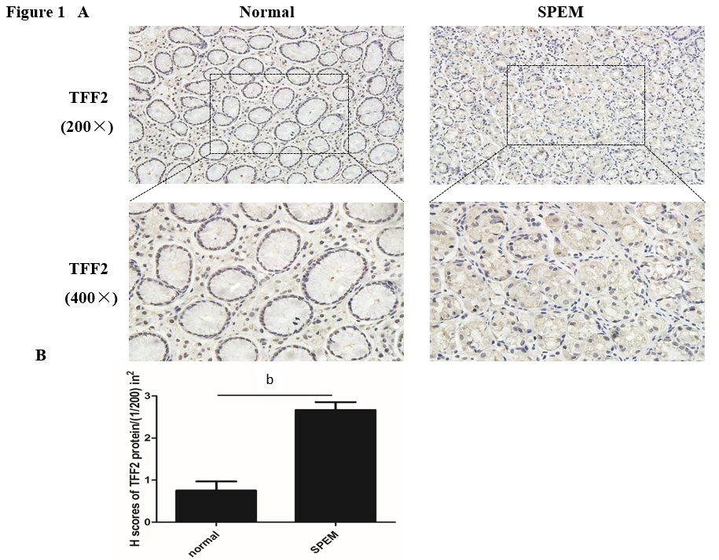
Figure 1 Immunohistochemical analysis of the expression of trefoil factor 2. A: Representative immunohistochemistry images of trefoil factor 2 in normal controls and spasmolytic polypeptide-expressing metaplasia (× 200, × 400). B: The expression of trefoil factor 2 in spasmolytic polypeptide-expressing metaplasia is much higher than that in normal controls (^{b}P < 0.01). TFF2: trefoil factor 2; SPEM: spasmolytic polypeptide-expressing metaplasia.
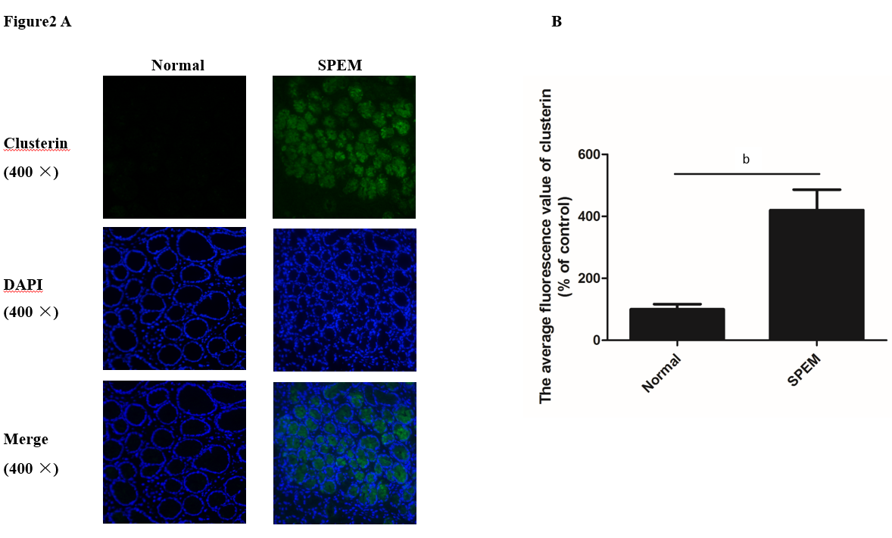
Figure 2 Representative immunofluorescence images of clusterin. A: The expression of clusterin in normal controls and spasmolytic polypeptide-expressing metaplasia by immunofluorescence (green: clusterin). B: The expression of clusterin in spasmolytic polypeptide-expressing metaplasia is much higher than that in normal controls (^{b}P < 0.01). SPEM: spasmolytic polypeptide-expressing metaplasia.
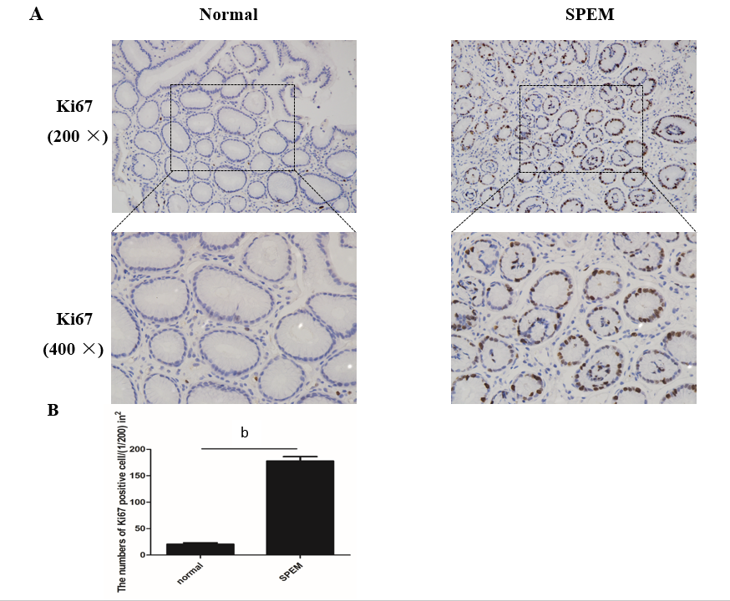
Figure 3 Immunohistochemical analysis of the expression of Ki67. A: Representative immunohistochemistry images of Ki67 in normal controls and spasmolytic polypeptide-expressing metaplasia (SPEM) (200 ×, 400 ×). B: The expression of Ki67 in spasmolytic polypeptide-expressing metaplasia is much higher than that in normal controls (^{b}P < 0.01). SPEM: spasmolytic polypeptide-expressing metaplasia.
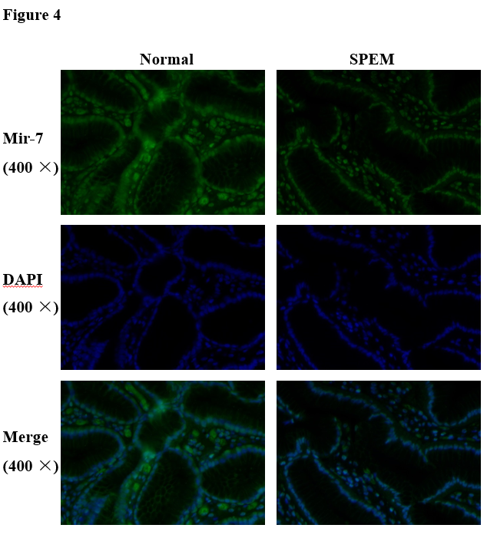
Figure 4 Fluorescence in situ hybridization analysis of microRNA-7 expression in spasmolytic polypeptide-expressing metaplasia and normal controls. The expression of microRNA-7 was downregulated in spasmolytic polypeptide-expressing metaplasia compared to in normal controls. SPEM: Spasmolytic polypeptide-expressing metaplasia; Mir-7: MicroRNA-7.
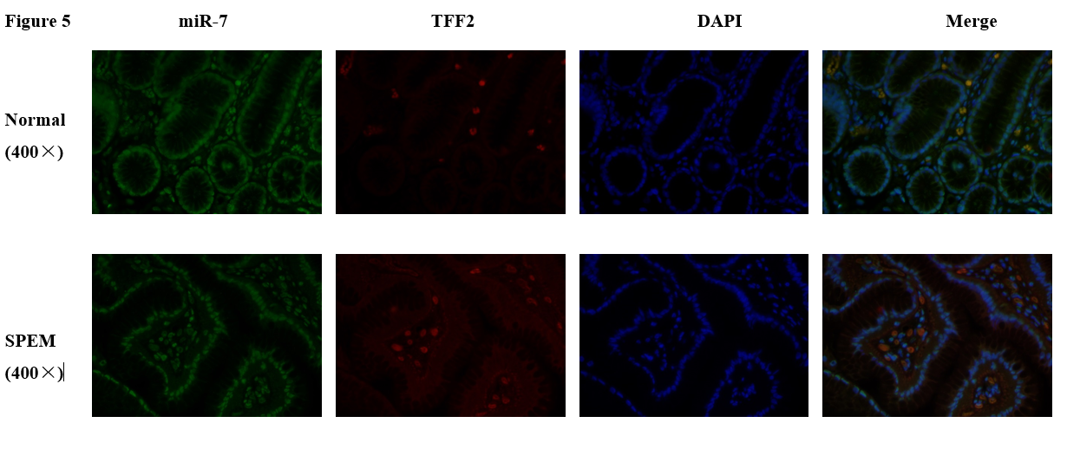
Figure 5 Representative fluorescence in situ hybridization images of microRNA-7 and trefoil factor 2 of human gastric mucosa (green: microRNA-7; red: trefoil factor 2; blue: DAPI). TFF2: trefoil factor 2; SPEM: Spasmolytic polypeptide-expressing metaplasia; miR-7: MicroRNA-7.
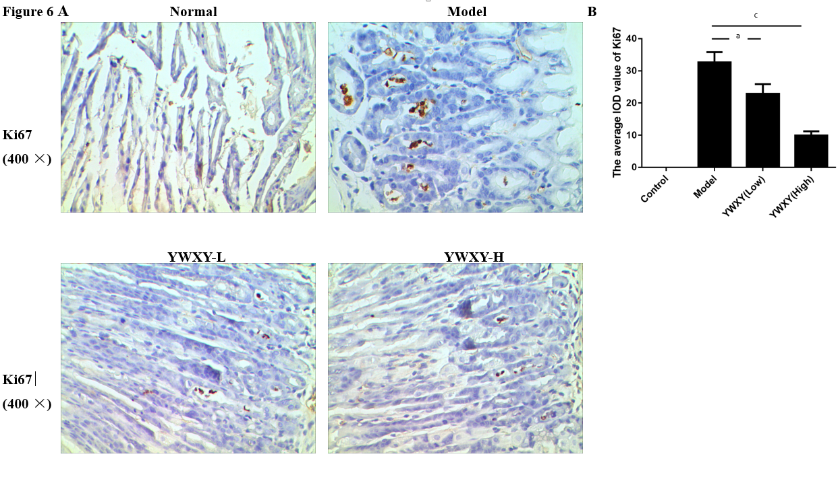
Figure 6 Expression of Ki67 in normal murine gastric mucosa and spasmolytic polypeptide-expressing metaplasia models. A: The expression of Ki67 was higher in the spasmolytic polypeptide-expressing metaplasia model than that in the normal control. B: Yiwei Xiaoyu granules had higher proliferative inhibition ability than spasmolytic polypeptide-expressing metaplasia models (ªP < 0.05, ^{c}P < 0.001). YWXY-L: low dose of Yiwei Xiaoyu granules; YWXY-H: high dose of Yiwei Xiaoyu granules.

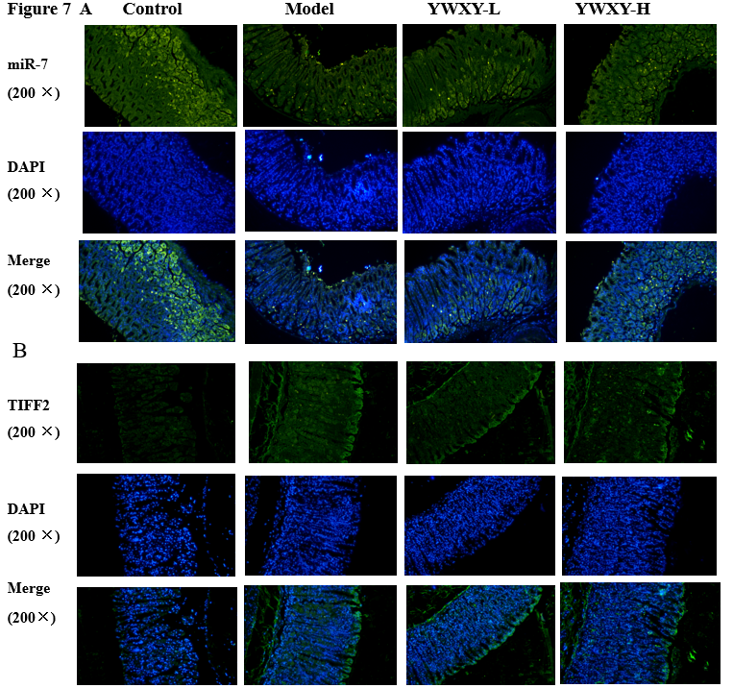
Figure 7 Expression of microRNA-7 and trefoil factor 2 in the murine gastric mucosa with Yiwei Xiaoyu granule administration. A: The expression of microRNA-7 for the spasmolytic polypeptide-expressing metaplasia mice model was restored with Yiwei Xiaoyu Granules (YWXY) administration (green: microRNA-7). B: The expression of trefoil factor 2 for the spasmolytic polypeptide-expressing metaplasia mice model was downregulated with Yiwei Xiaoyu administration. YWXY-H: high dose of Yiwei Xiaoyu granules; YWXY-L: low dose of Yiwei Xiaoyu granules; TFF2: trefoil factor 2; miR-7: MicroRNA-7.
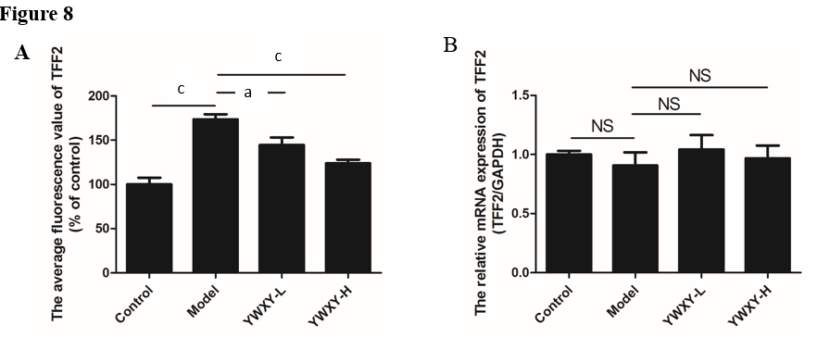
Figure 8 Yiwei Xiaoyu Granules administration could restore the expression of microRNA-7 by regulating trefoil factor 2 as measured by immunofluorescence but not reverse transcription-quantitative polymerase chain reaction. A: The expression of trefoil factor 2 in the model group was much higher than that in the control (P < 0.001). Intervening with Yiwei Xiaoyu granules (YWXY) could decrease the expression of trefoil factor 2 compared to the model (^{c}P < 0.001 in Yiwei Xiaoyu-High, ªP < 0.05 in Yiwei Xiaoyu-Low); B: There was no difference in the relative mRNA expression of trefoil factor 2 in different groups by reverse transcription-quantitative polymerase chain reaction. YWXY-H: high dose of Yiwei Xiaoyu Granules; YWXY-L: low dose of Yiwei Xiaoyu Granules; TFF2: trefoil factor 2; NS: Not significant.
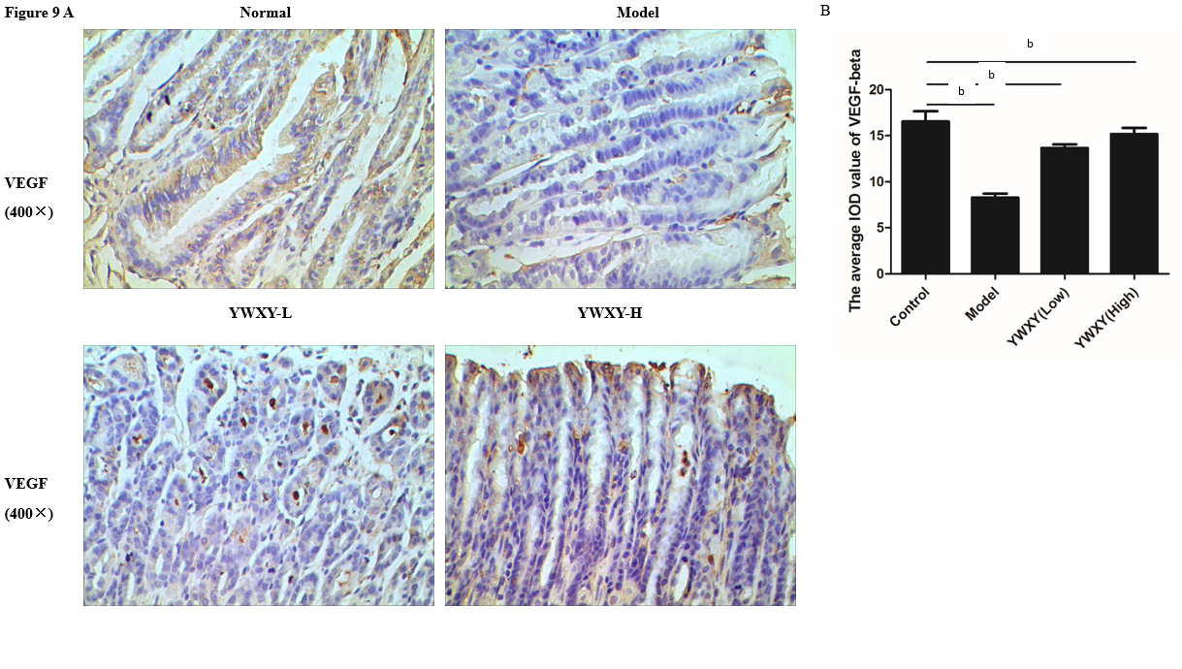
Figure 9 The expression of vascular endothelial growth factor-β was restored with Yiwei Xiaoyu granule administration in the spasmolytic polypeptide-expressing metaplasia lesions. A: The expression of vascular endothelial growth factor-β was upregulated with Yiwei Xiaoyu granules administration by immunohistochemistry measurement. B: Statistical differences existed between the control and the model (^{b}P < 0.01). YWXY-H: high dose of Yiwei Xiaoyu Granules; YWXY-L: low dose of Yiwei Xiaoyu Granules; VEGF: vascular endothelial growth factor.
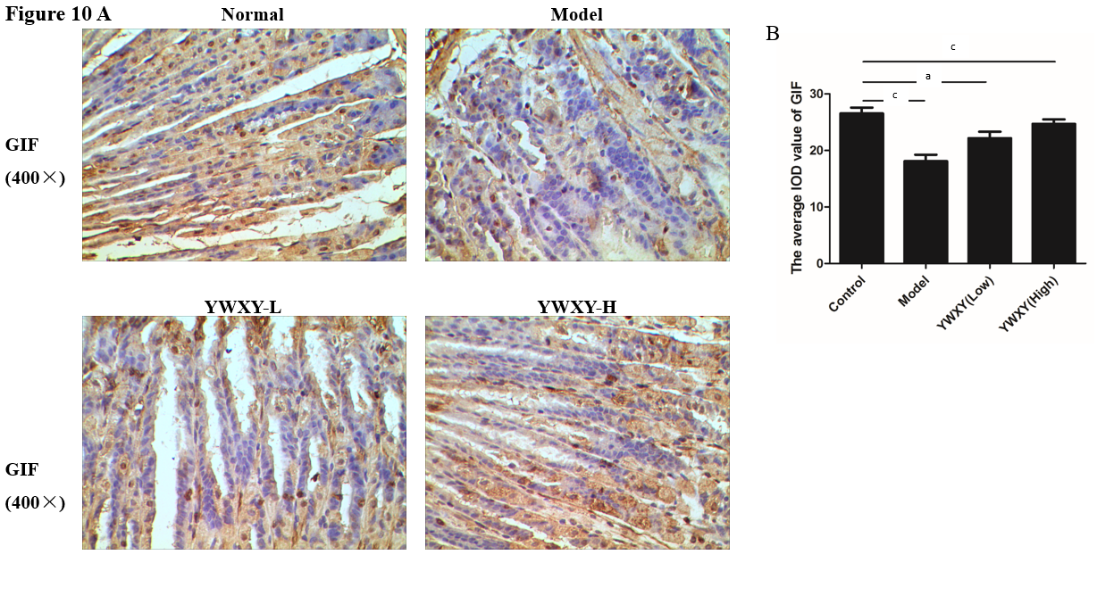
Figure 10 The expression of gastric intrinsic factor was restored with Yiwei Xiaoyu Granules administration in the spasmolytic polypeptide-expressing metaplasia lesions. A: The expression of gastric intrinsic factor was upregulated with Yiwei Xiaoyu Granules administration by immunohistochemistry. B: Statistics differences existed between the control and the model (ªP < 0.05, ^{c}P < 0.001). YWXY: Yiwei Xiaoyu Granules; YWXY-H: high dose of Yiwei Xiaoyu Granules; YWXY-L: low dose of Yiwei Xiaoyu Granules; GIF: gastric intrinsic factor.

