Name of Journal: World Journal of Clinical Cases
Manuscript NO: 66765
Manuscript Type: CASE REPORT

Synchronous concomitant pancreatic acinar cell carcin and gastric adenocarcinoma: A case report and review of literature

Fang T et al. Synchronous concomitant pancreatic and gastric cancer

Tian Fang, Ting-Ting Liang, Yi-Zhuo Wang, Hai-Tao Wu, Shu-Han Liu, Chang Wang

Tian Fang, Ting-Ting Liang, Yi-Zhuo Wang, Hai-Tao Wu, Shu-Han Liu, Chang Wang, Department of Oncology, First Hospital of Jilin University, Changchun 130021, Jilin Province, China

Author contributions: Fang T and Liang TT contributed equally to this work; Fang T carried out conceptualization, data sorting and manuscript writing; Liang TT carried out investigation and supervision; Wang YZ was responsible for visualization; Wu HT, Liu SH and Wang C were responsible for review and editing writing; all authors have read and approved the manuscript.

Corresponding author: Chang Wang, MD, Chief Doctor, Department of Oncology, First Hospital of Jilin University, No. 71 Xinmin Street, Changchun 130021, Jilin Province, China. wangchang@jlu.edu.cn

Received: April 5, 2021
Revised: July 19, 2021
Accepted: August 25, 2021
Published online: October 6, 2021

Abstract
BACKGROUND
Multiple primary malignant tumors are two or more malignancies in an individual without any relationship between the neoplasms. In recent years, an increasing number of cases have been reported. However, concomitant primary gastric and pancreatic cancer reported a relatively small incidence, involving no pancreatic acinar cell carcinoma reports. Here, we present the first case of concomitant pancreatic acinar cell carcinoma and gastric adenocarcinoma.

CASE SUMMARY
A 69-year-old male presented to our department with a history of vomiting, epigastric pain, and weight loss. Imaging revealed space-occupying lesions in the stomach and the tail of the pancreas, respectively. The patient underwent laparoscopic radical gastrectomy and pancreatectomy simultaneously. The pathologies of surgical specimens were completely different: The resected gastric specimen was moderate to poorly differentiated adenocarcinoma, whereas the pancreatic tumor was consistent with acinar cell carcinoma. The patient was treated with six cycles of oxaliplatin and S-1 chemotherapy. As of March 2021, the patient was healthy without any recurrence or metastasis. After thoroughly reviewing the literature on simultaneous pancreatic and gastric cancers at home and abroad, we discussed the clinical characteristics of these rare synchronous double cancers. Most of the cases had undergone surgery and adjuvant chemotherapy, and all of the cases were pathologically confirmed by the postoperative specimen.

CONCLUSION
Synchronous pancreatic acinar cells and gastric adenocarcinoma can occur and should be considered when tumors are found in these organs.

Key Words: Synchronous concomitant cancers; Pancreatic neoplasms; Stomach neoplasms; Pancreatic acinar cell carcinoma; Surgical procedures; Case report

©The Author(s) 2021. Published by Baishideng Publishing Group Inc. All rights reserved.

Citation: Fang T, Liang TT, Wang YZ, Wu HT, Liu SH, Wang C. Synchronous concomitant pancreatic acinar cell carcin and gastric adenocarcinoma: A case report and review of literature. World J Clin Cases 2021; 9(28): 8509-8515 URL: https://www.wjgnet.com/2307-8960/full/v9/i28/8509.htm DOI: https://dx.doi.org/10.12998/wjcc.v9.i28.8509

Core Tip: Acinar cell carcinoma of the pancreas is a rare form of pancreatic cancer, and the incidence of synchronous concomitant pancreatic and gastric cancer is relatively low. We report a patient with simultaneous acinar cell carcinoma of the pancreas with gastric cancer, and he underwent radical surgery for both the pancreas and the stomach. This is the first case of concomitant cancers related to pancreatic acinar cell carcinoma and gastric cancer. We also reviewed the literature on simultaneous pancreatic and gastric cancers.

INTRODUCTION
Pancreatic and gastric carcinoma are the second and fifth most common digestive system tumors, respectively^{[1]}. Pancreatic cancer is one of the deadliest malignancies and is usually diagnosed at an advanced stage, leading to poor overall survival, particularly the relatively low pancreatic acinar cell adenocarcinoma (PACC) incidence, accounting for approximately 1%–2% of exocrine pancreatic neoplasms^{[2]}. This report describes the first case of concomitant cancers related to PACC and gastric adenocarcinoma. Furthermore, we review the literature of synchronous gastric and pancreatic tumors in the PubMed, Web of Science, CNKI, and Embase databases and discuss the principles of treatment and prognosis of concomitant gastric and pancreatic cancer.

CASE PRESENTATION
Chief complaints
A 69-year-old male came to our department with a history of vomiting, epigastric pain for 3 mo, and weight loss of approximately 5 kg.

History of present illness
The patient developed vomiting, epigastric pain for 3 mo.

History of past illness
The patient had no past illness.

Personal and family history
Two younger brothers of patient had lung cancer and laryngocarcinoma, respectively.

Physical examination
The patient was afebrile at 36.3 ℃, the heart rate was 65 beats per min, respiration was 17 breaths per min, and blood pressure of 131/86 mmHg. Clinical abdominal examination showed tenderness in the upper abdomen without mass upon palpation, soft and relaxed, and no rebound pain.

Laboratory examinations
Laboratory test results were normal, including blood, urine, and stool were within the normal ranges. However, the carcinoembryonic antigen in tumor markers was slightly elevated at 4.06 ng/mL (normal values: < 3.4 ng/mL).

Imaging examinations
Gastroscopy revealed a large ulcer of approximately 5.5 cm × 6.6 cm × 0.5 cm originating from the gastric fundus, and pathological biopsy revealed gastric adenocarcinoma. In addition, abdominal contrast-enhanced computed tomography (CT) indicated uneven thickening in the antrum of the stomach with irregular mucosa and heterogeneous contrast enhancement on the antrum of the gastric wall and a space-occupying lesion of approximately 34 mm × 16 mm in the tail of the pancreas (Figure 1). However, there were no definite contraindications; therefore, the patient underwent laparoscopic exploration, which revealed the stomach and pancreatic masses. After evaluating the resectability of the gastric and pancreatic tumors, he underwent laparoscopic radical gastrectomy, gastric vagotomy, pancreatectomy, and splenectomy (Figure 2).

FINAL DIAGNOSIS
The resected stomach lesion was 5 cm × 5 cm × 1.5 cm, and the Lauren classification was the intestinal type. The pathology of the resected specimen from the stomach confirmed a moderately to poorly differentiated adenocarcinoma [pStage IIIB, T4aN2M0 per the American Joint Committee on Cancer (AJCC) eighth edition criteria] (Figure 3A). The tumor had invaded the serous membrane but did not involve the adjacent structures. Perineural and vascular infiltration were observed. Regional nodes were positive (4/32), and the resection margins were free of tumor cells. The cancer cells did not infiltrate the omentum, and there was no metastasis in the omentum lymph nodes.
Immunohistochemistry indicated positivity for pan-cytokeratin and villin and partial positivity for CK7 (Figure 3B). The tumor was negative for HER-2 (4B5) and CK20. The Ki-67 positivity was approximately 50% in a high-power field.
The volume of the resected pancreatic specimen was 4.1 cm × 2.2 cm × 1.5 cm. The pathology was consistent with PACC (pStage III, T3N1M0 per the AJCC eighth edition criteria) (Figure 4A and B). Perineural infiltration was observed, but there was no vascular infiltration. Regional nodes were negative, and the resection margins were free of tumor cells. Immunohistochemistry indicated positivity for CAM5.2, CK19, CK7, and membranous expression of beta-catenin and scattered positivity for carcinoembryonic antigen. The Ki-67 positivity was 30% in one high-power field (Figure 4C-F). The tumor was negative for vimentin, chromogranin A, synaptophysin, CD10, and CD56.

TREATMENT
One month after the operation, chemotherapy consisting of oxaliplatin and S-1 (SOX) was initiated and the patient was then treated with six chemotherapy cycles.

OUTCOME AND FOLLOW-UP
As of March 2021, the patient was healthy without any recurrence or metastasis.

DISCUSSION
Gastric cancer is characterized by a synchronous second primary cancer in 1.0%–5.0% of cases^{[3-5]}. This is the fourth most common cancer associated with pancreatic carcinoma, comprising approximately 5% of all cases of gastric carcinoma associated with carcinoma of other organs^{[3]}. Gastric cancer is the most common synchronous tumor associated with pancreatic cancer^{[6]}. Patients with pancreatic and stomach cancers demonstrated significantly better OS (33.9 mo) than patients with only pancreatic cancer (17.0 mo)^{[6]}. This may be because pancreatic cancer is generally early-stage when synchronous concomitant cancers are diagnosed.
A review of the literature on simultaneous pancreatic and gastric cancers at home and abroad revealed that synchronous concomitant tumors involving the two organs are rare, and PACC is more uncommon. Details of reported cases are shown in Table 1^{[7-20]}, including our case. The average age at diagnosis is 67 years (42–77 years), and men are twice as likely to be diagnosed with synchronous pancreatic and gastric cancer than women. Pancreatic ductal adenocarcinoma (PDAC) is the most common pancreatic tumor in these cases. Among the 17 synchronous concomitant cancer cases, PDAC accounted for 70.6% (12/17) and PACC accounted for 11.1% (2/17). The pathological type was not mentioned in the remaining three cases. The most common tumor location was the head of the pancreas, accounting for 66.7% of cases (10/15). Two cases of tumors in the body of the pancreas and three cases of tumors located in the tail of the pancreas have been described. In two cases, the tumor location was not reported. Eleven patients (64.7%) underwent surgery for pancreatic and gastric tumors. All were diagnosed pathologically after surgery—which is consistent with our case—and none were diagnosed before surgery. These patients underwent curative resection; this may indicate that these patients were diagnosed at earlier stages and are likely to have better prognoses than patients with only pancreatic cancer. Nevertheless, concomitant cancers exist, and a second tumor should not necessarily be considered as a metastasis from another organ, leading to misdiagnosis and the abandonment of surgical resection.
The clinical manifestations of PACC are related to the location and size of the tumor. Unlike patients with PDAC, patients with PACC present with nonspecific symptoms, including abdominal discomfort, weight loss, weakness, nausea, vomiting, melena, and diarrhea^{[21]}. However, the clinical symptoms of PDAC, such as painless obstructive jaundice, are uncommon in PACC^{[22]}.
Endoscopic ultrasonography (EUS) and imaging findings such as CT and magnetic resonance imaging (MRI) help achieve a correct preoperative diagnosis for concomitant cancers^{[23]}. CT is a valuable tool for the accurate preoperative evaluation of the local extent of gastric cancer; EUS can be used for histopathological confirmation^{[24]}. PACC tumors tend to be solid when small and contain cystic or necrotic areas when large. These tumors generally lack dilatation of the biliary or pancreatic ducts on CT^{[25]}. However, PACC can be difficult to diagnose based on radiological findings alone. EUS-guided fine-needle aspiration (EUS-FNA) has a very high sensitivity (> 85%) and specificity (> 95%) for diagnosis of malignancy in a solid pancreatic mass compared to cross-sectional imaging (CT/MRI)^{[26]}. Whereas the position of the pancreas is relatively deep and EUS-FNA is difficult. An experienced radiologist can give a preliminary imaging diagnosis of PDAC, which tends to be hypovascular, appearing hypoechoic on imaging^{[27]}. However, it is difficult to distinguish whether or not the primary tumor has metastasized to other organs in imaging, because tumors can also metastasize through the hematogenous or the lymphatic pathway in addition to direct invasion. If necessary, preoperative pathology must be performed to opt for the correct surgical approach. The present case of abdominal CT revealed a 41-mm heterogenous mass with a clear boundary in the tail of the pancreas, which is suggestive of a primary tumor.
The prevalence of pancreatic metastasis of gastric cancer is extremely rare with, only 12 cases of isolated pancreatic metastasis in gastric cancer have been reported in the literature^{[28]}. Correspondingly, metastatic gastric tumor secondary to pancreatic carcinoma is clinically unusual, with only seven cases of gastric metastasis of pancreatic cancer have been reported in the literature^{[29-35]}. In all these cases, the histopathology and immunohistochemical of primary cancer and metastatic cancer are consistent. However, this is completely different from our case. The histopathology of the two resected specimens was different, showing adenocarcinoma in the stomach and acinar cell carcinoma in the pancreas. Moreover, immunohistochemical studies showed differences in staining at the two sites. Finally, we concluded that both of them were primary tumors and not metastatic tumors.
PACC is associated with a better prognosis than PDAC but a worse prognosis than pancreatic neuroendocrine tumors^{[36]}. Metastatic PACCs are generally not curable and are treated with systemic chemotherapy^{[37]}. The treatment regimens have not yet been standardized. Takahashi et al^{[38]} reported that platinum-containing regimens exhibited some potential efficacy in patients with advanced PACC. The response to platinum-containing regimens was 40%, and the overall survival tended to be better in patients who had received a platinum-containing regimen^{[38]}. Simultaneous removal of concomitant primary carcinomas should be attempted; radiotherapy and chemotherapy should also be considered for patients who need adjuvant treatment decided by both disease stages^{[39]}. If adjuvant treatment is required, the physician should select an antineoplastic therapy that considers both cancers. In our case—whether gastric adenocarcinoma or PACC—the optimal chemotherapy regimen was SOX.

CONCLUSION
The presence of synchronous multiple primary malignancies does not necessarily signify an unfavorable prognosis as long as adequate diagnosis and effective treatment are performed. In the future, well-powered clinical trials will be needed to augment our understanding of these processes.

REFERENCES
1 Siegel RL, Miller KD, Jemal A. Cancer statistics, 2020. CA Cancer J Clin 2020; 70: 7-30 [PMID: 31912902 DOI: 10.3322/caac.21590]
2 Sridharan V, Mino-Kenudson M, Cleary JM, Rahma OE, Perez K, Clark JW, Clancy TE, Rubinson DA, Goyal L, Bazerbachi F, Visrodia KH, Qadan M, Parikh A, Ferrone CR, Casey BW, Fernandez-Del Castillo C, Ryan DP, Lillemoe KD, Warshaw AL, Krishnan K, Hernandez-Barco YG. Pancreatic acinar cell carcinoma: A multi-center series on clinical characteristics and treatment outcomes. Pancreatology 2021 [PMID: 34023183 DOI: 10.1016/j.pan.2021.05.011]
3 Ha TK, An JY, Youn HG, Noh JH, Sohn TS, Kim S. Surgical outcome of synchronous second primary cancer in patients with gastric cancer. Yonsei Med J 2007; 48: 981-987 [PMID: 18159590 DOI: 10.3349/ymj.2007.48.6.981]
4 Lee JH, Bae JS, Ryu KW, Lee JS, Park SR, Kim CG, Kook MC, Choi IJ, Kim YW, Park JG, Bae JM. Gastric cancer patients at high-risk of having synchronous cancer. World J Gastroenterol 2006; 12: 2588-2592 [PMID: 16688807 DOI: 10.3748/wjg.v12.i16.2588]
5 Buyukasik O, Hasdemir AO, Gulnerman Y, Col C, Ikiz O. Second primary cancers in patients with gastric cancer. Radiol Oncol 2010; 44: 239-243 [PMID: 22933922 DOI: 10.2478/v10019-010-0048-2]
6 Shin SJ, Park H, Sung YN, Yoo C, Hwang DW, Park JH, Kim KP, Lee SS, Ryoo BY, Seo DW, Kim SC, Hong SM. Prognosis of Pancreatic Cancer Patients with Synchronous or Metachronous Malignancies from Other Organs Is Better than Those with Pancreatic Cancer Only. Cancer Res Treat 2018; 50: 1175-1185 [PMID: 29268568 DOI: 10.4143/crt.2017.494]
7 Eriguchi N, Aoyagi S, Hara M, Okuda K, Tamae T, Fukuda S, Hashino K, Hashimoto M, Sato S, Furukawa S, Fujiki K, Jimi A. A case of synchronous double cancers of the pancreas and stomach. Kurume Med J 2000; 47: 169-171 [PMID: 10948656 DOI: 10.2739/kurumemedj.47.169]
8 Kubota E, Kataoka H, Hayashi K, Kamiya T, Sasaki M, Ogasawara N, Yamada T, Wada T, Mori Y, Mizoshita T, Shimura T, Mizushima T, Okamoto Y, Ohara H, Joh T. Advanced stomach and pancreas cancer successfully treated with combination chemotherapy with S-1/paclitaxel/lentinan. Hepatogastroenterology 2009; 56: 106-110 [PMID: 19453038]
9 Meng L, Fang SH, Jin M. An unusual case of pancreatic and gastric neoplasms (2010: 12b). Malignant GISTs originating from the pancreas and stomach. Eur Radiol 2011; 21: 663-665 [PMID: 21287351 DOI: 10.1007/s00330-010-1893-5]
10 Shen ZL, Wang S, Ye YJ, Wang YL, Sun KK, Yang XD, Jiang KW. Carcinosarcoma of pancreas with liver metastasis combined with gastrointestinal stromal tumour of the stomach: is there a good prognosis with the complete resection? Eur J Cancer Care (Engl) 2010; 19: 118-123 [PMID: 19486125 DOI: 10.1111/j.1365-2354.2008.00977.x]
11 Muroni M, D'Angelo F, Pezzatini M, Sebastiani S, Noto S, Pilozzi E, Ramacciato G. Synchronous gastric adenocarcinoma and pancreatic ductal adenocarcinoma. Hepatobiliary Pancreat Dis Int 2010; 9: 97-99 [PMID: 20133238]
12 Dasanu CA, Mesologites T, Trikudanathan G. Synchronous tumors: adenosquamous carcinoma of pancreas and GIST of stomach. J Gastrointest Cancer 2011; 42: 186-189 [PMID: 20623381 DOI: 10.1007/s12029-010-9187-3]
13 Kourie HR, Markoutsaki N, Roussel H, Rahmi G, Van der Stiegel M, Palazzo L, Fabre M, Cuenod CA, Dubreuil O, Landi B, Rougier P, Taieb J. Double pancreatic and gastric adenocarcinomas: a rare association. Clin Res Hepatol Gastroenterol 2013; 37: e137-e140 [PMID: 23158953 DOI: 10.1016/j.clinre.2012.09.008]
14 Ohtsubo K, Ishikawa D, Nanjo S, Takeuchi S, Yamada T, Mouri H, Yamashita K, Yasumoto K, Gabata T, Matsui O, Ikeda H, Takamatsu Y, Iwakami S, Yano S. Synchronous triple cancers of the pancreas, stomach, and cecum treated with S-1 followed by pancrelipase treatment of pancreatic exocrine insufficiency. JOP 2013; 14: 515-520 [PMID: 24018598 DOI: 10.6092/1590-8577/1719]
15 Baba H, Elfahssi M, Belhamidi MS, Elhjouji A, Bounaim A, Ali AA, Sair K, Zentar A. An exceptional collision tumor: gastric calcified stromal tumor and pancreatic adenocarcinoma. Pan Afr Med J 2015; 22: 289 [PMID: 26966485 DOI: 10.11604/pamj.2015.22.289.7574]
16 Ghothim M, Havlík R, Skalický P, Klos D, Vrba R, Strážnická J, Skopal L, Neoral Č, Loveček M. [Synchronous cancer duplicities of pancreas and stomach/kidney and their surgical treatment]. Rozhl Chir 2015; 94: 251-255 [PMID: 26174345]
17 Fiore M, de Stefano G, Coppola N, Giorgio A. Synchronous and metachronous gastric gist with pancreatic adenocarcinoma: report of 2 cases and a review of literature. Gastroenterol Hepatol Bed Bench 2015; 8: 298-301 [PMID: 26468351]
18 Santos-Fernández J, Arenal-Vera JJ, Cítores-Pascual MÁ, Fernández-Orcajo P, de-Benito-Sanz M, Benito-Fernández C, Tinoco-Carrasco C. Synchronic gastric and pancreatic ductal adenocarcinoma. A case report. Rev Esp Enferm Dig 2015; 107: 642-643 [PMID: 26437985 DOI: 10.17235/reed.2015.3720/2014]
19 Arabadzhieva E, Yonkov A, Bonev S, Bulanov D, Taneva I, Vlahova A, Dikov T, Dimitrova V. A rare case with synchronous gastric gastrointestinal stromal tumor, pancreatic neuroendocrine tumor, and uterine leiomyoma. World J Surg Oncol 2016; 14: 287 [PMID: 27846844 DOI: 10.1186/s12957-016-1051-x]
20 Yonenaga Y, Kurosawa M, Mise M, Yamagishi M, Higashide S. Pancreatic-type Acinar Cell Carcinoma of the Stomach Included in Multiple Primary Carcinomas. Anticancer Res 2016; 36: 2855-2864 [PMID: 27272797]
21 Wisnoski NC, Townsend CM Jr, Nealon WH, Freeman JL, Riall TS. 672 patients with acinar cell carcinoma of the pancreas: a population-based comparison to pancreatic adenocarcinoma. Surgery 2008; 144: 141-148 [PMID: 18656619 DOI: 10.1016/j.surg.2008.03.006]
22 Zhou W, Han X, Fang Y, Han S, Cai Y, Kuang T, Lou W, Wang D. Clinical Analysis of Acinar Cell Carcinoma of the Pancreas: A Single-Center Experience of 45 Consecutive Cases. Cancer Control 2020; 27: 1073274820969447 [PMID: 33121259 DOI: 10.1177/1073274820969447]
23 Tatli S, Mortele KJ, Levy AD, Glickman JN, Ros PR, Banks PA, Silverman SG. CT and MRI features of pure acinar cell carcinoma of the pancreas in adults. AJR Am J Roentgenol 2005; 184: 511-519 [PMID: 15671372 DOI: 10.2214/ajr.184.2.01840511]
24 Hwang SW, Lee DH, Lee SH, Park YS, Hwang JH, Kim JW, Jung SH, Kim NY, Kim YH, Lee KH, Kim HH, Park DJ, Lee HS, Jung HC, Song IS. Preoperative staging of gastric cancer by endoscopic ultrasonography and multidetector-row computed tomography. J Gastroenterol Hepatol 2010; 25: 512-518 [PMID: 20370729 DOI: 10.1111/j.1440-1746.2009.06106.x]
25 Liu K, Peng W, Zhou Z. The CT findings of pancreatic acinar cell carcinoma in five cases. Clin Imaging 2013; 37: 302-307 [PMID: 23465983 DOI: 10.1016/j.clinimag.2012.06.003]
26 Narkhede RA, Desai GS, Prasad PP, Wagle PK. Diagnosis and Management of Pancreatic Adenocarcinoma in the Background of Chronic Pancreatitis: Core Issues. Dig Dis 2019; 37: 315-324 [PMID: 30699408 DOI: 10.1159/000496507]
27 Wangermez M. Endoscopic ultrasound of pancreatic tumors. Diagn Interv Imaging 2016; 97: 1287-1295 [PMID: 27866871 DOI: 10.1016/j.diii.2016.10.002]
28 Yokoyama Y, Sakata H, Uekusa T, Tajima Y, Ishimaru M. Solitary pancreatic metastasis of gastric cancer with synchronous pancreatic ductal carcinoma: A case report. Int J Surg Case Rep 2020; 70: 164-167 [PMID: 32416485 DOI: 10.1016/j.ijscr.2020.04.006]
29 Umezaki N, Hashimoto D, Nakagawa S, Yamao T, Tsukamoto M, Kitano Y, Arima K, Yamamura K, Miyata T, Okabe H, Chikamoto A, Matsumura F, Baba H. Cystic gastric metastasis from pancreatic cancer. Surg Case Rep 2018; 4: 31 [PMID: 29633044 DOI: 10.1186/s40792-018-0443-2]
30 Takahashi M, Yoshitomi H, Kato A, Furukawa K, Takayashiki T, Kuboki S, Takano S, Sugiura K, Kawasaki K, Miyazaki M, Ohtsuka M. A case of successfully resected metachronous gastric and gallbladder metastases from pancreatic body cancer. Surg Case Rep 2019; 5: 21 [PMID: 30758733 DOI: 10.1186/s40792-019-0581-1]
31 Sasajima J, Okamoto K, Taniguchi M. Hematogenous Gastric Metastasis of Pancreatic Cancer. Case Rep Gastroenterol 2016; 10: 75-80 [PMID: 27403106 DOI: 10.1159/000444249]
32 Nakazuru S, Sakakibara Y, Ishida H, Mori K, Mita E. Gastric metastasis from pancreatic neuroendocrine tumor. Gastrointest Endosc 2018; 88: 559-560 [PMID: 29634914 DOI: 10.1016/j.gie.2018.04.008]
33 Rothermel LD, Strosberg C, Centeno BA, Malafa MP. Case Report of Isolated Gastric Metastasis of Pancreatic Cancer From a Diagnostic Biopsy: Management of a Rare Oncologic Entity. Cancer Control 2020; 27: 1073274820904042 [PMID: 32107943 DOI: 10.1177/1073274820904042]
34 Ito T, Inokuma T. Gastric metastasis of pancreatic neuroendocrine tumor 5 years after surgical resection of the primary lesion. Dig Endosc 2015; 27: 781 [PMID: 26257244 DOI: 10.1111/den.12531]
35 Takamori H, Kanemitsu K, Tsuji T, Kusano S, Chikamoto A, Okuma T, Iyama K. Metastatic gastric tumor secondary to pancreatic adenocarcinoma. J Gastroenterol 2005; 40: 209-212 [PMID: 15770407 DOI: 10.1007/s00535-004-1524-5]
36 Huang X, Li M, Zhang L, Xiong J, Lu H, Tian B. Clinical characteristics and treatment analysis of pancreatic acinar cell carcinoma: A single institutional comparison to pancreatic ductal adenocarcinoma. Surg Oncol 2021; 37: 101528 [PMID: 33611029 DOI: 10.1016/j.suronc.2021.101528]
37 Al-Hader A, Al-Rohil RN, Han H, Von Hoff D. Pancreatic acinar cell carcinoma: A review on molecular profiling of patient tumors. World J Gastroenterol 2017; 23: 7945-7951 [PMID: 29259370 DOI: 10.3748/wjg.v23.i45.7945]
38 Takahashi H, Ikeda M, Shiba S, Imaoka H, Todaka A, Shioji K, Yane K, Kojima Y, Kobayashi S, Asagi A, Ozaka M, Takada R, Nagashio Y, Horiguchi S, Kasuga A, Suzuki E, Terashima T, Ueno M, Morizane C, Furuse J. Multicenter Retrospective Analysis of Chemotherapy for Advanced Pancreatic Acinar Cell Carcinoma: Potential Efficacy of Platinum- and Irinotecan-Containing Regimens. Pancreas 2021; 50: 77-82 [PMID: 33370026 DOI: 10.1097/MPA.0000000000001718]
39 Fontenot J, Spieler B, Hudson C, Boulmay B. Pancreatic acinar cell carcinoma--literature review and case report of a 56-year-old man presenting with abdominal pain. Radiol Case Rep 2020; 15: 39-43 [PMID: 31737144 DOI: 10.1016/j.radcr.2019.10.009]

Footnotes
Informed consent statement: Informed consent was obtained from the patient.

Conflict-of-interest statement: All the authors are aware of the content of the manuscript and have no conflict of interest to disclose.

CARE Checklist (2016) statement: The authors have read the CARE Checklist (2016), and the manuscript was prepared and revised according to the CARE Checklist (2016).

Open-Access: This article is an open-access article that was selected by an in-house editor and fully peer-reviewed by external reviewers. It is distributed in accordance with the Creative Commons Attribution NonCommercial (CC BY-NC 4.0) license, which permits others to distribute, remix, adapt, build upon this work non-commercially, and license their derivative works on different terms, provided the original work is properly cited and the use is non-commercial. See: http://creativecommons.org/Licenses/by-nc/4.0/

Manuscript source: Unsolicited manuscript

Peer-review started: April 5, 2021
First decision: July 5, 2021
Article in press: August 25, 2021

Specialty type: Medicine, research and experimental
Country/Territory of origin: China
Peer-review report’s scientific quality classification
Grade A (Excellent): 0
Grade B (Very good): 0
Grade C (Good): C
Grade D (Fair): 0
Grade E (Poor): 0

P-Reviewer: Fusaroli P S-Editor: Fan JR L-Editor: A P-Editor: Li JH

Figure Legends
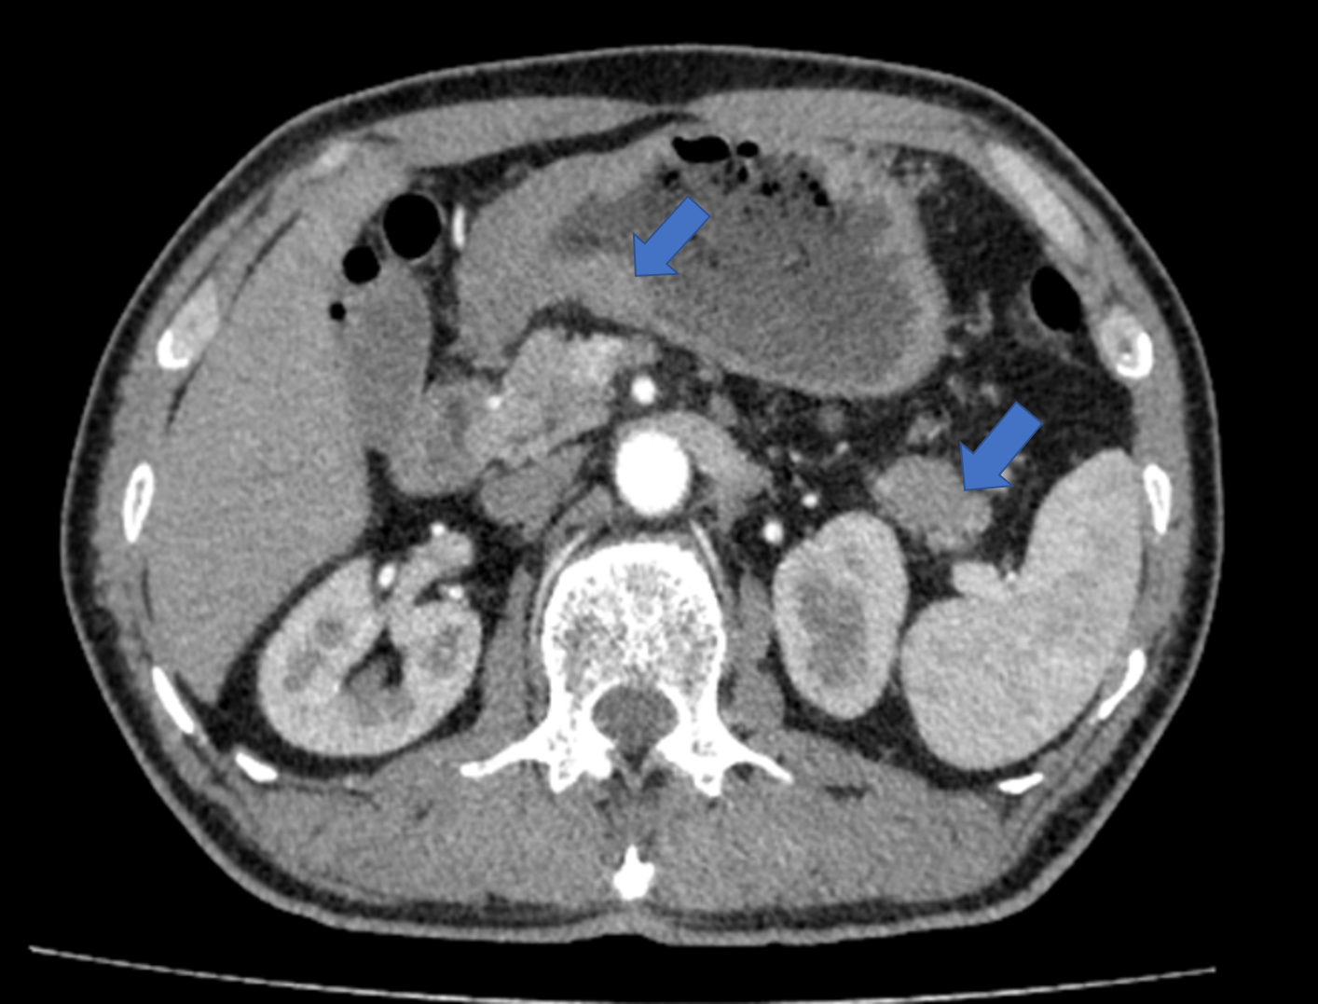
Figure 1 Imaging examinations performed before surgery. On contrast-enhanced computed tomography of stomach, arrow on the left showed uneven thickened with irregular mucosa and heterogeneous contrast enhancement on the antrum of gastric wall; arrow on the right indicated a space-occupying lesion about 34 mm × 16 mm in the tail of the pancreas.
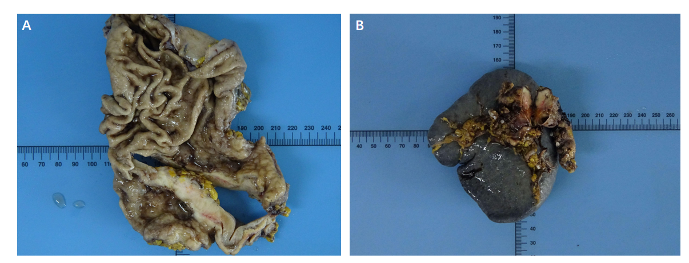
Figure 2 Resection specimen. A: Resection specimen of gastric tumor; B: Resection specimen of pancreatic tumor.
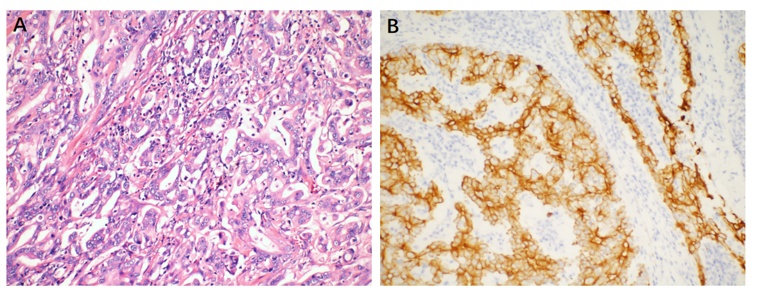
Figure 3 Microscopic examinations of gastric. A: Routine histology, stained using hematoxylin-eosin, shows gastric adenocarcinoma (magnification: × 200); B: Immunohistochemical staining of gastric tumor cells is partial positive for Cytokeratin 7 (magnification: × 200).
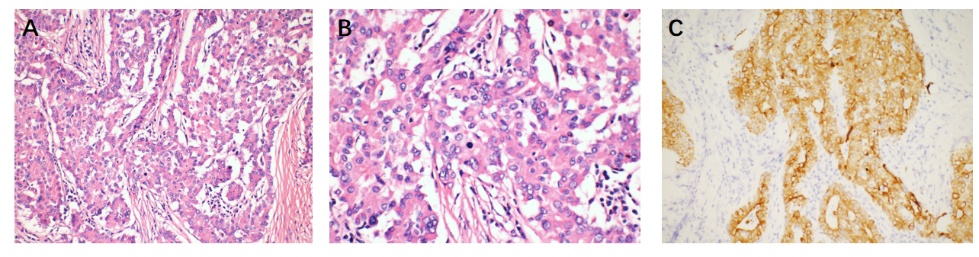
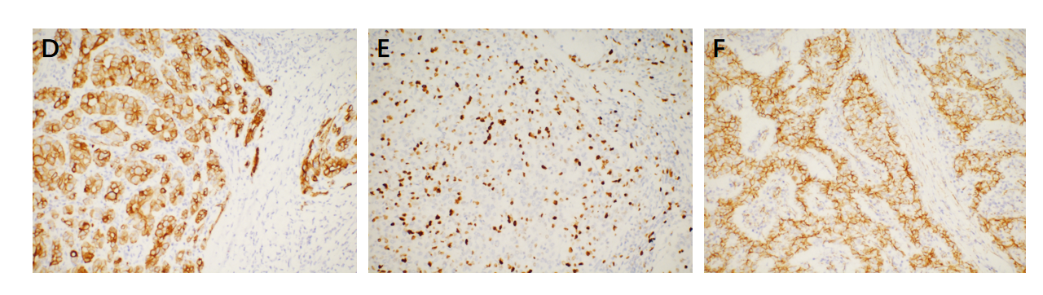
Figure 4 Microscopic examinations of pancreas. A: Routine histology, stained using hematoxylin-eosin, shows pancreatic acinar cell adenocarcinoma (magnification: × 200); B: Nuclear division in pancreatic acinar cell carcinoma (magnification: × 400); C: Immunohistochemical staining of pancreatic tumor cells: CAM5.2 expression in pancreatic tumor (magnification: × 200); D: CK19 expression in pancreatic tumor (magnification: × 200); E: Ki-67 partial expression in pancreatic tumor (+ 30%) (magnification: × 200); F: Membranous expression of beta-catenin in pancreatic tumor (magnification: × 200).

Table 1 Reported cases of synchronous gastric and pancreatic tumors
Ref. | Age | Gender | Gastric tumor  location | Gastric histology | Pancreatic tumor location | Pancreatic histology | Treatment
Eriguchi et al^{[7]}, 2000 | 76 | Male | Upper gastric angle | Moderately differentiated tubular adenocarcinoma | Not mentioned | Well to moderately differentiated tubular adenocarcinoma | Surgically treated
Kubota et al^{[8]}, 2009 | 67 | Male | Not mentioned | Moderately differentiated adenocarcinoma | Not mentioned | Absence of pancreatic histology | Chemotherapy: S-1, paclitaxel and lentinan
Meng et al^{[9]}, 2011 | 42 | Male | Gastric antrum | Gastric GIST | Pancreatic head | Pancreatic GIST | Surgically treated
Shen et al^{[10]}, 2010 | 72 | Female | Major gastric curvature | Gastric GIST | The head of the pancreas | Poorly differentiated PDAC; malignant fibrous histiocytoma | Surgically treated
Muroni et al^{[11]}, 2010 | 73 | None | Gastric antrum and pyloric portion | Moderately differentiated adenocarcinoma | Uncinate portion of the pancreas | Poorly differentiated PDAC | Surgically treated
Dasanu et al^{[12]}, 2011 | 75 | Male | Not mentioned | GIST | The head of the pancreas | Moderately to poorly differentiated carcinoma | Surgically treated
Kourie et al^{[13]}, 2013. case 1 | 56 | Male | Anterior part of the antrum | Poorly differentiated adenocarcinoma with independent mucus-secreting cells | The head of the pancreas | Necrotic ductal adenocarcinoma | Chemotherapy: Folfirinox
Kourie et al^{[13]}, 2013. case 2 | 62 | Male | Gastric wall of the greater curvature | Gastric adenocarcinoma with mucinous component | Tail of the pancreas | Tubular adenocarcinoma (ck7+; ck20-; ck19+) | Chemotherapy: Folfirinox
Ohtsubo et al^{[14]}, 2013 | 77 | Male | In the middle of stomach | Adenocarcinoma stage IB, T2bN0M0 | Pancreatic head | Adenocarcinoma stage IIA, T3N0M0 | Treated with chemotherapy: S-1
Baba et al^{[15]}, 2015 | 70 | Male | The fundal region and greater curvature of the stomach | Low grade gastric calcified stromal tumor (GIST) | The head of the pancreas | Adenocarcinoma | Surgically treated
Ghothim et al^{[16]}, 2015. case 1 | 73 | Male | The antrum of the stomach | Adenocarcinoma (pT1N1M0 stage IB, G2) | The head of the pancreas | Ductal pancreatic cancer. (pT2N1M0, stage IIB, G3) | Surgically treated; gemcitabine in six cycles
Ghothim et al^{[16]}, 2015. case 3 | 74 | Male | The antrum of the stomach | Gastric adenocarcinoma diffuse type (pT2bN2M0, G3) | Pancreatic head | Papillary mucinous carcinoma (pT2N0M0, stage IB, G1) | Surgically treated; Radiotherapy and chemotherapy
Fiore et al^{[17]}, 2015. case 1 | 63 | Male | Not mentioned | Gastric GIST (T2N0) | Pancreatic head | Adenocarcinoma (T2N0) | Surgically treated
Santos-Fernández et al^{[18]}, 2015 | 64 | Female | Prepiloric antral ulcer | Well differentiated gastric adenocarcinoma | Pancreatic tail | Pancreatic adenocarcinoma | Not mentioned
Arabadzhieva et al^{[19]}, 2016 | 60 | Female | In the pyloric area | Gastric GIST | Pancreatic body | Pancreatic neuroendocrine tumor | Surgically treated
Yonenaga et al^{[20]}, 2016 | 63 | Male | Antrum of the stomach | Poorly differentiated adenocarcinoma. | The body of the pancreas | PACC | Chemotherapy
Our case, 2021 | 69 | Male | Antrum of the stomach | Gastric adenocarcinoma | The tail of the pancreas | PACC | Surgically treated; Chemotherapy
GIST: Gastrointestinal stromal tumors; PDAC: Pancreatic ductal adenocarcinoma; PACC: Pancreatic acinar cell carcinoma.

Published by Baishideng Publishing Group Inc
7041 Koll Center Parkway, Suite 160, Pleasanton, CA 94566, USA
Telephone: +1-925-3991568
E-mail: bpgoffice@wjgnet.com
Help Desk: https://www.f6publishing.com/helpdesk
https://www.wjgnet.com

© 2021 Baishideng Publishing Group Inc. All rights reserved.

