Name of journal: World Journal of Gastrointestinal Pathophysiology
ESPS Manuscript NO: 10848
Columns: TOPIC HIGHLIGHT

WJGP 5th Anniversary Special Issues (9): Gastrointestinal bleeding

Diagnosis of gastrointestinal bleeding: A practical guide for clinicians

Kim BSM et al. Diagnostic guide to gastrointestinal bleeding

Bong Sik Matthew Kim, Bob T Li, Alexander Engel, Jaswinder S Samra, Stephen Clarke, Ian D Norton, Angela E Li

Bong Sik Matthew Kim, Ian D Norton, Department of Gastroenterology, Royal North Shore Hospital, St Leonards NSW 2065, Sydney, Australia

Bob T Li, Stephen Clarke, Department of Medical Oncology, Royal North Shore Hospital, St Leonards NSW 2065, Sydney, Australia

Alexander Engel, Department of Colorectal Surgery, Royal North Shore Hospital, St Leonards NSW 2065, Sydney, Australia

Jaswinder S Samra, Department of Gastrointestinal Surgery, Royal North Shore Hospital, St Leonards NSW 2065, Sydney, Australia

Bob T Li, Alexander Engel, Jaswinder S Samra, Stephen Clarke, Ian D Norton, Sydney Medical School, University of Sydney, Camperdown NSW 2050, Sydney, Australia

Jaswinder S Samra, Angela E Li, Australian School of Advanced Medicine, Macquarie University, North Ryde NSW 2109, Sydney, Australia

Author contributions: Kim BSM and Li BT equally contributed to writing the initial manuscript; Samra JS and Norton ID contributed to the Overt (Acute) GI Bleeding section; Norton ID provided the photographic images; Li AE produced the algorithms; Engel A and Clarke S appraised the overall work; Li BT coordinated the revision of final manuscript and submitted it on behalf of co-authors. All authors contributed to the conception and design of the manuscript.

Correspondence to: Dr. Bob T Li, Department of Medical Oncology, Royal North Shore Hospital, Reserve Rd, St Leonards NSW 2065, Sydney, Australia. bob.li@med.usyd.edu.au
Telephone: +61-2-94631172 Fax: +61-2-94631092

Received: April 22, 2014 Revised: July 15, 2014
Accepted: August 27, 2014

Published online:

Abstract
Gastrointestinal bleeding is a common problem encountered in the emergency department and in the primary care setting. Acute or overt gastrointestinal bleeding is visible in the form of hematemesis, melena or hematochezia. Chronic or occult gastrointestinal bleeding is not apparent to the patient and usually presents as positive fecal occult blood or iron deficiency anemia. Obscure gastrointestinal bleeding is recurrent bleeding when the source remains unidentified after upper endoscopy and colonoscopic evaluation and is usually from the small intestine. Accurate clinical diagnosis is crucial and guides definitive investigations and interventions. This review summarizes the overall diagnostic approach to gastrointestinal bleeding and provides a practical guide for clinicians.

© 2014 Baishideng Publishing Group Inc. All rights reserved.

Key words: Gastrointestinal hemorrhage; Diagnostic Techniques; Endoscopy; Colonoscopy; Capsule endoscopy; Enteroscopy; Computed tomography; Angiography

Core tip: This review provides a practical diagnostic guide for clinicians who encounter patients with suspected gastrointestinal bleeding in the hospital and primary health care settings. Clinical presentations of gastrointestinal bleeding are classified as overt (acute), occult (chronic) or obscure and the corresponding diagnostic algorithms are illustrated through review of the key evidence and consensus guidelines. Upper endoscopy and colonoscopy are the mainstay of initial investigations. Angiography and radionuclide imaging are best suited for acute overt gastrointestinal (GI) bleeding. Capsule endoscopy and deep enteroscopy play significant roles in the diagnosis of obscure GI bleeding, usually from the small bowel.

Kim BSM, Li BT, Engel A, Samra JS, Clarke S, Norton ID, Li AE. Diagnosis of gastrointestinal bleeding: A practical guide for clinicians. World J Gastrointest Pathophysiol 2014; In press

INTRODUCTION
Gastrointestinal (GI) bleeding is a common problem medical practitioners encounter in the emergency department and in the primary care setting^{[1]}. Annual hospital admissions for GI bleeding in the United States and United Kingdom have been estimated at up to 150 patients per 100000 population with a mortality rate of 5%-10%^{[2-5]}. While GI bleeding can be potentially life-threatening, it has been shown that many cases can be safely managed on an outpatient basis^{[6]}. The accurate diagnosis of GI bleeding relies on prompt resuscitation, initial risk evaluation, provisional clinical diagnosis followed by appropriate definitive investigation which enables specific interventions. This review provides a practical diagnostic guide for clinicians who may encounter patients with suspected GI bleeding.

DEFINITIONS
Overt (acute) vs occult (chronic) vs obscure
Although GI bleeding can be a result of benign pathology, life-threatening hemorrhage, varices, ulceration and malignant neoplasms need to be considered and carefully excluded^{[7, 8]}. Given the wide range of underlying pathology and the differences in their appropriate diagnostic approach, it is crucial for clinicians to define the type of GI bleeding based on clinical presentation.
Depending on the rate of blood loss, GI bleeding can manifest in several forms and can be classified as overt, occult or obscure. Overt GI bleeding, otherwise known as acute GI bleeding, is visible and can present in the form of hematemesis, “coffee-ground” emesis, melena, or hematochezia. Occult or chronic GI bleeding as a result of microscopic hemorrhage can present as Hemoccult-positive stools with or without iron deficiency anemia^{[9, 10]}. The American Gastroenterological Association defines occult GI bleeding as the initial presentation of a positive fecal occult blood test (FOBT) result and/or iron-deficiency anemia when there is no evidence of visible blood loss to the patient or clinician^{[11]}. Obscure GI bleeding refers to recurrent bleeding in which a source is not identified after upper endoscopy and colonoscopy. Obscure bleeding may be either overt or occult^{[10-12]}.

Upper vs lower
Upper GI bleeding includes hemorrhage originating from the esophagus to the ligament of Treitz, at the duodenojejunal flexure^{[13]}. Lower GI bleeding is defined as bleeding that originates from a site distal to the ligament of Treitz^{[14]}. In recent years upper GI bleeding has been redefined as bleeding above the ampulla of Vater within reach of an upper endoscopy; lower GI bleeding has been further subdivided into mid GI bleeding coming from the small bowel between the ampulla of Vater to the terminal ileum, and lower GI bleeding coming from the colon^{[11]}.

OVERT (ACUTE) GI BLEEDING
Epidemiology
Acute GI bleeding is a major cause of hospital admissions in the United States, which is estimated at 300000 patients annually.^{[15]} Upper GI bleeding has an annual incidence that ranges from 40-150 episodes per 100000 persons and a morality rate of 6%-10%^{[16-18]}; compared with lower GI bleeding which has an annual incidence ranging from 20-27 episodes per 100000 persons and a mortality rate of 4%-10%^{[19, 20]}. Acute GI bleeding is more common in men than women and its prevalence increases with age^{[13, 21]}.

Etiology and pathophysiology
Acute upper GI bleeding may originate in the esophagus, stomach, and duodenum. Upper GI bleeding can be categorized based upon anatomic and pathophysiologic factors: ulcerative, vascular, traumatic, iatrogenic, tumors, portal hypertension. The commonest causes of acute upper GI bleeding are peptic ulcer disease including from the use of aspirin and other non-steroidal anti-inflammatory drugs (NSAIDs), variceal hemorrhage, Mallory-Weiss tear and neoplasms including gastric cancers^{[8]}. Other relatively common causes include esophagitis, erosive gastritis/duodenitis, vascular ectasias and Dieulafoy’s lesions^{[22]}. Significant geographical variations in pathophysiology exist for esophageal varices and peptic ulceration between the East and the West, with East Asians having a stronger association with non-alcoholic cirrhosis and helicobacter pylori as their respective etiologies which generally have a more favorable prognosis^{[23, 24]}. However, esophageal varices and peptic ulcer disease are nevertheless major causes of upper GI bleeding in both Eastern and Western societies^{[24, 25]}.
Acute lower GI bleeding may originate in the small bowel, colon or rectum^{[21]}. The causes of acute lower GI bleeding may also be grouped into categories based on the pathophysiology: vascular, inflammatory, neoplastic, traumatic and iatrogenic. Common causes of lower GI bleeding are diverticular disease, angiodysplasia or angiectasia, neoplasms including colorectal cancer, colitis including Crohn’s disease and ulcerative colitis, and benign anorectal lesions such as hemorrhoids, anal fissures and rectal ulcers^{[8]}.
In the special setting where the patient is known to have an abdominal aortic aneurysm or an aortic graft, acute GI bleeding should be considered secondary to aortoenteric fistula until proven otherwise^{[26]}.

Initial evaluation
Rapid assessment and resuscitation should precede diagnostic evaluation in unstable patients with acute severe bleeding^{[27]}. Once hemodynamic stability is assured, patients should be evaluated for the immediate risk of rebleeding and complications, as well as the underlying source of bleeding. For acute upper GI bleeding, risk scores such as the Rockall Score and Glasgow Blatchford Score (GBS) have been developed and validated^{[6, 28]}. Patients with minimal or intermittent bleeding who are stratified as low risk can be evaluated in an outpatient setting, allowing more effective utilization of limited hospital in-patient resources^{[19]}. While the Rockall score uses endoscopic findings, the GBS is based upon the patient’s clinical presentation such as systolic blood pressure, pulse, presence of melena, syncope, hepatic disease, cardiac failure and laboratory parameters such as blood urea nitrogen and hemoglobin. A meta-analysis found that a GBS of zero decreases the likelihood of requiring urgent intervention (likelihood ratio 0.02, 95% confidence interval 0-0.05)^{[4]}. Therefore, the GBS may be best suited for initial risk evaluation of suspected acute upper GI bleeding, such as in the emergency department setting.
As in the diagnosis of any disease, the clinical history, physical examination and initial laboratory findings are crucial in determining the likely sources of bleeding which would help direct the appropriate definitive investigation and intervention. A medication history here is particularly important, especially on the use of aspirin and other NSAIDs.

Clinical presentation
Upper GI bleeding usually presents with hematemesis (vomiting of fresh blood), “coffee-ground” emesis (vomiting of dark altered blood), and/or melena (black tarry stools). Hematochezia (passing of red blood from rectum) usually indicates bleeding from the lower GI tract, but can occasionally be the presentation for a briskly bleeding upper GI source^{[9]}. The presence of frank bloody emesis suggests more active and severe bleeding in comparison to coffee-ground emesis^{[29]}. Variceal hemorrhage is life threatening and should be a major consideration in diagnosis as it accounts for up to 30% of all cases of acute upper GI bleeding and up to 90% in patients with liver cirrhosis^{[30]}.
Lower GI bleeding classically presents with hematochezia, however bleeding from the right colon or the small intestine can present with melena^{[31]}. Bleeding from the left side of the colon tends to present bright red in color, whereas bleeding from the right side of the colon often appears dark or maroon-colored and may be mixed with stool^{[31]}.
Other presentations which can accompany both upper and lower GI bleeding include hemodynamic instability, abdominal pain and symptoms of anemia such as lethargy, fatigue, syncope and angina^{[21]}. Patients with acute bleeding usually have normocytic red blood cells. Microcytic red blood cells or iron deficiency anemia suggests chronic bleeding. In contrast to patients with acute upper GI bleeding, patients with acute lower GI bleeding and normal renal perfusion usually have a normal blood urea nitrogen-to-creatinine or urea-to-creatinine ratio^{[32]}. In general, anatomic and vascular causes of bleeding present with painless, large-volume blood loss, whereas inflammatory causes of bleeding are associated with diarrhoea and abdominal pain^{[33]}.
When patients with known abdominal aortic aneurysm or aortic graft present with above symptoms of GI bleeding, aortoenteric fistula most commonly at the duodenum should be strongly suspected. In this case, urgent computed tomography (CT) abdomen or CT angiogram is indicated to look for loss of tissue plane between the aorta and duodenum, contrast extravasation and the presence of gas indicating graft infection. Upper endoscopy prior to surgical intervention may help exclude other diagnoses when CT findings are not definitive^{[26, 34]}. The details of these investigations are discussed later in this review.

Investigations
Options for the investigation of acute GI bleeding include upper endoscopy and/or colonoscopy, nuclear scintigraphy, computed tomography (CT) angiogram and catheter angiography. The investigation of choice would be guided by the suspected location of bleeding (upper vs lower GI) based on clinical presentation. In most circumstances, the standard of care for the initial diagnostic evaluation of suspected acute GI bleeding is urgent upper endoscopy and/or colonoscopy, as recommended by guidelines from the American College of Gastroenterology and the 2010 International Consensus Recommendations^{[20, 27]}. As investigations are being planned, infusions of proton pump inhibitor or octreotide should be initiated for suspected bleeding peptic ulcer and varices respectively^{[27, 30]}.

Upper endoscopy
In patients with acute upper GI bleeding, upper endoscopy is considered the investigation of choice^{[35]}. Early upper endoscopy within 24 h of presentation is recommended in most patients with acute upper GI bleeding to confirm diagnosis and has the benefit of targeted endoscopic treatment (Figure 1), resulting in reduced morbidity, hospital length of stay, risk of recurrent bleeding and the need for surgery^{[27]}. Endoscopic evacuation of hematoma or blood clot may enable visualization of underlying pathology such as a visible vessel in a peptic ulcer and allows directed endoscopic hemostatic therapy^{[36, 37]}. The reported sensitivity and specificity of endoscopy for upper gastroduodenal bleeding are 92%-98% and 30%-100%, respectively^{[38]}. Risks of upper endoscopy include aspiration, side-effects from sedation, perforation, and increased bleeding while attempting therapeutic intervention. The airway should be secured by endotracheal intubation in the case of massive upper GI bleeding.
The use of nasogastric-tube insertion and gastric lavage in all patients with suspected upper GI bleeding is controversial and studies have failed to demonstrate a benefit in clinical outcomes^{[39, 40]}. The use of prokinetics such as erythromycin and metoclopramide as a single dose before upper endoscopy promotes gastric emptying and clearance of blood, clots and food. Two meta-analyses have demonstrated the use of a prokinetic agent improved visibility at endoscopy and significantly reduced the need for repeat endoscopy^{[41, 42]}. In particular, the use of erythromycin was associated with a decrease in the amount of blood in the stomach, reduced amount of blood transfusion and shorter length of hospital stay^{[42]}. Therefore prokinetics such as erythromycin before upper endoscopy should be recommended for patients with major bleeding who are expected to have large amount of blood in the stomach.
The practice of routine second look endoscopy after hemostasis is achieved on first endoscopy remains controversial. Two meta-analyses of randomized controlled trials have shown that second look endoscopy significantly reduced peptic ulcer rebleeding but did not improve overall mortality^{[43, 44]}. Due to the relatively small number of subjects studied, suboptimal hemostatic measures used and the lack of proton pump inhibitor use in those trials, the 2010 International Consensus Recommendations did not recommend routine use of second look endoscopy but stated it may be useful in selected patients with high risk of re-bleeding^{[27]}. This should be considered particularly when there are concerns of suboptimal prior endoscopy and potential missed lesions.
In cases of acute upper GI bleeding where upper endoscopy is non-diagnostic in which a bleeding site cannot be identified or treated, the next investigation depends on the patient’s hemodynamic stability. If the patient is unstable with large volume upper GI blood loss, patient should proceed to urgent surgery, such as an exploration and partial gastrectomy for uncontrolled bleeding gastric ulcer^{[9]}. Intraoperative endoscopy may be a useful adjunct during surgery to help localize the source of bleeding^{[45, 46]}. If the patient is hemodynamically stable with low volume bleeding, repeat endoscopy may be considered. Colonoscopy should also be considered in the setting of melena to exclude a right-sided colonic source of bleeding, as discussed later.
Further imaging should be considered after non-diagnostic upper endoscopy with or without colonoscopy and the options include CT angiography, catheter angiography and nuclear scintigraphy^{[38]}, all of which are discussed separately in later sections of this review. Upper GI barium studies are contraindicated in the setting of acute upper GI bleeding because they may interfere with subsequent investigations or surgery^{[22]}, and due to the risk of barium peritonitis if there is a pre-existing perforation of the bowel wall^{[47]}.

Colonoscopy
In acute lower GI bleeding, the diagnostic approach is somewhat more variable. Colonoscopy and CT angiogram are the two diagnostic tools of choice for evaluation of acute lower GI bleeding^{[15]}. The American College of Gastroenterology guidelines suggest that colonoscopy should be the first-line diagnostic modality for evaluation and treatment of lower GI bleeding^{[20]}. Studies have indicated that colonoscopy identifies definitive bleeding sites (Figure 2) in 45%-90% of patients^{[48]}. Advantages of colonoscopy include direct visualization, access to tissue biopsy and endoscopic hemostatic therapy, and as an initial diagnostic test has a higher sensitivity^{[15, 49]}. However, there are several limitations to colonoscopy in the setting of acute lower GI bleeding, including potential inadequate bowel preparation, the inability to evaluate most of the small bowel, as well as risks associated with sedation, perforation and bleeding similar to upper endoscopy^{[50]}. In patients with inadequate bowel preparation, the sensitivity drops significantly and successful treatment may only be possible in as few as 21% of patients in the acute setting^{[51]}. It has been advocated that urgent colonoscopy in this setting should be preceded by a rapid purge with isotonic colonic lavage 4-6 liters orally until the effluent passed is diluted pink in color. This rapid purge may require the use of a nasogastric tube and a prokinetic agent such as metoclopramide. This is based on the findings that blood or stool in the colon can obscure the bleeding source during urgent colonoscopy^{[51, 52]}.
It is recommended by the American College of Radiology that colonoscopy be utilized as the initial modality in hemodynamically stable patients (allowing for adequate bowel preparation) and angiography in those are who are hemodynamically unstable with massive lower GI bleeding^{[53]}. It should be noted that colonoscopy is also indicated in the evaluation of patients presenting with melena who have negative upper endoscopy to exclude a right-sided colonic source of bleeding.
In cases where the source of bleeding is unidentified after upper endoscopy and/or colonoscopy, the utilization of subsequent diagnostic modalities should be guided by clinical presentation, hemodynamic stability and local expertise with the individual tests. No large randomized trials have demonstrated superiority of a particular strategy. The next section will outline the diagnostic use of CT angiography, catheter angiography and radionuclide imaging in acute GI bleeding.

CT angiography
CT angiography requires the rate of ongoing arterial bleeding to be at least 0.5mL/min to reliably show extravasation of contrast into the bowel lumen to identify a bleeding site^{[54]}. A systematic review of the diagnostic accuracy of CT angiography demonstrated a sensitivity of 86% and specificity of 95% in the evaluation of patients with acute GI bleeding^{[55]}. The potential advantages of CT angiogram in diagnosis of acute GI bleeding include its minimally invasive nature and its wider availability in comparison to catheter angiography^{[38]}. It can also demonstrate neoplasms or vascular malformations and provide evidence of recent bleeding, such as hyperdense blood in bowel lumen^{[38, 56]}. Active GI bleeding is diagnosed by extravasation of contrast into the bowel lumen, which appears as an area of high attenuation on the arterial phase scan which increases on the venous phase scan (Figure 3A-D). By demonstrating the precise site of bleeding and the underlying etiology, CT angiography is useful for directing and planning definitive treatment whether it be through endoscopy, catheter angiography or surgery^{[57]}. If the gastrointestinal bleeding is intermittent and the initial CT is negative, a repeat CT angiogram can be performed when rebleeding occurs^{[58]}.
Disadvantages of CT angiography is the lack of therapeutic capability, risk of contrast induced nephropathy in patients with renal impairment and contrast allergy^{[59]}. It has been suggested that the role of CT angiography in evaluation of patients with acute GI bleeding is in those who are stable and when upper endoscopy or colonoscopy is unable to locate the site of bleeding. Patients with massive GI hemorrhage with hemodynamic instability are recommended to proceed directly to catheter angiography or urgent surgery^{[38]}.

Catheter angiography
Catheter angiography can detect bleeding at rates of 0.5 to 1.5 mL/min^{[60, 61]}. It is used often in suspected acute lower GI bleeding due to anatomical availability of end arteries and is more challenging in acute upper GI bleeding due to the presence of multiple collateral vessels^{[62]}. In comparison to other imaging modalities it offers the advantages of being both a diagnostic and therapeutic tool allowing for infusion of vasoconstrictive drugs and/or embolization (Figure 3E, F). It also does not require bowel preparation. The sensitivity for a diagnosis of acute GI bleeding is 42%-86% with the specificity close to 100%^{[63]}. Other factors that may affect the sensitivity of angiography include intermittent bleeding, procedural delays, atherosclerotic anatomy, and venous or small vessel bleeding^{[64, 65]}.
Complications include access-site hematoma or pseudoaneurysm, arterial dissection or spasm, bowel ischemia, and contrast-induced nephropathy or allergic reaction. Complications occur in 0%-10% of patients undergoing angiography, with the incidence of serious complications occurring in < 2% of patients^{[48, 66]}. It is recommended that catheter angiography be reserved for patients in whom endoscopy is not feasible due to severe bleeding with hemodynamic instability, or in those with persistent or recurrent GI bleeding and a non-diagnostic upper endoscopy and/or colonoscopy^{[20]}.

Radionuclide imaging
The threshold rate of GI bleeding for localization with radionuclide scanning is 0.1 mL/min, and this is the most sensitive imaging modality for GI bleeding^{[67]}. Nuclear scans are either technetium-99m (^{99m}Tc) sulphur colloid or ^{99m}Tc pertechnetate-labelled autologous red blood cells. The short half-life of ^{99m}Tc sulphur colloid is a limitation as this means that patients must be actively bleeding during the few minutes the label is present in the intravascular space, and repeat scanning for intermittent bleeding is not possible without reinjection. ^{99m}Tc pertechnetate-labelled red blood cell scan allows for frequent abdominal images up to 24 h if necessary and is more commonly utilized for investigation of patients with obscure, intermittent bleeding. The main disadvantage of this test is poor anatomic localization of the bleeding site, and this poorly predicts subsequent angiogram results^{[68, 69]}. Furthermore, radionuclide only provides functional data, and is unable to diagnose the pathological cause of GI bleeding. Although advocated as a guide for surgical resection, surgical planning should not be based on only a positive nuclear scan^{[70]}.
All imaging studies have the advantage of allowing the clinician to identify the location of bleeding throughout the GI tract, especially those originating from the small bowel. However, their use is often limited by the need for active bleeding at the time of investigation. Other diagnostic modalities such as push enteroscopy, deep small bowel enteroscopy and capsule endoscopy may be of value when the above described investigations prove to be non-diagnostic and when patients are hemodynamically stable with low volume bleeding. These studies will be discussed in the subsequent section evaluating chronic occult GI bleeding.

OCCULT (CHRONIC) GI BLEEDING
Epidemiology
Chronic occult GI bleeding occurs in the setting of a positive FOBT and/or iron deficiency anemia. Iron deficiency is the most common cause of anemia worldwide. In developed countries the major cause of iron deficiency is secondary to chronic blood loss^{[71]}. In the United States, it is estimated that 5%-11% of women and 1%-4% of men are iron deficient and 5% and 2% of adult women and men have iron deficiency anemia, respectively^{[72]}. Iron deficiency anemia has traditionally been attributed to chronic occult GI bleeding, especially in groups other than premenopausal women, and warrants further investigation of the gastrointestinal tract, including for colorectal cancer^{[12]}.

Etiology and pathophysiology
Chronic occult GI bleeding may occur anywhere in the GI tract, from the oral cavity to the anorectum^{[73]}. In a systematic review of five prospective studies, 29%-56% of patients had an upper GI source and 20%-30% of patients had a colorectal source of occult GI bleeding diagnosed by the means of upper endoscopy and colonoscopy. These studies were unable to identify a source in 29%-52% of patients^{[74]}. Causes of chronic occult GI bleeding can be broadly categorized into mass lesions, inflammatory, vascular, and infectious^{[12]}. More common causes include colorectal cancer (especially right-sided colon), severe esophagitis, gastric or duodenal ulcers including from the use of aspirin and other NSAIDs, inflammatory bowel disease, gastric cancer, celiac disease, vascular ectasias (any site), diverticula, and portal hypertensive gastropathy. Non-GI sources of blood loss such as hemoptysis and oropharyngeal bleeding can also cause a positive FOBT^{[75]}. A small bowel source accounts for a high percentage of patients with chronic occult GI bleeding and negative findings on upper endoscopy and colonoscopy^{[10]}, which is classified as obscure GI bleeding.

Clinical presentation
Patients with iron deficiency anemia may or may not be symptomatic. Rockey et al^{[75]} recommended that initial investigation be directed towards the location of specific symptoms if possible. In the absence of symptoms, particularly in the elderly, the colon should be evaluated first, and if this is negative, upper GI tract is further investigated^{[75]}. A targeted history is of value to discern symptoms of unintentional weight loss (suggestive of malignancy), use of aspirin or other NSAIDs (ulcerative mucosal injury), antiplatelet or anticoagulant use, family history, liver disease, and previous gastrointestinal tract surgery^{[76]}. Physical signs could indicate presence of an underlying condition such as celiac disease, inflammatory bowel disease, Plummer-Vinson syndrome, and Peutz-Jeghers syndrome^{[74]}.

Investigations
Once a patient has been identified as having positive FOBT and/or iron deficiency anemia, multiple diagnostic procedures are available for investigation of the GI tract. The choice and sequence of procedures will depend on clinical suspicion and symptoms^{[10]}. Endoscopic measures include upper endoscopy, colonoscopy, deep enteroscopy, or capsule endoscopy. CT colonography, CT and magnetic resonance (MR) enterography are some of the radiographic investigations utilized in the evaluation of patients with chronic occult GI bleeding. The role of barium enema, small bowel series, enteroclysis, standard CT or MR imaging and nuclear scans have substantially declined due to their low diagnostic yield and the advent of capsule endoscopy^{[11]}. The choice of investigation should also incorporate consideration of patient risk factors and preference. In general, colonoscopy and upper endoscopy are the initial investigations of choice for chronic occult GI bleeding^{[11]}.

Colonoscopy and upper endoscopy
The 2007 American Gastroenterological Association guidelines on obscure GI bleeding recommended that the evaluation of a patient with a positive FOBT depends upon whether iron deficiency anemia is present. Patients with positive FOBT and no anemia should first be investigated with a colonoscopy (if upper GI symptoms present then also upper endoscopy) whereas patients with iron deficiency anemia should undergo both upper endoscopy and colonoscopy^{[11]}. Patients with negative findings on upper endoscopy and colonoscopy without anemia do not require further investigations, but those with anemia should be referred for further investigation of the small bowel. The initial small bowel investigation of choice, when available, is wireless capsule endoscopy^{[11]}.

Capsule endoscopy, push enteroscopy and deep enteroscopy
Wireless capsule endoscopy is a simple, non-invasive method to study the small intestine for evaluation of small intestinal occult GI bleeding (Figure 4). The diagnostic yield in patients with chronic occult and obscure GI bleeding (after negative upper endoscopy and colonoscopy) ranges from 55%-92% for capsule endoscopy^{[77, 78]} in comparison to 25%-30% for push endoscopy^{[79, 80]}. A meta-analysis of 14 studies demonstrated that the diagnostic yield of capsule endoscopy was superior to push enteroscopy (63% vs 28%) and barium studies (42% vs 6%).^{[81]} Capsule endoscopy also avoids the higher rates of morbidity and mortality associated with push enteroscopy^{[82]}. Capsule endoscopy is less useful in evaluating colonic sources of bleeding because of retained stool, battery life and poor field of vision due to the colon’s large diameter^{[48]}. Complications related to the procedure are rare and include capsule retention and obstruction^{[83]}.
Push enteroscopy can evaluate the GI tract to 60-80 cm of the proximal jejunum. However, with the availability of deep enteroscopy, which can reach to the distal small bowel, the use of push enteroscopy has diminished. Three systems widely used are: the double balloon endoscopy system, the single balloon enteroscope system, and the Endo-Ease Discovery SB small bowel enteroscope or spiral enteroscope, and may be performed via the oral or anal route^{[10]}. Studies comparing the three different modalities are lacking. The advantage of deep enteroscopy over capsule endoscopy is that it can also be a therapeutic modality. The diagnostic yield of double-balloon enteroscopy varies from 40%-80% and therapeutic success ranging between 15%-55%^{[84, 85]}.

Radiographic imaging modalities
Historically, an upper GI series with small bowel follow-through and/or enteroclysis was the next test performed, but in recent years, where available, CT and MR enterography have superseded these older radiographic modalities.
CT enterography involves ingestion of a neutral contrast agent to distend the small bowel which enables better evaluation of the small bowel wall in comparison to barium solutions. The alternative is MR enterography which has the advantage of not using ionizing radiation allowing serial imaging of the small bowel.
Compared to capsule endoscopy, CT enterography provides better visualization of the entire small bowel wall and shows extra-enteric complications of small bowel disease, whereas capsule endoscopy allows direct visualization of the small bowel mucosa and has a higher sensitivity for mucosal processes^{[86]}.

OBSCURE GI BLEEDING
Obscure GI bleeding accounts for 5% of patients of all cases of GI bleeding, both acute overt and chronic occult^{[12, 76]}. It is defined as recurrent bleeding when the source remains unidentified after endoscopic procedures and is most commonly caused by bleeding from the small intestine. The commonest causes of obscure GI bleeding include small bowel tumors, vascular anomalies such as angiodysplasias and varices, diverticula and Celiac disease. The emphasis in diagnosis of obscure GI bleeding is the investigation of the small bowel^{[76]}.
Repeat upper endoscopy and/or colonoscopy should be considered as one study using double-balloon enteroscopy showed that 24.3% of obscure GI bleed were of non-small bowel origin and within the reach of conventional upper and lower endoscopes^{[87]}. The already mentioned small bowel investigations using capsule endoscopy and deep enteroscopy techniques (including double-balloon enteroscopy, single-balloon enteroscopy and spiral enteroscopy) have enabled the diagnosis of substantially more cases of obscure GI bleeding. Independent series showed that capsule endoscopy had a diagnostic yield of 53%-68% in obscure GI bleeding, led to a specific intervention in the majority of patients and was associated with a significant reductions in hospitalizations and blood transfusions^{[88, 89]}. In a randomized controlled trial in patients with iron deficiency anemia and obscure GI bleeding, capsule endoscopy identified a bleeding source significantly more than push enteroscopy (50% vs 24%, P = 0.02)^{[90]}. Double-balloon enteroscopy was shown in a systematic review to have a diagnostic yield of approximately 68% in obscure GI bleeding^{[91]}. A meta-analysis of studies comparing capsule endoscopy and double-balloon enteroscopy concluded comparable diagnostic yield (60% vs 57%, P = 0.42) in small bowel disease and obscure GI bleeding^{[92]}. Capsule endoscopy has the major advantage of being less invasive than deep enteroscopy but the major advantage of deep enteroscopy techniques is their ability to perform treatment at the same time. The choice between capsule endoscopy and deep enteroscopy should be individualized for each patient and one approach may be initial capsule endoscopy followed by a directed deep enteroscopy as directed intervention^{[76]}.
CT or MR enterography may be considered as an alternative investigation for small bowel disease due to its ability to visualize the small bowel wall and extra-enteric complications, especially when capsule endoscopy and deep enteroscopy are non-diagnostic. In patients with signs of active bleeding, the above mentioned technetium-99 radionuclide scan, CT angiography and catheter angiography should be considered to help locate the lesion prior to intervention.

CONCLUSION
GI bleeding can be caused by a wide range of pathologies and they differ in onset, location, risk and clinical presentation. In patients with active GI bleeding who are unstable, acute resuscitation should precede any investigations. Accurate clinical diagnosis is crucial in determining the investigation of choice and specific treatment interventions. The correct diagnostic algorithm (Figure 5) relies on a good understanding of the type of GI bleeding, risk evaluation and clinical presentation which may indicate the nature and source of bleeding. Upper endoscopy and colonoscopy are the mainstay of initial investigations. Angiography and radionuclide imaging are best suited for acute overt GI bleeding. Capsule endoscopy and deep enteroscopy play significant roles in the diagnosis of obscure GI bleeding, usually from the small bowel.

REFERENCES
1 Cutler JA, Mendeloff AI. Upper gastrointestinal bleeding. Nature and magnitude of the problem in the U.S. Dig Dis Sci 1981; 26: 90S-96S [PMID: 6985341]
2 Hilsden RJ, Shaffer EA. Management of gastrointestinal hemorrhage. Can Fam Physician 1995; 41: 1931-196, 1931-196, [PMID: 8563510]
3 Blatchford O, Davidson LA, Murray WR, Blatchford M, Pell J. Acute upper gastrointestinal haemorrhage in west of Scotland: case ascertainment study. BMJ 1997; 315: 510-514 [PMID: 9329304]
4 Srygley FD, Gerardo CJ, Tran T, Fisher DA. Does this patient have a severe upper gastrointestinal bleed? JAMA 2012; 307: 1072-1079 [PMID: 22416103 DOI: 10.1001/jama.2012.253]
5 Lanas A, García-Rodríguez LA, Polo-Tomás M, Ponce M, Alonso-Abreu I, Perez-Aisa MA, Perez-Gisbert J, Bujanda L, Castro M, Muñoz M, Rodrigo L, Calvet X, Del-Pino D, Garcia S. Time trends and impact of upper and lower gastrointestinal bleeding and perforation in clinical practice. Am J Gastroenterol 2009; 104: 1633-1641 [PMID: 19574968 DOI: 10.1038/ajg.2009.164]
6 Stanley AJ, Ashley D, Dalton HR, Mowat C, Gaya DR, Thompson E, Warshow U, Groome M, Cahill A, Benson G, Blatchford O, Murray W. Outpatient management of patients with low-risk upper-gastrointestinal haemorrhage: multicentre validation and prospective evaluation. Lancet 2009; 373: 42-47 [PMID: 19091393 DOI: 10.1016/s0140-6736(08)61769-9]
7 Lewis JD, Brown A, Localio AR, Schwartz JS. Initial evaluation of rectal bleeding in young persons: a cost-effectiveness analysis. Ann Intern Med 2002; 136: 99-110 [PMID: 11790061]
8 Lee EW, Laberge JM. Differential diagnosis of gastrointestinal bleeding. Tech Vasc Interv Radiol 2004; 7: 112-122 [PMID: 16015555]
9 British Society of Gastroenterology Endoscopy Committee. Non-variceal upper gastrointestinal haemorrhage: guidelines. Gut 2002; 51 Suppl 4: iv1-iv6 [PMID: 12208839]
10 Bull-Henry K, Al-Kawas FH. Evaluation of occult gastrointestinal bleeding. Am Fam Physician 2013; 87: 430-436 [PMID: 23547576]
11 Raju GS, Gerson L, Das A, Lewis B. American Gastroenterological Association (AGA) Institute medical position statement on obscure gastrointestinal bleeding. Gastroenterology 2007; 133: 1694-1696 [PMID: 17983811 DOI: 10.1053/j.gastro.2007.06.008]
12 Rockey DC. Occult gastrointestinal bleeding. N Engl J Med 1999; 341: 38-46 [PMID: 10387941 DOI: 10.1056/nejm199907013410107]
13 Longstreth GF. Epidemiology of hospitalization for acute upper gastrointestinal hemorrhage: a population-based study. Am J Gastroenterol 1995; 90: 206-210 [PMID: 7847286]
14 Davila RE, Rajan E, Adler DG, Egan J, Hirota WK, Leighton JA, Qureshi W, Zuckerman MJ, Fanelli R, Wheeler-Harbaugh J, Baron TH, Faigel DO. ASGE Guideline: the role of endoscopy in the patient with lower-GI bleeding. Gastrointest Endosc 2005; 62: 656-660 [PMID: 16246674 DOI: 10.1016/j.gie.2005.07.032]
15 Manning-Dimmitt LL, Dimmitt SG, Wilson GR. Diagnosis of gastrointestinal bleeding in adults. Am Fam Physician 2005; 71: 1339-1346 [PMID: 15832537]
16 Vreeburg EM, Snel P, de Bruijne JW, Bartelsman JF, Rauws EA, Tytgat GN. Acute upper gastrointestinal bleeding in the Amsterdam area: incidence, diagnosis, and clinical outcome. Am J Gastroenterol 1997; 92: 236-243 [PMID: 9040198]
17 Wilcox CM, Clark WS. Causes and outcome of upper and lower gastrointestinal bleeding: the Grady Hospital experience. South Med J 1999; 92: 44-50 [PMID: 9932826]
18 Yavorski RT, Wong RK, Maydonovitch C, Battin LS, Furnia A, Amundson DE. Analysis of 3,294 cases of upper gastrointestinal bleeding in military medical facilities. Am J Gastroenterol 1995; 90: 568-573 [PMID: 7717312]
19 Hussain H, Lapin S, Cappell MS. Clinical scoring systems for determining the prognosis of gastrointestinal bleeding. Gastroenterol Clin North Am 2000; 29: 445-464 [PMID: 10836189]
20 Zuccaro G. Management of the adult patient with acute lower gastrointestinal bleeding. American College of Gastroenterology. Practice Parameters Committee. Am J Gastroenterol 1998; 93: 1202-1208 [PMID: 9707037 DOI: 10.1111/j.1572-0241.1998.00395.x]
21 Peura DA, Lanza FL, Gostout CJ, Foutch PG. The American College of Gastroenterology Bleeding Registry: preliminary findings. Am J Gastroenterol 1997; 92: 924-928 [PMID: 9177503]
22 Jutabha R, Jensen DM. Management of upper gastrointestinal bleeding in the patient with chronic liver disease. Med Clin North Am 1996; 80: 1035-1068 [PMID: 8804374]
23 Sarin SK, Kumar A, Angus PW, Baijal SS, Baik SK, Bayraktar Y, Chawla YK, Choudhuri G, Chung JW, de Franchis R, de Silva HJ, Garg H, Garg PK, Helmy A, Hou MC, Jafri W, Jia JD, Lau GK, Li CZ, Lui HF, Maruyama H, Pandey CM, Puri AS, Rerknimitr R, Sahni P, Saraya A, Sharma BC, Sharma P, Shiha G, Sollano JD, Wu J, Xu RY, Yachha SK, Zhang C. Diagnosis and management of acute variceal bleeding: Asian Pacific Association for Study of the Liver recommendations. Hepatol Int 2011; 5: 607-624 [PMID: 21484145 DOI: 10.1007/s12072-010-9236-9]
24 Terblanche J, Krige JE, Bornman PC. The treatment of esophageal varices. Annu Rev Med 1992; 43: 69-82 [PMID: 1580607 DOI: 10.1146/annurev.me.43.020192.000441]
25 Lam SK. Differences in peptic ulcer between East and West. Baillieres Best Pract Res Clin Gastroenterol 2000; 14: 41-52 [PMID: 10749088]
26 Busuttil SJ, Goldstone J. Diagnosis and management of aortoenteric fistulas. Semin Vasc Surg 2001; 14: 302-311 [PMID: 11740838]
27 Barkun AN, Bardou M, Kuipers EJ, Sung J, Hunt RH, Martel M, Sinclair P. International consensus recommendations on the management of patients with nonvariceal upper gastrointestinal bleeding. Ann Intern Med 2010; 152: 101-113 [PMID: 20083829 DOI: 10.7326/0003-4819-152-2-201001190-00009]
28 Rockall TA, Logan RF, Devlin HB, Northfield TC. Selection of patients for early discharge or outpatient care after acute upper gastrointestinal haemorrhage. National Audit of Acute Upper Gastrointestinal Haemorrhage. Lancet 1996; 347: 1138-1140 [PMID: 8609747]
29 Cappell MS, Friedel D. Initial management of acute upper gastrointestinal bleeding: from initial evaluation up to gastrointestinal endoscopy. Med Clin North Am 2008; 92: 491-509, xi [PMID: 18387374 DOI: 10.1016/j.mcna.2008.01.005]
30 Sharara AI, Rockey DC. Gastroesophageal variceal hemorrhage. N Engl J Med 2001; 345: 669-681 [PMID: 11547722 DOI: 10.1056/NEJMra003007]
31 Zuckerman GR, Trellis DR, Sherman TM, Clouse RE. An objective measure of stool color for differentiating upper from lower gastrointestinal bleeding. Dig Dis Sci 1995; 40: 1614-1621 [PMID: 7648958]
32 Mortensen PB, Nøhr M, Møller-Petersen JF, Balslev I. The diagnostic value of serum urea/creatinine ratio in distinguishing between upper and lower gastrointestinal bleeding. A prospective study. Dan Med Bull 1994; 41: 237-240 [PMID: 8039439]
33 Edelman DA, Sugawa C. Lower gastrointestinal bleeding: a review. Surg Endosc 2007; 21: 514-520 [PMID: 17294304 DOI: 10.1007/s00464-006-9191-7]
34 Hagspiel KD, Turba UC, Bozlar U, Harthun NL, Cherry KJ, Ahmed H, Bickston SJ, Angle JF. Diagnosis of aortoenteric fistulas with CT angiography. J Vasc Interv Radiol 2007; 18: 497-504 [PMID: 17446540 DOI: 10.1016/j.jvir.2007.02.009]
35 Adang RP, Vismans JF, Talmon JL, Hasman A, Ambergen AW, Stockbrügger RW. Appropriateness of indications for diagnostic upper gastrointestinal endoscopy: association with relevant endoscopic disease. Gastrointest Endosc 1995; 42: 390-397 [PMID: 8566625]
36 Jensen DM, Kovacs TO, Jutabha R, Machicado GA, Gralnek IM, Savides TJ, Smith J, Jensen ME, Alofaituli G, Gornbein J. Randomized trial of medical or endoscopic therapy to prevent recurrent ulcer hemorrhage in patients with adherent clots. Gastroenterology 2002; 123: 407-413 [PMID: 12145792]
37 Bleau BL, Gostout CJ, Sherman KE, Shaw MJ, Harford WV, Keate RF, Bracy WP, Fleischer DE. Recurrent bleeding from peptic ulcer associated with adherent clot: a randomized study comparing endoscopic treatment with medical therapy. Gastrointest Endosc 2002; 56: 1-6 [PMID: 12085028]
38 Jaskolka JD, Binkhamis S, Prabhudesai V, Chawla TP. Acute gastrointestinal hemorrhage: radiologic diagnosis and management. Can Assoc Radiol J 2013; 64: 90-100 [PMID: 23245297 DOI: 10.1016/j.carj.2012.08.001]
39 Huang ES, Karsan S, Kanwal F, Singh I, Makhani M, Spiegel BM. Impact of nasogastric lavage on outcomes in acute GI bleeding. Gastrointest Endosc 2011; 74: 971-980 [PMID: 21737077 DOI: 10.1016/j.gie.2011.04.045]
40 Pallin DJ, Saltzman JR. Is nasogastric tube lavage in patients with acute upper GI bleeding indicated or antiquated? Gastrointest Endosc 2011; 74: 981-984 [PMID: 22032314 DOI: 10.1016/j.gie.2011.07.007]
41 Barkun AN, Bardou M, Martel M, Gralnek IM, Sung JJ. Prokinetics in acute upper GI bleeding: a meta-analysis. Gastrointest Endosc 2010; 72: 1138-1145 [PMID: 20970794 DOI: 10.1016/j.gie.2010.08.011]
42 Bai Y, Guo JF, Li ZS. Meta-analysis: erythromycin before endoscopy for acute upper gastrointestinal bleeding. Aliment Pharmacol Ther 2011; 34: 166-171 [PMID: 21615438 DOI: 10.1111/j.1365-2036.2011.04708.x]
43 El Ouali S, Barkun AN, Wyse J, Romagnuolo J, Sung JJ, Gralnek IM, Bardou M, Martel M. Is routine second-look endoscopy effective after endoscopic hemostasis in acute peptic ulcer bleeding? A meta-analysis. Gastrointest Endosc 2012; 76: 283-292 [PMID: 22695209 DOI: 10.1016/j.gie.2012.04.441]
44 Tsoi KK, Chan HC, Chiu PW, Pau CY, Lau JY, Sung JJ. Second-look endoscopy with thermal coagulation or injections for peptic ulcer bleeding: a meta-analysis. J Gastroenterol Hepatol 2010; 25: 8-13 [PMID: 20136971 DOI: 10.1111/j.1440-1746.2009.06129.x]
45 Zmora O, Dinnewitzer AJ, Pikarsky AJ, Efron JE, Weiss EG, Nogueras JJ, Wexner SD. Intraoperative endoscopy in laparoscopic colectomy. Surg Endosc 2002; 16: 808-811 [PMID: 11997827 DOI: 10.1007/s00464-001-8226-3]
46 Bowden TA, Hooks VH, Mansberger AR. Intraoperative gastrointestinal endoscopy. Ann Surg 1980; 191: 680-687 [PMID: 6966910]
47 Grobmyer AJ, Kerlan RA, Peterson CM, Dragstedt LR. Barium peritonitis. Am Surg 1984; 50: 116-120 [PMID: 6703517]
48 Strate LL. Lower GI bleeding: epidemiology and diagnosis. Gastroenterol Clin North Am 2005; 34: 643-664 [PMID: 16303575 DOI: 10.1016/j.gtc.2005.08.007]
49 Chaudhry V, Hyser MJ, Gracias VH, Gau FC. Colonoscopy: the initial test for acute lower gastrointestinal bleeding. Am Surg 1998; 64: 723-728 [PMID: 9697900]
50 Lhewa DY, Strate LL. Pros and cons of colonoscopy in management of acute lower gastrointestinal bleeding. World J Gastroenterol 2012; 18: 1185-1190 [PMID: 22468081 DOI: 10.3748/wjg.v18.i11.1185]
51 Jensen DM, Machicado GA, Jutabha R, Kovacs TO. Urgent colonoscopy for the diagnosis and treatment of severe diverticular hemorrhage. N Engl J Med 2000; 342: 78-82 [PMID: 10631275 DOI: 10.1056/nejm200001133420202]
52 Jensen DM, Machicado GA. Diagnosis and treatment of severe hematochezia. The role of urgent colonoscopy after purge. Gastroenterology 1988; 95: 1569-1574 [PMID: 3263294]
53 Millward SF. ACR Appropriateness Criteria on treatment of acute nonvariceal gastrointestinal tract bleeding. J Am Coll Radiol 2008; 5: 550-554 [PMID: 18359441 DOI: 10.1016/j.jacr.2008.01.010]
54 Kuhle WG, Sheiman RG. Detection of active colonic hemorrhage with use of helical CT: findings in a swine model. Radiology 2003; 228: 743-752 [PMID: 12954894 DOI: 10.1148/radiol.2283020756]
55 Chua AE, Ridley LJ. Diagnostic accuracy of CT angiography in acute gastrointestinal bleeding. J Med Imaging Radiat Oncol 2008; 52: 333-338 [PMID: 18811756 DOI: 10.1111/j.1440-1673.2008.01964.x]
56 Ernst O, Bulois P, Saint-Drenant S, Leroy C, Paris JC, Sergent G. Helical CT in acute lower gastrointestinal bleeding. Eur Radiol 2003; 13: 114-117 [PMID: 12541118 DOI: 10.1007/s00330-002-1442-y]
57 Martí M, Artigas JM, Garzón G, Alvarez-Sala R, Soto JA. Acute lower intestinal bleeding: feasibility and diagnostic performance of CT angiography. Radiology 2012; 262: 109-116 [PMID: 22084211 DOI: 10.1148/radiol.11110326]
58 Geffroy Y, Rodallec MH, Boulay-Coletta I, Jullès MC, Ridereau-Zins C, Zins M. Multidetector CT angiography in acute gastrointestinal bleeding: why, when, and how. Radiographics 2011; 31: E35-E46 [PMID: 21721196 DOI: 10.1148/rg.313105206]
59 Yoon W, Jeong YY, Shin SS, Lim HS, Song SG, Jang NG, Kim JK, Kang HK. Acute massive gastrointestinal bleeding: detection and localization with arterial phase multi-detector row helical CT. Radiology 2006; 239: 160-167 [PMID: 16484350 DOI: 10.1148/radiol.2383050175]
60 Steer ML, Silen W. Diagnostic procedures in gastrointestinal hemorrhage. N Engl J Med 1983; 309: 646-650 [PMID: 6604219 DOI: 10.1056/nejm198309153091106]
61 Zuckerman DA, Bocchini TP, Birnbaum EH. Massive hemorrhage in the lower gastrointestinal tract in adults: diagnostic imaging and intervention. AJR Am J Roentgenol 1993; 161: 703-711 [PMID: 8372742 DOI: 10.2214/ajr.161.4.8372742]
62 Cherian MP, Mehta P, Kalyanpur TM, Hedgire SS, Narsinghpura KS. Arterial interventions in gastrointestinal bleeding. Semin Intervent Radiol 2009; 26: 184-196 [PMID: 21326563 DOI: 10.1055/s-0029-1225661]
63 Vernava AM, Moore BA, Longo WE, Johnson FE. Lower gastrointestinal bleeding. Dis Colon Rectum 1997; 40: 846-858 [PMID: 9221865]
64 Browder W, Cerise EJ, Litwin MS. Impact of emergency angiography in massive lower gastrointestinal bleeding. Ann Surg 1986; 204: 530-536 [PMID: 3094466]
65 Pennoyer WP, Vignati PV, Cohen JL. Mesenteric angiography for lower gastrointestinal hemorrhage: are there predictors for a positive study? Dis Colon Rectum 1997; 40: 1014-1018 [PMID: 9293927]
66 Walker TG, Salazar GM, Waltman AC. Angiographic evaluation and management of acute gastrointestinal hemorrhage. World J Gastroenterol 2012; 18: 1191-1201 [PMID: 22468082 DOI: 10.3748/wjg.v18.i11.1191]
67 Dusold R, Burke K, Carpentier W, Dyck WP. The accuracy of technetium-99m-labeled red cell scintigraphy in localizing gastrointestinal bleeding. Am J Gastroenterol 1994; 89: 345-348 [PMID: 8122642]
68 Hunter JM, Pezim ME. Limited value of technetium 99m-labeled red cell scintigraphy in localization of lower gastrointestinal bleeding. Am J Surg 1990; 159: 504-506 [PMID: 2334015]
69 Levy R, Barto W, Gani J. Retrospective study of the utility of nuclear scintigraphic-labelled red cell scanning for lower gastrointestinal bleeding. ANZ J Surg 2003; 73: 205-209 [PMID: 12662227]
70 Schuetz A, Jauch KW. Lower gastrointestinal bleeding: therapeutic strategies, surgical techniques and results. Langenbecks Arch Surg 2001; 386: 17-25 [PMID: 11405084]
71 Cook JD, Skikne BS. Iron deficiency: definition and diagnosis. J Intern Med 1989; 226: 349-355 [PMID: 2681511]
72 Looker AC, Dallman PR, Carroll MD, Gunter EW, Johnson CL. Prevalence of iron deficiency in the United States. JAMA 1997; 277: 973-976 [PMID: 9091669]
73 Mitchell SH, Schaefer DC, Dubagunta S. A new view of occult and obscure gastrointestinal bleeding. Am Fam Physician 2004; 69: 875-881 [PMID: 14989574]
74 Zuckerman GR, Prakash C, Askin MP, Lewis BS. AGA technical review on the evaluation and management of occult and obscure gastrointestinal bleeding. Gastroenterology 2000; 118: 201-221 [PMID: 10611170]
75 Rockey DC. Occult gastrointestinal bleeding. Gastroenterol Clin North Am 2005; 34: 699-718 [PMID: 16303578 DOI: 10.1016/j.gtc.2005.08.010]
76 Rockey DC. Occult and obscure gastrointestinal bleeding: causes and clinical management. Nat Rev Gastroenterol Hepatol 2010; 7: 265-279 [PMID: 20351759 DOI: 10.1038/nrgastro.2010.42]
77 Pennazio M, Santucci R, Rondonotti E, Abbiati C, Beccari G, Rossini FP, De Franchis R. Outcome of patients with obscure gastrointestinal bleeding after capsule endoscopy: report of 100 consecutive cases. Gastroenterology 2004; 126: 643-653 [PMID: 14988816]
78 Rastogi A, Schoen RE, Slivka A. Diagnostic yield and clinical outcomes of capsule endoscopy. Gastrointest Endosc 2004; 60: 959-964 [PMID: 15605012]
79 Adler DG, Knipschield M, Gostout C. A prospective comparison of capsule endoscopy and push enteroscopy in patients with GI bleeding of obscure origin. Gastrointest Endosc 2004; 59: 492-498 [PMID: 15044884]
80 Ell C, Remke S, May A, Helou L, Henrich R, Mayer G. The first prospective controlled trial comparing wireless capsule endoscopy with push enteroscopy in chronic gastrointestinal bleeding. Endoscopy 2002; 34: 685-689 [PMID: 12195324 DOI: 10.1055/s-2002-33446]
81 Triester SL, Leighton JA, Leontiadis GI, Fleischer DE, Hara AK, Heigh RI, Shiff AD, Sharma VK. A meta-analysis of the yield of capsule endoscopy compared to other diagnostic modalities in patients with obscure gastrointestinal bleeding. Am J Gastroenterol 2005; 100: 2407-2418 [PMID: 16279893 DOI: 10.1111/j.1572-0241.2005.00274.x]
82 Hartmann D, Schmidt H, Bolz G, Schilling D, Kinzel F, Eickhoff A, Huschner W, Möller K, Jakobs R, Reitzig P, Weickert U, Gellert K, Schultz H, Guenther K, Hollerbuhl H, Schoenleben K, Schulz HJ, Riemann JF. A prospective two-center study comparing wireless capsule endoscopy with intraoperative enteroscopy in patients with obscure GI bleeding. Gastrointest Endosc 2005; 61: 826-832 [PMID: 15933683]
83 Sears DM, Avots-Avotins A, Culp K, Gavin MW. Frequency and clinical outcome of capsule retention during capsule endoscopy for GI bleeding of obscure origin. Gastrointest Endosc 2004; 60: 822-827 [PMID: 15557969]
84 Di Caro S, May A, Heine DG, Fini L, Landi B, Petruzziello L, Cellier C, Mulder CJ, Costamagna G, Ell C, Gasbarrini A. The European experience with double-balloon enteroscopy: indications, methodology, safety, and clinical impact. Gastrointest Endosc 2005; 62: 545-550 [PMID: 16185969 DOI: 10.1016/j.gie.2005.04.029]
85 Mehdizadeh S, Ross A, Gerson L, Leighton J, Chen A, Schembre D, Chen G, Semrad C, Kamal A, Harrison EM, Binmoeller K, Waxman I, Kozarek R, Lo SK. What is the learning curve associated with double-balloon enteroscopy? Technical details and early experience in 6 U.S. tertiary care centers. Gastrointest Endosc 2006; 64: 740-750 [PMID: 17055868 DOI: 10.1016/j.gie.2006.05.022]
86 Boriskin HS, Devito BS, Hines JJ, Scarmato VJ, Friedman B. CT enterography vs. capsule endoscopy. Abdom Imaging 2009; 34: 149-155 [PMID: 18446400 DOI: 10.1007/s00261-008-9404-8]
87 Fry LC, Bellutti M, Neumann H, Malfertheiner P, Mönkemüller K. Incidence of bleeding lesions within reach of conventional upper and lower endoscopes in patients undergoing double-balloon enteroscopy for obscure gastrointestinal bleeding. Aliment Pharmacol Ther 2009; 29: 342-349 [PMID: 19035975 DOI: 10.1111/j.1365-2036.2008.03888.x]
88 Carey EJ, Leighton JA, Heigh RI, Shiff AD, Sharma VK, Post JK, Fleischer DE. A single-center experience of 260 consecutive patients undergoing capsule endoscopy for obscure gastrointestinal bleeding. Am J Gastroenterol 2007; 102: 89-95 [PMID: 17100969 DOI: 10.1111/j.1572-0241.2006.00941.x]
89 Estévez E, González-Conde B, Vázquez-Iglesias JL, de Los Angeles Vázquez-Millán M, Pértega S, Alonso PA, Clofent J, Santos E, Ulla JL, Sánchez E. Diagnostic yield and clinical outcomes after capsule endoscopy in 100 consecutive patients with obscure gastrointestinal bleeding. Eur J Gastroenterol Hepatol 2006; 18: 881-888 [PMID: 16825907]
90 de Leusse A, Vahedi K, Edery J, Tiah D, Fery-Lemonnier E, Cellier C, Bouhnik Y, Jian R. Capsule endoscopy or push enteroscopy for first-line exploration of obscure gastrointestinal bleeding? Gastroenterology 2007; 132: 855-62; quiz 1164-5 [PMID: 17324401 DOI: 10.1053/j.gastro.2006.12.002]
91 Xin L, Liao Z, Jiang YP, Li ZS. Indications, detectability, positive findings, total enteroscopy, and complications of diagnostic double-balloon endoscopy: a systematic review of data over the first decade of use. Gastrointest Endosc 2011; 74: 563-570 [PMID: 21620401 DOI: 10.1016/j.gie.2011.03.1239]
92 Pasha SF, Leighton JA, Das A, Harrison ME, Decker GA, Fleischer DE, Sharma VK. Double-balloon enteroscopy and capsule endoscopy have comparable diagnostic yield in small-bowel disease: a meta-analysis. Clin Gastroenterol Hepatol 2008; 6: 671-676 [PMID: 18356113 DOI: 10.1016/j.cgh.2008.01.005]

P-Reviewer: Delgado JS, Gurvits GE, Goenka MK, Maehata Y, Sivandzadeh GR S-Editor: Wen LL L-Editor: E-Editor:

Figure 1
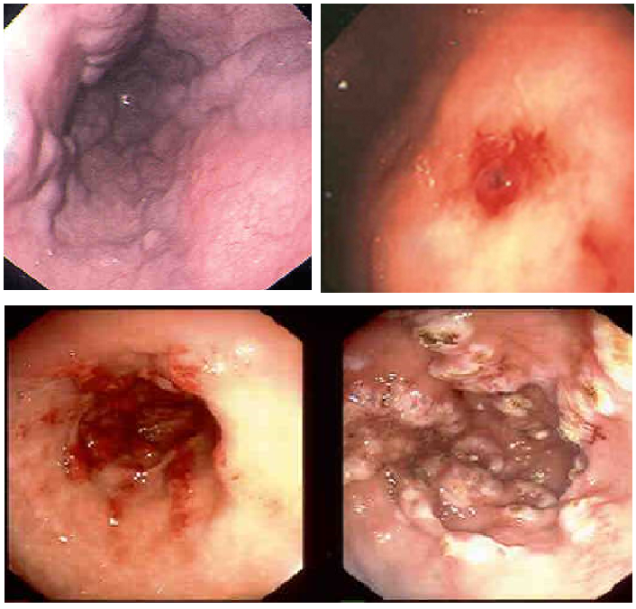
A, B

C, D

Figure 1 Upper endoscopic findings in patients with suspected upper gastrointestinal bleeding. Esophageal varices (A), Dieulafoy’s lesion in the stomach (B), gastric antral vascular ectasia (watermelon stomach) in the antrum of the stomach pre and post argon plasma coagulation therapy (C, D).

Figure 2
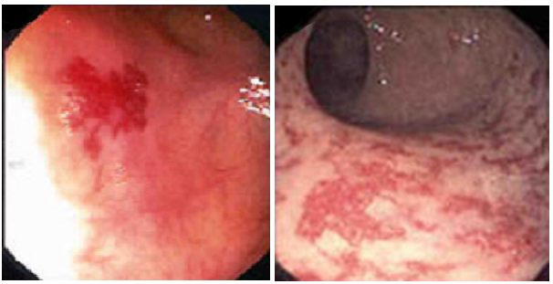
A, B

Figure 2 Colonoscopic findings in patients with suspected lower gastrointestinal bleeding. Colonic angiodysplasia (A) and radiation proctopathy (B).

Figure 3
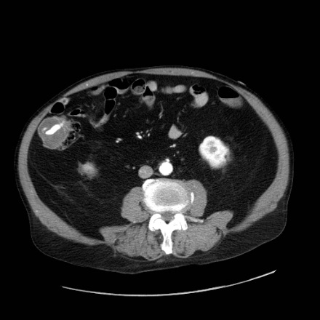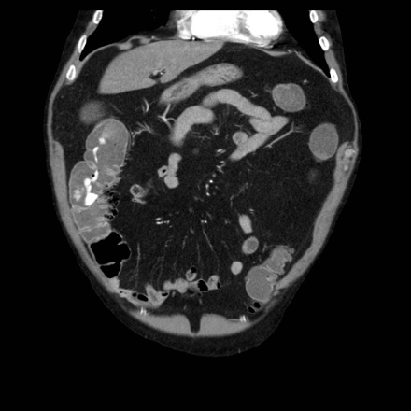A, B
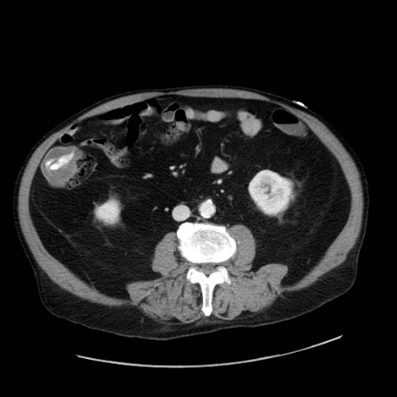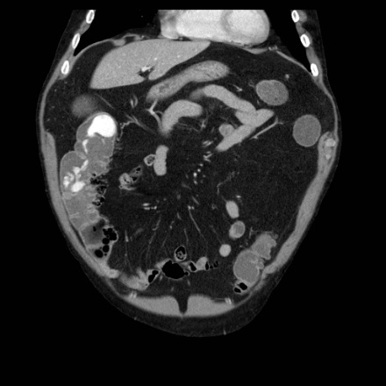C, D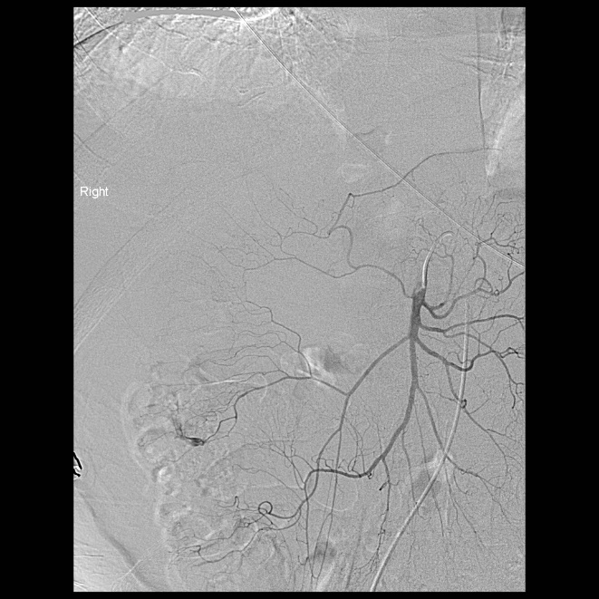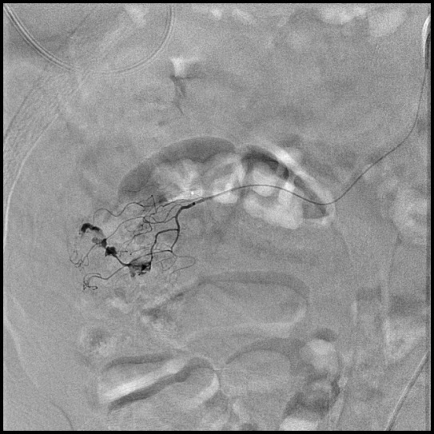E, F
Figure 3 73-year-old man with per rectal bleeding and active gastrointestinal hemorrhage. Contrast enhanced computed tomography (CT) angiogram images show extravasation of contrast into the lumen of the ascending colon, with pooling of contrast which increases from the arterial phase (A, B) to the delayed venous phase (C, D). Diverticula are seen arising from the medial wall of the ascending colon indicating the etiology of bleeding. Following the CT angiogram, the patient underwent catheter angiography, which demonstrated blush of contrast from the right colic branch of the superior mesenteric artery (E). Selective catheterization of the right colic artery demonstrates the bleeding focus more clearly (F). Gelfoam and coil embolization was subsequently performed.

Figure 4
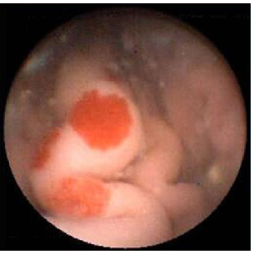
Figure 4 Jejunal angiodysplasia as seen on capsule endoscopy.

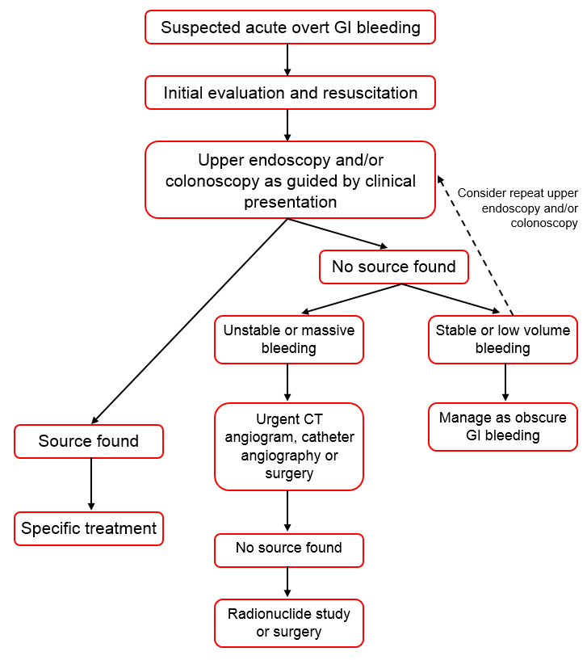
A
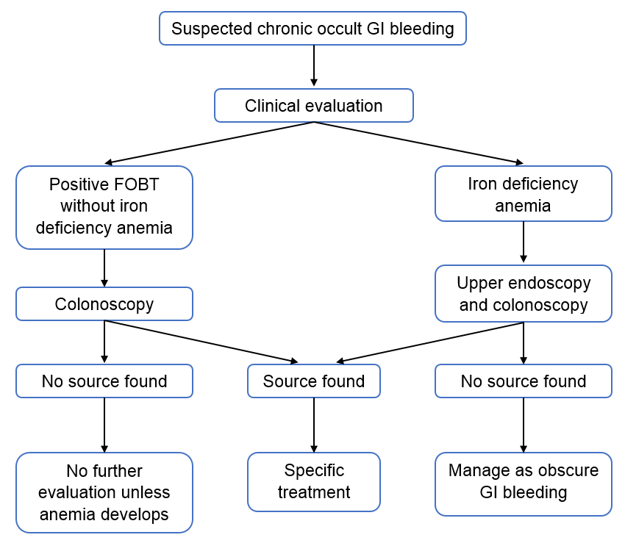
B

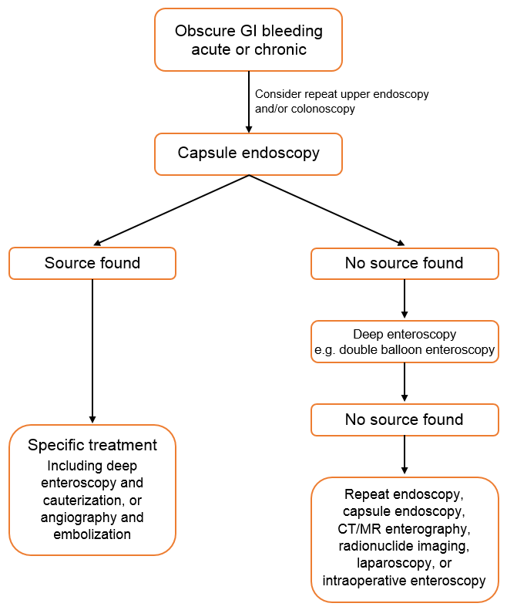
C
Figure 5 Diagnostic algorithms. A: Acute overt; B: Chronic occult; C: Obscure. CT: Computed tomography; MR: Magnetic resonance; GI: Gastrointestinal.

