Name of Journal: World Journal of Clinical Cases
Manuscript NO: 67467
Manuscript Type: ORIGINAL ARTICLE

Clinical Trials Study
Low-dose intralesional injection of 5-fluorouracil and triamcinolone reduces tissue resident memory T cells in chronic eczema

Wu Y et al. Additional 5-fluorouracil reduce resident memory T cells

Yun Wu, Guo-Jiang Wang, Hui-Qiong He, Hai-Hong Qin, Wen-Tong Shen, Yue Yu, Xun Zhang, Mao-Lin Zhou, Jian-Biao Fei

Yun Wu, Guo-Jiang Wang, Hui-Qiong He, Hai-Hong Qin, Wen-Tong Shen, Yue Yu, Xun Zhang, Mao-Lin Zhou, Jian-Biao Fei, Department of Dermatology, Shanghai University of Medicine & Health Sciences Affiliated Zhoupu Hospital, Shanghai 201318, China

Author contributions: Wu Y, Fei JB, and Wang GJ designed/performed most of the investigation, data analysis and wrote the manuscript; Zhang X and Zhou ML provided pathological assistance; Qin HH, Shen WT, He HQ, and Yu Y contributed to the interpretation of the data and analyses; All of the authors have read and approved the manuscript.

Supported by Pudong New District Science and Technology Development Fund People’s Livelihood Scientific Research Special Fund (No. PKJ2018-Y42); the Shanghai Pudong New District Health System Discipline Construction Project (No. PWZzk 2017-14); and the School-level Scientific Research Project of Shanghai University of Medicine and Health Sciences Affiliated with Zhoupu Hospital (No. ZPXM-2019A-13).

Corresponding author: Jian-Biao Fei, MD, Attending Doctor, Department of Dermatology, Shanghai University of Medicine and Health Sciences Affiliated Zhoupu Hospital, No. 1500 Zhouyuan Road, Pudong District, Shanghai 201318, China. zpyyfeijianbiao@163.com

Received: April 26, 2021
Revised: October 29, 2021
Accepted: November 28, 2021
Published online: January 7, 2022

Abstract
BACKGROUND
Tissue resident memory T (T_{RM}) cells have been reported to play a significant role in the pathogenesis and relapse of chronic eczema.

AIM
To compare the efficacy and safety of the intralesional injection of 5-fluorouracil (5-FU) and triamcinolone (TA) with those associated with TA alone for the treatment of chronic eczema.

METHODS
A total of 168 patients were randomized to 5-FU+TA or TA groups and received a one-time intralesional injection of 5-FU+TA or TA only. Biopsies were collected before and 2 wk after treatment for evaluation of histopathological changes. All patients were followed up monthly for up to 1 year.

RESULTS
No serious adverse event was observed in either group. Although the mean atopic dermatitis severity index scores and effective rates were comparable between the two groups after 2 wk of treatment, the relapse rate was significantly lower in the 5-FU+TA group than in the TA group. Histological examination showed significantly fewer CD8⁺ and CD103⁺ T cells but not CD4⁺ T cells in the 5-FU+TA group.

CONCLUSION
One-time intralesional injection of 5-FU+TA is effective and safe for chronic eczema treatment and can further reduce the retention of T_{RM} cells in the lesional skin and the relapse rate of chronic eczema.

Key Words: Chronic eczema; 5-Fluorouracil; Triamcinolone; Intralesional injection; Tissue resident memory T cell

©The Author(s) 2022. Published by Baishideng Publishing Group Inc. All rights reserved.

Citation: Wu Y, Wang GJ, He HQ, Qin HH, Shen WT, Yu Y, Zhang X, Zhou ML, Fei JB. Low-dose intralesional injection of 5-fluorouracil and triamcinolone reduces tissue resident memory T cells in chronic eczema. World J Clin Cases 2022; 10(1): 166-176
URL: https://www.wjgnet.com/2307-8960/full/v10/i1/166.htm
DOI: https://dx.doi.org/10.12998/wjcc.v10.i1.166

Core Tip: Chronic eczema is characterized by recurrent itchy papules and plaques with lichenification and hyperpigmentation, in which tissue resident memory T (T_{RM}) cells play a significant role. Intralesional injection of 5-fluorouracil (5-FU) and triamcinolone (TA) can effectively reduce local inflammation and recurrence in a mouse model, but no clinical study has been reported. In this study, low-dose intralesional injection of 5-FU+TA was found to effectively and safely treat the localized rash, by significantly reducing the retention of T_{RM} cells in the skin lesion, and to lower the relapse rate of chronic eczema. This combination may provide a new treatment option for chronic eczema patients with hypertrophy and localized rash.

INTRODUCTION
Chronic eczema is a chronic inflammatory skin condition, characterized by long-course, recurrent itchy papules, and plaques with lichenification and hyperpigmentation^{[1-3]}. Repeated scratching and irritation is the main cause of repeated delay and refractory eczema. In China, 7.5 out of every 100 people suffer from eczema^{[4]}. Recently, tissue resident memory T (T_{RM}) cells have been suggested to play a pivotal role in the pathogenesis of chronic eczema, in addition to Th2-dominant inflammation^{[5]}. It is reported that after 16 wk of treatment with topical corticosteroids (TCS), T_{RM} cells were still present in the tissue^{[6]}. Further studies have confirmed that the skin lesions of dermatitis and eczema patients are dominated by CD8⁺ T_{RM} cells, and these T_{RM} cells can persist for months and induce recurrent eczema^{[7,8]}.

TCS and topical calcineurin inhibitors (TCIs) are the most commonly used topical drugs for eczema treatment, and they can alleviate the localized inflammation^{[9]}. However, some patients still suffer from repeated attacks. Oral corticosteroids and immunosuppressants have been widely used for the treatment of severe eczema. However, their long-term use can cause severe side effects, such as high blood pressure, blood glucose level, electrolyte disorders, decreased immune function, and pathogen infection. So far, Dupilumab has been approved for the treatment of moderate to severe eczema. In a phase 3 clinical trial, more than 65% of patients treated with dupilumab in combination with topical steroids achieved 75% improvement in eczema area severity index from baseline^{[10]}. Other potential treatments for eczema such as mepolizumab and omalizumab are still under evaluation. A recent multicenter, randomized, double-blind, placebo-controlled, phase 2 clinical trial showed that 100 mg mepolizumab administered subcutaneously did not show any clinical improvement in patients with moderate to severe atopic eczema^{[11]}. Omalizumab is a safe and relatively well-tolerated with some clinical benefits in atopic dermatitis patients^{[12]}, though its efficacy in adults is still under debate^{[13]}. Moreover, these treatment modalities are expensive and require long-term use, which limits their clinical application.

Local intralesional glucocorticoid injection therapy has been used for decades in the treatment of localized dermatitis. Studies have shown that local injection of no more than 20 mg triamcinolone acetonide (TA) is safe and cost-effective for the treatment of localized dermatitis and other inflammatory skin diseases^{[14]}. 5-Fluorouracil (5-FU), another common drug for intralesional injection, has been used for treating inflammatory hypertrophy in the skin as in scarring^{[15,16]}. Our previous study has demonstrated that compared to the TA group, intralesional injection of 5-FU+TA can effectively reduce local inflammation and significantly reduce the recurrence of eczema in a mouse model^{[17]}. However, there have been no clinical studies investigating the effect of 5-FU+TA for chronic eczema via intralesional injection, let alone with large samples and long-term follow-up.

The aim of this double-blind randomized controlled prospective clinical study was to further evaluate the efficacy and safety of intralesional injection of 5-FU and TA for the treatment of localized rash and management of relapse in chronic eczema patients and to explore the potential underlying mechanism.

MATERIALS AND METHODS
Study design
This was a double-blind randomized controlled prospective study. The patients and the two dermatologists were both blinded to the group assignment. The diagnosis of chronic localized eczema was established based on the 2011 Guidelines for Eczema Diagnosis and Treatment designated by the Immunology Group, Dermatovenereology Society, Chinese Medical Association^{[4]}. The inclusion criteria were: Age from 28–80 years and a history of chronic localized eczema lasting for > 6 mo. The exclusion criteria were: i) nullipara, pregnant, planning a pregnancy or lactating; ii) known allergies to FU or glucocorticoid; iii) treatment with any systemic corticosteroids/ antibiotics/ immunosuppressants in the previous 6 wk or use of topical dermocorticoids/ antibiotics/ antihistamines or calcineurin-inhibiting type immunosuppressants in the previous 2 wk; and iv) renal failure, liver dysfunction, hematological disease, immune deficiency, systemic or local infection (including chronic obstructive pulmonary disease patients). The study protocol conformed to the ethical guidelines of the 1975 Declaration of Helsinki and was approved by the Shanghai University of Medicine and Health Science Affiliated Zhoupu Hospital’s Research Ethics Committee (No. 2018-C-014-M01). This study has been registered at http://www.chictr.org.cn/ (No. ChiCTR2100043660).

Patients
One hundred sixty-eight patients who visited our hospital from January 2018 to June 2019 and were diagnosed with chronic eczema with localized lesions were recruited for the study. All patients provided signed written consent. Using a random sequence generated by a computer program, patients were randomly assigned to two groups: a 5-FU+TA group (n = 84) and a TA (n = 84) group (Figure 1). Four patients from the 5-FU+TA group and three patients from the TA group discontinued the study for personal reasons.

Treatment protocol and follow-up
A one-time injection was performed for both groups. For the 5-FU+TA group, 2 mL normal saline (Shanghai Xudong Haipu Pharmaceutical Co., Ltd.) was mixed well with 1 mL 5-FU solution (Shanghai Xudong Haipu Pharmaceutical Co., Ltd.) (containing 25 mg 5-FU) and 1 mL TA solution (Shanghai General Medicine Industry Co., Ltd.) (containing 10 mg TA). Infiltration and injection were performed to allow 1 mL of the mixture into every 4 cm² of the skin lesion area. The total injection area should be less than 32 cm² and protected from contact with water for 3 days after injection to prevent secondary bacterial infection at the injection site. For the TA group, 3 mL of normal saline was mixed with 1 mL of TA solution (containing 10 mg TA). The injection method, total injection area, and course of treatment were the same as those for the 5-FU+TA treatment group.

Follow-up was conducted 2 wk after treatment and monthly thereafter for up to 12 mo. Effectiveness was evaluated, and adverse events were recorded and photographed.

Clinical data analysis
Before treatment and 2 wk after treatment, two dermatologists graded the skin lesions of each patient independently. The evaluation of clinical efficacy referred to the atopic dermatitis severity index (ADSI) scoring system^{[18]}. Because chronic eczema has no exudation, the remaining four indicators including pruritus, erythema, excoriation, and lichenification were graded on a 4-point scale (range 0–3): none = 0 point; mild = 1 point; moderate = 2 points; and severe = 3 points. The total score for these 4 items was ≤ 12 points. An efficacy score was calculated as:

Efficacy score = (score before treatment – score after treatment)/ score before treatment × 100%
The efficacy criteria were: cure, score > 90%; excellent response, score 61%–90%; good response, score 20%–60%; and poor or nonresponse, score < 20%.
Effectiveness percentage = (number of cured patients + number of patients with excellent response)/ total number of patients × 100%
The patients were followed up for 1 year, and the number of patients who relapsed was recorded.
Relapse rate = number of patients with eczema relapse/ total number of effective patients (cured patients + patients with excellent response) × 100%

Evaluation of adverse events
Routine blood tests and liver and kidney function tests were performed before and 2 wk after treatment. We also monitored and recorded the events of local infection, skin atrophy, pigmentation, etc. after treatment and during the 1-year follow-up.

Histopathological examination and immunohistochemical staining
To investigate the histopathological changes and the infiltration of T_{RM} cells and other immune cells after treatment of chronic localized eczema, we collected biopsy specimens at the lesion site from 15 patients in each group before and 2 wk after treatment.

For staining of lesional tissue with hematoxylin and eosin (HE), fixed tissues were embedded in paraffin and cut into 5 μm thin sections, followed by staining with HE.

For immunohistochemical staining, the lesional tissue sections were washed in phosphate-buffered saline and then boiled in EDTA for antigen retrieval, followed by 3% hydrogen peroxide incubation and 5% bovine serum albumin blockade. Tissue sections were incubated with primary antibodies against CD4 (1:100, Shanghai Jiehao Biotechnology Co., Ltd., Shanghai, China), CD8 (1:100, Shanghai Jiehao Biotechnology Co., Ltd.,), and CD103 (1:150, Abcam, Cambridge, UK). After incubation with a secondary antibody, staining results were observed under a microscope (Olympus, Tokyo, Japan). The images were recorded for further analysis. Cell counts were performed blindly on randomly selected histological images at ×100 magnification (High power field).

Statistical analyses
The data were analyzed using PASW software, version 22 (IBM Corporation, Armonk, NY). The graphs were plotted using GraphPad Prism, version 8.00 (GraphPad Software, Inc., San Diego, CA). Disease duration was compared between groups using the Mann–Whitney U test. Independent t-tests were used to compare the patients’ ages, ADSI scores, and T-cell counts. The chi-squared test and Fisher’s exact were used to determine statistical differences between the groups in relation to sex, the anatomical site treated, the effective rate of treatment, and the recurrence rate. A two-tailed P-value < 0.05 was considered statistically significant. Unless otherwise specified, data are presented as mean ± SD.

RESULTS
Patient characteristics
The baseline demographic and clinical characteristics of patients in the two groups are summarized in Table 1. The age, sex, number of anatomical sites treated, and disease duration did not differ significantly between the groups (P > 0.05 for all).

Clinical outcomes
The mean ADSI scores of patients who complete the treatment and evaluation of clinical efficacy before treatment were 7.89 ± 0.89 in the 5-FU+TA group and 7.68 ± 1.02 in the TA group (P = 0.154). Two weeks after treatment, pruritus was alleviated significantly according to the patients, and the color of erythema became lighter in both groups. A small amount of scales was found in 23 out of 84 patients (27.38%) in the TA group (Figure 2). The mean ADSI scores at 2 wk after treatment for the 5-FU+TA group and TA group were 1.55 ± 0.82 and 1.74 ± 0.94, respectively. The ADSI scores for both groups were significantly lower than those before treatment for the same group (P < 0.001 for both), and there was no significant difference between the two groups (t = -1.383, P = 0.168; Figure 3A). The 5-FU+TA group had a cure rate of 18.29% (n = 15) and an excellent response rate of 81.70% (n = 67), and no cases showed a good response or nonresponse. The TA group had a cure rate of 13.10% (n = 11), an excellent response rate of 80.95% (n = 68), a good response rate of 5.95% (n = 5), and no cases of nonresponse. There was no significant difference in the percentage of effectiveness between the two groups (c² = 3.201, P = 0.074; Figure 3B). Interestingly, at the 1-year follow-up, relapse had occurred in 4 patients (5.00%) in the 5-FU+TA group and 25 patients (30.86%) in the TA group (c² = 18.232, P < 0.01, Figure 3C).

Adverse events
Six patients in the 5-FU+TA group and five patients in the TA group had local pruritus after injection, which resolved without further treatment. During the follow-up, local pigmentation was observed in both groups, and it gradually improved over time. No obvious skin atrophy, redness, swelling, heat, pain, or other symptoms of infection were noted in either group. There were no adverse reactions such as leukopenia, anemia, and thrombocytopenia in either group during the 1-year follow-up.

Intralesional injection of 5-FU+TA reduced local retention of CD103⁺ memory T cells
To explore the mechanism by which 5-FU and TA reduced the relapse rate of chronic eczema, we investigated differences in T-cell infiltration in the local skin lesions of patients from both groups before treatment and 2 wk after treatment by HE and immunohistochemical staining. The results showed that the lesional skin was infiltrated with lymphocytes and other inflammatory cells in the epidermis before treatment. A number of CD4⁺, CD8⁺, and CD103⁺ T-cell infiltration was observed in both groups with no significant differences (P = 0.914, 0.945, 0.988, respectively; Figure 4A). Two weeks after treatment, the CD4⁺, CD8⁺, and CD103⁺ T cell counts for the two groups were significantly less than before treatment (all P < 0.001, n = 15 for each group). Although no significant difference was observed in the number of CD4⁺ T cells between the two groups (P = 0.355) at 2 wk after treatment, the numbers of CD8⁺ and CD103⁺ T cells in the skin lesions were significantly less in the 5-FU+TA group than in the TA group (P = 0.025, P < 0.001; Figure 4B). In some skin lesions from the 5-FU+TA group, no inflammatory cell infiltration was observed.

DISCUSSION
Chronic eczema recurs frequently, and its treatment has always been challenging. Once the skin lesions become hypertrophic, the penetration of conventional topical drugs such as TCIs is decreased. Although intralesional corticosteroid has been proven effective for localized dermatitis, long-term or high-dose application of TCI treatment may cause skin atrophy, telangiectasia, increased vellus hair, systemic absorption, prickling, and burning sensations^{[3,19]}. Intralesional 5-FU has been also used for treating localized inflammatory infection. The current study included 168 patients and showed that the combination therapy of 5-FU and TA was effective and safe for the treatment of chronic eczema. To the best of our knowledge, this prospective study is the first to observe the effect of 5-FU+TA on chronic eczema through intralesional injection.

To the best of our knowledge, there has been no study investigating the effectiveness of corticosteroids for eczema treatment through intralesional injection. A previous study investigated the use of 0.05% fluticasone propionate cream or 0.005% fluticasone propionate ointment given once or twice daily to eczema patients for 1 mo and continued twice weekly thereafter. In that study, the relapse rate at the 16 wk follow-up was 19% for the 0.05% fluticasone propionate cream group and 40% for the 0.005% fluticasone propionate ointment group. For the placebo group, the average relapse time was 6 wk, and the relapse rate was 64%^{[20]}. In the present double-blind randomized study, local injection using 5-FU+TA or TA only was applied, and the patients were followed up for up to 1 year. Our data demonstrate that a one-time intralesional injection of TA in combination with 5-FU could successfully treat the localized rash of chronic eczema. Most importantly, the relapse rate in the 5-FU+TA group was significantly lower than that in the TA group (4.9% vs 31.64%), and also much lower than the rate in the previously mentioned study, demonstrating that 5-FU+TA treatment via intralesional injection can significantly reduce the recurrence of eczema.

The aggravating factors for adult eczema include environmental factors, sweating, physical irritation (including scratching), microbes, stress, and food^{[21]}. Our study was a double-blind randomized controlled prospective study, and all participants were outpatients from our hospital with similar living environments and eating habits. We did not find statistically significant differences in age, sex, anatomical sites treated, or the treatment period among the groups.

There is a common concern of the potential adverse reaction of intralesional TA and 5-FU, such as infertility, skin atrophy, and telangiectasia. For the treatment of keloid scars, it is suggested that 5-FU (maximum 90 mg each injection) + TA treatment resulted in a lower incidence of skin atrophy and telangiectasia than treatment with TA alone (10-40 mg TA single injection)^{[22,23]}. The common dosage range of 5-FU is 45-50 mg/mL, and each injection volume is less than 2 mL, with more than 3 sessions^{[24]}. In this study, 25 mg 5-FU and 10 mg TA were used intralesionally once for the treatment. Compared with the dosage for keloid treatment, our dosage of 5-FU and TA is relatively low. Laboratory tests after 2 wk of treatment showed no abnormal results for blood and liver and renal function. Similarly, no such adverse events were observed during the 1-year follow-up. Moreover, the dosage of TA is half of the maximum safe dose reported in a previous study (20 mg) for the treatment of localized dermatitis^{[14]}. No adverse reactions such as skin atrophy or telangiectasia were observed in this study, suggesting that the combination of 5-FU and TA at these dosages was safe for chronic eczema treatment. 5-FU and TA both have an immune suppressive effect, which requires attention regarding the chance of local infection. Patients were informed about the risk of bacterial contamination. No local infection was observed in either group during the follow-up. In clinical practice, topical antibiotics such as Mupirocin could be prescribed for infection prevention.

T_{RM} cells are involved in the relapse of chronic eczema. T_{RM} cells are distributed in the epidermis and dermis of the skin, and they constantly move around in the local area to quickly recognize a pathogen or an antigen that invades again, and this activity plays an important protective role on the entire skin system. In addition, T_{RM} cells release IL-2, tumor necrosis factor-α, interferon-γ (IFN-γ), and other cytokines to further boost the immune response^{[25-27]}. Results from our histopathological and immunohistochemical examinations suggest that the skin lesions from the 5-FU+TA group had significantly fewer CD103⁺ T_{RM} cells and CD8⁺ cells than did those from the TA group at 2 wk after treatment, suggesting that 5-FU may reduce the recurrence of chronic localized eczema by minimizing the number of T_{RM} cells in the lesion. Recent studies have shown that allergens can induce the production of CD8⁺ T_{RM} cells through IL-17A and IFN-γ^{[28]}. The exact mechanisms by which 5-FU reduces the retention of T_{RM} cells require further investigation.

This study is not without limitations. Occupation may be a cofounding factor that we should have considered. A longer follow-up is warranted for monitoring the relapse rate and confirming the efficacy and safety of 5-FU+TA treatment. Finally, we would like to collect more samples to explore the potential mechanisms, possibly by measuring the cytokines secreted from the lesional site, in our future studies.

CONCLUSION
In summary, our study demonstrated that intralesional injection of 5-FU+TA can effectively and safely treat the localized rash of chronic eczema and significantly reduced the retention of T_{RM} cells in the skin lesion. This combination may provide a new treatment option for chronic eczema patients with epidermis hypertrophy and localized rash.

ARTICLE HIGHLIGHTS
Research background
Chronic eczema is an itchy, inflamed skin condition that tends to flare periodically. The latest findings suggest that tissue resident memory T (T_{RM}) cells may play an important role in the pathogenesis of chronic eczema.

Research motivation
Intralesional injection of 5-fluorouracil (5-FU) and triamcinolone (TA) can effectively reduce local inflammation and significantly reduce the recurrence of eczema in a mouse model. There have been no clinical studies investigating the effect of 5-FU+TA for chronic eczema via intralesional injection.

Research objectives
To evaluate the efficacy and safety of intralesional injection of 5-FU and TA for the treatment of localized rash and management of relapse in chronic eczema patients and explore the potential underlying mechanism.

Research methods
In this double-blind randomized controlled prospective study, we used the ADSI score to evaluate the efficacy of treatment and the effect on recurrence, and histopathological changes before and after treatment also were assessed.

Research results
The mean ADSI score and effective rates were comparable between the two groups, while the relapse rate was significantly lower in the 5-FU+TA group than in the TA group. Histological examination showed significantly fewer CD8⁺ and CD103⁺ T cells but not CD4⁺ T cells in the 5-FU+TA group.

Research conclusions
5-FU+TA can effectively and safely treat the localized rash of chronic eczema and significantly reduce the retention of T_{RM} cells in the skin lesion.

Research perspectives
Low-dose intralesional injection of 5-FU+TA may be a new treatment option for chronic eczema patients with epidermis hypertrophy and localized rash.

REFERENCES
1 Bieber T. Atopic dermatitis. N Engl J Med 2008; 358: 1483-1494 [PMID: 18385500 DOI: 10.1056/NEJMra074081]
2 Weidinger S, Beck LA, Bieber T, Kabashima K, Irvine AD. Atopic dermatitis. Nat Rev Dis Primers 2018; 4: 1 [PMID: 29930242 DOI: 10.1038/s41572-018-0001-z]
3 Raveendran R. Tips and Tricks for Controlling Eczema. Immunol Allergy Clin North Am 2019; 39: 521-533 [PMID: 31563186 DOI: 10.1016/j.iac.2019.07.006]
4 Association IGoDSoCM. Guidelines for eczema diagnosis and treatment. Chinese Journal of Dermatology 2011; 1: 5-6
5 Hale G, Davies E, Grindlay DJC, Rogers NK, Harman KE. What's new in atopic eczema? An analysis of systematic reviews published in 2017. Part 2: epidemiology, aetiology and risk factors. Clin Exp Dermatol 2019; 44: 868-873 [PMID: 31502320 DOI: 10.1111/ced.14075]
6 Brunner PM, Emerson RO, Tipton C, Garcet S, Khattri S, Coats I, Krueger JG, Guttman-Yassky E. Nonlesional atopic dermatitis skin shares similar T-cell clones with lesional tissues. Allergy 2017; 72: 2017-2025 [PMID: 28599078 DOI: 10.1111/all.13223]
7 Gamradt P, Laoubi L, Nosbaum A, Mutez V, Lenief V, Grande S, Redoulès D, Schmitt AM, Nicolas JF, Vocanson M. Inhibitory checkpoint receptors control CD8⁺ resident memory T cells to prevent skin allergy. J Allergy Clin Immunol 2019; 143: 2147-2157 [PMID: 30654051 DOI: 10.1016/j.jaci.2018.11.048]
8 Pan Y, Kupper TS. Metabolic Reprogramming and Longevity of Tissue-Resident Memory T Cells. Front Immunol 2018; 9: 1347 [PMID: 29967608 DOI: 10.3389/fimmu.2018.01347]
9 Eichenfield LF, Tom WL, Berger TG, Krol A, Paller AS, Schwarzenberger K, Bergman JN, Chamlin SL, Cohen DE, Cooper KD, Cordoro KM, Davis DM, Feldman SR, Hanifin JM, Margolis DJ, Silverman RA, Simpson EL, Williams HC, Elmets CA, Block J, Harrod CG, Smith Begolka W, Sidbury R. Guidelines of care for the management of atopic dermatitis: section 2. Management and treatment of atopic dermatitis with topical therapies. J Am Acad Dermatol 2014; 71: 116-132 [PMID: 24813302 DOI: 10.1016/j.jaad.2014.03.023]
10 Blauvelt A, de Bruin-Weller M, Gooderham M, Cather JC, Weisman J, Pariser D, Simpson EL, Papp KA, Hong HC, Rubel D, Foley P, Prens E, Griffiths CEM, Etoh T, Pinto PH, Pujol RM, Szepietowski JC, Ettler K, Kemény L, Zhu X, Akinlade B, Hultsch T, Mastey V, Gadkari A, Eckert L, Amin N, Graham NMH, Pirozzi G, Stahl N, Yancopoulos GD, Shumel B. Long-term management of moderate-to-severe atopic dermatitis with dupilumab and concomitant topical corticosteroids (LIBERTY AD CHRONOS): a 1-year, randomised, double-blinded, placebo-controlled, phase 3 trial. Lancet 2017; 389: 2287-2303 [PMID: 28478972 DOI: 10.1016/s0140-6736(17)31191-1]
11 Kang EG, Narayana PK, Pouliquen IJ, Lopez MC, Ferreira-Cornwell MC, Getsy JA. Efficacy and safety of mepolizumab administered subcutaneously for moderate to severe atopic dermatitis. Allergy 2020; 75: 950-953 [PMID: 31515809 DOI: 10.1111/all.14050]
12 Holm JG, Thomsen SF. Omalizumab for atopic dermatitis: evidence for and against its use. G Ital Dermatol Venereol 2019; 154: 480-487 [PMID: 30717578 DOI: 10.23736/s0392-0488.19.06302-8]
13 Yang N, Chen Z, Zhang X, Shi Y. Novel Targeted Biological Agents for the Treatment of Atopic Dermatitis. BioDrugs 2021; 35: 401-415 [PMID: 34213742 DOI: 10.1007/s40259-021-00490-x]
14 Richards RN. Update on intralesional steroid: focus on dermatoses. J Cutan Med Surg 2010; 14: 19-23 [PMID: 20128986 DOI: 10.2310/7750.2009.08082]
15 Wendling J, Marchand A, Mauviel A, Verrecchia F. 5-fluorouracil blocks transforming growth factor-beta-induced alpha 2 type I collagen gene (COL1A2) expression in human fibroblasts via c-Jun NH2-terminal kinase/activator protein-1 activation. Mol Pharmacol 2003; 64: 707-713 [PMID: 12920208 DOI: 10.1124/mol.64.3.707]
16 Huang L, Wong YP, Cai YJ, Lung I, Leung CS, Burd A. Low-dose 5-fluorouracil induces cell cycle G2 arrest and apoptosis in keloid fibroblasts. Br J Dermatol 2010; 163: 1181-1185 [PMID: 20633010 DOI: 10.1111/j.1365-2133.2010.09939.x]
17 Chen X, Wang G, Zeng Q, Zhang H, Hu Y, Yu A, Li T. Intralesional Treatment With 5-Fluorouracil and Steroid Improves Allergic Contact Dermatitis Without Causing Skin Atrophy and Rebound Lesions. Dermatitis 2017; 28: 223-224 [PMID: 28338541 DOI: 10.1097/der.0000000000000270]
18 Van Leent EJ, Gräber M, Thurston M, Wagenaar A, Spuls PI, Bos JD. Effectiveness of the ascomycin macrolactam SDZ ASM 981 in the topical treatment of atopic dermatitis. Arch Dermatol 1998; 134: 805-809 [PMID: 9681343 DOI: 10.1001/archderm.134.7.805]
19 Papier A, Strowd LC. Atopic dermatitis: a review of topical nonsteroid therapy. Drugs Context 2018; 7: 212521 [PMID: 29632548 DOI: 10.7573/dic.212521]
20 Berth-Jones J, Damstra RJ, Golsch S, Livden JK, Van Hooteghem O, Allegra F, Parker CA; Multinational Study Group. Twice weekly fluticasone propionate added to emollient maintenance treatment to reduce risk of relapse in atopic dermatitis: randomised, double blind, parallel group study. BMJ 2003; 326: 1367 [PMID: 12816824 DOI: 10.1136/bmj.326.7403.1367]
21 Katayama I, Aihara M, Ohya Y, Saeki H, Shimojo N, Shoji S, Taniguchi M, Yamada H; Japanese Society of Allergology. Japanese guidelines for atopic dermatitis 2017. Allergol Int 2017; 66: 230-247 [PMID: 28209325 DOI: 10.1016/j.alit.2016.12.003]
22 Hietanen KE, Järvinen TA, Huhtala H, Tolonen TT, Kuokkanen HO, Kaartinen IS. Treatment of keloid scars with intralesional triamcinolone and 5-fluorouracil injections - a randomized controlled trial. J Plast Reconstr Aesthet Surg 2019; 72: 4-11 [PMID: 30448246 DOI: 10.1016/j.bjps.2018.05.052]
23 Srivastava S, Patil A, Prakash C, Kumari H. Comparison of Intralesional Triamcinolone Acetonide, 5-Fluorouracil, and Their Combination in Treatment of Keloids. World J Plast Surg 2018; 7: 212-219 [PMID: 30083505]
24 Jiang ZY, Liao XC, Liu MZ, Fu ZH, Min DH, Yu XT, Guo GH. Efficacy and Safety of Intralesional Triamcinolone Versus Combination of Triamcinolone with 5-Fluorouracil in the Treatment of Keloids and Hypertrophic Scars: A Systematic Review and Meta-analysis. Aesthetic Plast Surg 2020; 44: 1859-1868 [PMID: 32342167 DOI: 10.1007/s00266-020-01721-2]
25 Seidel JA, Vukmanovic-Stejic M, Muller-Durovic B, Patel N, Fuentes-Duculan J, Henson SM, Krueger JG, Rustin MHA, Nestle FO, Lacy KE, Akbar AN. Skin resident memory CD8⁺ T cells are phenotypically and functionally distinct from circulating populations and lack immediate cytotoxic function. Clin Exp Immunol 2018; 194: 79-92 [PMID: 30030847 DOI: 10.1111/cei.13189]
26 Zaid A, Hor JL, Christo SN, Groom JR, Heath WR, Mackay LK, Mueller SN. Chemokine Receptor-Dependent Control of Skin Tissue-Resident Memory T Cell Formation. J Immunol 2017; 199: 2451-2459 [PMID: 28855310 DOI: 10.4049/jimmunol.1700571]
27 Mueller SN, Gebhardt T, Carbone FR, Heath WR. Memory T cell subsets, migration patterns, and tissue residence. Annu Rev Immunol 2013; 31: 137-161 [PMID: 23215646 DOI: 10.1146/annurev-immunol-032712-095954]
28 Schmidt JD, Ahlström MG, Johansen JD, Dyring-Andersen B, Agerbeck C, Nielsen MM, Poulsen SS, Woetmann A, Ødum N, Thomsen AR, Geisler C, Bonefeld CM. Rapid allergen-induced interleukin-17 and interferon-γ secretion by skin-resident memory CD8⁺ T cells. Contact Dermatitis 2017; 76: 218-227 [PMID: 27873334 DOI: 10.1111/cod.12715]

Footnotes
Institutional review board statement: The study protocol conformed to the ethical guidelines of the 1975 Declaration of Helsinki and was approved by the Shanghai University of Medicine & Health Science Affiliated Zhoupu Hospital’s Research Ethics Committee (No. 2018-C-014-M01).

Clinical trial registration statement: This study has been registered at http://www.chictr.org.cn/ (No. ChiCTR2100043660).

Informed consent statement: All study participants, or their legal guardian, provided informed written consent prior to study enrollment.

Conflict-of-interest statement: The authors declare that they have no conflict of interest.

Data sharing statement: The datasets generated and analyzed during the present study are available from the corresponding author on reasonable request. Participants gave informed consent for data sharing.

CONSORT 2010 statement: The authors have read the CONSORT 2010 statement, and the manuscript was prepared and revised according to the CONSORT 2010 statement.

Open-Access: This article is an open-access article that was selected by an in-house editor and fully peer-reviewed by external reviewers. It is distributed in accordance with the Creative Commons Attribution NonCommercial (CC BY-NC 4.0) license, which permits others to distribute, remix, adapt, build upon this work non-commercially, and license their derivative works on different terms, provided the original work is properly cited and the use is non-commercial. See: https://creativecommons.org/Licenses/by-nc/4.0/

Provenance and peer review: Unsolicited article; Externally peer reviewed.
Peer-review model: Single blind

Peer-review started: April 26, 2021
First decision: October 18, 2021
Article in press: November 28, 2021

Specialty type: Dermatology
Country/Territory of origin: China
Peer-review report’s scientific quality classification
Grade A (Excellent): 0
Grade B (Very good): B, B, B
Grade C (Good): 0
Grade D (Fair): 0
Grade E (Poor): 0

P-Reviewer: Bugaj AM, Gupta SK, Koritala T S-Editor: Wang JL L-Editor: A P-Editor: Wang JL
Figure Legends
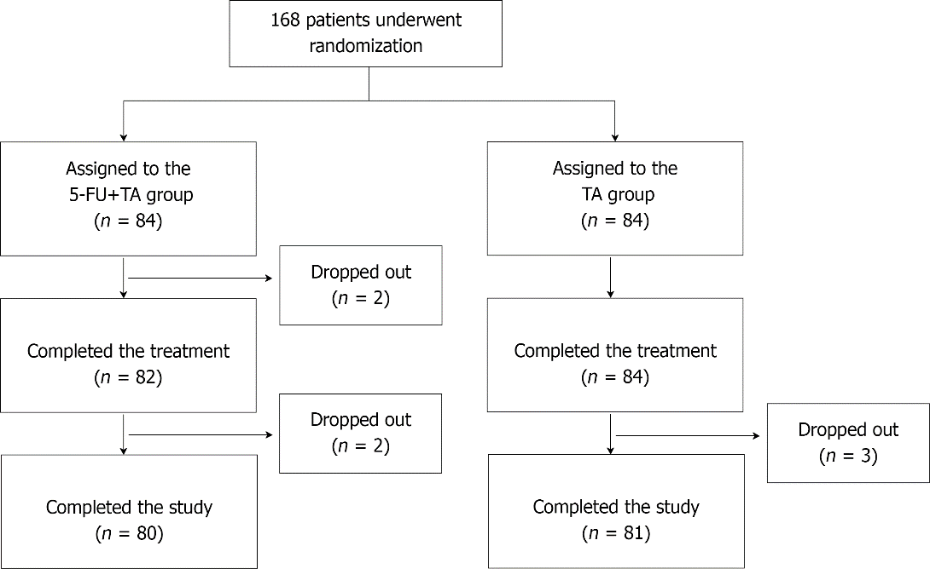
Figure 1 Randomization and allocation of patients to the study groups. 5-FU: 5-fluorouracil; TA: triamcinolone.

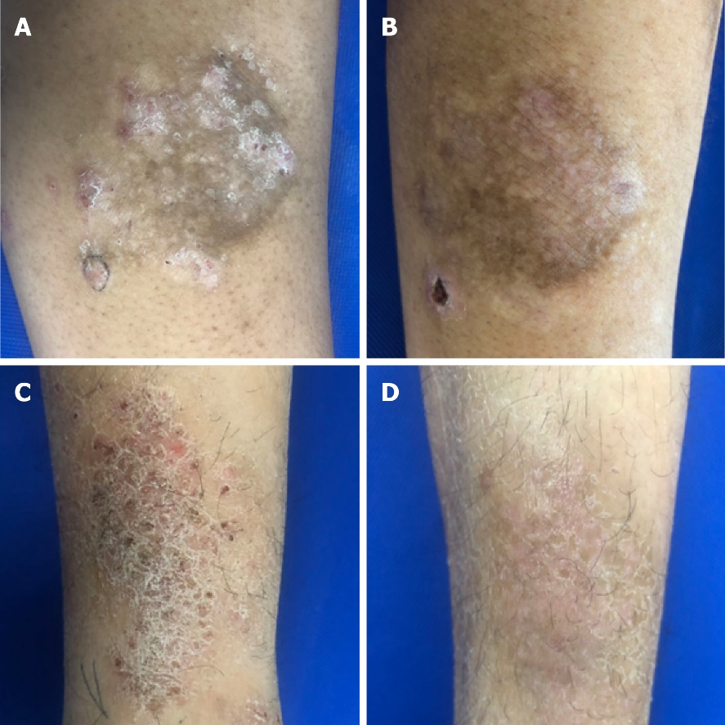
Figure 2 Representative images of localized chronic eczema lesions before and 2 wk after treatment. Skin lesion of a patient in the intralesional 5-FU+TA treatment group (A) at baseline and (B) 2 wk after 5-FU+TA treatment. Skin lesion of a patient in the intralesional TA treatment group (C) at baseline and (D) 2 wk after TA treatment. 5-FU: 5-fluorouracil; TA: triamcinolone.

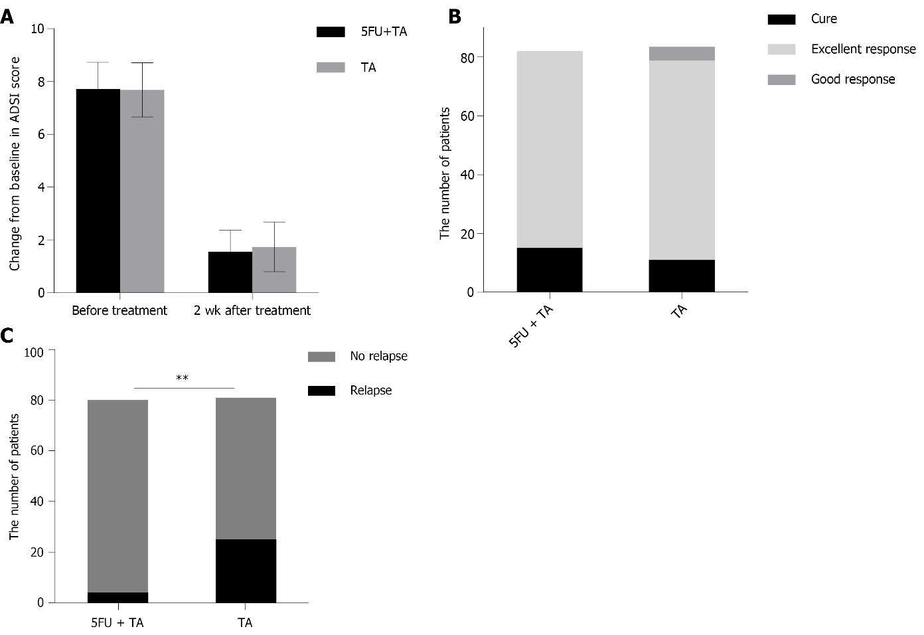
Figure 3 Clinical responses of the localized lesions of chronic eczema to intralesional treatment with low-dose 5-FU+TA and TA at 2 wk after treatment. (A) Mean atopic dermatitis severity index (ADSI) scores before and 2 wk after treatment. (B) A number of patients who achieved cure, excellent response, and good response 2 wk after treatment with 5-FU+TA or TA. (C) A number of patients who experienced relapse after treatment with 5-FU+TA (n = 4) or TA (n = 25) during 1-year follow-up. (^{b}P < 0.01). 5-FU: 5-fluorouracil; TA: triamcinolone.

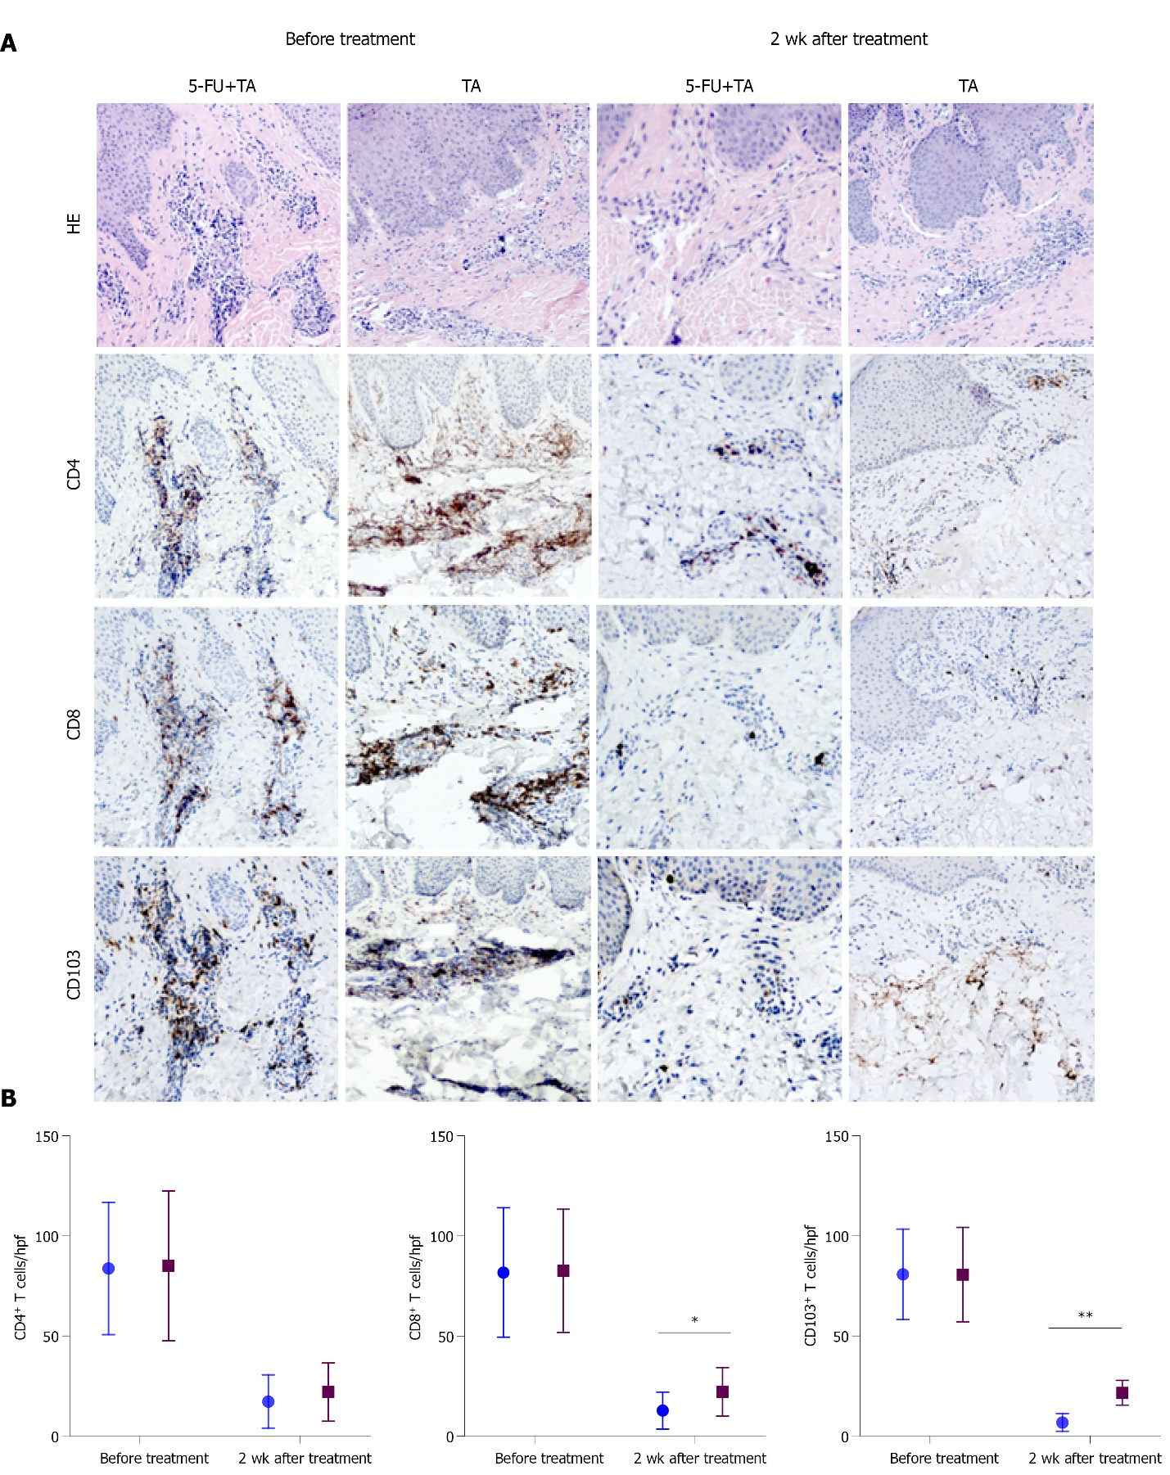
Figure 4. Histopathology and immunohistochemistry of localized lesions of chronic eczema to intralesional treatment with 5-FU+TA and TA before and 2 wk after treatment. (A) Representative histologic images of biopsy specimens from localized lesions of chronic eczema were collected before and at 2 wk after treatment. Tissue samples (n = 15 for each group) were stained with HE and antibodies against CD4, CD8, or CD103 to detect T-cell infiltration in the lesional skin. (B) CD4⁺, CD8⁺, and CD103⁺ T cell counts were quantified in high-power field images of lesions biopsied before and 2 wk after treatment. Blue points: 5-FU + TA group; Red points: TA group. ªP < 0.05, ^{b}P < 0.01. 5-FU, 5-fluorouracil; TA, triamcinolone.

Table 1 Patient demographic and baseline disease characteristics
 | Patients underwent  randomization  (n = 168) |  |  | Patients completed study  (n = 161)
 | 5-FU + TA (n = 84) | TA (n = 84) | P | 5-FU + TA (n = 80) | TA (n = 81) | P
Age (mean ± SD), yr | 54.39 ± 14.31 | 56.12 ± 14.82 | 0.643 | 54.74 ± 14.26 | 55.60 ± 12.56 | 0.683
Range | 28-74 | 28-79 |  | 28-74 | 29-79
28-45 | 36.17 | 38.48 | 0.120 | 36.27 | 38.16 | 0.236
46-60 | 53.48 | 53.41 | 0.962 | 53.50 | 53.41 | 0.950
61- | 67.27 | 66 | 0.258 | 64.56 | 66.13 | 0.416
Sex, n (%) |  |  | 0.739 |  |  | 0.774
Male | 59 (70.24) | 57 (67.86) |  | 56 (70) | 55 (67.90)
Female | 25 (29.76) | 27 (32.14) |  | 24 (30) | 26 (32.10)
Anatomical sites treated, n (%)
Trunk | 23 (27.38) | 22 (26.19) | 0.862 | 23 (28.75) | 22 (27.16) | 0.822
Limb | 58 (69.05) | 61 (72.62) | 0.611 | 54 (67.50) | 58 (71.60) | 0.571
Neck | 3 (3.57) | 1 (1.19) | 0.613 | 3 (3.75) | 1 (1.24) | 0.604
ADSI score (mean ± SD) | 7.72 ± 1 | 7.68 ± 1.02 | 0.468 | 7.71 ± 1 | 7.87 ± 0.90 | 0.278
Disease duration, yr (range) | 4 (1-24) | 4 (1-30) | 0.944 | 3 (1-24) | 3 (1-30) | 0.925
FU: 5-fluorouracil; TA: triamcinolone; ADSI: atopic dermatitis severity index.

Published by Baishideng Publishing Group Inc
7041 Koll Center Parkway, Suite 160, Pleasanton, CA 94566, USA
Telephone: +1-925-3991568
E-mail: bpgoffice@wjgnet.com
Help Desk: https://www.f6publishing.com/helpdesk
https://www.wjgnet.com

© 2022 Baishideng Publishing Group Inc. All rights reserved.

