Name of journal: World Journal of Gastroenterology
ESPS Manuscript NO: 6664
Columns: Topic Highlights

WJG 20th Anniversary Special Issues (13): Gastrointestinal endoscopy

Role of endoscopy in the bariatric surgery patients

De Palma GD et al. Pre- and post-operative endoscopy in the bariatric patients

Giovanni D De Palma, Pietro Forestieri

Giovanni D De Palma, Center of Excellence for Technical Innovation in Surgery, Department of Clinical Medicine and Surgery, University of Naples Federico II, School of Medicine, 80131 Naples, Italy

Pietro Forestieri, Department of Clinical Medicine and Surgery, University of Naples Federico II, School of Medicine, 80131 Naples, Italy

Author contributions: De Palma GD and Forestieri P were both responsible for the design, conception, drafting and final approval of this paper.

Correspondence to: Giovanni D De Palma, MD, Director of Center of Excellence for Technical Innovation in Surgery, Department of Clinical Medicine and Surgery, University of Naples Federico II, School of Medicine, Via Pansini 5, 80131 Napoli, Italy. giovanni.depalma@unina.it

Telephone: +39-81-7462773 Fax: +39-81-7462752
Received: October 26, 2013 Revised: December 31, 2013
Accepted: March 8, 2014

Published online:

Abstract

Obesity is an increasingly serious health problem in nearly all Western countries. It represents an important risk factor for several gastrointestinal diseases, such as gastroesophageal reflux disease, erosive esophagitis, hiatal hernia, Barrett’s esophagus, esophageal adenocarcinoma, Helicobacter pylori infection, colorectal polyps and cancer, nonalcoholic fatty liver disease, cirrhosis, and hepatocellular carcinoma. Surgery is the most effective treatment to date, resulting in sustainable and significant weight loss along with the resolution of metabolic comorbidities in up to 80% of cases. Many of these conditions can be clinically relevant and have a significant impact on patients undergoing bariatric surgery. There is evidence that the chosen procedure might be changed, if specific pathological upper gastrointestinal findings, such as large hiatal hernia or Barrett’s esophagus, are detected preoperatively. The value of a routine endoscopy before bariatric surgery in asymptomatic patients (screening esophagogastroduodenoscopy) remains controversial. The common indications for endoscopy in the postoperative bariatric patient include the evaluation of symptoms, the management of complications, and the evaluation of weight loss failure. It is of critical importance is for the endoscopist to be familiar with the postoperative anatomy and to work in close collaboration with bariatric surgery colleagues in order to maximize the outcome and safety of endoscopy in this setting. The purpose of this article is to review the role of the endoscopist in a multidisciplinary obesity center as it pertains to the preoperative, and postoperative management of bariatric surgery patients.

© 2014 Baishideng Publishing Group Co., Limited. All rights reserved.

Key words: Morbid obesity; Obesity surgery; Endoscopy; Complications; Endoscopic therapy

Core tip: Gastrointestinal endoscopists play an integral role in the multidisciplinary treatment of obese patients undergoing bariatric surgery, particularly in the treatment of postoperative complications. Endoscopy is emerging as an effective procedure in the treatment of bariatric surgery complications in selected patients, while avoiding an invasive surgical reoperation.

De Palma GD, Forestieri P. Role of endoscopy in the bariatric surgery patients.
Available from:
DOI:

INTRODUCTION
Obesity is an increasingly serious health problem in nearly all Western countries. Estimates of prevalence suggest that 7%–15% of subjects in developed countries are obese^{[1-8]}.
Obesity is usually defined in terms of body mass index (BMI, kg/m²). The World Health Organization, the National Institutes of Health (NIH), Healthy People 2010, and the 2000 Dietary Guidelines for Americans, proposed guidelines for the classification of weight status based on the body mass index (BMI)^{[9-11]}. Accordingly, a BMI of 25-30 is considered overweight, a BMI of 30 to 35 is considered as class 1 obesity, 35–40 as class 2, and over 40 as class 3. Morbid obesity is usually defined as a BMI of over 40 or a BMI over 35 in combination with comorbidities. Underweight is usually defined as a BMI of less than 18.5 kg/m².
Obesity is an independent risk factor for a variety of chronic diseases such as diabetes, hypertension, coronary heart disease, knee osteoarthritis, and cancer^{[12-18]}. A recent study on the association between different grades of obesity and the number of life-years lost indicated that life expectancy can be up to 20 years shorter in severe obesity^{[19]}.
Intentional weight loss offers substantial benefits to patients and is associated with an overall reduction in mortality^{[20]}. Current treatment modalities for obesity include lifestyle modification, diet and pharmacologic agents; however, their effectiveness and durability is limited^{[21]}. Surgery is the most effective treatment to date, resulting in sustainable and significant weight loss along with the resolution of metabolic comorbidities in up to 80% of cases^{[22-24]}.
The next frontier in the treatment of obesity might be represented by the development of endoscopic approaches to bariatric procedures^{[25-31]}. Endoluminal surgery, performed entirely by using flexible endoscopy, offers the potential for a less invasive approaches that may be safer and more cost-effective compared with current laparoscopic approaches, thus extending surgical indications to those with multiple comorbidities, older age, and those with mild obesity (BMI 30-35).
The purpose of this article is to review the role of the endoscopist in the preoperative and postoperative management of bariatric surgery patients, in the context of a multidisciplinary obesity center.

PRE-OPERATIVE ENDOSCOPY.
Obesity is an important risk factor for several digestive diseases, such as gastroesophageal reflux disease (GERD), erosive esophagitis, hiatal hernia (HH), Barrett’s esophagus, esophageal adenocarcinoma, Helicobacter pylori infection, colorectal polyps and cancer, nonalcoholic fatty liver disease (NAFLD), cirrhosis, and hepatocellular carcinoma. Most of these diseases are observed up to 2–3 times more frequently in obese patients than in normal weight individuals^{[32]}.
Many of these conditions can be clinically relevant and can have a significant impact on patients undergoing bariatric surgery. There is evidence that the chosen procedure might be changed, if specific pathological upper GI findings, such as a large HH or Barrett’s esophagus, are detected preoperatively.
The published guidelines of the European Association for Endoscopic Surgery state that esophagogastroduodenoscopy (EGDS), or upper-GI series, is advisable for all bariatric procedures and strongly recommended for gastric bypass patients (RYGB). Similarly, the recently published guidelines from the ASGE recommended that EGDS should be performed in all symptomatic patients undergoing bariatric surgery and is to be considered in all candidates^{[33,34]}. Symptomatic patients should undergo EGDS (diagnostic) in accordance with accepted practice guidelines, regardless of whether they are being considered for bariatric surgery or not.
The value of a routine endoscopy before bariatric surgery asymptomatic patients (screening EGDS) remains controversial^{[35]}. A lack of correlation between patient symptoms and endoscopic findings has been documented by many authors, suggesting that routine preoperative endoscopy might be useful in detecting both lesions and inflammation^{[36-40]}. However, considering the relatively weak clinical relevance of the majority of the lesions discovered on routine EGDS and the cost and invasiveness of the procedure, as well as the amount of secondary unnecessary workup prompted by irrelevant findings, several authors, on the contrary, advocated a non-endoscopic approach for asymptomatic patients^{[41,42]}.
One of the concerns of performing routine preoperative upper endoscopy is the risk of sedation. Cardiopulmonary complications are the most serious adverse reactions associated with conscious sedation at the time of EGDS, with a mortality rate of 0.03% and serious morbidity of 0.54%^{[43]}. In case of morbidly obese patients, the risk may be higher due to the higher incidence of restrictive lung disease, obstructive sleep apnea, pulmonary hypertension and cardiac diseases. It is of paramount importance that endoscopy procedures in obese patients are carried out in a fully equipped setting and by a well-organized team of anesthetists trained in the use of anesthetic drugs and in the treatment of adverse events.

POST-OPERATIVE ENDOSCOPIC MANAGEMENT.
Currently, several surgical procedures are performed to induce weight loss in obese patients. These procedures have been simplified into three categories: predominantly restrictive procedures, predominantly malabsorptive procedures and combined procedures (Table 1).
The common indications for endoscopy in postoperative bariatric patients include the evaluation of symptoms, the management of complications, and the evaluation of weight loss failure.
Of critical importance is for the endoscopist to be familiar with the postoperative anatomy and work in close collaboration with bariatric surgery colleagues to maximize outcomes and safety of endoscopy in this setting^{[44]}.
Although nausea, vomiting, and abdominal pain are commonly encountered symptoms after bariatric surgery and may result from dietary noncompliance, patients with persistent symptoms should be evaluated, because these symptoms may indicate the development of a complication especially within the first 6 postoperative months.
Each procedure is associated with specific GI complications (Table 2).
Gastrointestinal complications prompting endoscopy after surgery may be summarized as follow: acute bleeding and/or anemia, staple-line complications (such as anastomotic leaks, fistulae and strictures), band stenosis, erosion and slippage, bezoars and choledocholithiasis.
An endoscopy is the preferred strategy, unless there is a suspicion of leaks or fistulae when preliminary contrast radiography is more appropriate.

role of endoscopy to diagnose and treat hemorrhage
Early upper hemorrhage (within 48 h) are most reported after laparoscopic roux-en-Y gastric bypass (RYGB) surgery (1%-4%)^{[45-49]}. The bleeding lesions are often identified at the staple lines of the gastrojejunostomy and rarely at the jejunojejunostomy, the gastric pouch, and the bypassed stomach. Although there are a few published case series, endoscopic management of hemorrhage from the gastrojejunal anastomosis has been shown to be highly successful when using standard hemostatic modalities^{[50-53]}. Late hemorrhage may often arise from marginal ulcers or erosion (Figures 1, 2) and generally requires medical therapy (PPIs), or in cases of acute bleeding, an endoscopic treatment. Balloon enteroscopy has been reported in patients with GI bleeding arising from the bypassed stomach, but should be undertaken only with great caution^{[54-56]}.

role of endoscopy to treat staple-line complications
Endoscopic treatment play an important role in the management of a variety of staple-line complications such as stomal stenosis and anastomotic leaks.

Stricture of the gastrojejunal anastomosis: Stricture of the gastrojejunal anastomosis that results in dysphagia, vomiting, and nutritional deficiencies, is a relatively common late complication of both open and laparoscopic RYGBP, occurring in approximately 3% to 12% of patients after RYGB^{[57-61]}.
There is no formal definition of the stricture size, but generally an anastomosis with a diameter < 10 mm or the inability to allow passage of a standard upper endoscope (diameter 8.6-9.8 mm) is considered a significant stricture.
Endoscopic dilation of stomal stenosis via through-the scope balloon dilation or wire-guided bougie dilation is safe and highly effective, and should be considered the primary treatment for this complication^{[62-67]}. The majority of patients can be successfully treated with 1 or 2 sessions, and surgical revision is rarely necessary^{[62]}.
A potential risk of stricture dilation is inadvertent over dilatation leading to weight regain. Overall, it appears that stricture dilation to maximum of 15 mm is not associated with impaired postoperative weight loss outcomes^{[62,68]}.

Staple-line dehiscence, or leak formation: Staple-line dehiscence, or leak formation can lead to abdominal pain, thoracic pain nausea, vomiting, intra-abdominal abscess, and acute peritonitis.
Leak rates vary by type of surgical intervention with large series reporting 2.05% to 5.20% for laparoscopic RYGB and 1.68% to 2.60% for open RYGB. Sleeve gastrectomy has an associated leak rate of 0.6% to 7% of cases^{[49,5859,69-73]}.
The most common sites for RYGB leaks are at the gastrojejunal anastomosis, followed by the jejunojejunostomy anastomosis; in sleeve gastrectomy, leaks usually occur at the proximal border within 2 cm of the angle of His.
The first step is the treatment of sepsis and the supportive care, including total parenteral nutrition and transcutaneous drainage catheter placement. Some leaks may resolve with these conservative steps. In stable patients, in which conservative management has failed, a laparoscopic repair should be considered. Additionally, in these patients, endoscopy is emerging as an effective procedure in the treatment of anastomotic leakage, while avoiding an invasive surgical reoperation.
Chronic leaks have been successfully repaired endoscopically by using fibrin-glue injection^{[74-76]} , clip placement^{[77]}, self-expanding stents^{[78-82]}, and endoscopic suturing devices^{[83]} (Figure 3).
Although endoscopic therapy for gastric leak management holds promise, these procedures cannot be routinely recommended, due to the lack of controlled data.

role of endoscopy to diagnose and treat laparoscopic adjustable gastric banding complications
The laparoscopic adjustable gastric band (LAGB) is well established as a safe, effective, and durable bariatric procedure^{[84-86]}.
Several complications are related to the LAGB including reflux esophagitis, stenosis with esophageal dilation, band slippage and erosion.
LAGB erosions typically occur 1–2 years after placement. The prevalence varies in published studies from 0.9% to 3.8%^{[86-88]}. Gastric band erosion may occur with abdominal pain, nausea, vomiting, abdominal access port– site infection, increased food intake or weight gain and is easily identified with endoscopy. The traditional approach is surgical revision; however, there are reports of conservative management with endoscopic removal on complete intragastric erosion^{[89- 92]} (Figure 4).

role of endoscopy to treat choledocholithiasis in the patient with gastric by-pass
Morbid obesity is a risk factor for gallstone formation, and rapid weight loss is an independent and potentially compounding risk factor^{[93-95]}.
Whereas an ERCP usually can be performed after gastric banding, or sleeve gastrectomy, an ERCP in a patient with an RYGB presents significant technical challenges.
Several options are available to gain access to the biliary tree in patients after RYGB. Laparoscopic creation of a point of access to the gastric remnant or small bowel allows the duodenoscope to reach the papilla, but carries the inherent risks of general anesthesia and surgery^{[96-100]} (Figure 5). Enteroscopes, colonoscopes and more recently double-balloon endoscopes and single-balloon endoscopes have also been used. However, duct cannulation is difficult with the forward-viewing enteroscope and precut biliary sphincterotomy is often required. Furthermore, accessories are limited because of the length of the enteroscope^{[101-107]}.

CONCLUSION
GI endoscopists play an integral role in the multidisciplinary treatment of obese patients undergoing bariatric surgery, particularly in the treatment of postoperative complications. Direct communication and coordination with the surgical team is critical in the pre-operative and in the immediate postoperative setting. Endoscopy is emerging as an effective procedure in the treatment of bariatric surgery complications in selected patients, while avoiding an invasive surgical reoperation.

REFERENCES
1 Laurier D, Guiget M, Chau P, Wells JA, Valleron AJ. Prevalence of obesity: a comparative survey in France, the United Kingdom and the United States. Int J Obes Relat Metab Disord 1992; 16: 565–572 [PMID: 1326486]
2 Epstein FH, Higgins M. Human obesity: general aspects. In: Bjorntorp P, Brodoff BN, editors. Epidemiology of Obesity. Philadelphia: JB Lippincott, 1992: 330–42
3 Mendez MA, Monteiro CA, Popkin BM. Overweight exceeds underweight among women in most developing countries. Am J Clin Nutr 2005; 81: 714-721 [PMID: 15755843]
4 Malik VS, Willett WC, Hu FB. Global obesity: trends, risk factors and policy implications. Nat Rev Endocrinol 2013; 9: 13-27 [PMID: 23165161 DOI: 10.1038/nrendo.2012.199]
5 Wang Y, Lobstein T. Worldwide trends in childhood overweight and obesity. Int J Pediatr Obes 2006; 1: 11-25 [PMID: 17902211 DOI: 10.1080/17477160600586747]
6 Sturm R. Stemming the global obesity epidemic: what can we learn from data about social and economic trends? Public Health 2008; 122: 739-746 [PMID: 18490037 DOI: 10.1016/j.puhe.2008.01.004]
7 James WP. The fundamental drivers of the obesity epidemic. Obes Rev 2008; 9 Suppl 1: 6-13 [PMID: 18307693 DOI: 10.1111/j.1467-789X.2007.00432.x]
8 Kopelman PG. Obesity as a medical problem. Nature 2000; 404: 635-643 [PMID: 10766250 DOI: 10.1038/35007508]
9 Clinical Guidelines on the Identification, Evaluation, and Treatment of Overweight and Obesity in Adults--The Evidence Report. National Institutes of Health. Obes Res 1998; 6 Suppl 2: 51S-209S [PMID: 9813653 DOI: 10.1002/j.1550-8528.1998.tb00690.x]
10 US Department of Health and Human Services. Healthy People 2010. Washington, DC: US Government Printing Office, 2000. Available from: URL: http://www.healthypeople.gov/document/html/uih/uih_4.htm#overandobese
11 US Department of Agriculture and US Department of Health and Human Services. Nutrition and Your Health: Dietary Guidelines for Americans, 5th edn. Washington, DC: US Government Printing Office, 2000 (Home and Garden Bulletin no. 232)
12 Rippe JM, Crossley S, Ringer R. Obesity as a chronic disease: modern medical and lifestyle management. J Am Diet Assoc 1998; 98: S9-15 [PMID: 9787730 DOI: 10.1016/S0002-8223(98)00704-4]
13 Compston J. Obesity and bone. Curr Osteoporos Rep 2013; 11: 30-35 [PMID: 23288547 DOI: 10.1007/s11914-012-0127-y]
14 Gu W, Chen C, Zhao KN. Obesity-associated endometrial and cervical cancers. Front Biosci (Elite Ed) 2013; 5: 109-118 [PMID: 23276974]
15 Aleksandrova K, Nimptsch K, Pischon T. Obesity and colorectal cancer. Front Biosci (Elite Ed) 2013; 5: 61-77 [PMID: 23276970]
16 Cheraghi Z, Poorolajal J, Hashem T, Esmailnasab N, Doosti Irani A. Effect of body mass index on breast cancer during premenopausal and postmenopausal periods: a meta-analysis. PLoS One 2012; 7: e51446 [PMID: 23236502 DOI: 10.1371/journal.pone.0051446]
17 Allott EH, Masko EM, Freedland SJ. Obesity and prostate cancer: weighing the evidence. Eur Urol 2013; 63: 800-809 [PMID: 23219374 doi: 10.1016/j.eururo.2012.11.013]
18 Preston SH, Mehta NK, Stokes A. Modeling obesity histories in cohort analyses of health and mortality. Epidemiology 2013; 24: 158-166 [PMID: 23211348 DOI: 10.1097/EDE.0b013e3182770217]
19 Fontaine KR, Redden DT, Wang C, Westfall AO, Allison DB (2003) Years of life lost due to obesity. JAMA 2003; 289: 187–193 [PMID: 12517229 DOI: 10.1001/jama.289.2.187]
20 Astrup A. Healthy lifestyles in Europe: prevention of obesity and type II diabetes by diet and physical activity. Public Health Nutr 2001; 4: 499-515 [PMID: 11683545 Doi: 0.1079/PHN2001136]
21 Padwal R, Li SK, Lau DC. Long-term pharmacotherapy for obesity and overweight. Cochrane Database Syst Rev 2003; (4): CD004094 [PMID: 14584004 DOI: 10.1002/14651858.CD004094.pub2]
22 Gastrointestinal surgery for severe obesity: National Institutes of Health Consensus Development Conference Statement. Am J Clin Nutr 1992; 55: 615S-619S [PMID: 1733140]
23 Buchwald H, Avidor Y, Braunwald E, Jensen MD, Pories W, Fahrbach K, Schoelles K. Bariatric surgery: a systematic review and meta-analysis. JAMA 2004; 292: 1724-1737 [PMID: 15479938 DOI: 10.1001/jama.292.14.1724]
24 Buchwald H, Estok R, Fahrbach K, Banel D, Jensen MD, Pories WJ, Bantle JP, Sledge I. Weight and type 2 diabetes after bariatric surgery: systematic review and meta-analysis. Am J Med 2009; 122: 248-256.e5 [PMID: 19272486 DOI: 10.1016/j.amjmed.2008.09.041]
25 Stimac D, Majanović SK. Endoscopic approaches to obesity. Dig Dis 2012; 30: 187-195 [PMID: 22722437 DOI: 10.1159/000336683]
26 Coté GA, Edmundowicz SA. Emerging technology: endoluminal treatment of obesity. Gastrointest Endosc 2009; 70: 991-999 [PMID: 19879407 DOI: 10.1016/j.gie.2009.09.016]
27 Swidnicka-Siergiejko A, Wróblewski E, Andrzej D. Endoscopic treatment of obesity. Can J Gastroenterol 2011; 25: 627-633 [PMID: 22059171]
28 Tsesmeli N, Coumaros D. The future of bariatrics: endoscopy, endoluminal surgery, and natural orifice transluminal endoscopic surgery. Endoscopy 2010; 42: 155-162 [PMID: 20140832 DOI: 10.1055/s-0029-1243876]
29 ASGE Technology Committee, Kethu SR, Banerjee S, Barth BA, Desilets DJ, Kaul V, Pedrosa MC, Pfau PR, Pleskow DK, Tokar JL, Wang A, Song LM, Rodriguez SA. Endoluminal bariatric techniques. Gastrointest Endosc 2012; 76: 1-7 [PMID: 22579259 DOI: 10.1016/j.gie.2012.02.020]
30 Kumar N, Thompson CC. Endoscopic solutions for weight loss. Curr Opin Gastroenterol 2011; 27: 407-411 [PMID: 21743319 DOI: 10.1097/MOG.0b013e328349e240]
31 Singhal S, Le DL, Duddempudi S, Anand S. The role of endoscopy in bariatrics: past, present, and future. J Laparoendosc Adv Surg Tech A 2012; 22: 802-811 [PMID: 23039704 DOI: 10.1089/lap.2012.0091]
32 Gerson LB. Impact of obesity on endoscopy. Gastrointest Endosc 2009; 70: 758-762 [PMID: 19560765 DOI: 10.1016/j.gie.2009.03.023.]
33 Sauerland S, Angrisani L, Belachew M, Chevallier JM, Favretti F, Finer N, Fingerhut A, Garcia Caballero M, Guisado Macias JA, Mittermair R, Morino M, Msika S, Rubino F, Tacchino R, Weiner R, Neugebauer EA. Obesity surgery: evidence-based guidelines of the European Association for Endoscopic Surgery (EAES). Surg Endosc 2005; 19: 200-221 [PMID: 15580436 DOI: 10.1007/s00464-004-9194-1.]
34 ASGE Standards of practice committee, Anderson MA, Gan SI, Fanelli RD, Baron TH, Banerjee S, Cash BD, Dominitz JA, Harrison ME, Ikenberry SO, Jagannath SB, Lichtenstein DR, Shen B, Lee KK, Van Guilder T, Stewart LE. Role of endoscopy in the bariatric surgery patient. Gastrointest Endosc 2008; 68: 1-10 [PMID: 18577471 DOI: 10.1016/j.gie.2008.01.028]
35 Martin M. Routine preoperative endoscopy: necessity or excess? Surg Obes Relat Dis 2008; 4: 713-714 [PMID: 18514582 DOI: 10.1016/j.soard.2008.03.251]
36 Sharaf RN, Weinshel EH, Bini EJ, Rosenberg J, Sherman A, Ren CJ. Endoscopy plays an important preoperative role in bariatric surgery. Obes Surg 2004; 14: 1367-1372 [PMID: 15603653 DOI: 10.1381/0960892042583806]
37 Muñoz R, Ibáñez L, Salinas J, Escalona A, Pérez G, Pimentel F, Guzmán S, Boza C. Importance of routine preoperative upper GI endoscopy: why all patients should be evaluated? Obes Surg 2009; 19: 427-431 [PMID: 18795381 DOI: 10.1007/s11695-008-9673-x]
38 Csendes A, Burgos AM, Smok G, Beltran M. Endoscopic and histologic findings of the foregut in 426 patients with morbid obesity. Obes Surg 2007; 17: 28-34 [PMID: 17355765 DOI: 10.1007/s11695-007-9002-9]
39 Küper MA, Kratt T, Kramer KM, Zdichavsky M, Schneider JH, Glatzle J, Stüker D, Königsrainer A, Brücher BL. Effort, safety, and findings of routine preoperative endoscopic evaluation of morbidly obese patients undergoing bariatric surgery. Surg Endosc 2010; 24: 1996-2001 [PMID: 20135170 DOI: 10.1007/s00464-010-0893-5]
40 de Moura Almeida A, Cotrim HP, Santos AS, Bitencourt AG, Barbosa DB, Lobo AP, Rios A, Alves E. Preoperative upper gastrointestinal endoscopy in obese patients undergoing bariatric surgery: is it necessary? Surg Obes Relat Dis 2008; 4: 144-19; discussion 144-19; [PMID: 18294926 DOI: 10.1016/j.soard.2007.12.006]
41 Loewen M, Giovanni J, Barba C. Screening endoscopy before bariatric surgery: a series of 448 patients. Surg Obes Relat Dis 2008; 4: 709-712 [PMID: 18514584 DOI: 10.1016/j.soard.2008.02.009]
42 Peromaa-Haavisto P, Victorzon M. Is routine preoperative upper GI endoscopy needed prior to gastric bypass? Obes Surg 2013; 23: 736-739 [PMID: 23585025 DOI: 10.1007/s11695-013-0956-5]
43 Arrowsmith JB, Gerstman BB, Fleischer DE, Benjamin SB. Results from the American Society for Gastrointestinal Endoscopy/U.S. Food and Drug Administration collaborative study on complication rates and drug use during gastrointestinal endoscopy. Gastrointest Endosc 1991; 37: 421-427 [PMID: 1833259 DOI: 10.1016/S0016-5107(91)70773-6]
44 Stellato TA, Crouse C, Hallowell PT. Bariatric surgery: Creating new challenges for the endoscopist. Gastrointest Endosc 2003; 57: 86-94 [PMID: 12518137 DOI: 10.1067/mge.2003.24]
45 Azagury DE, Lautz DB. Endoscopic techniques in bariatric patients: Obesity basics and normal postbariatric surgery anatomy. Tech Gastrointest Endosc 2010; 12: 124-129 [doi: 10.1016/j.tgie.2010.10.004]
46 Spaw AT, Husted JD. Bleeding after laparoscopic gastric bypass: Case report and literature review. Surg Obes Relat Dis 2005; 1: 99-103 [PMID: 16925223 DOI: 10.1016/j.soard.2005.02.013]
47 Nguyen NT, Longoria M, Chalifoux S, Wilson SE. Gastrointestinal hemorrhage after laparoscopic gastric bypass. Obes Surg 2004; 14: 1308-1312 [PMID: 15603643 DOI: 10.1381/0960892042583879]
48 Steffen R. Early gastrointestinal hemorrhage after laparoscopic gastric bypass. Obes Surg 2003; 13: 466; author reply 466-467 [PMID: 12841915 DOI: 10.1381/096089203765887877]
49 Podnos YD, Jimenez JC, Wilson SE, Stevens CM, Nguyen NT. Complications after laparoscopic gastric bypass: a review of 3464 cases. Arch Surg 2003; 138: 957-961 [PMID: 12963651 DOI: 10.1001/archsurg.138.9.957]
50 Ferreira LE, Song LM, Baron TH. Management of acute postoperative hemorrhage in the bariatric patient. Gastrointest Endosc Clin N Am 2011; 21: 287-294 [PMID: 21569980 DOI: 10.1016/j.giec.2011.02.002]
51 Jamil LH, Krause KR, Chengelis DL, Jury RP, Jackson CM, Cannon ME, Duffy MC. Endoscopic management of early upper gastrointestinal hemorrhage following laparoscopic Roux-en-Y gastric bypass. Am J Gastroenterol 2008; 103: 86-91 [PMID: 17941960 DOI: 10.1111/j.1572-0241.2007.01588.x]
52 Fernández-Esparrach G, Bordas JM, Pellisé M, Gimeno-García AZ, Lacy A, Delgado S, Cárdenas A, Ginès A, Sendino O, Momblán D, Zabalza M, Llach J. Endoscopic management of early GI hemorrhage after laparoscopic gastric bypass. Gastrointest Endosc 2008; 67: 552-555 [PMID: 18294521 DOI: 10.1016/j.gie.2007.10.024]
53 Moretto M, Mottin CC, Padoin AV, Berleze D, Repetto G. Endoscopic management of bleeding after gastric bypass -- a therapeutic alternative. Obes Surg 2004; 14: 706 [PMID: 15186645 DOI: 10.1381/096089204323093552]
54 Tang SJ, Rivas H, Tang L, Lara LF, Sreenarasimhaiah J, Rockey DC. Endoscopic hemostasis using endoclip in early gastrointestinal hemorrhage after gastric bypass surgery. Obes Surg 2007; 17: 1261-1267 [PMID: 18074504 DOI: 10.1007/s11695-007-9206-z]
55 Tagaya N, Kasama K, Inamine S, Zaha O, Kanke K, Fujii Y, Kanehira E, Hiraishi H, Kubota K. Evaluation of the excluded stomach by double-balloon endoscopy after laparoscopic Roux-en-Y gastric bypass. Obes Surg 2007; 17: 1165-1170 [PMID: 18074489 DOI: 10.1007/s11695-007-9198-8]
56 Kuga R, Safatle-Ribeiro AV, Sakai p. Utility of Double Balloon Endoscopy for the Diagnosis and Treatment of Stomach and Small Intestine Disorders in Patients with Gastric Bypass. Tech Gastrointest Endosc 2008; 10: 136-140 [doi: 10.1016/j.tgie.2008.03.005]
57 Csendes A, Burgos AM, Burdiles P. Incidence of anastomotic strictures after gastric bypass: a prospective consecutive routine endoscopic study 1 month and 17 months after surgery in 441 patients with morbid obesity. Obes Surg 2009; 19: 269-273 [PMID: 18696171 DOI: 10.1007/s11695-008-9625-5]
58 Sanyal AJ, Sugerman HJ, Kellum JM, Engle KM, Wolfe L. Stomal complications of gastric bypass: incidence and outcome of therapy. Am J Gastroenterol 1992; 87: 1165-1169 [PMID: 1519574]
59 Blachar A, Federle MP. Gastrointestinal complications of laparoscopic roux-en-Y gastric bypass surgery in patients who are morbidly obese: findings on radiography and CT. AJR Am J Roentgenol 2002; 179: 1437-1442 [PMID: 12438032 DOI: 10.2214/ajr.179.6.1791437]
60 Nguyen NT, Stevens CM, Wolfe BM. Incidence and outcome of anastomotic stricture after laparoscopic gastric bypass. J Gastrointest Surg 2003; 7: 997-1003; discussion 1003 [PMID: 14675709 DOI: 10.1016/j.gassur.2003.09.016]
61 Goitein D, Papasavas PK, Gagné D, Ahmad S, Caushaj PF. Gastrojejunal strictures following laparoscopic Roux-en-Y gastric bypass for morbid obesity. Surg Endosc 2005; 19: 628-632 [PMID: 15759176 DOI: 10.1007/s00464-004-9135-z]
62 Peifer KJ, Shiels AJ, Azar R, Rivera RE, Eagon JC, Jonnalagadda S. Successful endoscopic management of gastrojejunal anastomotic strictures after Roux-en-Y gastric bypass. Gastrointest Endosc 2007; 66: 248-252 [PMID: 17451700]
63 Ukleja A, Afonso BB, Pimentel R, Szomstein S, Rosenthal R. Outcome of endoscopic balloon dilation of strictures after laparoscopic gastric bypass. Surg Endosc 2008; 22: 1746-1750 [PMID: 18347868 DOI: 10.1007/s00464-008-9788-0]
64 Ahmad J, Martin J, Ikramuddin S, Schauer P, Slivka A. Endoscopic balloon dilation of gastroenteric anastomotic stricture after laparoscopic gastric bypass. Endoscopy 2003; 35: 725-728 [PMID: 12929018 DOI: 10.1055/s-2003-41579]
65 Barba CA, Butensky MS, Lorenzo M, Newman R. Endoscopic dilation of gastroesophageal anastomosis stricture after gastric bypass. Surg Endosc 2003; 17: 416-420 [PMID: 12457221 DOI: 10.1007/s00464-002-8908-5]
66 Sataloff DM, Lieber CP, Seinige UL. Strictures following gastric stapling for morbid obesity. Results of endoscopic dilatation. Am Surg 1990; 56: 167-174 [PMID: 2316938]
67 Kretzschmar CS, Hamilton JW, Wissler DW, Yale CE, Morrissey JF. Balloon dilation for the treatment of stomal stenosis complicating gastric surgery for morbid obesity. Surgery 1987; 102: 443-446 [PMID: 3629472]
68 Swartz DE, Gonzalez V, Felix EL. Anastomotic stenosis after Roux-en-Y gastric bypass: A rational approach to treatment. Surg Obes Relat Dis 2006; 2: 632-66; discussion 637 [PMID: 17020824 DOI: 10.1016/j.soard.2006.08.010]
69 Gagner M, Deitel M, Kalberer TL, Erickson AL, Crosby RD. The Second International Consensus Summit for Sleeve Gastrectomy, March 19-21, 2009. Surg Obes Relat Dis 2009; 5: 476-485 [PMID: 19632647 DOI: 10.1016/j.soard.2009.06.001]
70 Nocca D, Krawczykowsky D, Bomans B, Noël P, Picot MC, Blanc PM, de Seguin de Hons C, Millat B, Gagner M, Monnier L, Fabre JM. A prospective multicenter study of 163 sleeve gastrectomies: results at 1 and 2 years. Obes Surg 2008; 18: 560-565 [PMID: 18317859 DOI: 10.1007/s11695-007-9288-7]
71 Fuks D, Verhaeghe P, Brehant O, Sabbagh C, Dumont F, Riboulot M, Delcenserie R, Regimbeau JM. Results of laparoscopic sleeve gastrectomy: a prospective study in 135 patients with morbid obesity. Surgery 2009; 145: 106-113 [PMID: 19081482 DOI: 19081482']
72 Aurora AR, Khaitan L, Saber AA. Sleeve gastrectomy and the risk of leak: a systematic analysis of 4,888 patients. Surg Endosc 2012; 26: 1509-1515 [PMID: 22179470 DOI: 10.1007/s00464-011-2085-3]
73 Stroh C, Birk D, Flade-Kuthe R, Frenken M, Herbig B, Höhne S, Köhler H, Lange V, Ludwig K, Matkowitz R, Meyer G, Pick P, Horbach T, Krause S, Schäfer L, Schlensak M, Shang E, Sonnenberg T, Susewind M, Voigt H, Weiner R, Wolff S, Wolf AM, Schmidt U, Lippert H, Manger T. Results of sleeve gastrectomy-data from a nationwide survey on bariatric surgery in Germany. Obes Surg 2009; 19: 632-640 [PMID: 19184256 DOI: 10.1007/s11695-009-9801-2]
74 Liu CD, Glantz GJ, Livingston EH. Fibrin glue as a sealant for high-risk anastomosis in surgery for morbid obesity. Obes Surg 2003; 13: 45-48 [PMID: 12630612 DOI: 10.1381/096089203321136575]
75 Kowalski C, Kastuar S, Mehta V, Brolin RE. Endoscopic injection of fibrin sealant in repair of gastrojejunostomy leak after laparoscopic Roux-en-Y gastric bypass. Surg Obes Relat Dis 2007; 3: 438-442 [PMID: 17544924 DOI: 10.1016/j.soard.2007.02.012]
76 Papavramidis ST, Eleftheriadis EE, Apostolidis DN, Kotzampassi KE. Endoscopic fibrin sealing of high-output non-healing gastrocutaneous fistulas after vertical gastroplasty in morbidly obese patients. Obes Surg 2001; 11: 766-769 [PMID: 11775579 DOI: 10.1381/09608920160558759]
77 Iacopini F, Di Lorenzo N, Altorio F, Schurr MO, Scozzarro A. Over-the-scope clip closure of two chronic fistulas after gastric band penetration. World J Gastroenterol 2010; 16: 1665-1669 [PMID: 20355247 DOI: 10.3748/wjg.v16.i13.1665]
78 Eisendrath P, Cremer M, Himpens J, Cadière GB, Le Moine O, Devière J. Endotherapy including temporary stenting of fistulas of the upper gastrointestinal tract after laparoscopic bariatric surgery. Endoscopy 2007; 39: 625-630 [PMID: 17611917 DOI: 10.1055/s-2007-966533]
79 Eubanks S, Edwards CA, Fearing NM, Ramaswamy A, de la Torre RA, Thaler KJ, Miedema BW, Scott JS. Use of endoscopic stents to treat anastomotic complications after bariatric surgery. J Am Coll Surg 2008; 206: 935-98; discussion 935-98; [PMID: 18471727 DOI: 10.1016/j.jamcollsurg.2008.02.016]
80 Nguyen NT, Nguyen XM, Dholakia C. The use of endoscopic stent in management of leaks after sleeve gastrectomy. Obes Surg 2010; 20: 1289-1292 [PMID: 20443150 DOI: 10.1007/s11695-010-0186-z]
81 Serra C, Baltasar A, Andreo L, Pérez N, Bou R, Bengochea M, Chisbert JJ. Treatment of gastric leaks with coated self-expanding stents after sleeve gastrectomy. Obes Surg 2007; 17: 866-872 [PMID: 17894143]
82 Puli SR, Spofford IS, Thompson CC. Use of self-expandable stents in the treatment of bariatric surgery leaks: a systematic review and meta-analysis. Gastrointest Endosc 2012; 75: 287-293 [PMID: 22047699 DOI: 10.1016/j.gie.2011.09.010]
83 Overcash WT. Natural orifice surgery (NOS) using StomaphyX for repair of gastric leaks after bariatric revisions. Obes Surg 2008; 18: 882-885 [PMID: 18438622 DOI: 10.1007/s11695-008-9452-8]
84 Favretti F, Ashton D, Busetto L, Segato G, De Luca M. The gastric band: first-choice procedure for obesity surgery. World J Surg 2009; 33: 2039-2048 [PMID: 19551427 DOI: 10.1007/s00268-009-0091-6]
85 Favretti F, Segato G, Ashton D, Busetto L, De Luca M, Mazza M, Ceoloni A, Banzato O, Calo E, Enzi G. Laparoscopic adjustable gastric banding in 1,791 consecutive obese patients: 12-year results. Obes Surg 2007; 17: 168-175 [PMID: 17476867 DOI: 10.1007/s11695-007-9043-0]
86 Weiner R, Blanco-Engert R, Weiner S, Matkowitz R, Schaefer L, Pomhoff I. Outcome after laparoscopic adjustable gastric banding - 8 years experience. Obes Surg 2003; 13: 427-434 [PMID: 12841906 DOI: 10.1381/096089203765887787]
87 Moreno P, Alastrué A, Rull M, Formiguera X, Casas D, Boix J, Fernández-Llamazares J, Broggi MA. Band erosion in patients who have undergone vertical banded gastroplasty: incidence and technical solutions. Arch Surg 1998; 133: 189-193 [PMID: 9484733 DOI: 10.1001/archsurg.133.2.189]
88 Abu-Abeid S, Szold A. Results and complications of laparoscopic adjustable gastric banding: an early and intermediate experience. Obes Surg 1999; 9: 188-190 [PMID: 10340776 DOI: 10.1381/096089299765553476]
89 Evans JA, Williams NN, Chan EP, Kochman ML. Endoscopic removal of eroded bands in vertical banded gastroplasty: a novel use of endoscopic scissors (with video). Gastrointest Endosc 2006; 64: 801-804 [PMID: 17055879 DOI: 10.1016/j.gie.2006.04.036]
90 De Palma GD, Formato A, Pilone V, Rega M, Giuliano ME, Simeoli I, Forestieri P. Endoscopic management of intragastric penetrated adjustable gastric band for morbid obesity. World J Gastroenterol 2006; 12: 4098-4100 [PMID: 16810770]
91 Chisholm J, Kitan N, Toouli J, Kow L. Gastric band erosion in 63 cases: endoscopic removal and rebanding evaluated. Obes Surg 2011; 21: 1676-1681 [PMID: 21710298 DOI: 10.1007/s11695-011-0468-0]
92 Nocca D, Frering V, Gallix B, de Seguin des Hons C, Noël P, Foulonge MA, Millat B, Fabre JM. Migration of adjustable gastric banding from a cohort study of 4236 patients. Surg Endosc 2005; 19: 947-950 [PMID: 15920690 DOI: 10.1007/s00464-004-2183-6]
93 Shiffman ML, Sugerman HJ, Kellum JM, Brewer WH, Moore EW. Gallstone formation after rapid weight loss: a prospective study in patients undergoing gastric bypass surgery for treatment of morbid obesity. Am J Gastroenterol 1991; 86: 1000-1005 [PMID: 1858735]
94 Shiffman ML, Sugerman HJ, Kellum JM, Moore EW. Changes in gallbladder bile composition following gallstone formation and weight reduction. Gastroenterology 1992; 103: 214-221 [PMID: 1612328]
95 Amaral JF, Thompson WR. Gallbladder disease in the morbidly obese. Am J Surg 1985; 149: 551-557 [PMID: 3985293 DOI: 10.1016/S0002-9610(85)80055-6]
96 Peters M, Papasavas PK, Caushaj PF, Kania RJ, Gagné DJ. Laparoscopic transgastric endoscopic retrograde cholangiopancreatography for benign common bile duct stricture after Roux-en-Y gastric bypass. Surg Endosc 2002; 16: 1106 [PMID: 11988790 DOI: 10.1007/s00464-001-4180-3]
97 Pimentel RR, Mehran A, Szomstein S, Rosenthal R. Laparoscopy-assisted transgastrostomy ERCP after bariatric surgery: case report of a novel approach. Gastrointest Endosc 2004; 59: 325-328 [PMID: 14745421 DOI: 10.1016/S0016-5107(03)02549-5]
98 Nguyen NT, Hinojosa MW, Slone J, Lee J, Khiatani V, Wilson SE. Laparoscopic transgastric access to the biliary tree after Roux-en-Y gastric bypass. Obes Surg 2007; 17: 416-419 [PMID: 17546853 DOI: 10.1007/s11695-007-9051-0]
99 Ceppa FA, Gagné DJ, Papasavas PK, Caushaj PF. Laparoscopic transgastric endoscopy after Roux-en-Y gastric bypass. Surg Obes Relat Dis 2007; 3: 21-24 [PMID: 17116423]
100 Roberts KE, Panait L, Duffy AJ, Jamidar PA, Bell RL. Laparoscopic-assisted transgastric endoscopy: current indications and future implications. JSLS 2008; 12: 30-36 [PMID: 18402736]
101 Gostout CJ, Bender CE. Cholangiopancreatography, sphincterotomy, and common duct stone removal via Roux-en-Y limb enteroscopy. Gastroenterology 1988; 95: 156-163 [PMID: 3371610]
102 Hintze RE, Adler A, Veltzke W, Abou-Rebyeh H. Endoscopic access to the papilla of Vater for endoscopic retrograde cholangiopancreatography in patients with billroth II or Roux-en-Y gastrojejunostomy. Endoscopy 1997; 29: 69-73 [PMID: 9101141 DOI: 10.1055/s-2007-1004077]
103 Chu YC, Yang CC, Yeh YH, Chen CH, Yueh SK. Double-balloon enteroscopy application in biliary tract disease-its therapeutic and diagnostic functions. Gastrointest Endosc 2008; 68: 585-591 [PMID: 18561917 DOI: 10.1016/j.gie.2008.03.1083]
104 Koornstra JJ. Double balloon enteroscopy for endoscopic retrograde cholangiopancreaticography after Roux-en-Y reconstruction: case series and review of the literature. Neth J Med 2008; 66: 275-279 [PMID: 18663254]
105 Aabakken L, Bretthauer M, Line PD. Double-balloon enteroscopy for endoscopic retrograde cholangiography in patients with a Roux-en-Y anastomosis. Endoscopy 2007; 39: 1068-1071 [PMID: 18072058 DOI: 10.1055/s-2007-966841]
106 Haruta H, Yamamoto H, Mizuta K, Kita Y, Uno T, Egami S, Hishikawa S, Sugano K, Kawarasaki H. A case of successful enteroscopic balloon dilation for late anastomotic stricture of choledochojejunostomy after living donor liver transplantation. Liver Transpl 2005; 11: 1608-1610 [PMID: 16315301 DOI: 10.1002/lt.20623]
107 Emmett DS, Mallat DB. Double-balloon ERCP in patients who have undergone Roux-en-Y surgery: a case series. Gastrointest Endosc 2007; 66: 1038-1041 [PMID: 17963892 DOI: 10.1016/j.gie.2007.06.056]

P-Reviewers: Abd Ellatif, ME, Hirahara N, Luigiano C, Shibata T S-Editor: Ma YJ L-Editor: E-Editor:

Table 1 Common bariatric surgery procedures
Predominantly restrictive  - - Vertical banded gastroplasty  - - Adjustable gastric band  - - Sleeve gastrectomy  - - Gastric plication | Predominantly malabsorptive  - Biliopancreatic diversion | Mixed  - Gastric bypass surgery  - Sleeve gastrectomy with duodenal switch

Table 2 Upper gastrointestinal postbatriatric surgical complications
Intervention  Banded gastroplasty  Adjustable gastric banding  RYGB  Biliary-pancreatic diversion and duodenal switch | Complications  Band erosion  Band erosion  Overinflated band  GI bleeding  Marginal ulceration  Anastomotic leak and fistula  GJ stricture  Anastomotic leak, fistula and stricture

Figure 1 Patient with late hemorrhage after roux-en-Y gastric bypass: endoscopic view shows a marginal ulceration with a visible vessel at the base of the lesion.

Figure 2 Multiple erosion in the anastomosed jejunum.

Figure 3 Patient with fistula after sleeve gastrectomy. A: Endoscopic view of fistula at the upper portion of staple line in a patient after laparoscopic sleeve gastrectomy; a clip is visible on the boundary of the fistulous orifice as a result of a unsuccessful previous attempt to treatment; B: A fully covered removable stent (Taewoong Niti-S™ esophageal Mega stent) was implanted promoting the healing of the fistula.

Figure 4 Different steps of endoscopic Lap-Band extraction. A: Endoscopic view of an almost penetrated band, with only a small tissue bridge holding the device to the gastric wall; B: Endoscopic view of the AMI gastric band cutter (CJ Medical, Haddenham, United Kingdom) passed around the band after the endoscopic resection of the tissue bridge; C: After the section, the band is grasped at the connection with the port-site, and extracted through the mouth; D: Gastric pouch outlet aspect after ring extraction (retrovision from the stomach).

Figure 5 Laparoscopic assisted endoscopic retrograde cholangiopancreatography after RYGB. A side-viewing endoscope is inserted through a 15-mm trocar that was previously placed into the excluded stomach. Subsequently, ERCP is performed in the usual fashion.

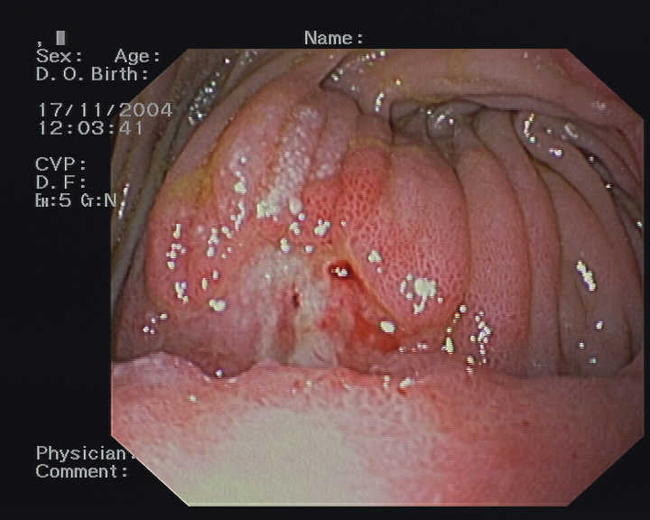

Figure 1

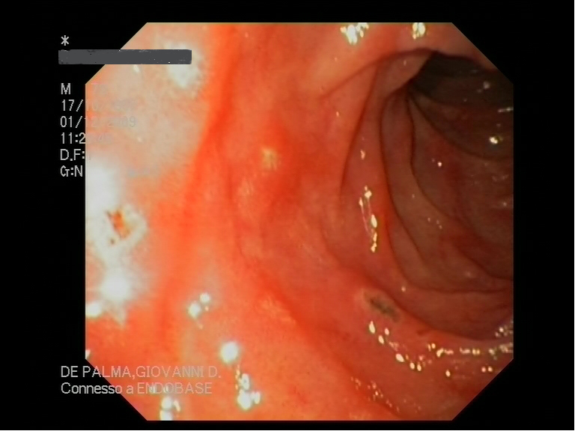

Figure 2

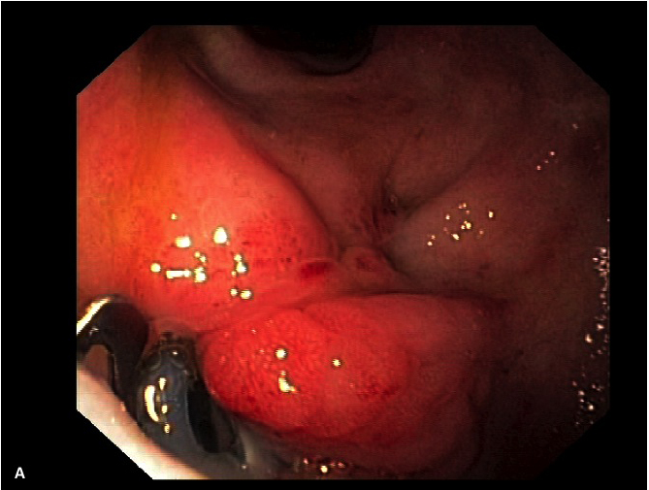

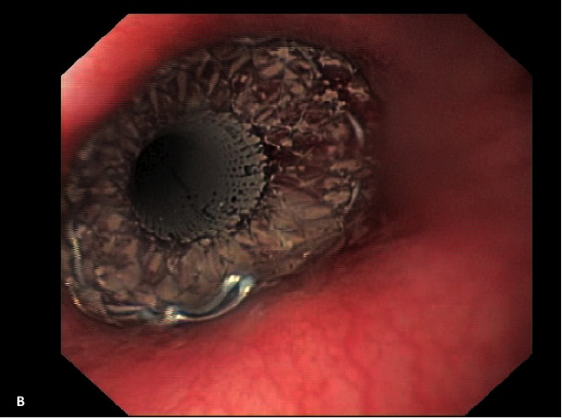

Figure 3

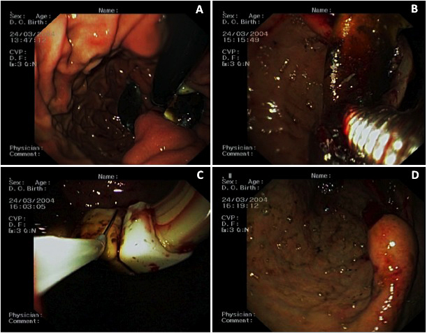
Figure 4

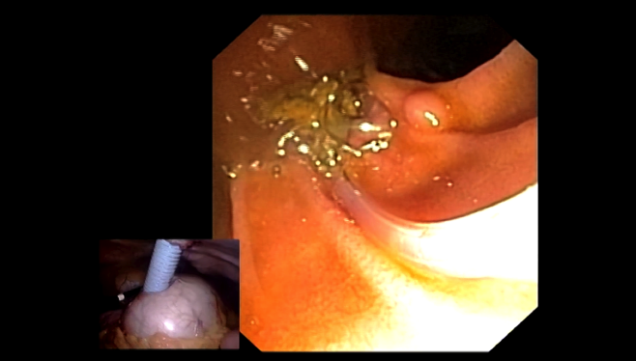

Figure 5

