Name of Journal: World Journal of Gastrointestinal Surgery
Manuscript NO: 86226
Manuscript Type: CASE REPORT

Gastric adenosquamous carcinoma with an elevated serum level of alpha-fetoprotein: A case report

Sun L et al. Gastric ASC positive for AFP

Liang Sun, Juan-Juan Wei, Ran An, Hui-Yun Cai, Yuan Lv, Tao Li, Xiao-Fei Shen, Jun-Feng Du, Gang Chen

Liang Sun, Hui-Yun Cai, Yuan Lv, Tao Li, Xiao-Fei Shen, Jun-Feng Du, Gang Chen, Department of General Surgery, The 7th Medical Center of PLA General Hospital, Beijing 100700, China

Juan-Juan Wei, Operating Room, Department of Anesthesiology, The 7th Medical Center of PLA General Hospital, Beijing 100700, China

Ran An, Department of Pathology, The 7th Medical Center of PLA General Hospital, Beijing 100700, China

Author contributions: Sun L and Wei JJ contributed equally to this work, contributed to the conceptualization and writing-original draft; An R, Cai HY, Li T, Lv Y and Shen XF provided technical support for the staining of the sections and performed standard pathologic analysis; Du JF and Chen G involved in the writing-review and editing; the work reported in the article has been performed by the authors, unless clearly specified in the text; and all authors read and approved the final manuscript.

Supported by the National Natural Science Foundation of China, No. 81970500, 81571563 and 81870393.

Corresponding author: Gang Chen, MD, PhD, Adjunct Professor, Chief Doctor, Department of General Surgery, The 7th Medical Center of PLA General Hospital, No. 5 NanmenCang, Beijing 100700, China. chengang@301hospital.com.cn

Received: June 16, 2023
Revised: July 29, 2023
Accepted: August 18, 2023
Published online: October 27, 2023

Abstract
BACKGROUND
Gastric adenosquamous carcinoma (ASC) is rare and characterized by coexisting of adenocarcinoma andsquamous carcinoma within the same tumor. We present a female patient with gastric ASC who had an elevated serum level of alpha-fetoprotein (AFP), which decreased to normal levels after a laparoscopic distant radical gastrectomy in a short period. The clinicopathological features in AFP-producing gastric cancer (GC) are discussed, as well as potentially available prognostic predictors.

CASE SUMMARY
A 50-year-old woman presented to our department with a chief complain of a 6-mo history of bloating. She had no basic diseases including heart diseases and respiratory diseases, and she also denied any prior history of dysphagia, hematemesis, melena, rectal bleeding, hematochezia, or unintentional weight loss. Based on her symptoms, an esophagogastroduodenoscopy was performed, showing an annular cavity lesion 3 cm from the pylorus with a diameter of 6 cm. A biopsy of the lesion showed gastric ASC, whereas the pylorus biopsy showed normal mucosa. The patient further received an enhanced computed tomography scan which demonstrated an invasive lesion close to the pylorus with a still clear margin of the tumor to peripheral organs such as the pancreas and liver. Scattered lymph nodes were visible around, whereas no sign of liver metastasis was discovered. Serum tumor markers including carcinoembryonic antigen (CEA), cancer antigen 199 (CA199), CA724, CA125, and CA242 were all normal, while the level of serum AFP increased to 172 ng/mL. A laparoscopic distant radical gastrectomy was performed after exclusion of surgical contraindications. Postoperative pathology results showed that the tumor displayed an ulcerated ASC phenotype (90% of medium to highly-differentiated squamous cell carcinoma, 10% of poorly differentiated adenocarcinoma. Surprisingly, the serum level of AFP decreased to normal level on post operation day 5. The tumor cells were positive for CK5/6, p63, and CEA, and negative for AFP and Epstein-Barr encoding region.

CONCLUSION
We presented a rare case of gastric ASC with elevated serum AFP level, which may be new subtype of AFP-producing GC. Follow-up detection of serum AFP might be a useful tool to predict patient prognosis.

Key Words: Gastric cancer; Gastric adenosquamous carcinoma; Alpha-fetoprotein; Case report

©The Author(s) 2023. Published by Baishideng Publishing Group Inc. All rights reserved.

Citation: Sun L, Wei JJ, An R, Cai HY, Lv Y, Li T, Shen XF, Du JF, Chen G. Gastric adenosquamous carcinoma with an elevated serum level of alpha-fetoprotein: A case report. World J Gastrointest Surg 2023; 15(10): 2357-2361
URL: https://www.wjgnet.com/1948-9366/full/v15/i10/2357.htm
DOI: https://dx.doi.org/10.4240/wjgs.v15.i10.2357

Core Tip: Most patients diagnosed with gastric cancer (GC) have a pathological phenotype of adenocarcinoma, and gastric adenosquamous carcinoma (ASC) is rare. We presented a rare case of gastric ASC with elevated serum alpha-fetoprotein (AFP) level, which may be new subtype of AFP-producing GC. AFP-GC is an aggressive cancer with high incidence of liver or lymph node metastasis. Follow-up detection of serum AFP might be a useful tool to predict prognosis.

INTRODUCTION
It is well known that gastric cancer (GC) is the fourth most common cancer worldwide with a third highest incidence and mortality in China^{[1]}. With a change in population structure and population growth, it is also suggested that the incidence of GC has increased by 25% between 2007 and 2017^{[2]}. 1 in 78 women and 1 in 33 men developed GC over a lifetime^{[2]}. Most patients diagnosed with gastric carcinoma had a pathological phenotype of adenocarcinoma which has been studied well over the last decades, and National Comprehensive Cancer Network guidelines also present a detailed management strategy for GC with a adenocarcinoma phenotype. However, there also exist other histological types of gastric carcinoma including primary gastric squamous cell carcinoma, carcinoid, and primary adenosquamous carcinoma (ASC) which is characterized by coexisting of adenocarcinoma and squamous carcinoma within the same tumor. Gastric ASC is rare and clinical features of ASC were described largely in case reports or case series.

CASE PRESENTATION
Chief complaints
A 50-year-old woman presented to our department with a chief complain of a 6-mo history of bloating.

History of present illness
Symptoms started 6-mo before presentation.

History of past illness
She had no basic diseases including heart diseases, respiratory diseases, active or chronic hepatits, liver cirrhosis, and she also denied any prior history of dysphagia, hematemesis, melena, rectal bleeding, hematochezia, or unintentional weight loss.

Personal and family history
The patient denied any family history of malignant tumors.

Physical examination
On physical examination, the vital signs were as follows: Body temperature, 36.7 °C; blood pressure, 125/76 mmHg; heart rate, 78 beats per min; respiratory rate, 18 breaths per min. Furthermore, the abdomen is flat without touching any lumps, without tenderness, rebound pain, or muscle tension. Digital anal examination was not performed.

Laboratory examinations
Serum tumor markers including carcinoembryonic antigen (CEA), cancer antigen 199 (CA199), CA724, CA125, and CA242 were all normal, while the level of serum alpha-fetoprotein (AFP) increased to 172 ng/mL. Liver function indicators and pathogenic tests were all normal.

Imaging examinations
The patient further received an enhanced computed tomography scan which demonstrated an invasive lesion close to the pylorus with a still clear margin of the tumor to peripheral organs such as the pancreas and liver (Figure 1). Scattered lymph nodes were visible around, whereas no sign of liver metastasis was discovered.

FINAL DIAGNOSIS
Combined with the patient’s medical history, the final diagnosis was ASC.

TREATMENT
A laparoscopic distant radical gastrectomy was performed after exclusion of surgical contraindications.

OUTCOME AND FOLLOW-UP
Postoperative pathology results showed that the tumor displayed an ulcerated ASC phenotype, 90% of medium to highly-differentiated squamous cell carcinoma, 10% of poorly differentiated adenocarcinoma (Figure 2A) and metastatic lymph nodes (Figure 2B). Surprisingly, the serum level of AFP decreased to normal level on post operation day 5. The tumor cells were positive for CK5/6, p63, and CEA, and negative for AFP (Figure 2C) and Epstein-Barr encoding region.

DISCUSSION
In this case report, we presented a female patient with gastric ASC who had an elevated serum level of AFP. Although immunohistochemistry staining results for AFP protein in tumor tissues were negative, serum AFP level decreased to normal level after a laparoscopic distant radical gastrectomy in a short period. Therefore, it is possible that gastric ASC in our patient may be accompanied with or even produces soluble AFP. As far as we know, this is the first case of gastric ASC with elevated AFP level partly due to a very low incidence of gastric ASC, which was suggested to account for less than 1% of all gastric malignancies^{[3]}. The whole story of gastric ASC has not been fully elucidated and only two case series with a total of 287 cases summarized clinicopathological features of gastric ASC^{[4]}. The diagnosis of gastric ASC is supported by the presence of both actinic cheilitis (AC) and ASC components with squamous cell carcinoma (SCC) accounting for at least 25% of tumors. In our case, SCC component accounted for approximately 90% of tumor. In addition, the location of tumor in our case was close to pylorus instead of cardia or esophagus, which was in consistent with previous studies showing the most common location of lower third for gastric ASC^{[4]}. No evidence of other AC or SCC was found elsewhere in the body which further confirmed the diagnosis of gastric ASC for our case.
It was suggested that gastric ASC was an extremely aggressive cancer and distant metastasis was usually found, with liver being the most common location for distant metastasis^{[3,4]}. Detailed analysis showed that both AC and SCC components were capable for distant metastasis. The T stage in our case was T4 which was inconsistent with previous study showing that 52.7% cases were stage T4. Lymph node metastasis also occurred in our case with AC component but not SCC component found in metastatic lymph nodes. It is interesting that AC component in our case only accounted for 10% of the tumor but played a predominant role in lymph node metastasis.
Radical resection of tumor remains the optimal treatment for patients without distant metastasis, and the following adjuvant therapy has not been established. Whether to choose chemotherapy or radiotherapy or a combination largely depends on the predominant component presented in gastric ASC. Due to personal reason, this patient refused to receive to any further chemotherapy or radiotherapy. The prognosis of gastric ASC was worse than typical gastric AC with a low 3-year overall survival ranging from 15.4%-32.4%^{[3-5]}. The patient in this report died one year after operation.
Based on the change of serum AFP in this patient before and after operation, we speculated that gastric ASC in this patient may be a new subtype of AFP-producing GC (AFPGC). Commonly, increased serum level of AFP could be seen in AFPGC or in hepatoid adenocarcinoma of the stomach (HAS). AFPGC is defined as primary GC with serum AFP level more than 20 ng/mL or positive immunohistochemistry staining of AFP in the tumor. The diagnosis of HAS is mainly dependent on the pathological character of hepatocellular carcinoma-like differentiation of GC. We didn’t find any proof of HAS in our case and the biological behavior in our case also partly matched those found in AFPGC. The most common location of AFPGC was gastric antrumand corpus^{[6]}, and the serum level of AFP predicted the 5-year overall survival^{[7]}. AFPGC is also an aggressive cancer with high incidence of liver or lymph node metastasis^{[7]}. We identified an elevation of serum AFP 6 mo after surgery in this patient, and the level of AFP remained high 3 mo before his death. No evidence of liver metastasis was identified during the follow-up period.

CONCLUSION
In conclusion, we presented a rare case of gastric ASC with elevated serum AFP level, which may be new subtype of AFP-producing GC. Follow-up detection of serum AFP might be a useful tool to predict patient prognosis.

REFERENCES
1 Torre LA, Bray F, Siegel RL, Ferlay J, Lortet-Tieulent J, Jemal A. Global cancer statistics, 2012. CA Cancer J Clin 2015; 65: 87-108 [PMID: 25651787 DOI: 10.3322/caac.21262]
2 Global Burden of Disease Cancer Collaboration, Fitzmaurice C, Allen C, Barber RM, Barregard L, Bhutta ZA, Brenner H, Dicker DJ, Chimed-Orchir O, Dandona R, Dandona L, Fleming T, Forouzanfar MH, Hancock J, Hay RJ, Hunter-Merrill R, Huynh C, Hosgood HD, Johnson CO, Jonas JB, Khubchandani J, Kumar GA, Kutz M, Lan Q, Larson HJ, Liang X, Lim SS, Lopez AD, MacIntyre MF, Marczak L, Marquez N, Mokdad AH, Pinho C, Pourmalek F, Salomon JA, Sanabria JR, Sandar L, Sartorius B, Schwartz SM, Shackelford KA, Shibuya K, Stanaway J, Steiner C, Sun J, Takahashi K, Vollset SE, Vos T, Wagner JA, Wang H, Westerman R, Zeeb H, Zoeckler L, Abd-Allah F, Ahmed MB, Alabed S, Alam NK, Aldhahri SF, Alem G, Alemayohu MA, Ali R, Al-Raddadi R, Amare A, Amoako Y, Artaman A, Asayesh H, Atnafu N, Awasthi A, Saleem HB, Barac A, Bedi N, Bensenor I, Berhane A, Bernabé E, Betsu B, Binagwaho A, Boneya D, Campos-Nonato I, Castañeda-Orjuela C, Catalá-López F, Chiang P, Chibueze C, Chitheer A, Choi JY, Cowie B, Damtew S, das Neves J, Dey S, Dharmaratne S, Dhillon P, Ding E, Driscoll T, Ekwueme D, Endries AY, Farvid M, Farzadfar F, Fernandes J, Fischer F, G/Hiwot TT, Gebru A, Gopalani S, Hailu A, Horino M, Horita N, Husseini A, Huybrechts I, Inoue M, Islami F, Jakovljevic M, James S, Javanbakht M, Jee SH, Kasaeian A, Kedir MS, Khader YS, Khang YH, Kim D, Leigh J, Linn S, Lunevicius R, El Razek HMA, Malekzadeh R, Malta DC, Marcenes W, Markos D, Melaku YA, Meles KG, Mendoza W, Mengiste DT, Meretoja TJ, Miller TR, Mohammad KA, Mohammadi A, Mohammed S, Moradi-Lakeh M, Nagel G, Nand D, Le Nguyen Q, Nolte S, Ogbo FA, Oladimeji KE, Oren E, Pa M, Park EK, Pereira DM, Plass D, Qorbani M, Radfar A, Rafay A, Rahman M, Rana SM, Søreide K, Satpathy M, Sawhney M, Sepanlou SG, Shaikh MA, She J, Shiue I, Shore HR, Shrime MG, So S, Soneji S, Stathopoulou V, Stroumpoulis K, Sufiyan MB, Sykes BL, Tabarés-Seisdedos R, Tadese F, Tedla BA, Tessema GA, Thakur JS, Tran BX, Ukwaja KN, Uzochukwu BSC, Vlassov VV, Weiderpass E, Wubshet Terefe M, Yebyo HG, Yimam HH, Yonemoto N, Younis MZ, Yu C, Zaidi Z, Zaki MES, Zenebe ZM, Murray CJL, Naghavi M. Global, Regional, and National Cancer Incidence, Mortality, Years of Life Lost, Years Lived With Disability, and Disability-Adjusted Life-years for 32 Cancer Groups, 1990 to 2015: A Systematic Analysis for the Global Burden of Disease Study. JAMA Oncol 2017; 3: 524-548 [PMID: 27918777 DOI: 10.1001/jamaoncol.2016.5688]
3 Chen H, Shen C, Yin R, Yin Y, Chen J, Han L, Zhang B, Chen Z, Chen J. Clinicopathological characteristics, diagnosis, treatment, and outcomes of primary gastric adenosquamous carcinoma. World J Surg Oncol 2015; 13: 136 [PMID: 25889482 DOI: 10.1186/s12957-015-0554-1]
4 Feng F, Zheng G, Qi J, Xu G, Wang F, Wang Q, Guo M, Lian X, Zhang H. Clinicopathological features and prognosis of gastric adenosquamous carcinoma. Sci Rep 2017; 7: 4597 [PMID: 28676632 DOI: 10.1038/s41598-017-04563-2]
5 Quan J, Zhang R, Liang H, Li F, Liu H. The clinicopathologic and prognostic analysis of adenosquamous and squamous cell carcinoma of the stomach. Am Surg 2013; 79: E206-E208 [PMID: 23635572]
6 Lin HJ, Hsieh YH, Fang WL, Huang KH, Li AF. Clinical manifestations in patients with alpha-fetoprotein-producing gastric cancer. Curr Oncol 2014; 21: e394-e399 [PMID: 24940098 DOI: 10.3747/co.21.1768]
7 Liu X, Cheng Y, Sheng W, Lu H, Xu Y, Long Z, Zhu H, Wang Y. Clinicopathologic features and prognostic factors in alpha-fetoprotein-producing gastric cancers: analysis of 104 cases. J Surg Oncol 2010; 102: 249-255 [PMID: 20740583 DOI: 10.1002/jso.21624]

Footnotes
Informed consent statement: Informed written consent was obtained from the patient for publication of this report and any accompanying images.

Conflict-of-interest statement: All the authors report no relevant conflicts of interest for this article.

CARE Checklist (2016) statement: The authors have read the CARE Checklist (2016), and the manuscript was prepared and revised in accordance with it.

Open-Access: This article is an open-access article that was selected by an in-house editor and fully peer-reviewed by external reviewers. It is distributed in accordance with the Creative Commons Attribution NonCommercial (CC BY-NC 4.0) license, which permits others to distribute, remix, adapt, build upon this work non-commercially, and license their derivative works on different terms, provided the original work is properly cited and the use is non-commercial. See: https://creativecommons.org/Licenses/by-nc/4.0/

Provenance and peer review: Unsolicited article; Externally peer reviewed.
Peer-review model: Single blind

Peer-review started: June 16, 2023
First decision: July 23, 2023
Article in press: August 18, 2023

Specialty type: Gastroenterology and hepatology
Country/Territory of origin: China
Peer-review report’s scientific quality classification
Grade A (Excellent): 0
Grade B (Very good): 0
Grade C (Good): C, C
Grade D (Fair): 0
Grade E (Poor): 0

P-Reviewer: koganti SB, United States; Kotelevets SM, Russia S-Editor: Wang JJ L-Editor: A P-Editor: Wang JJ

Figure Legends
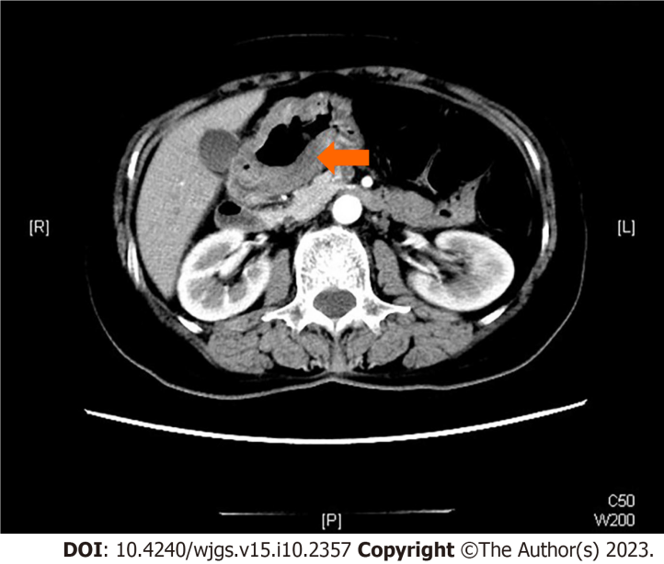
Figure 1 Enhanced computed tomography examination of the abdomen. Invasive lesion close to the pylorus can be seen, and the edges between the tumor and peripheral organs such as the pancreas and liver are still clear (arrow).

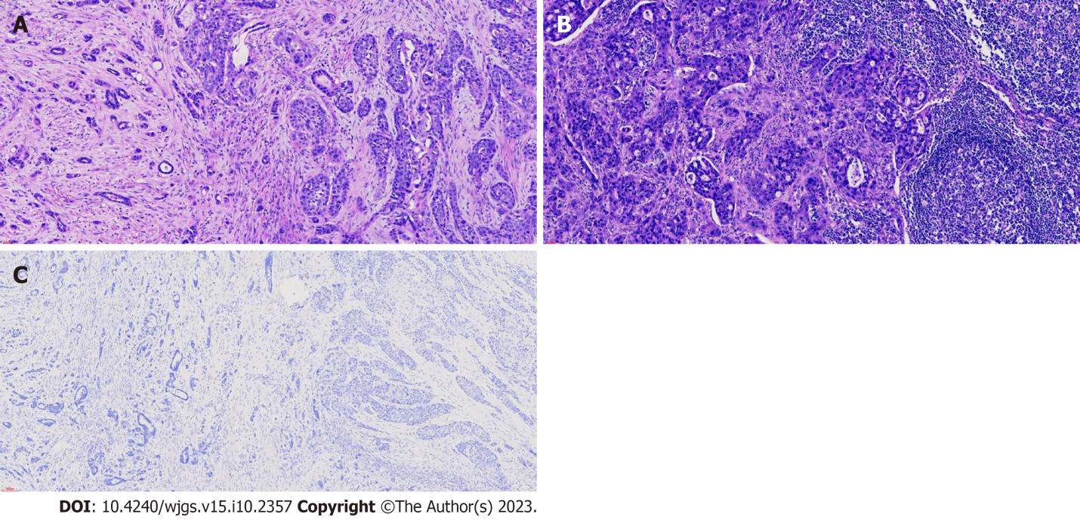
Figure 2 Histopathological analysis and immunohistochemical examination. A and B: Histopathological analysis and immunohistochemical examination of the resected specimen. Gastric adenosquamous carcinoma (20 ×), lymph node metastasis (20 ×); C: Immunohistochemistry staining for alpha-fetoprotein (AFP) of the resected specimen. Immunohistochemistry staining for AFP (10 ×).

Published by Baishideng Publishing Group Inc
7041 Koll Center Parkway, Suite 160, Pleasanton, CA 94566, USA
Telephone: +1-925-3991568
E-mail: bpgoffice@wjgnet.com
Help Desk: https://www.f6publishing.com/helpdesk
https://www.wjgnet.com

© 2023 Baishideng Publishing Group Inc. All rights reserved.

