Name of journal: World Journal of Gastroenterology
ESPS Manuscript NO: 13810
Columns: meta-analysis

Integrin antagonists are effective and safe for Crohn’s disease treatment: a meta-analysis

Ge WS et al. meta-analysis of integrin antagonists in CD

Wen-Song Ge, Jian-Gao Fan

Wen-Song Ge, Jian-Gao Fan, Department of Gastroenterology, Shanghai Xinhua Hospital Affiliated to Shanghai Jiao Tong University School of Medicine, Shanghai 200092, China

Author contributions: Fan JG designed the study; Ge WS and Fan JG screened the citations, did the data analyses and wrote the paper.

Supported by National Natural Science Foundation of China, No. 81200279; and Medical-Engineering (Science) cross-Research Fund of Shanghai Jiao Tong University, No. YG2011MS29

Correspondence to: Jian-Gao Fan, MD, Department of Gastroenterology, Shanghai Xinhua Hospital Affiliated to Shanghai Jiao Tong University School of Medicine, 1665 Kongjiang Rd, Shanghai 200092, China. xinhuafjg@126.com

Telephone: +86-21-25077344 Fax: +86-21-25077345
Received: September 2, 2014 Revised: October 11, 2014
Accepted: December 1, 2014

Published online:

Abstract
Aim: To evaluate the efficacy and safety of integrin antagonists including natalizumab and vedolizumab in Crohn’s disease.

Methods: Literatures were searched in Pubmed, Medline, Embase and the Cochrane library to screen citations from January 1990 to August 2014 in this study. Data analyses were done by using the Review Manager Software 5.2.

Results: A total of 1340 patients from 5 studies have been involved in this meta-analysis. During 6-12 wk treatment, integrin antagonists can increase the rate of clinical response and remission with OR =1.69 (95%CI: 1.37-2.09) and 1.84 (95%CI: 1.44-2.34) respectively. No significant difference was found between integrin antagonists and placebo treatments regarding their adverse reaction (OR = 1.07, 95%CI: 0.83-1.38) and serious adverse reaction (OR = 0.81, 95%CI: 0.57-1.15).

Conclusion: The results have proven the efficacy and safety of integrin antagonists for Crohn disease treatment, though the treatment strategies were various.

© 2014 Baishideng Publishing Group Inc. All rights reserved.

Key words: Crohn’s disease; Efficacy; Integrin antagonist; Meta-analysis; Safety

Core tip: α-integrin antagonists were used to treat Crohn’s disease, but their efficacy and safety are not certain yet. We performed this systematic review and meta-analysis to evaluate the efficacy and safety of integrin antagonists including natalizumab and vedolizumab in Crohn’s disease. During 6-12 wk treatment, integrin antagonists can increase the rate of clinical response and remission. And no significant difference was found between integrin antagonists and placebo treatments regarding their adverse reaction and serious adverse reaction. These results have proven the efficacy and safety of integrin antagonists for Crohn’s disease treatment.

Ge WS, Fan JG. Integrin antagonists are effective and safe for Crohn’s disease treatment: a meta-analysis. World J Gastroenterol 2014; In press

Introduction
Crohn's disease (CD) is a relapsing systemic inflammatory disease that commonly affects the gastrointestinal tract with extraintestinal manifestations and associated immune disorders^{[1]}. CD often leads to abdominal pain, fever, malaise, fatigue, diarrhea, fistulae formation, bowel obstruction, and malnutrition. The common therapies for CD are aminosalicylates, steroids, immunosuppressants and monoclonal antibodies^{[2]}. Aminosalicylates such as mesalamine and sulfasalazine are used to treat mild to moderate CD^{[3]}, while corticosteroids are used to treat acute active CD and patients who do not response to aminosalicylates^{[4]}. However, the use of corticosteroids has a high risk of Cushing’s syndrome, infection and diabetes in short term and bone loss, increased ocular pressure and diabetes in long term^{[5]}. Immunosuppressants are used to suppress immune system and inhibit inflammation. Long term use of immunosuppressants may cause infection, liver toxicity and bone marrow suppression^{[6]}. Biologic agents used to treat CD mainly consist of tumor necrosis factor α (TNF-α) inhibitors and α-integrin antagonists.
Natalizumab and Vedolizumab are the intergrin antagonists approved by the Food and Drug Administration. Natalizumab is a monoclonal antibody antagonizing α4β1 and α4β7 intergrin-mediated interactions in gut and brain^{[7]}. It is effective in treating CD while limited by increasing the risk of progressive multifocal leukoencephalopathy (PML)^{[8]}. Vedolizumab is a humanized immunoglobulin G1 monoclonal antibody for α4β7 integrin. Since it only regulates gut lymphocyte trafficking, vedolizumab is not likely to cause PML^{[9]}.
Previous studies have indicated the efficacy of intergrin inhibitors in CD therapy. However, the sample size of those studies was small. Therefore we performed a meta-analysis including current double-blind randomized controlled trials (RCTs) to evaluate the efficacy of intergrin antagonists for CD treatment.

MATERIALS AND METHODS
Search strategy and inclusion criteria
Databases (Embase, Medline, Pubmed and Cochrane library) were searched for RCTs from January 1990 to August 2014. The key words “Crohn disease” and “natalizumab” or “MLN0002” or “vedolizumab” were used in screening relevant citations. The inclusion criteria were: (1) the studies were randomized controlled trials; and (2) the studies provided the data at least with one of the main outcomes, including rate of clinical response, rate of clinical remission, common adverse reaction and serious adverse reaction. Clinical remission was defined as Crohn’s Disease Activity Index (CDAI) score < 150 and clinical response was defined as a decrement of ≥ 70-point in CDAI score from baseline (Week 0).

Data extraction and quality assessment
The following information was extracted from each study: first author name; year of publication; number of patients; rate of clinical response; rate of clinical remission; the number of common adverse reaction; the number of serious adverse reaction. The Jadad score was used to assess the quality of included studies. The studies with score no less than 3 were regarded as high quality RCTs, while studies with score less than 3 were defined as low quality RCTs.

Statistical analysis
Data analysis was performed by using the RevMan5.2 for each individual study, dichotomous data were reported as odds ratio (OR) with 95%CI. Heterogeneity between studies was assessed by Cochrane Q statistics and I² test. A significant level of no less than 50% for I² test was considered as evidence of heterogeneity. Fix effect model was used when there was no evidence of heterogeneity, otherwise random effect model was chosen. Ghosh et al^{[10]} used 3 different treatment strategies and Feagan et al^{[11]} used two treatment strategies. Each treatment strategy was regarded as a single treatment group. All of the treatments were analyzed together.

Results
Search results and characteristics
A total of 226 citations were obtained via database searches; five met the inclusion criteria for this study (Figure 1). A total of 1340 patients have been involved, in which 462 subjects were treated with natalizumab, 347 subjects were treated with vedolizumab and 531 subjects were treated with placebo. The information in these citations was summarized in Table 1. All five studies have been assessed by Jadad score system with score no less than 3 (Table 1).

Clinical response
Clinical response was reported in four studies. According to the results of the meta-analysis, integrin antagonists could increase the clinical response to CD. The OR for clinical response was 1.69 (95%CI: 1.37-2.09). There was no heterogeneity as I² = 0% (Figure 2).

Clinical remission
Clinical remission was reported in five studies. Integrin antagonists had a higher rate of remission than placebo. The OR for clinical remission was 1.84 (95%CI: 1.44-2.34). There was no heterogeneity as I² = 0% (Figure 3).

Safety
Both Natalizumab and Vedolizumab were well tolerated during the treatment. They had similar rates of common adverse reaction (OR = 1.07, 95%CI: 0.83-1.38) and serious adverse reaction (OR = 0.81, 95%CI: 0.57-1.15) compared to placebo with no significant difference (Figures 4 and 5).

Discussion
The incidence of Crohn disease is increasing worldwide with more and more young patients and it requires life-long medical and surgical input^{[15]}. Over the past decades, TNF-α inhibitors such as infliximab, adalimumab, certolizumab pegol, and golimumab have been used in patients with moderate to severe CD who failed to respond to corticosteroids^{[16]}. TNF-α inhibitors have been proved effective in CD treatment, however 40% of patients will lose response to them at a rate of 10%-13% per year^{[17]}. This led to researches looking for an alternative way to treat CD. It was found that the migration of leukocytes and other inflammatory cells into intestinal vasculature and the disruption of intestinal barrier function were important in the pathogenesis of CD^{[18]}. The integrin antagonists (natalizumab and vedolizumab) aim to block the interaction between leukocytes and endothelial cells to inhibit inflammation^{[19]}. A RCT showed that vedolizumab can lead to clinical remission at 10 wk in TNF antagonist–failure patients^{[20]}.
Our meta-analysis suggested that short term treatment with intergin antagonists could improve the clinical response and remission in CD patients. Compared to placebo, patients treated with 6 mg/kg natalizumab at 0 and 4 week showed the highest OR for clinical response (OR = 2.44, 95%CI: 1.14-5.23), followed by 3 mg/kg natalizumab at 0 and 4 wk (OR = 2.05, 95%CI: 1.02-4.14). However, there was not significant difference between natalizumab and vedolizumab in terms of clinical response and remission.
According to meta-analysis results, integrin antagonists had a similar rate of adverse reaction with placebo group. Previous studies showed that natalizumab could increase the risk of PML at a rate of 0.09 to 11 per 1000 patients^{[8]}. Vedolizumab was designed to target the α4β7 integrin heterodimer and can not cross the blood–brain barrier^{[21]}. There has been no reported case of PML in patients treated with vedolizumab for CD^{[22]}. However, we did not find PML reported in the included studies and compared to placebo, both natalizumab and vedolizumab had a similar rate of serious adverse reaction.
In addition, there were some limitations in our study. The treatment strategies were different in each study, for example Ghosh et al^{[10]} used 3 mg/kg natalizumab, while Targan et al^{[13]} used a fix dose of 300 mg. The duration of treatment was also various. Moreover, the inclusion criteria for patient were different in these trials. Sandborn et al^{[14]} included patients who previously received TNF antagonist therapy; however these patients were excluded in the other four trials. Despite these limitations, we believed that our analysis could contribute to the comprehensive evaluation of integrin antagonists in CD.
Our meta-analysis suggested that integrin antagonists were effective in improving CD response and remission rates with a similar rate of adverse reaction compared to placebo in the proper treatment strategy. However, due to the small size of samples in our study, large multicenter RCTs are needed to indentify our findings.

comments
Background
Crohn’s disease (CD) can affect the gastrointestinal tract with extraintestinal manifestations and often leads to abdominal pain, fever, malaise, fatigue, diarrhea and bowel obstruction. Traditional therapies for CD are aminosalicylates, steroids, immunosuppressants and monoclonal antibodies. However, they all have an apparent side effect. Intergrin antagonists including natalizumab and vedolizumab aim to block the interaction between leukocytes and endothelial cells. Previous studies have reported that intergrin antagonists can inhibit inflammation.

Research frontiers
Natalizumab is a monoclonal antibody antagonizing α4β1 and α4β7 intergrin-mediated interactions in gut and brain, while vedolizumab is a humanized immunoglobulin G1 monoclonal antibody for α4β7 intergrin. Current studies have reported intergrin antagonists can relieve symptoms in CD.

Innovations and breakthroughs
Previous studies have reported that natalizumab and vedolizumab are effective in CD treatment. However, the sample of these trials is small and there is still lack of large multicenter trials. To evaluate the efficacy and safety of intergrin antagonists including natalizumab and vedolizumab, the authors performed a meta-analysis which can overcome the limitation of single small sample trials. To date, no meta-analysis has been published yet in CD, which evaluates the efficacy and safety of the intergrin antagonists. Thus, the aim of this study was to carry out a systematic literature review and meta-analysis of published RCTs in order to evaluate the efficacy and safety of the intergrin antagonists, and this may contribute with important results to the evidence-based health care evaluation of CD that might support clinical as well as financial decision making.

Applications
Our study suggests that intergrin antagonists are effective in improving CD response and remission rate though the treatment strategies are various. Compared with placebo, intergrin antagonists have a similar safty.

Terminology
CD is a relapsing systemic inflammatory disease that commonly affects the gastrointestinal tract with extraintestinal manifestations and associated immune disorders. CD often leads to abdominal pain, fever, malaise, fatigue, diarrhea, fistulae formation, bowel obstruction, and malnutrition. Intergrin antagonists are antibodies which aim to block the interaction between leukocytes and endothelial cells to inhibit inflammation including natalizumab and vedolizumab.

Peer review
This study shows a meta-analysis that reviews the clinical evidence about the use of Integrin antagonists as a new treatment in refractory CD. Five papers meet with rigorous inclusion criteria and their analysis reported interesting data. Nevertheless, it`s not clear, in the methods and discussion section, if these clinical trials are directed to treat only anti-TNF refractory patients. To be exact, the analysis must be clarifying the inclusion criteria of the analyzed clinical trials (five papers) in order to get good conclusion. The other hand, author recognized that the treatment strategies were different in each study, and these weaknesses must be remarked in the conclusion and, of course, in the abstract.

References
1 Baumgart DC, Sandborn WJ. Crohn’s disease. Lancet 2012; 380: 1590-1605 [PMID: 22914295 DOI: 10.1016/S0140-6736(12)60026-9]
2 Dudley-Brown S, Nag A, Cullinan C, Ayers M, Hass S, Panjabi S. Health-related quality-of-life evaluation of crohn disease patients after receiving natalizumab therapy. Gastroenterol Nurs 2009; 32: 327-339 [PMID: 19820441 DOI: 10.1097/SGA.0b013e3181bb1484]
3 Nielsen OH, Munck LK. Drug insight: aminosalicylates for the treatment of IBD. Nat Clin Pract Gastroenterol Hepatol 2007; 4: 160-170 [PMID: 17339853 DOI: 10.1038/ncpgasthep0696]
4 De Cassan C, Fiorino G, Danese S. Second-generation corticosteroids for the treatment of Crohn’s disease and ulcerative colitis: more effective and less side effects? Dig Dis 2012; 30: 368-375 [PMID: 22796798 DOI: 10.1159/000338128]
5 Lichtenstein GR, Feagan BG, Cohen RD, Salzberg BA, Diamond RH, Chen DM, Pritchard ML, Sandborn WJ. Serious infections and mortality in association with therapies for Crohn’s disease: TREAT registry. Clin Gastroenterol Hepatol 2006; 4: 621-630 [PMID: 16678077 DOI: 10.1016/j.cgh.2006.03.002]
6 Kandiel A, Fraser AG, Korelitz BI, Brensinger C, Lewis JD. Increased risk of lymphoma among inflammatory bowel disease patients treated with azathioprine and 6-mercaptopurine. Gut 2005; 54: 1121-1125 [PMID: 16009685 DOI: 10.1136/gut.2004.049460]
7 Sandborn WJ, Yednock TA. Novel approaches to treating inflammatory bowel disease: targeting alpha-4 integrin. Am J Gastroenterol 2003; 98: 2372-2382 [PMID: 14638336 DOI: 10.1111/j.1572-0241.2003.08703.x]
8 Bloomgren G, Richman S, Hotermans C, Subramanyam M, Goelz S, Natarajan A, Lee S, Plavina T, Scanlon JV, Sandrock A, Bozic C. Risk of natalizumab-associated progressive multifocal leukoencephalopathy. N Engl J Med 2012; 366: 1870-1880 [PMID: 22591293 DOI: 10.1056/NEJMoa1107829]
9 Soler D, Chapman T, Yang LL, Wyant T, Egan R, Fedyk ER. The binding specificity and selective antagonism of vedolizumab, an anti-alpha4beta7 integrin therapeutic antibody in development for inflammatory bowel diseases. J Pharmacol Exp Ther 2009; 330: 864-875 [PMID: 19509315 DOI: 10.1124/jpet.109.153973]
10 Ghosh S, Goldin E, Gordon FH, Malchow HA, Rask-Madsen J, Rutgeerts P, Vyhnálek P, Zádorová Z, Palmer T, Donoghue S. Natalizumab for active Crohn’s disease. N Engl J Med 2003; 348: 24-32 [PMID: 12510039 DOI: 10.1056/NEJMoa020732]
11 Feagan BG, Greenberg GR, Wild G, Fedorak RN, Paré P, McDonald JW, Cohen A, Bitton A, Baker J, Dubé R, Landau SB, Vandervoort MK, Parikh A. Treatment of active Crohn’s disease with MLN0002, a humanized antibody to the alpha4beta7 integrin. Clin Gastroenterol Hepatol 2008; 6: 1370-1377 [PMID: 18829392 DOI: 10.1016/j.cgh.2008.06.007]
12 Gordon FH, Lai CW, Hamilton MI, Allison MC, Srivastava ED, Fouweather MG, Donoghue S, Greenlees C, Subhani J, Amlot PL, Pounder RE. A randomized placebo-controlled trial of a humanized monoclonal antibody to alpha4 integrin in active Crohn’s disease. Gastroenterology 2001; 121: 268-274 [PMID: 11487536]
13 Targan SR, Feagan BG, Fedorak RN, Lashner BA, Panaccione R, Present DH, Spehlmann ME, Rutgeerts PJ, Tulassay Z, Volfova M, Wolf DC, Hernandez C, Bornstein J, Sandborn WJ. Natalizumab for the treatment of active Crohn’s disease: results of the ENCORE Trial. Gastroenterology 2007; 132: 1672-1683 [PMID: 17484865 DOI: 10.1053/j.gastro.2007.03.024]
14 Sandborn WJ, Feagan BG, Rutgeerts P, Hanauer S, Colombel JF, Sands BE, Lukas M, Fedorak RN, Lee S, Bressler B, Fox I, Rosario M, Sankoh S, Xu J, Stephens K, Milch C, Parikh A. Vedolizumab as induction and maintenance therapy for Crohn’s disease. N Engl J Med 2013; 369: 711-721 [PMID: 23964933 DOI: 10.1056/NEJMoa1215739]
15 Molodecky NA, Soon IS, Rabi DM, Ghali WA, Ferris M, Chernoff G, Benchimol EI, Panaccione R, Ghosh S, Barkema HW, Kaplan GG. Increasing incidence and prevalence of the inflammatory bowel diseases with time, based on systematic review. Gastroenterology 2012; 142: 46-54.e42; quiz e30 [PMID: 22001864 DOI: 10.1053/j.gastro.2011.10.001]
16 Singh S, Pardi DS. Update on anti-tumor necrosis factor agents in Crohn disease. Gastroenterol Clin North Am 2014; 43: 457-478 [PMID: 25110253 DOI: 10.1016/j.gtc.2014.05.008]
17 Ben-Horin S, Chowers Y. Review article: loss of response to anti-TNF treatments in Crohn’s disease. Aliment Pharmacol Ther 2011; 33: 987-995 [PMID: 21366636 DOI: 10.1111/j.1365-2036.2011.04612.x]
18 Cominelli F. Inhibition of leukocyte trafficking in inflammatory bowel disease. N Engl J Med 2013; 369: 775-776 [PMID: 23964940 DOI: 10.1056/NEJMe1307415]
19 Van Assche G, Rutgeerts P. Physiological basis for novel drug therapies used to treat the inflammatory bowel diseases. I. Immunology and therapeutic potential of antiadhesion molecule therapy in inflammatory bowel disease. Am J Physiol Gastrointest Liver Physiol 2005; 288: G169-G174 [PMID: 15647604 DOI: 10.1152/ajpgi.00423.2004]
20 Sands BE, Feagan BG, Rutgeerts P, Colombel JF, Sandborn WJ, Sy R, D’Haens G, Ben-Horin S, Xu J, Rosario M, Fox I, Parikh A, Milch C, Hanauer S. Effects of vedolizumab induction therapy for patients with Crohn’s disease in whom tumor necrosis factor antagonist treatment failed. Gastroenterology 2014; 147: 618-627.e3 [PMID: 24859203 DOI: 10.1053/j.gastro.2014.05.008]
21 Milch C, Wyant T, Xu J, Parikh A, Kent W, Fox I, Berger J. Vedolizumab, a monoclonal antibody to the gut homing α4β7 integrin, does not affect cerebrospinal fluid T-lymphocyte immunophenotype. J Neuroimmunol 2013; 264: 123-126 [PMID: 24067534 DOI: 10.1016/j.jneuroim.2013.08.011]
22 Gilroy L, Allen PB. Is there a role for vedolizumab in the treatment of ulcerative colitis and Crohn’s disease? Clin Exp Gastroenterol 2014; 7: 163-172 [PMID: 24899819 DOI: 10.2147/CEG.S45261]

P-Reviewer:Garcia-OlmodS-Editor:Ma YJL-Editor:E-Editor:

Table 1 Main characteristics of the included studies
Ref. | Study  duration | Treatment | Age  (mean, yr) | Disease duration (yr) | Baseline CDAI  (mean) | Jadad score
Gordon et al^{[12]}, 2001 | 12 | Natalizumab 3mg/kg intravenous infusion at 0 wk n = 18 | 36 | 8.5 | 258 | 5
 |  | Placebo intravenous infusion at 0 wk n = 12 | 34 | 8.4 | 273
Ghosh et al^{[10]}, 2003 | 12 | Natalizumab 6mg/kg intravenous infusion at 0, 4 wk n = 51 | 35 | 7.8 | 298 | 5
 |  | Natalizumab 3mg/kg intravenous infusion at 0, 4 wk n = 66 | 36 | 8.1 | 300
 |  | Natalizumab 3mg/kg intravenous infusion at 0 wk n = 68 | 36 | 8.4 | 288
 |  | Placebo intravenous infusion at 0, 4 wk n = 63 | 34 | 8.9 | 300
Targan et al^{[13]}, 2007 | 12 | Natalizumab 300mg intravenous infusion at 0, 4, 8 wk n = 259 | 38 | 10.1 | 304 | 5
 |  | Placebo intravenous infusion at 0, 4, 8wk n = 250 | 38 | 10 | 300
Feagan et al^{[11]}, 2008 | 8 | Vedolizumab 2mg/kg intravenous infusion at 0, 4 wk n = 65 | 39 | 8 | 297 | 5
 |  | Vedolizumab 0.5mg/kg intravenous infusion at 0, 4 wk n = 62 | 36 | 8.8 | 288
 |  | Placebo intravenous infusion at 0, 4 wk n = 58 | 35 | 9 | 288
Sandborn et al^{[14]}, 2013 | 6 | Vedolizumab 300mg intravenous infusion at 0, 2 wk n = 220 | 36 | 9.2 | 327 | 5
 |  | Placebo intravenous infusion at 0, 2 wk n = 148 | 39 | 8.2 | 325
CDAI: Crohn’s disease activity index.

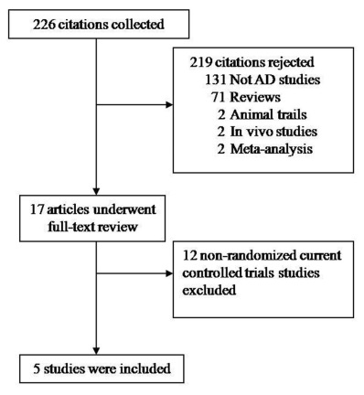
Figure 1 Flow diagram of the studies identified.

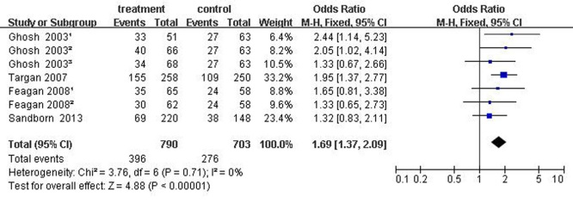
Figure 2 Forest plots of clinical response. Clinical response was defined as a decrement of ≥ 70-point in CDAI score from baseline (Week 0). Ghosh 2003¹: 6 mg/kg natalizumab at 0, 4 wk; Ghosh 2003²: 3 mg/kg natalizumab at 0, 4 wk; Ghosh 2003³: 3 mg/kg natalizumab at 0 wk. Feagan 2008¹: 2 mg/kg vedolizumab at 0, 4 wk; Feagan 2008²: 0.5 mg/kg vedolizumab at 0, 4 wk.

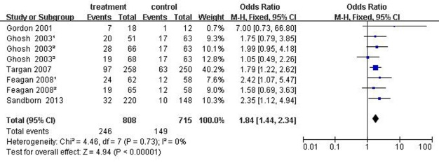
Figure 3 Forest plots of clinical remission. Clinical remission was defined as CDAI score < 150. Ghosh 2003¹: 6 mg/kg natalizumab at 0, 4 wk; Ghosh 2003²: 3 mg/kg natalizumab at 0, 4 wk; Ghosh 2003³: 3 mg/kg natalizumab at 0 wk. Feagan 2008¹: 2 mg/kg vedolizumab at 0, 4 wk; Feagan 2008²: 0.5 mg/kg vedolizumab at 0, 4 wk.

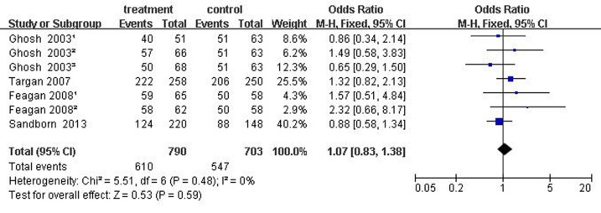
Figure 4 Forest plots of common adverse reaction. Ghosh 2003¹: 6 mg/kg natalizumab at 0, 4 wk; Ghosh 2003²: 3 mg/kg natalizumab at 0, 4 wk; Ghosh 2003³: 3 mg/kg natalizumab at 0 wk. Feagan 2008¹: 2 mg/kg vedolizumab at 0, 4 wk; Feagan 2008²: 0.5 mg/kg vedolizumab at 0, 4 wk.

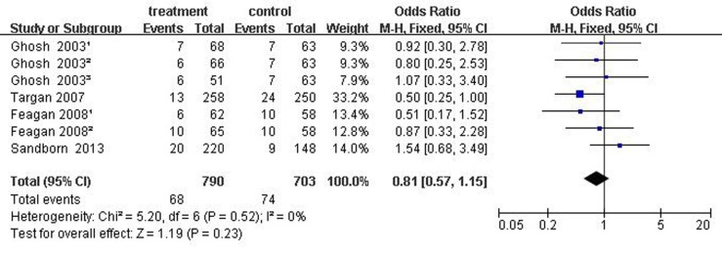
Figure 5 Forest plots of serious adverse reaction. Ghosh 2003¹: 6mg/kg natalizumab at 0, 4 wk; Ghosh 2003²: 3 mg/kg natalizumab at 0, 4 wk; Ghosh 2003³: 3 mg/kg natalizumab at 0 wk. Feagan 2008¹: 2 mg/kg vedolizumab at 0, 4 wk; Feagan 2008²: 0.5 mg/kg vedolizumab at 0, 4 wk.

