Name of Journal: World Journal of Clinical Cases
Manuscript NO: 56287
Manuscript Type: ORIGINAL ARTICLE

Retrospective Study
High serum lactate dehydrogenase and dyspnea: Positive predictors of adverse outcome in critical COVID-19 patients in Yichang

Lv XT et al. Positive predictors in critical COVID-19 patients

Xiao-Ting Lv, Yong-Ping Zhu, Ai-Guo Cheng, Yong-Xu Jin, Hai-Bo Ding, Cai-Yun Wang, Shu-Yu Zhang, Gong-Ping Chen, Qing-Quan Chen, Qi-Cai Liu

Xiao-Ting Lv, Yong-Xu Jin, Hai-Bo Ding, Cai-Yun Wang, Gong-Ping Chen, Department of Respiratory and Critical Care Medicine, the First Affiliated Hospital of Fujian Medical University, Fuzhou 350005, Fujian Province, China

Xiao-Ting Lv, Institute of Respiratory Disease, Fujian Medical University, Fuzhou 350005, Fujian Province, China

Yong-Ping Zhu, Department of Cardiovascular Surgery, Fujian Medical University Attached Union Hospital, Fuzhou 350001, Fujian Province, China

Ai-Guo Cheng, Department of Critical Medicine, the Third People's Hospital of Yichang, Yichang 443000, Hubei Province, China

Shu-Yu Zhang, Qing-Quan Chen, Department of Laboratory Medicine, Fujian Medical University, Fuzhou 350004, Fujian Province, China

Qi-Cai Liu, Department of Reproductive Medicine Centre, First Affiliated Hospital of Fujian Medical University, Fuzhou 350005, Fujian Province, China

Author contributions: Lv XT, Zhu YP, Chen GP and Liu QC contributed equally to this work; Chen GP, Chen QQ, and Liu QC designed the research study; Cheng AG, Jin YX, Ding HB, Wang CY and Zhang SY performed the research; Cheng AG, Jin YX, Ding HB and Lv XT contributed reagents and analytic tools; Lv XT and Zhu YP analyzed the data and wrote the manuscript; all authors have read and approve the final manuscript.

Supported by National Natural Science Foundation of China, No. 81800070; Development Fund Program of Fujian Provincial Health and Family Planning Commission, China, No. 2017-1-43.

Corresponding author: Qi-Cai Liu, MD, Chief Technician, Doctor, Teacher, Department of Reproductive Medicine Centre, First Affiliated Hospital of Fujian Medical University, No. 20 Chazhong Road, Taijiang District, Fuzhou 350005, Fujian Province, China. lqc673673673@163.com

Received: April 26, 2020
Revised: September 4, 2020
Accepted: September 16, 2020
Published online: November 26, 2020

Abstract
BACKGROUND
Coronavirus disease 2019 (COVID-19) caused by the severe acute respiratory syndrome coronavirus 2 (SARS-CoV-2) outbreak in China, constitutes a Public Health Emergency of International Concern. It is well known that COVID-19 patients may have increased serum lactate dehydrogenase (LDH) levels in the early stage. The clinical changes in LDH may have predictive value in disease evolution and prognosis in critically ill COVID-19 patients.

AIM
To examine serum LDH and clinical characteristics in patients with COVID-19 and their predictive value for prognosis.

METHODS
This retrospective study analyzed the clinical data of forty-seven critical COVID-19 patients in the intensive care unit of the Third People's Hospital of Yichang City from January 27 to March 25, 2020 and divided them into survivors and non-survivors. The patients were diagnosed according to the World Health Organization interim guidance and critical cases met any one of the following criteria: Respiratory failure and required mechanical ventilation, the occurrence of shock, and the combined failure of other organs that required intensive care unit monitoring and treatments, according to the diagnostic criteria of critical COVID-19. Clinical data including symptoms, detection of SARS-CoV-2, chest computed tomography (CT) images, changes in serum LDH in different clinical phases, and prognosis were collected. Statistical analysis of the data was performed. Continuous variables were expressed as median (interquartile range) and compared with the Mann-Whitney U test. Categorical variables were compared with the Chi-square test. Survival data were analyzed using Kaplan-Meier survival curves and log-rank tests.

RESULTS
According to chest CT images, we observed the alveolitis and fibrosis stages in all critical patients in this study. Most non-survivors died in the fibrosis stage. Non-survivors had fewer days of hospitalization, shorter disease duration, shorter duration of alveolitis and fibrosis, and had dyspnea symptoms at disease onset (P = 0.05). Both first and lowest LDH values in the alveolitis stage were more pronounced in non-survivors than in survivors (449.0 U/L vs 288.0 U/L, P = 0.0243; 445.0 U/L vs 288.0 U/L, P = 0.0199, respectively), while the first, lowest and highest values of serum LDH in non-survivors were all significantly increased compared to survivors in the fibrosis phase (449.0 U/L vs 225.5 U/L, P = 0.0028; 432.0 U/L vs 191.0 U/L, P = 0.0007; 1303.0 U/L vs 263.5 U/L, P = 0.0001, respectively). The cut-off points of first LDH values in the alveolitis and fibrosis phase for distinction of non-survivors from survivors were 397.0 U/L and 263.0 U/L, respectively. In the fibrosis stage, non-survivors had more days with high LDH than survivors (7.0 d vs 0.0 d, P = 0.0002). Importantly, patients with high LDH had a significantly shorter median survival time than patients with low LDH in the alveolitis phase (22.0 d vs 36.5 d, P = 0.0002), while patients with high LDH also had a significantly shorter median survival time than patients with low LDH in the fibrosis phase (27.5 d vs 40.0 d, P = 0.0008). The proportion of non-survivors with detectable SARS-CoV-2 until death in the alveolitis stage was significantly increased compared with that in the fibrosis stage (100% vs 35.7%, P = 0.0220).

CONCLUSION
High LDH and dyspnea symptoms were positive predictors of an adverse outcome in critical COVID-19. The rapid progressive fibrosis stage was more perilous than the alveolitis stage, even if SARS-CoV-2 is undetectable.

Key Words: COVID-19; SARS-CoV-2; Lactate dehydrogenase; Pulmonary fibrosis; Dyspnea; Overall survival

Citation: Lv XT, Zhu YP, Cheng AG, Jin YX, Ding HB, Wang CY, Zhang SY, Chen GP, Chen QQ, Liu QC. High serum lactate dehydrogenase and dyspnea: Positive predictors of adverse outcome in critical COVID-19 patients in Yichang. World J Clin Cases 2020; 8(22): 5535-5546
URL: https://www.wjgnet.com/2307-8960/full/v8/i22/5535.htm
DOI: https://dx.doi.org/10.12998/wjcc.v8.i22.5535

Core Tip: We examined the serum lactate dehydrogenase (LDH) and clinical characteristics in critical coronavirus disease 2019 (COVID-19) patients and their predictive value for prognosis. We retrospectively evaluated 47 critical COVID-19 patients and divided them into non-survivors and survivors. Clinical data including symptoms, detection of severe acute respiratory syndrome coronavirus 2 (SARS-CoV-2), chest computed tomography images, changes in serum LDH in different clinical phases, and prognosis were collected. In this study, high LDH was positively correlated with worsening overall survival. High LDH and dyspnea symptoms were positive predictors of adverse outcome in critical COVID-19 patients. The rapid progressive fibrosis stage may be more perilous than the alveolitis stage, even if SARS-CoV-2 is undetectable.

INTRODUCTION
The large-scale new coronavirus disease pneumonia (coronavirus disease 2019, COVID-19) broke out in Wuhan City, China and the basic reproductive number was 2.68 (95%CI: 2.47-2.86)^{[1,2]}. Millions of cases have been reported worldwide, and the fatality rate was up to 7%^{[3]}. The pathogen, officially named severe acute respiratory syndrome coronavirus 2 (SARS-CoV-2), was confirmed to be related to Middle East respiratory syndrome and severe acute respiratory syndrome (SARS)^{[3-6]}. However, the prognosis of critically ill and severe patients is extremely poor. It is well known that some patients have increased lactate dehydrogenase (LDH) levels in the early stage of COVID-19^{[7]} and predictors of poor outcome in SARS were increased age, comorbidities and high LDH in 2003^{[8]}. Whether serum LDH can be used as a marker related to COVID-19 treatment response as well as SARS is inconclusive.
Computed tomography (CT) images and pathological findings of critical COVID-19 patients have characteristic manifestations in the alveolitis and fibrosis stages. Chest CT images are characterized by multiple ground-glass opacities (GGO) and early infiltration in the acute alveolitis stage. Furthermore, critical cases often subsequently progressed to the fibrosis stage and showed consolidation, reticular pattern, and other fibrosis patterns on chest CT^{[7,9-11]}. In addition, autopsy results in critical COVID-19 patients who died within 14 d demonstrated typical pathological changes of acute respiratory distress syndrome such as desquamation of pneumocytes, hyaline membrane formation, interstitial monocytes and lymphocytes inflammatory infiltrates^{[12]}, while pathological findings of patients who died within 17-19 d showed lighter exudation of alveolar fluid and cellulose, less hyaline membrane, obvious changes in the proliferation of type II alveolar epithelial cells and alveolar fleshy change and interstitial fibrosis^{[13]}. The pathological findings were in accordance with CT images in the different stages of COVID-19. Early recognition and isolation of critical COVID-19 patients in the alveolitis and fibrosis stages are crucial in controlling this outbreak.
The aim of this study was to describe the clinical characteristics, and to examine the clinical changes in LDH in the alveolitis and fibrosis stages according to the CT findings in critically ill COVID-19 patients in the intensive care unit (ICU) and their predictive value for clinical prognosis.

MATERIALS AND METHODS
Study design and participants
A total of 47 patients in the ICU of the Third People's Hospital of Yichang City (one of the highly impacted epidemic areas in China) from January 27 to March 25, 2020 were enrolled in this study. The Third People's Hospital of Yichang is a teaching hospital affiliated to Sanxia University and is also an infectious disease specialist hospital responsible for the treatment of COVID-19 patients as assigned by the government. The patients were diagnosed according to the World Health Organization interim guidance^{[14]} and critical cases met any one of the following criteria: respiratory failure and required mechanical ventilation, the occurrence of shock, and the combined failure of other organs that required ICU monitoring and treatments, according to the diagnostic criteria of critical COVID-19^{[7]}. The protocols for the study and informed consents were approved by the ethics committee of First Affiliated Hospital of Fujian Medical University [Approval No. (2020) 153]. All survivors were discharged following two negative nucleic acid tests of throat swab samples^{[7]}.

Data collection
General information included the gender, age, days of hospitalization, disease duration, duration of viral shedding, days from illness onset to hospital admission, duration of alveolitis and fibrosis phases, the complications of chronic obstructive pulmonary disease, hypertension, coronary heart disease, cerebrovascular disease, diabetes, renal dysfunction, malignant tumors and other underlying diseases, the numbers of complications, the initial symptoms such as fever, cough, dyspnea, fatigue and so on were obtained. Chest CT images were used to make a distinction between the alveolitis and fibrosis phases.

Laboratory analyses
The serum concentrations of LDH were detected using an appropriate detection Kit (No. A0701) ordered from Sichuan Chengdu New Health City Biological Co., Ltd. (China), according to the manufacturer’s instructions. The recommended reference range for the normal population is (109-245) U/L. Throat swab samples were collected from the patients and fluorescent polymerase chain reaction was used to detect the ribonucleic acid (RNA) of SARS-CoV-2 using the new coronavirus 2019-nCov nucleic acid detection kit (No. DA0930-DA0932) provided by Sun Yat-sen University Daan Gene Co., Ltd. (China). Patients with positive detection of SARS-CoV-2 RNA were identified as confirmed cases.

Statistical analysis
Statistical analysis was performed using the Statistic Package for Social Science 18.0 software package (Statistic Package for Social Science Inc., Chicago, IL, United States). Continuous variables were expressed as median (interquartile range) and compared using the Mann-Whitney U test. Categorical variables were compared using the Chi-square test. Survival data were analyzed using Kaplan-Meier survival curves and the log-rank test. For all tests, P < 0.05 was considered statistically significant.

RESULTS
Clinical characteristics of patients with critical COVID-19
Forty-seven COVID-19 patients were divided into non-survivors (n = 17) and survivors (n = 30). The baseline characteristics of the patients with critical COVID-19 are summarized in Table 1. Non-survivors had fewer days of hospitalization, shorter disease duration and more dyspnea symptoms than survivors (P = 0.01). There was no significant difference between the two groups in terms of age (P = 0.595), gender (P = 0.330), days from illness onset to hospital admission (P = 0.689), duration of viral shedding (P = 0.118), complications as well as the number of complications (P = 0.139).
According to chest CT images, we observed the alveolitis and fibrosis stages in all critical patients included in the study. Chest CT images of the alveolitis stage showed that patients with critical COVID-19 had bilateral lung involvement, mainly with peripheral and diffuse distribution and focal GGO. Following progression to the fibrosis stage, chest CT showed consolidation and pulmonary interstitial fibrosis changes such as the air bronchogram sign, bronchiectasis and reticular pattern. Some non-survivors showed more consolidation lesions than the survivors (Figure 1). According to the imaging findings, we found that the duration of inflammation and fibrosis was shorter in non-survivors than in survivors (P = 0.020 and 0.016).

High serum LDH levels were positively related to poor prognosis of patients with critical COVID-19
The results (Figure 2) showed that both first and lowest LDH values in the alveolitis stage were more pronounced in non-survivors than in survivors (449.0 U/L vs 288.0 U/L, P = 0.0243; 445.0 U/L vs 288.0 U/L, P = 0.0199, respectively). No difference at the highest value of serum LDH between non-survivors and survivors in this stage was found (499.0 U/L vs 349.0 U/L, P = 0.1360). The cutoff point of the first serum LDH concentration in the alveolitis stage for differentiating non-survivors from survivors was 397.0 U/L, according to receiver operating characteristic curve analysis. The ratio of days with high LDH (more than 397.0 U/L) to disease duration in non-survivors was markedly higher compared to survivors (0.14 vs 0.00, P = 0.0284), although the days with high LDH was not statistically significant between the two groups in the alveolitis stage.
In the fibrosis phase, the first, lowest and highest values of serum LDH in non-survivors were all significantly increased compared to survivors (449.0 U/L vs 225.5 U/L, P = 0.0028; 432.0 U/L vs 191.0 U/L, P = 0.0007; 1303.0 U/L vs 263.5 U/L, P = 0.0001, respectively). The cutoff value of serum LDH for differentiating non-survivors from survivors was 263.0 U/L. Non-survivors had more days with LDH above 263.0 U/L than survivors (7.0 vs 0.0 d, P = 0.0002) in the fibrosis phase. Moreover, the ratio of days with high LDH to disease duration in non-survivors was higher than that in survivors (0.31 vs 0.00, P = 0.0001). Our results revealed that serum LDH was increased in non-survivors, and the elevated levels of serum LDH were positively related to adverse outcome in the acute alveolitis and fibrosis phases.

High serum LDH was correlated with worsening overall survival in patients with critical COVID-19
Kaplan-Meier analysis and the log-rank test showed that patients with high LDH (≥ 397.0 U/L) had a significantly shorter median survival time compared to those with low LDH (< 397.0 U/L) in the alveolitis phase (22.0 d vs 36.5 d, P = 0.0002) (Figure 3A). In addition, patients with high LDH (≥ 263.0 U/L) also had a significantly shorter median survival time compared to those with low LDH (< 263.0 U/L) in the fibrosis phase (27.5 d vs 40.0 d, P = 0.0008) (Figure 3B).

Proportion of non-survivors with detectable SARS-CoV-2 until death in the alveolitis and fibrosis stages
All non-survivors who died in the alveolitis stage had detectable SARS-CoV-2 until death, but only some patients (35.7%) who died in the fibrosis stage had detectable SARS-CoV-2. The proportion of non-survivors with detectable SARS-CoV-2 until death in the alveolitis stage was significantly increased compared to that in the fibrosis stage (P = 0.0220) (Figure 4).

DISCUSSION
Our results showed that fewer days of hospitalization, shorter course of disease, shorter duration of alveolitis and fibrosis, and more dyspnea symptoms at disease onset were positively associated with adverse outcome in critical COVID-19. In addition, the first and lowest values of LDH in the alveolitis and fibrosis phase, the highest LDH value in the fibrosis phase of non-survivors were higher than those in survivors, together with more days with high LDH (≥ 263.0 U/L) in the fibrosis phase and the higher ratio of days with high LDH levels (≥ 397.0 U/L) in the alveolitis phase and ≥ 263.0 U/L in the fibrosis phase, respectively, to disease duration. The elevated levels of first LDH in the acute alveolitis and fibrosis phases were correlated with worsening overall survival. The rapid progressive fibrosis stage may be more perilous than the alveolitis stage, even if SARS-CoV-2 is undetectable.
It was reported that older age was correlated with unfavorable outcomes in COVID-19, SARS and Middle East respiratory syndrome^{[15-18]}. A previous study confirmed that SARS-CoV-infected aged macaques developed an exacerbated innate host response with an increased expression of genes associated with inflammation^{[18]}. The current study showed that there was no significant difference between non-survivors and survivors in terms of the age of patients in Yichang, and the median age of survivors with critical COVID-19 was greater than COVID-19 survivors in Wuhan (67.0 years vs 52.0 years)^{[15]}. These results supported that older age may be a predictor of death in patients with critical COVID-19. In addition, there was no significant difference between the two groups in terms of gender as well as the median number of days from illness onset to hospital admission, similar to COVID-19 patients in Wuhan^{[15]}.
The median number of days from illness onset to hospital admission (5.0 d) was similar in survivors and non-survivors, and this value in Wuhan patients was 11.0 d. The concerns related to COVID-19 in Wuhan city helped patients receive earlier recognition and treatment in Yichang. Our results indicated that shorter disease course, shorter duration of alveolitis and fibrosis were associated with death in Yichang, which suggested non-survivors had more rapid progression, irrespective of disease stage.
Based on chest CT appearance, critical patients had diffuse GGO in the alveolitis phase, and massive consolidation lesions in the fibrosis phase. Fewer GGO and consolidation lesions were found in survivors than in non-survivors. Most non-survivors in our study died in the fibrosis phase (14/17), and few died in the alveolitis phase (3/17). It was reported that the virus was continuously detectable until death in all non-survivors^{[15]}. Our study demonstrated that the alveolitis phase was significantly associated with detectable SARS-CoV-2 in non-survivors and only 35.7% of non-survivors had detectable SARS-CoV-2 until death in the fibrosis phase. The replicated SARS-CoV injured alveolar epithelial cells, leading to alveolitis and fibrotic lesions^{[19]}. Combined with shorter duration of the fibrosis stage in non-survivors, the rapid progressive fibrosis stage may be more perilous than the alveolitis stage, even if SARS-CoV-2 is undetectable. Accumulating evidence suggests that a subgroup of patients with severe COVID-19 might have cytokine storm syndrome^{[20]}, and it was difficult for those who died in the alveolitis stage to eradicate the virus, and duration of viral shedding in these patients may be longer.
In addition, dyspnea symptoms at disease onset were associated with fatal outcome in the COVID-19 patients in our study. Dyspnea was also an independent clinical factor for H1N1 pneumonia^{[21]}. There are many possible causes for dyspnea. On the one hand, pathological findings in COVID-19 patients showed pulmonary edema and hyaline membrane formation^{[12]}. Aquaporin 5 (AQP5) and AQP1, located in the endothelial cells and secretory cells of terminal bronchioles and the alveolar type I cells, play an important role in water clearance in lungs. It was reported that porcine reproductive and respiratory syndrome virus infection usually caused pulmonary inflammation and edema in the infected lungs^{[13]}. The expression of AQPs and Na, K-adenosine triphosphatase may be downregulated, causing lung edema with apoptosis of alveolar epithelial cells in porcine reproductive and respiratory syndrome virus infection. The replicated SARS-CoV may cause alveolitis and fibrotic changes, leading to acute lung injury that may develop into life-threatening acute respiratory distress syndrome^{[18,19]}. On the other hand, a substantial portion of SARS patients had evidence of respiratory muscle weakness leading to air trapping, whereas inspiratory muscle weakness may lead to atelectasis, as at least 40% of patients suffered from acute respiratory failure requiring supplemental oxygen^{[22]}. Respiratory muscle weakness may be one cause of dyspnea.
LDH has been reported to be a useful inflammatory biomarker of community acquired pneumonia, Mycoplasma pneumoniae pneumonia, and complicated pneumonia^{[23-25]}. Our findings indicated that COVID-19 was associated with high levels of LDH, and elevated serum LDH could be used as a severity and poor prognosis indicator in patients with critical COVID-19 at different stages. Moreover, the best threshold of LDH level for predicting COVID-19 in the alveolitis and fibrosis phase was 397.0 U/L and 263.0 U/L, respectively. Among non-survivors, the first and lowest values of LDH in the alveolitis and fibrosis phase, and the highest LDH value in the fibrosis phase were higher than those in survivors, together with more days with high LDH (≥ 263.0 U/L) in the fibrosis phase and a higher ratio of days with high LDH levels (≥ 397.0 U/L in the alveolitis phase and ≥ 263.0 U/L in the fibrosis phase, respectively) to disease duration. Laboratory results showed that increases in LDH (28.3%) were more common in patients with COVID-19^{[3]}. The level of LDH in severe patients was significantly higher than those in mild patients in Wuhan^{[15,26]}.
Possible sources of elevated serum LDH levels during infection may be immunologic changes after SARS-COV-2 infection of the upper and lower respiratory tract which result in an early acute respiratory inflammatory response with consequent release of pro-inflammatory cytokines, including interleukin-1β, followed by inflammasome activation and production of active mature interleukin-1β which is a mediator of lung inflammation and fibrosis^{[27]}. High levels of serum LDH were also reported to be associated with the severe form of H1N1 influenza, and serum LDH level above 500 U/L was significantly more common in patients with pneumonia^{[21,28]}. Lung parenchymal cells and/or local inflammatory cells may be potential sources of elevated LDH in serum^{[29,30]} and elevated serum values of LDH indirectly indicate lung tissue damage^{[31,32]}. Therefore, the best LDH threshold for predicting COVID-19 in the acute alveolitis phase was higher than that in the fibrosis phase. The first, lowest and highest values of LDH in the alveolitis and fibrosis phase, together with more days with high LDH and a higher ratio of days with high LDH levels, were important for predicting the severity of critical COVID-19. As critical COVID-19 in the ICU is often combined with bacterial infection, LDH can convert pyruvate to lactate and might be the key enzyme for pneumococcal pyruvate metabolism and thus pneumococcal survival in blood^{[33]}.

CONCLUSION
High serum LDH and dyspnea symptoms in the early stages of infection may predict the severity and poor prognosis in patients with critical COVID-19. The disease in non-survivors developed rapidly in both the alveolitis stage and fibrosis stage, and the progressive fibrosis stage may be more perilous than the alveolitis stage, even if SARS-CoV-2 is undetectable.

ARTICLE HIGHLIGHTS
Research background
Millions of new coronavirus disease pneumonia (coronavirus disease 2019, COVID-19) cases have been reported worldwide. Moreover, the prognosis of critically ill and severe COVID-19 patients is extremely poor.

Research motivation
COVID-19 patients may have increased serum lactate dehydrogenase (LDH) levels in the early stage. The clinical changes in LDH may have predictive value in disease evolution and prognosis in critically ill COVID-19 patients.

Research objectives
To describe the clinical characteristics and examine the clinical changes in LDH in the alveolitis and fibrosis stages according to computed tomography findings in critically ill COVID-19 patients and their predictive value for clinical prognosis.

Research methods
We analyzed the clinical data of forty-seven critical COVID-19 patients in the intensive care unit of the Third People's Hospital of Yichang City and divided them into non-survivors and survivors. Clinical data including symptoms, detection of severe acute respiratory syndrome coronavirus 2 (SARS-CoV-2), chest computed tomography images, changes in serum LDH in different clinical phases, and prognosis were collected.

Research results
Most non-survivors died in the fibrosis stage. Non-survivors had fewer days of hospitalization, shorter disease duration, shorter duration of alveolitis and fibrosis, and had dyspnea symptoms at disease onset. Both first and lowest LDH values in the alveolitis and fibrosis stage were more pronounced in non-survivors than in survivors. Importantly, patients with high LDH had a significantly shorter median survival time in the alveolitis and fibrosis phase.

Research conclusions
High serum LDH and dyspnea symptoms in the early stages of infection were positive predictors of severity and poor prognosis in patients with critical COVID-19. The rapid progressive fibrosis stage was more perilous than the alveolitis stage, even if SARS-CoV-2 is undetectable.

Research perspectives
The immunologic mechanism of elevated serum LDH during SARS-COV-2 infection requires further investigation.

ACKNOWLEDGEMENTS
Thanks to all the medical teams that went to Hubei province to battle the COVID-19 epidemic in China. The authors thank Yujie Lin for reviewing and editing the article.

REFERENCES
1 Heymann DL, Shindo N; WHO Scientific and Technical Advisory Group for Infectious Hazards. COVID-19: what is next for public health? Lancet 2020; 395: 542-545 [PMID: 32061313 DOI: 10.1016/S0140-6736(20)30374-3]
2 Wu JT, Leung K, Leung GM. Nowcasting and forecasting the potential domestic and international spread of the 2019-nCoV outbreak originating in Wuhan, China: a modelling study. Lancet 2020; 395: 689-697 [PMID: 32014114 DOI: 10.1016/S0140-6736(20)30260-9]
3 Li LQ, Huang T, Wang YQ, Wang ZP, Liang Y, Huang TB, Zhang HY, Sun W, Wang Y. COVID-19 patients' clinical characteristics, discharge rate, and fatality rate of meta-analysis. J Med Virol 2020; 92: 577-583 [PMID: 32162702 DOI: 10.1002/jmv.25757]
4 Malik YS, Sircar S, Bhat S, Sharun K, Dhama K, Dadar M, Tiwari R, Chaicumpa W. Emerging novel coronavirus (2019-nCoV)-current scenario, evolutionary perspective based on genome analysis and recent developments. Vet Q 2020; 40: 68-76 [PMID: 32036774 DOI: 10.1080/01652176.2020.1727993]
5 Lu R, Zhao X, Li J, Niu P, Yang B, Wu H, Wang W, Song H, Huang B, Zhu N, Bi Y, Ma X, Zhan F, Wang L, Hu T, Zhou H, Hu Z, Zhou W, Zhao L, Chen J, Meng Y, Wang J, Lin Y, Yuan J, Xie Z, Ma J, Liu WJ, Wang D, Xu W, Holmes EC, Gao GF, Wu G, Chen W, Shi W, Tan W. Genomic characterisation and epidemiology of 2019 novel coronavirus: implications for virus origins and receptor binding. Lancet 2020; 395: 565-574 [PMID: 32007145 DOI: 10.1016/S0140-6736(20)30251-8]
6 Rothan HA, Byrareddy SN. The epidemiology and pathogenesis of coronavirus disease (COVID-19) outbreak. J Autoimmun 2020; 109: 102433 [PMID: 32113704 DOI: 10.1016/j.jaut.2020.102433]
7 National Health Commission. Guideline of Diagnosis and Treatment for COVID-19 (7th Edition). Available from: http://www.gov.cn/zhengce/zhengceku/2020-03/04/5486705/files/ae61004f930d47598711a0d4cbf874a9.pdf
8 Auyeung TW, Lee JS, Lai WK, Choi CH, Lee HK, Lee JS, Li PC, Lok KH, Ng YY, Wong WM, Yeung YM. The use of corticosteroid as treatment in SARS was associated with adverse outcomes: a retrospective cohort study. J Infect 2005; 51: 98-102 [PMID: 16038758 DOI: 10.1016/j.jinf.2004.09.008]
9 Zhou M, Zhang X, Qu J. Coronavirus disease 2019 (COVID-19): a clinical update. Front Med 2020; 14: 126-135 [PMID: 32240462 DOI: 10.1007/s11684-020-0767-8]
10 Ye Z, Zhang Y, Wang Y, Huang Z, Song B. Chest CT manifestations of new coronavirus disease 2019 (COVID-19): a pictorial review. Eur Radiol 2020; 30: 4381-4389 [PMID: 32193638 DOI: 10.1007/s00330-020-06801-0]
11 Pan F, Ye T, Sun P, Gui S, Liang B, Li L, Zheng D, Wang J, Hesketh RL, Yang L, Zheng C. Time Course of Lung Changes at Chest CT during Recovery from Coronavirus Disease 2019 (COVID-19). Radiology 2020; 295: 715-721 [PMID: 32053470 DOI: 10.1148/radiol.2020200370]
12 Xu Z, Shi L, Wang Y, Zhang J, Huang L, Zhang C, Liu S, Zhao P, Liu H, Zhu L, Tai Y, Bai C, Gao T, Song J, Xia P, Dong J, Zhao J, Wang FS. Pathological findings of COVID-19 associated with acute respiratory distress syndrome. Lancet Respir Med 2020; 8: 420-422 [PMID: 32085846 DOI: 10.1016/S2213-2600(20)30076-X]
13 Yao XH, Li TY, He ZC, Ping YF, Liu HW, Yu SC, Mou HM, Wang LH, Zhang HR, Fu WJ, Luo T, Liu F, Guo QN, Chen C, Xiao HL, Guo HT, Lin S, Xiang DF, Shi Y, Pan GQ, Li QR, Huang X, Cui Y, Liu XZ, Tang W, Pan PF, Huang XQ, Ding YQ, Bian XW. [A pathological report of three COVID-19 cases by minimal invasive autopsies]. Zhonghua Bing Li Xue Za Zhi 2020; 49: 411-417 [PMID: 32172546 DOI: 10.3760/cma.j.cn112151-20200312-00193]
14 World Health Organization. Clinical management of severe acute respiratory infection when novel coronavirus (2019-nCoV) infection is suspected: interim guidance, 28 January 2020. Available from: https://apps.who.int/iris/bitstream/handle/10665/330893/WHO-nCoV-Clinical-2020.3-eng.pdf?sequence=1&isAllowed=y
15 Zhou F, Yu T, Du R, Fan G, Liu Y, Liu Z, Xiang J, Wang Y, Song B, Gu X, Guan L, Wei Y, Li H, Wu X, Xu J, Tu S, Zhang Y, Chen H, Cao B. Clinical course and risk factors for mortality of adult inpatients with COVID-19 in Wuhan, China: a retrospective cohort study. Lancet 2020; 395: 1054-1062 [PMID: 32171076 DOI: 10.1016/S0140-6736(20)30566-3]
16 Choi KW, Chau TN, Tsang O, Tso E, Chiu MC, Tong WL, Lee PO, Ng TK, Ng WF, Lee KC, Lam W, Yu WC, Lai JY, Lai ST; Princess Margaret Hospital SARS Study Group. Outcomes and prognostic factors in 267 patients with severe acute respiratory syndrome in Hong Kong. Ann Intern Med 2003; 139: 715-723 [PMID: 14597455 DOI: 10.7326/0003-4819-139-9-200311040-00005]
17 Hong KH, Choi JP, Hong SH, Lee J, Kwon JS, Kim SM, Park SY, Rhee JY, Kim BN, Choi HJ, Shin EC, Pai H, Park SH, Kim SH. Predictors of mortality in Middle East respiratory syndrome (MERS). Thorax 2018; 73: 286-289 [PMID: 28724637 DOI: 10.1136/thoraxjnl-2016-209313]
18 Smits SL, de Lang A, van den Brand JM, Leijten LM, van IJcken WF, Eijkemans MJ, van Amerongen G, Kuiken T, Andeweg AC, Osterhaus AD, Haagmans BL. Exacerbated innate host response to SARS-CoV in aged non-human primates. PLoS Pathog 2010; 6: e1000756 [PMID: 20140198 DOI: 10.1371/journal.ppat.1000756]
19 Xie L, Liu Y, Xiao Y, Tian Q, Fan B, Zhao H, Chen W. Follow-up study on pulmonary function and lung radiographic changes in rehabilitating severe acute respiratory syndrome patients after discharge. Chest 2005; 127: 2119-2124 [PMID: 15947329 DOI: 10.1378/chest.127.6.2119]
20 Mehta P, McAuley DF, Brown M, Sanchez E, Tattersall RS, Manson JJ; HLH Across Speciality Collaboration, UK. COVID-19: consider cytokine storm syndromes and immunosuppression. Lancet 2020; 395: 1033-1034 [PMID: 32192578 DOI: 10.1016/S0140-6736(20)30628-0]
21 Kanchana S, Kanchana S, Vijitsopa T, Thammakumpee K, Yamwong S, Sawanyawisuth K. Clinical factors predictive of pneumonia caused by pandemic 2009 H1N1 influenza virus. Am J Trop Med Hyg 2013; 88: 461-463 [PMID: 23382162 DOI: 10.4269/ajtmh.12-0132]
22 Hui DS, Joynt GM, Wong KT, Gomersall CD, Li TS, Antonio G, Ko FW, Chan MC, Chan DP, Tong MW, Rainer TH, Ahuja AT, Cockram CS, Sung JJ. Impact of severe acute respiratory syndrome (SARS) on pulmonary function, functional capacity and quality of life in a cohort of survivors. Thorax 2005; 60: 401-409 [PMID: 15860716 DOI: 10.1136/thx.2004.030205]
23 Tao RJ, Luo XL, Xu W, Mao B, Dai RX, Li CW, Yu L, Gu F, Liang S, Lu HW, Chen KB, Bai JW, Ji XB, Gu SY, Sun XL, Dai FH, Jiang P, Cao WJ, Xu JF. Viral infection in community acquired pneumonia patients with fever: a prospective observational study. J Thorac Dis 2018; 10: 4387-4395 [PMID: 30174887 DOI: 10.21037/jtd.2018.06.33]
24 Saraya T, Ohkuma K, Tsukahara Y, Watanabe T, Kurai D, Ishii H, Kimura H, Goto H, Takizawa H. Correlation between clinical features, high-resolution computed tomography findings, and a visual scoring system in patients with pneumonia due to Mycoplasma pneumoniae. Respir Investig 2018; 56: 320-325 [PMID: 29764747 DOI: 10.1016/j.resinv.2018.03.001]
25 Breuer O, Picard E, Benabu N, Erlichman I, Reiter J, Tsabari R, Shoseyov D, Kerem E, Cohen-Cymberknoh M. Predictors of Prolonged Hospitalizations in Pediatric Complicated Pneumonia. Chest 2018; 153: 172-180 [PMID: 28943281 DOI: 10.1016/j.chest.2017.09.021]
26 Wan S, Xiang Y, Fang W, Zheng Y, Li B, Hu Y, Lang C, Huang D, Sun Q, Xiong Y, Huang X, Lv J, Luo Y, Shen L, Yang H, Huang G, Yang R. Clinical features and treatment of COVID-19 patients in northeast Chongqing. J Med Virol 2020; 92: 797-806 [PMID: 32198776 DOI: 10.1002/jmv.25783]
27 Conti P, Ronconi G, Caraffa A, Gallenga CE, Ross R, Frydas I, Kritas SK. Induction of pro-inflammatory cytokines (IL-1 and IL-6) and lung inflammation by Coronavirus-19 (COVI-19 or SARS-CoV-2): anti-inflammatory strategies. J Biol Regul Homeost Agents 2020; 34: 327-331 [PMID: 32171193 DOI: 10.23812/CONTI-E]
28 Perez-Padilla R, de la Rosa-Zamboni D, Ponce de Leon S, Hernandez M, Quiñones-Falconi F, Bautista E, Ramirez-Venegas A, Rojas-Serrano J, Ormsby CE, Corrales A, Higuera A, Mondragon E, Cordova-Villalobos JA; INER Working Group on Influenza. Pneumonia and respiratory failure from swine-origin influenza A (H1N1) in Mexico. N Engl J Med 2009; 361: 680-689 [PMID: 19564631 DOI: 10.1056/NEJMoa0904252]
29 Drent M, Cobben NA, Henderson RF, Wouters EF, van Dieijen-Visser M. Usefulness of lactate dehydrogenase and its isoenzymes as indicators of lung damage or inflammation. Eur Respir J 1996; 9: 1736-1742 [PMID: 8866602 DOI: 10.1183/09031936.96.09081736]
30 Liu TY, Lee WJ, Tsai CM, Kuo KC, Lee CH, Hsieh KS, Chang CH, Su YT, Niu CK, Yu HR. Serum lactate dehydrogenase isoenzymes 4 plus 5 is a better biomarker than total lactate dehydrogenase for refractory Mycoplasma pneumoniae pneumonia in children. Pediatr Neonatol 2018; 59: 501-506 [PMID: 29337082 DOI: 10.1016/j.pedneo.2017.12.008]
31 Mura M, Andrade CF, Han B, Seth R, Zhang Y, Bai XH, Waddell TK, Hwang D, Keshavjee S, Liu M. Intestinal ischemia-reperfusion-induced acute lung injury and oncotic cell death in multiple organs. Shock 2007; 28: 227-238 [PMID: 17666944 DOI: 10.1097/01.shk.0000278497.47041.e3]
32 Ding CY, Peng L, Lin YX, Yu LH, Wang DL, Kang DZ. Elevated Lactate Dehydrogenase Level Predicts Postoperative Pneumonia in Patients with Aneurysmal Subarachnoid Hemorrhage. World Neurosurg 2019; 129: e821-e830 [PMID: 31203058 DOI: 10.1016/j.wneu.2019.06.041]
33 Gaspar P, Al-Bayati FA, Andrew PW, Neves AR, Yesilkaya H. Lactate dehydrogenase is the key enzyme for pneumococcal pyruvate metabolism and pneumococcal survival in blood. Infect Immun 2014; 82: 5099-5109 [PMID: 25245810 DOI: 10.1128/IAI.02005-14]

Footnotes
Institutional review board statement: This study was reviewed and approved by the Ethics Committee of the First Affiliated Hospital of Fujian Medical University [(No. (2020) 153)].

Informed consent statement: Patients were not required to give informed consent to the study as the analysis used anonymous clinical data that were obtained after each patient gave their informed verbal consent prior to study inclusion.

Conflict-of-interest statement: We have no financial relationships to disclose.

Data sharing statement: No additional data are available.

Open-Access: This article is an open-access article that was selected by an in-house editor and fully peer-reviewed by external reviewers. It is distributed in accordance with the Creative Commons Attribution NonCommercial (CC BY-NC 4.0) license, which permits others to distribute, remix, adapt, build upon this work non-commercially, and license their derivative works on different terms, provided the original work is properly cited and the use is non-commercial. See: http://creativecommons.org/Licenses/by-nc/4.0/

Manuscript source: Invited manuscript

Peer-review started: April 26, 2020
First decision: August 23, 2020
Article in press: September 16, 2020

Specialty type: Medicine, research and experimental
Country/Territory of origin: China
Peer-review report’s scientific quality classification
Grade A (Excellent): 0
Grade B (Very good): B, B
Grade C (Good): 0
Grade D (Fair): 0
Grade E (Poor): 0

P-Reviewer: Maurea S, Phan T S-Editor: Zhang L L-Editor: Webster JR P-Editor: Xing YX

Figure Legends
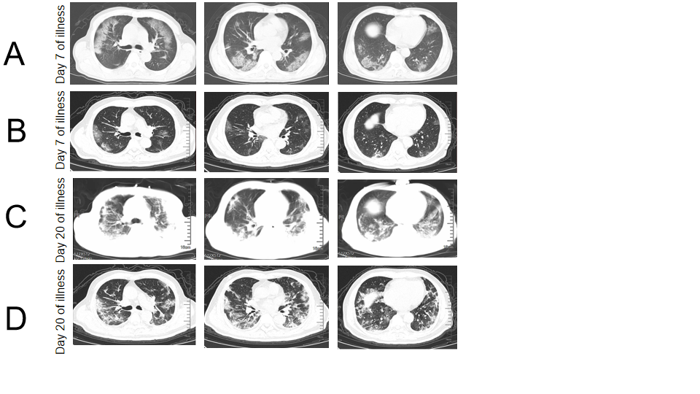
Figure 1 Chest computed tomography of critical coronavirus disease 2019 patients with different severity. A: Chest computed tomography (CT) of a 71-year-old man (non-survivor, case 1) showed multifocal and bilateral ground-glass opacities (GGO) in the alveolitis stage (Day 7 of illness); B: Chest CT of a 73-year-old male patient (survivor, case 2) exhibited slight GGO in the alveolitis stage (Day 7 of illness); C: Classified into the fibrosis stage (Day 20 of illness) and Chest CT (case 1) showed bilateral massive shadows of high density and GGO, accompanied by the air bronchogram sign and reticular pattern in the fibrosis stage; and D: Chest CT (case 2) showed that bilateral and multifocal lesions were observed with a combination of mixed GGO, reticular pattern, bronchiectasis and few consolidation (Day 20 of illness).

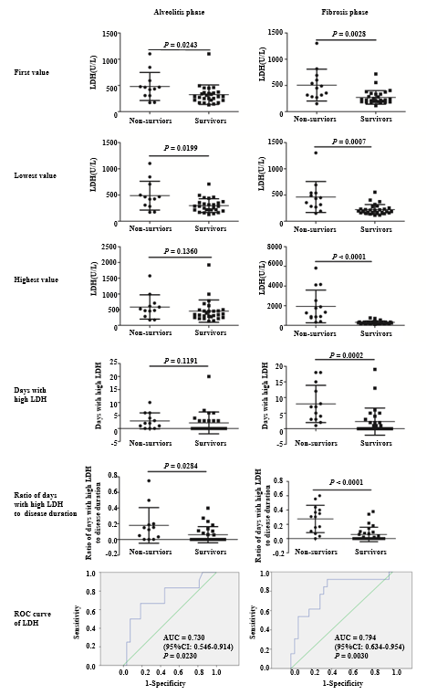
Figure 2 The relationship between serum lactate dehydrogenase levels and the prognosis of patients with critical coronavirus disease 2019. The first, lowest and highest values of serum lactate dehydrogenase (LDH), together with the days with high LDH (≥ 397.0 U/L in the alveolitis phase and ≥ 263.0 U/L in the fibrosis phase according to the receiver operating characteristic curve analysis, respectively) and the ratio of the days with high LDH to disease duration were analyzed by the Mann-Whitney U test between non-survivors and survivors in the alveolitis phase and fibrosis phase. P < 0.05 was considered statistically significant. LDH: lactate dehydrogenase.

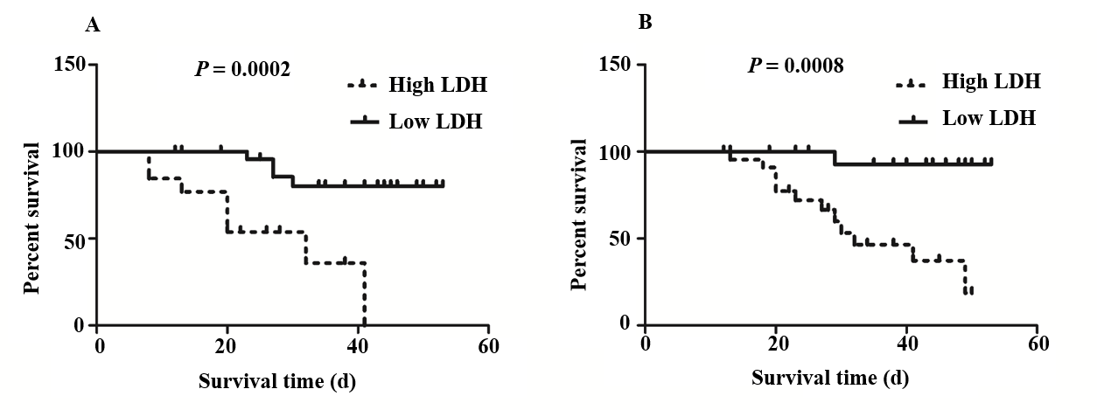
Figure 3 Association between the first value of serum lactate dehydrogenase and survival time of patients with critical coronavirus disease 2019. Kaplan-Meier analysis and the log-rank test were performed to analyze the association between the first values of serum lactate dehydrogenase (LDH) and the survival time of patients with critical coronavirus disease 2019. A: Patients with high LDH (≥ 397.0 U/L) had a significantly shorter survival time compared to those with low LDH (< 397.0 U/L) in the alveolitis phase; B: Patients with high LDH (≥ 263.0 U/L) also had a significantly shorter survival time compared to those with low LDH (< 263.0 U/L) in the fibrosis phase. LDH: lactate dehydrogenase.

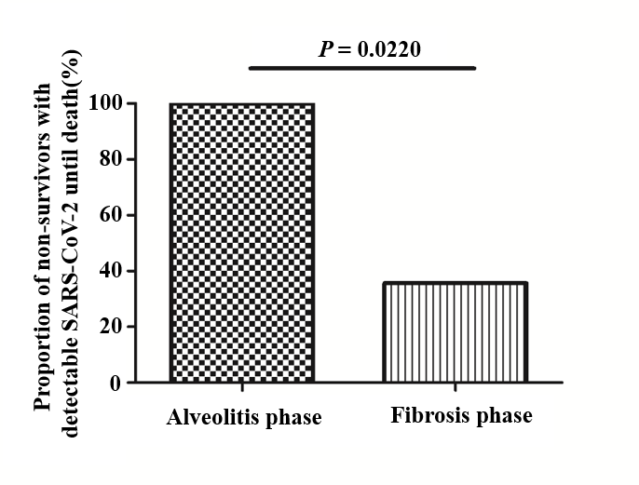
Figure 4 Proportion of non-survivors with detectable severe acute respiratory syndrome coronavirus 2 until death in the alveolitis and fibrosis phase. All non-survivors (100.0%) who died in the alveolitis stage had a persistent positive test for severe acute respiratory syndrome coronavirus 2 until death. Only 5 patients (35.7%) who died in the pulmonary fibrosis stage had positive virus nucleic acid test results. SARS-CoV-2: severe acute respiratory syndrome coronavirus 2.

Table 1 Clinical characteristics of patients with critical coronavirus disease 2019
Clinical features | Groups |  | P value
 | Non-survivors (n = 17) | Survivors (n = 30)
Age (yr) | 69.0 (63.5-78.0) | 67.0 (55.5-77.0) | 0.595
Male (%) | 11 (64.7) | 15 (50.0) | 0.33
Days of hospitalization (d) | 14.0 (8.0-24.5) | 33.0 (16.8-38.3) | 0.001⁵
Disease duration (d)¹ | 23.0 (15.5-29.5) | 38.0 (24.5-45.3) | 0.005⁵
Duration of viral shedding (d) | 8.0 (6.0-18.0) | 11.0 (8.8-20.5) | 0.118
Days from illness onset to hospital admission (d) | 5.0 (2.0-10.0) | 5.0 (3.75-7.25) | 0.689
Duration of alveolitis phase (d) | 12.0 (8.0-17.5) | 17.0 (13.8-21.0) | 0.020ª
Duration of fibrosis phase (d) | 10.0 (5.5-15.5) | 19.0 (10.0-26.0) | 0.016ª
Complication of COPD (%) | 3 (17.6) | 3 (10.0) | 0.764
Complication of hypertension (%) | 10 (58.8) | 11 (36.7) | 0.142
Complication of coronary heart disease (%) | 7 (41.2) | 6 (20.0) | 0.222
Complication of cerebrovascular disease (%) | 3 (17.6) | 7 (23.3) | 0.931
Complication of diabetes (%) | 5 (29.4) | 7 (23.3) | 0.912
Complication of renal dysfunction (%) | 2 (11.8) | 5 (16.7) | 0.978
Complication of malignant tumors (%) | 2 (11.8) | 3 (10.0) | 1.000
Other complications (%)² | 7 (41.2) | 6 (20.0) | 0.222
Number of complications | 2.0 (1.5-3.5) | 1.5 (0.0-3.0) | 0.139
Fever (%) (temperature ≥ 37.3℃) | 13 (76.5) | 26 (86.7) | 0.624
Cough (%) | 7 (41.2) | 20 (66.7) | 0.089
Dyspnea (%) | 9 (52.9) | 4 (13.3) | 0.010ª
Fatigue (%) | 5 (29.4) | 4 (13.3) | 0.337
Other symptoms (%)³ | 5 (29.4) | 4 (13.3) | 0.337
¹Time from illness onset to death or discharge, days; ²Thyroid dysfunction, prostatic hyperplasia, schizophrenia; ³Arthralgia, sputum, dizziness, nausea, chest pain, diarrhea; ªP < 0.05; ^{b}P < 0.01. COPD: Chronic obstructive pulmonary disease.

