Name of Journal: World Journal of Gastroenterology
Manuscript NO: 83637
Manuscript Type: ORIGINAL ARTICLE

Basic Study
Effects of ethanol and sex on propionate metabolism evaluated via a faster ¹³C-propionate breath test in rats

Sasaki Y et al. Propionate metabolism evaluation via faster PBT

Yosuke Sasaki, Naoyuki Kawagoe, Tsunehiko Imai, Yoshihisa Urita

Yosuke Sasaki, Naoyuki Kawagoe, Tsunehiko Imai, Yoshihisa Urita, Department of General Medicine and Emergency Care, Toho University School of Medicine, Tokyo 143-8541, Japan

Author contributions: Sasaki Y and Urita Y coordinated the study; Sasaki Y, Kawagoe N, Imai T, and Urita Y performed the experiments; Sasaki Y and Urita Y acquired and analyzed the data; Sasaki Y and Urita Y interpreted the data; and Sasaki Y and Urita Y wrote the manuscript; All authors approved the final version of the article.

Supported by the Japan Society for the Promotion of Science KAKENHI Grant, No. JP21K18089.

Corresponding author: Yosuke Sasaki, MD, PhD, Assistant Professor, Lecturer, Department of General Medicine and Emergency Care, Toho University School of Medicine, 6-11-1 Omori-Nishi, Ota-Ku, Tokyo 143-8541, Japan. yousuke.sasaki@med.toho-u.ac.jp

Received: February 2, 2023
Revised: March 13, 2023
Accepted: May 6, 2023
Published online:

Abstract
BACKGROUND
Alcoholism is regarded as a risk factor for vitamin B₁₂ (VB₁₂) deficiency. Because VB₁₂ serves as a coenzyme of methylmalonyl-CoA mutase, a key enzyme in propionate metabolism, the ¹³C-propionate breath test (PBT) has been studied as a non-invasive diagnostic modality for VB₁₂ deficiency. However, the conventional PBT requires 2 h, which is inconvenient in clinical practice. We hypothesized that a faster PBT can be used to evaluate propionate metabolism and is more easily adaptable for clinical practice.

AIM
To evaluate a faster PBT for assessing the effects of long-term ethanol consumption on propionate metabolism in ethanol-fed rats (ERs).

METHODS
ERs were obtained by replacing standard drinking water (for control rats, CRs) with 16% ethanol solution in descendants of F344/DuCrj rats. Faster PBT was performed by administering ¹³C-propionate aqueous solution to male and female ERs and CRs by inserting a metal tubule from the mouth to the stomach; exhaled gas was collected in a bag to measure its ¹³CO₂/¹²CO₂ isotope ratio via infrared isotope spectrometry. Serum VB₁₂ and alanine transaminase (ALT) levels were measured via chemiluminescence immunoassay and the lactate dehydrogenase–ultraviolet method, respectively. We evaluated statistical differences in mean body weight, change in ¹³CO₂ (Δ¹³CO₂‰), peak Δ¹³CO₂‰, and serum VB₁₂and ALT, between males and females and between ERs and CRs using the t-test and Mann–Whitney U test for normally and non-normally distributed variables, respectively.

RESULTS
Males weighed significantly more than females (P < 0.001); CRs weighed significantly more than ERs (P < 0.008). Δ¹³CO₂ reached a peak (C_{max}) at 20 min and 30 min in females and males, respectively, decreasing after 20–30 min without rebound in all groups. Males had significantly higher C_{max} and Δ¹³CO₂ at 15–45 min than females (P < 0.05; for all pairs). Propionate metabolism was enhanced in male ERs relative to male CRs, whereas metabolism did not differ markedly between ERs and CRs for females. Males had higher serum VB₁₂ levels than females, without prominent differences between the ER and CR groups. Male CRs had notably higher ALT levels than male ERs. Thus, chronic ethanol consumption may trigger fatty acid production via intestinal bacteria and changes in gut microbiome composition.

CONCLUSION
Faster PBT shows that 16% ethanol consumption promotes propionate metabolism without inducing liver injury. This PBT may be used clinically to evaluate gut flora status.

Key Words: Alcoholism; Breath test; Carbon isotope; Gut flora; Propionate; Vitamin B12

Sasaki Y, Kawagoe N, Imai T, Urita Y. Effects of ethanol and sex on propionate metabolism evaluated via a faster ¹³C-propionate breath test in rats. World J Gastroenterol 2023; In press

Core Tip: Alcoholism is a risk factor for vitamin B₁₂ (VB₁₂) deficiency. The ¹³C-propionate breath test (PBT) is a diagnostic modality for VB₁₂ deficiency, but requires 2 h for completion. We applied a faster PBT to evaluate propionate metabolism using an ethanol-fed rat model. After ¹³C-propionate administration, the ¹³CO₂/¹²CO₂ isotope ratio of gas collected every 5 min for 60 min was measured using infrared isotope spectrometry. The Δ¹³CO₂ peak occurred within 30 min. Ethanol-fed males showed marked propionate metabolism without associated liver injury. This study demonstrates the potential of the faster PBT to evaluate propionate metabolism under various clinical conditions.

INTRODUCTION
Chronic alcoholism is a risk factor for vitamin B₁₂ (VB₁₂) deficiency^{[1,2]}. Because VB₁₂ works as a coenzyme of methylmalonyl-CoA mutase, a key enzyme in propionate metabolism (Figure 1), the ¹³C-propionate breath test (PBT) has been studied as a non-invasive diagnostic modality for VB₁₂ deficiency, with favorable results^{[3,4]}. For instance, Wagner et al^{[3]} reported that the conventional PBT could reliably predict VB₁₂ deficiency in humans, with an area under the curve of the receiver operating curve value of 0.88. Propionate is a ubiquitous short chain fatty acid produced by intestinal bacteria, such as Phascolarctobacterium^{[5]}. Emerging evidence suggests that intestinal microbial flora have a healing influence on alcoholic liver damage^{[6]}, and propionate produced by intestinal bacteria has protective effects against alcoholic liver damage^{[7]}. Thus, we believe that PBT may provide important information not only regarding VB₁₂deficiency, but also regarding alcohol metabolism and alcoholic liver damage.
However, the conventional PBT requires 2 h to complete, which can be highly inconvenient for patients in clinical settings. Thus, in the present study, we aimed to evaluate the potential of a faster PBT for assessing the effects of long-term ethanol consumption on propionate metabolism as well as VB₁₂ deficiency using ethanol-fed rats (ERs) as an animal model of chronic alcoholism. As the protective effects of estrogen against VB₁₂ deficiency have been reported^{[8]}, we also evaluated the effect of sex-related differences on propionate metabolism, as detected by the faster PBT.

MATERIALS AND METHODS
Animals and treatments
All animal experiments were performed with approval of the Toho University School of Medicine, No. 21-51-4960. Descendants of F344/DuCrj rats purchased from CLEA Japan Inc. (Tokyo, Japan) for our previous study^{[9]} were used to establish the ER and control rat (CR) groups for this study. All rats used in the present study were 18th-generation descendants of the originally established ER and CR groups, maintaining the lines within treatments (i.e., parents of ERs were ERs, parents of CRs were CRs).
All rats were housed with their mothers until weaning at 4 wk of age. Subsequently, all rats were individually housed in a controlled environment (temperature, 23 ± 2 °C; humidity, 55% ± 5%) and provided a standard diet (CE-7; CLEA Japan Inc., Tokyo, Japan) and drinking liquid ad libitum. In the ER group, a 16% ethanol solution (Japanese Sake, Ozeki Corporation, Hyogo, Japan) was provided as a substitute for water by replacing the content of water bottles with ethanol solution in all cages of ERs.
A total of 16 ERs (8 males and 8 females) and 16 CRs (8 males and 8 females) aged 27–30 wk were used in the experiments; ERs continuously consumed alcohol for 23–27 wk. We used available descendants of F344/DuCrj rats that we had utilized in previous studies^{[9]}. Therefore, we did not perform sample size calculation, randomization, or blinding.

Administration of ¹³C-propionate and collection of exhaled gas
We purchased 1-¹³C-sodium propionate from Cambridge Isotope Laboratories (Andover, MA, United States) and prepared a ¹³C-propionate aqueous solution at 1 g/mL using distilled water immediately before administration. Body weight was measured immediately before administration. We performed gastrointestinal intubation in each rat and used a metal tubule, extending from the mouth to the stomach, to administer 0.1 mL/g of the ¹³C-propionate solution. Immediately after administration, the rats were individually placed in the chambers of a dedicated exhaled-gas collection machine consisting of sealed chambers, pumps, and collecting bags, designed by Uchida et al^{[10]}. We collected 100–200 mL of exhaled gas in the collecting bag for 90 s every 5 min for a total of 60 min.

Measurement of the ¹³C recovery rate
Because ¹³C-propionate is metabolized in the liver and exhaled as ¹³CO₂ (Figure 1), we measured the ¹³CO₂/¹²CO₂ isotope ratio of the collected gas using infrared isotope spectrometry (POCone; Otsuka Electrics Co, Ltd., Hirakata, Japan) and monitored the change in ¹³CO₂ (Δ¹³CO₂‰), as reported previously^{[11]}.

Evaluation of serum VB₁₂ and alanine transaminase levels
After collecting the exhaled gas for 60 min, the rats were immediately anesthetized via sevoflurane inhalation, and 5–10 mL of venous blood was collected from the inferior vena cava and the right atrium under laparotomy. After collecting sufficient blood samples, the animals were euthanized by rapid blood release. The blood was immediately centrifuged (relative centrifugal force: 1700 ×g) for 10 min, and the serum was collected. The serum was promptly frozen and submitted to FUJIFILM VET Systems Co. Ltd. (Tokyo, Japan) for measuring serum VB₁₂ and ALT levels via chemiluminescence immunoassay and the lactate dehydrogenase–ultraviolet method, respectively.

Statistical analyses
We analyzed Δ¹³CO₂‰ measured every 5 min after ¹³C-propionate administration for 60 min and serum VB₁₂ levels, comparing the sexes and the ER and CR groups. The normality of the distribution of all variables was evaluated using the Kolmogorov–Smirnov test, and differences between groups were compared using the t-test and Mann–Whitney U test for normally and non-normally distributed variables, respectively. Statistical significance was set at P < 0.05. All statistical analyses were performed using Stata/IC software (version 15.1; Stata Corp., College Station, TX, United States). We used R 4.2.0 for construction of graphics^{[12]}. The statistical methods were reviewed by Yosuke Sasaki from the Toho University School of Medicine (the first author). As Yosuke Sasaki has completed several certified biostatistics courses, we did not obtain additional biostatical review suggestions by external biomedical statisticians.

RESULTS
Influence of ethanol and sex on body weight
Body weight was significantly higher (P < 0.0001) in males (335.8 ± 37.0 g) than in females (176.6 ± 21.9 g). In addition, body weight was significantly higher in CRs than in ERs for both males and females (P = 0.0082 and P = 0.005, respectively, Table 1).

Sex-related difference in PBT results
The Δ¹³CO₂ reached its peak (C_{max}) at 20 min and 30 min in females and males, respectively. The Δ¹³CO₂ decreased after 20–30 min without rebound in both groups (Table 2 and Figure 2). Therefore, the overall trends in Δ¹³CO₂ over time were similar between males and females, although C_{max} was delayed in males and Δ¹³CO₂ was significantly higher in males at 30 min and thereafter (Table 2 and Figure 2). The C_{max} and Δ¹³CO₂ values between 15 and 45 min were significantly higher in males than in females (P < 0.05, Table 2). Considering these sex-based differences, we further compared the effects of ethanol in males and females separately.

Effects of ethanol on propionate metabolism
Propionate metabolism was accelerated in the ERs relative to that in the CRs in males (Figure 3), with Δ¹³CO₂ at 10 and 20 min being markedly higher in male ERs. However, Δ¹³CO₂ after 40 min was higher in the CR group (Table 3). The Δ¹³CO₂ reached C_{max} earlier in the ERs (at 20 min) than in the CRs (at 30 min). These findings suggest that ethanol promoted propionate metabolism in male rats. However, propionate metabolism was similar between the ER and CR groups among females, without any significant differences (P > 0.110 for all pairs, Table 3, Figure 4).

Effects of ethanol on serum VB₁₂ and ALT levels
The serum VB₁₂ levels were significantly higher in males than in females (P = 0.0013, Table 4); however, no significant differences were observed between the ER and CR groups for either sex (P > 0.05 for all pairs, Table 4). In contrast, serum ALT levels were significantly higher in male CRs than in male ERs (P = 0.0347, Table 5).

DISCUSSION
In this study, we compared propionate metabolism using a faster PBT in rats and compared serum VB₁₂ and ALT levels between males and females and between ER and CR groups. Overall, our study demonstrates that (1) The faster PBT is useful for evaluating differences in propionate metabolism after administration of a ¹³C-propionate solution; (2) Males show greater propionate metabolism, with higher serum VB₁₂ levels, than females; (3) Ethanol consumption promotes propionate metabolism in male rats only; and (4) Ethanol consumption reduces body weight and serum ALT levels.
In the faster PBT, Δ¹³CO₂ peaked at 30 min, then decreased over time without rebound in all groups. Accordingly, we consider the faster PBT, which is completed within only 60 min after ¹³C propionate administration, to be sufficiently sensitive to evaluate propionate metabolism, as a substitute for the conventional PBT that requires collecting exhaled gas for 2 h.
Using the PBT, our study showed a higher C_{max} and Δ¹³CO₂ between 15 and 45 min in male rats than in female rats, which suggests that male rats have stronger propionate metabolism. Suppression of carbohydrate metabolism and promotion of lipid metabolism by estrogen in females have been proposed as mechanisms contributing to lower carbohydrate metabolism in females than in males^{[13]}. Furthermore, a protective effect of estrogen against VB₁₂ deficiency in fertile females has been reported, along with higher susceptibility to VB₁₂ deficiency in postmenopausal women^{[8,14]}. Considering that VB₁₂ works as a coenzyme of methylmalonyl-CoA mutase, and that serum VB₁₂ levels were not pathologically low in the rats used in our study, we postulate that the lower propionate metabolism detected by the faster PBT and the lower serum VB₁₂ levels in females than in males may reflect underlying physiological sex-related differences in carbohydrate metabolism associated with estrogen.
As we aimed to use the faster PBT to evaluate impaired propionate metabolism due to VB₁₂ deficiency and liver disease caused by chronic alcohol consumption, we expected to find lower propionate metabolism and higher serum ALT levels in the ER group than in the CR group. However, we obtained contrasting results, with acceleration of propionate metabolism in the ER group and higher serum ALT levels in the CR group. Changes in the gut flora caused by chronic alcohol consumption may explain the promotion of propionate metabolism in the ER group. Using male marmosets, Zhu et al^{[15]} reported that the concentrations of short-chain fatty acids, including propionate, depend on changes in intestinal bacteria, based on an observed reduction in fecal propionate levels along with a reduction in the relative abundance of Phascolarctobacterium in the gut. Moreover, Watanabe et al^{[5]} reported that the substrates of short-chain fatty acids, including propionate, produced by intestinal bacteria depend not only on a single bacterial strain, but also on the specific composition of other bacteria present in the gut. According to these reports, ethanol can serve as both a potential substrate of fatty acid production by intestinal bacteria, such as Phascolarctobacterium, and as a trigger for changes in gut flora. Thus, we hypothesized that chronic alcohol consumption promotes propionate production both as a substrate for various fatty acids and as a trigger for changes in gut flora.
Alternatively, these observations may be due to the well-known difficulties in recapitulating the effects of chronic alcohol consumption in an animal model. We intended to establish a rat model of chronic alcoholism to evaluate the metabolic effect of ethanol consumption by oral administration of a 16% ethanol solution (corresponding to the level of alcohol commonly consumed by Japanese drinkers in the form of sake) for > 20 wk based on a previous study^{[16]}. Therefore, we expected higher serum ALT levels in the ER group. Our contrasting result (lower serum ALT after 16% ethanol consumption) highlights the difficulty in the development of alcoholic animal models. A recent review on the utility of animal models for alcoholic liver disease mentioned that, in contrast to primates, rodent models fail to sufficiently display the full disease spectrum of alcoholic liver disease found in humans, despite many trials under various conditions^{[17]}. The absence of craving in rats, owing to their natural aversion to ethanol^{[18,19]}, the faster ethanol catabolism in rodents than in humans^{[20]}, and differences in the innate immune systems of the species, have been proposed as the main factors contributing to the difficulty in establishing a useful rat model of human alcoholism^{[21]}. It is therefore possible that our results also reflect failure to generate a chronic alcoholism rat model; thus, studies using primates or other small animals rather than rodents may be more appropriate. Considering the ad libitum diet administration, and the higher body weight in the CR group, fatty liver due to excessive dietary intake may explain the higher serum ALT levels in CRs. Because all of the rats consumed the same diet, it is possible that consumption of 16% ethanol solution had a protective effect against liver damage. Given that propionate itself reportedly has protective effects against steatohepatitis^{[7]}, and that improvement of gut flora is an effective way to suppress liver damage^{[6]}, enhanced propionate metabolism and favorable changes in the gut flora might suppress liver damage in male ERs. As discussed earlier, the lack of acceleration in propionate metabolism in female ERs can be explained by sex-related differences in carbohydrate metabolism.
In addition to the lack of confirmation of the chronic alcoholism model, our study has other limitations. For instance, the serum methylmalonic acid (MMA) level, rather than the serum VB₁₂ level, is required for the precise diagnosis of VB₁₂ deficiency in humans^{[3]}. However, we were not able to evaluate MMA levels because major domestic commercial laboratories no longer perform MMA testing of human serum or urine, and we could not find or access domestic laboratories measuring serum MMA in animal samples. Similarly, comparing the PBT results with biomarkers, such as aldehyde dehydrogenase and alcohol dehydrogenase, which sensitively and precisely reflect hepatic alcohol metabolism, may provide more information^{[22]}. We believe that comparing levels of serum MMA and the markers evaluated using the faster PBT may provide further insight into the association between VB₁₂ deficiency and alcoholism. Moreover, the present study only focused on the association between propionate metabolism and VB₁₂ deficiency based on a previous study on PBT^{[3]}. However, considering the complexity of intestinal propionate production due to the variety of propionate-producing bacteria, including Clostridium spp., Veillonella spp., Fusobacterium spp., Salmonella ruminantium, and Propionibacterium spp., and the complexity of substrates^{[23]}, the findings obtained herein, including the promoted propionate metabolism in male ERs and sex-related difference, may have potential clinical utility and provide a basis for future research into propionate metabolism and intestinal microbiota under various conditions. For instance, comparison of findings between faster PBT and the composition or changes in gut microbiota may provide interesting information on the association between gut microbiota and their products. Despite these limitations and lack of confirmation of VB₁₂ deficiency under our experimental conditions, our study highlights the influence of ethanol and sex-related differences in propionate metabolism.

CONCLUSION
We evaluated a faster PBT in which C_{max} peaked within 30 min. This PBT could serve as a substitute for conventional PBT (which takes at least 2 h) for evaluating propionate metabolism and diagnosing VB₁₂ deficiency. Although we could not evaluate the usefulness of faster PBT as a diagnostic modality for VB₁₂ deficiency as initially intended because we failed to create a rat alcoholism model with VB₁₂ deficiency, our study suggests that chronic consumption of 16% ethanol changed the composition of fatty acids produced by the intestinal flora, likely by changing the intestinal flora composition without causing corresponding liver injury. Considering the accumulating evidence of alteration of the gut flora as one of the mechanisms of alcoholism-related health impacts^{[24]}, our study demonstrates the potential utility of the faster PBT as a non-invasive and more convenient modality to evaluate changes in the gut flora associated with ethanol consumption and various other conditions.

ARTICLE HIGHLIGHTS
Research background
The ¹³C-propionate breath test (PBT) has been studied as a non-invasive diagnostic modality for vitamin B₁₂ (VB₁₂) deficiency by utilizing the role of VB₁₂ as a coenzyme of methylmalonyl-CoA mutase in propionate metabolism. Although alcoholism has been regarded as a risk factor for deficiency, studies on propionate metabolism using the PBT in individuals with alcoholism is limited. Furthermore, conventional PBT requires up to 2 hours of breath collection time, which may undermine its clinical utility.

Research motivation
The scarcity of studies regarding the PBT in alcoholism, and the possibility of improving the clinical utility of the PBT by shortening the breath collection time, motivated us to perform this study.

Research objectives
The aim of this study was to evaluate the change in propionate metabolism due to long-term ethanol consumption in ethanol-fed rats (ERs) as an animal model of chronic alcoholism. We also aimed to evaluate the utility of a faster PBT that requires only 1 hour to collect breath.

Research methods
The ERs were 18th generation descendants of F344/DuCrj rats that had been bred by replacing standard drinking water with a 16% ethanol solution. A faster PBT was performed by injecting the ¹³C-propionate aqueous solution from the mouth to the stomach of ERs and control rats (CRs); we collected exhaled gas in bags, and measured the ¹³CO₂/¹²CO₂ isotope ratio using infrared isotope spectrometry. We measured serum VB₁₂ and alanine transaminase (ALT) levels via chemiluminescence immunoassay and the lactate dehydrogenase-ultraviolet method, respectively. We evaluated statistical differences in mean body weight, change in ¹³CO₂ (Δ¹³CO₂‰), peak Δ¹³CO₂‰, and serum VB₁₂ and ALT, between ERs and CRs, and males and females, respectively.

Research results
Besides male dominance of body weight (P < 0.001), CRs weighed significantly more than ERs (P < 0.008). The Δ¹³CO₂ reached a peak (C_{max}) within 30 min in both sex groups, while males had a significantly higher C_{max} and Δ¹³CO₂ at 15–45 min than females (P < 0.05; for all pairs). Enhanced propionate metabolism was observed in male ERs relative to male CRs, and although males had higher serum VB₁₂ levels than females, no prominent differences were observed between the ER and CR groups. Male CRs had notably higher ALT levels than male ERs. These results suggest that chronic ethanol consumption may trigger fatty acid production via intestinal bacteria and changes in gut microbiome composition.

Research conclusions
We believe that a faster (1-h) PBT could serve as a substitute for the conventional PBT, as the Δ¹³CO₂ reached a peak (C_{max}) within 30 min in both sex groups. We failed to evaluate the usefulness of the faster PBT as a diagnostic modality for VB₁₂ deficiency in the chronic alcoholism rat model; however, our study suggests that instead of inducing alcoholism, chronic consumption of 16% ethanol changed the composition of fatty acids produced by the intestinal flora.

Research perspectives
Our study demonstrates the potential utility of the faster PBT as a non-invasive and more convenient modality to evaluate changes in the gut flora associated with ethanol consumption and various other conditions via changes in propionate metabolism.

ACKNOWLEDGEMENTS
We thank Ms. Mitsuko Sato for her contributions to this study in a wide variety of areas, including the breeding of rats and the preparation of and participation in experiments.

REFERENCES
1 Lambert D, Benhayoun S, Adjalla C, Gélot MM, Renkes P, Gérard P, Felden F, Belleville F, Gaucher P, Guéant JL, Nicolas JP. Alcoholic cirrhosis and cobalamin metabolism. Digestion 1997; 58: 64-71 [PMID: 9018012 DOI: 10.1159/000201425]
2 Han KM, Chang HS, Choi IK, Ham BJ, Lee MS. CYP2D6 P34S Polymorphism and Outcomes of Escitalopram Treatment in Koreans with Major Depression. Psychiatry Investig 2013; 10: 286-293 [PMID: 24302953 DOI: 10.4306/pi.2013.10.3.286]
3 Wagner DA, Schatz R, Coston R, Curington C, Bolt D, Toskes PP. A new 13C breath test to detect vitamin B12 deficiency: a prevalent and poorly diagnosed health problem. J Breath Res 2011; 5: 046001 [PMID: 21697586 DOI: 10.1088/1752-7155/5/4/046001]
4 Manoli I, Pass AR, Harrington EA, Sloan JL, Gagné J, McCoy S, Bell SL, Hattenbach JD, Leitner BP, Duckworth CJ, Fletcher LA, Cassimatis TM, Galarreta CI, Thurm A, Snow J, Van Ryzin C, Ferry S, Mew NA, Shchelochkov OA, Chen KY, Venditti CP. 1-(13)C-propionate breath testing as a surrogate endpoint to assess efficacy of liver-directed therapies in methylmalonic acidemia (MMA). Genet Med 2021; 23: 1522-1533 [PMID: 33820958 DOI: 10.1038/s41436-021-01143-8]
5 Watanabe Y, Nagai F, Morotomi M. Characterization of Phascolarctobacterium succinatutens sp. nov., an asaccharolytic, succinate-utilizing bacterium isolated from human feces. Appl Environ Microbiol 2012; 78: 511-518 [PMID: 22081579 DOI: 10.1128/AEM.06035-11]
6 Meroni M, Longo M, Dongiovanni P. Alcohol or Gut Microbiota: Who Is the Guilty? Int J Mol Sci 2019; 20 [PMID: 31540133 DOI: 10.3390/ijms20184568]
7 Xu Q, Zhang R, Mu Y, Song Y, Hao N, Wei Y, Wang Q, Mackay CR. Propionate Ameliorates Alcohol-Induced Liver Injury in Mice via the Gut-Liver Axis: Focus on the Improvement of Intestinal Permeability. J Agric Food Chem 2022; 70: 6084-6096 [PMID: 35549256 DOI: 10.1021/acs.jafc.2c00633]
8 Margalit I, Cohen E, Goldberg E, Krause I. Vitamin B12 Deficiency and the Role of Gender: A Cross-Sectional Study of a Large Cohort. Ann Nutr Metab 2018; 72: 265-271 [PMID: 29597190 DOI: 10.1159/000488326]
9 Kawagoe N, Kijma S, Tanaka H, Takemoto I, Suzuki K, Saito T, Komatsu F, Yamada A, Kumade E, Sasaki Y, Maeda T, Kido H, Ishii T, Watanabe T, Miyazaki T, Hike N, Zai H, Urita Y, Nakajima H, Arai K, Imai T. Alteration of Breath Hydrogen and Methane in Ethanol-Fed Rats. Nihon Arukoru Yakubutsu Igakkai Zasshi 2016; 51: 403-413 [PMID: 30461248]
10 Uchida M, Endo N, Shimizu K. Simple and noninvasive breath test using 13C-acetic acid to evaluate gastric emptying in conscious rats and its validation by metoclopramide. J Pharmacol Sci 2005; 98: 388-395 [PMID: 16082175 DOI: 10.1254/jphs.fp0050153]
11 Kawagoe N, Kano O, Kijima S, Tanaka H, Takayanagi M, Urita Y. Investigation of Metabolism of Exogenous Glucose at the Early Stage and Onset of Diabetes Mellitus in Otsuka Long-Evans Tokushima Fatty Rats Using [1, 2, 3-13C]Glucose Breath Tests. PLoS One 2016; 11: e0160177 [PMID: 27483133 DOI: 10.1371/journal.pone.0160177]
12 R Core Team. R: A language and environment for statistical computing. R Foundation for Statistical Computing, Vienna, Austria. 2022. [cited 14 January 2023]. Available from: https://www.R-project.org/ [DOI:10.1007/s00607-022-01129-7]
13 Tarnopolsky MA, Ruby BC. Sex differences in carbohydrate metabolism. Curr Opin Clin Nutr Metab Care 2001; 4: 521-526 [PMID: 11706287 DOI: 10.1097/00075197-200111000-00010]
14 Miki A, Kinno R, Ochiai H, Kubota S, Mori Y, Futamura A, Sugimoto A, Kuroda T, Kasai H, Yano S, Hieda S, Kokaze A, Ono K. Sex Differences in the Relationship of Serum Vitamin B1 and B12 to Dementia Among Memory Clinic Outpatients in Japan. Front Aging Neurosci 2021; 13: 667215 [PMID: 33897411 DOI: 10.3389/fnagi.2021.667215]
15 Zhu L, Suhr Van Haute MJ, Hassenstab HR, Smith C, Rose DJ, Mustoe AC, Benson AK, French JA. Fecal Short-Chain Fatty Acid Concentrations Increase in Newly Paired Male Marmosets (Callithrix jacchus). mSphere 2020; 5 [PMID: 32938699 DOI: 10.1128/mSphere.00794-20]
16 Lieber CS, DeCarli LM, Sorrell MF. Experimental methods of ethanol administration. Hepatology 1989; 10: 501-510 [PMID: 2673971 DOI: 10.1002/hep.1840100417]
17 Lamas-Paz A, Hao F, Nelson LJ, Vázquez MT, Canals S, Gómez Del Moral M, Martínez-Naves E, Nevzorova YA, Cubero FJ. Alcoholic liver disease: Utility of animal models. World J Gastroenterol 2018; 24: 5063-5075 [PMID: 30568384 DOI: 10.3748/wjg.v24.i45.5063]
18 Brandon-Warner E, Schrum LW, Schmidt CM, McKillop IH. Rodent models of alcoholic liver disease: of mice and men. Alcohol 2012; 46: 715-725 [PMID: 22960051 DOI: 10.1016/j.alcohol.2012.08.004]
19 Bertola A, Mathews S, Ki SH, Wang H, Gao B. Mouse model of chronic and binge ethanol feeding (the NIAAA model). Nat Protoc 2013; 8: 627-637 [PMID: 23449255 DOI: 10.1038/nprot.2013.032]
20 Holmes RS, Duley JA, Algar EM, Mather PB, Rout UK. Biochemical and genetic studies on enzymes of alcohol metabolism: the mouse as a model organism for human studies. Alcohol Alcohol 1986; 21: 41-56 [PMID: 2937415]
21 Mestas J, Hughes CC. Of mice and not men: differences between mouse and human immunology. J Immunol 2004; 172: 2731-2738 [PMID: 14978070 DOI: 10.4049/jimmunol.172.5.2731]
22 Zakhari S. Overview: how is alcohol metabolized by the body? Alcohol Res Health 2006; 29: 245-254 [PMID: 17718403]
23 Eş I, Khaneghah AM, Hashemi SMB, Koubaa M. Current advances in biological production of propionic acid. Biotechnol Lett 2017; 39: 635-645 [PMID: 28150076 DOI: 10.1007/s10529-017-2293-6]
24 Engen PA, Green SJ, Voigt RM, Forsyth CB, Keshavarzian A. The Gastrointestinal Microbiome: Alcohol Effects on the Composition of Intestinal Microbiota. Alcohol Res 2015; 37: 223-236 [PMID: 26695747]

Footnotes
Institutional review board statement: The study was reviewed and approved by the Toho University School of Medicine Institutional Review Board, No. 21-51-496.

Conflict-of-interest statement: All the authors report no relevant conflicts of interest for this article.

Data sharing statement: Technical appendix, statistical code, and dataset available from the corresponding author at yousuke.sasaki@med.toho-u.ac.jp.

ARRIVE guidelines statement: The authors have read the ARRIVE guidelines, and the manuscript was prepared and revised according to the ARRIVE guidelines.

Open-Access: This article is an open-access article that was selected by an in-house editor and fully peer-reviewed by external reviewers. It is distributed in accordance with the Creative Commons Attribution NonCommercial (CC BY-NC 4.0) license, which permits others to distribute, remix, adapt, build upon this work non-commercially, and license their derivative works on different terms, provided the original work is properly cited and the use is non-commercial. See: https://creativecommons.org/Licenses/by-nc/4.0/

Provenance and peer review: Unsolicited article; Externally peer reviewed.

Peer-review model: Single blind

Peer-review started: February 2, 2023
First decision: March 8, 2023
Article in press:

Specialty type: Gastroenterology and hepatology
Country/Territory of origin: Japan
Peer-review report’s scientific quality classification
Grade A (Excellent): 0
Grade B (Very good): B
Grade C (Good): C
Grade D (Fair): 0
Grade E (Poor): 0

P-Reviewer: Baryshnikova NV, Russia; Wang Z, China S-Editor: Li L L-Editor: A P-Editor: Li L
Figure Legends
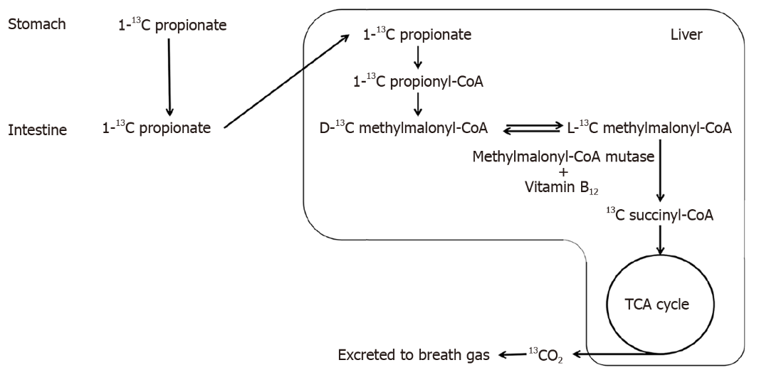
Figure 1 Propionate metabolism and the measuring principle of the propionate breath test. TCA: Tricarboxylic acid. Citation: Sasaki Y, Sato T, Maeda T, Komatsu F, Kawagoe N, Imai T, Shigeta T, Kashima N, Urita Y. [In Press] Evaluation of the One-Hour ¹³C-Propionate Breath Test in 49 Patients from a Single Center in Japan to Detect Vitamin B₁₂ Deficiency. Med. Sci. Monit. 2023 [DOI: 10.12659/MSM.940238]. Copyright © The Authors 2023. Published by Medical Science Monitor, International Scientific Information, Inc.

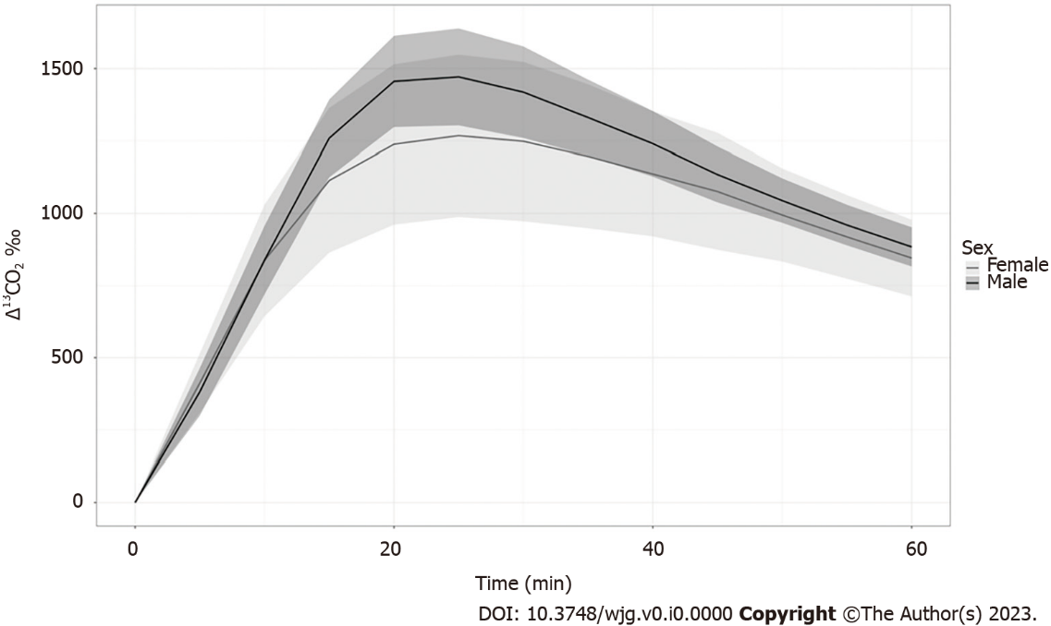

Figure 2 Comparison of faster propionate breath test results between the male and female rats. Note: Tinted area around each line indicates the standard deviation range.
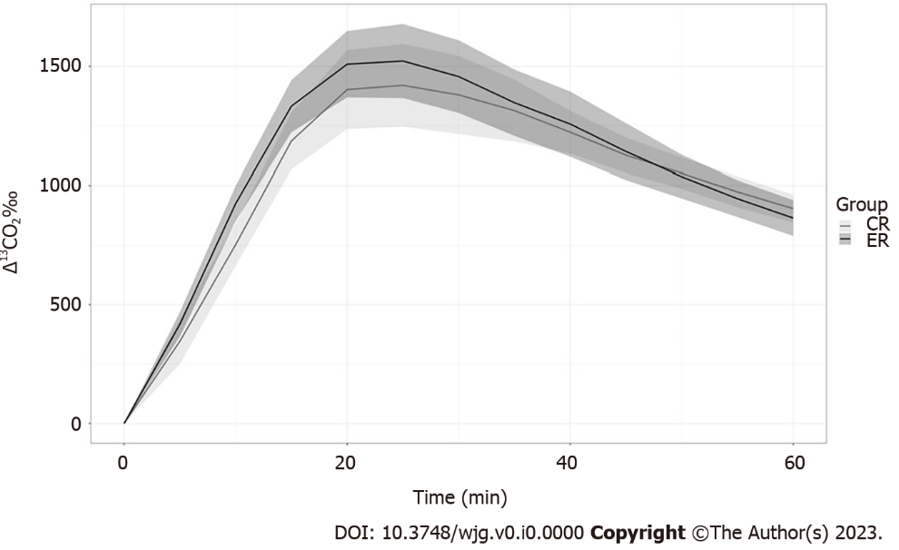
Figure 3 Comparison of propionate breath test results between the male ethanol-fed rat and male control rat groups. Note: Tinted area around each line indicates the standard deviation range. CR: Control rat; ER: Ethanol-fed rat.

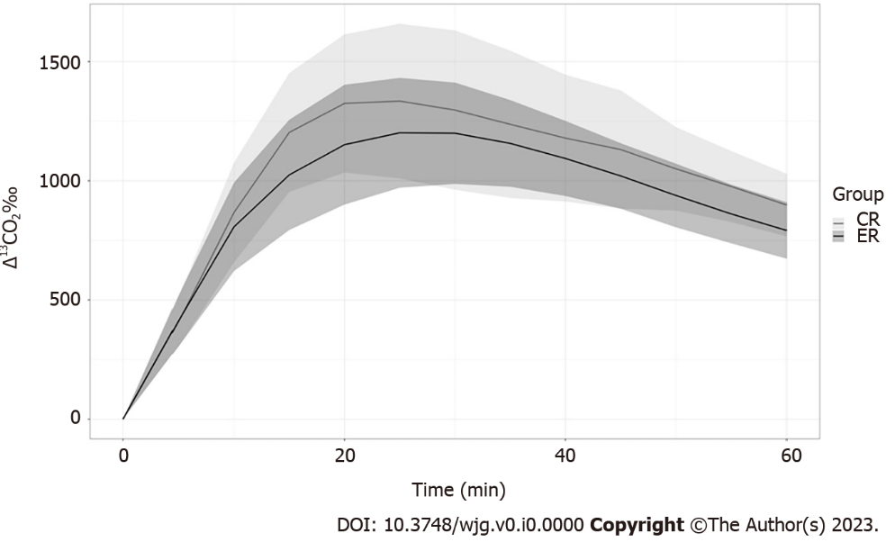
Figure 4 Comparison of propionate breath test results between the female ethanol-fed rat and female control rat groups. Note: Tinted area around each line indicates the standard deviation range. CR: Control rat; ER: Ethanol-fed rat.

Table 1 Body weight (g) in the ethanol-fed rat and control rat groups
 | ER (n = 16) | CR (n = 16) | P value
Male (n = 16) | 313.0 (18.4) | 358.5 (37.5) | 0.0082ª
Female (n = 16) | 162.5 (14.9) | 190.6 (18.7) | 0.005ª
ªP < 0.05.
Data are presented as mean (SD). CR: Control rat; ER: Ethanol-fed rat.

Table 2 Propionate breath test results in male and female rats
 | Male (n = 16) | Female (n = 16) | P value
C_{max} | 1478.0 | 1302.3 | 0.039ª
5 min | 381.8 | 412.5 | 0.358
10 min | 838.6 | 837.4 | 0.983
15 min | 1259.2 | 1114.1 | 0.049ª
20 min | 1455.7 | 1238.2 | 0.011ª
25 min | 1471.3 | 1267.9 | 0.007ª
30 min | 1418.5 | 1248.2 | 0.008ª
35 min | 1330.6 | 1197.1 | 0.010ª
40 min | 1240.3 | 1136.5 | 0.013ª
45 min | 1134.5 | 1075.9 | 0.035ª
50 min | 1044.7 | 994.6 | 0.050
55 min | 959.9 | 918.8 | 0.083
60 min | 884.2 | 845.6 | 0.309
ªP < 0.05.

Table 3 Propionate breath test results in the ethanol-fed rat and control rat groups
 | Male |  |  | Female
 | CR (n = 8) | ER (n = 8) | P value | CR (n = 8) | ER (n = 8) | P value
C_{max} | 1422.8 | 1533.1 | 0.192 | 1366.1 | 1238.5 | 0.401
5 min | 345.8 | 417.9 | 0.080 | 410.8 | 414.2 | 0.950
10 min | 752.3 | 924.9 | 0.0008ª | 867.6 | 807.3 | 0.552
15 min | 1186.1 | 1332.5 | 0.023ª | 1203.2 | 1025 | 0.160
20 min | 1402.3 | 1509.1 | 0.186 | 1324.7 | 1151.7 | 0.223
25 min | 1402.1 | 152.6 | 0.235 | 1334.5 | 1201.4 | 0.462
30 min | 1379.9 | 1457 | 0.348 | 1296.8 | 1199.7 | 0.753
35 min | 1313.9 | 46 | 0.629 | 1237.2 | 1157.1 | 0.753
40 min | 1223.2 | 1257.3 | 0.565 | 1179.2 | 1093.8 | 0.529
45 min | 1126.6 | 1142.3 | 0.756 | 1131.3 | 1020.6 | 0.208
50 min | 1051.8 | 1037.5 | 0.724 | 1050.4 | 938.7 | 0.172
55 min | 974.2 | 945.6 | 0.436 | 976.4 | 861.3 | 0.142
60 min | 904.1 | 864.4 | 0.256 | 898.9 | 792.3 | 0.110
ªP < 0.05.
CR: Control rat; ER: Ethanol-fed rat.

Table 4 Effects of ethanol and sex on serum vitamin B₁₂ (pg/mL)
 | Male (n = 16) | Female (n = 16) | P value¹ | Total (n = 32)
All (n = 32) | 884.0 (124.8) | 728.5 (123.3) | 0.0013ª | —
ER (n = 16) | 878.0 (152.5) | 696.3 (152.5) | 0.0323 ª | 787.1 (175.1)
CR (n = 16) | 890.0 (100.2) | 760.8 (81.7) | 0.0134 ª | 825.4 (110.7)
P-value² | 0.8551 | 0.3117 | — | 0.4658
¹Comparison of males vs females.
²Comparison of Ethanol-fed rat vs Control rat.
ªP < 0.05.
Data are presented as mean (SD). CR: Control rat; ER: Ethanol-fed rat.

Table 5 Serum alanine transaminase (IU/L) levels
 | ER (n = 16) | CR (n = 16) | P-value
Total (n = 32) | 55.7 (16.1) | 79.3 (39.5) | 0.0347ª
Male (n = 16) | 65.0 (16.8) | 110.3 (32.3) | 0.0034ª
Female (n = 16) | 46.4 (8.5) | 48.3 (9.9) | 0.6898
ªP < 0.05.
Data are presented as mean (SD). CR: Control rat; ER: Ethanol-fed rat.

