Name of Journal: World Journal of Gastroenterology
ESPS Manuscript NO: 24364
Manuscript Type: ORIGINAL ARTICLE

Basic Study
Faecalibacterium prausnitzii supernatant ameliorates dextran sulfate sodium induced colitis by regulating Th17 cell differentiation

Huang XL et al. F.prausnitzii supernatant ameliorates mice colitis

Xiao-Li Huang, Xin Zhang, Xian-yan Fei, Zhao-gui Chen, Yan-ping Hao,Shu Zhang, Ming-Ming Zhang, Yan-qiu Yu, Cheng-Gong Yu

Xiao-Li Huang, Yan-ping Hao, Yan-qiu Yu, Cheng-Gong Yu, Department of Gastroenterology, Gulou School of Clinical Medicine, Nanjing Medical University, Nanjing 210008, Jiangsu Province, China

Xiao-Li Huang, Department of Gastroenterology, Nanjing Jiangbei People’s Hospital Affiliated to Southeast University Medical School, Nanjing 210048, Jiangsu Province, China

Xin-Zhang, Xin-yan Fei, Zhao-gui Chen, Shu Zhang, Nanjing University Medical School, Nanjing 210093, Jiangsu Province, China

Cheng-Gong Yu, Ming-Ming Zhang, Department of Gastroenterology, Nanjing Drum Tower Hospital, the Affiliated Hospital of Nanjing University Medical School, Nanjing 210008, Jiangsu Province, China

Author contributions: Huang XL and Yu CG performed the majority of experiments, analyzed the data and wrote the paper; Zhang X, Fei XY and Cheng ZG participated equally in treatment of animals; Zhang X, Hao YP cultured cells; Zhang S, Zhang MM and Yu YQ performed the molecular investigations; and Yu CG designed the research and revised the paper as corresponding author.

Supported by the National Natural Science Foundation of China, No. 81470819.

Institutional review board statement: The study was reviewed and approved by the Ethics Committee of the Institute of Digestive Disease, Nanjing Drum Tower Hospital, the Affiliated Hospital of Nanjing University Medical School, China.

Institutional animal care and use committee statement: All procedures involving animals were reviewed and approved by the Institutional Animal Care and Use Committee of the Nanjing Drum Tower Hospital, Affiliated Hospital of Nanjing University Medical School.

Conflict-of-interest statement: The authors declare that there is no conflict of interest in this study.

Data sharing statement: No additional data are available.

Open-Access: This article is an open-access article which was selected by an in-house editor and fully peer-reviewed by external reviewers. It is distributed in accordance with the Creative Commons Attribution Non Commercial (CC BY-NC 4.0) license, which permits others to distribute, remix, adapt, build upon this work non-commercially, and license their derivative works on different terms, provided the original work is properly cited and the use is non-commercial. See: http://creativecommons.org/licenses/by-nc/4.0/

Correspondence to: Cheng-Gong Yu, MD, PhD, Department of Gastroenterology, Nanjing Drum Tower Hospital, the Affiliated Hospital of Nanjing University Medical School, No. 321 Zhongshan Road, Nanjing 210008, China. chenggong_yu@nju.edu.cn
Telephone: +86-25-83106666-61311
Fax: +86-25-83105206

Received: January 23, 2016
Peer-review started: January 25, 2016
First decision: February 18, 2016
Revised: February 28, 2016
Accepted: March 18, 2016
Article in press:
Published online:

Abstract
AIM: to explore the preventive and therapeutic effects of Faecalibacterium prausnitzii (F. prausnitzii) supernatant on dextran sulfate sodium (DSS) induced colitis in mice.

METHODS: Forty C57BL/6J male mice were randomly distributed into 4 groups, which named control group, model group, treatment group, and prevention group, respectively. Mice were weighed daily. In day 10, the colon length was measured, the colorectal histopathologic damage score (HDS) was assessed, plasma interleukin (IL)-17A, IL-6 and IL-4 levels were detected by enzyme-linked immunosorbent assay. The expression of transcription factor retinoic acid-related orphan receptor-γt (ROR-γt) and IL-17A in colon inflammatory mucosa tissue were determined by immunohistochemical assay, and the expression levels of ROR-γt mRNA, IL-17A mRNA and IL-6 mRNA were also detected by real-time quantitative PCR. The proportion of Th17 in mononuclear cells in spleen was assayed by fluorescence activated cell sorter.

RESULTS: When comparing with the model group, the colon length (P < 0.05) and body weight (P < 0.01) in treatment group and prevention group were significantly increased, the colon HDS was decreased (P < 0.05 and P < 0.01). But no statistical difference was found between treatment group and prevention group. After treatment of F. prausnitzii supernatant, the plasma levels of IL-17A and IL-6 (P < 0.05), the protein and mRNA expression of IL-17A and ROR-γt, the Th17 cell ratio of spleen cells (P < 0.01) were significantly decreased. Plasma IL-4 level in the prevention group was significantly high than that in the model group (P < 0.05), but there was no significantly difference of the expression of IL-6 both in the plasma and the colon mucosa tissues between two groups.

CONCLUSION: F. prausnitzii supernatant exerts protective and therapeutic effects on DSS-induced colitis in mice, probably mediated by inhibiting Th17 differentiation and IL-17A secretion in plasma and colon mucosa tissues. It can also treat colitis in mice by down-regulating IL-6 and prevent them by up-regulating IL-4.

Key words: Faecalibacterium prausnitzii; Ulcerative colitis; Animal model; Th17 cell; Treatment; Prevention

© The Author(s) 2016. Published by Baishideng Publishing Group Inc. All rights reserved.

Core tip: Faecalibacterium prausnitzii (F. prausnitzii) supernatant has anti-inflammatory and immune regulatory activity. This study showed that the preventive and therapeutic use of F. prausnitzii supernatant could ameliorate DSS-induced colitis in mice through inhibiting Th17 cell differentiation and inflammatory cytokines release.

Huang XL, Zhang X, Fei XY, Chen ZG, Hao yp, Zhang S, Zhang MM, Yu YQ, Yu CG. Faecalibacterium prausnitzii supernatant ameliorates dextran sulfate sodium induced colitis by regulating Th17 cell differentiation. World J Gastroenterol 2016; In press

INTRODUCTION
Inflammatory bowel diseases (IBD), including Crohn’s disease (CD) and ulcerative colitis (UC), are multifactorial ailments characterized by intestinal inflammation. Although the precise etiology and pathogenesis of IBD is not fully elucidated, IBD is associated with genetic background, environmental factors, intestinal flora imbalance and immune disorder^{[1-4]}. It has been hypothesized that an undesired intestinal mucosal immune response to intestinal flora imbalance contributes to the onset of IBD in genetically susceptible individual.
Th17 cell is defined as cell producing the cytokine IL-17A, but it also can secrete many other cytokines such as IL-17F, IL-6 and IL-23 in an inflammatory response^{[5]}. Th17 cell is characterized by the expression of transcription factor retinoic acid-related orphan receptor (RORγt) and is increasingly recognized as paramount in the development of human autoimmune diseases, including IBD^{[6-8]}. In the intestine of IBD patients, elevated numbers of Th17 cell and increased RORγt and IL-17 levels are found^{[9]}. The differentiation of Th17 cell from naive CD4+ T cells is known to be affected by multiple cytokines, such as TGF-β, IL-6, IL-4 and IL-23^{[10,11]}. IL-6 plays a key role in cooperating with TGF-β to initiate Th17 differentiation，while IL-4 inhibits Th17 differentiation.
Faecalibacterium prausnitzii(F. prausnitzii) is the major bacterium of the Clostridium leptum group and is one of the most abundant anaerobic bacteria in human gut^{[12]}. F. prausnitzii plays an important role in maintaining the intestinal health and providing energy to the colonocytes^{[13]}. A recent study indicated that the abundance of F. prausnitzii was decreased in IBD patients compared with healthy controls^{[14]}. Our previous animal experiment also confirmed that both the bacteria and its supernatant relieved trinitro-benzene-sulfonic acid induced colitis in rats^{[15]}. Nevertheless, the specific mechanism is largely unclear.
Dextran sulfate sodium (DSS) induced colitis is a well-established animal model used for IBD pathogenesis and preclinical studies for over two decades^{[16,17]}. Furthermore, it has been proved that the clinical features and pathological changes of DSS-induced colitis in mice were similar to human UC^{[18]}. Here in this research we mainly observed whether the F. prausnitzii supernatant could relieve DSS-induced colitis in mice by reducing Th17 cells and inflammatory cytokines.

MATERIALS AND METHODS
Animals
All experiments have been approved by the Experimental Animal Ethical Committee of Nanjing Drum Tower Hospital, the Affiliated Hospital of Nanjing University Medical School. Forty male C57BL/6J mice aged 8-10 wk and weighing 18-22 g were obtained from the Animal Center, Nanjing Drum Tower Hospital (Nanjing, China).The mice were allocated equally randomly into four groups: control group, model group, treatment group, and prevention group. The group divisible design is shown in figure 1. The period of observation was ten days. In the first five days, the mice of prevention group was given supernatant of F. prausnitzii (5 times concentrated, 0.1 ml/10 g) through gavage once a day, while the other groups received the same dosage of medium. For the latter five days, all groups were treated with 3.0% DSS in their drinking water ad libitum except for control group, and the treatment group were feed with F. prausnitzii supernatant by gavage once a day.
Mice were weighed daily and sacrificed by cervical dislocation at day 10. Colons were dissected and the distance from cecum to anus was measured. The colon tissues were fixed in 4% formalin for later pathological examination and immunohistochemical study. The peripheral blood and spleen were isolated for testing Th17 cell and cytokines.

F. prausnitzii culture
F. prausnitzii (ATCC 27766, Manassas, VA, United States) was cultured anaerobically at 37 °C in LYHBHI medium [main component of brain-heart infusion medium(37 g/L, BD, United States), yeast extract (5 g/L, Oxoid, United Kingdom), cellobiose ( 1 g/L, Sigma, United States), maltose (1 g/L, Amresco, United States), hemin (5 mg/L, Sigma, USA) and cysteine(0.5 g/L, Sigma, United States)]. The number of live bacteria (colony-forming units, CFU) was calculated according to optical density (OD) at 600 nm. The supernatant was collected from cultures with 109-1010 CFU/ml (OD = 1.9). Sterile culture medium acted as placebo. Then the bacterial supernatant and sterile culture medium were lyophilized and stored at -80 ℃. They were thawed and diluted to 5 times concentrated solution with PBS before administration.

Colon histopathologic grading
The histopathologic grading of colon damage was scored by two blinded pathologists under microscope based on Neurath Scoring criteria as previously described^{[19]}. (In short, 4: transmural leucocyte infiltrations, high vascular density, loss of goblet cells, and thickening of the colon wall; 3: high level of leucocyte infiltration, thickening of the colon wall, high vascular density; 2: low level of leucocyte infiltration; 1: very low level of leucocyte infiltration and 0: no inflammation).

Isolation of splenic mononuclear cells
Splenic mononuclear cells were isolated from spleens through Ficoll–Isopaue density gradient centrifugation^{[20]}. Fresh spleens were placed in RPMI-1640 (Gibco, New York, United States), mechanically disrupted by a 2 ml syringe plunger into cell suspensions. Cell suspensions were repeatedly aspirated with a sterile Pasteur pipette and gently filtered through a 200 μm strainer. Splenic single-cell suspensions were layered over an equal volume of Ficoll-Hypaque Solution (Haoyang BioScience Corporation, Tianjin, China) per spleen, and centrifuged at 1500 rpm for 20 min. The band of leukocyte enriched fraction at the interface was collected after centrifugation at 1800 rpm for 10 min without brake. The resulting splenic mononuclear cell density was counted in a haemocytometer and viability was assessed by Trypan blue staining.

fluorescence activated cell sorter analysis of Th17 in mononuclear cells
Flow cytometry followed routine procedures by using 2 × 10⁶ cells per sample. The splenic mononuclear cells were stimulated by phorbol-12-myristate-13-acetate (PMA), ionomycin and brefeldin A for 5 h in 37 ℃, 5% CO2 incubator, then labeled with FITC anti-mouse CD4 (eBioscience, United States), APC anti-mouse CD3 (eBioscience, United States). After permeabilized and fixed treatment, cells were labeled with PE anti-mouse IL-17 (eBioscience, United States). The stained cells were tested by flow cytometry (Becton Dickinson, United States) and analyzed by the Cell Quest software.

enzyme-linked immunosorbent assay assay cytokines in murine plasma
Cytokines (IL-17A, IL-6, IL-4) were measured using a commercially available enzyme-linked immunosorbent assay kit (Yunhan Biological Technology Corporation, Shanghai, China) according to the manufacturers’ instructions.

Real-time quantitative PCR
Total RNAs were extracted from mid-colon samples taken from mouse in each group using the Trizol reagent (Invitrogen, Carlsbad, CA, United States) with the following procedure. The concentration was determined by NanoDrop TM 1100 (NanoDrop Technologies, Wilmington, DE, United States). Total RNA was reversely transcripted into cDNA using reverse transcription kit. The PCR reactions were performed in a 96-well Optical Reaction Plate (Applied Biosystems, Foster City, CA, United States) with the following procedure: degeneration 95 ℃ for 30 s, annealing 95 ℃ for 5 s, 40 cycles of 60 ℃ for 34 s. All primers and probes used in this study are listed in table 1.

Immunohistochemistry
Paraffin slides of colon were re-hydrated in different concentration of ethanol and washed in PBS. Sections were microwaved in sodium citrate buffer. After being blocked with 10% goat serum for 30 min, they were incubated with rabbit anti-rat IL-17 antibodies (Abcam, United Kingdom) overnight at 4 ℃. Slides were then incubated with the corresponding secondary antibody (Zsbio, Beijing, China), labelled with horseradish peroxidase, developed using a diaminobenzidine (DAB) reaction, and counterstained with hematoxylin. Cells stained with the antibodies were calculated by random selection of five fields under microscope at 200 × magnification.

Statistical analysis
The GraphPad.prism version 5.0 was used for data analysis. Data were presented as mean ± SD and were analyzed using one-way ANOVA. P < 0.05 was considered to be significant.

RESULTS
symptoms and body weight of mice
Mice had symptoms (such as bloody diarrhea, weight loss and depression) at the third day after drinking 3.0% DSS ad libitum. The symptoms aggravated along with the prolonging of 3.0% DSS drinking time.
The mice in the model group had an obviously weight loss compared to the control group (P < 0.001). And the mice from the model group were significantly lighter than those from the treatment group and the prevention group. But there was no significant difference of weight loss between treatment group and prevention group (Figure 2).

colon length and pathological changes
Compared with the control group, the mice in model group had markedly shorter colon length (7.89 ± 1.536 vs 4.92 ± 0.925, P < 0.001), more serious colon damage and higher histopathologic damage scores (0.8 ± 0.632 vs 3.7 ± 0.483, P < 0.01). Histological examination of the mice in the model group showed that the normal colon mucous membrane structure disappeared, extensive ulceration developed and a large number of inflammation cells infiltrated. However, culturing supernatant of F. prausnitzii in mice from treatment and prevention group can significantly ameliorate the colon damage by increasing colon length (P < 0.01 and P < 0.05) and reducing high histopathologic damage scores (P < 0.05), compared with model group (Figure 2).

Th17 cell percentage change in splenic mononuclear cells
The ratio of Th17 cell in splenic mononuclear cells of the model group was significantly higher than that of the control group (4.02 ± 1.111 vs 1.34 ± 0.417, P < 0.001). It was obviously decreased after preventive and therapeutic application of F. prausnitzii supernatant (4.02 ± 1.111 vs 2.60 ± 0.839, P < 0.01 and 4.02 ± 1.111 vs 2.21 ± 1.030, P < 0.05). But there was no significant difference between treatment group and prevention group (Figure 3).

IL-17 A, IL–6 and IL-4 levels in peripheral plasma
Plasma IL-17A , IL-6 and IL-4 levels of the control group had significantly difference with the model group [15.73 ± 4.382 (pg/ml) vs 28.44 ± 4.116 (pg/ml) P < 0.01, 81.19 ± 13.609 (pg/ml) vs 111.82 ± 14.369 (pg/ml) P < 0.05, 79.91 ± 12.245 (pg/ml) vs 38.16 ± 9.507 (pg/ml) P < 0.001]. The IL-17A levels of plasma in the treatment and prevention groups were significantly lower than those in the model group (P < 0.05). Plasma IL-6 level in the treatment group also significantly decreased than that in the model group (P < 0.05), but there was no statistical significance between the prevention group and model group. On the contrary, level of plasma IL-4 in the prevention group was obviously higher than that in the model group (P < 0.05), while no difference was found between the treatment group and the model group (Figure 3).

expression of cytokines and RORγt mRNA in colon mucosal tissue
The expression of IL-17A, IL-6 and RORγt mRNA in colon tissue of mice in the model group was significantly higher than that in the control group (P < 0.001) and the treatment group (P < 0.05). Comparison with the model group, the expression of IL-17A and RORγt mRNA of colon inflammatory tissue of treatment and prevention groups had significantly declined (P < 0.01 or P < 0.05), but there was no difference of IL-6 between the model group and prevention group. As shown in figure 4, the expression of cytokines and RORγt mRNA in colon mucosal tissue did not significantly differ between the treatment and prevention groups.

Immunohistochemistry
To investigate the effects of IL-17A and RORγt on colon tissue , we conducted immunohistochemical staining of proinflammatory cytokines in tissue sections. Consistent with the results of qRT-PCR, the expression of IL-17A and RORγt in colon tissue in model group mice significantly increased than that in the control group (P < 0.001) and treatment group (P < 0.05). Though the expression of RORγt in colon tissue is declined after protective use of F. prausnitzii, there was no difference between the model group and prevention group (Figure 5).

DISCUSSION
In this study, we found that F. prausnitzii supernatant ameliorated the mice colitis by regulating Th17 cell differentiation and inhibiting the relevant inflammatory cytokines excretion. We also found that F. prausnitzii supernatant had the same effect in treating and preventing DSS-induced mice colitis, with different mechanisms in inhibiting differentiation of Th17 cell.
F. prausnitzii supernatant containing a mixture of secreted products, has been proved to have an anti-inflammatory effect as well as living F. prausnitzii^{[21]}. Compare to F. prausnitzii, supernatant could be more effective therapeutics, as they may have a longer shelf-life and facilitates to be delivered, handled and administrated^{[22]}. However, the exact composition and the anti-inflammatory mechanism of F. prausnitzii supernatant is currently largely unexplored. So we chose to use F. prausnitzii supernatant in our experiments to explore the effects and immune mechanisms on DSS-deduced colitis. Our study showed that the plasma levels of IL-17A and IL-6, the protein and mRNA expression of IL-17A and ROR-γt in intestinal mucosa and the Th17 cell ratio of spleen cells (P < 0.01) in supernatant treatment group were significantly decreased than those in colitis group. It indicated that the therapeutic use of F. prausnitzii supernatant could ameliorate DSS-induced colitis through inhibiting Th17 cell. Anders et al^{[23]} also demonstrated that the supernatant of F. prausnitzii affected the function of intestinal barrier.
Th17-related gene polymorphisms are associated with IBD susceptibility^{[24]}. Th17-derived cytokines, such as IL-17A, IL-6 and IL-22, have been shown to be upregulated in inflamed intestinal of IBD patients^{[25,26]}. IL-17A is a strong inflammatory cytokine, which can enhance cell permeability and promote the generation of other pro-inflammatory cytokines and chemokines^{[27]}. Nonetheless, animal experiments have implicated that neither IL-17A knockout nor neutralization of IL-17 could protect DSS-administrated mice from colitis, suggesting that the role of IL-17 in intestinal inflammation may not be entirely pathogenic^{[14,28]}. Adequate expression of IL-17A plays an important role in maintaining intestinal immune function. Consistent with previous studies, we found IL-17A levels in the plasma, spleen and colon tissue were significantly increased in mice with colitis, and were remarkably downregulated in the mice prevented and treated by F. prausnitzii culture supernatant, indicating that F. prausnitzii supernatant could attenuate DSS-induced mice colitis probably due to the inhibition of IL-17A expression^{[15,29]}.
We also found that levels of IL-6 in plasma and colon tissues of colitis mice were significantly reduced after F. prausnitzii supernatant treatment, which indicated that F. prausnitzii supernatant could alleviate mice colitis by down regulating IL-6 levels and inhibiting Th17 cell differentiation, and thus reduced the secretion of inflammatory cytokines (such as IL-17A and IL-6) and then attenuated local inflammatory response. However, inconsistence of the regulation of IL-6 expression between treatment group and prevention group suggested that there might be other ways of inhibiting Th17 differentiation. Fu SH et al demonstrated that boosting of Th2 associated cytokines (IL-4, IL-13 and IL-10) can reverse Th17-mediated intestinal inflammatory^{[29]}. We also found that the plasma IL-4 levels in mice of prevention group was significantly increased than those in model group.
In conclusion, F. prausnitzii supernatant can prevent DSS-deduced colitis in mice by inhibiting the generation of Th17 cells in the spleen and intestinal mucosa, leading to reduction of IL-17A and IL-6 and attenuation of the intestinal inflammation. This study provides theory basis for further application of F. prausnitzii supernatant in UC treatment and prevention in practice. However, what specific substances in supernatant of F. prausnitzii and what kind of materials possessing biological activity need to be elucidated in future studies? The safety and effectiveness of F. prausnitzii supernatant also warrant further investigation by more large scale clinical trials.

ACKNOWLEDGEMENTS
The study has an internal teamwork from Institute of Digestive Disease, Nanjing Drum Tower Hospital. We thank the people who generously gave their precious time to take part in this study. We also grateful to professor Jun Yang (pathology, Nanjing Tower Hospital) for the help of pathological diagnosis.

COMMENTS
Background
Inflammatory bowel disease (IBD) is a multifactorial ailment characterized by intestinal inflammation and its etiology is complicated and ambiguous. Genetic background, environmental factors, intestinal flora imbalance, immune disorder and interactions between them contributed to it.

Research frontiers
Faecalibacterium prausnitzii (F. prausnitzii) is one common anaerobic bacteria colonized in human gut, and plays a critical role in IBD. F. prausnitzii supernatant has anti-inflammatory and immune regulatory activity. The authors’ previous animal experiment also confirmed that both the bacteria and its supernatant relieved trinitro-benzene-sulfonic acid-induced colitis in rats. But the specific mechanism is largely unclear.

Innovations and breakthroughs
This study firstly showed that the preventive and therapeutic use of F. prausnitzii supernatant could ameliorate dextran sulfate sodium (DSS) induced mice colitis through inhibiting Th17 cells, whereas the molecular mechanism of proliferation and differentiation of Th17 cells was different. It may treat colitis in mice by down-regulating IL-6 and prevent them by up-regulating IL-4.

Applications
This study investigated the molecular mechanism of the preventive and therapeutic use of F. prausnitzii supernatant for IBD and provided the evidence for the prevention and treatment of the disease.

Terminology
F. prausnitzii is the major bacterium of the Clostridium leptum group and is one of the most abundant anaerobic bacteria in human gut.

Peer-review
The study investigates the preventive and therapeutic role of F. prausnitzii supernatant in a mouse model of UC induced by DSS. The paper is interesting. The design and methods have clear scientific values. The data are clear and well presented.

REFERENCES
1 Ghosh S, Dai C, Brown K, Rajendiran E, Makarenko S, Baker J, Ma C, Halder S, Montero M, Ionescu VA, Klegeris A, Vallance BA, Gibson DL. Colonic microbiota alters host susceptibility to infectious colitis by modulating inflammation, redox status, and ion transporter gene expression. Am J Physiol Gastrointest Liver Physiol 2011; 301: G39-G49 [PMID: 21454446 DOI: 10.1152/ajpgi.00509.2010]
2 Cooney R, Baker J, Brain O, Danis B, Pichulik T, Allan P, Ferguson DJ, Campbell BJ, Jewell D, Simmons A. NOD2 stimulation induces autophagy in dendritic cells influencing bacterial handling and antigen presentation. Nat Med 2010; 16: 90-97 [PMID: 19966812 DOI: 10.1038/nm.2069]
3 Scharl M, Rogler G. Inflammatory bowel disease pathogenesis: what is new? Curr Opin Gastroenterol 2012; 28: 301-309 [PMID: 22573190 DOI: 10.1097/MOG.0b013e328353e61e]
4 Steck N, Mueller K, Schemann M, Haller D. Republished: bacterial proteases in IBD and IBS. Postgrad Med J 2013; 89: 25-33 [PMID: 23257716 DOI: 10.1136/postgradmedj-2011-300775rep]
5 Annunziato F, Romagnani S. Heterogeneity of human effector CD4+ T cells. Arthritis Res Ther 2009; 11: 257 [PMID: 20053303 DOI: 10.1186/ar2843]
6 Maddur MS, Miossec P, Kaveri SV, Bayry J. Th17 cells: biology, pathogenesis of autoimmune and inflammatory diseases, and therapeutic strategies. Am J Pathol 2012; 181: 8-18 [PMID: 22640807 DOI: 10.1016/j.ajpath.2012.03.044]
7 Lubberts E. Th17 cytokines and arthritis. Semin Immunopathol 2010; 32: 43-53 [PMID: 20127485 DOI: 10.1007/s00281-009-0189-9]
8 Brucklacher-Waldert V, Stuerner K, Kolster M, Wolthausen J, Tolosa E. Phenotypical and functional characterization of T helper 17 cells in multiple sclerosis. Brain 2009; 132: 3329-3341 [PMID: 19933767 DOI: 10.1093/brain/awp289]
9 Hundorfean G, Neurath MF, Mudter J. Functional relevance of T helper 17 (Th17) cells and the IL-17 cytokine family in inflammatory bowel disease. Inflamm Bowel Dis 2012; 18: 180-186 [PMID: 21381156 DOI: 10.1002/ibd.21677]
10 Bettelli E, Korn T, Oukka M, Kuchroo VK. Induction and effector functions of T(H)17 cells. Nature 2008; 453: 1051-1057 [PMID: 18563156 DOI: 10.1038/nature07036]
11 Mangan PR, Harrington LE, O'Quinn DB, Helms WS, Bullard DC, Elson CO, Hatton RD, Wahl SM, Schoeb TR, Weaver CT. Transforming growth factor-beta induces development of the T(H)17 lineage. Nature 2006; 441: 231-234 [PMID: 16648837 DOI: 10.1038/nature04754]
12 Arumugam M, Raes J, Pelletier E, Le Paslier D, Yamada T, Mende DR, Fernandes GR, Tap J, Bruls T, Batto JM, Bertalan M, Borruel N, Casellas F, Fernandez L, Gautier L, Hansen T, Hattori M, Hayashi T, Kleerebezem M, Kurokawa K, Leclerc M, Levenez F, Manichanh C, Nielsen HB, Nielsen T, Pons N, Poulain J, Qin J, Sicheritz-Ponten T, Tims S, Torrents D, Ugarte E, Zoetendal EG, Wang J, Guarner F, Pedersen O, de Vos WM, Brunak S, Doré J, Antolín M, Artiguenave F, Blottiere HM, Almeida M, Brechot C, Cara C, Chervaux C, Cultrone A, Delorme C, Denariaz G, Dervyn R, Foerstner KU, Friss C, van de Guchte M, Guedon E, Haimet F, Huber W, van Hylckama-Vlieg J, Jamet A, Juste C, Kaci G, Knol J, Lakhdari O, Layec S, Le Roux K, Maguin E, Mérieux A, Melo Minardi R, M'rini C, Muller J, Oozeer R, Parkhill J, Renault P, Rescigno M, Sanchez N, Sunagawa S, Torrejon A, Turner K, Vandemeulebrouck G, Varela E, Winogradsky Y, Zeller G, Weissenbach J, Ehrlich SD, Bork P. Enterotypes of the human gut microbiome. Nature 2011; 473: 174-180 [PMID: 21508958 DOI: 10.1038/nature09944]
13 Louis P, Flint HJ. Diversity, metabolism and microbial ecology of butyrate-producing bacteria from the human large intestine. FEMS Microbiol Lett 2009; 294: 1-8 [PMID: 19222573 DOI: 10.1111/j.1574-6968.2009.01514.x]
14 Yang XO, Chang SH, Park H, Nurieva R, Shah B, Acero L, Wang YH, Schluns KS, Broaddus RR, Zhu Z, Dong C. Regulation of inflammatory responses by IL-17F. J Exp Med 2008; 205: 1063-1075 [PMID: 18411338 DOI: 10.1084/jem.20071978]
15 Zhang M, Qiu X, Zhang H, Yang X, Hong N, Yang Y, Chen H, Yu C. Faecalibacterium prausnitzii inhibits interleukin-17 to ameliorate colorectal colitis in rats. PLoS One 2014; 9: e109146 [PMID: 25275569 DOI: 10.1371/journal.pone.0109146]
16 Wirtz S, Neufert C, Weigmann B, Neurath MF. Chemically induced mouse models of intestinal inflammation. Nat Protoc 2007; 2: 541-546 [PMID: 17406617 DOI: 10.1038/nprot.2007.41]
17 Perše M, Cerar A. Dextran sodium sulphate colitis mouse model: traps and tricks. J Biomed Biotechnol 2012; 2012: 718617 [PMID: 22665990 DOI: 10.1155/2012/718617]
18 Melgar S, Karlsson L, Rehnström E, Karlsson A, Utkovic H, Jansson L, Michaëlsson E. Validation of murine dextran sulfate sodium-induced colitis using four therapeutic agents for human inflammatory bowel disease. Int Immunopharmacol 2008; 8: 836-844 [PMID: 18442787 DOI: 10.1016/j.intimp.2008.01.036]
19 Neurath MF, Fuss I, Kelsall BL, Stüber E, Strober W. Antibodies to interleukin 12 abrogate established experimental colitis in mice. J Exp Med 1995; 182: 1281-1290 [PMID: 7595199]
20 Sippel TR, Shimizu T, Strnad F, Traystman RJ, Herson PS, Waziri A. Arginase I release from activated neutrophils induces peripheral immunosuppression in a murine model of stroke. J Cereb Blood Flow Metab 2015; 35: 1657-1663 [PMID: 25966956 DOI: 10.1038/jcbfm.2015.103]
21 Sokol H, Pigneur B, Watterlot L, Lakhdari O, Bermúdez-Humarán LG, Gratadoux JJ, Blugeon S, Bridonneau C, Furet JP, Corthier G, Grangette C, Vasquez N, Pochart P, Trugnan G, Thomas G, Blottière HM, Doré J, Marteau P, Seksik P, Langella P. Faecalibacterium prausnitzii is an anti-inflammatory commensal bacterium identified by gut microbiota analysis of Crohn disease patients. Proc Natl Acad Sci USA 2008; 105: 16731-16736 [PMID: 18936492 DOI: 10.1073/pnas.0804812105]
22 Prisciandaro L, Geier M, Butler R, Cummins A, Howarth G. Probiotics and their derivatives as treatments for inflammatory bowel disease. Inflamm Bowel Dis 2009; 15: 1906-1914 [PMID: 19373788 DOI: 10.1002/ibd.20938]
23 Carlsson AH, Yakymenko O, Olivier I, Håkansson F, Postma E, Keita AV, Söderholm JD. Faecalibacterium prausnitzii supernatant improves intestinal barrier function in mice DSS colitis. Scand J Gastroenterol 2013; 48: 1136-1144 [PMID: 23971882 DOI: 10.3109/00365521.2013.828773]
24 Yu P, Shen F, Zhang X, Cao R, Zhao X, Liu P, Tu H, Yang X, Shi R, Zhang H. Association of single nucleotide polymorphisms of IL23R and IL17 with ulcerative colitis risk in a Chinese Han population. PLoS One 2012; 7: e44380 [PMID: 22984500 DOI: 10.1371/journal.pone.0044380]
25 Brand S. Crohn's disease: Th1, Th17 or both? The change of a paradigm: new immunological and genetic insights implicate Th17 cells in the pathogenesis of Crohn's disease. Gut 2009; 58: 1152-1167 [PMID: 19592695 DOI: 10.1136/gut.2008.163667]
26 Khor B, Gardet A, Xavier RJ. Genetics and pathogenesis of inflammatory bowel disease. Nature 2011; 474: 307-317 [PMID: 21677747 DOI: 10.1038/nature10209]
27 Weaver CT, Harrington LE, Mangan PR, Gavrieli M, Murphy KM. Th17: an effector CD4 T cell lineage with regulatory T cell ties. Immunity 2006; 24: 677-688 [PMID: 16782025 DOI: 10.1016/j.immuni.2006.06.002]
28 Ogawa A, Andoh A, Araki Y, Bamba T, Fujiyama Y. Neutralization of interleukin-17 aggravates dextran sulfate sodium-induced colitis in mice. Clin Immunol 2004; 110: 55-62 [PMID: 14962796 DOI: 10.1016/j.clim.2003.09.013]
29 Fu SH, Lin MH, Yeh LT, Wang YL, Chien MW, Lin SH, Chang DM, Sytwu HK. Targeting tumour necrosis factor receptor 1 assembly reverses Th17-mediated colitis through boosting a Th2 response. Gut 2015; 64: 765-775 [PMID: 25011937 DOI: 10.1136/gutjnl-2013-306585]

P-Reviewer: Decorti G, Howarth gs, Wittmann t S-Editor: Ma YJ L-Editor: E-Editor:

Table 1 PCR primers gene sequences
Target gene | Primer sequence | Product length（bp）
ROR-γt | forward:GACGGCCAACTTACTCTTGG | 109
 | reverse:AGAAACTGGGAATGCAGTGG
IL-17A | forward:TCCCTCTGTGATCTGGGAAG | 154
 | reverse:CTCGACCCTGAAAGTGAAGG
IL-6 | forward:CGGAGAGGAGACTTCACAGAG | 105
 | reverse:CATTTCCACGATTTCCCAGA
GAPDH | forward:CATGGCCTTCCGTGTTCCTA | 83
 | reverse:TGTCATCATACTTGGCAGGTTTCT

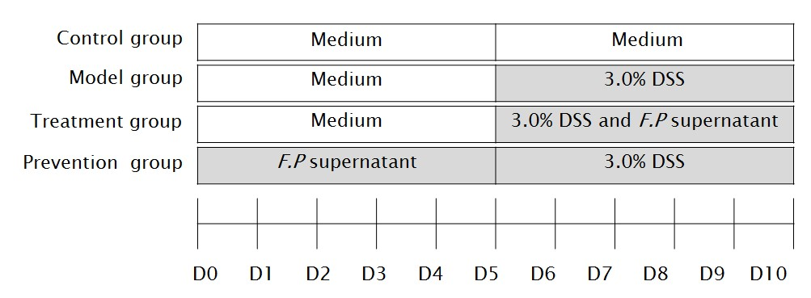
Figure 1 Flow diagram of the study design.

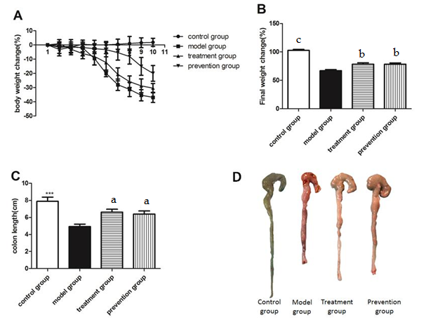
Figure 2 Body weight and colonic length in mice. A, B: Body weight change; C, D: Colon length. Data are the mean ± SD. n = 8–10. ªP < 0.05, ^{b}P < 0.01, ^{c}P < 0.001 vs model group.

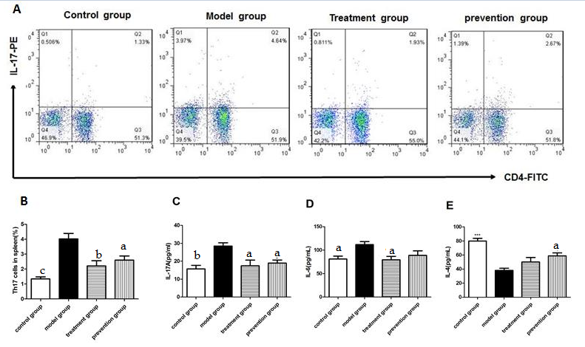
Figure 3 Proportion of Th17 cells in splenic mononuclear cells and plasma cytokines levels. Flow cytometry figures (A) and statistical analysis(B) of Th17 cell in each group of the mice splenic MNC. Plasma IL-17 A (C), IL–6 (D) and IL-4 (E) levels by enzyme-linked immunosorbent assay. Data are the mean ± SD. n = 8-10. ªP < 0.05, ^{b}P < 0.01, ^{c}P < 0.001 vs model group. IL: interleukin.

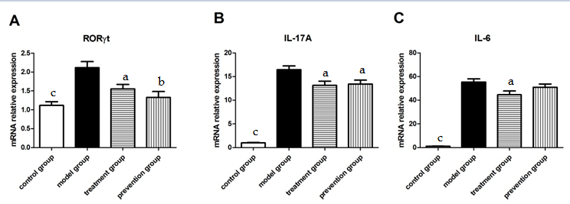

Figure 4 Cytokine mRNA expression in colon mucosal tissue. A: RORγt mRNA; B: IL-17A mRNA; C: IL-6 mRNA. Data are the mean ± SD. n = 8–10. ªP < 0.05, ^{b}P < 0.01, ^{c}P < 0.001 vs model group. ROR-γt: related orphan receptor-γt; IL: interleukin.

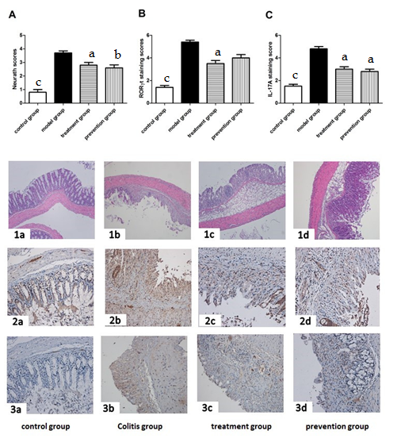
Figure 5 Colon Neurath Scores and related orphan receptor-γt and interleukin-17A protein expression. Colon Neurath Scores (A, 100 magnifications), RORγt (B, 200 magnifications) and IL-17A (C, 200 magnifications) protein expression in mice colon. Representative images of mice colonic mucosa (1a-1d). Representative immunohistochemical staining of RORγt (2a-2d) and IL-17A (3a-3d) in mice colon mucosa. Control group (a); model group (b); treatment group (c); prevention group (d). Data are the mean ± SD. n = 8–10. ªP < 0.05, ^{b}P < 0.01, ^{c}P < 0.001 vs model group.

