Name of journal: World Journal of Gastrointestinal Oncology
Manuscript NO: 31900
Manuscript type: Original Article

Retrospective Study
S-1 induced hepatic steatosis in patients with pancreatic cancer: retrospective analysis

Tsuji K et al. S-1 induced hepatic steatosis

Kunihiro Tsuji, Hisashi Doyama

Kunihiro Tsuji, Hisashi Doyama, Department of Gastroenterology, Ishikawa Prefectural Central Hospital, Ishikawa 920-8530, Japan

Author contributions: Tsuji K designed this study and wrote the paper; Doyama H contributed to revision of the manuscript for important content.

Institutional review board statement: This study was reviewed and approved by the Institutional Review Board of Ishikawa Prefectural Central Hospital.

Informed consent statement: All study participants provided informed consent to study enrollment.

Conflict-of-interest statement: The authors declare that they have no financial considerations or relationships that may pose a conflict of interest.

Open-Access: This article is an open-access article which was selected by an in-house editor and fully peer-reviewed by external reviewers. It is distributed in accordance with the Creative Commons Attribution Non Commercial (CC BY-NC 4.0) license, which permits others to distribute, remix, adapt, build upon this work non-commercially, and license their derivative works on different terms, provided the original work is properly cited and the use is non-commercial. See: http://creativecommons.org/licenses/by-nc/4.0/

Manuscript source: Invited manuscript

Correspondence to: Dr. Kunihiro Tsuji, Department of Gastroenterology, Ishikawa Prefectural Central Hospital, 2-1 Kuratsukihigashi, Kanazawa, Ishikawa 920-8530, Japan. m92162g@ipch.jp
Telephone: +81-76-2378211
Fax: +81-76-2385366

Received: December 13, 2016
Peer-review started: December 14, 2016
First decision: March 6, 2017
Revised: March 20, 2017
Accepted: June 12, 2017
Article in press:
Published online:

Abstract
Aim
To determine whether S-1 induces hepatic steatosis in patients being treated for pancreatic cancer.

Methods
This retrospective study evaluated 22 patients who received oral S-1 as a first-line treatment for pancreatic cancer between January 2008 and July 2015 at the Ishikawa Prefectural Central Hospital. Patients underwent abdominal computed tomography (CT) scans before chemotherapy and within 3 mo from the start of treatment. CT numbers of the liver and spleen were measured before and after S-1 administration. Steatosis was diagnosed when the ratio of the CT number of the liver to that of the spleen (liver/spleen ratio) was < 0.9.

Results
Median patient age was 68 years (range, 48-85 years), and median body mass index was 21 kg/m² (range, 18-27 kg/m²). Of the 22 patients, six (27%) regularly consumed alcohol, and five (23%) had liver metastases. The mean ratio of CT number of the liver to the spleen was significantly higher before administration of S-1 (1.27 vs 1.09, P = 0.012) compared with after. Of the 22 patients, five (23%) had hepatic steatosis and 17 (77%) did not. The pretreatment demographic and clinical characteristics of these two groups showed no significant differences. The relationship between liver/spleen ratio and alanine transaminase activity in these patients. A statistically significant inverse correlation was observed (r = -0.417, P < 0.027).

Conclusion
Of the 22 patients with pancreatic cancer, five (23%) experienced S-1 induced hepatic steatosis. Care should be taken during S-1 treatment of patients with pancreatic cancer.

Key words: S-1; hepatic steatosis; drug induced hepatitis; 5-fluorouracil; pancreatic cancer

© The Author(s) 2017. Published by Baishideng Publishing Group Inc. All rights reserved.

Core tip: Drug induced hepatic steatosis is a rare form of liver injury. Although hepatic steatosis has been observed in some patients with pancreatic cancer who were administered S-1, the ability of 5-fluorouracil alone to induce hepatic steatosis has not been evaluated systematically. The purpose of our study was to determine whether S-1 induces hepatic steatosis in patients being treated for pancreatic cancer. After analyzing a total of 22 patients, we found that S-1 chemotherapy induced hepatic steatosis in some patients with pancreatic cancer within three months and the correlation between the development of hepatic steatosis and liver function was weak in these patients.

Tsuji K, Doyama H. S-1 induced hepatic steatosis in patients with pancreatic cancer: retrospective analysis. World J Gastrointest Oncol 2017; In press
INTRODUCTION
S-1 is an oral antitumor drug that combines tegafur, a prodrug of 5-fluorouracil (5-FU), with 5-chloro-2,4-dihydroxypyridine and potassium oxonate^{[1]}. Following S-1 administration, fluorouracil concentrations in blood remain high for long periods of time^{[1]}. Several phase III trials have shown the efficacy and safety of S-1 in cancer patients^{[2-5]}, and S-1 has been approved in Japan for the treatment of various cancers, including gastric, head and neck, colorectal, lung, breast, pancreatic, and biliary tract cancers.
Nonalcoholic fatty liver disease is the most common form of chronic liver disease in Western countries, and its incidence is increasing, partly owing to the increasing prevalence of diabetes and obesity^{[6]}. In Japan also, nonalcoholic fatty liver diseases has become one of the most frequent types of liver disease^{[7]}.
In contrast to nonalcoholic fatty liver diseases, drug induced hepatic steatosis is a rare form of liver injury. Drugs found to induce hepatic steatosis include amiodarone, tamoxifen, irinotecan, and valproic acid, with their toxicities due to their effects on hepatocyte mitochondria^{[8,9]}. 5-FU, when combined with interferon (IFN) and folinic acid, has also been reported to induce hepatic steatosis^{[10,11]}, but the ability of 5-FU alone to induce hepatic steatosis has not been evaluated systematically.
Although hepatic steatosis has been observed in some patients with pancreatic cancer who were administered S-1 (Figure 1), it is not clear whether S-1 was responsible for drug induced hepatic steatosis in these patients. This study therefore evaluated whether S-1 induced hepatic steatosis in patients with pancreatic cancer.

Materials and methods
Study populations
This retrospective study analyzed patients with pancreatic cancer who underwent chemotherapy for pancreatic cancer at Ishikawa Prefectural Central Hospital between January 2008 and July 2015. Of the 107 pancreatic cancer patients who received chemotherapy during the study period, 37 received oral S-1 as first-line treatment. Patients were included if they: (1) were aged > 20 years; (2) had an Eastern Cooperative Oncology Group performance status (ECOG PS) of 0-2; (3) underwent regular computed tomography (CT) examinations; and (4) had no other cancer or serious complications, such as active infectious disease or serious heart disease. Twenty-two patients were deemed eligible. This study was performed in accordance with the principles of the Declaration of Helsinki and was approved by the Institutional Review Board of Ishikawa Prefectural Central Hospital.

CT
All patients underwent abdominal CT scans before the start of chemotherapy and within three months from the start of treatment. CT numbers of the liver and spleen were evaluated before and after administration of S-1. Steatosis was diagnosed when the ratio of the CT number of the liver to that of the spleen (liver/spleen ratio) was < 0.9^{[12]}. Blood was collected and blood tests performed at the time of each CT examination.

Statistical analysis
Continuous variables were reported as median (range) and analyzed using non-parametric Mann–Whitney U tests. Categorical variables were reported as number (percentage) and analyzed using Fisher’s exact tests or Wilcoxon signed rank tests. A P-value < 0.05 was considered statistically significant. All statistical analyses were performed with EZR software (Saitama Medical Center, Jichi Medical University, Saitama, Japan), a graphical user interface for R (The R Foundation for Statistical Computing, Vienna, Australia). More precisely, EZR is a modified version of R commander designed to add statistical functions frequently used in biostatistics^{[13]}.

RESULTS
The clinical characteristics of the 22 included patients are shown in Table 1. Their median age was 68 years (range, 48-85 years), and their median body mass index was 21 kg/m² (range, 18-27 kg/m²). Of the 22 patients, six (27%) regularly consumed alcohol, and five (23%) had liver metastases.
Figure 2 shows the median liver/spleen ratios in these patients before and after administration of S-1. This ratio was significantly higher before than after administration of S-1 (1.27 vs 1.09, P = 0.012).
Of the 22 patients, five (23%) had hepatic steatosis and 17 (77%) did not. The pretreatment demographic and clinical characteristics of these two groups showed no significant differences (Table 2).
Figure 3 shows the relationship between liver/spleen ratio and alanine transaminase activity in these patients. A statistically significant inverse correlation was observed (r = -0.417, P < 0.027).

DISCUSSION
This study showed that S-1 chemotherapy induced hepatic steatosis in some patients with pancreatic cancer within three months. This study also found that the correlation between the development of hepatic steatosis and liver function was weak in these patients.
Recognition of steatosis in patients receiving chemotherapy is important. The liver is of higher attenuation than the hepatic metastases, but it is difficult to delineate making assessment of size of the hepatic metastases as the liver becomes steatosis^{[10]}. Obesity, insulin resistance, and the metabolic syndrome have been found to induce nonalcoholic fatty liver disease, a fairly common entity. In contrast, drug induced steatosis is a rare form of liver injury. Agents found to induce steatosis include amiodarone, tamoxifen, irinotecan, and valproic acid^{[8,9]}. Drug induced steatosis is largely due to mitochondrial damage. In addition, mitochondrial damage can be induced by the inhibition of fatty acid beta oxidation, oxidative phosphorylation, and mitochondrial respiration^{[14]}.
In this study, 23% of patients with pancreatic cancer developed hepatic steatosis within three months of starting the oral chemotherapeutic agent S-1. S-1 is a combination of tegafur, a prodrug of 5-FU; 5-chloro-2,4-dihydroxypyridine, an inhibitor of dihydropyrimidine dehydrogenase, the enzyme responsible for generating 5-FU from tegafur; and potassium oxonate^{[1]}. 5-FU has been linked to the development of steatosis^{[8]}. For example, one study reported that 47% of patients receiving 5-FU-based therapy for advanced colorectal cancers developed steatosis during treatment^{[10]}, and a second study found that 30% of patients treated with IFN-alfa 2a and 5-FU developed steatosis^{[11]}. To date, however, hepatic steatosis had not been found to be induced by 5-FU alone.
Although a statistically significant inverse correlation was observed between the development of hepatic steatosis and the loss of liver function, this correlation was weak (r = -0.417, P < 0.027). A previous study reported no correlation between liver function test results and the degree of steatosis in patients receiving 5-FU-based therapy^{[10]}. Our findings are not strong enough to conclude that liver damage and the degree of steatosis are related.
In general, S-1 is safe for the liver, with few reports of S-1 induced fatal liver dysfunction. Indeed, the GEST trial, which compared S-1 and gemcitabine treatment in patients with mild to moderate pancreatic cancer, reported that the percentages of patients with grade ≥ 3 elevated AST and ALT levels were significantly lower in the S-1 than in the gemcitabine group^{[3]}. Steatosis and liver damage may be underdiagnosed because the laboratory abnormalities are slight. Further investigations are needed to assess the relationship between liver damage and the degree of steatosis in patients receiving S-1.
This study had at least four limitations. First, it was performed at a single institution. Second, this study had a retrospective design. Prospective studies are needed to show the rate of S-1 induced hepatic steatosis in patients with pancreatic and other cancers. Third, none of our patients was histologically evaluated by liver biopsy because all had mild liver damage. CT, however, is reliable in diagnosing hepatic steatosis, with significantly superior diagnostic sensitivity and accuracy than other modalities in diagnosing hepatic steatosis. Fourth, this study was limited to patients with unresectable pancreatic cancer. We experienced the S-1 induced steatohepatitis to patients with gastric cancer in adjuvant therapy. However, Even gastrectomy alone has been found to induce hepatic steatosis^{[15]}. Further study is needed to assess the effects of S-1 on steatosis in other types of cancer.
In conclusion, this study found that 23% of patients with pancreatic cancer who were treated with first-line S-1 chemotherapy developed hepatic steatosis. Because adjuvant S-1 chemotherapy has become a standard treatment in patients resected for pancreatic cancer, clinical use of S-1 and the risk of S-1-induced steatosis are expected to increase. The liver function of patients treated with S-1 should therefore be closely monitored during follow-up.

COMMENTS
Background
S-1 is an oral chemotherapeutic agent, consisting of tegafur, a prodrug of 5-fluorouracil, 5-chloro-2,4-dihydroxypyridine, and potassium oxonate. Recent randomized controlled trials in Japan have shown the clinical utility of S-1 treatment in patients with pancreatic cancer. Liver dysfunction, primarily steatohepatitis, has been observed in some S-1-treated patients, but it is not clear whether S-1 induced steatohepatitis.

Research frontiers
It is not clear whether S-1 was responsible for drug induced steatohepatitis.

Innovations and breakthrough
The literature suggests 5-FU has been linked to the development of steatosis, but the ability of 5-FU alone to induce hepatic steatosis has not been evaluated systematically. The current study adds that S-1 chemotherapy induced hepatic steatosis in some patients.

Applications
This study serves as additional evidence supporting the closely investigation of liver function in patients treated with S-1.

Terminology
S-1 is a combination of tegafur, a prodrug of 5-FU; 5-chloro-2,4-dihydroxypyridine, an inhibitor of dihydropyrimidine dehydrogenase, the enzyme responsible for generating 5-FU from tegafur; and potassium oxonate.

Peer-review
The paper is well-written and contributes important information.
REFERENCES
1 Shirasaka T, Shimamato Y, Ohshimo H, Yamaguchi M, Kato T, Yonekura K, Fukushima M. Development of a novel form of an oral 5-fluorouracil derivative (S-1) directed to the potentiation of the tumor selective cytotoxicity of 5-fluorouracil by two biochemical modulators. Anticancer Drugs 1996; 7: 548-557 [PMID: 8862723 DOI: 10.1097/00001813-199607000-00010]
2 Koizumi W, Narahara H, Hara T, Takagane A, Akiya T, Takagi M, Miyashita K, Nishizaki T, Kobayashi O, Takiyama W, Toh Y, Nagaie T, Takagi S, Yamamura Y, Yanaoka K, Orita H, Takeuchi M. S-1 plus cisplatin versus S-1 alone for first-line treatment of advanced gastric cancer (SPIRITS trial): a phase III trial. Lancet Oncol 2008; 9: 215-221 [PMID: 18282805 DOI: 10.1016/S1470-2045(08)70035-4]
3 Ueno H, Ioka T, Ikeda M, Ohkawa S, Yanagimoto H, Boku N, Fukutomi A, Sugimori K, Baba H, Yamao K, Shimamura T, Sho M, Kitano M, Cheng AL, Mizumoto K, Chen JS, Furuse J, Funakoshi A, Hatori T, Yamaguchi T, Egawa S, Sato A, Ohashi Y, Okusaka T, Tanaka M. Randomized phase III study of gemcitabine plus S-1, S-1 alone, or gemcitabine alone in patients with locally advanced and metastatic pancreatic cancer in Japan and Taiwan: GEST study. J Clin Oncol 2013; 31: 1640-1648 [PMID: 23547081 DOI: 10.1200/JCO.2012.43.3680]
4 Uesaka K, Boku N, Fukutomi A, Okamura Y, Konishi M, Matsumoto I, Kaneoka Y, Shimizu Y, Nakamori S, Sakamoto H, Morinaga S, Kainuma O, Imai K, Sata N, Hishinuma S, Ojima H, Yamaguchi R, Hirano S, Sudo T, Ohashi Y; JASPAC 01 Study Group. Adjuvant chemotherapy of S-1 versus gemcitabine for resected pancreatic cancer: a phase 3, open-label, randomised, non-inferiority trial (JASPAC 01). Lancet 2016; 388: 248-257 [PMID: 27265347 DOI: 10.1016/S0140-6736(16)30583-9]
5 Takashima T, Mukai H, Hara F, Matsubara N, Saito T, Takano T, Park Y, Toyama T, Hozumi Y, Tsurutani J, Imoto S, Watanabe T, Sagara Y, Nishimura R, Shimozuma K, Ohashi Y. Taxanes versus S-1 as the first-line chemotherapy for metastatic breast cancer (SELECT BC): an open-label, non-inferiority, randomised phase 3 trial. Lancet Oncol 2016; 17: 90-98 [PMID: 26617202 DOI: 10.1016/S1470-2045(15)00411-8]
6 Wang YC, Colditz GA, Kuntz KM. Forecasting the obesity epidemic in the aging U.S. population. Obesity (Silver Spring) 2007; 15: 2855-2865 [PMID: 18070778 DOI: 10.1038/oby.2007.339]
7 Okanoue T, Umemura A, Yasui K, Itoh Y. Nonalcoholic fatty liver disease and nonalcoholic steatohepatitis in Japan. J Gastroenterol Hepatol 2011; 26 Suppl 1: 153-162 [PMID: 21199527 DOI: 10.1111/j.1440-1746.2010.06547.x]
8 Maor Y, Malnick S. Liver injury induced by anticancer chemotherapy and radiation therapy. Int J Hepatol 2013; 2013: 815105 [PMID: 23970972 DOI: 10.1155/2013/815105]
9 Choti MA. Chemotherapy-associated hepatotoxicity: do we need to be concerned? Ann Surg Oncol 2009; 16: 2391-2394 [PMID: 19554374 DOI: 10.1245/s10434-009-0512-7]
10 Peppercorn PD, Reznek RH, Wilson P, Slevin ML, Gupta RK. Demonstration of hepatic steatosis by computerized tomography in patients receiving 5-fluorouracil-based therapy for advanced colorectal cancer. Br J Cancer 1998; 77: 2008-2011 [PMID: 9667683 DOI: 10.1038/bjc.1998.333]
11 Sørensen P, Edal AL, Madsen EL, Fenger C, Poulsen MR, Petersen OF. Reversible hepatic steatosis in patients treated with interferon alfa-2a and 5-fluorouracil. Cancer 1995; 75: 2592-2596 [PMID: 7736406]
12 Kato K, Takayama T, Katada N. Evaluation of computed tomography in the diagnosis of liver diseases. Kanzo 1980; 21: 1340-1351 [DOI: 10.2957/kanzo.21.1340]
13 Kanda Y. Investigation of the freely available easy-to-use software "EZR" for medical statistics. Bone Marrow Transplant 2013; 48: 452-458 [PMID: 23208313 DOI: 10.1038/bmt.2012.244]
14 Schumacher JD, Guo GL. Mechanistic review of drug-induced steatohepatitis. Toxicol Appl Pharmacol 2015; 289: 40-47 [PMID: 26344000 DOI: 10.1016/j.taap.2015.08.022]
15 Yamasaki H, Tanemura M, Morimoto Y, Hashimoto J, Sakamoto T, Yamasaki Y, Kuwata K. [Study of postgastrectomy fatty liver]. Nihon Geka Gakkai Zasshi 1992; 93: 1384-1389 [PMID: 1448045]
P-Reviewer: Tang Y S-Editor: Gong ZM
L-Editor: E-Editor:
Specialty type: Gastroenterology and hepatology
Country of origin: Japan
Peer-review report classification
Grade A (Excellent): 0
Grade B (Very good): 0
Grade C (Good): C
Grade D (Fair): 0
Grade E (Poor): 0

A B
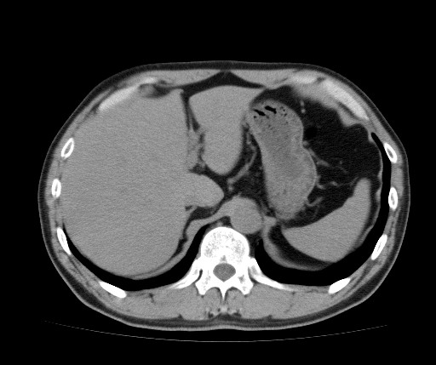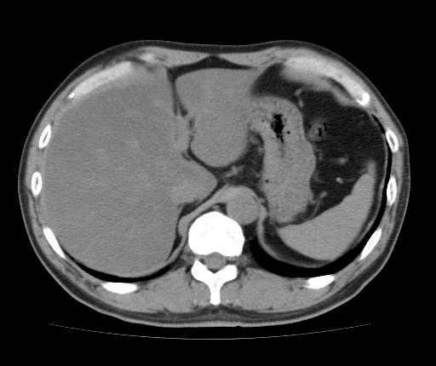
Figure 1 Abdominal computed tomography scans of a pancreatic cancer patient before (A) and during treatment (B) with S-1, showing that the liver/spleen ratio decreased after start of treatment.

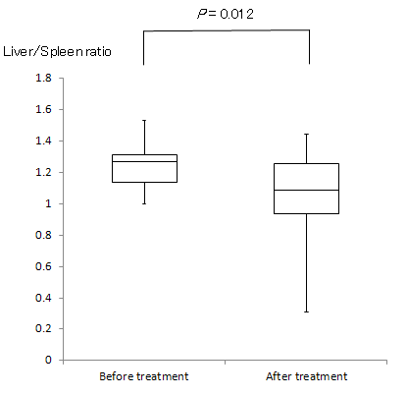
Figure 2 Median liver/spleen ratios in pancreatic cancer patients before and after treatment with S-1. The ratio decreased significantly, from 1.27 before treatment to 1.09 after S-1 treatment (P = 0.012).

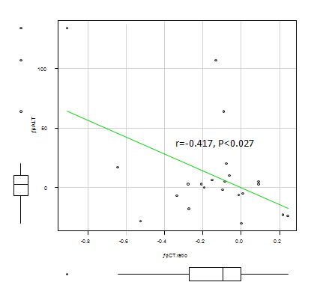
Figure 3 Correlation between liver/spleen ratio and alanine transaminase activity in pancreatic cancer patients treated with S-1. A significant inverse correlation was observed between these parameters (r = -0.417, P < 0.027).

Table 1 Demographic and clinical characteristics of patients with pancreatic cancer receiving S-1 treatment
 | Number of patients (n = 22)
Age (yr), median (range) | 68 (48-85)
Sex
Male | 9
Female | 13
Body mass index (kg/m²) median (range) | 21 (18-27)
ECOG PS
0 | 15
1 | 5
2 | 2
Drinking habit
Yes | 6
No | 16
Diabetes mellitus
Yes | 6
No | 16
Disease status
Locally advanced | 14
Metastatic | 8
Liver metastasis
Yes | 5
No | 17
Biliary drainage
Yes | 7
No | 15
Combination with radiotherapy
Yes | 12
No | 10
Alanine transaminase concentration (U/L), median (range) | 21 (8-73)

Table 2 Demographic and clinical characteristics of pancreatic cancer patients treated with S-1 who did and did not develop hepatic steatosis
 | Without hepatic steatosis (n = 11) | With hepatic steatosis ( n = 5) | P value
Age (yr), median (range) | 70 (57-85) | 67 (48-78) | 0.39
Sex
Male | 7 | 2 | 1
Female | 10 | 3
Body mass index (kg/m²), median (range) | 21.5 (17.9-26.9) | 22.6 (19.0-25.3) | 0.75
ECOG PS
0 | 11 | 4 | 1
1 | 4 | 1
2 | 2 | 0
Drinking habit
Yes | 5 | 1 | 1
No | 12 | 4
Diabetes mellitus
Yes | 5 | 1 | 1
No | 12 | 4
Disease status
Locally advanced | 10 | 4 | 0.61
Metastatic | 7 | 1
Liver metastasis
Yes | 5 | 0 | 0.29
No | 12 | 5
Biliary drainage
Yes | 4 | 3 | 0.27
No | 13 | 2
Combination with radiotherapy
Yes | 9 | 3 | 1
No | 8 | 2
Alanine transaminase concentration (U/L), median (range) | 24 (8-57) | 20.5 (11-73) | 0.97

