Name of Journal: World Journal of Gastrointestinal Surgery
Manuscript NO: 64091
Manuscript Type: SYSTEMATIC REVIEWS

Acute mesenteric ischemia and small bowel imaging findings in COVID-19: A comprehensive review of the literature

Pirola L et al. Small bowel imaging in COVID-19

Lorena Pirola, Andrea Palermo, Giacomo Mulinacci, Laura Ratti, Maria Fichera, Pietro Invernizzi, Chiara Viganò, Sara Massironi

Lorena Pirola, Andrea Palermo, Giacomo Mulinacci, Laura Ratti, Maria Fichera, Pietro Invernizzi, Chiara Viganò, Sara Massironi, Division of Gastroenterology and Center for Autoimmune Liver Diseases, Department of Medicine and Surgery, University of Milano-Bicocca, Monza 20900, Italy

Lorena Pirola, Andrea Palermo, Giacomo Mulinacci, Laura Ratti, Maria Fichera, Pietro Invernizzi, Chiara Viganò, Sara Massironi, European Reference Network on Hepatological Diseases, San Gerardo Hospital, Monza 20900, Italy

Author contributions: Pirola L and Viganò C planned the work; Pirola L, Viganò C and Massironi S contributed to the design and conceptualization of the study; Palermo A and Mulinacci G wrote the first draft of the manuscript and edited the figures and tables; Pirola L, Ratti L, Fichera M and Viganò C edited the subsequent versions of the manuscript; Viganò C and Massironi S revised the manuscript for relevant intellectual content; Invernizzi P corrected the final version; all the authors read and approved the final version of the manuscript.

Corresponding author: Chiara Viganò, MD, Doctor, Division of Gastroenterology and Center for Autoimmune Liver Diseases, Department of Medicine and Surgery, University of Milano-Bicocca, Via Pergolesi 33, Monza 20900, Italy. c.vigano@hotmail.it

Received: February 8, 2021
Revised: April 12, 2021
Accepted: July 2, 2021
Published online: July 27, 2021

Abstract
BACKGROUND
Coronavirus disease 2019 (COVID-19), an infectious condition caused by severe acute respiratory syndrome coronavirus 2 (SARS-CoV-2), has rapidly spread worldwide since its first description in Wuhan in December 2019. Even though respiratory manifestations are the most prevalent and responsible for disease morbidity and mortality, extrapulmonary involvement has progressively gained relevance. In particular, gastrointestinal (GI) signs and symptoms, reported in up to two-thirds of patients with COVID-19, might represent the first and, in some cases, the only disease presentation. Their presence has been associated in some studies with an increased risk of a severe disease course. Proposed pathogenic mechanisms explaining GI tract involvement are either direct viral access to intestinal cells via angiotensin-converting enzyme 2 or indirect damage of the intestinal wall through mesenteric ischemia induced by the hypercoagulable state associated with COVID-19 infection. Although not typical of SARS-CoV-2 infection, several small bowel manifestations have been described in infected patients who underwent any form of abdominal imaging. The radiological findings were mainly reported in patients with abdominal symptoms, among which abdominal pain was the most common.

AIM
To discuss small bowel radiological manifestations of SARS-CoV-2 infection in abdominal imaging studies.

METHODS
Bibliographical searches were performed in PubMed, using the following keywords: “covid-19” AND “imaging” AND “gastrointestinal” OR “abdominal” OR “small bowel”.

RESULTS
Of 62 patients with described radiologic small bowel alterations, mesenteric ischemia was diagnosed in 31 cases (50%), small bowel wall thickening in 10 cases (16%), pneumatosis in nine cases (15%), intussusception in eight cases (13%), pneumoperitoneum in two cases (3%) and paralytic ileus in two cases (3%). We also reported mesenteric adipose tissue hypertrophy and lymph nodes enlargement in a young woman.

CONCLUSION
So far it is difficult to establish whether these manifestations are the direct consequence of SARS-CoV-2 infection or collateral findings in infected patients, but their recognition would be pivotal to set a closer follow-up and to reduce missed diagnoses.

Key Words: COVID-19; SARS-CoV-2; Radiology; Small intestine; Abdomen

©The Author(s) 2021. Published by Baishideng Publishing Group Inc. All rights reserved.

Citation: Pirola L, Palermo A, Mulinacci G, Ratti L, Fichera M, Invernizzi P, Viganò C, Massironi S. Acute mesenteric ischemia and small bowel imaging findings in COVID-19: A comprehensive review of the literature. World J Gastrointest Surg 2021; 13(7): 702-716
URL: https://www.wjgnet.com/1948-9366/full/v13/i7/702.htm
DOI: https://dx.doi.org/10.4240/wjgs.v13.i7.702

Core Tip: Gastrointestinal manifestations of severe acute respiratory syndrome coronavirus 2 (SARS-CoV-2) infection have been increasingly reported and corresponding abdominal imaging findings have been recognized. The present review includes case reports, case series, and retrospective studies discussing small bowel radiological manifestations of SARS-CoV-2 infection in abdominal imaging studies. Out of 62 patients, the most commonly reported finding was mesenteric ischemia, with a prevalence of 50%. Other, less frequent features, were small bowel wall thickening (16%), pneumatosis intestinalis (15%), intussusception (13%), pneumoperitoneum (3%), and paralytic ileus (3%). We also report a patient with mesenteric adipose tissue hypertrophy and lymph node enlargement.
INTRODUCTION
Coronavirus disease 2019 (COVID-19) is an infectious condition caused by severe acute respiratory syndrome coronavirus 2 (SARS-CoV-2), firstly isolated in December 2019 in Wuhan, China^{[1]}. As of February 8, 2021, there have been more than one hundred million confirmed cases of COVID-19, with more than two million deaths^{[2]}. The most common COVID-19 symptoms include fever (85.6%), cough (65.7%), fatigue (42.4%) and dyspnea (21.4%)^{[3]}. Although respiratory tract manifestations are the most prevalent and responsible for disease morbidity and mortality, extrapulmonary involvement has progressively gained relevance. In particular, gastrointestinal (GI) symptoms are described in a significant proportion of infected patients, being reported in up to two-thirds of patients with COVID-19^{[4]}. Several studies suggest that GI symptoms might not only be the initial presentation of SARS-CoV-2 infection but are also the only manifestation reported during disease course in about 10% of cases^{[5]}. Patients presenting with GI manifestations alone have a delayed diagnosis^{[6]}. Furthermore, in some studies the presence of GI symptoms has been associated with an increased risk of severe clinical course, but the real impact of GI involvement on disease outcome is still a matter of debate^{[6,7]}. The most commonly reported GI symptoms were loss of appetite (21%), diarrhea (9%), nausea or vomiting (6%), and abdominal pain (3%)^{[6]}. It has been widely described and accepted in the literature that SARS-CoV-2 exploits angiotensin-converting enzyme 2 (ACE2) to gain access to single cells^{[8]}. Hence, it is possible to assume that cells with higher expression of ACE2, such as enterocytes in the GI tract^{[9]}, are more susceptible to infection^{[10]}. Several reports have evaluated the pulmonary radiological findings in COVID-19, which facilitate disease recognition and add to the understanding of its pathogenic mechanisms in the lung^{[11]}. However, despite the broad spectrum and the high prevalence of GI symptoms, only a few studies have assessed the abdominal radiological findings in COVID-19 patients, and only a few of those have focused on small bowel alterations. Furthermore, the pathogenic mechanisms behind the described findings remain unclear, highlighting the importance of collecting further evidence on the topic. In this review, we analyzed the radiological small bowel findings in patients with COVID-19 and evaluated their impact on the whole clinical picture of the disease.

MATERIALS AND METHODS
Bibliographical searches were performed in PubMed, using the keywords “covid-19” AND “imaging” AND “gastrointestinal” OR “abdominal” OR “small bowel”. PubMed was used to search for all relevant articles published since the first description of SARS-CoV-2 infection, which occurred in December 2019, until the end of January 2021. Reference lists from studies selected from the electronic search were manually searched to identify further relevant reports. Reference lists from all available review articles, primary studies, and proceedings of major meetings were also considered. Articles published as abstracts were included. Only English-language papers were included.

RESULTS
Thirty-nine articles describing small bowel imaging findings in patients with COVID-19 were identified. The review included 28 case reports, six case series, and five retrospective studies discussing radiological manifestations of SARS-CoV-2 infection in abdominal imaging studies. Several small bowel radiological manifestations have been described in infected patients, with a prevalence ranging from 3% to 21%^{[12,13]}. They were mainly reported in patients with abdominal symptoms, among which abdominal pain was the most common. Of the 62 patients with small bowel radiological findings, acute mesenteric ischemia (AMI) was the most prevalent condition, diagnosed in 31 cases (50%). The characteristics of COVID-19 patients with AMI are shown in Table 1. Other radiological findings (Figure 1) were small bowel wall thickening in 10 cases (16%), pneumatosis in nine (15%), intussusception in eight (13%), pneumoperitoneum in two (3%), and paralytic ileus in two (3%). A summary of those findings is shown in Table 2. In addition, we reported mesenteric adipose tissue hypertrophy and lymph node enlargement in a young woman.

AMI
AMI is a pathological condition characterized by a sudden decline in blood flow through the mesenteric vessels, resulting in a discrepancy between the metabolic need of the visceral organs and actual oxygen delivery^{[14]}. If untreated, it may lead to small bowel wall necrosis, with a mortality rate of up to 80%^{[15]}. Among the causes of AMI, the most prevalent are acute mesenteric artery embolism, nonocclusive mesenteric ischemia^{[16]}, and acute mesenteric vein thrombosis. So far, 22 papers have been published describing mesenteric ischemia in 31 COVID-19 patients, including 17 case reports, two case series, and three retrospective studies^{[17-38]}. The characteristics and radiological findings of COVID 19 patients with AMI are reported in Table 1. All but one patient underwent abdominal contrast-enhanced computed tomography (CT) scan after the onset of GI symptoms such as nausea, vomiting, and/or abdominal pain. Among the vascular findings, the most frequent were nine cases with thrombosis of the upper mesenteric artery or jejunal artery and nine cases of thrombosis of splanchnic veins, of which seven involved the portal vein, five involved the superior mesenteric vein (Figure 2), and one involved splenic and hepatic veins. Other findings described in association with AMI were the presence of liquid in the peritoneal cavity (two cases), bowel distension (one case), mesenteric intravenous air (one case), and splenic infarction (one case). From a pathological perspective, it is of interest that none of the patients had evidence of a systemic atherosclerotic disorder or other pathologic conditions that could possibly explain the findings. Treatment of AMI was reported in 17 cases. Thirteen (76%) were treated by segmental resection of small bowel, and anticoagulant therapy alone was administered in four cases. Of the nineteen patients with a reported outcome, nine (47%) died.

Small bowel wall thickening
Thickening of the small bowel wall may occur secondary to neoplastic, inflammatory, infectious, or ischemic conditions^{[39]}. It was first described by Hellinger et al^{[40]} in a patient presenting at the emergency room with abdominal symptoms, and this condition has been subsequently reported in other COVID-19 patients (Figure 3). At the time of writing, we identified five papers, three case reports and two retrospective studies, describing ten patients with radiological evidence of small bowel wall thickening. In a study of 412 patients admitted to the hospital for SARS-CoV-2 infection, 42 underwent abdominal CT scans. In five of those patients (11.9%) small bowel thickening, reported as a single-wall thickness greater than 3 mm in distended loops or greater than 5 mm in collapsed loops^{[12]}. In a report including 141 COVID-19 patients who underwent abdominopelvic CT within 14 d of diagnosis, Goldberg-Stein et al^{[13]} reported a small bowel thickening prevalence of 2.5%. In addition, diffuse mural wall thickening of the ileum was reported in a single case study of a 11-year-old boy with SARS-CoV-2 infection, who presented to the emergency room with fever, diarrhea, and abdominal pain, without respiratory symptoms^{[41]}. Lastly, Guo et al^{[42]} described segmental wall thickening involving a segment of jejunum in a 29-year-old man presenting with diarrhea and fever. The cause of small bowel thickening in SARS-CoV-2 infected patients is still unclear. It may be a manifestation of local inflammation and edema secondary to direct or indirect viral damage of the bowel wall. Another hypothesis is that may be linked to hypercoagulability secondary to viral infection, which may promote formation of fibrin clots in the microcirculation, leading to ischemia and edema.

Pneumatosis intestinalis
Pneumatosis intestinalis is a radiological sign reflecting the presence of gas within the intestinal wall, most commonly in the mucosa or submucosa. Pneumatosis can occur in any part of the digestive tract, and may even be accompanied by the presence of gas in the portal or mesenteric vein^{[43]}. The clinical relevance of pneumatosis intestinalis varies widely and ranges from a benign to life-threatening condition depending on the underlying cause^{[44]}. This pathologic finding has been previously described in association with viral infections, such as cytomegalovirus, adenovirus, rotavirus, and norovirus, and the proposed pathogenic mechanism was direct mucosal damage caused by viral activity^{[44-47]}.
So far, four papers, one case report, one case series, and two retrospective studies, have described pneumatosis intestinalis in nine patients with SARS-CoV-2 infection. Bhayana et al^{[12]} described pneumatosis intestinalis of the small bowel in four of 42 COVID-19 patients (9.5%) with abdominal CT scans. The percentage reached 20% in patients admitted to the intensive care unit. All patients underwent laparotomic exploration. Two cases showed frank signs of bowel necrosis, with bowel resection performed in one. Fibrin clots were detected in arterioles adjacent to the necrotic mucosa in histological samples. In a retrospective study, Tirumani et al^{[48]} described small bowel pneumatosis with portal venous gas in one of 73 SARS-CoV-2 infection patients with abdominal CT scans. Pneumatosis intestinalis of the small bowel was also reported in a small study of three cases and in a single-patient case report. Complete resolution was reported following conservative of a patient with widespread pneumatosis affecting the jejunum, proximal ileum, and caecum, for which surgery was deemed to be associated with unacceptably high morbidity^{[49]}. In the remaining three patients, an open abdomen with negative pressure therapy was successfully performed without the need of intestinal resection^{[50]}. The rationale behind this approach lies in the capability of either increasing gastrointestinal arterial and venous blood flow through intra-abdominal pressure reduction and dampening intestinal cytokine release in the peritoneal cavity, which might also prevent the deterioration of lung function^{[12,51,52]}.

Intussusception
Intussusception is the invagination of a segment of the bowel within a more distal one^{[53]}. It is the most common cause of bowel obstruction in infants, usually occurring between 4 and 10 mo of age^{[53]}. On the contrary, intussusception in adults is a rare disease, accounting for less than 5% of bowel obstruction episodes^{[53]}. In both children and adults, intussusception usually involves the ileum, with ileocecal valve invagination into the cecum being the most common localization. Furthermore, 90% of cases of intussusception in adults are secondary to a well-defined pathological condition, such as inflammatory bowel disease, postoperative tractions, Meckel’s diverticulum, benign and malignant lesions, metastatic neoplasms, or even an iatrogenic cause (e.g., intestinal tubes, jejunostomy feeding tubes, or gastric surgery)^{[53]}. Conversely, in the pediatric age group, approximately 90% of cases are idiopathic. In the literature, viral infection was cited as a possible cause of intussusception in children^{[54]}. Indeed, local immune activation and mesenteric adenitis may trigger enhanced peristaltic activity, consequently leading to the invagination of the proximal bowel segment into the distal one^{[54]}.
So far, eight cases of intussusception were reported in children between 4 and 10 mo of age with laboratory-confirmed SARS-CoV-2 infection in one case series, five case reports, and one retrospective study^{[54-60]}. The diagnosis was made mainly by ultrasound (US) through the presence of typical findings of intussusception, such as the doughnut sign (i.e. concentric alternating hyperechoic and hypoechoic rings); as expected, in all cases except one in which the site of intussusception was not specified, the ileocolic tract was involved. Three patients died of complications. To date, it has not been possible to establish an association between SARS-CoV-2 infection and intussusception. Testing for viral pathogens, including SARS-CoV-2, may be considered in infants with symptoms consistent with intussusception or with typical radiological findings.

Small bowel perforation
Pneumoperitoneum, an indirect sign of small bowel perforation, refers to the presence of free air in the abdominal cavity, often suspected through abdominal radiography and confirmed on CT scans^{[61]}. It has been less frequently reported than the previously mentioned radiologic features. One case report and one retrospective study described small bowel perforations in two patients with SARS-CoV-2 infection without any other possible explanation other than viral infection. Both cases were then confirmed by laparoscopic exploration^{[12,62]}. The clinical outcome was not specified in one study. In the other, despite prompt orotracheal-intubation and surgery, the patient developed refractory septic shock and died^{[12,62]}. As for the previously described findings, the disease pathogenesis is unknown. However, it is likely that small bowel perforation occurred as a consequence of either viral action on the intestinal mucosa or as a consequence of ischemic small bowel necrosis.

Paralytic ileus
Paralytic ileus is defined as a temporary functional cessation of propulsive contractions of the gastrointestinal tract, with subsequent upstream gut dilation and accumulation of secretions and gas within the lumen^{[63]}. Diagnosis of paralytic ileus is established by the coexistence of a clinical suspect and the support of radiological imaging. Many conditions may cause paralytic ileus, the most common being abdominal or retroperitoneal surgery. Other causes include the use of opioids, intra-abdominal infections, bleeding, hypokalemia, and the absence of enteral nutrition^{[64]}. In patients with SARS-CoV-2 infection, one case of paralytic ileus of the small bowel was reported in a retrospective study, and another, involving both the small and the large bowel was described in a case report^{[13,65]}.

Mesenteric adipose tissue hypertrophy and enlarged lymph nodes
Even though there are very few data available in literature at the time of writing, small bowel involvement in SARS-CoV-2 infection may also lead to mesenteric activation and lymph nodes enlargement^{[66]}. We report those alterations in a 34-year-old woman with SARS-CoV-2 infection presenting abdominal pain, vomiting, and diarrhea. Abdominal US showed enlarged abdominal lymph nodes with a maximum short-axis diameter of 17 mm, and mesenteric adipose tissue hypertrophy (Figure 4). Abdominal CT confirmed the presence of multiple mesenteric enlarged lymph nodes associated with adipose tissue hypertrophy (Figure 5).

DISCUSSION
In this review, we focused on the small bowel radiological findings in COVID-19 patients, as described so far mainly in patients presenting with GI symptoms. Although no specific aspect was identified, some radiological features have been reported in a significant proportion of patients with GI symptoms, reaching up to 21% of prevalence. Among them, AMI was the most frequent. AMI is an uncommon cause of abdominal pain, accounting for 0.09%-0.2% of all acute surgical admissions to emergency departments^{[15]}. Acute mesenteric arterial embolism caused by atrial fibrillation, thrombosis of the superior mesenteric artery (SMA) in a background of pre-existing chronic atherosclerotic disease, and nonocclusive mesenteric ischemia secondary to SMA vasoconstriction, are the major causes of AMI. Hypercoagulability, including that induced by inherited disorders such as Factor V Leiden and prothrombin mutations, protein S and C deficiency, and others, promote mesenteric venous thrombosis and have been described as causative agents of AMI^{[15]}.
Interestingly, enteric involvement has been described in other beta coronavirus infections such as SARS and Middle East respiratory syndrome, but a strong relationship with AMI has never been reported. Of note, all cases of AMI reported during COVID-19 infection were subsequent to direct vascular obstruction, thus ruling out the possibility of nonocclusive mesenteric ischemia^{[67,68]}. It has been widely reported that SARS-CoV-2 infection is associated with an increased risk of various thromboembolic complications^{[69]}. Indeed, SARS-CoV-2 infection induces a hypercoagulable state through systemic inflammation, endothelial activation, and hypoxia. The tropism of SARS-CoV-2 for the vascular endothelium may be explained by the expression of the ACE2, the target receptor for viral entry into cells, and endothelial damage induces massive release of Von Willebrand factor, further increasing the risk of thrombosis^{[70]}. Overall, both hemodynamic alterations consequent to vascular thrombosis and direct enterocyte damage might contribute to the development of small bowel ischemia and necrosis^{[70]}, although their exact contribution to the development of wall ischemia is still to be determined. Studies of histological samples are required to further explain the pathophysiology behind this manifestation. The mortality rate of AMI in COVID-19 is still unknown, yet it is likely to contribute significantly to an increased burden of disease. It is thus of the utmost importance to raise awareness among clinicians to recognize the typical signs of mesenteric ischemia, as early diagnosis and timely intervention are essential to decrease the mortality curve. Jung et al^{[71]} recently described the role of contrast-enhanced ultrasonography (CEUS) to detect abdominal microcirculatory disorders in severe cases of COVID-19. CEUS has good sensibility in detecting areas of reduced micro-vascularization, even in the early stages[71]. Small bowel wall thickening was reported in 16% of cases. The cause is still unclear, but it may be a manifestation of local inflammation and edema secondary to direct viral damage of the bowel wall. Pneumatosis intestinalis is a radiological finding described in 15% of cases. The etiology in patients with COVID-19 remains unclear. Direct viral mucosal damage, intestinal ischemia, or atrophy of the lymphoid follicles with secondary increased mucosal permeability^{[72]} were considered as possible pathogenic mechanisms.
Other reported imaging findings include intussusception (13%), pneumoperitoneum (3%), and paralytic ileus (3%). We also reported mesenteric enlarged lymph nodes and mesenteric adipose tissue hypertrophy in a young woman with COVID-19. It is possible that, in addition to direct viral damage of enterocytes, SARS-CoV-2 infection could promote a local immune activation with cytokines release, leading to the described alterations^{[66]}.
This review has some limitations. First, it is mainly based on case series and few retrospective studies, thus the real prevalence of the reported radiological findings may actually be significantly higher, as only a proportion of patients with GI symptoms undergo imaging studies. Further investigation of abdominal imaging abnormalities in COVID-19 patients is a topic for future research, and could help to decrease missed diagnosis, encourage closer follow-up, and decrease morbidity and mortality.

CONCLUSION
So far, the small number of reported cases does not allow to conclusively ascribe these manifestations to the direct action of SARS-CoV-2; nevertheless, it is important to exclude this infection in the current diagnostic workup of patients presenting with gastrointestinal symptoms.

ARTICLE HIGHLIGHTS
Research background
Coronavirus disease 2019 (COVID-19) is an infectious disease with predominant respiratory symptoms. Yet extrapulmonary manifestations have been increasingly recognized in COVID-19 patients. In particular, gastrointestinal (GI) symptoms are reported in up to two-thirds of patients and might be the only manifestations in some cases.

Research motivation
Given the high prevalence of gastrointestinal involvement of COVID-19 and the unclear association with disease clinical outcome, we believe that it could be of interest to deeply investigate small bowel involvement in severe acute respiratory syndrome coronavirus 2 infection.

Research objectives
To analyze and to summarize small bowel radiological features described in COVID-19 patients, and possibly clarify their impact on the clinical management of COVID19 patients presenting with GI symptoms.

Research methods
A literature search of the PubMed electronic database was conducted using the MeSH terms “covid-19”, “imaging” and “gastrointestinal” or “abdominal” or “small bowel”. The search was limited to English-language papers. All available case reports, case series and retrospective studies between December 2019 and January 2021 were included.

Research results
AMI is the major radiological finding in COVID-19 patients with small bowel involvement (50%). Less common findings are thickening of the small bowel wall, pneumatosis intestinalis, intussusception, and paralytic ileus. Furthermore, we described a case of mesenteric adipose tissue hypertrophy and enlarged lymph nodes associated to COVID-19.

Research conclusions
Gastrointestinal involvement in COVID-19 patients is highly prevalent. The most frequent small bowel alteration is AMI, a condition associated with high mortality. Raised awareness and prompt identification of small bowel involvement in COVID 19-patients could be essential to improve clinical management and clinical outcome, mainly in case of AMI.

Research perspectives
Further investigation of abdominal imaging abnormalities in COVID-19 patients may be a topic for future research and could help in reducing missed diagnoses and benefit overall morbidity and mortality.

REFERENCES
1 Wu F, Zhao S, Yu B, Chen YM, Wang W, Song ZG, Hu Y, Tao ZW, Tian JH, Pei YY, Yuan ML, Zhang YL, Dai FH, Liu Y, Wang QM, Zheng JJ, Xu L, Holmes EC, Zhang YZ. A new coronavirus associated with human respiratory disease in China. Nature 2020; 579: 265-269 [PMID: 32015508 DOI: 10.1038/s41586-020-2008-3]
2 WHO. Coronavirus Disease (COVID-19) Dashboard. [cited 8 February 2021]. Available from: https://covid19.who.int/
3 Hu Y, Sun J, Dai Z, Deng H, Li X, Huang Q, Wu Y, Sun L, Xu Y. Prevalence and severity of corona virus disease 2019 (COVID-19): A systematic review and meta-analysis. J Clin Virol 2020; 127: 104371 [PMID: 32315817 DOI: 10.1016/j.jcv.2020.104371]
4 Redd WD, Zhou JC, Hathorn KE, McCarty TR, Bazarbashi AN, Thompson CC, Shen L, Chan WW. Prevalence and Characteristics of Gastrointestinal Symptoms in Patients With Severe Acute Respiratory Syndrome Coronavirus 2 Infection in the United States: A Multicenter Cohort Study. Gastroenterology 2020; 159: 765-767.e2 [PMID: 32333911 DOI: 10.1053/j.gastro.2020.04.045]
5 COVIDSurg Collaborative. Global guidance for surgical care during the COVID-19 pandemic. Br J Surg 2020; 107: 1097-1103 [PMID: 32293715 DOI: 10.1002/bjs.11646]
6 Mao R, Qiu Y, He JS, Tan JY, Li XH, Liang J, Shen J, Zhu LR, Chen Y, Iacucci M, Ng SC, Ghosh S, Chen MH. Manifestations and prognosis of gastrointestinal and liver involvement in patients with COVID-19: a systematic review and meta-analysis. Lancet Gastroenterol Hepatol 2020; 5: 667-678 [PMID: 32405603 DOI: 10.1016/S2468-1253(20)30126-6]
7 Vespa E, Pugliese N, Colapietro F, Aghemo A. Stay (GI) Healthy: COVID-19 and Gastrointestinal Manifestations. Tech Innov Gastrointest Endosc 2021; 23: 179-189 [PMID: 33521703 DOI: 10.1016/j.tige.2021.01.006]
8 Hoffmann M, Kleine-Weber H, Schroeder S, Krüger N, Herrler T, Erichsen S, Schiergens TS, Herrler G, Wu NH, Nitsche A, Müller MA, Drosten C, Pöhlmann S. SARS-CoV-2 Cell Entry Depends on ACE2 and TMPRSS2 and Is Blocked by a Clinically Proven Protease Inhibitor. Cell 2020; 181: 271-280.e8 [PMID: 32142651 DOI: 10.1016/j.cell.2020.02.052]
9 Xiao F, Tang M, Zheng X, Liu Y, Li X, Shan H. Evidence for Gastrointestinal Infection of SARS-CoV-2. Gastroenterology 2020; 158: 1831-1833.e3 [PMID: 32142773 DOI: 10.1053/j.gastro.2020.02.055]
10 Zou X, Chen K, Zou J, Han P, Hao J, Han Z. Single-cell RNA-seq data analysis on the receptor ACE2 expression reveals the potential risk of different human organs vulnerable to 2019-nCoV infection. Front Med 2020; 14: 185-192 [PMID: 32170560 DOI: 10.1007/s11684-020-0754-0]
11 Bernheim A, Mei X, Huang M, Yang Y, Fayad ZA, Zhang N, Diao K, Lin B, Zhu X, Li K, Li S, Shan H, Jacobi A, Chung M. Chest CT Findings in Coronavirus Disease-19 (COVID-19): Relationship to Duration of Infection. Radiology 2020; 295: 200463 [PMID: 32077789 DOI: 10.1148/radiol.2020200463]
12 Bhayana R, Som A, Li MD, Carey DE, Anderson MA, Blake MA, Catalano O, Gee MS, Hahn PF, Harisinghani M, Kilcoyne A, Lee SI, Mojtahed A, Pandharipande PV, Pierce TT, Rosman DA, Saini S, Samir AE, Simeone JF, Gervais DA, Velmahos G, Misdraji J, Kambadakone A. Abdominal Imaging Findings in COVID-19: Preliminary Observations. Radiology 2020; 297: E207-E215 [PMID: 32391742 DOI: 10.1148/radiol.2020201908]
13 Goldberg-Stein S, Fink A, Paroder V, Kobi M, Yee J, Chernyak V. Abdominopelvic CT findings in patients with novel coronavirus disease 2019 (COVID-19). Abdom Radiol (NY) 2020; 45: 2613-2623 [PMID: 32761402 DOI: 10.1007/s00261-020-02669-2]
14 Lawson RM. Mesenteric Ischemia. Crit Care Nurs Clin North Am 2018; 30: 29-39 [PMID: 29413213 DOI: 10.1016/j.cnc.2017.10.003]
15 Bala M, Kashuk J, Moore EE, Kluger Y, Biffl W, Gomes CA, Ben-Ishay O, Rubinstein C, Balogh ZJ, Civil I, Coccolini F, Leppaniemi A, Peitzman A, Ansaloni L, Sugrue M, Sartelli M, Di Saverio S, Fraga GP, Catena F. Acute mesenteric ischemia: guidelines of the World Society of Emergency Surgery. World J Emerg Surg 2017; 12: 38 [PMID: 28794797 DOI: 10.1186/s13017-017-0150-5]
16 Fan BE. COVID-19-Associated Thromboembolic Events Causing Acute Mesenteric Ischaemia. Acad Radiol 2020; 27: 1788-1789 [PMID: 33011045 DOI: 10.1016/j.acra.2020.09.005]
17 de Barry O, Mekki A, Diffre C, Seror M, El Hajjam M, Carlier RY. Arterial and venous abdominal thrombosis in a 79-year-old woman with COVID-19 pneumonia. Radiol Case Rep 2020; 15: 1054-1057 [PMID: 32351657 DOI: 10.1016/j.radcr.2020.04.055]
18 A Beccara L, Pacioni C, Ponton S, Francavilla S, Cuzzoli A. Arterial Mesenteric Thrombosis as a Complication of SARS-CoV-2 Infection. Eur J Case Rep Intern Med 2020; 7: 001690 [PMID: 32399456 DOI: 10.12890/2020_001690]
19 Ofosu A, Ramai D, Novikov A, Sushma V. Portal Vein Thrombosis in a Patient With COVID-19. Am J Gastroenterol 2020; 115: 1545-1546 [PMID: 32694290 DOI: 10.14309/ajg.0000000000000781]
20 La Mura V, Artoni A, Martinelli I, Rossio R, Gualtierotti R, Ghigliazza G, Fusco S, Ierardi AM, Andrisani MC, Carrafiello G, Peyvandi F. Acute Portal Vein Thrombosis in SARS-CoV-2 Infection: A Case Report. Am J Gastroenterol 2020; 115: 1140-1142 [PMID: 32618673 DOI: 10.14309/ajg.0000000000000711]
21 Del Hoyo J, López-Muñoz P, Fernández-de la Varga M, Garrido-Marín A, Valero-Pérez E, Prieto M, Aguilera V. Hepatobiliary and Pancreatic: A fatal case of extensive splanchnic vein thrombosis in a patient with Covid-19. J Gastroenterol Hepatol 2020; 35: 1853 [PMID: 32839984 DOI: 10.1111/jgh.15174]
22 Karna ST, Panda R, Maurya AP, Kumari S. Superior Mesenteric Artery Thrombosis in COVID-19 Pneumonia: an Underestimated Diagnosis-First Case Report in Asia. Indian J Surg 2020: 1-3 [PMID: 33100738 DOI: 10.1007/s12262-020-02638-5]
23 Cheung S, Quiwa JC, Pillai A, Onwu C, Tharayil ZJ, Gupta R. Superior Mesenteric Artery Thrombosis and Acute Intestinal Ischemia as a Consequence of COVID-19 Infection. Am J Case Rep 2020; 21: e925753 [PMID: 32724028 DOI: 10.12659/AJCR.925753]
24 de Roquetaillade C, Chousterman BG, Tomasoni D, Zeitouni M, Houdart E, Guedon A, Reiner P, Bordier R, Gayat E, Montalescot G, Metra M, Mebazaa A. Unusual arterial thrombotic events in Covid-19 patients. Int J Cardiol 2021; 323: 281-284 [PMID: 32918938 DOI: 10.1016/j.ijcard.2020.08.103]
25 Vartanoglu Aktokmakyan T, Tokocin M, Meric S, Celebi F. Is Mesenteric Ischemia In COVID-19 Patients A Surprise? Surg Innov 2021; 28: 236-238 [PMID: 32996834 DOI: 10.1177/1553350620962892]
26 Fraissé M, Logre E, Pajot O, Mentec H, Plantefève G, Contou D. Thrombotic and hemorrhagic events in critically ill COVID-19 patients: a French monocenter retrospective study. Crit Care 2020; 24: 275 [PMID: 32487122 DOI: 10.1186/s13054-020-03025-y]
27 Ignat M, Philouze G, Aussenac-Belle L, Faucher V, Collange O, Mutter D, Pessaux P. Small bowel ischemia and SARS-CoV-2 infection: an underdiagnosed distinct clinical entity. Surgery 2020; 168: 14-16 [PMID: 32473831 DOI: 10.1016/j.surg.2020.04.035]
28 Pang JHQ, Tang JH, Eugene-Fan B, Lee CL, Low JK. A Peculiar Case of Small Bowel Stricture in a Coronavirus Disease 2019 Patient with Congenital Adhesion Band and Superior Mesenteric Vein Thrombosis. Ann Vasc Surg 2021; 70: 286-289 [PMID: 32861849 DOI: 10.1016/j.avsg.2020.08.084]
29 Bianco F, Ranieri AJ, Paterniti G, Pata F, Gallo G. Acute intestinal ischemia in a patient with COVID-19. Tech Coloproctol 2020; 24: 1217-1218 [PMID: 32506344 DOI: 10.1007/s10151-020-02255-0]
30 Norsa L, Bonaffini PA, Indriolo A, Valle C, Sonzogni A, Sironi S. Poor Outcome of Intestinal Ischemic Manifestations of COVID-19. Gastroenterology 2020; 159: 1595-1597.e1 [PMID: 32569772 DOI: 10.1053/j.gastro.2020.06.041]
31 Collange O, Tacquard C, Delabranche X, Leonard-Lorant I, Ohana M, Onea M, Anheim M, Solis M, Sauer A, Baloglu S, Pessaux P, Ohlmann P, Kaeuffer C, Oulehri W, Kremer S, Mertes PM. Coronavirus Disease 2019: Associated Multiple Organ Damage. Open Forum Infect Dis 2020; 7: ofaa249 [PMID: 32661498 DOI: 10.1093/ofid/ofaa249]
32 Vulliamy P, Jacob S, Davenport RA. Acute aorto-iliac and mesenteric arterial thromboses as presenting features of COVID-19. Br J Haematol 2020; 189: 1053-1054 [PMID: 32353183 DOI: 10.1111/bjh.16760]
33 Rodriguez-Nakamura RM, Gonzalez-Calatayud M, Martinez Martinez AR. Acute mesenteric thrombosis in two patients with COVID-19. Two cases report and literature review. Int J Surg Case Rep 2020; 76: 409-414 [PMID: 33083204 DOI: 10.1016/j.ijscr.2020.10.040]
34 E English W, Banerjee S. Coagulopathy and mesenteric ischaemia in severe SARS-CoV-2 infection. ANZ J Surg 2020; 90: 1826 [PMID: 32621375 DOI: 10.1111/ans.16151]
35 Helms J, Tacquard C, Severac F, Leonard-Lorant I, Ohana M, Delabranche X, Merdji H, Clere-Jehl R, Schenck M, Fagot Gandet F, Fafi-Kremer S, Castelain V, Schneider F, Grunebaum L, Anglés-Cano E, Sattler L, Mertes PM, Meziani F; CRICS TRIGGERSEP Group (Clinical Research in Intensive Care and Sepsis Trial Group for Global Evaluation and Research in Sepsis). High risk of thrombosis in patients with severe SARS-CoV-2 infection: a multicenter prospective cohort study. Intensive Care Med 2020; 46: 1089-1098 [PMID: 32367170 DOI: 10.1007/s00134-020-06062-x]
36 Mitchell JM, Rakheja D, Gopal P. SARS-CoV-2-related Hypercoagulable State Leading to Ischemic Enteritis Secondary to Superior Mesenteric Artery Thrombosis. Clin Gastroenterol Hepatol 2020 [PMID: 32562891 DOI: 10.1016/j.cgh.2020.06.024]
37 Azouz E, Yang S, Monnier-Cholley L, Arrivé L. Systemic arterial thrombosis and acute mesenteric ischemia in a patient with COVID-19. Intensive Care Med 2020; 46: 1464-1465 [PMID: 32424482 DOI: 10.1007/s00134-020-06079-2]
38 Franco-Moreno A, Piniella-Ruiz E, Montoya-Adarraga J, Ballano-Franco C, Alvarez-Miguel F, Peinado-Martinez C, Landete-Hernandez E, Saez-Vaquero T, Ulla-Anes M, Torres-Macho J. Portal vein thrombosis in a patient with COVID-19. Thromb Res 2020; 194: 150-152 [PMID: 32788107 DOI: 10.1016/j.thromres.2020.06.019]
39 Macari M, Balthazar EJ. CT of bowel wall thickening: significance and pitfalls of interpretation. AJR Am J Roentgenol 2001; 176: 1105-1116 [PMID: 11312162 DOI: 10.2214/ajr.176.5.1761105]
40 Hellinger JC, Sirous R, Hellinger RL, Krauthamer A. Abdominal presentation of covid-19. Appl Radiol 2020; 49: 24-26
41 Periyakaruppan M, Kumar S, Kandasamy S, Sangaralingam T, Srinivasan S, Thiagarajan A, Ganapathy N. COVID Abdomen: SARS-CoV-2 Infection Presenting as 'Acute Abdomen' in a Child. Indian J Pediatr 2021; 88: 299-300 [PMID: 32964367 DOI: 10.1007/s12098-020-03508-4]
42 Guo Y, Hu X, Yu F, Chen J, Zheng W, Liu J, Zeng P. Abdomen CT findings in a COVID-19 patient with intestinal symptoms and possibly false negative RT-PCR before initial discharge. Quant Imaging Med Surg 2020; 10: 1158-1161 [PMID: 32489939 DOI: 10.21037/qims-20-463]
43 Heye T, Bernhard M, Mehrabi A, Kauczor HU, Hosch W. Portomesenteric venous gas: is gas distribution linked to etiology and outcome? Eur J Radiol 2012; 81: 3862-3869 [PMID: 22901713 DOI: 10.1016/j.ejrad.2012.07.017]
44 Khalil PN, Huber-Wagner S, Ladurner R, Kleespies A, Siebeck M, Mutschler W, Hallfeldt K, Kanz KG. Natural history, clinical pattern, and surgical considerations of pneumatosis intestinalis. Eur J Med Res 2009; 14: 231-239 [PMID: 19541582 DOI: 10.1186/2047-783x-14-6-231]
45 St Peter SD, Abbas MA, Kelly KA. The spectrum of pneumatosis intestinalis. Arch Surg 2003; 138: 68-75 [PMID: 12511155 DOI: 10.1001/archsurg.138.1.68]
46 Kim MJ, Kim YJ, Lee JH, Lee JS, Kim JH, Cheon DS, Jeong HS, Koo HH, Sung KW, Yoo KH, Choe YH. Norovirus: a possible cause of pneumatosis intestinalis. J Pediatr Gastroenterol Nutr 2011; 52: 314-318 [PMID: 21150655 DOI: 10.1097/MPG.0b013e3181ebfa01]
47 Balasuriya HD, Abeysinghe J, Cocco N. Portal venous gas and pneumatosis coli in severe cytomegalovirus colitis. ANZ J Surg 2018; 88: 113-114 [PMID: 26177795 DOI: 10.1111/ans.13224]
48 Tirumani SH, Rahnemai-Azar AA, Pierce JD, Parikh KD, Martin SS, Gilkeson R, Ramaiya NH. Are asymptomatic gastrointestinal findings on imaging more common in COVID-19 infection? Study to determine frequency of abdominal findings of COVID-19 infection in patients with and without abdominal symptoms and in patients with chest-only CT scans. Abdom Radiol (NY) 2021; 46: 2407-2414 [PMID: 33394096 DOI: 10.1007/s00261-020-02920-w]
49 Kielty J, Duggan WP, O'Dwyer M. Extensive pneumatosis intestinalis and portal venous gas mimicking mesenteric ischaemia in a patient with SARS-CoV-2. Ann R Coll Surg Engl 2020; 102: e145-e147 [PMID: 32538098 DOI: 10.1308/rcsann.2020.0145]
50 Di Grezia M, Fransvea P, Santullo F, Tirelli F, Fico V, Mirco P, Cozza V, La Greca A, Sganga G. Intra-abdominal hypertension as a trigger of "gut failure" in SARS-CoV-2 infection: Effect of open abdomen (OA) and negative pressure therapy (NPT) on respiratory and gastrointestinal (GI) function. Med Hypotheses 2020; 144: 109954 [PMID: 32531539 DOI: 10.1016/j.mehy.2020.109954]
51 Kubiak BD, Albert SP, Gatto LA, Snyder KP, Maier KG, Vieau CJ, Roy S, Nieman GF. Peritoneal negative pressure therapy prevents multiple organ injury in a chronic porcine sepsis and ischemia/reperfusion model. Shock 2010; 34: 525-534 [PMID: 20823698 DOI: 10.1097/SHK.0b013e3181e14cd2]
52 Rossi M, Sganga G, Mazzone M, Valenza V, Guarneri S, Portale G, Carbone L, Gatta L, Pioli C, Sanguinetti M, Montalto M, Glieca F, Fadda G, Schiavello R, Silveri NG. Cardiopulmonary bypass in man: role of the intestine in a self-limiting inflammatory response with demonstrable bacterial translocation. Ann Thorac Surg 2004; 77: 612-618 [PMID: 14759448 DOI: 10.1016/S0003-4975(03)01520-0]
53 Marinis A, Yiallourou A, Samanides L, Dafnios N, Anastasopoulos G, Vassiliou I, Theodosopoulos T. Intussusception of the bowel in adults: a review. World J Gastroenterol 2009; 15: 407-411 [PMID: 19152443 DOI: 10.3748/wjg.15.407]
54 Makrinioti H, MacDonald A, Lu X, Wallace S, Jobson M, Zhang F, Shao J, Bretherton J, Mehmood T, Eyre E, Wong A, Pakkiri L, Saxena A, Wong G. Intussusception in 2 Children With Severe Acute Respiratory Syndrome Coronavirus-2 Infection. J Pediatric Infect Dis Soc 2020; 9: 504-506 [PMID: 32770243 DOI: 10.1093/jpids/piaa096]
55 Rajalakshmi L, Satish S. Unusual presentation of COVID-19 as intussusception. Indian J Pract Pediatr 2020; 22: 236
56 Moazzam Z, Salim A, Ashraf A, Jehan F, Arshad M. Intussusception in an infant as a manifestation of COVID-19. J Pediatr Surg Case Rep 2020; 59: 101533 [PMID: 32834997 DOI: 10.1016/j.epsc.2020.101533]
57 Bazuaye-Ekwuyasi EA, Camacho AC, Saenz Rios F, Torck A, Choi WJ, Aigbivbalu EE, Mehdi MQ, Shelton KJ, Radhakrishnan GL, Radhakrishnan RS, Swischuk LE. Intussusception in a child with COVID-19 in the USA. Emerg Radiol 2020; 27: 761-764 [PMID: 33025218 DOI: 10.1007/s10140-020-01860-8]
58 Cai X, Ma Y, Li S, Chen Y, Rong Z, Li W. Clinical Characteristics of 5 COVID-19 Cases With Non-respiratory Symptoms as the First Manifestation in Children. Front Pediatr 2020; 8: 258 [PMID: 32574284 DOI: 10.3389/fped.2020.00258]
59 Martínez-Castaño I, Calabuig-Barbero E, Gonzálvez-Piñera J, López-Ayala JM. COVID-19 Infection Is a Diagnostic Challenge in Infants With Ileocecal Intussusception. Pediatr Emerg Care 2020; 36: e368 [PMID: 32483084 DOI: 10.1097/PEC.0000000000002155]
60 Lu X, Zhang L, Du H, Zhang J, Li YY, Qu J, Zhang W, Wang Y, Bao S, Li Y, Wu C, Liu H, Liu D, Shao J, Peng X, Yang Y, Liu Z, Xiang Y, Zhang F, Silva RM, Pinkerton KE, Shen K, Xiao H, Xu S, Wong GWK; Chinese Pediatric Novel Coronavirus Study Team. SARS-CoV-2 Infection in Children. N Engl J Med 2020; 382: 1663-1665 [PMID: 32187458 DOI: 10.1056/NEJMc2005073]
61 Lee CH. Images in clinical medicine. Radiologic signs of pneumoperitoneum. N Engl J Med 2010; 362: 2410 [PMID: 20573929 DOI: 10.1056/NEJMicm0904627]
62 Corrêa Neto IJF, Viana KF, Silva MBS da, da Silva LM, de Oliveira G, da Silva Cecchini AR, Sá Rolim A, Robles L. Perforated acute abdomen in a patient with COVID-19: an atypical manifestation of the disease. J Coloproctology 2020; 40: 269-272 [DOI: 10.1016/j.jcol.2020.05.011]
63 Chapuis PH, Bokey L, Keshava A, Rickard MJ, Stewart P, Young CJ, Dent OF. Risk factors for prolonged ileus after resection of colorectal cancer: an observational study of 2400 consecutive patients. Ann Surg 2013; 257: 909-915 [PMID: 23579542 DOI: 10.1097/SLA.0b013e318268a693]
64 Beach EC, De Jesus O. Ileus. 2021 Feb 7. In: StatPearls [Internet]. Treasure Island (FL): StatPearls Publishing; 2021 [PMID: 32644363]
65 Ibrahim YS, Karuppasamy G, Parambil JV, Alsoub H, Al-Shokri SD. Case Report: Paralytic Ileus: A Potential Extrapulmonary Manifestation of Severe COVID-19. Am J Trop Med Hyg 2020; 103: 1600-1603 [PMID: 32876011 DOI: 10.4269/ajtmh.20-0894]
66 Calinescu AM, Vidal I, Grazioli S, Lacroix L, Wildhaber BE. Beware of Too Aggressive Approach in Children With Acute Abdomen During COVID-19 Outbreak! Ann Surg 2020; 272: e244-e245 [PMID: 32433301 DOI: 10.1097/SLA.0000000000004100]
67 Booth CM, Matukas LM, Tomlinson GA, Rachlis AR, Rose DB, Dwosh HA, Walmsley SL, Mazzulli T, Avendano M, Derkach P, Ephtimios IE, Kitai I, Mederski BD, Shadowitz SB, Gold WL, Hawryluck LA, Rea E, Chenkin JS, Cescon DW, Poutanen SM, Detsky AS. Clinical features and short-term outcomes of 144 patients with SARS in the greater Toronto area. JAMA 2003; 289: 2801-2809 [PMID: 12734147 DOI: 10.1001/jama.289.21.JOC30885]
68 Tsang KW, Ho PL, Ooi GC, Yee WK, Wang T, Chan-Yeung M, Lam WK, Seto WH, Yam LY, Cheung TM, Wong PC, Lam B, Ip MS, Chan J, Yuen KY, Lai KN. A cluster of cases of severe acute respiratory syndrome in Hong Kong. N Engl J Med 2003; 348: 1977-1985 [PMID: 12671062 DOI: 10.1056/NEJMoa030666]
69 Lodigiani C, Iapichino G, Carenzo L, Cecconi M, Ferrazzi P, Sebastian T, Kucher N, Studt JD, Sacco C, Bertuzzi A, Sandri MT, Barco S; Humanitas COVID-19 Task Force. Venous and arterial thromboembolic complications in COVID-19 patients admitted to an academic hospital in Milan, Italy. Thromb Res 2020; 191: 9-14 [PMID: 32353746 DOI: 10.1016/j.thromres.2020.04.024]
70 Parry AH, Wani AH, Yaseen M. Acute Mesenteric Ischemia in Severe Coronavirus-19 (COVID-19): Possible Mechanisms and Diagnostic Pathway. Acad Radiol 2020; 27: 1190 [PMID: 32475635 DOI: 10.1016/j.acra.2020.05.016]
71 Jung EM, Stroszczynski C, Jung F. Contrast enhanced ultrasonography (CEUS) to detect abdominal microcirculatory disorders in severe cases of COVID-19 infection: First experience. Clin Hemorheol Microcirc 2020; 74: 353-361 [PMID: 32333581 DOI: 10.3233/CH-209003]
72 Devgun P, Hassan H. Pneumatosis cystoides intestinalis: a rare benign cause of pneumoperitoneum. Case Rep Radiol 2013; 2013: 353245 [PMID: 23984156 DOI: 10.1155/2013/353245]

Footnotes
Conflict-of-interest statement: The authors declare that they have no competing interests.

PRISMA 2009 Checklist statement: The authors have read the PRISMA 2009 Checklist, and the manuscript was prepared and revised according to the PRISMA 2009 Checklist.

Open-Access: This article is an open-access article that was selected by an in-house editor and fully peer-reviewed by external reviewers. It is distributed in accordance with the Creative Commons Attribution NonCommercial (CC BY-NC 4.0) license, which permits others to distribute, remix, adapt, build upon this work non-commercially, and license their derivative works on different terms, provided the original work is properly cited and the use is non-commercial. See: http://creativecommons.org/Licenses/by-nc/4.0/

Manuscript source: Invited manuscript

Peer-review started: February 8, 2021
First decision: March 30, 2021
Article in press: July 2, 2021

Specialty type: Gastroenterology and hepatology
Country/Territory of origin: Italy
Peer-review report’s scientific quality classification
Grade A (Excellent): 0
Grade B (Very good): B, B, B, B
Grade C (Good): 0
Grade D (Fair): D
Grade E (Poor): 0

P-Reviewer: de Melo FF, Sabelnikova EA, Shivaji UN S-Editor: Zhang H L-Editor: Filipodia P-Editor: Li JH
Figure Legends
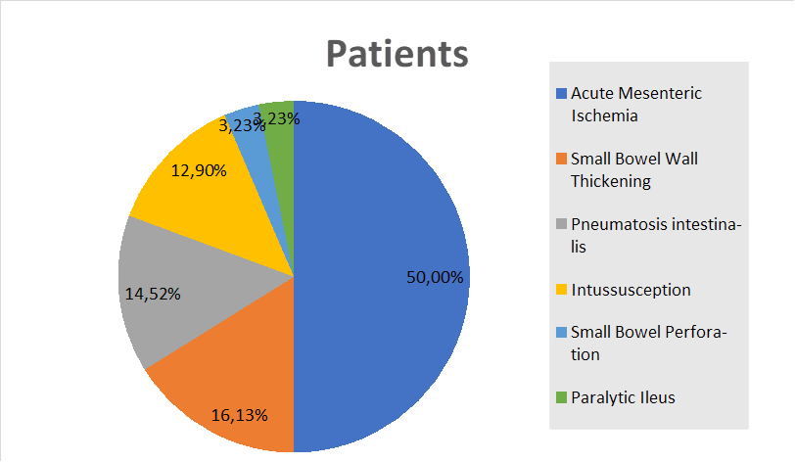
Figure 1 Proportions of radiologic small bowel manifestations reported since the beginning of the severe acute respiratory syndrome coronavirus 2 pandemic.
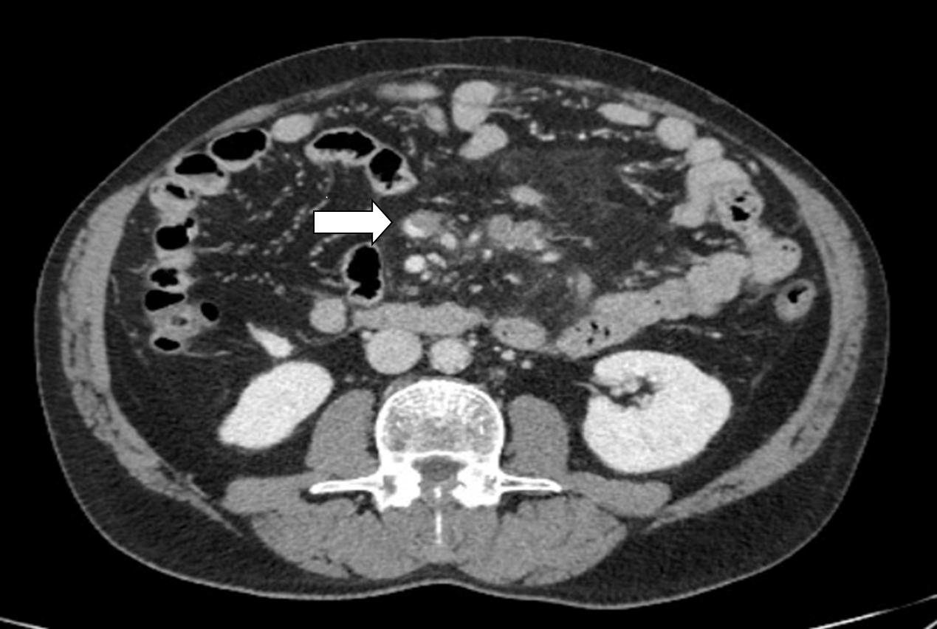\
Figure 2 Computed tomography image showing partial superior mesenteric vein thrombosis in a man with severe acute respiratory syndrome coronavirus 2 infection.
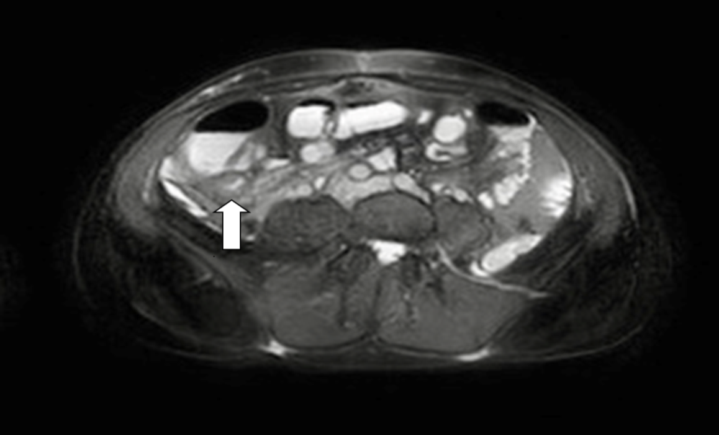
Figure 3 Magnetic resonance image showing distal ileum wall thickening in a young woman with severe acute respiratory syndrome coronavirus 2 infection.
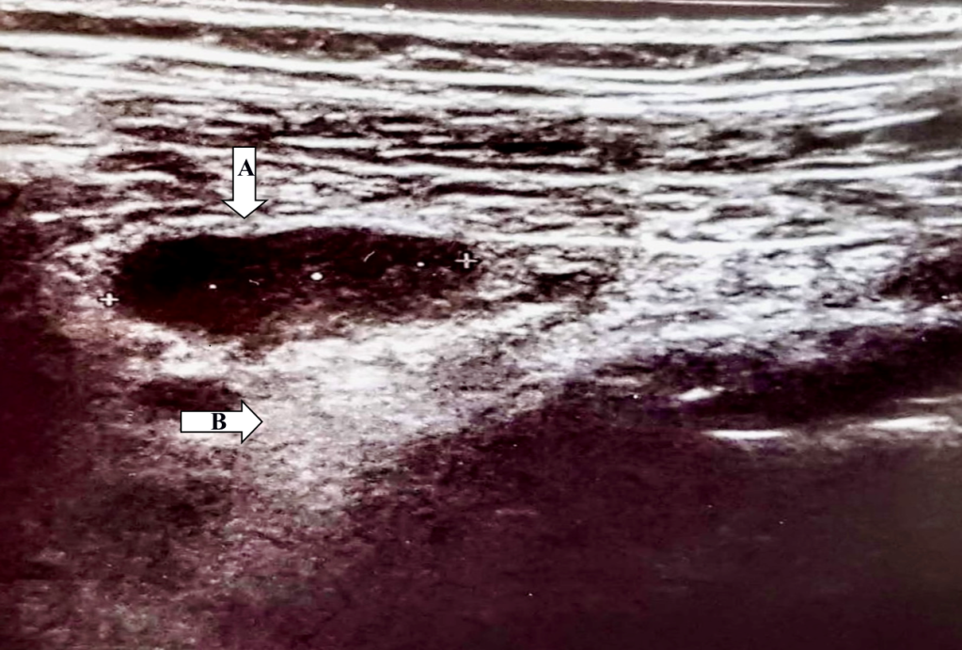
Figure 4 Abdominal ultrasound image in a 34-year-old woman with severe acute respiratory syndrome coronavirus 2 infection. Enlarged hypoechoic mesenteric lymph nodes, with a maximum longitudinal axis diameter of 17 mm (arrow, A) and hyperechoic mesenteric adipose tissue hypertrophy (arrow, B) are shown.
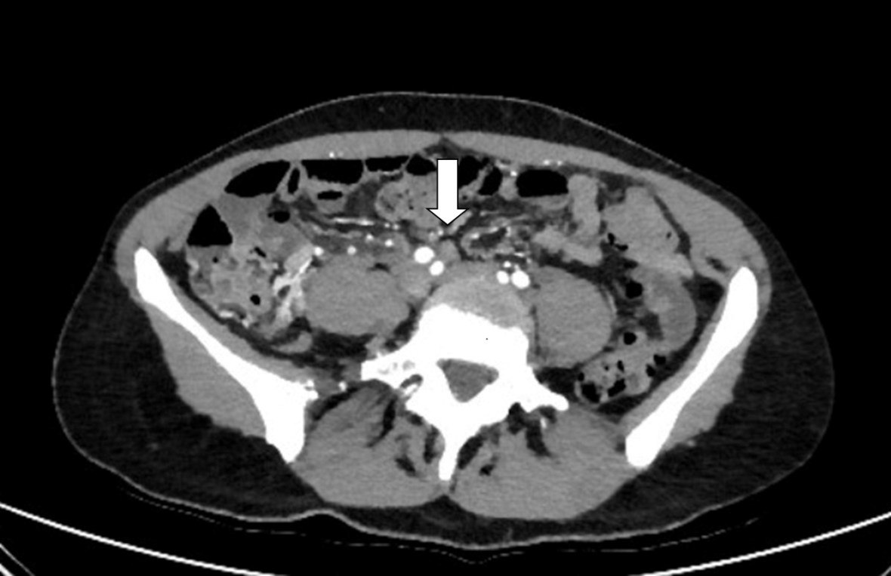
Figure 5 Abdominal computed tomography image showing multiple enlarged lymph nodes and mesenteric adipose tissue hypertrophy in a 34-year-old woman with severe acute respiratory syndrome coronavirus 2 infection.

Table 1 Clinical characteristics and radiological findings of acute mesenteric ischemia in coronavirus disease-2019 patients
Ref. | Patients, n | Age in yr | Gender | GI symptoms | Respiratory symptoms | Relevant laboratory test | Imaging modality | Radiological findings | Treatment | Outcome
de Barry et al^{[17]} | 1 | 79 | F | Abdominal pain, diarrhea | Yes | WBC 12.6 × 10⁹/L; CRP 125 mg/L | CT | Mesenteric ischemia; upper mesenteric vein and portal thrombosis; upper mesenteric artery and jejunal artery thrombosis | Laparotomy with segmental resection; thrombolysis and thrombectomy | Dead 4 d after surgery
Beccara et al^{[18]} | 1 | 52 | M | Abdominal pain, diarrhea, vomiting | Yes | WBC 30 × 10⁹/L; CRP 222 mg/L | CT | Mesenteric ischemia; upper mesenteric artery thrombosis | Laparotomy with segmental resection; anticoagulant; antiaggregant | NR
Ofosu et al^{[19]} | 1 | 55 | M | NR | Yes | WBC 9.5 × 10⁹/L; CRP 3 mg/L; D-dimer 440 ng/mL | CT | Mesenteric ischemia; portal vein thrombosis | Anticoagulant | Discharged
La Mura et al^{[20]} | 1 | 72 | M | NR | No | WBC 19.76 × 10⁹/L (n 81%); CRP 172.3 mg/L | CT | Mesenteric ischemia; portal vein thrombosis | Anticoagulant | Discharged
Del Hoyo et al^{[21]} | 1 | 61 | F | Abdominal pain, vomiting | No | CRP 9.43 mg/L; D-dimer 43.998 ng/mL | CT | Mesenteric ischemia; spleen-portal vein and hepatic vein thrombosis | Anticoagulant | Dead
Karna et al^{[22]} | 1 | 61 | F | Abdominal pain, distension | Yes | NR | CT | Mesenteric ischemia; upper mesenteric artery thrombosis | Laparotomy with segmental resection; anticoagulant; antiaggregant | Dead 36 h after surgery
Cheung et al^{[23]} | 1 | 55 | M | Abdominal pain, diarrhea, nausea | NR | NR | CT | Mesenteric ischemia; upper mesenteric artery thrombosis | NR | NR
de Roquetaillade et al^{[24]} | 1 | NR | NR | NR | NR | NR | CT | Mesenteric ischemia | NR | NR
Vartanoglu et al^{[25]} | 5 | NR | M | NR | Yes | WBC 8.67 × 10⁹/L (mean); CRP 970 mg/L (mean); D-dimer 447 ng/mL (mean); Fib 6245 mg/dL (mean) | NR | Mesenteric ischemia | NR | 1 patient dead
Fraissé et al^{[26]} | 3 | NR | NR | NR | NR | NR | NR | Mesenteric ischemia | NR | NR
Ignat et al^{[27]} | 1 | 28 | F | Abdominal pain, vomiting | No | NR | CT | Mesenteric ischemia; upper mesenteric vein and portal vein thrombosis | Laparotomy with segmental resection | NR
Pang et al^{[28]} | 1 | 30 | M | Abdominal pain, vomiting | No | D-dimer 20000 ng/mL; Fib 465 mg/dL | CT | Mesenteric ischemia; upper mesenteric vein thrombosis | Laparotomy with segmental resection; anticoagulant | Discharged
Bianco et al^{[29]} | 1 | 59 | M | Abdominal pain, nausea | Yes | NR | CT | Mesenteric ischemia; peritoneal free fluid | Laparotomy with segmental resection | Dead 4 d after surgery
Norsa et al^{[30]} | 3 | 79 | F | Abdominal pain | NR | D-dimer 8 × ULN | CT | Mesenteric ischemia | NR | NR
 |  | 62 | M | Abdominal pain, vomiting | NR | D-dimer 76 × ULN | CT | Mesenteric ischemia; upper mesenteric vein thrombosis | NR | Dead
 |  | 83 | F | Abdominal pain | NR | D-dimer 3 × ULN | CT | Mesenteric ischemia | NR | Dead
Collange et al^{[31]} | 1 | 56 | M | NR | NR | D-dimer 2260 ng/mL; Fib 113 mg/dL | CT | Mesenteric ischemia; mesenteric intravenous air | Laparotomy with segmental resection; anticoagulant | NR
Vulliamy et al^{[32]} | 1 | 75 | M | Abdominal pain, vomiting | Yes | WBC 18 × 10⁹/L; D-dimer 32000 ng/mL | CT | Mesenteric ischemia; embolic occlusion of upper mesenteric artery | Laparotomy with segmental resection; thrombectomy | NR
Rodriguez-Nakamura et al^{[33]} | 2 | 45 | M | Abdominal pain | Yes | WBC 16.6 × 10⁹/L (n 86%); CRP 367 mg/L; D-dimer 1450 ng/mL; Fib 579 mg/dL | CT | Mesenteric ischemia; upper mesenteric thrombosis | Laparotomy with segmental resection; anticoagulant | Discharged
 |  | 42 | F | Abdominal pain | Yes | WBC 18.8 × 10⁹/L (n 83.5%); CRP 239 mg/L; D-dimer 14.407 ng/mL; Fib 338 mg/dL | CT | Mesenteric ischemia; mesenteric veins and portal vein thrombosis | Laparotomy with segmental resection | Dead 48 h after surgery
E English et al^{[34]} | 1 | 40 | M | Abdominal distension | Yes | Fib 548 mg/dL | CT | Mesenteric ischemia | Laparotomy and laparoscopy with segmental resection | Dead 48 h after surgery
Helms et al^{[35]} | 1 | NR | NR | NR | NR | NR | CT | Mesenteric ischemia | NR | NR
Mitchell et al^{[36]} | 1 | 69 | M | Abdominal pain, constipation, eructation | NR | NR | CT | Mesenteric ischemia; upper mesenteric artery thrombosis | Laparotomy with segmental resection; thrombolysis and thrombectomy | Discharged
Azouz et al^{[37]} | 1 | 56 | M | Abdominal pain, vomiting | No | NR | CT | Mesenteric ischemia; upper mesenteric thrombosis | Laparotomy with segmental resection; anticoagulant | NR
Franco-Moreno et al^{[38]} | 1 | 27 | M | Abdominal pain | Yes | WBC 18 × 10⁹/L (n 85%); CRP 245 mg/L; D-dimer 9530 ng/mL; Fib > 500 mg/dL | CT | Mesenteric ischemia; portal vein thrombosis | Anticoagulant | Discharged
CRP: C-reactive protein; CT: Computed tomography; Fib: Fibrinogen; N: Neutrophil; NR: Not reported; RX: Radiography; US: Ultrasound; WBC: White blood cell.
Table 2 Other small bowel radiological findings in coronavirus disease-2019 patients and relevant clinical characteristics
Ref. | Patients, n | Age in yr | Gender | GI symptoms | Imaging modality | Radiological findings | Other relevant information
Hellinger et al^{[40]} | 1 | 64 | NR | Abdominal pain, nausea, vomiting, diarrhea, fever | CT | Small bowel thickening and hyperemia | -
Bhayana et al^{[12]} | 5 | 18-99 | NR | Abdominal pain, nausea, vomiting, diarrhea, fever | CT | Small bowel thickening | 100% of patients needed ICU
Goldberg-Stein et al^{[13]} | 2 | NR | NR | NR | CT | Small bowel thickening | -
Periyakaruppan et al^{[41]} | 1 | NR | M | Abdominal pain, diarrhea | CT | Small bowel thickening | Complete recovery after 2 d from I.V. immunoglobulin infusion
Guo et al^{[42]} | 1 | 29 | M | Diarrhea, fever | CT | Small bowel thickening | -
Bhayana et al^{[12]} | 4 | 18-99 | NR | Abdominal pain, nausea, vomiting, diarrhea, fever | CT | Pneumatosis intestinalis | 20% of patients needed ICU.  100% of patients underwent laparotomy
Tirumani et al^{[48]} | 1 | NR | NR | NR | CT | Pneumatosis intestinalis; portal venous gas | -
Kielty et al^{[49]} | 1 | 47 | M | Vomiting | CT | Pneumatosis intestinalis; peritoneal free fluid | The patient needed ICU. No need of surgery. Discharged
Di Grezia et al^{[50]} | 3 | NR | NR | NR | CT | Pneumatosis intestinalis | Needed surgical intervention with open abdomen and negative pressure therapy (no need of intestinal resection)
Makrinioti et al^{[54]} | 2 | 10-mo | F | Crying, vomiting, red currant jelly-like stool | US | Ileocolic intussusception | Dead
 |  | 10-mo | F | Bilious vomiting, red currant jelly-like stool | NR | Intussusception | Recovered after surgery
Rajalakshmi et al^{[55]} | 1 | 8-mo | M | Vomiting, blood-stained stools | US | Intussusception | Recovered after surgery
Moazzam et al^{[56]} | 1 | 4-mo | M | Abdominal pain | US | Intussusception with "doughnut sign" | Recovered after surgery
Bazuaye-Ekwuyasi et al^{[57]} | 1 | 9-mo | M | Abdominal pain, vomiting, decreased oral intake, and blood-streaked stool | RX | Intussusception with "target" sign | Recovered after surgery
 |  |  |  |  | US
Cai et al^{[58]} | 1 | 10-mo | F | Vomiting, currant jelly-like stool | US | Intussusception | Dead
Martínez-Castaño et al^{[59]} | 1 | 6-mo | M | Vomiting, abdominal cramps, currant jelly stools | US | Ileocolic intussusception | Discharged
Lu et al^{[60]} | 1 | 10-mo | NR | NR | NR | Intussusception | Dead
CT: Computer tomography; ICU: Intensive care unit; NR: Not reported; RX: Radiography; US: Ultrasound.

Published by Baishideng Publishing Group Inc
7041 Koll Center Parkway, Suite 160, Pleasanton, CA 94566, USA
Telephone: +1-925-3991568
E-mail: bpgoffice@wjgnet.com
Help Desk: https://www.f6publishing.com/helpdesk
https://www.wjgnet.com

© 2021 Baishideng Publishing Group Inc. All rights reserved.

