Name of Journal: World Journal of Clinical Cases
Manuscript NO: 70075
Manuscript Type: CASE REPORT

Posthepatectomy jaundice induced by paroxysmal nocturnal hemoglobinuria: A case report

Liang HY et al. Posthepatectomy jaundice induced by PNH

Hong-Yin Liang, Xiao-Dong Xie, Guang-Xu Jing, Meng Wang, Yang Yu, Jian-Feng Cui

Hong-Yin Liang, Xiao-Dong Xie, Jian-Feng Cui, Department of General Surgery, General Hospital of Western Theater Command, Chengdu 410000, Sichuan Province, China

Guang-Xu Jing, The Southwest Medical University, Luzhou 410000, Sichuan Province, China

Meng Wang, Department of Traditional Chinese Medicine, General Hospital of Western Theater Command, Chengdu 410000, Sichuan Province, China

Yang Yu, Department of Medical Examination, General Hospital of Western Theater Command, Chengdu 410000, Sichuan Province, China

Author contributions: Liang HY wrote the manuscript; Xie XD, Wang M, and Yu Y collected the data and drew the diagram; Jiang GX contributed to citations and references; Cui JF contributed to the discussion and revision; all authors issued final approval for the version to be submitted.

Corresponding author: Jian-Feng Cui, MD, Professor, Department of General Surgery, General Hospital of Western Theater Command, No. 260 Rongdu Avenue, Jinniu District, Chengdu 410000, Sichuan Province, China. cjfabear@126.com

Received: August 12, 2021
Revised: September 8, 2021
Accepted: September 22, 2021
Published online: November 16, 2021

Abstract
BACKGROUND
Jaundice is a major manifestation of posthepatectomy liver failure, a feared complication after hepatic resection. Herein, we report a case of posthepatectomy jaundice that was not caused by liver failure but by paroxysmal nocturnal hemoglobinuria (PNH)-induced hemolysis.

CASE SUMMARY
A 56-year-old woman underwent right hepatectomy and biliary tract exploration surgery due to hepatic duct stones. Prior to surgery, the patient was mildly anemic. The direct antiglobulin test was negative. A bone marrow biopsy showed mild histiocyte hyperplasia. After surgery, the patient suffered a progressive increase in serum bilirubin. Meanwhile, the patient developed hemolytic symptoms after blood transfusion. She was ultimately diagnosed with PNH. PNH is a rare bone marrow failure disorder that manifests as complement-dependent intravascular hemolysis with varying severity. After steroid treatment, the patient’s jaundice gradually decreased, and the patient was discharged on the 35th postoperative day.

CONCLUSION
PNH-induced hemolysis is a rare cause of posthepatectomy jaundice. It should be suspected in patients having posthepatectomy hyperbilirubinemia without other signs of liver failure. Steroid therapy can be considered for the treatment of PNH in such cases.

Key Words: Jaundice; Hepatectomy; Paroxysmal nocturnal hemoglobinuria; Case report

©The Author(s) 2021. Published by Baishideng Publishing Group Inc. All rights reserved.

Citation: Liang HY, Xie XD, Jing GX, Wang M, Yu Y, Cui JF. Posthepatectomy jaundice induced by paroxysmal nocturnal hemoglobinuria: a case report. World J Clin Cases 2021; 9(32): 10046-10051
URL: https://www.wjgnet.com/2307-8960/full/v9/i32/10046.htm
DOI: https://dx.doi.org/10.12998/wjcc.v9.i32.10046

Core Tip: We report a case of posthepatectomy jaundice that was not caused by liver failure but by paroxysmal nocturnal hemoglobinuria-induced hemolysis. After confirming the diagnosis, the patient received steroid therapy, and the jaundice gradually improved.

INTRODUCTION
Although the safety of liver resection has improved with advanced operative techniques and perioperative management, posthepatectomy liver failure (PHLF) remains a challenge for patients undergoing hepatectomy and a concern of hepatic surgeons^{[1]}. Postoperative hyperbilirubinemia and an increased international normalized ratio (INR) are the major manifestations of PHLF according to the definition of the International Study Group of Liver Surgery^{[2]}. Herein, we report a case of posthepatectomy jaundice that was not caused by PHLF but by paroxysmal nocturnal hemoglobinuria (PNH)-induced hemolysis. There have been no previous reports of posthepatectomy jaundice caused by PNH.

CASE PRESENTATION
Chief complaints
The subject was a 56-year-old female with a chief complaint of abdominal pain and fever.

History of present illness
Ten days before admission, the patient visited a local hospital for acute right upper quadrant abdominal pain. The pain was moderate, tolerable, and persistent. Additionally, the patient suffered from fever, with a temperature of up to 39 degrees Celsius. She did not complain of vomiting or diarrhea. An abdominal ultrasound revealed bile duct stones. After cefoperazone anti-infection treatment, the patient’s symptoms were relieved, and the patient was transferred to our hospital.

History of past illness
The patient had undergone cholecystectomy for gallbladder stones 20 years prior to presentation at our hospital.

Personal and family history
The patient had a previous history of mild anemia and did not have a remarkable family medical history.

Physical examination
On physical examination, the patient was conscious and cooperative. The abdominal region was flat and soft.

Laboratory examinations
The patient’s preoperative laboratory examinations were only mildly abnormal: Hemoglobin (Hgb) 91 g/L, white blood cell count, 9800/μL; platelet count, 107 × 10⁹/L; total bilirubin (TBIL), 58.6 µmol/L; direct bilirubin (DBIL), 35.3 µmol/L; aspartate aminotransferase (AST), 33.5 U/L; albumin, 38.7 g/L; C-reactive protein, 32.4 mg/dL; prothrombin time, 10.8 s; INR, 0.98; indocyanine green retention rate at 15 min, 5.5%. The result of direct antiglobulin test was negative, and bone marrow biopsy showed mild histiocyte hyperplasia.

Imaging examinations
Magnetic resonance imaging revealed right intrahepatic bile duct stones and common bile duct stones (Figure 1). The future liver remnant was 49%.

FINAL DIAGNOSIS
The patient was diagnosed with hepatolithiasis and choledocholithiasis. After surgery, she was diagnosed to have PNH induced hemolysis causing postoperative jaundice.

TREATMENT
Open surgery was performed after the preoperative examinations were completed. Intraoperative ultrasonography reconfirmed that the right intrahepatic bile duct was extensively dilated with stones. The common bile duct was approximately 1.4 cm. Eventually, right hepatectomy and biliary tract exploration with intraoperative choledochoscopic lithotripsy, without hepaticojejunostomy, were conducted. The operation proceeded successfully without a requirement for blood transfusion. The operating time was 250 min, and the estimated blood loss was less than 100 mL.
An artificial liver support system was required on the 8th and 11th postoperative days due to hyperbilirubinemia. The patient received a blood transfusion (erythrocyte suspensions, 3 U; and plasma, 400 mL) because of a decrease in Hgb to 65 g/L on the 12th postoperative day.
The patient was treated with steroids after the diagnosis of postoperative jaundice caused by PNH induced hemolysis was made. The treatment protocol is shown in Figure 2. On postoperative day 14, the patient started steroid treatment with methylprednisolone at a dose of 2.0 mg/kg/d. The patient's jaundice gradually stabilized. The dose of methylprednisolone was reduced to 1.5 mg/kg/d after 1 wk, 1.0 mg/kg/d after 2 wk, 0.75 mg/kg/d after 3 wk, and 0.5 mg/kg/d after 4 wk. The dose of 0.5 mg/kg/d was maintained for 4 wk, and 0.25 mg/kg/d was maintained for an additional 4 wk.

OUTCOME AND FOLLOW-UP
After surgery, the patient suffered a progressive increase in serum bilirubin (Figure 3A). Paradoxically, the AST and INR were mildly elevated postoperatively and declined gradually (Figure 3B). Postoperative ultrasound did not reveal intra- or extrahepatic bile duct dilatation. These results did not resemble the typical presentation of PHLF. During this time, the patient presented with low back pain and hemoglobinuria after the blood transfusion. Hemolytic screening was subsequently implemented. The direct antiglobulin test was repeated, and the result was still negative. The serum-free Hgb was elevated to 117 mg/L. The results of the glucose-6-phosphate dehydrogenase test and erythrocyte osmotic fragility test were negative. The flow cytometry analysis showed that CD59 was absent on the 27% of erythrocytes surface. Flow cytometry to detect populations of CD55 or CD59 deficient blood cells is firmly established as the method of choice for the diagnosis and monitoring of PNH. Thus, this patient's postoperative hyperbilirubinemia was confirmed to be caused by PNH-induced hemolysis.
The patient's jaundice gradually improved after steroid treatment (Figure 4). The patient was discharged on the 35th postoperative day. At discharge, the TBIL of the patient had decreased to 198.3 µmol/L. When followed up at 6 mo after surgery, the patient's Hgb was 85 g/L, and TBIL was 48.3 µmol/L.

DISCUSSION
PNH is a rare and acquired hematopoietic stem cell disorder that is characterized by the destruction of blood cells via the complement system due to a deficiency of glycosylphosphatidylinositol-anchored proteins (GPI-APs), such as CD55 and CD59, on the blood cell surface, resulting in symptoms such as hemoglobinuria^{[3]}. For the diagnosis of PNH, flow cytometry is recommended to identify a deficiency of GPI-APs in peripheral blood cells^{[4,5]}. In this patient, CD59 absence on the surface of 27% of erythrocytes was an important factor in the diagnosis of PHN. In terms of treatment, complement inhibition therapy in the form of eculizumab has improved treatment prospects for PNH patients in developed countries^{[6,7]}. However, high costs and access difficulties have limited the utilization of eculizumab in China, and steroid therapy is still the preferred treatment to control hemolytic attacks in PNH patients^{[8]}. In this case, the patient's hyperbilirubinemia was relieved after the administration of methylprednisolone, and the treatment achieved relatively favorable outcomes.
There were several points that deserve our attention in this case.
First, the severity of hemolysis varies in PNH patients. There are some PNH patients with insidious onset that have no characteristic manifestations^{[9]}. This patient only presented with mild anemia and elevated bilirubin preoperatively, which is also common in patients with bile duct stones. Moreover, the preoperative bone marrow biopsy showed no significant abnormalities. The patient was not diagnosed with PNH until hemolytic symptoms developed after blood transfusion.
Second, in this patient, it is possible that transfusion of plasma, rather than erythrocyte suspension, aggravated the patient’s hemolysis. PNH may induce complement-dependent intravascular hemolysis^{[10]}. Plasma transfusion might replenish the depleted complement, thus exacerbating the occurrence of hemolysis in PNH erythrocytes. Although the use of washed red blood cells for transfusion in PNH patients has been recommended previously, recent studies have found that transfusion of homozygous red blood cells does not significantly increase the occurrence of hemolysis in PNH patients^{[11]}.
Third, it has been reported that chronic hemolysis may lead to increased bilirubin excretion, resulting in an increased incidence of hepatobiliary stones^{[12]}. Therefore, theoretically, PNH patients have a higher chance of hepatobiliary stones. There have been reports of cholecystectomy in patients with PNH^{[13]}, but there have been no reports of hepatectomy in patients with PNH. Surgery may be one of the clinical conditions that triggers PNH-induced hemolysis^{[14]}. Perisurgical induction of eculizumab has been reported in a patient with PNH to inhibit surgery-triggered hemolysis^{[13,15]}.
Last, the jaundice caused by hemolysis typically features elevated indirect bilirubin (IBIL)^{[16]}. However, the postoperative DBIL elevation was more significant in this patient. The liver is the main metabolic site for bilirubin. The IBIL produced by hemolysis is transported to hepatocytes and combined with glucuronide to form DBIL, which is subsequently excreted into the bile ducts^{[17]}. Right hemicolectomy may lead to a reduction in liver size and a decrease in the liver’s ability to metabolize and excrete bilirubin. In the event of increased IBIL production from hemolysis, it is possible that the residual hepatic capacity to metabolize DBIL is greater than the hepatic capacity to excrete DBIL. This has not been reported in previous reports and may need to be validated in further animal experiments.

CONCLUSION
PNH-induced hemolysis is a rare cause of posthepatectomy jaundice. It should be suspected in patients having posthepatectomy hyperbilirubinemia without other signs of liver failure. Steroid therapy can be considered for the treatment of PNH in such cases.

REFERENCES
1 Søreide JA, Deshpande R. Post hepatectomy liver failure (PHLF) - Recent advances in prevention and clinical management. Eur J Surg Oncol 2021; 47: 216-224 [PMID: 32943278 DOI: 10.1016/j.ejso.2020.09.001]
2 Rahbari NN, Garden OJ, Padbury R, Brooke-Smith M, Crawford M, Adam R, Koch M, Makuuchi M, Dematteo RP, Christophi C, Banting S, Usatoff V, Nagino M, Maddern G, Hugh TJ, Vauthey JN, Greig P, Rees M, Yokoyama Y, Fan ST, Nimura Y, Figueras J, Capussotti L, Büchler MW, Weitz J. Posthepatectomy liver failure: a definition and grading by the International Study Group of Liver Surgery (ISGLS). Surgery 2011; 149: 713-724 [PMID: 21236455 DOI: 10.1016/j.surg.2010.10.001]
3 Devalet B, Mullier F, Chatelain B, Dogné JM, Chatelain C. Pathophysiology, diagnosis, and treatment of paroxysmal nocturnal hemoglobinuria: a review. Eur J Haematol 2015; 95: 190-198 [PMID: 25753400 DOI: 10.1111/ejh.12543]
4 Parker C, Omine M, Richards S, Nishimura J, Bessler M, Ware R, Hillmen P, Luzzatto L, Young N, Kinoshita T, Rosse W, Socié G; International PNH Interest Group. Diagnosis and management of paroxysmal nocturnal hemoglobinuria. Blood 2005; 106: 3699-3709 [PMID: 16051736 DOI: 10.1182/blood-2005-04-1717]
5 Parker CJ. Update on the diagnosis and management of paroxysmal nocturnal hemoglobinuria. Hematology Am Soc Hematol Educ Program 2016; 2016: 208-216 [PMID: 27913482 DOI: 10.1182/asheducation-2016.1.208]
6 Hillmen P, Young NS, Schubert J, Brodsky RA, Socié G, Muus P, Röth A, Szer J, Elebute MO, Nakamura R, Browne P, Risitano AM, Hill A, Schrezenmeier H, Fu CL, Maciejewski J, Rollins SA, Mojcik CF, Rother RP, Luzzatto L. The complement inhibitor eculizumab in paroxysmal nocturnal hemoglobinuria. N Engl J Med 2006; 355: 1233-1243 [PMID: 16990386 DOI: 10.1056/NEJMoa061648]
7 Loschi M, Porcher R, Barraco F, Terriou L, Mohty M, de Guibert S, Mahe B, Lemal R, Dumas PY, Etienne G, Jardin F, Royer B, Bordessoule D, Rohrlich PS, Fornecker LM, Salanoubat C, Maury S, Cahn JY, Vincent L, Sene T, Rigaudeau S, Nguyen S, Lepretre AC, Mary JY, Corront B, Socie G, Peffault de Latour R. Impact of eculizumab treatment on paroxysmal nocturnal hemoglobinuria: a treatment vs no-treatment study. Am J Hematol 2016; 91: 366-370 [PMID: 26689746 DOI: 10.1002/ajh.24278]
8 Fu R, Li L, Li L, Liu H, Zhang T, Ding S, Wang G, Song J, Wang H, Xing L, Guan J, Shao Z. Analysis of clinical characteristics of 92 patients with paroxysmal nocturnal hemoglobinuria: A single institution experience in China. J Clin Lab Anal 2020; 34: e23008 [PMID: 31502726 DOI: 10.1002/jcla.23008]
9 Brodsky RA. Paroxysmal nocturnal hemoglobinuria. Blood 2014; 124: 2804-2811 [PMID: 25237200 DOI: 10.1182/blood-2014-02-522128]
10 Merrill SA, Brodsky RA. Complement-driven anemia: more than just paroxysmal nocturnal hemoglobinuria. Hematology Am Soc Hematol Educ Program 2018; 2018: 371-376 [PMID: 30504334 DOI: 10.1182/asheducation-2018.1.371]
11 Brecher ME, Taswell HF. Paroxysmal nocturnal hemoglobinuria and the transfusion of washed red cells. A myth revisited. Transfusion 1989; 29: 681-685 [PMID: 2799892 DOI: 10.1046/j.1537-2995.1989.29890020439.x]
12 Ebert EC, Nagar M, Hagspiel KD. Gastrointestinal and hepatic complications of sickle cell disease. Clin Gastroenterol Hepatol 2010; 8: 483-9; quiz e70 [PMID: 20215064 DOI: 10.1016/j.cgh.2010.02.016]
13 Ando K, Gotoh A, Yoshizawa S, Gotoh M, Iwabuchi T, Ito Y, Ohyashiki K. Successful cholecystectomy in a patient with aplastic anemia-paroxysmal nocturnal hemoglobinuria during eculizumab treatment. Ann Hematol 2012; 91: 1987-1988 [PMID: 22739575 DOI: 10.1007/s00277-012-1514-2]
14 Kurita N, Obara N, Fukuda K, Nishikii H, Sato S, Inagawa S, Kurokawa T, Owada Y, Ninomiya H, Chiba S. Perisurgical induction of eculizumab in a patient with paroxysmal nocturnal hemoglobinuria: its inhibition of surgery-triggered hemolysis and the consequence of subsequent discontinuation. Blood Coagul Fibrinolysis 2013; 24: 658-662 [PMID: 23917586 DOI: 10.1097/MBC.0b013e328360d057]
15 Parker CJ. Management of paroxysmal nocturnal hemoglobinuria in the era of complement inhibitory therapy. Hematology Am Soc Hematol Educ Program 2011; 2011: 21-29 [PMID: 22160008 DOI: 10.1182/asheducation-2011.1.21]
16 Rifkind JM, Nagababu E. Hemoglobin redox reactions and red blood cell aging. Antioxid Redox Signal 2013; 18: 2274-2283 [PMID: 23025272 DOI: 10.1089/ars.2012.4867]
17 Kosmachevskaya OV, Topunov AF. Alternate and Additional Functions of Erythrocyte Hemoglobin. Biochemistry (Mosc) 2018; 83: 1575-1593 [PMID: 30878032 DOI: 10.1134/S0006297918120155]

Footnotes
Informed consent statement: Informed written consent was obtained from the patient for publication of this report and any accompanying images.

Conflict-of-interest statement: The authors declare that they have no conflict of interest.

CARE Checklist (2016) statement: The authors have read the CARE Checklist (2016), and the manuscript was prepared and revised according to the CARE Checklist (2016).

Open-Access: This article is an open-access article that was selected by an in-house editor and fully peer-reviewed by external reviewers. It is distributed in accordance with the Creative Commons Attribution NonCommercial (CC BY-NC 4.0) license, which permits others to distribute, remix, adapt, build upon this work non-commercially, and license their derivative works on different terms, provided the original work is properly cited and the use is non-commercial. See: http://creativecommons.org/Licenses/by-nc/4.0/

Manuscript source: Unsolicited manuscript

Peer-review started: August 12, 2021
First decision: September 2, 2021
Article in press: September 22, 2021

Specialty type: Surgery
Country/Territory of origin: China
Peer-review report’s scientific quality classification
Grade A (Excellent): 0
Grade B (Very good): 0
Grade C (Good): C
Grade D (Fair): 0
Grade E (Poor): 0

P-Reviewer: Kamiyama T S-Editor: Wang JL L-Editor: A P-Editor: Li JH

Figure Legends
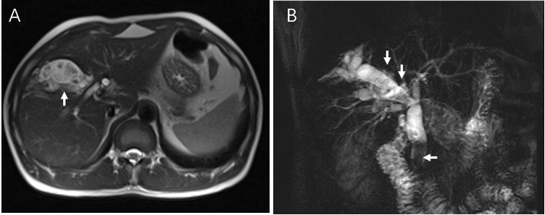
Figure 1 Preoperative magnetic resonance imaging of the patient. A: Cross-section; B: Magnetic resonance cholangiopancreatography. The right intrahepatic bile duct stones and common bile duct stones are presented (arrows).

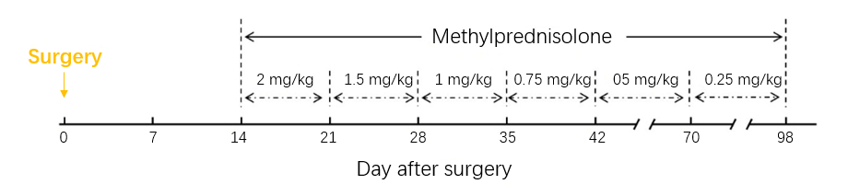
Figure 2 The steroid treatment protocol of the patient during hospitalization.

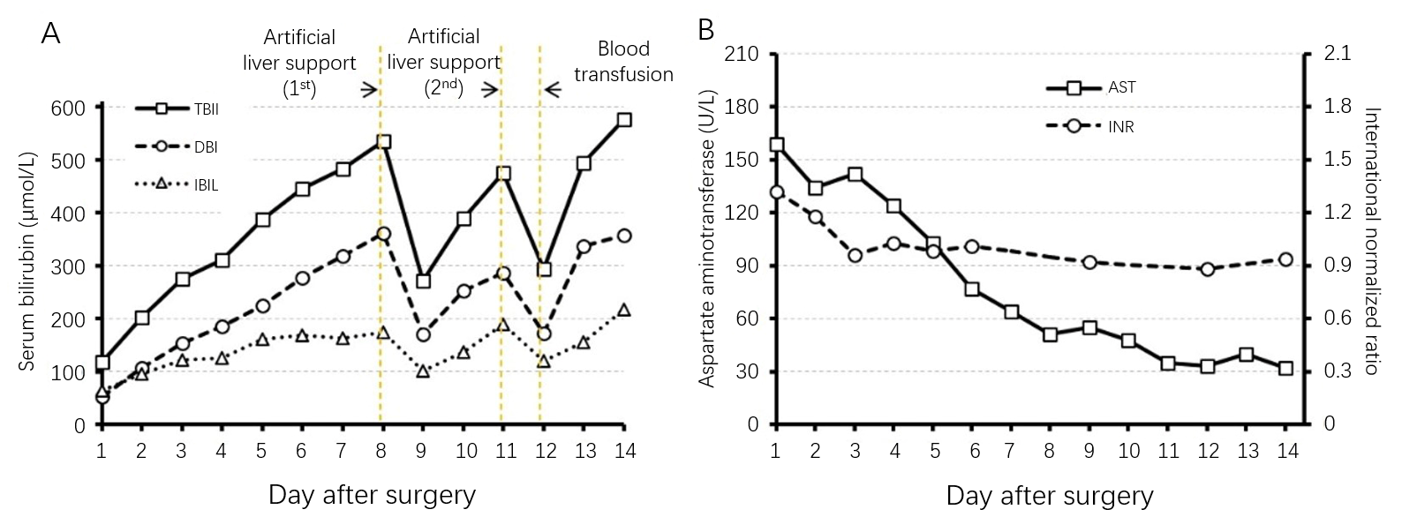
Figure 3 Hematological indices of the patient during the first 14 postoperative days. A: Serum bilirubin; B: Aspartate aminotransferase and international normalized ratio. TBIL: Total bilirubin; DBIL: Direct bilirubin; IBIL: Indirect bilirubin; AST: Aspartate aminotransferase; and INR: International normalized ratio.
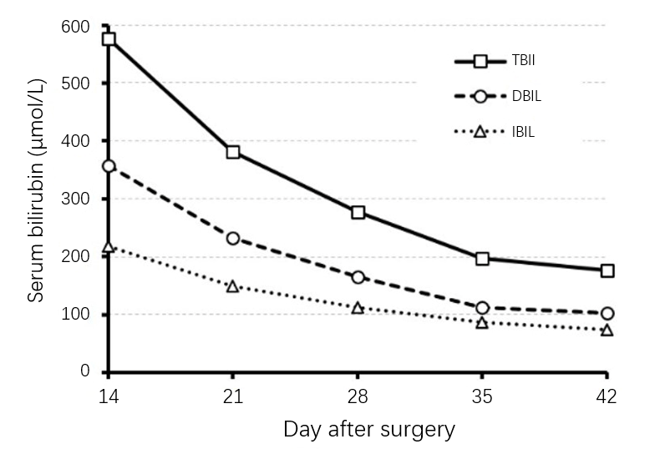
Figure 4 Serum bilirubin of the patient on postoperative days 14 to 42. TBIL: Total bilirubin; DBIL: Direct bilirubin; IBIL: Indirect bilirubin.

Published by Baishideng Publishing Group Inc
7041 Koll Center Parkway, Suite 160, Pleasanton, CA 94566, USA
Telephone: +1-925-3991568
E-mail: bpgoffice@wjgnet.com
Help Desk: https://www.f6publishing.com/helpdesk
https://www.wjgnet.com

© 2021 Baishideng Publishing Group Inc. All rights reserved.

