Name of journal: World Journal of Gastrointestinal Oncology
ESPS Manuscript NO: 9706
Columns: Case Report

Colonic adenocarcinoma, mucosa associated lymphoid tissue lymphoma and tuberculosis in a segment of colon: A case report

Kulandai Velu AR et al. Synchronous colonic carcinoma, lymphoma and tuberculosis

Ambedkar Raj Kulandai Velu, Banushree C Srinivasamurthy, Krishnan Nagarajan, Ilavarasi Sinduja

Ambedkar Raj Kulandai Velu, Banushree C Srinivasamurthy, Department of Pathology, Sri Manakula Vinayagar Medical College, Bhubaneswar 751019, India

Krishnan Nagarajan, Ilavarasi Sinduja, Department of Radiology, Sri Manakula Vinayagar Medical College, Bhubaneswar 751019, Odisha, India

Author contributions: Kulandai Velu AR collected clinical data and gave pathology opinion; Srinivasamurthy BC gave pathology opinion, designed the manuscript; Nagarajan K and Sinduja I gave radiological diagnosis; Nagarajan K did critical editing as well.

Correspondence to: Dr. Banushree C Srinivasamurthy, Assistant Professor, Department of Pathology, Sri Manakula Vinayagar Medical College, Madagadipet, Bhubaneswar 751019, India. drbanushree15@hotmail.com

Telephone: +91-674-2473313 Fax: +91-674-2473313

Received: February 24, 2014 Revised: May 11, 2014
Accepted: July 18, 2014

Published online:

Abstract
Synchronous occurrence of adenocarcinoma and mucosa associated lymphoid tissue (MALT) lymphoma of colon is rare, with coexisting tuberculosis is still rare. To our knowledge, this may be the first case report. In the present report, we describe a 43-year-old female who presented with a history of pain abdomen, fever, loss of weight and loss of apetite. Colonoscopy showed a large ulceroproliferative mass arising from the caecum, biopsy of which came out to be adenocarcinoma of colon. A right hemicolectomy was performed and microscopic study of colon revealed tuberculosis and synchronous adenocarcinoma with lymphoma. Eight of sixteen lymph node showed tuberculosis and three of sixteen pericolonic lymph node showed metastatic deposits. Immunostains further confirmed the tumour to be adenocarcinoma with MALT lymphoma. We would like to highlight the diagnostic challenges arising from the multi-faceted presentations of these three conditions.

© 2014 Baishideng Publishing Group Inc. All rights reserved.

Key words: Adenocarcinoma; Mucosa associated lymphoid tissue lymphoma; Tuberculosis

Core tip: We report a first case report of synchronous adenocarcinoma, mucosa associated lymphoid tissue (MALT) lymphoma and tuberculosis in the same segment of colon in 43-year-old immunocompetent female patient. There are around 4 case reports of sychronous adenocarcinoma and MALT lymphoma till date in literature. What we describe is first such a case in literature.

Kulandai Velu AR, Srinivasamurthy BC, Nagarajan K, Sinduja I. Colonic adenocarcinoma, mucosa associated lymphoid tissue lymphoma and tuberculosis in a segment of colon: A case report. World J Gastrointest Oncol 2014; In press

INTRODUCTION
Mucosa-associated lymphoid tissue (MALT) tumors are a distinct subtype of non-Hodgkin’s lymphoma associated with predisposing infectious or autoimmune process, resulting in chronic lymphoid proliferation. Though stomach is the most common site, MALT tumor has been reported in non-gastric sites like salivary gland, lung, ocular adnexa and skin^{[1]}. The colon is a rare location for MALT lymphoma^{[2]}. Synchronous colonic adenocarcinoma and malignant lymphoma in the same patient is rare with an estimated incidence of around 0.0002%^{[3]}. Only few cases have been reported in literature. Adenocarcinoma and tuberculosis occurring at the same site is exceedingly rare. Chronic inflammatory mucosal damage initiating a sequence of metaplasia and dysplasia could result in neoplastic change^{[4]}. We describe a case report never reported in literature, sychronous adenocarcinoma and lymphoma with tuberculosis of colon which pose a diagnostic and therapeutic challenges patient can present with equivocal symptoms.

CASE REPORT
A 43-year-old female referred with history of pain abdomen, fever, loss of weight and loss of appetite for 6 mo. Hematological investigations showed normocytic normochromic anemia with a raised ESR. Chest roentgenogram was normal. Human immunodeficiency virus antibodies were negative. Colonoscopy revealed ulcero-proliferative mass arising from caecum. Ultrasonography revealed thickened caecal wall with mesenteric lymphadenopathy. A biopsy diagnosed it as adenocarcinoma. A right hemicolectomy was performed. The gross pathological examination of the lesion showed a 4 cm × 3.5 cm × 3 cm ulcero-proliferative tumor present on the mucosal surface. Entire mucosal surface appeared normal without any abnormality or polypoidal lesion. Sixteen pericolic lymph nodes varying in size from 0.5 to 3 cm were isolated from pericolic fat. Sections from ulcero-proliferative growth revealed extensive mucosal necrosis with ill defined granuloma, langhans giant cells (Figure 1) and moderately differentiated adenocarcinoma that extended through the muscularis propria into the subserosal adipose tissue (Figure 2A). Dense lymphocytic infiltration was seen in submucosa. These lymphoid cells were small to medium sized cells with mildly irregular nuclear contour and moderate pale cytoplasm (Figure 2B). Thus, microscopic study revealed tuberculosis with tumor and the tumor type to be synchronous adenocarcinoma with lymphoma. The adenocarcinoma component was moderately differentiated while the lymphoma component was of low grade MALT lymphoma. The surgical cut margins were free of tumor. Eight of sixteen lymph node showed features of tuberculosis with acid fast bacilli in two of the lymph node and three of sixteen pericolonic lymph node showed metastatic deposits (Figure 3B). Tissue section from mucosa did not reveal acid fast bacilli. Immunohistochemical analysis was performed on representative sections from the colon and lymph node to characterize the lymphoid cells and to confirm adenocarcinoma.CD 20(Dako preparation) was diffusely positive (Figure 4A) and CD5 was negative in neoplastic lymphocytes. Cytokeratin and Epithelial membrane antigen (Figures 3A and4B) was positive in sections from colon, pericolonic tumor and metastatic deposits in lymph nodes.
After surgery, patient was put on anti-tubercular treatment. No other adjuvant therapy was started as patient was not willing and patient is alive and well after 6 mo post-operatively.

DISCUSSION
Our case, to the best of our knowledge, first ever reported case of synchronous adenocarcinoma and lymphoma with tuberculosis. Association of TB and malignancy have been noted by several authors in different organs^{[4]}. Some authors have proposed that the association of carcinoma and tuberculosis is coincidental^{[5]}. In our case both has occurred at the same segment of colon and its justified to think that inflammatory condition has facilitated malignancy and impaired immune mechanism has further facilitated the development of second malignancy. In 1987, Tanaka et al^{[6]} analysed 26 TB and adenocarcinoma cases reported in Japan and supported the possibility of cancer originating from a tuberculous lesion. Chronic inflammatory mucosal damage initiating a sequence of metaplasia and dysplasia may result in neoplastic change. On the other hand impaired host immune response due to malignancy would have reactivated the dormant tubercular lesion. However, it is still a matter of debate and further research is required to determine if a tuberculous infection, being similar to other chronic infections and inflammatory conditions, may facilitate carcinogenesis or the malignancy which reactivates the infection^{[7]}. Devi et al^{[8,9]} has first reported a case of synchronous adenocarcinoma and MALT lymphoma in a same segment of colon followed by series of three cases by Argyropoulos in 2012. Occurrence of secondary MALT-type lymphoma in a patient with prior colon adenocarcinoma after colectomy has been reported in literature^{[10]}. It is extremely difficult to diagnose synchronous tumour in the same segment. In our case, a dense lymphocytic infiltrate noted in the vicinity of adenocarcinoma alerted us to thoroughly sample the specimen and to assess the immunophenotype by immunohistochemistry which was of great help in confirming the diagnosis.

COMMENTS
Case characteristics
A 43-year-old female referred with history of pain abdomen, fever, loss of weight and loss of appetite for 6 mo.

Clinical diagnosis
Colonoscopy revealed ulcero-proliferative mass arising from caecum.

Differential diagnosis
Tuberculosis, adenocarcinoma of colon.

Laboratory diagnosis
Normocytic Normochromic Anaemia, raised ESR, human immunodeficiency virus antibodies negative.

Imaging diagnosis
Ultrasonography revealed thickened caecal wall and mesentric lymphadenopathy.

Pathological diagnosis
Synchronous adenocarcinoma, mucosa associated lymphoid tissue lymphoma and Tuberculosis of a segment of colon.

Treatment
Right hemicolectomy.

Related reports
On immunohistochemical stain, CD20, Cytokeratin and EMA were positive.

Experiences and lessons
Impaired host immune response due to malignancy can reactivate the dormant tubercular lesion. It is extremely difficult to diagnose synchronous tumour in the same segment. In this case, a dense lymphocytic infiltrate noted in the vicinity of adenocarcinoma alerted the authors to thoroughly sample the specimen and to assess the immunophenotype by immunohistochemistry which was of great help in confirming the diagnosis.

Peer review
This paper is the first report of synchronous adenocarcinoma and lymphoma with tuberculosis. This is an interesting case report.

REFERENCES
1 Zucca E, Conconi A, Pedrinis E, Cortelazzo S, Motta T, Gospodarowicz MK, Patterson BJ, Ferreri AJ, Ponzoni M, Devizzi L, Giardini R, Pinotti G, Capella C, Zinzani PL, Pileri S, López-Guillermo A, Campo E, Ambrosetti A, Baldini L, Cavalli F. Nongastric marginal zone B-cell lymphoma of mucosa-associated lymphoid tissue. Blood 2003; 101: 2489-2495 [PMID: 12456507]
2 Doolabh N, Anthony T, Simmang C, Bieligk S, Lee E, Huber P, Hughes R, Turnage R. Primary colonic lymphoma. J Surg Oncol 2000; 74: 257-262 [PMID: 10962456 DOI: 10.1002/1096-9098(200008)]
3 Barron BA, Localio SA. A statistical note on the association of colorectal cancer and lymphoma. Am J Epidemiol 1976; 104: 517-522 [PMID: 984025]
4 Chakravartty S, Chattopadhyay G, Ray D, Choudhury CR, Mandal S. Concomitant tuberculosis and carcinoma colon: coincidence or causal nexus? Saudi J Gastroenterol 2010; 16: 292-294 [PMID: 20871197 DOI: 10.4103/1319-3767.70619]
5 Jain BK, Chandra SS, Narasimhan R, Ananthakrishnan N, Mehta RB. Coexisting tuberculosis and carcinoma of the colon. Aust N Z J Surg 1991; 61: 828-831 [PMID: 1661111]
6 Tanaka K, Kondo S, Hattori F, Yamashita Y, Matsuda M, Itoh K, Okada Y, Kojima K, Nakagami K, Suzuki H. [A case of colonic carcinoma associated with intestinal tuberculosis, and an analysis of 26 cases reported in Japan]. Gan No Rinsho 1987; 33: 1117-1123 [PMID: 3626040]
7 Falagas ME, Kouranos VD, Athanassa Z, Kopterides P. Tuberculosis and malignancy. QJM 2010; 103: 461-487 [PMID: 20504861 DOI: 10.1093/qjmed/hcq068]
8 Devi P, Pattanayak L, Samantaray S. Synchronous adenocarcinoma and mucosa-associated lymphoid tissue lymphoma of the colon. Saudi J Gastroenterol 2011; 17: 69-71 [PMID: 21196657 DOI: 10.4103/1319-3767.74455]
9 Argyropoulos T, Foukas P, Kefala M, Xylardistos P, Papageorgiou S, Machairas N, Boltetsou E, Machairas A, Panayiotides IG. Simultaneous occurrence of colonic adenocarcinoma and MALT lymphoma: A series of three cases. World J Gastrointest Oncol 2012; 4: 89-93 [PMID: 22532883 DOI: 10.4251/wjgo.v4.i4.89]
10 Shaheen S, Guddati AK. Secondary mucosa-associated lymphoid tissue (MALT) lymphoma of the colon. Med Oncol 2013; 30: 502 [PMID: 23423787 DOI: 10.1007/s12032-013-0502-2]

P-Reviewer: Aurello P, Garcia-Elorriaga G, Kowada A, De Silva AP
S-Editor: Song XX L-Editor: E-Editor:

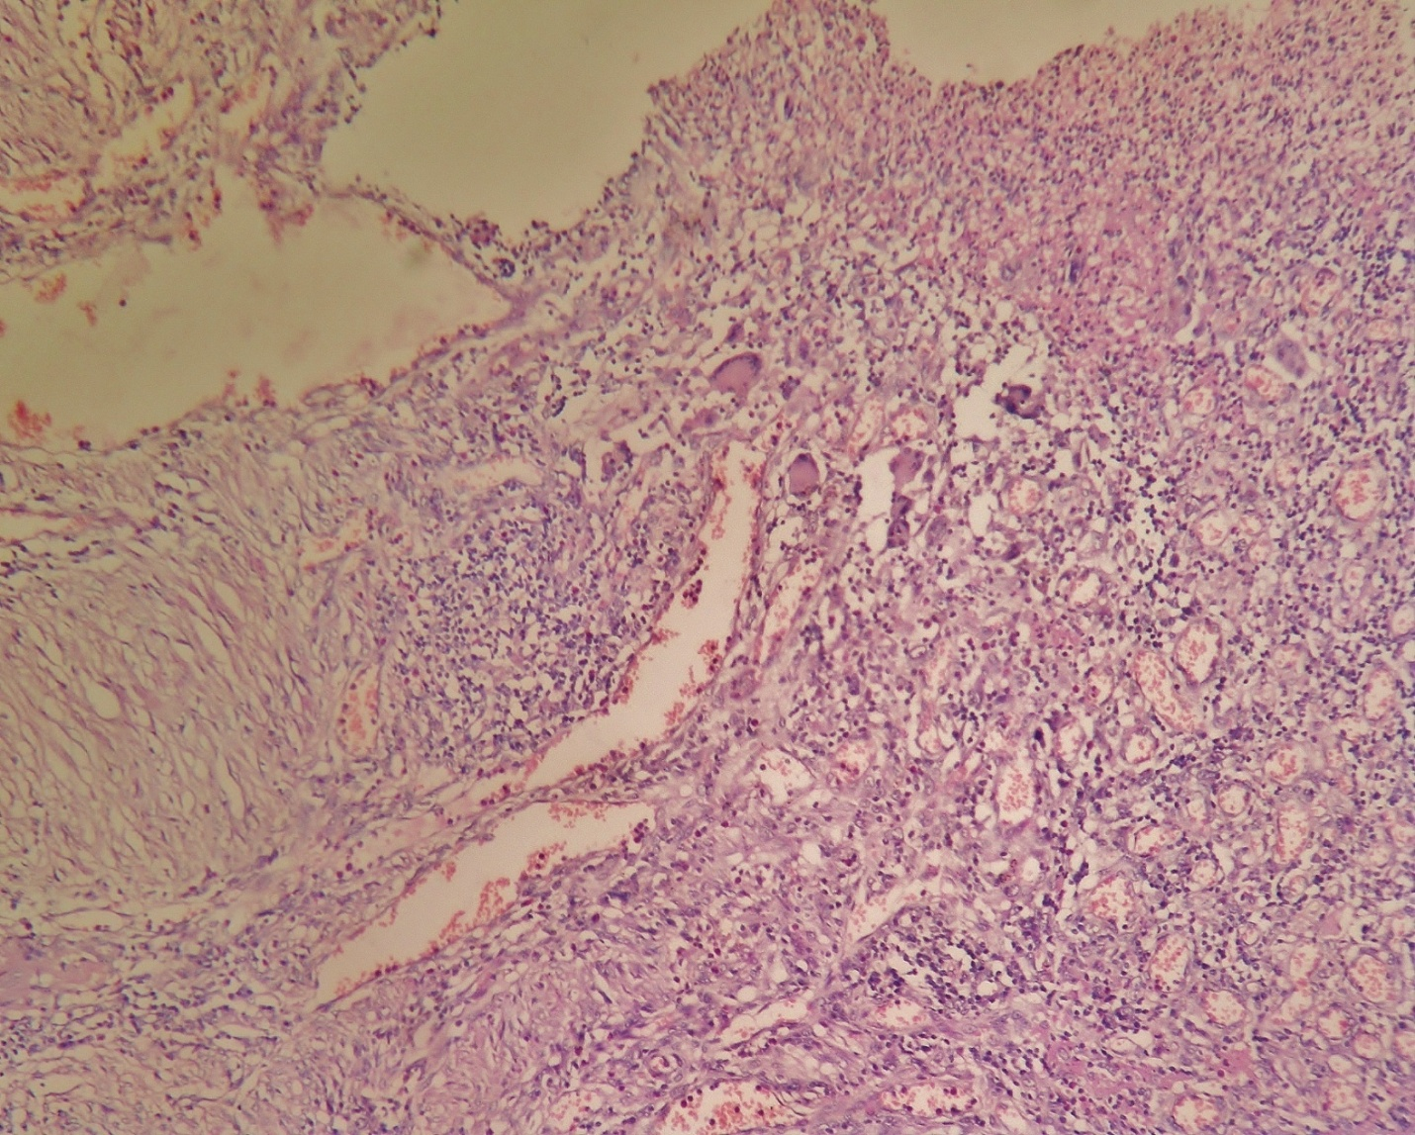
Figure 1 Histology showed extensive mucosal necrosis surrounded by lymphocytes and langhans giant cells.

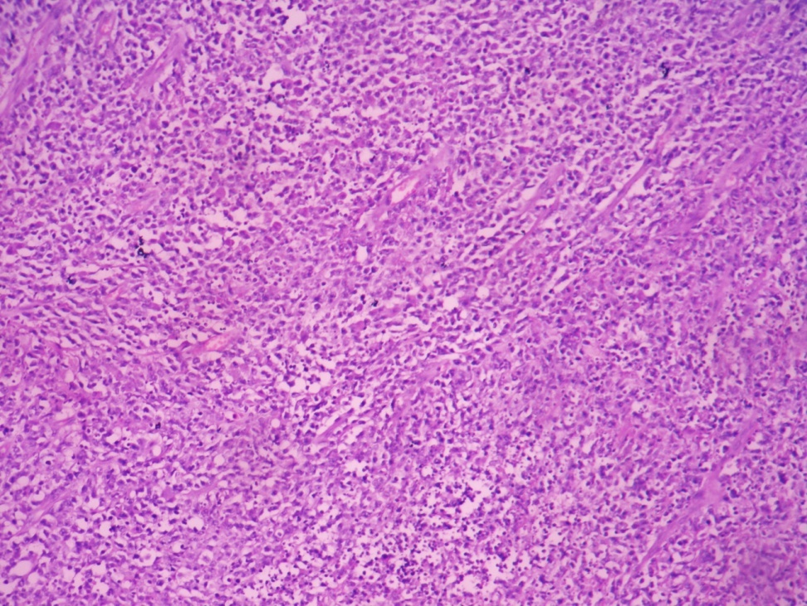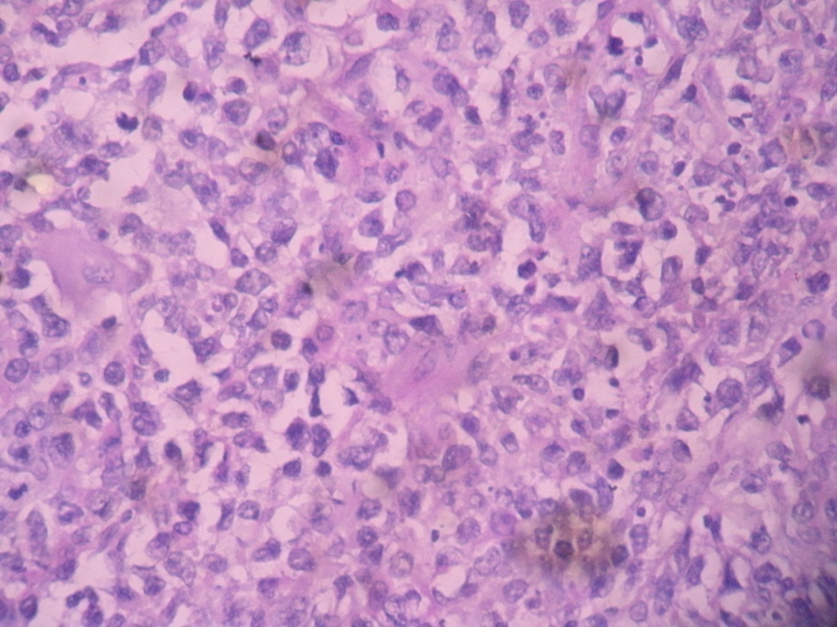
A B
Figure 2 Histology showed moderately differentiated adenocarcinoma infiltrating the submucosa and serosa (A: HE, × 10) with mitotic figures and surrounded by neoplastic lymphocytes (B: HE, × 40).

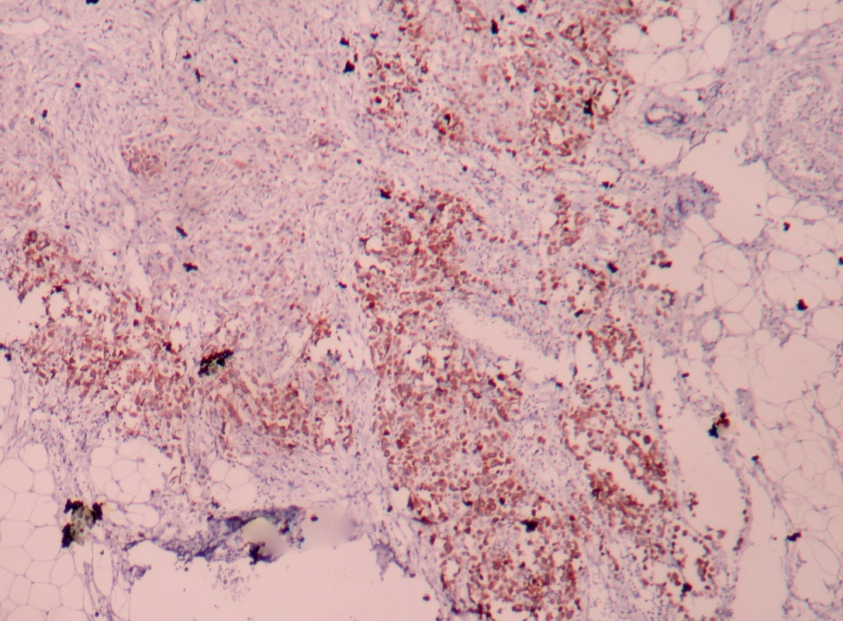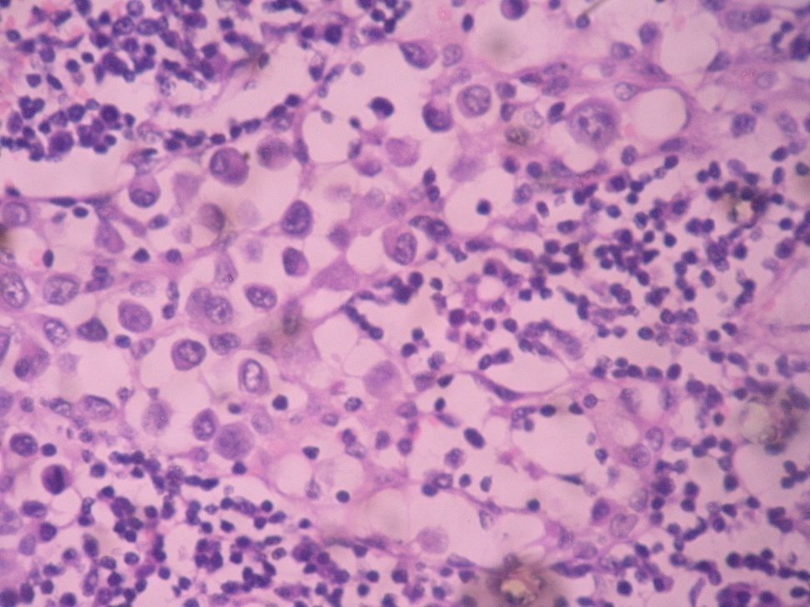
A B
Figure 3 Pericolonic fat infiltrated by adenocarcinoma showing cytokeratin positivity (A: IHC, × 10), histology of lymph node showing metastatic deposits of adenocarcinoma (B: HE, × 40).

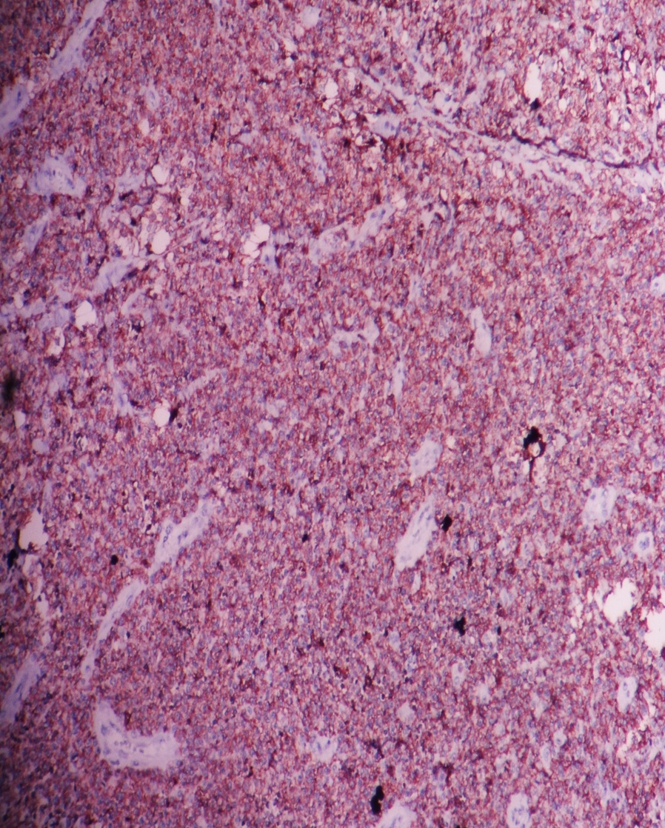
A
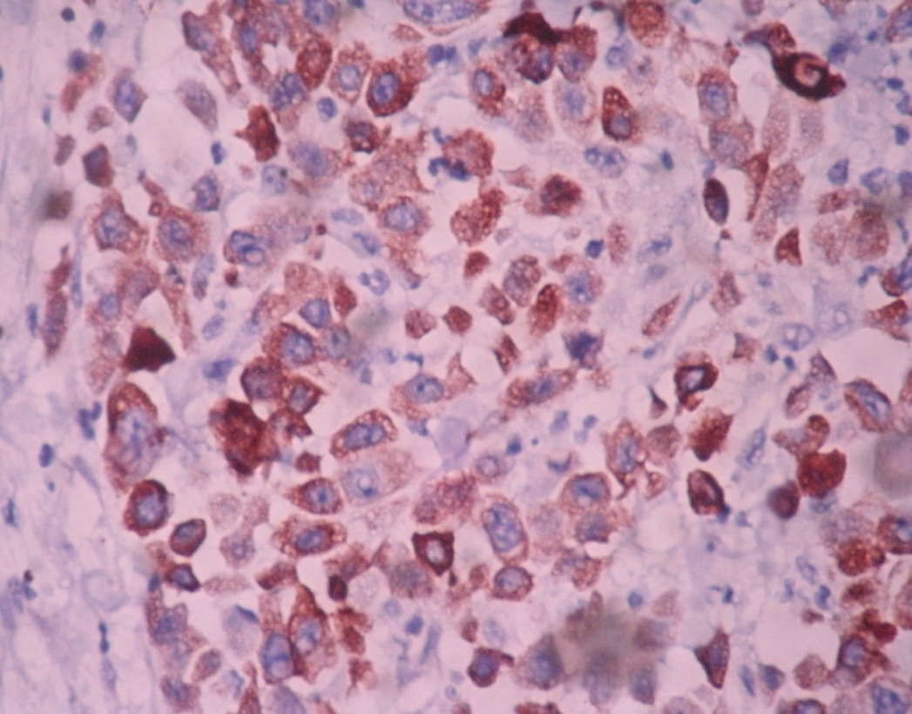
B
Figure 4 Mucosa associated lymphoid tissue lymphoma showing CD20 positivity (A: IHC, × 4) and diffuse cytoplasmic positivity of cytokeratin in pericolonic tissue suggestive of adenocarcinoma (B: IHC, × 40).

