Name of Journal: World Journal of Gastroenterology
Manuscript NO: 83365
Manuscript Type: ORIGINAL ARTICLE

Retrospective Study
Mucosal patterns change after Helicobacter pylori eradication: Evaluation using blue laser imaging in patients with atrophic gastritis

Nishikawa Y et al. Mucosal patterns change after H. pylori eradication

Yoshiyuki Nishikawa, Yoshio Ikeda, Hidehiro Murakami, Shin-ichiro Hori, Megumi Yoshimatsu, Naoki Nishikawa

Yoshiyuki Nishikawa, Department of Gastroenterology, Nishikawa Gastrointestinal Clinic, Matsuyama 790-0878, Ehime, Japan

Yoshio Ikeda, Endoscopy Center, Ehime University Hospital, Toon 791-0295, Ehime, Japan

Hidehiro Murakami, Department of Internal Medicine, Saiseikai Matsuyama Hospital, Matsuyama 791-8026, Ehime, Japan

Shin-ichiro Hori, Department of Gastroenterology, Himeji Red Cross Hospital, Himeji 670-8540, Hyogo, Japan

Megumi Yoshimatsu, Department of Gastroenterology, National Hospital Organization Shikoku Cancer Center, Matsuyama 791-0280, Ehime, Japan

Naoki Nishikawa, Department of Gastroenterology, Matsuyama Shimin Hospital, Matsuyama 790-0067, Ehime, Japan

Author contributions: Nishikawa Y conceived and designed the study; Nishikawa Y, Ikeda Y, Murakami H, Hori S, and Yoshimatsu M analyzed and interpreted the data; Nishikawa Y and Nishikawa N drafted the manuscript; Nishikawa Y, Ikeda Y, Murakami H, Hori S, Yoshimatsu M, and Nishikawa N critically revised the manuscript for important intellectual content; Nishikawa Y gave final approval of the manuscript; all authors approved the final version of the article to be published.

Corresponding author: Yoshiyuki Nishikawa, MD, PhD, Director, Department of Gastroenterology, Nishikawa Gastrointestinal Clinic, 2-72 Katsuyama-cho, Matsuyama 790-0878, Ehime, Japan. yonishik@ehime.med.or.jp

Received: February 8, 2023
Revised: March 3, 2023
Accepted: April 7, 2023
Published online: May 7, 2023

Abstract
BACKGROUND
Mucosal patterns (MPs) observed on blue laser imaging in patients with atrophic gastritis can be classified as spotty, cracked, and mottled. Furthermore, we hypothesized that the spotty pattern may change to the cracked pattern after Helicobacter pylori (H. pylori) eradication.

AIM
To further substantiate and comprehensively investigate MP changes after H. pylori eradication in a larger number of patients.

METHODS
We included 768 patients who were diagnosed with atrophic gastritis with evaluable MP using upper gastrointestinal endoscopy at the Nishikawa Gastrointestinal Clinic, Japan. Among them, 325 patients were H. pylori-positive, and of them, 101 patients who underwent upper gastrointestinal endoscopy before and after H. pylori eradication were evaluated for post-eradication MP changes. The patients’ MPs were interpreted by three experienced endoscopists who were blinded to their clinical features.

RESULTS
Among 76 patients with the spotty pattern before or after H. pylori eradication, the pattern disappeared or decreased in 67 patients [88.2%, 95% confidence interval (CI): 79.0%-93.6%), appeared or increased in 8 patients (10.5%, 95%CI: 5.4%-19.4%), and showed no change in 1 patient (1.3%, 95%CI: 0.2%-7.1%). In 90 patients with the cracked pattern before or after H. pylori eradication, the pattern disappeared or decreased in 7 patients (7.8%, 95%CI: 3.8%-15.2%), appeared or increased in 79 patients (87.8%, 95%CI: 79.4%-93.0%), and showed no change in 4 patients (4.4%, 95%CI: 1.7%-10.9%). In 70 patients with the mottled pattern before or after H. pylori eradication, the pattern disappeared or decreased in 28 patients (40.0%, 95%CI: 29.3%-51.7%), appeared or increased in 35 patients (50.0%, 95%CI: 38.6%-61.4%), and showed no change in 7 patients (10.0%, 95%CI: 4.9%-19.2%).

CONCLUSION
After H. pylori eradication, MPs changed from spotty to cracked in most patients, which may help endoscopists easily and precisely evaluate H. pylori-related gastritis status.

Key Words: Atrophic gastritis; Helicobacter pylori; Gastrointestinal endoscopy; Image enhancement; Classification

©The Author(s) 2023. Published by Baishideng Publishing Group Inc. All rights reserved.

Citation: Nishikawa Y, Ikeda Y, Murakami H, Hori SI, Yoshimatsu M, Nishikawa N. Mucosal patterns change after Helicobacter pylori eradication: Evaluation using blue laser imaging in patients with atrophic gastritis. World J Gastroenterol 2023; 29(17): 2657-2665
URL: https://www.wjgnet.com/1007-9327/full/v29/i17/2657.htm
DOI: https://dx.doi.org/10.3748/wjg.v29.i17.2657

Core Tip: We investigated whether the mucosal patterns on blue laser imaging may change from spotty to cracked after Helicobacter pylori (H. pylori) eradication. The spotty pattern disappeared or decreased in 88.2% of patients, while the cracked pattern appeared or increased in 87.8% of patients. These suggest that the spotty pattern observed in H. pylori-positive patients is likely to disappear after eradication and may be replaced by the cracked pattern. These observations may help endoscopists easily and precisely evaluate H. pylori-related gastritis status.
INTRODUCTION
Helicobacter pylori (H. pylori) infection and related atrophic gastritis is closely associated with the development of gastric cancer^{[1]}. Therefore, it is critical to observe the gastric mucosa to precisely judge the infection status as “current,” “previous,” or “none.” Recently, various types of image-enhanced endoscopy have been used to ensure the accurate evaluation of H. pylori infection^{[2-6]}.
In our previous study^{[7]}, we classified mucosal patterns (MPs) into three types (spotty, cracked, and mottled) using blue laser imaging (BLI)^{[8,9]} in patients with H. pylori-related gastritis. We found that the spotty pattern indicated the possibility of H. pylori infection, the cracked pattern indicated a post-inflammatory change after H. pylori eradication, and the mottled pattern indicated an intestinal metaplasia resulting from the progression of H. pylori-related gastritis. Thus, we hypothesized that the spotty pattern would disappear or decrease and the cracked pattern would newly appear or increase after H. pylori eradication.
To further explore these changes, we quantitatively analyzed the changes to determine whether each pattern would increase, decrease, or remain unchanged. Since little is known concerning the pattern changes after H. pylori eradication, clarification of these changes may help endoscopists diagnose the existing pattern as being pre- or post-eradication and understand the MP changes more precisely. Thus, this study aimed to clarify the significance and diagnostic viability of each MP using BLI.

MATERIALS AND METHODS
Patients and methods
A total of 2242 patients underwent upper gastrointestinal (GI) endoscopy at the Nishikawa Gastrointestinal Clinic, Ehime, Japan from April 1, 2015 to March 31, 2017. Of these, 768 patients were endoscopically diagnosed with atrophic gastritis. The presence or absence of H. pylori infection was confirmed. Among them, 325 patients were H. pylori-positive, and of them, 101 patients who underwent H. pylori eradication and subsequent endoscopy were examined for MP changes.
An EG-L580NW nasal upper GI endoscope (FUJIFILM Medical Co. Ltd., Tokyo, Japan) was used orally or nasally. The BLI bright mode was used to evaluate MPs in the intermediate or distant views.
This study was approved by the Ethics Committee of Ehime University Hospital (No: 1605010; August 22, 2016). Prior to receiving an endoscopic examination, all patients agreed that the data obtained in this study might be published in academic papers.

Classification of MPs
The MPs were classified into three types: The spotty pattern, which consists of 1-2 mm diameter spots (Figure 1); the cracked pattern, which consists of net-like cracks (Figure 2); and the mottled pattern, which has a mottled appearance (Figure 3)^{[7]}.

Evaluation of the MP changes after H. pylori eradication
The MP patterns were evaluated as follows: (1) Three expert GI endoscopists, with at least 25 years of experience, evaluated the mucosal changes after H. pylori eradication; (2) They were blinded to the patients’ endoscopic data, including the patterns obtained before and/or after H. pylori eradication; (3) They compared two randomly listed endoscopic image groups and evaluated which image group was dominant, less dominant, equal, or absent for the spotty, cracked, and mottled patterns; (4) When two or all endoscopists agreed on a particular pattern, that pattern was adopted for analysis. When they had conflicting pattern determinations, the final determination was reached through a joint discussion; and (5) H. pylori infection was diagnosed using the anti-H. pylori IgG antibody serology tests^{[10,11]}, urea breath tests^{[12-15]}, and biopsies.

Statistical analysis
Student’s t-test was used for the analysis of age, and the χ² test was used for the analyses of other variables. Statistical significance was set at P < 0.05. A 95% confidence interval (CI) was calculated to determine the uncertainty of the sample estimates. All statistical analyses were performed using Microsoft Excel 2016, version 1907, Build 11901.20176 (Microsoft Corporation, Redmond, WA, United States), and the statistical methods of this study were reviewed by Dr. Natsumi Yamashita from Clinical Research Center, National Hospital Organization Shikoku Cancer Center.

RESULTS
Patient characteristics
The number of patients evaluated was 768 (480 females and 288 males) with a mean age of 65.8 ± 12.9 (standard deviation) years. The numbers of patients with and without H. pylori infection were 325 (204 females and 121 males) and 443 (276 females and 167 males), respectively.
The mean ages of patients with and without H. pylori infection were 61.6 ± 14.3 years and 68.9 ± 10.7 years, respectively, with significant differences among them (P < 0.001). No significant difference was observed between the proportions of female and male patients with and without H. pylori infection (P = 0.895; Table 1).

Changes in MPs after H. pylori eradication
Upper GI endoscopy was performed for 101 patients (females: 75; males: 26; mean age: 57.5 ± 14.1 years) who successfully underwent H. pylori eradication, and the endoscopic mucosal changes were evaluated. Patients in whom evaluation was difficult because there were no comparable images of the specific parts were excluded from the analysis. The mean interval between H. pylori eradication and post-eradication endoscopy was 27.1 ± 13.1 mo.
In our study, multiple patterns commonly coexisted in many patients, with some patients having all three patterns. Of the 101 patients, 38 patients showed all three patterns (spotty, cracked, and mottled), 59 had two patterns (spotty and cracked, 28; spotty and mottled, 7; and cracked and mottled, 24), and 4 patients presented with only one pattern (spotty, 3; cracked, 0; and mottled, 1) either before or after eradication.
In 76 patients with a spotty pattern before or after H. pylori eradication, the pattern disappeared or decreased in 67 patients (88.2%, 95%CI: 79.0%-93.6%) and appeared or increased in 8 patients (10.5%, 95%CI: 5.4%-19.4%). In 1 patient (1.3%, 95%CI: 0.2%-7.1%), no change was observed after H. pylori eradication.
In 90 patients with a cracked pattern before or after H. pylori eradication, the pattern disappeared or decreased in 7 patients (7.8%, 95%CI: 3.8%-15.2%) and appeared or increased in 79 patients (87.8%, 95%CI: 79.4%-93.0%). In 4 patients (4.4%, 95%CI: 1.7%-10.9%), no change was observed after H. pylori eradication.
In 70 patients with a mottled pattern before or after H. pylori eradication, the pattern disappeared or decreased in 28 patients (40.0%, 95%CI: 29.3%-51.7%) and appeared or increased in 35 patients (50.0%, 95%CI: 38.6%-61.4%). In 7 patients (10.0%, 95%CI: 4.9%-19.2%), no change was observed after H. pylori eradication (Figure 4).
We investigated the relationship between the spotty and cracked patterns before and after eradication. The spotty pattern disappeared or decreased in 67 out of the 76 patients who had a spotty pattern before or after eradication. Of the 67 patients, the cracked pattern appeared or increased in 55 patients. Among the 8 patients with spotty patterns that appeared or increased after eradication, the cracked pattern appeared or increased in 5 patients. The cracked pattern appeared or increased in most of the 25 patients who did not have a spotty pattern before or after eradication (Figure 5).
We further investigated the difference in MP changes due to H. pylori eradication between the short-term (8-24 mo) and long-term (25-60 mo) observation groups. The spotty pattern disappeared or decreased in 88.6% and 87.8% (short-term vs long-term) of the patients. The cracked pattern newly appeared or increased in 88.9% and 86.7% (short-term vs long-term) of the patients. No significant differences were observed between the patients under short-term and long-term observations.

DISCUSSION
We investigated the use of BLI, an image-enhanced endoscopy, for the diagnosis of H. pylori-related gastritis, with a focus on the MP changes after H. pylori eradication. The Kyoto Classification of Gastritis was established in 2014 for the endoscopic diagnosis of H. pylori-related gastritis^{[16,17]}. The classification of MPs observed on BLI in this study is simpler and easier to use in endoscopic assessment than the Kyoto classification and thus has the potential to become a new standard method with the addition of new diagnostic information to the Kyoto classification. We previously reported the efficacy of MPs on BLI in an intermediate-to-distant view evaluation of H. pylori infection and had the benefits of easy detection of atrophic gastritis and easy diagnosis of infection status (current, previous, or no infection)^{[7]}.
The results obtained in the current study indicate that the disappearance of the spotty pattern is evidence of H. pylori clearance, while newly-appearing cracked pattern is evidence of post-gastritis healing. The mottled pattern may reflect “intestinal metaplasia,” as identified in our previous study using biopsies.
Knowledge of the endoscopic changes after H. pylori eradication is helpful in clarifying the meaning of each MP. The spotty pattern disappeared or decreased in 88.2% of patients, whereas the cracked pattern appeared or increased in 87.8% of patients after H. pylori eradication. The mottled pattern exhibited no specific tendency. As indicated in Figure 5, the spotty pattern observed in H. pylori-positive patients before eradication may disappear and may be replaced by the cracked pattern. Based on these observations, we can diagnose the H. pylori infection status as current, previous, or no infection. No difference was detected between the short-term and long-term observations of MP changes after H. pylori eradication, suggesting that the changes in MP would occur relatively quickly after eradication. The primary tendency of MP changes after H. pylori eradication have been clarified in this study. Irregular pattern changes (those other than spotty to cracked pattern) were observed after eradication in a limited number of patients. Further verification is necessary.

CONCLUSION
In conclusion, the spotty pattern may indicate H. pylori infection, the cracked pattern may indicate post-inflammatory changes after H. pylori eradication, and the mottled pattern may indicate intestinal metaplasia resulting from the progression of H. pylori-related gastritis. We verified that MPs on BLI may change from a spotty to a cracked pattern after H. pylori eradication. These observations may help endoscopists easily and precisely evaluate the status of H. pylori-related gastritis. We hope that MP changes on BLI will be routinely used to confirm the diagnosis of H. pylori-related gastritis in the future.

ARTICLE HIGHLIGHTS
Research background
Determination of the presence or absence of Helicobacter pylori (H. pylori) infection is important in the diagnosis of atrophic gastritis. Various studies have been conducted to distinguish these two conditions.

Research motivation
In our previous study, we reported that H. pylori eradication may lead to the disappearance of the spotty pattern and the appearance of the cracked pattern.

Research objectives
To further substantiate and comprehensively investigate mucosal pattern changes after H. pylori eradication in a larger number of patients.

Research methods
Among the patients with atrophic gastritis in whom H. pylori positivity was confirmed, we investigated 101 patients who underwent both H. pylori eradication and follow-up endoscopy and evaluated the change of patterns before and after eradication.

Research results
The spotty pattern tended to disappear or decrease, and the cracked pattern tended to appear or increase after H. pylori eradication, while the mottled pattern exhibited no specific tendency.

Research conclusions
The spotty pattern likely changes to the cracked pattern after H. pylori eradication.

Research perspectives
In future studies, it will be necessary to examine the morphological and histological changes of each mucosal pattern, compare these pattern changes with the Kyoto classification, examine the relationship with other classifications of atrophic gastritis, and clarify the meaning of the mucosal pattern changes.

REFERENCES
1 Uemura N, Okamoto S, Yamamoto S, Matsumura N, Yamaguchi S, Yamakido M, Taniyama K, Sasaki N, Schlemper RJ. Helicobacter pylori infection and the development of gastric cancer. N Engl J Med 2001; 345: 784-789 [PMID: 11556297 DOI: 10.1056/NEJMoa001999]
2 Dohi O, Majima A, Naito Y, Yoshida T, Ishida T, Azuma Y, Kitae H, Matsumura S, Mizuno N, Yoshida N, Kamada K, Itoh Y. Can image-enhanced endoscopy improve the diagnosis of Kyoto classification of gastritis in the clinical setting? Dig Endosc 2020; 32: 191-203 [PMID: 31550395 DOI: 10.1111/den.13540]
3 Glover B, Teare J, Patel N. A systematic review of the role of non-magnified endoscopy for the assessment of H. pylori infection. Endosc Int Open 2020; 8: E105-E114 [PMID: 32010741 DOI: 10.1055/a-0999-5252]
4 Alaboudy AA, Elbahrawy A, Matsumoto S, Yoshizawa A. Conventional narrow-band imaging has good correlation with histopathological severity of Helicobacter pylori gastritis. Dig Dis Sci 2011; 56: 1127-1130 [PMID: 20857197 DOI: 10.1007/s10620-010-1414-z]
5 Tongtawee T, Kaewpitoon S, Kaewpitoon N, Dechsukhum C, Loyd RA, Matrakool L. Correlation between Gastric Mucosal Morphologic Patterns and Histopathological Severity of Helicobacter pylori Associated Gastritis Using Conventional Narrow Band Imaging Gastroscopy. Biomed Res Int 2015; 2015: 808505 [PMID: 26120585 DOI: 10.1155/2015/808505]
6 Takeda T, Asaoka D, Nojiri S, Nishiyama M, Ikeda A, Yatagai N, Ishizuka K, Hiromoto T, Okubo S, Suzuki M, Nakajima A, Nakatsu Y, Komori H, Akazawa Y, Nakagawa Y, Izumi K, Matsumoto K, Ueyama H, Sasaki H, Shimada Y, Matsumoto K, Osada T, Hojo M, Kato M, Nagahara A. Linked Color Imaging and the Kyoto Classification of Gastritis: Evaluation of Visibility and Inter-Rater Reliability. Digestion 2020; 101: 598-607 [PMID: 31302654 DOI: 10.1159/000501534]
7 Nishikawa Y, Ikeda Y, Murakami H, Hori SI, Hino K, Sasaki C, Nishikawa M. Classification of atrophic mucosal patterns on Blue LASER Imaging for endoscopic diagnosis of Helicobacter pylori-related gastritis: A retrospective, observational study. PLoS One 2018; 13: e0193197 [PMID: 29596454 DOI: 10.1371/journal.pone.0193197]
8 Yoshida N, Yagi N, Inada Y, Kugai M, Okayama T, Kamada K, Katada K, Uchiyama K, Ishikawa T, Handa O, Takagi T, Konishi H, Kokura S, Yanagisawa A, Naito Y. Ability of a novel blue laser imaging system for the diagnosis of colorectal polyps. Dig Endosc 2014; 26: 250-258 [PMID: 23731034 DOI: 10.1111/den.12127]
9 Osawa H, Yamamoto H. Present and future status of flexible spectral imaging color enhancement and blue laser imaging technology. Dig Endosc 2014; 26 Suppl 1: 105-115 [PMID: 24373002 DOI: 10.1111/den.12205]
10 Feldman RA, Deeks JJ, Evans SJ. Multi-laboratory comparison of eight commercially available Helicobacter pylori serology kits. Helicobacter pylori Serology Study Group. Eur J Clin Microbiol Infect Dis 1995; 14: 428-433 [PMID: 7556232 DOI: 10.1007/BF02114899]
11 Loy CT, Irwig LM, Katelaris PH, Talley NJ. Do commercial serological kits for Helicobacter pylori infection differ in accuracy? A meta-analysis. Am J Gastroenterol 1996; 91: 1138-1144 [PMID: 8651160]
12 Graham DY, Klein PD, Evans DJ Jr, Evans DG, Alpert LC, Opekun AR, Boutton TW. Campylobacter pylori detected noninvasively by the 13C-urea breath test. Lancet 1987; 1: 1174-1177 [PMID: 2883491 DOI: 10.1016/s0140-6736(87)92145-3]
13 Logan RP, Polson RJ, Misiewicz JJ, Rao G, Karim NQ, Newell D, Johnson P, Wadsworth J, Walker MM, Baron JH. Simplified single sample 13Carbon urea breath test for Helicobacter pylori: comparison with histology, culture, and ELISA serology. Gut 1991; 32: 1461-1464 [PMID: 1773948 DOI: 10.1136/gut.32.12.1461]
14 Ohara S, Kato M, Asaka M, Toyota T. Studies of 13C-urea breath test for diagnosis of Helicobacter pylori infection in Japan. J Gastroenterol 1998; 33: 6-13 [PMID: 9497214 DOI: 10.1007/pl00009968]
15 Gisbert JP, Pajares JM. Review article: 13C-urea breath test in the diagnosis of Helicobacter pylori infection -- a critical review. Aliment Pharmacol Ther 2004; 20: 1001-1017 [PMID: 15569102 DOI: 10.1111/j.1365-2036.2004.02203.x]
16 Haruma K, Kato M, Inoue K, Murakami K, Kamada T, editors. Kyoto Classification of Gastritis. Tokyo: Nihon Medical Center, Ltd., 2014
17 Toyoshima O, Nishizawa T, Koike K. Endoscopic Kyoto classification of Helicobacter pylori infection and gastric cancer risk diagnosis. World J Gastroenterol 2020; 26: 466-477 [PMID: 32089624 DOI: 10.3748/wjg.v26.i5.466]

Footnotes
Institutional review board statement: This study was approved by the Ethics Committee of Ehime University Hospital (No. 1605010; August 22, 2016).

Informed consent statement: This study was conducted retrospectively from data obtained for clinical purposes. The study was approved by the institutional review board at the Ethics Committee of Ehime University Hospital. Prior to receiving an endoscopic examination, all patients agreed that the data obtained in this study might be published in academic papers.

Conflict-of-interest statement: None of the authors have any financial relationships to disclose with relevance to this article.

Data sharing statement: Data presented in this study is available on request from the corresponding author.

Open-Access: This article is an open-access article that was selected by an in-house editor and fully peer-reviewed by external reviewers. It is distributed in accordance with the Creative Commons Attribution NonCommercial (CC BY-NC 4.0) license, which permits others to distribute, remix, adapt, build upon this work non-commercially, and license their derivative works on different terms, provided the original work is properly cited and the use is non-commercial. See: https://creativecommons.org/Licenses/by-nc/4.0/

Provenance and peer review: Unsolicited article; Externally peer reviewed.
Peer-review model: Single blind

Corresponding Author’s Membership(s) in Professional Societies: American Society for Gastrointestinal Endoscopy.

Peer-review started: February 8, 2023
First decision: February 16, 2023
Article in press: April 7, 2023

Specialty type: Gastroenterology and hepatology
Country/Territory of origin: Japan
Peer-review report’s scientific quality classification
Grade A (Excellent): 0
Grade B (Very good): 0
Grade C (Good): C, C
Grade D (Fair): D
Grade E (Poor): 0

P-Reviewer: Kotelevets SM, Russia; Senchukova M, Russia S-Editor: Yan JP L-Editor: A P-Editor: Chen YX

Figure Legends
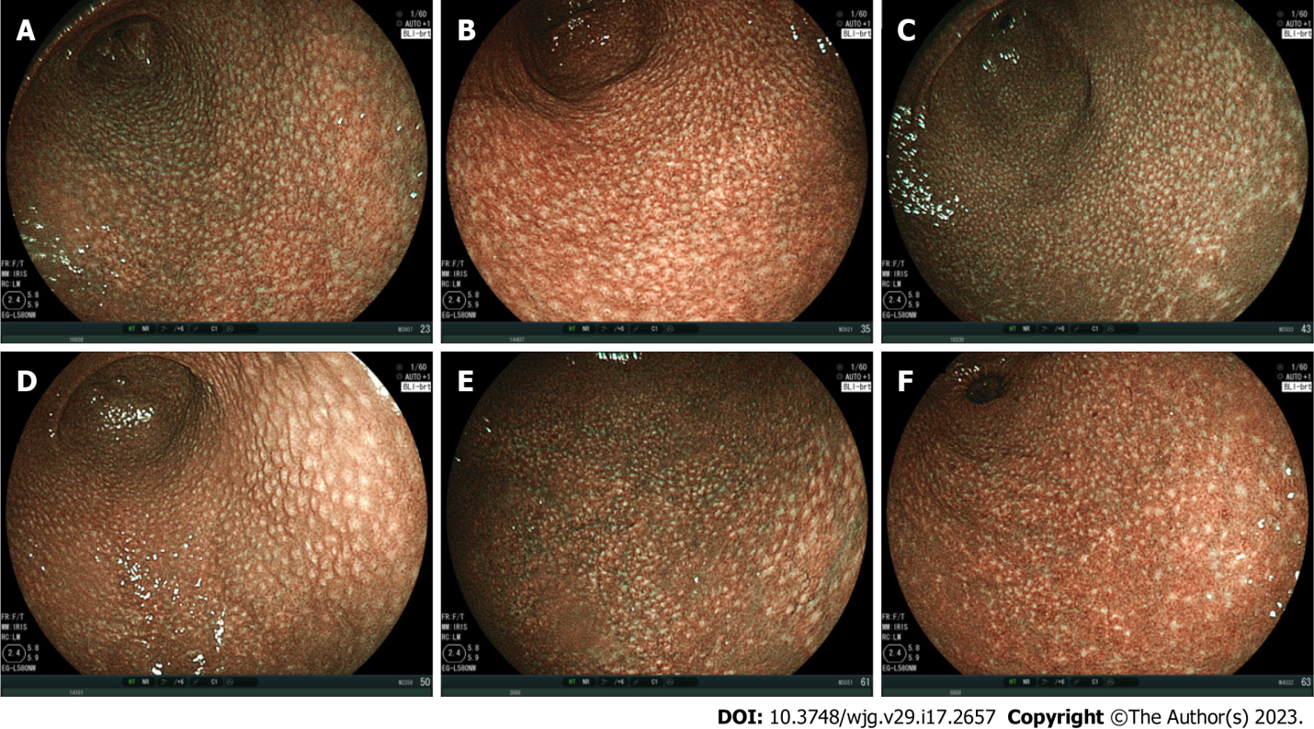
Figure 1 Spotty pattern. Representative images of the spotty pattern shown as white spots of 1-2 mm in diameter in the gastric antrum of 6 patients infected with Helicobacter pylori (H. pylori) observed using blue laser imaging-bright mode. A: 45-year-old female, H. pylori-positive; B: 51-year-old female, H. pylori-positive; C: 27-year-old female, H. pylori-positive; D: 59-year-old female, H. pylori-positive, nodular gastritis; E: 49-year-old male, H. pylori-positive; F: 66-year-old female, H. pylori-positive.

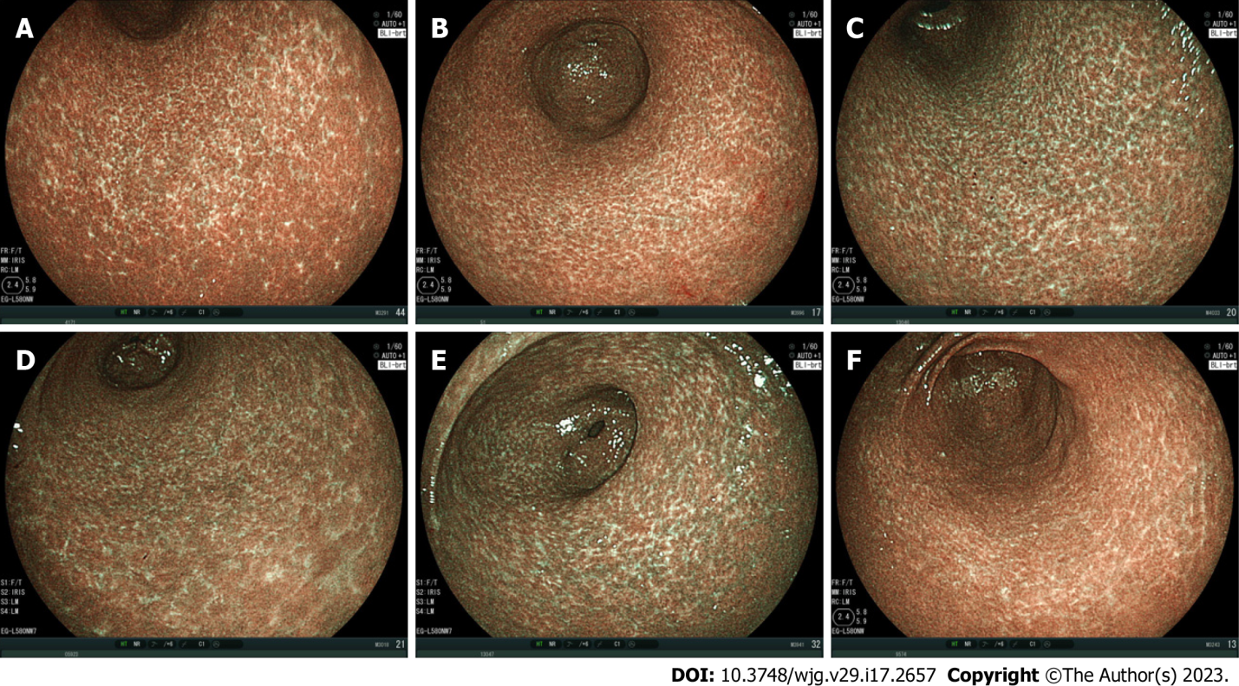
Figure 2 Cracked pattern. Representative images of the cracked pattern as white net-like cracks consisting of lines in the gastric antrum of 6 patients after Helicobacter pylori (H. pylori) eradication observed using blue laser imaging-bright mode. A: 69-year-old female, H. pylori-negative, 2 years, 11 mo after eradication; B: 75-year-old female, H. pylori-negative, 6 years, 0 mo after eradication; C: 63-year-old female, H. pylori-negative, 1 year, 2 mo after eradication; D: 72-year-old female, H. pylori-negative, 1 year, 0 mo after eradication; E: 63-year-old female, H. pylori-negative, 1 year, 2 mo after eradication; F: 52-year-old male, H. pylori-negative, 2 years, 1 mo after eradication.

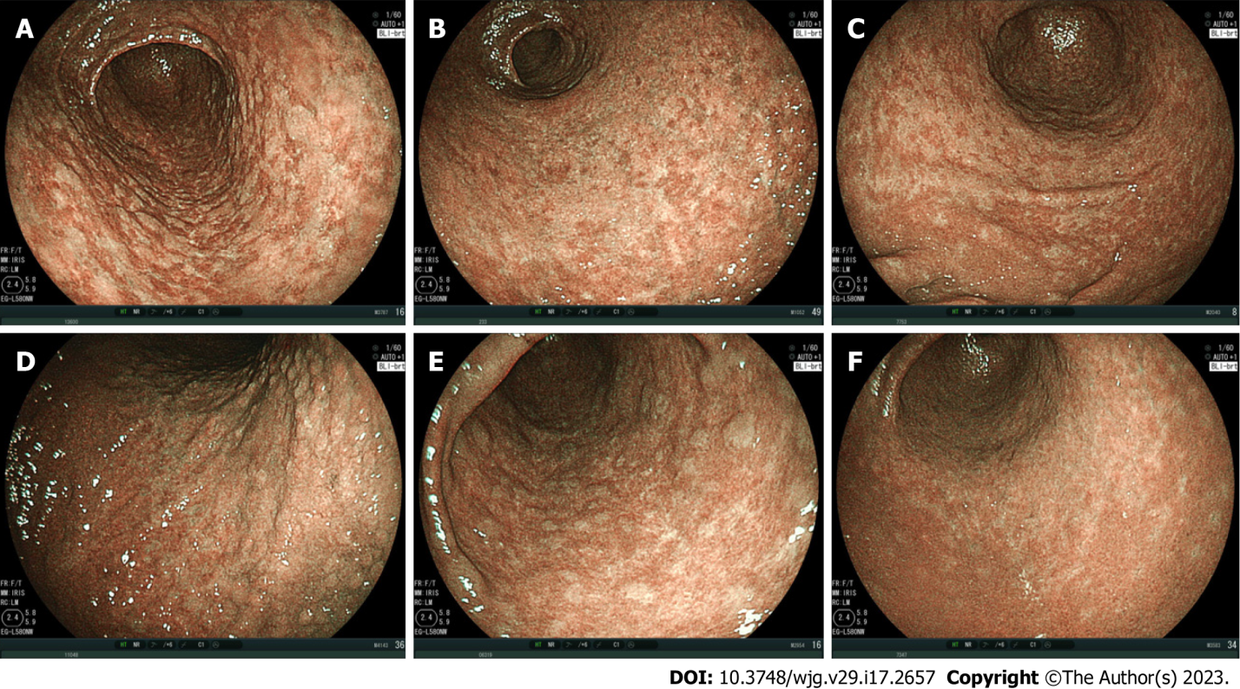
Figure 3 Mottled pattern. Representative images of the mottled pattern observed using blue laser imaging-bright mode in the gastric antrum of 6 patients. The whitish-colored mottled areas varied from small to large. Only panel A shows the pattern of a patient infected with Helicobacter pylori (H. pylori). A: 67-year-old male, H. pylori-positive, before eradication; B: 74-year-old male, H. pylori-negative, no eradication; C: 73-year-old female, H. pylori-negative, 2 years, 11 mo after eradication; D: 87-year-old male, H. pylori-negative, no eradication; E: 83-year-old male, H. pylori-negative, 5 years, 2 mo after eradication; F: 60-year-old female, H. pylori-negative, 2 years, 2 mo after eradication.

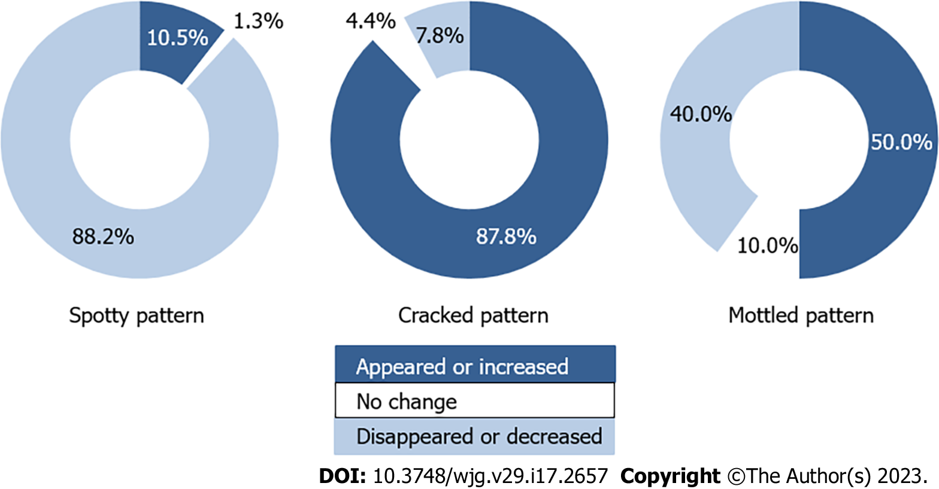
Figure 4 Change in mucosal pattern after Helicobacter pylori eradication. The spotty pattern tended to disappear or decrease, the cracked pattern appeared or increased, and the mottled pattern exhibited no specific tendency.

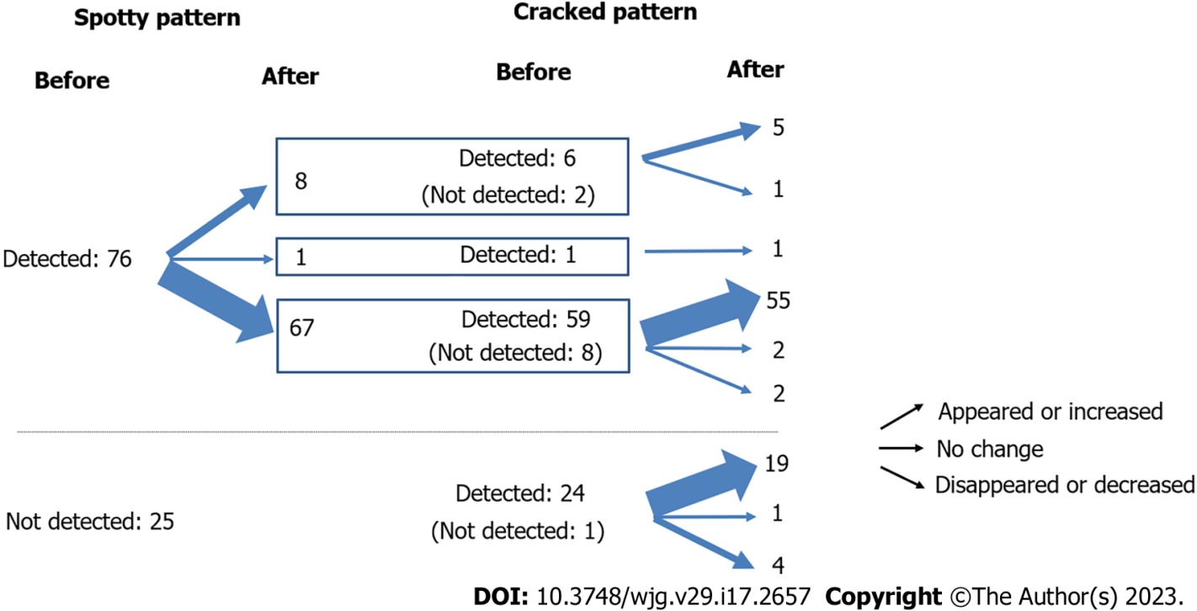
Figure 5 Relationship between the spotty and cracked patterns before and after Helicobacter pylori eradication.

Table 1 Patient characteristics
Item | Patients with atrophic gastritis | Patients with  H. pylori infection | Patients underwent both H. pylori eradication and follow up endoscopy
No. of patients | 768 | 325 | 101
Age, mean ± SD | 65.8 ± 12.9 | 61.6 ± 14.3 | 57.5 ± 14.1
Female | 480 | 204 | 75
Male | 288 | 121 | 26
SD: Standard deviation; H. pylori: Helicobacter pylori.

Published by Baishideng Publishing Group Inc
7041 Koll Center Parkway, Suite 160, Pleasanton, CA 94566, USA
Telephone: +1-925-3991568
E-mail: bpgoffice@wjgnet.com
Help Desk: https://www.f6publishing.com/helpdesk
https://www.wjgnet.com

© 2023 Baishideng Publishing Group Inc. All rights reserved.

