Name of Journal: World Journal of Clinical Cases
Manuscript NO: 77510
Manuscript Type: CASE REPORT

Autoimmune encephalitis with posterior reversible encephalopathy syndrome: A case report

Yu QJ et al. Autoimmune encephalitis and PRES

Shu-Juan Dai, Qiu-Jian Yu, Xiao-Yan Zhu, Qun-Zhu Shang, Ji-Bo Qu, Qing-Long Ai

Shu-Juan Dai, Qiu-Jian Yu, Xiao-Yan Zhu, Qun-Zhu Shang, Qing-Long Ai, Department of Neurology, First Affiliated Hospital of Kunming Medical University, Kunming 650000, Yunnan Province, China

Ji-Bo Qu, Department of Neurology, Hospital of Honghe State Affiliated to Kunming Medical University, Honghe 661000, Yunnan Province, China

Author contributions: All authors contributed to the article, critically revised the manuscript and approved the submitted version.

Supported by National Natural Science Foundation of China, No. 8216050484.

Corresponding author: Qiu-Jian Yu, MD, PhD, Doctor, Department of Neurology, First Affiliated Hospital of Kunming Medical University, No 295 Xichang Road, Xishan District, Kunming 650000, Yunnan Province, China. q.yu4@foxmail.com

Received: May 6, 2022
Revised: August 9, 2022
Accepted: September 23, 2022
Published online:

Abstract
BACKGROUND
Posterior reversible encephalopathy syndrome (PRES) is a neuroimaging-based syndrome and is associated with multifocal vasogenic cerebral edema. Patients with PRES frequently demonstrate headache, seizure, encephalopathy, altered mental function, visual loss and so on. We here report a patient who showed persistent neurologic deficits after PRES and was ultimately diagnosed with autoimmune encephalitis (AE).

CASE SUMMARY
This case exhibits a rare imaging manifestation of anti-casper 2 encephalitis which was initially well-matched with PRES and associated vasogenic edema.

CONCLUSION
AE should be further considered when the etiology, clinical manifestations, and course of PRES are atypical.

Key Words: Autoimmune encephalitis; Posterior reversible encephalopathy syndrome; Neuroimaging; Immunotherapy; Blood-brain barrier; Case report

Dai SJ, Yu QJ, Zhu XY, Shang QZ, Qu JB, Ai QL. Autoimmune encephalitis with posterior reversible encephalopathy syndrome: A case report. World J Clin Cases 2022; In press

Core Tip: Posterior reversible encephalopathy syndrome (PRES) is associated with many diverse clinical comorbid, the most common of which are hypertension, eclampsia, renal failure and immunosuppressive treatment. PRES is a neuroimaging-based syndrome and is associated with multifocal vasogenic cerebral edema. Patients with PRES are frequently manifested by headache, seizure, encephalopathy, altered mental function, visual loss, etc. We here report a patient who showed persistent neurologic deficits after PRES and was ultimately diagnosed with autoimmune encephalitis.

INTRODUCTION
A 37-year-old man visited the Department of neurological care unit in the First Affiliated Hospital of Kunming Medical University complaining of a general fatigue for 1 wk, aggravated with disturbance of consciousness for 1 d. He had no past medical history. When admitted to the hospital, his Glasgow Coma Scale (GCS) score was 9 (E4/V1/M4), he showed a normal blood pressure, no cervical resistance, increased muscle tone, hyperreflexia and hyperactivity ankle clonus. At presentation, brain magnetic resonance imaging (MRI) showed bilateral multifocal vasogenic edema especially in his bilateral occipital lobes, which is compatible with posterior reversible encephalopathy syndrome (PRES) (Figure 1A). Spot-like microbleeds were found on susceptibility weighted imaging (SWI) mapping (Figure 1C). During admission, follow-up MRI at 1 wk showed reduced vasogenic edema in both cerebral hemispheres considerably, with less prominent microbleeds on SWI (Figure 1B and D). Serum and cerebrospinal fluid (CSF) autoantibody tests using a cell-based immunocytochemistry kit (Shaanxi MYBiotech Co., Ltd.) showed the presence of anti-Casper 2 antibody with tilter of 1: 3.2 in CSF and 1: 100 in blood serum. The patient’s CSF profile was otherwise normal (red blood cell 20/μL; white blood cell 1/μL; protein 0.25 g/L; and glucose 4.5 mmol/L) with no evidence of infection. The patient finally diagnosed as an anti-Casper 2 autoimmune encephalitis (AE). After intravenous immunoglobulin (IVIG) for 5 d (400 mg/kg/d), his GCS score increased to 10 (E4/V1/M5), which means patient’s movement was improved. Unfortunately, due to economic problem, he didn’t perform electroencephalography (EEG) and electromyography (EMG). After 3 wk, he was transferred to local hospital.

CASE PRESENTATION
Chief complaints
A general fatigue for 1 wk, aggravated with disturbance of consciousness for 1 d.

History of present illness
There is no special illness except the chief complaints.

History of past illness
There is no history of past illness.

Personal and family history
There is no personal and family history.

Physical examination
The patient's GCS score was 9 (E4/V1/M4), he showed a normal blood pressure, no cervical resistance, increased muscle tone, hyperreflexia and hyperactivity ankle clonus.

Laboratory examinations
Serum and CSF autoantibody tests using a cell-based immunocytochemistry kit (Shaanxi MYBiotech Co., Ltd.) showed the presence of anti-Casper 2 antibody with tilter of 1: 3.2 in CSF and 1: 100 in blood serum. The patient’s CSF profile was otherwise normal (red blood cell 20/μL; white blood cell 1/μL; protein 0.25 g/L; and glucose 4.5 mmol/L) with no evidence of infection.

Imaging examinations
Brain MRI showed bilateral multifocal vasogenic edema especially in his bilateral occipital lobes, which is compatible with PRES (Figure 1A). Spot-like microbleeds were found on SWI mapping (Figure 1C). During admission, follow-up MRI at 1 wk showed reduced vasogenic edema in both cerebral hemispheres considerably, with less prominent microbleeds on SWI (Figure 1B and D).

FINAL DIAGNOSIS
Anti-Casper 2 AE.

TREATMENT
IVIG for 5 d (400 mg/kg/d)

OUTCOME AND FOLLOW-UP
After intravenous immunoglobulin (IVIG) for 5 d (400 mg/kg/d), his GCS score increased to 10 (E4/V1/M5), which means patient’s movement was improved. Unfortunately, due to economic problem, he didn’t perform EEG and EMG. After 3 wk, he was transferred to local hospital.

DISCUSSION
This case exhibits a rare imaging manifestation of anti-Casper 2 encephalitis which was initially well-matched with PRES and associated vasospasm. Generally, PRES is predicted to be both clinically and radiologically reversible and especially has a good prognosis. One of the major causes of PRES is acute hypertension. Patients with normal BP who accompanied with systemic autoimmune disorders can also produce features of classic PRES radiologically. Tetsuka and Ogawa^{[1]}, proposed a case of PRES patient with anti-LGI 1 antibody whose MRI showed apparent vasospasm edema. It is presumed that factors such as tumor necrosis factor alpha (TNF-α) and interleukin-1 (IL-1), that lead to PRES can activate the immune system and release other cytokines. These cytokines produce expression of adhesion molecules (vascular cell adhesion molecule 1 and intercellular adhesion molecule 1), which cooperate with leukocytes and lead them to produce reactive oxygen species (ROS) and proteases that result in endothelial damage and consequent fluid leakage. TNF-α and IL-1 can furthermore stimulate astrocytes to secret vascular endothelial growth factor (VEGF), which deteriorates the form of junctions of the brain vasculature. These cascades result in vasogenic edema. In conclusion, endothelial hypotheses may be considered the most relevant in PRES patients with autoimmune disorders^{[2]}. Meanwhile, PRES might cause the breakdown of blood-brain barrier (BBB) and the dis-organization of brain tissue^{[3]}. In this case, it can be either presumed that BBB breakdown could uncover neuronal membrane antigen epitopes, such as Caspr 2, and further induce a process of autoimmune inflammatory encephalitis. More experiments should be taken in vitro and in vivo to further test the pathogenesis associated PRES-AE. Clinical diagnosis should also be made cautiously when a patient original has PRES neuroradiological features. PRES has been reported in patients with acute demyelinating encephalomyelitis (ADEM), multiple sclerosis (MS), other systemic autoimmune encephalitis (e.g. Hashimoto's disease, systemic lupuserythematosus, Behcet's disease), and paraneoplastic encephalitis^{[4]}.

CONCLUSION
In the present case, the patient was diagnosed as Caspr 2 AE rather than PRES due to the effectiveness of immunotherapy. In conclusion, AE can mimic PRES radiologically. AE should be further considered when the etiology, clinical manifestations and course of PRES are atypical. Persistent encephalopathic symptoms, imaging abnormalities in the multiple cortical and subcortical areas, and specifically, autoantibody analysis can be the evidences of AE. At last, immunotherapy and relevant systemic supportive treatment such as antiepileptic treatment, can lead to a better prognosis.

REFERENCES
1 Tetsuka S, Ogawa T. Posterior reversible encephalopathy syndrome: A review with emphasis on neuroimaging characteristics. J Neurol Sci 2019; 404: 72-79 [PMID: 31349066 DOI: 10.1016/j.jns.2019.07.018]
2 Marra A, Vargas M, Striano P, Del Guercio L, Buonanno P, Servillo G. Posterior reversible encephalopathy syndrome: the endothelial hypotheses. Med Hypotheses 2014, 82: 619-622 [PMID: 24613735 DOI: 10.1016/j.mehy.2014.02.022]
3 Kim J, Lee ST, Park S, Joo EY, Chung CS, Lee MJ. Posterior reversible encephalopathy syndrome as initial manifestation of autoimmune encephalitis. Neurol Clin Pract 2019; 9: e42-e44 [PMID: 31750033 DOI: 10.1212/CPJ.0000000000000609]
4 Wang Q, Huang B, Shen G, Zeng Y, Chen Z, Lu C, Lerner A, Gao B. Blood-Brain Barrier Disruption as a Potential Target for Therapy in Posterior Reversible Encephalopathy Syndrome: Evidence From Multimodal MRI in Rats. Front Neurol 2019; 10: 1211 [PMID: 31849806 DOI: 10.3389/fneur.2019.01211]

Footnotes
Informed consent statement: The study participant's legal guardian, provided informed written consent prior to study enrollment.

Conflict-of-interest statement: All the authors report no relevant conflicts of interest for this article.

CARE Checklist (2016) statement: The authors have read the CARE Checklist (2016), and the manuscript was prepared and revised according to the CARE Checklist (2016).

Open-Access: This article is an open-access article that was selected by an in-house editor and fully peer-reviewed by external reviewers. It is distributed in accordance with the Creative Commons Attribution NonCommercial (CC BY-NC 4.0) license, which permits others to distribute, remix, adapt, build upon this work non-commercially, and license their derivative works on different terms, provided the original work is properly cited and the use is non-commercial. See: https://creativecommons.org/Licenses/by-nc/4.0/

Provenance and peer review: Unsolicited article; Externally peer reviewed.
Peer-review model: Single blind

Peer-review started: May 6, 2022
First decision: July 29, 2022
Article in press:

Specialty type: Neuroimaging
Country/Territory of origin: China
Peer-review report’s scientific quality classification
Grade A (Excellent): 0
Grade B (Very good): 0
Grade C (Good): C, C
Grade D (Fair): D
Grade E (Poor): 0

P-Reviewer: Beran RG, Australia; Jensen-Kondering U, Germany; Teragawa H, Japan S-Editor: Xing YX L-Editor: A P-Editor: Xing YX
Figure Legends
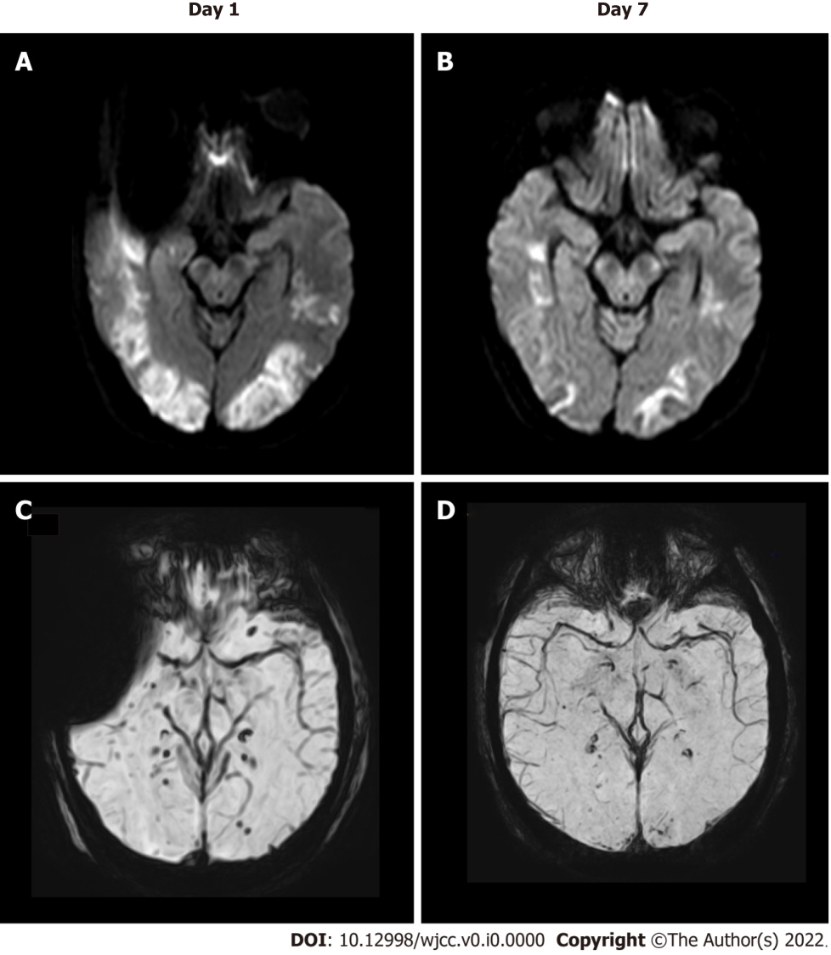
Figure 1 Brain magnetic resonance imaging showed bilateral multifocal vasogenic edema especially in bilateral occipital lobes. A: Compatible with posterior reversible encephalopathy syndrome; B and D: Follow-up magnetic resonance imaging after 7 d showed significantly reduced vasogenic edema in both cerebral hemispheres, with decreased microbleeds on susceptibility weighted imaging (SWI) mapping; C: Spot-like microbleeds were found on SWI mapping.

