Name of journal: World Journal of Gastroenterology
ESPS manuscript NO: 28755
Manuscript Type: LETTER TO THE EDITOR

Establishment of various biliary tract carcinoma cell lines and xenograft models for appropriate preclinical studies

Ojima H et al. Establishing biliary tract carcinoma cell lines

Hidenori Ojima, Seri Yamagishi, Kazuaki Shimada, Tatsuhiro Shibata

Hidenori Ojima, Division of Molecular Pathology, National Cancer Center Research Institute, Tokyo 104-0045, Japan

Hidenori Ojima, Department of Pathology, Keio University School of Medicine, Tokyo 104-0045, Japan

Seri Yamagishi, Tatsuhiro Shibata, Division of Cancer Genomics, National Cancer Center Research Institute, Tokyo 104-0045, Japan

Kazuaki Shimada, Hepatobiliary and Pancreatic Surgery Division, National Cancer Center Hospital, Tokyo 104-0045, Japan

Author contributions: Ojima H wrote and revised this letter; Ojima H, Yamagishi S, and Shibata T conducted the study and performed the data analyses; Shimada K obtained surgical biliary tract carcinoma specimens and performed the clinical data analyses; all authors read and approved the final manuscript.

Conflict-of-interest statement: Ojima H reports grants from Merck Serono Co., Ltd., grants from Eli Lilly Japan Co., Ltd., outside the submitted work.

Open-Access: This article is an open-access article which was selected by an in-house editor and fully peer-reviewed by external reviewers. It is distributed in accordance with the Creative Commons Attribution Non Commercial (CC BY-NC 4.0) license, which permits others to distribute, remix, adapt, build upon this work non-commercially, and license their derivative works on different terms, provided the original work is properly cited and the use is non-commercial. See: http://creativecommons.org/licenses/by-nc/4.0/

Manuscript source: Invited manuscript

Correspondence to: Hidenori Ojima, MD, PhD, Division of Molecular Pathology, National Cancer Center Research Institute, 5-1-1 Tsukiji, Chuo-ku, Tokyo 104-0045, Japan. hojima@a3.keio.jp
Telephone: +81-3-35475137
Fax: +81-3-35453567

Received: July 13, 2016
Peer-review started: July 16, 2016
First decision: August 19, 2016
Revised: September 8, 2016
Accepted: September 28, 2016
Article in press:
Published online:

Abstract
We recently reported several driver genes of biliary tract carcinoma (BTC) that are known to play important roles in oncogenesis and disease progression. Although the need for developing novel therapeutic strategies is increasing, there are very few BTC cell lines and xenograft models currently available for conducting preclinical studies. Using a total of 88 surgical BTC specimens and 536 immunodeficient mice, 27 xenograft models and 13 new BTC cell lines, including subtypes, were established. Some of our cell lines were found to be resistant to gemcitabine, which is currently the first choice of treatment, thereby allowing highly practical preclinical studies to be conducted. Using the aforementioned cell lines and xenograft models and a clinical pathological database of patients undergoing BTC resection, we can establish a preclinical study system and appropriate parameters for drug efficacy studies to explore new biomarkers for practical applications in the future studies.

Key words: Biliary tract carcinoma; Cell line; Xenograft model; Preclinical study

© The Author(s) 2016. Published by Baishideng Publishing Group Inc. All rights reserved.

Core tip: Although the need for developing novel therapeutic strategies for biliary tract carcinoma (BTC) is increasing, there are only few xenograft models and cell lines available for in vivo and in vitro studies, respectively. To conduct appropriate preclinical studies, we established 27 xenograft models and 13 new BTC cell lines using several surgical BTC specimens and immunodeficient mice. Using the aforementioned cell lines and xenograft models and a clinical pathological database of patients undergoing BTC resection, we can establish appropriate parameters for drug efficacy studies to explore new biomarkers for practical applications in the future studies.

Hidenori Ojima, Seri Yamagishi, Kazuaki Shimada, Tatsuhiro Shibata. Establishment of various biliary tract carcinoma cell lines and xenograft models for appropriate preclinical studies. World J Gastroenterol 2016; In press

TO THE EDITOR
Biliary tract carcinoma (BTC) is an extremely malignant tumor. The incidence and mortality rates of BTC are currently rising and are particularly high in Asian countries. Surgical resection is the only curative treatment; however, most cases are diagnosed to be at advanced and inoperable stages by the time patients visit a hospital. The most serious problem is that there are no efficient chemotherapeutic regimens for patients with inoperable or recurrent BTC. Worldwide, gemcitabine–cisplatin combination therapy is the first choice, but clinicians are not satisfied with its efficacy. New drugs are needed for BTC patients.
Recently, we conducted genomic analyses of clinical specimens from 260 patients, which is the largest study till date, wherein we identified genomic abnormalities, which could be potential therapeutic targets, in 32 driver genes that play important roles in oncogenesis and disease progression in approximately 40% of BTC patients^{[1]}. Although the need for developing novel therapeutic strategies is increasing, there are very few BTC-related resources currently available for conducting preclinical studies. The main reasons are as follows: the number of surgical BTC patients is not high at a single institute, and there is no large clinicopathological database. It is difficult to obtain surgical specimens for basic research. Therefore, there are only few xenograft models and cell lines available for in vivo and in vitro studies.
To conduct appropriate preclinical studies, surgical BTC specimens (collected from Japanese patients at the National Cancer Center Hospital, Tokyo, Japan since 2005 in an appropriate manner without any interference to pathological diagnosis) were directly transplanted into immunodeficient mice and subjected to cell culture medium to establish xenograft models and cell lines, respectively, as reported in 2010 ^{[2]}. From a total of 88 BTC specimens and 536 immunodeficient mice during the period 2005–2013, we established 27 xenograft models (18 intrahepatic cholangiocarcinoma, four perihilar, and five distal BTC) and 13 new BTC cell lines, including subtypes (eight intrahepatic cholangiocarcinoma, two perihilar, and three distal BTC) (Table 1). Some of our established cell lines were found to be resistant to gemcitabine (Table 2), thereby allowing highly practical preclinical studies to be conducted. In addition, we conducted molecular pathology analyses of cell lines and constructed a clinical pathological database of patients undergoing BTC resection to establish appropriate parameters for drug efficacy studies to explore new biomarkers for practical applications (Figure 1) ^{[2-5]}. All experiments were approved by the Animal Care and Ethics Committee of the National Cancer Center (ID: T05-046). This study was approved by the Ethical Committee of the National Cancer Center (ID: 2007-022).
Preclinical studies have found very little evidence regarding the combined effects of prospective anticancer combination therapies, including gemcitabine. Therefore, we continue to examine the combined effects of the utility of the Bliss method and combination index to assess the prognosis of BTC. Moreover, we are going to release some of our resources and data in the near future. We believe that our materials and data will not only aid in conducting appropriate preclinical studies but also accelerate basic research of BTC.

REFERENCES
1 Nakamura H, Arai Y, Totoki Y, Shirota T, Elzawahry A, Kato M, Hama N, Hosoda F, Urushidate T, Ohashi S, Hiraoka N, Ojima H, Shimada K, Okusaka T, Kosuge T, Miyagawa S, Shibata T. Genomic spectra of biliary tract cancer. Nat Genet 2015; 47: 1003-1010 [PMID: 26258846 DOI: 10.1038/ng.3375]
2 Ojima H, Yoshikawa D, Ino Y, Shimizu H, Miyamoto M, Kokubu A, Hiraoka N, Morofuji N, Kondo T, Onaya H, Okusaka T, Shimada K, Sakamoto Y, Esaki M, Nara S, Kosuge T, Hirohashi S, Kanai Y, Shibata T. Establishment of six new human biliary tract carcinoma cell lines and identification of MAGEH1 as a candidate biomarker for predicting the efficacy of gemcitabine treatment. Cancer Sci 2010; 101: 882-888 [PMID: 20088962 DOI: 10.1111/j.1349-7006.2009.01462.x]
3 Morofuji N, Ojima H, Onaya H, Okusaka T, Shimada K, Sakamoto Y, Esaki M, Nara S, Kosuge T, Asahina D, Ushigome M, Hiraoka N, Nagino M, Kondo T. Macrophage-capping protein as a tissue biomarker for prediction of response to gemcitabine treatment and prognosis in cholangiocarcinoma. J Proteomics 2012; 75: 1577-1589 [PMID: 22155129 DOI: 10.1016/j.jprot.2011.11.030]
4 Takahashi H, Ojima H, Shimizu H, Furuse J, Furukawa H, Shibata T. Axitinib (AG-013736), an oral specific VEGFR TKI, shows potential therapeutic utility against cholangiocarcinoma. Jpn J Clin Oncol 2014; 44: 570-578 [PMID: 24755544 DOI: 10.1093/jjco/hyu045]
5 Shirota T, Ojima H, Hiraoka N, Shimada K, Rokutan H, Arai Y, Kanai Y, Miyagawa S, Shibata T. Heat Shock Protein 90 Is a Potential Therapeutic Target in Cholangiocarcinoma. Mol Cancer Ther 2015; 14: 1985-1993 [PMID: 26141945 DOI: 10.1158/1535-7163.MCT-15-0069]

P-Reviewer: Cho YB, Peraldo-Neia C S-Editor: Qi Y L-Editor: E-Editor:
Specialty type: Gastroenterology and hepatology
Country of origin: Japan
Peer-review report classification
Grade A (Excellent): 0
Grade B (Very good): B
Grade C (Good): 0
Grade D (Fair): 0
Grade E (Poor): E

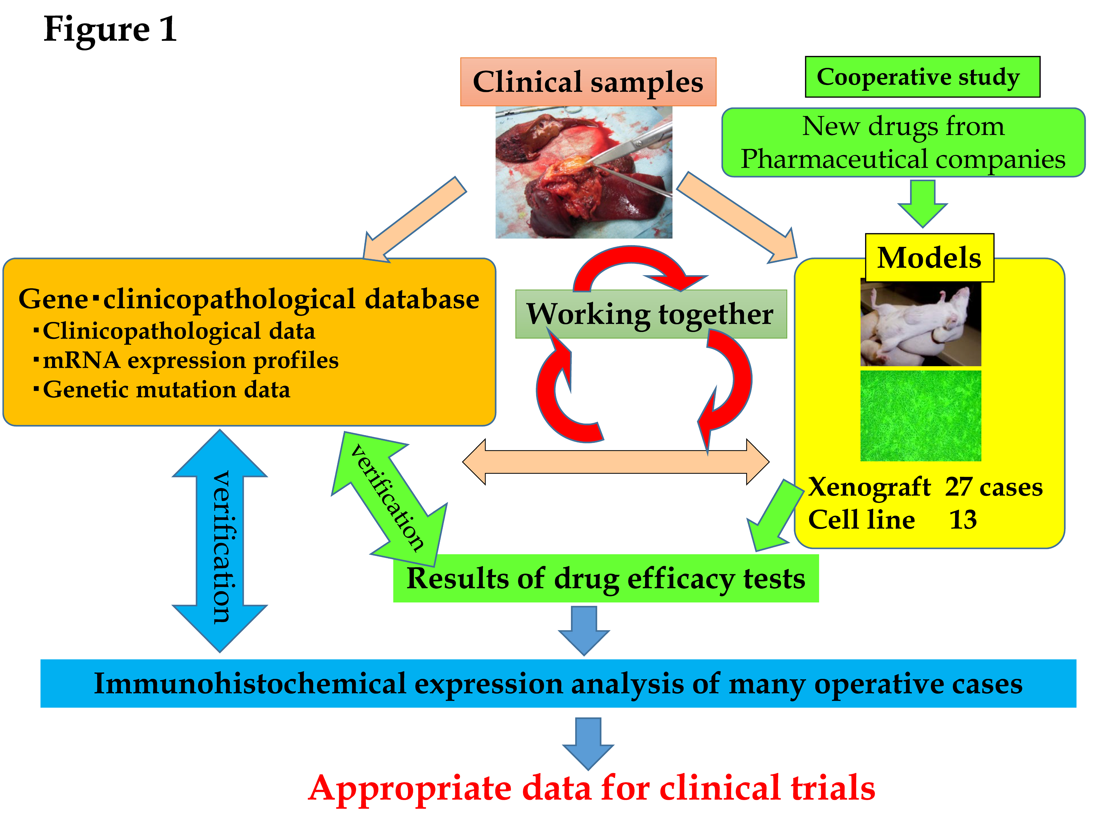

Figure 1 Relationship between our materials and databases. There are three key factors: clinical samples, databases, and BTC models. Both the models and the databases are derived from the clinical samples. These databases comprise “clinicopathological data,” “mRNA expression profiles,” and “genetic mutation data.” BTC models are “xenograft models” and “cell lines.” These models are used for cooperative studies with pharmaceutical companies for translational research. For example, they provide us with new anti-cancer drugs, and we can perform drug efficacy tests. If necessary, we can also perform an immunohistochemical expression analysis. Then, we can compare the results of the analysis with those in the databases and validate them. After these steps, we can provide appropriate data to clinicians. Together, these databases and materials make translational research far more detailed and suitable for clinical trials.
Table 1 Clinicopathological features of original biliary tract tumors

Xenograft | Pathological diagnosis of original tumor | Age/Sex | Histologic type | Prognosis  (survival days) | Chemotherapy | Clinical evaluation of chemotherapy effect (effective days) | Established cell line
1 | CCC | 70 F | Adeno, mod | Death (402) | non |  | NCC-CC1
2 | CCC | 71 F | Adeno, mod | Death (175) | non |  | NCC-CC3-1
 |  |  |  |  |  |  | NCC-CC3-2
3 | CCC | 59 M | Adeno, mod | Alive (2172) | non |  | NCC-CC4-1
 |  |  |  |  |  |  | NCC-CC4-2
 |  |  |  |  |  |  | NCC-CC4-3(NCC-CC5)
4 | CCC | 31 M | Adeno, mod + PSC | Death (386) | GEM + TS1 | SD (84 d) | NCC-CC6-1
 |  |  |  |  |  |  | NCC-CC6-2
5 | Distal BDCa | 58 F | Adeno, mod | Death (299) | GEM | PD | NCC-BD1
 | Distal BDCa | 77 F | Adeno, mod | Death (393) | GEM | PD | NCC-BD2¹
6 | Distal BDCa | 80 M | Adeno, mod | Death (212) | non |  | NCC-BD3
7 | Hilar BDCa | 74M | Adeno, mod | Death (172) | non |  | NCC-BD4-1
 |  |  |  |  |  |  | NCC-BD4-2
8 | Hilar BDCa | 48 M | Adeno, well | Alive (500) | GEM | PD | NA
9 | Hilar BDCa | 43 M | Adeno, mod | Alive (1422) | non |  | NA
10 | CCC | 69 M | Adeno, mod | Death (174) | non |  | NA
11 | CCC | 54 F | Adeno, mod | Death (181) | non |  | NA
12 | CCC | 56 M | Adeno, mod | Death (319) | GEM | PD | NA
13 | CCC | 73 M | Adeno, mod | Death (53) | non |  | NA
14 | CCC | 54 M | Adeno, mod | Alive (2608) | non |  | NA
15 | CCC | 45 F | Adeno, mod | Alive (882) | GEM + CDDP | unknown | NA
16 | CCC | 72 M | Muc | Death (749) | GEM/GEM + TS1 | unknown | NA
17 | CCC | 78 M | Adeno, mod | Death (382) | GEM | unknown | NA
18 | CCC | 66 M | Adeno, mod | Death (168) | non |  | NA
19 | CCC | 65 M | CoCC | Alive (1604) | non |  | NA
20 | CCC | 70 M | Adeno, por | Death (851) | GEM | SD (49 days) | NA
21 | CCC | 63 F | Adeno, mod | Alive (363) | unknown | unknown | NA
22 | CCC | 72 M | Adeno, mod | Death (394) | GEM | PD | NA
23 | CCC | 77 F | Adeno, mod | Death (445) | GEM | SD (105days) | NA
24 | Hilar BDCa | 66 M | Adeno, mod | Alive (102) | GEM + TS1 | unknown | NA
25 | Distal BDCa | 54 M | Adeno, mod | Alive (2096) | non |  | NA
26 | Distal BDCa | 67 M | Adeno, mod | Death (672) | GEM + TS1 | PD | NA
27 | Distal BDCa | 80 M | Adeno, mod | Alive (2024) | GEM | PR-CR (548 days) | NA
¹BD2 was obtained from the direct culture of patient specimens. CCC: Cholangiocellular carcinoma; BDCa: Bile duct carcinoma; Adeno: Adenocarcinoma; mod: Moderately differentiated; PSC: Primary sclerosing cholangitis; Muc: Mucinous carcinoma; CoCC: Cholangiolocellular carcinoma; por: Poorly differentiated; non: No chemotherapy received; GEM: Gemcitabine; CDDP: Cisplatin; SD: Stable disease; PD: Progressive disease; PR: Partial response; CR: Complete response; IC50: Inhibitory concentration 50.

Table 2 Sensitivity to gemcitabine in each cell line
Cell line | Sensitivity to gemcitabine in cell line¹
 | IC50 (µmol/L) | IC60 (µmol/L ) | IC70 (µmol/L ) | IC80 (µmol/L )
NCC-CC1 | 86.78 | N.A | N.A | N.A
NCC-CC3-1 | 0.04 | 1.82 | 9.31 | 85.21
NCC-CC3-2 | 0.10 | 1.92 | 43.83 | N.A
NCC-CC4-1 | 0.05 | 4.08 | N.A | N.A
NCC-CC4-2 | 0.03 | 11.53 | N.A | N.A
NCC-CC4-3 (NCC-CC5) | 0.06 | 4.92 | 95.10 | N.A
NCC-CC6-1 | 0.01 | 0.02 | 0.06 | 3.76
NCC-CC6-2 | 10.98 | 35.67 | N.A | N.A
NCC-BD1 | 7.66 | 58.00 | N.A | N.A
NCC-BD2 | N.A | N.A | N.A | N.A
NCC-BD3 | N.A | N.A | N.A | N.A
NCC-BD4-1 | 0.04 | 0.06 | 0.09 | 2.93
NCC-BD4-2 | 0.06 | 0.07 | 0.19 | 5.37

¹The cytotoxicity of gemcitabine for each cell line was assessed by a modified 3-(4,5-dimethylthiazol-2-yl)-5-(3-carboxymethoxyphenyl)-2-(4-sulfophenyl)-2H-tetrazolium, inner salt assay with CellTiter 96 Aqueous One Solution Reagent (Promega, Madison, WI, United States). Tumor cells (3000 cells⁄well) in the exponential growth phase were grown in 96-well plates.

